Name of Journal: World Journal of Gastrointestinal Pathophysiology
Manuscript NO: 34208
Manuscript Type: Minireviews

Acute cholangitis - an update

Ahmed M. Acute cholangitis

Monjur Ahmed

Monjur Ahmed, Division of Gastroenterology and Hepatology, Department of Internal Medicine, Thomas Jefferson University, Philadelphia, PA 19107, United States

Author contributions: Ahmed M solely contributed to this work.

Conflict-of-interest statement: None to declare.

Open-Access: This article is an open-access article which was selected by an in-house editor and fully peer-reviewed by external reviewers. It is distributed in accordance with the Creative Commons Attribution Non Commercial (CC BY-NC 4.0) license, which permits others to distribute, remix, adapt, build upon this work non-commercially, and license their derivative works on different terms, provided the original work is properly cited and the use is non-commercial. See: http://creativecommons.org/licenses/by-nc/4.0/

Manuscript source: Invited manuscript

Correspondence to: Monjur Ahmed, MD, FRCP, Division of Gastroenterology and Hepatology, Department of Internal Medicine, Thomas Jefferson University, 132 South 10th Street, Suite 468, Main Building, Philadelphia, PA 19107, United States. monjur.ahmed@jefferson.edu
Telephone: +1-215-9521493
Fax: +1-215-7551850

Received: April 6, 2017
Peer-review started: April 10, 2017
First decision: May 26, 2017
Revised: July 5, 2017
Accepted: October 30, 2017
Article in press:
Published online:

Abstract
Acute cholangitis is bacterial infection of the extra-hepatic biliary system. As it is caused by gallstones blocking the common bile duct in most of the cases, its prevalence is more in ethnicities with high prevalence of gallstones. Biliary obstruction of any cause is the main predisposing factor. Diagnosis is established by the presence of clinical features, laboratory results and imaging studies. The treatment modalities include administration of intravenous fluid, antibiotics, and drainage of the bile duct. The outcome is good if the treatment is started early, otherwise it could be grave.

Key words: Acute cholangitis; Ascending cholangitis; Biliary infection; Hepatic fever; Infection of the bile duct

© The Author(s) 2017. Published by Baishideng Publishing Group Inc. All rights reserved.

Core tip: Acute cholangitis is a serious medical problem unless treated early. High clinical suspicion is essential to diagnose this condition. The different diagnostic criteria, treatment options including different modalities of biliary drainage and prognosis are described in this article.

Ahmed M. Acute cholangitis - an update. World J Gastrointest Pathophysiol 2017; In press

INTRODUCTION
Acute cholangitis is a clinical entity caused by bacterial infection of the biliary system most commonly secondary to partial or complete obstruction of the bile duct or hepatic ducts. The diagnosis is established by the characteristic clinical symptoms and signs of infection, abnormal laboratory studies suggestive of infection and biliary obstruction, and abnormal imaging studies suggestive of biliary obstruction^{[1]}. The main importance of this condition is that it is a very treatable condition if treated appropriately but the mortality can be high if there is delay in treatment. There are other varieties of cholangitis which include primary biliary cholangitis, primary sclerosing cholangitis, IgG4-related autoimmune cholangitis and recurrent pyogenic cholangitis or Oriental cholangiohepatitis^{[2]}. We will be exclusively discussing here acute bacterial cholangitis also called ascending cholangitis. The term ascending cholangitis comes from the migration of bacteria from the duodenum into the common bile duct. But rarely translocation of bacteria from the portal vein into the bile duct can also occur.

ETIOLOGY
The biliary obstruction is most commonly caused by choledocholithiasis. Other causes of obstruction include benign or malignant stricture of the bile duct or hepatic ducts, pancreatic cancer, ampullary adenoma or cancer, porta hepatis tumor or metastasis, biliary stent obstruction (due to microbial biofilm formation, biliary sludge deposition and duodenal reflux of food content), primary sclerosing cholangitis, amyloid deposition in the biliary system^{[3]}, Mirizzi syndrome (gallstone impacted in cystic duct or neck of the gall bladder causing compression on common bile duct or common hepatic duct), Lemmel’s syndrome (peri-ampullary diverticulum causing distal biliary obstruction), round worm (Ascaris lumbricoides) or tapeworm (Taenia saginata) infestation of the bile duct^{[4]}, AIDS cholangiopathy and strictured bilioenteric anastomoses^{[5]}. Choledochocele and narrow calibered bile duct are other risk factors for acute cholangitis. Recently, there was an outbreak of cholangitis due to carbapenem -resistant Enterobacteriaceae (CRE) as a result of exposure to contaminated duodenoscope^{[6]}. Post-endoscopic retrograde cholangiopancreatography (ERCP) acute cholangitis can occur in 0.5% to 2.4% cases (Figure 1)^{[7]}. As cholelithiasis is the most important risk factor, the same risk factors may play important roles in the development of acute cholangitis, particularly high fat (triglyceride) intake, sedentary life styles, obesity and rapid weight loss. Heavy alcohol consumption may lead to cirrhosis of liver which is a risk factor for gallstone formation.

EPIDEMIOLOGY
The prevalence of cholelithiasis varies in different ethnicities. Gallstones are found in 10% to 15% of the white population in United States. It is much more prevalent in native Americans (60%-70%) and Hispanics but less common in Asians and African Americans^{[8]}. Many patients get admitted to the hospital with gallstone disease and 6% to 9% of them are diagnosed with acute cholangitis^{[9]}. Males and females are equally affected. The average age of patients presenting with acute cholangitis is 50 to 60 years. Less than 200000 cases of cholangitis occur per year in the United States.

PATHOPHYSIOLOGY
Biliary obstruction is an important factor in the pathogenesis of cholangitis. When bile flow occurs, presence of bacteria in the bile is not that significant because bacterial concentration does not increase and the intraductal pressure does not increase. Normally there are different defensive mechanisms to prevent cholangitis. The bile salts have bacteriostatic activity and the biliary epithelium secrete IgA and mucous which probably act as anti-adherent factors. Kupffer cells on the biliary epithelium and the tight junction between the cholangiocytes prevent translocation of bacteria from the hepatobiliary system into the portal venous system. Normal bile flow flushes out any bacteria into the duodenum. The sphincter of Oddi also prevents any migration of bacteria from the duodenum into the biliary system. In case of biliary obstruction, bile becomes stagnant in the biliary system, the intraductal pressure increases, the tight junction between cholangiocytes widen, Kupffer cells malfunction and the production of Ig A is decreased^{[10]}. “Choledochal pressure” plays an important role in the pathogenesis of acute cholangitis. The normal biliary ductal pressure is 7 cm to 14 cm of water (H₂O). When the intraductal pressure exceeds 25 cm of H₂O, cholangiovenous and cholangiolymphatic reflux can occur leading to bacteremia and endotoxinemia^{[11]}. Besides this, systemic release of inflammatory mediators like TNF, souble TNF receptors, IL-1, IL-6 and IL-10 leads to profound hemodynamic compromise.
The most frequently found pathogens isolated in acute cholangitis are coliform organisms^{[12,13]}. These include Escherechia coli (25%-50%), Klebsiella species (15%-20%), Enterococcus species (10%-20% and Enterobacter species (5% -10%). Sometime anerobic bacteria like Bacteroids fragilis, and Clostridium perfringens can also cause acute cholangitis particularly in patients with previous biliary surgery and in the elderly population^{[14]}. Parasitic infestation of the biliary system by the liver flukes Clonorchis sinensis, Opisthorchis viverrini and Opisthorchis felineus and the roundworm Ascaris lumbricoides may lead to cholangitis^{[15]}.

CLINICAL PRESENTATION
The presentation depends on the severity of cholangitis. Classically, patients present with high fever persisting for more than 24 h, abdominal pain and jaundice (Charcot’s triad or hepatic fever). The right upper quadrant abdominal pain is generally mild. When the cholangitis becomes more severe, patients become hypotensive and confused (Reynold’s pentad). Charcot’s triad has low sensitivity (26.4%) and high specificity (95.9%). Although the presence of Charcot’s triad is suggestive of acute cholangitis, it is not diagnostic. Charcot’s triad is present in 26.4% to 72% of patients with acute cholangitis^{[16]}. To improve the sensitivity of Charcot’s triad, TG07 diagnostic criteria for acute cholangitis was made at the International Consensus Meeting held in Tokyo in 2006. TG07 criteria included: Clinical: (1) history of biliary disease; (2) fever and/or chills; (3) jaundice; and (4) abdominal pain (RUQ or epigastric); Lab data: (5) evidence of inflammatory response; and (6) abnormal liver function tests; Imaging findings: (7) biliary dilatation or evidence of an etiology (stone, stricture, stent etc.). Suspected diagnosis: 2 or more items in A. Definite diagnosis: (1) Charcot’s triad (2 + 3 + 4); and (2) 2 or more items in A plus both items in B plus item C.
The sensitivity and specificity of diagnosing acute cholangitis in TG07 were 82.6% and 79.8% respectively. In 2012, TG13, a new Tokyo guideline for the diagnosis of acute cholangitis was published^{[17]}. (1) The criteria included: Systemic inflammation: A-1: Fever (body temperature > 38 °C and/or shaking chills; A-2: Lab data: Evidence of inflammatory response - WBC < 4000/cmm or > 10000/cmm, CRP - ≥ 1 mg/dL; and (2) cholestasis: B-1: Jaundice – total bilirubin ≥ 2 mg/dl; B-2: Lab data: Abnormal liver function tests. Alkaline phosphatase (IU) > 1.5 × upper limit of normal; Gamma-glutamyl transpeptidase (IU) > 1.5 × upper limit of normal; Asparate aminotransferase (IU) > 1.5 × upper limit of normal; Alanine aminotransfearse (IU) > 1.5 × upper limit of normal. Imaging: C-1: Biliary dilatation; C-2: Evidence of etiology on imaging (stricture, stone stent etc.).
Suspected diagnosis: one item in A + one item in either B or C. Definite diagnosis: one item in A, one item in B and one item in C. The sensitivity of diagnosing acute cholangitis improved to 91.8% but the specificity remained similar (77.7%) in TG13. The false positive rate of diagnosing acute cholecystitis also decreased to 5.9% in TG13 in comparison to Charcot’s triad (11.9%) and TG07 (15.5%).
Physical examination may show high temperature, tachycardia, hypotension, jaundice, right upper quadrant or epigastric tenderness and altered mental status.
Severity of acute cholangitis: two clinical factors determine the severity of acute cholangitis: (1) response to initial medical treatment; and (2) organ dysfunction^{[1]}.
Grade I is mild acute cholangitis. Patients do not have any organ dysfunction and do not meet the criteria of moderate acute cholangitis. They respond to the initial antibiotic treatment.
Grade II is moderate acute cholangitis. Patients do not have any organ dysfunction and do not respond to the initial antibiotic treatment. Any two of the five conditions should be present: (1) leucocytosis (WBC > 12000/cmm) or leukopenia (WBC < 4000/cmm); (2) high temperature (≥ 39 °C); (3) elderly (age > 75 years); and (4) hyperbilirubinemia (total bilirubin ≥ 5 mg/dL); and (5) hypoalbuminemia (< 0.7 × lower limit of normal).
Grade III is severe acute cholangitis. Patients do not respond to initial medical treatment and have organ dysfunction in at least one of the following organs/systems: (1) cardiovascular system: hypotension requiring dopamine infusion ≥ 5 microgram/kg per minute, or any dose of norepinephrine; (2) nervous system: disturbance of consciousness; (3) respiratory system: PaO₂/FiO₂ ratio < 300; (4) renal system: oliguria, serum creatinine > 2 mg/dL; (5) hepatic system: PT-INR > 1.5; and (6) hematological system: platelet count < 100000/cm.
Sometimes we make the diagnosis of acute suppurative cholangitis (ASC) when we notice pus extruding from the ampulla of Vater during ERCP (Figures 1 and 2).
ASC does not always mean severe acute cholangitis. Sometimes patients with severe acute cholangitis do not have pus in the bile duct, and sometimes patients with ASC are not that sick^{[18]}. Severe acute cholangitis or toxic cholangitis is present in 5% of all cases of cholangitis^{[19]}.
Differential diagnoses of acute cholangitis^{[20]}: (1) acute cholecystitis; (2) cirrhosis of liver; (3) acute hepatitis; (4) liver abscess; (5) septic shock due to any cause; (6) right sided diverticulitis; and (7) righted sided pyelonephritis.
Recurrent acute cholangitis can occur when pigment stone is formed in the intrahepatic ducts leading to stricture formation, mainly in the lateral segment of left lobe or posterior segment of right lobe^{[21]}. This condition is also called oriental cholangiohepatitis as it occurs almost exclusively in the natives of Southeast Asia. The exact mechanism is not known but related to malnutrition, ascariasis (Ascaris Lumbricoides) and clonorchiasis (Clonorchis sinensis). Transient portal bacteremia allows entrance of bacteria (E. coli, klebsiella, pseudomona, proteus, anerobes) into the biliary system initiating a vicious cycle of infection and stone formation^{[22]}. This condition may cause cholangiocarcinoma in 5% of cases.

INVESTIGATIONS
Lab tests should include complete blood count, ESR or C-reactive protein (CRP), complete metabolic profile including renal and hepatic function, prothrombin time and INR. Blood culture should be done as early as possible. TG13 guideline also recommends collection of bile sample during the drainage procedure. Bile culture can be positive in 59% to 93% cases of acute cholangitis.
Imaging studies may include ultrasound of abdomen, regular or helical CT, Magentic Resonance Cholangiopancreaticography (MRCP) and endoscopic ultrasound (EUS). CT without contrast is more sensitive than abdominal ultrasound in detecting common bile duct stones^{[23]}. Among these, MRCP (82.2% accuracy in detecting choledocholithiasis) and EUS (96.9% accuracy in detecting choledocholithiasis) are the most sensitive imaging modalities which can detect the level and cause of biliary obstruction^{[24]}. Transabdominal ultrasound is able to detect choledocholithiasis in 30% of cases, and CT in 42% of cases. Although MRCP is being increasingly used in the setting of acute cholangitis, its sensitivity in detecting less than 6 mm stone is low^{[11]}.

MANAGEMENT
Patients with cholangitis should be managed at the hospital as this is considered as an emergent condition. Patients should be resuscitated first. As cholangitis is due to infection and obstruction of the biliary system, we have to treat both aspects. Intravenous fluid and antibiotics should be started as soon as possible. Fresh frozen plasma or vitamin K may be required for correction of coagulopathy. The choice of antibiotics depends on multiple factors including patient’s renal function, hepatic function, drug allergies, comorbidities, hospital acquired (multiple or resistant organisms like Pseudomonas, CRE, vancomycin- resistant enterococcus or methicillin-resistant staphylococcus aureus) or community acquired infection (single agent like E. coli, Klebsiella, or Enterococcus), and also on the severity of cholangitis. The empiric antibiotics should cover both gram negative and anaerobic organisms. The initial choice should be piperacillin-tazobactam, ticarcillin-clavulanate, ceftriaxone plus metronidazole or ampicillin-sulbactam. If the patient is sensitive to penicillin, ciprofloxacin plus metronidazole, carbapenems or gentamicin plus metronidazole are good choices^{[25]}. The antibiotics should be further evaluated and adjusted according to the blood culture results. Blood culture is positive in 21% to 71% of cases of acute cholangitis^{[26]}. The dose of the antibiotics should be adjusted according to renal and hepatic functions. Ideally the antibiotics should be continued for 7 to 10 d^{[12]}.
Because of high biliary intraductal pressure, biliary secretion of antibiotics is impaired. So biliary drainage is the next step. It can be best done by therapeutic ERCP. Depending on the etiology of biliary obstruction, intervention should be done. For example, in case of choledocholithiasis, sphincterotomy and stone extraction (Figures 3, 4 and 5) should be done with or without transpapillary biliary stent placement. Sometimes, there is an increased risk of bleeding from biliary sphincterotomy if the patient is coagulopathic or on anti-platelet agents. In those cases, biliary stent can be placed temporarily without sphincterotomy. In case of biliary stricture, transpapillary biliary stent placement should give adequate drainage. If there is blockage of the existing stent due to growth of bacterial biofilm and formation of bile sludge, the old stent should be removed and replaced with a new one^{[27]}.
Other modalities of biliary drainage include endoscopic nasobiliary drainage (ENBD) by nasobiliary catheter (Figure 6), percutaneous transhepatic biliary drainage (PTBD), endoscopic ultrasound (EUS) guided drainage and open surgical drainage (T-tube drainage after laparotomy).
In clinical practice, ENBD is done much less frequently as compared to biliary stent placement. ENBD has the advantages that repeat cholangiogram could be done when the location of biliary stricture is not known, thick pus or purulent bile can be drained more effectively, washing can be done if the tube is clogged, biliary aspirate can be cultured and no additional sphincterotomy is required. The disadvantages are: It is uncomfortable to the patient and confused patient may pull it out^{[28]}.
PTBD is generally done in case of failed ERCP or if the patient has multiple comorbidities and is not a good candidate for ERCP. There is no need for intravenous sedation or anesthesia for PTBD. The disadvantages include patient’s discomfort, increased length of hospital stay, risks of biliary peritonitis, intraperitoneal hemorrhage and sepsis^{[29]}. It is contraindicated in patients with ascites, coagulopathies and intrahepatic biliary obstructions.
EUS guided biliary drainage (EUS-BD) can be performed when ERCP is unsuccessful due to various reasons like ampullary obstruction, gastric outlet obstruction or surgically altered anatomy (Roux-en-Y surgery, gastric bypass, etc.), and intrahepatic bile ducts are not dilated^{[30]}. Urgent EUS-guided choledochoduodenostomy (EUS-CDS) with placement of a covered metallic stent is an option in the setting of acute cholangitis^{[31]}, mainly in tertiary care centers.
Surgical drainage is reserved when other modalities of biliary drainage are contra-indicated or fail. It is done rarely now-a-days because of high morbidity and mortality of 20% to 60%^{[32]}. To avoid prolonged surgery, choledochotomy with T-tube drainage without choledocholithotomy is recommended^{[33]}. Laparoscopic choledochotomy with stone extraction can be done in case of failed endoscopic extraction of common bile duct stone^{[34]}.
In patients with surgically altered anatomy like Roux-en-Y anastomosis or hepaticojejunostomy, balloon enteroscope-assisted ERCP with biliary drainage is done with variable success rate of 40% to 95%^{[35]}.
Timing of biliary drainage: In grade I or mild acute cholangitis: biliary drainage should be done in 24 to 48 h. In grade II or moderate acute cholangitis (i.e., patient has not responded to antibiotics in first 24 h): early biliary drainage, and in grade III or severe acute cholangitis: urgent biliary drainage should be done. Following endoscopic management of acute cholangitis, laparoscopic cholecystectomy is recommended in patients with gallstone disease^{[36]}. The various techniques of performing laparoscopic cholecystectomy safely have been described over the last few decades^{[37-39]}.
Management of recurrent pyogenic cholangitis (oriental cholangiohepatitis) requires a multidisciplinary team (endoscopist, interventional radiologist and surgeon). Initial treatment includes administration of intravenous fluid and antibiotics, endoscopic treatment with stricture dilation, stone extraction and stent placement for biliary drainage or percutaneous biliary drainage in case of failed ERCP. Segmental hepatic resection should be considered in case of localized disease^{[40]}. Orthotopic liver transplantation has also been reported in case of diffuse disease and end stage liver disease due to recurrent acute cholangiti^{s[41,42]}.

PROGNOSIS
The prognosis depends on the timing of biliary drainage, administration of antibiotics and comorbidities of the patient. Early biliary drainage leads to rapid clinical improvement. But if biliary drainage is delayed, patients can deteriorate quickly and die. The overall mortality acute cholangitis is less than10% after biliary drainage^{[43]}. In pre-ERCP era, severe acute cholangitis was associated with a mortality of more than 50%^{[44]}. Emergency surgery for severe acute cholangitis also carries a high mortality of about 30%^{[45]}.
Poor prognostic factors in the setting of acute cholangitis include old age, high fever, leukocytosis, hyperbilirubinemia and hypoalbuminemia^{[11]}. Patients with comorbidities like cirrhosis, malignancy, liver abscess, and coagulopathy also carry poor prognosis.
Patients with high pre-biliary drainage serum creatinine is also associated with higher mortality^{[46]}. Recent study also suggested that serum IL-7 level of less than 6.0 and serum procalcitonin level of more than 0.5 was associated with higher mortality^{[47]}.

REFERENCES
1 Wada K, Takada T, Kawarada Y, Nimura Y, Miura F, Yoshida M, Mayumi T, Strasberg S, Pitt HA, Gadacz TR, Büchler MW, Belghiti J, de Santibanes E, Gouma DJ, Neuhaus H, Dervenis C, Fan ST, Chen MF, Ker CG, Bornman PC, Hilvano SC, Kim SW, Liau KH, Kim MH. Diagnostic criteria and severity assessment of acute cholangitis: Tokyo Guidelines. J Hepatobiliary Pancreat Surg 2007; 14: 52-58 [PMID: 17252297 DOI: 10.1007/s00534-006-1156-7]
2 Lee SP, Roberts JR, Kuver R. The changing faces of cholangitis. F1000Res 2016; 5: [PMID: 27347393 DOI: 10.12688/f1000research.8745.1]
3 Clough J, Shah R. Primary Amyloidosis Presenting as Common Bile Duct Obstruction With Cholangitis. ACG Case Rep J 2015; 2: 107-109 [PMID: 26157929 DOI: 10.14309/crj.2015.20]
4 Uygur-Bayramiçli O, Ak O, Dabak R, Demirhan G, Ozer S. Taenia saginata a rare cause of acute cholangitis: a case report. Acta Clin Belg 2012; 67: 436-437 [PMID: 23340150 DOI: 10.2143/ACB.67.6.2062709]
5 Mosler P. Management of acute cholangitis. Gastroenterol Hepatol (N Y) 2011; 7: 121-123 [PMID: 21475420]
6 Epstein L, Hunter JC, Arwady MA, Tsai V, Stein L, Gribogiannis M, Frias M, Guh AY, Laufer AS, Black S, Pacilli M, Moulton-Meissner H, Rasheed JK, Avillan JJ, Kitchel B, Limbago BM, MacCannell D, Lonsway D, Noble-Wang J, Conway J, Conover C, Vernon M, Kallen AJ. New Delhi metallo-β-lactamase-producing carbapenem-resistant Escherichia coli associated with exposure to duodenoscopes. JAMA 2014; 312: 1447-1455 [PMID: 25291580 DOI: 10.1001/jama.2014.12720]
7 Kimura Y, Takada T, Strasberg SM, Pitt HA, Gouma DJ, Garden OJ, Büchler MW, Windsor JA, Mayumi T, Yoshida M, Miura F, Higuchi R, Gabata T, Hata J, Gomi H, Dervenis C, Lau WY, Belli G, Kim MH, Hilvano SC, Yamashita Y. TG13 current terminology, etiology, and epidemiology of acute cholangitis and cholecystitis. J Hepatobiliary Pancreat Sci 2013; 20: 8-23 [PMID: 23307004 DOI: 10.1007/s00534-012-0564-0]
8 Shaffer EA. Gallstone disease: Epidemiology of gallbladder stone disease. Best Pract Res Clin Gastroenterol 2006; 20: 981-996 [PMID: 17127183 DOI: 10.1016/j.bpg.2006.05.004]
9 What if it's acute cholangitis? Drug Ther Bull 2005; 43: 62-64 [PMID: 16111086 DOI: 10.1136/dtb.2005.43862]
10 Sung JY, Costerton JW, Shaffer EA. Defense system in the biliary tract against bacterial infection. Dig Dis Sci 1992; 37: 689-696 [PMID: 1563308 DOI: 10.1007/BF01296423]
11 Buyukasik K, Toros AB, Bektas H, Ari A, Deniz MM. Diagnostic and therapeutic value of ERCP in acute cholangitis. ISRN Gastroenterol 2013; 2013: 191729 [PMID: 23997958 DOI: 10.1155/2013/191729]
12 van den Hazel SJ, Speelman P, Tytgat GN, Dankert J, van Leeuwen DJ. Role of antibiotics in the treatment and prevention of acute and recurrent cholangitis. Clin Infect Dis 1994; 19: 279-286 [PMID: 7986900 DOI: 10.1093/clinids/19.2.279]
13 Jain MK, Jain R. Acute bacterial cholangitis. Curr Treat Options Gastroenterol 2006; 9: 113-121 [PMID: 16539872 DOI: 10.1007/s11938-006-0030-7]
14 Kinney TP. "Management of ascending cholangitis". Gastrointestinal Endosc Clin North Am 2007; 17: 289–306 [PMID: 17556149 DOI: 10.1016/j.giec.2007.03.006]
15 Lim JH. Liver flukes: the malady neglected. Korean J Radiol 2011; 12: 269-279 [PMID: 21603286 DOI: 10.3348/kjr.2011.12.3.269]
16 Kiriyama S, Takada T, Strasberg SM, Solomkin JS, Mayumi T, Pitt HA, Gouma DJ, Garden OJ, Büchler MW, Yokoe M, Kimura Y, Tsuyuguchi T, Itoi T, Yoshida M, Miura F, Yamashita Y, Okamoto K, Gabata T, Hata J, Higuchi R, Windsor JA, Bornman PC, Fan ST, Singh H, de Santibanes E, Gomi H, Kusachi S, Murata A, Chen XP, Jagannath P, Lee S, Padbury R, Chen MF, Dervenis C, Chan AC, Supe AN, Liau KH, Kim MH, Kim SW; Tokyo Guidelines Revision Committee. TG13 guidelines for diagnosis and severity grading of acute cholangitis (with videos). J Hepatobiliary Pancreat Sci 2013; 20: 24-34 [PMID: 23307001 DOI: 10.1007/s00534-012-0561-3]
17 Kiriyama S, Takada T, Strasberg SM, Solomkin JS, Mayumi T, Pitt HA, Gouma DJ, Garden OJ, Büchler MW, Yokoe M, Kimura Y, Tsuyuguchi T, Itoi T, Yoshida M, Miura F, Yamashita Y, Okamoto K, Gabata T, Hata J, Higuchi R, Windsor JA, Bornman PC, Fan ST, Singh H, de Santibanes E, Gomi H, Kusachi S, Murata A, Chen XP, Jagannath P, Lee S, Padbury R, Chen MF; Tokyo Guidelines Revision Committee. New diagnostic criteria and severity assessment of acute cholangitis in revised Tokyo Guidelines. J Hepatobiliary Pancreat Sci 2012; 19: 548-556 [PMID: 22825491 DOI: 10.1007/s00534-012-0537-3]
18 Boey JH, Way LW. Acute cholangitis. Ann Surg 1980; 191: 264-270 [PMID: 7362292 DOI: 10.1097/00000658-198003000-00002]
19 Lipsett PA, Pitt HA. Acute cholangitis. Front Biosci 2003; 8: s1229-s1239 [PMID: 12957832]
20 Scott TM, Rosh AJ. Acute Cholangitis Differential Diagnoses. Medscape. Updated November 21, 2016. Available from: URL: http://www.medscape.com
21 Lim JH. Oriental cholangiohepatitis: pathologic, clinical, and radiologic features. AJR Am J Roentgenol 1991; 157: 1-8 [PMID: 2048504 DOI: 10.2214/ajr.157.1.2048504]
22 Okuno WT, Whitman GJ, Chew FS. Recurrent pyogenic cholangiohepatitis. AJR Am J Roentgenol 1996; 167: 484 [PMID: 8686632 DOI: 10.2214/ajr.167.2.8686632]
23 Gallix BP, Aufort S, Pierredon MA, Garibaldi F, Bruel JM. [Acute cholangitis: imaging diagnosis and management]. J Radiol 2006; 87: 430-440 [PMID: 16691174 DOI: 10.1016/S0221-0363(06)74025-2]
24 de Lédinghen V, Lecesne R, Raymond JM, Gense V, Amouretti M, Drouillard J, Couzigou P, Silvain C. Diagnosis of choledocholithiasis: EUS or magnetic resonance cholangiography? A prospective controlled study. Gastrointest Endosc 1999; 49: 26-31 [DOI: 10.1016/S0016-5107(99)70441-4]
25 Qureshi WA. Approach to the patient who has suspected acute bacterial cholangitis. Gastroenterol Clin North Am 2006; 35: 409-423 [PMID: 16880073 DOI: 10.1016/j.gtc.2006.05.005]
26 Tanaka A, Takada T, Kawarada Y, Nimura Y, Yoshida M, Miura F, Hirota M, Wada K, Mayumi T, Gomi H, Solomkin JS, Strasberg SM, Pitt HA, Belghiti J, de Santibanes E, Padbury R, Chen MF, Belli G, Ker CG, Hilvano SC, Fan ST, Liau KH. Antimicrobial therapy for acute cholangitis: Tokyo Guidelines. J Hepatobiliary Pancreat Surg 2007; 14: 59-67 [PMID: 17252298 DOI: 10.1007/s00534-006-1157-6]
27 Donelli G, Guaglianone E, Di Rosa R, Fiocca F, Basoli A. Plastic biliary stent occlusion: factors involved and possible preventive approaches. Clin Med Res 2007; 5: 53-60 [PMID: 17456835 DOI: 10.3121/cmr.2007.683]
28 Nagino M, Takada T, Kawarada Y, Nimura Y, Yamashita Y, Tsuyuguchi T, Wada K, Mayumi T, Yoshida M, Miura F, Strasberg SM, Pitt HA, Belghiti J, Fan ST, Liau KH, Belli G, Chen XP, Lai EC, Philippi BP, Singh H, Supe A. Methods and timing of biliary drainage for acute cholangitis: Tokyo Guidelines. J Hepatobiliary Pancreat Surg 2007; 14: 68-77 [PMID: 17252299 DOI: 10.1007/s00534-006-1158-5]
29 Clouse ME, Evans D, Costello P, Alday M, Edwards SA, McDermott WV Jr. Percutaneous transhepatic biliary drainage. Complications due to multiple duct obstructions. Ann Surg 1983; 198: 25-29 [PMID: 6859989]
30 Karaliotas C, Sgourakis G, Goumas C, Papaioannou N, Lilis C, Leandros E. Laparoscopic common bile duct exploration after failed endoscopic stone extraction. Surg Endosc 2008; 22: 1826-1831 [PMID: 18071799 DOI: 10.1007/s00464-007-9708-8]
31 Artifon EL, Ferreira FC, Sakai P. Endoscopic ultrasound-guided biliary drainage. Korean J Radiol 2012; 13 Suppl 1: S74-S82 [PMID: 22563291 DOI: 10.3348/kjr.2012.13.S1.S74]
32 Minaga K, Kitano M, Imai H, Yamao K, Kamata K, Miyata T, Omoto S, Kadosaka K, Yoshikawa T, Kudo M. Urgent endoscopic ultrasound-guided choledochoduodenostomy for acute obstructive suppurative cholangitis-induced sepsis. World J Gastroenterol 2016; 22: 4264-4269 [PMID: 27122677 DOI: 10.3748/wjg.v22.i16.4264]
33 Liu CL, Fan ST. Acute cholangitis. In: Surgical Treatment: Evidence-Based and Problem-Oriented. Holzheimer RG, Mannick JA, editors. Munich: Zuckschwerdt, 2001
34 Tsuyuguchi T, Takada T, Kawarada Y, Nimura Y, Wada K, Nagino M, Mayumi T, Yoshida M, Miura F, Tanaka A, Yamashita Y, Hirota M, Hirata K, Yasuda H, Kimura Y, Strasberg S, Pitt H, Büchler MW, Neuhaus H, Belghiti J, de Santibanes E, Fan ST, Liau KH, Sachakul V. Techniques of biliary drainage for acute cholangitis: Tokyo Guidelines. J Hepatobiliary Pancreat Surg 2007; 14: 35-45 [PMID: 17252295 DOI: 10.1007/s00534-006-1154-9]
35 Itoi T, Tsuyuguchi T, Takada T, Strasberg SM, Pitt HA, Kim MH, Belli G, Mayumi T, Yoshida M, Miura F, Büchler MW, Gouma DJ, Garden OJ, Jagannath P, Gomi H, Kimura Y, Higuchi R; Tokyo Guideline Revision Committee. TG13 indications and techniques for biliary drainage in acute cholangitis (with videos). J Hepatobiliary Pancreat Sci 2013; 20: 71-80 [PMID: 23307008 DOI: 10.1007/s00534-012-0569-8]
36 Poon RT, Liu CL, Lo CM, Lam CM, Yuen WK, Yeung C, Fan ST, Wong J. Management of gallstone cholangitis in the era of laparoscopic cholecystectomy. Arch Surg 2001; 136: 11-16 [PMID: 11146767 DOI: 10.1001/archsurg.136.1.11]
37 Strasberg SM, Hertl M, Soper NJ. An analysis of the problem of biliary injury during laparoscopic cholecystectomy. J Am Coll Surg 1995; 180: 101-125 [PMID: 8000648]
38 Callery MP. Avoiding biliary injury during laparoscopic cholecystectomy: technical considerations. Surg Endosc 2006; 20: 1654-1658 [PMID: 17063288 DOI: 10.1007/s00464-006-0488-3]
39 Hori T, Oike F, Furuyama H, Machimoto T, Kadokawa Y, Hata T, Kato S, Yasukawa D, Aisu Y, Sasaki M, Kimura Y, Takamatsu Y, Naito M, Nakauchi M, Tanaka T, Gunji D, Nakamura K, Sato K, Mizuno M, Iida T, Yagi S, Uemoto S, Yoshimura T. Protocol for laparoscopic cholecystectomy: Is it rocket science? World J Gastroenterol 2016; 22: 10287-10303 [PMID: 28058010 DOI: 10.3748/wjg.v22.i47.10287]
40 Cosenza CA, Durazo F, Stain SC, Jabbour N, Selby RR. Current management of recurrent pyogenic cholangitis. Am Surg 1999; 65: 939-943 [PMID: 10515539]
41 Jeyarajah DR. Recurrent Pyogenic Cholangitis. Curr Treat Options Gastroenterol 2004; 7: 91-98 [PMID: 15010022 DOI: 10.1007/s11938-004-0029-x]
42 Strong RW, Chew SP, Wall DR, Fawcett J, Lynch SV. Liver transplantation for hepatolithiasis. Asian J Surg 2002; 25: 180-183 [PMID: 12376243 DOI: 10.1016/S1015-9584(09)60170-6.]
43 Zhang WZ, Chen YS, Wang JW, Chen XR. Early diagnosis and treatment of severe acute cholangitis. World J Gastroenterol 2002; 8: 150-152 [PMID: 11833092 DOI: 10.3748/wjg.v8.i1.150]
44 Andrew DJ, Johnson SE. Acute suppurative cholangitis, a medical and surgical emergency. A review of ten years experience emphasizing early recognition. Am J Gastroenterol 1970; 54: 141-154 [PMID: 5458220]
45 Lai EC, Tam PC, Paterson IA, Ng MM, Fan ST, Choi TK, Wong J. Emergency surgery for severe acute cholangitis. The high-risk patients. Ann Surg 1990; 211: 55-59 [PMID: 2294844 DOI: 10.1097/00000658-199001000-00009]
46 Tai DI, Shen FH, Liaw YF. Abnormal pre-drainage serum creatinine as a prognostic indicator in acute cholangitis. Hepatogastroenterology 1992; 39: 47-50 [PMID: 1568708]
47 Suwa Y, Matsuyama R, Goto K, Kadokura T, Sato M, Mori R, Kumamoto T, Taguri M, Miyasho T, Endo I. IL-7 and procalcitonin are useful biomarkers in the comprehensive evaluation of the severity of acute cholangitis. J Hepatobiliary Pancreat Sci 2017; 24: 81-88 [PMID: 28002647 DOI: 10.1002/jhbp.420]

P-Reviewer: Hori H, Sergi CM, Tamori A S-Editor: Qi Y L-Editor: E-Editor:
Specialty type: Gastroenterology and hepatology
Country of origin: United States
Peer-review report classification
Grade A (Excellent): A
Grade B (Very good): B
Grade C (Good): 0
Grade D (Fair): D
Grade E (Poor): 0

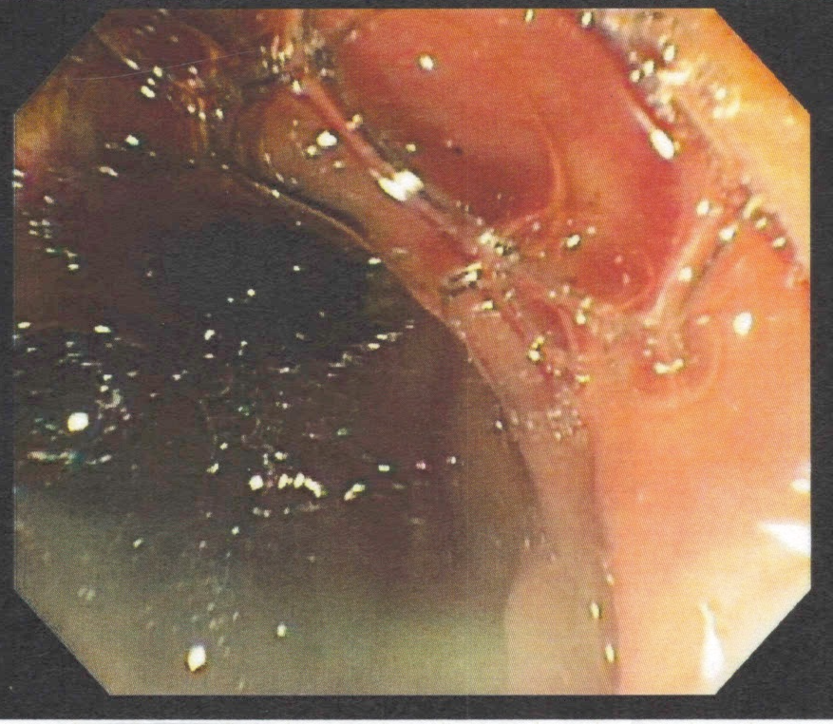
Figure 1 Pus seen extruding from the ampulla of Vater.

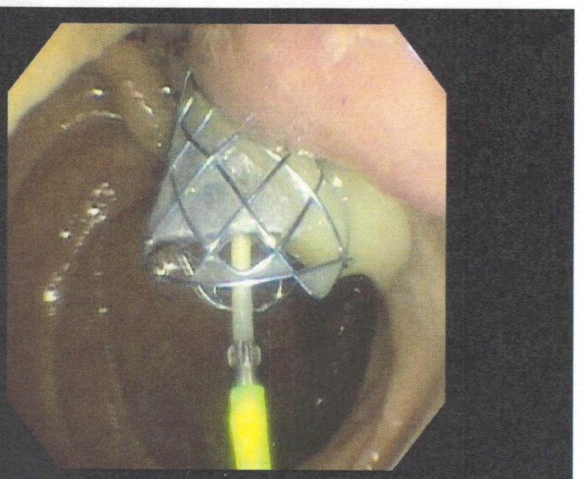Figure 2 Drainage of pus after biliary stenting during Post-endoscopic retrograde cholangiopancreatography.

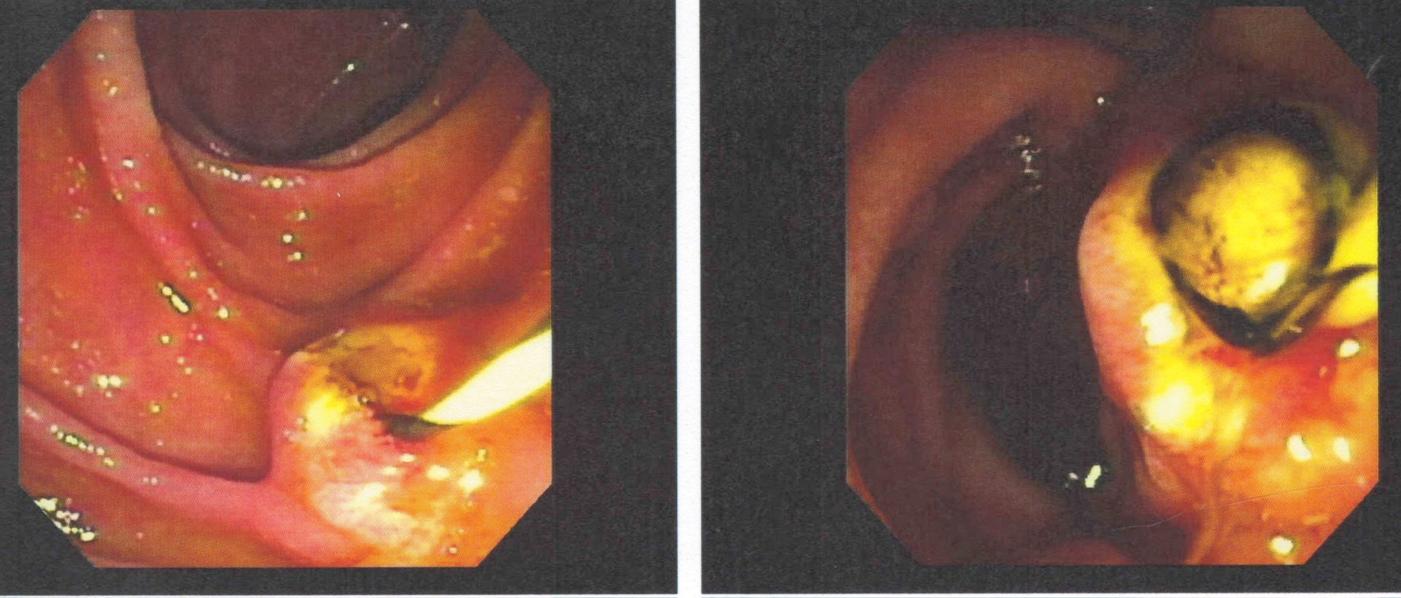
Figure 3 Biliary sphincterotomy followed by stone extraction.
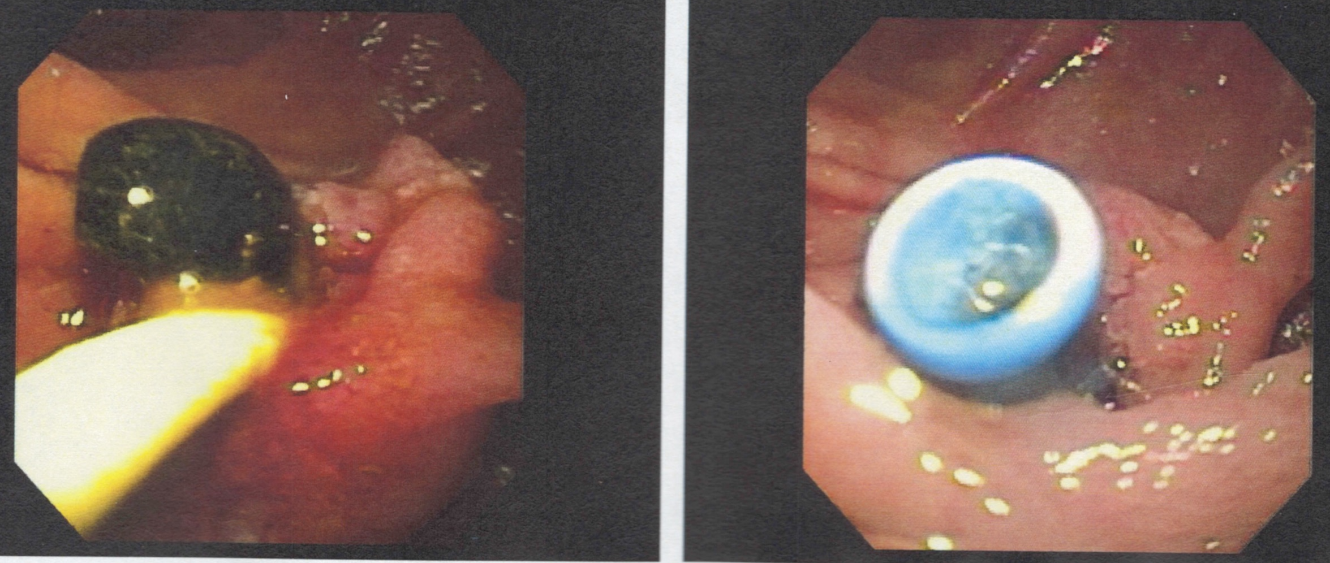
Figure 4 Biliary stone extraction followed by stent placement.

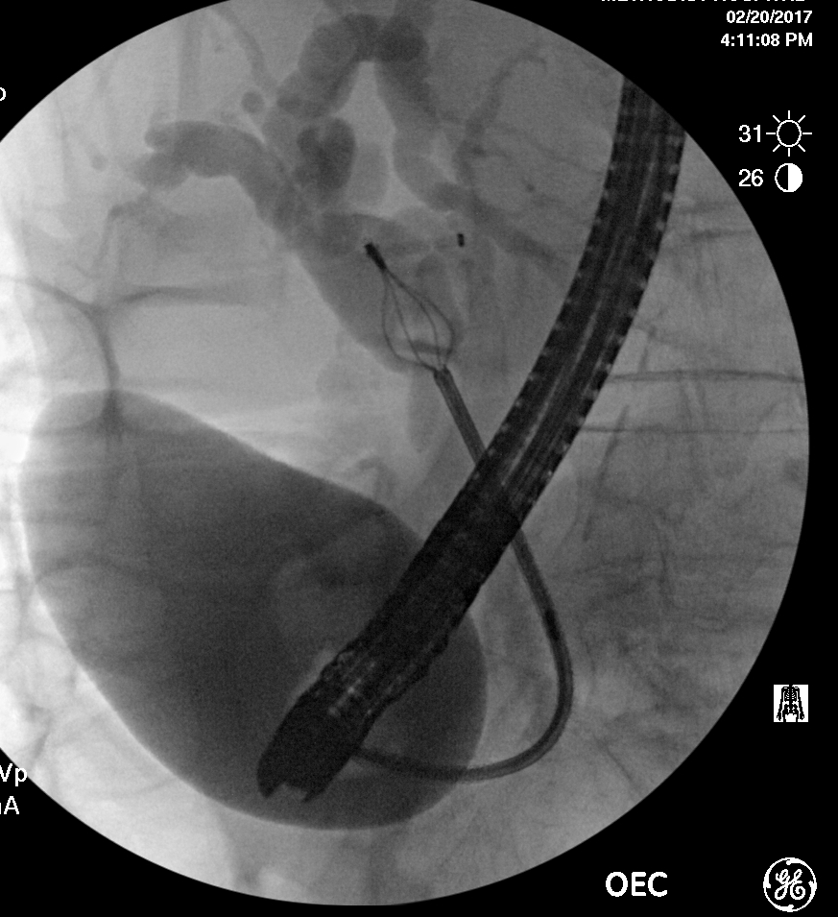
Figure 5 Fluoroscopy showing lithotripsy basket assisted stone extraction.
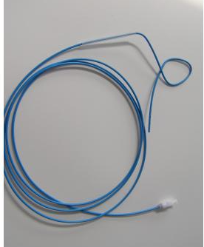
Figure 6 Nasobiliary catheter.

