Name of Journal: World Journal of Clinical Cases
Manuscript NO: 57021
Manuscript Type: CASE REPORT

Facial microcystic adnexal carcinoma — treatment with a “jigsaw puzzle” advancement flap and immediate esthetic reconstruction: A case report

Xiao YD et al. “Jigsaw puzzle” advancement flap for MAC

Yi-Ding Xiao, Ming-Zi Zhang, Ang Zeng

Yi-Ding Xiao, Ming-Zi Zhang, Ang Zeng, Department of Plastic Surgery, Peking Union Medical College Hospital, Beijing 100730, China

Author contributions: Xiao YD and Zhang MZ contributed equally to this study; Xiao YD drafted the manuscript; Zhang MZ selected the figures and revised the manuscript; Zeng A was the patient’s doctor.

Corresponding author: Ang Zeng, MD, Adjunct Professor, Surgeon, Department of Plastic Surgery, Peking Union Medical College Hospital, No. 1 Shuaifu Yuan, Beijing 100730, China. zmzzxwk@126.com

Received: May 23, 2020
Revised: November 30, 2020
Accepted: December 10, 2020
Published online: January 26, 2021

Abstract
BACKGROUND
Microcystic adnexal carcinoma (MAC) is a rare malignant tumor of the skin that is commonly found on the face. It grows slowly and has a low mortality rate. However, for various reasons, including strong histological invasiveness, clinical inexperience and inadequate procedure design, immediate or permanent facial deformity may occur after surgical operations.

CASE SUMMARY
This article describes a middle-aged female artist who was diagnosed with MAC on the left upper lip. She declined the recommended treatment plan, which included two-stage reconstruction, skin grafting, or surgery that could have resulted in obvious facial dysfunction or esthetic deformity. We accurately designed a personalized procedure involving a “jigsaw puzzle advancement flap” for the patient based on the lesion location and the estimated area of skin loss. The procedure was successful; both pathological R0 resection and immediate and long-term esthetic reconstruction effects were achieved.

CONCLUSION
This study suggests that when treating facial MAC or other skin malignancies, a surgical team should have sufficient plastic surgery-related knowledge and skills. An optimal surgical plan for an individual is needed to achieve good facial esthetics and functional recovery and shorten the treatment course.

Key Words: Microcystic adnexal carcinoma; Esthetic reconstruction; Jigsaw puzzle advancement flap; Plastic surgery; Reconstruction; Esthetics; Case report

©The Author(s) 2021. Published by Baishideng Publishing Group Inc. All rights reserved.

Citation: Xiao YD, Zhang MZ, Zeng A. Facial microcystic adnexal carcinoma — treatment with a “jigsaw puzzle” advancement flap and immediate esthetic reconstruction: A case report. World J Clin Cases 2021; 9(3): 607-613
URL: https://www.wjgnet.com/2307-8960/full/v9/i3/607.htm
DOI: https://dx.doi.org/10.12998/wjcc.v9.i3.607

Core Tip: Microcystic adnexal carcinoma is a rare skin malignancy, which has a low mortality rate. In this study, we offered a new idea in treating a patient with microcystic adnexal carcinoma on the left upper lip and obtained satisfying esthetic reconstruction effect.
INTRODUCTION
Microcystic adnexal carcinoma (MAC) is a rare skin malignancy that was first reported by Goldstein et al^{[1]} in 1982. Mostly occurring as a single lesion on the face, MAC grows slowly and has a low mortality rate. The major treatment approach is radical resection. The postoperative recurrence rate is high because MAC exhibits irregular invasive growth and is difficult to pathologically diagnose. Surgical treatment often leads to immediate or permanent facial deformities, which seriously affect patients’ quality of life and psychological health. Based on our successful experience treating a patient with MAC on the left upper lip, we present a new idea to address the importance of adequate pre-planning before surgery and esthetic reconstruction of body surfaces in the context of MAC.

CASE PRESENTATION
Chief complaints
A 60-year-old female presented with complaints of a slowly growing mass on her left upper lip for 8 years.

History of present illness
The mass was soybean-sized and did not cause any specific discomfort. One month earlier, this patient considered the mass might be continuously growing and decided to remove it. She went to another hospital and was diagnosed with pigmented nevus. The mass was removed without any extended resection and the wound was directly closed. The patient recovered well and removed the sutures on time with no infection or other complications occurring. Postoperative pathological and immunohistochemical diagnosis indicated skin MAC with positive lateral and basal margins.

History of past illness
The patient had a history of surgery for papillary thyroid carcinoma and denied any history of postoperative radiotherapy. No other positive history of past illness was offered.

Personal and family history
This patient declared no smoking or alcohol history and any other noteworthy family medical history.

Physical examination
Physical examination on admission showed a light red scar on the left upper lip with a length of approximately 3 cm (Figure 1A).

FINAL DIAGNOSIS
According to pathological and immunohistochemical diagnosis, this patient was diagnosed as MAC on left upper lip with positive lateral and basal margins.

TREATMENT
Considering the rareness of MAC in Asian populations, we recommended Mohs micrographic surgery (MMS) or extended surgical resection as a treatment plan based on existing treatment principles. All these surgical procedures included two-stage reconstruction and skin grafting, and may have caused obvious facial dysfunction or esthetic deformity. The patient consented to surgery; however, because she was an artist and had high expectations for postoperative facial appearance, she declined the original surgical plan. These preferences required us to deeply understand the facial skin defect caused by surgery and fully control the facial appearance after reconstruction.
To this end, we referred to the “jigsaw puzzle advancement flap” concept proposed by Paradisi et al^{[2]} and performed one-stage reconstruction of the lateral subunit of the patient’s left upper lip (Figure 1B). To completely remove the mass, an incision was made along a marked line 1.5 cm from the edge of the original surgical scar, superior to the lower edge of the alae nasi and inferior to the vermilion border, with depth to the deep surface of the orbicularis oris muscle. Intraoperative frozen section indicated negative cutting margins. In accordance with our plan, we designed and used a puzzle advancement flap for repair of the dog-ear deformity. The wound was then closed with layered intermittent sutures (Figure 2).

OUTCOME AND FOLLOW-UP
The operation went smoothly, and the patient recovered and was discharged. Postoperative paraffin-embedded sections and immunohistochemical results confirmed the diagnosis of MAC and showed negative resection margins (Figure 3). Examinations immediately after surgery and at 1 year of follow-up showed that the surgical incision healed well without obvious scarring. The bilateral nasolabial folds and the philtrum were essentially symmetrical and exhibited good facial sensation and movement function (Figure 4). The patient was satisfied with the effectiveness of treatment.

DISCUSSION
MAC is a rare skin malignant tumor with slow growth but locally asymmetric invasion. Reports have indicated an incidence of MAC of approximately 16-65 per million individuals^{[3-6]}. Moreover, 90% of reported cases of MAC have involved middle-aged Caucasians, although occasional cases involving patients of African or Asian descent have been reported^{[7-9]}. Because MAC appears to be related to ultraviolet radiation exposure, lesions are found in the head and neck regions in 74% of patients^{[3,5,9]}. Particularly common locations for this tumor include the cheeks, nasolabial folds, neck, scalp, and periorbital areas. In a few cases, MAC has been detected in the breasts or axillary fossa^{[4,7,10]}. Diagnosis of MAC is mainly based on full-thickness skin pathological biopsy. However, clinical and pathological misdiagnosis rates are high. It is difficult to confirm a diagnosis of MAC using frozen sections. Moreover, common pathological misdiagnoses include folliculitis, eccrine syringoma, desmoplastic trichoepithelioma, morpheaform basal cell carcinoma, squamous cell carcinoma, and sebaceous gland carcinoma. The misdiagnosis rate is as high as 27%-53%, and the final diagnosis needs to be determined via pathology combined with immunohistochemistry after surgery^{[3,5,7,11,12]}. The course of this lesion may be as long as 30 years due to its insidious onset and slow progression. Except for the numbness and burning caused by perineural invasion, MAC is generally not associated with specific clinical discomfort^{[13,14]}. Moreover, the mortality rate for this malignant tumor is extremely low, and almost no distant metastases have been reported^{[4,15,16]}.
Based on the primary characteristics of this tumor that have been described above, MAC should be classified as a relatively “mild and friendly” malignant tumor. However, the situation is completely different with respect to treatment. Most reports show that MAC is not sensitive to chemotherapy. Although radiotherapy can reduce tumor burden, it cannot achieve clinical cure and has the risk of causing MAC to become more aggressive. Therefore, it is not recommended^{[3,7,8]}. Radical resection is the most definitive and effective method for treating MAC, and the main options include extensive surgical resection or Mohs MMS (with MMS being the preferred surgery for periorbital MAC because of the tumor’s perineural invasion). The recurrence rate of MMS is relatively low. This phenomenon may be related to the limited duration of postoperative follow-up, as it has been reported that MAC can recur up to 30 years after surgery^{[3,5,15,17]}. MAC is typically solitary, and the average size of the lesion under naked-eye inspection is less than 2 cm. These characteristics lead both doctors and patients to underestimate the difficulty of surgery^{[3]}. Most patients seek medical attention due to concern about cosmetic facial appearance rather than malignant tumors. Surgeons do not accurately determine the region of extensive resection prior to surgery. These facts are associated with final treatment effectiveness. It has been reported that the actual full-thickness skin defect after MMS is approximately 4 times the size of the original lesion. The wound that remains after extensive resection or MMS needs to be closed using local flaps, myocutaneous flaps, or skin grafts. Insufficient preoperative estimates or inexperienced surgeons (who are usually not plastic surgeons) may cause facial disfigurement that requires a multiple-stage procedure for improvement^{[8,13,14,18]}.
We believe that a well-prepared surgical plan can not only greatly shorten the course of treatment and achieve better facial esthetics and functional recovery but also allow surgeons to be more comfortable during preoperative communication with patients and establish better relationships between doctors and patients. Unfortunately, to date, no preoperative design for treating MAC, which is commonly found on the face and is associated with medical disfigurement, has been reported. The rarity of the disease itself and the high misdiagnosis rate limit the development of scientific research, and the unexplored nature of the interdisciplinary field of dermatology, pathology, and plastic surgery is the fundamental cause of the slow progress of research on surgery for facial MAC. In fact, in the field of plastic surgery alone, the introduction of reconstruction methods for facial defects at various positions has been extensively reported. In terms of the left upper lip lesion described in this article, Menick recommended that the corresponding anatomical subunit (i.e. the lateral subunit of the upper lip) should be reconstructed after extended resection to meet the patient’s functional and esthetic needs^{[19]}. Burget et al^{[20]} suggested that the medial edge of the surgical incision should not be close to the philtrum and discouraged the use of a rotating flap of the cheek that would cause significant scarring and differences in skin color^{[21]}. Paradisi proposed a puzzle advancement flap that can be used to effectively avoid having the nasolabial folds disappear or become shallow after reconstruction of the lateral subunit of the upper lip in one-stage surgery^{[2]}. As plastic surgeons, based on fully studying and understanding the treatment principles for the rare tumor MAC, we respected the patient’s high expectations for the esthetic effect of surgery in the current case. Using the puzzle advancement flap as the template, we designed and successfully performed the subtle surgery described here and achieved results that were satisfactory to both the surgeons and the patient.
Furthermore, in the treatment of MAC and other types of skin malignancies, many doctors have focused excessively on the radical effect of resection but ignored the importance of body surface function or esthetic reconstruction after resection. It is important to know that most skin malignancies have a low mortality rate; therefore, an operation that is an “esthetic failure” may result in an ugly or deformed appearance that affects the patient’s entire life. With this consideration in mind, we would propose that before performing surgery on patients with various skin malignancies, particularly patients with facial skin malignancies, surgeons should have sufficient plastic surgery-related knowledge and skills or should request a consultation with a plastic surgeon to jointly develop a “better” surgical plan, even if this proposed treatment is not necessarily the “best” surgical plan. This approach would ensure that surgeons and patients fight together to win a well-prepared battle against such malignancies.

CONCLUSION
MAC is a rare skin malignant tumor which grows slowly and has a low mortality rate. Most patients with skin malignancies may not only desire treatment, but also a satisfying appearance. In this case, we would suggest plastic surgery-related knowledge or consultation with a plastic surgeon would help surgeons and patients to obtain satisfying post-operative effect.

REFERENCES
1 Goldstein DJ, Barr RJ, Santa Cruz DJ. Microcystic adnexal carcinoma: a distinct clinicopathologic entity. Cancer 1982; 50: 566-572 [PMID: 7093897 DOI: 10.1002/1097-0142(19820801)50:3<566::aid-cncr2820500330>3.0.co;2-q]
2 Paradisi A, Sonego G, Ricci F, Abeni D. Reconstruction of a Lateral Upper Lip Defect. Dermatol Surg 2018; 44: 291-294 [PMID: 29401163 DOI: 10.1097/DSS.0000000000000926]
3 Boos MD, Elenitsas R, Seykora J, Lehrer MS, Miller CJ, Sobanko J. Benign subclinical syringomatous proliferations adjacent to a microcystic adnexal carcinoma: a tumor mimic with significant patient implications. Am J Dermatopathol 2014; 36: 174-178 [PMID: 24061399 DOI: 10.1097/DAD.0b013e3182a041a6]
4 Ceballos PI, Penneys NS, Cohen BH. Microcystic adnexal carcinoma: a case showing eccrine duct differentiation. J Dermatol Surg Oncol 1988; 14: 1236-1239 [PMID: 3183176 DOI: 10.1111/j.1524-4725.1988.tb03480.x]
5 Aslam A. Microcystic Adnexal Carcinoma and a Summary of Other Rare Malignant Adnexal Tumours. Curr Treat Options Oncol 2017; 18: 49 [PMID: 28681209 DOI: 10.1007/s11864-017-0491-z]
6 Rustemeyer J, Zwerger S, Pörksen M, Junker K. Microcystic adnexal carcinoma of the upper lip misdiagnosed benign desmoplastic trichoepithelioma. Oral Maxillofac Surg 2013; 17: 141-144 [PMID: 22847035 DOI: 10.1007/s10006-012-0341-x]
7 Brent AJ, Deol SS, Vaidhyanath R, Saldanha G, Sampath R. A case and literature review of orbital microcystic adnexal carcinoma. Orbit 2018; 37: 472-475 [PMID: 29461905 DOI: 10.1080/01676830.2018.1440607]
8 Gordon S, Fischer C, Martin A, Rosman IS, Council ML. Microcystic Adnexal Carcinoma: A Review of the Literature. Dermatol Surg 2017; 43: 1012-1016 [PMID: 28654578 DOI: 10.1097/DSS.0000000000001142]
9 Diamantis SA, Marks VJ. Mohs micrographic surgery in the treatment of microcystic adnexal carcinoma. Dermatol Clin 2011; 29: 185-190, viii [PMID: 21421144 DOI: 10.1016/j.det.2011.01.012]
10 Yavuzer R, Boyaci M, Sari A, Ataoğlu O. Microcystic adnexal carcinoma of the breast: a very rare breast skin tumor. Dermatol Surg 2002; 28: 1092-1094 [PMID: 12460312 DOI: 10.1046/j.1524-4725.2002.02098.x]
11 Ongenae KC, Verhaegh ME, Vermeulen AH, Naeyaert JM. Microcystic adnexal carcinoma: an uncommon tumor with debatable origin. Dermatol Surg 2001; 27: 979-984 [PMID: 11737137 DOI: 10.1046/j.1524-4725.2001.01061.x]
12 Mukherjee B, Subramaniam N, Kumar K, Nivean PD. Microcystic adnexal carcinoma of the orbit mimicking pagetoid sebaceous gland carcinoma. Orbit 2018; 37: 235-237 [PMID: 29053046 DOI: 10.1080/01676830.2017.1383472]
13 Abbate M, Zeitouni NC, Seyler M, Hicks W, Loree T, Cheney RT. Clinical course, risk factors, and treatment of microcystic adnexal carcinoma: a short series report. Dermatol Surg 2003; 29: 1035-1038 [PMID: 12974700 DOI: 10.1046/j.1524-4725.2003.29296.x]
14 Fischer S, Breuninger H, Metzler G, Hoffmann J. Microcystic adnexal carcinoma: an often misdiagnosed, locally aggressive growing skin tumor. J Craniofac Surg 2005; 16: 53-58 [PMID: 15699645 DOI: 10.1097/00001665-200501000-00011]
15 Carroll P, Goldstein GD, Brown CW Jr. Metastatic microcystic adnexal carcinoma in an immunocompromised patient. Dermatol Surg 2000; 26: 531-534 [PMID: 10848932 DOI: 10.1046/j.1524-4725.2000.00005.x]
16 Eisen DB, Zloty D. Microcystic adnexal carcinoma involving a large portion of the face: when is surgery not reasonable? Dermatol Surg 2005; 31: 1472-7; discussion 1478 [PMID: 16416625 DOI: 10.2310/6350.2005.31222]
17 Burns MK, Chen SP, Goldberg LH. Microcystic adnexal carcinoma. Ten cases treated by Mohs micrographic surgery. J Dermatol Surg Oncol 1994; 20: 429-434 [PMID: 8034836 DOI: 10.1111/j.1524-4725.1994.tb03212.x]
18 Kim LH, Teston L, Sasani S, Henderson C. Microcystic adnexal carcinoma: successful management of a large scalp lesion. J Plast Surg Hand Surg 2014; 48: 158-160 [PMID: 23968368 DOI: 10.3109/2000656X.2013.777218]
19 Menick FJ. Principles and Planning in Nasal and Facial Reconstruction: Making a Normal Face. Plast Reconstr Surg 2016; 137: 1033e-1047e [PMID: 27219255 DOI: 10.1097/PRS.0000000000002237]
20 Burget GC, Hsiao YC. Nasolabial rotation flaps based on the upper lateral lip subunit for superficial and large defects of the upper lateral lip. Plast Reconstr Surg 2012; 130: 556-560 [PMID: 22929240 DOI: 10.1097/PRS.0b013e31825dc09f]
21 Salibian AA, Zide BM. Elegance in Upper Lip Reconstruction. Plast Reconstr Surg 2019; 143: 572-582 [PMID: 30688905 DOI: 10.1097/PRS.0000000000005279]

Footnotes
Informed consent statement: Informed written consent was obtained from the patient for publication of this report.

Conflict-of-interest statement: The authors declare that they have no conflict of interest.

CARE Checklist (2016) statement: The authors have read the CARE Checklist (2016), and the manuscript was prepared and revised according to the CARE Checklist (2016).

Open-Access: This article is an open-access article that was selected by an in-house editor and fully peer-reviewed by external reviewers. It is distributed in accordance with the Creative Commons Attribution NonCommercial (CC BY-NC 4.0) license, which permits others to distribute, remix, adapt, build upon this work non-commercially, and license their derivative works on different terms, provided the original work is properly cited and the use is non-commercial. See: http://creativecommons.org/Licenses/by-nc/4.0/

Manuscript source: Unsolicited manuscript

Peer-review started: May 23, 2020
First decision: November 26, 2020
Article in press: December 10, 2020

Specialty type: Medicine, general and internal
Country/Territory of origin: China
Peer-review report’s scientific quality classification
Grade A (Excellent): 0
Grade B (Very good): B, B, B
Grade C (Good): 0
Grade D (Fair): 0
Grade E (Poor): 0

P-Reviewer: Ferreira GSA, Okajima H S-Editor: Zhang L L-Editor: Filipodia P-Editor: Liu JH

Figure Legends
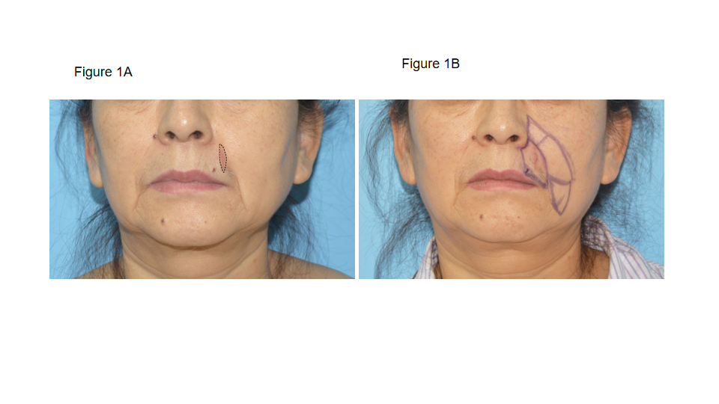Figure 1 Pre-operative mass appearance and skin flap design. A: The patient’s facial appearance before surgery. She had undergone resection of a left upper lip tumor at another hospital 1 mo earlier. The pathological diagnosis indicated microcystic adnexal carcinoma with positive lateral and basal margins. The patient was admitted at this time for additional radical surgery. The photograph shows a longitudinal light red surgical scar lateral to the left upper lip with a length of approximately 3 cm; B: Preoperative skin flap design. The lateral subunit of the left upper lip was the targeted region for extended resection. A puzzle-type advancement flap was designed to fit the shape of this region on the left cheek. The triangular areas marked on the upper and lower sides are the dog-ear deformity expected to be repaired during the surgery.
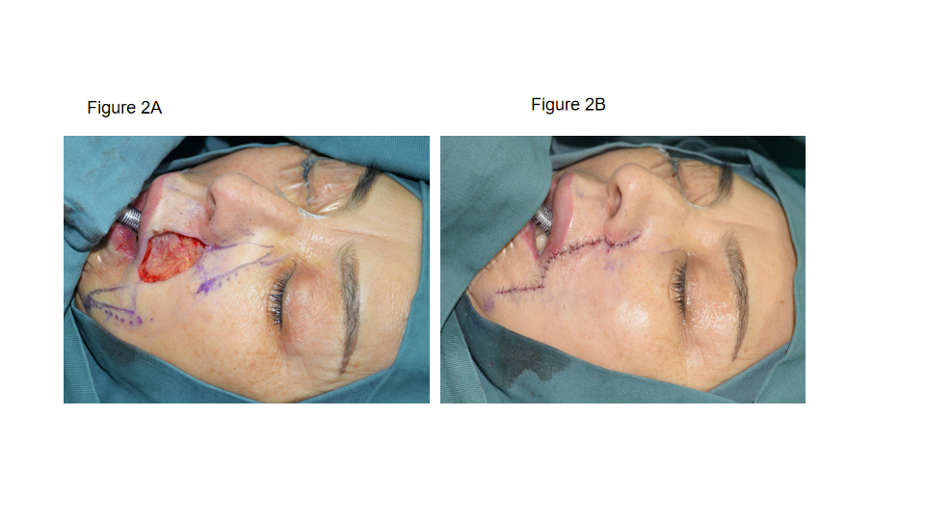
Figure 2 Wound appearance during surgery and wound repair after surgery. A: Appearance of the wound after extended resection. At this time, frozen sections showed negative results for all resection margins and the basal area; B: Immediate appearance of the facial reconstruction after the cat ear deformity was repaired with the advancement flap.
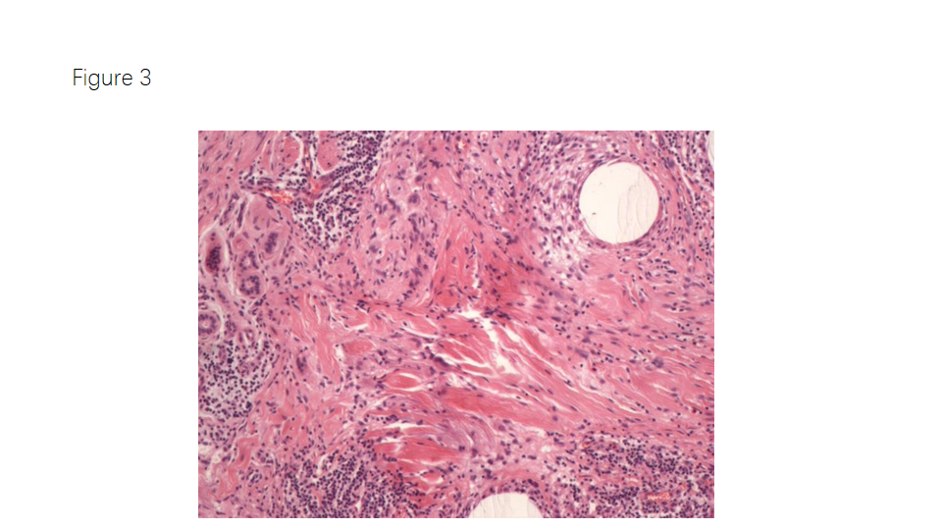
Figure 3 Postoperative paraffin-embedded sections confirmed the diagnosis of microcystic adnexal carcinoma (red arrow) with negative resection margins. Tubercles were observed in microcystic adnexal carcinoma whose cells were observed as cords, cell clusters and glandular structures, with significant atypia.
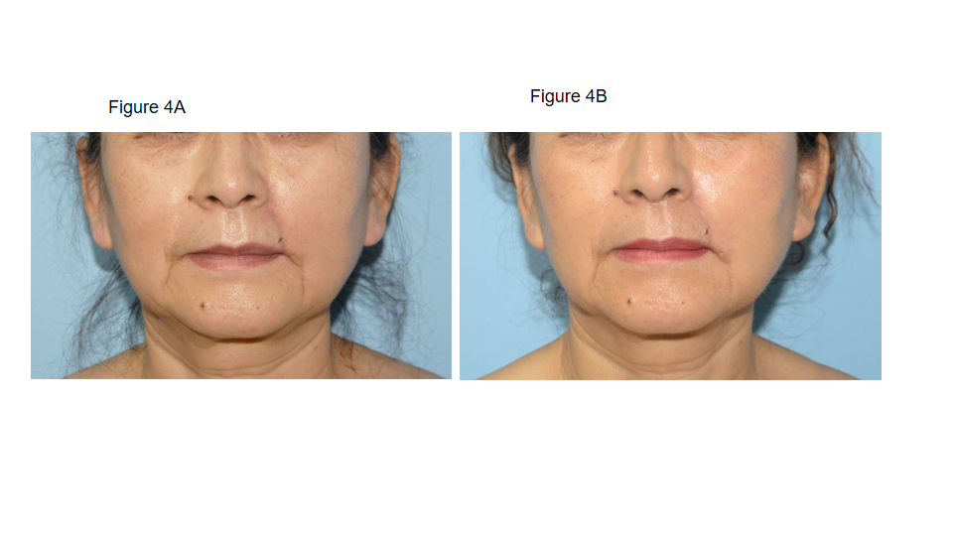
Figure 4 Appearance during the follow-up. A: The patient’s facial appearance at the 1-mo follow-up after surgery; B: The patient’s facial appearance at the 1-year follow-up after surgery. The surgical incision healed well without obvious scarring. The bilateral nasolabial folds and philtrum were essentially symmetrical and exhibited good facial sensation and movement function.

Published by Baishideng Publishing Group Inc
7041 Koll Center Parkway, Suite 160, Pleasanton, CA 94566, USA
Telephone: +1-925-3991568
E-mail: bpgoffice@wjgnet.com
Help Desk: https://www.f6publishing.com/helpdesk
https://www.wjgnet.com

© 2021 Baishideng Publishing Group Inc. All rights reserved.

