Name of Journal: World Journal of Clinical Cases
Manuscript NO: 77264
Manuscript Type: CASE REPORT

Diagnostic features and therapeutic strategies for malignant paraganglioma in a patient: A case report

Gan L et al. Diagnosis and treatment of malignant paraganglioma

Lei Gan, Xu-Dong Shen, Yang Ren, Hong-Xia Cui, Zhi-Xiang Zhuang

Lei Gan, Xu-Dong Shen, Yang Ren, Zhi-Xiang Zhuang, Department of Oncology, The Second Affiliated Hospital of Soochow University, Suzhou 215004, Jiangsu Province, China

Hong-Xia Cui, Department of Pathology, The Second Affiliated Hospital of Soochow University, Suzhou 215004, Jiangsu Province, China

Author contributions: Gan L wrote the initial draft of the manuscript; Shen XD, Yang Ren, Cui HX, and Zhuang ZX analyzed data, and wrote, edited, and reviewed the manuscript; all authors approved the final version of the manuscript and agree to be accountable for all aspects of the work in ensuring that questions related to the accuracy or integrity of any part of the work are appropriately investigated and resolved.

Supported by National Natural Sciences Foundation of China, No. 81803553; and National Natural Science Foundation Pre-research Program of China, No. SDFEYGJ1608.

Corresponding author: Lei Gan, PhD, Doctor, Department of Oncology, The Second Affiliated Hospital of Soochow University, No. 1055 Sanxiang Road, Gusu District, Suzhou 215004, Jiangsu Province, China. ganlei19870810@163.com

Received: April 25, 2022
Revised: July 1, 2022
Accepted:
Published online:

Abstract
BACKGROUND
Paragangliomas and extra-adrenal pheochromocytomas are uncommon neuroendocrine tumors with ubiquitous distribution. Malignant paraganglioma is a relatively rare entity. We report the treatment and pathological characteristics of a patient with malignant paraganglioma, and summarize the latest advances in the treatment of malignant paraganglioma based on a literature review.

CASE SUMMARY
A 45-year-old Chinese woman presented to the hospital due to pain in the waist (right side) and right buttock, and was diagnosed as malignant paraganglioma after the placement of ureteral stent, implantation of ileus catheter, and transvaginal removal of the vaginal mass. After relief of intestinal obstruction, the patient received intravenous chemotherapy and peritoneal perfusion chemotherapy. Although her pelvic mass disease was stable, she developed multiple liver metastases and bone metastases. Due to the development of spinal cord compression, she underwent orthopedic surgery, followed by radiotherapy, and molecular targeted therapy with apatinib, but with poor disease control.

CONCLUSION
Clinical management of paraganglioma is challenging for endocrinologists and oncologists. Prospective studies are required to develop standardized therapeutic strategies for malignant paragangliomas.

Key Words: Malignant paraganglioma; Chemotherapy; Radiotherapy; Targeted therapy; Case report

Gan L, Shen XD, Ren Y, Cui HX, Zhuang ZX. Diagnostic features and therapeutic strategies for malignant paraganglioma in a patient: A case report. World J Clin Cases 2022; In press

Core Tip: Paragangliomas are widely distributed and have diverse clinical manifestations. Although most paragangliomas are benign, the malignancy is involved in approximately 10% of paragangliomas. The traditional treatment of malignant paragangliomas is surgery to the primary site. Surgery followed by adjuvant radiation is used less frequently, and chemotherapy is typically reserved for the distant disease. This study indicated the diagnostic features and therapeutic strategies of malignant paraganglioma. Therapeutic strategies for malignant paragangliomas are lacking. After the initial treatment, the patient’s progression-free survival reached 21 mo. Subsequently, the patient progressed and was treated again with chemoradiotherapy, surgery, and targeted therapy.

INTRODUCTION
Pheochromocytomas and paragangliomas (PPGLs) are rare catecholamine-secreting endocrine tumors. Paraganglioma, ﬁrst reported by Felix Frankel in 1886^{[1]}, is a neuroendocrine tumor arising from the neural crest cells and may occur anywhere along the paraganglia of the autonomic nervous system^{[2,3]}. PGL is characterized by persistent hypertension and sympathetic activation. The main clinical features include hypertension, headache, hypermetabolism, hyperglycemia, and excessive sweating^{[4]}. Approximately 10% of paragangliomas are malignant^{[5]} and are characterized by metastatic spread. The traditional treatment for malignant paragangliomas is surgical excision of the primary lesion. Surgery followed by adjuvant radiation is used less frequently, and chemotherapy is typically reserved for cases with distant metastasis^{[6-8]}. On immunohistochemical staining, paragangliomas generally exhibit positivity for neuron specific enolase (NSE), synaptophysin (Syn), and chromogranin A (CgA) within the chief cells, and S-100 and GFAP within the sustentacular cells^{[9-11]}. Here we report the treatment of a middle-aged Chinese woman with malignant paraganglioma who was diagnosed based on immunohistochemical analyses, clinical symptoms, hematological examination, and imaging findings.

CASE PRESENTATION
Chief complaints
A 45-year-old Chinese woman presented with pain in right side of waist and right buttock, which has been present since April 2018.

History of present illness
She was experiencing pain extending from the right waist to the right buttock since April 2018. Initial physical examination and vital signs showed no significant abnormalities, and initial laboratory results were within the normal range.

History of past illness
Twenty-three years ago, the patient had a history of removal of a vaginal mass and a cesarean section. The previously removed vaginal mass was considered benign (not available for review). She was told that additional clinical or radiological follow-up was not necessary.

Personal and family history
There was no family history of specific genetic or infectious diseases.

Physical examination
Physical examination revealed tenderness over the kidney region on percussion. Her vital parameters were: temperature, 36.5 °C; pulse rate, 75 beats/min; blood pressure, 135/88 mmHg.

Laboratory examinations
The laboratory test findings were unremarkable. Biochemical tests showed normal levels of glutamic oxaloacetic transaminase, glutamic pyruvic transaminase, total bilirubin, direct bilirubin, indirect bilirubin. Her electrolyte profile and renal function tests were normal. Tumor markers such as α-fetoprotein, carcinoembryonic antigen, and carbohydrate antigen 199 were negative, and there was no evidence of hepatitis A, B, C or E virus infection. Her blood pressure increased during hospitalization, and auxiliary examination showed increased levels of 24-h urine vanillylmandelic acid (VMA) (22.40 mg/24 h) and urine methoxynorepinephrine (NMN) levels (3880 μg/24 h).

Pathological examination
Ureteral stent implantation and laparoscopic pelvic mass biopsy were performed on May 17, 2018. Routine postoperative pathology showed that the cystic wall-like tissues of the pelvic mass were covered with squamous epithelium and other nerve tissues, suggesting the possibility of mature cystic teratoma. The patient recovered well after the operation and was referred to the gynecology department for further treatment. On December 6, 2018, the patient underwent transvaginal resection of the vaginal mass and laparoscopic release of pelvic adhesions. Routine postoperative pathology showed that the vaginal wall nodule was a malignant tumor, pending further diagnosis by the immunopathology. After the surgery, the patient developed abdominal distension and failed to pass flatus. X-ray indicated ileus and an ileus catheter was placed. However, the abdominal distension continued to aggravate. On December 24, 2018, CT-guided peritoneal puncture and drainage were performed; cytological examination revealed no tumor cells in the ascites fluid. The immunopathological examination of the vaginal mass was consistent with malignant paraganglioma. On immunohistochemical analysis, the tumor cells expressed S100 (+), Syn (+), CgA (+), CD56 (+), CD10 (-), Ki67 (+, 5%) and CK (-).

Imaging examinations
At the onset of symptoms in early April 2018, the patient had undergone B-ultrasonography at a local hospital, which showed right-sided hydronephrosis accompanied by distension of the right upper ureter and hypoechoic pelvic cavity on the right side. On admission at our hospital, enhanced computed tomography (CT) showed right hydronephrosis, right lower ureter mass, and right-sided vaginal mass (Figure 1).

FINAL DIAGNOSIS
The final pathological diagnosis after biopsy was malignant paraganglioma (Figure 2).

TREATMENT
After the patient was relieved of intestinal obstruction, she received 2 cycles of liposome doxorubicin (25 mg/m²) intravenous chemotherapy combined with cisplatin (75 mg/m²) intraperitoneal infusion chemotherapy, which resulted in significant reduction in the pelvic effusion (Figure 3). The patient received a total of 7 cycles of liposome doxorubicin (25 mg/m²) in combination with cisplatin (75 mg/m²) intravenous chemotherapy until June 2019.

OUTCOME AND FOLLOW-UP
After completion of chemotherapy, the patient was followed up regularly, and the patient's symptoms were stable until April 2020 (Figure 4). During the diagnosis, treatment and follow-up of this patient, we simultaneously analyzed her blood tumor biomarkers. There are no specific tumor biomarkers for malignant paraganglioma, but on follow-up examinations, we found a gradual decrease in the ferritin content of this patient following the effective treatment. This indicated that ferritin content is a potential evaluation index of therapeutic efficacy in these patients (Figure 5).
In September 2020, the patient came to our hospital for re-examination. Enhanced CT scan indicated an increase in the size of the right pelvic mass (Figure 6A). After comprehensive evaluation, the patient's disease was classified as progressive. Palliative radiotherapy was performed for the right pelvic mass (total dose 50 Gy administered in 25 sessions; 2 Gy per fraction). During the radiotherapy, two cycles of albumin-bound paclitaxel (260 mg/m²) in combination with nedaplatin (75 mg/m²) were simultaneously administered. After the radiotherapy, two cycles of intravenous chemotherapy with albumin-bound paclitaxel (260 mg/m²) combined with nedaplatin (75 mg/m²) were continued until December 2020. Repeat evaluation of the patient in March 2021, revealed multiple liver metastasis on enhanced CT scan, and the patient’s disease was classified as progressive once more (Figure 6B).
After one month, the patient complained of discomfort in neck and left shoulder, and numbness in left upper limb. Neck and thoracic enhanced magnetic resonance imaging (MRI) showed multiple lesions in the cervical and thoracic vertebral bodies, considered as tumor metastasis. MRI also showed narrowing of the C6 vertebral body (Figure 7A). Enhanced CT showed further increase in the liver metastatic lesions (Figure 7B). In order to relieve the patient's spinal cord compression, anterior jugular tumor resection and iliac bone graft fusion and internal fixation were performed under general anesthesia by the orthopedic surgeon on May 18, 2021. Immunohistochemical analysis of the excised jugular tumor was consistent with bone metastasis of malignant paraganglioma (Figure 7C). In the follow-up process of the patient, the results of the patient's tumor biomarkers were shown in Figure 8. One month after the surgery, the patient received palliative radiotherapy for bone metastases. Finally, the patient was initiated on molecular targeted therapy with apatinib.

DISCUSSION
Paragangliomas are defined as neuroendocrine tumors which may or may not produce catecholamines. Catecholamines such as dopamine, norepinephrine, and epinephrine are a class of neurotransmitters^{[12]}. The most common symptoms of catecholamine excess are hypertension, tachycardia, headache, pallor, sweating, and anxiety^{[13, 14]}. Pheochromocytomas/paragangliomas originate from chromaffin cells in the neural crest. Chromaffin cells are widely distributed in the adrenal medulla, sympathetic ganglia, and parasympathetic ganglia, and form Luckerkanal body which gradually atrophies in the adulthood in the para-aorta and the root of the inferior mesenteric artery. Paragangliomas were mostly believed to be undegenerated chromaffin tissues. Paragangliomas are widely distributed and have more diverse clinical manifestations than pheochromocytomas. In addition to the symptoms associated with excessive catecholamine secretion, local symptoms caused by tumor invasion may provide clues to the discovery of adrenal mass. Lesions in the retroperitoneal space may cause abdominal pain and/or lower back pain and constipation. Moreover, the mass may be palpable on physical examination. The common manifestations of paraganglioma include a series of sympathetic hyperactivity-related symptoms (such as paroxysmal hypertension and metabolic disorders), which are mainly attributable to the increase in blood catecholamine levels. Plasma and urine metanephrines and 24-h VMA levels may also increase. The first symptom of our patient was right-sided pain in the waist and hip. During hospitalization, her blood pressure increased and auxiliary examination revealed elevated 24-h urine VMA and urine NMN levels.
However, early diagnosis of malignant paraganglioma is difficult; moreover, pathological distinction between benign and malignant is challenging. Currently, the most reliable evidence for the determination of malignant lesions is the occurrence of vascular tumor emboli, local infiltration or lymph node involvement, and hematogenous metastasis (such as bone metastasis, liver metastasis, lung metastasis). The cytologic diagnosis of paraganglioma can be challenging because of its rarity, wide anatomic distribution, and variable cytomorphological features. On immunohistochemical staining, malignant paraganglioma typically stain positive for CgA, NSE, vimentin, and S100, and negative for AE1/AE3. In the present case, immunohistochemical examination of the jugular tumor specimen showed high protein expression of S100, CgA, and Syn in the tumor cells. The best treatment of paraganglioma is complete surgical resection, but is challenging in case of local invasion and systemic spread of disease. Radiation therapy > 40 Gy typically achieves local tumor control and symptom relief^{[15-17]}. Systemic chemotherapy is indicated in cases of unresectable and progressive PGL, especially in patients with a high tumor burden and rapid progression. Combination chemotherapy with cyclophosphamide, vincristine, and dacarbazine is optional^{[18,19]}. While no prospective clinical trials have evaluated its use, cardiovascular disease (CVD) has been shown to benefit 37% of PGL patients. CVD stops tumor growth, improves symptoms of catecholamine excess, and perhaps, prolongs survival^{[20,21]}. Tyrosine kinase inhibitors, such as sunitinib, as an additional option^{[22,23]}, have shown clinical benefit in 47% of patients with progressive PGL, demonstrating a poor median progression-free survival (PFS) of 4.1 mo^{[23]}. The efficacy of cytotoxic T-lymphocyte-associated antigen 4 and programmed death 1 immune checkpoint inhibitors ipilimumab, nivolumab, and pembrolizumab for treatment of metastatic PPGL is under investigation in phase II clinical trials.
There is a lack of standardized therapeutic strategies for malignant paragangliomas. Targeted radionuclide therapies using ¹³¹I-metaiodobenzylguanidine (¹³¹I-MIBG) and peptide receptor radionuclide therapy (¹⁷⁷Lu or ⁹⁰Y) are viable therapeutic options in the management of metastatic/inoperable pheochromocytoma/paraganglioma. Recently, high-specific-activity-¹³¹I-MIBG therapy was approved by the FDA and both ¹⁷⁷Lu-DOTATATE and ¹³¹I-MIBG therapy have been recommended by the National Comprehensive Cancer Network guidelines for the treatment of metastatic pheochromocytoma/paraganglioma. After ¹³¹I-MIBG treatment, the reported PFS was 24–36 mo^{[18]}. Metastatic pheochromocytomas and paragangliomas have been shown to exhibit increased angiogenesis and expression of VEGF and PDGF-β receptors. A phase II study evaluated the antitumor activity of another tyrosine kinase receptor inhibitor, pazopanib, in MPPG by measuring the tumor response rate; of the six patients recruited to the study, two exhibited partial response^{[24]}. A phase II study of cabozantinib is currently recruiting patients with MPPG. The primary endpoint is to estimate objective response rate. An open-label phase II study of pembrolizumab in patients with MPPG has recently been activated. Other potential therapeutic targets such as mammalian target of rapamycin inhibitors, ATR inhibitors, and Wnt antagonists have been explored in clinical trials for patients with MPPG^{[25]}.
Because our patient had a large amount of abdominal and pelvic effusion, peritoneal puncture and drainage were performed, and peritoneal perfusion chemotherapy with cisplatin and intravenous chemotherapy with doxorubicin liposomes were administered. After two cycles of chemotherapy, there was significant reduction in abdominal and pelvic effusion. Several molecular targeted therapies, a novel radiopharmaceutical medication that targets the catecholamine transporter, and immunotherapy are under evaluation for the treatment of patients with malignant PPGs. Doxorubicin (DOX) is the most effective chemotherapeutic drug developed against a broad range of cancers such as solid tumors, leukemias, and lymphomas. Conventional DOX-induced cardiotoxicity has limited its use. FDA-approved drugs such as non-pegylated liposomal (Myocet®) and pegylated liposomal (Doxil®) formulations have no doubt shown comparatively reduced cardiotoxicity, but have raised new toxicity issues. The entrapment of doxorubicin in biocompatible, biodegradable, and safe nano delivery systems can prevent its degradation in circulation, minimize its toxicity with increased half-life, and enhance its pharmacokinetic profile leading to improved patient compliance. In addition, nano delivery systems can actively and passively target the tumor resulting in increased therapeutic index and decreased side effects of drug. In our case report, the patient accepted chemotherapy combined with the pegylated liposomal doxorubicin and cisplatin 7 cycles until June 2019.
Our patient showed good therapeutic response after the initial treatment with 7 cycles of chemotherapy with cisplatin combined with doxorubicin liposomes, and the PFS reached 21 mo. However, after the first chemotherapy, the patient did not accept maintenance treatment, which led to disease progression. Subsequently, she opted for chemotherapy again combined with local radiotherapy. The patient received 4 cycles of palliative chemotherapy consisting of albumin-bound paclitaxel (260 mg/m²) combined with nedaplatin (75 mg/m²) totally. Although her pelvic mass disease was stable, she developed multiple metastatic lesions such as liver metastases and bone metastases, and subsequent targeted drug therapy with apatinib for almost 3 mo could not control the disease well. Surgery is the only cure for PCC/PGL; however, there is limited biochemical and tumor control of metastatic disease with treatments, including ¹³¹I-MIBG, chemotherapy, and radiation^{[26]}. The poor characterization of the histological behavior and natural history of the disease makes clinical management of paraganglioma a great challenge for endocrinologists and oncologists. Prospective studies are required to develop standardized therapeutic strategies.

CONCLUSION
After the initial treatment, the patient’s PFS was 21 mo. During follow-up, enhanced CT scan showed enlargement of that right-sided pelvic mass, for which radiotherapy and chemotherapy were administered. Repeat imaging evaluation revealed bone metastases and liver metastases. Due to the development of spinal cord compression, she underwent orthopedic surgery, followed by radiotherapy and molecular targeted therapy with apatinib. The clinical management of paraganglioma is challenging. Management strategies for malignant paragangliomas include a combination of surgical resection, drug therapy to control symptoms of catecholamine overdose (metyrosine), radionuclide therapy (¹³¹I-MIBG or somatostatin analogue), chemotherapy (cyclophospamide, vincristine combined with dacarbazine), and external irradiation therapy. Most of these treatments are palliative, and targeted gene therapy based on tumor gene expression needs to be further explored. Prospective studies are required to develop more refined therapeutic strategies for paragangliomas.

REFERENCES
1 Classics in oncology. A case of bilateral completely latent adrenal tumor and concurrent nephritis with changes in the circulatory system and retinitis: Felix Fränkel, 1886. CA Cancer J Clin 1984; 34: 93-106 [PMID: 6423225 DOI: 10.3322/canjclin.34.2.93]
2 Luna-Ortiz K, Rascon-Ortiz M, Villavicencio-Valencia V, Granados-Garcia M, Herrera-Gomez A. Carotid body tumors: review of a 20-year experience. Oral Oncol 2005; 41: 56-61 [PMID: 15598586 DOI: 10.1016/j.oraloncology.2004.06.006]
3 Lee JH, Barich F, Karnell LH, Robinson RA, Zhen WK, Gantz BJ, Hoffman HT. National Cancer Data Base report on malignant paragangliomas of the head and neck. Cancer 2002; 94: 730-737 [PMID: 11857306 DOI: 10.1002/cncr.10252]
4 Cui Q, Lu J, Zhang C, Tan S. Diagnostic challenges and good treatment outcomes in pediatric paraganglioma of the abdomen: A case report. Medicine (Baltimore) 2018; 97: e13268 [PMID: 30461634 DOI: 10.1097/MD.0000000000013268]
5 Lenders JW, Duh QY, Eisenhofer G, Gimenez-Roqueplo AP, Grebe SKG, Murad MH, Naruse M, Pacak K, Young WF. Pheochromocytoma and paraganglioma: an endocrine society clinical practice guideline. J Clin Endocrinol Metab 2014; 99: 1915-1942 [PMID: 24893135 DOI: 10.1210/jc.2014-1498]
6 Moskovic DJ, Smolarz JR, Stanley D, Jimenez C, Williams MD, Hanna EY, Kupferman ME. Malignant head and neck paragangliomas: is there an optimal treatment strategy? Head Neck Oncol 2010; 2: 23 [PMID: 20863367 DOI: 10.1186/1758-3284-2-23]
7 Hinerman RW, Amdur RJ, Morris CG, Kirwan J, Mendenhall WM. Definitive radiotherapy in the management of paragangliomas arising in the head and neck: a 35-year experience. Head Neck 2008; 30: 1431-1438 [PMID: 18704974 DOI: 10.1002/hed.20885]
8 Bastounis E, Maltezos C, Pikoulis E, Leppäniemi AK, Klonaris C, Papalambros E. Surgical treatment of carotid body tumours. Eur J Surg 1999; 165: 198-202 [PMID: 10231651 DOI: 10.1080/110241599750007045]
9 Srivastava R, Wadhwa N, Gupta S, Razdan U. Nasal Polyp-An Incidental Paraganglioma. Turk Patologi Derg 2016; 32: 196-199 [PMID: 27562394 DOI: 10.5146/tjpath.2014.01255]
10 Welkoborsky HJ, Gosepath J, Jacob R, Mann WJ, Amedee RG. Biologic characteristics of paragangliomas of the nasal cavity and paranasal sinuses. Am J Rhinol 2000; 14: 419-426 [PMID: 11197119 DOI: 10.2500/105065800779954284]
11 Wasserman PG, Savargaonkar P. Paragangliomas: classiﬁcation, pathology, and diﬀerential diagnosis. Otolaryngol Clin North Am 2001; 34: 845-862, v-vi [PMID: 11557443 DOI: 10.1016/s0030-6665(05)70351-0]
12 Eisenhofer G, Bornstein SR, Brouwers FM, Cheung NV, Dahia PL, de Krijger RR , Giordano TJ, Greene LA, Goldstein DS, Lehnert H, Manger WM, Maris JM, Neumann HPH, Pacak K, Shulkin BL, Smith DI, Tischler AS, Young WF. Malignant pheochromocytoma: current status and initiatives for future progress. Endocr Relat Cancer 2004; 11: 423-436 [PMID: 15369446 DOI: 10.1677/erc.1.00829]
13 Zelinka T, Eisenhofer G, Pacak K. Pheochromocytoma as a catecholamine producing tumor: implications for clinical practice. Stress 2007; 10: 195-203 [PMID: 17514588 DOI: 10.1080/10253890701395896]
14 Lenders JW, Eisenhofer G, Mannelli M, Pacak K. Phaeochromocytoma. Lancet 2005; 366: 665-675 [PMID: 16112304 DOI: 10.1016/S0140-6736(05)67139-5]
15 Edström Elder E, Hjelm Skog AL, Höög A, Hamberger B. The management of benign and malignant pheochromocytoma and abdominal paraganglioma. Eur J Surg Oncol 2003; 29: 278-283 [PMID: 12657240 DOI: 10.1053/ejso.2002.1413]
16 Pham TH, Moir C, Thompson GB, Zarroug AE, Hamner CE, Farley D, van Heerden J, Lteif AN, Young WF. Pheochromocytoma and paraganglioma in children: a review of medical and surgical management at a tertiary care center. Pediatrics 2006; 118: 1109-1117 [PMID: 16951005 DOI: 10.1542/peds.2005-2299]
17 Fishbein L, Bonner L, Torigian DA, Nathanson KL, Cohen DL, Pryma D, Cengel KA. External beam radiation therapy (EBRT) for patients with malignant pheochromocytoma and non-head and -neck paraganglioma: combination with 131I-MIBG. Horm Metab Res 2012; 44: 405-410 [PMID: 22566196 DOI: 10.1055/s-0032-1308992]
18 Baudin E, Habra MA, Deschamps F, Cote G, Dumont F, Cabanillas M, Arfi-Roufe J, Berdelou A, Moon B, Ghuzlan AA, Patel S, Leboulleux S, Jimenez C. Therapy of endocrine disease: treatment of malignant pheochromocytoma and paraganglioma. Eur J Endocrinol 2014; 171: R111-122 [PMID: 24891137 DOI: 10.1530/EJE-14-0113]
19 Garibaldi E, Bresciani S, Panaia R, Delmastro E, Malinverni G, Gabriele P. Hereditary paraganglioma syndrome associated with SDHD gene mutations: a patient with multicentric presentation treated with radiotherapy. Case report. Tumori 2011; 97: 214-220 [PMID: 21617718 DOI: 10.1700/667.7786]
20 van Hulsteijn LT, Niemeijer ND, Dekkers OM, Corssmit EP. (131)I-MIBG therapy for malignant paraganglioma and phaeochromocytoma: systematic review and meta-analysis. Clin Endocrinol (Oxf) 2014; 80: 487-501 [PMID: 24118038 DOI: 10.1111/cen.12341]
21 Asai S, Katabami T, Tsuiki M, Tanaka Y, Naruse M. Controlling Tumor Progression with Cyclophosphamide, Vincristine, and Dacarbazine Treatment Improves Survival in Patients with Metastatic and Unresectable Malignant Pheochromocytomas/Paragangliomas. Horm Cancer 2017; 8: 108-118 [PMID: 28108930 DOI: 10.1007/s12672-017-0284-7]
22 Cassol CA, Winer D, Liu W, Guo M, Ezzat S, Asa SL. Tyrosine kinase receptors as molecular targets in pheochromocytomas and paragangliomas. Mod Pathol 2014; 27: 1050-1062 [PMID: 24390213 DOI: 10.1038/modpathol.2013.233]
23 Ayala-Ramirez M, Chougnet CN, Habra MA, Palmer JL, Leboulleux S, Cabanillas ME, Caramella C, Anderson P, Ghuzlan AA, Waguespack SG, Deandreis D, Baudin E, Jimenez C. Treatment with sunitinib for patients with progressive metastatic pheochromocytomas and sympathetic paragangliomas. J Clin Endocrinol Metab 2012; 97: 4040-4050 [PMID: 22965939 DOI: 10.1210/jc.2012-2356]
24 Jimenez C, Cabanillas ME, Santarpia L, Jonasch E, Kyle KL, Lano EA, Matin SF, Nunez RF, Perrier ND, Phan A, Rich TA, Shah B, Williams MD, Waguespack SG. Use of the tyrosine kinase inhibitor sunitinib in a patient with von Hippel-Lindau disease: targeting angiogenic factors in pheochromocytoma and other von Hippel-Lindau disease-related tumors. J Clin Endocrinol Metab 2009; 94: 386-391 [PMID: 19017755 DOI: 10.1210/jc.2008-1972]
25 Roman-Gonzalez A, Jimenez C. Malignant pheochromocytoma-paraganglioma: pathogenesis, TNM staging, and current clinical trials. Curr Opin Endocrinol Diabetes Obes 2017; 24: 174-183 [PMID: 28234804 DOI: 10.1097/MED.0000000000000330]
26 Fishbein L. Pheochromocytoma and Paraganglioma: Genetics, Diagnosis, and Treatment. Hematol Oncol Clin North Am 2016; 30: 135-150 [PMID: 26614373 DOI: 10.1016/j.hoc.2015.09.006]

Footnotes
Informed consent statement: The present study was approved by the Ethics Committee of the Second Affiliated Hospital of Soochow University. The patient provided written informed consent form prior to commencing the study.

Conflict-of-interest statement: All the authors report no relevant conflicts of interest for this article.

CARE Checklist (2016) statement: The authors have read the CARE Checklist (2016) statement, and the manuscript was prepared and revised according to the CARE Checklist (2016) statement.

Open-Access: This article is an open-access article that was selected by an in-house editor and fully peer-reviewed by external reviewers. It is distributed in accordance with the Creative Commons Attribution NonCommercial (CC BY-NC 4.0) license, which permits others to distribute, remix, adapt, build upon this work non-commercially, and license their derivative works on different terms, provided the original work is properly cited and the use is non-commercial. See: https://creativecommons.org/Licenses/by-nc/4.0/

Provenance and peer review: Unsolicited article; Externally peer reviewed.
Peer-review model: Single blind

Corresponding Author's Membership in Professional Societies: Youth Committee of Oncology Branch of Suzhou Medical Association

Peer-review started: April 25, 2022
First decision: June 8, 2022
Article in press:

Specialty type: Oncology
Country/Territory of origin: China
Peer-review report’s scientific quality classification
Grade A (Excellent): 0
Grade B (Very good): B
Grade C (Good): C
Grade D (Fair): 0
Grade E (Poor): 0

P-Reviewer: Fazilat-Panah D, Iran; Ghimire R, Nepal S-Editor: Xing YX L-Editor: A P-Editor: Xing YX

Figure Legends
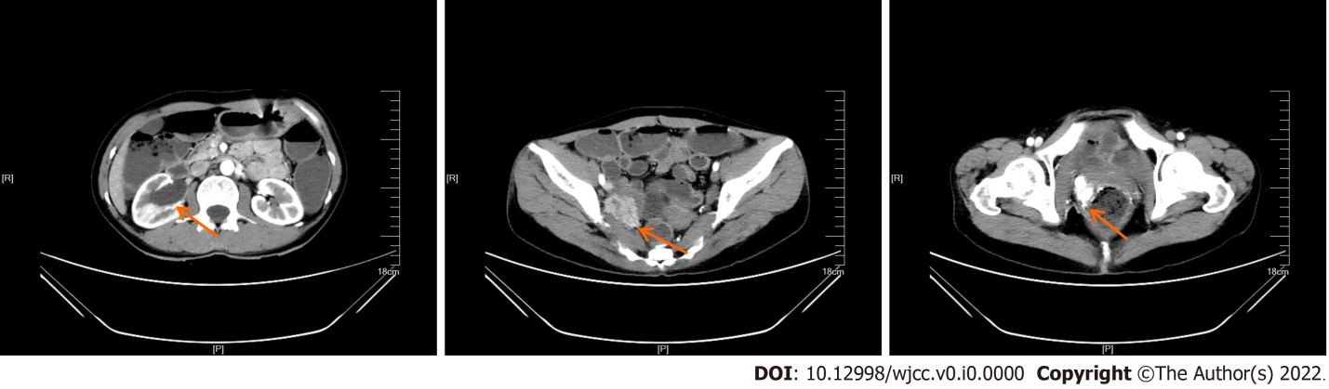
Figure 1 Contrast-enhanced computed tomography images. The images show dilatation caused by hydronephrosis in the right-side of pelvis and renal calyces, space occupying lesion in the right uterine adnexal area, and space occupying lesion in the right side of the vagina.
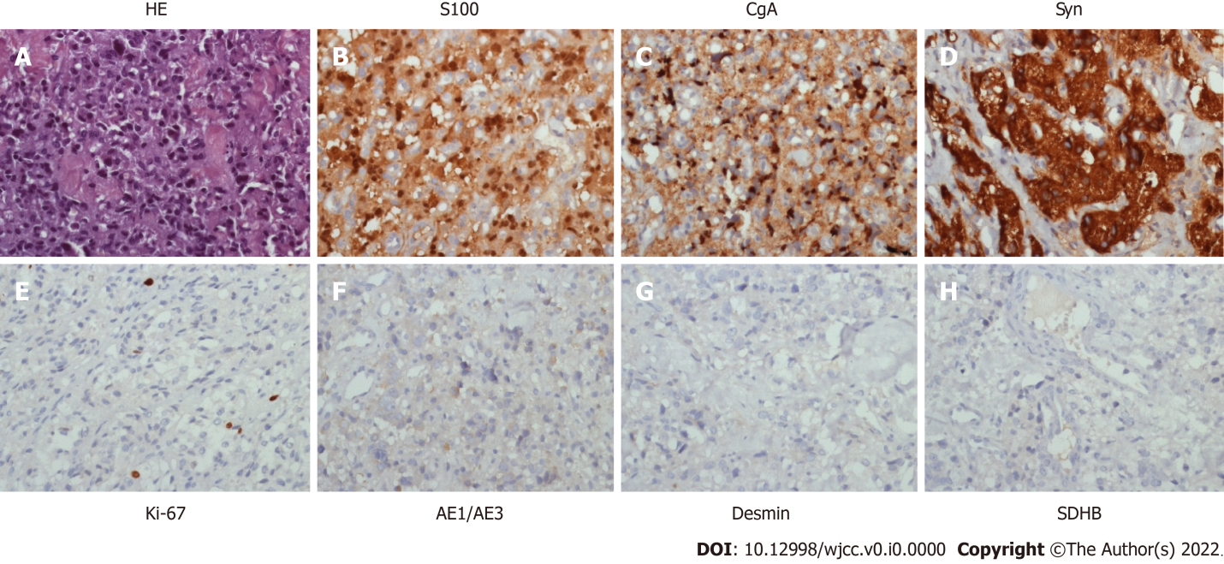
Figure 2 Representative immunohistochemical staining of the metastatic tumor. A: HE-stained section; B: Cancer cells show positive staining for S100 in the cytoplasm and nucleus; C: Positive staining for CgA in the cytoplasm; D: Positive staining for Syn in the cytoplasm; E: Positive nuclear staining for Ki-67; F-H: Negative staining for AE1/AE3, Desmin, and SDHB in the cytoplasm of cancer cells (original magnification × 400).
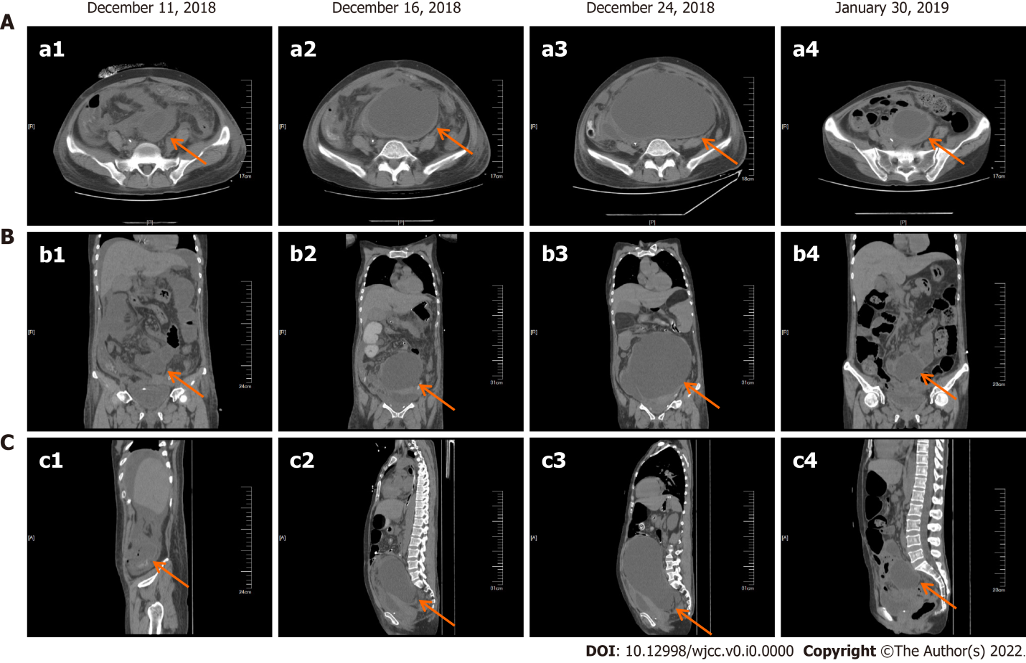
Figure 3 Representative radiologic images of the patient before and after chemotherapy. A: Transverse plane; B: Coronal plane; C: Sagittal plane. a1-c1: December 11, 2018; a2-c2: December 16, 2018; a3-c3: December 24, 2018, before the treatment; a4-c4: January 30, 2019, after two cycles chemotherapy.
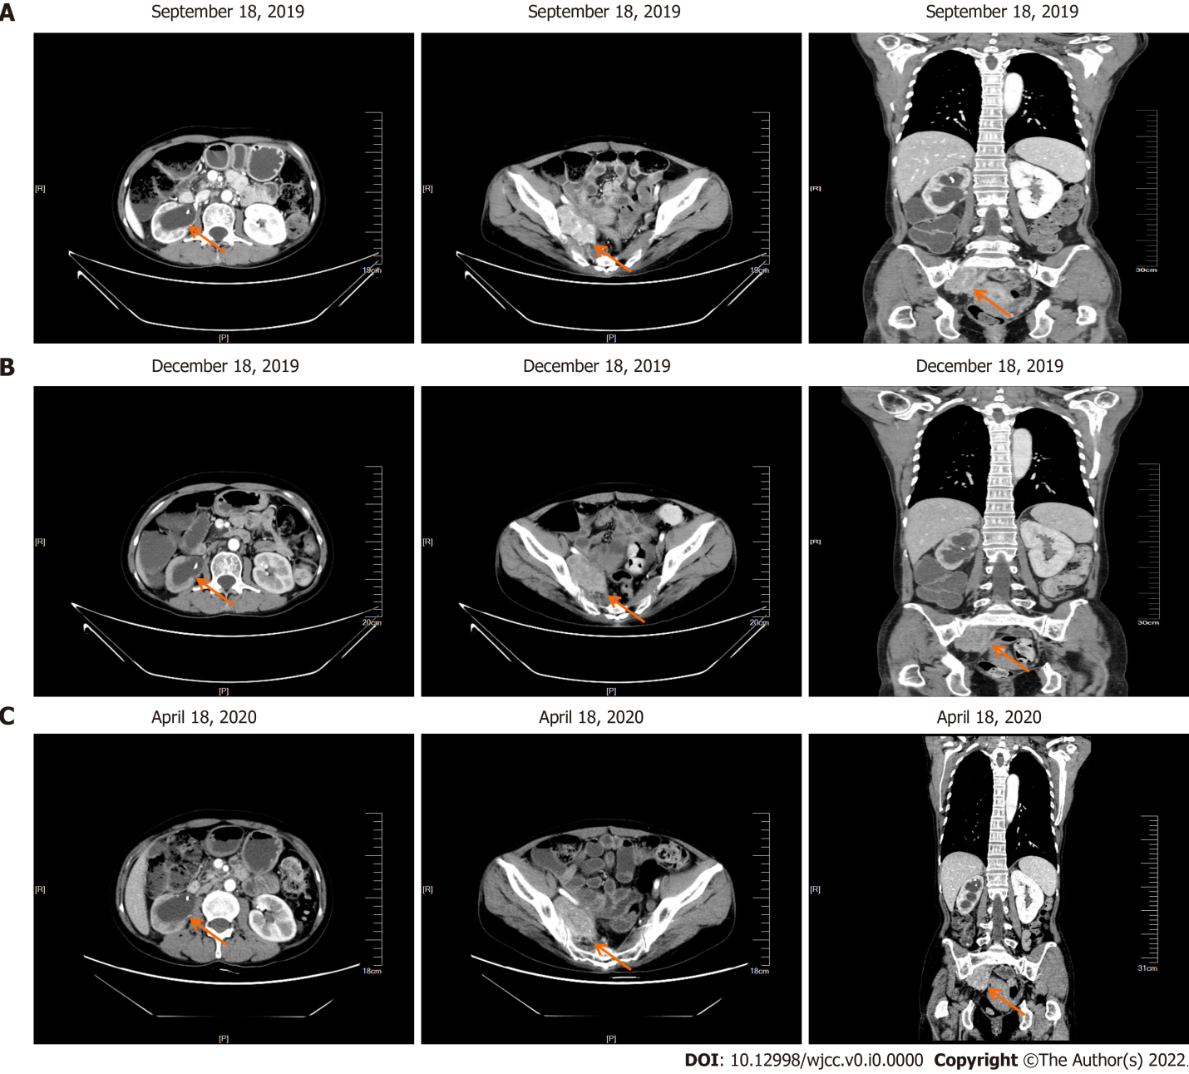
Figure 4 Follow-up results. Enhanced computed tomography showing the same condition in the hydronephrosis of the right pelvis and renal calyces, accompanied with pelvic neoplasm. A: September 18, 2019; B: December 18, 2019; C: April 18, 2020.
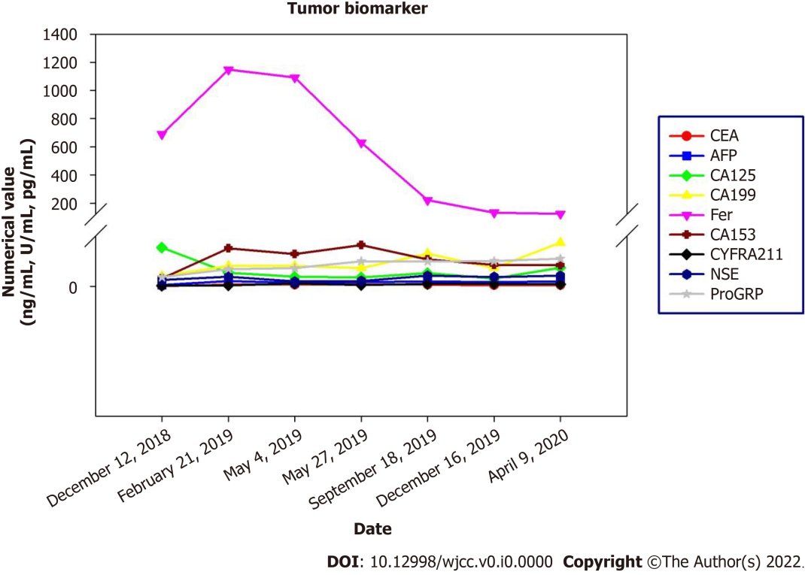
Figure 5 Blood tumor biomarkers. CEA: Carcinoembryonic antigen; AFP: Acute flaccid paralysis; NSE: Neuron specific enolase.
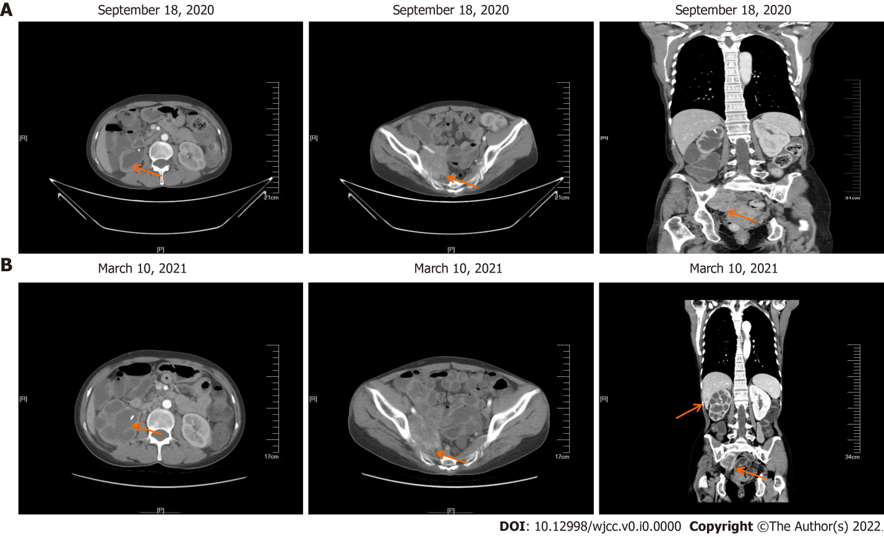
Figure 6 Follow-up imaging findings. A: Enhanced computed tomography showing hydronephrosis of the right pelvis and renal calyces, accompanied with a larger pelvic neoplasm; B: Enhanced computed tomography scan showing multiple metastases in the liver.
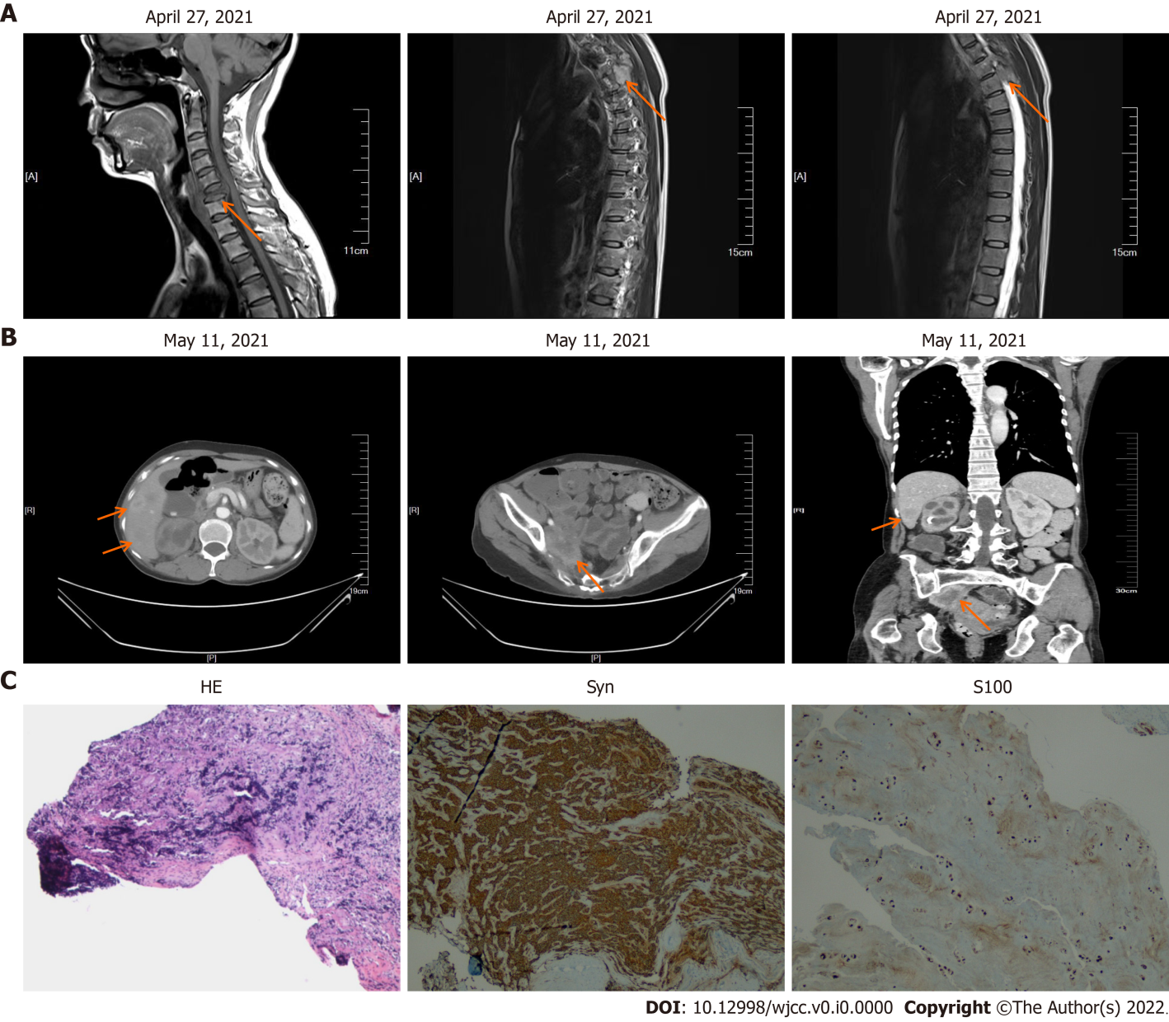
Figure 7 Follow-up imaging findings and representative immunohistochemical staining of the metastatic jugular tumor. A: Enhanced computed tomography (CT) showing hydronephrosis of the right pelvis and renal calyces, accompanied with larger pelvic neoplasm; B: Enhanced CT scan showing multiple metastases in the liver; and C: Representative immunohistochemical staining of the metastatic jugular tumor: HE, cancer cells show positive staining for Syn in the cytoplasm, and positive staining for S100 in the cytoplasm and nucleus (magnification × 100).
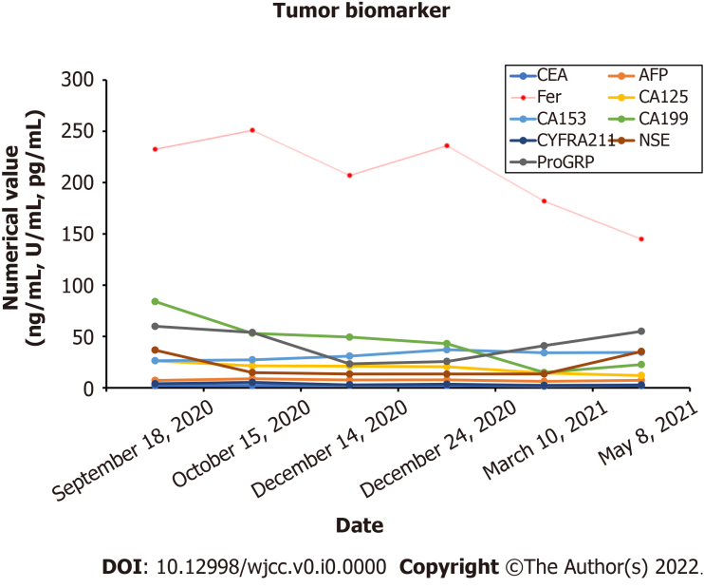
Figure 8 Blood tumor biomarkers after disease progression. CEA: Carcinoembryonic antigen; AFP: Acute flaccid paralysis; NSE: Neuron specific enolase.

