Name of Journal: World Journal of Clinical Cases
Manuscript NO: 73194
Manuscript Type: CASE REPORT

Nontraumatic convexal subarachnoid hemorrhage: A case report

Chen HL et al. A case of nontraumatic convexal subarachnoid hemorrhage

Hong-Liang Chen, Bin Li, Chao Chen, Xiao-Xuan Fan, Wen-Bin Ma

Hong-Liang Chen, Bin Li, Chao Chen, Wen-Bin Ma, Department of Neurology, Binzhou Medical University Hospital, Binzhou 256600, Shandong Province, China

Xiao-Xuan Fan, Department of Clinical Medicine, Binzhou Medical University, Binzhou 256600, Shandong Province, China

Author contributions: Ma WB conceived the study, participated in its design and draft the manuscript; Li B, Chen C and Fan XX collected data; Chen HL helped to draft the manuscript; all authors read and approved the final manuscript.

Supported by Research Fund of the Department of Science and Technology of Shandong Province, China, No. 2019WS328.

Corresponding author: Wen-Bin Ma, MD, Associate Professor, Department of Neurology, Binzhou Medical University Hospital, No. 661 Huanghe 2nd Road, Binzhou 256600, Shandong Province, China. mawbin@163.com

Received: November 14, 2021
Revised: December 17, 2021
Accepted: April 29, 2022
Published online:

Abstract
BACKGROUND
Nontraumatic convexal subarachnoid hemorrhage (cSAH) is a rare type of atypical subarachnoid hemorrhage. It mainly presents as a focal and transient neurological deficit with similar manifestations as transient ischemic attack.

CASE SUMMARY
We report a case of a 64-year-old man who visited the hospital with paroxysmal left-sided numbness and weakness is presented in this study. Computed tomography examination indicated a high-density image of the right frontal-parietal sulcus. Digital subtraction angiography showed severe stenosis at the right anterior cerebral artery A2-A3 junction (stenosis rate approximately 70%).

CONCLUSION
The findings of this case indicate that anterior cerebral artery stenosis may lead to the occurrence of cSAH.

Key Words: Nontraumatic convexal subarachnoid hemorrhage; Subarachnoid hemorrhage; Transient ischemic attack; Artery atherosclerosis stenosis; Case report

Chen HL, Li B, Chen C, Fan XX, Ma WB. Nontraumatic convexal subarachnoid hemorrhage: A case report. World J Clin Cases 2022; In press

Core Tip: This is a rare case of convexal subarachnoid hemorrhage (cSAH) with transient ischemic attack as the first presentation. We reported the whole course. This case indicated the clinical characteristics, laboratory findings, imaging examinations and adjustment of treatment and discussed the possible relation between anterior cerebral artery stenosis and the occurrence of cSAH.

INTRODUCTION
Nontraumatic convexal subarachnoid hemorrhage (cSAH) is a subtype of atypical SAH. Its bleeding site is mainly confined to one or more cerebral hemisphere convexocortical sulci with high incidence in the central sulcus. It does not affect the brain parenchyma, basal cistern, or interhemispheric fissure. It is characterized by low hemorrhage, and only the local cerebral cortex is involved. In addition, it is not associated with typical symptoms such as severe headache and meningeal irritation. In the present study, a case of a cSAH patient with transient ischemic attack (TIA) and a summary of relevant literature are presented.

CASE PRESENTATION
Chief complaints
A 64-year-old male was admitted to the hospital after experiencing paroxysmal left-sided numbness and weakness for 4 d.

History of present illness
These symptoms occurred 2-3 times a day and lasted approximately 20 min each time.

History of past illness
The patient had a clinical history of ischemic stroke and no history of hypertension, diabetes, coronary heart disease, or major trauma.

Personal and family history
The patient had no history of smoking or drinking, and no family history.

Physical examination
The systolic and diastolic blood pressure of the patient during admission was 130/80 mmHg. The patient presented with paroxysmal left hemiplegia without obvious inducement. The left limb could not move during the attack and was accompanied by numbness and discomfort on the left face, trunk, upper, and lower limbs; and the patient presented with dizziness. The National Institute of Health Stroke Scale score of the patient was 0.

Laboratory examinations
Routine clinical biochemistry showed normal results.

Imaging examinations
Computed tomography (CT) examination was performed during admission and showed a high-density image of the right frontal-parietal sulcus. Magnetic resonance imaging examination showed a slight increase in the T1 flair and a high T2 flair. Diffusion-weighted imaging (DWI) revealed high signal intensity, whereas susceptibility weighted imaging (SWI) showed slightly increased signal intensity in the right frontal lobe. Machine records activity results indicated short local stenosis of the right anterior cerebral artery of the A3 segment, and magnetic resonance venography revealed a thin contrast in the left transverse sinus and left sigmoid sinus (Figure 1). Severe stenosis was observed in the right anterior cerebral artery A2-A3 junction (stenosis rate approximately 70%), and mild stenosis was observed in the distal end of A3 (stenosis rate approximately 30%) through digital subtraction angiography (DSA) (Figure 2).

MULTIDISCIPLINARY EXPERT CONSULTATION
There is no multidisciplinary expert consultation.

FINAL DIAGNOSIS
The complete evidence supported the final diagnosis of cSAH.

TREATMENT
The patient was given blood pressure monitoring, cerebrovascular spasm prevention (nimodipine), cerebral protection, and other treatments.

OUTCOME AND FOLLOW-UP
The range of brain CT-showed bleeding was significantly reduced compared to the previous range after 9 d. The patient had no recurrence of paroxysmal left-sided numbness and weakness.

DISCUSSION
cSAH is a subtype of atypical SAH. Approximately 49% of patients with SAH present with TIA-like symptoms; therefore, the actual annual incidence is more than 5.1 cases in every 100000 people^{[1]}. The etiology of cSAH is highly correlated with age, hypertension, coronary heart disease, and diabetes. Common causes of cSAH include cerebral amyloidosis (CAA), reversible cerebral vasoconstriction syndrome (RCVS), cortical vein thrombosis (CoVT), intracranial large artery atherosclerosis stenosis or occlusion, moyamoya disease, and vasculitis. Notably, CAA is the main cause, accounting for approximately 39% of all cSAH cases^{[1]}. Transient sensorimotor dysfunction (TFNE) is the main symptom in cSAH patients above 60 years of age, and CAA is the common cause of disease, followed by intracranial atherosclerosis stenosis or occlusion^{[2,3]}. In contrast, headache is the main clinical manifestation in patients under 60 years of age, whereas rCVS and CoVT are the main causes of cSAH in these patients^{[3]}. Nakajima et al reported that more than half of patients with cSAH presented with cerebral vascular occlusion and TFNE and were often misdiagnosed with transient cerebral ischemia^{[4-5]}. Notably, CAA is a progressive age-related cerebrovascular disease. The severity of the disease increases with age due to deposition of amyloid beta protein in the cortex and leptomeningeal vessels, which is the main cause of cSAH. A previous study reported that TFNE is the main characteristic clinical manifestation of CAA-induced cSAH, followed by cortical superficial siderosis (CSS) and rebleeding^{[6]}. The incidence of hypercholesterolemia is lower in patients with CAA-induced cSAH than in patients with TIA. Cholesterol is negatively correlated with the incidence of nontraumatic intracerebral hemorrhage and aneurysmal hemorrhage^{[5]}. Symptoms of cSAH are paroxysmal and include TIA attacks, seizures, and TFNE. This indicates that TIA attacks can occur as a result of ischemic infarction or may occur as a clinical manifestation of hemorrhagic stroke.
A previous study reported that hyperacute arterial ischemic stroke occurs in patients within 4.5 h and 6 days after a concurrent rate of cSAH 0.5%^{[4]}. Acute changes in hemodynamics and damage to the blood brain barrier may be important mechanisms for the occurrence of cSAH. The incidence of SAH is associated with cerebrovascular disease risk factors such as hypertension, coronary heart disease, and diabetes, and this relationship can be explained by collateral circulation. ICA stenosis or occlusion and MCA stenosis or occlusion can promote the formation of Willis circle and the opening of PIA meningostomy vessels, respectively^{[7-8]}.
CT scan is important for the diagnosis of cSAH. However, the sensitivity of CT decreases after a period of time. Notably, flair is highly sensitive to hemorrhage in the cerebral convexity cortex sulcus and is more effective in the diagnosis of acute and subacute SAH than plain CT scans. DWI and SWI are characterized by high sensitivity and accuracy in the diagnosis of SAH. Cerebrospinal fluid examination cannot confirm the diagnosis of cSAH; however, it helps in determining the etiology of the disease^{[9]}. Notably, DSA is performed to further confirm the diagnosis when the cause of disease cannot be determined through noninvasive examination. Studies report that cSAH may be a marker of vascular fragility and a major risk factor for future lobar hemorrhage^{[10]}. Cortical or watershed subarachnoid hemorrhage may be the result of excessive cerebral perfusion. High-grade stenosis is always a sign of hemodynamic compromise, and collateral circulation might be a predictor of excessive cerebral perfusion^{[11]}. The clinical and imaging findings of the patient in the present study indicate a positive diagnosis of cSAH and rule out the possibility of CAA. The cause of the disease was initially considered to be atherosclerotic stenosis of the large cerebral artery; however, later severe stenosis of the anterior cerebral artery was considered the cause of the present case. It is speculated that the pathogenesis may be severe stenosis of the anterior cerebral artery, which can cause compensatory dilation and vulnerability of cortical lateral branch vessels in the corresponding region, when hemodynamic changes occur, such as a sudden increase in intracranial perfusion pressure, resulting in the rupture of the leptic lateral branch circulation vessels that have already undergone expansion or increased permeability, resulting in bleeding, or the arrival of embolus to the fragile collateral vessels causing blood vessel rupture and causing a small amount of bleeding, which as indicated by DSA examination. Intracranial artery stenosis/occlusion caused by cSAH is common in MCA. In summary, the findings of the present study indicate that ACA stenosis may lead to the occurrence of cSAH.
cSAH is treated using different treatment strategies depending on the cause of the disease. Antiplatelet therapy is used for intracranial artery stenosis or occlusion caused by arteriosclerosis, nimodipine is administered for reversible cerebral vasoconstriction syndrome, and steroid hormone is given for the treatment of vasculitis. Symptomatic therapy for cSAH includes reduction of intracranial pressure, anti-epilepsy drugs, and administration of drugs for lowering blood pressure. The prognosis of cSAH depends on the cause, and most patients present with good prognosis. However, CAA-induced intracranial hemorrhage is recurrent and associated with poor prognosis^{[12]}.

CONCLUSION
Symptoms of cSAH are complex and not easily detected during clinical investigations. The cause of the disease should be explored to minimize missed diagnosis and misdiagnosis.

REFERENCES
1 Khurram A, Kleinig T, Leyden J. Clinical associations and causes of convexity subarachnoid hemorrhage. Stroke 2014; 45: 1151-1153 [PMID: 24496391 DOI: 10.1161/STROKEAHA.113.004298]
2 Kumar S, Goddeau RP Jr, Selim MH, Thomas A, Schlaug G, Alhazzani A, Searls DE, Caplan LR. Atraumatic convexal subarachnoid hemorrhage: clinical presentation, imaging patterns, and etiologies. Neurology 2010; 74: 893-899 [PMID: 20231664 DOI: 10.1212/WNL.0b013e3181d55efa]
3 Martínez-Lizana E, Carmona-Iragui M, Alcolea D, Gómez-Choco M, Vilaplana E, Sánchez-Saudinós MB, Clarimón J, Hernández-Guillamon M, Munuera J, Gelpi E, Gómez-Anson B, de Juan-Delago M, Delgado-Mederos R, Montaner J, Ois A, Amaro S, Blesa R, Martí-Fàbregas J, Lleó A, Fortea J. Cerebral amyloid angiopathy-related atraumatic convexal subarachnoid hemorrhage: an ARIA before the tsunami. J Cereb Blood Flow Metab 2015; 35: 710-717 [PMID: 25735919 DOI: 10.1038/jcbfm.2015.25]
4 Nakajima M, Inatomi Y, Yonehara T, Hirano T, Ando Y. Nontraumatic convexal subarachnoid hemorrhage concomitant with acute ischemic stroke. J Stroke Cerebrovasc Dis 2014; 23: 1564-1570 [PMID: 24630829 DOI: 10.1016/j.jstrokecerebrovasdis.2013.12.046]
5 Stanton JED, Chandratheva A, Wilson D, Hostettler IC, Islam S, Werring DJ. Clinical features distinguish cerebral amyloid angiopathy-associated convexity subarachnoid haemorrhage from suspected TIA. J Neurol 2020; 267: 133-137 [PMID: 31583428 DOI: 10.1007/s00415-019-09558-9]
6 Charidimou A, Jäger RH, Fox Z, Peeters A, Vandermeeren Y, Laloux P, Baron JC, Werring DJ. Prevalence and mechanisms of cortical superficial siderosis in cerebral amyloid angiopathy. Neurology 2013; 81: 626-632 [PMID: 23864315 DOI: 10.1212/WNL.0b013e3182a08f2c]
7 Sato T, Sakai K, Mimori M, Komatsu T, Sakuta K, Terasawa Y, Umehara T, Omoto S, Mitsumura H, Murakami H, Shimizu T, Matsushima S, Iguchi Y. Convexity Subarachnoid Hemorrhage Accompanied by Hyperacute Ischemic Stroke. Cerebrovasc Dis 2020; 49: 70-78 [PMID: 31910410 DOI: 10.1159/000505013]
8 Chandra RV, Leslie-Mazwi TM, Oh D, Mehta B, Yoo AJ. Extracranial internal carotid artery stenosis as a cause of cortical subarachnoid hemorrhage. AJNR Am J Neuroradiol 2011; 32: E51-2; author reply E53 [PMID: 21349955 DOI: 10.3174/ajnr.A2456]
9 Refai D, Botros JA, Strom RG, Derdeyn CP, Sharma A, Zipfel GJ. Spontaneous isolated convexity subarachnoid hemorrhage: presentation, radiological findings, differential diagnosis, and clinical course. J Neurosurg 2008; 109: 1034-1041 [PMID: 19035716 DOI: 10.3171/JNS.2008.109.12.1034]
10 Raposo N, Charidimou A, Roongpiboonsopit D, Onyekaba M, Gurol ME, Rosand J, Greenberg SM, Goldstein JN, Viswanathan A. Convexity subarachnoid hemorrhage in lobar intracerebral hemorrhage: A prognostic marker. Neurology 2020; 94: e968-e977 [PMID: 32019785 DOI: 10.1212/WNL.0000000000009036]
11 Raposo N, Charidimou A, Roongpiboonsopit D, Onyekaba M, Gurol ME, Rosand J, Greenberg SM, Goldstein JN, Viswanathan A. Convexity subarachnoid hemorrhage in lobar intracerebral hemorrhage: A prognostic marker. Neurology 2020; 94: e968-e977 [PMID: 32019785 DOI: 10.1212/WNL.0000000000009036]
12 Usmani N, Ahmad FU, Koch S. Convexity subarachnoid hemorrhage in ischemic stroke. J Neurol Sci 2015; 348: 259-261 [PMID: 25498843 DOI: 10.1016/j.jns.2014.11.031]

Footnotes
Informed consent statement: Written informed consent was obtained from the patient for publication of this case report.

Conflict-of-interest statement: The authors declare no conflict of interest.

CARE Checklist (2016) statement: The authors have read the CARE Checklist (2016), and the manuscript was prepared and revised according to the CARE Checklist (2016).

Open-Access: This article is an open-access article that was selected by an in-house editor and fully peer-reviewed by external reviewers. It is distributed in accordance with the Creative Commons Attribution NonCommercial (CC BY-NC 4.0) license, which permits others to distribute, remix, adapt, build upon this work non-commercially, and license their derivative works on different terms, provided the original work is properly cited and the use is non-commercial. See: https://creativecommons.org/Licenses/by-nc/4.0/

Provenance and peer review: Unsolicited article; Externally peer reviewed.
Peer-review model: Single blind

Peer-review started: November 14, 2021
First decision: December 10, 2021
Article in press:

Specialty type: Clinical neurology
Country/Territory of origin: China
Peer-review report’s scientific quality classification
Grade A (Excellent): 0
Grade B (Very good): 0
Grade C (Good): C, C
Grade D (Fair): 0
Grade E (Poor): 0

P-Reviewer: Diana F, Italy; Nag DS, India S-Editor: Xing YX L-Editor: A P-Editor: Xing YX

Figure Legends
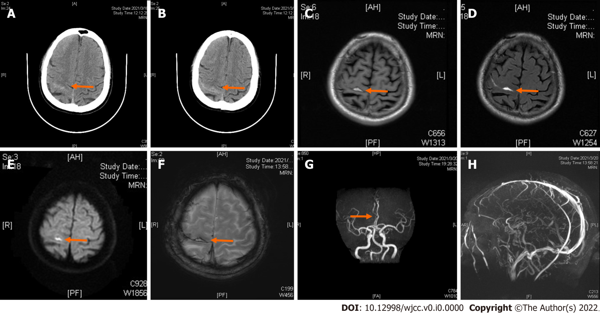
Figure 1 Computed tomography imaging. A and B: Axial computed tomography images showing a high-density image of right frontal-parietal sulcus; C: Magnetic resonance imaging showing slightly elevated T1-flair; D: Elevated T2-flair; E: Diffusion-weighted imaging revealed high signal intensity; F: Susceptibility weighted imaging showing slightly increased signal intensity in the right frontal; G: Machine records activity showing short local stenosis of the right anterior cerebral artery of A3 segment; H: Magnetic resonance venography revealed a thinner contrast in the left transverse sinus and left sigmoid sinus.
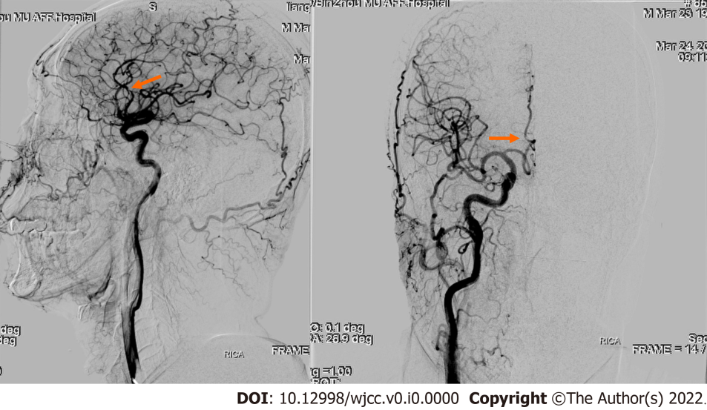
Figure 2 Digital subtraction angiography showing severe stenosis in the right anterior cerebral artery A2-A3 junction.

