Name of Journal: World Journal of Clinical Cases
Manuscript NO: 66193
Manuscript Type: ORIGINAL ARTICLE

Observational Study
Comparative study for predictability of type 1 gastric variceal rebleeding after endoscopic variceal ligation: High-frequency intraluminal ultrasound study

Kim JH et al. Evaluation of GOV1 using HFIUS

Jeong Hwan Kim, Won Hyeok Choe, Sun-Young Lee, So Young Kwon, In-Kyung Sung, Hyung Seok Park

Jeong Hwan Kim, Won Hyeok Choe, In-Kyung Sung, Department of Internal Medicine, Konkuk University School of Medicine, Konkuk University Medical Center, Seoul 05030, South Korea

Sun-Young Lee, Department of Internal Medicine, Konkuk University Medical Center, Seoul 143729, South Korea

So Young Kwon, Department of Internal Medicine, Konkuk University School of Medicine, Seoul 05030, South Korea

Hyung Seok Park, Department of Internal Medicine, Digestive Disease Center, Konkuk University School of Medicine, Seoul 05030, South Korea

Author contributions: Kim JH and Choe WH contributed to study conception and design; Kim JH, Choe WH, and Kwon SY contributed to collection of clinical data; Kim JH, Choe WH, Kwon SY, Lee SY, Sung IK, and Park HS contributed to data acquisition, data analysis, and interpretation; Kim JH, Choe WH, Kwon SY, Lee SY, Sung IK, and Park HS contributed to writing of the article, editing, reviewing, and final approval of the article.

Supported by Konkuk University Medical Center Research Grant 2018.

Corresponding author: Won Hyeok Choe, MD, PhD, Professor, Department of Internal Medicine, Konkuk University School of Medicine, Konkuk University Medical Center, 120-1 Neungdong-ro, Gwangjin-gu, Seoul 05030, South Korea. 20050101@kuh.ac.kr

Received: March 22, 2021
Revised: May 31, 2021
Accepted: October 15, 2021
Published online: December 6, 2021

Abstract
BACKGROUND
The efficacy of endoscopic ultrasonography for the follow-up of gastric varices treated with endoscopic variceal ligation (EVL) has not been established.

AIM
To evaluate the diagnostic correlation of esophagogastroduodenoscopy (EGD) and high-frequency intraluminal ultrasound (HFIUS) for type 1 gastric varices (GOV1) after EVL and to identify the predictability for rebleeding of EGD and HFIUS.

METHODS
In liver cirrhosis patients with GOV1, we performed endoscopic follow-up using EGD and HFIUS synchronously after EVL for hemorrhage from GOV1. Endoscopic grading and red color signs were analyzed using EGD, and the largest variceal cross-sectional areas were measured using HFIUS. In addition, 1-year follow-up was performed. Variceal rebleeding was defined as the presence of hematemesis, hematochezia, or melena without other evidence of bleeding on endoscopic follow-up.

RESULTS
In 26 patients with GOV1, variceal cross-sectional areas on HFIUS of GOV1 was poorly correlated with EGD grading of GOV1 (r = 0.36). In 17 patients who completed the 1-year follow-up, variceal cross-sectional areas on HFIUS was a good predictor of subsequent rebleeding, whereas EGD grading was not a predictor of subsequent rebleeding.

CONCLUSION
HFIUS measurement is more predictive of GOV1 rebleeding than EGD grading, so HFIUS measurement may be necessary for endoscopic follow-up after EVL in patients with GOV1.

Key Words: Endoscopic variceal ligation; Esophagogastroduodenoscopy; High-frequency intraluminal ultrasound; Rebleeding; Type 1 gastric varices

©The Author(s) 2021. Published by Baishideng Publishing Group Inc. All rights reserved.

Citation: Kim JH, Choe WH, Lee SY, Kwon SY, Sung IK, Park HS. Comparative study for predictability of type 1 gastric variceal rebleeding after endoscopic variceal ligation: High-frequency intraluminal ultrasound study. World J Clin Cases 2021; 9(34): 10566-10575
URL: https://www.wjgnet.com/2307-8960/full/v9/i34/10566.htm
DOI: https://dx.doi.org/10.12998/wjcc.v9.i34.10566

Core Tip: Endoscopic ultrasound was an important modality in the diagnosis of varices. Recently, high-frequency intraluminal ultrasound (HFIUS) enables quantitative measurement of variceal size, so it is a more sensitive imaging modality for the estimation of the size of varices. So we examined the diagnostic correlation of esophagogastroduodenoscopy (EGD) grades and HFIUS measurements in estimating post-endoscopic variceal ligation (EVL) type 1 gastric varices (GOV1). The results suggest that HFIUS measurement is more predictive of GOV1 rebleeding than EGD grading, so HFIUS measurement may be necessary for endoscopic follow-up after EVL in patients with GOV1.

INTRODUCTION
Endoscopic variceal ligation (EVL) was introduced in the 1980s as an alternative to endoscopic injection sclerotherapy^{[1]}. Several prospective trials reported that EVL was superior to endoscopic injection sclerotherapy in that it eradicated varices more rapidly with less recurrent bleeding and fewer complications^{[2−7]}. Thus, EVL has become the endoscopic treatment of choice for both the control of acute bleeding and the prevention of rebleeding from esophageal varices (EV)^{[8]}.
Gastric varices (GVs) are commonly categorized based on their location in the stomach and their relationship with EVs^{[9,10]}. Type 1 gastric varices (GOV1) are the most common subtype of GV and constitute an extension of EV along the lesser curvature of the stomach^{[9,11]}. Because they are considered a continuation of EV, current recommendations have emphasized that GOV1 should be treated as EV. In contrast, the other subtypes of GV, such as IGV1 (varices in the gastric fundus), IGV2 (ectopic varices around the pylorus), and GOV2 (varices extending along the greater curvature toward the gastric fundus), do not respond well to therapeutic modalities used for EV^{[11−14]}.
After successful control of acute bleeding with emergency EVL, endoscopic follow-up should be repeated, and residual or recurrent varices should be treated with elective EVL to prevent variceal rebleeding if indicated^{[12,13]}. Esophagogastroduodenoscopy (EGD) is the best practical modality for the follow-up of EV after EVL^{[12]}. However, little is known about whether it is an effective modality for post-EVL endoscopic follow-up of GOV1.
Recently, endoscopic ultrasound (EUS) has been introduced as an important modality in the diagnosis of varices^{[15,16]}. In particular, high-frequency intraluminal ultrasound (HFIUS) has been reported to enable quantitative measurement of variceal size, so it may be a more sensitive and reproducible imaging modality than EGD for the detection of varices and the estimation of their size^{[17−22]}. However, these data are very limited.
The aims of this study were to examine the diagnostic correlation of EGD grades and HFIUS measurements in estimating post-EVL GOV1 and to evaluate their ability to predict variceal rebleeding based on EGD findings and the cross-sectional area (CSA) of varices using HFIUS.

MATERIALS AND METHODS
Study protocol
This study was performed at the Konkuk University Medical Center, Seoul, Korea from January 2017 to December 2018. Of the participants with liver cirrhosis with GOV1, consecutive patients who underwent EVL for GOV1 bleeding were initially selected. Patients with hepatocellular carcinoma or Child-Pugh classification C cirrhosis (Child-Pugh class score ≥ 10) were excluded. Within 2 mo after the initial EVL, a follow-up EGD was performed biweekly to reassess variceal grade, and elective EVL was performed to obliterate the residual varices. One to two months after the initial EVL, endoscopic follow-up using synchronous EGD and HFIUS was conducted on 26 patients who were enrolled in this study. Of these, 17 patients whose varices were reduced to grade 0/1 according to EGD were prospectively followed up for 1 year without additional sessions of EVL. Patients received propranolol during follow-up if red color signs (RC signs) were evident on varices and nonselective beta blockers were not contraindicated. Variceal rebleeding was defined as the presence of hematemesis, hematochezia, or melena when the source of the bleeding was endoscopically proven to be GOV1 (spurting or oozing from varices or the presence of a recent blood clot over varices). The primary end point of the study was the correlation between EGD grades and HFIUS measurements as measured by the Spearman correlation coefficient in 26 patients initially enrolled. The secondary end point was the predictabilities for variceal rebleeding of EGD grades and HFIUS measurements in 17 patients who completed the 1-year follow-up. This study was approved by the Institutional Review Board of Konkuk University Hospital and was performed in accordance with the most recent (2008) revision of the Helsinki Declaration, and informed consent was obtained directly from all enrolled patients.

Diagnostic and therapeutic endoscopy
EVL was performed using a pneumatic-active ligating device (Samjin, Seoul, Korea) with a 25-cm overtube or using a multiband ligator (Saeed Six Shooter; Cook Endoscopy, Winston-Salem, NC, United States). The variceal hemorrhage site was first ligated. Then, surrounding varices were ligated as much as possible. Concomitant EVs were also ligated.
Follow-up EGD was performed using a double-channel endoscope (GIF2T–240; Olympus Co. Ltd, Tokyo, Japan). During the procedure, endoscopic images were electronically recorded for subsequent review by two endoscopists (JHK and WHC). Post-EVL EGD grades of varices were classified according to the General Rules for Recording Endoscopic Findings of Esophagogastric Varices of the Japanese Research Society for Portal Hypertension: Grade 0, not visible; grade 1, small, straight; grade 2, enlarged, tortuous; grade 3, large, coil-shaped, or tumorous^{[23,24]}. RC signs were classed as positive or negative. Positive was defined as clear evidence of a cherry-red spot, a red wale marking, or a hemocystic spot.

HFIUS examination
HFIUS was performed simultaneously with EGD. The HFIUS catheter assembly consisted of a 2.3-mm diameter ultrasonic miniprobe equipped with a 20-MHz transducer (UM–G20–29R, Olympus). The catheter was inserted via one of the accessory channels, and an automatic water infusion pump was attached to another channel to facilitate infusion of deaerated water. The HFIUS miniprobe, which has an axial resolution of approximately 0.1 mm and a penetration depth of 2.0 cm, was advanced to the mid-body of the stomach and was gradually withdrawn along the lesser curvature until the distal third of the esophagus was scanned. EUS images were recorded electronically for subsequent review by two examiners (JHK and WHC). The largest CSA sizes of varices using HFIUS were estimated using ImageJ software (NIH, Bethesda, MD, United States). The CSA of each varix was measured between the hypoechoic blood-filled lumen and the hyperechoic submucosa or mucosa (Figures 1 and 2).

Statistical analysis
Quantitative variables are expressed as the mean ± standard deviation and were compared using Student’s t test. Qualitative variables were compared using the χ² test. The correlation between EGD grade and HFIUS estimates was analyzed using the Spearman correlation coefficient. Receiver operating characteristic curves and sensitivity and specificity plots were constructed to identify predictors of variceal rebleeding. Cutoff values that resulted in the best sensitivity and specificity were identified. All P values were two-tailed, and a P value < 0.05 was considered significant.

RESULTS
Twenty-six patients were enrolled in this study. Table 1 shows the baseline characteristics of the patients. Varices were reduced to grade 0/1 at EGD findings within four sessions of EVL (single session in 2 patients; two sessions in 5 patients; three sessions in 7 patients; four sessions in 3 patients) in 17 patients, whereas varices were not reduced to grade 0/1 in 9 patients. Among the 17 patients who completed the 1-year follow-up, 6 patients (35%) experienced variceal rebleeding during follow-up. Patient characteristics, such as age, sex, etiology of cirrhosis, and Child-Pugh score, were not significantly associated with variceal rebleeding (Table 2).
In 26 patients, EGD identified GOV1 grades 0, 1, 2, and 3 in 11, 6, 6, and 3 patients, respectively. The mean largest variceal CSA values measured using HFIUS in patients with EGD grades 0, 1, 2, and 3 were 13.9 ± 9.5 mm², 17.2 ± 11.6 mm², 21.0 ± 9.8 mm², and 28.9 ± 18.7 mm², respectively. GOV1 grades estimated using EGD were not significantly correlated with largest variceal CSA measured using EUS (correlation coefficient = 0.36, P = 0.07), and the mean largest variceal CSA of grade 2/3 GOV1 was not significantly different from that of grade 0/1 GOV1 (23.7 ± 12.7 vs 15.1 ± 10.0; P = 0.07) (Figure 3).
Among the 17 patients who completed the 1-year follow-up, the mean largest variceal CSA of GOV1 was significantly greater in patients who experienced rebleeding compared with patients who did not (22.2 ± 7.7 mm² vs 11.2 ± 9.2 mm², respectively; P = 0.03) (Figure 4). A cutoff value of 17.2 mm² for largest variceal CSA resulted in a sensitivity and specificity for subsequent GOV1 bleeding of 83% and 82%, respectively. Rebleeding was significantly more frequent in those with largest variceal CSAs greater than the CSA cutoff value compared with those with largest variceal CSAs less than the CSA cutoff value, whereas EGD grading and RC sign were not predictive of GOV1 rebleeding (Table 3).

DISCUSSION
In this study, we initially enrolled 26 patients with liver cirrhosis with GOV1 who underwent synchronous EGD and HFIUS as endoscopic follow-up after the initial EVL and evaluated the diagnostic correlation of these two modalities. Then, in 17 patients with 1-year follow-up, we confirmed that HFIUS was a good predictor of subsequent rebleeding compared with EGD grading.
Theoretically, both GOV1 and EV bleeding can be treated with EVL given their similar pathophysiology^{[12]}. Technically as well as theoretically, EVL exhibits an advantage with respect to controlling acute bleeding from GOV1 given its better endoscopic view and easier accessibility compared with other subtypes of GV. However, from a practical perspective, EVL does not always eradicate GOV1 because its effect is limited to superficial layers, and GV often extends into the submucosa or deeper layers^{[25,26]}. Therefore, endoscopic follow-ups are very important for preventing GOV1 rebleeding.
EGD is less sensitive than EUS for the evaluation of GV^{[22,27−29]}. However, the availability of EUS is limited in clinical practice, and conventional EGD is typically used as an endoscopic follow-up modality after gastric variceal ligation^{[24,25]}. It has not been established whether EUS or EGD is more appropriate for post-EVL follow-up of GOV1. In patients with GOV1 in this study, EGD grading was not significantly correlated with post-EVL HFIUS size estimation of GOV1. Moreover, EGD findings, including grading and RC signs, did not predict post-EVL GOV1 bleeding. In contrast, HFIUS measurement of a cutoff value for the largest CSA enabled prediction of rebleeding. Therefore, we suggest that EGD grading is insufficient for post-EVL follow-up of GOV1 and that endoscopic follow-up with EUS, especially HFIUS, could be performed to estimate the accurate variceal size and predict rebleeding of GOV1.
There are some limitations to the present study. First, the EUS finding of small varices is very similar to the EUS finding of small cyst in the fundus, yet the doppler examination is able to differentiate small varices from small cysts. However, we did not perform the doppler examination in our study, so we are unable to completely distinguish small varices from small cysts. Nonetheless, the patients in this study experienced active bleeding from gastric varices before the enrollment, and bleeding from small cysts in the fundus is extremely rare. As it follows, we have ruled out the possibility of finding small cysts in the fundus even without performing the doppler examination. Second, as the sample size of this study is relatively small, the present results need to be validated in future studies.
We used 20 MHz HFIUS for EUS evaluation of post-EVL GOV1. This technique is more sensitive than conventional 7.5 MHz EUS because it enables better visualization of details at close range and accurate and quantitative measurement of variceal size^{[16,19−21]}. In addition, the HFIUS miniprobe does not require placement of a water-filled balloon around the ultrasound transducer, which prevents compression or distortion of varices. Patient discomfort is also minimized because HFIUS can be performed as a single-step procedure during EGD. We estimated variceal size based on the largest CSA instead of the largest diameter because post-EVL varices may be deformed by overlying scar tissue.

CONCLUSION
To our knowledge, this is the first study in which HFIUS has been used to predict post-EVL GOV1. This study demonstrated that HFIUS measurement is predictive of post-EVL GOV1 rebleeding; on the other hand, EGD is insufficient. Therefore, we suggest that HFIUS could be mandatory for endoscopic follow-up of GOV1 after EVL.

ARTICLE HIGHLIGHTS
Research background
After successful control of acute bleeding with emergency endoscopic variceal ligation (EVL), endoscopic follow-up should be repeated, and residual or recurrent varices should be treated with elective EVL to prevent variceal rebleeding if indicated. Recently, endoscopic ultrasound (EUS) has been introduced as an important modality in the diagnosis of varices, because EUS is more sensitive than esophagogastroduodenoscopy (EGD) for the evaluation of gastric varices.

Research motivation
The efficacy of endoscopic ultrasonography for the follow-up of gastric varices treated with EVL has not been established.

Research objectives
This study aimed to evaluate the diagnostic correlation of EGD and high-frequency intraluminal ultrasound (HFIUS) for type 1 gastric varices (GOV1) after EVL and to identify the predictability for rebleeding with EGD and HFIUS.

Research methods
In liver cirrhosis patients with GOV1, we performed endoscopic follow-up using EGD and HFIUS synchronously after EVL for hemorrhage from GOV1. Endoscopic grading and red color signs were analyzed using EGD, and the largest variceal cross-sectional areas (CSAs) were measured using HFIUS. In addition, 1-year follow-up was performed. Variceal rebleeding was defined as the presence of hematemesis, hematochezia or melena without other evidence of bleeding on endoscopic follow-up.

Research results
In 26 patients with GOV1, variceal CSA on HFIUS of GOV1 was poorly correlated with EGD grading of GOV1 (r = 0.36). In 17 patients who completed the 1-year follow-up, variceal CSA on HFIUS was a good predictor of subsequent rebleeding, whereas EGD grading was not a predictor of subsequent rebleeding.

Research conclusions
HFIUS measurement is more predictive of GOV1 rebleeding than EGD grading, so HFIUS measurement may be necessary for endoscopic follow-up after EVL in patients with GOV1.

Research perspectives
Future work and basic research should be performed to confirm that EUS, especially HFIUS, could be performed to estimate the accurate variceal size and predict rebleeding of GOV1.

REFERENCES
1 Stiegmann GV, Goff JS, Sun JH, Davis D, Bozdech J. Endoscopic variceal ligation: an alternative to sclerotherapy. Gastrointest Endosc 1989; 35: 431-434 [PMID: 2792677 DOI: 10.1016/s0016-5107(89)72850-9]
2 Stiegmann GV, Goff JS, Michaletz-Onody PA, Korula J, Lieberman D, Saeed ZA, Reveille RM, Sun JH, Lowenstein SR. Endoscopic sclerotherapy as compared with endoscopic ligation for bleeding esophageal varices. N Engl J Med 1992; 326: 1527-1532 [PMID: 1579136 DOI: 10.1056/NEJM199206043262304]
3 Lo GH, Lai KH, Cheng JS, Hwu JH, Chang CF, Chen SM, Chiang HT. A prospective, randomized trial of sclerotherapy vs ligation in the management of bleeding esophageal varices. Hepatology 1995; 22: 466-471 [PMID: 7635414]
4 Gimson AE, Ramage JK, Panos MZ, Hayllar K, Harrison PM, Williams R, Westaby D. Randomised trial of variceal banding ligation vs injection sclerotherapy for bleeding oesophageal varices. Lancet 1993; 342: 391-394 [PMID: 8101900 DOI: 10.1016/0140-6736(93)92812-8]
5 Laine L, el-Newihi HM, Migikovsky B, Sloane R, Garcia F. Endoscopic ligation compared with sclerotherapy for the treatment of bleeding esophageal varices. Ann Intern Med 1993; 119: 1-7 [PMID: 8498757 DOI: 10.7326/0003-4819-119-1-199307010-00001]
6 Hou MC, Lin HC, Kuo BI, Chen CH, Lee FY, Lee SD. Comparison of endoscopic variceal injection sclerotherapy and ligation for the treatment of esophageal variceal hemorrhage: a prospective randomized trial. Hepatology 1995; 21: 1517-1522 [PMID: 7768494]
7 Baroncini D, Milandri GL, Borioni D, Piemontese A, Cennamo V, Billi P, Dal Monte PP, D'Imperio N. A prospective randomized trial of sclerotherapy vs ligation in the elective treatment of bleeding esophageal varices. Endoscopy 1997; 29: 235-240 [PMID: 9255524 DOI: 10.1055/s-2007-1004182]
8 Brunner F, Berzigotti A, Bosch J. Prevention and treatment of variceal haemorrhage in 2017. Liver Int 2017; 37 Suppl 1: 104-115 [PMID: 28052623 DOI: 10.1111/liv.13277]
9 Park EJ, Jang JY, Lee JE, Jeong SW, Lee SH, Kim SG, Cha SW, Kim YS, Cho YD, Cho JY, Kim HS, Kim BS, Kim YJ. The risk factors for bleeding of fundal varices in patients with liver cirrhosis. Gut Liver 2013; 7: 704-711 [PMID: 24312712 DOI: 10.5009/gnl.2013.7.6.704]
10 Triantafyllou M, Stanley AJ. Update on gastric varices. World J Gastrointest Endosc 2014; 6: 168-175 [PMID: 24891929 DOI: 10.4253/wjge.v6.i5.168]
11 Vine LJ, Subhani M, Acevedo JG. Update on management of gastric varices. World J Hepatol 2019; 11: 250-260 [PMID: 30967903 DOI: 10.4254/wjh.v11.i3.250]
12 Ashkenazi E, Kovalev Y, Zuckerman E. Evaluation and treatment of esophageal varices in the cirrhotic patient. Isr Med Assoc J 2013; 15: 109-115 [PMID: 23516775]
13 Jakab SS, Garcia-Tsao G. Evaluation and Management of Esophageal and Gastric Varices in Patients with Cirrhosis. Clin Liver Dis 2020; 24: 335-350 [PMID: 32620275 DOI: 10.1016/j.cld.2020.04.011]
14 Hwang JH, Shergill AK, Acosta RD, Chandrasekhara V, Chathadi KV, Decker GA, Early DS, Evans JA, Fanelli RD, Fisher DA, Foley KQ, Fonkalsrud L, Jue T, Khashab MA, Lightdale JR, Muthusamy VR, Pasha SF, Saltzman JR, Sharaf R, Cash BD; American Society for Gastrointestinal Endoscopy. The role of endoscopy in the management of variceal hemorrhage. Gastrointest Endosc 2014; 80: 221-227 [PMID: 25034836 DOI: 10.1016/j.gie.2013.07.023]
15 Girotra M, Raghavapuram S, Abraham RR, Pahwa M, Pahwa AR, Rego RF. Management of gastric variceal bleeding: Role of endoscopy and endoscopic ultrasound. World J Hepatol 2014; 6: 130-136 [PMID: 24672642 DOI: 10.4254/wjh.v6.i3.130]
16 Hammoud GM, Ibdah JA. Utility of endoscopic ultrasound in patients with portal hypertension. World J Gastroenterol 2014; 20: 14230-14236 [PMID: 25339809 DOI: 10.3748/wjg.v20.i39.14230]
17 Wang AJ, Li BM, Zheng XL, Shu X, Zhu X. Utility of endoscopic ultrasound in the diagnosis and management of esophagogastric varices. Endosc Ultrasound 2016; 5: 218-224 [PMID: 27503152 DOI: 10.4103/2303-9027.187840]
18 Carneiro FO, Retes FA, Matuguma SE, Albers DV, Chaves DM, Dos Santos ME, Herman P, Chaib E, Sakai P, Carneiro D'Albuquerque LA, Maluf Filho F. Role of EUS evaluation after endoscopic eradication of esophageal varices with band ligation. Gastrointest Endosc 2016; 84: 400-407 [PMID: 26905936 DOI: 10.1016/j.gie.2016.02.006]
19 Jeong SW, Kim HS, Kim SG, Yoo JJ, Jang JY, Lee SH, Kim HS, Lee JS, Kim YS, Kim BS. Useful Endoscopic Ultrasonography Parameters and a Predictive Model for the Recurrence of Esophageal Varices and Bleeding after Variceal Ligation. Gut Liver 2017; 11: 843-851 [PMID: 28651302 DOI: 10.5009/gnl16458]
20 Masalaite L, Valantinas J, Stanaitis J. Endoscopic ultrasound findings predict the recurrence of esophageal varices after endoscopic band ligation: a prospective cohort study. Scand J Gastroenterol 2015; 50: 1322-1330 [PMID: 25956657 DOI: 10.3109/00365521.2015.1043640]
21 Liao SC, Yang SS, Ko CW, Lien HC, Tung CF, Peng YC, Yeh HZ, Chang CS. A miniature ultrasound probe is useful in reducing rebleeding after endoscopic cyanoacrylate injection for hemorrhagic gastric varices. Scand J Gastroenterol 2013; 48: 1347-1353 [PMID: 24073667 DOI: 10.3109/00365521.2013.838995]
22 Seno H, Konishi Y, Wada M, Fukui H, Okazaki K, Chiba T. Endoscopic ultrasonograph evaluation of vascular structures in the gastric cardia predicts esophageal variceal recurrence following endoscopic treatment. J Gastroenterol Hepatol 2006; 21: 227-231 [PMID: 16460478 DOI: 10.1111/j.1440-1746.2006.04129.x]
23 Bandoh T, Mitarai Y, Kitano S, Yoshida T, Kobayashi M. Clinical significance of esophageal variceal pressure in patients with esophageal varices. J Hepatol 1994; 21: 326-331 [PMID: 7836700 DOI: 10.1016/s0168-8278(05)80309-5]
24 European Association for the Study of the Liver. Electronic address: easloffice@easloffice.eu; European Association for the Study of the Liver. EASL Clinical Practice Guidelines for the management of patients with decompensated cirrhosis. J Hepatol 2018; 69: 406-460 [PMID: 29653741 DOI: 10.1016/j.jhep.2018.03.024]
25 Tantau M, Crisan D, Popa D, Vesa S, Tantau A. Band ligation vs. N-Butyl-2-cyanoacrylate injection in acute gastric variceal bleeding: a prospective follow-up study. Ann Hepatol 2013; 13: 75-83 [PMID: 24378269]
26 Tan PC, Hou MC, Lin HC, Liu TT, Lee FY, Chang FY, Lee SD. A randomized trial of endoscopic treatment of acute gastric variceal hemorrhage: N-butyl-2-cyanoacrylate injection vs band ligation. Hepatology 2006; 43: 690-697 [PMID: 16557539 DOI: 10.1002/hep.21145]
27 Liao WC, Chen PH, Hou MC, Chang CJ, Su CW, Lin HC, Lee FY. Endoscopic ultrasonography assessment of para-esophageal varices predicts efficacy of propranolol in preventing recurrence of esophageal varices. J Gastroenterol 2015; 50: 342-349 [PMID: 24908097 DOI: 10.1007/s00535-014-0970-y]
28 Sharma M, Singh P, Pathak A, Arya S. Diagnostic dilemma in gastric varices: Endoscopic ultrasound resolves the issue (with videos). Endosc Ultrasound 2017; 6: 409-411 [PMID: 28663534 DOI: 10.4103/2303-9027.199764]
29 Fung BM, Abadir AP, Eskandari A, Levy MJ, Tabibian JH. Endoscopic ultrasound in chronic liver disease. World J Hepatol 2020; 12: 262-276 [PMID: 32742569 DOI: 10.4254/wjh.v12.i6.262]

Footnotes
Institutional review board statement: This study was reviewed and approved by the Institutional Review Board of Konkuk University Hospital (KUH1010094).

Informed consent statement: Patients were not required to give informed consent to the study because the analysis used anonymous clinical data that were obtained from the Electronic Medical Record of the Konkuk University Medical Center.

Conflict-of-interest statement: The authors declare that they have no conflicts of interest to disclose.

Data sharing statement: No additional data are available.

STROBE statement: The authors have read the STROBE Statement-checklist of items, and the manuscript was prepared and revised according to the STROBE Statement-checklist of items.

Open-Access: This article is an open-access article that was selected by an in-house editor and fully peer-reviewed by external reviewers. It is distributed in accordance with the Creative Commons Attribution NonCommercial (CC BY-NC 4.0) license, which permits others to distribute, remix, adapt, build upon this work non-commercially, and license their derivative works on different terms, provided the original work is properly cited and the use is non-commercial. See: http://creativecommons.org/Licenses/by-nc/4.0/

Provenance and peer review: Unsolicited article; Externally peer reviewed

Peer-review started: March 22, 2021
First decision: April 29, 2021
Article in press: October 15, 2021

Specialty type: Medicine, research and experimental
Country/Territory of origin: South Korea
Peer-review report’s scientific quality classification
Grade A (Excellent): 0
Grade B (Very good): B
Grade C (Good): 0
Grade D (Fair): 0
Grade E (Poor): 0

P-Reviewer: Li Y S-Editor: Fan JR L-Editor: Filipodia P-Editor:
Figure Legends
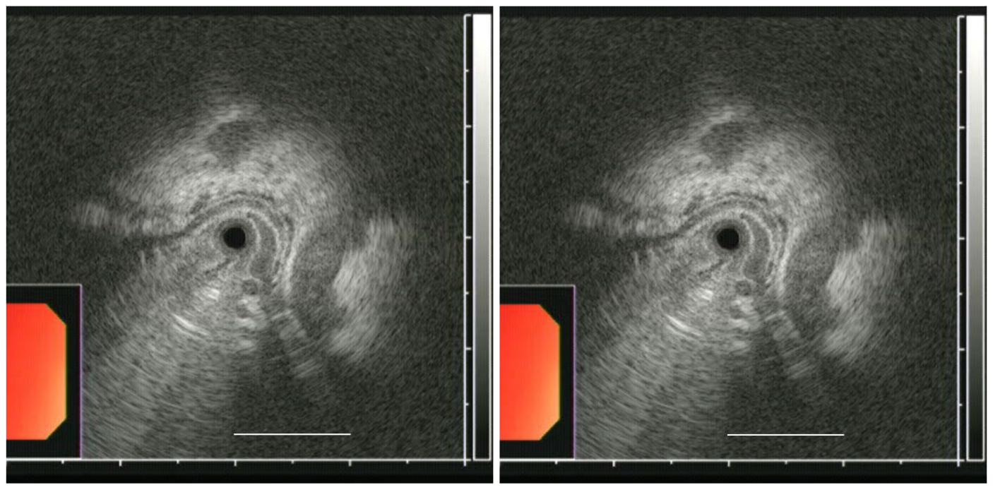
Figure 1 High-frequency intraluminal ultrasound images of post-endoscopic variceal ligation of type 1 gastric varices. The post-endoscopic variceal ligation sizes of varices were assessed according to the largest cross-sectional area (CSA). CSA was measured between the hypoechoic blood-filled lumen and the hyperechoic submucosa or mucosa. The dotted line indicates the largest CSA of the varix. The scale bar represents 10 mm.

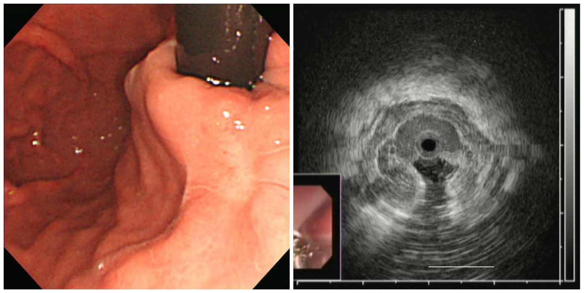
Figure 2 Representative esophagogastroduodenoscopy and high-frequency intraluminal ultrasound images of type 1 gastric varices. The type 1 gastric varices was grade 0 according to esophagogastroduodenoscopy, but the largest variceal cross-sectional area was 31.4 mm² according to high-frequency intraluminal ultrasound.

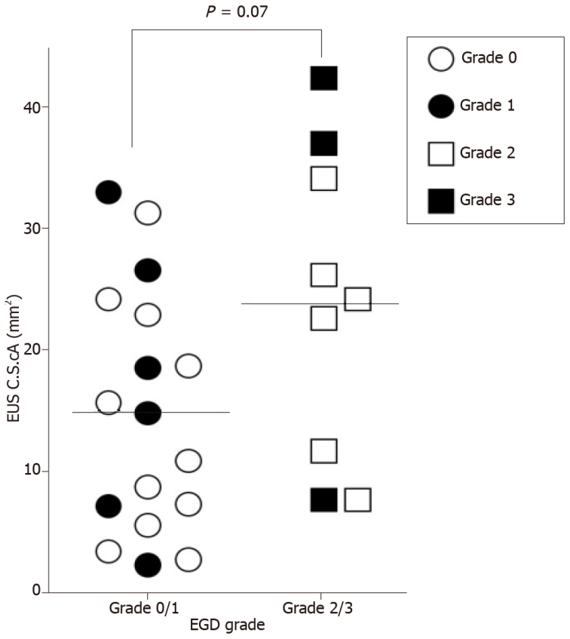
Figure 3 Post-endoscopic variceal ligation esophagogastroduodenoscopy grades and cross-sectional areas. The mean largest variceal cross-sectional area (CSA) for grade 0/1 type 1 gastric varices (GOV1) did not differ from that for grade 2/3 GOV1 (15.1 ± 10.0 mm² vs 23.7 ± 12.7 mm², respectively; P = 0.07). EUS: Endoscopic ultrasound; EGD: Esophagogastroduodenoscopy.

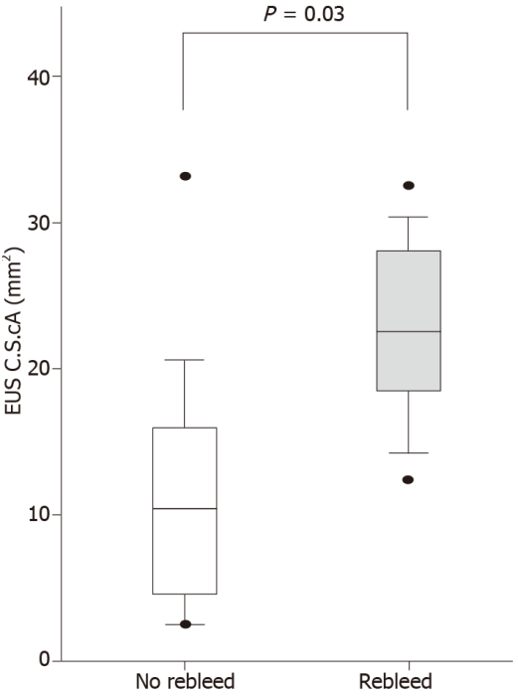
Figure 4 Comparison of high-frequency intraluminal ultrasound estimates of largest variceal cross-sectional area between patients with or without post-endoscopic variceal ligation variceal bleeding. The mean largest variceal cross-sectional area (CSA) of type 1 gastric varices patients who experienced post-endoscopic variceal ligation (EVL) bleeding was significantly greater than that of patients who did not experience post-EVL bleeding (22.2 ± 7.7 mm² vs 11.2 ± 9.2 mm², respectively; P = 0.03). Horizontal bars represent median values, and the upper and lower ends of the bars represent quartile values. EUS: Endoscopic ultrasound.

Table 1 Baseline characteristics of patients (n = 26) initially enrolled
Characteristic
Age (yr) | 52.7 ± 10.5
Sex (M/F) | 22/4
Alcohol/nonalcoholic | 6/20
Child-Pugh score 5/6/7/8/9 | 3/3/8/7/5
MELD score | 12.8 ± 3.8
Hepatocellular carcinoma | 0 (0%)
Serum albumin (gm/dL) | 3.2 ± 0.5
Serum bilirubin (mg/dL) | 2.2 ± 1.3
Prothrombin time (INR) | 1.4 ± 0.2
Serum creatinine | 1.1 ± 0.2
Presence of ascites | 12 (46.2%)
Presence of hepatic encephalopathy | 1 (3.8%)
Platelet count (K/mm³) | 88.1 ± 39.8
Hemoglobin (g/dL) | 7.8 ± 2.2
Blood transfused (units) | 3.0 ± 1.5
Data are expressed as the mean ± standard deviation. M: Male; F: Female; MELD: Model for end-stage liver disease; INR: International normalized ratio.
Table 2 Predictable factors of rebleeding in patients (n = 17) at the 1-yr follow-up
 | Rebleeding (+) | Rebleeding (-) | P value
Age (yr) | 55.5 ± 11.8 | 51.9 ± 10.7 | 0.533
Sex (M/F) | 5/9 | 1/2 | 0.728
Alcohol/nonalcoholic | 2/2 | 4/9 | 0.445
Child-Pugh classification A/B | 1/3 | 5/8 | 0.555
MELD score | 12.8 ± 2.6 | 13.4 ± 3.1 | 0.725
M: Male; F: Female; MELD: Model for end-stage liver disease.
Table 3 Comparison of high-frequency intraluminal ultrasound and esophagogastroduodenoscopy for variceal rebleeding
Endoscopic modality |  | GOV1, n = 17 (100%)
 |  | Rebleeding (+), n = 6 (35%) | Rebleeding (–), n = 11 (65%) | P value
HFIUS | ≥ CSA cutoff value¹ | 5 (29) | 2 (12) | 0.02
 | < CSA cutoff value¹ | 1 (6) | 9 (53)
EGD | Grade 1 with RCS | 2 (12) | 2 (12) | 0.58
 | Grade 0 or 1 without RCS | 4 (24) | 9 (53)
¹The cutoff value for the largest cross-sectional area was 17.2 mm². With these cutoff values, the sensitivity and specificity were 83% and 82%, respectively, for post-endoscopic variceal ligation type 1 gastric varices bleeding. The receiver operating characteristic curve had an area below the curve of 0.83 ± 0.10, which was statistically significant (P = 0.03).
CSA: Cross-sectional area; EGD: Esophagogastroduodenoscopy; GOV1: Type 1 gastric varices; HFIUS: High-frequency intraluminal ultrasound; Red color signs.

Published by Baishideng Publishing Group Inc
7041 Koll Center Parkway, Suite 160, Pleasanton, CA 94566, USA
Telephone: +1-925-3991568
E-mail: bpgoffice@wjgnet.com
Help Desk: https://www.f6publishing.com/helpdesk
https://www.wjgnet.com

© 2021 Baishideng Publishing Group Inc. All rights reserved.

