Name of journal: World Journal of Orthopedics
ESPS Manuscript NO: 17904
Manuscript Type: CASE REPORT

“Push back” technique: A simple method to remove broken drill bit from the proximal femur

Chouhan DK et al. Push-back technique for broken drill bit

Devendra K Chouhan, Siddhartha Sharma

Devendra K Chouhan, Siddhartha Sharma, Department of Orthopaedics, Postgraduate Institute of Medical Education and Research, Chandigarh 160012, India

Author contributions: Chouhan DK and Sharma S equally contributed to this work.

Institutional review board statement: This study was approved by the Orthopedics Departmental Review Board, Postgraduate Institute of Medical Education and Research.

Informed consent statement: The patient gave their informed consent to take part in the study.

Conflict-of-interest statement: The authors have no conflicts of interest.

Open-Access: This article is an open-access article which was selected by an in-house editor and fully peer-reviewed by external reviewers. It is distributed in accordance with the Creative Commons Attribution Non Commercial (CC BY-NC 4.0) license, which permits others to distribute, remix, adapt, build upon this work non-commercially, and license their derivative works on different terms, provided the original work is properly cited and the use is non-commercial. See: http://creativecommons.org/licenses/by-nc/4.0/

Correspondence to: Dr. Siddhartha Sharma, Department of Orthopaedics, Postgraduate Institute of Medical Education and Research, Sector 12, Chandigarh160012, India. sids82@gmail.com
Telephone: +91-998-8793537
Fax: +91-172-2756743

Received: March 29, 2015
Peer-review started: March 31, 2015
First decision: April 27, 2015
Revised: May 7, 2015
Accepted: August 30, 2015
Article in press:
Published online:

Abstract
Broken drill bits can be difficult to remove from the proximal femur and may necessitate additional surgical exploration or special instrumentation. We present a simple technique to remove a broken drill bit that does not require any special instrumentation and can be accomplished through the existing incision. This technique is useful for those cases where the length of the broken drill bit is greater than the diameter of the bone.

Key words: Broken drill bit; Interlocking nail; Femoral fracture; Surgical technique

© The Author(s) 2015. Published by Baishideng Publishing Group Inc. All rights reserved.
Core tip: Drill bits can break during locking in femoral intramedullary nailing. In this article, the authors describe an innovative yet simple technique to remove a broken drill bit from the proximal femur.

Chouhan DK, Sharma S. “Push back” technique: A simple method to remove broken drill bit from the proximal femur. World J Orthop 2015; In press

INTRODUCTION
Locked intramedullary nailing of the femur is widely used to treat fractures of the shaft of femur. Drill bit breakage is one of the most commonly encountered hardware breakage problems^{[1]} and may occur during proximal or distal locking. The presence of muscle bulk and the femoral neurovascular bundle make drill bit retrieval from the proximal femur difficult. We present a simple method to remove a broken drill bit from the proximal locking hole.

CASE REPORT
The stab incision for the proximal locking hole is extended by 2 cm both proximally and distally. Dissection proceeds down to the proximal femur after splitting the vastus lateralis muscle and the drill hole is identified. Maintaining a strictly sub-periosteal plane, the vastus intermedius and medialis origin is lifted subperiosteally and two curved Hohmann retractors are introduced to aid in retraction. Next, a right angled narrow blade Langenbeck retractor (10 mm blade width, 30 mm blade length) is inserted through the incision with its blade tip facing proximally. A retractor with a smaller blade (6 mm blade width, 20 mm blade length) may be used if the surgeon encounters difficulty in introducing the 10 mm × 30 mm blade retractor. Care is taken to ensure that the shaft of the retractor is flush with the anterior cortex of femur. The blade is advanced well beyond the medial cortex of femur and this is confirmed on the image intensifier in the antero-posterior (AP) view (Figure 1). Next, the blade is rotated by 90 degrees so that its blade tip faces posteriorly and the broken drill bit lies in the center of the retractor’s blade (Figure 2). Once the correct position has been verified on the image intensifier, the blade of the retractor is pushed towards the medial cortex of femur and on to the penetrating drill bit. This ‘pushes back’ the drill bit into the drill hole and out through the lateral entry hole from where it can be retrieved under direct vision (Figure 3).
A 34-year-old male with mid - diaphyseal, comminuted shaft femur fracture was taken up for locked intramedullary nailing (Simplified Universal Nail, Synthes, Paoli). The drill bit broke while statically locking the screw hole. On image intensifier examination, it was found the broken end of the drill bit was protruding from the medial cortex of the femur. The drill bit was removed using the ‘push back’ technique (Figure 4).

DISCUSSION
Broken drill bits protruding through the far cortex of a drill hole can be difficult to retrieve from the proximal femur. The usual method in other locations is to make an incision on the far side, dissect the soft tissues and retrieve the drill bit under direct vision or to push the bit out through the opposite side by inserting K wires^{[2]} or new screws^{[3]}. However, this method may be difficult to perform in the proximal femur as the large bulk of the adductor compartment necessitates a longer skin incision and a lot of soft tissue dissection. Also of concern is the femoral neurovascular bundle that courses within the adductor canal and may be inadvertently injured during dissection.
We believe that our method is a safe alternative to retrieve broken drill bits in such situations. It can be easily adapted for the distal femur as well. Also, it is important to use a narrow blade Langenbeck retractor since the iliopsoas tendon and the periosteum may make placements of larger retractors difficult. The only time this method would not work is when the length of the broken drill bit is quite small and it is retained entirely within the medullary canal of the proximal femur. In such cases, the surgeon may need to fish out the drill bit through a small cortical window in the lateral or the medial cortex. Alternatively, the technique described by Matthews et al^{[4]} may be useful.
Fortunately, such occurrences are rare and in the authors’ experience, the broken drill bit is invariably longer than the diameter of the medullary canal.
To conclude, we believe that the “push back” technique may be an effective and safe alternative to retrieve broken drill bits from the proximal femur if the length of the drill bit is greater than the diameter of the femur and the method may be adapted to other sites as well.

COMMENTS
Case characteristics
A 34-year-old male presented with injury to right thigh after road traffic accident.

Clinical diagnosis
Fracture shaft of femur.

Imaging diagnosis
Comminuted mid-diaphyseal fracture of the femoral shaft.

Treatment
Statically locked femoral intramedullary nailing (Simplied Universal Nail, Synthes).

Experiences and lessons
Drill bit breakage is a frequent occurrence in orthopedic surgery and the surgeon must be prepared to handle it; the push-back technique can be a vaulable alternative in some cases.

Peer-review
This Case Report paper presents an alternative technique for removing broken drill bits from the proximal (or distal) femur.

REFERENCES
1 Price MV, Molloy S, Solan MC, Sutton A, Ricketts DM. The rate of instrument breakage during orthopaedic procedures. Int Orthop 2002; 26: 185-187 [PMID: 12073114 DOI: 10.1007/s00264-002-0344-6]
2 Sancineto CF, Rubel IF, Seligson D, Ferro GV. Technique for removal of broken interlocking screws. J Orthop Trauma 2001; 15: 132-134 [PMID: 11232652 DOI: 10.1097/00005131-200102000-00010]
3 Davies NM, Farnell RD, Unwin AJ, Jones JR. A technique for removal of fractured locking screws from an intramedullary nail. Injury 1997; 28: 159 [PMID: 9205588 DOI: 10.1016/S0020-1383(96)00193-3]
4 Matthews SJ, Landsmeer RE, Thomas TL. Removal of broken drill bits and locking screws from an intramedullary nail. Ann R Coll Surg Engl 2006; 88: 316 [PMID: 17387825 DOI: 10.1308/003588406X106342a]

P-Reviewer: Franklyn MJ, Maheshwari AV S-Editor: Tian YL
L-Editor: E-Editor:

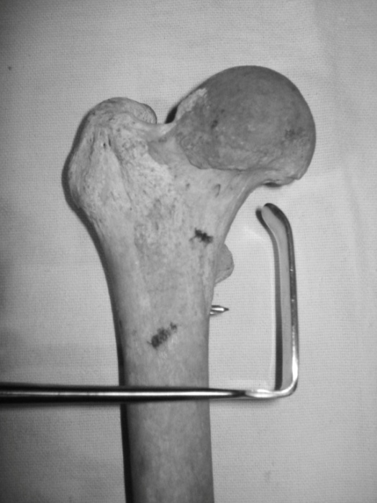
Figure 1 Langenbeck retractor is inserted with its blade tip facing proximally and advanced well beyond the medial cortex of femur (in this example a 15 × 45 mm retractor is shown, in clinical practice a 10 x 30 mm or smaller retractor is preferable).

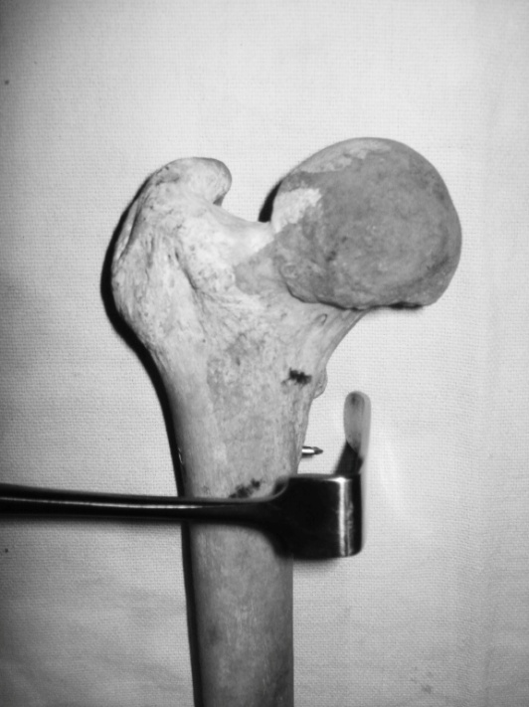
Figure 2 Retractor blade is rotated by 90°.

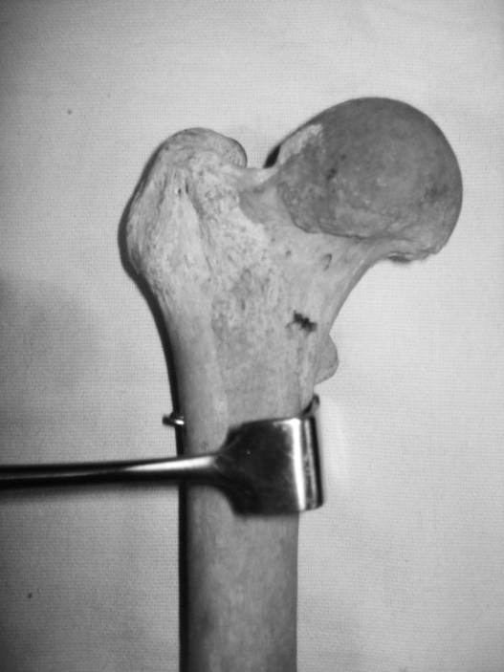
Figure 3 Drill bit is pushed back by the blade of the retractor.

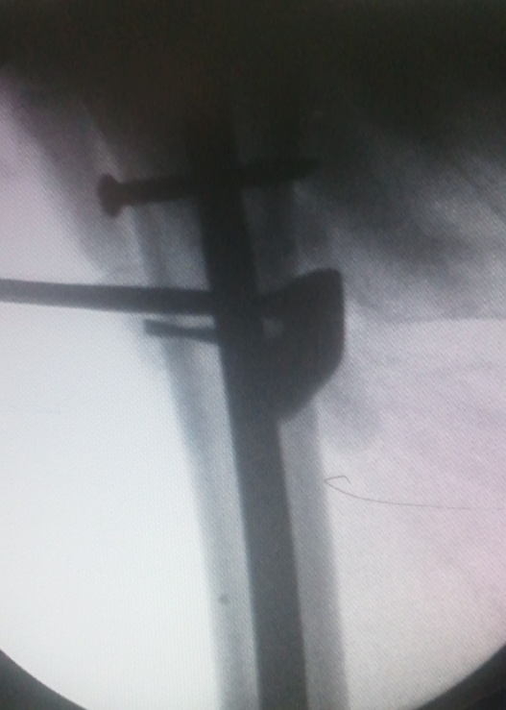
Figure 4 Image intensifier view of the technique.

