Name of Journal: World Journal of Clinical Cases
Manuscript NO: 62170
Manuscript Type: CASE REPORT

late-onset Leigh syndrome without delayed development in China: A case report

Liang JM et al. A case of the late-onset Leigh syndrome

Jian-min Liang, Cui-juan Xin, Guang-liang Wang, Xue-mei Wu

Jian-min Liang, Cui-juan Xin, Xue-mei Wu, Department of Pediatric Neurology, 1st hospital of Jilin University, Changchun 130021, Jilin province, China

Jian-min Liang, Cui-juan Xin, Xue-mei Wu, Department of Pediatric Neurology, Jilin Provincial Key Laboratory of Pediatric Neurology, Changchun 130021, Jilin province, China

Guang-liang Wang, Department of Cardiology, Dalinghe Hospital of Far Eastern Horizon, Dalinghe 121200, Liaoning Province, China

Author contributions: Liang JM drafted the manuscript; Xin CJ collected the data; Wang GL helped draft the manuscript; Wu XM revised the manuscript; All authors read and approved the final manuscript.

Supported by the National Natural Science Foundation of China, No. 81801284 and No. 81771396.

Corresponding author: Xue-mei Wu, MD, Doctor, Department of Pediatric Neurology, 1st hospital of Jilin University, No. 1 Xinmin Street, Changchun 130021, Jilin province, China. xmwu@jlu.edu.cn

Received: December 31, 2020
Revised: June 25, 2021
Accepted: July 6, 2021
Published online:

Abstract
BACKGROUND
Leigh syndrome (LS) is one of the most common mitochondrial diseases in infants and children. LS often manifests as early-onset with delayed phenotypic development. However, late-onset LS with normal development and white matter lesions in the brain is rarely reported, thereby highlighting the phenotypic variability of LS expression.

CASE SUMMARY
We report a 12-year-old boy who presented with an unusual late-onset and fulminant form of LS that is maternally inherited without developmental delay. The patient was admitted to the hospital with symptoms of ptosis and somnolence, and died within 2 mo. Analysis of peripheral blood leukocytes showed a homoplasmic m.9176T>C mutation in the patient. Magnetic resonance imaging also revealed lesions in bilateral white matter as well as symmetrical lesions in the basal ganglia and brain stem. The patient was diagnosed with LS. The patient was treated with vitamin C, vitamin D, and adenosine-triphosphate. The patient died within 2 mo of hospital admission.

CONCLUSION
LS can present in both infants and older children with different phenotypes.

Key Words: Leigh syndrome; 9176 mutation; late-onset; case report

Liang JM, Xin CJ, Wang GL, Wu XM. Late-onset Leigh syndrome without delayed development in China: A case report. World J Clin Cases 2021; In press

Core Tip: Leigh syndrome (LS) often manifests as early-onset with delayed phenotypic development. However, late-onset LS with normal development and white matter lesions in the brain is rarely reported. Here, we present a late-onset LS case of a previously healthy12-year-old boy that suddenly and unexpectedly died within 2 mo after the onset of symptoms that included myasthenia oculi and subsequent energy failure. Gene analysis revealed that the boy had a T-to-C transition at nucleotide 9176 of the mitochondrial adenosine triphosphatase 6 gene. The current case is reported for the first time in China and highlights the variability of phenotypic expression of LS.

INTRODUCTION
Leigh syndrome (LS) is an early-onset neurodegenerative pediatric disorder and is characterized by bilateral symmetrical necrotic lesions of gray matter nuclei in the basal ganglia and brainstem, as well as in the diencephalon and cerebellum^{[1]}. LS patients traditionally present in early infancy, resulting in regression or psychomotor delay in their early age^{[2]}. Late-onset LS has also been reported, however, it is very rare. Here, we present a late-onset LS case of a previously healthy 12-year-old boy that suddenly and unexpectedly died within 2 mo after the onset of symptoms that included myasthenia oculi and subsequent energy failure. Gene analysis revealed that the boy had a T-to-C transition at nucleotide 9176 of the mitochondrial adenosine triphosphatase (ATPase) 6 gene. Biochemical evaluation and magnetic resonance imaging (MRI) revealed positive acetylcholine antibody in the blood, a positive oligoclonal band in the cerebral fluid, and abnormal signals in white matter. The current case is reported for the first time in China and highlights the variability of phenotypic expression of LS.

CASE PRESENTATION
Chief complaints
A previously healthy 12-year-old boy was admitted to the hospital on February 12, 2016 with complaints of blepharoptosis, voice hoarseness, fever, and the inability to walk and talk.

History of present illness
The patient exhibited persistent blepharoptosis, voice hoarseness, and fever for about 2 mo. He then became severely agitated with the main complaints of sleepiness, dysphagia, limb weakness, and respiratory and circulatory failure. The patient unfortunately died soon thereafter.

History of past illness
The patient was diagnosed with subacute ptosis at 12-years-old.

Personal and family history
The patient was delivered vaginally at term with a birth weight of 3250 g and without developmental delay. His height was 156 cm and weight was 50 kg upon admission to the hospital. The patient's mother exhibited no abnormal symptoms after the birth. The family history of the patient regarding a similar condition was negative.

Physical examination
Clinical examination showed that the patient presented with pyramidal signs and very easily elicited reflexes and extensor toe signs on both feet.

Laboratory examinations
The routine blood and urine tests, urinary sediment examination, routine fecal tests, and occult blood test were performed, which all showed normal results. The arterial blood gas was tested and the pH value was 7.32. The oxygen pressure was 11.3 kPa, the carbon dioxide pressure was 4.9 kPa, and the oxygen saturation was 99%. The arterial plasma lactate level was slightly elevated to 3 mg/dL. Ammonia and blood sugar levels were normal. Other blood biochemistry indexes were also normal. The cytological and biochemical examination showed the normal presence of cerebrospinal fluid (CSF)-positive antibodies to acetylcholine, presynaptic membrane receptor, and thymoma in the blood, and positive oligoclonal bands in the CSF. The antibody tests to Mycoplasma pneumoniae, herpes simplex virus, and Epstein-Barr virus were negative. Gene sequencing analysis revealed a T-to-C transition at nucleotide 9176 of the mitochondrial ATPase 6 gene (Leu to Pro) in the patient and a heteroplasmic mutation in the patient’s mother (Figure 1).

Imaging examinations
Electroencephalogram analysis revealed slow-waves of background activity. The brain MRI scan showed symmetrical abnormal signals in the basal ganglia, medial thalami, periaqueductal region of the midbrain and pons, and the bilateral white matter around the lateral ventricles (Figure 2).

FINAL DIAGNOSIS
The physician diagnosed mitochondrial encephalopathy or LS based on the clinical phenotypes, the observation of lactic acidosis and cerebral lesions, as well as the gene sequencing analysis. This case was an unusual late-onset and fulminate form of LS and was maternally inherited.

TREATMENT
The patient was treated for 2 mo with antiviral and dehydration medication to reduce intracranial pressure. Otherwise, the physician prescribed therapy (daily 100 mg vitamin B complex, 300 mg vitamin C, 50 mg vitamin E, 90 mg coenzyme Q10, and 300 mg carnitine).

OUTCOME AND FOLLOW-UP
The clinical features of the patient rapidly intensified after admission to the hospital. He died from progressive brainstem dysfunction 2 mo later.

DISCUSSION
LS (OMIM 256000), also known as subacute necrotizing encephalomyelopathy, is a severe, fatal, early-onset progressive disorder that develops during infancy or childhood. LS is characterized by the presence of bilateral symmetrical necrotizing lesions in the brainstem, basal ganglia, thalamus, and spinal cord^{[3]}. In this report, we described the clinical and molecular features of an unusual late-onset fulminant case in a previously healthy 12-year-old boy with a mitochondrial DNA T9176C mutation (which leads to a severe phenotype).
MRI showed that the patient presented with symmetrical lesions in the basal ganglia, consistent with onset symptoms typically observed in LS patients between 3 and 12 mo old^{[1]}. McKelvie et al^{[4]} reported a case of late-adult onset LS but failed to identify the specific underlying mutation with genetic studies. At the onset of LS, the main parental complaints describe the loss of motor milestones and cognitive deterioration. Nutritional troubles resulting from the decreased ability to feed may precede or exacerbate the underlying encephalopathy, leading to an apparent reduced body and head growth^{[2]}. Rahman et al^{[3]} proposed stringent criteria for defining LS in infants and children. In this study, a 12-year-old boy with late-onset LS was previously healthy with normal body and head growth. The motor and intellectual delay in early age is indispensable for LS diagnosis but was missed in this unusual case. The clinical presentations of LS are highly variable and lead to difficulty in defining diagnostic criteria. Survival is variable, with most patients dying between the ages of 1 mo to 21 years (the average is 2.4 years). Poor survival has been associated with age of disease onset, genetically identified markers, epileptic seizures, brainstem lesions as observed on neuroimaging data, failure to gain weight, and intensive care admission^{[5-7]}. In this study, the onset of the unusual LS case was 12-years-old and led to patient death within 2 mo after hospital admission. This case highlights the variability of phenotypic expression of LS.
MRI of the brain was used to identify rare symmetrical lesions in white matter, in addition to typical symmetrical lesions of gray matter in the basal ganglia and brainstem. Characteristic neuropathologies includes spongiform lesions throughout the brain, including in the basal ganglia, brain stem, and cerebellum^{[2,8]}. In this study, the bilateral white matter around the lateral ventricles was detected in this unusual case, which might be associated with demyelination or gliosis. White matter lesions on MRI are so prominent and can often mimic leukodystrophy. The typical lesions are observed bilaterally and symmetrically throughout the brain but have a particular predilection for the brainstem and are often accompanied by demyelination^{[1,9,10]}. Laboratory test results of this case revealed a positive antibody presence to acetylcholine, presynaptic membrane receptor, and thymoma in blood, suggesting that LS was accompanied by an immune-disorder.
The inheritance pattern of LS can be different from the autosomal recessive, X-linked dominant or maternal pattern. LS can be caused by mutations in a number of both nuclear and mitochondrial genes^{[11]}. Here, we reported a T9176C mutation in the mitochondrial ATPase 6 gene (OMIM 516060) in the late-onset LS patient. A heteroplasmic (T and C) 9176 mutation was also detected in a sample from the patient’s mother. The T9176C mutation was first identified in two brothers who were diagnosed with a milder variant of LS^{[12]} and results in the most common maternally inherited form of LS. Nevertheless, a nucleotide change (T-to-G and T-to-C) at the same location (8993) of the mitochondrial DNA, which affects the ATP 6 subunit of ATPase, is more commonly associated with LS^{[11]}. The degree of heteroplasmy producing LS is likely a key influencing factor that drives different phenotypes.

CONCLUSION
In conclusion, here we present the case of a 12-year-old boy with late-onset fulminant LS without developmental delay. The T9176C mutation was detected to confirm the severe phenotype of LS. The neuroradiological features were also typical for LS. The bilateral white matter around the lateral ventricles indicated that typical lesions were accompanied by demyelination. Overall, LS is highly variable regarding clinical genotypes and create a persistent challenge for clinicians to diagnosis LS.

REFERENCES
1 Lake NJ, Bird MJ, Isohanni P, Paetau A. Leigh syndrome: neuropathology and pathogenesis. J Neuropathol Exp Neurol 2015; 74: 482-492 [PMID: 25978847 DOI: 10.1097/nen.0000000000000195]
2 Baertling F, Rodenburg RJ, Schaper J, Smeitink JA, Koopman WJ, Mayatepek E, Morava E, Distelmaier F. A guide to diagnosis and treatment of Leigh syndrome. J Neurol Neurosurg Psychiatry 2014; 85: 257-265 [PMID: 23772060 DOI: 10.1136/jnnp-2012-304426]
3 Rahman S, Blok RB, Dahl HH, Danks DM, Kirby DM, Chow CW, Christodoulou J, Thorburn DR. Leigh syndrome: clinical features and biochemical and DNA abnormalities. Ann Neurol 1996; 39: 343-351 [PMID: 8602753 DOI: 10.1002/ana.410390311]
4 McKelvie P, Infeld B, Marotta R, Chin J, Thorburn D, Collins S. Late-adult onset Leigh syndrome. J Clin Neurosci 2012; 19: 195-202 [PMID: 22273117 DOI: 10.1016/j.jocn.2011.09.009]
5 Sofou K, De Coo IF, Isohanni P, Ostergaard E, Naess K, De Meirleir L, Tzoulis C, Uusimaa J, De Angst IB, Lönnqvist T, Pihko H, Mankinen K, Bindoff LA, Tulinius M, Darin N. A multicenter study on Leigh syndrome: disease course and predictors of survival. Orphanet J Rare Dis 2014; 9: 52 [PMID: 24731534 DOI: 10.1186/1750-1172-9-52]
6 Ruhoy IS, Saneto RP. The genetics of Leigh syndrome and its implications for clinical practice and risk management. Appl Clin Genet 2014; 7: 221-234 [PMID: 25419155 DOI: 10.2147/tacg.S46176]
7 Aulbert W, Weigt-Usinger K, Thiels C, Köhler C, Vorgerd M, Schreiner A, Hoffjan S, Rothoeft T, Wortmann SB, Heyer CM, Podskarbi T, Lücke T. Long survival in Leigh syndrome: new cases and review of literature. Neuropediatrics 2014; 45: 346-353 [PMID: 25111564 DOI: 10.1055/s-0034-1383823]
8 Bonfante E, Koenig MK, Adejumo RB, Perinjelil V, Riascos RF. The neuroimaging of Leigh syndrome: case series and review of the literature. Pediatr Radiol 2016; 46: 443-451 [PMID: 26739140 DOI: 10.1007/s00247-015-3523-5]
9 Gerards M, Sallevelt SC, Smeets HJ. Leigh syndrome: Resolving the clinical and genetic heterogeneity paves the way for treatment options. Mol Genet Metab 2016; 117: 300-312 [PMID: 26725255 DOI: 10.1016/j.ymgme.2015.12.004]
10 Hung PC, Wang HS. A previously undescribed leukodystrophy in Leigh syndrome associated with T9176C mutation of the mitochondrial ATPase 6 gene. Dev Med Child Neurol 2007; 49: 65-67 [PMID: 17209980 DOI: 10.1017/s0012162207000163.x]
11 Lake NJ, Compton AG, Rahman S, Thorburn DR. Leigh syndrome: One disorder, more than 75 monogenic causes. Ann Neurol 2016; 79: 190-203 [PMID: 26506407 DOI: 10.1002/ana.24551]
12 Thyagarajan D, Shanske S, Vazquez-Memije M, De Vivo D, DiMauro S. A novel mitochondrial ATPase 6 point mutation in familial bilateral striatal necrosis. Ann Neurol 1995; 38: 468-472 [PMID: 7668837 DOI: 10.1002/ana.410380321]

Footnotes
Informed consent statement: The parents of the patient provided written informed consent for publication.

Conflict-of-interest statement: The authors declare that they have no conflict of interest.

CARE Checklist (2016) statement: The authors have read the CARE Checklist (2016), and the manuscript was prepared and revised according to the CARE Checklist (2016).

Open-Access: This article is an open-access article that was selected by an in-house editor and fully peer-reviewed by external reviewers. It is distributed in accordance with the Creative Commons Attribution NonCommercial (CC BY-NC 4.0) license, which permits others to distribute, remix, adapt, build upon this work non-commercially, and license their derivative works on different terms, provided the original work is properly cited and the use is non-commercial. See: http://creativecommons.org/Licenses/by-nc/4.0/

Manuscript source: Unsolicited manuscript

Peer-review started: December 31, 2020
First decision: June 15, 2021
Article in press:

Specialty type: Neurosciences
Country/Territory of origin: China
Peer-review report’s scientific quality classification
Grade A (Excellent): 0
Grade B (Very good): B
Grade C (Good): 0
Grade D (Fair): 0
Grade E (Poor): 0

P-Reviewer: Al-Haggar M S-Editor: Gong ZM L-Editor: Filipodia P-Editor:

Figure Legends
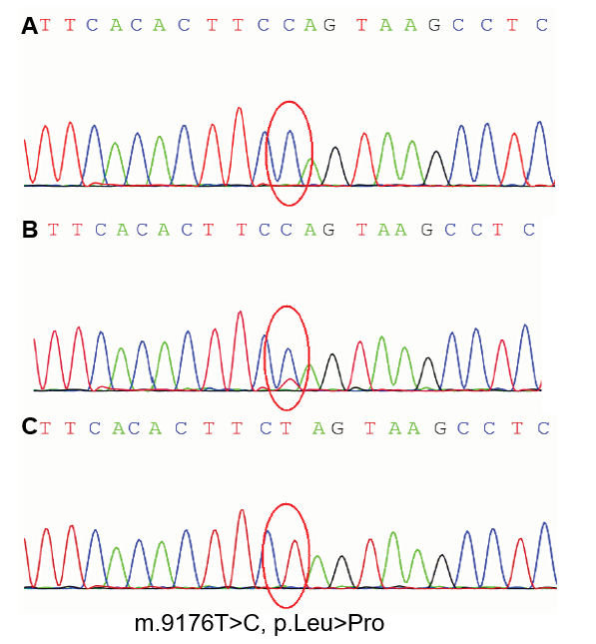
Figure 1 Sequence electropherograms showing the m.9176T>C substitution disclosed in the patient’s and his parents’ blood samples. Restriction fragment length polymorphism (RFLP) analysis of the m.9176T>C mutation. A: The mutational load assessment by polymerase chain reaction-RFLP analysis confirmed that the patient harbored the mutation in blood leukocytes. Moreover, the variant was nearly homoplasmic (> 99%) in the tissues examined; B: The mutation was also found in maternal blood at a low level of heteroplasmy; C: The mutation was not found in DNA samples derived from the patient’s father.
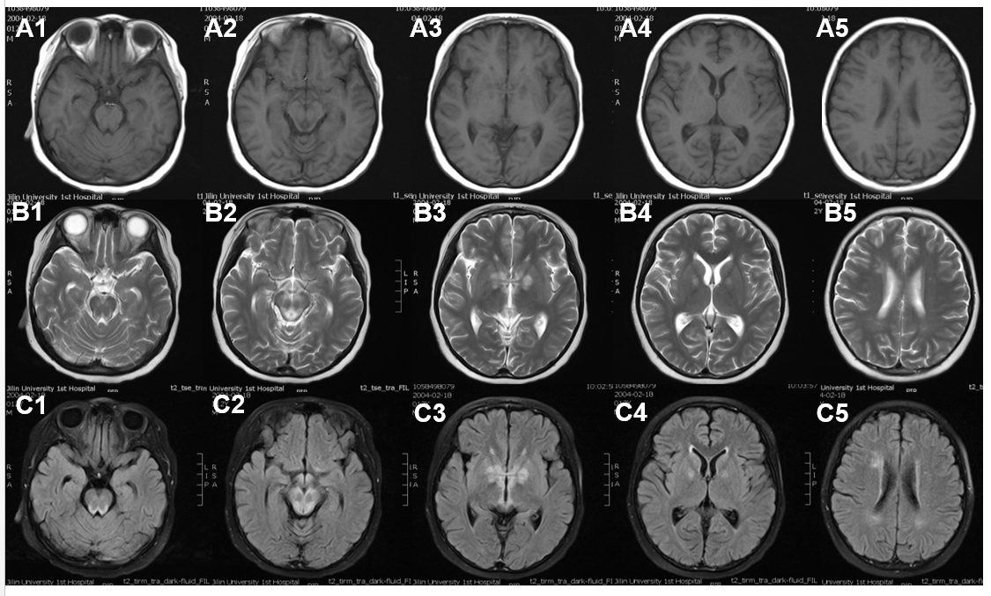
Figure 2 Neuroradiological features. Sequential magnetic resonance imaging (MRI) scans showed bilateral symmetric signal abnormalities in the basal ganglia, medial thalami, periaqueductal region of the midbrain and pons, and bilateral white matter around the lateral ventricles (A1-5: T1-weighted images, B1-5: T2-weighted images). C1-5: Diffusion-weighted images of the brain MRI showing bilateral signal abnormalities in the basal ganglia, brain stem, and white matter.

