Name of journal: World Journal of Gastroenterology
ESPS Manuscript NO: 15981
Columns: ORIGINAL ARTICLE

Basic Study
Extrahepatic portacaval shunt via magnetic compression technique: A cadaveric feasibility study

Yan XP et al. Portacaval shunt using magnetic compression

Xiao-Peng Yan, Wen-Yan Liu, Jia Ma, Jian-Peng Li, Yi Lv

Xiao-Peng Yan, Wen-Yan Liu, Jian-Peng Li, Yi Lv, Department of Hepatobiliary Surgery, First Affiliated Hospital, Xi’an Jiaotong University, Xi’an 710061, Shaanxi Province, China

Xiao-Peng Yan, Wen-Yan Liu, Jia Ma, Jian-Peng Li, Yi Lv, XJTU Research Institute of Advanced Surgical Technology and Engineering, Xi’an Jiaotong University, Xi’an 710061, Shaanxi Province, China

Jia Ma, Department of Surgical Oncology, Third Affiliated Hospital, Xi’an Jiaotong University (Shaanxi Provincial People’s Hospital), Xi’an 710061, Shaanxi Province, China

Author contributions: Yan XP and Liu WY contributed equally to this work; Yan XP and Lv Y designed the study; Yan XP, Lv Y and Ma J performed the research and acquired the data; Yan XP and Li JP analyzed the data; Yan XP, Liu WY and Li JP drafted the manuscript; Yan XP, Liu WY, Ma J and Li JP contributed significantly to the revision of the manuscript.

Supported by Key Project of Clinical Discipline of Ministry of Health Subordinates of China, No. 2010105.

Ethics approval: The entire study was carried out in strict accordance with protocols approved by the Xi’an Jiaotong University Biomedical Ethics Committee (Ethics Permit Number: 2014-0303).

Institutional animal care and use committee: This study doesn’t involve any animal experiments.

Conflict-of-interest: The authors declare no conflict of interests.

Data sharing: Technical appendix, statistical code, and dataset available from the corresponding author at luyi169@126.com. Participants gave informed consent for data sharing.

Open-Access: This article is an open-access article which was selected by an in-house editor and fully peer-reviewed by external reviewers. It is distributed in accordance with the Creative Commons Attribution Non Commercial (CC BY-NC 4.0) license, which permits others to distribute, remix, adapt, build upon this work non-commercially, and license their derivative works on different terms, provided the original work is properly cited and the use is non-commercial. See: http://creativecommons.org/licenses/by-nc/4.0/

Correspondence to: Yi Lv, MD, PhD, Department of Hepatobiliary Surgery, First Affiliated Hospital, Xi’an Jiaotong University, 28 Xianning West Road, Xi’an 710061, Shaanxi Province, China. luyi169@126.com
Telephone: +86-29-82657541
Fax: +86-29-82657541
Received: December 19, 2014
Peer-review started: December 21, 2014
First decision: January 22, 2015
Revised: February 11, 2015
Accepted: March 18, 2015

Article in press:
Published online:
Abstract
AIM: To explore the anatomic feasibility of portacaval shunt using the magnetic compression technique (MCT) in cadavers.

METHODS: Computed tomography (CT) images of 30 portal hypertensive patients were obtained. The diameters of the portal vein (PV), the inferior vena cava (IVC), and distance between the two structures were measured. Similar measurements were performed on 20 adult corpses. The feasibility of portacaval shunt based on those measurements was analyzed. First stage extrahepatic portacaval shunt using MCT was performed on 5 cadavers. Specifically, the PV and IVC were exposed through an abdominal incision of the cadavers. The parent magnet was introduced from the femoral vein and was delivered into the IVC by an anchor wire and a 5F Cook catheter. The daughter magnet was introduced into the portal vein through the splenic vein using an interventional guide wire. When the daughter magnet met the parent magnet, they automatically clipped together and the first stage of the portacaval shunt was set up.

RESULTS: The average diameters of the PV and the IVC measured from the 30 CT image were 14.39 ± 2.36 mm and 18.59 ± 4.97 mm, and the maximum and minimum distances between the PV and the IVC were 9.79 ± 4.56 mm and 9.50 ± 4.79 mm. From 20 cadavers, the average diameters of the PV and the IVC were 14.48 ± 1.47 mm and 24.71 ± 2.64 mm, and the maximum and minimum distances between the PV and the IVC were 10.14 ± 1.70 mm and 8.93 ± 1.17 mm. The distances between the PV and the IVC from both the CT images and the cadavers were within the effective length of portacaval anastomosis using MCT (30.30 ± 4.19 mm). The PV and IVC are in close proximity to each other with no intervening tissues or structures in between. The first stage simulated surgeries using MCT on 5 cadavers was successfully performed.

CONCLUSION: Anatomically, extrahepatic portacaval shunt employing MCT is highly feasible in human.

Key words: Portal vein, Inferior vena cava, Portacaval shunt; Magnetic compression technique; Anatomy; Cadaver

© The Author(s) 2015. Published by Baishideng Publishing Group Inc. All rights reserved.

Core tip: Portacaval shunt using magnetic compression technique (MCT) was first established by our group in a canine model. Here, we assessed its feasibility in human by analyzing computed tomography images and the anatomic parameters of cadavers. The average diameters of the portal vein (PV), the inferior vena cava (IVC) and the distances between the PV and the IVC were all within the parameters that allowed the setup of portacaval shunt using MCT. Finally, first stage simulation of portacaval shunt was successfully set up in five cadavers. Our result supported that portacaval shunt is highly feasible in human.

Yan XP, Liu WY, Ma J, Li JP, Lv Y. Extrahepatic portacaval shunt via magnetic compression technique: A cadaveric feasibility study. World J Gastroenterol 2015; In press

INTRODUCTION
Surgical shunting is an important treatment option for portal hypertension^{[1]}. The traditional hand-sewn surgical shunt currently used is time-consuming, highly technical, and subject to postoperative complications. Side-to-side portacaval shunt has a high incidence of hepatic encephalopathy^{[2,3]}. H-graft portacaval shunt, as a limited portacaval shunt, can effectively reduce the incidence of hepatic encephalopathy^{[4]}. However, it is also technically challenging and patients underwent the procedure must be put on long-term use of anticoagulants.
Magnetic compression technique (MCT) utilizes the attraction between magnets to pull together an area of ischemic necrosis and its surrounding tissue to promote healing. The major advantages of the MCT are that it is simple, minimally invasive, and reliable. Currently, MCT is applied in esophageal atresia^{[5,6]}, biliary stenosis^{[7-12]}, vascular anastomosis^{[13-19]}, and gastro-intestinal anastomosis^{[20-27]}. Previously, we applied Roux-en-Y choledochojejunostomy incorporated MCT for obstructive jaundice in a canine model^{[28]}. We also confirmed that magnetic rings could be used for rapid vascular reconstruction in a canine liver transplantation model^{[19]}.
We first reported the establishment of a portacaval shunt using MCT in dogs, the significant advantage of which is that no stent or any other foreign device was installed^{[29]}. In the present study, we assessed some anatomical parameters that might affect the establishment of extrahepatic portacaval shunt using MCT in human, and performed 5 preliminary cadaveric surgeries.

MATERIALS AND METHODS
Ethical statement
The entire study was carried out in strict accordance with protocols approved by the Xi’an Jiaotong University Biomedical Ethics Committee (Ethics Permit Number: 2014-0303). The cadavers were obtained from the Department of Anatomy, Health Science Center, Xi’an Jiaotong University, Shaan Xi Province, China. Written consent was obtained from the immediate family members of the deceased for educational and scientific research purposes. The format of the consent form is in accordance with the guidelines of the China Organ Donation Administrative Center.
The Xi’an Jiaotong University Biomedical Ethics Committee approved use of the computed tomography (CT) data collected from patients. The project was explained to the patients. The privacy of the patients in this study was strictly protected and only age and CT data essential for this study were collected.

Human cadaver and gross anatomy
Twenty adult cadavers (14 male, 6 female) embalmed with formaldehyde were obtained. Exclusion were cadavers of people with a history of abdominal surgery; abdominal tumor that might change the anatomical location of portal vein (PV) or inferior vena cava (IVC); diseases of PV or IVC system; prolonged storage after death, or improper handling that might interfere with the measurements.
We first opened the abdomen of the cadaver and assessed the abdominal organs, and verified the absence of structural abnormalities or obvious lesions. We then incised the hepatoduodenal ligament, blunt dissected and observed the PV, IVC, common bile duct, and hepatic proper artery. The lower boundary of the effective area of portacaval anastomosis was defined as the plane of the splenic-mesenteric confluence (S, Figure 1). The upper boundary was defined as the plane of PV bifurcation (P, Figure 1A) or the inferior margin of the liver caudate lobe (C, Figure 1B). The effective length of portacaval anastomosis was defined as the distance between S and P (L1, Figure 1A) or S and C (L2, Figure 1B). 20 cadavers were measured.

CT images of patients with portal hypertension
From 2012 to 2013, 30 adult patients with portal hypertension underwent abdominal CT scans. All CT studies were performed with a 16-slice CT scanner (Somatom Sensation 16; Siemens, Germany). Excluded were patients with a history of abdominal surgery, portal venous system thrombosis, or other factors that might lead to distinct anatomical changes of the PV or IVC. The diameters of the PV and IVC at the position of the splenic-mesenteric confluence (S, Figure 1) and PV bifurcation (P, Figure 1A) or inferior margin of the liver caudate lobe (C, Figure 1B) were each measured as illustrated in Figure 1.

Magnetic device
Two neodymium (Nd-Fe-B) permanent magnets (parent and daughter) were custom-manufactured for vascular experimental use (Northwest Institute for Nonferrous Metal Research, Xi’an, China; Figure 2). The parent magnet is a semi-cylinder with round ends, 15 mm L × 4 mm W × 3 mm H (Figure 2A-C). The parent magnet was attached to a special anchor wire, which was modified from a 2-0 prolene wire (Ethicon; Johnson and Johnson, Somerville, NJ, United States) by cutting off the suture needles from its ends. The daughter magnet, without wire, has the same dimensions as the parent magnet but with a long-axis paralleled foramen (diameter, 1.2 mm) inserted through the center.
The parent magnet was introduced from the femoral vein and delivered into the IVC by an anchor wire and a 5F Cook catheter (Cook, Bloomington, IN, United States). An interventional guide wire was inserted through the foramen of the daughter magnet. The daughter magnet was introduced into the PV through the splenic vein using an interventional guide wire (0.035 in; TERUMO, Japan) and a 5F Cook catheter (Cook, Bloomington, IN, United States; Figure 2D).
The force of the parent and daughter magnet is 6.8 N with 0-mm intermagnet separation and magnetic density 2400 G. The weights of the parent and daughter magnet are 0.80 g and 0.75 g, respectively.

Shunt procedure
Shunt surgery was performed with reference to our previous procedure^{[31]}. The PV and IVC were exposed through an abdominal incision, and the splenic vein and 15 mm of the right femoral vein were exposed. The prolene wire affixed to the parent magnet was inserted into a 5F cook catheter, and the end of the prolene wire was tightly drawn to ensure that the parent magnet was fixed to the other end of the Cook catheter. An incision was made at the right femoral vein. Then through the incision, the parent magnet was advanced to the target position on the IVC by the 5F Cook catheter.
A venotomy was performed on the splenic vein. An interventional guide wire was inserted through the hole of the daughter magnet. One end of the interventional guide wire was introduced to the PV through the incision on the splenic vein, and the other end was inserted into a 5F Cook catheter and extended the catheter. While the interventional guide wire was maintained in the PV, the daughter magnet, guided by the catheter, was moved to the target position of the PV through the incision of the splenic vein.
After the daughter magnet met the parent magnet, they automatically clipped together. The interventional guide wire and catheter were then withdrawn from the splenic vein and femoral vein. The first stage (step 1-4) of the surgery was thus finished.
After a period of time (5-7 d in dogs), a RUPS-100 set with vascular sheath was navigated to the position of the magnet in the IVC through the femoral vein. Under X-ray guidance, the needle of the RUPS-100 set was advanced slowly and smoothly along the outline of the magnets and the magnets was detached from the vascular wall. The magnets were pulled out of the body by the wire fixed to the parent magnet. The portal-IVC shunt was set up (Figure 3).
In this study, only the first stage shunt procedures were performed on 5 cadavers.

Statistical analysis
The statistical methods of this study were reviewed by Qian Li from First Affiliated Hospital, Xi’an Jiaotong University. Data are expressed as mean ± SD. Gross anatomy and CT scan data were analyzed with an independent samples t-test. A P-value < 0.05 was considered statistically significant. Data were analyzed with SPSS 17.0 software.

RESULTS
In this cadaveric study, the IVC was at the right-posterior position of the PV, with hepatoduodenal ligament, small amount of connective tissue, and retroperitoneum lay between them. The hepatic proper artery was located at the left-inferior side of the PV and the common bile duct was right anterior to the PV (Figure 4). There was no important structure in the effective area of the portacaval anastomosis.
From 30 CT imaging measurements, the average diameters of the PV and the IVC in portal hypertensive patients were 14.39 ± 2.36 mm and 18.59 ± 4.97 mm, respectively (Table 1). The maximum and minimum distances between the PV and the IVC were 9.79 ± 4.56 mm and 9.50 ± 4.79 mm (Table 1).
From 20 cadavers, the average diameters of the PV and IVC were 14.48 ± 1.47 mm and 24.71 ± 2.64 mm (Table 1). The maximum and minimum distances between the PV and the IVC were 10.14 ± 1.70 mm and 8.93 ± 1.17 mm (Table 1). The distances between the PV and the IVC from both the CT image analysis and that of the cadavers are within the effective length of portacaval anastomosis using MCT (30.30 ± 4.19 mm).
The average diameters of the IVC determined from CT image measurements and those from the cadavers were significantly different (P = 0.000). The cross sections of the IVCs were highly variable on CT images, in that some were oval rather than round shaped. In such cases, we measured the length and width of the oval-shaped cross section and took the average as the value of its diameter. However, this measurement might not be accurate and might account for the deviation between CT and cadaveric measurements. Nevertheless, despite the discrepancy, the value of the IVC diameter measured from CT images is still within the parameters that allow the performance of the operation. There were no significant differences between the CT images and cadavers with regard to the diameters of the PV or distances between the PV and the IVC (P > 0.005). This suggests that measurements taken from CT images are mostly reliable and close to anatomical measurements.
The operation utilizing MCT was performed on 5 adult cadavers successfully without any unexpected events. When the parent and daughter magnets each reached their target positions, they automatically joined and there was no damage to the proper hepatic artery, common bile duct, or other important structures due to the compression. More importantly, the magnetism was maintained at the satisfactory force and overcame the tension of the blood vessels (Figure 5).

DISCUSSION
Although we previously verified the reliability, feasibility, safety and efficiency of MCT in dogs^{[29]}, three essential issues remain to be resolved before it can be applied in humans: First, whether there are intervening structures between the PV and the IVC that will be compressed when the parent and daughter magnets join. Secondly, whether the magnetic force between the parent and daughter magnets is strong enough to pull the two structures together. Thirdly, whether human anatomical characteristics allow this operation. The present study addressed all three of these key issues.
Zirinsky et al^{[30]} first proposed the concept of a portacaval space, defining it as the gap between the PV and the IVC. Many researches have shown that the caudate lobe of the liver is generally in the upper part of the portacaval space, and the portacaval node, the portacaval vessels, and the cystic duct are in the lower part of the portacaval space^{[31,32]}. Our anatomical analysis of 20 adult cadavers indicates that these structures cannot interfere with the portacaval anastomosis and will not be affected by the procedure. The hepatic PV lies left-inferior to the IVC, so when the parent and daughter magnets join, the right-posterior wall of the hepatic PV and the left-anterior wall of the IVC are compressed. Our autopsies show that the proper hepatic artery and the bile duct are located left-inferior and right-inferior of the hepatic PV, respectively. However, simulation procedure on the corpses confirmed that the magnets hardly compress these two structures.
One prerequisite for the procedure is that the distance between the PV and the IVC is within the working range of the magnets. According to our previous studies, the maximum distance that will allow attraction between the magnets is 3.5 cm. However, the ideal interval in experimental dogs was < 1.6 cm, due to the tension of the hepatic PV and the IVC vessel. The mean minimum distance between the hepatic PV and the IVC, based on measurements in the 20 adult corpses, was 0.96 cm ± 0.17 cm. Therefore, we assume that the parent and daughter magnets are also able overcome the resistance of the blood vessels in human body. We conclude that the magnetic attraction is sufficient to pull the PV and the IVC together.
In our previous study in dogs^{[29]}, the designed magnet was 12 mm in length and 2.5 mm in width. In humans, the diameter of the transjugular intrahepatic portosystemic shunt (TIPS) stent and prosthetic H-graft portacaval shunt is from 8 to 10 mm^{[1,4]}. In our current study the dimension of the magnet used was 15 mm × 4 mm × 3 mm. Our anatomical analysis revealed that the dimension of the hepatic PV and the IVC is sufficient to accommodate this size. Therefore, we suggest that the optimum length of a magnet used for a human portacaval shunt should be around 10 to 15 mm.
To better visualize the progress of the surgery, we opened the cadavers’ abdomen in this study. We reset the daughter magnet to the hepatic PV via the splenic vein. However, it is highly feasible clinically to implement minimally invasive surgery in humans by introducing the daughter magnet to the hepatic PV via the transjugular and transhepatic path.
Taken together, the results we present above addressed the three essential issues regarding the feasibility of portacaval shunt with MCT in humans.
Based on our preliminary studies, the automatic assembly of the magnets was the critical problem. We emphasized the importance of previous abdominal surgeries free, for the postoperative adhesion might lead to extra resistance and impede the magnets attachment. In the procedure, once the magnets had successfully clipped together, the detachment was unavailable under interventional guidance, so it was crucial to hold still one magnet (the daughter one or the parent one) at the suitable compressed spot till the other one came for assembling. Also, during the withdrawal of the magnets, it required a RUPS-100 needle assistance to detach the device and the risk of puncturing inferior vena cava should be avoided.
A limitation of this study is that we only performed the first stage of the entire procedure. This is because the second stage requires the formation of copious fibrous connective tissue around the anastomosis, which is impossible to simulate on cadavers. In addition, the timing of the second surgery is crucial to the success of MCT—if there is not enough time for remolding, hemorrhage will be inevitable during the second surgery. On the other hand, if the second surgery is performed after a prolonged interval from the first, the magnets will become embedded in the adhesive tissues and will be difficult to remove. Based on our experience, 7 days after the first surgery is the optimum working window for the second surgery in dogs. The optimum timeframe for portacaval remolding in humans requires further study.
In conclusion, Through preliminary trials on cadavers we have confirmed the anatomic feasibility of implementing extrahepatic portacaval shunt using magnetic compression technique in humans. However, this pioneering technique requires further clinical validation.

COMMENTS
Background
Magnetic compression techniques has been applied in alimentary anastomosis like gastroenterostomy and bilioenterostomy, as well as the end-to-end or side-to side vascular anastomosis. We originally established the side-to-side portacaval shunt using magnetic compression technique and interventional techniques in canine. We analyzed the anatomical data and conducted the simulated operation on cadavers aiming to preliminarily demonstrate the feasibility of this procedure in human.

Research frontiers
The magnetic compression technique, which is easy, reliable, efficient and fast tracking, has been intensively researched and applied in hollow organ anastomosis, while no application in portacaval shunt establishment has been reported.

Innovations and breakthroughs
Our study innovatively established side-to-side portacaval shunt combining magnetic compression technique and interventional techniques, and laid a foundation for the further clinical application by analyzing the anatomical relations and conducting the simulated procedure on corpses.

Applications
Utilizing the side-to-side portacaval shunt under magnetic compression technique and interventional techniques makes an alternative for the portal hypertension theapy with the advantages like minimal invasive, stoma stable, and long-term implants free.

Terminology
Magnetic compression technique is a novel procedure utilizing the magnetic force to fulfill sutureless anastomosis in hollow organs. Combined with endoscopic or interventional techniques, some conventional laparotomy may turn to be solved in simplified minimal invasive procedure.

Peer-review
The research group pioneered the animal experiment of portacaval shunt using magnetic compression techniques. Based on the previous study, they further tested the feasibility of human application. The study was well designed and conducted with a great innovativenesss.

REFERENCES
1 Rosemurgy AS, Bloomston M, Clark WC, Thometz DP, Zervos EE. H-graft portacaval shunts versus TIPS: ten-year follow-up of a randomized trial with comparison to predicted survivals. Ann Surg 2005; 241: 238-246 [PMID: 15650633 DOI: 00000658-200502000-00008]
2 Sakurabayashi S, Sezai S, Yamamoto Y, Hirano M, Oka H. Embolization of portal-systemic shunts in cirrhotic patients with chronic recurrent hepatic encephalopathy. Cardiovasc Intervent Radiol 1997; 20: 120-124 [PMID: 9030502]
3 Tashiro H, Ide K, Amano H, Kobayashi T, Onoe T, Ishiyama K, Kuroda S, Tazawa H, Kono H, Aikata H, Takahashi S, Chayama K, Ohdan H. Surgical treatment for portosystemic encephalopathy in patients with liver cirrhosis: Occlusion of portosystemic shunt in combination with splenectomy. Hepatol Res 2013; 43: 249-254 [PMID: 22734925 DOI: 10.1111/j.1872-034X.2012.01059.x.[PMID: 22734925]
4 Rosemurgy AS, Zervos EE, Bloomston M, Durkin AJ, Clark WC, Goff S. Post-shunt resource consumption favors small-diameter prosthetic H-graft portacaval shunt over TIPS for patients with poor hepatic reserve. Ann Surg 2003; 237: 820-85; discussion 820-85; [PMID: 12796578 DOI: 12796578]']
5 Takamizawa S, Yamanouchi E, Muraji T, Nishijima E, Satoh S, Tsugawa J. MCRA of an anastomotic stenosis after esophagoesophagostomy for long gap esophageal atresia: a case report. J Pediatr Surg 2007; 42: 769-772 [PMID: 17502180 DOI: S0022-3468(06)00961-4]
6 Zaritzky M, Ben R, Zylberg GI, Yampolsky B. Magnetic compression anastomosis as a nonsurgical treatment for esophageal atresia. Pediatr Radiol 2009; 39: 945-949 [PMID: 19506849 DOI: 10.1007/s00247-009-1305-7.[PMID: 19506849]
7 Muraoka N, Uematsu H, Yamanouchi E, Kinoshita K, Takeda T, Ihara N, Matsunami H, Itoh H. Yamanouchi magnetic compression anastomosis for bilioenteric anastomotic stricture after living-donor liver transplantation. J Vasc Interv Radiol 2005; 16: 1263-1267 [PMID: 16151070 DOI: 16/9/1263]
8 Itoi T, Yamanouchi E, Ikeda T, Sofuni A, Kurihara T, Tsuchiya T, Tsuchida A, Kasuya K, Moriyasu F. Magnetic compression anastomosis: a novel technique for canalization of severe hilar bile duct strictures. Endoscopy 2005; 37: 1248-1251 [PMID: 16329026 DOI: 10.1055/s-2005-870269.[PMID: 16329026]
9 Okajima H, Kotera A, Takeichi T, Ueno M, Ishiko T, Hirota M, Asonuma K, Yamauchi E, Inomata Y. Magnet compression anastomosis for bile duct stenosis after duct-to-duct biliary reconstruction in living donor liver transplantation. Liver Transpl 2005; 11: 473-475 [PMID: 15776404 DOI: 10.1002/lt.20364.[PMID: 15776404]
10 Matsuno N, Uchiyama M, Nakamura Y, Iwamoto H, Hama K, Ashizawa T, Nagao T, Yamanouchi E. A nonsuture anastomosis using magnetic compression for biliary stricture after living donor liver transplantation. Hepatogastroenterology 2009; 56: 47-49 [PMID: 19453026]
11 Avaliani M, Chigogidze N, Nechipai A, Dolgushin B. Magnetic compression biliary-enteric anastomosis for palliation of obstructive jaundice: initial clinical results. J Vasc Interv Radiol 2009; 20: 614-623 [PMID: 19393505 DOI: 10.1016/j.jvir.2009.01.019S1051-0443(09)00058-X]
12 Jang SI, Kim JH, Won JY, Lee KH, Kim HW, You JW, Itoi T, Lee D. Magnetic compression anastomosis is useful in biliary anastomotic strictures after living donor liver transplantation. Gastrointest Endosc 2011; 74: 1040-1048 [PMID: 21855872 DOI: 10.1016/j.gie.2011.06.026S0016-5107(11)01865-7]
13 Klima U, Falk V, Maringka M, Bargenda S, Badack S, Moritz A, Mohr F, Haverich A, Wimmer-Greinecker G. Magnetic vascular coupling for distal anastomosis in coronary artery bypass grafting: a multicenter trial. J Thorac Cardiovasc Surg 2003; 126: 1568-1574 [PMID: 14666034 DOI: 10.1016/S0022S002252230301314X]
14 Klima U, Maringka M, Bagaev E, Kirschner S, Haverich A. Total magnetic vascular coupling for arterial revascularization. J Thorac Cardiovasc Surg 2004; 127: 602-603 [PMID: 14762386 DOI: 10.1016/j.jtcvs.2003.09.050S0022522303018737]
15 Casselman FP, Meco M, Dom H, Foubert L, Van Praet F, Vanermen H. Multivessel distal sutureless off-pump coronary artery bypass grafting procedure using magnetic connectors. Ann Thorac Surg 2004; 78: e38-e40 [PMID: 15276590 DOI: 10.1016/j.athoracsur.2003.07.050S0003497504010197]
16 Athanasiou T, Ashrafian H, Glenville B, Casula R. Coronary artery bypass with the use of a magnetic distal anastomotic device: surgical technique and preliminary experience. Heart Surg Forum 2004; 7: 356-359 [PMID: 15769704 DOI: JWN82TQ5NAK6AW7G]
17 Klima U, MacVaugh H, Bagaev E, Maringka M, Kirschner S, Beilner J, Haverich A. Magnetic Vascular Port in minimally invasive direct coronary artery bypass grafting. Circulation 2004; 110: II55-II60 [PMID: 15364839 DOI: 10.1161/01.CIR.0000138391.77285.d9110/11_suppl_1/II-55]
18 Vicol C, Eifert S, Oberhoffer M, Boekstegers P, Knez A, Christ F, Reichart B. Early clinical results with a magnetic connector for distal coronary artery anastomoses. Ann Thorac Surg 2005; 79: 1738-142; discussion 1738-142; [PMID: 15854967 DOI: S0003-4975(04)01223-8]
19 Shi Y, Lv Y, Wang B, Zhang Y, Jiang A, Li JH, Zhang XF, Li QY, Meng KW, Liu C, Yu L, Pan CE. Novel magnetic rings for rapid vascular reconstruction in canine liver transplantation model. Transplant Proc 2006; 38: 3070-3074 [PMID: 17112902 DOI: S0041-1345(06)01114-6]
20 Cope C. Evaluation of compression cholecystogastric and cholecystojejunal anastomoses in swine after peroral and surgical introduction of magnets. J Vasc Interv Radiol ; 6: 546-552 [PMID: 7579862]
21 Cope C, Clark TW, Ginsberg G, Habecker P. Stent placement of gastroenteric anastomoses formed by magnetic compression. J Vasc Interv Radiol 1999; 10: 1379-1386 [PMID: 10584655]
22 Cope C, Ginsberg GG. Long-term patency of experimental magnetic compression gastroenteric anastomoses achieved with covered stents. Gastrointest Endosc 2001; 53: 780-784 [PMID: 11375591 DOI: S0016-5107(01)75550-2]
23 Chopita N, Vaillaverde A, Cope C, Bernedo A, Martinez H, Landoni N, Jmelnitzky A, Burgos H. Endoscopic gastroenteric anastomosis using magnets. Endoscopy 2005; 37: 313-317 [PMID: 15824939 DOI: 10.1055/s-2005-861358]
24 van Hooft JE, Vleggaar FP, Le Moine O, Bizzotto A, Voermans RP, Costamagna G, Devière J, Siersema PD, Fockens P. Endoscopic magnetic gastroenteric anastomosis for palliation of malignant gastric outlet obstruction: a prospective multicenter study. Gastrointest Endosc 2010; 72: 530-535 [PMID: 20656288 DOI: 10.1016/j.gie.2010.05.025S0016-5107(10)01685-8]
25 Myers C, Yellen B, Evans J, DeMaria E, Pryor A. Using external magnet guidance and endoscopically placed magnets to create suture-free gastro-enteral anastomoses. Surg Endosc 2010; 24: 1104-1109 [PMID: 20033734 DOI: 10.1007/s00464-009-0735-5]
26 Pichakron KO, Jelin EB, Hirose S, Curran PF, Jamshidi R, Stephenson JT, Fechter R, Strange M, Harrison MR. Magnamosis II: Magnetic compression anastomosis for minimally invasive gastrojejunostomy and jejunojejunostomy. J Am Coll Surg 2011; 212: 42-49 [PMID: 21184956 DOI: 10.1016/j.jamcollsurg.2010.09.031S1072-7515(10)01154-3]
27 Ryou M, Cantillon-Murphy P, Azagury D, Shaikh SN, Ha G, Greenwalt I, Ryan MB, Lang JH, Thompson CC. Smart Self-Assembling MagnetS for ENdoscopy (SAMSEN) for transoral endoscopic creation of immediate gastrojejunostomy (with video). Gastrointest Endosc 2011; 73: 353-359 [PMID: 21183179 DOI: 10.1016/j.gie.2010.10.024S0016-5107(10)02210-8]
28 Fan C, Yan XP, Liu SQ, Wang CB, Li JH, Yu L, Wu Z, Lv Y. Roux-en-Y choledochojejunostomy using novel magnetic compressive anastomats in canine model of obstructive jaundice. Hepatobiliary Pancreat Dis Int 2012; 11: 81-88 [PMID: 22251474 DOI: 1570]
29 Yan X, Fan C, Ma J, Li J, Dong D, Wang H, Ma F, Zheng X, Lv Y. Portacaval shunt established in six dogs using magnetic compression technique. PLoS One 2013; 8: e76873 [PMID: 24098809 DOI: 10.1371/journal.pone.0076873PONE-D-13-21426]
30 Zirinsky K, Auh YH, Rubenstein WA, Kneeland JB, Whalen JP, Kazam E. The portacaval space: CT with MR correlation. Radiology 1985; 156: 453-460 [PMID: 4011910 DOI: 10.1148/radiology.156.2.4011910]
31 Ito K, Choji T, Fujita T, Kuramitsu T, Nakaki H, Kurokawa F, Fujita N, Nakanishi T. Imaging of the portacaval space. AJR Am J Roentgenol 1993; 161: 329-334 [PMID: 8333371 DOI: 10.2214/ajr.161.2.8333371]
32 McLoughlin RF, Rankin RN. Portacaval space anatomy: potential implications for percutaneous portacaval shunts. J Vasc Interv Radiol 1996; 7: 761-767 [PMID: 8897348]

P-Reviewer: Ozen H S-Editor: Qi Y L-Editor: E-Editor:
Figure 1 Effective length of the portacaval anastomosis using magnetic compression technique. A: When the origin of the PV branch is below the lower edge of the caudate lobe, the effective length, L1, is the distance between the intersection of the splenic vein and the PV, here S, and the origin of the PV branching, P. B: When the origin of the PV branch is higher than the lower edge of the caudate lobe, the effective length, L2, is the distance between S and the lower edge of caudate lobe, C. The red arrow indicates the diameter of the IVC; the green arrow indicates the diameter of the PV; the black arrow indicates the distance between the PV and IVC.
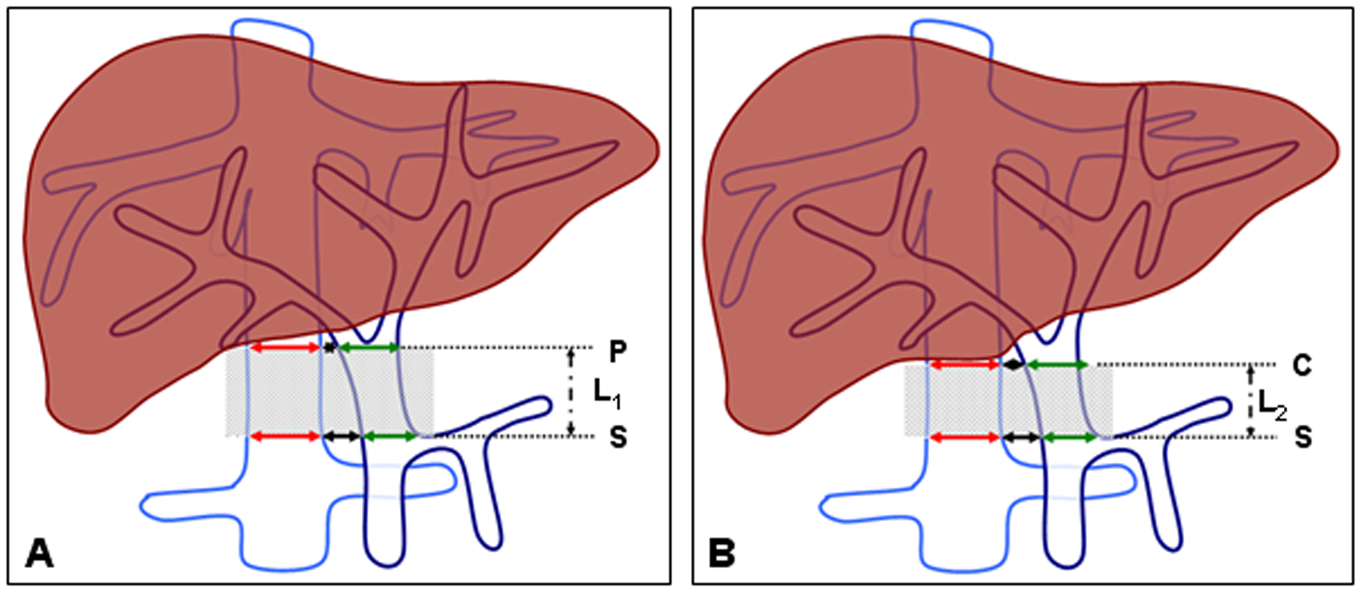
Figure 2 Magnetic compression system devices. A: Schematic of the parent and daughter magnets; B, C: The magnetic compression system devices; D: Guide wire and catheter used to complete the operation.
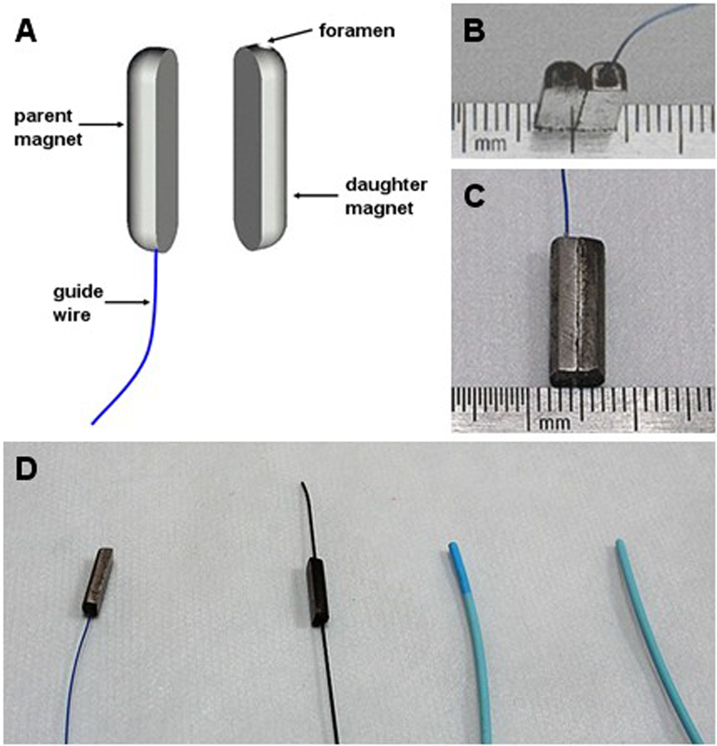
Figure 3 Surgical protocol and procedures. A: The parent magnet was guided to the target position of the IVC by the wire fixed to one end and the catheter; B: The daughter magnet was advanced to the anastomosis position of the PV by the guide wire and catheter through the incision on the splenic vein; C: Position of the magnets and the wire after the first surgery; D: The magnets were pulled out of the body by the wire fixed to the parent magnet and the portal-IVC shunt was set up.
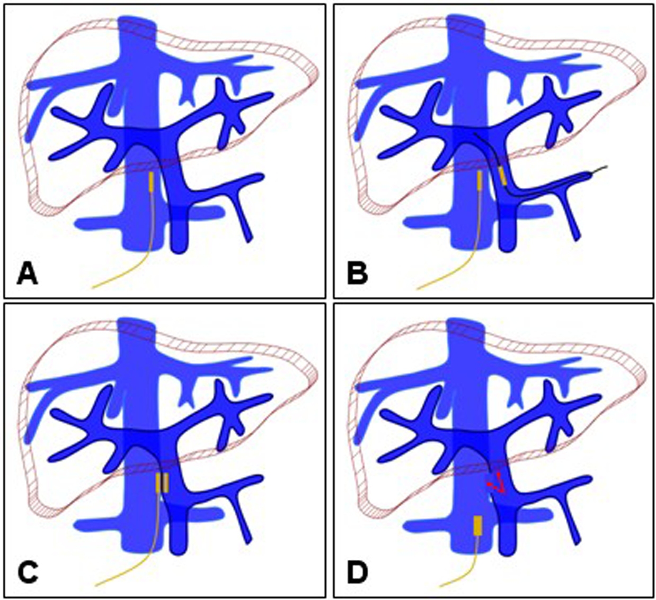
Figure 4 Anatomy of portacaval anastomosis in cadaver. The right posterior wall of the PV faces the left anterior wall of the inferior postcava. The common bile duct is at the right anterior of the PV. There is no important tissue in the postcaval space.
V
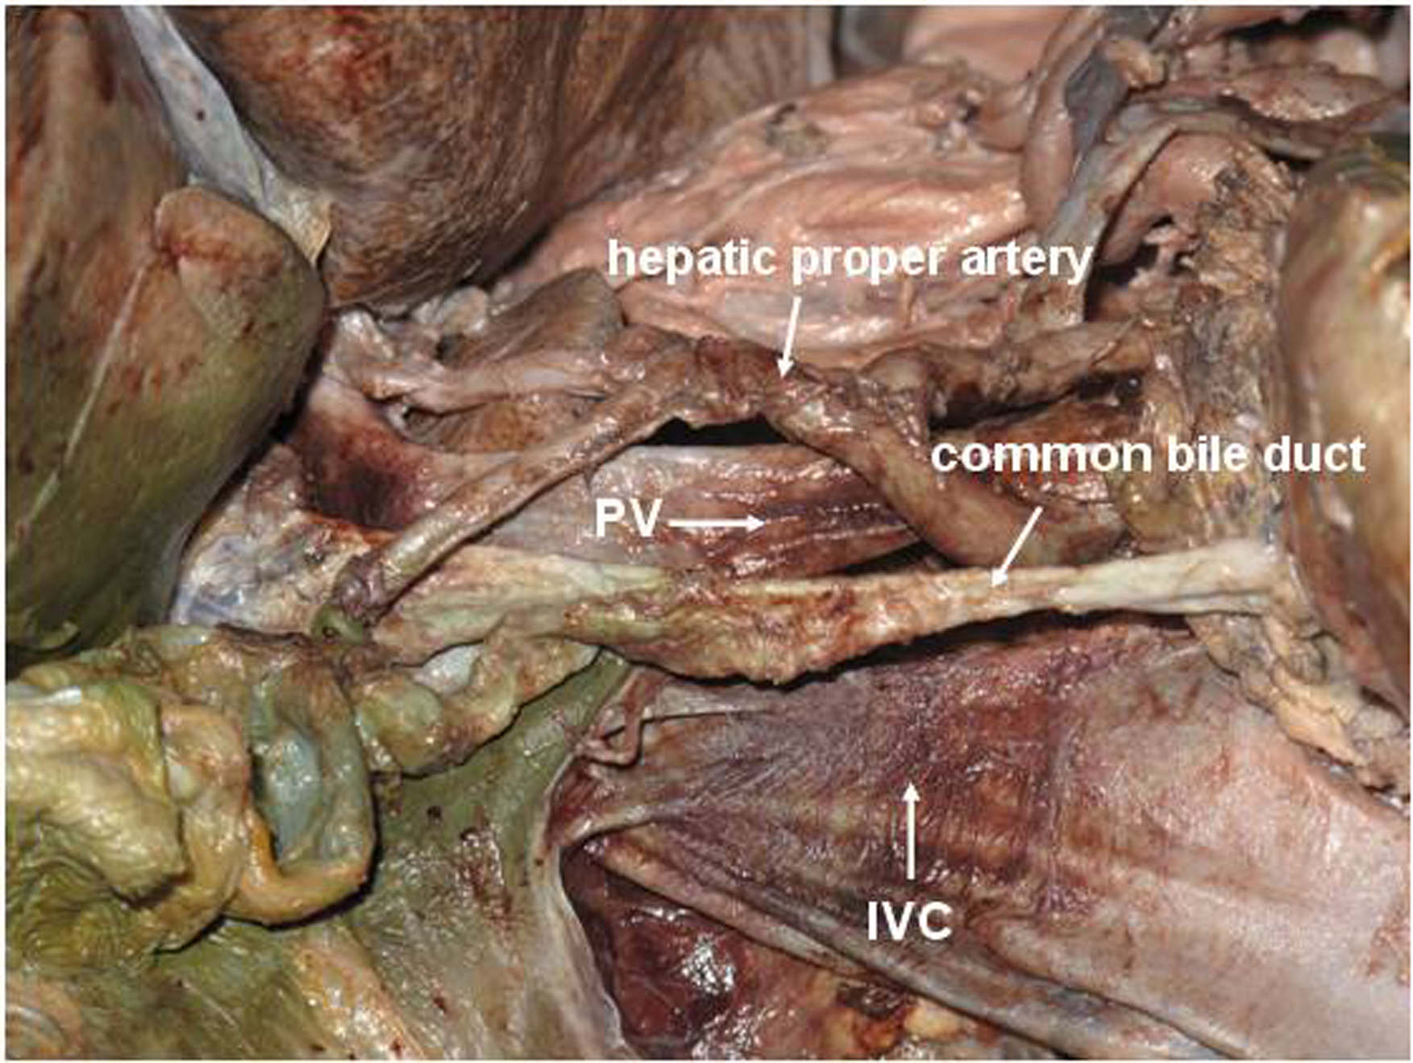
Figure 5 Compression of the walls of the portal vein and postcava implemented through the attraction of the parent and daughter magnets in a cadaver. The elliptical area circled in red indicates the effective zone of the compression. No other vessel or bile duct was compressed.
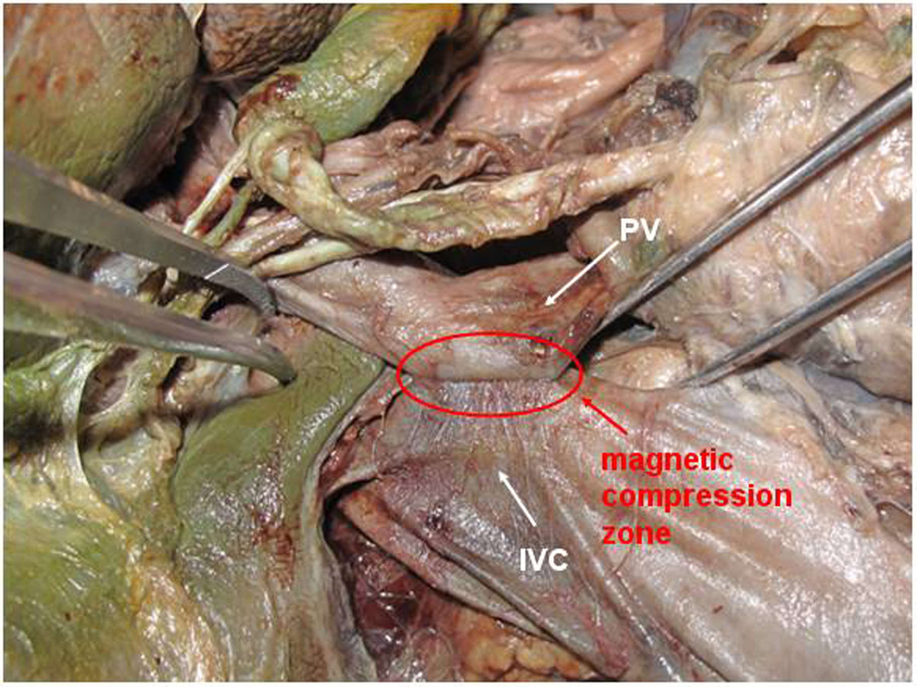

Table 1 Parameters of the portal vein and the inferior vena cava from cadavers and computed tomography scan of portal hypertension patients
 | CT Scan¹ | Cadaver² | P-value³
Male, n | 17 | 14
Female, n | 13 | 6
Age, yr | 50.2 ± 11.0 | 53.9 ± 10.7
Diameter of PV, mm | 14.39 ± 2.36 | 14.48 ± 1.47 | 0.871
Diameter of IVC, mm | 17.17 ± 5.94 | 24.71 ± 2.64 | 0.000
Interval space 1, mm⁴ | 9.50 ± 4.79 | 10.14 ± 1.70 | 0.509
Interval space 2, mm⁵ | 9.79 ± 4.56 | 8.93 ± 1.17 | 0.332
Effective length, mm | — | 30.30 ± 4.19 | —
¹n = 30; ²n = 20; ³P-value < 0.05 is considered significant; ⁴at the plane of S; ⁵at the plane of P or C. PV: Portal vein; IVC: Inferior vena cava; CT: Computed tomography.

