Name of Journal: World Journal of Clinical Cases
Manuscript NO: 52083
Manuscript Type: CASE REPORT

Hyalinizing clear cell carcinoma-a rare entity in the oral cavity: A case report

Donohue-Cornejo A et al. Hyalinizing clear cell carcinoma

Alejandro Donohue-Cornejo, Oslei Paes de Almeida, Celeste Sánchez-Romero, León Francisco Espinosa-Cristóbal, Simón Yobanny Reyes-López, Juan Carlos Cuevas González

Alejandro Donohue-Cornejo, León Francisco Espinosa-Cristóbal, Simón Yobanny Reyes- López, Juan Carlos Cuevas-González, Stomatology Department, Biomedical Sciences Institute, Autonomous University of Ciudad Juárez, Chihuahua 32310, México

Oslei Paes de Almeida, Celeste Sánchez-Romero, Diagnosis Department, Oral Pathology Section, Dentistry Faculty of Piracicaba, State University of Campinas, São Paulo 13414-903, Brazil

ORCID number: Alejandro Donohue-Cornejo (0000-0002-9325-6165); Oslei Paes de Almeida (0000-0003-2002-8003); Celeste Sánchez-Romero (0000-0001-5365-2692); León Francisco Espinosa-Cristobal (0000-0002-9295-6928); Simón Yobanny Reyes- López (0000-0002-9017-3233); Juan Carlos Cuevas-González (0000-0002-6981-8025).

Author contributions: Espinosa-Cristobal LF and Cuevas-González JC treated the patient; Donohue-Cornejo A and Reyes-López SY reviewed the literature and contributed to manuscript drafting; Paes de Almeida O and Sanchez-Romero C performed the histopathological analyses.

Informed consent statement: Informed written consent was obtained from the patient for publication of this report and any accompanying images.
Conflict-of-interest statement: The authors declare that they have no conflict of interest.

CARE Checklist (2016) statement: The authors have read the CARE Checklist (2013), and the manuscript was prepared and revised according to the CARE Checklist (2016).
Open-Access: This article is an open-access article which was selected by an in-house editor and fully peer-reviewed by external reviewers. It is distributed in accordance with the Creative Commons Attribution Non Commercial (CC BY-NC 4.0) license, which permits others to distribute, remix, adapt, build upon this work non-commercially, and license their derivative works on different terms, provided the original work is properly cited and the use is non-commercial. See: http://creativecommons.org/licenses/by-nc/4.0/

Manuscript source: Unsolicited manuscript

Corresponding author: Juan Carlos Cuevas González, PhD, Academic Research, Research professor, Stomatology Department, Biomedical Sciences Institute, Autonomous University of Ciudad Juárez, Anillo Envolvente del Pronaf s/n, Zona Pronaf Núm. 32315, Cd. Juárez, Chihuahua 32310, México. juan.cuevas@uacj.mx
Telephone: +52-656-6881800
Fax: +52-656-6881800

Received: October 15, 2019
Peer-review started: October 15, 2019
First decision: November 13, 2019
Revised: November 18, 2019
Accepted: November 30, 2019
Article in press:
Published online:

Abstract
Background
Hyalinizing clear cell carcinoma (HCCC) is an uncommon tumor that originates in the salivary glands. This neoplasia constitutes less than 1% of minor salivary gland tumors.

Case summary
A 67-year-old female visited the maxillofacial surgery department owing to a smooth, slightly yellowish protruding mass on the left side of the floor of the mouth, at the level of the molars; the tumor mass had a soft consistency on palpation and did not adhere to deep planes. The microscopical analysis of the excisional biopsy showed that the lesion was composed of sheets and cords of clear cells separated by thick eosinophilic bands of hyaline collagen. Normal glandular tissue was absent, periodic acid-Schiff with and without diastase stains, and immunohistochemical reactions were performed to confirm the diagnosis. This is the second case reported in the literature of HCCC arising in the floor of the mouth.

Conclusion
HCCC is a rare salivary gland tumor that has not been studied extensively. Its diagnosis is usually challenging, because clinically, it can be confused with a benign neoplasm.

Key words: Hyalinizing clear cell carcinoma; salivary gland tumor; immunohistochemical reactions; Case report

© The Author(s) 2019. Published by Baishideng Publishing Group Inc. All rights reserved.
Core tip: Hyalinizing clear cell carcinoma is a rare tumor that originates in the salivary glands. This neoplasia constitutes less than 1% of minor salivary gland tumors, the lesion is composed for clear cells that formed compact groups and cords that were separated by thick eosinophilic bands of collagen, with the appearance of hyaline. This carcinoma is a rare salivary gland tumor that has not been studied extensively. Its diagnosis is usually challenging, because clinically, it can be confused with a benign neoplasm.

Donohue-Cornejo A, Paes de Almeida O, Sánchez-Romero C, Espinosa-Cristóbal LF, Reyes- López SY, Cuevas González JC. Hyalinizing clear cell carcinoma-a rare entity in the oral cavity: A case report. World J Clin Cases 2019; In press

Introduction
Hyalinizing clear cell carcinoma (HCCC) is a rare tumor that originates in the salivary glands. Although this neoplasia constitutes less than 1% of minor salivary gland tumors, when this carcinoma presents, it has a predilection to develop in this type of gland. Due to its rarity, it has not been studied extensively. To this end, we present this case report, the clinical, histopathological, and immunohistochemical documentation of which can be useful for the clinician and pathologist when making the diagnosis, increasing our understanding and recognition of this carcinoma^{[1,2]}.

CASE PRESENTATION
Chief complaints
A 67-year-old female visited the maxillofacial surgery department due to a smooth, slightly yellowish protruding mass on the left side of the floor of the mouth, at the level of the molars (Figure 1A).

History of present illness
The tumor mass had a soft consistency on palpation and did not adhere to deep planes. The patient reported having noticed an increase in the volume of the mass for approximately 1 year asymptomatically.

Pathological findings
Based on the clinical features, the surgeon chose to perform an excisional biopsy. The tumor was well-demarcated from the surrounding tissues therefore, it was completely removed, measuring 5 cm × 4 cm × 4 cm (Figure 1B), and once the sample was processed and stained with hematoxylin and eosin (HE), a tumor lesion was observed, composed primarily of diffuse, proliferating clear cells that formed compact groups and cords that were separated by thick eosinophilic bands of collagen, with the appearance of hyaline (Figure 2A and B). Despite the predominance of clear cells, focal groups of tumor cells with eosinophilic cytoplasm were identified (Figure 2D), occasional mitoses and neural invasion were observed (Figure 2C).
Periodic acid-Schiff (PAS) stains and immunohistochemical reactions were performed to confirm the diagnosis. HCCC is diastase sensitive due to the glycogen of the tumor cells, as showed by our case, it was negative for PAS with diastase (Figure 3A) and positive for PAS without diastase (Figure 3B). Antibodies against AE1-AE3, CK5, CK7, p63, and Ki-67 were positive. In contrast, there was no signal with CK14, CK19, or smooth muscle antibodies (SMAs) (Figures 3 and 4).

FINAL DIAGNOSIS
Considering the clinical, histopathological, histochemical, and immunohistochemical findings, a diagnosis of HCCC was reached. Once the diagnosis was established and the cell morphology was re-evaluated surgical borders with neoplastic cells were identified.

TREATMENT
The patient underwent a second surgery, widen the margins, to ensure complete removal of the lesion.

OUTCOME AND FOLLOW-UP
Close long-term follow-up.

DISCUSSION
Several studies suggest that HCCC presents primarily as a painless lesion that most often affects females (2:1), between the sixth and seventh decades of life. It is considered a low-grade neoplasm that rarely recurs or metastasizes^{[3]}.
This case had clinical characteristics of a benign lesion with duration of a year, which was intact covering mucosa and well-demarcated from the surrounding tissues. When the computerized axial tomography was performed, a small isodense exophytic mass was described on the floor of the mouth, close to the left molar area without growth towards the deep planes. According to our research, this is the second case of HCCC located on the floor of the mouth (Table 1), the patient did not seek consultation until the volume increase was considerable.
Due to the clinical characteristics, such as its well-defined increase in volume, its similarity in color to the adjacent mucosa, and its asymptomatic nature and evolution, our clinical impression was that of a benign neoplasm. However, following the standard protocol of care, a biopsy was performed by histopathology and complementary approaches, which allowed us to reach a definitive diagnosis of HCCC.
Overall, 81.8% of cases of HCCC occur in the buccal cavity. The most frequent sites are the tongue, hard palate, floor of the mouth, and base of the tongue; HCCC is uncommon in the major salivary glands, nasopharynx, hypopharynx, and lacrimal gland^{[4]}. In a review of the literature that we conducted in cases from 2011 to date, we found 13 published clinical cases located in oral cavity of which 8 (61%) affected the female sex and 5 (39%) the male (Table 1).
Histopathologically, HCCC comprises proliferating epithelial cells with a clear cytoplasm. In some cases, a subgroup of cells with eosinophilic cytoplasm are present, all of which are organized in trabeculae, cords, or solid nests that are surrounded by a stroma of hyaline fibrous tissue. This tumor usually presents with immunohistochemical positivity for p63, CK5, CK7, CK14, and CK19 and negative S-100, CK 14, SMA, and PAX8 expression, in addition to negativity for PAS with diastase, which favors a diagnosis of HCCC and helps rule out other histopathological differential diagnoses, such as malignant myoepithelioma, epithelial-myoepithelial carcinoma, clear cell mucoepidermoid carcinoma, low-grade polymorphic adenocarcinoma, acinar cell carcinoma, clear cell oncocytoma, and renal metastatic carcinoma^{[5-9]}. Thus, an immunohistochemical panel with the appropriate antibodies must be performed.
In our case, we observed immunolabeling with antibodies against AE1-AE3, CK5, CK7, p63, and Ki67, whereas SMA, CK14, and CD10 were negative. Thus, we recommend using these immunohistochemical markers to aid in the diagnosis of this neoplasia with the histopathological characteristics that we have described.
HCCC is considered a low-grade malignancy. However, the size of the tumor, the cellular atypia, and the number of mitoses is related to its prognosis, and as with any other carcinoma, to decrease the likelihood of recurrence, it must be removed completely^{[10]}. In case series, up to 25% of evidence of metastasis has been reported^{[11]}. Although the treatment depends on the clinical characteristics of the tumor, in 50% of cases, it is limited to surgery, versus surgery and radiotherapy in 25.7%, with a 5-year survival of 77.6%; the remainder corresponds to other treatment modalities or is unknown to due to the unavailability of data^{[1]}.
In our case, by histopathology, we noted that the frequency of atypia and mitosis was low and that the positivity to Ki-67 antibody was of 3%, which was consistent with a low-grade malignant neoplasm. Although some tumor cells had infiltrated nervous tissue, the presence of metastases was ruled out by imaging (positron emission tomography). Because the edges of the excisional biopsy were not free of tumor cells, the patient underwent a second surgery to eliminate the possibility of recurrence. After 2 years of follow-up, there are no data that suggest recurrence, but continuous and long-term follow-up is indicated to identify any eventual alterations in a timely manner.

CONCLUSION
HCCC is a rare salivary gland tumor that has not been studied extensively. We presented herein the second case reported in the literature affecting the floor of the mouth. Its diagnosis is usually challenging, because clinically, it can be confused with a benign neoplasm, whereas histologically, there are several differential diagnoses. Thus, auxiliary techniques, such as PAS staining and immunohistochemistry, are valuable tools in reaching the correct diagnosis of this tumor.

REFERENCES
1 Oliver J, Wu P, Chang C, Roden D, Wang B, Liu C, Hu K, Schreiber D, Givi B. Patterns of Care and Outcome of Clear Cell Carcinoma of the Head and Neck. Otolaryngol Head Neck Surg 2019; 161: 98-104 [PMID: 30857486 DOI: 10.1177/0194599819835779]
2 Icard B, Grider DJ, Aziz S, Rubio E. Primary tracheal hyalinizing clear cell carcinoma. Lung Cancer 2018; 125: 100-102 [PMID: 30429005 DOI: 10.1016/j.lungcan.2018.09.009]
3 Gon S, Bhattacharyya A, Majumdar B, Das TK. Post-radiotherapy locoregional recurrence of hyalinizing clear cell carcinoma of palate. J Cancer Res Ther 2013; 9: 281-283 [PMID: 23771375 DOI: 10.4103/0973-1482.113386]
4 Baghirath PV, Kumar JV, Vinay BH. Hyalinizing clear cell carcinoma: A rare entity. J Oral Maxillofac Pathol 2011; 15: 335-339 [PMID: 22144841 DOI: 10.4103/0973-029X.86714]
5 Yamanishi T, Kutsuma K, Masuyama K. A Case of Hyalinizing Clear Cell Carcinoma, So-Called Clear Cell Carcinoma, Not Otherwise Specified, of the Minor Salivary Glands of the Buccal Mucosa. Case Rep Otolaryngol 2015; 2015: 471693 [PMID: 26600962 DOI: 10.1155/2015/471693]
6 Hwang G, Goldenberg D, Warrick J, Slonimsky G. A Hyalinizing Clear Cell Carcinoma of the Base of Tongue. Ear Nose Throat J 2019; 145561319840513 [PMID: 30987464 DOI: 10.1177/0145561319840513]
7 AlAli BM, Alyousef MJ, Kamel AS, Al Hamad MA, Al-Bar MH, Algowiez RM. Primary paranasal sinus hyalinizing clear cell carcinoma: a case report. Diagn Pathol 2017; 12: 70 [PMID: 28946910 DOI: 10.1186/s13000-017-0659-7]
8 Roby BB, Pambuccian SE, Khariwala SS. Pathology quiz case 2. Hyalinizing clear cell carcinoma. Arch Otolaryngol Head Neck Surg 2012; 138: 207 [PMID: 22351872 DOI: 10.1001/archoto.2011.1245a]
9 Gushi E, Seki U, Orhan K. Hyalinizing Clear Cell Carcinoma of Maxilla. J Clin Diagn Res 2017; 11: ZL01-ZL02 [PMID: 28893056 DOI: 10.7860/JCDR/2017/29193.10228]
10 Zhao W, Yang L, Wang L, Zuo W, Yuan S, Yu J, Yu Q, Hu X, Wang S, Liu N, Zhang H, Wei Y. Primary clear cell carcinoma of nasal cavity: report of six cases and review of literature. Int J Clin Exp Med 2014; 7: 5469-5476 [PMID: 25664057]
11 O'Sullivan-Mejia ED, Massey HD, Faquin WC, Powers CN. Hyalinizing clear cell carcinoma: report of eight cases and a review of literature. Head Neck Pathol 2009; 3: 179-185 [PMID: 20596970 DOI: 10.1007/s12105-009-0124-3]
12 Bostanci A, Ozbudak IH, Turhan M. Hyalinizing Clear Cell Carcinoma of the Maxilla. J Maxillofac Oral Surg 2019; 18: 391-394 [PMID: 31371880 DOI: 10.1007/s12663-018-1163-7]
13 Moreno-Zafra S, Rodríguez-Verdugo M, Hernandez-Lopez R. Carcinoma de celulas claras en la base de la lengua. Acta Otorrinolaringol Esp 2014; 65: 133-34 [DOI: 10.1016/j.otorri.2012.09.004]
14 Lin JC, Liao JB, Fu HT, Chang TS, Wang JS. Salivary Gland Hyalinizing Clear Cell Carcinoma. J Pathol Transl Med 2015; 49: 351-353 [PMID: 26076720 DOI: 10.4132/jptm.2015.05.06]
15 Kim DW, Park HJ, Cha IH, Yang DH, Kim HS, Nam W. An atypical case of rare salivary malignancy, hyalinizing clear cell carcinoma. J Korean Assoc Oral Maxillofac Surg 2013; 39: 283-288 [PMID: 24516818 DOI: 10.5125/jkaoms.2013.39.6.283]
16 Saleh KA, Nurishmah MI, Firouzeh GN, Goh BS. Primary clear cell carcinoma of minor salivary gland of the soft palate: a case report. Med J Malaysia 2012; 67: 335-336 [PMID: 23082431]
17 Kauzman A, Tabet JC, Stiharu TI. Hyalinizing clear cell carcinoma: a case report and review of the literature. Oral Surg Oral Med Oral Pathol Oral Radiol Endod 2011; 112: e26-e34 [PMID: 21669357 DOI: 10.1016/j.tripleo.2011.02.041]
18 Chatelain B, Curlier A, Euvrard E, Vitte F, Ricbourg B, Meyer C. [Hyalinizing clear cell carcinoma of the maxilla]. Rev Stomatol Chir Maxillofac 2011; 112: 183-186 [PMID: 21497361 DOI: 10.1016/j.stomax.2011.03.002]
19 Masilamani S, Rao S, Chirakkal P, Kumar AR. Hyalinizing clear cell carcinoma of the base of tongue: a distinct and rare entity. Indian J Pathol Microbiol 2011; 54: 167-169 [PMID: 21393908 DOI: 10.4103/0377-4929.77393]

P-Reviewer: Ikura Y, Ishizawa K S-Editor: Ma YJ L-Editor: E-Editor:

Specialty type: Medicine, research and experimental
Country of origin: Mexico
Peer-review report classification
Grade A (Excellent): 0
Grade B (Very good): B
Grade C (Good): 0
Grade D (Fair): D
Grade E (Poor): 0

Table 1 Hyalinizing clear cell carcinoma cases reported from 2011 to 2019
Ref. | Sex | Age (yr) | Location | Treatment | Prognosis
Bostanci et al^{[12]}, 2019 | F | 51 | Right upper gingiva | Maxillectomy | Tumor recurrence
Hwang et al^{[6]}, 2019 | F | 71 | Base of tongue | Surgical treatment and chemoradiation | Not referred
Gushi et al^{[9]}, 2017 | F | 31 | Maxillary alveolar mucosa | Excisional biopsy | Good
Moreno et al^{[13]}, 2014 | F | 47 | Base of tongue | Surgical treatment | Good
Lin et al^{[14]}, 2015 | F | 37 | Tongue | Surgical treatment | Good
Kim et al^{[15]}, 2013 | M | 54 | Mouth floor | Surgical treatment and radiation | Good
Gon et al^{[3]}, 2013 | F | 70 | Palate | Surgical treatment | Tumor recurrence
Saleh et al^{[16]}, 2012 | M | 31 | Soft Palate | Incisional biopsy | Bad, the patient declined any treatment
Roby et al^{[8]}, 2012 | F | 60 | Tongue | Surgical excision | Not referred
Baghirath et al^{[4]}, 2011 | F | 36 | Right upper gingiva | Surgical treatment | Not referred
Kauzman et al^{[17]}, 2011 | M | 53 | Right upper gingiva | Surgical excision and radiation treatment | Good
Chatelain et al^{[18]}, 2011 | M | 48 | Right upper gingiva | Maxillectomy, cervical lymph node dissection, and postoperative radiotherapy | No recurrence at 12 mo
Masilamani et al^{[19]}, 2011 | M | 73 | Base of tongue | Surgical excision | No recurrence at 12 mo

Figure 1 Clinical and macroscopic aspects of the lesion. A: Volume increase in floor of mouth on the left side, measuring approximately 5 cm × 4 cm × 4 cm, with smooth, flat surface on palpation, not adherent to deep planes; B: Macroscopic appearance of the specimen by excisional biopsy.

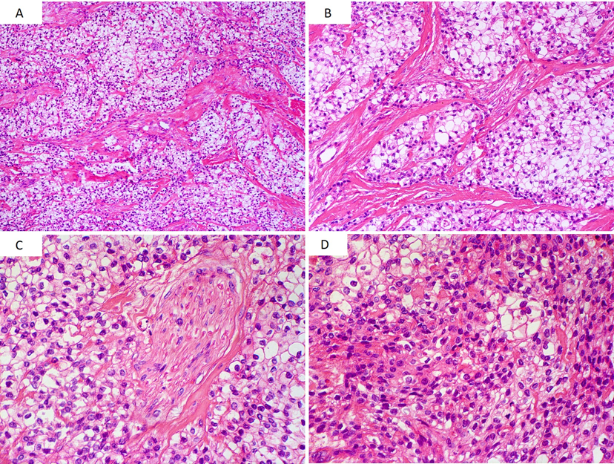
Figure 2 Histological characteristics of the tumor. A and B: Groups of clear cells separated by thick bundles of eosinophilic collagen fibers with hyaline appearance; C: Neural invasion area; D: Diffuse proliferation of tumor cells forming solid areas or tumor sheets. A population of tumor cells with eosinophilic cytoplasm was also observed (Hematoxylin and eosin, original magnification A: ×100, B: ×200, C, D: ×400).
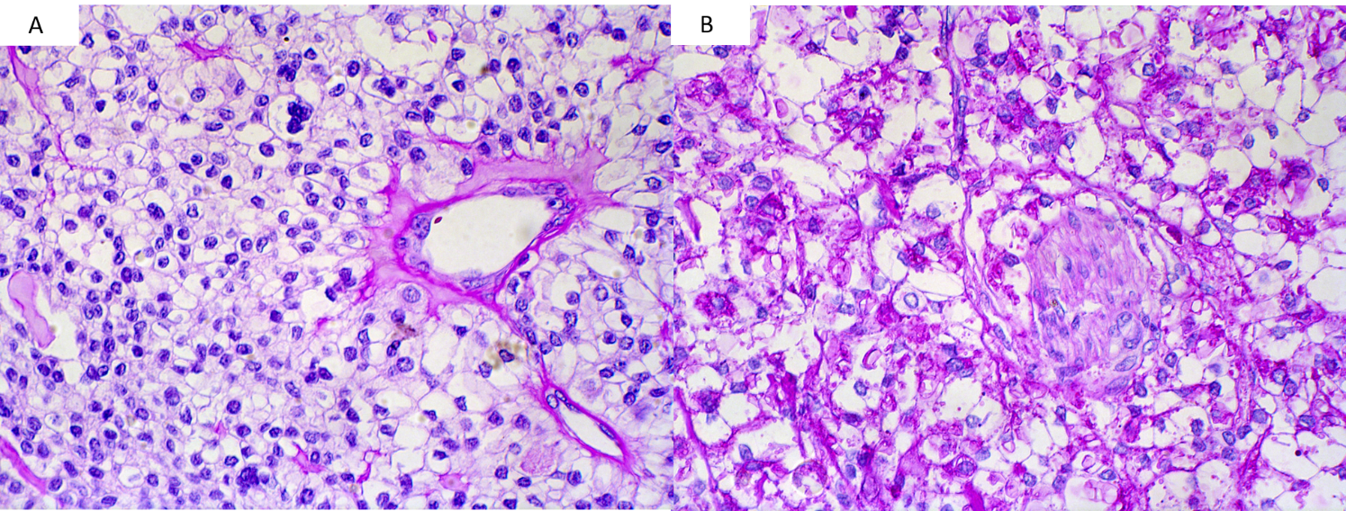Figure 3 Negative tumor cells staining and histochemistry periodic acid-Schiff positive without diastase. A: Negative tumor cells staining by periodic acid-Schiff with diastase; B: Histochemistry periodic acid-Schiff positive without diastase (original magnification, ×400).

Figure 4 Immunohistochemical profile of the tumor. An intense and diffuse positive reaction was observed in most tumor cells for AE1-AE3 (A), CK7 (C), and p63 (D), whereas CK5 (B) showed focal positivity (original magnification A, B, C, D. ×200).

