Name of journal: World Journal of Virology
ESPS Manuscript NO: 14852
Columns: Meta-Analysis

Elevated homocysteine levels in human immunodeficiency virus-infected patients under antiretroviral therapy: A meta-analysis

Rafael D et al. Elevated homocysteine levels in HIV-infected patients

Deminice Rafael, Capoani Vieira Silva Talita, Hugo Fernando de Oliveira Vitor

Deminice Rafael, Capoani Vieira Silva Talita, Hugo Fernando de Oliveira Vitor, Department of Physical Education, State University of Londrina, Londrina 86057-970, Brazil

Author contributions: The study was designed by Rafael D; data were collected and analyzed by Rafael D and Talita CVS; data interpretation and manuscript preparation were undertaken by Rafael D, Talita CVS and Vitor HFO; Manuscript preparation Rafael D, Talita CVS and VHFO. Have final responsibility to the manuscript Rafael D.

Supported by Rafael Deminice is supported by Brazilian grants SETI-PR (Programa Universidade sem Fronteiras, Secretaria da Ciência, Tecnologia e Ensino Superior).

Conflict-of-interest: All authors declared that there is no potential conflict of interests regarding this article.

Data sharing: All data generated during the project will be made freely available via correspondent author e-mail (deminice@ig.com.br). Data will be maintained for a minimum of 10 years. There are no security or licensing related to the expected data, and all data used in the project will be generated directly as a result of the project, without any pre-existing data being used.

Open-Access: This article is an open-access article which was selected by an in-house editor and fully peer-reviewed by external reviewers. It is distributed in accordance with the Creative Commons Attribution Non Commercial (CC BY-NC 4.0) license, which permits others to distribute, remix, adapt, build upon this work non-commercially, and license their derivative works on different terms, provided the original work is properly cited and the use is non-commercial. See: http://creativecommons.org/licenses/by-nc/4.0/

Correspondence to: Deminice Rafael, PhD, Assistant Professor, Department of Physical Education, State University of Londrina, Rodovia Celso Garcia Cid | Pr 445 Km 380 | Campus Universitário, Londrina, Paraná 86057-970, Brazil. deminice@ig.com.br

Telephone: +55-43-33715481
Fax: +55-43-33715481

Received: October 28, 2014
Peer-review started: October 28, 2014
First decision: November 14, 2014
Revised: November 28, 2014
Accepted: March 4, 2015
Article in press:
Published online:

Abstract
AIM: To evaluate the association between the levels of homocysteine (Hcy), folate, vitamin B12 in human immunodeficiency virus (HIV)-infected patients who were treated with antiretroviral therapy (ART) or not treated with ART.

METHODS: The PubMed and Scielo databases were searched. Eligible studies regarding plasma Hcy level in HIV-infected patients were firstly identified. After careful analysis by two independent researches, the identified articles were included in the review according to two outcomes (1) Hcy, folate and vitamin B12 blood concentration in HIV-infected subjects vs health controls and; (2) Hcy blood concentration in HIV-infected subjects under ART vs not treated with ART. RevMan (version 5.2) was employed for data synthesis.

RESULTS: A total of 12 studies were included in outcome 1 (1649 participants, 932 cases and 717 controls). Outcome 1 meta-analysis demonstrated higher plasma Hcy (2.05 µmol/L; 95%CI: 0.10 to 4.00, P < 0.01) and decreased plasma folate concentrations (-2.74 ng/mL; 95%CI: -5.18 to -0.29, P < 0.01) in HIV-infected patients compared to healthy controls. No changes in vitamin B12 plasma concentration were observed between groups. All studies included in the outcome 2 meta-analysis (1167 participants; 404 HIV-infected exposed to HAART and 757 HIV-infected non-ART patients) demonstrated higher mean Hcy concentration in subjects HIV-infected under ART compared to non-ART HIV subjects (4.13 µmol/L; 95%CI: 1.34 to 6.92, P < 0.01).

CONCLUSION: This meta-analysis demonstrated that the levels of Hcy and folate, but not vitamin B12, were associated with HIV infection. In addition, Hcy levels were higher in HIV-infected patients who were under ART compared to HIV-infected patients who were not exposed to ART. Our results suggest that hyperhomocysteinemia should be included among the several important metabolic disturbances that are associated with ART in patients with HIV infection.

Key words: Homocysteine; Folate; Vitamin B12; Antiretroviral therapy; Human immunodeficiency virus; Acquired immune deficiency syndrome

© The Author(s) 2015. Published by Baishideng Publishing Group Inc. All rights reserved.

Core tip: Although antiretroviral therapy (ART) has changed dramatically the speciation of life of human immunodeficiency virus (HIV)-infected patients, it has increased the incidence of chronic diseases, especially cardiovascular diseases. Nowadays, elevated levels of homocysteine have been considered to be an independent risk factor for cardiovascular disease development. Our study demonstrated that the levels of Hcy and folate, were associated with HIV infection, especially for those exposed to ART.

Rafael D, Talita CVS, Vitor HFO. Elevated homocysteine levels in human immunodeficiency virus-infected patients under antiretroviral therapy: A meta-analysis. World J Virol 2015; In press

INTRODUCTION
The introduction of antiretroviral therapy (ART) has changed the spectrum of human immunodeficiency virus (HIV) infections, reducing the risk of opportunistic infections and substantially reducing mortality rates^{[1]}. Although ART has changed HIV infection from an acute to a chronic disease, this therapy has increased the incidence of cardiovascular disease (CVD) among HIV-infected subjects^{[2]}, associated with the presentation of risk factors, such as dyslipidemia, insulin resistance, and lipodystrophy, among others. Development of these risk factors may be due to HIV infection itself or ART-associated toxicity^{[3]}. Epidemiological studies have demonstrated an increased incidence of myocardial infarction, atherosclerotic disease, and mortality in HIV-infected patients compared to noninfected individuals, especially when exposed to ART^{[4-7]}.
Since McCully et al^{[8]} firstly demonstrated elevated incidence of homocystinuria in patients with severe atherosclerosis and arterial thrombosis, elevated levels of homocysteine (Hcy) have been considered to be an independent risk factor for CVD development^{[9,10]}. Recently, several studies have demonstrated an association between hyperhomocysteinemia (HHcy) and a spectrum of diseases, including neurodegenerative diseases, diabetes, chronic kidney disease, and fatty liver disease^{[11-15]}. Much of this association has been attributed to the characteristics of Hcy, which is a potent toxic agent that may increase oxidative stress and promote neurotoxicity, endothelial dysfunction, and accelerate the atherosclerotic process^{[16-19]}. Hcy is an amino acid formed exclusively by demethylation of methionine^{[10]}. In Hcy synthesis, methionine is activated by ATP to form S-adenosylmethionine (SAM). SAM acts primarily as a universal methyl donor in the synthesis of methylated compounds such as neurotransmitters (epinephrine, norepinephrine), DNA, RNA, phosphatidylcholine and creatine^{[11]}. A subproduct of these methylation reactions is S-adenosylhomocysteine (SAH), which is hydrolyzed to adenosine and Hcy^{[10]}. Hcy can be remethylated to form metionine by the action of the enzyme methionine synthase (MS) which uses N^{5’10}-methylene-THF-reductase (MTHFR) as a methyl donor. Vitamins B12 and folate are co-factors in this reaction. The catabolism of methionine is performed by transsulfuration, with Hcy reacting with serine to form cystathionine in an irreversible reaction catalyzed by cystathione-β-synthase (CβS) and dependent of vitamin B6^{[16]}.
Owing to their involvement in the Hcy remethylation pathway, vitamin B-12 and folate deficiencies have been associated with elevated Hcy concentrations^{[20,21]}. However, studies examining this association in HIV patients have reported conflicting results. Folate and vitamin B12 deficiencies have been reported in HIV-infected patients due to low intake and/or malabsorption^{[22,23]}. Remacha et al^{[23]} demonstrated that HIV-infected subjects with low serum vitamin B12 and red blood cell folate concentrations had HHcy. In contrast, studies found no changes in folate and vitamin B12 levels during follow-up after ART^{[24-26]}.
Given the inconsistency of the existing literature and the insufficient statistical power of primary studies, we conducted a meta-analysis to clarify the relationship between the levels of Hcy, folate, and vitamin B12 in HIV-infected patients. We also investigated the relationship between Hcy levels in HIV-infected patients who were treated with ART or not treated with ART.

MATERIALS AND METHODS
The PubMed and Scielo databases were searched for English- or Spanish-language articles, by using the following keywords: “homocysteine,” “HIV-infected,” and “AIDS”. Any case-control, cross-sectional, or cohort study that assayed the blood concentrations of Hcy, vitamin B12, or folate in HIV-infected patients was analyzed. After careful analysis by two independent researchers, identified articles were included in the review if they satisfied the following criteria: (1) contained human clinical outcomes (rather than outcomes from animal experiments); (2) used a case-control, cross-sectional trial or cohort design; (3) contained quantitative information regarding Hcy, vitamin B12, or folate plasma or serum concentrations; and (4) included a healthy control group. Relevant articles that were cited in the publications were reviewed and included in the meta-analysis if they satisfied the inclusion criteria.
The search was conducted considering two main outcomes: (1) Hcy blood concentrations in HIV-infected subjects compared to healthy controls; and (2) Hcy blood concentrations in HIV-infected individuals who were treated by ART compared to HIV-infected individuals who were not treated by ART (HIV-infected ART vs non-ART groups, Figure 1). A subgroup of outcome 1 was created to determine the vitamin B12 and folate plasma concentrations in HIV-infected individuals compared to healthy controls. The selection process is described in Figure 1.
For all articles included in the meta-analyses for the two outcomes, the following data were extracted: authors and year of publication; country where the study was conducted; study design; number of subjects in the study; plasma/serum concentrations of Hcy, vitamin B12, percent of each group with HHcy; and folate in HIV-infected and control subjects. Inclusion of studies in the meta-analyses was discussed by the 3 authors. All meta-analysis procedures were conducted as described by Stroup et al^{[27]}.

Statistical analysis
Effects of HIV infection on the Hcy blood concentration were quantified by performing meta-analyses for the two outcomes described above with the RevMan software package (version 5.0). In outcome 1, two subgroup analyses were performed to access the impact of HIV on the folate and vitamin B12 plasma concentrations. RevMan was used to calculate the weighted mean difference. The 95%CI was employed for presenting the statistical results for continuous outcomes. Weighted percentages were based on the sample sizes of respective studies. Differences with a P value < 0.05 were considered to be statistically significant. Study heterogeneity was evaluated by the I² statistic. All meta-analyses were considered to be of high heterogeneity (I² > 75%), and the random-effects model was used^{[28]}. All data were analyses with a biostatistician support.

RESULTS
Outcome 1
The initial search was independently executed by two reviewers, resulting in the selection of 73 articles. Reviews, repeated studies, and studies conducted in the absence of a control group identified 43 relevant studies. Screening by title and abstract was conducted in accordance with inclusion criteria. After extensive discussions between the authors, 16 articles were identified and included in the meta-analyses. Studies were included in either outcome 1 or 2, as described in Figure 1.
Four of the 16 selected studies were excluded because of the absence of a control group^{[40-43]}. Thus, 12 studies were included in the meta-analysis for outcome 1. Table 1 describes the characteristics of the 12 studies included in outcome 1. These studies included 1649 participants (932 HIV-infected patients and 717 healthy controls). Nine of the 12 studies reported that the mean Hcy concentration was greater in HIV-infected individuals compared to controls. Only five^{[33,34,36,38,39]} and four^{[33,36,38,39]} of the included studies described quantitative folate and vitamin B12 data, respectively (Table 1).
A meta-analysis performed on outcome 1 indicated that the plasma Hcy levels in HIV-infected patients were 2.05 µmol/L higher than the plasma Hcy levels in uninfected controls (95%CI: 0.13–4.01, P < 0.01; Figure 2).
Subgroup analyses on folate and vitamin B12 plasma concentrations between test groups (Figure 3) demonstrated plasma folate levels were -2.74 ng/mL decreased in HIV-infected patients compared to uninfected controls (95%CI: -5.18 – -0.29, P < 0.01), but no significant difference in the B12 concentration between the two groups. Funnel plot analysis did not show evidence of substantial publication bias for the association between Hcy level and HIV infection.

Outcome 2
Nine of the 16 studies selected were excluded from outcome 2 because of the absence of an HIV-infected non-ART group^{[29,30-33,36-39]} (Figure 1). Table 2 describes the characteristics of the 7 studies included in outcome 2. These studies included 1167 participants (404 patients in the HIV-infected ART group and 757 patients in the HIV-infected non-ART group). All studies included in the meta-analysis for outcome 2 described a higher mean Hcy concentration in the HIV-infected ART group compared to the HIV-infected non-ART group (4.13 µmol/L; 95%CI: 1.34–6.92, P < 0.01; Figure 4).

DISCUSSION
Overall, we found that HIV infection and ART were significantly associated with elevated plasma Hcy levels. The pooled mean Hcy concentration was greater in HIV-infected subjects compared to healthy controls. Hcy blood concentrations were elevated among HIV-infected patients who were exposed to ART compared to patients who were not exposed to ART. In addition, HIV-infected patients presented decreased plasma levels of folate, but not vitamin B12. These findings provide consistent evidence that Hcy and folate levels are associated with HIV infection, especially when patients are also receiving ART.
Studies in rodents and in vitro have demonstrated that HHcy may be associated with decreased nitric oxide bioavailability and endothelial dysfunction^{[44]}, altered cellular methylation, formation of Hcy adducts (e.g., Hcy-thiolactone), and oxidative stress. These perturbations are linked to cell toxicity^{[16]}, in addition to atherosclerosis and thrombotic processes^{[17-19]}. In humans, a total Hcy level of 14.3 µmol/L or greater was independently associated with a relative risk of mortality (54% for all-cause mortality and 52% for cardiovascular mortality)^{[21,45]}. Humphrey et al^{[46]} demonstrated that each increase of 5 μmol/L in Hcy levels increased the risk of cardiovascular events by approximately 20%. However, previous studies have provided conflicting results regarding circulating Hcy levels in HIV-infected patients.
In nine of the 12 studies included in the meta-analysis of outcome 1, the mean Hcy concentrations were greater in HIV-infected subjects compared to levels in healthy controls. Our meta-analysis demonstrated that the plasma Hcy levels in HIV-infected patients were 2.05 µmol/L higher compared to levels in healthy controls. This observation is particularly relevant considering the heterogeneity of patients included in those studies with regard to the disease stage, ART status, comorbidities, and gender, among others. Considering the relationship between the Hcy level and ART status, we observed that the Hcy levels were higher by an average of 4.13 µmol/L in HIV-infected subjects who were exposed to ART compared to HIV-infected patients who were not exposed to ART.
ART is a causal factor of increased cardiovascular risk in HIV-infected subjects. ART promotes different metabolic disturbances, including hepatic and neurotoxicities, lipodystrophy syndrome, hyperlactatemia, hyperlipidemia, and insulin resistance^{[47,48]}. The present study demonstrates that HHcy can be included on this list. Different classes of antiretroviral drugs and time exposed to the treatment may generate different ART-associated adverse metabolic effects^{[47,49]}. However, a lack of data in the revised papers prevents us from determining the contributions of different drug classes and durations of ART on Hcy levels (Table 2).
Although the precise mechanisms by which HIV infection and ART affect Hcy metabolism are not known, the vitamin B12 and folate levels have been shown to affect Hcy levels in HIV-infected patients^{[23,50]}. Specifically, Hcy levels are inversely related to the daily intake of folate and vitamin B12 in general population^{[20,21]}. That is because Hcy remethylation to methionine by methionine synthase (MTR) requires folate^{[10]}. However, this association appears to be different in the context of HIV infection. Remacha et al^{[23]} identified HHcy in 100% and 51.5% of HIV-infected patients who had erythrocyte folate concentrations below the 2.5th and 10th percentiles, respectively. In our results, decreased levels of plasma folate, but not vitamin B12, were associated with elevated Hcy levels in HIV-infected subjects. Deminice et al^{[39]} demonstrated that folate intake was higher in HIV-infected patients compared to healthy controls. Coria-Ramirez et al^{[43]} noted that nutritional abnormalities, such as decreased vitamin B12 and folate intake, were not responsible for the high incidence of HHcy observed in HIV-infected patients. Taken together, these findings suggest that disturbances in Hcy metabolism and the Hcy levels observed in HIV-infected patients may not be due to nutritional status. Instead, it may be that HIV and/or ART complications are linked to disturbances in Hcy metabolism. One possibility is that ART impairs the metabolism of Hcy, such as its remethylation or transsulfuration because both pathways may be affected^{[43]}. However, to the best of our knowledge, here are no studies demonstrating ART modify Hcy metabolism enzymes. It is probably because liver biopsies are an invasive procedure with a relatively high risk of complications. Animal models could enable studies on ART and Hcy metabolism however; few studies have tested ART in animal models.
This study has some limitations that need to be considered. First, only a few of the included studies analyzed HIV-infected patients in the context of Hcy metabolism. This fact contributed to the lack of clinical homogeneity among subjects of the included studies. Most of the studies did not consider the nature or duration of the ART that was administered. Most studies excluded the effects of comorbidities and diseases that may have affected Hcy levels (e.g., kidney disease). Second, many studies did not include information regarding vitamin levels, or assessed folate plasma levels of determining folate status. Plasma folate levels may not be the best parameter for assessing folate deficiency or intake^{[43,51,52]}. Erythrocyte folate or serum methylmalonic acid levels are better indicators of folate status, because they reflect folate turnover over the preceding 2 to 3 mo^{[23,43]}. Lamarre et al^{[52]} recently showed that formate levels provide important information regarding folate metabolism, and that increased Hcy levels can be caused by defects in the remethylation and transsulfuration pathways. Finally, some studies have demonstrated an association of the MTHFR polymorphisms and HHcy in different cases and diseases. However, this association was not considered in our included studies.
In conclusion, the levels of Hcy and folate, but not vitamin B12, were associated with HIV infection. Hcy levels were higher in HIV-infected patients who were exposed to ART compared to HIV-infected patients who were not exposed to ART. Finally, HHcy can be included among the several important metabolic disturbances that are associated with ART in patients with HIV infection.

COMMENTS
Background
Although antiretroviral therapy (ART) has changed dramatically the speciation of life of human immunodeficiency virus (HIV)-infected patients, it has increased the incidence of metabolic disorders as dyslipidemia, insulin resistance, lipodystrophy and others. Elevated homocysteine (Hcy) levels have been considered to be an independent risk factor for cardiovascular disease development. However, few studies have been considered Hcy levels in HIV-infected patients.

Research frontiers
Elevated Hcy levels have been considered to be an independent risk factor for cardiovascular disease development. Recently, several studies have demonstrated an association between hyperhomocysteinemia (HHcy) and a spectrum of diseases, including neurodegenerative diseases, diabetes, chronic kidney disease, and fatty liver disease. However, few researchers have focused in study Hcy levels HIV-infected patients.

Innovations and breakthroughs
Our data demonstrated that the levels of Hcy and folate, were associated with HIV infection, especially for those exposed to ART. That is the first meta analysis carried out in search of a relationship between plasma homocysteine levels and HIV infection.

Applications
HHcy is associated to ART can be included among the several important metabolic disturbances that are associated with ART in patients with HIV infection.

Terminology
Hcy is an S-containing amino acid formed exclusively by demethylation of methionine. Hcy has gained attention in medical field because its instability and toxicity, especially in elevated concentrations.

Peer-review
The topic of manuscript is interesting and valuable. The logical thinking is reasonable and convincing. The reference collection and analysis process described in detailed, it is easy to follow.

REFERENCES
1 Ciccolo JT, Jowers EM, Bartholomew JB. The benefits of exercise training for quality of life in HIV/AIDS in the post-HAART era. Sports Med 2004; 34: 487-499 [PMID: 15248786]
2 Sension MG. Long-Term suppression of HIV infection: benefits and limitations of current treatment options. J Assoc Nurses AIDS Care 2007; 18: S2-10 [PMID: 17275719 DOI: 10.1016/j.jana.2006.11.012]
3 Gresele P, Falcinelli E, Momi S, Francisci D, Baldelli F. Highly active antiretroviral therapy-related mechanisms of endothelial and platelet function alterations. Rev Cardiovasc Med 2014; 15 Suppl 1: S9-20 [PMID: 24987863]
4 Currier JS, Taylor A, Boyd F, Dezii CM, Kawabata H, Burtcel B, Maa JF, Hodder S. Coronary heart disease in HIV-infected individuals. J Acquir Immune Defic Syndr 2003; 33: 506-512 [PMID: 12869840]
5 Klein D, Hurley LB, Quesenberry CP, Sidney S. Do protease inhibitors increase the risk for coronary heart disease in patients with HIV-1 infection? J Acquir Immune Defic Syndr 2002; 30: 471-477 [PMID: 12154337]
6 Obel N, Thomsen HF, Kronborg G, Larsen CS, Hildebrandt PR, Sørensen HT, Gerstoft J. Ischemic heart disease in HIV-infected and HIV-uninfected individuals: a population-based cohort study. Clin Infect Dis 2007; 44: 1625-1631 [PMID: 17516408 DOI: 10.1086/518285]
7 Triant VA, Lee H, Hadigan C, Grinspoon SK. Increased acute myocardial infarction rates and cardiovascular risk factors among patients with human immunodeficiency virus disease. J Clin Endocrinol Metab 2007; 92: 2506-2512 [PMID: 17456578 DOI: 10.1210/jc.2006-2190]
8 McCully KS. Vascular pathology of homocysteinemia: implications for the pathogenesis of arteriosclerosis. Am J Pathol 1969; 56: 111-128 [PMID: 5792556]
9 Lentz SR. Mechanisms of homocysteine-induced atherothrombosis. J Thromb Haemost 2005; 3: 1646-1654 [PMID: 16102030 DOI: 10.1111/j.1538-7836.2005.01364.x]
10 Steed MM, Tyagi SC. Mechanisms of cardiovascular remodeling in hyperhomocysteinemia. Antioxid Redox Signal 2011; 15: 1927-1943 [PMID: 21126196 DOI: 10.1089/ars.2010.3721]
11 Deminice R, da Silva RP, Lamarre SG, Brown C, Furey GN, McCarter SA, Jordao AA, Kelly KB, King-Jones K, Jacobs RL, Brosnan ME, Brosnan JT. Creatine supplementation prevents the accumulation of fat in the livers of rats fed a high-fat diet. J Nutr 2011; 141: 1799-1804 [PMID: 21880953 DOI: 10.3945/jn.111.144857]
12 Seshadri S. Homocysteine and the risk of dementia. Clin Chem 2012; 58: 1059-1060 [PMID: 22510400 DOI: 10.1373/clinchem.2011.181099]
13 Wijekoon EP, Brosnan ME, Brosnan JT. Homocysteine metabolism in diabetes. Biochem Soc Trans 2007; 35: 1175-1179 [PMID: 17956306 DOI: 10.1042/BST0351175]
14 Hu XW, Qin SM, Li D, Hu LF, Liu CF. Elevated homocysteine levels in levodopa-treated idiopathic Parkinson's disease: a meta-analysis. Acta Neurol Scand 2013; 128: 73-82 [PMID: 23432663 DOI: 10.1111/ane.12106]
15 Zhang H, Tao X, Wu J. Association of homocysteine, vitamin B12, and folate with bone mineral density in postmenopausal women: a meta-analysis. Arch Gynecol Obstet 2014; 289: 1003-1009 [PMID: 24193243 DOI: 10.1007/s00404-013-3075-6]
16 Jakubowski H. Pathophysiological consequences of homocysteine excess. J Nutr 2006; 136: 1741S-1749S [PMID: 16702349]
17 Hofmann MA, Lalla E, Lu Y, Gleason MR, Wolf BM, Tanji N, Ferran LJ, Kohl B, Rao V, Kisiel W, Stern DM, Schmidt AM. Hyperhomocysteinemia enhances vascular inflammation and accelerates atherosclerosis in a murine model. J Clin Invest 2001; 107: 675-683 [PMID: 11254667 DOI: 10.1172/JCI10588]
18 Morita H, Kurihara H, Yoshida S, Saito Y, Shindo T, Oh-Hashi Y, Kurihara Y, Yazaki Y, Nagai R. Diet-induced hyperhomocysteinemia exacerbates neointima formation in rat carotid arteries after balloon injury. Circulation 2001; 103: 133-139 [PMID: 11136698 DOI: 10.1161/01.CIR.103.1.133]
19 Guo YH, Chen FY, Wang GS, Chen L, Gao W. Diet-induced hyperhomocysteinemia exacerbates vascular reverse remodeling of balloon-injured arteries in rat. Chin Med J (Engl) 2008; 121: 2265-2271 [PMID: 19080331]
20 Selhub J. The many facets of hyperhomocysteinemia: studies from the Framingham cohorts. J Nutr 2006; 136: 1726S-1730S [PMID: 16702347]
21 Selhub J, Jacques PF, Dallal G, Choumenkovitch S, Rogers G. The use of blood concentrations of vitamins and their respective functional indicators to define folate and vitamin B12 status. Food Nutr Bull 2008; 29: S67-S73 [PMID: 18709882]
22 Malavazi I, Abrão EP, Mikawa AY, Tagliavini SA, da Costa PI. [Evaluation of the polymorphisms in methylenetetrahydrofolate reductase gene and the levels of folate and B12 in HIV-infected patients under antiretroviral therapy]. Rev Soc Bras Med Trop 2004; 37: 469-475 [PMID: 15765596]
23 Remacha AF, Cadafalch J, Sardà P, Barceló M, Fuster M. Vitamin B-12 metabolism in HIV-infected patients in the age of highly active antiretroviral therapy: role of homocysteine in assessing vitamin B-12 status. Am J Clin Nutr 2003; 77: 420-424 [PMID: 12540403]
24 Look MP, Riezler R, Berthold HK, Stabler SP, Schliefer K, Allen RH, Sauerbruch T, Rockstroh JK. Decrease of elevated N,N-dimethylglycine and N-methylglycine in human immunodeficiency virus infection during short-term highly active antiretroviral therapy. Metabolism 2001; 50: 1275-1281 [PMID: 11699044 DOI: 10.1053/meta.2001.27201]
25 Hepburn MJ, Dyal K, Runser LA, Barfield RL, Hepburn LM, Fraser SL. Low serum vitamin B12 levels in an outpatient HIV-infected population. Int J STD AIDS 2004; 15: 127-133 [PMID: 15006076 DOI: 10.1258/095646204322764334]
26 Drain PK, Kupka R, Mugusi F, Fawzi WW. Micronutrients in HIV-positive persons receiving highly active antiretroviral therapy. Am J Clin Nutr 2007; 85: 333-345 [PMID: 17284727]
27 Stroup DF, Berlin JA, Morton SC, Olkin I, Williamson GD, Rennie D, Moher D, Becker BJ, Sipe TA, Thacker SB. Meta-analysis of observational studies in epidemiology: a proposal for reporting. Meta-analysis Of Observational Studies in Epidemiology (MOOSE) group. JAMA 2000; 283: 2008-2012 [PMID: 10789670 DOI: 10.1001/jama.283.15.2008]
28 Higgins JP, Thompson SG, Deeks JJ, Altman DG. Measuring inconsistency in meta-analyses. BMJ 2003; 327: 557-560 [PMID: 12958120 DOI: 10.1136/bmj.327.7414.557]
29 Castagna A, Le Grazie C, Accordini A, Giulidori P, Cavalli G, Bottiglieri T, Lazzarin A. Cerebrospinal fluid S-adenosylmethionine (SAMe) and glutathione concentrations in HIV infection: effect of parenteral treatment with SAMe. Neurology 1995; 45: 1678-1683 [PMID: 7675226]
30 Müller F, Svardal AM, Aukrust P, Berge RK, Ueland PM, Frøland SS. Elevated plasma concentration of reduced homocysteine in patients with human immunodeficiency virus infection. Am J Clin Nutr 1996; 63: 242-248 [PMID: 8561066]
31 Naisbitt DJ, Vilar FJ, Stalford AC, Wilkins EG, Pirmohamed M, Park BK. Plasma cysteine deficiency and decreased reduction of nitrososulfamethoxazole with HIV infection. AIDS Res Hum Retroviruses 2000; 16: 1929-1938 [PMID: 11153075 DOI: 10.1089/088922200750054657]
32 Bernasconi E, Uhr M, Magenta L, Ranno A, Telenti A. Homocysteinaemia in HIV-infected patients treated with highly active antiretroviral therapy. AIDS 2001; 15: 1081-1082 [PMID: 11400001]
33 Vilaseca MA, Sierra C, Colomé C, Artuch R, Valls C, Muñoz-Almagro C, Vilches MA, Fortuny C. Hyperhomocysteinaemia and folate deficiency in human immunodeficiency virus-infected children. Eur J Clin Invest 2001; 31: 992-998 [PMID: 11737242 DOI: 10.1046/j.1365-2362.2001.00916.x]
34 de Larrañaga G, Alonso B, Puga L, Benetucci J. [Plasma homocysteine in human immunodeficiency virus infected patient]. Medicina (B Aires) 2003; 63: 393-398 [PMID: 14628648]
35 Raiszadeh F, Hoover DR, Lee I, Shi Q, Anastos K, Gao W, Kaplan RC, Glesby MJ. Plasma homocysteine is not associated with HIV serostatus or antiretroviral therapy in women. J Acquir Immune Defic Syndr 2009; 51: 175-178 [PMID: 19333128 DOI: 10.1097/QAI.0b013e3181a42bdf]
36 Vigano A, Bedogni G, Cerini C, Meroni L, Giacomet V, Stucchi S, Fabiano V, Coletto S, Catalano M, Minola M, Zuccotti GV. Both HIV-infection and long-term antiretroviral therapy are associated with increased common carotid intima-media thickness in HIV-infected adolescents and young adults. Curr HIV Res 2010; 8: 411-417 [PMID: 20426755 DOI: 10.2174/157016210791330419]
37 Abdollahi A, Shoar TS. Hyperhomocysteinemia in HIV-Infected Individuals: Correlation of a Frequent Prothrombotic Factor with CD4+ Cell Count. Oman Med J 2012; 27: 224-227 [PMID: 22811772 DOI: 10.5001/omj.2012.50]
38 Borges-Santos MD, Moreto F, Pereira PC, Ming-Yu Y, Burini RC. Plasma glutathione of HIV⁺ patients responded positively and differently to dietary supplementation with cysteine or glutamine. Nutrition 2012; 28: 753-756 [PMID: 22261571 DOI: 10.1016/j.nut.2011.10.014]
39 Deminice R, Vassimon HS, Machado AA, de Paula FJ, Monteiro JP, Jordao AA. Plasma homocysteine levels in HIV-infected men with and without lipodystrophy. Nutrition 2013; 29: 1326-1330 [PMID: 24045000 DOI: 10.1016/j.nut.2013.04.017]
40 Mercié P, Thiébaut R, Lavignolle V, Pellegrin JL, Yvorra-Vives MC, Morlat P, Ragnaud JM, Dupon M, Malvy D, Bellet H, Lawson-Ayayi S, Roudaut R, Dabis F. Evaluation of cardiovascular risk factors in HIV-1 infected patients using carotid intima-media thickness measurement. Ann Med 2002; 34: 55-63 [PMID: 12014436]
41 Martí-Carvajal A, Nicita G, Palma A, Leal U, Brito N, Chacín A. Hiperhomocisteinemia en adultos venezolanos infectados por el virus de la inmunodeficiencia humana. Gac Méd Caracas 2007; 115: 297-303
42 Currier JS, Kendall MA, Henry WK, Alston-Smith B, Torriani FJ, Tebas P, Li Y, Hodis HN. Progression of carotid artery intima-media thickening in HIV-infected and uninfected adults. AIDS 2007; 21: 1137-1145 [PMID: 17502724 DOI: 10.1097/QAD.0b013e32811ebf79]
43 Coria-Ramirez E, Cisneros LN, Treviño-Perez S, Ibarra-Gonzalez I, Casillas-Rodriguez J, Majluf-Cruz A. Effect of highly active antiretroviral therapy on homocysteine plasma concentrations in HIV-1-infected patients. J Acquir Immune Defic Syndr 2010; 54: 477-481 [PMID: 20351558 DOI: 10.1097/QAI.0b013e3181d91088]
44 Chambers JC, McGregor A, Jean-Marie J, Obeid OA, Kooner JS. Demonstration of rapid onset vascular endothelial dysfunction after hyperhomocysteinemia: an effect reversible with vitamin C therapy. Circulation 1999; 99: 1156-1160 [PMID: 10069782 DOI: 10.1161/01.CIR.99.9.1156]
45 Bostom AG, Silbershatz H, Rosenberg IH, Selhub J, D'Agostino RB, Wolf PA, Jacques PF, Wilson PW. Nonfasting plasma total homocysteine levels and all-cause and cardiovascular disease mortality in elderly Framingham men and women. Arch Intern Med 1999; 159: 1077-1080 [PMID: 10335684 DOI: 10.1001/archinte.159.10.1077]
46 Humphrey LL, Fu R, Rogers K, Freeman M, Helfand M. Homocysteine level and coronary heart disease incidence: a systematic review and meta-analysis. Mayo Clin Proc 2008; 83: 1203-1212 [PMID: 18990318 DOI: 10.4065/83.11.1203]
47 Friis-Møller N, Reiss P, Sabin CA, Weber R, Monforte Ad, El-Sadr W, Thiébaut R, De Wit S, Kirk O, Fontas E, Law MG, Phillips A, Lundgren JD. Class of antiretroviral drugs and the risk of myocardial infarction. N Engl J Med 2007; 356: 1723-1735 [PMID: 17460226 DOI: 10.1056/NEJMoa062744]
48 Ridha E, Devitt E, Boffito M, Boag F. Antiretroviral therapy and cardiovascular risk. BMJ Case Rep 2011; 2011 [PMID: 22707576 DOI: 10.1136/bcr.10.2010.3429]
49 Apostolova N, Blas-García A, Esplugues JV. Mitochondrial toxicity in HAART: an overview of in vitro evidence. Curr Pharm Des 2011; 17: 2130-2144 [PMID: 21718249 DOI: 10.2174/138161211796904731]
50 Uccelli MC, Torti C, Lapadula G, Labate L, Cologni G, Tirelli V, Moretti F, Costarelli S, Quiros-Roldan E, Carosi G. Influence of folate serum concentration on plasma homocysteine levels in HIV-positive patients exposed to protease inhibitors undergoing HAART. Ann Nutr Metab 2006; 50: 247-252 [PMID: 16508252 DOI: 10.1159/000091682]
51 Lamarre SG, Molloy AM, Reinke SN, Sykes BD, Brosnan ME, Brosnan JT. Formate can differentiate between hyperhomocysteinemia due to impaired remethylation and impaired transsulfuration. Am J Physiol Endocrinol Metab 2012; 302: E61-E67 [PMID: 21934042 DOI: 10.1152/ajpendo.00345.2011]
52 Lamarre SG, MacMillan L, Morrow GP, Randell E, Pongnopparat T, Brosnan ME, Brosnan JT. An isotope-dilution, GC-MS assay for formate and its application to human and animal metabolism. Amino Acids 2014; 46: 1885-1891 [PMID: 24748098 DOI: 10.1007/s00726-014-1738-7]

P-Reviewer: Knysz B, Pajares MA, Shih WL S-Editor: Song XX L-Editor: E-Editor:

43 potentially relevant studies identified
16 studies received more detailed evaluation
12 studies included in the systematic review
27 studies not meet inclusion criteria.
4 studies excluded because the absence of relevant information for meta-analysis
5 studies with plasma folate data
4 studies with plasma vitamin B12 data
7 studies included in the systematic review
Outcome 1:
HIV vs Control
9 studies excluded because the absence of Non-HAART group and relevant information for meta-analysis
Outcome 2:
Non-HAART vs HAART
73 studies identified thought databases search
30 studies excluded: Reasons: reviews; absence of HIV patients; repeated studies.
Figure 1 PRISMA flow diagram of the study selection process. After careful discussion between the 3 reviewers, two outcomes were identified and included in the meta-analysis.
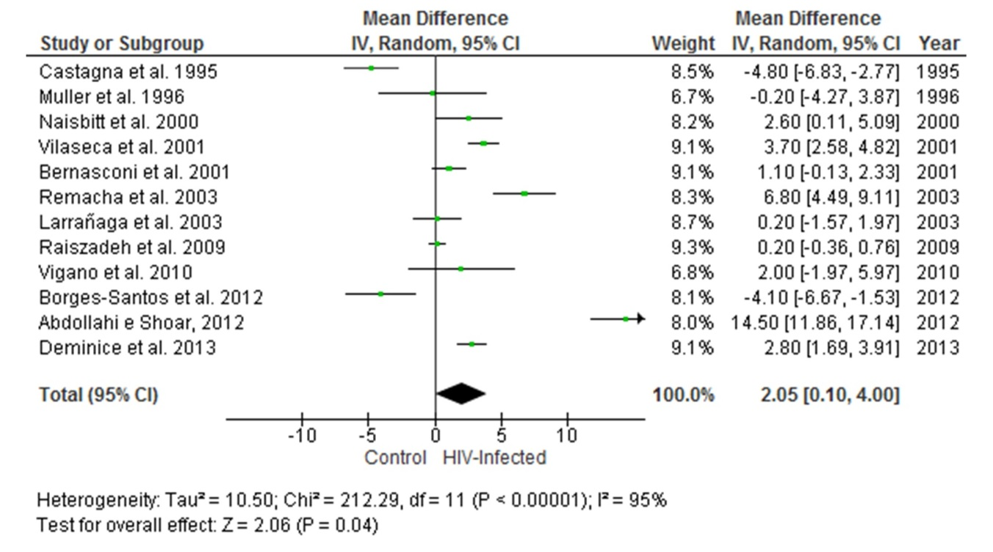
Figure 2 Meta-analysis of blood homocysteine concentration in human immunodeficiency virus-infected subjects compared with healthy controls. Calculation based on random effects model. Results are expressed as weighted mean difference of homocysteine (µmol/L) and 95%CI.

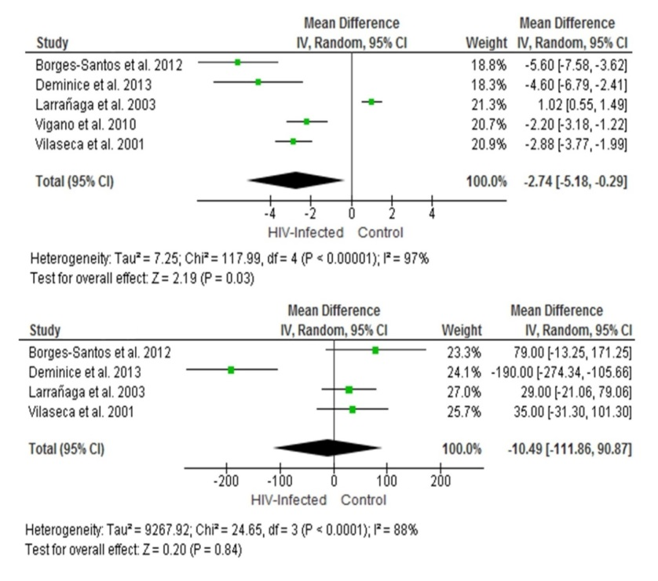
Figure 3 Meta-analysis of serum folate and vitamin B12 levels in human immunodeficiency virus-infected subjects compared with healthy controls. Calculation based on random effects model. Results are expressed as weighted mean difference of folate (ɳg/mL) and vitamin B12 (pg/mL) and 95%CI.
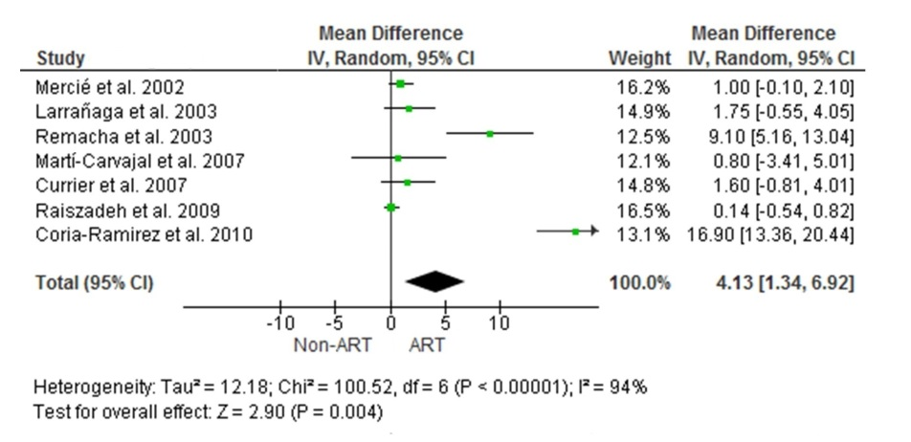
Figure 4 Meta-analysis of blood homocysteine concentration in human immunodeficiency virus-infected exposed and non-exposed to antiretroviral therapy. Calculation based on random effects model. Results are expressed as weighted mean difference of homocysteine (µmol/L) and 95%CI.

Table 1 Characteristics of studies included in the outcome 1
Ref. | Country | Sample size | Study | Hcy (µmol/L) |  | HHcy | Folate (ng/mL)/Vitamin B12 (pg/mL)
 |  | (Control/HIV) | Design | Control | HIV |  | Control | HIV
Castagna et al^{[29]} | Italy | 20/14 | CS and CC of some patients | 10.8±3.8 | 6.0±2.2 | - | - | -
Muller et al^{[30]} | Norway | 15/21 | CS | 9.2±7.3 | 9.0±5.0 | - | - | -
Naisbitt et al^{[31]} | England | 33/33 | CS | 11.9±4.7 | 14.5±5.6 | - | - | -
Bernasconi et al^{[32]} | Swaziland | 80/73 | COS | 7.6±3.6 | 8.7±4.1 | 5% control;  12.3% HIV | - | -
Vilaseca et al^{[33]} | Spain | 170/69 | COS | 6.2 (4.0-10.4)² | 9.9 (5.5-23.3)² | 50.7% HIV | Folate 19.1±7.5/  B12 455±160¹ | Folate 12.6±6.7/  B12 481±181¹
Larrañaga et al^{[34]} | Argentina | 31/128 | CS | 9.0 (7.2-13.0)² | 9.0 (6.5-12.7)² | 12.9% control;  16.4% HIV | Folate 2.5 (2.1-3.1)²/B12 309 (268-477)² | Folate 3.6 (2.5-5.6)²/B12 337.4 (222-493)²
Remacha et al^{[23]} | Spain | 128/235 | CS | 7.5±7.8 | 14.3±12.9 | 6.2% control; | - | B12 368.6±219
Raiszadeh et al^{[35]} | United  States | 127/249 | COS | 7.2±2.7 | 7.4±2.7 | 13.4% control;  16.9% | - | -
Vigano et al^{[36]} | Italy | 19/23 | CS | 9.0±5.0 | 11.0±8.0 | - | Folate 6.9±1.7 | Folate 4.7±1.5
Abdollahi and Shoar^{[37]} | Iran | 58/58 | CC | 12.6±1.1 | 27.1±10.2 | 91.4% HIV | - | -
Borges-Santos et al^{[38]} | Brazil | 20/12 | CC | 13.9±5.5 | 9.8±1.6 | - | Folate 7.5 (6.3-9.0)²/B12 288±130 | Folate 1.9 (1.4-6.6)²/B12 367±139
Deminice et al^{[39]} | Brazil | 10/23 | CS | 6.6±1.5 | 9.4±2.7 | 0% controls; 30.4% HIV | Folate 11.7±3.4/  B12 713.1±110.1 | Folate 7.0±2/ B12 514.6±99.3
¹Folate and vitamin B12 determined in 56 controls and 69 HIV-infected patients only. Values in Hcy, folate and vitamin B12 are expressed as mean ± DP; ²Values expressed as range (25th–75th percentiles). CC: Case-control; CS: Cross-sectional; COS: Cohort study; Hcy: Homocysteine; HHcy: Hyperhomocysteinenemia.

Table 2 Characteristics of studies included in the outcome 2
Ref. | Country | Sample size | Study | Hcy (µmol/L) |  | HHcy | ART
 |  | (Control/HIV) | Design | ART | Non-ART
Mercié et al^{[42]} | France | 78/304 | COS | 12.5±4.8 | 11.5±4.3 | - | -
Larrañaga et al^{[34]} | Argentina | 31/128 | CS | 9.7±7.1 | 8.0±6.1 | - | -
Remacha et al^{[23]} | Spain | 128/235 | CS | 17.3±13 | 8.2±7.8 | - | Patients under ART (taking > 3 antiretroviral drugs)
Martí-Carvajal et al^{[41]} | Venezuela | 14/40 | CS | 10±7.5 | 9.2±6.7 | 48.6% non-ART; 45.5% ART | -
Currier et al^{[42]} | United  States | 40/41 | COS | 9.6±5 | 8.0±6.1 | - | Patients on ART including a PI continuously for 2 yr
Raiszadeh et al^{[35]} | United  States | 127/249 | COS | 7.5±2.8 | 7.3±2.4 | - | -
Coria-Ramirez et al^{[43]} | Mexico | 69/69 | CC | 24.8±14.6 | 7.9±3.4 | 7.3% non-ART; 79.9% ART | Patients who began ART and maintained the treatment for 6 mo
CC: Case-control; CS: Cross-sectional; COS: Cohort study; Hcy: Homocysteine; HHcy: Hyperhomocysteinenemia; PI: Protease inhibitors; ART: Antiretroviral therapy.

