Name of Journal: World Journal of Transplantation
ESPS Manuscript NO: 21115
Manuscript Type: REVIEW

Reducing transfusion requirements in liver transplantation

Donohue CI et al. Reducing transfusion requirements in liver transplantation

Ciara I Donohue, Susan V Mallett

Ciara I Donohue, Susan V Mallett, Royal Free Perioperative Research Group (RoFPoR), Department of Anaesthesia, Royal Free London NHS Trust, London NW3 2QG, United Kingdom

Author contributions: Donohue CI and Mallett SV contributed equally to this manuscript.

Conflict-of-interest statement: The authors declare no conflict of interest.

Open-Access: This article is an open-access article which was selected by an in-house editor and fully peer-reviewed by external reviewers. It is distributed in accordance with the Creative Commons Attribution Non Commercial (CC BY-NC 4.0) license, which permits others to distribute, remix, adapt, build upon this work non-commercially, and license their derivative works on different terms, provided the original work is properly cited and the use is non-commercial. See: http://creativecommons.org/licenses/by-nc/4.0/

Correspondence to: Ciara I Donohue, MBChB, BSc, FRCA, Anaesthetic Registrar, Royal Free Perioperative Research Group (RoFPoR), Department of Anaesthesia, Royal Free London NHS Trust, Pond Street, Hampstead, London NW3 2QG, United Kingdom. ciara.donohue@nhs.net
Telephone: +44-207-7945000

Received: June 29, 2015
Peer-review started: July 1, 2015
First decision: August 4, 2015
Revised: October 21, 2015
Accepted: November 23, 2015
Article in press:
Published online:

Abstract
Liver transplantation (LT) was historically associated with massive blood loss and transfusion. Over the past two decades transfusion requirements have reduced dramatically and increasingly transfusion-free transplantation is a reality. Both bleeding and transfusion are associated with adverse outcomes in LT. Minimising bleeding and reducing unnecessary transfusions are therefore key goals in the perioperative period. As the understanding of the causes of bleeding has evolved so too have techniques to minimize or reduce the impact of blood loss. Surgical “piggyback” techniques, anaesthetic low central venous pressure and haemodilution strategies and the use of autologous cell salvage, point of care monitoring and targeted correction of coagulopathy, particularly through use of factor concentrates, have all contributed to declining reliance on allogenic blood products. Pre-emptive management of preoperative anaemia and adoption of more restrictive transfusion thresholds is increasingly common as patient blood management (PBM) gains momentum. Despite progress, increasing use of marginal grafts and transplantation of sicker recipients will continue to present new challenges in bleeding and transfusion management. Variation in practice across different centres and within the literature demonstrates the current lack of clear transfusion guidance. In this article we summarise the causes and predictors of bleeding and present the evidence for a variety of PBM strategies in LT.

Key words: Liver transplantation; Transfusion; Blood conservation; Patient blood management; Coagulation

© The Author(s) 2015. Published by Baishideng Publishing Group Inc. All rights reserved.

Core tip: Liver transplantation (LT) was historically associated with massive blood loss. Many factors have contributed to the decline in bleeding and transfusion in the past two decades including refinement of surgical techniques, anaesthetic management and the use of point of care guided goal-directed haemostatic therapies. Increasing awareness of the adverse associations of allogenic transfusion has driven the quest for transfusion-free transplantation. Increasing use of marginal grafts and transplantation of sicker recipients will continue to challenge perioperative care and transfusion practice. Inter-institutional variability suggests a current lack of clear guidance and limited application of the principles of patient blood management to LT.

Donohue CI, Mallett SV. Reducing transfusion requirements in liver transplantation. World J Transplant 2015; In press

INTRODUCTION
Liver transplantation (LT) was historically associated with massive blood loss. Over the last two decades mean transfusion requirements have dramatically reduced. It is increasingly common for patients to undergo the procedure without transfusion of allogeneic blood^{[1]}. Nevertheless, a significant proportion of patients (10%-20%) will still require large volume transfusion of red blood cells (RBC) and blood products^{[2]}. The understanding of the causes of and the consequences of bleeding in these patients continues to evolve, and has contributed to the steady fall in transfusion requirements. However, substantial variability in transfusion practice remains^{[3]}. Patients undergoing LT represent a heterogenous group, yet such variation also suggests a lack of clear guidance and consensus regarding transfusion practice. Evidence for the negative impact of transfusion upon outcomes has driven the reduction in transfusion, alongside refinement of surgical and anaesthetic techniques, and use of point of care coagulation monitoring with goal directed haemostatic interventions. In this review we aim to provide an overview of the current understanding of the causes and predictors of excess bleeding, and methods available to minimise transfusion requirements in patients undergoing LT.

HISTORICAL CONTEXT AND PROGRESS
The early years of transplantation in the 1980’s were associated with high perioperative mortality, often related to bleeding complications^{[4]}. Massive transfusion was commonplace with typical mean RBC transfusions of 20 units per patient^{[2]} and blood products accounting for up to 10% of transplant costs^{[5]} (Figure 1).
Blood conservation, transfusion requirement, patient outcomes and survival have all improved in the subsequent years with evolving experience, techniques and therapeutic options. In some centres, transfusion free transplants are now a common occurrence^{[7]}. Massicotte et al^{[8,9]} reported a mean RBC transfusion per patient of 0.5 (± 1.4) and a 77.4% transfusion-free transplantion rate in over 700 LTs.

WHY IS REDUCING TRANSFUSION OF ALLOGENIC BLOOD AND PRODUCTS DESIRABLE?
Drivers for transfusion-free transplantation
The negative implications of transfusion are increasingly recognized despite improvements in donor screening, leucocyte and pathogen depletion^{[10]}. Adverse outcomes include immediate and delayed immune and non-immune reactions. A growing body of evidence suggests that allogenic blood and products are associated with excess short and longer-term morbidity (reduced graft function, infection, renal injury, reoperation) and mortality in LT^{[11,12]}. It is difficult to exclude the possibility that RBC transfusion might be a surrogate marker for other underlying causes of poor outcome. Ramos et al^{[13]} noted that RBC transfusion was the most significant factor adversely affecting length of stay (LOS) and survival (Figure 2). De Boer also found that patient survival was significantly associated with number of RBCs transfused. Transfusion remained the strongest independent predictor of survival when disease severity was excluded as a potential confounder^{[14]}. A transfusion-free perioperative period was associated with improved early outcomes, fewer infections, reduced dialysis requirement, shorter hospital LOS and a reduction in mortality compared with a transfused group with similar recipient, graft and donor quality variables^{[15]}. Benson and colleagues reported a significant dose dependent association between transfusion of RBC, fresh frozen plasma (FFP) and platelets and post-operative infections^{[16]}. Number of RBC units transfused was predictive for re-operation post LT in one centre^{[17]}, an event associated with high financial burden and excess mortality^{[18]}.
Mechanisms for poor outcomes and increased post-operative infection associated with RBC transfusion are not fully understood. One theory is transfusion-related immunomodulation (TRIM). A retrospective analysis by Boyd et al^{[19]} noted reduced survival post LT in patients bearing anti-RBC alloantibodies (suggestive of previous transfusion). These findings raise the possibility that transfusion may alter the immune system and impact negatively on susceptibility to infection and survival.
Platelet transfusions have been identified as an independent predictor of adverse outcomes post LT, in keeping with findings in cardiac surgery^{[20]}. De Boer demonstrated that even a 1 unit platelet transfusion was an important prognostic factor for post LT survival with a hazard of death ratio (HR 1.37/unit platelets^{[14]} (Figure 3).
Pereboom attributed the reduced survival in patients who received platelets to the significantly higher rate of transfusion related acute lung injury (TRALI) and associated early mortality^{[21]}. The biologically active mediators in plasma rich products (for example FFP and particularly platelets) are thought to underlie the risk of TRALI. Interestingly the incidence of TRALI appears to be lower in patients undergoing LT (1.3%) compared with other critically ill patients with liver disease (29.3%), possibly due to modulation of the inflammatory response by the high dose steroids administered intra-operatively or effects of the grafted liver itself^{[16]}. The development of TRALI post LT carries a poor prognosis with a tenfold increase in mortality. Platelets have been implicated in worsening ischaemia-reperfusion injury, which accounts for 10% of early graft dysfunction and predisposes to acute and chronic rejection. The suggested mechanism is via platelet sequestration in the hepatic microvasculature, where up regulation of proinflammatory endothelial injury and necrotic apoptosis could be exacerbated by platelet transfusion^{[22]}. The vasoactive effects of platelets may cause other negative systemic consequences such as pulmonary hypertension and haemodynamic disturbance. In one study platelet infusion was associated with reduced re-operation rates, a reminder that balancing risks of bleeding and side effects is a real clinical challenge^{[18,23]}.
While it is difficult to isolate the detrimental effects of platelet transfusion from the association with sicker thrombocytopaenic patients and higher intraoperative blood loss, Pereboom et al^{[21]} attempted to minimize confounders using a propensity score adjusted analysis. An independent negative effect of platelets on survival was suggested. Patients with low preoperative platelet counts and high intraoperative blood loss who did not receive platelets had improved survival compared with those that did, and in fact had similar survival to a reference population of patients with a normal preoperative platelet count and minimal blood loss^{[21]}. The decision to transfuse platelets should be therapeutic rather than prophylactic to avoid excess morbidity when the actual bleeding risk is unknown^{[24]}.
FFP used for volume replacement or pre-emptive non-specific correction of coagulopathy in the dissection phase of LT may exacerbate splanchnic hyperaemia and portal hypertension^{[25]}. Bleeding, increased RBC requirement and a cycle of dilutional coagulopathy may ensue^{[26]}. In a retrospective analysis of 206 LTs, transfusion of plasma was associated with an increase in mortality at one year. The negative impact of FFP on survival was greater than that associated with RBC transfusion^{[27]}.
The current evidence suggests transfusion of blood or blood products conveys negative consequences yet it remains a life saving intervention in certain clinical situations. Without clear evidence-based triggers for transfusion in LT however, the risk-benefit decision-making process remains subjective and results in variation in clinical practice.

PATIENT BLOOD MANAGEMENT
Concerns over patient safety and cost have fuelled interest in improving bleeding and transfusion management. Research into bloodless and transfusion free surgery in Jehovah’s Witness patients has pushed the boundaries of best practice for general application^{[28]}. Patient blood management (PBM) refers to the implementation of evidence-based practices to minimize transfusion of blood and products and improve patient outcomes. PBM principles are based on three pillars: recognition of anaemia and optimization of RBC mass, minimization of blood loss, and improved tolerance to anaemia with implementation of restrictive transfusion triggers and alternatives. These principles have been endorsed by the World Health Organisation (WHO) and are now considered standards of care^{[29]}. The principles should be rigorously applied to patients awaiting and undergoing LT in order to reduce and rationalise unnecessary transfusion and improve outcomes^{[30]}.
Preoperative anaemia is a major predictor for perioperative blood transfusion and poor outcome^{[9,31]}. Preoperative management with erythropoiesis stimulating agents and intravenous iron has been shown to improve haemoglobin levels in anaemic patients with absolute or functional iron deficiency^{[32,33]}. Further research is needed to define the role of intravenous iron in LT. Surgical and anaesthetic strategies to minimize haemoglobin drop (including autologous transfusion) should be implemented and will be discussed further in this article. Clear transfusion triggers reflecting the emerging evidence for the safety and benefits of restrictive policies, even in high-risk patients, should be applied^{[34]}. In a transplant centre with exceptionally low transfusion rates, a trigger Hb of 60 g/L has been used successfully^{[35]}. The principles of PBM should continue into the postoperative period.

WHY DO PATIENTS UNDERGOING LT BLEED AND HOW CAN BLEEDING RISK BE MITIGATED?
Underlying coagulation incompetence
Patients with acute and chronic end stage liver disease are a heterogenous group with complex alterations of coagulation. Certain aetiologies convey increased thrombotic tendency, such as the cholestatic conditions and non-alcoholic steatohepatitis (NASH)^{[36]}. Liver disease leads to a fragile state of rebalanced haemostasis affecting multiple cellular and humeral components of clot formation and stability^{[37]}. Production of both pro and anti-haemostatic factors is impaired. Diminished prothrombotic factors V, VII, IX, X, XII, prothrombin (II) and fibrinogen (I) are offset by increased factor VIII activity due to endothelial injury and reduced levels of the anticoagulants antithrombin, protein C, co-factor S and tissue factor pathway inhibitor (TFPI). Reduced platelet number or function due to bone marrow suppression, the hypersplenism of portal hypertension or uraemia is counteracted by enhanced platelet-endothelial adhesion mediated by Von Willebrand Factor (vWF). vWF concentrations are increased and breakdown reduced in the context of impaired production of liver derived ADAMTS-13, a vWF-cleaving protease^{[38]}. Thrombin generation is well preserved^{[39]} and may even be enhanced in patients with liver disease compared with healthy controls^{[40]}. Fibrinolytic pathways are altered. Increased tissue plasminogen activator (tPA) and reduced thrombin activateable fibrinolysis inhibitors (TAFI) drive lysis whilst reduced plasminogen levels limit clot breakdown. In acute liver failure (ALF) and cholestatic disease, elevated levels of plasminogen activator inhibitor (PAI), further reduce fibrinolysis.
Conventional laboratory tests fail to capture the subtlety and complexity of this rebalanced state and over-emphasise the potential for bleeding. The prothrombin time (PT), international normalized ratio (INR) or platelet count offer information about underlying hepatic synthetic function and clinical status, but provide an incomplete and misleading description of the coagulation profile in vivo and are of limited use in predicting bleeding risk or guiding haemostatic management^{[41]}. Whole blood viscoelastic tests (VETs) assess clot initiation, formation, strength and stability and are more representative of the in vivo process. The rebalanced haemostasis in liver disease is precarious and patients with limited haemostatic reserve can be readily tipped towards either bleeding or thrombotic tendency^{[42]} (Figure 4).

IMPACT OF TRANSPLANTATION ON COAGULATION
From this complex and variable baseline, the dynamic stresses during transplantation add to the challenge of maintaining optimal haemostasis. Dissection can precipitate acute haemorrhage, particularly in patients with portal hypertension and collateral vessels. Volume resuscitation, especially with colloids, can lead to a dilutional coagulopathy. Clot disturbance due to haemodilution is exaggerated in patients with liver disease due to a diminished haemostatic reserve^{[44]}. Concentrations of prothrombotic factors rapidly reach critical levels and there is a marked impairment in thrombin generation^{[45]}. The loss of thrombin potential can be detected on thromboelastography (TEG) as a characteristic “arrowhead” trace (Figure 5).
During the anhepatic period, reduced coagulation factor production including fibrinogen and reduced tPA clearance can lead to a hypocoagulable state with reduced clot quality and hyperfibrinolysis.
At reperfusion several factors contribute to increased bleeding tendency. Platelet entrapment and sinusoidal sequestration in the new liver depletes circulating numbers. Coagulation factors are globally reduced. Release of endogenous heparinoids from the vascular endothelial glycocalyx of the donor liver causes a heparin like effect (HLE) that can be detected on VETs with heparin inhibitors. This may be more pronounced with marginal grafts from DCD donors and with significant hepatic-ischaemic-reperfusion insult^{[46]}. The clinical significance of the HLE is not fully understood but it usually resolves spontaneously by the end of the case in the context of a good functioning graft^{[47]}. Hyperfibrinolysis is common due to an increase in tPA from the new liver and decreased production of antifibrinolytic factors and may be associated with increased bleeding^{[48]}.
It has been demonstrated that patients frequently become pro-thrombotic during the perioperative period^{[49]}. This typifies the challenges of haemostatic management during LT since inappropriate correction of a transient coagulopathy could lead to excess thrombotic complications, including hepatic artery thrombosis (HAT)^{[50]}.

THE ROLE OF GRAFT FUNCTION
The quality of the graft liver plays a significant role in bleeding post reperfusion. Delayed or primary non-function of the graft liver can cause the sustained deterioration of coagulation status with a global reduction of coagulation factors and fibrinogen, hyperfibrinolysis and HLE^{[51]}. Predisposing factors for graft failure include: Marginal grafts, poor preservation and prolonged cold and warm ischaemic times. In one retrospective analysis the use of extended donor criteria grafts was an independent risk factor for reoperation for bleeding^{[52]}.

SURGICAL BLEEDING AND MANAGEMENT STRATEGIES
Surgical skill and experience play an important role in limiting blood loss but are difficult to quantify. Patient factors including previous abdominal surgery with adhesions, portal hypertension with collateral vessels and portal vein thrombosis all increase technical difficulty, surgical duration and risk of bleeding^{[53]}. During surgery poor placement of retractors can increase venous pressure and exacerbate bleeding.
Different surgical techniques have been introduced and refined with the aim of improving patient outcomes. Veno-venous bypass decompresses the splanchnic system during the anhepatic phase and may reduce venous pressure and bleeding, whilst improving venous return to the heart. However increased blood loss due to hyperfibrinolysis, haemolysis and platelet consumption within the extracorporeal circuit has been reported. A Cochrane review found no evidence for reduced transfusion requirement with use of veno-veno bypass in LT (MD 1.13 units; 95%CI: -0.06 to 2.31; P = 0.062)^{[54]}.
In the piggyback technique part of the native retrohepatic inferior vena cava (IVC) is left in situ, preserving venous return to the heart throughout the anhepatic stage^{[55]}. Extensive retroperitoneal dissection is avoided and the single anastomosis between native and donor cavae is quicker and reduces warm ischaemic time. A favourable cardiovascular status may facilitate anaesthetic strategies to maintain low central venous pressure (CVP) and indirectly contribute to reduced blood loss^{[56]}. There are inconsistent reports of the blood conserving efficacy of the technique^{[57,58]}. A Cochrane review found no difference in transfusion requirement between piggyback and classical groups (SMD -0.09; 95%CI: -0.47 to 0.29; P = 0.65)^{[59]}.
Preoperative portal decompression with splenic artery trunk embolization (SATE) is described by Li et al^{[60]}. Portal pressures and hepatic artery flows were improved, as was hepatic functional reserve with more favourable INR, platelet count and plasma albumin a month post SATE. Surgery was shorter with less bleeding.
Live-related LT was associated with significantly lower allogenic blood and product usage compared with cadaveric LT despite the fact that the split graft has a raw surface from which bleeding could occur^{[61]}. The authors attribute this to the better graft quality and clinical status in live related recipients compared to those receiving cadaveric grafts on the waiting list.

PERIOPERATIVE ANAESTHETIC STRATEGIES
The evolution of modern anaesthetic practice means there are more options for monitoring, modifying and minimizing surgical and non-surgical bleeding during the perioperative period^{[62]}.

CENTRAL VENOUS PRESSURE REDUCTION AND BLOOD VOLUME MANAGEMENT
Liberal volume loading in cirrhotic patients may have several detrimental consequences. Acute volume loading tends to pool in the splanchnic circulation leading to bleeding and hepatic congestion with minimal improvement in cardiac preload or output^{[63]}. Dilution of clotting factors and interruption of clot formation (particularly with colloid administration) can lead to significant clot disturbance^{[64,65]} in this susceptible patient group^{[44]}. Reduction of CVP and therefore portal pressures with reduced engorgement of collateral vessels can help minimize surgical venous bleeding^{[66]}. Methods to lower CVP include volume restriction, phlebotomy, use of diuretics such as mannitol, low tidal volume ventilation and avoidance of high positive end expiratory pressure (PEEP)^{[2]}.
Volume restriction and early use of compensatory vasopressors is common practice in liver resection surgery, although a Cochrane review did not find that this strategy was associated with reduced transfusion (RR 0.72; 95%CI: 0.45 to 1.14)^{[67]}. Massicotte et al^{[9,68]} reported excellent transfusion rates and outcomes when stable LT patients with preoperative Hb > 85 g/L received protocolised care with a 40% reduction in CVP by phlebotomy according to body weight (mean CVP 6.4 mmHg SD ± 3.9). Volume was not replaced until after reperfusion when the collected blood was returned, thus maintaining a low CVP and higher coagulation factor concentrations.
Normovolaemic haemodilution involves phlebotomy plus volume replacement with an acellular fluid leading to a reduced haematocrit and limited loss of RBCs during subsequent bleeding^{[69]}. Evidence from an animal model of haemodilution indicated that the kidney is at risk of ischaemic insult with this technique^{[70]}. Schroeder et al^{[71]} compared outcomes at two centres with contrasting protocols where CVP was maintained at either < 5 mmHg or 7-10 mmHg. Though transfusions were reduced in the low CVP centre, postoperative renal impairment, dialysis requirement and 30 d mortality were increased.
Any reduction in CVP must be a decision in which the potential benefits outweigh the risks of organ hypoperfusion and renal injury in these physiologically complex patients^{[72]}. Anaesthetic management ultimately seeks to maintain tissue oxygen delivery in the perioperative period, guided only by surrogate markers of this endpoint (e.g., mixed venous saturations and lactate). The ability to directly measure tissue oxygenation could lead to individualized haemodynamic management based upon this ultimate physiological goal.

MAINTENANCE OF HOMEOSTATIC CONDITIONS FOR CLOTTING
Maintenance of core body temperature > 35 °C, pH > 7.2 and plasma calcium levels > 1 mmol/L optimizes conditions for clot formation^{[42]}. Acidosis reduces thrombin generation and increases clot lysis, while hypothermia reduces fibrin and clotting factor synthesis and impairs platelet function. Active patient warming with forced air blankets, heated mattresses and efficient fluid delivery systems with the ability to heat rapid infusions to > 39 ⁰C should be standard practice.

VISCOELASTIC TESTS FOR MONITORING AND GUIDING COAGULATION MANAGEMENT
Laboratory assays offer limited and potentially misleading information in the context of liver disease. They have long turnaround times for results (30-90 min). VETs rapidly describe the cellular and humeral contribution to clot initiation, formation, strength and stability, enabling near patient thera-nostics. Though VETs have been around since the 1940’s there has been a recent explosion of interest in their utility. The European Society of Anaesthesiology (ESA) guidelines recommend VETs in the management of severe bleeding in liver transplant (grade 1C evidence)^{[26]}.
Two main devices exist on the market: TEG and rotational thromboelastometry (ROTEM). These are based on similar principles measuring change in resistance to free rotation of a pin and cup as clotting occurs over time. Use of different reagents and activators results in measurements of clot dynamics that are comparable but not interchangeable, between devices^{[73]} (Figure 6).
Empirical management of coagulation leads to excessive administration of allogenic products. VETs can improve perioperative care in LT through rapid diagnosis of coagulation defects, enabling individualised goal directed therapy and reducing unrationalised product usage. Both TEG and ROTEM employ activators and reagents to broaden their diagnostic scope^{[74]}. Results can be obtained more quickly by adding kaolin (K-TEG) or thromboplastin/ellagic acid (INTEM-ROTEM) to activate the intrinsic pathway or tissue factor (Rapid TEG and EXTEM-ROTEM) to activate the extrinsic pathway^{[75]}.
Measurement of TEG functional fibrinogen (TEG FF) or FIBTEM-ROTEM to quantify the fibrin contribution to clot strength can guide fibrinogen replacement. Without this additional information there may be a tendency to treat a low maximum amplitude (MA) or maximum clot firmness (MCF) due to hypofibrinogenaemia inappropriately with platelets. Normal clot strength should negate need for fibrinogen or platelet supplementation since a MA/MCF greater than 40mm has a high negative predictive accuracy for bleeding (> 95%). The decision to supplement fibrinogen or platelets should not solely be based on low MA/MCF as the positive predictive value is low (< 50%) and would risk overtreatment^{[76]}.
Hyperfibrinolysis can be detected by a reduction in MA/MCF of greater than 15% in an hour (TEG Ly30 7.5% or Ly60 15% and ROTEM Clot lysis index CLI60 < 85%). Platelet induced clot retraction is seen as a modest reduction in MA/MCF, which could be misinterpreted as fibrinolysis. An additional test, the APTEM-ROTEM, involves adding the antifibrinolyitic aprotinin to whole blood in order to inhibit fibrinolysis. Comparison with the uninhibited curve enables early detection of accelerated clot breakdown (Figure 7A and C).
Use of a heparin inhibitor (TEG heparinase and HEPTEM-ROTEM) enables demonstration of an endogenous HLE common in ALF and transiently post reperfusion (Figure 7B and D).
Several studies have demonstrated the close correlation and predictive value of clot firmness at 5 min (A5) with maximum mature clot strength^{[77]}, reinforcing VETs usefulness in real-time coagulation management^{[78]}.
Gorlinger^{[79]} developed and implemented a ROTEM based point of care (POC) algorithm for LT to guide response to clearly defined abnormal ROTEM parameters. A POC algorithm with first line use of factor concentrates applied to a variety of clinical contexts (trauma, cardiac, transplant and critical care) in three major teaching hospitals in Germany and Austria was associated with an impressive 90% reduction in FFP use, 72% reduction in platelet use, 62% reduction in RBC use and 50% reduction in incidence of massive transfusion and increased use of factor concentrates^{[80]}. It must be remembered that comparisons were made with a historical cohort introducing many confounding factors. Small single centre observational and randomised studies have demonstrated reductions in RBC and FFP usage with VET guided haemostasis, with varying significance^{[81,82]}, and improved postoperative outcomes with reduced rates of reoperation and kidney injury^{[83]}.
TEG was one of only three interventions found on Cochrane review to have potential for RBC and FFP transfusion reduction in LT (SMD -0.73; 95%CI: -1.25 to -0.2 and SMD -0.82; 95%CI: -1.6 to -0.05 respectively)^{[84]}.

LIMITATIONS OF VET
Large robust randomized controlled trials are lacking and as yet there is no evidence that use of VETs has a positive impact on morbidity or mortality^{[85]}. Introduction of VET requires infrastructure to establish and maintain quality controls and training. The moderate complexity of performing and interpreting the tests can lead to inter-operator variability and limits widespread use. It should be acknowledged that VETs do not incorporate the endothelial, vascular or flow related contribution to clot formation in vivo. Nor do they readily detect platelet inhibition, which require specialized tests (TEG platelet mapping or impedance aggregometry)^{[86]}. New generation devices with cartridge technology will address some of these issues by simplifying testing and incorporating platelet inhibition assays.

PHARMACOLOGICAL STRATEGIES
POC results enable a timely and accurate pharmacological response. A number of drugs and concentrates have been assessed for their beneficial haemostatic potential in LT and can be administered according to a “pyramid of therapy” (Figure 8).

ANTIFIBRINOLYTICS
Hyperfibrinolysis can contribute significantly to non-surgical bleeding during transplantion. Antifibrinolytic drugs can target such bleeding and reduce transfusion requirement. Empirical prophylactic use of antifibrinolytics is no longer recommended in LT because the balance of risk has shifted with declining massive haemorrhage^{[26]}. The significance of detected fibrinolysis depends on clinical context and timing. Fibrinolysis is relatively common in the initial post reperfusion stages and may not require treatment in the absence of clinical clot lysis and in the presence of a good quality graft where spontaneous resolution is expected. A retrospective review of practice in a single centre found that only 60% of patients with TEG evidence of fibrinolysis received antifibrinolytics^{[87]} and similar practice has been reported elsewhere^{[79]}. Significant pre-reperfusion fibrinolysis is concerning and may warrant treatment in anticipation of further deterioration of clot stability.
Aprotinin is a serine protease inhibitor inhibiting plasmin and kallikrein. It was used widely to reduce hyperfibrinolysis and bleeding in cardiac patients on cardiopulmonary bypass and in high-risk liver transplant patients. It had been accredited with reducing LT transfusion requirements dramatically^{[88,89]}. Aprotinin was withdrawn from the market amid concerns over excess mortality in 2007 but it is available once more, following a revoked suspension in 2012 by the European Medicines Agency^{[90,91]}. A meta-analysis of 7 studies in LT demonstrated significantly lower RBC and FFP requirements patients who received aprotinin compared with controls but no differences in terms of reoperation rates, thrombotic events or mortality^{[92]}.
Tranexamic acid and epsilon aminocaproic acid (EACA) are lysine analogues that adhere to lysine binding sites on plasminogen preventing its conversion to plasmin. Tranexamic acid has superior efficacy compared with EACA^{[93]}. Use of tranexamic acid at a dose of 25 mg/kg is recommended in the ESA guidelines for the treatment of surgical ooze with viscoelastic evidence of fibrinolysis during LT (grade 1C evidence)^{[26]}.
There is variation in the literature regarding the relative efficacy of aprotinin and tranexamic acid. Some authors found equivalent blood conservation, transfusion requirements and outcomes in cohorts receiving aprotinin and tranexamic acid^{[35,87]} whilst in two Cochrane reviews aprotinin appeared to have superior efficacy^{[84]}, but with an increased risk of death^{[94]}.

FIBRINOGEN CONCENTRATES
Fibrinogen is the first factor to reach critically low levels in the context of bleeding or dilution. Hypofibrinogenaemia is an important early occurrence which compromises clot quality and haemostasis.
Several studies in a variety of clinical settings have demonstrated reduced blood loss, transfusion requirements^{[95,96]} and increased transfusion-free transplantation^{[97]} with use of fibrinogen concentrate (FC). A Cochrane review reported efficacy of FC without increased thromboembolic risk^{[98]}, though a lack of large robust trials was noted. Fibrinogen is the vital substrate of the clot and supplementation may be beneficial in the context of dilutional coagulopathy and platelet impairment^{[44,99]}. In both in vitro and in vivo studies of dilutional coagulopathy, FC improved clot strength but did not increase thrombin generation^{[100,101]}. Adequate fibrinogen levels may compensate for a degree of platelet dysfunction and FC may represent a platelet concentrate sparing therapy (Figure 9)^{[99,102]}.
There is no consensus on the appropriate trigger for fibrinogen supplementation in LT but it should be considered at a plasma level of 1.5-2 g/L or with evidence of hypofibrinogenaemia on TEG FF/FIBTEM (MCF_{FIB} < 8 mm) in the context of bleeding. Prophylactic use is not recommended since not all patients with low fibrinogen will bleed^{[76]}.
Fibrinogen concentrate is available as a lyophilized powder for rapid reconstitution to deliver a precise dose. The dose can be calculated according to the measured and target fibrinogen levels or according to desired MCF_{FIB} increase^{[80]}.
Fibrinogen dose = Target level (g/L) – Measured level (g/L)/0.017 (g/L per mg/kg body weight)
Fibrinogen dose = Target increase in MCF_{FIB} (mm) × body weight (kg)/140
Typical dosing is 2-4 g (approximately 25-50 mg/kg) with assessment of clinical and viscoelastic response to guide subsequent titrated doses.
Fibrinogen can be also be supplemented with cryoprecipitate (200-250 mg fibrinogen/unit) or FFP (1-2.5 g fibrinogen/L). The low fibrinogen content of FFP means large volumes of up to 30 mL/kg are required to increase plasma fibrinogen levels risking dilutional coagulopathy and other adverse events^{[104]}.

PROTHROMBIN COMPLEX CONCENTRATES
Prothrombin complex concentrate (PCC) comprises either 3 or 4 vitamin K dependent procoagulant factors (II, ± VII, IX, X) and the anticoagulants protein C and S, extracted from pooled plasma. PCCs can improve haemostasis where loss or dilution of prothombotic factors is contributing to bleeding^{[45]}. In LT a dose of 25 iu/kg is advocated if there is severe bleeding associated with prolonged clotting time on VETs (TEG R time or EXTEM Clotting time > 80 s) after excluding a HLE. PCC may be the ideal therapy to restore thrombin generation in dilutional coagulopathy (Figure 10).
There is currently a lack of evidence to inform and guide PCC use in LT. A large multicentre double blinded RCT “PROTON-trial” will test the hypothesis that preoperative normalization of INR with PCC will reduce perioperative blood loss and transfusion^{[106]}. Several European centres have incorporated PCC into POC guided algorithms in view of the potential benefits of low volume delivery of a potent thrombin generator without excess thromboembolic events^{[79,95]}. In trauma patients, concerns remain about the sustained prothrombotic potential for up to 4 d post PCC administration^{[107]}. In light of evidence for perioperative hypercoagulability in some patients with liver disease the prothrombotic potential of PCC should not be dismissed^{[108-110]}

RECOMBINANT FACTOR VIIA
Recombinant factor VIIa (rFVIIA) binds with tissue factor at the site of injury to activate factor X and generate a thrombin burst. Concerns over thromboembolic risk exist^{[111]}. rFVIIIa was associated with increased transfusion-free LT^{[112]} and tentatively identified as a method for reducing blood loss and transfusion in LT, without excess thrombotic events, in a Cochrane review^{[84]}.
ESA guidelines advocate the use of rFVIIa as a rescue therapy at a dose of 40 mcg/kg in the context of intractable bleeding following correction of coagulation factors, fibrinogen, platelets and calcium (grade 1A evidence). Where POC guided algorithms have been implemented use of rFVIIIa has declined^{[113]}.

PROTAMINE
Protamine is a positively charged polypeptide that neutralizes heparin. Reversal of endogenous heparins with protamine in LT is rarely necessary. A small empirical dose of 50 mg protamine can be considered if there is profuse bleeding and a HLE on VET. At high doses protamine can exert a paradoxical anticoagulant effect by inhibiting Factor V activation and impairing endogenous thrombin potential^{[114]}.

FACTOR XIII
Factor XIII (FXIII) contributes to clot stability by crosslinking the fibrin mesh and rendering fibrin chains insoluble. Levels can become depleted in the context of massive blood loss, reaching clinical significance when < 60%. FXIII deficiency may be difficult to detect with standard assays and an index of suspicion is needed. Mild reduction in MA or MCF may be seen on VETs that persists despite anti-fibrinolytic therapy or reverses with the addition of FXIII to whole blood. FXIII (e.g., Fibrogammin) can be supplemented at a dose of 15-30 mL/kg to help support clot durability. There is no clear evidence for its use in LT.

AUTOLOGOUS CELL SALVAGE
Autologous cell salvage (ACS) enables collection of blood from the operative field, which is then anticoagulated, centrifuged, filtered, washed and suspended in saline with a haematocrit of up to 80%. The volume of RBC suspension will be in proportion to blood losses and haematocrit. The suspension lacks factors and platelets and supplementation should be considered in large autologous transfusions to avoid dilutional coagulopathy. A Cochrane review found that use of cell salvage in elective patients was associated with a 38% reduction in rate of exposure to allogenic blood, though included trials were subject to bias given the impossibility of blinding the intervention^{[115]}. No safety concerns were raised. Attempts to avoid aspiration of ascitic fluid and bile should be made. The role for ACS in the context of LT with malignancy (hepatocellular carcinoma) remains controversial. The ESA suggest pragmatism when balancing relative risks of haemorrhage and allogenic transfusion (implicated in tumour recurrence^{[116]}) with the theoretical potential for reinfusion of tumour cells. Leucocyte depletion filters may reduce tumour cell load at the expense of reinfusion rate. There is a paucity of evidence appraising the cost-effectiveness of ACS in the setting of LT and its economic impact will vary according to the transfusion rates and practice in different institutions^{[117]}. Obviating the need for at least 2 units of allogenic RBC delivers a cost-benefit and therefore ACS is likely to be financially viable in major blood loss surgery where transfusion is expected.

PREDICTING BLEEDING AND TRANSFUSION
Several recipient, donor and surgical related variables predicting intra and postoperative bleeding and transfusion have been identified in different patient populations and transplant centres. There are many similarities and discrepancies: preoperative haemoglobin, haematocrit, preoperative platelet count, fibrinogen levels^{[118]}, coagulation assays, bilirubin, creatinine, recipient age, disease severity scores, previous surgery, surgical technique and graft function have all been found to be positive predictors by some studies but not others^{[12,13,57,119-121]}. McCluskey derived and internally validated a predictive risk index for > 6 unit RBC transfusion based on 7 preoperative variables: baseline haemoglobin < 10 g/dL, INR > 2, platelet count < 70 × 10⁹, elevated creatinine, albumin < 24 g/L and redo procedure^{[122]}. Such indices are unlikely to be applicable in other clinical settings with different patient populations, practices and transfusion protocols. The main value of identifying predictors is in highlighting those factors that can be modified and intervening pre-emptively.
Low preoperative haemoglobin is perhaps the most relevant modifiable predictor of non-massive perioperative transfusion in transplant and other patient groups^{[9,123,124]}. As transfusion declines generally, optimising preoperative haemoglobin may have an increasingly significant impact on allogenic blood use. Identifying and managing preoperative anaemia in patients awaiting transplantation could impact dramatically on transfusion if implemented alongside other PBM interventions such as restrictive transfusion triggers^{[35]}.
Our inability to definitively predict or exclude risk of massive haemorrhage in LT despite best practice means that the infrastructure to deliver a massive transfusion should always be available perioperatively.

THE SECRET INGREDIENT
Organisations with different aspirations, expectations and experiences undoubtedly account for a great deal of the inter-institutional variation in patient management. By addressing various aspects of the LT service, fostering strong multidisciplinary relationships and implementing evidence based protocols, Hevesi et al^{[125]} were able to deliver improvements in patient outcomes. Transfusion rates, ventilator days and LOS fell dramatically following the introduction of their quality improvement measures (Figure 11).

CONCLUSION
The multifactorial reduction in bleeding and allogenic transfusion over the past decades reflects progress and the changing landscape of LT. Rates of massive transfusion are generally declining but in an era increasingly reliant on marginal grafts, profound coagulopathy and bleeding remain pertinent issues. With the decline in median RBC transfusion per LT, the impact of baseline haemoglobin gains significance. Widespread preoptimisation and adoption of restrictive transfusion thresholds may increase transfusion-free LT in future. As our understanding of the interplay between bleeding, transfusion and outcome improves, there is a responsibility to uphold best evidence based practice and reduce the current inter-institutional variability.

REFERENCES
1 Massicotte L, Denault AY, Beaulieu D, Thibeault L, Hevesi Z, Nozza A, Lapointe R, Roy A. Transfusion rate for 500 consecutive liver transplantations: experience of one liver transplantation center. Transplantation 2012; 93: 1276-1281 [PMID: 22617090 DOI: 10.1097/TP.0b013e318250fc25]
2 Hannaman MJ, Hevesi ZG. Anesthesia care for liver transplantation. Transplant Rev (Orlando) 2011; 25: 36-43 [PMID: 21126662 DOI: 10.1016/j.trre.2010.10.004]
3 Ozier Y, Pessione F, Samain E, Courtois F. Institutional variability in transfusion practice for liver transplantation. Anesth Analg 2003; 97: 671-679 [PMID: 12933381]
4 Bismuth H, Castaing D, Ericzon BG, Otte JB, Rolles K, Ringe B, Sloof M. Hepatic transplantation in Europe. First Report of the European Liver Transplant Registry. Lancet 1987; 2: 674-676 [PMID: 2887952]
5 Showstack J, Katz PP, Lake JR, Brown RS, Dudley RA, Belle S, Wiesner RH, Zetterman RK, Everhart J. Resource utilization in liver transplantation: effects of patient characteristics and clinical practice. NIDDK Liver Transplantation Database Group. JAMA 1999; 281: 1381-1386 [PMID: 10217053]
6 Porte RJ, Hendriks HG, Slooff MJ. Blood conservation in liver transplantation: The role of aprotinin. J Cardiothorac Vasc Anesth 2004; 18: 31S-37S [PMID: 15368204]
7 Jabbour N, Gagandeep S, Mateo R, Sher L, Genyk Y, Selby R. Transfusion free surgery: single institution experience of 27 consecutive liver transplants in Jehovah's Witnesses. J Am Coll Surg 2005; 201: 412-417 [PMID: 16125075 DOI: 10.1016/j.jamcollsurg.2005.04.006]
8 Massicotte L, Lenis S, Thibeault L, Sassine MP, Seal RF, Roy A. Reduction of blood product transfusions during liver transplantation. Can J Anaesth 2005; 52: 545-546 [PMID: 15872137 DOI: 10.1007/BF03016538]
9 Massicotte L, Thibeault L, Roy A. Classical Notions of Coagulation Revisited in Relation with Blood Losses, Transfusion Rate for 700 Consecutive Liver Transplantations. Semin Thromb Hemost 2015; 41: 538-546 [PMID: 26080304 DOI: 10.1055/s-0035-1550428]
10 Vamvakas EC. Meta-analysis of the randomized controlled trials of the hemostatic efficacy and capacity of pathogen-reduced platelets. Transfusion 2011; 51: 1058-1071 [PMID: 21058955 DOI: 10.1111/j.1537-2995.2010.02925.x]
11 Massicotte L, Sassine MP, Lenis S, Seal RF, Roy A. Survival rate changes with transfusion of blood products during liver transplantation. Can J Anaesth 2005; 52: 148-155 [PMID: 15684254 DOI: 10.1007/BF03027720]
12 Boin IF, Leonardi MI, Luzo AC, Cardoso AR, Caruy CA, Leonardi LS. Intraoperative massive transfusion decreases survival after liver transplantation. Transplant Proc 2008; 40: 789-791 [PMID: 18455018 DOI: 10.1016/j.transproceed.2008.02.058]
13 Ramos E, Dalmau A, Sabate A, Lama C, Llado L, Figueras J, Jaurrieta E. Intraoperative red blood cell transfusion in liver transplantation: influence on patient outcome, prediction of requirements, and measures to reduce them. Liver Transpl 2003; 9: 1320-1327 [PMID: 14625833 DOI: 10.1016/jlts.2003.50204]
14 de Boer MT, Christensen MC, Asmussen M, van der Hilst CS, Hendriks HG, Slooff MJ, Porte RJ. The impact of intraoperative transfusion of platelets and red blood cells on survival after liver transplantation. Anesth Analg 2008; 106: 32-44, table of contents [PMID: 18165548 DOI: 10.1213/01.ane.0000289638.26666.ed]
15 Goldaracena N, Méndez P, Quiñonez E, Devetach G, Koo L, Jeanes C, Anders M, Orozco F, Comignani PD, Mastai RC, McCormack L. Liver Transplantation without Perioperative Transfusions Single-Center Experience Showing Better Early Outcome and Shorter Hospital Stay. J Transplant 2013; 2013: 649209 [PMID: 24455193 DOI: 10.1155/2013/649209]
16 Benson AB, Burton JR, Austin GL, Biggins SW, Zimmerman MA, Kam I, Mandell S, Silliman CC, Rosen H, Moss M. Differential effects of plasma and red blood cell transfusions on acute lung injury and infection risk following liver transplantation. Liver Transpl 2011; 17: 149-158 [PMID: 21280188 DOI: 10.1002/lt.22212]
17 Hendriks HG, van der Meer J, de Wolf JT, Peeters PM, Porte RJ, de Jong K, Lip H, Post WJ, Slooff MJ. Intraoperative blood transfusion requirement is the main determinant of early surgical re-intervention after orthotopic liver transplantation. Transpl Int 2005; 17: 673-679 [PMID: 15717214 DOI: 10.1007/s00147-004-0793-5]
18 Thompson MA, Redden DT, Glueckert L, Smith AB, Crawford JH, Jones KA, Eckhoff DE, Gray SH, White JA, Bloomer J, DuBay DA. Risk Factors Associated with Reoperation for Bleeding following Liver Transplantation. HPB Surg 2014; 2014: 816246 [PMID: 25505820 DOI: 10.1155/2014/816246]
19 Boyd SD, Stenard F, Lee DK, Goodnough LT, Esquivel CO, Fontaine MJ. Alloimmunization to red blood cell antigens affects clinical outcomes in liver transplant patients. Liver Transpl 2007; 13: 1654-1661 [PMID: 18044783 DOI: 10.1002/lt.21241]
20 Spiess BD, Royston D, Levy JH, Fitch J, Dietrich W, Body S, Murkin J, Nadel A. Platelet transfusions during coronary artery bypass graft surgery are associated with serious adverse outcomes. Transfusion 2004; 44: 1143-1148 [PMID: 15265117 DOI: 10.1111/j.1537-2995.2004.03322.x]
21 Pereboom IT, de Boer MT, Haagsma EB, Hendriks HG, Lisman T, Porte RJ. Platelet transfusion during liver transplantation is associated with increased postoperative mortality due to acute lung injury. Anesth Analg 2009; 108: 1083-1091 [PMID: 19299765 DOI: 10.1213/ane.0b013e3181948a59]
22 Mende K, Reifart J, Rosentreter D, Manukyan D, Mayr D, Krombach F, Rentsch M, Khandoga A. Targeting platelet migration in the postischemic liver by blocking protease-activated receptor 4. Transplantation 2014; 97: 154-160 [PMID: 24434483 DOI: 10.1097/01.TP.0000437430.89485.a0]
23 Pereboom IT, Lisman T, Porte RJ. Platelets in liver transplantation: friend or foe? Liver Transpl 2008; 14: 923-931 [PMID: 18581510 DOI: 10.1002/lt.21510]
24 Fayed NA, Abdallah AR, Khalil MK, Marwan IK. Therapeutic rather than prophylactic platelet transfusion policy for severe thrombocytopenia during liver transplantation. Platelets 2014; 25: 576-586 [PMID: 24246132 DOI: 10.3109/09537104.2013.849335]
25 Stellingwerff M, Brandsma A, Lisman T, Porte RJ. Prohemostatic interventions in liver surgery. Semin Thromb Hemost 2012; 38: 244-249 [PMID: 22510858 DOI: 10.1055/s-0032-1302440]
26 Kozek-Langenecker SA, Afshari A, Albaladejo P, Santullano CA, De Robertis E, Filipescu DC, Fries D, Görlinger K, Haas T, Imberger G, Jacob M, Lancé M, Llau J, Mallett S, Meier J, Rahe-Meyer N, Samama CM, Smith A, Solomon C, Van der Linden P, Wikkelsø AJ, Wouters P, Wyffels P. Management of severe perioperative bleeding: guidelines from the European Society of Anaesthesiology. Eur J Anaesthesiol 2013; 30: 270-382 [PMID: 23656742 DOI: 10.1097/EJA.0b013e32835f4d5b]
27 Massicotte L, Beaulieu D, Thibeault L. Con: low central venous pressure during liver transplantation. J Cardiothorac Vasc Anesth 2008; 22: 315-317 [PMID: 18375342 DOI: 10.1053/j.jvca.2008.01.001]
28 Detry O, Deroover A, Delwaide J, Delbouille MH, Kaba A, Joris J, Damas P, Lamy M, Honoré P, Meurisse M. Avoiding blood products during liver transplantation. Transplant Proc 2005; 37: 2869-2870 [PMID: 16182837 DOI: 10.1016/j.transproceed.2005.05.014]
29 (NBTC) NENBTC. Patient blood management. An evidence-based approach to patient care. 2014. Available from: URL: http://www.transfusionguidelines.org.uk/uk-transfusion-committees/national-blood-transfusion-committee/patient-blood-management
30 Clevenger B, Mallett SV. Transfusion and coagulation management in liver transplantation. World J Gastroenterol 2014; 20: 6146-6158 [PMID: 24876736 DOI: 10.3748/wjg.v20.i20.6146]
31 Aydogan MS, Ozgül U, Erdogan MA, Yucel A, Toprak HI, Durmus M, Colak C. Effect of preoperative iron deficiency in liver transplant recipients on length of intensive care unit stay. Transplant Proc 2013; 45: 978-981 [PMID: 23622603 DOI: 10.1016/j.transproceed.2013.02.057]
32 Shander A, Van Aken H, Colomina MJ, Gombotz H, Hofmann A, Krauspe R, Lasocki S, Richards T, Slappendel R, Spahn DR. Patient blood management in Europe. Br J Anaesth 2012; 109: 55-68 [PMID: 22628393 DOI: 10.1093/bja/aes139]
33 Litton E, Xiao J, Ho KM. Safety and efficacy of intravenous iron therapy in reducing requirement for allogeneic blood transfusion: systematic review and meta-analysis of randomised clinical trials. BMJ 2013; 347: f4822 [PMID: 23950195 DOI: 10.1136/bmj.f4822]
34 Spahn DR, Spahn GH, Stein P. Evidence base for restrictive transfusion triggers in high-risk patients. Transfus Med Hemother 2015; 42: 110-114 [PMID: 26019706 DOI: 10.1159/000381509]
35 Massicotte L, Denault AY, Beaulieu D, Thibeault L, Hevesi Z, Roy A. Aprotinin versus tranexamic acid during liver transplantation: impact on blood product requirements and survival. Transplantation 2011; 91: 1273-1278 [PMID: 21617589 DOI: 10.1097/TP.0b013e31821ab9f8]
36 Northup PG, Sundaram V, Fallon MB, Reddy KR, Balogun RA, Sanyal AJ, Anstee QM, Hoffman MR, Ikura Y, Caldwell SH. Hypercoagulation and thrombophilia in liver disease. J Thromb Haemost 2008; 6: 2-9 [PMID: 17892532 DOI: 10.1111/j.1538-7836.2007.02772.x]
37 Mallett SV. Clinical Utility of Viscoelastic Tests of Coagulation (TEG/ROTEM) in Patients with Liver Disease and during Liver Transplantation. Semin Thromb Hemost 2015; 41: 527-537 [PMID: 26049072 DOI: 10.1055/s-0035-1550434]
38 Zanetto A, Senzolo M, Ferrarese A, Simioni P, Burra P, Rodríguez-Castro K. Assessment of Bleeding Risk in Patients with Cirrhosis. Curr Hepatology Rep 2015; 14: 9-18 [DOI: 10.1007/s11901-015-0250-1]
39 Tripodi A, Mannucci PM. The coagulopathy of chronic liver disease. N Engl J Med 2011; 365: 147-156 [PMID: 21751907 DOI: 10.1056/NEJMra1011170]
40 Lisman T, Bakhtiari K, Pereboom IT, Hendriks HG, Meijers JC, Porte RJ. Normal to increased thrombin generation in patients undergoing liver transplantation despite prolonged conventional coagulation tests. J Hepatol 2010; 52: 355-361 [PMID: 20132999 DOI: 10.1016/j.jhep.2009.12.001]
41 Mallett SV, Chowdary P, Burroughs AK. Clinical utility of viscoelastic tests of coagulation in patients with liver disease. Liver Int 2013; 33: 961-974 [PMID: 23638693 DOI: 10.1111/liv.12158]
42 Weeder PD, Porte RJ, Lisman T. Hemostasis in liver disease: implications of new concepts for perioperative management. Transfus Med Rev 2014; 28: 107-113 [PMID: 24721432 DOI: 10.1016/j.tmrv.2014.03.002]
43 Saner FH, Gieseler RK, Akız H, Canbay A, Görlinger K. Delicate balance of bleeding and thrombosis in end-stage liver disease and liver transplantation. Digestion 2013; 88: 135-144 [PMID: 24008288 DOI: 10.1159/000354400]
44 Nicińska B, Pluta J, Kosieradzki M, Lągiewska B, Wasiak D, Lazowski T, Chmura A, Trzebicki J. The effects of in vitro hemodilution and fibrinogen concentrate substitution on thromboelastometry analysis in patients qualified for liver transplantation - preliminary results. Transplant Proc 2014; 46: 2758-2761 [PMID: 25380911 DOI: 10.1016/j.transproceed.2014.09.048]
45 Schols SE, Lancé MD, Feijge MA, Damoiseaux J, Marcus MA, Hamulyák K, Ten Cate H, Heemskerk JW, van Pampus EC. Impaired thrombin generation and fibrin clot formation in patients with dilutional coagulopathy during major surgery. Thromb Haemost 2010; 103: 318-328 [PMID: 20024495 DOI: 10.1160/th09-06-0396]
46 Kim EH, Song SH, Kim GS, Ko JS, Gwak MS, Lee SK. Evaluation of "flat-line" thromboelastography after reperfusion during liver transplantation. Transplant Proc 2015; 47: 457-459 [PMID: 25769590 DOI: 10.1016/j.transproceed.2014.11.032]
47 Agarwal S, Senzolo M, Melikian C, Burroughs A, Mallett SV. The prevalence of a heparin-like effect shown on the thromboelastograph in patients undergoing liver transplantation. Liver Transpl 2008; 14: 855-860 [PMID: 18508379 DOI: 10.1002/lt.21437]
48 Roullet S, Freyburger G, Labrouche S, Morisse E, Stecken L, Quinart A, Laurent C, Sztark F. Hyperfibrinolysis during liver transplantation is associated with bleeding. Thromb Haemost 2015; 113: 1145-1148 [PMID: 25693891 DOI: 10.1160/TH14-08-0655]
49 Krzanicki D, Sugavanam A, Mallett S. Intraoperative hypercoagulability during liver transplantation as demonstrated by thromboelastography. Liver Transpl 2013; 19: 852-861 [PMID: 23696318 DOI: 10.1002/lt.23668]
50 Arshad F, Lisman T, Porte RJ. Hypercoagulability as a contributor to thrombotic complications in the liver transplant recipient. Liver Int 2013; 33: 820-827 [PMID: 23490221 DOI: 10.1111/liv.12140]
51 Broomhead RH, Patel S, Fernando B, O'Beirne J, Mallett S. Resource implications of expanding the use of donation after circulatory determination of death in liver transplantation. Liver Transpl 2012; 18: 771-778 [PMID: 22315207 DOI: 10.1002/lt.23406]
52 Park C, Huh M, Steadman RH, Cheng R, Hu KQ, Farmer DG, Hong J, Duffy J, Busuttil RW, Xia VW. Extended criteria donor and severe intraoperative glucose variability: association with reoperation for hemorrhage in liver transplantation. Transplant Proc 2010; 42: 1738-1743 [PMID: 20620513 DOI: 10.1016/j.transproceed.2009.12.066]
53 Feltracco P, Brezzi M, Barbieri S, Galligioni H, Milevoj M, Carollo C, Ori C. Blood loss, predictors of bleeding, transfusion practice and strategies of blood cell salvaging during liver transplantation. World J Hepatol 2013; 5: 1-15 [PMID: 23383361 DOI: 10.4254/wjh.v5.i1.1]
54 Gurusamy KS, Koti R, Pamecha V, Davidson BR. Veno-venous bypass versus none for liver transplantation. Cochrane Database Syst Rev 2011; (3): CD007712 [PMID: 21412907 DOI: 10.1002/14651858.CD007712.pub2]
55 Tzakis AG, Reyes J, Nour B, Marino IR, Todo S, Starzl TE. Temporary end to side portacaval shunt in orthotopic hepatic transplantation in humans. Surg Gynecol Obstet 1993; 176: 180-182 [PMID: 8421808]
56 de Boer MT, Molenaar IQ, Hendriks HG, Slooff MJ, Porte RJ. Minimizing blood loss in liver transplantation: progress through research and evolution of techniques. Dig Surg 2005; 22: 265-275 [PMID: 16174983 DOI: 10.1159/000088056]
57 Mangus RS, Kinsella SB, Nobari MM, Fridell JA, Vianna RM, Ward ES, Nobari R, Tector AJ. Predictors of blood product use in orthotopic liver transplantation using the piggyback hepatectomy technique. Transplant Proc 2007; 39: 3207-3213 [PMID: 18089355 DOI: 10.1016/j.transproceed.2007.09.029]
58 Miyamoto S, Polak WG, Geuken E, Peeters PM, de Jong KP, Porte RJ, van den Berg AP, Hendriks HG, Slooff MJ. Liver transplantation with preservation of the inferior vena cava. A comparison of conventional and piggyback techniques in adults. Clin Transplant 2004; 18: 686-693 [PMID: 15516245 DOI: 10.1111/j.1399-0012.2004.00278.x]
59 Gurusamy KS, Pamecha V, Davidson BR. Piggy-back graft for liver transplantation. Cochrane Database Syst Rev 2011; (1): CD008258 [PMID: 21249703 DOI: 10.1002/14651858.CD008258.pub2]
60 Li YN, Miao XY, Qi HZ, Hu W, Si ZZ, Li JQ, Li T, He ZJ. Splenic artery trunk embolization reduces the surgical risk of liver transplantation. Hepatobiliary Pancreat Dis Int 2015; 14: 263-268 [PMID: 26063026]
61 Frasco PE, Poterack KA, Hentz JG, Mulligan DC. A comparison of transfusion requirements between living donation and cadaveric donation liver transplantation: relationship to model of end-stage liver disease score and baseline coagulation status. Anesth Analg 2005; 101: 30-37, table of contents [PMID: 15976201 DOI: 10.1213/01.ane.0000155288.57914.0d]
62 Schumann R, Mandell S, Michaels MD, Klinck J, Walia A. Intraoperative fluid and pharmacologic management and the anesthesiologist's supervisory role for nontraditional technologies during liver transplantation: a survey of US academic centers. Transplant Proc 2013; 45: 2258-2262 [PMID: 23953537 DOI: 10.1016/j.transproceed.2013.03.026]
63 Ozier Y, Tsou MY. Changing trends in transfusion practice in liver transplantation. Curr Opin Organ Transplant 2008; 13: 304-309 [PMID: 18685322 DOI: 10.1097/MOT.0b013e3282faa0dd]
64 Bolliger D, Görlinger K, Tanaka KA. Pathophysiology and treatment of coagulopathy in massive hemorrhage and hemodilution. Anesthesiology 2010; 113: 1205-1219 [PMID: 20881594 DOI: 10.1097/ALN.0b013e3181f22b5a]
65 Levi M, Fries D, Gombotz H, van der Linden P, Nascimento B, Callum JL, Bélisle S, Rizoli S, Hardy JF, Johansson PI, Samama CM, Grottke O, Rossaint R, Henny CP, Goslings JC, Theusinger OM, Spahn DR, Ganter MT, Hess JR, Dutton RP, Scalea TM, Levy JH, Spinella PC, Panzer S, Reesink HW. Prevention and treatment of coagulopathy in patients receiving massive transfusions. Vox Sang 2011; 101: 154-174 [PMID: 21749403 DOI: 10.1111/j.1423-0410.2011.01472.x]
66 Lekerika N, Gutiérrez Rico RM, Arco Vázquez J, Prieto Molano L, Arana-Arri E, Martínez Indart L, Martínez Ruiz A, Ortiz de Urbina López J. Predicting fluid responsiveness in patients undergoing orthotopic liver transplantation: effects on intraoperative blood transfusion and postoperative complications. Transplant Proc 2014; 46: 3087-3091 [PMID: 25420830 DOI: 10.1016/j.transproceed.2014.10.005]
67 Gurusamy KS, Li J, Vaughan J, Sharma D, Davidson BR. Cardiopulmonary interventions to decrease blood loss and blood transfusion requirements for liver resection. Cochrane Database Syst Rev 2012; 5: CD007338 [PMID: 22592720 DOI: 10.1002/14651858.CD007338.pub3]
68 Massicotte L, Lenis S, Thibeault L, Sassine MP, Seal RF, Roy A. Effect of low central venous pressure and phlebotomy on blood product transfusion requirements during liver transplantations. Liver Transpl 2006; 12: 117-123 [PMID: 16382461 DOI: 10.1002/lt.20559]
69 Spahn DR, Goodnough LT. Alternatives to blood transfusion. Lancet 2013; 381: 1855-1865 [PMID: 23706802 DOI: 10.1016/S0140-6736(13)60808-9]
70 Crystal GJ. Regional tolerance to acute normovolemic hemodilution: evidence that the kidney may be at greatest risk. J Cardiothorac Vasc Anesth 2015; 29: 320-327 [PMID: 25440629 DOI: 10.1053/j.jvca.2014.06.014]
71 Schroeder RA, Collins BH, Tuttle-Newhall E, Robertson K, Plotkin J, Johnson LB, Kuo PC. Intraoperative fluid management during orthotopic liver transplantation. J Cardiothorac Vasc Anesth 2004; 18: 438-441 [PMID: 15365923]
72 Schroeder RA, Kuo PC. Pro: low central venous pressure during liver transplantation--not too low. J Cardiothorac Vasc Anesth 2008; 22: 311-314 [PMID: 18375341 DOI: 10.1053/j.jvca.2007.12.009]
73 Coakley M, Reddy K, Mackie I, Mallett S. Transfusion triggers in orthotopic liver transplantation: a comparison of the thromboelastometry analyzer, the thromboelastogram, and conventional coagulation tests. J Cardiothorac Vasc Anesth 2006; 20: 548-553 [PMID: 16884987 DOI: 10.1053/j.jvca.2006.01.016]
74 Stravitz RT. Potential applications of thromboelastography in patients with acute and chronic liver disease. Gastroenterol Hepatol (NY) 2012; 8: 513-520 [PMID: 23293564]
75 Whiting D, DiNardo JA. TEG and ROTEM: technology and clinical applications. Am J Hematol 2014; 89: 228-232 [PMID: 24123050 DOI: 10.1002/ajh.23599]
76 Blasi A, Beltran J, Pereira A, Martinez-Palli G, Torrents A, Balust J, Zavala E, Taura P, Garcia-Valdecasas JC. An assessment of thromboelastometry to monitor blood coagulation and guide transfusion support in liver transplantation. Transfusion 2012; 52: 1989-1998 [PMID: 22304465 DOI: 10.1111/j.1537-2995.2011.03526.x]
77 Song JG, Jeong SM, Jun IG, Lee HM, Hwang GS. Five-minute parameter of thromboelastometry is sufficient to detect thrombocytopenia and hypofibrinogenaemia in patients undergoing liver transplantation. Br J Anaesth 2014; 112: 290-297 [PMID: 24065728 DOI: 10.1093/bja/aet325]
78 Görlinger K, Dirkmann D, Solomon C, Hanke AA. Fast interpretation of thromboelastometry in non-cardiac surgery: reliability in patients with hypo-, normo-, and hypercoagulability. Br J Anaesth 2013; 110: 222-230 [PMID: 23112213 DOI: 10.1093/bja/aes374]
79 Görlinger K. [Coagulation management during liver transplantation]. Hamostaseologie 2006; 26: S64-S76 [PMID: 16953295]
80 Gorlinger K, Fries D, Dirkmann D, Weber CF, Hanke AA, Schochl H. Reduction of Fresh Frozen Plasma Requirements by Perioperative Point-of-Care Coagulation Management with Early Calculated Goal-Directed Therapy. Transfus Med Hemother 2012; 39: 104-113 [PMID: 22670128]
81 Trzebicki J, Flakiewicz E, Kosieradzki M, Blaszczyk B, Kołacz M, Jureczko L, Pacholczyk M, Chmura A, Lagiewska B, Lisik W, Wasiak D, Kosson D, Kwiatkowski A, Lazowski T. The use of thromboelastometry in the assessment of hemostasis during orthotopic liver transplantation reduces the demand for blood products. Ann Transplant 2010; 15: 19-24 [PMID: 20877262]
82 Wang SC, Shieh JF, Chang KY, Chu YC, Liu CS, Loong CC, Chan KH, Mandell S, Tsou MY. Thromboelastography-guided transfusion decreases intraoperative blood transfusion during orthotopic liver transplantation: randomized clinical trial. Transplant Proc 2010; 42: 2590-2593 [PMID: 20832550 DOI: 10.1016/j.transproceed.2010.05.144]
83 Leon-Justel A, Noval-Padillo JA, Alvarez-Rios AI, Mellado P, Gomez-Bravo MA, Álamo JM, Porras M, Barrero L, Hinojosa R, Carmona M, Vilches-Arenas A, Guerrero JM. Point-of-care haemostasis monitoring during liver transplantation reduces transfusion requirements and improves patient outcome. Clin Chim Acta 2015; 446: 277-283 [PMID: 25916692 DOI: 10.1016/j.cca.2015.04.022]
84 Gurusamy KS, Pissanou T, Pikhart H, Vaughan J, Burroughs AK, Davidson BR. Methods to decrease blood loss and transfusion requirements for liver transplantation. Cochrane Database Syst Rev 2011; (12): CD009052 [PMID: 22161443 DOI: 10.1002/14651858.CD009052.pub2]
85 Afshari A, Wikkelsø A, Brok J, Møller AM, Wetterslev J. Thrombelastography (TEG) or thromboelastometry (ROTEM) to monitor haemotherapy versus usual care in patients with massive transfusion. Cochrane Database Syst Rev 2011; (3): CD007871 [PMID: 21412912 DOI: 10.1002/14651858.CD007871.pub2]
86 Enriquez LJ, Shore-Lesserson L. Point-of-care coagulation testing and transfusion algorithms. Br J Anaesth 2009; 103 Suppl 1: i14-i22 [PMID: 20007984 DOI: 10.1093/bja/aep318]
87 Schofield N, Sugavanam A, Thompson K, Mallett SV. No increase in blood transfusions during liver transplantation since the withdrawal of aprotinin. Liver Transpl 2014; 20: 584-590 [PMID: 24481770 DOI: 10.1002/lt.23839]
88 Massicotte L, Sassine MP, Lenis S, Roy A. Transfusion predictors in liver transplant. Anesth Analg 2004; 98: 1245-1251, table of contents [PMID: 15105195]
89 Porte RJ, Molenaar IQ, Begliomini B, Groenland TH, Januszkiewicz A, Lindgren L, Palareti G, Hermans J, Terpstra OT. Aprotinin and transfusion requirements in orthotopic liver transplantation: a multicentre randomised double-blind study. EMSALT Study Group. Lancet 2000; 355: 1303-1309 [PMID: 10776742]
90 Fergusson DA, Hébert PC, Mazer CD, Fremes S, MacAdams C, Murkin JM, Teoh K, Duke PC, Arellano R, Blajchman MA, Bussières JS, Côté D, Karski J, Martineau R, Robblee JA, Rodger M, Wells G, Clinch J, Pretorius R. A comparison of aprotinin and lysine analogues in high-risk cardiac surgery. N Engl J Med 2008; 358: 2319-2331 [PMID: 18480196 DOI: 10.1056/NEJMoa0802395]
91 Tanaka KA, Bader SO, Görlinger K. Novel approaches in management of perioperative coagulopathy. Curr Opin Anaesthesiol 2014; 27: 72-80 [PMID: 24263685 DOI: 10.1097/ACO.0000000000000025]
92 Liu CM, Chen J, Wang XH. Requirements for transfusion and postoperative outcomes in orthotopic liver transplantation: a meta-analysis on aprotinin. World J Gastroenterol 2008; 14: 1425-1429 [PMID: 18322960]
93 Dalmau A, Sabaté A, Acosta F, Garcia-Huete L, Koo M, Sansano T, Rafecas A, Figueras J, Jaurrieta E, Parrilla P. Tranexamic acid reduces red cell transfusion better than epsilon-aminocaproic acid or placebo in liver transplantation. Anesth Analg 2000; 91: 29-34 [PMID: 10866882]
94 Henry DA, Carless PA, Moxey AJ, O'Connell D, Stokes BJ, Fergusson DA, Ker K. Anti-fibrinolytic use for minimising perioperative allogeneic blood transfusion. Cochrane Database Syst Rev 2011; (3): CD001886 [PMID: 21412876 DOI: 10.1002/14651858.CD001886.pub4]
95 Kirchner C, Dirkmann D, Treckmann JW, Paul A, Hartmann M, Saner FH, Görlinger K. Coagulation management with factor concentrates in liver transplantation: a single-center experience. Transfusion 2014; 54: 2760-2768 [PMID: 24827116 DOI: 10.1111/trf.12707]
96 Rahe-Meyer N, Solomon C, Hanke A, Schmidt DS, Knoerzer D, Hochleitner G, Sørensen B, Hagl C, Pichlmaier M. Effects of fibrinogen concentrate as first-line therapy during major aortic replacement surgery: a randomized, placebo-controlled trial. Anesthesiology 2013; 118: 40-50 [PMID: 23249928 DOI: 10.1097/ALN.0b013e3182715d4d]
97 Noval-Padillo JA, León-Justel A, Mellado-Miras P, Porras-Lopez F, Villegas-Duque D, Gomez-Bravo MA, Guerrero JM. Introduction of fibrinogen in the treatment of hemostatic disorders during orthotopic liver transplantation: implications in the use of allogenic blood. Transplant Proc 2010; 42: 2973-2974 [PMID: 20970586 DOI: 10.1016/j.transproceed.2010.08.011]
98 Wikkelsø A, Lunde J, Johansen M, Stensballe J, Wetterslev J, Møller AM, Afshari A. Fibrinogen concentrate in bleeding patients. Cochrane Database Syst Rev 2013; 8: CD008864 [PMID: 23986527 DOI: 10.1002/14651858.CD008864.pub2]
99 Lang T, Johanning K, Metzler H, Piepenbrock S, Solomon C, Rahe-Meyer N, Tanaka KA. The effects of fibrinogen levels on thromboelastometric variables in the presence of thrombocytopenia. Anesth Analg 2009; 108: 751-758 [PMID: 19224779 DOI: 10.1213/ane.0b013e3181966675]
100 Caballo C, Escolar G, Diaz-Ricart M, Lopez-Vílchez I, Lozano M, Cid J, Pino M, Beltrán J, Basora M, Pereira A, Galan AM. Impact of experimental haemodilution on platelet function, thrombin generation and clot firmness: effects of different coagulation factor concentrates. Blood Transfus 2013; 11: 391-399 [PMID: 23058866 DOI: 10.2450/2012.0034-12]
101 Fenger-Eriksen C, Jensen TM, Kristensen BS, Jensen KM, Tønnesen E, Ingerslev J, Sørensen B. Fibrinogen substitution improves whole blood clot firmness after dilution with hydroxyethyl starch in bleeding patients undergoing radical cystectomy: a randomized, placebo-controlled clinical trial. J Thromb Haemost 2009; 7: 795-802 [PMID: 19320829 DOI: 10.1111/j.1538-7836.2009.03331.x]
102 Solomon C, Rahe-Meyer N. Fibrinogen concentrate as first-line therapy in aortic surgery reduces transfusion requirements in patients with platelet counts over or under 100×10(9)/L. Blood Transfus 2015; 13: 248-254 [PMID: 25369608 DOI: 10.2450/2014.0147-14]
103 Velik-Salchner C, Haas T, Innerhofer P, Streif W, Nussbaumer W, Klingler A, Klima G, Martinowitz U, Fries D. The effect of fibrinogen concentrate on thrombocytopenia. J Thromb Haemost 2007; 5: 1019-1025 [PMID: 17461931 DOI: 10.1111/j.1538-7836.2007.02481.x]
104 Levy JH, Goodnough LT. How I use fibrinogen replacement therapy in acquired bleeding. Blood 2015; 125: 1387-1393 [PMID: 25519751 DOI: 10.1182/blood-2014-08-552000]
105 Schols SEM. Thrombin generation and fibrin clot formationin diutional coagulopathy towards improved peri-operative transfusion protocols. Thesis Universiteit Maastricht, Maastricht, The Netherlands, 2010
106 Arshad F, Ickx B, van Beem RT, Polak W, Grüne F, Nevens F, Ilmakunnas M, Koivusalo AM, Isoniemi H, Strengers PF, Groen H, Hendriks HG, Lisman T, Pirenne J, Porte RJ. Prothrombin complex concentrate in the reduction of blood loss during orthotopic liver transplantation: PROTON-trial. BMC Surg 2013; 13: 22 [PMID: 23815798 DOI: 10.1186/1471-2482-13-22]
107 Schöchl H, Voelckel W, Maegele M, Kirchmair L, Schlimp CJ. Endogenous thrombin potential following hemostatic therapy with 4-factor prothrombin complex concentrate: a 7-day observational study of trauma patients. Crit Care 2014; 18: R147 [PMID: 25008277 DOI: 10.1186/cc13982]
108 Habib M, Roberts LN, Patel RK, Wendon J, Bernal W, Arya R. Evidence of rebalanced coagulation in acute liver injury and acute liver failure as measured by thrombin generation. Liver Int 2014; 34: 672-678 [PMID: 24164805 DOI: 10.1111/liv.12369]
109 Potze W, Alkozai EM, Adelmeijer J, Porte RJ, Lisman T. Hypercoagulability following major partial liver resection - detected by thrombomodulin-modified thrombin generation testing. Aliment Pharmacol Ther 2015; 41: 189-198 [PMID: 25382796 DOI: 10.1111/apt.13022]
110 Nielsen VG, Asmis LM. Hypercoagulability in the perioperative period. Best Pract Res Clin Anaesthesiol 2010; 24: 133-144 [PMID: 20402176]
111 Simpson E, Lin Y, Stanworth S, Birchall J, Doree C, Hyde C. Recombinant factor VIIa for the prevention and treatment of bleeding in patients without haemophilia. Cochrane Database Syst Rev 2012; 3: CD005011 [PMID: 22419303 DOI: 10.1002/14651858.CD005011.pub4]
112 Lodge JP, Jonas S, Jones RM, Olausson M, Mir-Pallardo J, Soefelt S, Garcia-Valdecasas JC, McAlister V, Mirza DF. Efficacy and safety of repeated perioperative doses of recombinant factor VIIa in liver transplantation. Liver Transpl 2005; 11: 973-979 [PMID: 16035095 DOI: 10.1002/lt.20470]
113 Weber CF, Görlinger K, Meininger D, Herrmann E, Bingold T, Moritz A, Cohn LH, Zacharowski K. Point-of-care testing: a prospective, randomized clinical trial of efficacy in coagulopathic cardiac surgery patients. Anesthesiology 2012; 117: 531-547 [PMID: 22914710 DOI: 10.1097/ALN.0b013e318264c644]
114 Ni Ainle F, Preston RJ, Jenkins PV, Nel HJ, Johnson JA, Smith OP, White B, Fallon PG, O'Donnell JS. Protamine sulfate down-regulates thrombin generation by inhibiting factor V activation. Blood 2009; 114: 1658-1665 [PMID: 19531655 DOI: 10.1182/blood-2009-05-222109]
115 Carless PA, Henry DA, Moxey AJ, O'Connell D, Brown T, Fergusson DA. Cell salvage for minimising perioperative allogeneic blood transfusion. Cochrane Database Syst Rev 2010; (4): CD001888 [PMID: 20393932 DOI: 10.1002/14651858.CD001888.pub4]
116 Vamvakas EC. Perioperative blood transfusion and cancer recurrence: meta-analysis for explanation. Transfusion 1995; 35: 760-768 [PMID: 7570938]
117 Massicotte L, Thibeault L, Beaulieu D, Roy JD, Roy A. Evaluation of cell salvage autotransfusion utility during liver transplantation. HPB (Oxford) 2007; 9: 52-57 [PMID: 18333113 DOI: 10.1080/13651820601090596]
118 Costa M, Dalmau A, Sabate A, Koo M, Aparicio I, Contreras L. Low plasma fibrinogen levels and blood product transfusion in liver transplantation. Minerva Anestesiol 2014; 80: 568-573 [PMID: 24280814]
119 Cacciarelli TV, Keeffe EB, Moore DH, Burns W, Busque S, Concepcion W, So SK, Esquivel CO. Effect of intraoperative blood transfusion on patient outcome in hepatic transplantation. Arch Surg 1999; 134: 25-29 [PMID: 9927126]
120 Steib A, Freys G, Lehmann C, Meyer C, Mahoudeau G. Intraoperative blood losses and transfusion requirements during adult liver transplantation remain difficult to predict. Can J Anaesth 2001; 48: 1075-1079 [PMID: 11744582 DOI: 10.1007/BF03020372]
121 Esmat Gamil M, Pirenne J, Van Malenstein H, Verhaegen M, Desschans B, Monbaliu D, Aerts R, Laleman W, Cassiman D, Verslype C, Van Steenbergen W, Van Pelt J, Nevens F. Risk factors for bleeding and clinical implications in patients undergoing liver transplantation. Transplant Proc 2012; 44: 2857-2860 [PMID: 23146542 DOI: 10.1016/j.transproceed.2012.09.085]
122 McCluskey SA, Karkouti K, Wijeysundera DN, Kakizawa K, Ghannam M, Hamdy A, Grant D, Levy G. Derivation of a risk index for the prediction of massive blood transfusion in liver transplantation. Liver Transpl 2006; 12: 1584-1593 [PMID: 16952177 DOI: 10.1002/lt.20868]
123 Aydogan MS, Erdogan MA, Yucel A, Konur H, Bentli R, Toprak HI, Durmus M. Effects of preoperative iron deficiency on transfusion requirements in liver transplantation recipients: a prospective observational study. Transplant Proc 2013; 45: 2277-2282 [PMID: 23742834 DOI: 10.1016/j.transproceed.2012.11.001]
124 Clevenger B, Richards T. Pre-operative anaemia. Anaesthesia 2015; 70 Suppl 1: 20-8, e6-8 [PMID: 25440391 DOI: 10.1111/anae.12918]
125 Hevesi ZG, Lopukhin SY, Mezrich JD, Andrei AC, Lee M. Designated liver transplant anesthesia team reduces blood transfusion, need for mechanical ventilation, and duration of intensive care. Liver Transpl 2009; 15: 460-465 [PMID: 19399745 DOI: 10.1002/lt.21719]

P-Reviewer: Ohkoshi S, Xia VW S-Editor: Ji FF L-Editor: E-Editor:

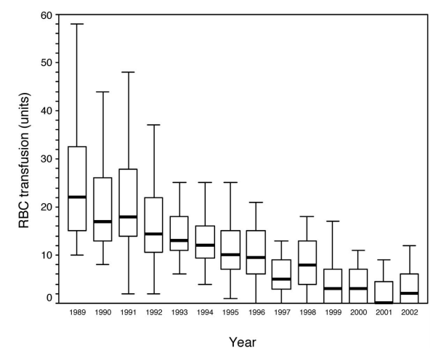
Figure 1 Red blood cell transfusion requirement in patients undergoing primary liver transplantation at the University Medical Centre, Groningen from 1989 to 2002. Data presented as box and whisker plots representing median, interquartile range and 5%-95% range. Both variation in transfusion and median number of RBC transfused has declined over time. From Porte et al^{[6]} 2004. RBC: Red blood cell.

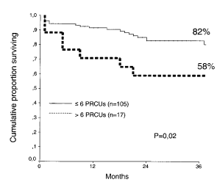
Figure 2 Kaplan meier survival curve demonstrating reduced survival in patients who received > 6 units red blood cell up to 36 mo post liver transplantation. From Ramos et al^{[13]}. PRCUs: Packed red cell units.

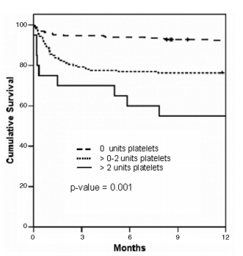
Figure 3 Kaplan Meier curve representing cumulative survival with transfusion of no, 0-2 units and > 2 units of platelets. From De Boer^{[14]} 2008.

Dysfibrinogen,
platelet dysfunction,
RES dysfunction
Platelets, vitamin K dependent factors (II, VII, IX and X), V, protein C and S, AT,
Plasminogen, α₂ – AP,
ADAMTS13
LPS, TF, vWF, FVIII, tPA, PAI-1
Increased up to 200%
Decreased to about 25-70%
5%
Low level balance
High risk of bleeding and thrombosis!

Figure 4 Fragile rebalancing of pro and anti-haemostatic factors with limited reserves leads to increased thrombotic and bleeding tendency. From Saner et al^{[43]} 2013. TF: Tissue factor; vWF: Von Willebrand Factor; FVIII: Factor III; tPA: Tissue plasminogen activator; PAI: Plasminogen activator inhibitor; ADAMTS13: A disintegrin and metalloproteinase with a thrombospondin type 1 motif, member 13; AT: Antithrombin; LPS: Lipopolysaccharide.

A
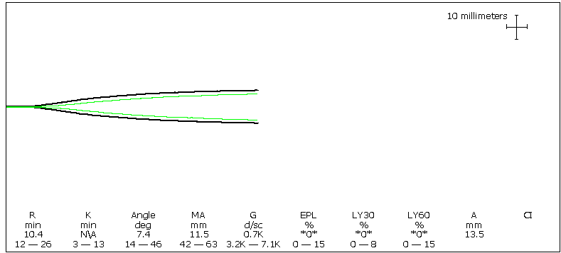
B
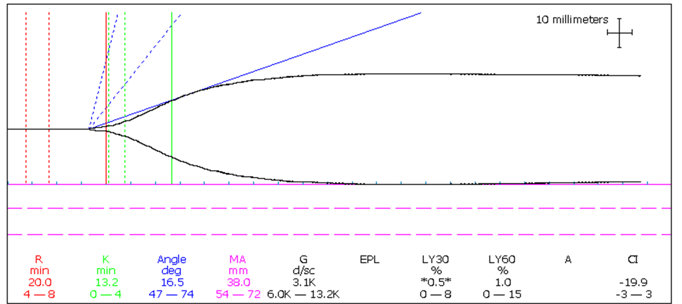
C
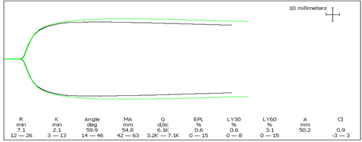
D
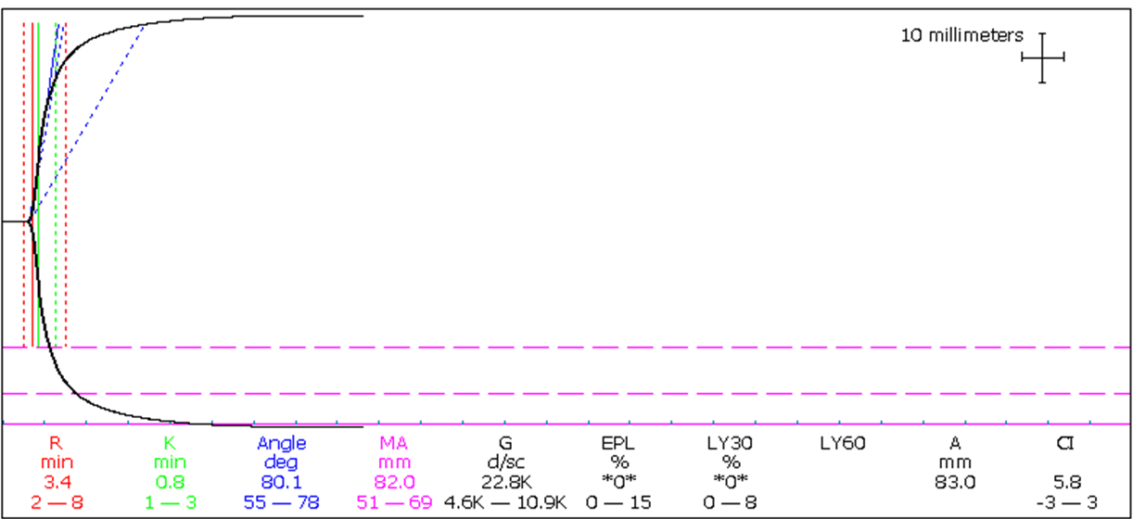
Figure 5 Thromboelastography traces depicting. A: Dilutional coagulopathy with loss of endogenous thrombin generating potential, low fibrinogen and platelets seen as a typical “arrowhead” trace; B: Hypocoagulable state with prolonged reaction (R) time but retention of thrombin generation; C: Normal coagulation profile; D: Hypercoagulability with a short R time, steep rate of clot formation (α angle) and increased clot maximum amplitude (MA).

 | TEG | ROTEM
Clot initiation or  Clotting time | R (reaction time) | CT (clotting time) | Period of initial fibrin formation
Clot Kinetics | K (K value) | CFT (clot formation time) | A measure of the speed to reach a specific level of clot strength
 | α (angle in degrees) | α | Measures the rate of clot formation, reflects fibrin rate of fibrin build up and cross linking
Clot strength | MA (maximum amplitude) | MCF (maximum clot firmness) | Represents the ultimate strength of the clot (platelets and fibrin) function of maximum dynamic properties of fibrin and platelet bonding via GPIIb/IIIa receptors
Clot stability | Ly39 (Lysis at 30 min as ratio of MA) | CLI (clot lyisis index) | Measures rate of amplitude reduction from MA at 30 min, detects fibrinolysis

Figure 6 Schematic of thromboelastography/rotational thromboelastometry parameters. TEG: Thromboelastography; K time, coagulation time (20-mm clot); Ly30: Lysis at 30 min; MA: Maximum amplitude; R time: Reaction time (2-mm clot); ROTEM: Rotational thromboelastometry; CFT: Clot formation time (20-mm clot); CLI: Clot lysis index; CT: Clotting time (2-mm clot); MCF: Maximum clot firmness; ML: Maximal lysis. From Mallett^{[37]} 2015.

A B
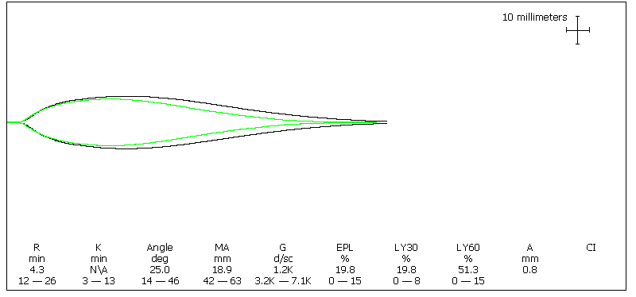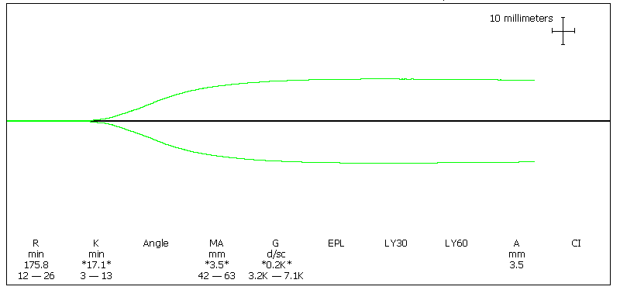
C D
Figure 7 Viscoelastic traces depicting hyperfibrinolysis (A) on thromboelastography and (C) on rotational thromboelastometry with APTEM test (reversal of fibrinolysis with aprotinin); Viscoelastic traces depicting heparin-like effect (B) on thromboelastography and (D) on Rotational thromboelastometry with reversal of heparin-like effect on HEPTEM. APTEM: Aprotinin thromboelastometry; HEPTEM: Heparinase modified thromboelastometry; INTEM: Intrinsic thromboelastometry CT: Clotting time; CFT: Clot formation time; A10: Clot firmness (amplitude) at 10 min; MCF: Maximum clot firmness; ML: Maximum lysis.

Thrombocytopenia Platelets
Fibrinogen deficiency
FC/Cryo
Surgical stanching
damage control surgery
Coagulation factor deficiency
4F PCC/FFP
rFVII
FXIII
Hyperfibrinolysis
TXA/EACA
Preconditions
Temp >35⁰C, pH,>7.2 Ca >1mmol/L, Hb >8g/dL
Drug history
?aspirin ?clopidogrel ?warfarin ?heparin

Figure 8 Pyramid of therapy in coagulopathy with sequence of hemostatic therapeutic interventions (from base to tip). Ca: Calcium; Hb: Haemoglobin; TXA: Tranexamic acid; EACA: Epsilon aminocaproic acid; FC: Fibrinogen concentrate; Cryo: Cryoprecipitate; rFVIIa: Recombinant activated factor VII; FXIII: Factor XIII. From Gorlinger et al^{[79]} 2006.

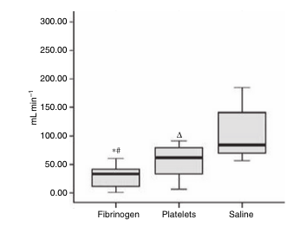
Figure 9 Rate of blood loss (mL/min) in thrombocytopenic pigs with an induced haemorrhagic liver injury infused with fibrinogen concentrate, platelet concentrate or saline. Lowest rate of blood loss seen in pigs infused with fibrinogen concentrate. ªP < 0.05 fibrinogen vs platelet group, ^{c}P<0.05 fibrinogen vs saline group, ^{e}P < 0.05 platelet vs saline group. From Velik-Salchner^{[103]} 2007.

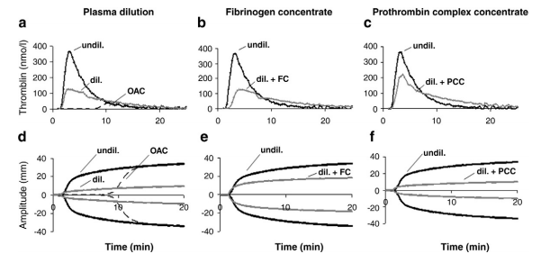
Figure 10 Effect of plasma dilution and factor deficiency on thrombin generation and fibrin clot formation. Representative curves of tissue factor‐induced thrombin generation (A-C) and fibrin clot formation (D-F) of undiluted normal plasma (undil.), 5 × diluted plasma (dil.), and plasma from patient taking oral anticoagulants (OAC, INR = 4). Effects of supplementing diluted plasma with fibrinogen concentrate (+ FC): increase in clot strength with no effect on thrombin generation (B, E). Effects of supplementing diluted plasma with prothrombin complex concentrate (+ PCC): increase in thrombin generation but no effect on clot strength (C, F). From Schols^{[105]} 2010.

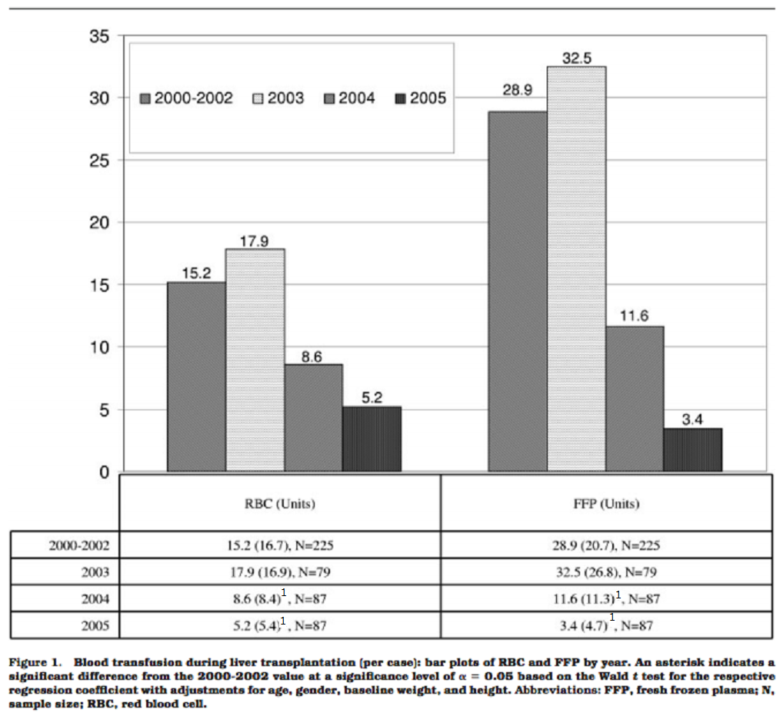
Figure 11 Blood transfusion during liver transplantation per case: Bar plots of red blood cells and fresh frozen plasma by year. ¹Indicates a significant difference from the 2000-2002 value at a significance level of P = 0.05 based on the Wald t test for the respective regression coefficient with adjustments for age, gender, baseline weight and height. FFP: Fresh frozen plasma; N: Samples size; RBC: Red blood cells. From Hevesi et al^{[125]} 2009.

