Name of Journal: World Journal of Gastrointestinal Oncology
Manuscript NO: 57834
Manuscript Type: ORIGINAL ARTICLE

Retrospective Cohort Study
Cholecystectomy reduces subsequent cholangiocarcinoma risk in choledocholithiasis patients undergoing endoscopic intervention

Wang CC et al. CCY reduces subsequent cholangiocarcinoma risk by decreasing RBEs

Chi-Chih Wang, Ming-Hseng Tseng, Sheng-Wen Wu, Tzu-Wei Yang, Hsuan-Yi Chen, Wen-Wei Sung, Chang-Cheng Su, Yao-Tung Wang, Chun-Che Lin, Ming-Chang Tsai

Chi-Chih Wang, Tzu-Wei Yang, Hsuan-Yi Chen, Chang-Cheng Su, Ming-Chang Tsai, Division of Gastroenterology and Hepatology, Department of Internal Medicine, Chung Shan Medical University Hospital, and Institute of Medicine, School of Medicine, Chung Shan Medical University, Taichung 40201, Taiwan

Ming-Hseng Tseng, Department of Medical Informatics, Chung Shan Medical University, Taichung 402, Taiwan

Sheng-Wen Wu, Department of Internal Medicine, Chung Shan Medical University Hospital and School of Medicine, Chung Shan Medical University, Taichung 402, Taiwan

Wen-Wei Sung, Department of Urology, Chung Shan Medical University Hospital, and Institute of Medicine, School of Medicine, Chung Shan Medical University, Taichung 40201, Taiwan

Yao-Tung Wang, Division of Pulmonary Medicine, Chung Shan Medical University Hospital, and Institute of Medicine, School of Medicine, Chung Shan Medical University, Taichung 402, Taiwan

Chun-Che Lin, Department of Internal Medicine, China Medical University Hospital and School of Medicine, China Medical University, Taichung 402, Taiwan

Author contributions: Wang CC and Tsai MC contributed to study conception and design; Tseng MH and Wu SW contributed to acquisition of the data; Wang CC, Wang YT, and Wu SW contributed to analysis and interpretation of the data; Wang CC, Yang TW, and Chen HY contributed to drafting of the manuscript; Tsai MC, Yang TW, Sung WW, and Lin CC contributed to critical revision of the manuscript; Tseng MH, Tsai MC, and Su CC contributed to statistical analysis; Tsai MC contributed to supervision.

Supported by Chung Shan Medical University Hospital Research program, No. CSH-2013-C-032.

Corresponding author: Ming-Chang Tsai, MD, PhD, Assistant Professor, Doctor, Division of Gastroenterology and Hepatology, Department of Internal Medicine, Chung Shan Medical University Hospital, No. 110, Sec. 1, Jianguo N. Road, South District, Taichung 402, Taiwan. tsaimc1110@gmail.com

Received: July 4, 2020
Revised: September 26, 2020
Accepted: October 30, 2020
Published online: December 15, 2020

Abstract
BACKGROUND
Cholangiocarcinoma is a disease with a high mortality rate. Our previous study revealed that cholelithiasis patients who undergo endoscopic sphincterotomy (ES)/endoscopic papillary balloon dilatation are at a higher risk for subsequent cholangiocarcinoma than cholelithiasis patients who undergo cholecystectomy.

AIM
To clarify the relationship between recurrent biliary events and subsequent cholangiocarcinoma risk in choledocholithiasis patients.

METHODS
From one million random cases in the Taiwan National Health Insurance Research Database 2004–2011, we selected symptomatic choledocholithiasis patients older than 18 years who were admitted from January 2005 to December 2009 (study group). Cases for a control group were defined as individuals who had never been diagnosed with cholelithiasis, matched by sex and age in a 1:3 ratio. The study group was further divided into ES/endoscopic papillary balloon dilatation, both ES/endoscopic papillary balloon dilatation and cholecystectomy, and no intervention groups.

RESULTS
We included 2096 choledocholithiasis patients without previous intervention or cholangiocarcinoma. A total of 12 (2.35%), 11 (0.74%), and 1 (1.00%) subsequent cholangiocarcinoma cases were diagnosed among 511 ES/endoscopic papillary balloon dilatation patients, 1485 patients with no intervention, and 100 ES/endoscopic papillary balloon dilatation and cholecystectomy patients, respectively. The incidence rates of recurrent biliary event were 527.79/1000 person-years and 286.69/1000 person-years in the subsequent cholangiocarcinoma and no cholangiocarcinoma group, showing a high correlation between subsequent cholangiocarcinoma risk and recurrent biliary events.

CONCLUSION
Choledocholithiasis patients who undergo further cholecystectomy after ES/endoscopic papillary balloon dilatation have decreased subsequent cholangiocarcinoma risk due to reduced recurrent biliary events.

Key Words: Cholangiocarcinoma; Endoscopic sphincterotomy; Endoscopic papillary balloon dilatation; Cholecystectomy; Recurrent biliary events

Citation: Wang CC, Tseng MH, Wu SW, Yang TW, Chen HY, Sung WW, Su CC, Wang YT, Lin CC, Tsai MC. Cholecystectomy reduces subsequent cholangiocarcinoma risk in choledocholithiasis patients undergoing endoscopic intervention. World J Gastrointest Oncol 2020; 12(12): 1381-1393
URL: https://www.wjgnet.com/1948-5204/full/v12/i12/1381.htm
DOI: https://dx.doi.org/10.4251/wjgo.v12.i12.1381

Core Tip: Choledocholithiasis patients who undergo further cholecystectomy after endoscopic sphincterotomy/endoscopic papillary balloon dilatation have a decreased subsequent cholangiocarcinoma risk. The relationship between the incidence of recurrent biliary events and that of subsequent cholangiocarcinoma is statistically meaningful.

INTRODUCTION
Cholangiocarcinoma, which carries a medium incidence and high mortality rate^{[1]}, has been under re-evaluation in Asia-Pacific countries^{[2,3]}. Over the past two decades, the incidence of intra-hepatic cholangiocarcinoma (ICC) has increased, while the incidence of extra-hepatic cholangiocarcinoma has declined internationally^{[4-7]}. The most important factor for survival in cholangiocarcinoma patients is R0 resection^{[8]}, and this means that a surveillance program that can lead to early detection is the key to survival.
There are many historical risk factors for cholangiocarcinoma that have been discussed in the previous literature, like primary sclerosing cholangitis^{[9-11]}, choledochal cyst disease^{[12,13]}, parasite infection^{[14]}, cholelithiasis^{[15,16]}, diabetes mellitus^{[17,18]}, and Helicobacter pylori infection^{[19,20]}. The impact of liver cirrhosis^{[21,22]} and chronic hepatitis C^{[23,24]} and B^{[21,22,25]} virus infections has also been confirmed in recent studies. Because the etiology of cholangiocarcinoma is not fully understood, several hypotheses were proposed to explain its cause, including chronic inflammation of the bile duct or the destruction of the integrity of the bile duct^{[26]}, such as from endoscopic retrograde cholangiopancreatography. The topic of endoscopic sphincterotomy and endoscopic papillary balloon dilatation (EPBD) and the late complication, like cholangiocarcinoma, is still a matter of debate^{[27-31]}, and the current evidence is insufficient for a conclusion to be drawn. Because cholelithiasis itself is an important risk factor for cholangiocarcinoma, the impact on the incidence of subsequent cholangiocarcinoma from advanced bile duct management is difficult to evaluate.
Although previous studies have shown differing results regarding cholecystectomy (CCY) due to cholelithiasis and subsequent ICC^{[32]} or extra-hepatic cholangiocarcinoma^{[33,34]}, our prior study revealed that cholelithiasis patients who undergo endoscopic sphincterotomy/endoscopic papillary balloon dilatation (ES/EPBD) are at a greater risk for subsequent cholangiocarcinoma, while cholelithiasis patients who undergo CCY have reduced risk for subsequent cholangiocarcinoma^{[3]}. These results can be explained by different inflammation sites or by CCY reducing recurrent biliary events (RBEs)^{[35]} and further decreasing future cholangiocarcinoma rates.
Because of the inconsistent results of the previous evidence, we performed this study using the National Health Insurance Research Database (NHIRD) 2004–2011 of Taiwan to clarify the risk of cholangiocarcinoma after ES/EPBD, ES/EPBD and CCY, and supportive care with no invasive intervention in patients who were admitted to the hospital because of choledocholithiasis.

MATERIALS AND METHODS
This study was a population-based retrospective cohort study based on Taiwan’s NHIRD 2004-2011, and the study methods of the NHIRD have been described in detail in previous studies^{[3,35-37]}. This study was approved by the Institutional Review Board (IRB) of Chung Shan Medical University Hospital, Taiwan. All methods were performed in accordance with the relevant guidelines and regulations and under surveillance by the IRB of Chung Shan Medical University Hospital. All authors declare they have no any conflict of interest to report.

Study design
Symptomatic choledocholithiasis cases in patients over 18 years old were obtained from among one million random samples of the NHIRD between January 2005 and December 2009 by the codes of the International Statistical Classification of Diseases and Related Health Problems, ninth revision (ICD-9), which were registered when patients were admitted to hospital. Then, we excluded patients who had already undergone ES/EPBD or CCY in 2004, were diagnosed with cholangiocarcinoma before 2005, or who had been diagnosed with cholangiocarcinoma prior to being diagnosed with choledocholithiasis. After the study group was selected, we built a control group, matched by sex and age in a 1:3 ratio. The cases for the control group were defined as individuals who had never been diagnosed with cholelithiasis or had never undergone a related medical procedure prior to 2005. The study group was further divided into ES/EPBD, ES/EPBD and CCY, and no intervention groups. Because cholangiocarcinoma patients in Taiwan use a catastrophic illness card to wave medical expenses when the patients seek for medical help using ICD-9 registration of cholangiocarcinoma, we believe that a 1-year exclusion period is enough. Variables such as economic status, place of residence, follow-up time, and historical common risk factors, including chronic hepatitis B (CHB), chronic hepatitis C, Helicobacter pylori infection, diabetes mellitus, end-stage renal disease on dialysis, congenital cystic disease of the liver, Clonorchis/Opisthorchis infection, and inflammatory bowel disease, were compared among the ES/EPBD, ES/EPBD and CCY, and no intervention groups. We calculated the number and rates for cholangiocarcinoma just after the procedure and then again 6, 12, and 18 mo after the procedure. The study flow chart is shown in Figure 1. The ICD-9 codes for the above diseases and procedure codes are listed in Supplementary Table 1.
Furthermore, we chose cholangiocarcinoma that occurred after the first 18 mo post-ES/EPBD or biliary event to be considered as subsequent cholangiocarcinoma because the incidence of cholangiocarcinoma during the first 18 mo were obviously higher than that in the following years (Figure 2) and this condition was most obvious in the no intervention group. We believed that these cases should be considered as concurrent malignancies rather than subsequent cholangiocarcinoma. The incidence of subsequent cholangiocarcinoma in patients in the ES/EPBD, ES/EPBD and CCY, or no intervention group was compared with that of the normal population. The time cumulative risk for subsequent cholangiocarcinoma in the different groups was calculated. The definition of RBEs was further ER visits or admission course due to cholangitis, cholecystitis, or biliary pancreatitis. The incidence of RBEs and that of subsequent cholangiocarcinoma were compared in different groups to identify their relationships.

Data processing and statistical analysis
The NHIRD was managed by employing the Microsoft SQL Server 2008 R2 (Microsoft Corporation, Redmond, WA, United States), and the data query and data processing procedures were done using the SQL programming language. Statistical analyses was performed using OpenEpi: Open Source Epidemiologic Statistics for Public Health, version 3.01^{[38]}. Kaplan-Meier survival analyses were completed using SPSS version 19. Person-time analyses were done using OpenEpi version 3.01.
Data obtained from the study were compared by a chi-square (χ²) test for the categorical variables, t-test or one-way ANOVA (analysis of variance) for the continuous variables, and log-rank (Mantel-Cox) test for the survival curves. A Cox regression model was used for analysis of the hazard ratio of subsequent cholangiocarcinoma. A two-tailed P-value of 0.05 was considered statistically significant in this study.

RESULTS
In total, 2204 adult symptomatic choledocholithiasis admission cases were obtained from one million random samples of the NHIRD between January 2005 and December 2009. After excluding 25 cases who had undergone ES/EPBD or CCY in 2004 and 7 cases with confirmed cholangiocarcinoma in 2004, we excluded another 76 cases who had a diagnosis of cholangiocarcinoma prior to a diagnosis of choledocholithiasis. We finally selected 2096 choledocholithiasis patients without prior ES/EPBD, CCY, or cholangiocarcinoma between January 2005 and December 2009. The control group, built with cases without cholelithiasis by matching by age and sex, included 6288 cases. The mean age was 66.18 years in both the study and control groups.

Choledocholithiasis cases undergoing ES/EPBD, ES/EPBD and CCY, and no intervention
There were 511 patients who had undergone ES/EPBD without CCY, while 100 patients had ES/EPBD with further CCY. At the same time, there were 1485 patients with choledocholithiasis who accepted supportive care without any further intervention during admission because of either disease severity or baseline health condition. Regarding the demographic data, the average age was 67.44 ± 15.23 years in the ES/EPBD group, 59.96 ± 16.87 years in the ES/EPBD and CCY group and 66.16 ± 16.02 years in the no intervention group.
We found that only age, age distribution, and follow-up time had statistically significant differences among the three groups in the demographic data, which also included gender, economic status, place of residence, and comorbidities. Patients who underwent ES/EPBD and CCY were younger than those in the ES/EPBD and no intervention groups, and they had the longest follow-up time, with 47.91 mo vs 42.77 mo and 36.14 mo, respectively. Meanwhile, the proportion of historical risk factors for cholangiocarcinoma, such as CHB, chronic hepatitis C, DM, end-stage renal disease on dialysis, cystic disease of the liver, Clonorchis/Opisthorchis infection, and inflammatory bowel disease, were similar in these three groups except that there was a non-significantly lower CHB proportion in the ES/EPBD and CCY group (3% vs 9.78% and 10.37%) in Table 1.
Thirty-nine (7.63%) patients were diagnosed with cholangiocarcinoma in the ES/EPBD group, while 90 cholangiocarcinoma (6.06%) patients were found in the no intervention group and four (4.00%) were diagnosed in the ES/EPBD and CCY group. Because the incidence of cholangiocarcinoma during the first 6 mo was extremely high in all groups and abnormally high during the first 18 mo in the no intervention group, we excluded the cholangiocarcinoma cases that were diagnosed during the first 18 mo after index admission to build the definition of subsequent cholangiocarcinoma. The detailed information is revealed in Figure 2. After the exclusion, 12 (2.35%), 11 (0.74%), and 1 (1.00%) subsequent cholangiocarcinoma cases were diagnosed in the ES/EPBD, no intervention, and ES/EPBD and CCY groups, respectively. The hazard ratio for subsequent cholangiocarcinoma was 3.45 in the ES/EPBD group and 1.31 in the ES/EPBD and CCY group when compared with the no intervention group. The results were similar in that the no intervention group had the lowest subsequent cholangiocarcinoma rate if we excluded the cholangiocarcinoma cases diagnosed within 6 mo or 1 year after index admission. The cumulative cholangiocarcinoma rates in the ES/EPBD, ES/EPBD and CCY, no intervention, and control groups during the 7-year follow-up period revealed that choledocholithiasis patients who needed an ES/EPBD intervention initially had the highest subsequent cholangiocarcinoma rate. The subsequent cholangiocarcinoma rate in the no intervention group exceeded that in the ES/EPBD and CCY group after the 5-year follow-up period. The cumulative subsequent cholangiocarcinoma rates in the ES/EPBD, ES/EPBD and CCY, no intervention, and control groups are shown in Figure 3.

Incidence of cholangiocarcinoma
As for the comparisons between the patients who had undergone ES/EPBD, ES/EPBD and CCY, and no intervention for choledocholithiasis and the normal population, the incidence of cholangiocarcinoma after the first 18 mo was compared using incidence rate/1000 person-years. In the ES/EPBD group, the incidence of subsequent cholangiocarcinoma was 7.23 (3.92–12.29) per 1000 person-years, which is more than 25 times the incidence in the normal population. The incidence of subsequent cholangiocarcinoma in the ES/EPBD group was higher especially in females (10.39/1000 person-years) and patients above 70 years old (8.42/1000 person-years).
In the ES/EPBD and CCY group, the incidence of subsequent cholangiocarcinoma was 2.54 (0.13–12.55) per 1000 person-years, which was higher than that of the normal population. As for choledocholithiasis patients without any intervention, the incidence of subsequent cholangiocarcinoma, which was 2.52 (1.35–4.38) per 1000 person-years, was similar to that in the ES/EPBD and CCY group. The incidence of subsequent cholangiocarcinoma was the highest in the ES/EPBD group, and it was almost equal in the ES/EPBD and CCY and no intervention groups. Meanwhile, the incidence of subsequent cholangiocarcinoma was significantly higher for all choledocholithiasis patients as compared to the normal population. The detailed information is shown in Table 2.

Relationship between RBEs and subsequent cholangiocarcinoma rate
We further analyzed the relationship between RBEs and the incidence of subsequent cholangiocarcinoma. Using the RBE incidence rate/1000 person-years of the no intervention group as a reference, the RBE incidence rate/1000 person-years of the ES/EPBD group was 350.06, which was significantly higher than that of the ES/EPBD and CCY and no intervention groups. Meanwhile, the incidence of subsequent cholangiocarcinoma was highest in the ES/EPBD group at 7.23/1000 person-years. Based on the idea that frequent RBEs may increase the subsequent cholangiocarcinoma rate, we separated the entire study group into two groups: Patients diagnosed with subsequent cholangiocarcinoma and patients without cholangiocarcinoma. The RBE incidence rates/1000 person-years were 527.79 and 286.69 in the subsequent cholangiocarcinoma group and the without cholangiocarcinoma group, respectively. The RBE event rate and the proportion of RBEs in patients with confirmed subsequent cholangiocarcinoma were significantly higher in our results.

DISCUSSION
Southeast Asia has the highest incidence of cholangiocarcinoma worldwide. Its annual incidence ranges from 0.1/100000 to 71.3/100000^{[39]}, and our reports came from this endemic area. Although the most famous risk factor for cholangiocarcinoma in the Western world is primary sclerosing cholangitis^{[10]}, this rarely occurs in Asian countries except in Japan. At the same time, choledochal cyst disease contributes to a more than 30-fold higher cholangiocarcinoma risk^{[40]} over that of the normal population, but this kind of disease is as rare as Clonorchis/Opisthorchis infection^{[14]} in patients in modern Taiwan. Because hepatolithiasis is associated with a 6- to 50-fold increased risk for ICC^{[40]} and there has been an increase in worldwide incidence of cholelithiasis in recent years^{[41,42]}, we analyzed the relationship between RBEs and the incidence of subsequent cholangiocarcinoma in choledocholithiasis patients who required admission for medical management.
Because we used only age and sex to find three times as many in the normal population without a cholelithiasis diagnosis to be our control group, other risk factors for cholangiocarcinoma may confound the results in our three study groups. Meanwhile, we can observe the distribution of these well-known risk factors for cholangiocarcinoma in the different groups.
We noticed that the subsequent and overall cholangiocarcinoma risks of choledocholithiasis patients were statistically higher than those of the normal population (Table 2 and Figure 3). These results are compatible with the previous literature in proving that cholelithiasis is an important risk factor for cholangiocarcinoma^{[15,16]}.
The comparison among the choledocholithiasis patients who had undergone ES/EPBD, ES/EPBD and CCY, and no intervention showed no statistically significant differences regarding previous risk factors for cholangiocarcinoma. Because the cholangiocarcinoma incidence was obviously higher during the first 6 mo after index admission in the ES/EPBD and ES/EPBD and CCY groups, we considered these events as initial misdiagnoses or concurrent cholangiocarcinoma events. Interestingly, we noticed that the incidence of cholangiocarcinoma in the choledocholithiasis patients who were admitted without any further endoscopic or surgical intervention was still abnormally higher during the 6–12 mo and 12–18 mo after index admission. Because there were no further advanced interventions in this group, we chose to exclude cholangiocarcinoma that occurred within 18 mo after index admission to build up the subsequent cholangiocarcinoma definition in our database. The subsequent cholangiocarcinoma cumulative risk was highest in the ES/EPBD group, and the cumulative risk for subsequent cholangiocarcinoma in the no intervention group gradually exceeded that of the ES/EPBD and CCY group as the observation time went by. The overall subsequent cholangiocarcinoma hazard ratios were 3.45, 1.31, and 1.0 in the ES/EPBD, ES/EPBD and CCY, and no intervention groups, respectively. This phenomenon can be explained by the fact that the greater the severity of the inflammation in the bile duct, the more advanced the interventions performed. Meanwhile, the frequency or severity of bile duct inflammatory events may increase the risk of subsequent cholangiocarcinoma. We believe that the lowest subsequent cholangiocarcinoma risk in the no intervention group comes from having fewer inflammatory events than the other two groups. We further hypothesize that more RBEs result in a higher subsequent cholangiocarcinoma rate. The comparisons between RBE incidence and subsequent cholangiocarcinoma incidence among the ES/EPBD, ES/EPBD and CCY, and no intervention groups showed a strong correlation: The incidence of RBEs was much higher in the choledocholithiasis patients who were later diagnosed with cholangiocarcinoma than in those who were not, which is shown in Table 3. These results prove that RBEs can increase the subsequent cholangiocarcinoma rate.
Second, we attempted to prove that early or delayed CCY can decrease subsequent cholangiocarcinoma risk by reducing future RBEs, and it has already been proved in the previous literature that early or delayed CCY can reduce future RBEs^{[35,43]}. In our study, the risk for subsequent cholangiocarcinoma in the no intervention group was initially low but gradually increased and exceeded that of the ES/EPBD and CCY group, starting with the fifth year after index admission. We believe that this result gives us a clue that CCY after ES/EPBD for choledocholithiasis management maybe reduces long-term subsequent cholangiocarcinoma risk by decreasing RBEs.
There are two major limitations to our study. First, this is a retrospective database cohort study that showed no laboratory data results or clinical images, and this makes concurrent cholangiocarcinoma or misdiagnoses initially hard to identify. That is why we excluded cholangiocarcinoma during the first 18 mo after index admission in our study design. Second, although this study used a representative database sample of one million patients, the incidence of cholangiocarcinoma was low, and we could only find 12, 1, and 11 cases in the ES/EPBD, ES/EPBD, and CCY and no intervention groups, respectively. However, the relationship between the incidence of RBEs and that of subsequent cholangiocarcinoma was statistically meaningful. Further large-scale retrospective or prospective studies are needed on this topic. We have already started to initiate a prospective hospital-based cohort study of cholelithiasis patients who have undergone therapeutic endoscopic or surgical interventions to clarify the results that we found in this retrospective cohort study.

CONCLUSION
In conclusion, choledocholithiasis patients who have undergone ES/EPBD intervention without further CCY have a 25–26-fold higher subsequent cholangiocarcinoma risk than the normal population. Further CCY in ES/EPBD patients decreases subsequent cholangiocarcinoma risk by reducing RBEs.

ARTICLE HIGHLIGHTS
Research background
Our previous study revealed that cholelithiasis patients who undergo endoscopic sphincterotomy/endoscopic papillary balloon dilatation (ES/EPBD) are at a greater risk for subsequent cholangiocarcinoma, while cholelithiasis patients who undergo cholecystectomy (CCY) have a much lower risk for subsequent cholangiocarcinoma.

Research motivation
Because of problems in prior study’s design, we could not identify whether different inflammation sites or CCY-reduced recurrent biliary events (RBEs) influenced the subsequent cholangiocarcinoma risk in cholelithiasis patients.

Research objectives
To evaluate the relationships of recurrent biliary events with subsequent cholangiocarcinoma risk.

Research methods
We selected symptomatic choledocholithiasis patients older than 18 years who were admitted from January 2005 to December 2009 from one million random samples in the National Health Insurance Research Database of Taiwan.

Research results
This study showed that choledocholithiasis patients who underwent further CCY after ES/EPBD can reduce subsequent cholangiocarcinoma risk from 2.35% to 1%. And the subsequent cholangiocarcinoma risks had a good correlation with RBEs in our study. Choledocholithiasis patients who have undergone an ES/EPBD intervention without further CCY had a 25–26-fold higher subsequent cholangiocarcinoma risk than the normal population.

Research conclusions
Further CCY in ES/EPBD patients decreases subsequent cholangiocarcinoma risk by reducing RBEs.

Research perspectives
This study not only showed different subsequent cholangiocarcinoma risks in the ES/EPBD, ES/EPBD and CCY, and no intervention groups of symptomatic choledocholithiasis patients, but also the significant relationship between the incidence of RBEs and that of subsequent cholangiocarcinoma.

REFERENCES
1 Chaiteerakij R, Pan-Ngum W, Poovorawan K, Soonthornworasiri N, Treeprasertsuk S, Phaosawasdi K. Characteristics and outcomes of cholangiocarcinoma by region in Thailand: A nationwide study. World J Gastroenterol 2017; 23: 7160-7167 [PMID: 29093624 DOI: 10.3748/wjg.v23.i39.7160]
2 Treeprasertsuk S, Poovorawan K, Soonthornworasiri N, Chaiteerakij R, Thanapirom K, Mairiang P, Sawadpanich K, Sonsiri K, Mahachai V, Phaosawasdi K. A significant cancer burden and high mortality of intrahepatic cholangiocarcinoma in Thailand: a nationwide database study. BMC Gastroenterol 2017; 17: 3 [PMID: 28056836 DOI: 10.1186/s12876-016-0565-6]
3 Wang CC, Tsai MC, Sung WW, Yang TW, Chen HY, Wang YT, Su CC, Tseng MH, Lin CC. Risk of cholangiocarcinoma in patients undergoing therapeutic endoscopic retrograde cholangiopancreatography or cholecystectomy: A population based study. World J Gastrointest Oncol 2019; 11: 238-249 [PMID: 30918596 DOI: 10.4251/wjgo.v11.i3.238]
4 Welzel TM, McGlynn KA, Hsing AW, O'Brien TR, Pfeiffer RM. Impact of classification of hilar cholangiocarcinomas (Klatskin tumors) on the incidence of intra- and extrahepatic cholangiocarcinoma in the United States. J Natl Cancer Inst 2006; 98: 873-875 [PMID: 16788161 DOI: 10.1093/jnci/djj234]
5 Patel T. Worldwide trends in mortality from biliary tract malignancies. BMC Cancer 2002; 2: 10 [PMID: 11991810 DOI: 10.1186/1471-2407-2-10]
6 West J, Wood H, Logan RF, Quinn M, Aithal GP. Trends in the incidence of primary liver and biliary tract cancers in England and Wales 1971-2001. Br J Cancer 2006; 94: 1751-1758 [PMID: 16736026 DOI: 10.1038/sj.bjc.6603127]
7 Patel T. Increasing incidence and mortality of primary intrahepatic cholangiocarcinoma in the United States. Hepatology 2001; 33: 1353-1357 [PMID: 11391522 DOI: 10.1053/jhep.2001.25087]
8 Zhou Y, Liu S, Wu L, Wan T. Survival after surgical resection of distal cholangiocarcinoma: A systematic review and meta-analysis of prognostic factors. Asian J Surg 2017; 40: 129-138 [PMID: 26337377 DOI: 10.1016/j.asjsur.2015.07.002]
9 Bergquist A, Ekbom A, Olsson R, Kornfeldt D, Lööf L, Danielsson A, Hultcrantz R, Lindgren S, Prytz H, Sandberg-Gertzén H, Almer S, Granath F, Broomé U. Hepatic and extrahepatic malignancies in primary sclerosing cholangitis. J Hepatol 2002; 36: 321-327 [PMID: 11867174 DOI: 10.1016/s0168-8278(01)00288-4]
10 Burak K, Angulo P, Pasha TM, Egan K, Petz J, Lindor KD. Incidence and risk factors for cholangiocarcinoma in primary sclerosing cholangitis. Am J Gastroenterol 2004; 99: 523-526 [PMID: 15056096 DOI: 10.1111/j.1572-0241.2004.04067.x]
11 Chapman MH, Webster GJ, Bannoo S, Johnson GJ, Wittmann J, Pereira SP. Cholangiocarcinoma and dominant strictures in patients with primary sclerosing cholangitis: a 25-year single-centre experience. Eur J Gastroenterol Hepatol 2012; 24: 1051-1058 [PMID: 22653260 DOI: 10.1097/MEG.0b013e3283554bbf]
12 Scott J, Shousha S, Thomas HC, Sherlock S. Bile duct carcinoma: a late complication of congenital hepatic fibrosis. Case report and review of literature. Am J Gastroenterol 1980; 73: 113-119 [PMID: 6249119]
13 Lipsett PA, Pitt HA, Colombani PM, Boitnott JK, Cameron JL. Choledochal cyst disease. A changing pattern of presentation. Ann Surg 1994; 220: 644-652 [PMID: 7979612 DOI: 10.1097/00000658-199411000-00007]
14 Watanapa P, Watanapa WB. Liver fluke-associated cholangiocarcinoma. Br J Surg 2002; 89: 962-970 [PMID: 12153620 DOI: 10.1046/j.1365-2168.2002.02143.x]
15 Welzel TM, Mellemkjaer L, Gloria G, Sakoda LC, Hsing AW, El Ghormli L, Olsen JH, McGlynn KA. Risk factors for intrahepatic cholangiocarcinoma in a low-risk population: a nationwide case-control study. Int J Cancer 2007; 120: 638-641 [PMID: 17109384 DOI: 10.1002/ijc.22283]
16 Hsing AW, Gao YT, Han TQ, Rashid A, Sakoda LC, Wang BS, Shen MC, Zhang BH, Niwa S, Chen J, Fraumeni JF Jr. Gallstones and the risk of biliary tract cancer: a population-based study in China. Br J Cancer 2007; 97: 1577-1582 [PMID: 18000509 DOI: 10.1038/sj.bjc.6604047]
17 Jing W, Jin G, Zhou X, Zhou Y, Zhang Y, Shao C, Liu R, Hu X. Diabetes mellitus and increased risk of cholangiocarcinoma: a meta-analysis. Eur J Cancer Prev 2012; 21: 24-31 [PMID: 21857525 DOI: 10.1097/CEJ.0b013e3283481d89]
18 Zhang LF, Zhao HX. Diabetes mellitus and increased risk of extrahepatic cholangiocarcinoma: a meta-analysis. Hepatogastroenterology 2013; 60: 684-687 [PMID: 23321031 DOI: 10.5754/hge12966]
19 Chang JS, Tsai CR, Chen LT. Medical risk factors associated with cholangiocarcinoma in Taiwan: a population-based case-control study. PLoS One 2013; 8: e69981 [PMID: 23894567 DOI: 10.1371/journal.pone.0069981]
20 Murphy G, Michel A, Taylor PR, Albanes D, Weinstein SJ, Virtamo J, Parisi D, Snyder K, Butt J, McGlynn KA, Koshiol J, Pawlita M, Lai GY, Abnet CC, Dawsey SM, Freedman ND. Association of seropositivity to Helicobacter species and biliary tract cancer in the ATBC study. Hepatology 2014; 60: 1963-1971 [PMID: 24797247 DOI: 10.1002/hep.27193]
21 Palmer WC, Patel T. Are common factors involved in the pathogenesis of primary liver cancers? A meta-analysis of risk factors for intrahepatic cholangiocarcinoma. J Hepatol 2012; 57: 69-76 [PMID: 22420979 DOI: 10.1016/j.jhep.2012.02.022]
22 Razumilava N, Gores GJ. Cholangiocarcinoma. Lancet 2014; 383: 2168-2179 [PMID: 24581682 DOI: 10.1016/S0140-6736(13)61903-0]
23 El-Serag HB, Engels EA, Landgren O, Chiao E, Henderson L, Amaratunge HC, Giordano TP. Risk of hepatobiliary and pancreatic cancers after hepatitis C virus infection: A population-based study of U.S. veterans. Hepatology 2009; 49: 116-123 [PMID: 19085911 DOI: 10.1002/hep.22606]
24 Shin HR, Lee CU, Park HJ, Seol SY, Chung JM, Choi HC, Ahn YO, Shigemastu T. Hepatitis B and C virus, Clonorchis sinensis for the risk of liver cancer: a case-control study in Pusan, Korea. Int J Epidemiol 1996; 25: 933-940 [PMID: 8921477 DOI: 10.1093/ije/25.5.933]
25 Sekiya S, Suzuki A. Intrahepatic cholangiocarcinoma can arise from Notch-mediated conversion of hepatocytes. J Clin Invest 2012; 122: 3914-3918 [PMID: 23023701 DOI: 10.1172/JCI63065]
26 Kurumado K, Nagai T, Kondo Y, Abe H. Long-term observations on morphological changes of choledochal epithelium after choledochoenterostomy in rats. Dig Dis Sci 1994; 39: 809-820 [PMID: 8149847 DOI: 10.1007/BF02087428]
27 Kalaitzis J, Vezakis A, Fragulidis G, Anagnostopoulou I, Rizos S, Papalambros E, Polydorou A. Effects of endoscopic sphincterotomy on biliary epithelium: a case-control study. World J Gastroenterol 2012; 18: 794-799 [PMID: 22371639 DOI: 10.3748/wjg.v18.i8.794]
28 Oliveira-Cunha M, Dennison AR, Garcea G. Late Complications After Endoscopic Sphincterotomy. Surg Laparosc Endosc Percutan Tech 2016; 26: 1-5 [PMID: 26679684 DOI: 10.1097/SLE.0000000000000226]
29 Peng YC, Lin CL, Hsu WY, Chow WK, Lee SW, Yeh HZ, Chang CS, Kao CH. Association of Endoscopic Sphincterotomy or Papillary Balloon Dilatation and Biliary Cancer: A Population-Based Cohort Study. Medicine (Baltimore) 2015; 94: e926 [PMID: 26061315 DOI: 10.1097/MD.0000000000000926]
30 Langerth A, Sandblom G, Karlson BM. Long-term risk for acute pancreatitis, cholangitis, and malignancy more than 15 years after endoscopic sphincterotomy: a population-based study. Endoscopy 2015; 47: 1132-1136 [PMID: 26165737 DOI: 10.1055/s-0034-1392482]
31 Strömberg C, Böckelman C, Song H, Ye W, Pukkala E, Haglund C, Nilsson M. Endoscopic sphincterotomy and risk of cholangiocarcinoma: a population-based cohort study in Finland and Sweden. Endosc Int Open 2016; 4: E1096-E1100 [PMID: 27747285 DOI: 10.1055/s-0042-114982]
32 Guo L, Mao J, Li Y, Jiao Z, Guo J, Zhang J, Zhao J. Cholelithiasis, cholecystectomy and risk of hepatocellular carcinoma: a meta-analysis. J Cancer Res Ther 2014; 10: 834-838 [PMID: 25579515 DOI: 10.4103/0973-1482.135992]
33 Tao LY, He XD, Qu Q, Cai L, Liu W, Zhou L, Zhang SM. Risk factors for intrahepatic and extrahepatic cholangiocarcinoma: a case-control study in China. Liver Int 2010; 30: 215-221 [PMID: 19840244 DOI: 10.1111/j.1478-3231.2009.02149.x]
34 Nordenstedt H, Mattsson F, El-Serag H, Lagergren J. Gallstones and cholecystectomy in relation to risk of intra- and extrahepatic cholangiocarcinoma. Br J Cancer 2012; 106: 1011-1015 [PMID: 22240785 DOI: 10.1038/bjc.2011.607]
35 Wang CC, Tsai MC, Wang YT, Yang TW, Chen HY, Sung WW, Huang SM, Tseng MH, Lin CC. Role of Cholecystectomy in Choledocholithiasis Patients Underwent Endoscopic Retrograde Cholangiopancreatography. Sci Rep 2019; 9: 2168 [PMID: 30778100 DOI: 10.1038/s41598-018-38428-z]
36 Wu CY, Kuo KN, Wu MS, Chen YJ, Wang CB, Lin JT. Early Helicobacter pylori eradication decreases risk of gastric cancer in patients with peptic ulcer disease. Gastroenterology 2009; 137: 1641-8.e1-2 [PMID: 19664631 DOI: 10.1053/j.gastro.2009.07.060]
37 Wu CY, Chan FK, Wu MS, Kuo KN, Wang CB, Tsao CR, Lin JT. Histamine2-receptor antagonists are an alternative to proton pump inhibitor in patients receiving clopidogrel. Gastroenterology 2010; 139: 1165-1171 [PMID: 20600012 DOI: 10.1053/j.gastro.2010.06.067]
38 Dean AG, Sullivan KM, Soe MM. OpenEpi: Open Source Epidemiologic Statistics for Public Health, Version. Available from: https://www.scienceopen.com/document?vid=61cdd360-9883-4330-8c18-3f0341b0f715
39 Blechacz B. Cholangiocarcinoma: Current Knowledge and New Developments. Gut Liver 2017; 11: 13-26 [PMID: 27928095 DOI: 10.5009/gnl15568]
40 Tyson GL, El-Serag HB. Risk factors for cholangiocarcinoma. Hepatology 2011; 54: 173-184 [PMID: 21488076 DOI: 10.1002/hep.24351]
41 Shaffer EA. Epidemiology and risk factors for gallstone disease: has the paradigm changed in the 21st century? Curr Gastroenterol Rep 2005; 7: 132-140 [PMID: 15802102 DOI: 10.1007/s11894-005-0051-8]
42 Shaffer EA. Gallstone disease: Epidemiology of gallbladder stone disease. Best Pract Res Clin Gastroenterol 2006; 20: 981-996 [PMID: 17127183 DOI: 10.1016/j.bpg.2006.05.004]
43 Huang RJ, Barakat MT, Girotra M, Banerjee S. Practice Patterns for Cholecystectomy After Endoscopic Retrograde Cholangiopancreatography for Patients With Choledocholithiasis. Gastroenterology 2017; 153: 762-771.e2 [PMID: 28583822 DOI: 10.1053/j.gastro.2017.05.048]

Footnotes
Institutional review board statement: This study was approved by the Institutional Review Board (IRB) of Chung Shan Medical University Hospital, Taiwan. All methods were performed in accordance with the relevant guidelines and regulations and under surveillance by the IRB of Chung Shan Medical University Hospital.

Conflict-of-interest statement: Chun-Che Lin has received research funding from Chung Shan Medical University Hospital Research program (CSH- 2013-C-032) for national health insurance data collection.

Data sharing statement: No additional data are available.

STROBE statement: The authors have read the STROBE Statement—checklist of items, and the manuscript was prepared and revised according to the STROBE Statement—checklist of items.

Open-Access: This article is an open-access article that was selected by an in-house editor and fully peer-reviewed by external reviewers. It is distributed in accordance with the Creative Commons Attribution NonCommercial (CC BY-NC 4.0) license, which permits others to distribute, remix, adapt, build upon this work non-commercially, and license their derivative works on different terms, provided the original work is properly cited and the use is non-commercial. See: http://creativecommons.org/Licenses/by-nc/4.0/

Manuscript source: Unsolicited manuscript

Corresponding Author's Membership in Professional Societies: The Gastroenterological Society of Taiwan.

Peer-review started: July 4, 2020
First decision: September 18, 2020
Article in press: October 30, 2020

Specialty type: Gastroenterology and hepatology
Country/Territory of origin: Taiwan
Peer-review report’s scientific quality classification
Grade A (Excellent): 0
Grade B (Very good): 0
Grade C (Good): C
Grade D (Fair): D
Grade E (Poor): 0

P-Reviewer: Kawabata H, Kitamura K S-Editor: Zhang L L-Editor: Wang TQ P-Editor: Li JH

Figure Legends
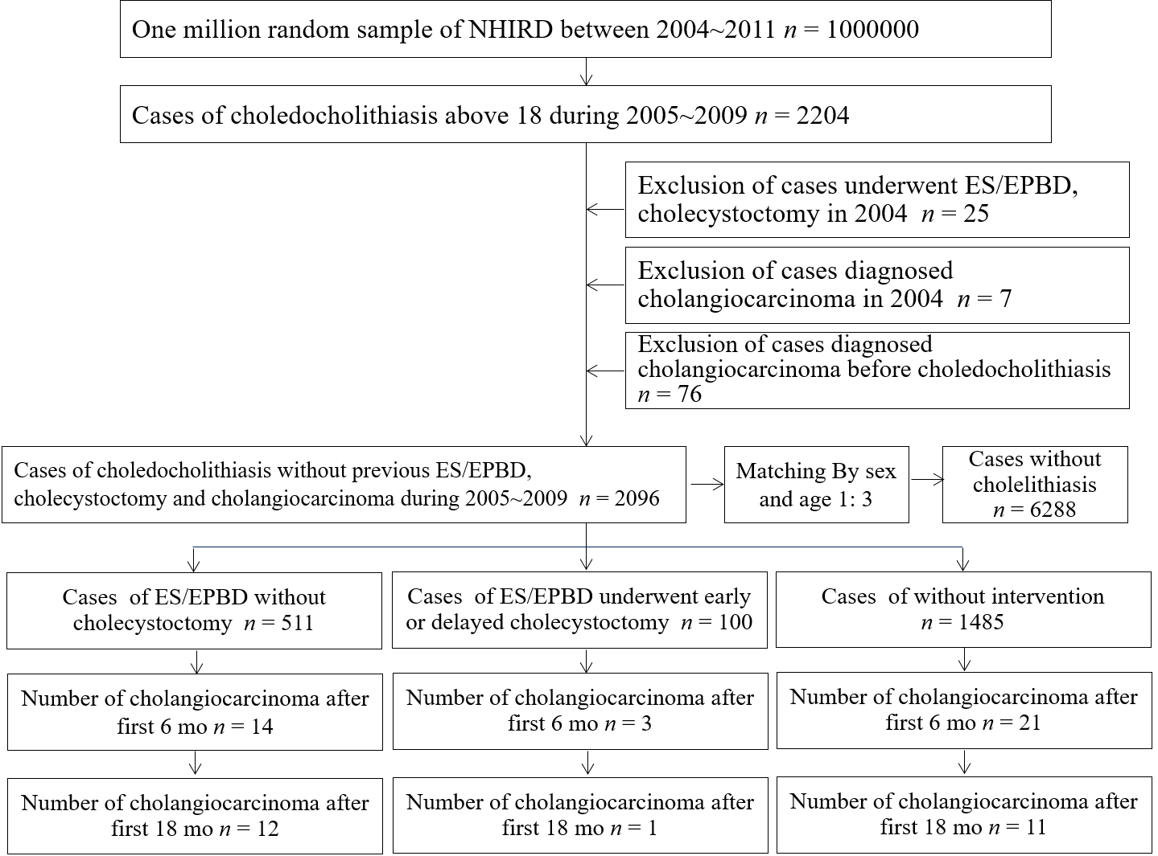
Figure 1 Case selection flow chart for the one million nationwide representative database. ES: Endoscopic sphincterotomy; EPBD: Endoscopic papillary balloon dilatation; nhird: National Health Insurance Research Database.

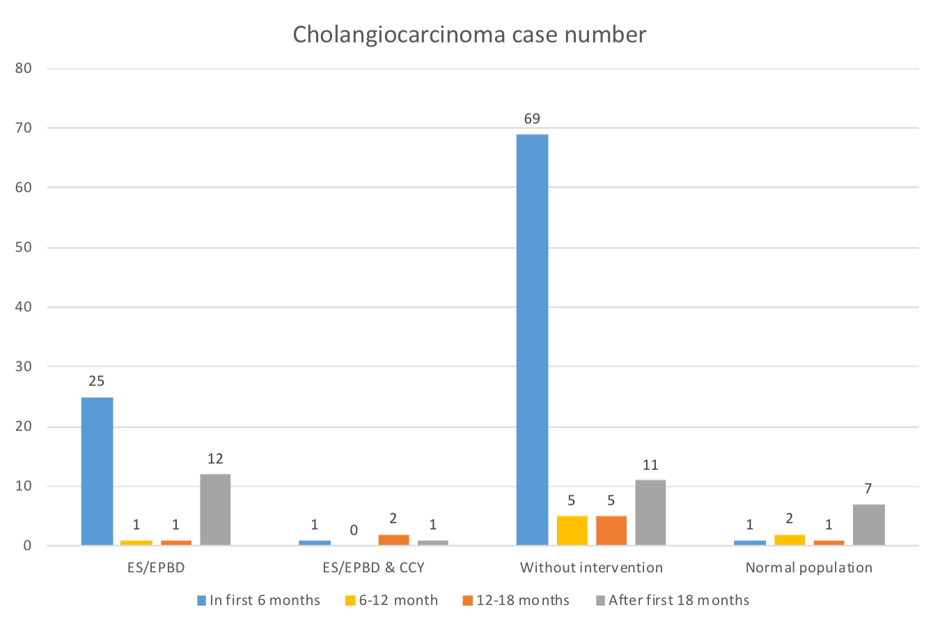
Figure 2 Cholangiocarcinoma cases diagnosed during different follow-up periods in the endoscopic sphincterotomy/endoscopic papillary balloon dilatation group, endoscopic sphincterotomy/endoscopic papillary balloon dilatation and cholecystectomy group, no intervention group, and normal population. ES: Endoscopic sphincterotomy; EPBD: Endoscopic papillary balloon dilatation; CCY: Cholecystectomy.
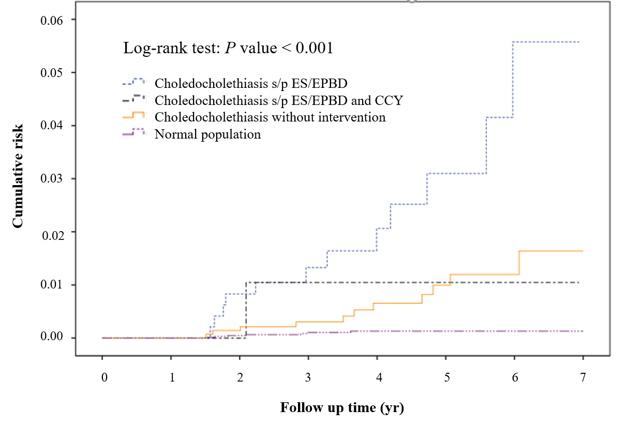
Figure 3 Cumulative subsequent cholangiocarcinoma risk in the endoscopic sphincterotomy/endoscopic papillary balloon dilatation group, endoscopic sphincterotomy/endoscopic papillary balloon dilatation and cholecystectomy group, no intervention group, and normal population (The cases of cholangiocarcinoma within 18 mo after index admission were excluded). ES: Endoscopic sphincterotomy; EPBD: Endoscopic papillary balloon dilatation; CCY: Cholecystectomy.

Table 1 Comparisons of choledocholithiasis patients who underwent endoscopic sphincterotomy/endoscopic papillary balloon dilatation, endoscopic sphincterotomy/endoscopic papillary balloon dilatation and cholecystectomy, and no intervention
 | ES/EPBD, n = 511, n (SD; %) | ES/EPBD and CCY, n = 100, n (SD; %) | Without intervention, n = 1485, n (SD; %) | P value
Age, mean (SD) | 67.44 (15.23) | 59.96 (16.87) | 66.16 (16.02) | < 0.001
Age, yr
18-49 | 40.08 (6.91) | 39.13 (8.43) | 39.48 (6.76)
50-69 | 60.48 (5.43) | 58.21 (5.88) | 60.14 (5.55)
> 70 | 79.45 (6.02) | 77.58 (4.71) | 79.89 (6.43)
Gender |  |  |  | 0.450
Male | 282 (55.19) | 49 (49.00) | 824 (55.49)
Female | 229 (44.81) | 51 (51.00) | 661 (44.51)
Follow-up time (mo), mean (SD) | 42.77 (22.20) | 47.91 (20.86) | 36.14 (24.87) | < 0.001
Economic status |  |  |  | 0.445
MBS | 292 (57.14) | 54 (54.00) | 867 (58.38)
1-3 times MBS | 189 (36.99) | 36 (36.00) | 536 (36.09)
Above 3 times MBS | 29 (5.68) | 10 (10.00) | 82 (5.52)
Place of residence |  |  |  | 0.154
City | 288 (56.36) | 68 (68.00) | 900 (60.61)
Countryside | 213 (41.68) | 31 (31.00) | 551 (37.10)
Remote village | 9 (1.76) | 1 (1.00) | 33 (2.22)
Comorbidity
CHB | 50 (9.78) | 3 (3.00) | 154 (10.37) | 0.057
CHC | 23 (4.50) | 5 (5.00) | 103 (6.94) | 0.127
DM | 172 (33.66) | 29 (29.00) | 504 (33.94) | 0.599
ESRD | 8 (1.57) | 1 (1.00) | 32 (2.15) | 0.552
CCDL | 12 (2.35) | 2 (2.00) | 20 (1.35) | 0.289
CO | 0 (0.00) | 0 (0.00) | 0 (0.00) | 1.000
IBD | 8 (1.57) | 0 (0.00) | 32 (2.15) | 0.253
Cholangiocarcinoma
Number of CC | 39 (7.63) | 4 (4.00) | 90 (6.06) | 0.279
Number of CC after first 18 mo | 12 (2.35) | 1 (1.00) | 11 (0.74) | 0.013
Hazard ratio | 3.45 (1.52-7.82) | 1.31 (0.17-10.13) | 1.00 | 0.012
Time to diagnosis of CC (excluding case in first 18 mo), month | 39.71 (18.93) | 25.12 (0.00) | 43.27 (17.98) | 0.624
Overall mortality rate | 146 (28.57) | 12 (12.00) | 596 (40.13) | < 0.001
ES: Endoscopic sphincterotomy; EPBD: Endoscopic papillary balloon dilatation; CCY: Cholecystectomy; SD: Standard deviation; MBS: Minimum basic salary; CHB: Chronic hepatitis B; CHC: Chronic hepatitis C; HP: Helicobacter infection; DM: Diabetes mellitus; ESRD: End-stage renal disease; CCDL: Congenital cystic disease of liver; CO: Clonorchis/Opisthorchis; IBD: Inflammatory bowel disease; CC: Cholangiocarcinoma.

Table 2 Incidence of cholangiocarcinoma among patients with choledocholithiasis who underwent therapeutic endoscopic retrograde cholangiopancreatography, endoscopic retrograde cholangiopancreatography and cholecystectomy, or no intervention compared with normal population (excluding cholangiocarcinoma in the first 18 mo)
Variable | Person-years at risk in study cohort | Person-years at risk in control cohort | No. of observed cases of cholangiocarcinoma in study cohort | No. of observed cases of cholangiocarcinoma in control cohort | Incidence rate/1000 person-years (95%CI) in study cohort | Incidence rate/1000 person-years (95%CI) in control cohort | P value
ES/EPBD
Total | 1659.70 | 25360.07 | 12 | 7 | 7.23 (3.92-12.29) | 0.28 (0.12-0.55) | < 0.001
Gender
Male | 889.95 | 13822.88 | 4 | 3 | 4.50 (1.43-10.84) | 0.22 (0.06-0.59) | < 0.001
Female | 769.76 | 11537.20 | 8 | 4 | 10.39 (4.83-19.74) | 0.35 (0.11-0.84) | < 0.001
Age, years
18-49 | 253.84 | 4392.03 | 1 | 0 | 3.94 (0.20-19.43) | 0.00 (0.00-0.00) | < 0.001
50-69 | 574.78 | 8631.76 | 4 | 5 | 6.96 (2.21-16.79) | 0.58 (0.21-1.28) | < 0.001
> 70 | 831.08 | 12336.28 | 7 | 2 | 8.42 (3.68-16.66) | 0.16 (0.03-0.54) | < 0.001
ES/EPBD and CCY
Total | 393.11 | 25360.07 | 1 | 7 | 2.54 (0.13-12.55) | 0.28 (0.12-0.55) | 0.011
Gender
Male | 184.36 | 13822.88 | 0 | 3 | 0.00 (0.00-0.00) | 0.22 (0.06-0.59) | 0.842
Female | 208.75 | 11537.20 | 1 | 4 | 4.79 (0.24-23.63) | 0.35 (0.11-0.84) | 0.002
Age, yr
18-49 | 113.01 | 4392.03 | 0 | 0 | 0.00 (0.00-0.00) | 0.00 (0.00-0.00) | NA
50-69 | 143.37 | 8631.76 | 1 | 5 | 6.98 (0.35-34.40) | 0.58 (0.21-1.28) | 0.004
> 70 | 136.73 | 12336.28 | 0 | 2 | 0.00 (0.00-0.00) | 0.16 (0.03-0.54) | 0.882
Without intervention
Total | 4364.45 | 25360.07 | 11 | 7 | 2.52 (1.35-4.38) | 0.28 (0.12-0.55) | < 0.001
Gender
Male | 2345.22 | 13822.88 | 6 | 3 | 2.56 (1.04-5.32) | 0.22 (0.06-0.59) | < 0.001
Female | 2019.23 | 11537.20 | 5 | 4 | 2.48 (0.91-5.49) | 0.35 (0.11-0.84) | < 0.001
Age, yr
18-49 | 871.87 | 4392.03 | 0 | 0 | 0.00 (0.00-0.00) | 0.00 (0.00-0.00) | NA
50-69 | 1528.74 | 8631.76 | 6 | 5 | 3.93 (1.601-8.16) | 0.58 (0.21-1.28) | < 0.001
> 70 | 1963.84 | 12336.28 | 5 | 2 | 2.55 (0.93-5.64) | 0.16 (0.03-0.54) | < 0.001
ES: Endoscopic sphincterotomy; EPBD: Endoscopic papillary balloon dilatation; CCY: Cholecystectomy; NA: Not applicable.
Table 3 Recurrent biliary event incidence and relationship with cholangiocarcinoma incidence among patients with choledocholithiasis underwent therapeutic endoscopic retrograde cholangiopancreatography, endoscopic retrograde cholangiopancreatography and cholecystectomy, or without intervention (excluding cholangiocarcinoma in the first 18 mo)
Variable | Number of RBE events | Number of RBE patients | RBE per person (SD) | Incidence proportion (person) | Person-years | Cholangiocarcinoma incidence rate/1000 person-years | RBEs incidence rate/1000 person-years | P value
ES/EPBD, n = 511 | 581 | 126 | 1.14 (2.28) | 24.66% | 1659.70 | 7.23 | 350.06 | < 0.001¹
ES/EPBD and CCY, n = 100 | 70 | 14 | 0.70 (1.36) | 14.00% | 393.11 | 2.54 | 178.07 | < 0.001¹
Choledocholithiasis without intervention, n = 1485 | 1213 | 286 | 0.82 (1.52) | 19.26% | 4364.45 | 2.52 | 277.93 | Reference
Patients had cholangiocarcinoma after 18 mo, n = 24 | 43 | 10 | 1.79 (2.06) | 41.67% | 81.47 | NA | 527.79 | < 0.001
Patients without cholangiocarcinoma, n = 1963 | 1812 | 414 | 0.92 (1.76) | 21.09% | 6320.31 | NA | 286.69 | Reference
¹Z-score. ES: Endoscopic sphincterotomy; EPBD: Endoscopic papillary balloon dilatation; CCY: Cholecystectomy; RBE: Recurrent biliary event; NA: Not applicable.

