Name of journal: World Journal of Gastroenterology
ESPS Manuscript NO: 17196
Manuscript Type: ORIGINAL ARTICLE

Observational Study
Characteristics of symptomatic reflux episodes in Japanese proton pump inhibitor-refractory non-erosive reflux disease patients

Nakagawa K et al. Characteristics of reflux episodes in NERD

Kenichiro Nakagawa, Tomoyuki Koike, Katsunori Iijima, Masahiro Saito, Hiroki Kikuchi, Waku Hatta, Nobuyuki Ara, Kaname Uno, Naoki Asano, Tooru Shimosegawa

Kenichiro Nakagawa, Tomoyuki Koike, Katsunori Iijima, Masahiro Saito, Hiroki Kikuchi, Waku Hatta, Nobuyuki Ara, Kaname Uno, Naoki Asano, Tooru Shimosegawa, Division of Gastroenterology, Tohoku University Graduate School of Medicine, Sendai Miyagi 980-8574, Japan

Author contributions: All authors contributed to the manuscript.

Institutional review board statement: This study was approved by the Tohoku University Hospital Ethics Committee.

Informed consent statement: Informed consent was obtained from all subjects.

Conflict-of-interest statement: The authors declare that they have no conflicts of interest.

Data sharing statement: The technical appendix, statistical code, and dataset are available from the corresponding author at tkoike@rd5.so-net.ne.jp.

Open-Access: This article is an open-access article which was selected by an in-house editor and fully peer-reviewed by external reviewers. It is distributed in accordance with the Creative Commons Attribution Non Commercial (CC BY-NC 4.0) license, which permits others to distribute, remix, adapt, build upon this work non-commercially, and license their derivative works on different terms, provided the original work is properly cited and the use is non-commercial. See: http://creativecommons.org/licenses/by-nc/4.0/

Correspondence to: Tomoyuki Koike, MD, PhD, Division of Gastroenterology, Tohoku University Graduate School of Medicine, 1-1 Seiryo-machi Aoba-ku, Sendai Miyagi 980-8574, Japan. tkoike@rd5.so-net.ne.jp
Telephone: +81-22-7177171
Fax: +81-22-7177177

Received: February 23, 2015
Peer-review started: February 24, 2015
First decision: March 26, 2015
Revised: April 13, 2015
Accepted: September 30, 2015
Article in press:
Published online:

Abstract
AIM: To clarify the pathogenesis of gastroesophageal reflux disease symptoms in non-erosive reflux disease (NERD) patients.

METHODS: Thirty-five NERD patients with persistent symptoms, despite taking rabeprazole 10 mg twice daily for at least 8 wk, were included. All patients underwent 24-h combined impedance - pH on rabeprazole. The symptom index (SI) was considered to be positive if ≥ 50%, and proximal reflux episodes were determined when reflux reached 15 cm above the proximal margin of the lower esophageal sphincter.

RESULTS: In 14 (40%) SI-positive patients with liquid weakly acid reflux, the occurrence rate of reflux symptoms in proximal reflux episodes was significantly more frequent (46.7%) than in distal ones (5.7%) (P < 0.001). With liquid acid reflux, there were no significant differences in the occurrence rate of reflux symptoms between proximal reflux episodes (38.5%) and distal ones (20.5%). With mixed liquid-gas weakly acid reflux, the occurrence rate of reflux symptoms in proximal reflux episodes was significantly more frequent (31.0%) than in distal reflux ones (3.3%) (P < 0.001). With mixed liquid-gas acid reflux, there were no significant differences in the occurrence rate of reflux symptoms between proximal reflux episodes (29.4%) and distal ones (14.3%).

CONCLUSION: The proximal extent of weakly acidic liquid and mixed liquid-gas reflux is a major factor associated with reflux perception in SI-positive patients on PPI therapy.

Key words: Proton pump inhibitor; Symptomatic reflux episodes; Proximal reflux; Non-erosive reflux disease; Impedance-pH monitoring

© The Author(s) 2015. Published by Baishideng Publishing Group Inc. All rights reserved.

Core tip: Thirty-five non-erosive reflux disease patients with persistent symptoms, despite taking rabeprazole 10 mg twice daily for at least 8 wk, were included. In 14 (40%) symptom index (SI)-positive patients with liquid weakly acid reflux, the occurrence rate of reflux symptoms in proximal reflux episodes was significantly more frequent (46.7%) than in distal ones (5.7%) (P < 0.001). With liquid acid reflux, there were no significant differences in the occurrence rate of reflux symptoms between proximal reflux episodes (38.5%) and distal ones (20.5%). The proximal extent of weakly acidic liquid and mixed liquid-gas reflux is a major factor associated with reflux perception in SI-positive patients on proton pump inhibitors therapy.

Nakagawa K, Koike T, Iijima K, Saito M, Kikuchi H, Hatta W, Ara N, Uno K, Asano N, Shimosegawa T. Characteristics of symptomatic reflux episodes in Japanese proton pump inhibitor-refractory non-erosive reflux disease patients. World J Gastroenterol 2015; In press

INTRODUCTION
The reflux of gastric juice containing acid, bile, and pepsin into the esophagus is a causal factor of gastroesophageal reflux disease (GERD). It was reported that the incidence of GERD has increased significantly in each of the last two decades in western countries^{[1]}. The incidence of GERD is also increasing in Japan as well as in the West^{[2]} because of the decreasing prevalence of Helicobacter pylori (H. pylori) infection and westernization of the diet in recent decades.
Proton pump inhibitors (PPIs) are commonly used as the first-line treatment because of their high effectiveness and prolonged duration in suppressing of gastric acid secretion. Several studies have demonstrated that non-erosive reflux disease (NERD) patients are less sensitive to PPI treatment than patients with erosive reflux disease (ERD)^{[3-5]}. Patients with NERD are hypersensitive to visceral stimulation, which is characterized by a reduced pain threshold to experimental stimulation^{[6,7]}.
With a combined pH and multiple intraluminal impedance (MII-pH) technique that can detect GERD irrespective of acidity, reflux with a nadir pH between 4 and 7 (weakly acidic reflux) and with a nadir pH above 7 (alkaline reflux) can also be detected^{[8]}. In Western countries, several studies have reported using MII-pH monitoring in GERD patients^{[9-11]}, but the pathogenesis of heartburn and acid regurgitation has not yet been fully elucidated in PPI-refractory NERD patients on PPI.
Few studies have evaluated the association between reflux symptoms and reflux episodes, and reflux episodes that are liquid reflux and mixed liquid-gas reflux in PPI-refractory NERD patients on PPI. Therefore, the aim of this study was to clarify reflux episodes, the occurrence of reflux symptoms, and the pH values at each impedance site by classifying them into acid reflux and weakly acid reflux.

MATERIALS AND METHODS
From August 2011 to April 2014, 35 consecutive NERD patients [14 men; median age, 65 (21 – 76) years] with persistent symptoms suggestive of gastro-esophageal reflux despite taking rabeprazole 10 mg twice daily for at least 8 wk, were included in this study. Patients with troublesome GERD symptoms in the absence of visible esophageal mucosal injury at endoscopy without taking off PPI were defined as NERD. In fact, patients’ symptoms were assessed using a questionnaire for the diagnosis of reflux disease, the frequency scale for symptoms of gastro-esophageal reflux disease (FSSG)^{[12]}. PPI-refractory NERD patients were so defined if their FSSG scores were higher than 8 and they had persistently troublesome GERD symptoms such as heartburn or regurgitation even while taking a double dose of PPI (rabeprazole, 10 mg bid) for at least 8 wk. All PPI-refractory NERD patients were administered 24-h combined MII-pH on PPI. “Heavy alcohol use” was defined as taking more than 75 mL ethanol per day.
Subjects with peptic ulcer disease, malignant disease, a history of previous esophagogastric surgery, or who had taken antibiotics and prokinetic drugs prior to the endoscopic examination were excluded from the analysis. This study was approved by the Tohoku University Hospital Ethics Committee. Informed consent was obtained from all subjects, and the study was conducted according to the provisions of the Declaration of the Helsinki. No complications occurred in any patients during this study.

Endoscopic findings
All patients underwent esophagogastroduodenoscopy. Hiatus hernia was diagnosed when the distance between the esophagogastric junction and the diaphragmatic hiatus was ≥ 2 cm. The gastric atrophy was endoscopically assessed by the pattern system described by Kimura and Takemoto^{[13]}. The extent of atrophy was classified as either closed or open according to their classification. The closed type is defined as having an atrophic border restricted to the lesser curvature of the stomach, whereas the open type is when the atrophic border is absent on the lesser curvature but extends along the anterior and posterior walls of the stomach. In this study, “Gastric atrophy” was defined as the open type.

Evaluation of H. pylori infection
Serum IgG antibodies against H. pylori were measured by enzyme linked immunosorbent assay using an EIA kit (E Plate “Eiken” H. pylori-antibody, Eiken Chemical Co. Ltd. Tokyo, Japan). Patients were considered to be infected with H. pylori if their serum test values were greater than 9.90 U/mL.

MII-pH catheter characteristics and placement
The data of intraluminal electrical impedance were recorded with a 2.1-mm in diameter polyvinyl assembly containing a series of cylindrical electrodes spaced at 2-cm intervals (ConforTec MII / pH, Sandhill Scientific, Highland Ranch, CO, United States). Each pair of electrodes formed a measuring segment corresponding to one recording channel (Sandhill Scientific, Highland Ranch, CO, United States). The signals from 6 impedance channels and 2 pH channels were recorded at 50 samples per second.
The data were stored in a portable recorder and saved on a 256 Mb Compact Flash card (San Disk, Milpitas, CA, United States). The esophageal pH level and gastric pH level were measured using an antimony pH electrode. PH electrodes were calibrated using pH 4.0 and pH 7.0 buffer solutions before beginning the recording.
Patients were studied after an overnight fast of at least 10 h. After stationary esophageal manometry to locate the lower esophageal sphincter (LES), the pH- MII was passed through the nose under topical anesthesia and positioned with the pH electrodes at 5 cm above the proximal border of the LES and 10 cm below the LES. In this position, impedance was measured at 3, 5, 7, 9, 15, and 17 cm proximal to the LES. Once the desired location was achieved, the catheter was taped to the patient’ s nose and connected to a recording device on the patient’ s belt, and then the impedance and pH data were stored. Patients were encouraged to maintain normal activity, sleep schedules and usual meals at regular times. Subjects were in the upright position as much as possible during daytime and were allowed free movement and one recumbent period. All subjects had 3 usual meals at regular times without between-meal eating during the measurement period. All events during testing, including meals, symptoms, and body position (upright / recumbent), were entered by the patient directly into the monitor. Portable MII-pH monitoring was performed over 24 h, after which patients returned to the testing laboratory for catheter removal.

MII-pH interpretation
The data stored on the Compact Flash card were downloaded onto a personal computer and visually analyzed with the assistance of dedicated software, Bioview analysis version 5.4.3 (Sandhill Scientific, Highland Ranch, CO, United States). Each recording was manually reviewed, edited, and analyzed by two authors (K.N. and T.K.) independently. Discordant readings were reviewed until agreement was reached. Reflux episodes were classified according to previously described criteria^{[14]}. Liquid reflux was defined as a retrograde 50% drop in impedance starting distally (above the LES) and propagating at least to the next two more proximal impedance measuring segments. Gas reflux was defined as a rapid (3 kV/s) increase in impedance 0.5000 V, occurring simultaneously in at least two esophageal measuring segments, in the absence of swallowing. Mixed liquid–gas reflux was defined as gas reflux occurring immediately before or during a liquid reflux. Reflux episodes consisting of only gaseous reflux, which appears as a simultaneous increase in impedance ＞3000 Ω, in any two consecutive sites were excluded from the study. Reflux events were divided into two subcategories based on the pH level at the point of reflux, including acid reflux (reflux episodes that reduced the pH of the esophagus to below 4 or that occurred when the esophageal pH was already below 4), weakly acid reflux (an impedance-detected reflux event occurring when the esophageal pH was between 4 < pH < 7) and weakly alkaline reflux was defined as a reflux episode during which the pH did not drop below 7^{[8]}. The numbers and duration of total reflux events, acid reflux, and weakly acid reflux were analyzed, whereas meal periods (3 periods of about 20 min each) were excluded from the analysis. A reflux episode was considered to be proximal reflux if the impedance indicated liquid and mixed liquid-gas reflux at 15 cm above the LES, and distal reflux if reflux was below that level.
Symptoms were considered to be associated with reflux if reflux episodes were detected 5 min prior to the symptom occurring. The symptom index (SI) was calculated for each patient in relation to liquid reflux and mixed liquid-gas reflux. SI was defined as the ratio of the number of symptoms related to the reflux to the total number of symptoms^{[15]}. The relationship between reflux symptoms and reflux episodes was analyzed only in SI positive patients.
Pathological acid reflux is present when the intra-esophageal pH is below 4 for greater than 4.2% of the time^{[16]}.

Statistical analysis
Parametric data were expressed as mean ± SD and non-parametric data as median (interquartile range). The frequencies of different impedance / pH patterns of reflux in each group were analyzed and compared using Mann – Whitney U -test. Correlations among intragastric pH levels and the numbers of total reflux events, acid reflux, and non-acid reflux, were analyzed by Spearman’s rank correlation. Fisher’s exact test was used to compare the categorical variables in the clinicopathological features between SI positive and negative. A P value of < 0.05 was considered to be significant. Analyses were carried out using SPSS software (version 11.0; Chicago, IL, United States).

RESULTS
Patient population
Comparisons of related parameters between the SI-positive group and the SI-negative group are shown in Table 1. Of the 35 NERD patients, 14 (40.0%) were SI-positive and 21 (60.0%) were SI-negative. There were no significant differences in gender, heavy alcohol use, current smokers, body mass index, presence of esophageal hiatus hernia, gastric atrophy, prevalence of H. pylori infection. The mean FSSG score of SI-negative (23.1 ± 9.0) was significantly higher than that of SI-positive (16.7 ± 8.7) (P = 0.044). Five patients (3 patients with SI positive and two patients with SI negative) had abnormal esophageal acid exposure times.
In the 14 patients with a positive SI, 589 liquid and mixed liquid-gas reflux episodes were recorded. Amongst these, 94 (16.0%) were acid reflux, 477 (80.9%) were weakly acidic reflux and 18 (3.1%) were weakly alkaline reflux.
In the SI-positive patients, a total of 383 liquid reflux episodes with acid reflux and weakly acid reflux were detected. Overall, 51 (13.3%) reflux episodes were symptomatic, including 14 (27.5%) acid, and 37 (72.5%) weakly acidic. The total reflux episodes and symptoms above the proximal margin of the LES at each impedance site are shown in Figure 1. The three hundred and twenty five distal reflux episodes were significantly more frequent (84.9%) than the 58 proximal ones (15.1%) (P < 0.001). The occurrence rate of reflux symptoms above the proximal margin of the LES at each impedance site is shown in Figure 2A. The occurrence rate of reflux symptoms in proximal reflux episodes was significantly more frequent (44.8%) than in distal ones (7.7%) (P < 0.001). With liquid acid reflux, there were no significant differences in the occurrence rate of reflux symptoms between proximal reflux episodes (38.5%) and distal ones (20.5%) (Figure 2B). On the other hand, with liquid weakly acid reflux, the occurrence rate of reflux symptoms in proximal reflux episodes was significantly more frequent (46.7%) than in distal ones (5.7%) (P < 0.001) (Figure 2C).
A total of 188 mixed liquid-gas reflux episodes with acid reflux and weakly acidic were detected and 29 (15.4%) were symptomatic. The total reflux episodes and symptoms above the proximal margin of the LES at each impedance site are shown in Figure 3. Distal reflux episodes were significantly more frequent (60.1%) than proximal reflux ones (39.9%) (P = 0.0047). The occurrence rate of reflux symptoms above the proximal margin of the LES at each impedance site is shown in Figure 2D. The occurrence rate of reflux symptoms in proximal reflux episodes was significantly more frequent (30.7%) than in distal ones (5.3%) (P < 0.001). In addition, when classifying acid reflux and weakly acid reflux, as simply acid reflux, there were no significant differences in the occurrence rate of reflux symptoms between proximal reflux episodes (29.4%) and distal ones (14.3%) (NS) (Figure 2E). On the other hand, with weakly acid reflux, the occurrence rate of reflux symptoms in proximal reflux episodes was significantly more frequent (31.0%) than in distal ones (3.3%) (P < 0.001) (Figure 2F).

DISCUSSION
In western countries, 20 mg of rabeprazole is the standard dose for GERD patients, but 20-mg rabeprazole is used as a double dose PPI therapy for such patients in Japan. Therefore, patients with persistent symptoms despite using 20-mg rabeprazole were considered to be PPI- refractory NERD patients in Japan.
In this study, the relationship between reflux symptoms and reflux episodes were analyzed only in SI positive patients. SI negative patients didn’t show a relationship between reflux symptoms and reflux episodes because they were not analyzed.
Of the 35 NERD patients, 14 (40.0%) were SI-positive and 21 (60.0%) were SI-negative. SI-negative is characterized by functional heartburn (FH), which is generally defined according to the Rome Ⅲ criteria as the presence of reflux symptoms with no evidence of symptomatic reflux by MII-pH monitoring^{[17]}.
The FSSG score, which is widely used for the diagnosis of GERD in Japan, assesses the 12 symptoms that Japanese patients with GERD complain of most often, not only heartburn, but also dyspeptic symptoms such as “heavy stomach” and “feeling full quickly”^{[12,18-19]}. In the present study, the FSSG score in the SI-negative group was significantly higher than that in the SI-positive group because patients with FH had a tendency to be more sensitive both to heartburn and dyspeptic symptoms than those who were SI positive.
In our study, of total reflux episodes 94 (16.0%) were acid reflux, 477 (80.9%) weakly acidic reflux, and 18 (3.1%) weakly alkaline reflux. Therefore, it is considered that weakly acid reflux is a major factor in the reflux symptoms of SI positive patients with NERD, despite taking a double-dose of PPI. These results in which weakly acid reflux was a major factor are similar to previous results reported from western countries^{[20, 21]} and Japan^{[22,23]}.
A previous study suggested that the level of reflux might play an important role in the symptoms of GERD, including NERD patients^{[10,20-23]}. In western countries, it has been reported that a high proximal extent of the refluxate is an important factor associated with reflux perception in patients with GERD off-PPI therapy^{[10,13]} and on-PPI therapy^{[24,25]}. In Japan, it was reported that proximal liquid migration was associated with symptomatic reflux in PPI-refractory NERD patients^{[22,23]}. However, few studies have evaluated the associations between reflux symptoms and reflux episodes by comparing that were liquid reflux and mixed liquid-gas reflux in PPI-refractory NERD in Japan. In addition, few studies have classified reflux episodes and the occurrence of reflux symptoms at each impedance site into acid reflux and weakly acid reflux.
In our study, with liquid reflux, the occurrence rate of reflux symptoms in the proximal reflux episodes was significantly more frequent (44.8%) than in distal ones (7.7%). With liquid weakly acid reflux, the occurrence rate of reflux symptoms in proximal reflux episodes was significantly more frequent (46.7%) than in distal ones (5.7%). And with mixed liquid-gas weakly acid reflux, the occurrence rate of reflux symptoms in proximal reflux episodes was significantly more frequent (31.0%) than in distal ones (3.3%). That the proximal extent of reflux with liquid weakly acid reflux is major factor in the perception of reflux is further supported by the findings of previous studies^{[22,23]}. The etiology of the association between the symptoms and proximal extent of gastroesophageal reflux still remains to be fully elucidated. In a previous study, a secondary mechanical hyperalgesia of the proximal esophagus (not exposed to acid) was demonstrated following acid perfusion of the distal esophagus by Sarkar et al^{[26]}. Additionally, dilation of the intercellular spaces of the esophageal epithelium, first demonstrated in the distal esophagus and proposed as a mechanism of reflux perception in NERD, has since been demonstrated also in the proximal esophagus by Caviglia et al^{[27]}. Additionally, the proximal esophagus might have a larger number of mechanoreceptors than the distal esophagus as a result of dilatation of the intercellular spaces of the epithelium^{[28]}. In NERD patients, the presence of gas in the refluxate significantly enhances the probability of reflux perception^{[13]}. Concerning mixed liquid-gas reflux, it is considered that clarification of these mechanisms could be useful. However, with liquid acid reflux, there were no significant differences in the occurrence rate of reflux symptoms between proximal reflux episodes (38.5%) and distal ones (20.5%). With mixed liquid-gas acid reflux, there were no significant differences in the occurrence rate of reflux symptoms between proximal reflux episodes (29.4%) and distal ones (14.3%). The occurrence rate of reflux symptoms was more frequent in the proximal esophagus with weakly acid reflux, although it was more frequent in distal esophagus as well as proximal esophagus with acid reflux. Therefore, acid reflux is an important factor even in distal esophageal reflux in PPI-refractory NERD patients. Acid reflux causes macroscopic damage to the esophageal wall, which is a stimulating factor that contributes to the reflux symptoms^{[29]}. Even if the proportion of acid reflux is less than that of weakly acid reflux, acid reflux is one of the important factors in the perception of reflux with insufficient acid suppressive therapy in NERD patients.
In this study, the subjects did not have standardized meals during the measurement period because we wanted to evaluate reflux conditions in their usual daily activity.
Reflux episodes consisting of gas reflux events without liquid (belches) and weakly alkaline were not considered for the purpose of this study. We did not include the relationship between gas-only reflux episodes and symptoms because of differences in the mechanisms and therapeutic approaches for liquid-containing and gas-only reflux episodes. Furthermore, the frequency of symptomatic pure gas reflux and weakly alkaline was very low and, therefore, not further analyzed.
In conclusion, the proximal extent of weakly acidic liquid and mixed liquid-gas reflux are major factor associated with reflux perception in SI-positive patients on PPI therapy. And with acid reflux that includes gas, reflux to the distal esophagus is associated with reflux perception in SI-positive patients with PPI-refractory NERD.

COMMENTS
Background
The pathogenesis of heartburn and acid regurgitation in non-erosive reflux disease (NERD) patients still remains to be fully elucidated.

Research frontiers
Several studies have demonstrated that non-erosive reflux disease NERD patients are less sensitive to PPI treatment than patients with erosive reflux disease. With a combined pH and multiple intraluminal impedance (MII-pH) technique that can detect gastroesophageal reflux disease (GERD) irrespective of acidity, reflux with a nadir pH between 4 and 7 (weakly acidic reflux) and with a nadir pH above 7 (alkaline reflux) can also be detected.

Innovations and breakthroughs
In Western countries, several studies have reported using MII-pH monitoring in GERD patients, but the pathogenesis of heartburn and acid regurgitation has not yet been fully elucidated in proton pump inhibitors (PPIs)-refractory NERD patients on PPI. Few studies have evaluated the association between reflux symptoms and reflux episodes, and reflux episodes that are liquid reflux and mixed liquid-gas reflux in PPI-refractory NERD patients on PPI. The proximal extent of weakly acidic liquid and mixed liquid-gas reflux is a major factor associated with reflux perception in symptom index (SI)-positive patients on PPI therapy.

Applications
The proximal extent of weakly acidic liquid and mixed liquid-gas reflux is a major factor associated with reflux perception in SI-positive patients on PPI therapy. Additionally, with acid reflux that includes gas, reflux to the distal esophagus is associated with reflux perception in SI-positive patients with PPI-refractory NERD.

Terminology
PPI are commonly used as the first-line treatment because of their high effectiveness and prolonged duration in suppressing of gastric acid secretion. Several studies have demonstrated that NERD patients are less sensitive to PPI treatment than patients with erosive reflux disease. Patients with NERD are hypersensitive to visceral stimulation, which is characterized by a reduced pain threshold to experimental stimulation. With a combined MII-pH technique that can detect GERD irrespective of acidity, reflux with a nadir pH between 4 and 7 (weakly acidic reflux) and with a nadir pH above 7 (alkaline reflux) can also be detected. The SI was calculated for each patient in relation to liquid reflux and mixed liquid-gas reflux. SI was defined as the ratio of the number of symptoms related to the reflux to the total number of symptoms.

Peer-review
This is an interesting and carefully conducted study, which sheds some light into the nature of NERD. The aim of this study was to clarify reflux episodes, the occurrence of reflux symptoms, and the pH values at each impedance site by classifying them into acid reflux and weakly acid reflux. Authors concluded that the proximal extent of weakly acidic liquid and mixed liquid-gas reflux is a major factor associated with reflux perception in SI-positive patients on PPI therapy.

REFERENCES
1 El-Serag HB. Time trends of gastroesophageal reflux disease: a systematic review. Clin Gastroenterol Hepatol 2007; 5: 17-26 [PMID: 17142109 DOI: 10.1016/j.cgh.2006.09.016]
2 Fujiwara Y, Arakawa T. Epidemiology and clinical characteristics of GERD in the Japanese population. J Gastroenterol 2009; 44: 518-534 [PMID: 19365600 DOI: 10.1007/s00535-009-0047-5]
3 Tew S, Jamieson GG, Pilowsky I, Myers J. The illness behavior of patients with gastroesophageal reflux disease with and without endoscopic esophagitis. Dis Esophagus 1997; 10: 9-15 [PMID: 9079267]
4 Lind T, Havelund T, Carlsson R, Anker-Hansen O, Glise H, Hernqvist H, Junghard O, Lauritsen K, Lundell L, Pedersen SA, Stubberöd A. Heartburn without oesophagitis: efficacy of omeprazole therapy and features determining therapeutic response. Scand J Gastroenterol 1997; 32: 974-979 [PMID: 9361168 DOI: 10.3109/00365529709011212]
5 Richter JE, Kovacs TO, Greski-Rose PA, Huang section sign B, Fisher R. Lansoprazole in the treatment of heartburn in patients without erosive oesophagitis. Aliment Pharmacol Ther 1999; 13: 795-804 [PMID: 10383510 DOI: 10.1046/j.1365-2036.1999.00558.x]
6 Trimble KC, Pryde A, Heading RC. Lowered oesophageal sensory thresholds in patients with symptomatic but not excess gastro-oesophageal reflux: evidence for a spectrum of visceral sensitivity in GORD. Gut 1995; 37: 7-12 [PMID: 7672684 DOI: 10.1136/gut.37.1.7]
7 Rodriguez-Stanley S, Robinson M, Earnest DL, Greenwood-Van Meerveld B, Miner PB. Esophageal hypersensitivity may be a major cause of heartburn. Am J Gastroenterol 1999; 94: 628-631 [PMID: 10086642 DOI: 10.1111/j.1572-0241.1999.00925.x]
8 Sifrim D, Castell D, Dent J, Kahrilas PJ. Gastro-oesophageal reflux monitoring: review and consensus report on detection and definitions of acid, non-acid, and gas reflux. Gut 2004; 53: 1024-1031 [PMID: 15194656 DOI: 10.1136/gut.2003.033290]
9 Vela MF, Camacho-Lobato L, Srinivasan R, Tutuian R, Katz PO, Castell DO. Simultaneous intraesophageal impedance and pH measurement of acid and nonacid gastroesophageal reflux: effect of omeprazole. Gastroenterology 2001; 120: 1599-1606 [PMID: 11375942 DOI: 10.1053/gast.2001.24840]
10 Bredenoord AJ, Weusten BL, Curvers WL, Timmer R, Smout AJ. Determinants of perception of heartburn and regurgitation. Gut 2006; 55: 313-318 [PMID: 16120760 DOI: 10.1136/gut.2005.074690]
11 Sifrim D, Holloway R, Silny J, Xin Z, Tack J, Lerut A, Janssens J. Acid, nonacid, and gas reflux in patients with gastroesophageal reflux disease during ambulatory 24-hour pH-impedance recordings. Gastroenterology 2001; 120: 1588-1598 [PMID: 11375941 DOI: 10.1053/gast.2001.24841]
12 Kusano M, Shimoyama Y, Sugimoto S, Kawamura O, Maeda M, Minashi K, Kuribayashi S, Higuchi T, Zai H, Ino K, Horikoshi T, Sugiyama T, Toki M, Ohwada T, Mori M. Development and evaluation of FSSG: frequency scale for the symptoms of GERD. J Gastroenterol 2004; 39: 888-891 [PMID: 15565409 DOI: 10.1007/s00535-004-1417-7]
13 Kimura K, Takemoto T. An endoscopic recognition of the atrophic border and its significance in chronic gastritis. Endoscopy 1969; 3: 87–97 [DOI: 10.1055/s-0028-1098086]
14 Emerenziani S, Sifrim D, Habib FI, Ribolsi M, Guarino MP, Rizzi M, Caviglia R, Petitti T, Cicala M. Presence of gas in the refluxate enhances reflux perception in non-erosive patients with physiological acid exposure of the oesophagus. Gut 2008; 57: 443-447 [PMID: 17766596 DOI: 10.1136/gut.2007.130104]
15 Wiener GJ, Richter JE, Copper JB, Wu WC, Castell DO. The symptom index: a clinically important parameter of ambulatory 24-hour esophageal pH monitoring. Am J Gastroenterol 1988; 83: 358-361 [PMID: 3348191]
16 Johnson LF, Demeester TR. Twenty-four-hour pH monitoring of the distal esophagus. A quantitative measure of gastroesophageal reflux. Am J Gastroenterol 1974; 62: 325-332 [PMID: 4432845]
17 Galmiche JP, Clouse RE, Bálint A, Cook IJ, Kahrilas PJ, Paterson WG, Smout AJ. Functional esophageal disorders. Gastroenterology 2006; 130: 1459-1465 [PMID: 16678559 DOI: 10.1053/j.gastro.2005.08.060]
18 Shimoyama Y, Kusano M, Sugimoto S, Kawamura O, Maeda M, Minashi K, Kuribayashi S, Higuchi T, Zai H, Ino K, Horikoshi T, Moki F, Sugiyama T, Toki M, Ohwada T, Mori M. Diagnosis of gastroesophageal reflux disease using a new questionnaire. J Gastroenterol Hepatol 2005; 20: 643-647 [PMID: 15836717 DOI: 10.1111/j.1440-1746.2005.03776.x]
19 Kusano M, Shimoyama Y, Kawamura O, Maeda M, Kuribayashi S, Nagoshi A, Zai H, Moki F, Horikoshi T, Toki M, Sugimoto S, Mori M. Proton pump inhibitors improve acid-related dyspepsia in gastroesophageal reflux disease patients. Dig Dis Sci 2007; 52: 1673-1677 [PMID: 17385034 DOI: 10.1007/s10620-006-9674-3]
20 Savarino E, Zentilin P, Tutuian R, Pohl D, Gemignani L, Malesci A, Savarino V. Impedance-pH reflux patterns can differentiate non-erosive reflux disease from functional heartburn patients. J Gastroenterol 2012; 47: 159-168 [PMID: 22038553 DOI: 10.1007/s00535-011-0480-0]
21 Mainie I, Tutuian R, Shay S, Vela M, Zhang X, Sifrim D, Castell DO. Acid and non-acid reflux in patients with persistent symptoms despite acid suppressive therapy: a multicentre study using combined ambulatory impedance-pH monitoring. Gut 2006; 55: 1398-1402 [PMID: 16556669 DOI: 10.1136/gut.2005.087668]
22 Kohata Y, Fujiwara Y, Machida H, Okazaki H, Yamagami H, Tanigawa T, Watanabe K, Watanabe T, Tominaga K, Arakawa T. Pathogenesis of proton-pump inhibitor-refractory non-erosive reflux disease according to multichannel intraluminal impedance-pH monitoring. J Gastroenterol Hepatol 2012; 27 Suppl 3: 58-62 [PMID: 22486873 DOI: 10.1111/j.1440-1746.2012.07074.x]
23 Iwakiri K, Sano H, Tanaka Y, Kawami N, Umezawa M, Futagami S, Hoshihara Y, Nomura T, Miyashita M, Sakamoto C. Characteristics of symptomatic reflux episodes in patients with non-erosive reflux disease who have a positive symptom index on proton pump inhibitor therapy. Digestion 2010; 82: 156-161 [PMID: 20588027 DOI: 10.1159/000309483]
24 Zerbib F, Duriez A, Roman S, Capdepont M, Mion F. Determinants of gastro-oesophageal reflux perception in patients with persistent symptoms despite proton pump inhibitors. Gut 2008; 57: 156-160 [PMID: 17951358 DOI: 10.1136/gut.2007.133470]
25 Tutuian R, Vela MF, Hill EG, Mainie I, Agrawal A, Castell DO. Characteristics of symptomatic reflux episodes on Acid suppressive therapy. Am J Gastroenterol 2008; 103: 1090-1096 [PMID: 18445095 DOI: 10.1111/j.1572-0241.2008.01791.x]
26 Sarkar S, Hobson AR, Furlong PL, Woolf CJ, Thompson DG, Aziz Q. Central neural mechanisms mediating human visceral hypersensitivity. Am J Physiol Gastrointest Liver Physiol 2001; 281: G1196-G1202 [PMID: 11668028]
27 Caviglia R, Ribolsi M, Gentile M, Rabitti C, Emerenziani S, Guarino MP, Petitti T, Cicala M. Dilated intercellular spaces and acid reflux at the distal and proximal oesophagus in patients with non-erosive gastro-oesophageal reflux disease. Aliment Pharmacol Ther 2007; 25: 629-636 [PMID: 17305764 DOI: 10.1111/j.1365-2036.2006.03237.x]
28 Cicala M, Habib FI, Emerenziani S. Proximal oesophagus: the added value in understanding GORD symptoms. Neurogastroenterol Motil 2009; 21: 790-795 [PMID: 19624384 DOI: 10.1111/j.1365-2982.2009.01355.x]
29 Tobey NA, Carson JL, Alkiek RA, Orlando RC. Dilated intercellular spaces: a morphological feature of acid reflux--damaged human esophageal epithelium. Gastroenterology 1996; 111: 1200-1205 [PMID: 8898633 DOI: 10.1053/gast.1996.v111.pm8898633]
P-Reviewer: Slomiany BL S-Editor: Qi Y L-Editor: E-Editor:

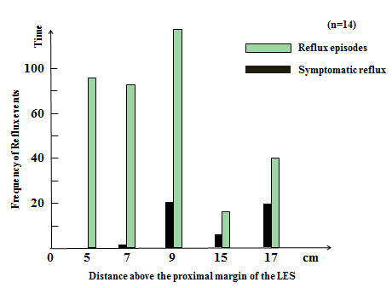
Figure 1 Total liquid reflux episodes and symptoms above the proximal margin of the lower esophagogastric junction at each impedance site. The 325 distal reflux episodes were significantly more frequent (84.9%) than 58 proximal ones (15.1%) (P < 0.001, distal reflux episodes vs proximal ones). LES: Lower esophagogastric junction.

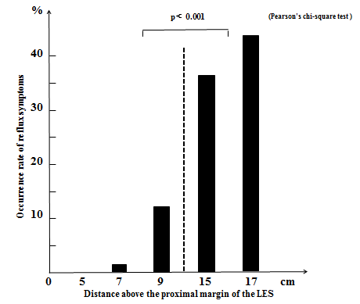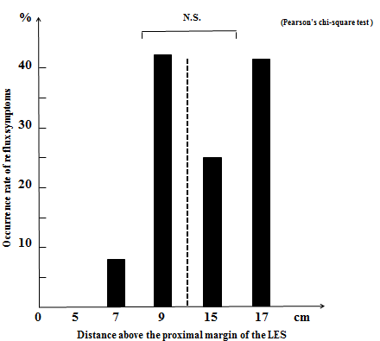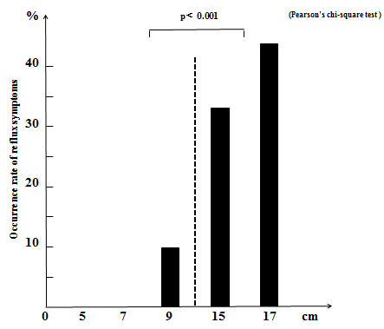
A B C

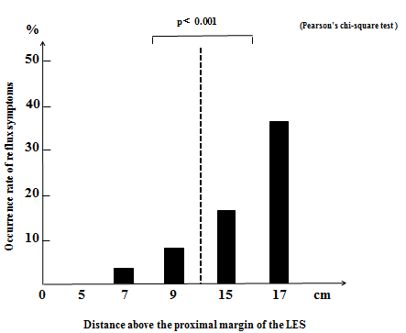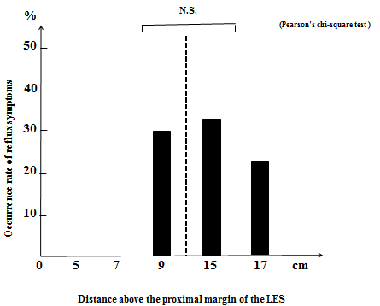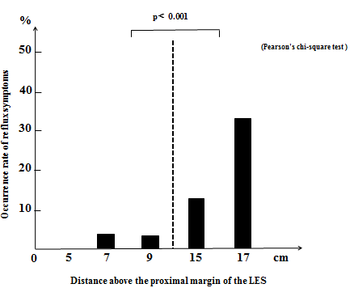
D E F
Figure 2 Occurrence rates of reflux symptoms. A: Occurrence rates of reflux symptoms above the proximal margin of the lower esophagogastric junction at each impedance site with liquid reflux. The occurrence rate of reflux symptoms in proximal reflux episodes was significantly more frequent (44.8%) than in distal ones (7.7%) (P < 0.001, proximal reflux episodes vs distal ones); B: Occurrence rates of reflux symptoms above the proximal margin of the lower esophagogastric junction at each impedance site with acid reflux. There were no significant differences in the occurrence rate of reflux symptoms between proximal reflux episodes (38.5%) and distal ones (20.5%) (NS); C: Occurrence rates of reflux symptoms above the proximal margin of the lower esophagogastric junction at each impedance site with liquid weakly acid reflux. The occurrence rate of reflux symptoms in proximal reflux episodes was significantly more frequent (46.7%) than in distal ones (5.7%) (P < 0.001, proximal reflux episodes vs distal ones); D: Occurrence rates of reflux symptoms above the proximal margin of the lower esophagogastric junction at each impedance site with mixed gas-liquid reflux. The occurrence rate of reflux symptoms in proximal reflux episodes was significantly more frequent (30.7%) than in distal ones (5.3%) (P < 0.001, proximal reflux episodes vs distal ones); E: Occurrence rates of reflux symptoms above the proximal margin of the lower esophagogastric junction at each impedance site with mixed liquid-gas acid reflux. There were no significant differences in the occurrence rate of reflux symptoms between the proximal reflux episodes (29.4%) and distal ones (14.3%) (NS); F: Occurrence rates of reflux symptoms above the proximal margin of the lower esophagogastric junction at each impedance site with mixed liquid-gas weakly acid reflux. The occurrence rate of reflux symptoms in proximal reflux episodes was significantly more frequent (31.0%) than in distal ones (3.3%) (P < 0.001, proximal reflux episodes vs distal ones). LES: Lower esophagogastric junction.

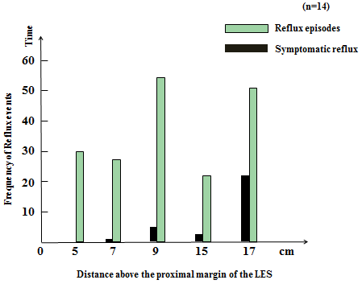
Figure 3 Total mixed liquid-gas reflux episodes and symptoms above the proximal margin of the lower esophagogastric junction at each impedance site. The 113 distal reflux episodes were significantly more frequent (60.1%) than 35 proximal reflux (39.9%) (P = 0.0047, distal reflux episodes vs proximal reflux). LES: Lower esophagogastric junction.

Table 1 Clinicopathological features n (%)
 | SI positive | SI negative | P value
No. patients | 14 (40.0) | 21 (60.0) | NS¹
Age (SD) | 61.9 (12.3) | 59.3 (15.6) | NS¹
Gender (male/female) | 6 / 8 | 7 / 14 | NS²
Heavy drinker | 3 (21.4) | 4 (19.0) | NS²
Current smoker | 2 (14.3) | 1 (4.8) | NS²
BMI | 21.1 (2.1) | 21.0 (2.3) | NS²
Hiatus hernia | 3 (21.4) | 8 (38.1) | NS²
Helicobacter pylori | 4 (28.5) | 6 (28.6) | NS²
Gastric atrophy | 6 (42.9) | 7 (33.3) | NS²
FSSG score (SD) | 16.7 (8.7) | 23.1 (9.0) | 0.0437³
¹Unpaired t test; ²Fisher’s exact test; ³Mann-Whitney U-test; SI: Symptom index; SD: Standard deviation; BMI: Body mass index.

