Name of Journal: World Journal of Clinical Cases
Manuscript NO: 61201
Manuscript Type: CASE REPORT

Metachronous pulmonary and pancreatic metastases arising from sigmoid colon cancer: A case report

Yang J et al. Pulmonary and pancreatic metastases of CRC

Jian Yang, Yu-Chen Tang, Ni Yin, Wei Liu, Zhi-Fei Cao, Xi Li, Xiao Zou, Zi-Xiang Zhang, Jian Zhou

Jian Yang, Yu-Chen Tang, Zi-Xiang Zhang, Jian Zhou, Department of General Surgery, The First Affiliated Hospital of Soochow University, Suzhou 215006, Jiangsu Province, China

Ni Yin, Department of Oncology, The First Affiliated Hospital of Soochow University, Suzhou 215006, Jiangsu Province, China

Wei Liu, Department of Pathology, The First Affiliated Hospital of Soochow University, Suzhou 215006, Jiangsu Province, China

Zhi-Fei Cao, Department of Pathology, The Second Affiliated Hospital of Soochow University, Suzhou 215004, Jiangsu Province, China

Xi Li, Xiao Zou, Department of Medicine, Burning Rock Biotech, Guangzhou 510300, Guangdong Province, China

Author contributions: Yang J and Tang YC reviewed the literature and contributed to manuscript drafting; Yin N and Liu W reviewed the literature, collected and integrated clinical information on the case; Cao ZF analyzed and interpreted the imaging findings; Li X and Zou X analyzed and interpreted next-generation sequencing results, and contributed to manuscript drafting; Zhang ZX and Zhou J were responsible for revision of the manuscript; all authors approved the final version of the manuscript.

Supported by National Natural Science Foundation of China, No. 81902385; Medical Research Projects of Jiangsu Province, No. Y2018094 and No. H2018056; and Science and Technology Project of Jiangsu Province, No. BK20201173.

Corresponding author: Jian Zhou, MD, PhD, Doctor, Department of General Surgery, The First Affiliated Hospital of Soochow University, No. 188 Shizi Street, Suzhou 215006, Jiangsu Province, China. zhoujian06@suda.edu.cn

Received: December 4, 2020
Revised: February 6, 2021
Accepted: March 18, 2021
Published online: May 26, 2021

Abstract
BACKGROUND
Metachronous pulmonary and pancreatic metastases from colorectal cancer are rare. The diagnosis of pancreatic metastases is difficult and predominantly relies on computed tomography, pathology and immunohistochemistry. Here, we describe the use of next-generation sequencing (NGS) for determination of the origin of metastasis and prognostic prediction of colorectal cancer.

CASE SUMMARY
A 59-year-old man was diagnosed with sigmoid adenocarcinoma stage IIA (T3N0M0) and underwent surgery in April 2014, followed by XELOX adjuvant chemotherapy. The patient developed pulmonary metastasis in the right upper lung and underwent surgery in May 2016 without further adjuvant chemotherapy. In May 2018, pancreatic metastasis was found and he underwent pancreaticoduodenectomy. After surgery, he was treated with adjuvant S-1 chemotherapy from June 2018 to March 2019. Histopathological review of the specimens from all three lesions indicated consistent patterns characteristic of colon cancer. Concordant gene mutation profiles were observed across the three lesions that included oncogenic driver mutations most frequently seen in colon cancer (e.g., APC, TP53, KRAS and FBXW7). Blood circulating tumor (ct)DNA before adjuvant chemotherapy was undetectable with NGS, suggesting a favorable response to chemotherapy. The patient was alive and well at the latest follow-up visit, achieving a disease-free survival of 17 mo.

CONCLUSION
The genetic profiles of primary tumor, metastases and ctDNA may have clinical value in auxiliary diagnosis, prognosis and therapeutic decision-making.

Key Words: Pancreatic metastasis; Pancreatic metastasectomy; Colon cancer; Circulating tumor DNA; Next-generation sequencing; Case report

©The Author(s) 2021. Published by Baishideng Publishing Group Inc. All rights reserved.

Citation: Yang J, Tang YC, Yin N, Liu W, Cao ZF, Li X, Zou X, Zhang ZX, Zhou J. Metachronous pulmonary and pancreatic metastases arising from sigmoid colon cancer: A case report. World J Clin Cases 2021; 9(15): 3668-3674
URL: https://www.wjgnet.com/2307-8960/full/v9/i15/3668.htm
DOI: https://dx.doi.org/10.12998/wjcc.v9.i15.3668

Core Tip: We describe a rare case of metachronous pulmonary and pancreatic metastases from colorectal cancer. Immunohistochemistry and next-generation sequencing (NGS) results suggested that pancreatic and pulmonary metastases both originated from the primary colon cancer. To our knowledge, this is the first case to utilize NGS to detect the origin of pancreatic metastasis from colon cancer. NGS also provided useful information for predicting clinical outcome and therapeutic decision-making.
INTRODUCTION
Pancreatic metastases are rare tumor entities that account for 2%-4% of all pancreatic malignancies^{[1]}. More often, metastatic lesions in the pancreas occur as part of a systemic spread, as noted in 6%-10% of cases at autopsy^{[2]}. Less common are isolated metastases amenable to resection. The handful of cohort analyses of pancreatic metastasis reported a range of 18 cases over a span of 18 years^{[3]} to 29 cases over 12 years^{[4]}. Kidney (approximately 80% of cases) is by far the most common primary site, followed by colon (8%), melanoma (5%), and others^{[1]}. As a result, there are even fewer data on pancreatic metastasis arising from colon cancer. This was illustrated by a comprehensive review by Sperti et al^{[2]} who found 24 cases among published works indexed in PubMed and other search engines up to 2014. The scant data make it unlikely that prospective or case-controlled studies have been conducted to address key clinical issues such as prognostic factors and optimal treatment regimens. Instead, retrospective studies and cases have become the major source of reference for clinical decision-making. In this article, we add another case to this small reservoir of evidence. Our patient developed serial pulmonary and pancreatic metastases several years after removal of primary sigmoid colon adenocarcinoma. He was treated with pancreaticoduodenectomy and adjuvant S-1 chemotherapy, and was alive and well at the latest follow-up 17 mo after surgery despite initial postoperative complications.

CASE PRESENTATION
Chief complaints
A 59-year-old old man was referred to our hospital in May 2018 due to detection of a space-occupying mass in the head of the pancreas at another institution.

History of present illness
He was diagnosed with sigmoid adenocarcinoma stage IIA (T3N0M0) and underwent curative surgery in April 2014. After surgery, the patient was treated with XELOX adjuvant chemotherapy from May to October 2014. The patient developed pulmonary metastasis in the right upper lung, with lesions of 2.5 cm × 2.5 cm, and underwent thoracoscopic right upper lobectomy in May 2016. After surgery, he was not treated with further adjuvant chemotherapy (Figure 1).

History of past illness
The patient had no previous medical history.

Personal and family history
The patient did not have relevant personal or family history.

Physical examination
The patient’s temperature was 36.9°C, heart rate 86 bpm, blood pressure 133/84 mmHg, and neurological examination suggested no abnormalities. An abdominal examination showed no palpable mass or tenderness.

Laboratory examinations
Blood carcinoembryonic antigen (CEA) level was elevated to 23.17 ng/mL (normal range 0-5 ng/mL), and carbohydrate antigen 19-9 was elevated to 52.71 U/mL (normal range 0-40 U/mL).

Imaging examinations
Positron emission tomography/computed tomography (CT) and ultrasound scans confirmed the presence of a space-occupying lesion with glucose hypermetabolism (2.3 cm in greatest dimension) in the head of the pancreas (Figure 2). Except for gallstones, no abnormalities were noted in the stomach, duodenum, common bile duct, or main pancreatic duct.

FINAL DIAGNOSIS
The final diagnosis of the presented case was pancreatic recurrence of colon cancer.

TREATMENT
The patient was assessed as fit for surgery and received pancreaticoduodenectomy. A review of pathological specimens indicated moderately to poorly differentiated adenocarcinoma invading the duodenal submucosa, muscular layer, and serosa. All six resected lymph nodes were negative. There was no tumor involvement of the stomach, gallbladder or the surgical incisional edges of the duodenum and pancreas. The pancreatic specimen showed histopathological features consistent with those of the sigmoid and lung lesions, suggesting that the pancreatic lesion arose from primary colon cancer (Figure 3). Specimens from all three sites were also subjected to next-generation sequencing (NGS) targeting 520 cancer-related genes (OncoScreen Plus, Burning Rock, China) for mutational profiling. As shown in Table 1, of the 23 detected genomic alterations, 10 (43.5%) were present in all three specimens, including three double mutations in TP53, APC and FBXW7. Circulating tumor DNA (ctDNA) from blood collected before adjuvant chemotherapy tested negative for mutations in the same panel of 520 genes.

OUTCOME AND FOLLOW-UP
The patient received adjuvant S-1 chemotherapy from June 2018 to March 2019. He experienced two rounds of complications over the following months due to abdominal pain and fever. CT scans showed bloody fluid oozing from the drain entrance and wounds mid-healing in the right abdomen. Supportive care was given to alleviate symptoms with sulperazon and omeprazole sodium, and both times the patient was discharged from hospital within 3 d upon recovery. There was no sign of new lesions upon the latest follow-up visit in July 2019, thereby achieving a disease-free interval of 17 mo after pancreatic metastasectomy (Figure 1).

DISCUSSION
Approximately 30% of colon cancer patients develop metastasis, but the pancreas appears to be an unusual site^{[5]}. To date, there are only 17 case reports of primary colon cancer with metachronous metastases to the pancreas indexed in PubMed^{[1]}. Few data have left many critical questions regarding disease management unanswered, including benefit and risk assessment of surgical resection, efficacy of surgery compared with chemotherapy, and prognostic factors. Evidence provided in reports of sporadic cases is therefore all the more relevant in this uncommon scenario.
The value of surgery in managing pancreatic metastasis has been evaluated in several recent studies^{[2,6,7]}. Morbidity rates reportedly range from 30% to 48%, while mortality rates were cited at 0%-1.4%^{[6,8,9]}. Considering also the well-documented benefit from resection of liver metastases of colorectal cancer^{[10]}, there is a rationale for surgery as a treatment option. However, caution is warranted as to whether surgery is superior to other treatment modalities. Therefore, more evidence is clearly needed to establish the optimal treatment for pancreatic metastasis.
Additionally, regular long-term follow-up appears necessary for metastatic colon cancer patients, as survival rate after pancreatic metastasis reportedly dropped from 88.2% at 1 year after surgery to 24.8% at 5 years^{[1]}. It is unclear whether clinical outcome is associated with specific factors. A study of pancreatic metastases arising from renal cell carcinoma suggested that timing of metastasis, primary tumor lymph node status, and size and number of metastases are not associated with survival outcome^{[1]}. Abnormally high postoperative CEA level is indicative of residual or recurrent disease from primary colon cancer, suggesting CEA levels as a potential prognostic factor^{[11]}.
Liquid biopsy is a minimally invasive and reliable method utilizing body fluids of cancer patients to provide important genetic information for complementary cancer diagnosis^{[12,13]}. ctDNA in peripheral blood has been suggested as a surrogate marker for prognosis and treatment response in several cancer types^{[14,15]}. An earlier study showed an inverse correlation between baseline blood ctDNA level and progression-free survival in response to second-line regorafenib chemotherapy in metastatic colorectal cancer^{[14]}. In our case, ctDNA from blood specimens collected before S-1 chemotherapy tested negative for mutations in 520 cancer-related genes, which appears to be consistent with the favorable clinical outcome observed so far. Large-scale trials are ongoing to evaluate the utility of ctDNA status determined by comprehensive NGS panels in predicting the efficacy of surgery and/or chemotherapy in metastatic colon cancer, which will shed light on integrating ctDNA-based tumor monitoring into a more personalized version of the treatment framework^{[16]}.

CONCLUSION
We describe a rare case of pancreatic metastasis arising from colon cancer after resection of previous pulmonary metastasis. Histopathological features of the specimens from the primary and two metastatic lesions indicated a characteristic colorectal cancer pattern. NGS revealed concordant mutation profiles of the three lesions, highlighting its role in determining the tissue of origin for metastases. Our patient was treated with pancreatic metastasectomy and adjuvant S-1 chemotherapy and is alive 17 mo after surgery. An undetectable level of blood ctDNA was observed before the start of adjuvant chemotherapy, which could harbinger long-term survival. This case indicates that NGS could provide auxiliary diagnostic information for identifying metastatic tumors, and ctDNA detection in peripheral blood could be helpful in predicting clinical outcome. Solutions to significant questions, such as the superiority of surgery over other treatment options and the utility of ctDNA detection and predicting clinical outcome, will benefit from continued accumulation of evidence of this rare disease and insight from studies of similar medical conditions.

REFERENCES
1 Hung JH, Wang SE, Shyr YM, Su CH, Chen TH, Wu CW. Resection for secondary malignancy of the pancreas. Pancreas 2012; 41: 121-129 [PMID: 21633316 DOI: 10.1097/MPA.0b013e31821fc8f2]
2 Sperti C, Moletta L, Patanè G. Metastatic tumors to the pancreas: The role of surgery. World J Gastrointest Oncol 2014; 6: 381-392 [PMID: 25320654 DOI: 10.4251/wjgo.v6.i10.381]
3 Wiltberger G, Bucher JN, Krenzien F, Benzing C, Atanasov G, Schmelzle M, Hau HM, Bartels M. Extended resection in pancreatic metastases: feasibility, frequency, and long-term outcome: a retrospective analysis. BMC Surg 2015; 15: 126 [PMID: 26772176 DOI: 10.1186/s12893-015-0114-1]
4 Chikhladze S, Lederer AK, Kühlbrey CM, Hipp J, Sick O, Fichtner-Feigl S, Wittel UA. Curative-intent pancreas resection for pancreatic metastases: surgical and oncological results. Clin Exp Metastasis 2020; 37: 313-324 [PMID: 32095913 DOI: 10.1007/s10585-020-10029-z]
5 Riihimäki M, Hemminki A, Sundquist J, Hemminki K. Patterns of metastasis in colon and rectal cancer. Sci Rep 2016; 6: 29765 [PMID: 27416752 DOI: 10.1038/srep29765]
6 Reddy S, Wolfgang CL. The role of surgery in the management of isolated metastases to the pancreas. Lancet Oncol 2009; 10: 287-293 [PMID: 19261257 DOI: 10.1016/S1470-2045(09)70065-8]
7 Adler H, Redmond CE, Heneghan HM, Swan N, Maguire D, Traynor O, Hoti E, Geoghegan JG, Conlon KC. Pancreatectomy for metastatic disease: a systematic review. Eur J Surg Oncol 2014; 40: 379-386 [PMID: 24462547 DOI: 10.1016/j.ejso.2013.12.022]
8 Sperti C, Pasquali C, Berselli M, Frison L, Vicario G, Pedrazzoli S. Metastasis to the pancreas from colorectal cancer: is there a place for pancreatic resection? Dis Colon Rectum 2009; 52: 1154-1159 [PMID: 19581861 DOI: 10.1007/DCR.0b013e31819f7397]
9 Huang Q, Zhou H, Liu C, Jin K, Fan K, Cheng H, Fan Z, Yang C, Liu L, Long J, Xu J, Ni Q, Hu Z, Yu X. Surgical Resection for Metastatic Tumors in the Pancreas: A Single-Center Experience and Systematic Review. Ann Surg Oncol 2019; 26: 1649-1656 [PMID: 30924017 DOI: 10.1245/s10434-019-07258-2]
10 Akgül Ö, Çetinkaya E, Ersöz Ş, Tez M. Role of surgery in colorectal cancer liver metastases. World J Gastroenterol 2014; 20: 6113-6122 [PMID: 24876733 DOI: 10.3748/wjg.v20.i20.6113]
11 Hall C, Clarke L, Pal A, Buchwald P, Eglinton T, Wakeman C, Frizelle F. A Review of the Role of Carcinoembryonic Antigen in Clinical Practice. Ann Coloproctol 2019; 35: 294-305 [PMID: 31937069 DOI: 10.3393/ac.2019.11.13]
12 Vacante M, Ciuni R, Basile F, Biondi A. The Liquid Biopsy in the Management of Colorectal Cancer: An Overview. Biomedicines 2020; 8 [PMID: 32858879 DOI: 10.3390/biomedicines8090308]
13 Pantel K, Alix-Panabières C. Liquid biopsy and minimal residual disease - latest advances and implications for cure. Nat Rev Clin Oncol 2019; 16: 409-424 [PMID: 30796368 DOI: 10.1038/s41571-019-0187-3]
14 Wong AL, Lim JS, Sinha A, Gopinathan A, Lim R, Tan CS, Soh T, Venkatesh S, Titin C, Sapari NS, Lee SC, Yong WP, Tan DS, Pang B, Wang TT, Zee YK, Soong R, Trnkova Z, Lathia C, Thiery JP, Wilhelm S, Jeffers M, Goh BC. Tumour pharmacodynamics and circulating cell free DNA in patients with refractory colorectal carcinoma treated with regorafenib. J Transl Med 2015; 13: 57 [PMID: 25889309 DOI: 10.1186/s12967-015-0405-4]
15 Song Y, Hu C, Xie Z, Wu L, Zhu Z, Rao C, Liu L, Chen Y, Liang N, Chen J, Hu C, Yang N, Hu J, Zhao W, Tong G, Dong X, Zheng D, Jin M, Chen J, Huang M, He Y, Rosell R, Lippi G, Mino-Kenudson M, Han-Zhang H, Mao X, Zhang L, Liu H, Field JK, Chuai S, Ye J, Han Y, Lu S; Written on behalf of AME Lung Cancer Collaborative Group. Circulating tumor DNA clearance predicts prognosis across treatment regimen in a large real-world longitudinally monitored advanced non-small cell lung cancer cohort. Transl Lung Cancer Res 2020; 9: 269-279 [PMID: 32420066 DOI: 10.21037/tlcr.2020.03.17]
16 Dasari A, Morris VK, Allegra CJ, Atreya C, Benson AB 3rd, Boland P, Chung K, Copur MS, Corcoran RB, Deming DA, Dwyer A, Diehn M, Eng C, George TJ, Gollub MJ, Goodwin RA, Hamilton SR, Hechtman JF, Hochster H, Hong TS, Innocenti F, Iqbal A, Jacobs SA, Kennecke HF, Lee JJ, Lieu CH, Lenz HJ, Lindwasser OW, Montagut C, Odisio B, Ou FS, Porter L, Raghav K, Schrag D, Scott AJ, Shi Q, Strickler JH, Venook A, Yaeger R, Yothers G, You YN, Zell JA, Kopetz S. ctDNA applications and integration in colorectal cancer: an NCI Colon and Rectal-Anal Task Forces whitepaper. Nat Rev Clin Oncol 2020; 17: 757-770 [PMID: 32632268 DOI: 10.1038/s41571-020-0392-0]

Footnotes
Informed consent statement: Informed consent form was obtained from the patient for the publication of the case.

Conflict-of-interest statement: The authors declare no potential conflicts of interest.

CARE Checklist (2016) statement: The authors have read the CARE Checklist (2016), and the manuscript was prepared and revised according to the CARE Checklist (2016).

Open-Access: This article is an open-access article that was selected by an in-house editor and fully peer-reviewed by external reviewers. It is distributed in accordance with the Creative Commons Attribution NonCommercial (CC BY-NC 4.0) license, which permits others to distribute, remix, adapt, build upon this work non-commercially, and license their derivative works on different terms, provided the original work is properly cited and the use is non-commercial. See: http://creativecommons.org/Licenses/by-nc/4.0/

Manuscript source: Unsolicited manuscript

Peer-review started: December 4, 2020
First decision: January 25, 2021
Article in press: March 18, 2021

Specialty type: Medicine, research and experimental
Country/Territory of origin: China
Peer-review report’s scientific quality classification
Grade A (Excellent): 0
Grade B (Very good): 0
Grade C (Good): C
Grade D (Fair): 0
Grade E (Poor): 0

P-Reviewer: Chakrabarti S S-Editor: Gao CC L-Editor: Webster JR P-Editor: Wang LL

Figure Legends
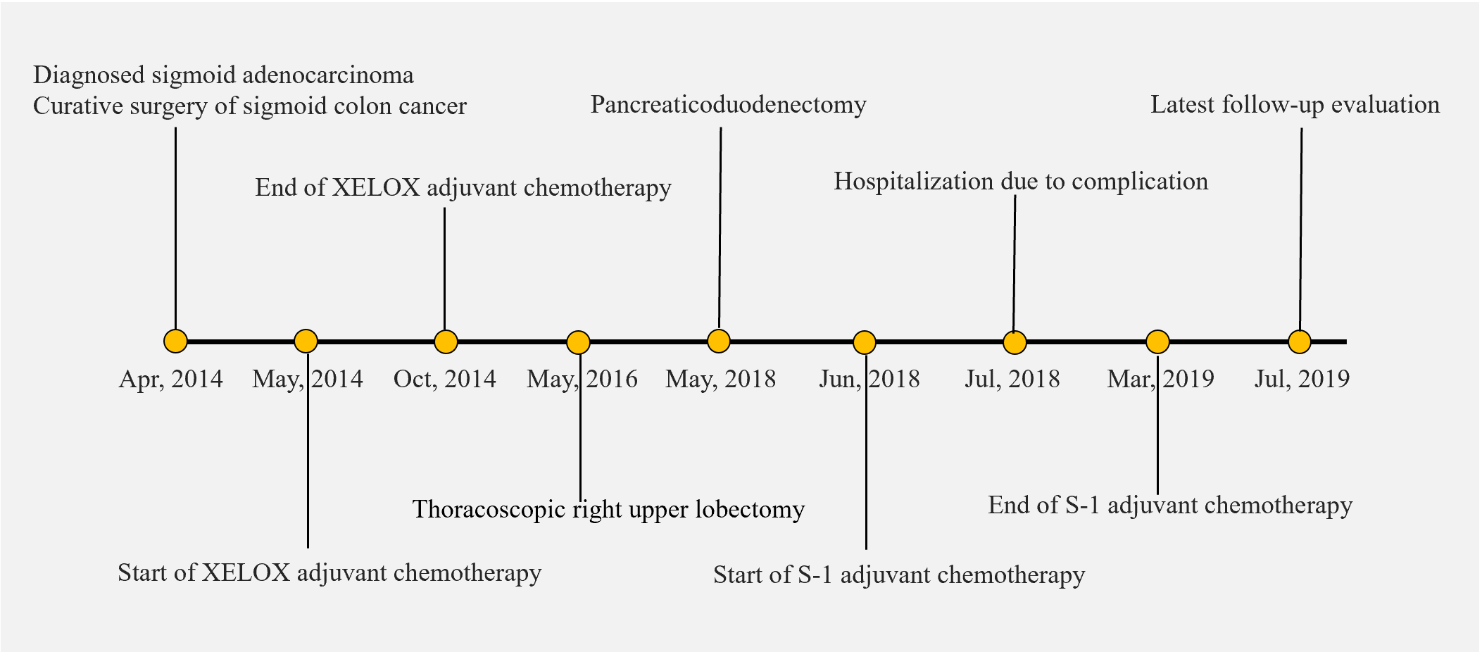
Figure 1 Course of disease management for the case described in this report.
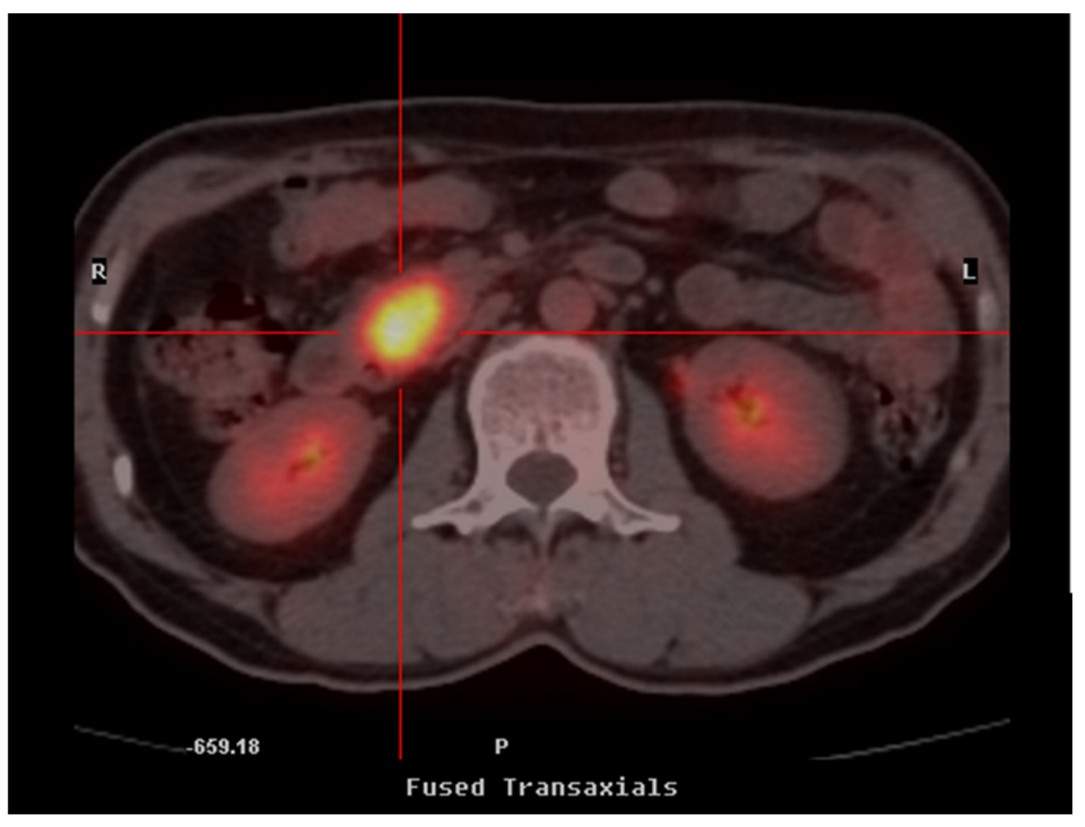
Figure 2 Positron emission tomography/computed tomography scan showing pathological hypermetabolism in the head of the pancreas. No abnormalities were noted in the stomach, duodenum, common bile duct, or main pancreatic duct.
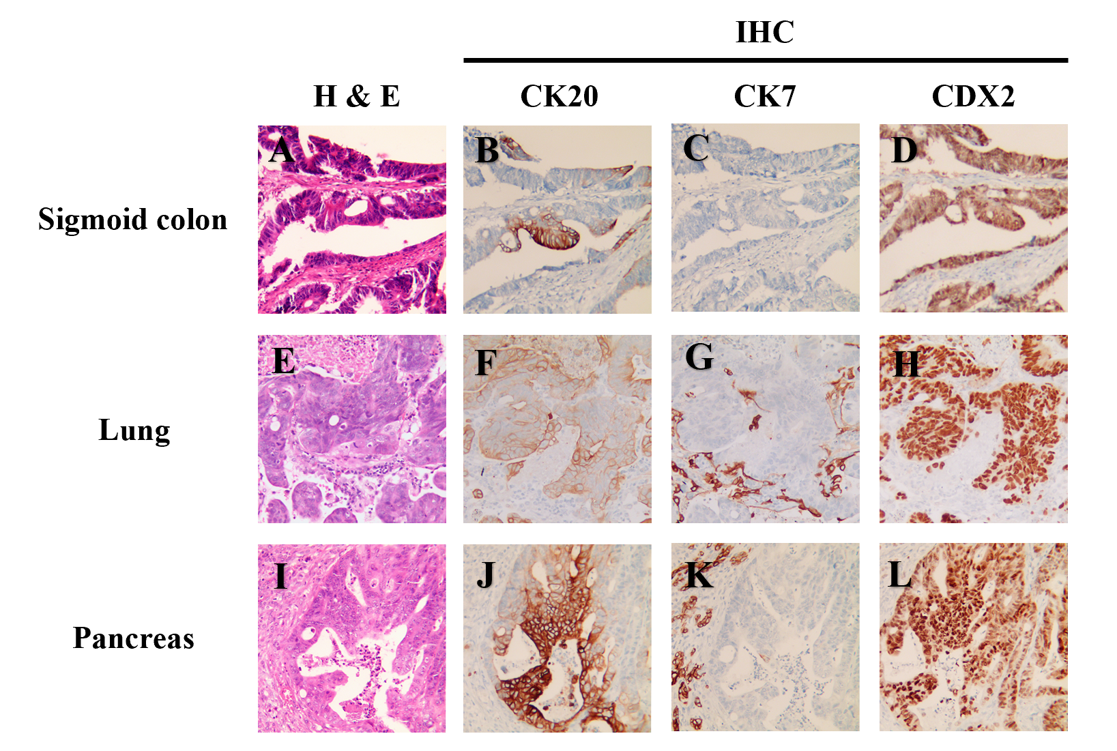
Figure 3 Representative results of hematoxylin and eosin and immunohistochemical staining of specimens from primary and metastatic lesions. A-L: In the primary sigmoid adenocarcinoma, H&E staining (A) and CK20⁺ (B), CK7⁻ (C), and CDX2⁺ (D) with IHC were similar to findings in lung metastasis (E-H) of CK20⁺ (F), CK7⁻ (G), and CDX2⁺ (H). In addition, the pancreatic metastasis (I-L) also displayed biomarker expression profile consistent with colon cancer as the tissue of origin. H&E: Hematoxylin and eosin; IHC: Immunohistochemical.
Table 1 Targeted next-generation sequencing of 520 cancer-related genes revealed highly concordant mutation profiles of specimens from the primary sigmoid cancer, lung metastasis, and pancreatic resection
Mutated gene and impact on protein sequence | Primary sigmoid cancer | Lung metastasis | Pancreatic resection
KRAS p.G12A | + | + | +
TP53 p.R248W | + | + | +
TP53 p.C275Y | + | + | +
APC p.E893* | + | + | +
APC p.L1488fs | + | + | +
PTEN p.T319fs | + | + | +
FBXW7 p.E664* | + | + | +
FBXW7 p.G597R | + | + | +
PIK3C2G p.V508A | + | + | +
LRP1B p.A3643D | + | + | +
PIK3CA p.G118D | +
ERCC5 p.T105M | +
FAT3 p.S1086G |  | + | +
TSHR p.D487N |  | + | +
ASXL1 p.G668S |  |  | +
INHBA p.K198N |  |  | +
FGF3 p.A87S |  | +
INPP4B p.K891M |  | +
MITF p.I220L |  | +
EZH2 p.D730fs |  | +
LRP1B p.P1191T |  | +
GNAS amplification | +
DAXX amplification |  | +
+: Tested positive for indicated alteration; APC: APC regulator of WNT signaling pathway; ASXL1: ASXL transcriptional regulator 1; DAXX: Death domain associated protein; ERCC5: ERCC excision repair 5, endonuclease; EZH2: Enhancer of zeste 2 polycomb repressive complex 2 subunit; FAT3: FAT atypical cadherin 3; FBXW7: F-box and WD repeat domain containing 7; FGF3: Fibroblast growth factor 3; GNAS: GNAS complex locus; INHBA: Inhibin subunit beta A; INPP4B: Inositol polyphosphate-4-phosphatase type II B; KRAS: KRAS proto-oncogene, GTPase; LRP1B: LDL receptor related protein 1B; MITF: Melanocyte inducing transcription factor; PIK3C2G: Phosphatidylinositol-4-phosphate 3-kinase catalytic subunit type 2 gamma; PIK3CA: Phosphatidylinositol-4,5-bisphosphate 3-kinase catalytic subunit alpha; PTEN: Phosphatase and tensin homolog; TP53: Tumor protein p53; TSHR: Thyroid stimulating hormone receptor.

Published by Baishideng Publishing Group Inc
7041 Koll Center Parkway, Suite 160, Pleasanton, CA 94566, USA
Telephone: +1-925-3991568
E-mail: bpgoffice@wjgnet.com
Help Desk: https://www.f6publishing.com/helpdesk
https://www.wjgnet.com

© 2021 Baishideng Publishing Group Inc. All rights reserved.

