Name of Journal: World Journal of Clinical Cases
Manuscript NO: 91384
Manuscript Type: EDITORIAL

Using clinical cases to guide healthcare

Colwill M et al. Using clinical cases to guide healthcare

Michael Colwill, Samantha Baillie, Richard Pollok, Andrew Poullis

Michael Colwill, Samantha Baillie, Richard Pollok, Andrew Poullis, Department of Gastroenterology, St George's University Hospital NHS Foundation Trust, London SW17 0QT, United Kingdom

Author contributions: Colwill M and Poullis A designed the research; Colwill M performed the literature review; Colwill M wrote the initial paper and Colwill M, Poullis A, Pollok R and Baillie S were all involved in manuscript review.

Corresponding author: Michael Colwill, BSc, MBBS, MRCP, Doctor, Research Fellow, Department of Gastroenterology, St George's University Hospital NHS Foundation Trust, Blackshaw Road, London SW17 0QT, United Kingdom. michael.colwill@nhs.net

Received: December 29, 2023
Revised: January 26, 2024
Accepted: February 27, 2024
Published online:

Abstract
Evidence-based practice (EBP) has been the gold standard in healthcare for nearly three centuries and aims to assist physicians in providing the safest and most effective healthcare for their patients. The well-established hierarchy of evidence lists systematic reviews and meta-analyses at the top however these methodologies are not always appropriate or possible and in these instances case-control studies, case series and case reports are utilised to support EBP. Case-control studies allow simultaneous study of multiple risk factors and can be performed rapidly and relatively cheaply. A recent example was during the Coronavirus pandemic where case-control studies were used to assess the efficacy of personal protective equipment for healthcare workers. Case series and case reports also play a role in EBP and are particularly useful to study rare diseases such as inflammatory bowel disease in transgender and gender non-conforming individuals. They are also vital in generating and disseminating early signals and encouraging further research. Whilst these methodologies have weaknesses, particularly with regards to bias and loss of patient confidentiality for rare pathologies, they have an important part to play in EBP and when appropriately utilised can significantly impact upon clinical practice.

Key Words: Evidence based medicine; Hierarchy of evidence; Case reports; Case series

Colwill M, Baillie S, Pollok R, Poullis A. Using clinical cases to guide healthcare. World J Clin Cases 2024; In press

Core Tip: Evidence-based practice is used by physicians to select the optimum treatment for their patients. The hierarchy of evidence lists systematic reviews and meta-analyses as the highest quality of evidence however this is not always appropriate or possible which is when clinical cases, either as case-control studies or case reports, can be utilised. This paper will look at the strength and weaknesses of these methodologies and use recent examples to demonstrate the impact they can have on clinical practice.

INTRODUCTION
James Lind, a Scottish physician in the 18th century, is considered to have conducted the first recorded clinical trial in the 1740s when he selected 12 sailors with scurvy and divided them into six cohorts of two to whom he administered various contemporary treatments and noted the greatest improvement in those given lemons and oranges^{[1]}. Even though it took 50 years for the British navy to make lemon juice compulsory for sailor’s diets because of the cost, the age of evidence-based medicine had begun.
Evidence-based practice (EBP) has dramatically changed since the 1700s and is now well recognised as key to providing the most effective and safe healthcare for patients^{[2,3]}. A hierarchy of scientific evidence known as the evidence pyramid^{[4]}, has been developed in recognition of the fact that not all research is the same in terms of scientific significance and validity (Figure 1). At the top of this pyramid are the systematic review and meta-analysis, followed by double-blinded randomised-control trials, then cohort studies, case-control studies, case series, reports and expert opinion and all of these tiers have a role to play in EBP.
Whilst perhaps ideally all clinical decisions would have the backing of a meta-analysis or systematic review, there are many occasions where there simply is not the data available. For example when bringing a new therapy to market the most appropriate level of evidence is a randomised double-blinded placebo control trial (RCT) and this, whilst expensive and sometimes ethically problematic, provides the strongest evidence of a cause and effect relationship and is therefore the gold-standard for clinical trials and often a pre-requisite to achieve regulator approval. Similarly, in rare disease (sometimes called orphan diseases) there are not enough cases to be able to power a study, apply statistical analysis and determine the validity of a hypothesis. This is where case-control studies and case reports can be useful to allow healthcare professionals to perform EBP.

Case-Control Studies
These are retrospective observational studies which involve the identification of cases and researchers then constructing a control group with similar characteristics. Historical factors are then identified to see if these exposures are more frequently found in the case group rather than the controls. This study design allows for multiple risk factors to be examined at once and they can also be useful when disease outbreaks occur and potential links and exposures need to be identified.
Recent examples of the utility of these studies were during the initial phases of the coronavirus pandemic in 2020. A study in Thailand comparing 211 coronavirus infections with 839 controls aimed to assess the efficacy of personal protective equipment. The nature of their analysis meant they were able to examine multiple variables and identified that only with other measures, such as social distancing, was there a significant reduction in infections with personal protective equipment use^{[5]}. Later in the pandemic, in response to rising concern regarding the rate of healthcare worker infection, further research was conducted into the factors putting them at risk. This suggested using a double-mask technique to reduce infection rates^{[6]} but also identified other factors such as education and anxiety regarding infection which were found to be protective against infection outside the workplace.
Whilst there were some undoubted weaknesses in these studies, such as bias and lack of clear accounting for confounding variables, these examples demonstrate the utility of case-control studies particularly with regards to the speed at which they can be performed and the ability to react to a changing environment with new questions or concerns. However, these studies rely on a large pool of affected cases and it would not have been possible to do so for rarer diseases which is where case-series and case-reports can be used.

Case Reports
Case reports and case series are descriptive studies which are used to present the clinical history and progress of patients in the ‘real-world’. Case reports consist of 3 or fewer patients whilst case series tend to have multiple patients and offer further qualitative methodology. The observational nature of these studies means that they are cheap and relatively quick to perform but perhaps their greatest utility is in rare diseases or treatments^{[7]} where the lack of available patients makes other research methodologies impossible.
An example is with regards to inflammatory bowel disease in trans-gender or gender non-conforming patients (IBD-TGNC). Research using census data has identified there are approximately 2000 IBD-TGNC patients in the United Kingdom^{[8]}. Given the heterogenous and complex nature of this patient group as well as the low numbers, there is a lack of good quality evidence and the literature is largely made up of case reports and series. An example is the experience of a trans-gender woman, who had undergone previous vaginoplasty using her sigmoid colon 10 years previously, who later presented with diarrhoea, rectal bleeding and blood-stained vaginal discharge. Examination revealed histological changes consistent with ulcerative colitis within the neo-vagina, matching those from the colonic biopsies^{[9]}. Whilst a rare occurrence this illustrates the educational utility of case reports.
Case reports can also be used to generate hypotheses which, once disseminated to the wider medical community, can be further tested and a body of evidence developed. One example of this, published in the Lancet in 1983, is that of an infant who required multiple blood transfusions but went on to die at 17 months of opportunistic infections and was found to have an acquired immunodeficiency. The authors hypothesised this may be due to a blood borne virus, later identified as the human immunodeficiency virus, and led to an unprecedented research effort which continues to this day.
Whilst advantageous in certain settings, one of the main areas of concern is regarding patient identity particularly in rare pathology. Even though the publication will anonymise some elements of the data, the description of very rare phenomena may be sufficient to de-anonymise individuals. Therefore, safeguarding measures should be in place as well as open communication with the patients described in these case reports to ensure explicit informed consent is gained and various institutions have published guidance regarding this^{[10]}.
Other disadvantages of these studies are that they are uncontrolled, suffer from selection bias and generally have an insufficient follow-up period. There can also be difficulty in using these studies for scientific research given that the cases described may not be easily generalisable to the wider population. However, whilst their value remains a matter for scientific debate^{[4]}, dismissing these studies as completely useless is incorrect and ignores their definite, if somewhat limited, strengths described above.

Case Series
Case series were historically the backbone of medical literature and whilst their importance has become smaller, they continue to be an important part of research.
They are particularly useful for novel observations and publishing early signals can inform the medical community to be vigilant for similar cases. This was recently demonstrated in a series published in January 2020 regarding patients infected with coronavirus in Wuhan^{[11]}. Case series can also be useful for testing novel treatments, demonstrated by an IBD study in 2018 which wanted to provide preliminary data on dual biologic therapy (DBT)^{[12]}. Through a case series of four patients they were able to show safety and efficacy signals which led to larger studies and DBT is now considered an effective option for difficult to treat disease^{[13]}.
These series, similar to case reports, can also be useful for studying rarer pathology. A 2021 study by Phillips et al^{[14]} used a case series of 15 patients across 8 different centres to investigate factors associated with intestinal lymphoma in the context of IBD, a rare pathology believed to be related to thiopurine and anti-TNF use. As well as helping to identify risk factors, such as male sex and thiopurine use in two-thirds of their cohort, the series also helped to address the challenging clinical conundrum regarding the safety of restarting immunosuppressive therapy in patients with a history of intestinal lymphoma.
Case series can be published quickly, a particular strength with regards to the coronavirus series described above, and are cheap to develop compared to other methodologies such as RCTs which can cost in excess of $100000 per patient enrolled^{[15]}. However, their use as a research modality also suffers from similar disadvantages as described for case reports particularly a lack of control, selection bias and difficulty around generalising to the wider population. Nevertheless, as demonstrated, they certainly have utility in the correct setting.

CONCLUSION
Whilst they are the lowest ranked strata of research in EBP with clear disadvantages, case reports and case studies still represent an important and useful modality that are relatively quick and cost-effective to produce. When utilised in the appropriate context, these studies continue to have a significant impact upon clinical practice.

REFERENCES
1 Collier R. Legumes, lemons and streptomycin: a short history of the clinical trial. CMAJ 2009; 180: 23-24 [PMID: 19124783 DOI: 10.1503/cmaj.081879]
2 Connor L, Dean J, McNett M, Tydings DM, Shrout A, Gorsuch PF, Hole A, Moore L, Brown R, Melnyk BM, Gallagher-Ford L. Evidence-based practice improves patient outcomes and healthcare system return on investment: Findings from a scoping review. Worldviews Evid Based Nurs 2023; 20: 6-15 [PMID: 36751881 DOI: 10.1111/wvn.12621]
3 Leufer T, Cleary-Holdforth J. Evidence-based practice: improving patient outcomes. Nurs Stand 2009; 23: 35-39 [PMID: 19441625 DOI: 10.7748/ns2009.04.23.32.35.c6935]
4 Murad MH, Asi N, Alsawas M, Alahdab F. New evidence pyramid. Evid Based Med 2016; 21: 125-127 [PMID: 27339128 DOI: 10.1136/ebmed-2016-110401]
5 Doung-Ngern P, Suphanchaimat R, Panjangampatthana A, Janekrongtham C, Ruampoom D, Daochaeng N, Eungkanit N, Pisitpayat N, Srisong N, Yasopa O, Plernprom P, Promduangsi P, Kumphon P, Suangtho P, Watakulsin P, Chaiya S, Kripattanapong S, Chantian T, Bloss E, Namwat C, Limmathurotsakul D. Case-Control Study of Use of Personal Protective Measures and Risk for SARS-CoV 2 Infection, Thailand. Emerg Infect Dis 2020; 26: 2607-2616 [PMID: 32931726 DOI: 10.3201/eid2611.203003]
6 Rodriguez-Lopez M, Parra B, Vergara E, Rey L, Salcedo M, Arturo G, Alarcon L, Holguin J, Osorio L. A case-control study of factors associated with SARS-CoV-2 infection among healthcare workers in Colombia. BMC Infect Dis 2021; 21: 878 [PMID: 34452600 DOI: 10.1186/s12879-021-06581-y]
7 Torres-Duque CA, Patino CM, Ferreira JC. Case series: an essential study design to build knowledge and pose hypotheses for rare and new diseases. J Bras Pneumol 2020; 46: e20200389 [PMID: 32901691 DOI: 10.36416/1806-3756/e20200389]
8 Colwill M, Patel K, Poullis A. Inflammatory bowel disease in the LGBTIQ+ population: estimates of prevalence in England & Wales and the implication for services. United European Gastroenterol J 2023; 11 [DOI: 10.14309/00000434-201810001-00654]
9 Hennigan TW, Theodorou NA. Ulcerative colitis and bleeding from a colonic vaginoplasty. J R Soc Med 1992; 85: 418-419 [PMID: 1629855 DOI: 10.1177/014107689208501016]
10 Yale University. Resource Documents and Guidance | Health Insurance Portability and Accountability Act. Available from: https://hipaa.yale.edu/resources/resource-documents-and-guidance
11 Huang C, Wang Y, Li X, Ren L, Zhao J, Hu Y, Zhang L, Fan G, Xu J, Gu X, Cheng Z, Yu T, Xia J, Wei Y, Wu W, Xie X, Yin W, Li H, Liu M, Xiao Y, Gao H, Guo L, Xie J, Wang G, Jiang R, Gao Z, Jin Q, Wang J, Cao B. Clinical features of patients infected with 2019 novel coronavirus in Wuhan, China. Lancet 2020; 395: 497-506 [PMID: 31986264 DOI: 10.1016/S0140-6736(20)30183-5]
12 Mao EJ, Lewin S, Terdiman JP, Beck K. Safety of dual biological therapy in Crohn's disease: a case series of vedolizumab in combination with other biologics. BMJ Open Gastroenterol 2018; 5: e000243 [PMID: 30538822 DOI: 10.1136/bmjgast-2018-000243]
13 McCormack MD, Wahedna NA, Aldulaimi D, Hawker P. Emerging role of dual biologic therapy for the treatment of inflammatory bowel disease. World J Clin Cases 2023; 11: 2621-2630 [PMID: 37214562 DOI: 10.12998/wjcc.v11.i12.2621]
14 Corrigendum to: ECCO CONFER Investigators, Diagnosis and Outcome of Extranodal Primary Intestinal Lymphoma in Inflammatory Bowel Disease: An ECCO CONFER Case Series. J Crohns Colitis 2022; 16: 1648 [PMID: 35751543 DOI: 10.1093/ecco-jcc/jjac088]
15 Speich B, von Niederhäusern B, Schur N, Hemkens LG, Fürst T, Bhatnagar N, Alturki R, Agarwal A, Kasenda B, Pauli-Magnus C, Schwenkglenks M, Briel M; MAking Randomized Trials Affordable (MARTA) Group. Systematic review on costs and resource use of randomized clinical trials shows a lack of transparent and comprehensive data. J Clin Epidemiol 2018; 96: 1-11 [PMID: 29288136 DOI: 10.1016/j.jclinepi.2017.12.018]

Footnotes
Conflict-of-interest statement: None of the authors have any conflict of interest to declare.

Open-Access: This article is an open-access article that was selected by an in-house editor and fully peer-reviewed by external reviewers. It is distributed in accordance with the Creative Commons Attribution NonCommercial (CC BY-NC 4.0) license, which permits others to distribute, remix, adapt, build upon this work non-commercially, and license their derivative works on different terms, provided the original work is properly cited and the use is non-commercial. See: https://creativecommons.org/Licenses/by-nc/4.0/

Provenance and peer review: Invited article; Externally peer reviewed.
Peer-review model: Single blind
Corresponding Author's Membership in Professional Societies: British Society of Gastroenterology, BSG60672.

Peer-review started: December 29, 2023
First decision: January 20, 2024
Article in press:

Specialty type: Methodology
Country/Territory of origin: United Kingdom
Peer-review report’s scientific quality classification
Grade A (Excellent): 0
Grade B (Very good): 0
Grade C (Good): C
Grade D (Fair): 0
Grade E (Poor): 0

P-Reviewer: Gu GL, China S-Editor: Gong ZM L-Editor: A P-Editor:

Figure Legends
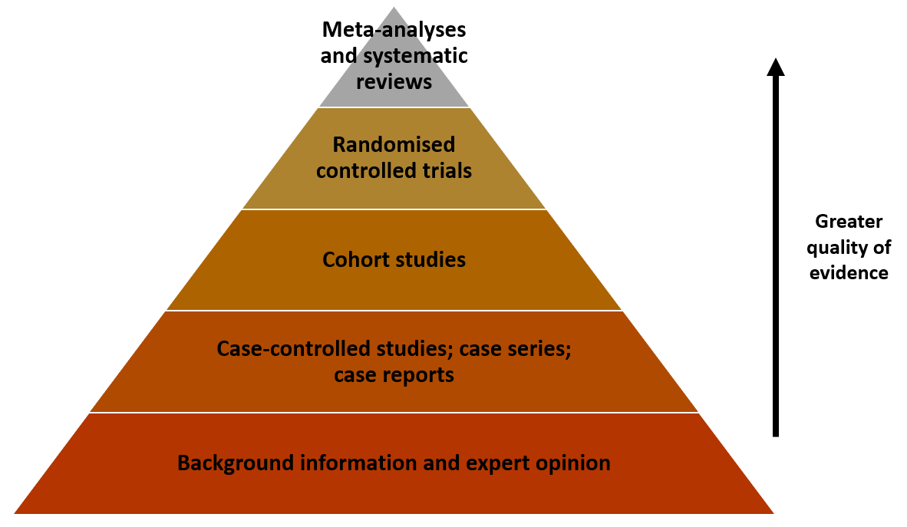
Figure 1 The hierarchy of evidence pyramid.

