Name of Journal: World Journal of Orthopedics
Manuscript NO: 57468
Manuscript Type: CASE REPORT

Use of short stems in revision of standard femoral stem: A case report

Evola FR et al. Femoral stem revision with short implant

Francesco Roberto Evola, Giuseppe Evola, Giuseppe Sessa

Francesco Roberto Evola, Giuseppe Sessa, University of Catania, Department of Surgery, Clinic Orthopaedic, Catania 95124, Italy

Giuseppe Evola, General and Emergency Surgery Department, Surgery Clinic, Catania 95124, Italy

Author contributions: Evola FR reviewed the literature and contributed to conception and design of the study; Evola G contributed to drafting the article and making critical revisions related to important intellectual content of the manuscript; Sessa G revised the manuscript and approved the final version of the article.

Corresponding author: Francesco Roberto Evola, MD, PhD, Assistant Professor, Doctor, University of Catania, Department of Surgery, Clinic Orthopaedic, Via Plebiscito 628, Catania 95124, Italy. robertoevola@virgilio.it

Received: June 10, 2020
Revised: September 14, 2020
Accepted: September 25, 2020
Published online: November 18, 2020

Abstract
BACKGROUND
Short stems are usually uncemented prosthetics and are recommended in the treatment of traumatic or degenerative diseases of hip. In revision procedures for elderly patients with serious comorbidity, applying a short stem could reduce peri- and post-operative secondary surgical risks to femoral osteotomy, which are necessary for the removal of parts of the implant or acrylic cement from the medullary canal. There are no cases in the literature that apply a short stem for prosthetic revision by acrylic cement anchorage.

CASE SUMMARY
A male patient had a left hip replacement in 1995 due to coxarthrosis. At the age of eighty the patient reported an accidental trauma and walked with pain in the left thigh. The X-ray highlighted the stem breakage in the distal section without fracturing the femoral cortex. The patient had various comorbidities (diabetes, anaemia, heart deficiency, and arrhythmia) presenting a high operation risk (ASA 4). During the revision procedure, the distal apex of the stem could not be removed from the femoral cortex. Because of the poor general health of the patient, the surgeon decided not to perform a Wagner femoral osteotomy to remove the distal section of the stem and decided to implant a short stem to avoid removing the stem section of the previous implant. The patient had his left femur X-rayed 15 d post-trauma.

CONCLUSION
A field of application of short stem may be the development of a cemented short stem to reduce the complexity of the revision procedure.

Key Words: Short stem; Revision procedure; Cementless implant; Total hip replacement; Prosthesis design; Case report

Evola FR, Evola G, Sessa G. Use of short stems in revision of standard femoral stem: A case report. World J Orthop 2020; 11(11): 528-533 URL: https://www.wjgnet.com/2218-5836/full/v11/i11/528.htm DOI: https://dx.doi.org/10.5312/wjo.v11.i11.528

Core Tip: Short stems, because of their reduced size, could be applied for post-traumatic obliteration of the femoral canal when it is difficult to apply a standard stem; moreover, in revision procedures for patients with serious comorbidity, the use of a short stem could reduce the surgical risks to femoral osteotomy, which is necessary for the removal of parts of the implant or acrylic cement from the medullary canal. The availability of cemented short stems could help surgeons in cases where there is a lack or reduced quality of bone to treat particular prosthetic revisions, limiting surgical invasiveness and the use of long stems.
INTRODUCTION
Standard uncemented femoral stems have proven to be clinically, functionally, and radiologically successful in total hip replacement, particularly in young and active patients^{[1,2]}. Recently, the use of short stems (stems with length < 120 mm) has become more popular; short stems have been designed to obtain optimal load transfer to the proximal femur, to ease stem removal in revision procedures, to reduce the rate of periprosthetic fractures, to preserve proximal femoral medullary bone, and to make implantation less invasive^{[3,4]}. While standard stems have diaphyseal engagement that could likely cause proximal stress shielding, short stems have metaphyseal fixation and allow proximal load transfer, thereby reducing bone resorption. Clinical studies on short stems have found an increase in bone mineral density in the first and seventh area of Gruen from the 3rd mo^{[5,6]}. Implant longevity relies upon an initial “press-fit” between the implant and the surrounding bone, which is a prerequisite for osseointegration of the stem, in order to achieve axial and rotational stability^{[7]}. Metaphyseal stems could be an alternative for primary total hip replacement in young patients because this group has a high probability of undergoing revision surgery^{[8-10]}. Because of their reduced size, short stems could be applied to first implants for post-traumatic obliteration of the femoral canal or excessive thickness of the diaphyseal cortex, when it is difficult to apply a standard stem. Some authors have used the short stem with cement^{[11]}; advantages of a short-cemented implant include preservation of diaphyseal femoral bone, more proximal load transfer, easier insertion, and easier stem and cement removal in case of revision procedure^{[11]}. Furthermore, in revision procedures for elderly patients with serious comorbidity and osteoporosis, applying a short-cemented stem could reduce the peri- and post-operative secondary surgical risks to femoral osteotomy, which is necessary for the removal of parts of the implant or acrylic cement from the medullary canal. Generally short stems require biological anchorage to the femur, so it would be particularly useful in select revision procedures to apply short stem anchorage in acrylic cement in cases where there is a lack of or reduced quality of the cancellous bone to obtain a primary stability of implant. Cemented short stems permit solid and immediate stability and do not require additional time for biological fixation^{[11]}. There are no cases in the literature of applying a short stem for prosthetic revision by acrylic cement anchorage.
This clinical case describes the unusual application of a biological short stem with acrylic cement in prosthetic revision, and we propose extending its application to special revision procedures and in selected patients in an attempt to reduce surgical invasiveness.

CASE PRESENTATION
Chief complaints
An 80-year-old Caucasian patient with left hip prosthesis, 1.75 cm tall, first degree obesity (body mass index 33.5), and male sex, reported an accidental trauma to the pelvis and left femur after falling on the street.

History of present illness
Post-trauma, the patient walked with steppage gait and reported feeling pain in the left thigh; the pain did not decrease despite the administration of drugs.

History of past illness
Before the trauma the patient was asymptomatic and did not report any hip pain.

Personal and family history
There was no family history of treatment with elective hip replacement for osteoarthritis.

Physical examination
The patient reported pain in response to pressure on the thigh and external and internal rotation movements of the hip; no thigh oedema was found at the clinic examination.

Laboratory examinations
No laboratory tests were performed on the patient.

Imaging examinations
The patient had his left femur X-rayed 15 d post-trauma. The prosthesis had not been X-rayed for several years prior.

FINAL DIAGNOSIS
The X-ray highlighted the stem breakage in the distal section without fracture of the femoral cortex (Figure 1). Moreover, the stem showed a thickening of the femoral cortex at the distal end of implant, and the proximal part was loose without osteointegration. The radiographic image demonstrated a chronic implant loosening with subsequent traumatic rupture due to a positioning varus of the stem.

TREATMENT
Despite being active and autonomous in daily life, the patient had various comorbidities (diabetes, anaemia, heart deficiency, and arrhythmia) presenting a high operation risk (ASA 4). In the same month, the patient underwent a prosthetic stem revision. Watson-Jones access was performed with the patient in a supine position. During the revision, the distal apex of the stem could not be removed as it was anchored between the femoral cortex due to the reduced size of the medullary canal.
Because of the poor general health of the patient, the surgeon decided not to perform a Wagner femoral osteotomy to remove the distal section of the stem. Implantation of a long stem with distal anchorage would have led to greater blood loss and a higher risk of infection with the likely exitus of the patient. The surgeon decided to implant a short Fitmore stem to avoid removing the stem section of the previous implant that was solidly anchored to the medullary canal.
Normally applied in selected patients as a biological implant, the Fitmore stem was used because of its reduced size to enable the revision of a standard-length stem. Due to the poor quality of bone tissue and the difficulty in obtaining primary stability for the new implant, the surgeon used acrylic cement to anchor the prosthesis. During surgery, a metallic femoral head (+ 4 mm) was used to obtain implant stability. The acetabulum showed no signs of movement, whereas the polyethylene insert showed signs of wear so it needed replacing. After 7 d in intensive care, the patient was transferred to the Orthopaedic Department and discharged 15 d after the operation. Subsequently, the patient was admitted to the rehabilitation unit for about 30 d.

OUTCOME AND FOLLOW-UP
X-ray and clinical checks were carried out for the next 2 years without showing signs of breakage to the femoral stem nor loosening of implant from cement. No subsidence at the stem-cement interface was observed, demonstrating the excellent stability of the cemented implant. The patient resumed normal life 3 mo post-operation. During the final check, roughly 2 years after the operation, the patient reported feeling no thigh pain and did not indicate limited articulation, living daily life without the assistance of walking aids (Figure 2).

DISCUSSION
There are three categories of prosthetic implant revision: Patient causes (infections), implant causes (aseptic loosening, peri-prosthetic fractures, implant failure or breakage), and surgical errors (instability, pain)^{[12]}. Implant breakage is less common than aseptic loosening or infections and is caused by the mechanical stress generated by cyclic loads in most cases. Most stem failures are due to stainless steel components and present years after the operation.
Steel stems often deform and then fracture before breaking, whereas chrome-cobalt stems fatigue and fracture without deforming. The section that is most often involved is the middle third distal stem, which shows a loss of bone support close to the femur, exposing that section to a shearing force followed by metal fatigue failure. The risk factors most associated with prosthetic stem breakage are weight gain or increased physical activity, the varus position of the stem, increased offset, small cross-section stems, the use of steel stems, and loosening of implant^{[12]}.
Cementless implants have shown excellent long-term survival with respect to cemented prosthesis^{[1,2]}. An essential condition in cementless implants is an optimal press-fit with low micromotions in the femur in order to allow secondary fixation to the bone. Proximal load transfer and the absence of distal fixation are essential for better clinical results in total hip arthroplasty. To reproduce natural load transfer in the subtrochanteric area, short stem devices were developed. Short stems include a large variety of prostheses that differ in shape, length, anchorage, level of bone resection, and reconstruction of the biomechanics of the femur^{[3]}.
Within the family of short stems, the Fitmore stem is made of a titanium forged alloy covered with a porous coating, which allows the bone ingrowth process to be increased^{[5]}. The anchorage concept is based on apposition to the calcar by the medial curve and contact with the lateral cortex through the axial load^{[13]}. The concept of this stem geometry is based on the redistribution of 70% of loading forces on the calcar of the femur^{[14]}. Trapezoidal cross-section allows for increase in primary stability, which is enhanced by a slightly oversized titanium coating. The Fitmore stem has a special design; the system portfolio consists of three different shaped stem families with different medial calcar curve radii to allow calcar and medial metaphyseal bony contact to be maximized^{[3]}. There is a correlation between the calcar curve radius and the off-set; the valgus stem with large medial calcar radii has less of an off-set, while the varus stem with smaller calcar radii has a greater off-set. Generally, larger off-set is observed in males than in females. An increase in the offset leads to improved muscle strength, a greater range of motion and joint contact forces, and higher wear rate^{[15,16]}; disadvantages are the increase in medial bending load, loading of the distal portion of the stem, and an increased risk of trochanteric pain.
In this clinical case, we think the standard stem had a distal diaphyseal anchor on the femur and a chronic loosening of the proximal portion; the trauma broke the stem that had no anchorage in the metaphysis and proximal shaft, only in the distal part. In the literature, the revision of this implant required removal of the prosthesis and replacement with a standard or long stem^{[17,18]}. The stem was easily removed during the surgery, while the distal apex of the stem could not be removed, as it was anchored between the femoral cortex. Patient's serious general clinical condition and intraoperative blood loss required a reduction in operating times. The presence of the tip of the stem in the femoral canal did not allow neither the use of a standard stem nor a long stem. Removing the broken part of the stem by a femoral osteotomy would have increased the surgical risk to the patient. Therefore, the small size of the short stems, normally used in primary implants and not in revisions, prevented femoral osteotomy and therefore reduced the risk of bleeding and infection in a patient with serious comorbidity. Due to the poor quality of bone tissue, the level of bone resection and the difficulty in obtaining primary stability for the new uncemented implant, the surgeon used acrylic cement to anchor the prosthesis. The surgeon did not have a short-cemented stem available, only the uncemented stem Fitmore. Short stems are usually uncemented prosthetic devices. The use of acrylic cement became necessary because of the lack of nearby bone, thereby preventing sufficient stable anchorage.
Advantages of a short-cemented implant are minimal bone invasiveness, a decrease risk of bone-cement implantation syndrome, and an easier future revision procedure^{[11]}. The main disadvantage of using an uncemented short stem with cement is the detachment of the implant at the prosthesis-cement interface due to the porous coating of Fitmore stem, causing short-term implant failure. The anchoring of the stem did not occur in the three points, calcar, lateral, and medial cortex of the metaphysis, but in the cortical femoral evenly, through the acrylic cement. The various off-sets of the Fitmore stem enabled the articular biomechanics to be reconstructed and ensured implant stability^{[16]}.
Using an uncemented stem with acrylic cement is not correct. The short-cemented stem is little used among orthopaedists as they prefer biological fixation and these implants are unavailable. A short-cemented stem is feasible but requires specific implants and a perfect bone cement obtainable with cementation techniques. A precise cementing technique has permitted a homogeneous 2 mm cement mantle all around the stem, a prerequisite for a greater survival of prosthesis. Therefore, as more elderly osteoporotic patients require joint arthroplasty, it is possible to predict a return of cemented implants.
One limitation of this study was the short-term follow-up given that the patient was assessed for 2 years after the revision before dying, so it was not possible to observe any loosening of the stem cement or any change in long-term implant stability.

CONCLUSION
A suggestive field of application of short stem may be the development of a cemented short design with different tapering angles to match the smaller femur in specific populations and to reduce the complexity of cemented or uncemented stem revision. Furthermore, the availability of cemented short stems could help surgeons to treat particular prosthetic revisions in patients in poor general health, thereby limiting surgical invasiveness and the use of long stems.

REFERENCES
1 Evola FR, Evola G, Graceffa A, Sessa A, Pavone V, Costarella L, Sessa G, Avondo S. Performance of the CLS Spotorno uncemented stem in the third decade after implantation. Bone Joint J 2014; 96-B: 455-461 [PMID: 24692610 DOI: 10.1302/0301-620X.96B4.32607]
2 Giardina F, Castagnini F, Stea S, Bordini B, Montalti M, Toni A. Short Stems Versus Conventional Stems in Cementless Total Hip Arthroplasty: A Long-Term Registry Study. J Arthroplasty 2018; 33: 1794-1799 [PMID: 29395723 DOI: 10.1016/j.arth.2018.01.005]
3 Falez F, Casella F, Papalia M. Current concepts, classification, and results in short stem hip arthroplasty. Orthopedics 2015; 38: S6-13 [PMID: 25826635 DOI: 10.3928/01477447-20150215-50]
4 Lidder S, Epstein DJ, Scott G. A systematic review of short metaphyseal loading cementless stems in hip arthroplasty. Bone Joint J 2019; 101-B: 502-511 [PMID: 31037973 DOI: 10.1302/0301-620X.101B5.BJJ-2018-1199.R1]
5 Gasbarra E, Celi M, Perrone FL, Iundusi R, Di Primio L, Guglielmi G, Tarantino U. Osseointegration of Fitmore stem in total hip arthroplasty. J Clin Densitom 2014; 17: 307-313 [PMID: 24613452 DOI: 10.1016/j.jocd.2013.11.001]
6 Meyer JS, Freitag T, Reichel H, Bieger R. Periprosthetic Bone Mineral Density Changes After Implantation of a Curved Bone Preserving Hip Stem Compared to a Standard Length Straight Stem: 5-Yr Results of a Prospective, Randomized DXA-Analysis. J Clin Densitom 2019; 22: 96-103 [PMID: 30126775 DOI: 10.1016/j.jocd.2018.07.007]
7 Migliorini F, Driessen A, Colarossi G, El Mansy Y, Gatz M, Tingart M, Eschweiler J. Short stems for total hip replacement among middle-aged patients. Int Orthop 2020; 44: 847-855 [PMID: 32193611 DOI: 10.1007/s00264-020-04516-x]
8 Stulberg SD, Patel RM. The short stem: promises and pitfalls. Bone Joint J 2013; 95-B: 57-62 [PMID: 24187354 DOI: 10.1302/0301-620X.95B11.32936]
9 Gruner A, Heller KD. Patient selection for shorter femoral stems. Orthopedics 2015; 38: S27-S32 [PMID: 25826629 DOI: 10.3928/01477447-20150215-53]
10 Kutzner KP, Freitag T, Bieger R. Defining 'undersizing' in short-stem total hip arthroplasty: the importance of sufficient contact with the lateral femoral cortex. Hip Int 2020; 1120700020940276 [PMID: 32644828 DOI: 10.1177/1120700020940276]
11 Santori N, Falez F, Potestio D, Santori FS. Fourteen-year experience with short cemented stems in total hip replacement. Int Orthop 2019; 43: 55-61 [PMID: 30411248 DOI: 10.1007/s00264-018-4205-3]
12 Ulrich SD, Seyler TM, Bennett D, Delanois RE, Saleh KJ, Thongtrangan I, Kuskowski M, Cheng EY, Sharkey PF, Parvizi J, Stiehl JB, Mont MA. Total hip arthroplasties: what are the reasons for revision? Int Orthop 2008; 32: 597-604 [PMID: 17443324 DOI: 10.1007/s00264-007-0364-3]
13 Acklin YP, Jenni R, Bereiter H, Thalmann C, Stoffel K. Prospective clinical and radiostereometric analysis of the Fitmore short-stem total hip arthroplasty. Arch Orthop Trauma Surg 2016; 136: 277-284 [PMID: 26739137 DOI: 10.1007/s00402-015-2401-9]
14 Gustke K. Short stems for total hip arthroplasty: initial experience with the Fitmore stem. J Bone Joint Surg Br 2012; 94: 47-51 [PMID: 23118380 DOI: 10.1302/0301-620X.94B11.30677]
15 von Roth P, Perka C, Mayr HO, Preininger B, Ziebula F, Matziolis G, Hube R. Reproducibility of femoral offset following short stem and straight stem total hip arthroplasty. Orthopedics 2014; 37: e678-e684 [PMID: 24992068 DOI: 10.3928/01477447-20140626-61]
16 Schmidutz F, Beirer M, Weber P, Mazoochian F, Fottner A, Jansson V. Biomechanical reconstruction of the hip: comparison between modular short-stem hip arthroplasty and conventional total hip arthroplasty. Int Orthop 2012; 36: 1341-1347 [PMID: 22262250 DOI: 10.1007/s00264-011-1477-2]
17 Canovas F, Putman S, Dagneaux L, Chadli L, Le Béguec P. Cementless revision femoral stems application of press-fit principles and clinical outcomes. Int Orthop 2019; 43: 2261-2267 [PMID: 30554260 DOI: 10.1007/s00264-018-4265-4]
18 Zimmerer A, Slouka S, Kinkel S, Fritz T, Weiss S, Sobau C, Miehlke W. Comparison of short-stem with conventional-stem prostheses in total hip arthroplasty: an 8-year follow-up study. Arch Orthop Trauma Surg 2020; 140: 1285-1291 [PMID: 32572595 DOI: 10.1007/s00402-020-03519-y]

Footnotes
Informed consent statement: Informed consent is not necessary for the study because the authors used anonymous clinical data and the patient died.

Conflict-of-interest statement: The authors declare that they have no conflict of interest and financial relationships for the realization of this work.

CARE Checklist (2016) statement: The authors have read the CARE Checklist (2016), and the manuscript was prepared and revised according to the CARE Checklist (2016).

Open-Access: This article is an open-access article that was selected by an in-house editor and fully peer-reviewed by external reviewers. It is distributed in accordance with the Creative Commons Attribution NonCommercial (CC BY-NC 4.0) license, which permits others to distribute, remix, adapt, build upon this work non-commercially, and license their derivative works on different terms, provided the original work is properly cited and the use is non-commercial. See: http://creativecommons.org/Licenses/by-nc/4.0/

Manuscript source: Unsolicited manuscript

Peer-review started: June 10, 2020
First decision: July 4, 2020
Article in press: September 25, 2020

Specialty type: Orthopedics
Country/Territory of origin: Italy
Peer-review report’s scientific quality classification
Grade A (Excellent): 0
Grade B (Very good): B
Grade C (Good): C
Grade D (Fair): 0
Grade E (Poor): 0

P-Reviewer: Malik S, Zacharia B S-Editor: Zhang L L-Editor: Filipodia P-Editor: Xing YX
Figure Legends
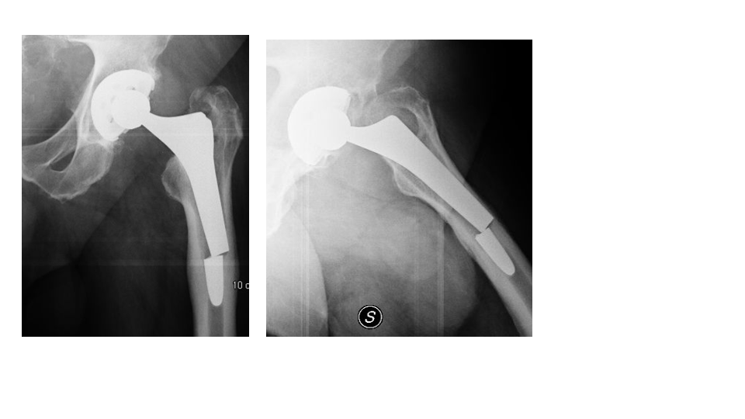
Figure 1 The X-ray of stem breakage. Left hip radiographs obtained at 21 years follow-up demonstrating stem breakage in the distal section without fracturing the femoral cortex.
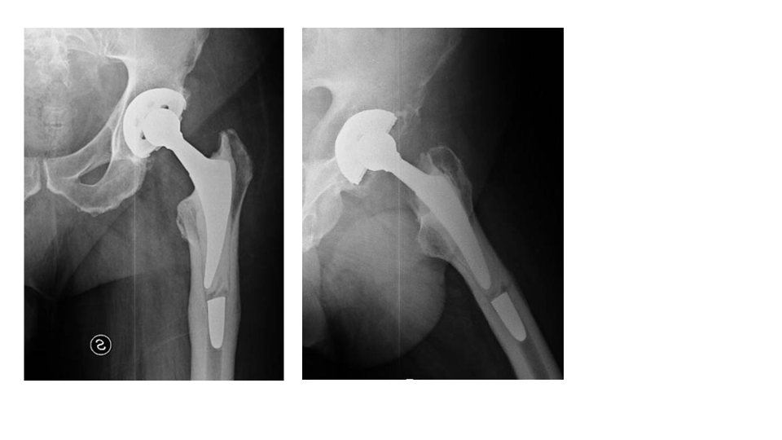
Figure 2 Radiographs at 2 years of follow-up. Radiographs at 2 years of follow-up, there are no signs of implant loosening.

