Name of journal: World Journal of Gastroenterology
ESPS Manuscript NO: 9645
Columns: ORIGINAL ARTICLE

Gut-liver axis improves with meloxicam treatment after cirrhotic liver resection

Hamza AR et al. Gut-liver axis improves with meloxicam treatment

Astrit R Hamza, Avdyl S Krasniqi, Pramod Kadaba Srinivasan, Mamdouh Afify, Christian Bleilevens, Uwe Klinge, René H Tolba

Astrit R Hamza, Pramod Kadaba Srinivasan, Mamdouh Afify, René H Tolba, Institute for Laboratory Animal Science and Experimental Surgery, University Hospital Rheinisch-Westfälische Technische Hochschule Aachen, Aachen 52074, Germany

Astrit S Hamza, Avdyl Krasniqi, Department of Abdominal Surgery, University Clinical Center of Kosova, Prishtina 10000, Kosovo

Christian Bleilevens, Department of Anesthesiology, University Hospital Rheinisch-Westfälische Technische Hochschule Aachen, Aachen 52074, Germany

Uwe Klinge, Department of Surgery, University Hospital Rheinisch-Westfälische Technische Hochschule Aachen, Aachen 52074, Germany

Author contributions: Hamza AR designed the study, performed experiments, collected and analyzed data, and wrote the article; Krasniqi AS designed the study and wrote the article; Srinivasan PK collected and analyzed data; Afify M analyzed histologic data; Bleilevens C performed polymerase chain reaction experiments and analysis; Klinge U performed collagen quantification; Tolba RH designed the study, analyzed data, revised the article and approved final version for publication.

Correspondence to: René H Tolba, MD, PhD, Professor, Director, Institute for Laboratory Animal Science and Experimental Surgery, University Hospital Rheinisch-Westfälische Technische Hochschule Aachen, Pauwelsstraße 30, Aachen 52074, Germany. rtolba@ukaachen.de

Telephone: +49-241-8080472 Fax: +49-241-8082462

Received: February 22, 2014 Revised: June 7, 2014
Accepted: June 25, 2014

Published online:

Abstract
AIM: To investigate the effect of meloxicam on the gut-liver axis after cirrhotic liver resection.

METHODS: Forty-four male Wistar rats were assigned to three groups: (1) control group (CG); (2) bile duct ligation with meloxicam treatment (BDL + M); (3) bile duct ligation without meloxicam treatment (BDL). Secondary biliary liver cirrhosis was induced via ligature of the bile duct in the BDL + M and BDL groups. After 2 wk, the animals underwent a 50% hepatectomy. In the BDL + M group 15 min prior to the hepatectomy, one single dose of meloxicam was administered. Parameters measured included: microcirculation of the liver and small bowel; portal venous flow (PVF); gastrointestinal (GI) transit; alanine aminotransferase (ALT); malondialdehyde (MDA); interleukin 6 (IL-6), transforming growth factor beta 1 (TGF-β1) and hypoxia-inducible factor 1 alpha (HIF-1α) levels; mRNA expression of cyclooxigenase-2 (COX-2), IL-6 and TGF-β1; liver and small bowel histology; immunohistochemical evaluation of hepatocyte and enterocyte proliferation with Ki-67 and COX-2 liver expression.

RESULTS: Proliferative activity of hepatocytes after liver resection, liver flow and PVF were significantly higher in CG vs BDL + M and CG vs BDL group (P < 0.05), whereasone single dose of meloxicam ameliorated liver flow and proliferative activity of hepatocytes in BDL + M vs BDL group. COX-2 liver expression at 24 h observation time (OT), IL-6 concentration and mRNA IL-6 expression in the liver especially at 3 h OT, were significantly higher in BDL group when compared with the BDL + M and CG groups (P < 0.01, P < 0.001, P < 0.01, respectively). Liver and small bowel histology, according to a semi quantitative scoring system, showed better integrity in BDL + M and CG as compared to BDL group. ALT release and HIF-1α levels at 1 h OT were significantly higher in BDL + M compared to CG and BDL group (P < 0.001 and P< 0.01, respectively). Moreover, ALT release levels at 3 and 24 h OT were significantly higher in BDL group compared to CG, P < 0.01. GI transit, enterocyte proliferative activity and number of goblet cells were in favor of meloxicam treatment vs BDL group (P < 0.05, P < 0.001, P < 0.01, respectively). Additionally, villus length were higher in BDL + M as compared to BDL group.

CONCLUSION: One single dose of meloxicam administered after cirrhotic liver resection was able to cause better function and integrity of the remaining liver and small bowel.

© 2014 Baishideng Publishing Group Inc. All rights reserved.

Key words: Liver cirrhosis; Liver resection; Gut-liver axis; Meloxicam; Cyclooxigenase-2; Microcirculation.

Core tip: Cyclooxygenase-2 (COX-2) inhibitors have been used in liver cirrhosis (LC), suppressing inflammation and liver fibrosis. However, the effects of COX-2 inhibition on the gut-liver axis after cirrhotic liver resection was not investigated previously. For the first time it can be concluded that one single dose of meloxicam administered 15 min prior to a 50% hepatectomy in LC, alleviates impairment of many functions of the gut-liver axis such as microcirculation, hepatocyte and enterocyte regeneration rate, and gastrointestinal transit, enabling better function and integrity of the remaining liver and the small bowel.

Hamza AR, Krasniqi AS, Srinivasan PK, Afify M, Bleilevens C, Klinge U, Tolba RH. Gut-liver axis improves with meloxicam treatment after cirrhotic liver resection. World J Gastroenterol 2014; In press
INTRODUCTION
Liver cirrhosis (LC) represents the final common pathophysiological end stage for a broad spectrum of chronic liver diseases. It is characterized by the replacement of normal tissue with fibrous tissue, caused by different noxae (e.g., viruses, alcohol, metabolic disorders etc.), and loss of normal liver function.
LC has become a considerable public health problem with high morbidity and mortality. Previously published data show that LC affects up to 4.5%-9.5% of the global population in reference to autopsy studies^{[1,2]}. Cirrhosis per se, carries very high risk factor of altering into a hepatocellular carcinoma (HCC), because up to 85%-95% of HCCs arise in cirrhotic livers^{[3-5]}. Surgical resection is the only potentially curative treatment for HCC in noncirrhotic patients and in cirrhotics with preserved liver function^{[4]}. However, the recurrence rate after resection with up to 70% remains high, especially in patients with cirrhosis^{[6]}. The up-regulation of cyclooxygenase-2 (COX-2) has been shown in human LC as a result of active inflammation, even higher in comparison to patients with HCC^{[7,8]}.
Cyclooxygenase (COX) is the key enzyme in the synthesis of prostaglandins (PGs) from arachidonic acid; also COX represents the main pharmacological target for non-steroidal anti-Inflammatory drugs (NSAIDs). There are three COX isoforms which have been identified: First, COX-1 which is expressed constitutively in many tissues and plays an important role for various physiological functions^{[9]}; Second, in contrast, COX-2 is dramatically up-regulated in response to cytokines, hormones, and mitogenic or inflammatory stimuli^{[10]}; Third, and latest detected COX-3, which is especially sensitive to acetaminophen and related compounds, as a variant of COX-1, which is abundantly expressed in cerebral cortex and heart^{[11]}. PGs produced by the action of COX are important mediators of systemic vasodilatation and inflammation in LC^{[9]}. Furthermore, prostacyclin I₂ has been shown to play a role in hyperdynamic circulation in portal hypertension (PHT)^{[12-14]}.
PHT, as a consequence of cirrhosis leads to hemodynamic disturbances throughout the gastrointestinal (GI) tract causing venous and capillary ectasia in the mucosa and submucosa with associated inflammatory activity^{[15]}. Many clinical and experimental studies have reported that LC causes impairment of the intestinal microcirculation and mucosal barrier. This affects the motor activity of the gut and contributes to an increased intestinal permeability and bacterial translocation^{[16-20]}. It is well known that patients with LC exhibit PHT which causes various pathological changes in the entire GI tract (from esophagus to anus)^{[21,22]}. Indeed, these changes are termed congestive gastroenteropathy and they are attributed to alterations in the GI microcirculation^{[23-27]}. Due to the drastic reduction within the microvascular bed after major hepatectomy, the remaining liver is exposed to higher portal venous pressure (PVP), known to induce irreversible sinusoidal endothelium injury as described in small-for-size liver grafts (SFSGs)^{[28-31]}. On the other hand, many surgical centers have reported that SFSGs were successfully treated with surgical manipulations, by reducing PVP and portal venous flow (PVF) with different portocaval shunts or splenectomy^{[29,32-35]}. Yagi et al^{[32]} found that the intestinal mucosa was severely damaged with PHT following SFSG liver transplantation in a porcine model. Moreover, to our knowledge there is still a lack of quantitative data that describe the gut-liver axis within an experimental setting after liver resection. Therefore, the aim of this study was to elucidate the mechanisms involved in disturbed function of the gut-liver axis after cirrhotic liver resection and possible pharmacological interventions with a preferential COX-2 inhibitor in a rat model.

MATERIALS AND METHODS
Experimental protocols and animals
All experiments were conducted in accordance with German Federal Law regarding the protection of animals and the British Government's proposals for the transposition of European Directive 2010/63/EU on the protection of animals used for scientific purposes. The Guide for the care and use of laboratory animals (8th edition, National Institutes of Health Publication, 2011, USA) were also followed. Forty-four male Wistar albino rats with a mean body weight (BW) = 300 g were obtained from Charles River Laboratories GmbH (Sulzfeld, Germany). The animals were housed in Type 2000 rat filter top cages (Tecniplast, Hohenpreisenberg, Germany) under specific pathogen free (SPF)-conditions according to Federation of European Laboratory Animal Science Associations (FELASA) guidelines (www.felasa.eu) in a temperature and humidity controlled environment with a 12-h light/dark cycle and allowed food (standard rat diet, Sniff-Spezial Diäten GmbH, Soest, Germany) and water ad libitum.

Experimental groups and operative procedures
The animals were divided into three groups: (1) control group (CG): no bile duct ligation (n = 15); (2) bile duct ligation group with meloxicam treatment 10 mg/kg BW (BDL + M) (n = 15); (3) bile duct ligation group without meloxicam treatment (BDL)(n = 14). Each group was divided into three subgroups according to the time points of observation time (OT); 1, 3 and 24 h OT post liver resection (n = 5 at each time point in each group, except n = 4 at 3 h OT in the BDL group). After induction of general anesthesia by inhalation of 5 vol% isoflurane and 5 L/min of oxygen (Abbott GmbH & Co. KG, Wiesbaden, Germany), for ~2 min, anesthesia was then maintained by reducing the isoflurane to 2 vol%, 2 L/min of oxygen. Preoperative prophylactic antibiotic treatment and analgesia were achieved by subcutaneous injection of cefuroxime sodium (16 mg/kg/24 h) (Cefuroxim Fresenius; Fresenius Kabi Deutschland GmbH, Bad Hamburg, Germany), and of buprenorphine (0.1 mg/kg/24 h) (Temgesic; Essex Pharma, München, Germany) for 24 h after surgery. The abdomen was opened by a midline laparotomy. In the second and third groups (BDL + M and BDL), a secondary biliary LC was induced via ligature of the bile duct. After laparotomy, the duodenum was reached through the incision in order to place the common bile duct under tension. The common bile duct was isolated and ligated twice using PDS-6.0 (Ethicon, Johnson and Johnson, Lenneke Marelaan, Belgium). The abdomen wall was closed in two-layers, the first layer with a continuous suture and the skin with interrupted suture. The animals were allowed to recover in a special intensive care unit (Vetario; Brinsea Products Ltd., North Somerset, UK) with warmed air (30-35 °C) for at least 15 min. After 2 wk the animals underwent a partial liver resection of a 50% of the liver mass [left liver lobe (LLL), anterior caudate (AC) and posterior caudate (PC), liver lobe]. In the BDL + M group, the animals were treated with a single dose of the preferential COX-2 inhibitor meloxicam at a dose of 10 mg/kg body weight iv via penile vein (Metacam® Boehringer Ingelheim Vetmedica GmbH Ingelheim/Rhein-Deutschland), 15 min before resection. All surgical procedures were performed under aseptic conditions. In the first group (CG) the same surgical procedure was performed without prior BDL and meloxicam administration. This group served as the control group.

Microcirculation of the liver, small bowel and portal venous flow measurements
The microcirculation of the liver and small bowel was assessed by a combined laser Doppler flowmetry and near infrared spectrophotometry device (O2C: oxygen to see; LEA Medizintechnik GmbH, Giessen, Germany). The portal venous flow was evaluated with a transit-time perivascular flowmeter (T403; Transonic Systems, Inc., Ithaca, NY).

Gastrointestinal transit evaluation
The GI was investigated 24 h after operation using oral administration of indocyanine green (ICG) (Pulsion Medical System, Munich, Germany). For this purpose, the animals were briefly anaesthetized (isoflurane 2 vol%, 2 L/min of oxygen); thereafter, they received 0.2 mL of ICG (5 mg/mL) via gastric tube 22 h post operatively. 2 h after administration of the ICG, the GI transit in the small bowel was visualised ex vivo using the IC-View System (Pulsion Medical System, Munich, Germany). The non-invasive IC-VIEW system contains of an infrared source and a digital video camera with the special ability to detect near-infrared light in a special mode with a filter. Excitation light is provided by an IC-VIEW camera mounted near-infrared light source (NIR-light, laser class 3B, energy 0.16 W, wave length 780 nm). ICG-derived fluorescence is detected by the digital IC-VIEW Video Camera and can be viewed in real-time. Results are recorded on the camera tape and the digital data is then transferred to a PC (Sony Vaio Laptop, PCG-3192; Sony Corp., Tokyo, Japan), stored and analyzed. Details are described previously^{[36]}.

Hepatocellular damage
Hepatocellular damage was evaluated by the increase of liver parenchymal enzyme, alanine aminotransferase (ALT), in serum, after liver resection according to the different time points at 1, 3 and 24 h.

Histopathology and immunohistochemistry analysis
Tissue samples of the liver and intestine (jejunum) were collected at the time when the rats were euthanized. The samples were immediately fixed in 4% neutral buffered formalin (Roti®-Histofix 4%, Roth, Karlsruhe-Germany), then were shaken overnight on a vortex shaker (Lab net, International Inc. USA). The specimens were processed in grading series of alcohol and xylene, embedded in paraffin and sectioned at 4–6 µm thin slices using a microtome and were stained with hematoxylin and eosin (HE). Tissue sections of the liver and the small bowel were all examined in a blinded fashion by two independent investigators including a senior pathologist (M.A.). A semiquantitative scoring system was used, which was modified from the previous scoring system of Neil and Hubscher^{[37]}, regarding the histological features of hepatic parenchyma (neutrophil and macrophage infiltration, bile duct hyperplasia, regenerative activities of hepatocytes, and necrosis). Examinations of the whole slides were performed using a Leica DM 2500 optic microscope (Wetzlar, Germany) under × 400 magnification. Lesions were graded on a scale from 1 to 4 (1 = no changes or negligible, lesions affecting 0%-10% of the field; 2 = mild, lesions affecting 10%-40% of the field; 3 = moderate, lesions affecting 40%-70% of the field; 4 = severe, lesions affecting > 70% of the field). Samples of the small intestine were also examined using HE stained sections. Ischemic mucosal lesions of the small bowel was graded using a semiquantitative scoring system according to Chiu^{[38]}. The villus length and the number of goblet cells were measured in 10 villi of each sample.

Assessment of liver fibrosis
To quantify hepatic fibrosis histopathologically, liver specimens were stained with picrosirius red (PSR) and sectioned as previously prescribed^{[39]}. The sections were analyzed using amicroscope (Olympus BX51, Hamburg, Germany), equipped with ﬁlters to provide circularly polarized illumination. Five photos at × 400 magnification were taken for each specimen (n = 5). Image-Pro Plus 4.5 (Media Cybernetics, Silver Spring, USA) photo analysis software was employed for quantification of collagen I (red) and III (green) by calculating color area (μm²). In addition, for each biopsy sample stained with PSR, there was a histological evaluation of the BDL-induced liver damage. For this purpose, the Ishak scoring system was adopted, which scores cirrhotic alterations of the liver from (0 to 6 grade) according to the fibrous expansion from portal to portal and portal to central area of the liver^{[40]}.

Immunohistochemistry assessment of the liver and small bowel regeneration with
Ki-67 and COX-2 liver expression
Tissue sections of the liver and small bowel were subjected to immunohistochemical testing using the avidin-biotin-complex method and diaminobenzidine. Antibodies used in this study were monoclonal mouse Ki-67 (MIB5, 1:10; DACO, Glostrup, Denmark) for assessing cell proliferation rate. The Ki-67 labeling index (LI) represented the percentage of hepatocytes or enterocytes with Ki-67-positive nuclei relative to the total number of hepatocytes or enterocytes in randomly selected sections. For liver, ten fields avoiding periportal area, while for the gut, ten crypts (under × 400 magnification) were chosen in each animal (n = 5), with a total of fifty fields for each group. For the immunohistochemistry of the COX-2 expression, we used polyclonal rabbit antimurine COX-2 serum (Cayman Chemical, Ann Arbor, MI, USA) diluted to 2.5 mg/mL. Immunoreactive complexes were visualized with the peroxidase substrate 3-amino-9-ethyl-carbazole. The same quantifying method was followed as for Ki-67.

Malondialdehyde
In order to assess the impact of oxygen free radicals aftercirrhotic liver resection, we measured malondialdehyde (MDA) concentrations in the serum. One hundred microliters of plasma were mixed with 750 µL of 0.44 MH₃PO₄, 250 µL of 42 mmol/L aqueous solution of thiobarbituric acid (TBA), and 500 µL H₂O. Samples were incubated in boiling water for 60 min and then chilled on ice. Fluorescent LPO-TBA adduct were measured using a fluorescence spectrophotometer Tecan Infinite (Tecan Deutschland GmbH, Crailsheim, Germany). Different dilutions of tetraethoxypropene were used as the external standard. Further details were described previously^{[41]}.

Enzyme-linked immunosorbent assay
Serum levels of pro-inflammatory cytokine, interleukin 6 (IL-6) (R&D Systems, Minneapolis, MN, # R6000B), transforming growth factor beta 1 (TGF-β1) (R&D Systems, Minneapolis, MN,# MB100B) and hypoxia-inducible factor 1 alpha (HIF-1α)(MyBioSource.com, San Diego, California, USA # MBS727993), were measured byrat Enzyme-linked immunosorbent assay (ELISA) kits according to the manufacturer’s instructions.

Real-time reverse transcription polymerase chain reaction
Liver samples and 5-cm portions of the jejunum (retrieved mucosa from muscularis/serosa), were immediately snap frozen in liquid nitrogen and kept at -80 °C until analysis. Total RNA was extracted using a commercially available RNA/protein extraction kit (NucleoSpin® RNA/Protein, Machery-Nagel, Düren/Germany). Using a high capacity reverse transcription kit (Applied Biosystems®, Carlsbad, California/ USA), 250 ng of total RNA was reverse transcribed to cDNA. A polymerase chain reaction (PCR) reaction was performed using 50 ng of cDNA, a Taqman® Gene Expression Master Mix (Applied Biosystems®) and specific TaqMan® probes for IL-6 (Rn01410330_m1), TGF-β1 (Rn00572010_m1), COX-2 (Rn01483828_m1) and the house-keeping gene glycerinaldehyde 3-phosphate dehydrogenase (GAPDH, Rn01775763_g1) on a StepOne-Plus® Cycler (Applied Biosystems®). The gene expression levels of the cytokines were calculated as a relative quantity (RQ) value according to the ΔΔCt method, which reflects the differences in threshold for each target gene relative to GAPDH and the control group.

Statistical analysis
The results are expressed as the mean ± standard error of mean (SEM) for each group. Levels of ALT, MDA, IL-6, HIF-1α and TGF-β1 in the serum, microcirculation of the liver, small bowel and portal venous flow measurements between groups at each time point were tested using 2-way analysis of variance (ANOVA) and Bonferroni’s post-hoc test. Whereas, quantifications of the goblet cells, villus length, Ki-67, COX-2 liver expression between groups at 24 h OT were tested using one-way ANOVA and Tukey's Multiple Comparison Test. A non-parametric method (the Dunn procedure under the Kruskal-Wallis test) was used for Real-time reverse transcription PCR (RT-PCR) results in liver and small bowel for multiple comparisons between the groups. A P-value of < 0.05 was considered statistically significant. Calculations were made with the help of Prism 5 Windows software (GraphPad Software Inc., San Diego, CA).

RESULTS
Enzyme release
ALT release was measured as general parameter of hepatocellular damage. In our study, we observed significantly higher levels of parenchymal enzyme release in BDL + M at 1 h OT compared to CG and BDL, P < 0.001. At two other time points 3 h and 24 h, ALT release was high in all three groups, however it was much higher in BDL + M and BDL compared to CG (P < 0.001, P < 0.01, P < 0.05)(Figure 1).

Microcirculation of the liver, small bowel and portal venous flow measurements
The microcirculation of the liver and small bowel, as an important factor in maintenance of their function, was assessed by an O2C-device after liver resection at three different time points. Liver flow was significantly higher in CG vs BDL P < 0.05. Although meloxicam treatment maintained liver flow in BDL + M compared to the BDL group, this difference did not reach statistical significance (Table 1). Regarding the microcirculation of the small bowel no statistical difference were observed between the three groups (Table 1). PVF was evaluated with a transit-time perivascular flowmeter on the portal vein after liver resection according to three different time points. In CG, PVF was significantly higher compared to BDL + M and BDL groups, P < 0.05 (Table 1).

GI transit evaluation
In order to evaluate GI transit after liver resection, ICG was administered orally through a gastric tube 22 h postopertively in the 24 h group. After laparotomy, the entire small bowel was resected and visualized with the IC-VIEW System ex vivo. In the CG and BDL + M animals, homogenous ICG signal could be detected in nearly the entire small bowel up to the caecum (77 and 82 cm respectively); however in the BDL group the ICG signal was observed in a much shorter length of the bowel (52 cm) (Figure 2A). The histogram (Figure 2B) shows ICG transit of small bowel in centimeter (cm). In BDL vs BDL + M, the ICG signal was seen in a significantly shorter length of bowel (52 vs 82 cm of the small bowel length, P < 0.05).

Histopathological and immunohistochemical assessment of the liver
Histopathological changes of the liver (HE staining), at 24 h OT after liver resection were analyzed using a semiquantitative scoring system^{[37]}. The liver tissue in CG showed negligible lesions (score 1)(Figure 3A). There was mild periportal neutrophil and mononuclear cell infiltration with expressed regenerative activities of hepatocytes (megakaryocytes and megalocytosis). On the other hand, liver tissue in the BDL group showed moderate to severe lesions (mean; score 4)(Figure 3C). The microscopy showed biliary proliferation in different locations involving multiple lobules, spreading from portal to portal space, with a tendency to reach the central vein. Moreover, Kupffer cell proliferation, some necrotic areas, and inflammatory cell infiltration in periportal areas were seen in this group. On the contrary, in the substrate meloxicam treatment group (BDL + M) the lesions were of moderate degree (mean; score 3)(Figure 3B). In this group there was seen moderate proliferation of biliary epithelium (reserve cells) in different locations extending in moderate degree, not reaching another portal area.
Hepatocyte proliferationwas assessed with immunohistochemistry Ki-67-positive nuclei. Note the higher number of Ki-67-positive hepatocytes in CG (Figure 3D) and BDL + M (Figure 3E) compared to the BDL group (Figure 3F). Whereas, COX-2 expression in the liver assessed with immunohistochemistry was much more expressed in the BDL group (Figure 3I) compared to CG (Figure 3G) and BDL + M groups (Figure 3H). Table 2 summarizes the quantified immunohistochemical findings of hepatocyte proliferation with Ki-67-positive nuclei and COX-2 expression after liver resection of three groups at 24 h OT. Ki-67-positive hepatocytes was significantly higher in CG vs BDL group, P < 0.05. Although the number of Ki-67-positive hepatocytes was higher in BDL + M vs BDL, the difference did not reach statistical significance (Table 2). Hepatic COX-2 positive cells were significantly attenuated with meloxicam treatment in BDL + M vs BDL group, P < 0.01; also the BDL group showed higher expression of COX-2 vs CG, P < 0.01 (Table 2).

Histopathological and immunohistochemical assessment of the small bowel
The semiquantitative scoring system according to Chiu^{[38]} for scoring mucosal lesions of the small bowel was chosen because we thought that it is most appropriate for these type of lesions. Although, in CG the ischemic lesions with development of Gruenhagen space at the apex of the villus were seen (grade 1)(Figure 4A), and in the BDL groupwith extension of sub-epithelial space with moderate lifting of the epithelial layer from the lamina propria (grade 2)(Figure 4C), these changes were not significantly different in the BDL + M group (Figure 4B)(Table 3). In nearly all sections there was a variable degree of leukocyte infiltration, a sign of previous ischemic and degenerative changes that indicates a degree of proliferative activity of the epithelial lining and the duration, which allowed such regeneration. Moreover, proliferation of enterocytes was assessed with immunohistochemistry for Ki-67-positive enterocytes. Note the highernumber of Ki-67-positive enterocytes in CG (Figure 4D) and BDL + M (Figure 4E) compared to the BDL group (Figure 4F). Table 3 summarizes the quantified immunohistochemical findings of enterocyte proliferation with Ki-67-positive nuclei in ten randomly selected crypts of the gut (× 400). In addition, in this table are shown the quantified number of goblet cells and the length of the villus in ten randomly picked villi of the small intestine (× 400).
In the gut, the number of Ki-67-positive enterocytes was significantly higher in CG compared to BDL + M [91 ± 2 arbitrary unit (AU) vs 77 ± 1 AU; P < 0.001] and CG compared to BDL group (91 ± 2 AU vs 50 ± 1 AU; P < 0.001). Additionally, the number of Ki-67-positive enterocytes was also significantly higher in BDL + M vs BDL group (77 ± 1 AU vs 50 ± 1 AU; P < 0.001)(Table 3). The number of goblet cells was significantly higher in the BDL group compared to BDL + M and CG, P < 0.01 (Table 3). Villus length was significantly longer in CG compared to BDL group, P < 0.05. Although length of the villus was longer in BDL + M compared to BDL, the difference did not reach statistical significance (Table 3).

Assessment of liver fibrosis
Collagen I and III quantification with the help of Image-Pro Plus 4.5 software did not show any difference between the BDL + M and BDL groups, while it was significantly higher compared to CG (Figure 5). In order to evaluate BDL-induced liver fibrosis, the Ishak scoring system was adopted. We were able to see different grades of fibrosis even within the same group of BDL and BDL + M. In the BDL group, according to fibrous expansion portal-to-portal (P-P) and portal-to-central (P-C) linkage with fibrotic bands, liver samples were scored from grade 4; fibrous expansion of portal areas with marked bridging P-P as well as P-C, up to grade 6; definite cirrhosis, with the mean value grade 5; marked bridging P-P and P-C with occasional nodules (incomplete cirrhosis)(Figure 5C). In BDL + M, even though some slides have shown lower grade, the mean value was the same grade 5 (Figure 5B). In CG, there was no fibrosis grade 0 (Figure 5A).

ELISA
Proinflammatory cytokine IL-6, HIF-1α and TGF-β1 were evaluated with ELISA. The data showed that IL-6 concentration was significantly higher in BDL especially at 3 h OT, compared to BDL + M (151 ± 101.7 pg/mL vs 52.4 ± 23.6 pg/mL; P < 0.001) and BDL group vs CG (151 ± 101.7 pg/mL vs 12.4 ± 6.2 pg/mL; P < 0.001)(Figure 6A). HIF-1α level was found to be significantly higher in BDL + M especially at 1 h OT, compared to BDL group (3.1 ± 0.5 pg/mL vs 2.2 ± 0.4 ng/mL; P < 0.01) and CG, BDL + M vs CG (3.1 ± 0.5 pg/mL vs 2.1 ± 0.4 ng/mL; P < 0.01)(Figure 6B). Regarding TGF-β1 there was no statistical difference between BDL and BDL + M groups (192.6 ± 32.1 pg/mL vs 212.2 ± 46.04 pg/mL), but was significantly higher in BDL + M compared to CG (212.2 ± 46.04 pg/mL vs 136.9 ± 12.3 pg/mL; P < 0.05), only at 24 h OT (Figure 6C).

Lipid peroxidation
The MDA levels in serum were assessed to measure the impact of oxygen free radicals on lipid peroxidation (Figure 7). We could observe significantly higher levels of MDA in the BDL and BDL + M groups compared to the CG group: BDL vs CG (21.14 ± 3 nmol/mL vs 11.01 ± 0.6 nmol/mL; P < 0.001), and BDL + M vs CG (19.49 ± 2.77 nmol/mL vs 11.01 ± 0.6 nmol/mL; P < 0.01).

mRNA expression of IL-6, TGF-β1, and COX-2 in the liver and small bowel
The expression of messenger RNA (mRNA) for IL-6, TGF-β1, and COX-2 in the liver and mucosa/serosa of the small bowel were analyzed by RT-PCR. Similar to the ELISA results, IL-6 expression in the liver was up-regulated significantly in the BDL group, especially at 3 h OT compared to BDL + M and CG, P < 0.01. However, it was significantly down-regulated at 24 h OT in both groups compared to CG, P < 0.05 (Figure 8A).
In mucosa, IL-6 was undetectable; while in muscularis/serosa was down-regulated significantly in BDL + M compared to BDL and CG especially at 3 h OT, P < 0.01 (Figure 8A). There was no statistical difference between the BDL + M and BDL groups in TGF-β1 mRNA expression in liver and small bowel. Whereas, statistical difference was observed in comparison with CG: in the liver at 24 h OT, BDL vs CG, P < 0.05; in mucosa at 3 h OT, BDL + M and BDL vs CG , P < 0.001; and in muscularis/serosa at 3 h OT, BDL vs CG, P < 0.01 (Figure 8B). In the liver, meloxicam treatment, as we assessed with immunohistochemistry, down-regulated significantly COX-2 mRNA expression in BDL + M at 3 h OT vs BDL at 24 h OT, P < 0.05. In mucosa and muscularis/serosa of the small bowel there was no statistical difference in COX-2 mRNA expression between the BDL + M and BDL groups. While, statistical difference was observed in comparison with CG; BDL + M and BDL groups vs CG at 3 h OT, P < 0.01, and BDL + M vs CG at 24 h OT, P < 0.05 (Figure 8C).

DISCUSSION
LC as a final pathophysiological pathway of many chronic liver diseases, has become a considerable public health problem because its incidence in western countries is rising^{[16]}. Several noxae (e.g., viruses, alcohol, metabolic disorders, etc.), trigger an inflammatory response within the liver and, if the causes persist, the pathophysiological process leads to end-stage liver disease such as LC. In this inflammatory milieu, many studies have confirmed that COX-2 is up-regulated, regardless of the cause either by cholestasis, viruses or toxins^{[7,9]}. COX-2 is an inducible enzyme originally found to be induced by various stimuli, such as cytokines, mitogens and growth factors^{[8]}. It has been previously shown that the administration ofselective COX-2 inhibitors from the beginning of acute inflammation in LC induced either by BDL or toxins could suppress inflammation and fibrogenesis^{[7,42]}. Contrary to others, in the present study we administered a single dose of meloxicam in a LC rat model, when fibrosis was already established for 2 wk.
Thereafter, ~50% of liver volume was resected. Our aim was to investigate gut-liver axis disturbances after liver resection and, possible pharmacological interventions with selective COX-2 inhibition in a rat model. In this study, we administered meloxicam, an oxicam derivative of NSAIDs, which preferentially inhibits COX-2 over COX-1. It is a preferred drug for rheumatoid arthritis and osteoarthritis due to lower cardiac and gastrointestinal side effects compare to other selective COX-2 inhibitors^{[43-46]}. In the present study, one single dose of meloxicam was able to ameliorate the ischemia/reperfusion injury of the liver and small bowel after liver resection in the BDL + M group in comparison to the BDL group. Due to the inflammatory process in the liver induced by bile duct ligation and surgical stress, many functions of the liver were disturbed. However, suppression of inflammation with meloxicam preserved many of them. Microcirculation of the liver, as an important parameter in maintenance of liver function, was better maintained with meloxicam treatment compared to the BDL group. Although there was no differencein PVF between the BDL + M and BDL groups, whereas in CG was significantly higher, suppression of inflammation with meloxicam was connected with better liver regeneration in comparison with the BDL group. This was in line with down-regulation of COX-2 expression and up-regulation of Ki-67 in the liver assessed by immunohistochemistry. Moreover, attenuation of IL-6 release into the serum as a proinflammatory cytokine with meloxicam, assessed by ELISA and RT-PCR, showed better regeneration and integrity of the liver in comparison with the BDL group.
We were surprised that elevation of ALT in the serum after liver resection was significantly higher in BDL + M compared to CG and only after 1 h OT compared to the BDL group. This rise of ALT in BDL + M group may be attributed to meloxicam metabolism and elimination. It was reported that cholestasis produced by BDL has been associated with decreased concentrations of hepatic microsomal cytochrome P450 and decreased hepatic microsomal oxidative drug metabolism^{[47,48]}. Thus, the half-life of meloxicam may be extended. This could probably lead to a concentration-dependent adverse effect. This minorside effect of meloxicam was attenuated at 24 h OT after liver resection. Indeed, liver histology of 24 h OT in the BDL group also showed moderate to severe changes in liver tissue according to the semiquantitative scoring system with biliary proliferation in different locations involving multiple lobules, inflammatory cells infiltration, and some areas of necrosis. Meloxicam treatment attenuated these changes to a moderate degree. Interestingly, HIF-1α was significantly higher in BDL + M compared to BDL and CG, especially at 1 h OT. Its role in liver regeneration and fibrosis is controversial. Tajima et al^{[49]} showed that HIF-1α found in hepatocytes after liver resection was required for the maintenance of normal blood glucose levels by regulating gluconeogenesis and glycogen synthesis during liver regeneration. Research with HIF-1α KO mice in hepatocytes corroborated these results. On the other hand, Moon et al^{[50]} reported that liver fibrosis was reduced in HIF-1α-deficient mice after 3 wk of BDL compared to the wild mice type. The extent of LC determined by the Ishak scoring system and collagen I & III quantification in the BDL + M group was not different compare to the BDL only group. Since, in our rat model, in the treatment group after liver resection HIF-1α was up-regulated, this may be very helpful to overcome the stress after surgery by regulating glucose utilization during liver regeneration. Yamamoto et al^{[51]} showed that HIF-1α was up-regulated in liver and intestine during liver regeneration after hepatectomy, which is in line with our results.
Cholestasis induced by BDL may cause mitochondrial dysfunction, biochemical, and molecular changes related to oxidative stress in the liver. In order to evaluate the oxygen free radical activity we measured MDA levels in serum. This activity was higher in the BDL group; however meloxicam could not suppress this activity significantly. Huang et al^{[52]} reported high levels of MDA in serum after two, even higher after 4 wk post-BDL, suggesting that the extent of lipid peroxidation increased with progressive fibrosis. Nevertheless, previously it was documented that COX-2 inhibitors administered from the beginning of acute inflammation could suppress inflammation, fibrosis, and oxidative stress by lowering MDA levels and profibrogenic factors in LC induced by CCl₄ treatment^{[42]}. In our study due to the severe oxidative stress, establishment of fibrosis, and adding surgical stress by the hepatectomy, the single dose of meloxicam did not lower MDA levels significantly.
Earlier it was reported that administration of COX-2 inhibitors from the beginning of the inflammation process is able to suppress fibrosis in LC caused by BDL and toxins, through down-regulation of TGF-β1^{[7,42]}. Similar to liver fibrosis and collagen quantification, TGF-β1 as a profibrinogenic factor assessed with ELISA, and TGF-β1 mRNA expression in liver and small bowel assessed with RT-PCR, showed no significant difference between BDL + M and BDL group. Williams and Iredale^{[53]} reported that liver regeneration is characterized not only by hepatocyte proliferation but also by increased TGF-β1 expression. Thus, hepatocytes proliferate despite the presence of a strong antiproliferative stimulus.
The small bowel, as an integral part of GI tract, plays an important role in many functions of the body, while in LC many of these are compromised. It was shown previously that the GI transit is altered in patients with LC^{[20]}. In the present study, meloxicam treatment showed significant acceleration of GI transit compared to the BDL group. This is in agreement with the other results published previously. Josephs et al^{[54]} reported that COX-2 inhibition improved early postoperative GI transit, whereas Schwarz et al^{[55]} have shown that PGs, produced by the action of COX-2, are major participants in rodent postoperative ileus induced by intestinal manipulation. Moreover, they showed that due to the molecular up-regulation of COX-2, jejunal circular muscle contractility and GI transit was decreased. Experiments in COX-2 KO mice have confirmed these findings. Same results were shown earlier by our group, that intestinal manipulation caused GI transit delay and an impairment in bowel wall perfusion and microcirculation^{[36]}. Similarly, in our study, COX-2 mRNA expression in the gut was attenuated by meloxicam treatment. Thus, although PGs are both inhibitory and excitatory on intestinal smooth muscle cells, the data in this study showed predominantly inhibitory effects on small bowel circular smooth muscle cells. However, a single iv administration of meloxicam caused no difference on microcirculation of the small bowel between groups; however, histological and immunohistochemical analysis showed that meloxicam treatment attenuated ischemic lesions in comparison with the BDL group. Proliferative activity, assessed by the number of Ki-67-positive nuclei enterocytes, the number of goblet cells quantified, and the length of the villi were in favor of treatment with meloxicam. These results are in agreement with other results previously published. Gulo et al^{[56]} have shown that the number of goblet cells was increased in mucosa of the small bowel under chronic ischemia. Additionally, ischemic intestinal injury has been shown to be reflected by a lowering of villus length of the gut ^{[56,57]}.
In summary, it can be concluded that even one single dose of meloxicam administered after cirrhotic liver resection could improve the impairment of many functions of the gut-liver axis, enabling better function and integrity of the remaining liver and small bowel. In future, further studies are warranted to have better insight about the pharmacokinetics of meloxicam in established cholestatic LC, in order to avoid some side effects in LC. Perhaps, by reducing meloxicam dosage and using it in a repetitive manner we would be able to gain better results in gut-liver axis after cirrhotic liver resection.

ACKNOWLEDGMENTS
The authors thank Pascal Paschenda and Mareike Schulz, for their skillful technical assistance.

COMMENTS
Background
Liver cirrhosis (LC), represent end-stage of wide variety of chronic liver diseases which leads to hemodynamic disturbances throughout the gastrointestinal (GI) tract associated with inflammatory activity. Cyclooxygenase-2 (COX-2) is up-regulated in this milieu, and administration of selective COX-2 inhibitors from the beginning of acute inflammation in LC could suppress inflammation and fibrogenesis. Whereas, influence of meloxicam on gut-liver axis after cirrhotic liver resection was not studied previously.

Research frontiers
The aim of this study was to elucidate the mechanisms involved in disturbed function of the gut-liver axis after cirrhotic liver resection and possible pharmacological interventions with the COX-2 inhibitor meloxicam in a rat model, recognizing reports of up-regulation of COX-2 in human liver cirrhosis as a result of active inflammation. Involvement of different pathophysiological mechanisms on microcirculation of small bowel after cirrhotic liver resection in rats is not yet clarified.

Innovations and breakthroughs
The related research will help to understand the basic mechanism about the initiation of fibrosis as well as regeneration and the systemic consequences for the small bowel function. This is the first study to report that one single dose of meloxicam administered 15 min. before cirrhotic liver resection could improve the impairment of many functions of the gut-liver axis, enabling better function and integrity of the remaining liver and small bowel such as microcirculation, liver and small bowel regeneration and GI transit etc.

Applications
The study indicates that meloxicam may serve as a novel therapeutic target for improving gut-liver axis functions after cirrhotic liver resection in the future.

Terminology
Meloxicam, an oxicam derivative of non-steroidal anti-Inflammatory drugs (NSAIDs), which preferentially inhibits COX-2 over COX-1. It is a preferred drug for rheumatoid arthritis and osteoarthritis due to lower cardiac and gastrointestinal side effects compare to other selective COX-2 inhibitors.

Peer review
The manuscript is excellently written and addresses an important topic. The aim of this work is of interest, the methodology is appropriate and the results are enlightening. This work could help to clarify if one single dose of meloxicam administered after cirrhotic liver resection could improve the impairment of some functions of the enterohepatic circuit.

REFERENCES
1 Chandok N, Watt KD. Pain management in the cirrhotic patient: the clinical challenge. Mayo Clin Proc 2010; 85: 451-458 [PMID: 20357277 DOI: 10.4065/mcp.2009.0534]
2 Lim YS, Kim WR. The global impact of hepatic fibrosis and end-stage liver disease. Clin Liver Dis 2008; 12: 733-746, vii [PMID: 18984463 DOI: 10.1016/j.cld.2008.07.007]
3 Ruzzenente A, Valdegamberi A, Campagnaro T, Conci S, Pachera S, Iacono C, Guglielmi A. Hepatocellular carcinoma in cirrhotic patients with portal hypertension: is liver resection always contraindicated? World J Gastroenterol 2011; 17: 5083-5088 [PMID: 22171142 DOI: 10.3748/wjg.v17.i46.5083]
4 Llovet JM, Bruix J. Novel advancements in the management of hepatocellular carcinoma in 2008. J Hepatol 2008; 48 Suppl 1: S20-S37 [PMID: 18304676 DOI: 10.1016/j.jhep.2008.01.022]
5 Akriviadis EA, Llovet JM, Efremidis SC, Shouval D, Canelo R, Ringe B, Meyers WC. Hepatocellular carcinoma. Br J Surg 1998; 85: 1319-1331 [PMID: 9782009 DOI: 10.1046/j.1365-2168.1998.00865.x]
6 Duffy JP, Hiatt JR, Busuttil RW. Surgical resection of hepatocellular carcinoma. Cancer J 2008; 14: 100-110 [PMID: 18391615 DOI: 10.1097/PPO.0b013e31816a5c1f]
7 Kim SM, Park KC, Kim HG, Han SJ. Effect of selective cyclooxygenase-2 inhibitor meloxicam on liver fibrosis in rats with ligated common bile ducts. Hepatol Res 2008; 38: 800-809 [PMID: 18462380 DOI: 10.1111/j.1872-034X.2008.00339.x]
8 Yamamoto H, Kondo M, Nakamori S, Nagano H, Wakasa K, Sugita Y, Chang-De J, Kobayashi S, Damdinsuren B, Dono K, Umeshita K, Sekimoto M, Sakon M, Matsuura N, Monden M. JTE-522, a cyclooxygenase-2 inhibitor, is an effective chemopreventive agent against rat experimental liver fibrosis1. Gastroenterology 2003; 125: 556-571 [PMID: 12891558 DOI: 10.1016/S0016-5085(03)00904-1]
9 Mohammed NA, Abd El-Aleem SA, El-Hafiz HA, McMahon RF. Distribution of constitutive (COX-1) and inducible (COX-2) cyclooxygenase in postviral human liver cirrhosis: a possible role for COX-2 in the pathogenesis of liver cirrhosis. J Clin Pathol 2004; 57: 350-354 [PMID: 15047734 DOI: 10.1136/jcp.2003.012120]
10 Simmons DL, Botting RM, Hla T. Cyclooxygenase isozymes: the biology of prostaglandin synthesis and inhibition. Pharmacol Rev 2004; 56: 387-437 [PMID: 15317910 DOI: 10.1124/pr.56.3.3]
11 Chandrasekharan NV, Dai H, Roos KL, Evanson NK, Tomsik J, Elton TS, Simmons DL. COX-3, a cyclooxygenase-1 variant inhibited by acetaminophen and other analgesic/antipyretic drugs: cloning, structure, and expression. Proc Natl Acad Sci U S A 2002; 99: 13926-13931 [PMID: 12242329 DOI: 10.1073/pnas.162468699]
12 Tsugawa K, Hashizume M, Migou S, Kishihara F, Kawanaka H, Tomikawa M, Sugimachi K. A selective cyclo-oxygenase-2 inhibitor, NS-398, may improve portal hypertension without inducing gastric mucosal injury. J Gastroenterol Hepatol 1999; 14: 642-651 [PMID: 10440208 DOI: 10.1046/j.1440-1746.1999.01930.x]
13 Skill NJ, Theodorakis NG, Wang YN, Wu JM, Redmond EM, Sitzmann JV. Role of cyclooxygenase isoforms in prostacyclin biosynthesis and murine prehepatic portal hypertension. Am J Physiol Gastrointest Liver Physiol 2008; 295: G953-G964 [PMID: 18772366 DOI: 10.1152/ajpgi.00013.2008]
14 Sitzmann JV, Campbell K, Wu Y, St Clair C. Prostacyclin production in acute, chronic, and long-term experimental portal hypertension. Surgery 1994; 115: 290-294 [PMID: 8128353]
15 El-Khayat HR, El Khattib A, Nosseir M, Ezz MA, El-Amin H, Fouad YM. Portal hypertensive enteropathy before and after variceal obliteration: an endoscopic, histopathologic and immunohistochemical study. J Gastrointestin Liver Dis 2010; 19: 175-179 [PMID: 20593051 DOI: 10.1016/S0016-5085(10)63759-6]
16 Maksan SM, Ryschich E, Ulger Z, Gebhard MM, Schmidt J. Disturbance of hepatic and intestinal microcirculation in experimental liver cirrhosis. World J Gastroenterol 2005; 11: 846-849 [PMID: 15682478]
17 Llovet JM, Bartolí R, March F, Planas R, Viñado B, Cabré E, Arnal J, Coll P, Ausina V, Gassull MA. Translocated intestinal bacteria cause spontaneous bacterial peritonitis in cirrhotic rats: molecular epidemiologic evidence. J Hepatol 1998; 28: 307-313 [PMID: 9580278 DOI: 10.1016/0168-8278(88)80018-7]
18 Parlesak A, Schäfer C, Schütz T, Bode JC, Bode C. Increased intestinal permeability to macromolecules and endotoxemia in patients with chronic alcohol abuse in different stages of alcohol-induced liver disease. J Hepatol 2000; 32: 742-747 [PMID: 10845660 DOI: 10.1016/S0168-8278(00)80242-1]
19 Pascual S, Such J, Esteban A, Zapater P, Casellas JA, Aparicio JR, Girona E, Gutiérrez A, Carnices F, Palazón JM, Sola-Vera J, Pérez-Mateo M. Intestinal permeability is increased in patients with advanced cirrhosis. Hepatogastroenterology 2003; 50: 1482-1486 [PMID: 14571769]
20 Madrid AM, Cumsille F, Defilippi C. Altered small bowel motility in patients with liver cirrhosis depends on severity of liver disease. Dig Dis Sci 1997; 42: 738-742 [PMID: 9125642]
21 Sarfeh IJ, Tarnawski A. Gastric mucosal vasculopathy in portal hypertension. Gastroenterology 1987; 93: 1129-1131 [PMID: 3498660]
22 Abdelaal UM, Morita E, Nouda S, Kuramoto T, Miyaji K, Fukui H, Tsuda Y, Fukuda A, Murano M, Tokioka S, Arafa UA, Kassem AM, Umegaki E, Higuchi K. Evaluation of portal hypertensive enteropathy by scoring with capsule endoscopy: is transient elastography of clinical impact? J Clin Biochem Nutr 2010; 47: 37-44 [PMID: 20664729 DOI: 10.3164/jcbn.10-14]
23 Thiruvengadam R, Gostout CJ. Congestive gastroenteropathy--an extension of nonvariceal upper gastrointestinal bleeding in portal hypertension. Gastrointest Endosc 1989; 35: 504-507 [PMID: 2599293]
24 Nagral AS, Joshi AS, Bhatia SJ, Abraham P, Mistry FP, Vora IM. Congestive jejunopathy in portal hypertension. Gut 1993; 34: 694-697 [PMID: 8504973 DOI: 10.1136/gut.34.5.694]
25 Misra V, Misra SP, Dwivedi M, Gupta SC. Histomorphometric study of portal hypertensive enteropathy. Am J Clin Pathol 1997; 108: 652-657 [PMID: 9384446]
26 Viggiano TR, Gostout CJ. Portal hypertensive intestinal vasculopathy: a review of the clinical, endoscopic, and histopathologic features. Am J Gastroenterol 1992; 87: 944-954 [PMID: 1642217]
27 Misra SP, Dwivedi M, Misra V, Gupta M. Ileal varices and portal hypertensive ileopathy in patients with cirrhosis and portal hypertension. Gastrointest Endosc 2004; 60: 778-783 [PMID: 15557954 DOI: 10.1016/S0016-5107(04)02049-8]
28 Eipel C, Glanemann M, Nuessler AK, Menger MD, Neuhaus P, Vollmar B. Ischemic preconditioning impairs liver regeneration in extended reduced-size livers. Ann Surg 2005; 241: 477-484 [PMID: 15729071 DOI: 10.1097/01.sla.0000154264.41201.51]
29 Troisi R, Cammu G, Militerno G, De Baerdemaeker L, Decruyenaere J, Hoste E, Smeets P, Colle I, Van Vlierberghe H, Petrovic M, Voet D, Mortier E, Hesse UJ, de Hemptinne B. Modulation of portal graft inflow: a necessity in adult living-donor liver transplantation? Ann Surg 2003; 237: 429-436 [PMID: 12616129 DOI: 10.1097/01.SLA.0000055277.78876.B7]
30 Man K, Fan ST, Lo CM, Liu CL, Fung PC, Liang TB, Lee TK, Tsui SH, Ng IO, Zhang ZW, Wong J. Graft injury in relation to graft size in right lobe live donor liver transplantation: a study of hepatic sinusoidal injury in correlation with portal hemodynamics and intragraft gene expression. Ann Surg 2003; 237: 256-264 [PMID: 12560784 DOI: 10.1097/01.SLA.0000048976.11824.67]
31 Man K, Lo CM, Ng IO, Wong YC, Qin LF, Fan ST, Wong J. Liver transplantation in rats using small-for-size grafts: a study of hemodynamic and morphological changes. Arch Surg 2001; 136: 280-285 [PMID: 11231846 DOI: 10.1001/archsurg.136.3.280]
32 Yagi S, Iida T, Hori T, Taniguchi K, Nagahama M, Isaji S, Uemoto S. Effect of portal haemodynamics on liver graft and intestinal mucosa after small-for-size liver transplantation in swine. Eur Surg Res 2012; 48: 163-170 [PMID: 22653087 DOI: 10.1159/000338622]
33 Takada Y, Ueda M, Ishikawa Y, Fujimoto Y, Miyauchi H, Ogura Y, Ochiai T, Tanaka K. End-to-side portocaval shunting for a small-for-size graft in living donor liver transplantation. Liver Transpl 2004; 10: 807-810 [PMID: 15162477 DOI: 10.1002/lt.20164]
34 Yamada T, Tanaka K, Uryuhara K, Ito K, Takada Y, Uemoto S. Selective hemi-portocaval shunt based on portal vein pressure for small-for-size graft in adult living donor liver transplantation. Am J Transplant 2008; 8: 847-853 [PMID: 18261170 DOI: 10.1111/j.1600-6143.2007.02144.x]
35 Shimada M, Ijichi H, Yonemura Y, Harada N, Shiotani S, Ninomiya M, Terashi T, Yoshizumi T, Soejima Y, Suehiro T, Maehara Y. The impact of splenectomy or splenic artery ligation on the outcome of a living donor adult liver transplantation using a left lobe graft. Hepatogastroenterology 2004; 51: 625-629 [PMID: 15143878]
36 Behrendt FF, Tolba RH, Overhaus M, Hirner A, Minor T, Kalff JC. Indocyanine green fluorescence measurement of intestinal transit and gut perfusion after intestinal manipulation. Eur Surg Res 2004; 36: 210-218 [PMID: 15263826 DOI: 10.1159/000078855]
37 Neil DA, Hubscher SG. Histologic and biochemical changes during the evolution of chronic rejection of liver allografts. Hepatology 2002; 35: 639-651 [PMID: 11870379 DOI: 10.1053/jhep.2002.31726]
38 Chiu CJ, McArdle AH, Brown R, Scott HJ, Gurd FN. Intestinal mucosal lesion in low-flow states. I. A morphological, hemodynamic, and metabolic reappraisal. Arch Surg 1970; 101: 478-483 [PMID: 5457245 DOI: 10.1001/archsurg.1970.01340280030009]
39 Puchtler H, Waldrop FS, Valentine LS. Polarization microscopic studies of connective tissue stained with picro-sirius red FBA. Beitr Pathol 1973; 150: 174-187 [PMID: 4129194 DOI: 10.1016/S0005-8165(73)80016-2]
40 Ishak K, Baptista A, Bianchi L, Callea F, De Groote J, Gudat F, Denk H, Desmet V, Korb G, MacSween RN. Histological grading and staging of chronic hepatitis. J Hepatol 1995; 22: 696-699 [PMID: 7560864 DOI: 10.1016/0168-8278(95)80226-6]
41 Minor T, Kötting M. Gaseous oxygen for hypothermic preservation of predamaged liver grafts: fuel to cellular homeostasis or radical tissue alteration? Cryobiology 2000; 40: 182-186 [PMID: 10788318 DOI: 10.1006/cryo.2000.2231]
42 Chávez E, Segovia J, Shibayama M, Tsutsumi V, Vergara P, Castro-Sánchez L, Salazar EP, Moreno MG, Muriel P. Antifibrotic and fibrolytic properties of celecoxib in liver damage induced by carbon tetrachloride in the rat. Liver Int 2010; 30: 969-978 [PMID: 20524983 DOI: 10.1111/j.1478-3231.2010.02256.x]
43 Ahmed M, Khanna D, Furst DE. Meloxicam in rheumatoid arthritis. Expert Opin Drug Metab Toxicol 2005; 1: 739-751 [PMID: 16863437 DOI: 10.1517/17425255.1.4.739]
44 Ogino K, Hatanaka K, Kawamura M, Katori M, Harada Y. Evaluation of pharmacological profile of meloxicam as an anti-inflammatory agent, with particular reference to its relative selectivity for cyclooxygenase-2 over cyclooxygenase-1. Pharmacology 1997; 55: 44-53 [PMID: 9309800]
45 Martin RM, Biswas P, Mann RD. The incidence of adverse events and risk factors for upper gastrointestinal disorders associated with meloxicam use amongst 19,087 patients in general practice in England: cohort study. Br J Clin Pharmacol 2000; 50: 35-42 [PMID: 10886116 DOI: 10.1046/j.1365-2125.2000.00229.x]
46 Ogino K, Saito K, Osugi T, Satoh H. [Meloxicam (Mobic): a review of its pharmacological and clinical profile]. Nihon Yakurigaku Zasshi 2002; 120: 391-397 [PMID: 12528470 DOI: 10.1254/fpj.120.391]
47 Schacter BA, Joseph E, Firneisz G. Effect of cholestasis produced by bile duct ligation on hepatic heme and hemoprotein metabolism in rats. Gastroenterology 1983; 84: 227-235 [PMID: 6401253]
48 George J, Murray M, Byth K, Farrell GC. Differential alterations of cytochrome P450 proteins in livers from patients with severe chronic liver disease. Hepatology 1995; 21: 120-128 [PMID: 7806144]
49 Tajima T, Goda N, Fujiki N, Hishiki T, Nishiyama Y, Senoo-Matsuda N, Shimazu M, Soga T, Yoshimura Y, Johnson RS, Suematsu M. HIF-1alpha is necessary to support gluconeogenesis during liver regeneration. Biochem Biophys Res Commun 2009; 387: 789-794 [PMID: 19643083 DOI: 10.1016/j.bbrc.2009.07.115]
50 Moon JO, Welch TP, Gonzalez FJ, Copple BL. Reduced liver fibrosis in hypoxia-inducible factor-1alpha-deficient mice. Am J Physiol Gastrointest Liver Physiol 2009; 296: G582-G592 [PMID: 19136383 DOI: 10.1152/ajpgi.90368.2008]
51 Yamamoto C, Yagi S, Hori T, Iida T, Taniguchi K, Isaji S, Uemoto S. Significance of portal venous VEGF during liver regeneration after hepatectomy. J Surg Res 2010; 159: e37-e43 [PMID: 19394640 DOI: 10.1016/j.jss.2008.11.007]
52 Huang YT, Hsu YC, Chen CJ, Liu CT, Wei YH. Oxidative-stress-related changes in the livers of bile-duct-ligated rats. J Biomed Sci 2003; 10: 170-178 [PMID: 12595753 DOI: 68715]
53 Williams E, Iredale J. Hepatic regeneration and TGF-beta: growing to a prosperous perfection. Gut 2000; 46: 593-594 [PMID: 10764698 DOI: 10.1136/gut.46.5.593]
54 Josephs MD, Cheng G, Ksontini R, Moldawer LL, Hocking MP. Products of cyclooxygenase-2 catalysis regulate postoperative bowel motility. J Surg Res 1999; 86: 50-54 [PMID: 10452868 DOI: 10.1006/jsre.1999.5692]
55 Schwarz NT, Kalff JC, Türler A, Engel BM, Watkins SC, Billiar TR, Bauer AJ. Prostanoid production via COX-2 as a causative mechanism of rodent postoperative ileus. Gastroenterology 2001; 121: 1354-1371 [PMID: 11729115 DOI: 10.1053/gast.2001.29605]
56 Gulo LF, Kotov VA, Sedov VM, Khoroshinina LP, Mamedov VK. [Morphologic characteristics of lesions of the small intestinal mucosa in chronic ischemia]. Arkh Patol 1990; 52: 23-26 [PMID: 2082869]
57 Puglisi RN, Whalen TV, Doolin EJ. Computer analyzed histology of ischemic injury to the gut. J Pediatr Surg 1995; 30: 839-844 [PMID: 7666320]

P- Reviewers: Castiella A, Mattner J, Romero MR
S- Editor: Nan J L- Editor: E- Editor:
Figures:
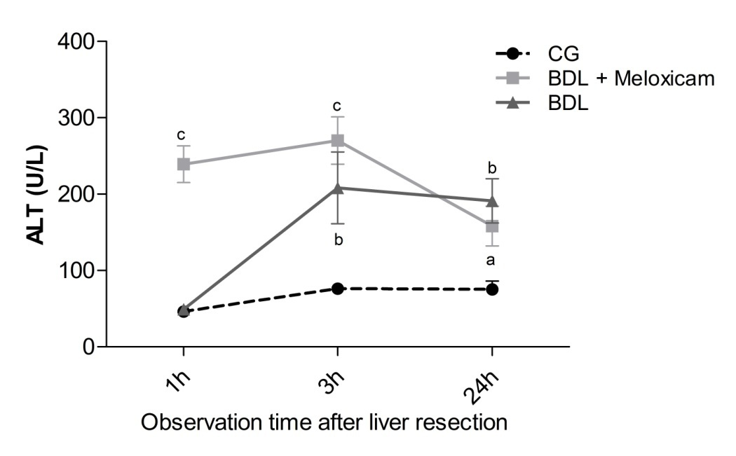
Figure 1 Release of alanine aminotransferase in the serum after liver resection at three different time points 1, 3 and 24 h for three groups: Control group; bile duct ligation + meloxicam; and bile duct ligation. Values are given as mean ± SEM. 2-way ANOVA. Bonferroni’s post-test: ªP < 0.05 vs CG; ^{b}P < 0.01 vs CG; ^{c}P < 0.001 vs CG and BDL (n = 15). CG: Control group; BDL: Bile duct ligation; BDL + M: BDL + meloxicam; ALT: Alanine aminotransferase.

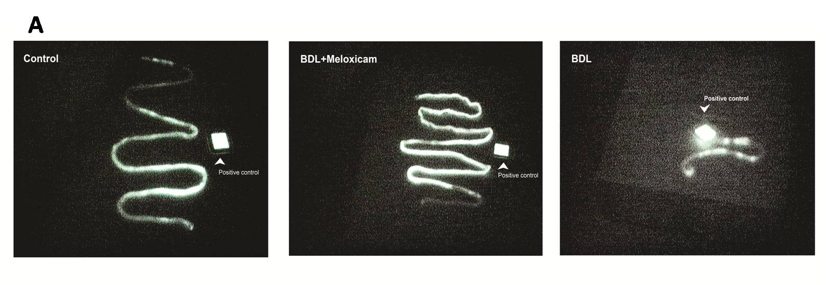
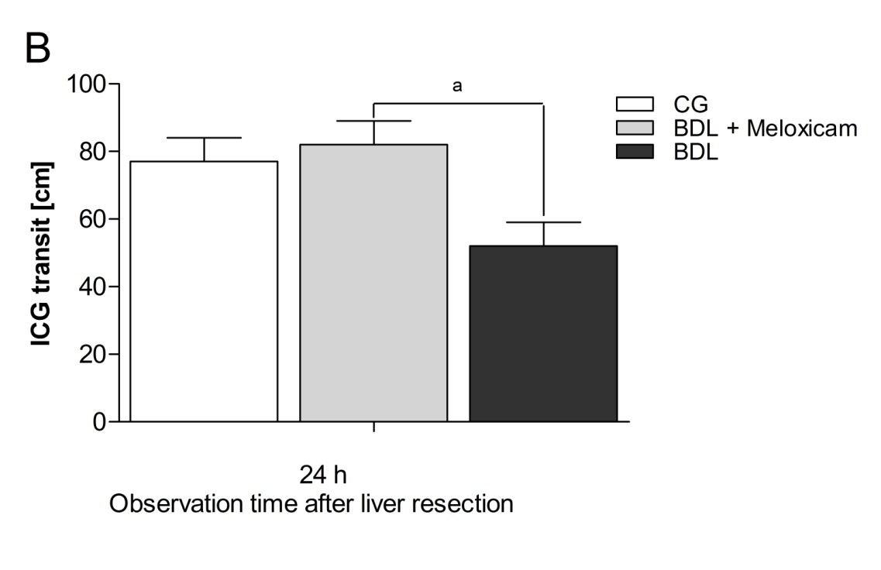
Figure 2 Indocyanine green transit evaluation into the gastrointestinal tract with IC-View System in a 24 h observation time of three groups: Control group; bile duct ligation + meloxicam; and bile duct ligation. A: Images of ICG transit in small bowel viewed by IC-View System; B: Histogram of the quantified gastrointestinal transit. Values are given as means ± SEM. One-way ANOVA. Tukey's Multiple Comparison Test: ªP < 0.05 vs BDL + M (n = 5). CG: Control group; BDL: Bile duct ligation; BDL + M: BDL + meloxicam; ICG: Indocyanine green.
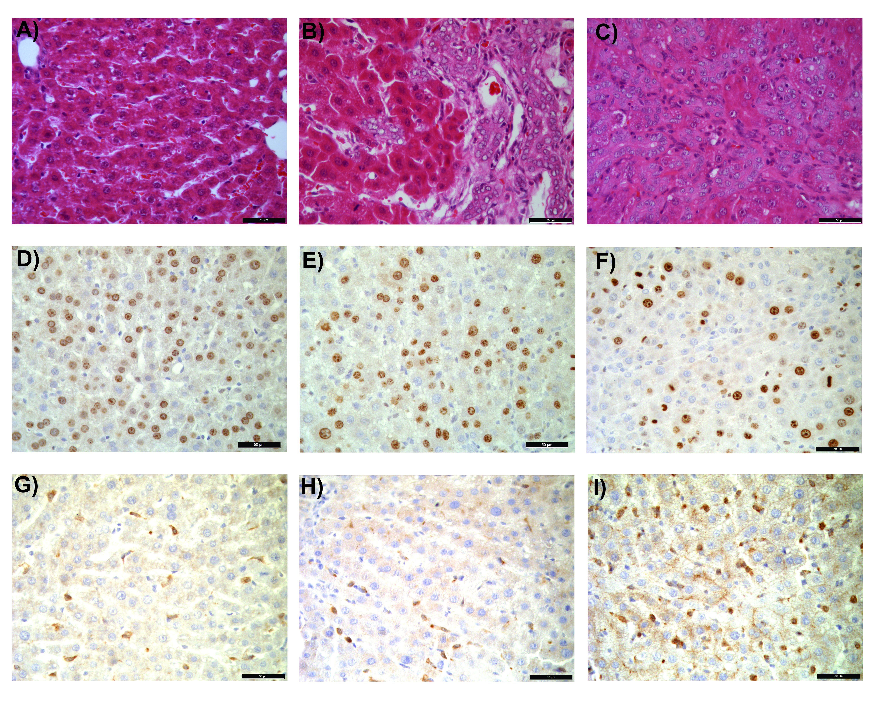
Figure 3 Histopathological findings. HE staining of liver tissue at 24 h after liver resection of three groups: CG (A), BDL + M (B) and BDL (C); Immunohistochemical analysis of hepatocyte proliferation with Ki-67-positive nuclei, CG (D), BDL + M (E) and BDL (F), and COX-2 expression after liver resection, CG (G), BDL + M (H) and BDL (I)(× 400)(n = 5). CG: Control group; BDL: Bile duct ligation; BDL + M: BDL + meloxicam; HE: Hematoxylin and eosin; COX-2: Cyclooxigenase-2.
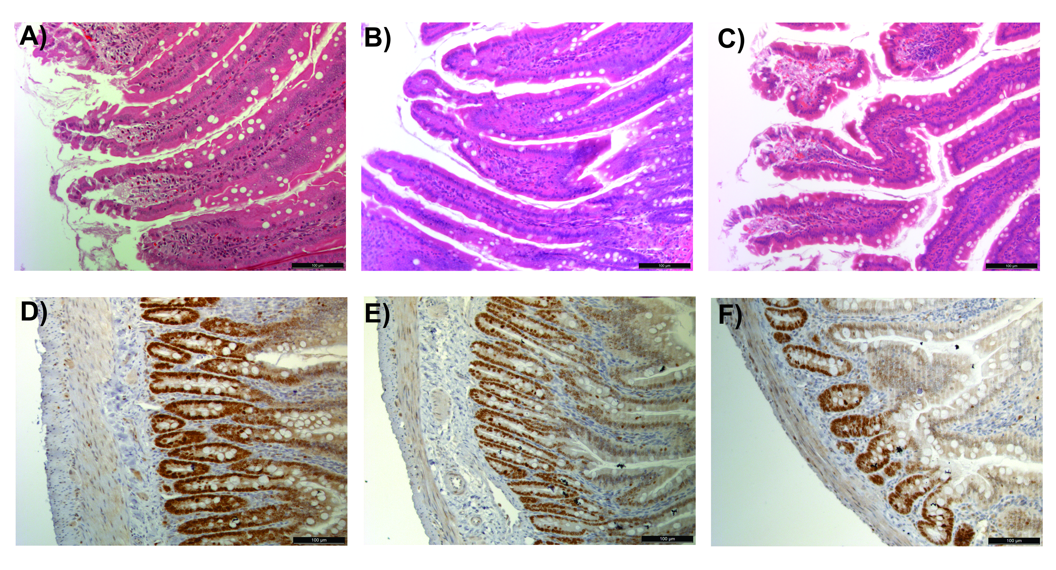

Figure 4 Histopathological findings. HE staining of the small bowel at 24 h after liver resection of three groups: CG (A), BDL + M (B) and BDL (C) (× 200); Immunohistochemical analysis of enterocyte proliferation with Ki-67-positive nuclei, CG (D), BDL + M (E) and BDL (F), of three groups (× 400) (n = 5). CG: Control group; BDL: Bile duct ligation; BDL + M: BDL + meloxicam; HE: Hematoxylin and eosin.

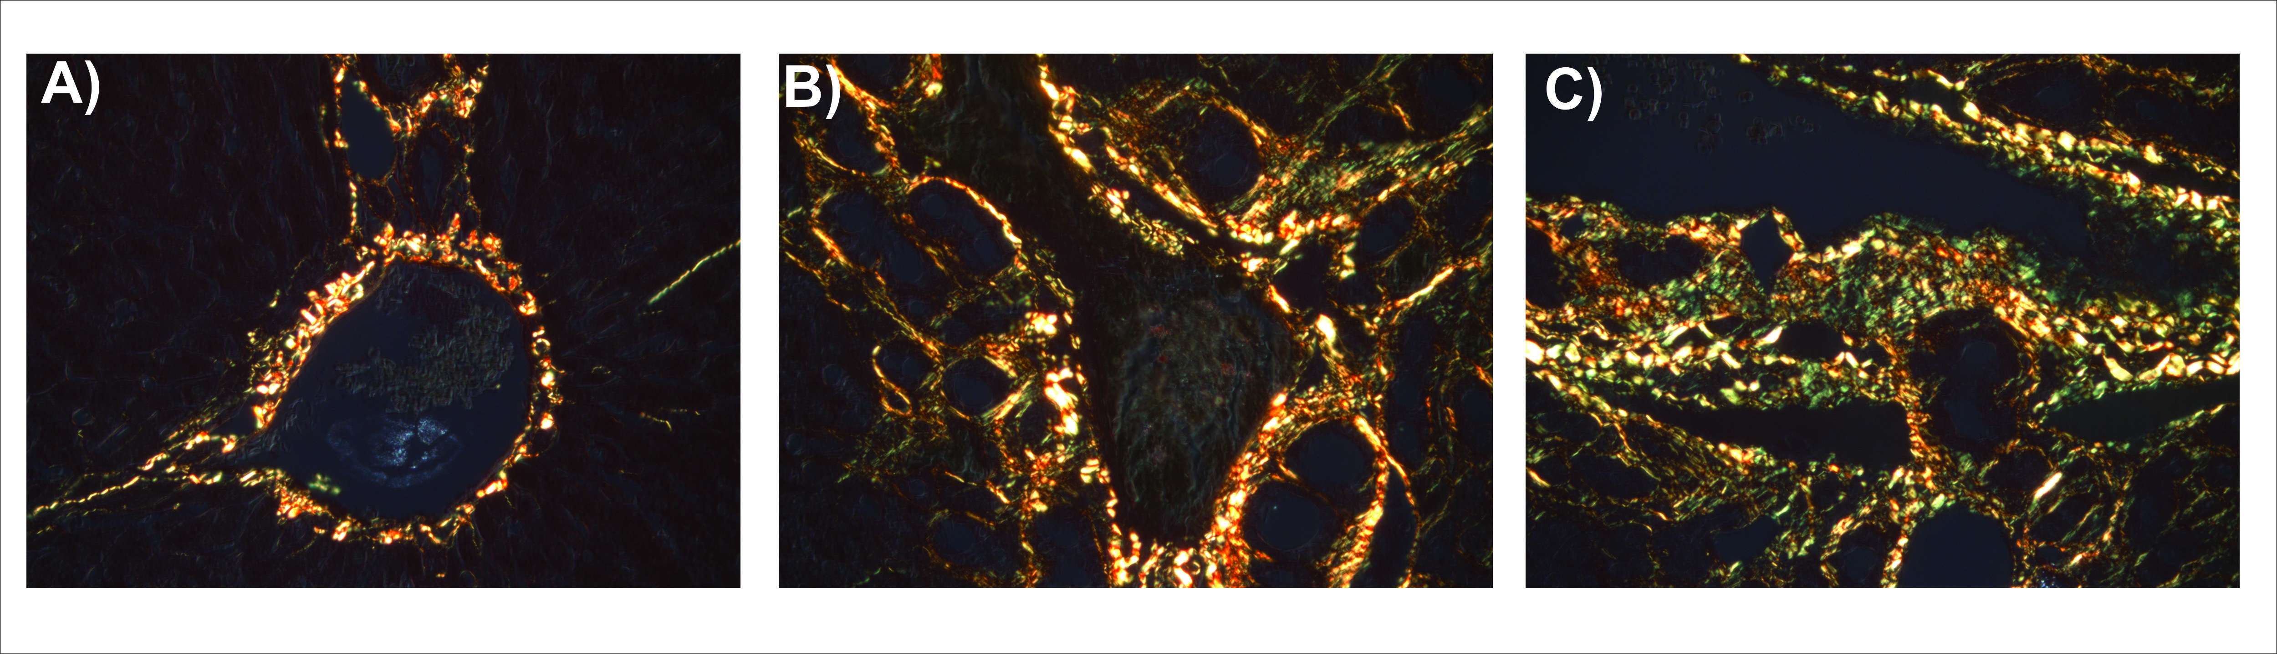

Figure 5 Quantification of collagen I (red) and collagen III (green) at 24 h after liver resection of three groups: Control group (A); bile duct ligation + meloxicam (B); and bile duct ligation (C). Ishak scoring system was adopted to score cirrhotic alterations in the liver of three groups (n = 5). CG: Control group; BDL: Bile duct ligation; BDL + M: BDL + meloxicam.
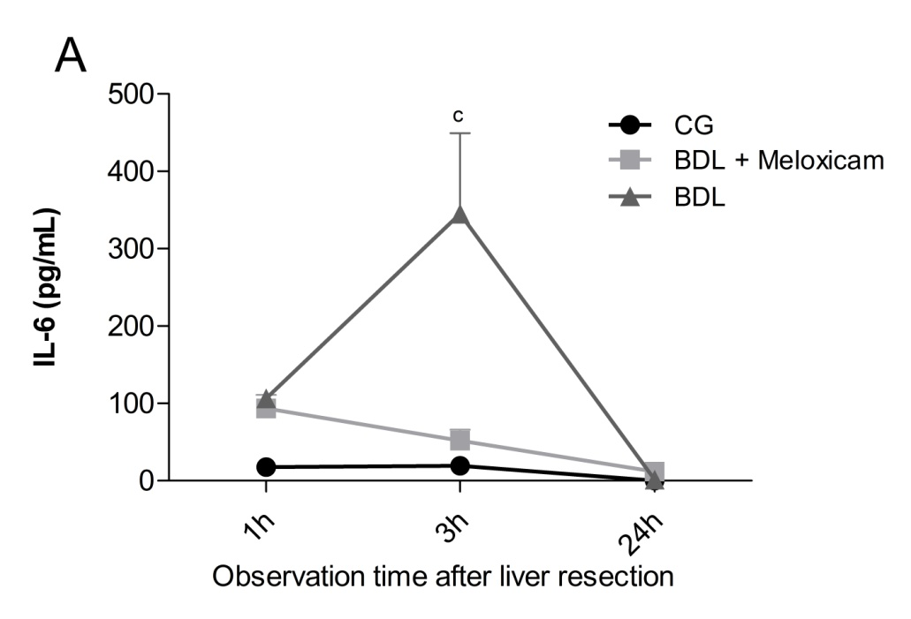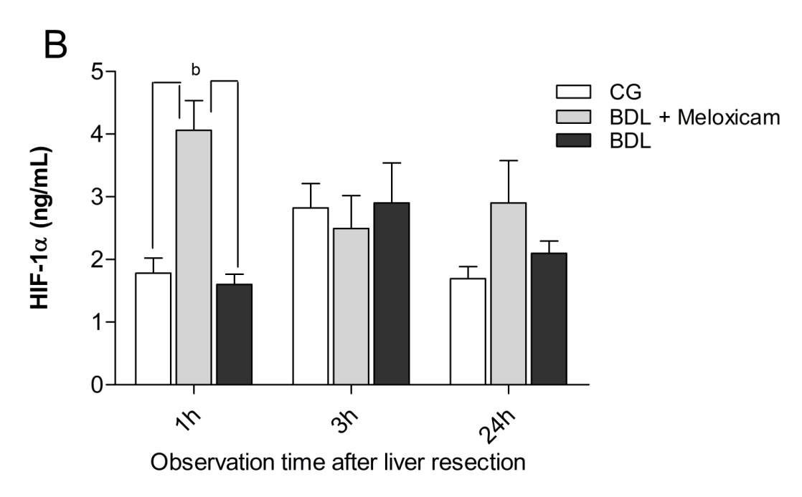
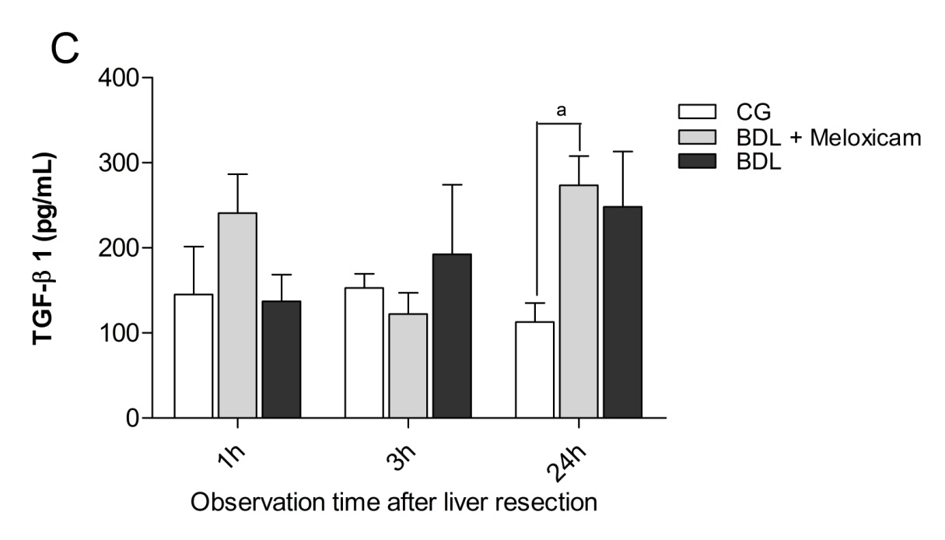

Figure 6 Release of interleukin 6 (A), hypoxia-inducible factor 1 alpha (B) and transforming growth factor beta 1 (C) in the serum after liver resection in three different groups at 1, 3 and 24 h. Values are given as mean ± SEM. 2-way ANOVA. Bonferroni’s post-test: ªP < 0.05 vs CG; ^{b}P < 0.01 vs BDL and CG; ^{c}P < 0.001 vs BDL + M and CG (n = 15). CG: Control group; BDL: Bile duct ligation; BDL + M: BDL + meloxicam; IL-6: Interleukin 6; HIF-1α: Hypoxia-inducible factor 1 alpha; TGF-β1: Transforming growth factor beta 1.
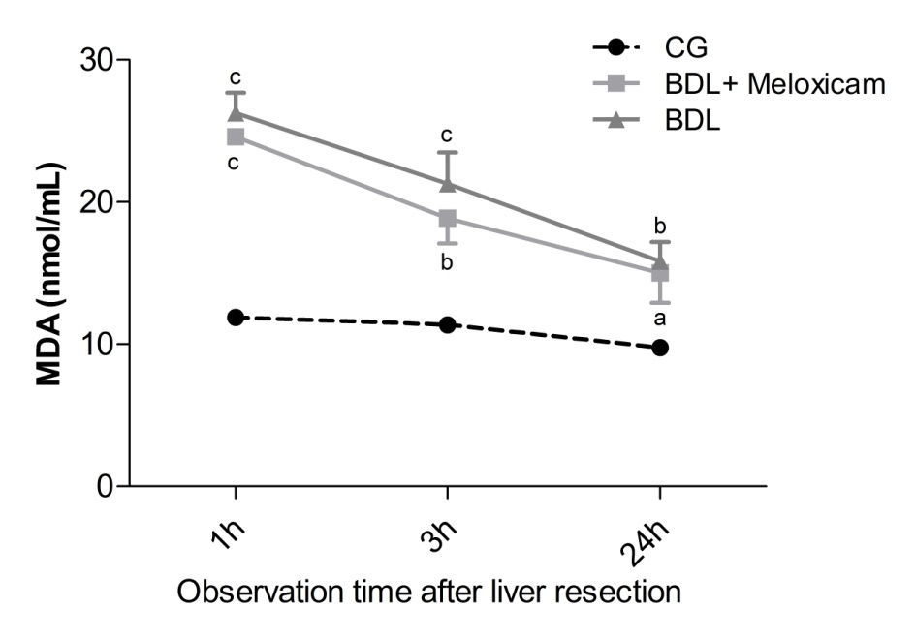

Figure 7 Release of malondialdehyde in the serum after liver resection at three different time points 1, 3 and 24 h for three groups: Control group; bile duct ligation + meloxicam; and bile duct ligation. Values are given as mean ± SEM. 2-way ANOVA. Bonferroni’s post-test: ªP < 0.05 vs CG; ^{b}P < 0.01 vs CG; ^{c}P < 0.001 vs CG (n = 15). CG: Control group; BDL: Bile duct ligation; BDL + M: BDL + meloxicam; MDA: Malondialdehyde.
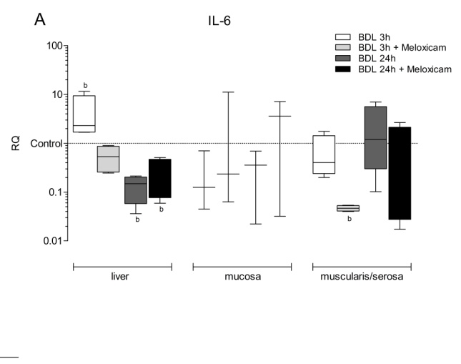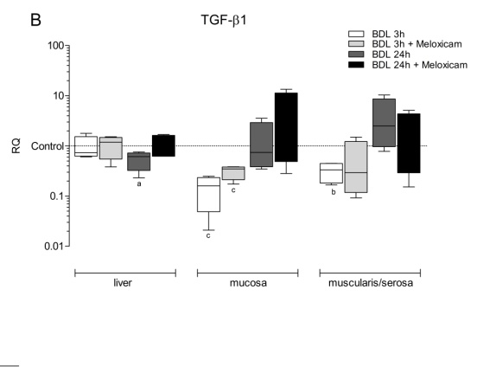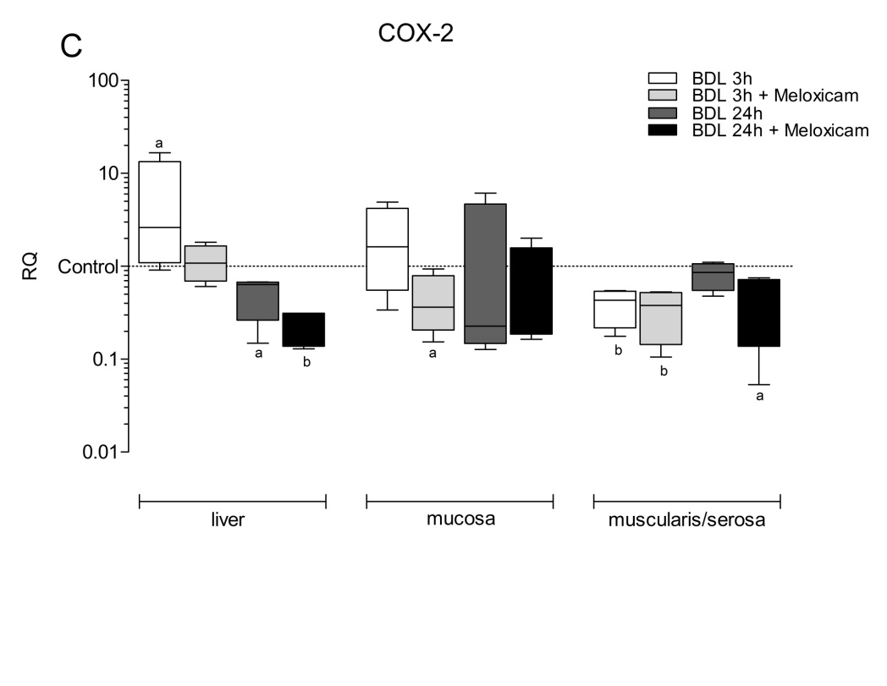
Figure 8 Hepatic and the small bowel (mucosa and muscularis/serosa) messenger RNA (mRNA) expression for interleukin 6 (A), transforming growth factor beta 1 (B), and cyclooxigenase-2 (C), after liver resection at two time points 3 and 24 h. Values are given as mean ± SEM. Multiple comparisons between groups under the Kruskal-Wallis test were performed. ªP < 0.05 vs BDL + M and BDL; ^{b}P < 0.01 vs BDL + M and CG; ^{c}P < 0.001 vs BDL + M and BDL (n = 15). CG: Control group; BDL: Bile duct ligation; BDL + M: BDL + meloxicam; IL-6: Interleukin 6; TGF-β1: Transforming growth factor beta 1; COX-2: Cyclooxigenase-2.

Tables:

Table 1 The microcirculation of the liver, small bowel, and portal venous flow measurements after liver resection for three groups
 | CG | BDL + M | BDL | P value
Liver flow (AU) | 232 ± 11 | 207 ± 10 | 188 ± 11ª | < 0.05ª
Small bowel flow (AU) | 323 ± 10 | 280 ± 21 | 289 ± 21 | n.s.
PVF (mL/min) | 27 ± 3 | 17 ± 2ª | 17 ± 3ª | < 0.05ª
Values are given as mean ± SEM; 2-way ANOVA. Bonferroni’s post-test: n = 15, ªP < 0.05 vs CG. CG: Control group; BDL: Bile duct ligation; BDL + M: BDL + meloxicam; n.s.: Not significant; AU: Arbitrary unit; PVF: Portal venous flow.

Table 2 Quantifying of Ki-67 positive cells, cyclooxigenase-2 expression, and fibrotic scoring system of the liver according to Ishak^{[40]}
 | CG | BDL + M | BDL | P value
Ki-67 LI (AU) | 88 ± 13 | 54 ± 11 | 38 ± 9ª | < 0.05ª
COX-2 expression (AU) | 29 ± 4^{b} | 23 ± 8^{b} | 57 ± 7 | < 0.01^{b}
Ishak score | 0 (0-1) | 5 (3-6) | 5 (4-6) | n.s.
Values are given as mean ± SEM; 1-way ANOVA. Tukey's Multiple Comparison Test: n = 5; ªP < 0.05 vs CG; ^{b}P < 0.01 vs BDL. CG: Control group; BDL: Bile duct ligation; BDL + M: BDL + meloxicam; n.s.: not significant; AU: Arbitrary unit; LI: Labeling index; COX-2: Cyclooxigenase-2.

Table 3 Quantifyingof Ki-67, goblet cells, villus length and ischemic lesions of the small bowel according to Chiu^{[38]}
 | CG | BDL + M | BDL | P value
Ki-67 LI (AU) | 91 ± 2 | 77 ± 1ª | 50 ± 1ª | < 0.001ª
Goblet cells (AU) | 31 ± 2^{b} | 32 ± 3^{b} | 55 ± 5 | < 0.01^{b}
Length of the villi (µm) | 617 ± 24 | 562 ± 30 | 494 ± 22^{c} | < 0.05^{c}
Chiu score | 1 (0-2) | 0 (0-1) | 1 (0-2) | n.s.
Values are given as mean ± SEM; 1-way ANOVA. Tukey's Multiple Comparison Test: n = 5; ªP < 0.001 vs BDL + M and CG; ^{b}P < 0.01 vs CG and BDL + M; ^{c}P < 0.05 vs CG; CG: Control group; BDL: Bile duct ligation; BDL + M: BDL + meloxicam; n.s.: Not significant; AU: Arbitrary unit; LI: Labeling index.

