Name of Journal: World Journal of Diabetes
Manuscript NO: 87907
Manuscript Type: ORIGINAL ARTICLE

Clinical Trials Study
Relationship between GCKR gene rs780094 polymorphism and type 2 diabetes with albuminuria

Liu YY et al. GCKR rs780094 and T2D

Yi-Ying Liu, Qin Wan

Yi-Ying Liu, Department of Endocrinology, Deyang People’s Hospital, Deyang 618000, Sichuan Province, China

Qin Wan, Department of Endocrinology, The Affiliated Hospital of Southwest Medical University, Luzhou 646000, Sichuan Province, China

Author contributions: Liu YY was responsible for experimental design and implementation, and paper writing; Wan Q was responsible for quality review and control.

Supported by the Key R&D Project of the Ministry of Science and Technology, No. 2016YFC0901200 and 2016YFC0901205.

Corresponding author: Qin Wan, Doctor, Department of Endocrinology, The Affiliated Hospital of Southwest Medical University, No. 25 Taiping Street, Jiangyang District, Luzhou 646000, Sichuan Province, China. wanqin3@163.com

Received: September 1, 2023
Revised: October 10, 2023
Accepted: November 28, 2023
Published online: December 15, 2023

Abstract
BACKGROUND
Diabetic kidney disease is one of the common complications of type 2 diabetes (T2D). There are no typical symptoms in the early stage, and the disease will progress to moderate and late stage when albuminuria reaches a high level. Treatment is difficult and the prognosis is poor. At present, the pathogenesis of diabetic kidney disease is still unclear, and it is believed that it is associated with genetic and environmental factors.

AIM
To explore the relationship between the glucokinase regulatory protein (GCKR) gene rs780094 polymorphism and T2D with albuminuria.

METHODS
We selected 252 patients (126 males and 126 females) with T2D admitted to our hospital from January 2020 to October 2020, and 66 healthy people (44 females and 22 males). According to the urinary albumin/creatinine ratio, the subjects were divided into group I (control), group II (T2D with normoalbuminuria), group III (T2D with microalbuminuria), and group IV (T2D with macroalbuminuria). Additionly, the subjects were divided into group M (normal group) or group N (albuminuria group) according to whether they developed albuminuria. We detected the GCKR gene rs780094 polymorphism (C/T) of all subjects, and measured the correlation between GCKR gene rs780094 polymorphism (C/T) and T2D with albuminuria.

RESULTS
Gene distribution and genotype distribution among groups I-IV accorded with the Hardy-Weinberg equilibrium. Genotype frequency was significantly different among the four groups (P = 0.048, χ² = 7.906). T allele frequency in groups II, III, and IV was significantly higher than that in group I. Logistic regression analysis of the risk factors for T2D with albuminuria showed that the CT + TT genotype (odds ratio = 1.710, 95% confidence interval: 1.172-2.493) was a risk factor.

CONCLUSION
CT + TT genotype is a risk factor for T2D with albuminuria. In the future, we can assess the risk of individuals carrying susceptible genes to delay the onset of T2D.

Key Words: Type 2 diabetes mellitus; Albuminuria; Glucokinase regulatory protein rs780094; Gene polymorphism

©The Author(s) 2023. Published by Baishideng Publishing Group Inc. All rights reserved.

Citation: Liu YY, Wan Q. Relationship between GCKR gene rs780094 polymorphism and type 2 diabetes with albuminuria. World J Diabetes 2023; 14(12): 1803-1812
URL: https://www.wjgnet.com/1948-9358/full/v14/i12/1803.htm
DOI: https://dx.doi.org/10.4239/wjd.v14.i12.1803

Core Tip: Diabetic nephropathy (DN) is a serious complication of diabetes with no typical clinical manifestations at the beginning of the disease, and treatment efficacy is poor. Currently, it is believed that the pathogenesis of DN is associated with environmental and genetic factors. In this study, we found that CT + TT genotype in glucokinase regulatory protein rs780094 is a risk factor for type 2 diabetes complicated with albuminuria at the genetic level.

INTRODUCTION
Type 2 diabetes (T2D) is a common chronic metabolic disease. The latest epidemiological survey showed an incidence rate of 10.3% for diabetes in China, of which T2D accounted for about 90%^{[1]}. Diabetic nephropathy (DN) is one of the common complications of T2D. In China, the incidence rate of DN in patients with T2D is 20%-40%^{[2]}. There are no typical symptoms in early kidney injury. When there is a high level of proteinuria and other symptoms, DN has reached the middle or late stage. At these stages, it is difficult to treat and often causes end-stage renal disease (ESRD), with a poor prognosis. Therefore, early and effective intervention in diabetes, regular monitoring of urinary protein, and timely symptomatic treatment can reduce the probability of T2D developing into DN and ESRD.
The pathogenesis of T2D and DN is not clear. Currently, it is believed to be caused by multiple factors. Genome-wide association study (GWAS) is a method of studying the association between a specific gene and a disease, using a large number of DNA samples for high density of single nucleotide polymorphisms genetic markers to find out the presence of sequence variations. Recent GWAS conducted domestically and internationally have identified > 250 candidate genes for susceptibility to T2D^{[3]}, such as PRKAA2^{[4]}, ATP binding cassette transporter 1^{[5]}, FTO^{[6]}, FADS^{[7]}, and glucokinase regulatory protein (GCKR)^{[8]}. Human GCKR plays an important role in sugar regulation. At present, the genetic polymorphism of GCKR rs780094 is still controversial. Some studies believe that the T allele in GCKR rs780094 is related to the occurrence of T2D, and some scholars believe that the A allele is related to it. Because of the uncertainty of this relationship, it is worth further study.

MATERIALS AND METHODS
Research subjects
In this study, 252 T2D patients (126 males and 126 females) and 66 healthy people (44 females and 22 males) were selected by simple random sampling from January 2020 to October 2020 at our hospital. All subjects were free of acute infection and secondary diabetes (such as acromegaly or Cushing’s syndrome), and were not pregnant. Patients with type 1 diabetes were excluded.

Patient grouping
According to the 1999 World Health Organization diagnostic criteria for T2D and the consensus of Chinese experts on prevention and treatment of diabetes in 2014, all subjects were divided into group I (control group), group II [diabetes with normoalbuminuria, urinary albumin/creatinine ratio (UACR) < 30 mg/mg], group III (diabetes with microalbuminuria group, 30-299 mg/mg), and group IV (diabetes with albuminuria, UACR ≥ 300 mg/mg). Additionally, the subjects were divided into either group M (normal group) or group N (albuminuria group). The study was approved by the Ethics Committee of the Affiliated Hospital of Southwest Medical University.

Questionnaire survey
All study populations used a unified survey questionnaire, which included name, gender, age, birth date, disease history, drug use, smoking history (never smoking refers to never smoking; smoking refers to still smoking in the past 30 d), and alcohol consumption (never drinking; occasional drinking < 1 time/wk in the past year; frequent drinking ≥ 1 time/wk in the past year).

Physical and biochemical examinations
We recorded the patients’ height and weight and calculated their body mass index (BMI). Fasting blood was collected to detect 2-h postprandial blood glucose, fasting insulin, fasting C-peptide, blood lipid levels, etc. The glucose oxidase method was used for blood glucose detection; C-peptide and insulin were measured by radioimmunoassay; glycated hemoglobin was detected by hyphenated to liquid chromatography; and triglyceride (TG), total cholesterol (TC), high-density lipoprotein (HDL), low-density lipoprotein (LDL), blood urea nitrogen (BUN), and blood uric acid (BUA) were measured using a Hitachi 7600 automatic biochemical analyzer. The levels of urinary albumin and creatinine were detected with an automatic urine analyzer, and UACR was calculated. In addition, the subjects underwent oral glucose tolerance testing (OGTT).

DNA extraction and detection of gene polymorphism with TaqMan probe
TaqMan fluorescent probe is a kind of oligonucleotide probe. During polymerase chain reaction (PCR) amplification, a specific fluorescent probe is added along with a pair of primers. When the probe is complete, the fluorescence signal emitted by the reporter group is absorbed by the quencher group. During PCR amplification, the 5’-3’ exonuclease activity of Taq enzyme degrades the probe, separating the reporter fluorophores from the quench fluorophores, so that the fluorescence monitoring system can receive the fluorescence signal, that is, for each amplified DNA strand, a fluorescence molecule is formed, and the accumulation of fluorescence signal is completely synchronized with the formation of PCR products (Table 1 and Figure 1).

Statistical analysis
The research data were statistically analyzed using SPSS version 22.0. Measurement data with a normal distribution are expressed as the mean ± SD. Two independent samples t-test was used for comparison between two groups, and one-way analysis of variance was used for comparison among multiple groups. Measurement data with a non-normal distribution are expressed by median (interquartile interval). The Mann-Whitney U test was used for comparison between two groups. The Kruskal-Wallis H test was used for comparison among multiple groups. Numerical data were analyzed by the χ² test or Fisher’s exact probability method. Multivariate logistic regression was used to analyze the influencing factors of T2D with albuminuria. P < 0.05 was considered statistically significant.

RESULTS
This study included 318 subjects, who were divided into group I (controls, n = 66), group II (diabetes with normoalbuminuria, n = 101), group III (diabetes with microalbuminuria, n = 81), and group IV (diabetes with macroalbuminuria, n = 70). Age, diastolic blood pressure, systolic blood pressure, weight, BMI, disease course, glycated hemoglobin, fasting blood glucose, 2-h postprandial blood glucose, BUN, BUA, creatinine, TG, TC, and UACR differed significantly among the groups (P < 0.05), while height, fasting insulin, fasting C-peptide, HDL, and LDL did not differ significantly (P > 0.05) (Table 2).
Some samples were selected for sequencing identification, and the sequencing results and probe results were completely consistent with the typing results (Figure 2). The genotype frequency and allele distribution of the control, normoalbuminuria, microalbuminuria, and macroalbuminuria groups are shown in Table 3. The gene distribution among the four groups and the whole genotype distribution were in accordance with the Hardy-Weinberg equilibrium (P > 0.05). The genotype frequency differed significantly among the four groups (P = 0.048, χ² = 7.906). There were significant differences between the control and normoalbuminuria groups (P = 0.012, U = 2613), between the control and microalbuminuria groups (P = 0.024, U = 2131), and between the control and macroalbuminuria groups (P = 0.027, U = 1836.5). There were significant differences in genotype frequency among the four groups (P = 0.032, χ² = 8.786). There were significant differences between the control and normoalbuminuria groups (P = 0.007, U = 11328), between the control and microalbuminuria groups (P = 0.017, U = 9192), between the control and macroalbuminuria groups (P = 0.020, U = 7938), and between the normoalbuminuria and microalbuminuria or macroalbuminuria groups. There was no significant difference in gene distribution or genotype distribution between the microalbuminuria and macroalbuminuria groups (P > 0.05) (Table 3).
T2D complicated with albuminuria was analyzed by logistic regression with diastolic blood pressure, systolic blood pressure, height, weight, BMI, disease course, glycated hemoglobin, fasting blood glucose, 2-h postprandial blood glucose, BUN, creatinine, TG, TC, UCAR as dependent variables, and each genotype as independent variables. Diastolic blood pressure, systolic blood pressure, weight, BMI, hypertension, hyperlipidemia history, history of alcohol consumption, glycated hemoglobin, fasting blood glucose, 2-h postprandial blood glucose, BUN, TG, TC, and CT + TT genotype were identified to be risk factors for T2D with albuminuria (Table 4).

DISCUSSION
DN is one of the common complications of T2D and one of the main causes of ESRD^{[9]}. At present, the pathogenesis of DN is not clear, and research shows that its pathogenesis is mainly related to long-term hyperglycemia, polyol pathway, microcirculatory disorder caused by oxidative stress, glycosylation of protein kinase, hyperfunction of platelet aggregation, increased glomerular filtration pressure, change of basement membrane charge, inflammatory reaction, and even dysbacteriosis^{[10,11]}. However, these do not seem to fully explain the occurrence and development of DN. Therefore, it is increasingly believed that DN may be caused by environmental and genetic factors.
Glucokinase (GCK) is an important regulatory enzyme for glucose metabolism that can catalyze glucose phosphorylation in pancreatic islet β cells and mammalian liver cells, and it serves as a glucose sensor, regulating the function of pancreatic islets in releasing insulin and synthesizing glycogen. When glucose metabolism is normal, GCK binds to its inhibitory protein GCKR in the liver cell nucleus, causing an increase in glucose concentration, leading to dissociation of the GCK-GCKR complex, and promoting GCK translocation to the cytoplasm, glucose phosphorylation in liver cells, and insulin release and glycogen synthesis by pancreatic islet β cells^{[12]}, and GCKR transforms into inactive GCKR. rs780094 is a single-nucleotide polymorphism site in the noncoding region of the GCKR gene. It was first reported in a GWAS of T2D in 2007^{[13]}. It was found that the GCKR gene was closely related to blood lipids in the Danish population, and that the level of TG in G allele carriers was reduced, accompanied by an increase in fasting plasma glucose. The insulin level assessed by the steady-state model was reduced, and insulin release related to OGTT was increased, slightly increasing the risk of T2D^{[14]}. Subsequent in-depth analysis by GWAS showed that GCKR rs780094 was closely related to T2D and its complications. Zhou et al^{[15]} found that carriers of the GCKR rs780094 C allele had a significantly higher risk of T2D. This conclusion is consistent with the large-scale meta-analysis conducted by Wang et al^{[16]}, which showed that GCKR rs780094 mutation leads to an increased risk of cross-ethnic T2D. A study on Han Chinese showed a significant correlation between rs780094 and T2D^{[17]}. Some studies have shown that GCKR is an independent susceptibility gene for T2D, and its T allele can reduce fasting blood glucose and the incidence rate of T2D^{[18]}. Some studies have also shown that the incidence of T2D was reduced by the GCKR rs780094 G allele^{[19]}. Li et al^{[20]} and Bi et al^{[21]} found racial differences in this effect. A study in the Han Chinese population showed that the A allele in GCKR rs780094 was associated with a reduced risk of T2D and obesity^{[22]}. Another study showed that the GCKR rs780094 polymorphism was not associated with the occurrence of T2D^{[23]}. We found that there was a significant difference in genotype frequency among groups I-IV, indicating that the differences in GCKR rs780094 in the population were related to glucose metabolism. This correlation is related to GCK as the first rate-limiting enzyme of the glucose metabolic pathway. This difference existed in the control group and T2D patients, but was not related to whether the patients had albuminuria, nor to the severity of albuminuria in the patients. It is speculated that the change from C to T can cause the substitution of an amino acid, thus affecting the activity of GCKR, but how GCKR acts on urinary protein warrants further study. Of course, it may also be related to the small sample size of our study and the variation of gene frequencies in different races, which still needs to be further explored by large-scale cohort studies in the future.
In our study, we also found that GCKR rs780094 was associated with type 2 diabetes mellitus, and this association was related to lipid levels. The possible reason is that obesity can release a large number of pro-inflammatory factors, which can increase the body’s resistance to insulin. At the same time, these inflammatory factors can also interfere with the regulation of gene expression and the interaction between genes, thus affecting our glycolysis pathway and causing glucose metabolism disorders.
We also carried out a logistic correlation analysis on the factors related to T2D with albuminuria, and found that TG, TC, and CT + TT genotypes were risk factors. After adjusting blood pressure, BMI, and other indicators, the correlation was still significant. However, this significance was only expressed in the CC + CT genotype. We did not find this correlation in C, T, CC, CT, and TT genotypes. This may be due to the increased expression of GCKR accompanied by insulin resistance, and high insulin levels may stimulate the brush border of the proximal convoluted tubules, promote the exchange of UA and sodium ions, increase UA reabsorption, and thus increase UA levels^{[24]}. The increase in UA level can damage the kidneys through a series of events, such as inflammatory reaction, destruction of endothelial cells, activation of the renin-angiotensin-aldosterone system, proliferation of vascular smooth muscle cells, causing renal vasoconstriction and thickening of glomerular arterial wall^{[25]}, and then production of albuminuria. Present and previous studies have shown that GCKR rs780094 is associated with T2D and T2D with albuminuria, and this correlation is related to UA, gender, and blood lipid level.
This study had some limitations. First, the sample size was small. Second, the selected subjects were from the Southwest region, which is geographically limited, so extrapolation of our results to other ethnic groups or the whole country should be cautious. Third, the effect of drugs on albuminuria was ignored. Finally, since we only selected the GCKR rs780094 locus for study, we may have ignored the impact of other gene polymorphisms on T2D with albuminuria. In future research, the sample size should be increased to conduct large-scale, multi-regional, and gene-locus-centered studies.

CONCLUSION
T2D and DN are the results of a variety of factors and their interactions, including environment, eating habits, lifestyle, race, and family history. Genetic factors also play an important role in the occurrence of diabetes. This is why a susceptible gene may exhibit different phenotypes in different populations or regions. Various studies have reported the relationship between genetic variation and susceptibility to T2D. In clinical practice, we can start with proteinuria detection, assess the risk of individuals carrying susceptibility genes, and take comprehensive prevention and control measures to delay the onset of T2D.

ARTICLE HIGHLIGHTS
Research background
Diabetic nephropathy (DN) is a serious complication of diabetes with no typical clinical manifestations at the beginning of the disease, and treatment efficacy is poor. Currently, it is believed that the pathogenesis of DN is associated with environmental and genetic factors. In this study, we found that CT + TT genotype in glucokinase regulatory protein (GCKR) rs780094 is a risk factor for type 2 diabetes (T2D) complicated with albuminuria.

Research motivation
Human GCKR plays an important role in sugar regulation. However, the association between GCKR gene rs780094 polymorphism and diabetes and its complications is uncertain.

Research objectives
To explore the relationship between the GCKR gene rs780094 polymorphism and T2D with albuminuria.

Research methods
The correlation between GCKR rs780094 and diabetes mellitus with proteinuria was studied by different grouping methods.

Research results
Studies have found that there are many risk factors for T2D with albuminuria. From the perspective of environmental factors, there were history of hypertension, alcohol consumption, history of hyperlipidemia, and blood glucose levels. At the genetic level, CT + TT genotype was identified to be a risk factor for T2D mellitus with albuminuria.

Research conclusions
In clinical practice, we can start with proteinuria detection, assess the risk of individuals carrying susceptibility genes, and take comprehensive prevention and control measures to delay the onset of T2D.

Research perspectives
While promising, the study has some limitations, including that it did not take into account whether patients were taking lipid-lowering and blood-pressure medications, and did not calculate insulin resistance indexes, among others. In addition, due to the limited geographical options in this study, there may be selection bias, and further clinical trials are needed to refine the conclusions of this study.

REFERENCES
1 Chinese Elderly Type 2 Diabetes Prevention and Treatment of Clinical Guidelines Writing Group; Geriatric Endocrinology and Metabolism Branch of Chinese Geriatric Society; Geriatric Endocrinology and Metabolism Branch of Chinese Geriatric Health Care Society; Geriatric Professional Committee of Beijing Medical Award Foundation; National Clinical Medical Research Center for Geriatric Diseases (PLA General Hospital). [Clinical guidelines for prevention and treatment of type 2 diabetes mellitus in the elderly in China (2022 edition)]. Zhonghua Nei Ke Za Zhi 2022; 61: 12-50 [PMID: 34979769 DOI: 10.3760/cma.j.cn112138-20211027-00751]
2 Aldemir O, Turgut F, Gokce C. The association between methylation levels of targeted genes and albuminuria in patients with early diabetic kidney disease. Ren Fail 2017; 39: 597-601 [PMID: 28805547 DOI: 10.1080/0886022X.2017.1358180]
3 Karaderi T, Drong AW, Lindgren CM. Insights into the Genetic Susceptibility to Type 2 Diabetes from Genome-Wide Association Studies of Obesity-Related Traits. Curr Diab Rep 2015; 15: 83 [PMID: 26363598 DOI: 10.1007/s11892-015-0648-8]
4 Li Q, Li C, Li H, Zeng L, Kang Z, Mao Y, Tang X, Zheng P, He L, Luo F, Li Z. Effect of AMP-activated protein kinase subunit alpha 2 (PRKAA2) genetic polymorphisms on susceptibility to type 2 diabetes mellitus and diabetic nephropathy in a Chinese population. J Diabetes 2018; 10: 43-49 [PMID: 28322508 DOI: 10.1111/1753-0407.12553]
5 Hasan MM, Hosen MB, Rahman MM, Howlader MZH, Kabir Y. Association of ATP binding cassette transporter 1 (ABCA 1) gene polymorphism with type 2 diabetes mellitus (T2DM) in Bangladeshi population. Gene 2019; 688: 151-154 [PMID: 30529097 DOI: 10.1016/j.gene.2018.12.003]
6 Lin Z, Wang Y, Zhang B, Jin Z. Association of type 2 diabetes susceptible genes GCKR, SLC30A8, and FTO polymorphisms with gestational diabetes mellitus risk: a meta-analysis. Endocrine 2018; 62: 34-45 [PMID: 30091126 DOI: 10.1007/s12020-018-1651-z]
7 Brayner B, Kaur G, Keske MA, Livingstone KM. FADS Polymorphism, Omega-3 Fatty Acids and Diabetes Risk: A Systematic Review. Nutrients 2018; 10 [PMID: 29899246 DOI: 10.3390/nu10060758]
8 Dupuis J, Langenberg C, Prokopenko I, Saxena R, Soranzo N, Jackson AU, Wheeler E, Glazer NL, Bouatia-Naji N, Gloyn AL, Lindgren CM, Mägi R, Morris AP, Randall J, Johnson T, Elliott P, Rybin D, Thorleifsson G, Steinthorsdottir V, Henneman P, Grallert H, Dehghan A, Hottenga JJ, Franklin CS, Navarro P, Song K, Goel A, Perry JR, Egan JM, Lajunen T, Grarup N, Sparsø T, Doney A, Voight BF, Stringham HM, Li M, Kanoni S, Shrader P, Cavalcanti-Proença C, Kumari M, Qi L, Timpson NJ, Gieger C, Zabena C, Rocheleau G, Ingelsson E, An P, O'Connell J, Luan J, Elliott A, McCarroll SA, Payne F, Roccasecca RM, Pattou F, Sethupathy P, Ardlie K, Ariyurek Y, Balkau B, Barter P, Beilby JP, Ben-Shlomo Y, Benediktsson R, Bennett AJ, Bergmann S, Bochud M, Boerwinkle E, Bonnefond A, Bonnycastle LL, Borch-Johnsen K, Böttcher Y, Brunner E, Bumpstead SJ, Charpentier G, Chen YD, Chines P, Clarke R, Coin LJ, Cooper MN, Cornelis M, Crawford G, Crisponi L, Day IN, de Geus EJ, Delplanque J, Dina C, Erdos MR, Fedson AC, Fischer-Rosinsky A, Forouhi NG, Fox CS, Frants R, Franzosi MG, Galan P, Goodarzi MO, Graessler J, Groves CJ, Grundy S, Gwilliam R, Gyllensten U, Hadjadj S, Hallmans G, Hammond N, Han X, Hartikainen AL, Hassanali N, Hayward C, Heath SC, Hercberg S, Herder C, Hicks AA, Hillman DR, Hingorani AD, Hofman A, Hui J, Hung J, Isomaa B, Johnson PR, Jørgensen T, Jula A, Kaakinen M, Kaprio J, Kesaniemi YA, Kivimaki M, Knight B, Koskinen S, Kovacs P, Kyvik KO, Lathrop GM, Lawlor DA, Le Bacquer O, Lecoeur C, Li Y, Lyssenko V, Mahley R, Mangino M, Manning AK, Martínez-Larrad MT, McAteer JB, McCulloch LJ, McPherson R, Meisinger C, Melzer D, Meyre D, Mitchell BD, Morken MA, Mukherjee S, Naitza S, Narisu N, Neville MJ, Oostra BA, Orrù M, Pakyz R, Palmer CN, Paolisso G, Pattaro C, Pearson D, Peden JF, Pedersen NL, Perola M, Pfeiffer AF, Pichler I, Polasek O, Posthuma D, Potter SC, Pouta A, Province MA, Psaty BM, Rathmann W, Rayner NW, Rice K, Ripatti S, Rivadeneira F, Roden M, Rolandsson O, Sandbaek A, Sandhu M, Sanna S, Sayer AA, Scheet P, Scott LJ, Seedorf U, Sharp SJ, Shields B, Sigurethsson G, Sijbrands EJ, Silveira A, Simpson L, Singleton A, Smith NL, Sovio U, Swift A, Syddall H, Syvänen AC, Tanaka T, Thorand B, Tichet J, Tönjes A, Tuomi T, Uitterlinden AG, van Dijk KW, van Hoek M, Varma D, Visvikis-Siest S, Vitart V, Vogelzangs N, Waeber G, Wagner PJ, Walley A, Walters GB, Ward KL, Watkins H, Weedon MN, Wild SH, Willemsen G, Witteman JC, Yarnell JW, Zeggini E, Zelenika D, Zethelius B, Zhai G, Zhao JH, Zillikens MC; DIAGRAM Consortium; GIANT Consortium; Global BPgen Consortium, Borecki IB, Loos RJ, Meneton P, Magnusson PK, Nathan DM, Williams GH, Hattersley AT, Silander K, Salomaa V, Smith GD, Bornstein SR, Schwarz P, Spranger J, Karpe F, Shuldiner AR, Cooper C, Dedoussis GV, Serrano-Ríos M, Morris AD, Lind L, Palmer LJ, Hu FB, Franks PW, Ebrahim S, Marmot M, Kao WH, Pankow JS, Sampson MJ, Kuusisto J, Laakso M, Hansen T, Pedersen O, Pramstaller PP, Wichmann HE, Illig T, Rudan I, Wright AF, Stumvoll M, Campbell H, Wilson JF; Anders Hamsten on behalf of Procardis Consortium; MAGIC investigators, Bergman RN, Buchanan TA, Collins FS, Mohlke KL, Tuomilehto J, Valle TT, Altshuler D, Rotter JI, Siscovick DS, Penninx BW, Boomsma DI, Deloukas P, Spector TD, Frayling TM, Ferrucci L, Kong A, Thorsteinsdottir U, Stefansson K, van Duijn CM, Aulchenko YS, Cao A, Scuteri A, Schlessinger D, Uda M, Ruokonen A, Jarvelin MR, Waterworth DM, Vollenweider P, Peltonen L, Mooser V, Abecasis GR, Wareham NJ, Sladek R, Froguel P, Watanabe RM, Meigs JB, Groop L, Boehnke M, McCarthy MI, Florez JC, Barroso I. New genetic loci implicated in fasting glucose homeostasis and their impact on type 2 diabetes risk. Nat Genet 2010; 42: 105-116 [PMID: 20081858 DOI: 10.1038/ng.520]
9 Martínez-Castelao A, Navarro-González JF, Górriz JL, de Alvaro F. The Concept and the Epidemiology of Diabetic Nephropathy Have Changed in Recent Years. J Clin Med 2015; 4: 1207-1216 [PMID: 26239554 DOI: 10.3390/jcm4061207]
10 Li ZW, Li CH, Guo H. [Diagnostic value of joint detection of Glycated hemoglobin, Cystatin C, serum amyloid A, Retinol binding protein in early diabetes nephropathy]. Modern Medicine 2019; 47
11 Wang H, Wang DF, Song HX, Ma XR, Miao JX, Li J, Yang WP, Wang HN. [Research progress on the role of Gut microbiota imbalance in the pathogenesis of diabetes nephropathy]. J Hainan Medical University 2022
12 Petta S, Miele L, Bugianesi E, Cammà C, Rosso C, Boccia S, Cabibi D, Di Marco V, Grimaudo S, Grieco A, Pipitone RM, Marchesini G, Craxì A. Glucokinase regulatory protein gene polymorphism affects liver fibrosis in non-alcoholic fatty liver disease. PLoS One 2014; 9: e87523 [PMID: 24498332 DOI: 10.1371/journal.pone.0087523]
13 Diabetes Genetics Initiative of Broad Institute of Harvard and MIT, Lund University, and Novartis Institutes of BioMedical Research, Saxena R, Voight BF, Lyssenko V, Burtt NP, de Bakker PI, Chen H, Roix JJ, Kathiresan S, Hirschhorn JN, Daly MJ, Hughes TE, Groop L, Altshuler D, Almgren P, Florez JC, Meyer J, Ardlie K, Bengtsson Boström K, Isomaa B, Lettre G, Lindblad U, Lyon HN, Melander O, Newton-Cheh C, Nilsson P, Orho-Melander M, Råstam L, Speliotes EK, Taskinen MR, Tuomi T, Guiducci C, Berglund A, Carlson J, Gianniny L, Hackett R, Hall L, Holmkvist J, Laurila E, Sjögren M, Sterner M, Surti A, Svensson M, Svensson M, Tewhey R, Blumenstiel B, Parkin M, Defelice M, Barry R, Brodeur W, Camarata J, Chia N, Fava M, Gibbons J, Handsaker B, Healy C, Nguyen K, Gates C, Sougnez C, Gage D, Nizzari M, Gabriel SB, Chirn GW, Ma Q, Parikh H, Richardson D, Ricke D, Purcell S. Genome-wide association analysis identifies loci for type 2 diabetes and triglyceride levels. Science 2007; 316: 1331-1336 [PMID: 17463246 DOI: 10.1126/science.1142358]
14 Han XR, Ji LN, Tang Y, Zhang SM, Lv Chao, Guo WL, Luo YY, Zhang XY, Zhou XH, Ren Q. [Study on the relationship between rs780094 of GCKR gene and Glucose test#Fasting blood sugar, insulin sensitivity and type 2 diabetes in Chinese Han population]. Chinese J Diabetes 2013; 21: 4 [DOI: 10.3969/j.issn.1006-6187.2013.01.005]
15 Zhou W, Li Y, Zhang L, Shi Y, Wang C, Zhang D, Liu X, Mao Z, Li L. Gene-gene interactions lead to higher risk for development of type 2 diabetes in a Chinese Han population: a prospective nested case-control study. Lipids Health Dis 2018; 17: 179 [PMID: 30055620 DOI: 10.1186/s12944-018-0813-6]
16 Wang H, Liu L, Zhao J, Cui G, Chen C, Ding H, Wang DW. Large scale meta-analyses of fasting plasma glucose raising variants in GCK, GCKR, MTNR1B and G6PC2 and their impacts on type 2 diabetes mellitus risk. PLoS One 2013; 8: e67665 [PMID: 23840762 DOI: 10.1371/journal.pone.0067665]
17 Ling Y, Li X, Gu Q, Chen H, Lu D, Gao X. Associations of common polymorphisms in GCKR with type 2 diabetes and related traits in a Han Chinese population: a case-control study. BMC Med Genet 2011; 12: 66 [PMID: 21569451 DOI: 10.1186/1471-2350-12-66]
18 Ma HF. [Study on the association between plasma uric acid level, GCKR gene polymorphism and type 2 diabetes]. Huazhong University of Science and Technology 2016 [DOI: 10.7666/d.D01074595]
19 Sparsø T, Andersen G, Nielsen T, Burgdorf KS, Gjesing AP, Nielsen AL, Albrechtsen A, Rasmussen SS, Jørgensen T, Borch-Johnsen K, Sandbaek A, Lauritzen T, Madsbad S, Hansen T, Pedersen O. The GCKR rs780094 polymorphism is associated with elevated fasting serum triacylglycerol, reduced fasting and OGTT-related insulinaemia, and reduced risk of type 2 diabetes. Diabetologia 2008; 51: 70-75 [PMID: 18008060 DOI: 10.1007/s00125-007-0865-z]
20 Li H, Xu R, Peng X, Wang Y, Wang T. Association of glucokinase regulatory protein polymorphism with type 2 diabetes and fasting plasma glucose: a meta-analysis. Mol Biol Rep 2013; 40: 3935-3942 [PMID: 23307301 DOI: 10.1007/s11033-012-2470-6]
21 Bi M, Kao WH, Boerwinkle E, Hoogeveen RC, Rasmussen-Torvik LJ, Astor BC, North KE, Coresh J, Köttgen A. Association of rs780094 in GCKR with metabolic traits and incident diabetes and cardiovascular disease: the ARIC Study. PLoS One 2010; 5: e11690 [PMID: 20661421 DOI: 10.1371/journal.pone.0011690]
22 Xuan L, Hou Y, Wang T, Li M, Zhao Z, Lu J, Xu Y, Chen Y, Qi L, Wang W, Bi Y, Xu M. Association of branched chain amino acids related variant rs1440581 with risk of incident diabetes and longitudinal changes in insulin resistance in Chinese. Acta Diabetol 2018; 55: 901-908 [PMID: 29855804 DOI: 10.1007/s00592-018-1165-4]
23 Gao K, Wang J, Li L, Zhai Y, Ren Y, You H, Wang B, Wu X, Li J, Liu Z, Li X, Huang Y, Luo XP, Hu D, Ohno K, Wang C. Polymorphisms in Four Genes (KCNQ1 rs151290, KLF14 rs972283, GCKR rs780094 and MTNR1B rs10830963) and Their Correlation with Type 2 Diabetes Mellitus in Han Chinese in Henan Province, China. Int J Environ Res Public Health 2016; 13 [PMID: 26927145 DOI: 10.3390/ijerph13030260]
24 Bhole V, Choi JW, Kim SW, de Vera M, Choi H. Serum uric acid levels and the risk of type 2 diabetes: a prospective study. Am J Med 2010; 123: 957-961 [PMID: 20920699 DOI: 10.1016/j.amjmed.2010.03.027]
25 Zhu M, Yu MH, Shi HL, Liu Y. [Analysis of related factors of type 2 diabetes with Hyperuricemia]. Fudan J (Med J) 2004; 31: 71-73 [DOI: 10.3969/j.issn.1672-8467.2004.01.020]

Footnotes
Institutional review board statement: The study was approved by the Ethics Committee of the Affiliated Hospital of Southwest Medical University.

Clinical trial registration statement: As the study was retrospective and non-interventional, it was not clinically registered.

Informed consent statement: All study participants, or their legal guardian, provided informed written consent prior to study enrollment.

Conflict-of-interest statement: All the authors report no relevant conflicts of interest for this article.

Data sharing statement: The data that support the findings of this study are available from the corresponding author, Qin Wan, upon reasonable request.

CONSORT 2010 statement: The authors have read the CONSORT 2010 Statement, and the manuscript was prepared and revised according to the CONSORT 2010 Statement.

Open-Access: This article is an open-access article that was selected by an in-house editor and fully peer-reviewed by external reviewers. It is distributed in accordance with the Creative Commons Attribution NonCommercial (CC BY-NC 4.0) license, which permits others to distribute, remix, adapt, build upon this work non-commercially, and license their derivative works on different terms, provided the original work is properly cited and the use is non-commercial. See: https://creativecommons.org/Licenses/by-nc/4.0/

Provenance and peer review: Unsolicited article; Externally peer reviewed.
Peer-review model: Single blind

Peer-review started: September 1, 2023
First decision: September 29, 2023
Article in press: November 28, 2023

Specialty type: Endocrinology and metabolism
Country/Territory of origin: China
Peer-review report’s scientific quality classification
Grade A (Excellent): 0
Grade B (Very good): 0
Grade C (Good): C, C
Grade D (Fair): D
Grade E (Poor): 0

P-Reviewer: Cigrovski Berkovic M, Croatia; Trevino S, Mexico; Dabla PK, India S-Editor: Wang JJ L-Editor: Wang TQ P-Editor: Zhao S

Figure Legends
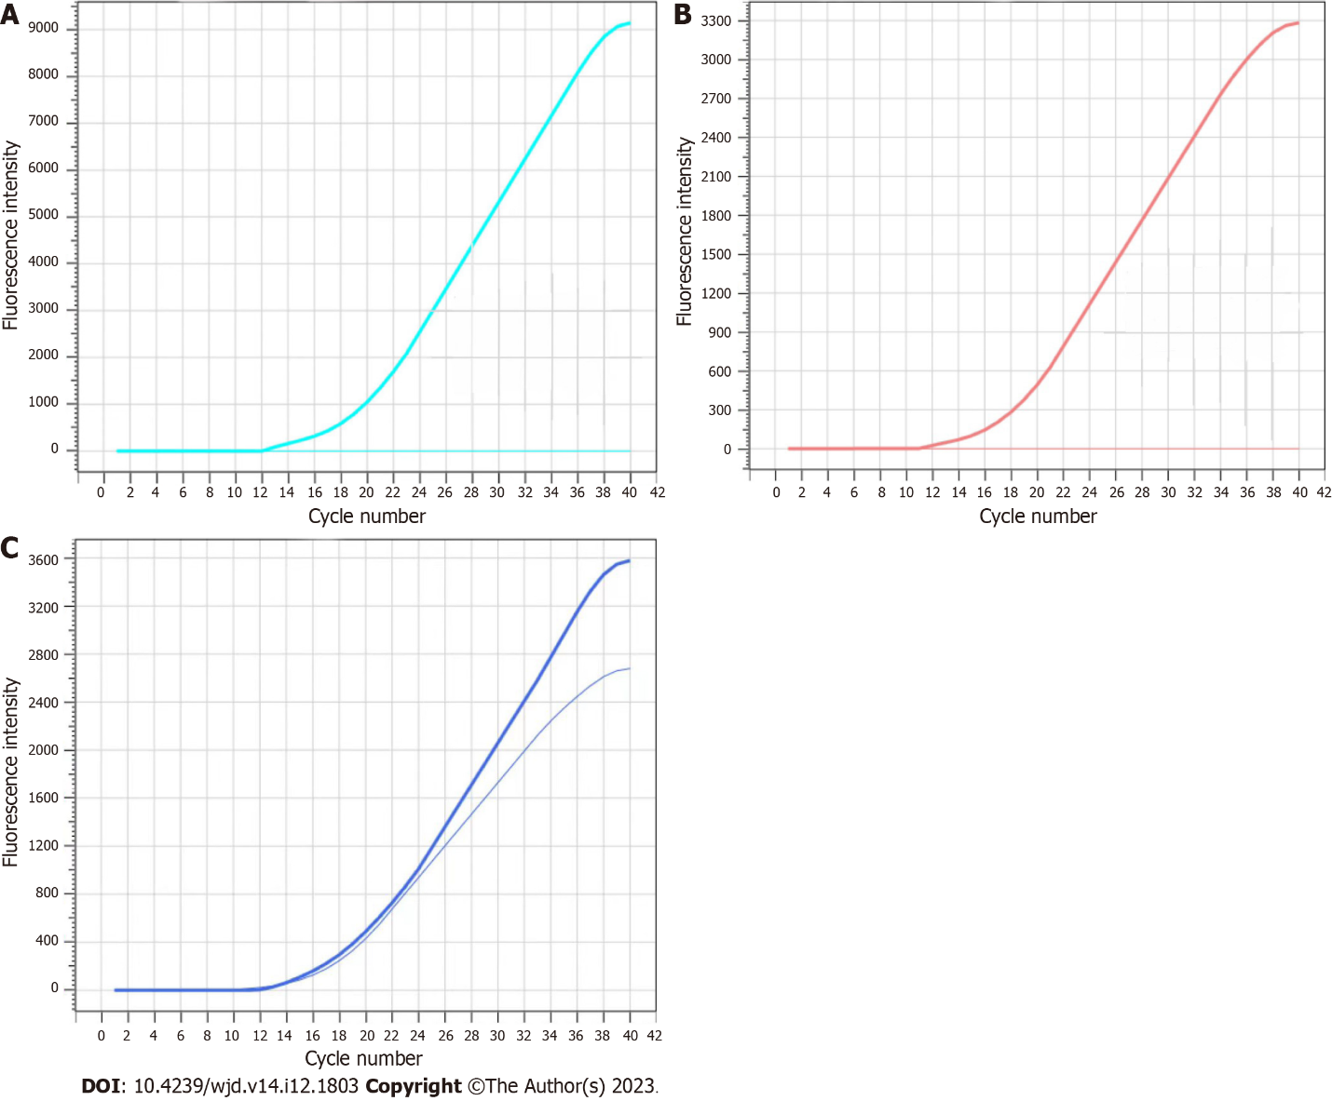
Figure 1 Reaction diagram in a standard plasmid. A: rs780094-PA; B: rs780094-PG; C: rs780094-PA/G.

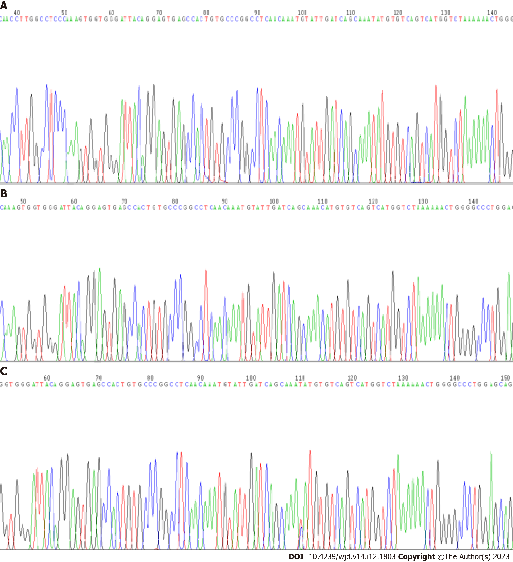
Figure 2 Sequencing maps. A: Patient with normoalbuminuria; B: Patient with microalbuminuria group; C: Patient with macroalbuminuria.

Table 1 Probe sequence
Name | SNP site | Primer | Sequence | Modification
 |  |  |  | 5’ | 3’
Human | rs780094 | rs780094-F | GGCCCCAGTTTTTTAGACCAT
 |  | rs780094-R | GCCCGGCCTCAACAAAT
 |  | rs780094-PG | CTGACACATGTTTGCT | FAM | MGB
 |  | rs780094-PA | TGACACATATTTGCTG | VIC | MGB
SNP: Single nucleotide polymorphism.

Table 2 Comparison of baseline data among the four groups
Group | I | II | III | IV | Statistics | P value
Number | 66 | 101 | 81 | 70 | - | -
Sex (male/female) | 22/44 | 57/44ª | 36/45 | 33/37 | 8.755¹ | 0.033
Age (yr) | 51 (19) | 55 (16)ª | 55.5 (15.75)ª | 58 (13.75)ª | 14.314² | 0.003
DBP (mmHg) | 73 (17.5) | 87 (17.75)ª | 86 (17.75)ª | 92 (17.75)^{a,b} | 45.370² | < 0.001
SBP (mmHg) | 125 (24.5) | 153 (34.5)ª | 153.5 (35.5)ª | 154 (29)ª | 54.376² | < 0.001
Height (cm) | 158 (11) | 160 (14) | 157 (10.75) | 158.5 (14.75) | 0.674² | 0.879
Weight (kg) | 54.4 (15.5) | 62 (15.5)ª | 62 (13)ª | 64.5 (17.75)ª | 30.99² | < 0.01
BMI (kg/m²) | 21.74 (3.91) | 25.3 (3.82)ª | 25.40 (4.53)ª | 25.39 (4.47)ª | 40.147² | < 0.01
Course of disease (mo) | - | 90 (133.35)ª | 111.5 (132.5)ª | 118.5 (1332.5)ª | 147.932² | < 0.01
HbA1c (%) | 5.7 (0.6) | 9.6 (3.55)ª | 9.7 (3.5)ª | 9.35 (2.88)ª | 151.947² | < 0.01
FBG (mmol/L) | 5.33 (0.75) | 7.35 (2.93)ª | 8.85 (5.68)^{a,b} | 8.85 (3.2)^{b} | 106.139² | < 0.01
2-h PBG (mmol/L) | 9.43 (1.83) | 12.65 (2.45)ª | 13.4 (6.92)ª | 13.6 (7.47)^{a,b} | 102.209² | < 0.01
INS (mmol/L) | 7.47 (5.79) | 8.23 (8.54)ª | 8.0 (9.26)ª | 7.94 (8.01) | 5.999² | 0.112
Fasting C-peptide (mmol/L) | 1.61 (1) | 1.73 (1.58) | 1.35 (1.62) | 1.97 (2.37) | 5.645² | 0.130
BUN (mmol/L) | 4.92 (1.79) | 5.85 (2.15)ª | 5.67 (1.94)ª | 7.82 (2.56)^{a,b,c} | 56.728² | < 0.01
Cr (μmol/L) | 55 (29.05) | 58.6 (25.33) | 57.4 (22.65) | 87.95 (53.78)^{a,b,c} | 53.938² | < 0.01
UA (μmol/L) | 347.6 (122.9) | 318.25 (187.6) | 298.95 (138.18) | 389.1 (189.58)^{b} | 10.817² | 0.013
TG (mmol/L) | 1.42 (0.75) | 1.69 (1.54)ª | 1.81 (1.40)ª | 1.74 (1.43)ª | 14.974² | 0.02
TC (mmol/L) | 3.77 (1.67) | 4.51 (1.66)ª | 4.58 (1.53)ª | 4.44 (1.91)ª | 14.796² | 0.02
HDL (mmol/L) | 1.14 (0.35) | 1.08 (0.40) | 1.09 (0.30) | 1.09 (0.40) | 1.305² | 0.728
LDL (mmol/L) | 2.55 (1.14) | 2.61 (1.45) | 2.54 (1.42) | 2.69 (1.95) | 1.145² | 0.766
UCAR (μg/mg) | 18.95 (11.92) | 21.9 (48.63)ª | 67.85 (67.3)^{a,b} | 2314.5 (3161.08)^{a,b,c} | 218.326² | < 0.01
Hypertension (yes/no) | 57/9 | 64/37ª | 29/52^{a,b} | 31/39^{a,b} | 44.444¹ | < 0.01
Hyperlipidemia (yes/no) | 52/14 | 62/39ª | 48/33ª | 46/24 | 7.301¹ | 0.063
CHD (yes/no) | 63/3 | 90/11 | 72/9 | 66/4 | 3.482¹ | 0.323
Stoke (yes/no) | 63/3 | 95/6 | 72/9 | 63/7 | 4.182¹ | 0.242
Drink (yes/no) | 55/11 | 66/35 | 60/21 | 45/35 | 8.359¹ | 0.039
Smoke (yes/no) | 53/13 | 68/33ª | 57/24 | 46/24ª | 4.305¹ | 0.230
ªRepresents a statistically significant difference from group I.
^{b}Represents a statistically significant difference from group II.
^{c}Represents a statistically significant difference from group III.
¹Represents χ² value.
²Represents H value.
DBP: Diastolic blood pressure; SBP: Systolic blood pressure; BMI: Body mass index; HbA1c: Glycosylated hemoglobin; FBG: Fasting blood glucose; 2-h PBG: 2-h postprandial blood glucose; BUN: Blood urea nitrogen; UA: Uric acid; TG: Triglyceride; TC: Total cholesterol; HDL: High-density lipoprotein; LDL: Low-density lipoprotein; UCAR: Urinary albumin/creatinine ratio; CHD: Coronary heart disease.

Table 3 Comparison of genotype frequency and allele frequency among the four groups
Group | N | CC | CT | TT | C | T
I | 66 | 25 (37.9%) | 28 (42.4%) | 13 (19.7%) | 78 (59.1%) | 54 (40.9%)
II | 101 | 22 (21.7%) | 45 (44.6%) | 34 (33.7%) | 89 (44.1%) | 113 (55.9%)
III | 81 | 18 (22.2%) | 37 (45.7%) | 26 (32.1%) | 73 (45.1%) | 89 (54.9%)
IV | 70 | 15 (21.4%) | 33 (47.1%) | 22 (31.5%) | 63 (45.0%) | 77 (55.0%)

Table 4 Logistic regression analysis of risk factors for type 2 diabetes mellitus complicated with proteinuria
Variable | B | SE | Wald χ² | P value | OR (95%CI)
DBP (mmHg) | 0.077 | 0.013 | 35.65 | < 0.01 | 1.080 (1.053-1.017)
SBP (mmHg) | 0.036 | 0.006 | 36.858 | < 0.01 | 1.037 (1.025-1.049)
Weight (kg) | 0.072 | 0.015 | 23.121 | < 0.01 | 1.075 (1.044-1.107)
BMI (kg/m²) | 0.300 | 0.051 | 34.472 | < 0.01 | 1.350 (1.221-1.492)
Hypertension (yes/no) | 1.878 | 0.380 | 24.391 | < 0.01 | 6.538 (3.103-13.773)
Hyperlipidemia (yes/no) | 0.827 | 0.328 | 6.358 | 0.012 | 2.286 (1.202-4.346)
Drink (yes/no) | 0.862 | 0.357 | 5.841 | 0.016 | 2.368 (1.177-4.766)
HbA1c (%) | 4.834 | 0.904 | 28.614 | < 0.01 | 125.687 (21.385-738.706)
FBG (mmol/L) | 1.258 | 0.187 | 45.233 | < 0.01 | 3.517 (2.438-5.074)
2-h PBG (mmol/L) | 0.631 | 0.092 | 47.502 | < 0.01 | 1.879 (1.571-2.248)
BUN (mmol/L) | 0.477 | 0.099 | 23.410 | < 0.01 | 1.612 (1.328-1.956)
TG (mmol/L) | 0.464 | 0.159 | 8.548 | 0.003 | 1.591 (1.165-2.171)
TC (mmol/L) | 0.470 | 0.122 | 14.801 | < 0.01 | 1.600 (1.259-2.032)
CT + TT | 0.536 | 0.192 | 7.765 | 0.005 | 1.710 (1.172-2.493)
OR: Odds ratio; CI: Confidence interval; DBP: Diastolic blood pressure; SBP: Systolic blood pressure; BMI: Body mass index; TG: Triglyceride; TC: Total cholesterol; 2-h PBG: 2-h postprandial blood glucose; HbA1c: Glycosylated hemoglobin; FBG: Fasting blood glucose; BUN: Blood urea nitrogen.

Published by Baishideng Publishing Group Inc
7041 Koll Center Parkway, Suite 160, Pleasanton, CA 94566, USA
Telephone: +19253991568
Email: bpgoffice@wjgnet.com
Help Desk: https://www.f6publishing.com/helpdesk
https://www.wjgnet.com

© 2023 Baishideng Publishing Group Inc. All rights reserved.

