Name of Journal: World Journal of Meta-Analysis
Manuscript NO: 57836
Manuscript Type: META-ANALYSIS

Prevalence, awareness and control of hypertension in Malaysia from 1980-2018: A systematic review and meta-analysis

Soo MJ et al. Prevalence, awareness and control of hypertension in Malaysia

Man Jun Soo, Zhen Yee Chow, Siew Mooi Ching, Chun Han Tan, Kai Wei Lee, Navin Kumar Devaraj, Hani Syahida Salim, Vasudevan Ramachandran, Poh Ying Lim, Dhashani Sivaratnam, Fan Kee Hoo, Ai Theng Cheong, Yook Chin Chia

Man Jun Soo, Siew Mooi Ching, Kai Wei Lee, Navin Kumar Devaraj, Hani Syahida Salim, Ai Theng Cheong, Department of Family Medicine, Universiti Putra Malaysia, Serdang 43400, Malaysia

Zhen Yee Chow, Chun Han Tan, Hospital Seberang Jaya, Perai 13700, Malaysia

Vasudevan Ramachandran, Malaysian Research Institute on Ageing, Universiti Putra Malaysia, Serdang 43400, Malaysia

Poh Ying Lim, Department of Community Health, Universiti Putra Malaysia, Serdang 43400, Malaysia

Dhashani Sivaratnam, Department of Surgery, Universiti Putra Malaysia, Serdang 43400, Malaysia

Fan Kee Hoo, Department of Medicine, Universiti Putra Malaysia, Serdang 43400, Malaysia

Yook Chin Chia, Department of Medical Sciences, Sunway University, Bandar Sunway 47500, Malaysia

Author contributions: Ching SM, Chia YC, Devaraj NK, Hoo FK, Chow ZY, Lim PY and Tan CH conceived and designed the study; Chow ZY, an CH, Soo MJ and Lee KW performed the study; Ching SM, Soo MJ, Lee KW, Chow ZY, Lim PY and Tan CH analyzed the data; Ching SM, Soo MJ, Lee KW, Chow ZY and Tan CH wrote the paper; Ching SM, Soo MJ, Lee KW, Chow ZY, Tan CH, Cheong AT and Devaraj NK contributed to the data interpretation; Chia YC, Ching SM, Cheong AT, Devaraj NK, Salim HS, Ramachandran V, Sivaratnam D, Lee KW and Hoo FK critically revised the manuscript; all authors have read and approved the manuscript.

Corresponding author: Siew Mooi Ching, MD, MMed (FamMed), Associate Professor, Department of Family Medicine, Faculty of Medicine and Health Sciences, Universiti Putra Malaysia, Selangor, Serdang 43400, Malaysia. sm_ching@upm.edu.my

Received: June 27, 2020
Revised: August 22, 2020
Accepted: August 27, 2020
Published online:

Abstract
BACKGROUND
Hypertension is a common public health problem worldwide and is a well-known risk factor for increased risk of cardiovascular diseases, contributing to high morbidity and mortality. However, there has been no systematic review and meta-analysis of a multiethnic population such as that of Malaysia.

AIM
To determine the trend in prevalence, awareness and control rate of hypertension in Malaysia.

METHODS
Systematic searches were conducted in six databases (PubMed, Scopus, Ovid, CINAHL, Malaysian Medical Repository and Malaysia Citation Index) for articles published between 1980 and 2018. Two authors reviewed the studies and performed quality assessment and data extraction independently. Pooled estimates of hypertension prevalence, awareness and control rate were calculated using the DerSimonian-Laird random-effects model. Subgroup and sensitivity analyses were performed.

RESULTS
We included 56 studies involving a total of 241796 participants. The overall pooled prevalence of hypertension aged ≥ 18 years was 29.7%. The prevalence of hypertension was the lowest in the 1980s (16.2%, 95% confidence interval (CI): 13.4, 19.0), increasing up to 36.8% (95%CI: 6.1, 67.5) in the 1990s, then decreasing to 28.7% (95%CI: 21.7, 35.8) in the 2000s and 26.8% (95%CI: 21.3, 32.3) in the 2010s. The prevalence of awareness was 51.4% (95%CI: 46.6, 56.3), while 33.3% (95%CI: 28.4, 38.2) of those on treatment had achieved control of their blood pressure.

CONCLUSION
In Malaysia, three in ten adults aged ≥ 18 years have hypertension, while four in ten adults aged ≥ 30 years have hypertension. Five out of ten people are aware of their hypertension status and only one-third of those under treatment achieved control of their hypertension. Concerted efforts by policymakers and healthcare professionals to improve awareness and control of hypertension should be of high priority.

Key words: Prevalence; Awareness; Control; Hypertension; Blood pressure; Malaysia; Systematic review; Meta-analysis

Soo MJ, Chow ZY, Ching SM, Tan CH, Lee KW, Devaraj NK, Salim HS, Ramachandran V, Lim PY, Sivaratnam D, Hoo FK, Cheong AT, Chia YC. Prevalence, awareness and control of hypertension in Malaysia from 1980-2018: A systematic review and meta-analysis. World J Meta-Anal 2020; In press

Core tip: This is a systematic review and meta-analysis reporting that the pooled prevalence of hypertension in people aged ≥ 18 years in Malaysia was 29.7%. The pooled prevalence of awareness towards hypertension was 51.4 % and blood pressure control rate was 33.3%.

INTRODUCTION
Hypertension is a common public health problem over the past several decades^{[1,2]}. It is one of the major risk factors for cardiovascular diseases such as stroke, heart failure and ischemic heart disease^{[3]}. In Malaysia, trend analyses have been conducted based on the National Health and Morbidity Surveys, which are nationwide studies that have been performed every 10 years since 1986. The analyses have also shown the trend of hypertension in different genders and ethnicities^{[4-7]}. Besides the National Health and Morbidity Surveys, several other studies have examined the prevalence, awareness and control of hypertension that differed from that of the National Health and Morbidity Surveys^{[8,9]}. The prevalence in different settings and in different age groups may present a slightly different picture along with their accompanying set of problems.
The present systematic review aimed to determine the pooled prevalence of hypertension, awareness and control of hypertension in Malaysia from 1980 to 2018 based on a nationwide survey and other important studies that reported the prevalence of hypertension in different settings and specific groups. Heterogeneities among cross-sectional studies and the national survey may conceivably cause different rates of prevalence. Hence, there is a need for a systematic review and meta-analysis to estimate the pooled prevalence of hypertension in Malaysia. We are not only reporting the trend of hypertension prevalence in Malaysia from 1980 to 2018 but are also providing some important insights into the awareness and control of hypertension among Malaysians.

MATERIALS AND METHODS
Protocol registration
The present review was registered with PROSPERO (2018: CRD42018075369) and conducted according to the Preferred Reporting Items for Systematic Reviews and Meta-Analyses guidelines^{[10]}.

Data sources
We searched six databases (PubMed, Ovid, Scopus, CINAHL, Malaysian Medical Repository and Malaysia Citation Index) for the relevant articles and included all relevant citations published before 28 February 2018.

Search strategy
The literature search used the following search terms: (prevalence) and (awareness) and (control) and (hypertension or high blood pressure) and (Malaysia), and a combination of expanded MeSH terms and free-text searches were used for the final search up to 28 February, 2018: (Prevalence OR Aware* OR Unaware* OR Undiagnosed OR Control* OR Uncontrol* OR ‘Achieved target’) AND (Hypertension OR ‘Blood pressure’ OR ‘Systolic blood pressure’ OR ‘Diastolic blood pressure’ OR ‘Raised blood pressure’ OR ‘High blood pressure’) AND (Malaysia OR Perlis OR Kedah OR Penang OR ‘Pulau Pinang’ OR Perak OR Johor OR Selangor OR Pahang OR Malacca OR Melaka OR Terengganu OR Kelantan OR ‘Negeri Sembilan’ OR Sabah OR Sarawak OR ‘Wilayah Persekutuan’ OR Putrajaya OR ‘Kuala Lumpur’ OR ‘Labuan’).

Eligibility criteria
Any studies, reports or articles published between 1 January, 1980 and 28 February, 2018 and fulfilling the following criteria were included in the analysis: (1) included the general population aged ≥ 18 years; (2) studied the prevalence of hypertension diagnosed using digital automated or mercury sphygmomanometers; (3) studied either the prevalence, awareness and control of blood pressure (BP) or hypertension individually or any combination of the three; and (4) in English only. We excluded intervention studies, case studies, pharmacogenetic studies, case series, qualitative data, comments or letters, audits, narrative reviews, conference proceeding, opinion pieces, methodological, editorials, animal studies or any other publications lacking primary data and/or explicit method descriptions. When several publications were derived from the same dataset or cohorts, the article that provided the most updated data was selected. We identified other pertinent studies through reverse–forward citation tracking of relevant articles.

Selection process
We imported relevant articles identified through the databases into EndNote X5 and removed duplicate publications. Two authors (Chow ZY and Tan CH) screened the titles and abstracts independently to search for eligible articles based on the inclusion criteria. If there were discrepancies on including studies, discussions were held and resolved by the senior authors (Ching SM, Hoo FK, Devaraj NK, Salim HS and Cheong AT) for final consensus before the full text of each relevant article was reviewed.

Data collection
One author (Ramachandran V) recorded data from the selected studies into the extraction form using Excel, while the second author (Ching SM) verified the accuracy and completeness of the extracted data.

Data items
The following characteristics of the selected studies were extracted: first author, year of publication, study setting, study design, location of study, geographical area (rural or urban), BP apparatus, sample size and cases with hypertension. The outcome measures extracted were the prevalence of hypertension in terms of the difference of proportion/percent of hypertension, awareness and control in the total patients examined.

Summary measures
Hypertension was defined as BP ≥ 140/90 mmHg based on guidelines from the Fifth Joint National Committee. Awareness was defined as knowing one’s own hypertension status or having been diagnosed with hypertension previously. Control was defined as achieving a target BP of < 140/90 mmHg^{[11]}.

Risk of assessment based on the critical appraisal checklist
Each article underwent quality assessment by two authors (Soo MJ and Lee KW) using a modified critical appraisal checklist (Supplementary material Appendix 1)^{[8]}. The checklist consisted of 11 items that assessed the components in observational studies. Whenever the information provided was insufficient to assist in the evaluation of a certain item, the two authors agreed to grade that item as ‘0’ indicating absence of the item, ‘0.5’ indicated that the information was incomplete, and ‘1’ indicated that the item was presented clearly. The quality of each article was graded as high if it scored ≥ 7/11, or low if it scored < 7/11^{[8]}. The results of the quality assessment are shown in supplementary material Appendix 2.

Data synthesis
The results from the meta-analysis summarized the data narrative and statistically used a tabulated format. Heterogeneity between studies for the pooled estimates was examined using I² (I² < 25%, low; I² = 25%-30%, moderate; I² > 50%, high), indicating the percent of total discrepancy due to variation in the studies^{[12]}.

Statistical analysis
We used OpenMeta[Analyst] for data analysis (http://www.cebm.brown.edu/openmeta/index.html)^{[13]}. The prevalence estimated from individual studies was pooled using random-effects (DerSimonian-Laird method) meta-analysis and was reported with 95% confidence interval (CI). Subgroup analysis was performed to examine the prevalence, awareness and control of hypertension by age group, sex, ethnicity, study setting, study design, geographical origin and BP tools.

Additional analysis
Publication bias was assessed by sensitivity analysis using the leave-one-out analysis. We also performed sensitivity analyses for the prevalence of hypertension by discarding low-quality studies, removing outlier subpopulations (point estimates > ± 3 standard deviations)^{[14]} or removing smaller subpopulations (size < 100) or large sample sizes (size > 5000)^{[15]}, where these publication biases are known to have effects on the estimated prevalence. The effect size of interest was the proportion of individuals with hypertension. The secular trend of prevalence was estimated by calculating the point estimates for four separate decades.

RESULTS
Description of included studies
We identified 1493 manuscripts in the initial search (Figure 1). After removal of duplicate records (n = 251), 1242 studies were retrieved for further assessment. After careful evaluation of the inclusion/exclusion criteria, 52 studies fulfilled our criteria, and this together with another four studies identified from cross-referencing, a total of 56 studies were included in our meta-analysis.

Characteristics of the included studies
The main characteristics of the included studies are shown in Table 1^{[16-71]} and supplementary material Appendix 3 in encompassing the prevalence, awareness and control of hypertension of the included studies. A total sample size of 241796 respondents from Malaysia was included in the analysis. Overall, the ethnicity distribution was 56.5% Malay, 24.2% Chinese, 9.7% Indian and 9.5% other ethnicities. Fifty-one studies were conducted in the community setting, four were in a hospital setting and one was in a primary care clinic. Quality assessment using a modified critical appraisal checklist showed that the majority of the studies (52/56) were of good quality with only four having poor quality.

Prevalence of hypertension: Overall and subgroup analysis
Table 2 shows the prevalence of hypertension in Malaysia is 29.7% (95%CI: 26.1, 33.3) (Figure 2). The prevalence of hypertension for those aged ≥ 30 years was 40.0% (Figure 3). The pooled prevalence of hypertension increased with age as the prevalence was 8.6% in adults aged 18–29 years as compared to 42.8% in adults aged ≥ 60 years (Figure 4).
Among adults aged ≥ 18 years, the prevalence of hypertension was higher in men compared to women (31.4%, 95%CI: 26.5, 36.2 vs 27.8%, 95%CI: 20.7, 34.9) (Figure 5A and 5B). The prevalence of hypertension was highest among Malays (37.3%, 95%CI: 32.9, 41.7), followed by Chinese (36.4%, 95%CI: 31.6, 41.2) and Indians (34.8%, 95%CI: 31.2, 38.4) (Figure 6A-D). The prevalence of hypertension was 24.3% in healthcare setting as compared to 30.2% in community setting (Figure 7). The prevalence of hypertension in rural areas was 35.6% as compared to 25.4% in urban areas (Figure 8A and 8B).
The prevalence of hypertension was 16.2% in the first decade (1980–1989), 36.8% in the second decade (1990–1999), 28.7% in the third decade (2000–2009) and 26.8% in the fourth decade (2010–2018) (Figure 9).
The prevalence of hypertension in studies that used mercury sphygmomanometers was 33.2% (95%CI: 26.4, 40.0) as compared to 30.8% (95%CI: 25.5, 36.0) in those studies that used a digital BP device (Figure 10). Sensitivity analysis showed that all studies affected the pooled prevalence of hypertension causing it to vary from 25.6% to 30.2%. Therefore, we did not eliminate any studies from the analysis.

Prevalence of awareness towards hypertension
The overall prevalence of awareness towards hypertension in Malaysia was 51.4% (95%CI: 46.6, 56.3) (Table 3 and Figure 11). The prevalence of awareness towards hypertension among male hypertensive patients was 67.8% (Figure 12A), whereas it was 62.7% (Figure 12B) among female hypertensive patients^{[52,56]}. Hypertension awareness among the Malays was 45.4% (Figure 13A), while that among non-Malay was 47.9% (Figure 13B). The prevalence of awareness towards hypertension among hypertensive patients living in rural areas was 45.3% (Figure 14) as compared to 54.1% in urban areas (Table 3).

Prevalence of control rate in hypertension
The control rate of hypertension was indicated in Table 3. Among the patients who were aware they were hypertensive, 33.3% (95%CI: 28.4, 38.2) achieved control of their BP (Figure 15). Our analysis found that men had slightly better control than women (37.1% vs 30.4%) (Figure 16A and 16B). We also found that 29.3% of Malays had control of their BP (Figure 17A), while that of non-Malays was 35.6% (Figure 17B). Urbanites had higher hypertension control than those living in rural areas (36.5% vs 34.1%) (Figure 18) (Table 3).

Sensitivity analyses
Visual inspection of the funnel plot of the result of overall prevalence of hypertension showed an asymmetrical plot, suggesting some degree of publication bias (Figure 19). The main analysis for the prevalence of hypertension was rerun by removing one subpopulation at a time. The pooled estimates did not vary much from the original analysis during each removal. The removal of five low-quality studies or smaller subpopulations (size < 100) also did not affect the original estimate of hypertension rates (Table 4).

DISCUSSION
To the best of our knowledge, this systematic review is the first in Malaysia to describe the prevalence and its trends over four decades for hypertension awareness and control. In addition, due to the fact that Malaysia is a multiethnic country, its variation in the prevalence, awareness and control of hypertension is crucial for us to examine in order to plan our policy in managing hypertension on a nationwide scale.

Prevalence
The overall pooled prevalence of hypertension in Malaysia was 29.7%. The overall prevalence of hypertension in Malaysia was within the range of worldwide hypertension prevalence (20%–50%), as described in a systematic review by Kearney et al^{[72]}. Malaysia has a higher prevalence of hypertension as compared to Thailand (24.7%), Singapore (23.5%) and China (25.2%)^{[73-75]}. A review showed that this prevalence is as high as that in developed countries despite Malaysia being a developing country^{[76]}. In fact, the prevalence of hypertension in Malaysia is higher than that of the United States by 0.7%^{[77]}.

Trend of hypertension
We noticed a low prevalence of hypertension in the 1980s. This could be due to only having one study that reported the prevalence of hypertension in the 1980s. Furthermore, that study involved the Kadazan and Bajau ethnic groups, which are minority groups in a rural part of Sabah^{[32]}. Hence, it is not surprising that the prevalence was so low. The possible explanations include the fact that the study was not only limited to a rural population, but it was also the era before urbanization whereby unhealthy lifestyles were not practiced commonly reflected strongly by a low prevalence of diabetes of less than 5% in the years 1980-1985 in South East Asia^{[78]}. Otherwise, we noticed a spike in hypertension prevalence from the 1980s to the 1990s (36.8%). Then, it decreased to 28.7% in the 2000s and further decreased to 26.8% in the 2000s. A possible reason for the increased prevalence in the 1990s could be due to the fact that among the 30 studies that specified their study period, only two studies were conducted in the 1990s. One study, which reported hypertension prevalence of 21.1%, involved three rural communities in Bagan Datoh involving a wide variation of citizens from different age groups^{[56]}, whereas the other study involved three semi-rural areas in Kuala Langat where the study respondents were from the older age groups (range, 55–95 years; mean age, 65.4 years)^{[29]}. This significantly increases the overall pooled prevalence of hypertension if we only take these two studies with their extreme ends of prevalence into account. In comparison to the trend of prevalence of hypertension in other countries, United States was one of the countries with a consistent prevalence of hypertension of around 29% according to the United States’ National Health and Nutrition Examination Survey^{[77]}.

Age and hypertension
Epidemiological studies have shown that the prevalence of hypertension increases with age, which is consistent with our review. Importantly, we also found that hypertension prevalence was doubled in those aged 40–49 years (27.9%) from those aged 30–39 years (13.5%). Comparing our results to that of a developed country, we also found a similar doubling phenomenon in hypertension prevalence, but it only happened in the older age group, which was 63.1% in those aged ≥ 60 years, rising from 33.2% from those aged 40–59 years^{[77]}. It is expected that aging is closely related to increased rates of hypertension because of the arterial structure alteration and ongoing calcification that leads to increased arterial stiffness^{[79]}. However, when focusing on the older population aged ≥ 60 years, the prevalence of hypertension in this age group in Malaysia is the lowest among Asian countries such as Singapore (73.9%), Korea (68.7%), India and Bangladesh (65%), Taiwan (60.4%), Thailand (51.5%) and China (48.8%)^{[80-85]}. However, this could be due to the fact that studies in Malaysia have defined the elderly as people aged ≥ 60 years old compared to the other studies above, which defined the elderly as people aged ≥ 65 years^{[80,81,83,85]}. In Malaysia, the prevalence of hypertension was 8.6% among those aged 18–29 years and 13.5% among those aged 30–39 years. The prevalence rates are fairly similar to China (18–29 year age group, 9.6%; 30–39 year age group, 13.1%)^{[86]} but lower compared to India (18–29 year age group, 13%; 30–39 year age group, 23%)^{[87]}.

Gender and hypertension
We found that the prevalence of hypertension was higher in men compared to women. This finding is similar to that of the National Health and Nutrition Examination Survey in the United States^{[88]}, which reported that regardless of race and ethnicity, men in the 20–40 year age group had higher prevalence of hypertension than women^{[88]}. The sex differences in hypertension are due to both biological and behavioral factors^{[89]}. Biologically, the female sex hormone, estrogen, serves as a protective factor against hypertension and other cardiovascular-related diseases in women^{[90,91]}. Unhealthy lifestyle such as smoking was more prevalent among men compared to women^{[90-93]}. Because smoking is a risk factor for hypertension^{[94,95]}, it is not surprising that the prevalence of hypertension is higher in men.

Awareness
In our review, 51.4% (95%CI: 46.6, 56.3) of the included sample was aware of their hypertension status. This finding is lower than the rates reported in United States (63%)^{[96]}, Singapore (69.7%)^{[80]} and Korea (91.7%)^{[81]}. Even though, the awareness of hypertension in Malaysia is higher than that in India (25.1%)^{[83]} and Indonesia (35.8%)^{[73]}, this finding is still worrying as it indicates one out of two adults remain undetected or untreated for their hypertension. Therefore, various nationwide blood pressure screening campaign is urgently needed. Indeed May Measurement Month was a good move as it was a nationwide blood pressure screening program that was conducted in conjunction with World Hypertension Day under the tutelage of the International Society of Hypertension^{[94]}.
Regarding the higher prevalence of awareness towards hypertension in Malaysia as compared to India^{[83]} and Indonesia^{[73]}, the possible explanation could be due to the fact that one of the studies was conducted in a residential home with a higher caregiver to resident ratio and frequent supervision. This explained why the residents’ awareness of hypertension was high^{[58]}. On the other hand, another study involved university staff with high education levels, and therefore the awareness of hypertension will certainly be high^{[61]}. In terms of ethnicity, only one study examined the ethnic differences of hypertension awareness^{[16]}, while the two other studies involved only Malay ethnicity as the study population^{[62]} and Malay villagers in rural communities, respectively^{[70]}. Comparison of geographical origin yielded similar results, where only one study examined the difference in awareness^{[16]} while the three other studies all focused on awareness among the rural communities rather than examining the geographical difference of hypertensive awareness^{[46,52,62]}. It will be right to assume that there will be much bias and higher heterogeneity, and therefore pooled analyses were not done for these subgroups.

Control
Hypertension control in Malaysia was 33.3%, which is much lower than that of developed countries such as the United States (53%)^{[17]}. Conversely, it is higher than that of nearby countries such as China (13.8%)^{[73,84]}, Hong Kong (25.8%)^{[95]} and the Philippines (27.0%)^{[97]}. This could be due to the fact that Malaysia has been improving its quality of healthcare facilities, building more clinics and hospitals and more of the latest drugs are available in these healthcare facilities^{[98]}. We found that men achieved better BP control than women. This is surprising because the literature reported that women are always more likely to have better health-seeking behavior and expected to have better blood pressure control^{[99]}. Urban dwellers had better BP control, which correlates with a study in Southern China that reported similar results^{[100]}. This may be due to limited access to healthcare facilities in rural areas despite the number of rural clinics increasing throughout the past four decades in Malaysia^{[98]}. It seems likely that a poorer health awareness among those living in rural areas or with lower socioeconomic profiles remains an important barrier to visiting healthcare facilities and thereby receiving proper treatment.

Strengths and limitations
The strength of this review was the large sample size summarizing prevalence of hypertension in Malaysia across four decades. Furthermore, this is interesting to analyze the prevalence of hypertension according to different subgroups especially when Malaysia is known to have different races with corresponding different cultures and lifestyle. The accompanying underlying problems were different from each other, and it has been addressed in this systematic review.
However, there are several limitations. First, we found that many studies did not report data of prevalence, awareness and control of hypertension in subgroups of gender, ethnicity and geographical origin, whereby these factors could further help health care policy makers to configure hypertension screening and awareness campaigns according to these subgroups in regards to hypertension prevalence, poor awareness and lack of control. Secondly, we adopted strict inclusion and exclusion criteria and therefore unpublished data or grey literature were not included in the study. However, based on the sensitivity analysis, prevalence of hypertension after removal of these studies with poor quality, nonrandom sampling and/or extreme sample size were not changed as compared to overall pooled prevalence of hypertension. Thirdly, the estimates for the earlier time periods were based on fewer studies when compared to that for latter periods, which may have caused a paucity of literature on the topic of interest.

Suggestion for future research
Future studies on the prevalence of hypertension can address some of the issues noted in this research. The prevalence of hypertension according to gender, ethnicity and geographical origin should be studied in more detail. Nonrandom sampling method should be avoided because it would lead to bias in the conducted study. Besides that, future studies should also emphasize on adequate or larger sample size, which is more representative of a population.

CONCLUSION
One-third of Malaysian adults are hypertensive. The prevalence of hypertension is higher in people who reside in rural areas than in those who stay in urban areas. Slightly more than half of the adults are aware of their hypertension status and one-third of these patients achieved target BP control. In view of these findings, urgent steps for improving health promotion and health education need to be undertaken on a larger scale. Although our review shows a decreasing trend of hypertension prevalence throughout the past four decades, hypertension awareness and BP control among Malaysians have yet to improve significantly.

ARTICLE HIGHLIGHTS
Research background
Hypertension is a common public health problem worldwide.

Research motivation
Future studies on the prevalence of hypertension can address some of issues noted in this research. The prevalence of hypertension according to gender, ethnicity and geographical origin should be studied in more detail.

Research objectives
This systematic review aimed to determine the trend in prevalence, awareness and control rate of hypertension in Malaysia.

Research methods
A systematic search was conducted in six databases for articles published between 1980 and 2018. Authors reviewed the studies and performed quality assessment and data extraction independently.

Research results
The overall pooled prevalence of hypertension in Malaysia was 29.7%. The overall prevalence of awareness was 51.4%, and 33.3% of those on treatment had achieved control of their blood pressure.

Research conclusions
In Malaysia, three in ten adults aged ≥ 18 years have hypertension, while four in ten adults aged ≥ 30 years have hypertension. Five out of ten people are aware of their hypertension status and only one-third of those under treatment achieved control of their hypertension.

Research perspectives
Concerted efforts by policymakers and healthcare professionals to improve awareness and control of hypertension should be of high priority.

REFERENCES
1 Sengul S, Akpolat T, Erdem Y, Derici U, Arici M, Sindel S, Karatan O, Turgan C, Hasanoglu E, Caglar S, Erturk S; Turkish Society of Hypertension and Renal Diseases. Changes in hypertension prevalence, awareness, treatment, and control rates in Turkey from 2003 to 2012. J Hypertens 2016; 34: 1208-1217 [PMID: 26991534 DOI: 10.1097/HJH.0000000000000901]
2 Bundy JD, He J. Hypertension and Related Cardiovascular Disease Burden in China. Ann Glob Health 2016; 82: 227-233 [PMID: 27372527 DOI: 10.1016/j.aogh.2016.02.002]
3 Ogah OS, Okpechi I, Chukwuonye II, Akinyemi JO, Onwubere BJ, Falase AO, Stewart S, Sliwa K. Blood pressure, prevalence of hypertension and hypertension related complications in Nigerian Africans: A review. World J Cardiol 2012; 4: 327-340 [PMID: 23272273 DOI: 10.4330/wjc.v4.i12.327]
4 Ministry of Health Malaysia. National Health and Morbidity Survey 2. 1996
5 Ministry of Health Malaysia. National Health and Morbidity Survey 3. 2006
6 Ministry of Health Malaysia. National Health and Morbidity Survey 4 (2011-2014). 2014
7 Ministry of Health Malaysia. National Health and Morbidity Survey 5 (2015-2018). 2018
8 Rizwan SA, Kumar R, Singh AK, Kusuma YS, Yadav K, Pandav CS. Prevalence of hypertension in Indian tribes: a systematic review and meta-analysis of observational studies. PLoS One 2014; 9: e95896 [PMID: 24797244 DOI: 10.1371/journal.pone.0095896]
9 Ministry of Health Malaysia. Summary of NHMS Report on Disease Prevalence: National Prevalence of Noncommunicable Diseases/Risk Factors From NHMS 1996 to 2015. 2017
10 Moher D, Shamseer L, Clarke M, Ghersi D, Liberati A, Petticrew M, Shekelle P, Stewart LA; PRISMA-P Group. Preferred reporting items for systematic review and meta-analysis protocols (PRISMA-P) 2015 statement. Syst Rev 2015; 4: 1 [PMID: 25554246 DOI: 10.1186/2046-4053-4-1]
11 Gifford RW Jr. The fifth report of the Joint National Committee on Detection, Evaluation, and Treatment of High Blood Pressure: insights and highlights from the chairman. Cleve Clin J Med 1993; 60: 273-277 [PMID: 8339452 DOI: 10.3949/ccjm.60.4.273]
12 Higgins JP, Thompson SG. Quantifying heterogeneity in a meta-analysis. Stat Med 2002; 21: 1539-1558 [PMID: 12111919 DOI: 10.1002/sim.1186]
13 Wallace BC, Dahabreh IJ, Trikalinos TA, Lau J, Trow P, Schmid CH. Closing the gap between methodologists and end-users: R as a computational back-end. J Stat Softw 2012; 49: 1-15 [DOI:10.18637/jss.v049.i05]
14 Ghosh D, Vogt A. Outliers: An evaluation of methodologies. In: Joint statistical meetings. San Diego: American Statistical Association, 2012: 3455–3460
15 Sagie A, Koslowsky M. Detecting moderators with meta‐analysis: An evaluation and comparison of techniques. Pers Psychol 1993; 46: 629-640 [DOI: 10.1111/j.1744-6570.1993.tb00888.x]
16 Abdul-Razak S, Daher AM, Ramli AS, Ariffin F, Mazapuspavina MY, Ambigga KS, Miskan M, Abdul-Hamid H, Mat-Nasir N, Nor-Ashikin MN, Ng KK, Nawawi H, Yusoff K; REDISCOVER Investigators. Prevalence, awareness, treatment, control and socio demographic determinants of hypertension in Malaysian adults. BMC Public Health 2016; 16: 351 [PMID: 27097542 DOI: 10.1186/s12889-016-3008-y]
17 Jinam TA, Phipps ME, Indran M, Kuppusamy UR, Mahmood AA, Hong LC, Edo J. An update of the general health status in the indigenous populations of Malaysia. Ethn Health 2008; 13: 277-287 [PMID: 18568977 DOI: 10.1080/13557850801930478]
18 Akter SFU, Fauzi ARM, Nordin MS, Satwi S, Mohamed A, Aznan MA, Samsul D. Prevalence of cardiovascular risk factors in a selected community at Kuantan, Pahang, Malaysia. Int J Med Med Sci 2010; 2: 322-328
19 Amiri M, Majid HA, Hairi F, Thangiah N, Bulgiba A, Su TT. Prevalence and determinants of cardiovascular disease risk factors among the residents of urban community housing projects in Malaysia. BMC Public Health 2014; 14 Suppl 3: S3 [PMID: 25436515 DOI: 10.1186/1471-2458-14-S3-S3]
20 Amplavanar NT, Gurpreet K, Salmiah MS, Odhayakumar N. Prevalence of cardiovascular disease risk factors among attendees of the Batu 9, Cheras Health Centre, Selangor, Malaysia. Med J Malaysia 2010; 65: 173-179 [PMID: 21939163]
21 Aniza I, Hayati K, Juhaida M, Taufik JA, Badilla II, Khalib L. Obesity related hypertension-gender specific analysis among adults in Tanjung Karang, Selangor, Malaysia. Msian J Public Health Med 2015; 15: 41-52
22 Aniza I, Nurmawati A, Hanizah Y, Ahmad Taufik J. Modifiable risk factors of cardiovascular disease among adults in rural community of Malaysia: a cross sectional study. Msian J Public Health Med 2016; 16: 53-61
23 Annamalai C, Govindaraja C, Chandramouli C. Prevalence, awareness and control of hypertension in estate workers in Malaysia. N Am J Med Sci 2011; 3: 540-543 [PMID: 22363074 DOI: 10.4297/najms.2011.3540]
24 Azuwani A, Noor Khairiah K, Cheong YZ, Kok, CC, Aw NSL, Nadiah MS, Abdul Rashid K. Body Fat Percentage Distribution of an Orang Asli Group (Aborigines) in Cameron Highlands, Malaysia. Mal J Nutr 2013; 19: 205-214
25 Tan BY, Kantilal HK, Singh R. Prevalence of metabolic syndrome among Malaysians using the international diabetes federation, national cholesterol education program and modified World Health Organization definitions. Mal J Nutr 2008; 14: 65-77
26 Chang CT, Lee PY, Cheah WL. The prevalence of cardiovascular risk factors in the young and middle-aged rural population in Sarawak, Malaysia. Malays J Med Sci 2012; 19: 27-34 [PMID: 22973135]
27 Cheah WL, Hazmi H, Chia HQ, Tindin E, Ahmad Zafri NA, Mohd Shah SH. Hypertension and its association with anthropometric indexes among pre-university students. Int J Adolesc Med Health 2016; 28: 373-379 [PMID: 26215534 DOI: 10.1515/ijamh-2015-0020]
28 Chee HL, Rampal KG. Relationship between selected health problems and exposures among women semiconductor workers in Malaysia. Med J Malaysia 2003; 58: 387-398 [PMID: 14750379]
29 Chin CY, Pengal S. Cardiovascular disease risk in a semirural community in Malaysia. Asia Pac J Public Health 2009; 21: 410-420 [PMID: 19661103 DOI: 10.1177/1010539509343973]
30 Chow CK, Teo KK, Rangarajan S, Islam S, Gupta R, Avezum A, Bahonar A, Chifamba J, Dagenais G, Diaz R, Kazmi K, Lanas F, Wei L, Lopez-Jaramillo P, Fanghong L, Ismail NH, Puoane T, Rosengren A, Szuba A, Temizhan A, Wielgosz A, Yusuf R, Yusufali A, McKee M, Liu L, Mony P, Yusuf S; PURE (Prospective Urban Rural Epidemiology) Study investigators. Prevalence, awareness, treatment, and control of hypertension in rural and urban communities in high-, middle-, and low-income countries. JAMA 2013; 310: 959-968 [PMID: 24002282 DOI: 10.1001/jama.2013.184182]
31 Chua EY, Zalilah MS, Haemamalar K, Norhasmah S, Geeta A. Obesity indices predict hypertension among indigenous adults in Krau Wildlife Reserve, Peninsular Malaysia. J Health Popul Nutr 2017; 36: 24 [PMID: 28545536 DOI: 10.1186/s41043-017-0102-4]
32 Gan CY, Chan MK. A blood pressure profile of rural Kadazans and Bajaus in Sabah, east Malaysia. Southeast Asian J Trop Med Public Health 1993; 24: 583-589 [PMID: 8160073]
33 Ghazi HF, Elnajeh M, AbdalQader M, Baobaid MF, Omar AB. Prevalence of Hypertension and its Association with Nutritional Factors Among University Students in Shah Alam, Malaysia. Pakistan J Nutr 2017; 16: 544-549 [DOI: 10.3923/pjn.2017.544.549]
34 Goh SC, Ho EL, Goh KL. Prevalence and risk factors of non-alcoholic fatty liver disease in a multiracial suburban Asian population in Malaysia. Hepatol Int 2013; 7: 548-554 [PMID: 26201786 DOI: 10.1007/s12072-012-9359-2]
35 Hasnah H, Amin I, Suzana S. Bone health status and lipid profile among post-menopausal malay women in Cheras, Kuala Lumpur. Malays J Nutr 2012; 18: 161-171 [PMID: 24575664]
36 Hazmi H, Ishak WR, Jalil RA, Hua GS, Hamid NF, Haron R, Shafei MN, Ibrahim MI, Bebakar WM, Ismail SB, Musa KI. Traditional cardiovascular risk-factors among healthcare workers in Kelantan, Malaysia. Southeast Asian J Trop Med Public Health 2015; 46: 504-511 [PMID: 26521525]
37 Ministry of Health Malaysia. National Health and Morbidity Survey 2015 (NHMS 2015). Vol. II: Non-Communicable Diseases, Risk Factors Other Health Problems. Available from: https://www.researchgate.net/publication/305213149_National_Health_and_Morbidity_Survey_2015-VOLUME_II_Non-Communicable_Diseases_Risk_Factors_Other_Health_Problems
38 Jamal R, Syed Zakaria SZ, Kamaruddin MA, Abd Jalal N, Ismail N, Mohd Kamil N, Abdullah N, Baharudin N, Hussin NH, Othman H, Mahadi NM; Malaysian Cohort Study Group. Cohort Profile: The Malaysian Cohort (TMC) project: a prospective study of non-communicable diseases in a multi-ethnic population. Int J Epidemiol 2015; 44: 423-431 [PMID: 24729425 DOI: 10.1093/ije/dyu089]
39 Khan AR, Narayan K, Ab Manan AH. The prevalence of hypertension among the elderly in fourteen villages in Kedah, Malaysia. Msian J Med Health Sci 2008; 4: 33-39
40 Latiffah A, Hanachi P. To investigate the relation of hypertension and anthropometric measurement among elderly in Malaysia. J Appl Psychol 2008; 8: 3963-3968 [DOI: 10.3923/jas.2008.3963.3968]
41 Latiffah AL, Hanachi P, Khania S. The Association of Hypertension with Major Risks Factors among University Putra Malaysia Retirees. J Med Sci 2008; 8: 254-261 [DOI: 10.3923/jms.2008.254.261]
42 Lee P, Ong T, Muna S, Syed Alwi S, Kamarudin K. Brief report do university students have high cardiovascular risk? A pilot study from universiti malaysia sarawak (unimas). Malays Fam Physician 2010; 5: 41-43 [PMID: 25606185]
43 Lian CW, Hazmi H, Thon CC, Muda W. Physical Activity and Cardiovascular Risk Factors Among Malays In Selected Rural and Urban Communities In Sarawak. Msian J Public Health Med 2015; 15: 104-111
44 Liao S, Mohamed Izham M, Hassali M, Shafie A, Nik Mohamed M, Hamdi M. Outcomes of cardiovascular risk factors screening programme among employees of a Malaysian public university. J Clin Diagn Res 2010; 4: 2208-2216
45 Lim TO, Ngah BA. The Mentakab Hypertension Study Project. Part III--Detection of hypertension in the outpatient department. Singapore Med J 1991; 32: 338-341 [PMID: 1788580]
46 Loh KW, Rani F, Chan TC, Loh HY, Ng CW, Moy FM. The association between risk factors and hypertension in perak, malaysia. Med J Malaysia 2013; 68: 291-296 [PMID: 24145254]
47 Ministry of Health Malaysia. Malaysia STEPS Noncommunicable Disease Risk Factors Survey 2005-2006. Available from: http://ghdx.healthdata.org/record/malaysia-steps-noncommunicable-disease-risk-factors-survey-2005-2006
48 Mohamed M, Winn T, Rampal GL, Abdul Rashid A, Mustaffa B. A Prelimenary Result of the Cardiovascular Risk factors Intervention Study (Pikom Study): Diabetes Mellitus, Hypertension and their Associated Factors. Malays J Med Sci 2005; 12: 20-25 [PMID: 22605943]
49 Nazri SM, Imran MK, Ismail IM, Faris AA. Prevalence of overweight and self-reported chronic diseases among residents in Pulau Kundur, Kelantan, Malaysia. Southeast Asian J Trop Med Public Health 2008; 39: 162-167 [PMID: 18567457]
50 Nazri SM, Tengku MA, Winn T. The association of shift work and hypertension among male factory workers in Kota Bharu, Kelantan, Malaysia. Southeast Asian J Trop Med Public Health 2008; 39: 176-183 [PMID: 18567459]
51 Moy FM, Hoe VC, Tan CPL, Rosmawati M. Cardiovascular risks among shift and non-shift workers in a public medical centre in Kuala Lumpur. J Univ Malaya Medical Cent 2010; 13: 45-49
52 Narayan KA, Khan AR. Blood pressure patterns and prevalence of hypertension and its associated factors in a rural community in northern Malaysia. Msian J Public Health Med 2007; 7: 14-19
53 Narayan K, Khan AR. Body mass index and nutritional status of adults in two rural villages in Northern Malaysia. Malays J Nutr 2007; 13: 9-17
54 Nasarudin SH, Ahmad N. Correlation between prehypertension and obesity indices among young adults. Msian J Public Health Med 2016; 16: 235-240
55 Nawawi HM, Nor IM, Noor IM, Karim NA, Arshad F, Khan R, Yusoff K. Current status of coronary risk factors among rural Malays in Malaysia. J Cardiovasc Risk 2002; 9: 17-23 [PMID: 11984213 DOI: 10.1177/174182670200900103]
56 Ng TK Jr, Tee ES, Rosman A. Rural communities in nutritional transition: emergence of obesity, hypertension and hypercholesterolemia as public health problems in three kampungs in Bagan Datoh, Perak. Malays J Nutr 1995; 1: 129-139 [PMID: 22692058]
57 Noor Hassim I, Norazman MR, Diana M, Khairul Hazdi Y, Rosnah I. Cardiovascular risk assessment between urban and rural population in Malaysia. Med J Malaysia 2016; 71: 331-337 [PMID: 28087957]
58 Ong HT, Oung LS, Ong LM, Tan KP. Hypertension in a residential home for the elderly in Penang, Malaysia. Med J Malaysia 2010; 65: 18-20 [PMID: 21265241]
59 Ong LM, Punithavathi N, Thurairatnam D, Zainal H, Beh ML, Morad Z, Lee SY, Bavanandan S, Kok LS. Prevalence and risk factors for proteinuria: the National Kidney Foundation of Malaysia Lifecheck Health Screening programme. Nephrology (Carlton) 2013; 18: 569-575 [PMID: 23782264 DOI: 10.1111/nep.12112]
60 Raihan K, Azmawati M. Cigarette smoking and cardiovascular risk factor among male youth population. Msian J Public Health Med 2013; 13: 28-36
61 Rampal L, Rampal S, Azhar MZ, Rahman AR. Prevalence, awareness, treatment and control of hypertension in Malaysia: a national study of 16,440 subjects. Public Health 2008; 122: 11-18 [PMID: 17981310 DOI: 10.1016/j.puhe.2007.05.008]
62 Rashid A, Azizah A. Prevalence of hypertension among the elderly Malays living in rural Malaysia. Australas Med J 2011; 4: 283-290 [PMID: 23386889 DOI: 10.4066/AMJ.2011.660]
63 Rasiah R, Thangiah G, Yusoff K, Manikam R, Chandrasekaran SK, Mustafa R, Bakar NB. The impact of physical activity on cumulative cardiovascular disease risk factors among Malaysian adults. BMC Public Health 2015; 15: 1242 [PMID: 26673166 DOI: 10.1186/s12889-015-2577-5]
64 Shahar S, Hassan J, Sundar VV, Kong AY, Ping Chin S, Ahmad SA, Kuan Lee L. Determinants of depression and insomnia among institutionalized elderly people in Malaysia. Asian J Psychiatr 2011; 4: 188-195 [PMID: 23051116 DOI: 10.1016/j.ajp.2011.06.001]
65 Samsudin S, Abdullah N, Applanaidu SD. The prevalence of diabetes mellitus and hypertension and its effects on healthcare demand among elderly in Malaysia. Int J Public Health Res 2016; 6: 741-749
66 Sherina M, Rampal L, Hejar A, Rozali A, Yunus AM. Prevalence of Urban Poor and Its Health Related Factors in the State of Selangor, Malaysia. Malays J Med Health Sci 2011; 7: 17-26
67 Shomad MBA, Rahman NAA, Rahman NIA, Haque M. The prevalence of cardiovascular disease risk factors among students of international Islamic University Malaysia, Kuantan Campus. J Appl Pharm 2016; 6: 051-057 [DOI: 10.7324/JAPS.2016.60309]
68 Sidik SM, Rampal L, Afifi M. Physical and mental health problems of the elderly in a rural community of sepang, selangor. Malays J Med Sci 2004; 11: 52-59 [PMID: 22977360]
69 Teh JK, Tey NP, Ng ST. Ethnic and gender differentials in non-communicable diseases and self-rated health in Malaysia. PLoS One 2014; 9: e91328 [PMID: 24603609 DOI: 10.1371/journal.pone.0091328]
70 Yusoff MF, Baki MM, Mohamed N, Mohamed AS, Yunus MR, Ami M, Othman I, Ishak AI. Obstructive sleep apnea among express bus drivers in Malaysia: important indicators for screening. Traffic Inj Prev 2010; 11: 594-599 [PMID: 21128189 DOI: 10.1080/15389588.2010.505255]
71 Zainuddin LR, Isa N, Muda WM, Mohamed HJ. The prevalence of metabolic syndrome according to various definitions and hypertriglyceridemic-waist in malaysian adults. Int J Prev Med 2011; 2: 229-237 [PMID: 22174962]
72 Kearney PM, Whelton M, Reynolds K, Muntner P, Whelton PK, He J. Global burden of hypertension: analysis of worldwide data. Lancet 2005; 365: 217-223 [PMID: 15652604 DOI: 10.1016/S0140-6736(05)17741-1]
73 Chia YC, Buranakitjaroen P, Chen CH, Divinagracia R, Hoshide S, Park S, Shin J, Siddique S, Sison J, Soenarta AA, Sogunuru GP, Tay JC, Turana Y, Wang JG, Wong L, Zhang Y, Kario K; HOPE Asia Network. Current status of home blood pressure monitoring in Asia: Statement from the HOPE Asia Network. J Clin Hypertens (Greenwich) 2017; 19: 1192-1201 [PMID: 28815840 DOI: 10.1111/jch.13058]
74 Ministry of Health Singapore. National Health Survey. 2010
75 Wang HH, Wang JJ, Wong SY, Wong MC, Li FJ, Wang PX, Zhou ZH, Zhu CY, Griffiths SM, Mercer SW. Epidemiology of multimorbidity in China and implications for the healthcare system: cross-sectional survey among 162,464 community household residents in southern China. BMC Med 2014; 12: 188 [PMID: 25338506 DOI: 10.1186/s12916-014-0188-0]
76 Pereira M, Lunet N, Azevedo A, Barros H. Differences in prevalence, awareness, treatment and control of hypertension between developing and developed countries. J Hypertens 2009; 27: 963-975 [PMID: 19402221 DOI: 10.1097/hjh.0b013e3283282f65]
77 Fryar CD, Ostchega Y, Hales CM, Zhang G, Kruszon-Moran D. Hypertension Prevalence and Control Among Adults: United States, 2015-2016. NCHS Data Brief 2017: 1-8 [PMID: 29155682]
78 NCD Risk Factor Collaboration (NCD-RisC). Worldwide trends in diabetes since 1980: a pooled analysis of 751 population-based studies with 4.4 million participants. Lancet 2016; 387: 1513-1530 [PMID: 27061677 DOI: 10.1016/S0140-6736(16)00618-8]
79 McInnes GT. Integrated approaches to management of hypertension: promoting treatment acceptance. Am Heart J 1999; 138: 252-255 [PMID: 10467221 DOI: 10.1016/s0002-8703(99)70318-2]
80 Pinto E. Blood pressure and ageing. Postgrad Med J 2007; 83: 109-114 [PMID: 17308214 DOI: 10.1136/pgmj.2006.048371]
81 Malhotra R, Chan A, Malhotra C, Østbye T. Prevalence, awareness, treatment and control of hypertension in the elderly population of Singapore. Hypertens Res 2010; 33: 1223-1231 [PMID: 20882026 DOI: 10.1038/hr.2010.177]
82 Kim KI, Chang HJ, Cho YS, Youn TJ, Chung WY, Chae IH, Choi DJ, Kim CH. Current status and characteristics of hypertension control in community resident elderly Korean people: data from a Korean longitudinal study on health and aging (KLoSHa study). Hypertens Res 2008; 31: 97-105 [PMID: 18360024 DOI: 10.1291/hypres.31.97]
83 Hypertension Study Group. Prevalence, awareness, treatment and control of hypertension among the elderly in Bangladesh and India: a multicentre study. Bull World Health Organ 2001; 79: 490-500 [PMID: 11436469]
84 Lu FH, Tang SJ, Wu JS, Yang YC, Chang CJ. Hypertension in elderly persons: its prevalence and associated cardiovascular risk factors in Tainan City, southern Taiwan. J Gerontol A Biol Sci Med Sci 2000; 55: M463-M468 [PMID: 10952370 DOI: 10.1093/gerona/55.8.m463]
85 Chen WW, Gao RL, Liu LS, Zhu ML, Wang W, Wang YJ, Wu ZS, Li HJ, Gu DF, Yang YJ, Zheng Z, Jiang LX, Hu SS. China cardiovascular diseases report 2015: a summary. J Geriatr Cardiol 2017; 14: 1-10 [PMID: 28270835 DOI: 10.11909/j.issn.1671-5411.2017.01.012]
86 Gu D, Reynolds K, Wu X, Chen J, Duan X, Muntner P, Huang G, Reynolds RF, Su S, Whelton PK, He J; InterASIA Collaborative Group. The International Collaborative Study of Cardiovascular Disease in ASIA. Prevalence, awareness, treatment, and control of hypertension in china. Hypertension 2002; 40: 920-927 [PMID: 12468580 DOI: 10.1161/01.hyp.0000040263.94619.d5]
87 Liu X, Xiang Z, Shi X, Schenck H, Yi X, Ni R, Liu C. The Risk Factors of High Blood Pressure among Young Adults in the Tujia-Nationality Settlement of China. Biomed Res Int 2017; 2017: 8315603 [PMID: 28932747 DOI: 10.1155/2017/8315603]
88 Zafar K, Ram V, Kumar M, Gupta M, Kumar S, Verma V. The prevalence of hypertension among young adults in a rural population of North India. Int J Res Med Sci 2017; 5: 4869-4872 [DOI: 10.18203/2320-6012.ijrms20174935]
89 Cutler JA, Sorlie PD, Wolz M, Thom T, Fields LE, Roccella EJ. Trends in hypertension prevalence, awareness, treatment, and control rates in United States adults between 1988-1994 and 1999-2004. Hypertension 2008; 52: 818-827 [PMID: 18852389 DOI: 10.1161/HYPERTENSIONAHA.108.113357]
90 Everett B, Zajacova A. Gender differences in hypertension and hypertension awareness among young adults. Biodemography Soc Biol 2015; 61: 1-17 [PMID: 25879259 DOI: 10.1080/19485565.2014.929488]
91 Vitale C, Mendelsohn ME, Rosano GM. Gender differences in the cardiovascular effect of sex hormones. Nat Rev Cardiol 2009; 6: 532-542 [PMID: 19564884 DOI: 10.1038/nrcardio.2009.105]
92 Reckelhoff JF. Gender differences in the regulation of blood pressure. Hypertension 2001; 37: 1199-1208 [PMID: 11358929 DOI: 10.1161/01.hyp.37.5.1199]
93 Naing C, Yeoh PN, Wai VN, Win NN, Kuan LP, Aung K. Hypertension in Malaysia: An Analysis of Trends From the National Surveys 1996 to 2011. Medicine (Baltimore) 2016; 95: e2417 [PMID: 26765422 DOI: 10.1097/MD.0000000000002417]
94 Chia YC, Ching SM, Chew BN, Devaraj NK, Siti Suhaila MY, Tay CL, Kang PS, Verna Lee KM, Kong SZ, Teoh SW, Nurjasmine AJ, Poulter NR, Beaney T, Xia X. May Measurement Month 2017 blood pressure screening: findings from Malaysia-South-East Asia and Australasia. Eur Heart J Suppl 2019; 21: D77-D79 [PMID: 31043885 DOI: 10.1093/eurheartj/suz061]
95 Leung GM, Ni MY, Wong PT, Lee PH, Chan BH, Stewart SM, Schooling CM, Johnston JM, Lam WW, Chan SS, McDowell I, Lam TH, Pang H, Fielding R. Cohort Profile: FAMILY Cohort. Int J Epidemiol 2017; 46: e1 [PMID: 25617647 DOI: 10.1093/ije/dyu257]
96 Shahbabu B, Dasgupta A, Sarkar K, Sahoo SK. Which is More Accurate in Measuring the Blood Pressure? A Digital or an Aneroid Sphygmomanometer. J Clin Diagn Res 2016; 10: LC11-LC14 [PMID: 27134902 DOI: 10.7860/JCDR/2016/14351.7458]
97 Sison JA. Philippine Heart Association––Council on Hypertension Report on Survey of Hypertension (PRESYON 3). A report on prevalence of hypertension, awareness and treatment profile. Phil J Cardiol 2013; 41: 43-48
98 Thomas S, Beh L, Nordin RB. Health care delivery in Malaysia: changes, challenges and champions. J Public Health Afr 2011; 2: e23 [PMID: 28299064 DOI: 10.4081/jphia.2011.e23]
99 Jaafar NI, Ainin S, Yeong MW. Why bother about health? A study on the factors that influence health information seeking behaviour among Malaysian healthcare consumers. Int J Med Inform 2017; 104: 38-44 [PMID: 28599815 DOI: 10.1016/j.ijmedinf.2017.05.002]
100 Ma WJ, Tang JL, Zhang YH, Xu YJ, Lin JY, Li JS, Lao XQ, Tam WW, Wong MC, Yu IT. Hypertension prevalence, awareness, treatment, control, and associated factors in adults in southern China. Am J Hypertens 2012; 25: 590-596 [PMID: 22337206 DOI: 10.1038/ajh.2012.11]

Footnotes
Conflict-of-interest statement: The authors declare that they have no competing interests.

PRISMA 2009 Checklist statement: This study was conducted according to the Preferred Reporting Items for Systematic Reviews and Meta-Analyses guidelines.

Open-Access: This article is an open-access article that was selected by an in-house editor and fully peer-reviewed by external reviewers. It is distributed in accordance with the Creative Commons Attribution NonCommercial (CC BY-NC 4.0) license, which permits others to distribute, remix, adapt, build upon this work non-commercially, and license their derivative works on different terms, provided the original work is properly cited and the use is non-commercial. See: http://creativecommons.org/Licenses/by-nc/4.0/

Manuscript source: Unsolicited manuscript

Peer-review started: June 27, 2020
First decision: August 8, 2020
Article in press:

Specialty type: Public, environmental and occupational health
Country/Territory of origin: Malaysia
Peer-review report’s scientific quality classification
Grade A (Excellent): 0
Grade B (Very good): 0
Grade C (Good): C, C
Grade D (Fair): D
Grade E (Poor): 0

P-Reviewer: Cheng TH, Tan X, Yang MS S-Editor: Wang JL L-Editor: Filipodia P-Editor:
Figure Legends
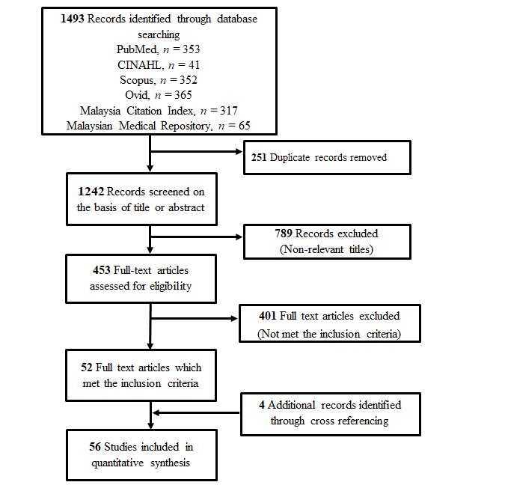
Figure 1 Preferred reporting items for systematic review and meta-analysis flow diagram of the literature screening process. Numbers indicate the article count retained at each step of the process.

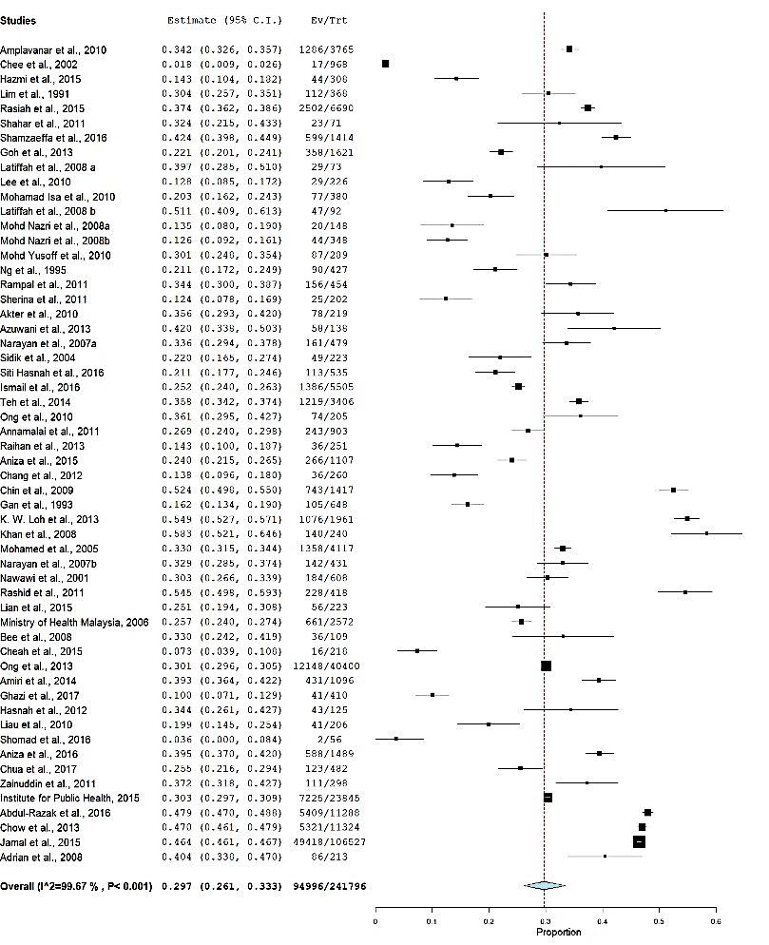
Figure 2 Pooled prevalence of hypertension.

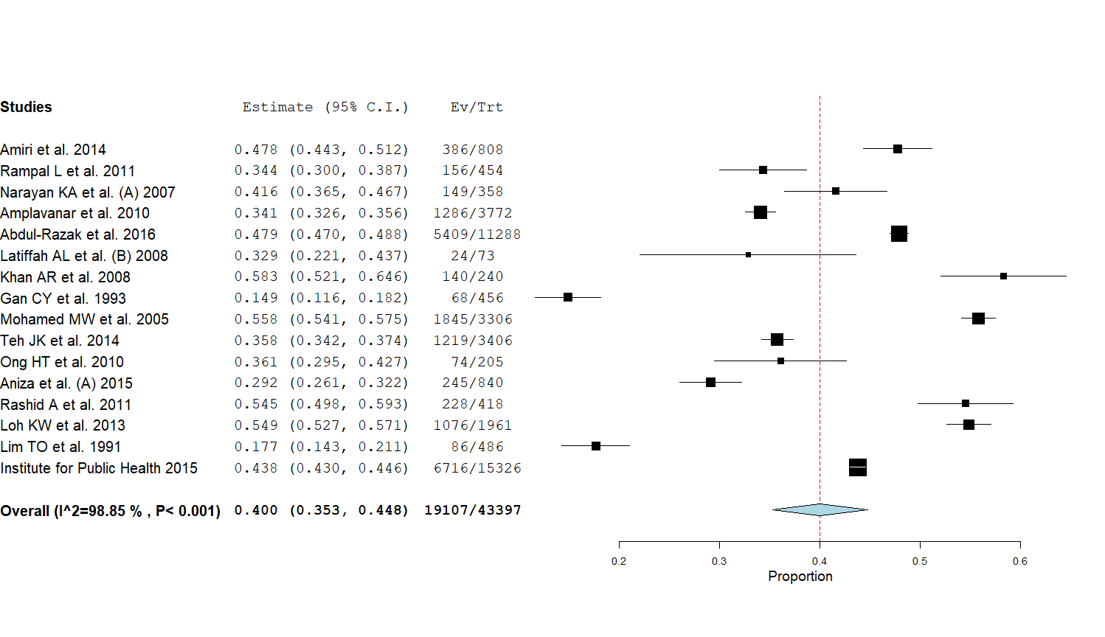
Figure 3 Pooled prevalence of hypertension in adults aged ≥ 30 years.

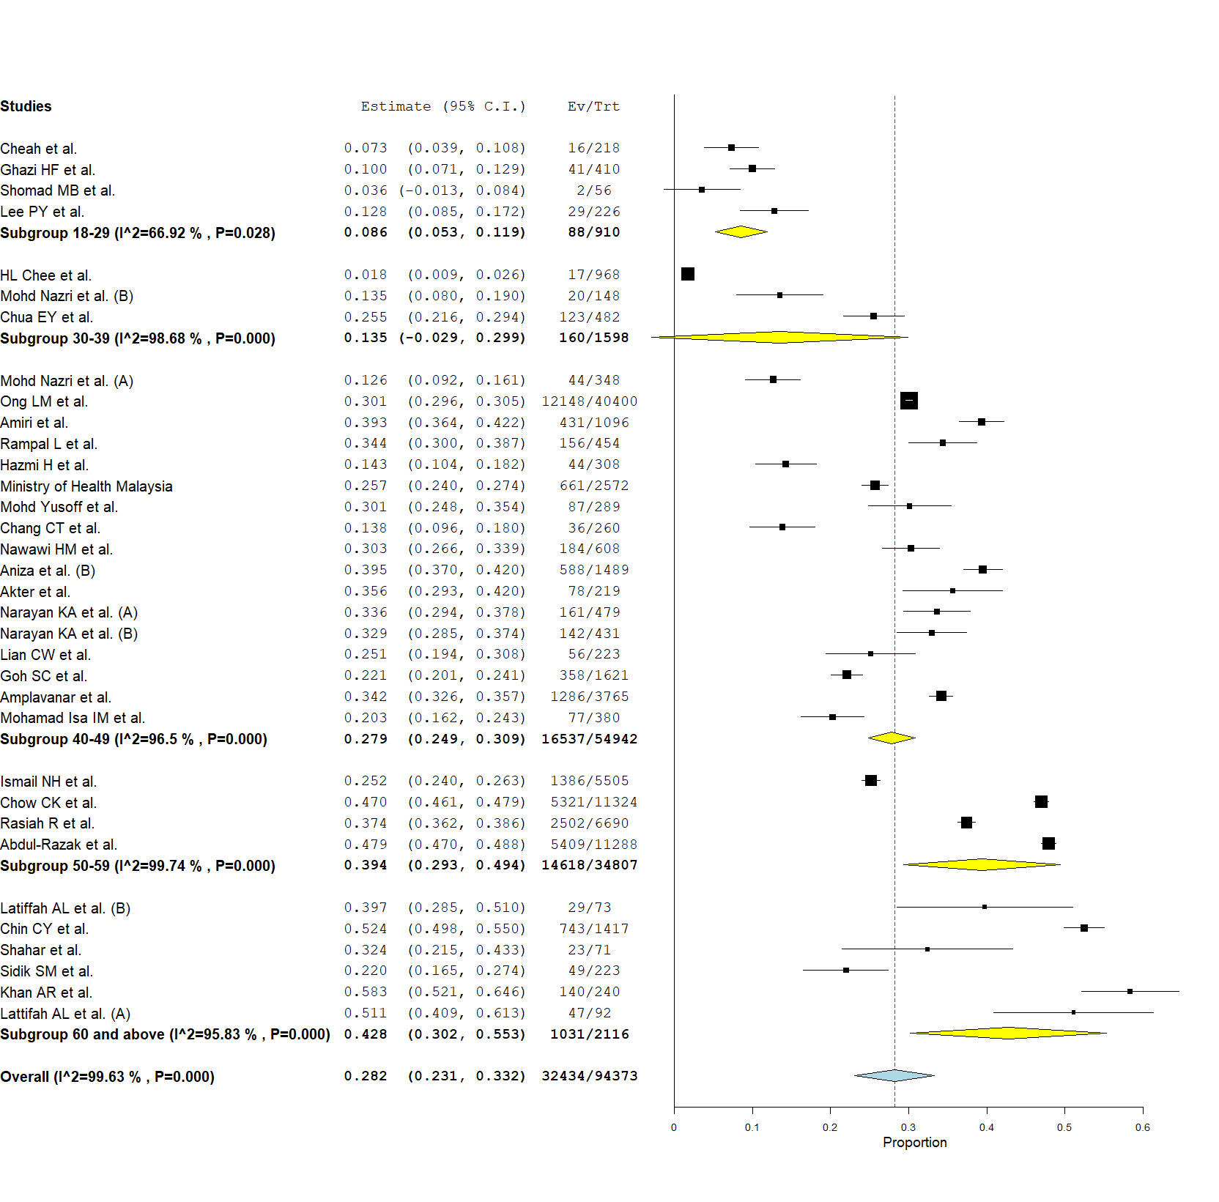
Figure 4 Pooled prevalence of hypertension subanalysis by age groups.

A
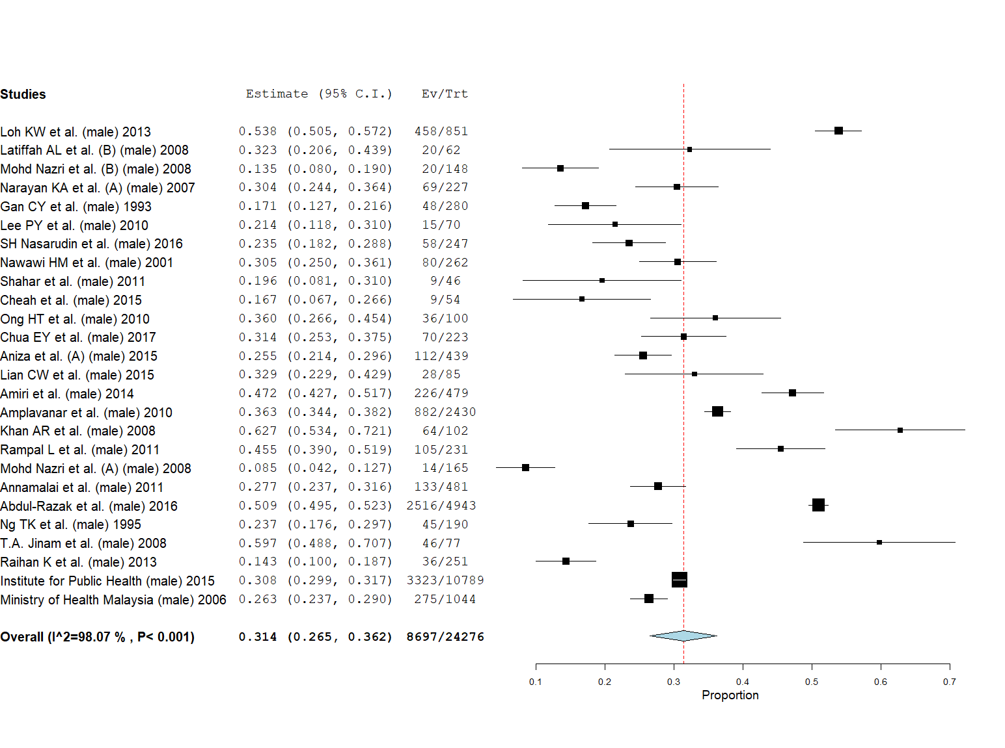
B
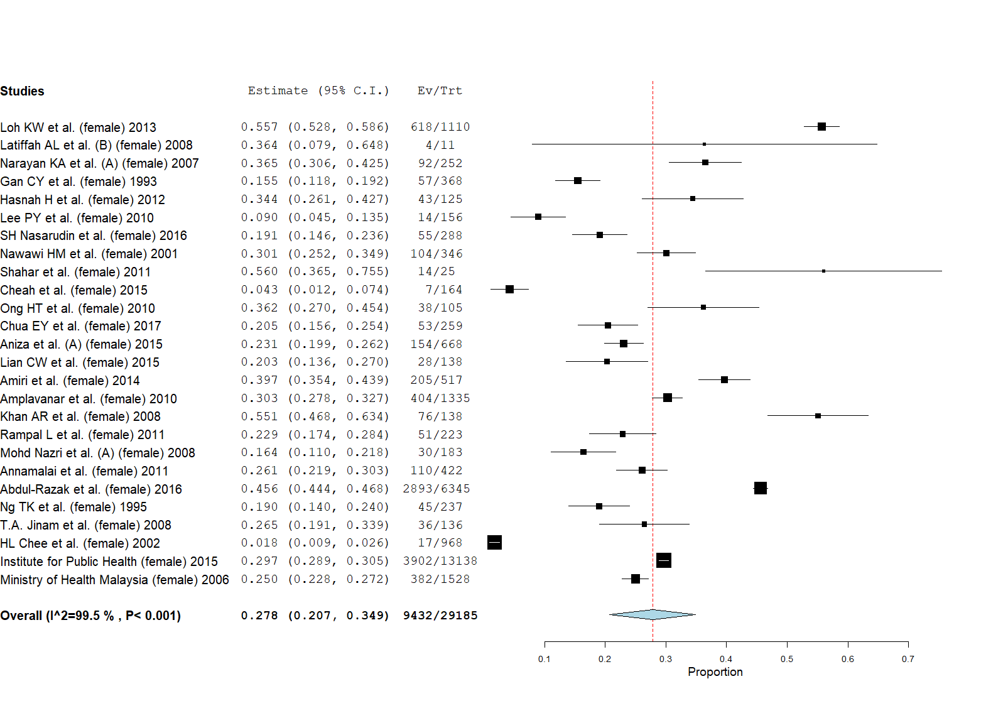
Figure 5 Pooled prevalence of hypertension in male and female adults. A: In male adults; B: In female adults.

A
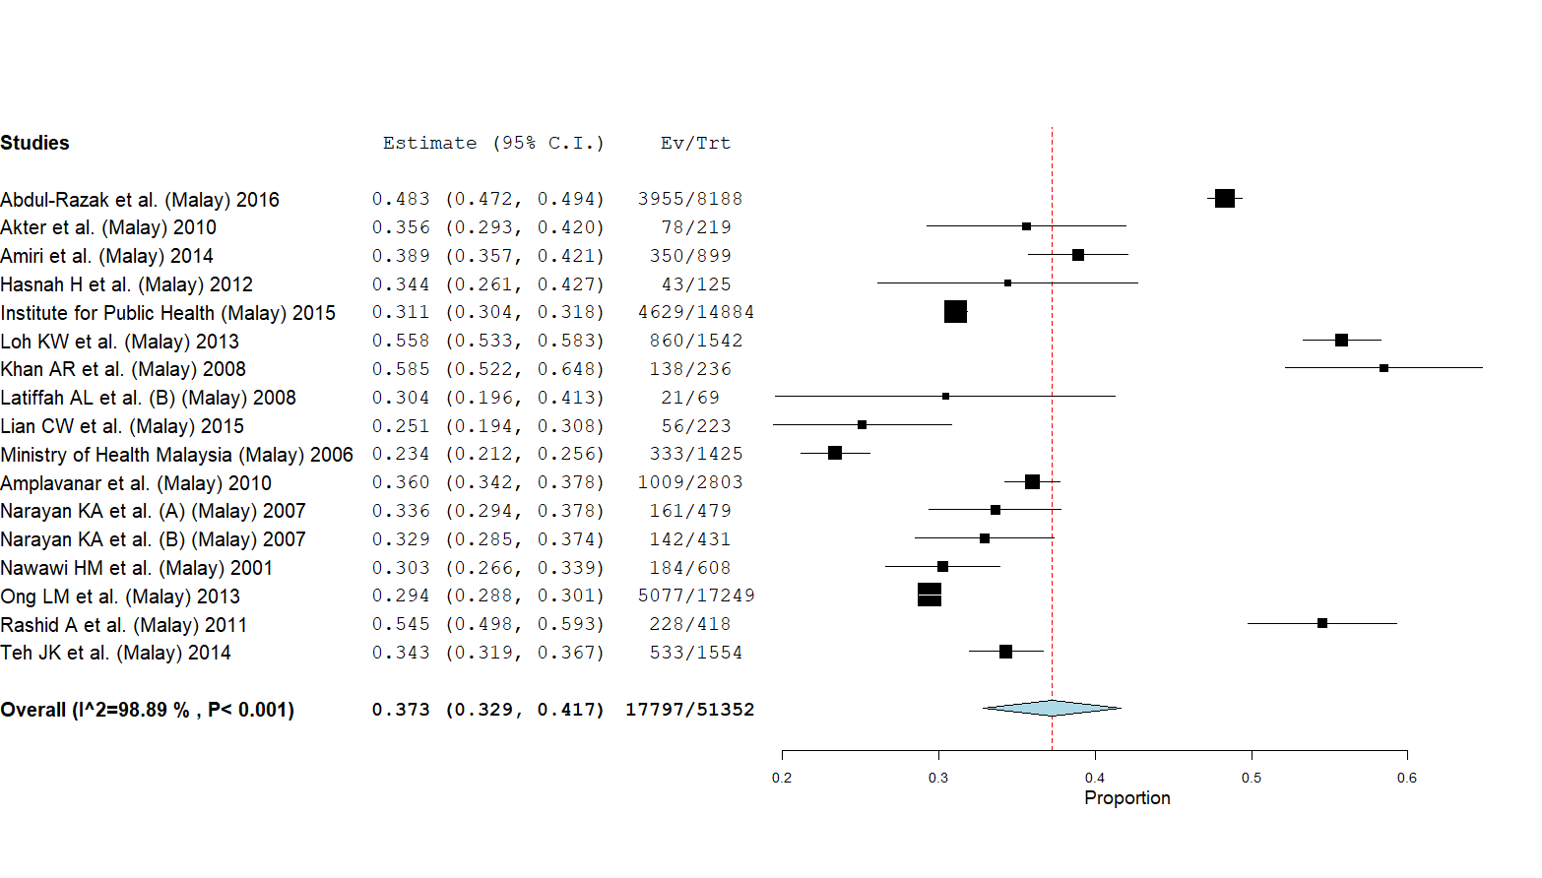
B
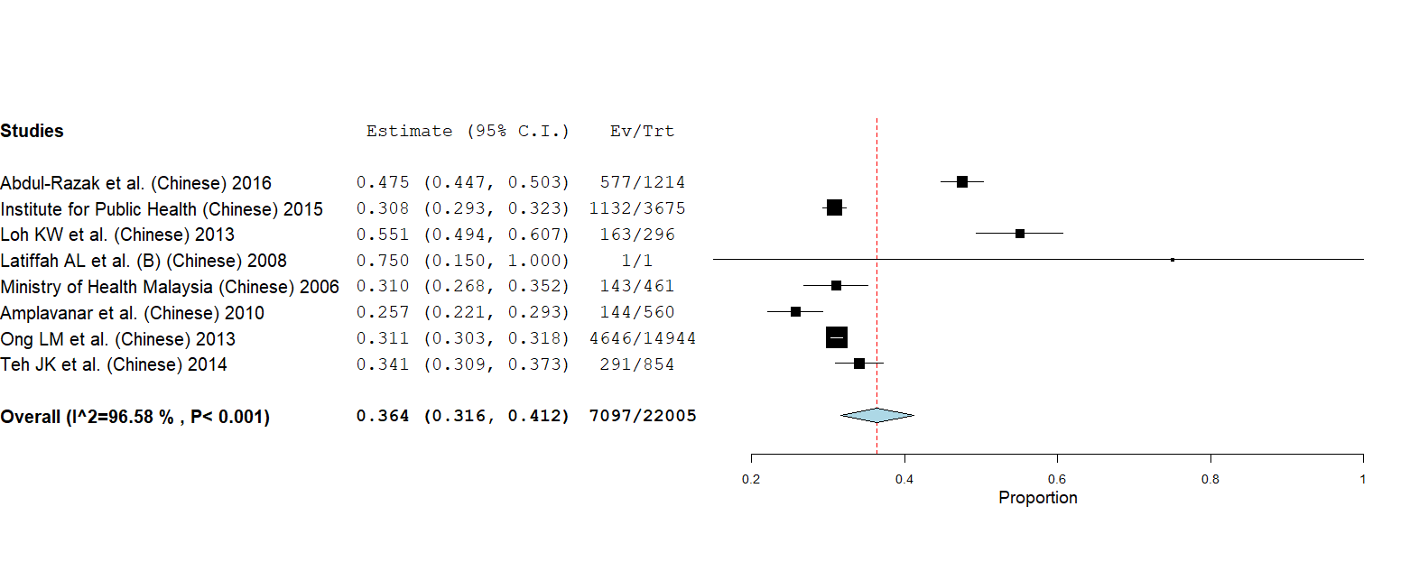

C
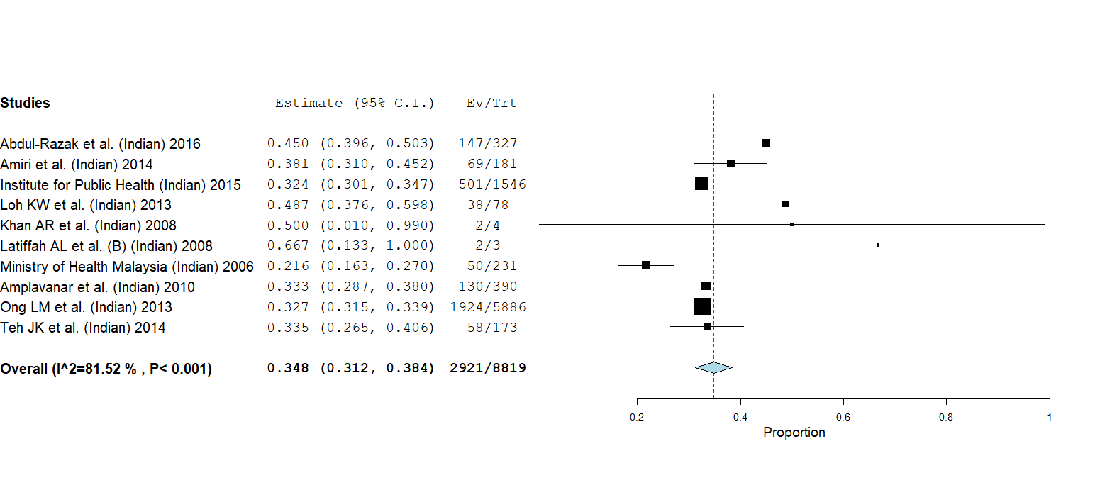
D
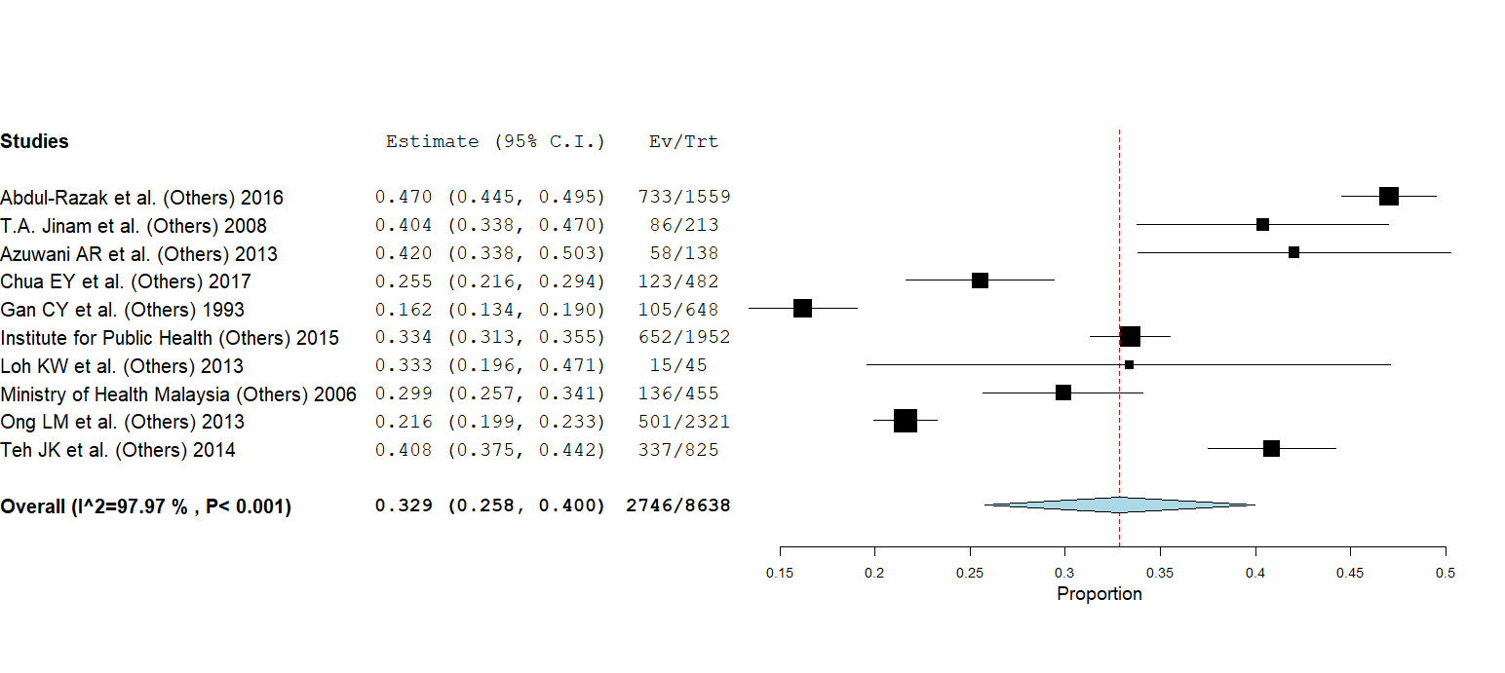
Figure 6 Pooled prevalence of hypertension in Malay, Chinese, Indian and other ethnicity. A: In Malay; B: In Chinese; C: In Indian; D: In other ethnicity.

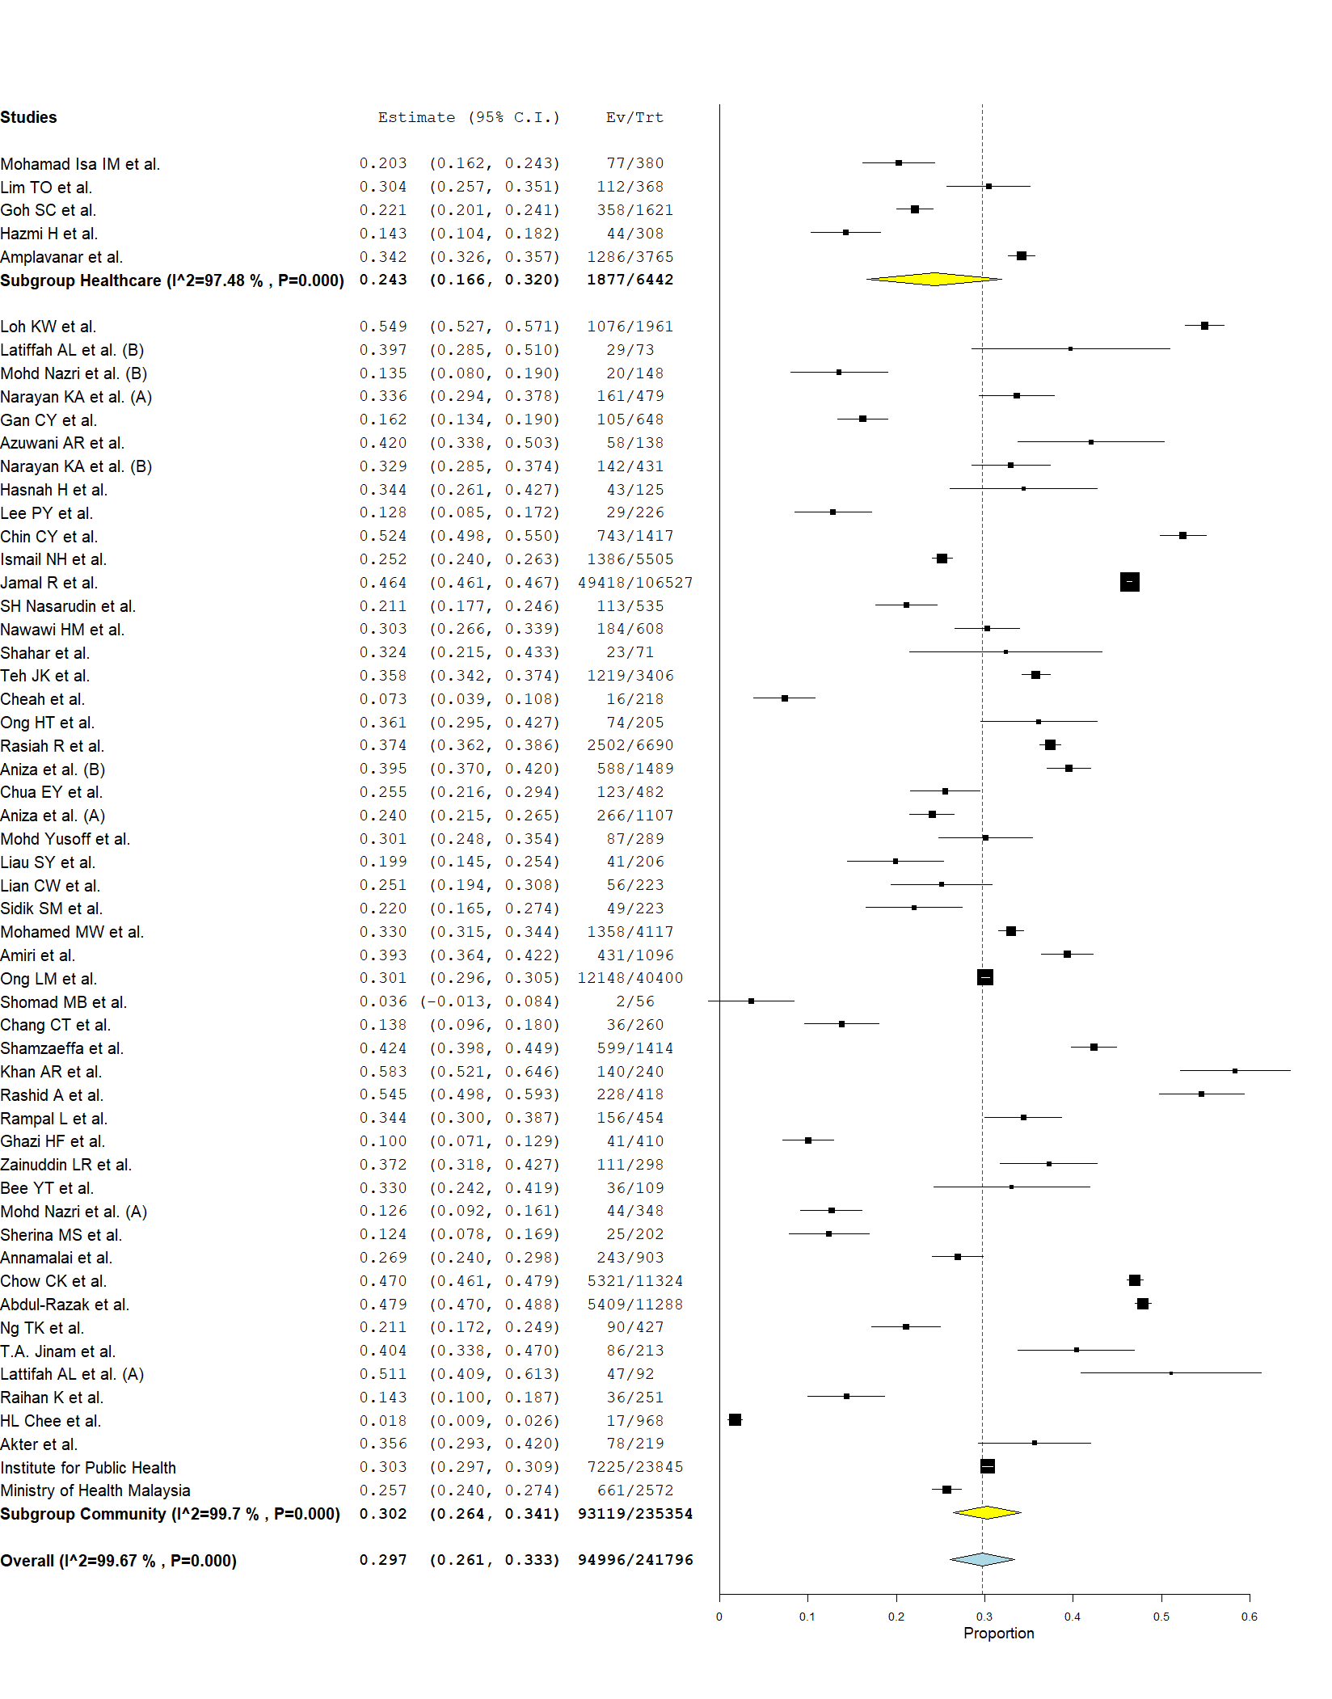
Figure 7 Prevalence of hypertension subanalysis by study setting.

A
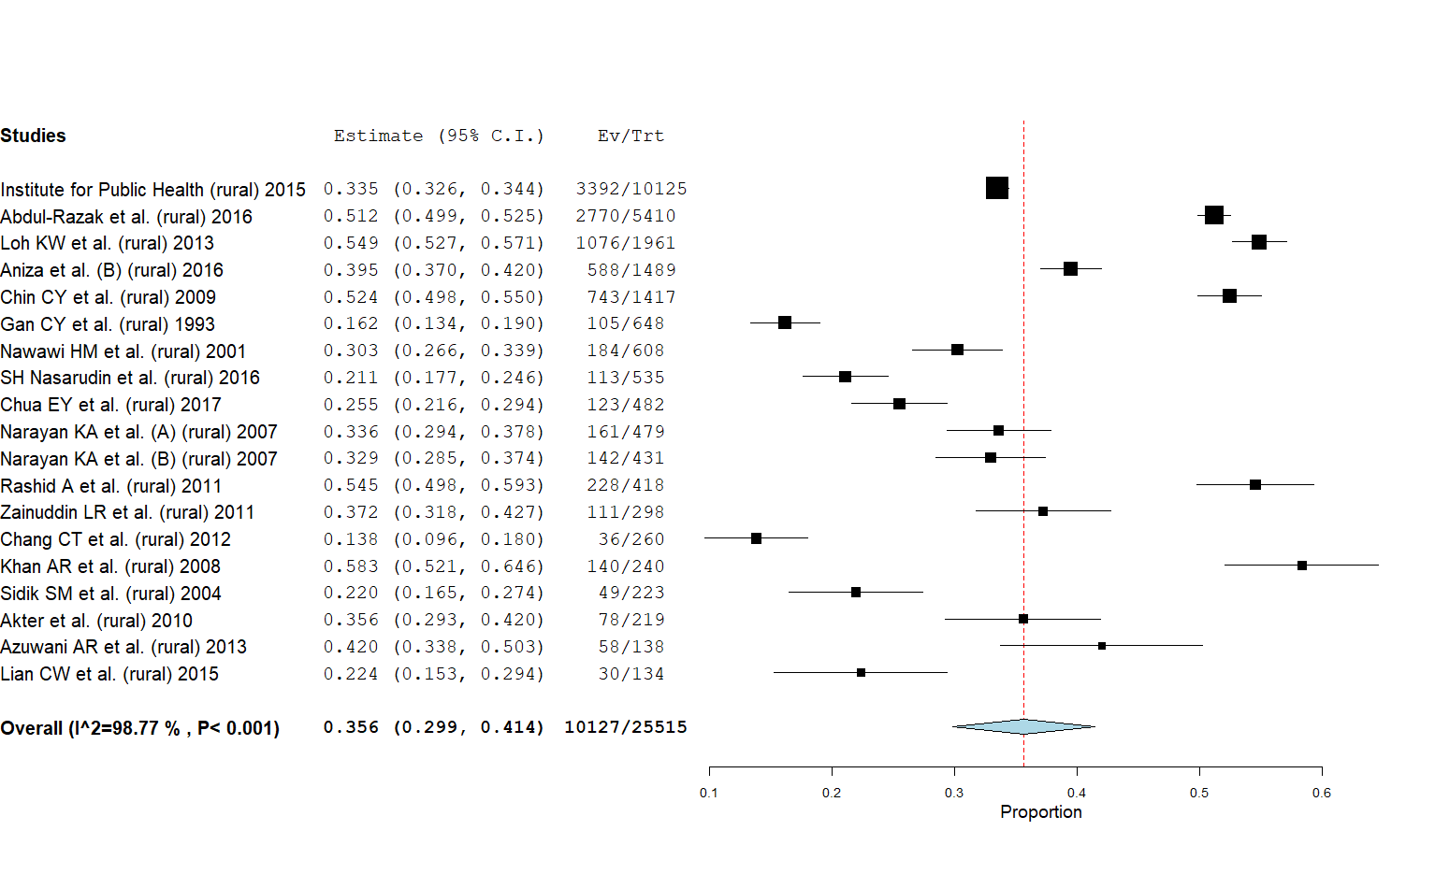
B
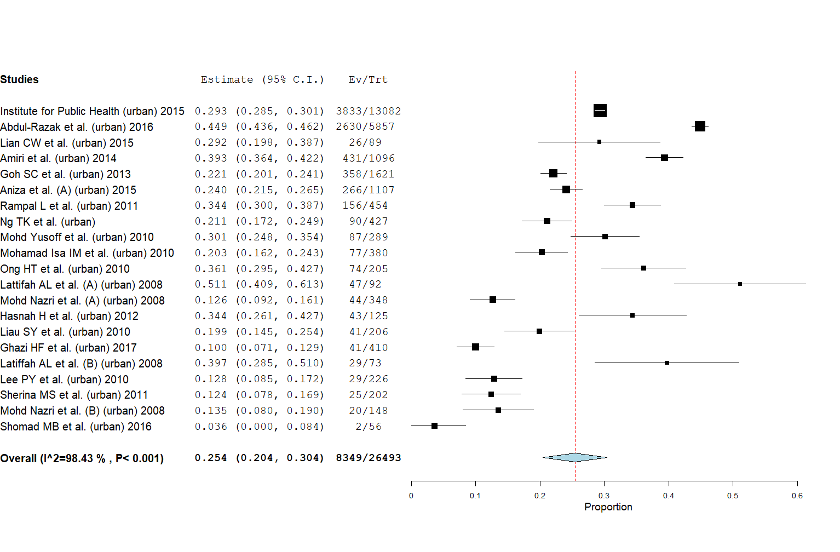
Figure 8 Pooled prevalence of hypertension in rural and urban area. A: In rural areas; B: In urban areas.

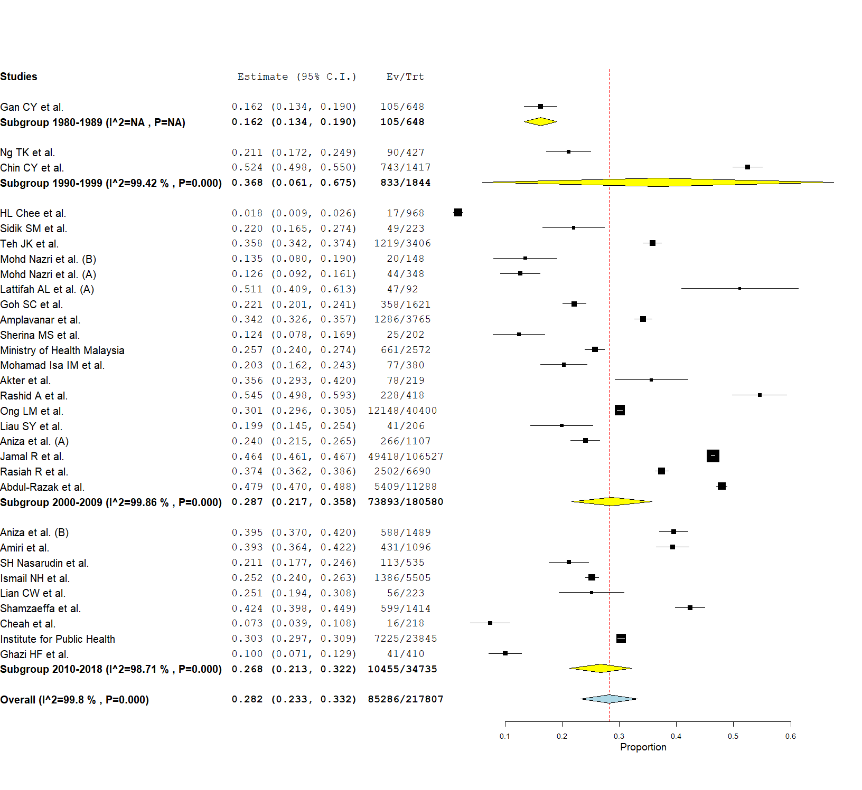
Figure 9 Overall pooled prevalence of hypertension subgroup by study decade.

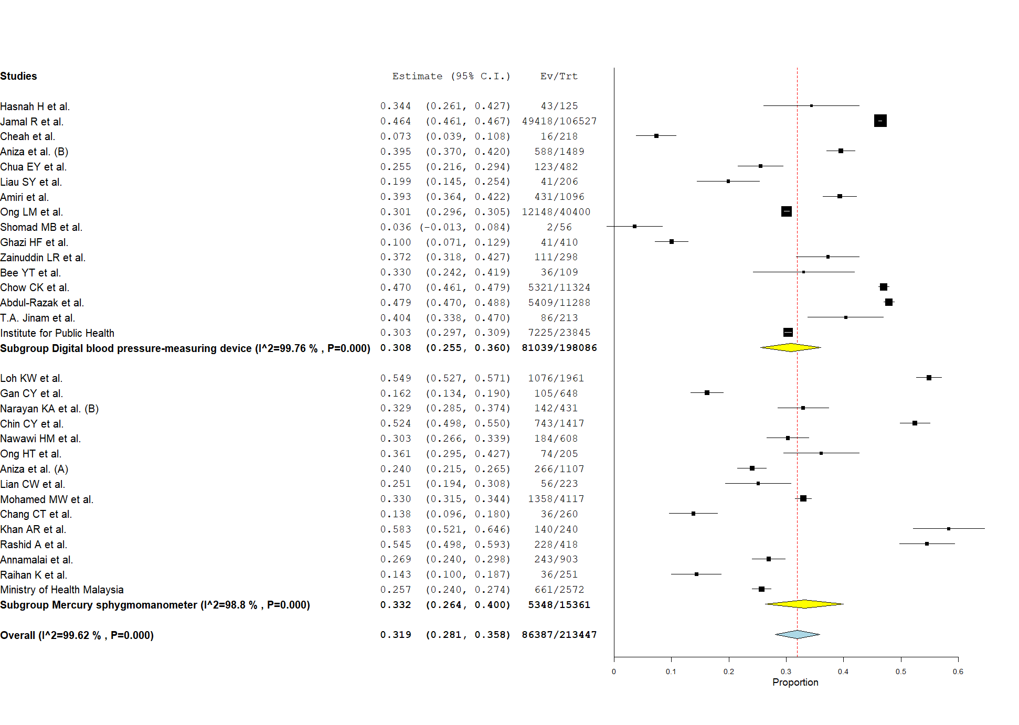
Figure 10 Pooled prevalence of hypertension subanalysis by measurement tools.

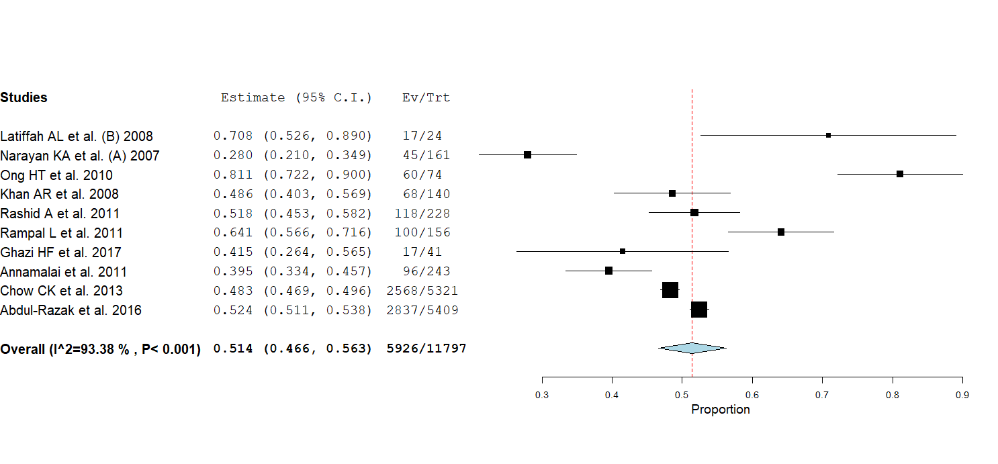
Figure 11 Pooled prevalence of awareness in hypertension.

A
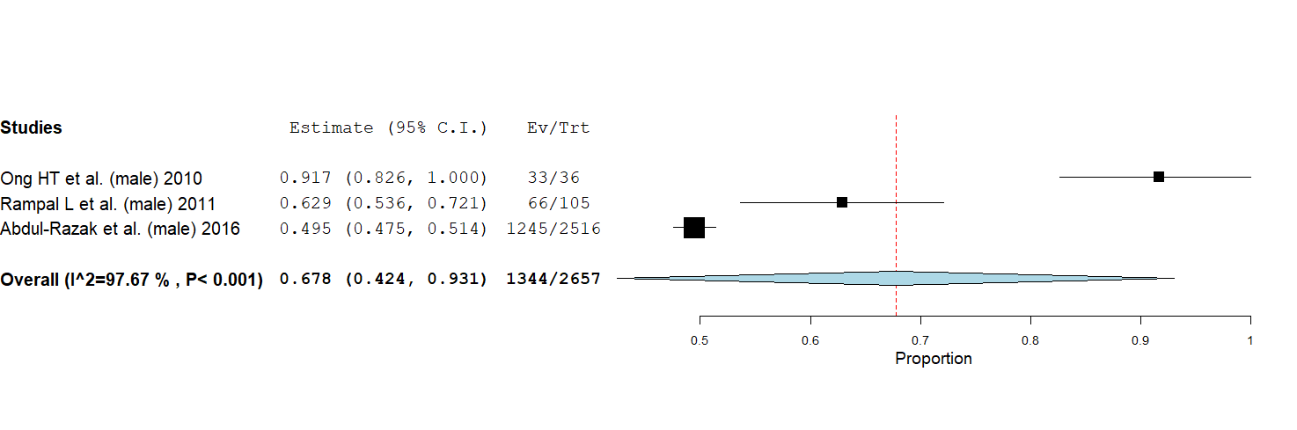
B
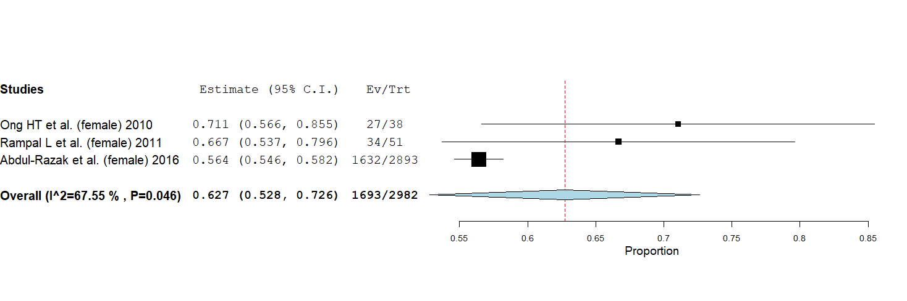
Figure 12 Pooled prevalence of awareness in hypertension in male and female. A: In male; B: In female.

A
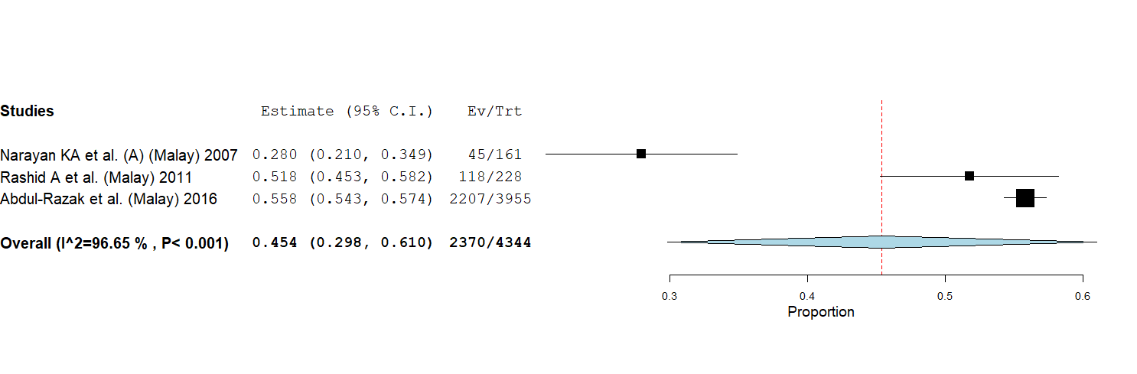
B
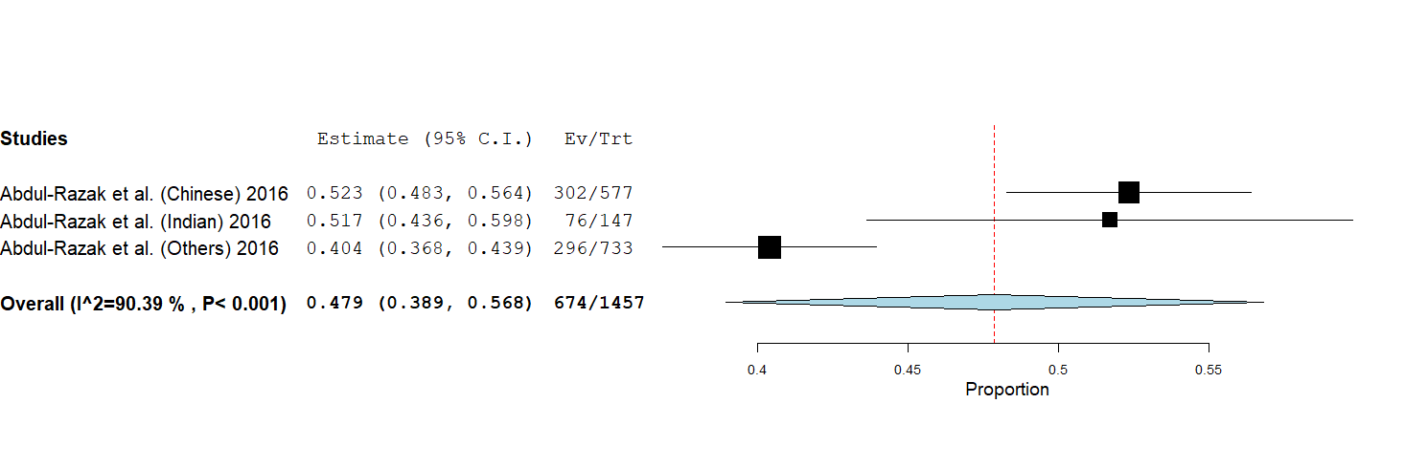
Figure 13 Pooled prevalence of awareness in hypertension in Malay and non-Malay. A: In Malay; B: In non-Malay.

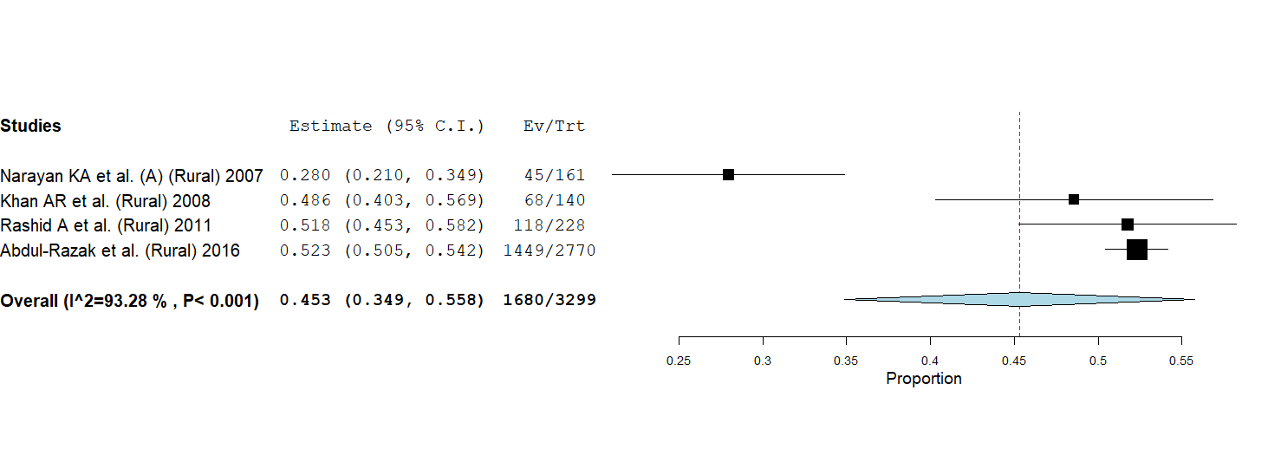
Figure 14 Pooled prevalence of awareness in hypertension in rural areas.

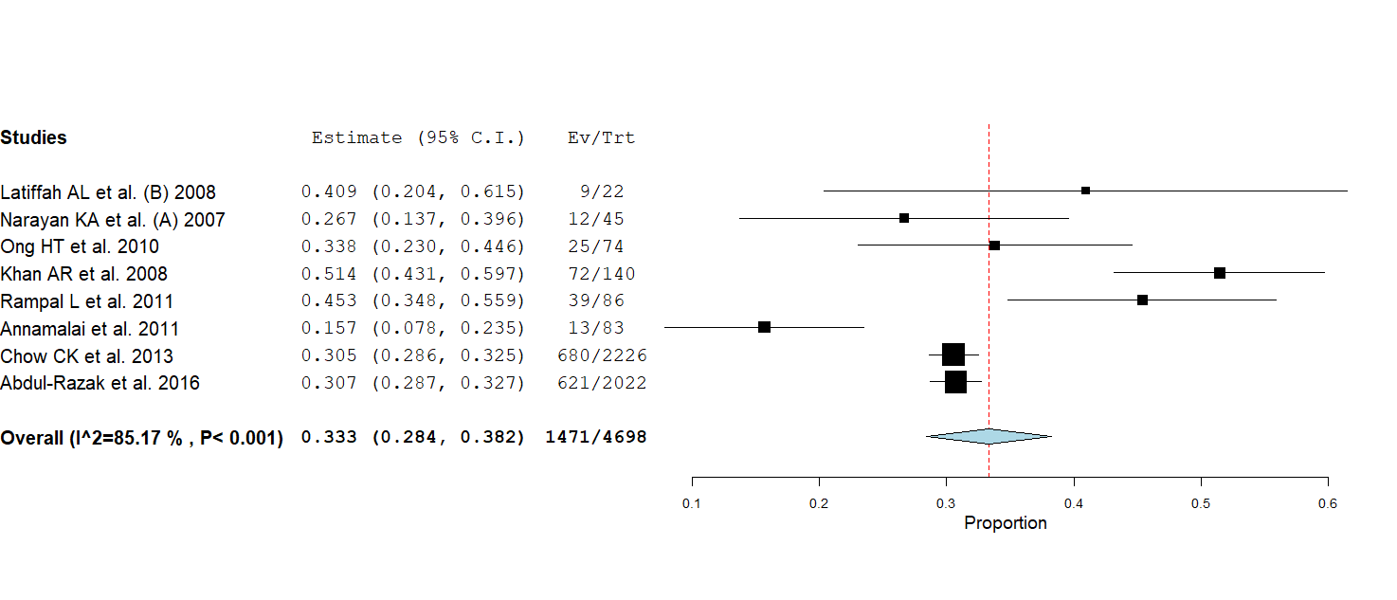
Figure 15 Pooled prevalence of control in hypertension.

A
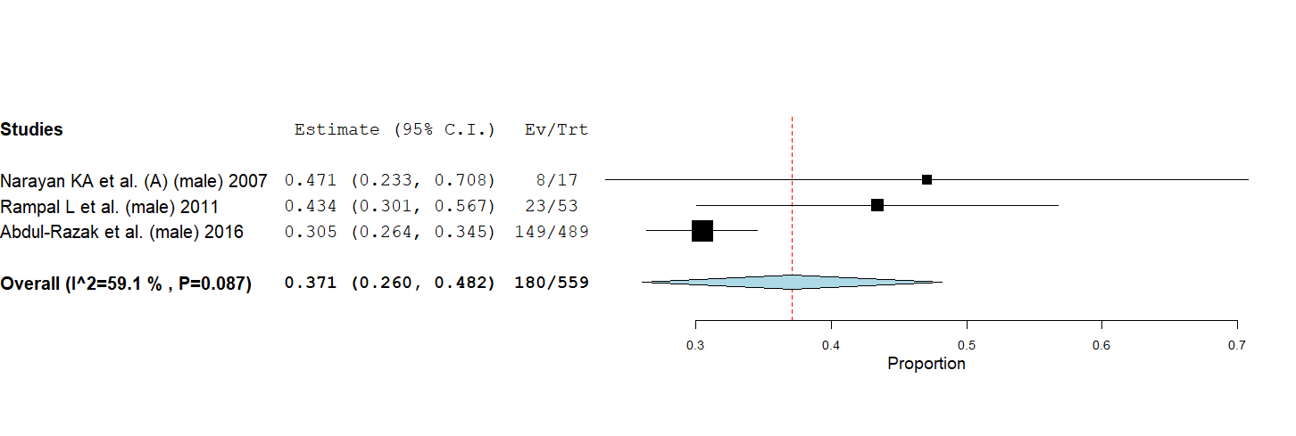
B
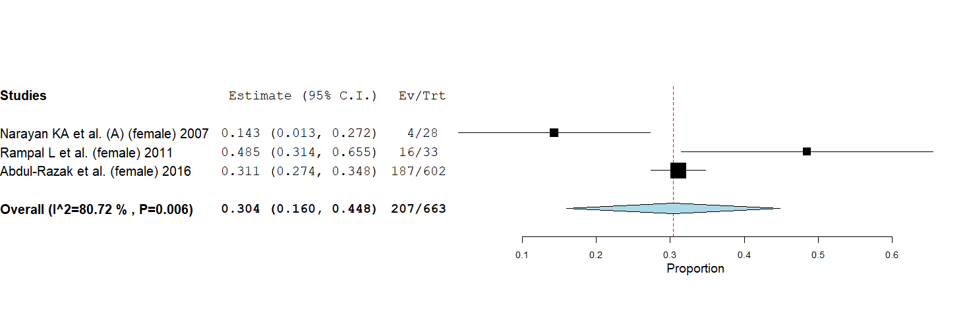
Figure 16 Pooled prevalence of control in hypertension in male and female. A: In male; B: In female.

A
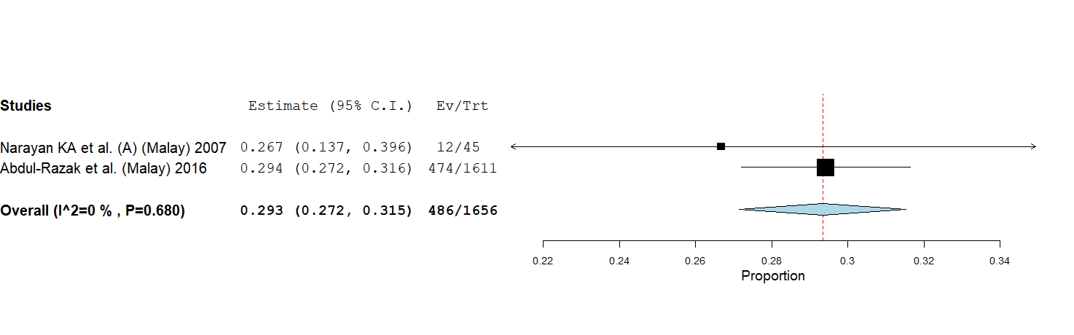
B
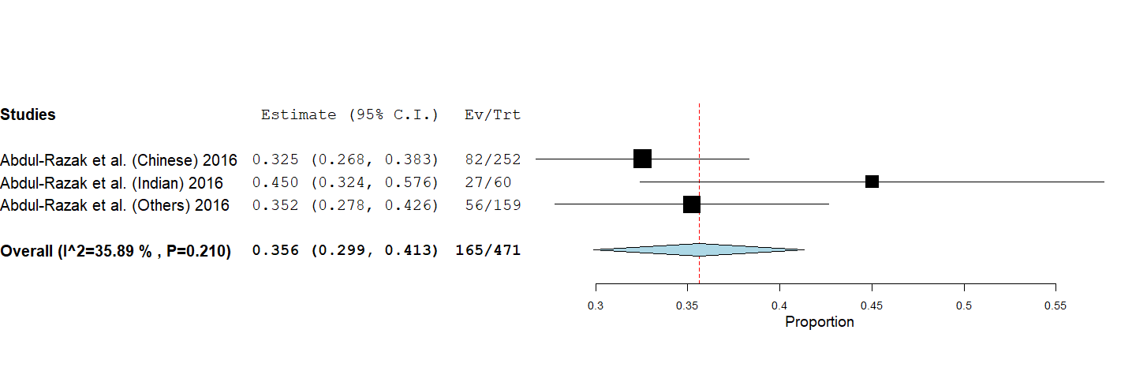
Figure 17 Pooled prevalence of control in hypertension in Malay and non-Malay. A: in Malay; B: In non-Malay.

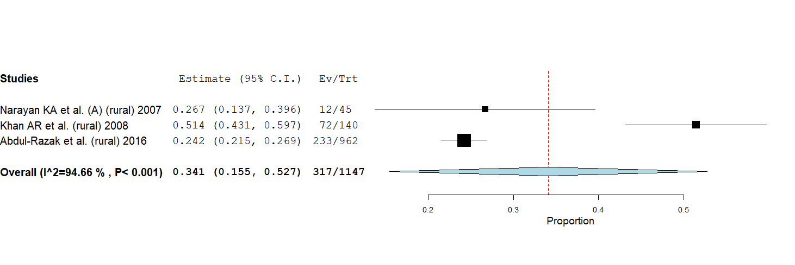
Figure 18 Pooled prevalence of control in hypertension in rural areas.

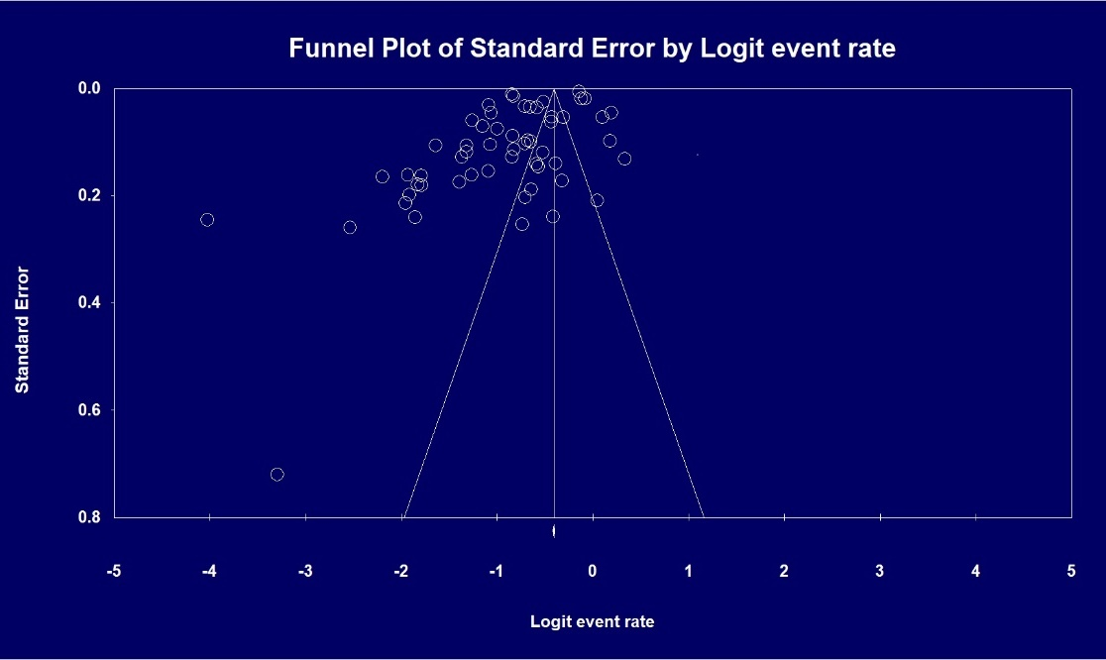
Figure 19 Publication bias assessed using funnel plot.

Table 1 Prevalence, awareness and control of hypertension in Malaysia
Ref. | Sample size, n | Prevalence of hypertension, % | Prevalence of awareness, % | Prevalence of control, % | Quality of article
Abdul-Razak et al^{[16]}, 2016 | 11288 | 47.9 | 52.5 | 15.9 | High
Jinam et al^{[17]}, 2008 | 213 | 40.4 | NA | NA | High
Akter et al^{[18]}, 2010 | 219 | 35.6 | NA | NA | High
Amiri et al^{[19]}, 2014 | 1096 | 39.3 | NA | NA | High
Amplavanar et al^{[20]}, 2010 | 3765 | 34.2 | NA | NA | High
Aniza et al^{[21]}, 2015 | 1107 | 24.0 | NA | NA | High
Aniza et al^{[22]}, 2016 | 1489 | 39.5 | NA | NA | High
Annamalai et al^{[23]}, 2011 | 903 | 26.9 | 39.5 | 15.7 | High
Azuwani et al^{[24]}, 2013 | 138 | 42.0 | NA | NA | High
Tan et al^{[25]}, 2008 | 109 | 33.0 | NA | NA | High
Chang et al^{[26]}, 2012 | 260 | 13.9 | NA | NA | High
Cheah et al^{[27]}, 2015 | 218 | 7.3 | NA | NA | High
Chee et al^{[28]}, 2002 | 968 | 1.8 | NA | NA | High
Chin et al^{[29]}, 2009 | 1417 | 52.4 | NA | NA | High
Chow et al^{[30]}, 2013 | 11324 | 47.0 | 48.3 | 12.8 | High
Chua et al^{[31]}, 2017 | 482 | 25.5 | NA | NA | High
Gan et al^{[32]}, 1993 | 648 | 16.2 | NA | NA | High
Ghazi et al^{[33]}, 2017 | 410 | 10.0 | 41.5 | NA | Low
Goh et al^{[34]}, 2013 | 1621 | 22.1 | NA | NA | High
Hasnah et al^{[35]}, 2012 | 125 | 34.4 | NA | NA | High
Hazmi et al^{[36]}, 2015 | 308 | 14.3 | NA | NA | High
Ministry of Health Malaysia^{[37]}, 2015 | 23845 | 30.3 | NA | NA | High
Jamal et al^{[38]}, 2015 | 106527 | 46.4 | NA | NA | High
Khan et al^{[39]}, 2008 | 240 | 58.3 | 48.6 | 51.4 | High
Latiffah et al^{[40]}, 2008 | 73 | 39.7 | 70.8 | 40.9 | High
Latiffah et al^{[41]}, 2008 | 92 | 51.1 | NA | NA | High
Lee et al^{[42]}, 2010 | 226 | 12.8 | NA | NA | Low
Lian et al^{[43]}, 2015 | 223 | 25.1 | NA | NA | High
Liao et al^{[44]}, 2010 | 206 | 19.9 | NA | NA | High
Lim et al^{[45]}, 1991 | 368 | 30.4 | NA | NA | High
Loh et al^{[46]}, 2013 | 1961 | 54.9 | NA | NA | High
Ministry of Health Malaysia^{[47]}, 2010 | 2572 | 25.7 | NA | NA | High
Mohamed et al^{[48]}, 2005 | 4117 | 33.0 | NA | NA | High
Nazri et al^{[49]}, 2008 | 148 | 13.5 | NA | NA | High
Nazri et al^{[50]}, 2008 | 348 | 12.6 | NA | NA | High
Moy et al^{[51]}, 2010 | 380 | 20.3 | NA | NA | High
Narayan et al^{[52]}, 2007 | 431 | 33.0 | NA | NA | High
Narayan et al^{[53]}, 2007 | 479 | 33.6 | 28.0 | 27.5 | High
Nasarudin et al^{[54]}, 2016 | 535 | 21.1 | NA | NA | Low
Nawawi et al^{[55]}, 2002 | 608 | 30.3 | NA | NA | High
Ng et al^{[56]}, 1995 | 427 | 21.1 | NA | NA | Low
Noor Hassim et al^{[57]}, 2016 | 5505 | 25.2 | NA | NA | High
Ong et al^{[58]}, 2010 | 205 | 36.1 | 81.1 | 33.8 | High
Ong et al^{[59]}, 2013 | 40400 | 30.1 | NA | NA | High
Raihan et al^{[60]}, 2013 | 251 | 14.3 | NA | NA | High
Rampal et al^{[61]}, 2008 | 454 | 34.4 | 64.1 | 25.0 | High
Rashid et al^{[62]}, 2011 | 418 | 54.6 | 51.8 | NA | High
Rasiah et al^{[63]}, 2015 | 6690 | 37.4 | NA | NA | High
Shahar et al^{[64]}, 2011 | 71 | 32.4 | NA | NA | High
Samsudin et al^{[65]}, 2016 | 1414 | 42.4 | NA | NA | High
Sherina et al^{[66]}, 2011 | 202 | 12.4 | NA | NA | High
Shomad et al^{[67]}, 2016 | 56 | 4.00 | NA | NA | High
Sidik et al^{[68]}, 2004 | 223 | 22.0 | NA | NA | High
Teh et al^{[69]}, 2014 | 3406 | 35.8 | NA | NA | Low
Yusoff et al^{[70]}, 2010 | 289 | 30.1 | NA | NA | High
Zainuddin et al^{[71]}, 201 | 298 | 37.3 | NA | NA | High
NA: Not available.

Table 2 Pooled prevalence and 95% confidence interval of hypertension and its subgroup analysis
Variable | Number of studies, n | Prevalence, % | 95%CI |  | P value | I², % | Figure
Overall prevalence
Malaysia | 56 | 29.7 | 26.1, 33.3 |  | < 0.001 | 99.7 | 2
30 and above | 16 | 40.0 | 35.3, 44.8 |  | < 0.001 | 98.9 | 3
Mean age, yr |  |  |  |  |  |  | 4
18–29 | 4 | 8.6 | 5.30, 11.90 |  | 0.03 | 66.9
30–39 | 3 | 13.5 | 2.9, 29.9 |  | < 0.001 | 98.7
40–49 | 17 | 27.9 | 24.9, 30.9 |  | < 0.001 | 96.5
50–59 | 4 | 39.4 | 29.3, 49.4 |  | < 0.001 | 99.7
60 and above | 6 | 42.8 | 30.2, 55.3 |  | < 0.001 | 95.8
Gender
Male | 26 | 31.4 | 26.5, 36.2 |  | < 0.001 | 98.1 | 5A
Female | 26 | 27.8 | 20.7, 34.9 |  | < 0.001 | 99.5 | 5B
Ethnicity
Malay | 17 | 37.3 | 32.9, 41.7 |  | < 0.001 | 98.9 | 6A
Chinese | 8 | 36.4 | 31.6, 41.2 |  | < 0.001 | 96.6 | 6B
Indian | 10 | 34.8 | 31.2, 38.4 |  | < 0.001 | 81.5 | 6C
Other | 9 | 32.9 | 25.8, 40.0 |  | < 0.001 | 98.0 | 6D
Study setting |  |  |  |  |  |  | 7
Community | 51 | 30.2 | 26.4, 34.1 |  | < 0.001 | 99.7
Health care setting | 5 | 24.3 | 16.6, 32.0 |  | < 0.001 | 97.5
Geographical origin
Rural | 19 | 35.6 | 29.9, 41.4 |  | < 0.001 | 98.77 | 8A
Urban | 21 | 25.4 | 20.4, 30.4 |  | < 0.001 | 98.43 | 8B
Study decade |  |  |  |  |  |  | 9
1980-1989 | 1 | 16.2 | 13.4, 19.0 |  | NA | NA
1990-1999 | 2 | 36.8 | 6.1, 67.5 |  | < 0.001 | 99.42
2000-2009 | 19 | 28.7 | 21.7, 35.8 |  | < 0.001 | 99.9
2010-2018 | 9 | 26.8 | 21.3, 32.2 |  | < 0.001 | 98.7
Blood pressure measurement tools |  |  |  |  |  |  | 10
Mercury sphygmomanometer | 15 | 33.2 | 26.4, 40.0 |  | < 0.001 | 98.8
Digital blood pressure device | 16 | 30.8 | 25.5, 36.0 |  | < 0.001 | 99.8
CI: Confidence interval.

Table 3 Pooled awareness, pooled control and subgroup analyses
Variable | Number of studies, n | Prevalence, % | 95%CI | P value | I², % | Figure
Overall awareness | 10 | 51.4 | 46.6, 56.3 | < 0.001 | 93.4 | 11
Gender
Male | 3 | 67.8 | 42.4, 93.1 | < 0.001 | 97.7 | 12A
Female | 3 | 62.7 | 52.8, 72.6 | 0.046 | 67.6 | 12B
Ethnicity
Malay | 3 | 45.4 | 29.8, 61.0 | < 0.001 | 96.7 | 13A
Non-Malay | 3 | 47.9 | 38.9, 56.8 | < 0.001 | 90.4 | 13B
Geographical origin
Rural | 4 | 45.3 | 34.9, 55.8 | < 0.001 | 93.3 | 14
Urban | 1 | 54.1 | 52.2, 56.0 | NA | NA
Overall control | 8 | 33.3 | 28.4, 38.2 | < 0.001 | 85.2 | 15
Gender
Male | 3 | 37.1 | 26.0, 48.2 | < 0.001 | 59.1 | 16A
Female | 3 | 30.4 | 16.0, 44.8 | < 0.001 | 80.7 | 16B
Ethnicity
Malay | 2 | 29.3 | 27.2, 31.5 | 0.68 | 0 | 17A
Non-Malay | 3 | 35.6 | 29.9, 41.3 | 0.210 | 35.9 | 17B
Geographical origin
Rural | 3 | 34.1 | 15.5, 52.7 | < 0.001 | 94.7 | 18
Urban | 1 | 36.5 | 33.6, 39.3 | NA | NA
CI: Confidence interval; NA: Not available.

Table 4 Sensitivity analysis
Variable | Number of studies, n | Total sample size, n | Total hypertensive, n | Prevalence, % | 95%CI | P value | I², %
Overall prevalence | 56 | 241796 | 94996 | 29.7 | 26.1, 33.3 | < 0.001 | 99.7
Upon removal of studies with poor quality studies | 51 | 237181 | 93473 | 28.5 | 26.0, 31.2 | < 0.001 | 99.4
Upon removal of studies with nonrandom sampling | 19 | 131904 | 59786 | 29.7 | 26.2, 33.4 | < 0.001 | 98.6
Upon removal of studies with sample size < 100 | 52 | 131904 | 59786 | 28.0 | 25.6, 30.6 | < 0.001 | 99.3
Upon removal of studies with large sample size > 500 | 47 | 28335 | 8943 | 28.4 | 23.3, 33.4 | < 0.001 | 99.2
Upon removal of poor-quality studies, nonrandom studies and studies with sample size < 100 | 12 | 46618 | 16031 | 26.3 | 21.6, 31.6 | < 0.001 | 99.2
CI: Confidence interval.

