Name of Journal: World Journal of Diabetes
Manuscript NO: 85364
Manuscript Type: MINIREVIEWS

Hypothesis that alpha-amylase evokes regulatory mechanisms originating in the pancreas, gut and circulation, which govern glucose/insulin homeostasis

Pierzynowski SG et al. Alpha-amylase and glucose/insulin homeostasis

Stefan G Pierzynowski, Christine Stier, Kateryna Pierzynowska

Stefan G Pierzynowski, Department of Medical Biology, Institute of Rural Health, Lublin 20090, Poland

Stefan G Pierzynowski, Kateryna Pierzynowska, Department of Biology, Lund University, Lund 22362, Sweden

Stefan G Pierzynowski, Kateryna Pierzynowska, Anara AB, Trelleborg 23132, Sweden

Christine Stier, Department of General, Visceral, Transplant, Vascular, and Pediatric Surgery and Division of Endocrinology, University Hospital Würzburg, Würzburg 97080, Germany

Christine Stier, Department of Surgical Endoscopy, Sana Hospital, Huerth 50354, Germany

Kateryna Pierzynowska, Department of Animal Physiology, The Kielanowski Institute of Animal Physiology and Nutrition, Jablonna 05110, Poland

Kateryna Pierzynowska, Anagram Therapeutics, Inc, Framingham, MA 01701, United States

Author contributions: Pierzynowski SG conceived and wrote the manuscript; Stier C and Pierzynowska K wrote the manuscript and prepared the figures.

Corresponding author: Kateryna Pierzynowska, DSc, PhD, Researcher, Department of Biology, Lund University, Sölvegatan 35, Lund 22362, Sweden. katerina.goncharova@biol.lu.se

Received: April 24, 2023
Revised: June 28, 2023
Accepted: August 2, 2023
Published online: September 15, 2023

Abstract
The anti-incretin theory involving the abolishment of diabetes type (DT) II by some of methods used in bariatric surgery, first appeared during the early years of the XXI century and considers the existence of anti-incretin substances. However, to date no exogenous or endogenous anti-incretins have been found. Our concept of the acini-islet-acinar axis assumes that insulin intra-pancreatically stimulates alpha-amylase synthesis (“halo phenomenon”) and in turn, alpha-amylase reciprocally inhibits insulin production, thus making alpha-amylase a candidate for being an anti-incretin. Additionally, gut as well as plasma alpha-amylase, of pancreatic and other origins, inhibits the appearance of dietary glucose in the blood, lowering the glucose peak after iv or oral glucose loading. This effect of alpha-amylase can be interpreted as an insulin down regulatory mechanism, possibly limiting the depletion of pancreatic beta cells and preventing their failure. Clinical observations agree with the above statements, where patients with high blood alpha-amylase concentrations are seldom obese and seldom develop DT2. Obese-DT2, as well as DT1 patients, usually develop exocrine pancreatic insufficiency (EPI) and vice versa. Ultimately, DT2 patients develop DT1, when the pancreatic beta cells are exhausted and insulin production ceases. Studies on biliopancreatic diversion (BPD) and on BPD with duodenal switch, a type of bariatric surgery, as well as studies on EPI pigs, allow us to observe and investigate the above-mentioned phenomena of intra-pancreatic interactions.

Key Words: Pancreas; Alpha-amylase; Acini-islet-acinar axis; Hyperglycaemia; Bariatrics; Insulin; Incretins; Glucose-dependent insulinotropic polypeptide; Glucagon-like peptide-1; Exocrine pancreatic insufficiency; Pancreatic enzyme therapy; Diabetes

©The Author(s) 2023. Published by Baishideng Publishing Group Inc. All rights reserved.

Citation: Pierzynowski SG, Stier C, Pierzynowska K. Hypothesis that alpha-amylase evokes regulatory mechanisms originating in the pancreas, gut and circulation, which govern glucose/insulin homeostasis. World J Diabetes 2023; 14(9): 1341-1348
URL: https://www.wjgnet.com/1948-9358/full/v14/i9/1341.htm
DOI: https://dx.doi.org/10.4239/wjd.v14.i9.1341

Core Tip: The concept of the acini-islet-acinar axis postulates that insulin stimulates amylase synthesis and amylase in turn inhibits insulin production. This regulation is of particular significance with regards to postoperative glucose regulation after bariatric bypass surgery. The interaction of salivary amylase at the alimentary limb and pancreatic amylase, exclusively at the common channel, results in an immediate metabolic effect that leads to a significant reduction in incretin-induced hyperinsulinaemia and a marked improvement in glucose action on insulin production. As a result, both pancreatic beta cells and acinar cells are effectively protected against depletion.

INTRODUCTION
Studies on the dependency of pancreatic enzyme synthesis on insulin release started 60 years ago and resulted in the discovery of the so-called “halo phenomenon”^{[1-5]}. For several years we have explored the ‘reverse arm’ of regulation; namely the dependency of insulin release on pancreatic enzyme secretion and the role of the interaction between these parameters on glucose metabolism^{[6]}. Our studies indicate the local and peripheral dependency of insulin secretion on pancreatic alpha-amylase. Alpha-amylase, beyond its digestive functions, actively participates in glucose metabolism, both via inhibition of glucose absorption from the gut^{[7,8]} and by lowering insulin release^{[9]}.
It should be mentioned that other pancreatic-like enzymes, such as proteinases and lipases of microbial origin, were tested with respect to their effect on insulin secretion and glucose utilization. We have shown that lipase does not affect the afore mentioned parameters, while proteinase decreases the insulin sensitivity index and stimulates insulin release^{[6]}.
The above-described alpha-amylase-dependent inhibition of glucose absorption, through its storage or metabolism in the gut tissues could reduce insulin release, making the secretion adequate to glucose levels entering the circulation. Thus, there appears to be some sort of intra-pancreatic down regulation effect of alpha-amylase on insulin secretion and/or synthesis. Insulin stimulates the secretion of alpha-amylase and other pancreatic enzymes, while alpha-amylase inhibits insulin release^{[10]}. In fact, chronic hyperinsulinemia could lead not only to insulin resistance, but also to the destruction of pancreatic acinar cells, with the further development of exocrine pancreatic insufficiency (EPI)^{[11]}.
The above observations were confirmed in several in vitro and in vivo studies in our lab^{[9,10,12-14]}. Both the alpha-amylase-insulin reciprocal acini-islet-acinar (AIA) local interactions, as well as the peripheral interactions originating in the gut and blood, which attenuate and downregulate insulin secretion, belong to the postulated new type of regulations where alpha-amylase exhibits a hormonal-like action. In 1976, Arnesjö and Lundquist^{[15]} demonstrated a decrease in insulin release and the improvement of glucose tolerance in rats with long-term CCK-PZ stimulated pancreatic enzymes secretion^{[15]}. We noted the stronger suppression of insulin release after pancreatin administration in the meal glucose tolerance test (44%), when compared to the intravenous glucose tolerance test (31%)^{[13]}. In the same year, Lindqvist et al^{[16]} observed a decrease in levels of active glucagon-like peptide-1 (GLP-1) after Roux-and-Y gastric bypass (RYGB) surgery in pigs^{[16]}, and in early 2018 our group showed a consequential increase in plasma amylase activity in the EPI porcine model^{[14]}. We recognized that the effects of amylase on the regulation of insulin secretion are para-hormonal and considering all our observations, we thought it would be suitable to locate the anti-incretin action of amylase in the same place where incretins e.g., GLP-1 usually act.
Reciprocal AIA regulations are likely species- and individual-dependent, thus they are in some way immanent. We recognize that dietary factors e.g., carbohydrates (glucose), acting from the duodenum, stimulate insulin and alpha-amylase secretion in a species-specific manner and in individuals’ adequate amount in islands and acini surrounding them. Previous studies have shown that an iv infusion of glucose does not stimulate the secretion of pancreatic alpha-amylase^{[17]}. Considering the observed counteraction of alpha-amylase to glucose-dependent insulinotropic polypeptide (GIP)-1 we used the term anti-incretin to describe metabolic effects of alpha-amylase. This "anti-incretin" hypothesis needs to be confirmed by future studies, with specific focus on enteral-insular regulatory mechanisms. In fact, comparative studies on the exclusive effect of pancreatic alpha-amylase on insulin secretion, stimulated by oral or intravenous glucose administration, have not yet been carried out. The effect of alpha-amylase on the secretion of incretins (GLP-1 and GIP) has also not yet been assessed to date.
Incretin-dependent regulation of insulin secretion is coupled with the intake of “quick” energy in the form of carbohydrates and thus could be recognized as temporal. These regulatory mechanisms need to be abruptly inhibited after the digestion of simple, ‘easily-digested’ carbohydrates in order to prevent the overproduction of insulin by beta cells and thus beta cell exhaustion. The overlooked alpha-amylase dependent downregulation of insulin levels protects both pancreatic beta and acinar cells from metabolic failure.

BILIOPANCREATIC DIVERSION SURGERY REVEALS THE INHIBITORY EFFECT OF ALPHA-AMYLASE ON INSULIN SECRETION
The clinical efficacy of bariatric surgery has encouraged scientific investigation of the gut as a major endocrine organ. Manipulation of gastrointestinal anatomy, through bariatric surgery, has profound effects. Even though these procedures were designed to restrict food intake and increase nutrient malabsorption, evidence suggests that the contribution of the above-mentioned factors to weight loss is minimal. Instead, these interventions reduce body weight gain by decreasing hunger, increasing satiation during a meal, changing food preferences and energy expenditure. GLP-1 analogues, currently used as a treatment for diabetes type 2 (DT2) or slimming injections, are now recognized as alternatives to bariatric surgery in terms of their weight loss and anti-diabetic effects. However, not much is known about their safety with regards to beta cell function in the long run, since the primary target of GLP-1 analogues is the stimulation of insulin release^{[18]}.
It is worth noticing that RYGB and sleeve gastrectomy (SG)^{[19-21]} (Figure 1) have very similar outcomes both in short-term excessive weight loss and long term total weight loss, as well as in type II diabetes resolution and both procedures are superior when compared to the adjustable gastric banding^{[22-24]}. At the same time, the greatest diabetes remission was observed for patients undergoing biliopancreatic diversion with duodenal switch (BPD-DS) (Figure 2^{[25,26]}) (95.1% resolved), followed by gastric bypass (80.3%), gastroplasty (79.7%), and then laparoscopic adjustable gastric banding (56.7%) The same pattern was observed even for an excessive weight loss and total body weight loss in the long term perspective^{[27-29]}. However, despite better outcomes in terms of obesity and obesity-related comorbidities, BPD-DS counts only for ca 2% of bariatric surgeries performed worldwide due to increased risk of complications and development of malnutrition^{[30]}.
We describe the possible pathways of alpha-amylase-dependent AIA regulation of insulin secretion and their integration with food-related “dietary” incretin regulation of insulin secretion, which are usually eliminated or ameliorated by successful bariatric surgery, using the example of BPD or BPD-DS surgery (Figure 3). Breaking contact between the duodenal mucosa and the digesta coming from the stomach through BPD/BPD-DS surgery, in a broad sense interrupts the enteral-insular axis and thus the resulting decrease in insulin secretion could be due to other mechanisms-it is obvious. However, alpha-amylase still flows into the duodenum as a result of stimulation by gastro-pancreatic reflexes and by the attenuated (yet still existing) reflexes which originate in the alimentary limb (stimulated by digesta). Thus, the inhibitory effect of alpha-amylase on insulin secretion can result in the enhanced elimination of incretins.
It seems that BPD/BPD-DS bariatric surgery followed by immediate and long-term remission of DT2^{[22-24,27-30]} has allowed us, for the first time, to observe and reveal these alpha-amylase-dependent inhibitory effects on insulin secretion and glucose metabolism. BPD/BPD-DS surgery prominently highlights the role of pancreatic alpha-amylase in the down regulation of insulin secretion, not only by means of elimination of the duodenal incretin effects on insulin release.
As shown in Figures 3, the remission of DT2 is related to the elimination of the action of incretins from the duodenum in BPD-SD patients. In these patients, insulin production is mainly dependent on blood glucose levels and its local (in pancreas) down regulation by alpha-amylase and in the diverted duodenum, as was proven in a pig model^{[13]}.
Attenuation of incretin release, due to the absence of contact between the chyme and the gastro-duodenal mucosa in the biliopancreatic limb after BPD-SD surgery, results in lower insulin release. At the same time, the passage of food to the alimentary limb is responsible for the slight stimulation of pancreatic enzyme secretion. Since alpha-amylase from the pancreatic juice which is being secreted into the biliopancreatic limb does not interact with its’ starch substrate, the other functions of alpha-amylase, over and above that of starch digestion, e.g., inhibitory effect on insulin secretion, can be highlighted. Whole or partially digested alpha-amylase attenuates glucose absorption and improves the metabolism and/or storage of glucose in the gut tissues^{[13]}. One should bear in mind that alpha-amylase, as well as the other pancreatic enzymes being digested in the BP limb, could serve as a source of different types of biologically active peptides which could affect insulin secretion, as has been proven for alpha-amylase-derived peptides^{[13]}. At the same time, alpha-amylase from the acini surrounding the pancreatic islets can additionally slow down insulin release, which can be recognized as the inhibitory action of alpha-amylase on insulin release. These events are most probably responsible for the elimination of DT2, following BPD/BPD-DS bariatric surgery.
To highlight the efficacy of classical RYGB bariatric surgery, in terms of DT2 remission, one should consider that the residual secretion of stomach/gastric juice is probably the most important factor which could influence the overall success of bariatric metabolic surgery. Lack of stomach juice entering the biliopancreatic limb-which is what happens in patients after BPD/BPD-DS surgery-eliminates the release of most incretins (GIP, GLP-1), thus insulin secretion is stimulated to a much lower extent. The above is not true for other types of bariatric surgery where small amounts of gastric juice still enter the duodenum, thus stimulating incretin release. The role of alpha-amylase in AIA regulations^{[10,13]} has been experimentally proven both in the pig model of BPD^{[13]}, with complete isolation of the stomach from the biliopancreatic limb, and in in vitro experiments, where alpha-amylase directly inhibited insulin release from an insulinoma cell line, BRIN-11^{[9]}.
Importantly, the pharmacological duodenal inhibition of the actions of incretins, through the use of GLY-200 polymer^{[31]}, which mimics bariatric (metabolic) surgery, is being studied in a clinical trial. Mechanical duodenal exclusion, realized via endoscopy, is now being tested in clinics and has produced very good results to date with respect to the remission of DT2^{[32]}. Both strategies assume the exclusion of incretin action and the mechanical prevention of contact between the duodenal mucosa and digesta from the stomach (duodenum isolation), thus allowing AIA pancreatic reflexes, including the anti-incretin action of alpha-amylase, to be realized to the full extent.
Pancreatic alpha-amylase, which is synthesized in the acinar cells and then appears in the pancreatic juice, also leaks into the periinsular interstitial fluid, downregulating insulin secretion. Additionally, digesta entering the alimentary arm (proximal jejunum) stimulates reflexes responsible for insulin and enzyme secretion to a lower extent, since in the proximal jejunum the number of incretins and other gastrointestinal hormone receptors is markedly decreased, when compared to the duodenum.

PANCREATIC ENZYME THERAPY AMELIORATES EPI-DEPENDENT HYPERINSULINEMIA
EPI is frequently diagnosed in both DT1 and DT2 patients^{[11]}. Our own studies on streptozotocin (STZ)-induced diabetes^{[9]} and on EPI^{[12]} pig models have clearly shown that both iv administration of alpha-amylase of microbial origin (Amano, Japan) and the oral administration of pig pancreatic enzymes (enteric coated pancrelipase-Abbot Healthcare Products Ltd, Southampton, United Kingdom), lowers insulin and glucose levels during an iv-glucose tolerance test (IvGTT). However, responses to oral glucose loading are very weak compared to that observed following intravenous loading of a similar amount of glucose. Moreover, studies on healthy pigs^{[6]} have shown that different pancreatic-like enzymes of microbial origin (Sigma-Aldrich), after oral administration, affect insulin release differently; alpha-amylase lowers insulin release, while protease enhances insulin release during an IvGTT and lipase has no effect on insulin release. The above-mentioned studies on EPI and STZ pigs have allowed us to explore the potency of the alpha-amylase-induced, long-lasting AIA regulations of glucose homeostasis, revealing at the same time the protective/downregulating effects of enteral and blood alpha-amylase on the survival of pancreatic beta cells.
Enteral or parenteral alpha-amylase, of microbial or porcine origin, lowers blood levels of insulin and glucose during IvGTT and oral glucose tolerance tests. Undoubtfully, in this scenario, high levels of alpha-amylase in the gut and blood should be treated as a factor which protects pancreatic beta cells from metabolic failure. Nowadays more and more reports about the negative correlation between high plasma amylase activity and the development of metabolic diseases have become available in the literature^{[33,34]}.
The “anti-incretin” theory of metabolic surgery mode of action was presented by Rubino et al^{[35-37]} in the beginning of century. The authors considered the gut as a primary organ involved in the regulation of metabolism and describe the balance of “anti-incretins” as a crucial factor which regulates glucose metabolism and could be impaired in metabolic disorders. In their comments to the article by Lindqvist et al^{[38]} describing an increase in b-cell mass after RYGB surgery, Rubino and Amiel^{[37]} point out that proliferation is not always beneficial and in fact, could be due to impaired “incretin/anti-incretin” balance^{[37]}. The same research group demonstrated an improvement in insulin sensitivity in diabetic rats after duodenal-jejunal bypass surgery, without changes in incretin and insulin secretion^{[39]} and revealed the anti-incretin effect of orally administered glucose^{[40]}.
However, no endogenic “anti-incretin” factor have been recognized until now what is conditio sine qua non to complete anti-incretin hypotheses. At the same time, the number of reports confirming the alternative, anti-incretin-like role of alpha-amylase, has been increasing over the last few years. For example, the active role of alpha-amylase of duodenal origin in the regulation of enterocytes’ proliferation was shown by Date et al^{[41,42]}; there are reports about antiproliferative effects of alpha-amylase in cancer cell lines^{[43,44]}; alpha-amylase is currently even being considered as one of the main energy regulators in the brain^{[45]}. Although almost all tissues express their own amylase and the extra-digestive roles of amylase have become more and more obvious, the possible role of amylase in the regulation of glucose metabolism is still ignored and overlooked.
The overarching question is how are alpha-amylase signals from the gut lumen and from the blood transferred to pancreatic beta and acinar cells? Due to the nature of the portal vascular system in the pancreas^{[46,47]}, local peri-islet insulin levels are very high compared to systemic levels. Our supraphysiological doses of iv infused alpha-amylase were much higher than physiological alpha-amylase levels and thus could possibly have increased the alpha-amylase concentration in the peri-islet circulation to a level which inhibited insulin release^{[12]}. The inhibitory action of alpha-amylase on insulin from the gut lumen requires the existence of a gut-pancreas, alpha-amylase-dependent reflex, which ends in the peri-islet interstitial tissue. The more physiological mechanism, however, would be the direct action of alpha-amylase or alpha-amylase-derived peptides on gut glucose absorption^{[9,13]} or on its storage and metabolism in the gut.
To confirm this intriguing postulation, it is necessary to perform in vivo studies on direct infusion of alpha-amylase alone and/or as a mixture with other pancreatic enzymes, to the artery suppling the pancreas, during iv glucose loading. The expected inhibition of insulin release during such an experiment will finally confirm the role of alpha-amylase in the protection of beta cells from the overproduction of insulin.

CONCLUSION
In summary, we suggest that bariatric BPD/BPD-DS surgery (which is actually seldom performed due to the development of severe EPI syndrome) highlights the never before described alpha-amylase-induced, anti-incretin-like regulation of glucose metabolism, which protects the pancreatic beta cells from exhaustion and subsequent failure. BPD/BPD-DS surgery eliminates the incretin-dependent vicious cycle driven from the duodenum in obese diabetic patients. Food stimulates the synthesis of insulin and alpha-amylase in parallel. Alpha-amylase synthesis is extraordinarily stimulated by insulin-halo phenomenon. In turn, alpha-amylase, through its ability to inhibit glucose absorption and direct downregulation of insulin release^{[9]} limits hyperglycemia and hyperinsulinemia to a certain degree.

ACKNOWLEDGEMENTS
The authors would like to express their thanks to Dr. Janine Donaldson for her constructive feedback and valuable input with regards to the editing of the manuscript.

REFERENCES
1 Hellman B, Wallgren A, Petersson B. Cytological characteristics of the exocrine pancreatic cells with regard to their position in relation to the islets of Langerhans. A study in normal and obese-hyperglycaemic mice. Acta Endocrinol (Copenh) 1962; 39: 465-473 [PMID: 13906279 DOI: 10.1530/acta.0.0390465]
2 Henderson JR, Daniel PM, Fraser PA. The pancreas as a single organ: the influence of the endocrine upon the exocrine part of the gland. Gut 1981; 22: 158-167 [PMID: 6111521 DOI: 10.1136/gut.22.2.158]
3 Pierzynowski S, Barej W. The dependence of exocrine pancreatic secretion on insulin in sheep. Q J Exp Physiol 1984; 69: 35-39 [PMID: 6201945 DOI: 10.1113/expphysiol.1984.sp002793]
4 Williams JA, Goldfine ID. The insulin-pancreatic acinar axis. Diabetes 1985; 34: 980-986 [PMID: 2412919 DOI: 10.2337/diab.34.10.980]
5 Pierzynowski SG, Podgurniak P, Mikołajczyk M, Szczesny W. Insulin and the parasympathetic dependence of pancreatic juice secretion in healthy and alloxan diabetic sheep. Q J Exp Physiol 1986; 71: 401-407 [PMID: 3532163 DOI: 10.1113/expphysiol.1986.sp002998]
6 Pierzynowski SG, Goncharova K, Woliński J, Prykhodko O, Weström B, Lozinska L. Enteral pancreatic-like enzymes of microbial origin affect insulin release during an intravenous glucose tolerance test. J Diabetes Met 2016; 7: 681
7 Asanuma-Date K, Hirano Y, Le N, Sano K, Kawasaki N, Hashii N, Hiruta Y, Nakayama K, Umemura M, Ishikawa K, Sakagami H, Ogawa H. Functional regulation of sugar assimilation by N-glycan-specific interaction of pancreatic α-amylase with glycoproteins of duodenal brush border membrane. J Biol Chem 2012; 287: 23104-23118 [PMID: 22584580 DOI: 10.1074/jbc.M111.314658]
8 Date K, Satoh A, Iida K, Ogawa H. Pancreatic α-Amylase Controls Glucose Assimilation by Duodenal Retrieval through N-Glycan-specific Binding, Endocytosis, and Degradation. J Biol Chem 2015; 290: 17439-17450 [PMID: 26023238 DOI: 10.1074/jbc.M114.594937]
9 Pierzynowska K, Oredsson S, Pierzynowski S. Amylase-Dependent Regulation of Glucose Metabolism and Insulin/Glucagon Secretion in the Streptozotocin-Induced Diabetic Pig Model and in a Rat Pancreatic Beta-Cell Line, BRIN-BD11. J Diabetes Res 2020; 2020: 2148740 [PMID: 33294459 DOI: 10.1155/2020/2148740]
10 Pierzynowski SG, Gregory PC, Filip R, Woliński J, Pierzynowska KG. Glucose homeostasis dependency on acini-islet-acinar (AIA) axis communication: a new possible pathophysiological hypothesis regarding diabetes mellitus. Nutr Diabetes 2018; 8: 55 [PMID: 30293998 DOI: 10.1038/s41387-018-0062-9]
11 Radlinger B, Ramoser G, Kaser S. Exocrine Pancreatic Insufficiency in Type 1 and Type 2 Diabetes. Curr Diab Rep 2020; 20: 18 [PMID: 32239341 DOI: 10.1007/s11892-020-01304-0]
12 Lozinska L, Weström B, Prykhodko O, Lindqvist A, Wierup N, Ahrén B, Szwiec K, Pierzynowski SG. Decreased insulin secretion and glucose clearance in exocrine pancreas-insufficient pigs. Exp Physiol 2016; 101: 100-112 [PMID: 26663041 DOI: 10.1113/EP085431]
13 Pierzynowski SG, Goncharova K, Gregory PC, Weström B, Podpryatov SE, Podpriatov SS, Woliński J, Repich H, Wierup N, Lozinska L. Experiments suggesting extra-digestive effects of enteral pancreatic amylase and its peptides on glucose homeostasis in a pig model. Sci Rep 2017; 7: 8628 [PMID: 28819193 DOI: 10.1038/s41598-017-07387-2]
14 Pierzynowska KG, Lozinska L, Woliński J, Pierzynowski S. The inverse relationship between blood amylase and insulin levels in pigs during development, bariatric surgery, and intravenous infusion of amylase. PLoS One 2018; 13: e0198672 [PMID: 29874296 DOI: 10.1371/journal.pone.0198672]
15 Arnesjö II, Lundquist I. Effects on exocrine and endocrine rat pancreas of long-term administration of CCK-PZ (cholecystokinin-pancreozymin) or synthetic octapeptide - CCK-PZ. Scand J Gastroenterol 1976; 11: 529-535 [PMID: 785590]
16 Lindqvist A, Ekelund M, Pierzynowski S, Groop L, Hedenbro J, Wierup N. Gastric bypass in the pig increases GIP levels and decreases active GLP-1 levels. Peptides 2017; 90: 78-82 [PMID: 28242256 DOI: 10.1016/j.peptides.2017.02.009]
17 O'Keefe SJ, Lemmer ER, Ogden JM, Winter T. The influence of intravenous infusions of glucose and amino acids of pancreatic enzyme and mucosal protein synthesis in human subjects. JPEN J Parenter Enteral Nutr 1998; 22: 253-258 [PMID: 9739026 DOI: 10.1177/0148607198022005253]
18 Kapitza C, Dahl K, Jacobsen JB, Axelsen MB, Flint A. Effects of semaglutide on beta cell function and glycaemic control in participants with type 2 diabetes: a randomised, double-blind, placebo-controlled trial. Diabetologia 2017; 60: 1390-1399 [PMID: 28526920 DOI: 10.1007/s00125-017-4289-0]
19 IFSO. Sleeve Gastrectomy. [cited 20 December 2022]. Available from: https://www.ifso.com/sleeve-gastrectomy/
20 IFSO. Roux-en-Y Gastric Bypass. [cited 20 December 2022]. Available from: https://www.ifso.com/roux-en-y-gastric-bypass/
21 IFSO. One Anastomosis Gastric Bypass. [cited 20 December 2022]. Available from: https://www.ifso.com/alternative-intestinal-procedures/
22 Colquitt JL, Pickett K, Loveman E, Frampton GK. Surgery for weight loss in adults. Cochrane Database Syst Rev 2014; 2014: CD003641 [PMID: 25105982 DOI: 10.1002/14651858.CD003641.pub4]
23 Kang JH, Le QA. Effectiveness of bariatric surgical procedures: A systematic review and network meta-analysis of randomized controlled trials. Medicine (Baltimore) 2017; 96: e8632 [PMID: 29145284 DOI: 10.1097/MD.0000000000008632]
24 Sudan R, Jain-Spangler K. Tailoring Bariatric Surgery: Sleeve Gastrectomy, Roux-en-Y Gastric Bypass and Biliopancreatic Diversion with Duodenal Switch. J Laparoendosc Adv Surg Tech A 2018; 28: 956-961 [PMID: 30059264 DOI: 10.1089/lap.2018.0397]
25 IFSO. Biliopancreatic Diversion (BPD). [cited 20 December 2022]. Available from: https://www.ifso.com/bilio-pancreatic-diversion/
26 IFSO. Biliopancreatic Diversion with Duodenal Switch. [cited 20 December 2022]. Available from: https://www.ifso.com/bilio-pancreatic-diversion-with-duodenal-switch/
27 Buchwald H, Estok R, Fahrbach K, Banel D, Jensen MD, Pories WJ, Bantle JP, Sledge I. Weight and type 2 diabetes after bariatric surgery: systematic review and meta-analysis. Am J Med 2009; 122: 248-256.e5 [PMID: 19272486 DOI: 10.1016/j.amjmed.2008.09.041]
28 Frenken M, Kemmet O, Frenken M, Röhrig I, Fischer L, Hellinger A. Long-term Remission of Type 2 Diabetes and Patient Survival After Biliopancreatic Diversion with Duodenal Switch. Obes Surg 2022; 32: 3340-3350 [PMID: 35939221 DOI: 10.1007/s11695-022-06223-5]
29 Kapeluto JE, Tchernof A, Masckauchan D, Biron S, Marceau S, Hould FS, Lebel S, Lescelleur O, Julien F, Biertho L. Ten-year remission rates in insulin-treated type 2 diabetes after biliopancreatic diversion with duodenal switch. Surg Obes Relat Dis 2020; 16: 1701-1712 [PMID: 32800734 DOI: 10.1016/j.soard.2020.06.052]
30 Buchwald H, Oien DM. Metabolic/bariatric surgery worldwide 2011. Obes Surg 2013; 23: 427-436 [PMID: 23338049 DOI: 10.1007/s11695-012-0864-0]
31 Gluscend. Mimicking the effect of bariatric surgery with an oral pill. [cited 28 November 2022]. Available from: https://glyscend.com/
32 Maselli DB, Abusaleh R, Trad KS, Lopez-Nava G, Turró R, Abu Dayyeh BK. Feasibility of a single endoscopic plication procedure for the treatment of gastroesophageal reflux disease and obesity. Endoscopy 2022; 54: E203-E204 [PMID: 33979860 DOI: 10.1055/a-1481-7844]
33 Ko J, Cho J, Petrov MS. Low serum amylase, lipase, and trypsin as biomarkers of metabolic disorders: A systematic review and meta-analysis. Diabetes Res Clin Pract 2020; 159: 107974 [PMID: 31811884 DOI: 10.1016/j.diabres.2019.107974]
34 Nakajima K. Low serum amylase and obesity, diabetes and metabolic syndrome: A novel interpretation. World J Diabetes 2016; 7: 112-121 [PMID: 27022442 DOI: 10.4239/wjd.v7.i6.112]
35 Rubino F, Gagner M. Potential of surgery for curing type 2 diabetes mellitus. Ann Surg 2002; 236: 554-559 [PMID: 12409659 DOI: 10.1097/00000658-200211000-00003]
36 Rubino F. Is type 2 diabetes an operable intestinal disease? A provocative yet reasonable hypothesis. Diabetes Care 2008; 31 Suppl 2: S290-S296 [PMID: 18227499 DOI: 10.2337/dc08-s271]
37 Rubino F, Amiel SA. Is the gut the "sweet spot" for the treatment of diabetes? Diabetes 2014; 63: 2225-2228 [PMID: 24962924 DOI: 10.2337/db14-0402]
38 Lindqvist A, Spégel P, Ekelund M, Garcia Vaz E, Pierzynowski S, Gomez MF, Mulder H, Hedenbro J, Groop L, Wierup N. Gastric bypass improves β-cell function and increases β-cell mass in a porcine model. Diabetes 2014; 63: 1665-1671 [PMID: 24487021 DOI: 10.2337/db13-0969]
39 Salinari S, le Roux CW, Bertuzzi A, Rubino F, Mingrone G. Duodenal-jejunal bypass and jejunectomy improve insulin sensitivity in Goto-Kakizaki diabetic rats without changes in incretins or insulin secretion. Diabetes 2014; 63: 1069-1078 [PMID: 24241532 DOI: 10.2337/db13-0856]
40 Salinari S, Mingrone G, Bertuzzi A, Previti E, Capristo E, Rubino F. Downregulation of Insulin Sensitivity After Oral Glucose Administration: Evidence for the Anti-Incretin Effect. Diabetes 2017; 66: 2756-2763 [PMID: 28851712 DOI: 10.2337/db17-0234]
41 Date K, Yamazaki T, Toyoda Y, Hoshi K, Ogawa H. α-Amylase expressed in human small intestinal epithelial cells is essential for cell proliferation and differentiation. J Cell Biochem 2020; 121: 1238-1249 [PMID: 31478242 DOI: 10.1002/jcb.29357]
42 Date K. Regulatory Functions of α-Amylase in the Small Intestine Other than Starch Digestion: α-Glucosidase Activity, Glucose Absorption, Cell Proliferation, and Differentiation [Internet]. New Insights Into Metabolic Syndrome. IntechOpen; 2021. [cited 20 December 2022]. Available from: https://www.intechopen.com/chapters/72321
43 Fedrowitz M, Hass R, Bertram C, Löscher W. Salivary α-amylase exhibits antiproliferative effects in primary cell cultures of rat mammary epithelial cells and human breast cancer cells. J Exp Clin Cancer Res 2011; 30: 102 [PMID: 22027017 DOI: 10.1186/1756-9966-30-102]
44 Pierzynowska K, Thomasson S, Oredsson S. Alpha-Amylase Inhibits Cell Proliferation and Glucose Uptake in Human Neuroblastoma Cell Lines. Biomed Res Int 2022; 2022: 4271358 [PMID: 35924266 DOI: 10.1155/2022/4271358]
45 Byman E, Schultz N; Netherlands Brain Bank, Fex M, Wennström M. Brain alpha-amylase: a novel energy regulator important in Alzheimer disease? Brain Pathol 2018; 28: 920-932 [PMID: 29485701 DOI: 10.1111/bpa.12597]
46 Lifson N, Kramlinger KG, Mayrand RR, Lender EJ. Blood flow to the rabbit pancreas with special reference to the islets of Langerhans. Gastroenterology 1980; 79: 466-473 [PMID: 7000613]
47 Lifson N, Lassa CV, Dixit PK. Relation between blood flow and morphology in islet organ of rat pancreas. Am J Physiol 1985; 249: E43-E48 [PMID: 2409813 DOI: 10.1152/ajpendo.1985.249.1.E43]

Footnotes
Conflict-of-interest statement: Authors declare no competing interests.

Open-Access: This article is an open-access article that was selected by an in-house editor and fully peer-reviewed by external reviewers. It is distributed in accordance with the Creative Commons Attribution NonCommercial (CC BY-NC 4.0) license, which permits others to distribute, remix, adapt, build upon this work non-commercially, and license their derivative works on different terms, provided the original work is properly cited and the use is non-commercial. See: https://creativecommons.org/Licenses/by-nc/4.0/

Provenance and peer review: Invited article; Externally peer reviewed.

Peer-review model: Single blind

Peer-review started: April 24, 2023
First decision: June 14, 2023
Article in press: August 2, 2023

Specialty type: Endocrinology and metabolism
Country/Territory of origin: Sweden
Peer-review report’s scientific quality classification
Grade A (Excellent): A
Grade B (Very good): B, B
Grade C (Good): 0
Grade D (Fair): 0
Grade E (Poor): 0

P-Reviewer: Gong N, China; Shuang W, China; Horowitz M, Australia S-Editor: Fan JR L-Editor: A P-Editor: Chen YX

Figure Legends
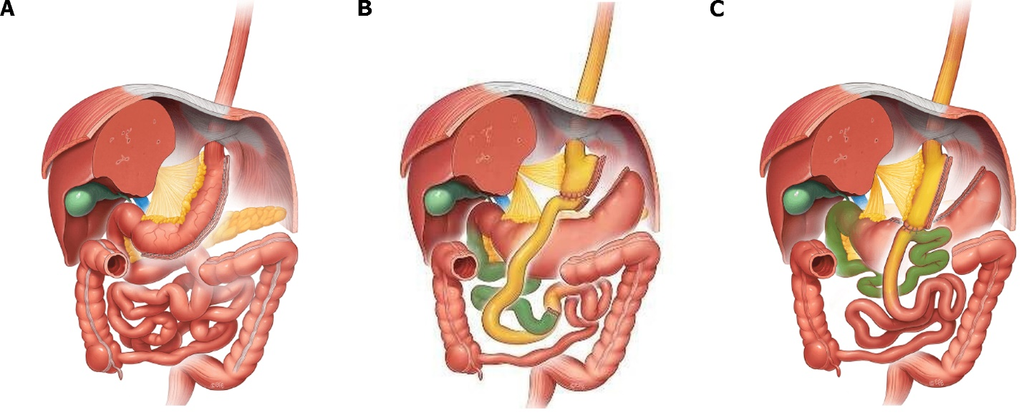
Figure 1 Main types of bariatric surgery, from left to right. A: Sleeve gastrectomy; B: Roux-en-Y gastric bypass; C: One-anastomosis gastric bypass. Citation: IFSO. Sleeve Gastrectomy. [cited 20 December 2022]. Available from: https://www.ifso.com/sleeve-gastrectomy/^{[19]}; IFSO. Roux-en-Y Gastric Bypass. [cited 20 December 2022]. Available from: https://www.ifso.com/roux-en-y-gastric-bypass/^{[20]}; IFSO. One Anastomosis Gastric Bypass. [cited 20 December 2022]. Available from: https://www.ifso.com/alternative-intestinal-procedures/^{[21]}. Copyright© Dr. Levent Efe, courtesy of IFSO, 2022.
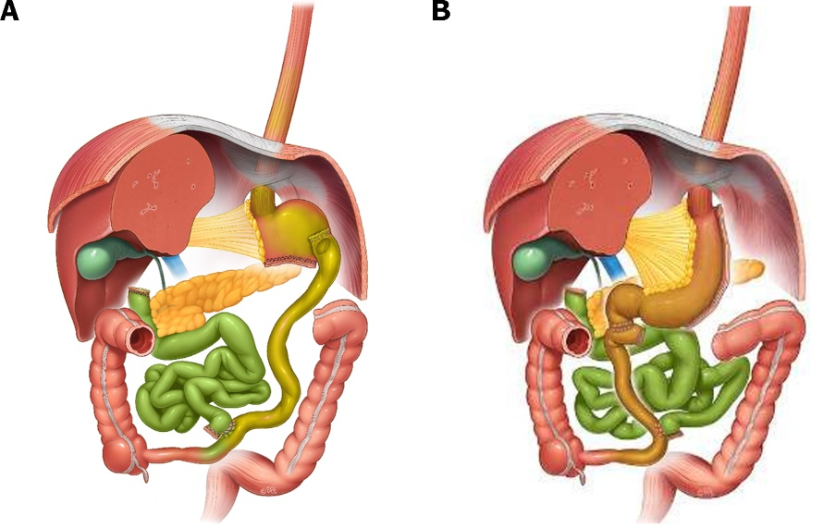
Figure 2 Forms of biliopancreatic diversions, from left to right. A: Biliopancreatic diversion (BPD); B: BPD with duodenal switch. Citation: IFSO. Biliopancreatic Diversion (BPD). [cited 20 December 2022]. Available from: https://www.ifso.com/bilio-pancreatic-diversion/^{[25]}; IFSO. Biliopancreatic Diversion with Duodenal Switch. [cited 20 December 2022]. Available from: https://www.ifso.com/bilio-pancreatic-diversion-with-duodenal-switch/^{[26]}. Copyright© Dr. Levent Efe, courtesy of IFSO, 2022.

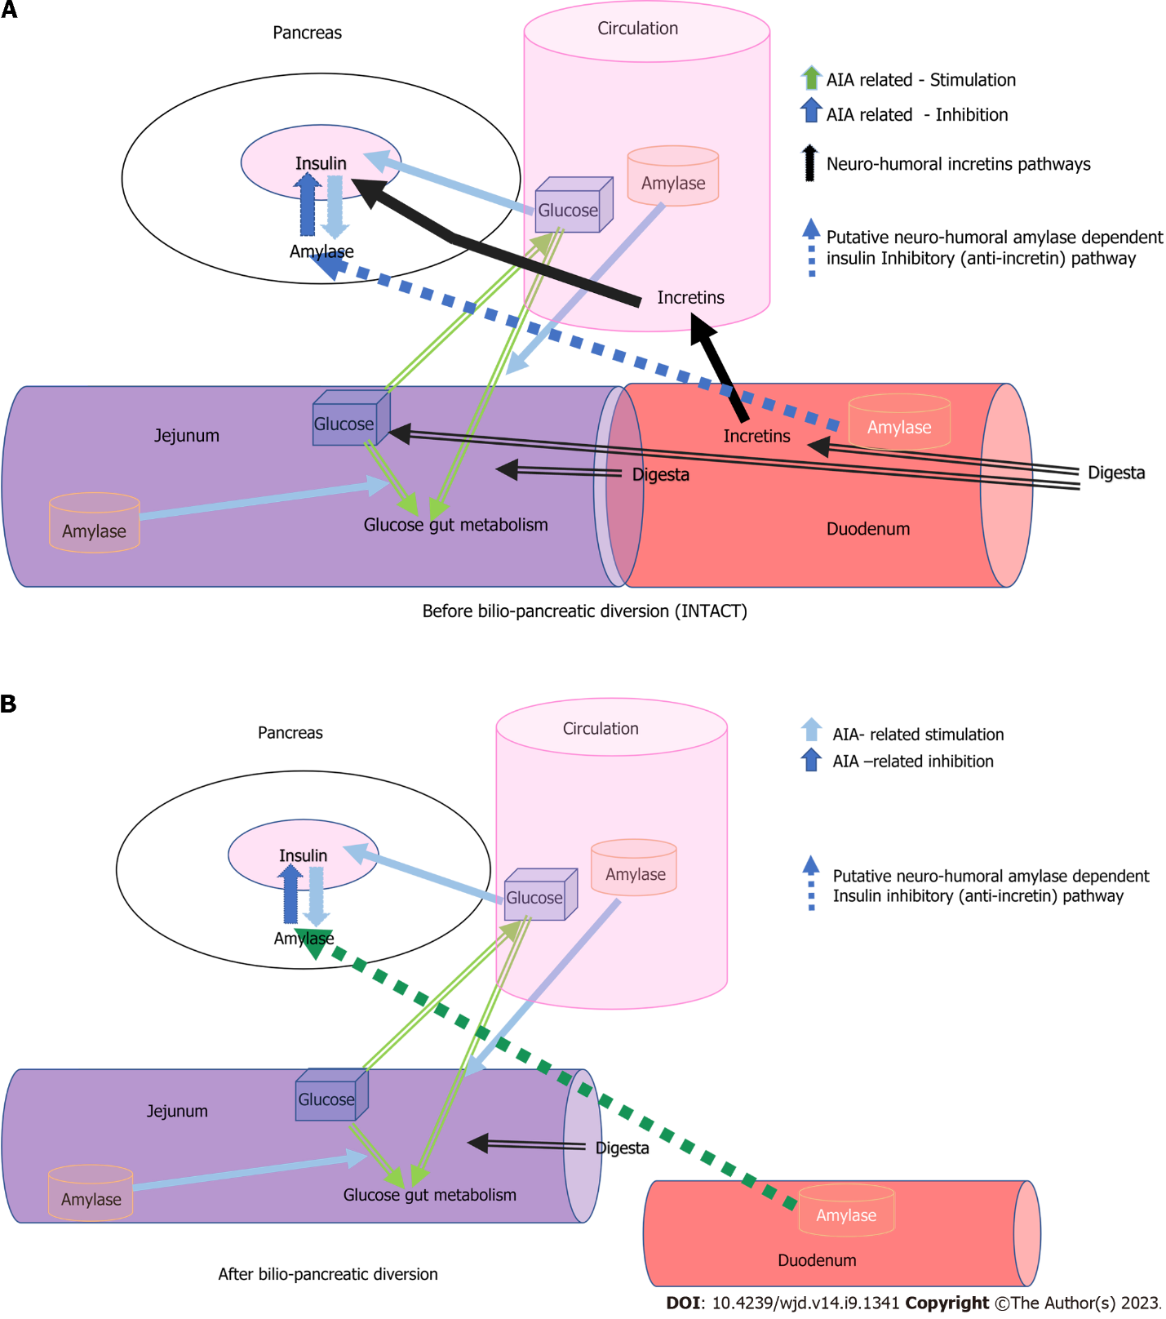
Figure 3 A schematic view of acini-islet-acinar- and alpha-amylase-dependent inhibitory pathway involved in the regulation of glucose metabolism before and after Biliopancreatic diversion surgery. A: Before biliopancreatic diversion surgery; B: After biliopancreatic diversion surgery. Incretin-dependent, quick stimulatory pathways (black) and acini-islet-acinar–dependent intrapancreatic inhibitory pathway and downregulating alpha-amylase dependent pathways, originating in the duodenum, of insulin secretion (orange and green respectively). AIA: Acini-islet-acinar.

Published by Baishideng Publishing Group Inc
7041 Koll Center Parkway, Suite 160, Pleasanton, CA 94566, USA
Telephone: +19253991568
Email: bpgoffice@wjgnet.com
Help Desk: https://www.f6publishing.com/helpdesk
https://www.wjgnet.com

© 2023 Baishideng Publishing Group Inc. All rights reserved.

