Name of Journal: World Journal of Clinical Cases
Manuscript NO: 85888
Manuscript Type: ORIGINAL ARTICLE

Retrospective Study
Appropriate leucine-rich α-2 glycoprotein cut-off value for Japanese patients with ulcerative colitis

Yamazato M et al. Appropriate LRG cut-off value in UC

Masanao Yamazato, Shunichi Yanai, Tomofumi Oizumi, Makoto Eizuka, Shun Yamada, Yosuke Toya, Noriyuki Uesugi, Tamotsu Sugai, Takayuki Matsumoto

Masanao Yamazato, Shunichi Yanai, Tomofumi Oizumi, Makoto Eizuka, Shun Yamada, Yosuke Toya, Takayuki Matsumoto, Division of Gastroenterology and Hepatology, Department of Internal Medicine, Iwate Medical University, Yahaba 028-3695, Japan

Noriyuki Uesugi, Tamotsu Sugai, Division of Molecular Diagnostic Pathology, Iwate Medical University, Yahaba 028-3695, Japan

Author contributions: Yamazato M, and Yanai S performed the conception and design; Yamazato M, Yanai S, Oizumi T, Eizuka M, Yamada S, Toya Y, Uesugi N, and Sugai T performed the data collection; Yamazato M, and Yanai S contributed to the data analysis and statistical analysis; The first draft of manuscript was written by Yamazato M, and Yanai S; Matsumoto T critically reviewed and revised the manuscript; All authors read and approved the final manuscript for submission.

Corresponding author: Shunichi Yanai, Doctor, Division of Gastroenterology and Hepatology, Department of Internal Medicine, Iwate Medical University, 2-1-1 Idaidori, Yahaba 028-3695, Japan. syanai@iwate-med.ac.jp

Received: May 22, 2023
Revised: August 18, 2023
Accepted: November 2, 2023
Published online:

Abstract
BACKGROUND
It has been suggested that serum leucine-rich α-2 glycoprotein (LRG) could be a novel monitoring biomarker for the assessment of disease activity in inflammatory bowel disease. In particular, the relationship between LRG levels and the endoscopically assessed activity of ulcerative colitis (UC) has become a matter of interest.

AIM
To clarify appropriate LRG cut-off values for the prediction of endoscopic and histologic remission in Japanese patients with UC.

METHODS
This was a cross-sectional, single-center, observational study of Japanese patients with UC. Among 213 patients with UC, in whom LRG was measured from September 2020 to February 2022, we recruited 30 patients for whom a total colonoscopy and measurements of LRG and C-reactive protein (CRP) were performed on the same day. We retrospectively analyzed correlations between the LRG and CRP levels and endoscopic indices, including the Mayo endoscopic subscore and UC endoscopic index of severity.

RESULTS
Correlations between the LRG values and the Mayo endoscopic subscore or UC endoscopic index of severity were significant (r = 0.754, P < 0.0001; r = 0.778, P < 0.0001, respectively). There were also significant correlations between CRP levels and Mayo endoscopic subscore or UC endoscopic index of severity (r = 0.599, P = 0.0005; r = 0.563, P = 0.0012, respectively), although the correlation coefficients were higher for LRG. The LRG cut-off value for predicting endoscopic remission was 13.4 μg/mL for a Mayo endoscopic subscore of 0 [area under the curve (AUC): 0.871; 95% confidence interval (CI): 0.744–0.998], and 13.4 μg/mL for an UC endoscopic index of severity of 0 or 1 (AUC: 0.904; 95%CI: 0.792–1.000).

CONCLUSION
LRG may be a surrogate marker for endoscopic activity in UC, with a cut-off value of around 13.4 μg/mL for endoscopically inactive disease.

Key Words: Ulcerative colitis; Leucine-rich alpha-2 glycoprotein; C-reactive protein; Japanese patients

Yamazato M, Yanai S, Oizumi T, Eizuka M, Yamada S, Toya Y, Uesugi N, Sugai T, Matsumoto T. Appropriate leucine-rich α-2 glycoprotein cut-off value for Japanese patients with ulcerative colitis. World J Clin Cases 2023; In press

Core Tip: Leucine-rich α-2 glycoprotein (LRG) has recently been proposed as a reliable surrogate marker for clinical, endoscopic and histologic activity in ulcerative colitis (UC). Our aim was to determine appropriate LRG cut-off values for predicting clinical and endoscopic remission in Japanese patients with UC. LRG was found to be correlated with endoscopic indices, and the LRG cut-off value for predicting endoscopic remission was determined to be 13.4 μg/mL. LRG < 13.4 μg/mL may be predictive of endoscopically inactive disease in UC.

INTRODUCTION
Mucosal healing (MH) has recently become an important treatment goal in ulcerative colitis (UC). The achievement of MH has been reported to decrease the recurrence, malignant transformation, hospitalization rates, and surgical requirements of various gastrointestinal disorders^{[1-5]}. In addition, histological remission is superior to endoscopic healing in predicting long-term remission and cancer prevention^{[6-10]}. The Selecting Therapeutic Targets in Inflammatory Bowel Diseases (IBD) IBD (STRIDE)-II initiative encompasses recommendations for treat-to-target strategies for adults and children with IBD^{[11]}. STRIDE-II has recommended the use of clinical remission, C-reactive protein (CRP) normalization, and decreased fecal calprotectin levels as intermediate targets, with endoscopic remission and histological healing as long-term targets.
Serum leucine-rich α-2 glycoprotein (LRG) is a novel monitoring biomarker for the assessment of disease activity in IBD. LRG levels have been shown to reflect gastrointestinal inflammation^{[12-18]}. However, appropriate LRG cut-off values have not been established in patients with UC. We thus aimed to investigate reasonable LRG cut-off values for predicting endoscopic and histologic activity in Japanese patients with UC.

MATERIALS AND METHODS
Patients
This was a cross-sectional, single-center, observational study of Japanese patients with UC. All patients were recruited at the Division of Gastroenterology and Hepatology, Iwate Medical University Hospital, Iwate, Japan. The diagnosis of UC was based on established clinical, endoscopic, radiological, and histological criteria. UC was classified into the following types: total colitis, left-sided colitis, proctitis, and segmental colitis. Exclusion criteria were as follows: presence of infectious enterocolitis, colorectal cancer, Crohn’s disease (CD), or indeterminate colitis; inability to collect fecal samples; pregnancy; history of colorectal resection; or regular intake of aspirin/nonsteroidal anti-inflammatory drugs, defined as ≥ 2 tablets/wk. Blood samples were collected for the measurement of white blood cell counts, platelet counts, hemoglobin levels, and serum levels of albumin, LRG, and CRP.
We recruited 213 patients with UC for the measurement of LRG during the period from September 2020 to February 2022. Among those patients, 30 underwent total colonoscopy, and LRG and CRP measurements were made on the same day. These 30 patients were the subjects of the present study. The study protocol was approved by the Ethics Committee at Iwate Medical University Hospital (MH2020-193), and the study was conducted in accordance with the Declaration of Helsinki.

Clinical, endoscopic and histological assessment
The association between clinical activity and biomarkers was examined in all patients. The clinical activity of UC was assessed according to the partial Mayo score (PMS)^{[19]}; clinical remission was defined as a PMS of 0 without rectal bleeding and no requirement for steroid therapy during the previous 3 mo.
Endoscopic activity was assessed according to the Mayo Endoscopic Subscore (MES) and the UC Endoscopic Index of Severity (UCEIS)^{[20]}. The MES is a 4-point scale (0-3). The three items included in the UCEIS were vascular pattern, bleeding, and erosion/ulceration. The sum of the scores for each endoscopic item ranged from 0 to 8. The UCEIS and MES were scored retrospectively by experienced endoscopists (MY and SY), who were blinded to patient LRG and CRP levels. The histological grade of inflammation was assessed on biopsy specimens obtained endoscopically from the most severely inflamed sites according to the Matts score^{[21]}, Riley score^{[22]}, and Geboes histopathology score (GHS)^{[23]} by a pathologist (TS) who was blinded to endoscopic findings and LRG and CRP levels. Histologic remission for each biopsy specimen was defined as Matts grade 1, Riley’s score 0 or 1, and GHS 0 or 1.

Statistical analysis
Statistical analysis was performed with JMP 13 (SAS Institute Inc., Cary, NC, United States) and SPSS version 22 software for MAC OS (SPSS Inc., Chicago, IL, United States). Numerical variables are presented as medians and interquartile ranges (IQRs), while categorical variables are presented as frequencies. Associations between LRG levels and blood test results, clinical disease activity, endoscopically assessed activity, or histological activity were evaluated with Spearman’s rank sum correlation test. Receiver operating characteristic (ROC) curves were drawn to estimate the area under the curve (AUC) and the best cut-off levels of LRG that predicted clinical, endoscopically assessed, and histologic remission. Based on the cut-off levels, test characteristics, including sensitivity, specificity, positive predictive value, and positive likelihood ratio were calculated. Patient age and laboratory data were compared with the Wilcoxon test. Gender and frequency of medical treatment were compared with the χ² test. Relapse rates were compared between any two groups with the Cox proportional hazards model. For each analysis, P < 0.05 was considered statistically significant.

RESULTS
Associations between clinical or endoscopic activity and biomarkers
Table 1 summarizes the baseline characteristics of the 30 patients in whom endoscopic and histological activity were examined and LRG and CRP were measured on the same day. There were significant correlations between LRG level and MES (r = 0.754, P < 0.0001) and between LRG level and UCEIS (r = 0.778, P < 0.0001). There were also significant correlations between CRP level and MES (r = 0.599, P = 0.0005) and between CRP level and UCEIS (r = 0.563, P = 0.0012). The correlation coefficients were higher for LRG level (Figure 1).
The LRG cut-off value for predicting clinical remission was 12.9 μg/mL for PMS = 0 [AUC: 0.951, 95% confidence interval (CI): 0.873–1.000], with sensitivity of 89% and specificity of 91%. The LRG cut-off value for predicting endoscopically assessed remission was 13.4 μg/mL for MES = 0 (AUC: 0.871, 95%CI: 0.744–0.998), with sensitivity of 100% and specificity of 64%; and 13.4 µg/mL for UCEIS = 0 or 1 (AUC: 0.904; 95%CI: 0.792–1.000), with sensitivity of 100% and specificity of 69% (Table 2).

Associations between histological activity and biomarkers
There were significant correlations between LRG level and Matts grade (r = 0.432, P = 0.017) and between LRG level and Riley’s score (r = 0.380, P = 0.038). In contrast, no significant correlations were found between LRG level and GHS (r = 0.285, P = 0.126), CRP level and Matts grade (r = 0.306, P = 0.099), CRP level and Riley score (r = 0.198, P = 0.293), or CRP level and GHS (r = 0.115, P = 0.544) (Figure 2).
As to histological remission, the appropriate LRG cut-off value was 9.7 μg/mL for Matts grade (AUC: 0.889, 95%CI: 0.755–1.000), with sensitivity of 100% and specificity of 81%; 13.4 μg/mL for Riley score (AUC: 0.739, 95%CI: 0.550–0.929), with sensitivity of 100% and specificity of 46%; and 13.4 μg/mL for GHS (AUC: 0.679, 95%CI: 0.477–0.880), with sensitivity of 92% and specificity of 59% (Table 2).

DISCUSSION
LRG is a 50-kDa glycoprotein containing eight leucine-rich repeat domains. It has been reported to be a novel serum biomarker for the detection of rheumatoid arthritis and IBD^{[24]}. The primary sites of LRG production are thought to be intestinal epithelial cells, neutrophils, and hepatocytes that are stimulated by interleukin (IL)-6, tumor necrosis factor-α, and IL-22, among other cytokines^{[25,26]}. CRP is a protein that is representative of acute phase reactants. The liver, under the stimulation of circulating IL-6, is the primary organ for CRP production^{[27]}. Thus, it has been presumed that LRG is more sensitive than CRP for assessing the severity of inflammation in systemic diseases.
Several papers have reported that serum levels of LRG are correlated with endoscopic activity in patients with UC^{[12-18]}. Shinzaki et al^{[14]} recently published results of a prospective, observational study that evaluated serum LRG as a biomarker for disease activity in IBD (PLANET study). Their study found that serum LRG was a useful biomarker of endoscopic activity in patients with UC receiving adalimumab treatment^{[14]}. A subanalysis of the PLANET study revealed that LRG, rather than CRP, may be a more accurate marker for predicting the trough level of adalimumab in patients with CD or UC^{[28]}.
Our study included 30 patients for whom total colonoscopy and measurements of LRG and CRP were performed on the same day. There were significant correlations between LRG levels and MES and LRG levels and UCEIS. There were also significant correlations between CRP levels and MES, and CRP levels and UCEIS, although the correlation coefficients were higher for LRG level. Thus, it seems possible that LRG is a candidate that is equal or, possibly, superior to CRP for the assessment of disease activity in UC.
The recommended cut-off value of LRG for the detection of active disease in patients with UC is regarded as 16 μg/mL. Subsequently, the cut-off value of the serum level of LRG for the detection of active disease in patients with UC was reported by other investigators. Horiuchi et al^{[15]} reported that a serum LRG cut-off value of 10.8 g/mL could be a novel biomarker for identifying patients with active total or left-sided colitis^{[15]}. Shimoyama et al^{[16]} reported that the optimal LRG cut-off value for the detection of endoscopically active disease defined as MES ≥ 1 was 12.7 μg/mL^{[16]}. Yoshida et al^{[17]} reported that the cut-off value of LRG for MH with the identical definition was 16.3 μg/mL^{[17]}. Another study by Yasutomi et al^{[18]} showed that the LRG cut-off for complete MH defined as an MES of 0 was 13 μg/mL^{[18]}. The cut-off value varies according to the definition of MH and to the study population, whereas our study revealed that the LRG cut-off value for the prediction of MH defined as an MES of 0 was 13.4 μg/mL and it was 12.9 μg/mL for the prediction of UCEIS of 0 or 1. These observations suggest that a cut-off value of LRG at around 13 μg/mL is appropriate for the prediction of MH in patients with UC.
We also showed that there were significant correlations between LRG level and two of the three widely accepted histological activity systems for UC, namely, the Matts grade and Riley score. This observation seems reasonable, because neutrophil infiltration is the main item for the assessment of activity. In contrast, we could not find a significant correlation between GHS and LRG. This may be explained by the fact that mucosal damage, rather than inflammatory infiltration, is the key histological finding. Thus, LRG may be representative of grade of inflammation in patients with UC. Also, it should be noted that the practical cut-off values of LRG for endoscopic remission and histological remission were similar, indicating the significance of LRG in clinical practice.
This study had several limitations. First, it was performed at a single center and involved a limited number of patients. Second, since it was a retrospective study, there were some variations in patient comorbidities, such as infectious colitis and rheumatoid arthritis, and in applied medications. Third, we could not compare LRG with fecal calprotectin, a reliable fecal biomarker for UC. The comparison of LRG with fecal calprotectin remains to be examined in future prospective studies.

CONCLUSION
Our analysis revealed that LRG is a biomarker for patients with UC with respect to clinical, endoscopic and histological prediction of remission, and that the cut-off value of LRG for each may be around 13 μg/mL. With the use of the appropriate cut-off value, LRG seems to be a biomarker that is more specific and more sensitive than CRP.

ARTICLE HIGHLIGHTS
Research background
Serum leucine-rich α-2 glycoprotein (LRG) can be used for the assessment of disease activity in ulcerative colitis (UC). However, practical cut-off values of LRG for remission have not been established in patients with UC.

Research motivation
LRG cut-off value for remission will lessen the need for colonoscopy.

Research objectives
To establish cut-off values of LRG for endoscopic and histological remission in UC.

Research methods
We retrospectively analyzed the relationship between LRG and clinical, endoscopic and histologic activities in patients with UC.

Research results
In 30 patients, the correlations between LRG value and Mayo Endoscopic Subscore (MES) or UC Endoscopic Index of Severity (UCEIS) were significant (r = 0.754, P < 0.0001; r = 0.778, P < 0.0001, respectively). Significant correlations were also found between CRP level and MES or UCEIS (r = 0.599, P = 0.0005; r = 0.563, P = 0.0012, respectively); however, the correlation coefficients were higher for LRG value. The LRG cut-off value for predicting endoscopic remission was 13.4 μg/mL for an MES of 0 [area under the curve (AUC): 0.871, 95% confidence interval (CI): 0.744–0.998], and 13.4 μg/mL for a UCEIS of 0 or 1 (AUC: 0.904; 95%CI: 0.792–1.000).

Research conclusions
LRG can be applied to the prediction of endoscopic and histological remission in UC.

Research perspectives
Further prospective studies are deemed to validate our findings.

REFERENCES
1 Frøslie KF, Jahnsen J, Moum BA, Vatn MH; IBSEN Group. Mucosal healing in inflammatory bowel disease: results from a Norwegian population-based cohort. Gastroenterology 2007; 133: 412-422 [PMID: 17681162 DOI: 10.1053/j.gastro.2007.05.051]
2 Colombel JF, Rutgeerts P, Reinisch W, Esser D, Wang Y, Lang Y, Marano CW, Strauss R, Oddens BJ, Feagan BG, Hanauer SB, Lichtenstein GR, Present D, Sands BE, Sandborn WJ. Early mucosal healing with infliximab is associated with improved long-term clinical outcomes in ulcerative colitis. Gastroenterology 2011; 141: 1194-1201 [PMID: 21723220 DOI: 10.1053/j.gastro.2011.06.054]
3 Meucci G, Fasoli R, Saibeni S, Valpiani D, Gullotta R, Colombo E, D’Incà R, Terpin M, Lombardi G; IG-IBD. Prognostic significance of endoscopic remission in patients with active ulcerative colitis treated with oral and topical mesalazine: a prospective, multicenter study. Inflamm Bowel Dis 2012; 18: 1006-1010 [PMID: 21830282 DOI: 10.1002/ibd.21838]
4 Neurath MF, Travis SP. Mucosal healing in inflammatory bowel diseases: a systematic review. Gut 2012; 61: 1619-1635 [PMID: 22842618 DOI: 10.1136/gutjnl-2012-302830]
5 Laharie D, Filippi J, Roblin X, Nancey S, Chevaux JB, Hébuterne X, Flourié B, Capdepont M, Peyrin-Biroulet L. Impact of mucosal healing on long-term outcomes in ulcerative colitis treated with infliximab: a multicenter experience. Aliment Pharmacol Ther 2013; 37: 998-1004 [PMID: 23521659 DOI: 10.1111/apt.12289]
6 Ullman TA, Itzkowitz SH. Intestinal inflammation and cancer. Gastroenterology 2011; 140: 1807-1816 [PMID: 21530747 DOI: 10.1053/j.gastro.2011.01.057]
7 Baars JE, Nuij VJ, Oldenburg B, Kuipers EJ, van der Woude CJ. Majority of patients with inflammatory bowel disease in clinical remission have mucosal inflammation. Inflamm Bowel Dis 2012; 18: 1634-1640 [PMID: 22069022 DOI: 10.1002/ibd.21925]
8 Bryant RV, Winer S, Travis SP, Riddell RH. Systematic review: histological remission in inflammatory bowel disease. Is ‘complete’ remission the new treatment paradigm? An IOIBD initiative. J Crohns Colitis 2014; 8: 1582-1597 [PMID: 25267173 DOI: 10.1016/j.crohns.2014.08.011]
9 Peyrin-Biroulet L, Bressenot A, Kampman W. Histologic remission: the ultimate therapeutic goal in ulcerative colitis? Clin Gastroenterol Hepatol 2014; 12: 929-34.e2 [PMID: 23911875 DOI: 10.1016/j.cgh.2013.07.022]
10 Cushing KC, Tan W, Alpers DH, Deshpande V, Ananthakrishnan AN. Complete histologic normalization is associated with reduced risk of relapse among patients with ulcerative colitis in complete endoscopic remission. Aliment Pharmacol Ther 2020; 51: 347-355 [PMID: 31696961 DOI: 10.1111/apt.15568]
11 Turner D, Ricciuto A, Lewis A, D’Amico F, Dhaliwal J, Griffiths AM, Bettenworth D, Sandborn WJ, Sands BE, Reinisch W, Schölmerich J, Bemelman W, Danese S, Mary JY, Rubin D, Colombel JF, Peyrin-Biroulet L, Dotan I, Abreu MT, Dignass A; International Organization for the Study of IBD. STRIDE-II: An Update on the Selecting Therapeutic Targets in Inflammatory Bowel Disease (STRIDE) Initiative of the International Organization for the Study of IBD (IOIBD): Determining Therapeutic Goals for Treat-to-Target strategies in IBD. Gastroenterology 2021; 160: 1570-1583 [PMID: 33359090 DOI: 10.1053/j.gastro.2020.12.031]
12 Serada S, Fujimoto M, Terabe F, Iijima H, Shinzaki S, Matsuzaki S, Ohkawara T, Nezu R, Nakajima S, Kobayashi T, Plevy SE, Takehara T, Naka T. Serum leucine-rich alpha-2 glycoprotein is a disease activity biomarker in ulcerative colitis. Inflamm Bowel Dis 2012; 18: 2169-2179 [PMID: 22374925 DOI: 10.1002/ibd.22936]
13 Shinzaki S, Matsuoka K, Iijima H, Mizuno S, Serada S, Fujimoto M, Arai N, Koyama N, Morii E, Watanabe M, Hibi T, Kanai T, Takehara T, Naka T. Leucine-rich Alpha-2 Glycoprotein is a Serum Biomarker of Mucosal Healing in Ulcerative Colitis. J Crohns Colitis 2017; 11: 84-91 [PMID: 27466171 DOI: 10.1093/ecco-jcc/jjw132]
14 Shinzaki S, Matsuoka K, Tanaka H, Takeshima F, Kato S, Torisu T, Ohta Y, Watanabe K, Nakamura S, Yoshimura N, Kobayashi T, Shiotani A, Hirai F, Hiraoka S, Watanabe M, Matsuura M, Nishimoto S, Mizuno S, Iijima H, Takehara T, Naka T, Kanai T, Matsumoto T. Leucine-rich alpha-2 glycoprotein is a potential biomarker to monitor disease activity in inflammatory bowel disease receiving adalimumab: PLANET study. J Gastroenterol 2021; 56: 560-569 [PMID: 33942166 DOI: 10.1007/s00535-021-01793-0]
15 Horiuchi I, Horiuchi A, Umemura T. Serum Leucine-Rich α2 Glycoprotein: A Biomarker for Predicting the Presence of Ulcerative Colitis but Not Ulcerative Proctitis. J Clin Med 2022; 11 [PMID: 36362594 DOI: 10.3390/jcm11216366]
16 Shimoyama T, Yamamoto T, Yoshiyama S, Nishikawa R, Umegae S. Leucine-Rich Alpha-2 Glycoprotein Is a Reliable Serum Biomarker for Evaluating Clinical and Endoscopic Disease Activity in Inflammatory Bowel Disease. Inflamm Bowel Dis 2023; 29: 1399-1408 [PMID: 36334015 DOI: 10.1093/ibd/izac230]
17 Yoshida T, Shimodaira Y, Fukuda S, Watanabe N, Koizumi S, Matsuhashi T, Onochi K, Iijima K. Leucine-Rich Alpha-2 Glycoprotein in Monitoring Disease Activity and Intestinal Stenosis in Inflammatory Bowel Disease. Tohoku J Exp Med 2022; 257: 301-308 [PMID: 35598974 DOI: 10.1620/tjem.2022.J042]
18 Yasutomi E, Inokuchi T, Hiraoka S, Takei K, Igawa S, Yamamoto S, Ohmori M, Oka S, Yamasaki Y, Kinugasa H, Takahara M, Harada K, Furukawa M, Itoshima K, Okada K, Otsuka F, Tanaka T, Mitsuhashi T, Kato J, Okada H. Leucine-rich alpha-2 glycoprotein as a marker of mucosal healing in inflammatory bowel disease. Sci Rep 2021; 11: 11086 [PMID: 34045529 DOI: 10.1038/s41598-021-90441-x]
19 Schroeder KW, Tremaine WJ, Ilstrup DM. Coated oral 5-aminosalicylic acid therapy for mildly to moderately active ulcerative colitis. A randomized study. N Engl J Med 1987; 317: 1625-1629 [PMID: 3317057 DOI: 10.1056/NEJM198712243172603]
20 Travis SP, Schnell D, Krzeski P, Abreu MT, Altman DG, Colombel JF, Feagan BG, Hanauer SB, Lémann M, Lichtenstein GR, Marteau PR, Reinisch W, Sands BE, Yacyshyn BR, Bernhardt CA, Mary JY, Sandborn WJ. Developing an instrument to assess the endoscopic severity of ulcerative colitis: the Ulcerative Colitis Endoscopic Index of Severity (UCEIS). Gut 2012; 61: 535-542 [PMID: 21997563 DOI: 10.1136/gutjnl-2011-300486]
21 MATTS SG. The value of rectal biopsy in the diagnosis of ulcerative colitis. Q J Med 1961; 30: 393-407 [PMID: 14471445]
22 Riley SA, Mani V, Goodman MJ, Herd ME, Dutt S, Turnberg LA. Comparison of delayed release 5 aminosalicylic acid (mesalazine) and sulphasalazine in the treatment of mild to moderate ulcerative colitis relapse. Gut 1988; 29: 669-674 [PMID: 2899536 DOI: 10.1136/gut.29.5.669]
23 Geboes K, Riddell R, Ost A, Jensfelt B, Persson T, Löfberg R. A reproducible grading scale for histological assessment of inflammation in ulcerative colitis. Gut 2000; 47: 404-409 [PMID: 10940279 DOI: 10.1136/gut.47.3.404]
24 Naka T, Fujimoto M. LRG is a novel inflammatory marker clinically useful for the evaluation of disease activity in rheumatoid arthritis and inflammatory bowel disease. Immunol Med 2018; 41: 62-67 [PMID: 30938267 DOI: 10.1080/13497413.2018.1481582]
25 Shirai R, Hirano F, Ohkura N, Ikeda K, Inoue S. Up-regulation of the expression of leucine-rich alpha(2)-glycoprotein in hepatocytes by the mediators of acute-phase response. Biochem Biophys Res Commun 2009; 382: 776-779 [PMID: 19324010 DOI: 10.1016/j.bbrc.2009.03.104]
26 Serada S, Fujimoto M, Ogata A, Terabe F, Hirano T, Iijima H, Shinzaki S, Nishikawa T, Ohkawara T, Iwahori K, Ohguro N, Kishimoto T, Naka T. iTRAQ-based proteomic identification of leucine-rich alpha-2 glycoprotein as a novel inflammatory biomarker in autoimmune diseases. Ann Rheum Dis 2010; 69: 770-774 [PMID: 19854709 DOI: 10.1136/ard.2009.118919]
27 Gabay C, Kushner I. Acute-phase proteins and other systemic responses to inflammation. N Engl J Med 1999; 340: 448-454 [PMID: 9971870 DOI: 10.1056/NEJM199902113400607]
28 Yanai S, Shinzaki S, Matsuoka K, Mizuno S, Iijima H, Naka T, Kanai T, Matsumoto T. Leucine-Rich Alpha-2 Glycoprotein May Be Predictive of the Adalimumab Trough Level and Antidrug Antibody Development for Patients with Inflammatory Bowel Disease: A Sub-Analysis of the PLANET Study. Digestion 2021; 102: 929-937 [PMID: 34350873 DOI: 10.1159/000517339]

Footnotes
Institutional review board statement: This study was reviewed and approved by the Ethics Committee of the Iwate Medical University Hospital.

Informed consent statement: Patients were not required to give informed consent as this is a retrospective study.

Conflict-of-interest statement: All the authors report no relevant conflicts of interest for this article.

Data sharing statement: No additional data are available.

Open-Access: This article is an open-access article that was selected by an in-house editor and fully peer-reviewed by external reviewers. It is distributed in accordance with the Creative Commons Attribution NonCommercial (CC BY-NC 4.0) license, which permits others to distribute, remix, adapt, build upon this work non-commercially, and license their derivative works on different terms, provided the original work is properly cited and the use is non-commercial. See: https://creativecommons.org/Licenses/by-nc/4.0/

Provenance and peer review: Unsolicited article; Externally peer reviewed.

Peer-review model: Single blind

Peer-review started: May 22, 2023
First decision: August 8, 2023
Article in press:

Specialty type: Medicine, research and experimental
Country/Territory of origin: Japan
Peer-review report’s scientific quality classification
Grade A (Excellent): 0
Grade B (Very good): 0
Grade C (Good): C, C
Grade D (Fair): D
Grade E (Poor): 0

P-Reviewer: B Lankarani K, Iran; Ding WW, China; Jin X, China S-Editor: Fan JR L-Editor: Kerr C P-Editor:

Figure Legends
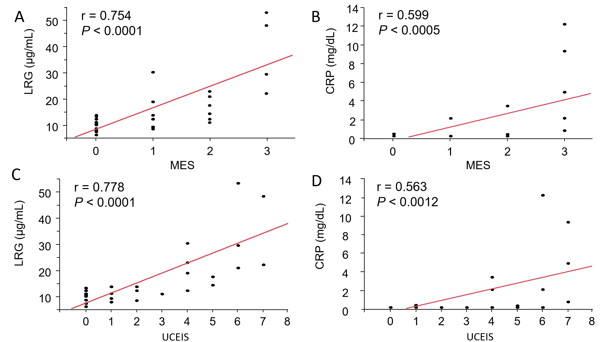
Figure 1 Relationship between endoscopic findings and biomarkers (n = 30). A and B: Mayo Endoscopic Subscore; C and D: Ulcerative Colitis Endoscopic Index of Severity. CRP: C-reactive protein; LRG: Leucine-rich α-glycoprotein; MES: Mayo Endoscopic Subscore; UCEIS: Ulcerative Colitis Endoscopic Index of Severity.
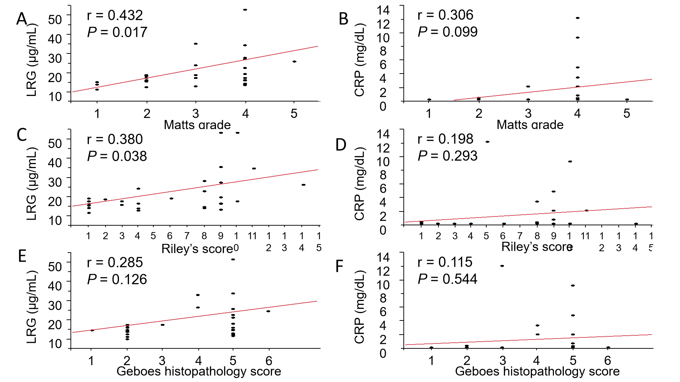
Figure 2 Relationship between histological findings and biomarkers (n = 30). A and B: Matts Grade; C and D: Riley’s Score; E and F: Geboes Histopathology Score. CRP: C-reactive protein; LRG: Leucine-rich α-glycoprotein.
Table 1 Baseline characteristics of the 30 patients
Parameter | Patients (n = 30)
Age, year, median (IQR) | 37 (28-47)
Male/Females, n/n | 21/ 9
Disease duration, year, median (IQR) | 1 (0-1)
Actual disease extent, n (%)
Proctitis | 3 (10)
Left-sided colitis | 7 (23.3)
Total colitis | 20 (66.7)
Segmental colitis | 0
Laboratory data
LRG, μg/mL, median (IQR) | 11.9 (9.8-20.1)
CRP, mg/dL, median (IQR) | 0.10 (0.10-0.33)
Medication, n (%)
5-aminosalicylic acid | 30 (100)
Immunomodulators | 3 (10)
Anti-TNF | 2 (6.7)
Ustekinumab | 1 (3.3)
Tofacitinib | 3 (10)
IQR: Interquartile range; LRG: Leucine-rich α-2 glycoprotein; CRP: C-reactive protein; TNF: Tumor necrosis factor.
Table 2 Associations of variables with leucine-rich α-2 glycoprotein to predict remission
Variable | Cut-off value (μg/mL) | AUC | 95%CI | SENS (%) | SPEC (%) | PPV (%) | PLR
PMS 0 | 12.9 | 0.951 | 0.873-1.000 | 89 | 91 | 94 | 10.6
MES 0 | 13.4 | 0.871 | 0.744-0.998 | 100 | 64 | 68 | 2.8
UCEIS 0,1 | 13.4 | 0.904 | 0.792-1.000 | 100 | 69 | 73 | 3.2
Matts grade 1 | 9.7 | 0.889 | 0.755-1.000 | 100 | 81 | 37 | 5.4
Riley’s score 0,1 | 13.4 | 0.739 | 0.550-0.929 | 100 | 46 | 32 | 1.8
GHS 0,1 | 13.4 | 0.679 | 0.477-0.880 | 92 | 59 | 63 | 2.2
LRG: Leucine-rich α-2 glycoprotein; AUC: Area under the curve; CI: Confidence interval; SENS: Sensitivity; SPEC: Specificity; PPV: Positive predictive value; PLR: Positive likelihood ratio; MS: Mayo Score; MES: Mayo Endoscopic Subscore; UCEIS: Ulcerative Colitis Endoscopic Index of Severity; GHS: Geboes Histopathology Score.

