Name of Journal: World Journal of Hepatology
Manuscript NO: 39863
Manuscript Type: Case Report

Neuroendocrine tumor incidentally detected during living donor hepatectomy: Two cases treated with complete response

Akbulut s et al. Neuroendocrine tumor in living liver donors

Sami Akbulut, Burak Isik, Egemen Cicek, Emine Samdanci, Sezai Yilmaz

Sami Akbulut, Burak Isik, Sezai Yilmaz, Department of Surgery and Liver Transplant Institute, Inonu University Faculty of Medicine, Malatya 44280, Turkey

Egemen Cicek, Department of Surgery, Inonu University Faculty of Medicine, Malatya 44280, Turkey

Emine Samdanci, Department of Pathology, Inonu University Faculty of Medicine, Malatya 44280, Turkey

ORCID Number: Sami Akbulut (0000-0002-6864-7711); Egemen Cicek (0000-0003-2691-7418); Burak Isik (0000-0002-2395-3985); Emine Samdanci (0000-0002-0034-5186); Sezai Yilmaz (0000-0002-8044-0297).

Author contributions: Akbulut S, Isik B, and Cicek E designed the report; Akbulut S collected the patient’s clinical data; Samdanci E provided histopathological information; Akbulut S and Yilmaz S analyzed the data and wrote the paper.

Informed consent statement: The patient involved in this study gave his informed written consent prior to study enrollment, authorizing the use and disclosure of his protected health information.

Conflict-of-interest statement: The author declares no potential conflict of interest

CARE Checklist (2013) statement: Guidelines of the CARE Checklist (2013) have been adopted while writing this manuscript.

Open-Access: This article is an open-access article which was selected by an in-house editor and fully peer-reviewed by external reviewers. It is distributed in accordance with the Creative Commons Attribution Non Commercial (CC BY-NC 4.0) license, which permits others to distribute, remix, adapt, build upon this work non-commercially, and license their derivative works on different terms, provided the original work is properly cited and the use is non-commercial. See: http://creativecommons.org/licenses/by-nc/4.0/

Manuscript source: Invited manuscript

Correspondence to: Sami Akbulut, MD, Associate Professor, Department of Surgery and Liver Transplant Institute, Inonu University Faculty of Medicine, Elazig Yolu 10. Km, Malatya 44280, Turkey. sami.akbulut@inonu.edu.tr

Telephone: +90-422-3410660
Fax: +90-422-3410036

Received: May 18, 2018
Peer-review started: May 18, 2018
First decision: June 6, 2018
Revised: June 19, 2018
Accepted: June 27, 2018
Article in press:
Published online:

Abstract
To our best knowledge, no case of a tumor that was incidentally detected during living donor hepatectomy (LDH) has been reported in the English language medical literature. We aimed to present two cases that were incidentally detected to have a grade I neuroendocrine tumor (NET) during our twelve-year LDH experience. First Case: A 29-year-old male underwent right lobe LDH for his father with hepatitis B virus (HBV)-related chronic liver disease (CLD). An abdominal exploration immediately prior to the closure of the incision revealed that the appendix vermiformis was edematous and had firmness with a size of 8-10 mm at its tip. An appendectomy was performed. Second Case: A 26-year-old male underwent LDH for his brother suffering from HBV-related CLD. After right lobe LDH, intestinal length was measured as part of a study concerning the relationship between small intestinal lengths and surgical procedure. At this stage, a mass lesion with a size of 10 mm×10 mm was detected on the antimesenteric surface, approximately 90 cm proximal to the ileocecal valve. A wedge resection with primary intestinal anastomosis was performed. The pathological examinations of the specimens of both patients revealed grade 1 NET. In conclusion, even if patients undergoing LDH are healthy individuals, whole abdominal cavity should be gently palpated and all findings be recorded after completing laparotomy. Suspected masses or lesions should be confirmed by frozen section examination. Such an approach would avert some future potential medicolegal issues.

Key words: Living donor hepatectomy; hepatitis B virus; Incidental tumor; Neuroendocrine tumor; chronic liver disease

© The Author(s) 2018. Published by Baishideng Publishing Group Inc. All rights reserved.

Core tip: To our best knowledge, no case of a tumor that was incidentally detected during living donor hepatectomy (LDH) has been reported in the English language medical literature. Herein, we aimed to present two cases who were incidentally detected to have a grade I neuroendocrine tumor during our twelve-year LDH experience. Even if patients undergoing LDH are healthy individuals, whole abdominal cavity should be gently palpated and all findings be recorded after completing laparotomy. Suspected masses or lesions should be confirmed by frozen section examination. Such an approach would avert some future potential medicolegal issues.

Akbulut S, Isik B, Cicek E, Samdanci E, Yilmaz S. Neuroendocrine tumor ıncidentally detected during living donor hepatectomy: Two cases treated with complete response. World J Hepatol 2018; In press

INTRODUCTION
While deceased donors an important part of liver donor pool in western countries, living donors constitute an important portion of donor pool in many Asian countries including Turkey^{[1]}. The most important problem with living donor liver transplantation is the mortality and morbidity risk faced by completely healthy donor candidates due to a major surgery like liver resection. In order to minimize those risks, all living liver donor (LLD) candidates undergo investigations according to an algorithm consisting of biochemical blood tests and advanced radiological instruments^{[2]}. Incidental hemangioma, focal nodular hyperplasia, cystic lesions, median arcuate ligament, and ventricular septal defect have been rarely reported to be detected during investigations of LLD candidates^{[3-5]}. On the other hand, no publication other than our study has ever reported unusual findings such as cancer detected incidentally in liver or other intraabdominal organs during neither preoperative investigations nor in living donor hepatectomy (LDH) procedure^{[6]}. In this study we aimed to report two neuroendocrine tumor (NET) cases detected incidentally by us during our 12-year LDH experience.

CASE REPORTS
Case 1
A 26-year-old healthy man applied to our transplant center for being LLD to his 37-year-old brother with chronic liver disease (HBV). The donor candidate was taken into operating room for LDH in May 2017. A laparotomy was performed through an incision starting from xiphoidus to umblicus and extending laterally on the right side. As no macroscopic finding was detected in the liver, a right lobe LDH was performed. As part of a study conducted in our department investigating the relationship of mesenteric and antimesenteric lengths of small intestine with the surgical procedure, intestinal lengths of this patient were also measured. At this time, a mass lesion measuring approximately 10 mm was detected on the antimesenteric face of the intestine, approximately 90 cm proximal to the ileocecal valve (Figure 1). The mass was resected together with the mesentery of the adjacent intestinal segment. A wedge resection with primary intestinal anastomosis was performed. Intestinal mucosa and submucosa were closed with polyglactin 910 suture material while the seromuscular layer was closed with polypropylene. The patient experienced no complication during his postoperative follow-up and was discharged. A histopathological examination revealed a Grade I neuroendocrine tumor (carcinoid tumor) with a size of 7 mm × 5 mm, which had intact surgical margins (Figure 2). An immunohistochemical analysis showed that it was NSE (+), Chromogranin (+), Synaptophysin (+) and Ki 67 proliferation index (1%-2%) positive (Figures 3 and 4). The patient was put under follow-up by the medical oncology department, and a thoracoabdominal computerized tomography taken in the first controls revealed no additional lesion.

Case 2
A 29-year-old healthy man applied to our transplant center for being LLD candidate for his 51-year-old father who had chronic liver disease (HBV+HCC). His preoperative biochemical tests and radiological studies were normal. The patient was taken into operating room for right donor hepatectomy in May 2008. A laparotomy was performed through a incision starting from xiphoidus to umblicus and extending laterally on the right side. As no macroscopic finding was detected in the liver, right lobe LDH was performed. At the time when the surgeon suspended the anterior abdominal wall in order to place a drain into the surgical field, it was noticed that the appendix vermiformis was edematous and had prominent superficial arterioles. In addition, a firmness measuring 8-10 cm in size was palpated at the tip of the appendix. Therefore, appendectomy was performed. As no complication developed at postoperative follow-up, the patient was discharged to be seen at control visits. The pathology report of the appendix vermiformis showed a Grade I neuroendocrine tumor (NET) with a diameter of 10 cm at the tip of the appendix vermiformis, which showed full-thickness invasion but no spared the mesoappendix (Figure 2). In addition, the lesion was NSE (+), Chromogranin (+), Synaptophysin (+) and Ki 67 (%1) positive on immunohistochemical analysis (Figures 3 and 4). As the patient was living in another city, he is currently under follow-up of another center there, and he has recently informed us that no problem occurred in this final control visit.

DISCUSSION
World Health Organization classified NETs in two main categories as well differentiated (low grade, intermediate grade, high grade neuroendocrine tumor) and poorly differentiated (high grade neuroendocrine carcinoma). The most important ones of the basic criteria for this classification are the Ki 67 proliferation index (< 3%, 3%-20%, > 20%) and number of mitosis (< 2 mitosis, 2-20 mitosis, > 20 mitosis).
NETs most commonly involve small intestine. In other words, NETs are the leading malignant tumor involving small intestine. NETs are most commonly located in the first 60-cm segment before the ileocecal valve. Unlike appendix NETs, small intestinal NETs have the potential to make both nodal and distant metastasis independent of their size. Therefore, the most appropriate surgical approach is to perform a partial small intestinal resection to involve lymph nodes and mesentery, independent of the tumor size. As small intestinal NETs have the potential of being multiple, all intestinal loops should be carefully inspected during operation^{[7-9]}.
Appendix vermiformis is the second most commonly involved organ by NETs in the gastrointestinal system^{[10]}. The majority of appendix NETs are incidentally detected in patients taken into operating room for a presumed diagnosis of acute appendicitis. In other words, NETs are diagnosed at a rate of 0.3%-2.27% in the specimens of patients operated with diagnosis of acute appendicitis while they are detected in 1.8-2.3% of the specimens of patients undergoing incidental appendectomy ^{[7-9]}. The prognosis and metastasis potential of appendix NETs depend on their size. Ninety-five percent of appendix NETs are smaller than 2 cm at the time of diagnosis and have a low metastasis potential (4%). In tumors with a diameter ≥ 2 cm or patients with mesoappendix invasion right hemicolectomy is the most appropriate approach. In tumors with a diameter ranging between 1.0 cm and 1.9 cm, adjunct hemicolectomy is the most appropriate approach when there is one or more of the following parameters exists: mesoappendix invasion, vascular invasion, high proliferation index (grade 2), suspicious/positive surgical margins, and mixed histology (goblet cell carcinoid, adenocarcinoid). Simple appendectomy is sufficient for patients without mesoappendix invasion despite a diameter of 1.0-1.9 cm and appendix NETs with a diameter < 1 cm. No adjunctive surgical procedure was undertaken since the patient presented here had a Grade I NET.
The follow-up of patients with NET depends on tumor size and grade. One or the combination of several of diagnostic modalities of biochemical (5-hydroxyindoleacetic acid, serum chromogranin), endoscopic (pan endoscopy, colonoscopy) and radiological (computed tomography, magnetic resonance imaging, Indium-111 pentetreotide (OctreoScan), functional PET imaging with 68-Ga DOTA-TATE) can be used for diagnosis. Patients with an appendix NET having a diameter of ≥ 2 cm should be evaluated clinically and with biochemical/radiological studies whenever indicated at postoperative 3rd and 12th months. Controls should be carried out after one year and advanced radiological tests should be performed as needed. In cases with a tumor size of less than 2 cm routine controls are not needed. The follow-up protocol of small intestinal NETs should be in the form of close follow-up as for appendix NETs.
So far in the discussion section we summarized the approach to NETs. We would like to open into discussion two questions. First one is the question whether it is necessary to palpate the whole abdominal cavity and especially gastrointestinal organs in healthy individuals undergoing laparotomy for LDH. Many studies so far have recommended not to touch gastrointestinal tract unless indicated because even powder on surgical gloves may trigger development of postoperative adhesions. In addition, handling, palpating bowel loops or bringing out of the abdominal cavity may delay the return of intestinal motility at postoperative period. The second question is what to do when a mass lesion is encountered in the gastrointestinal system. This question should be dealt with under two headers: (1) when a tumoral lesion is detected in the gastrointestinal system before the LDH procedure starts, the lesion’s gross macroscopic features should be definitely evaluated and the entire mass or part of it should be resected and sent for frozen examination. When the result of the latter is a benign pathology, the hepatectomy procedure should be resumed. Whenever the result of frozen examination is a malignant condition, hepatectomy procedure should be aborted and a definitive surgery should be performed against the mass; and (2) when a tumoral lesion is encountered incidentally at the exploration after the completion of the LDH procedure, a frozen examination of the tumoral lesion should be performed. In these patients, too, the result of the frozen examination should be waited and surgical treatment should be carried out on the basis of oncological principles. However, an important caveat is what would be the fate of the liver graft harvested from these patients. To our opinion, ultrasonography should be performed for the living liver graft on the back table, and it should be transplanted when no hepatic lesion could be identified. We assume that preoperative hepatic MDCT and dynamic MRI examinations are already negative for hepatic lesions in such patients. Patients who are transplanted a liver harvested from such patients should still be closely followed. Unfortunately, we did not perform frozen examination in both patients presented here. The lesion of the patient with the appendix NET was both very small and located at the tip of the appendix. Hence, the frozen report would not affect our surgical strategy. As for the intestinal NET case, the lesion was of completely benign appearance, as can be seen in Figure 1. Despite this, we resected the segment with the lesion on the basis of the oncological principles. The recipients of both donors were put under close follow-up, and none of them developed any lesion suspected to be a tumor to the date of writing of this article.
In patients undergoing LDH operation, the abdominal cavity may be explored very gently using powderless gloves. This approach both creates a chance for early detection of some unexpected lesions and avoids future potential medicolegal problems.
Whenever a suspicious lesion is detected before starting the LDH procedure, a frozen examination should be done from that lesion. When the frozen report indicates a malignant lesion, the LDH procedure should be aborted and the lesion should be resected on the basis of oncological principles. However, the question whether donors with NETs having a diameter smaller than 2 cm that are located to the tip of the appendix should be used is open to discussion.

ARTICLE HIGHLIGHTS
Case characteristics
We aimed to present two cases who were incidentally detected to have a grade I neuroendocrine tumor during our twelve-year living donor hepatectomy experience.

Clinical diagnosis
Intraoperative appearance of the lesions of both patients was compatible with a benign disease.

Differential diagnosis
Differential diagnosis of the first case includes calcified nodüle, benign intestinal tumor and early stage malignant tumor. Differential diagnosis of the second case includes acute appendicitis, mucocele and carcinoid tumor

Laboratory diagnosis
No abnormal findings were detected in preoperative biochemical blood tests in both living liver donor candidates.

Imaging diagnosis
No abnormal findings were detected in preoperative radiological examinations in both living liver donor candidates.

Pathological diagnosis
The immunohistochemical examinations of the specimens of both patients were reported as grade I neuroendocrine tumor.

Treatment
While a wedge resection with primary intestinal anastomosis was performed in the first case, simple appendectomy in the second case.

Related reports
To our knowledge, no publication other than our study has ever reported unusual findings such as cancer detected incidentally during living donor hepatectomy procedure

Experiences and lessons
Even if patients undergoing living donor hepatectomy are healthy individuals, whole abdominal cavity should be gently palpated and all findings be recorded after completing laparotomy. Suspected masses or lesions should be confirmed by frozen section examination.

REFERENCES
1 Akbulut S, Yilmaz S. Liver transplantation in Turkey: historical review and future perspectives. Transplant Rev (Orlando) 2015; 29: 161-167 [PMID: 25535023 DOI: 10.1016/j.trre.2014.12.002]
2 Sapisochin G, Goldaracena N, Laurence JM, Levy GA, Grant DR, Cattral MS. Right lobe living-donor hepatectomy-the Toronto approach, tips and tricks. Hepatobiliary Surg Nutr 2016; 5: 118-126 [PMID: 27115005 DOI: 10.3978/j.issn.2304-3881.2015.07.03]
3 Salama IA, Dessouky BA, Korayem EM, Aal SA. Impact of multislice spiral computed tomography on donor selection and surgical planning in living-related liver transplant. Exp Clin Transplant 2010; 8: 111-124 [PMID: 20565367]
4 Zirpe D, Muthukumaran CS, Vaidya A, Ramamurthy A. Incidental Ventricular Septal Defect (VSD) in the Donor of a Live Donor Liver Transplant: Tackle and Proceed. J Clin Diagn Res 2016; 10: PD06-PD07 [PMID: 27790513 DOI: 10.7860/JCDR/2016/20839.8448]
5 Akamatsu N, Sugawara Y, Tamura S, Kaneko J, Togashi J, Makuuchi M. Impact of celiac axis stenosis on living donor hepatectomy. Transplant Proc 2006; 38: 2948-2950 [PMID: 17112871 DOI: 10.1016/j.transproceed.2006.08.107]
6 Yilmaz M, Olmez A, Piskin T, Unal B, Ersan V, Sarici KB, Dirican A, Yilmaz S. Incidental appendectomy in donors undergoing hepatectomy for living-donor liver transplantation. Transplant Proc 2012; 44: 1630-1634 [PMID: 22841232 DOI: 10.1016/j.transproceed.2012.04.012]
7 Akbulut S, Tas M, Sogutcu N, Arikanoglu Z, Basbug M, Ulku A, Semur H, Yagmur Y. Unusual histopathological findings in appendectomy specimens: a retrospective analysis and literature review. World J Gastroenterol 2011; 17: 1961-1970 [PMID: 21528073 DOI: 10.3748/wjg.v17.i15.1961]
8 Tartaglia D, Bertolucci A, Galatioto C, Palmeri M, Di Franco G, Fantacci R, Furbetta N, Chiarugi M. Incidental appendectomy? Microscopy tells another story: A retrospective cohort study in patients presenting acute right lower quadrant abdominal pain. Int J Surg 2016; 28: 149-152 [PMID: 26931338 DOI: 10.1016/j.ijsu.2016.02.085]
9 Lee JH, Choi JS, Jeon SW, Son CE, Bae JW, Hong JH, Lee KW, Lee YS. Laparoscopic incidental appendectomy during laparoscopic surgery for ovarian endometrioma. Am J Obstet Gynecol 2011; 204: 28.e1-28.e5 [PMID: 20887970 DOI: 10.1016/j.ajog.2010.08.042]
10 Caldarella A, Crocetti E, Paci E. Distribution, incidence, and prognosis in neuroendocrine tumors: a population based study from a cancer registry. Pathol Oncol Res 2011; 17: 759-763 [PMID: 21476126 DOI: 10.1007/s12253-011-9382-y]

P-Reviewer: Maida M, Ozdemir F, Sazcı A, Sugimura H S-Editor: Ma YJ L-Editor: E-Editor:

Specialty type: Gastroenterology and hepatology
Country of origin: Turkey
Peer-review report classification
Grade A (Excellent): A
Grade B (Very good): B
Grade C (Good): C
Grade D (Fair): D
Grade E (Poor): 0

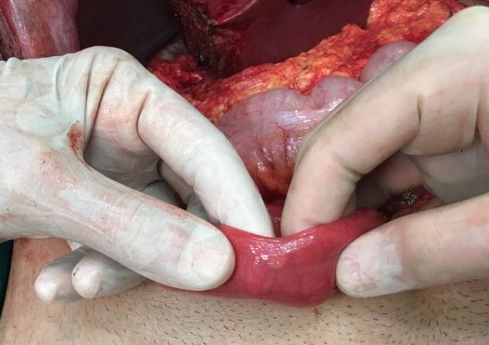

Figure 1 Intraoperative view of the tumor located in the antimesenteric border of the small intestine.

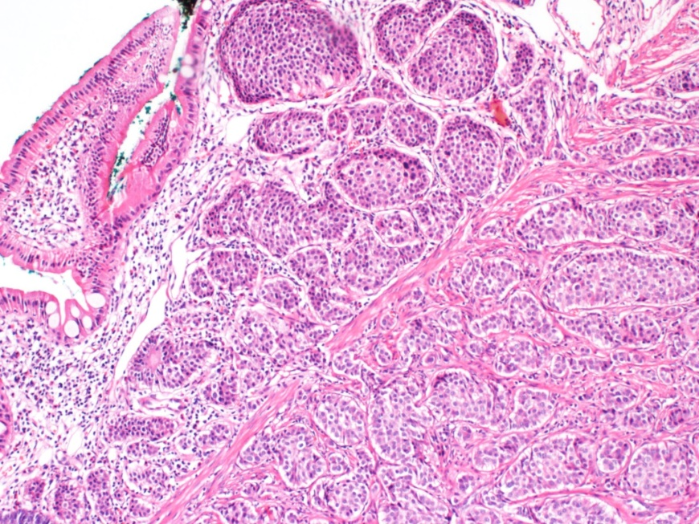
Figure 2 Tumor cells are seen in the submucosa with insulary pattern (HE x 100).

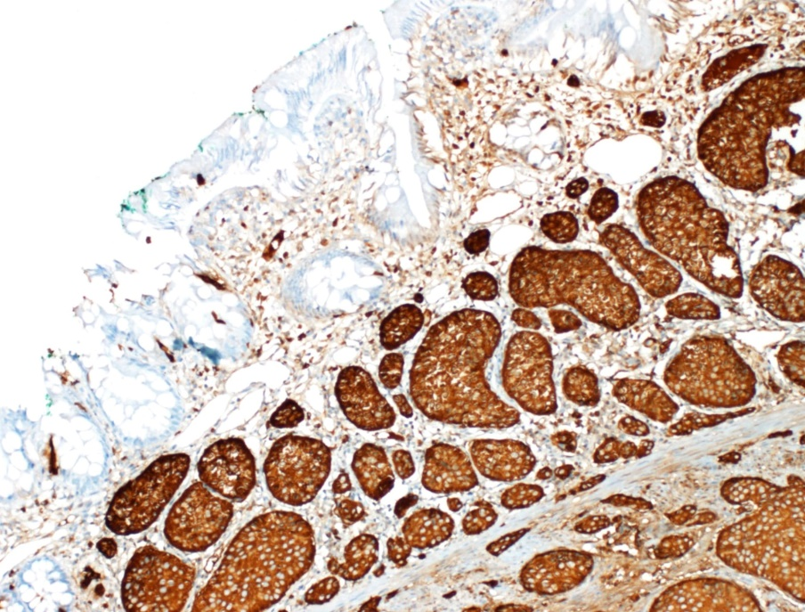
A
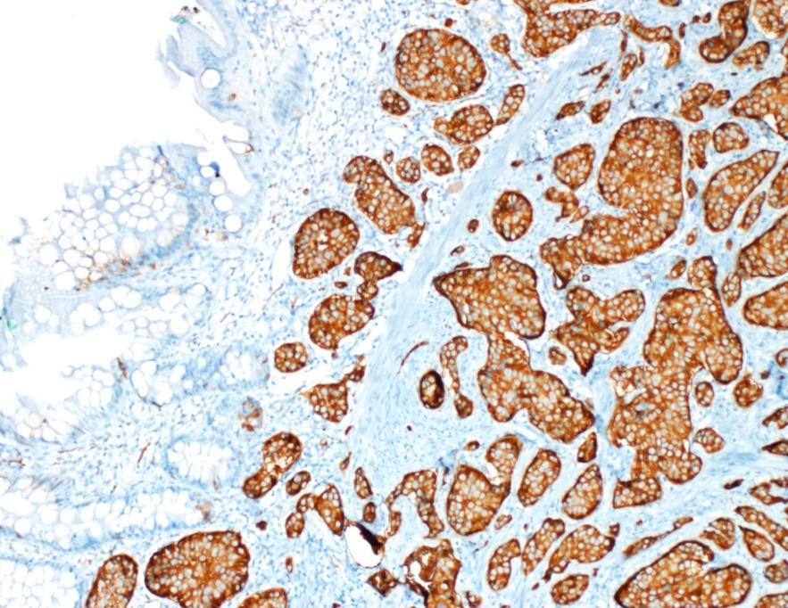
B
Figure 3 Positive immuno staining of tumor cells with choromogranin (a) or synaptophisin (b) antibody (HE x 100).

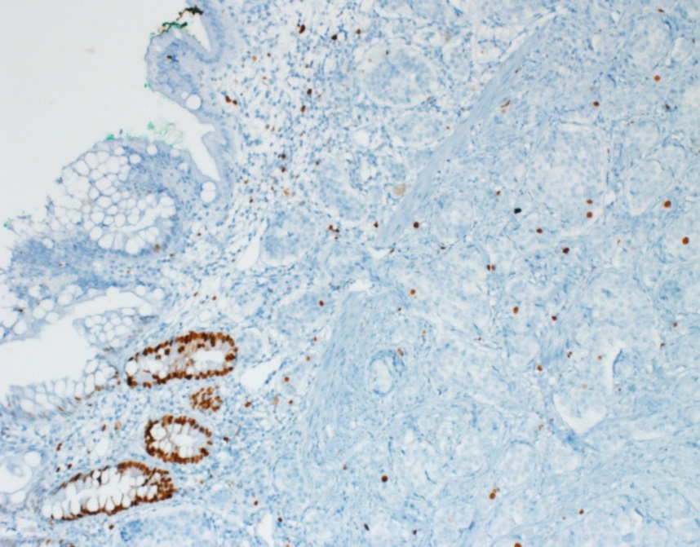
Figure 4 The low proliferation index in the tumor with Ki 67 antibody (HE x 100).

