Name of journal: World Journal of Gastroenterology
Manuscript NO: 31467
Manuscript Type: ORIGINAL ARTICLE

Basic Study
Naringenin prevents experimental liver fibrosis by blocking TGFβ-Smad3 and JNK-Smad3 pathways

Hernández-Aquino E et al. Naringenin prevents fibrosis by blocking the Smad3 pathway

Erika Hernández-Aquino, Natanael Zarco, Sael Casas-Grajales, Erika Ramos-Tovar, Rosa E Flores-Beltrán, Jonathan Arauz, Mineko Shibayama, Liliana Favari, Víctor Tsutsumi, José Segovia, Pablo Muriel

Erika Hernández-Aquino, Sael Casas-Grajales, Erika Ramos-Tovar, Rosa E Flores-Beltrán, Liliana Favari, Pablo Muriel, Department of Pharmacology, Cinvestav-IPN, Apartado Postal 14-740, Mexico City, Mexico

Natanael Zarco, José Segovia, Department of Physiology, Biophysics and Neurosciences, Cinvestav-IPN, Apartado Postal 14-740, Mexico City, Mexico

Víctor Tsutsumi, Mineko Shibayama, Department of Infectomics and Molecular Pathogenesis. Cinvestav-IPN, Apartado Postal 14-740, Mexico City, Mexico

Jonathan Arauz, Department of Pharmacology, School of Medicine, Autonomous University of Baja California, Mexicali, Baja California, Mexico

Author contributions: Hernández-Aquino E, Zarco N, Casas-Grajales S, Ramos-Tovar E, Flores-Beltrán RE, Arauz J, Segovia J and Favari L performed the biochemical, molecular and zymography determinations; Tsutsumi V and Shibayama M performed the histological stains and their interpretation; and Muriel P designed the research and wrote the paper together with Hernández-Aquino E.

Supported by National Council of Science and Technology (Conacyt) of Mexico, No. 253037 to Muriel P, and No. 239516 to Segovia J; fellowship No. 358378 Hernández-Aquino E to from Conacyt; This work was also partially supported by a grant of PRODEP (UABC-PTC-464) Mexico.

Institutional animal care and use committee statement: The study complies with the Institution’s guidelines and the Mexican official regulation (NOM-062-ZOO-1999).

Conflict-of-interest statement: The authors declare no conflicts of interest.

Data sharing statement: No additional data are available.

Open-Access: This article is an open-access article which was selected by an in-house editor and fully peer-reviewed by external reviewers. It is distributed in accordance with the Creative Commons Attribution Non Commercial (CC BY-NC 4.0) license, which permits others to distribute, remix, adapt, build upon this work non-commercially, and license their derivative works on different terms, provided the original work is properly cited and the use is non-commercial. See: http://creativecommons.org/licenses/by-nc/4.0/

Manuscript source: Invited manuscript

Correspondence to: Pablo Muriel, PhD, Laboratory of Experimental Hepatology, Department of Pharmacology, CINVESTAV-IPN, Av. Instituto Politécnico Nacional 2508, Apartado postal 14–740, 07000, Mexico City, Mexico. pmuriel@cinvestav.mx
Telephone: +52-55-57473303
Fax: +52-55-57473394

Received: November 18, 2016
Peer-review started: November 18, 2016
First decision: March 3, 2017
Revised: March 22, 2017
Accepted: June 1, 2017
Article in press:
Published online:

Abstract
AIM
To study the molecular mechanisms involved in the hepatoprotective effects of naringenin (NAR) on carbon tetrachloride (CCl₄)-induced liver fibrosis.

METHODS
Thirty-two male Wistar rats (120-150 g) were randomly divided into four groups: (1) a control group (n = 8) that received 0.7% carboxy methyl-cellulose (NAR vehicle) 1 ml /daily p.o.; (2) a CCl₄ group (n = 8) that received 400 mg of CCl₄/kg body weight i.p. 3 times a week for 8 weeks; (3) a CCl₄ + NAR (n = 8) group that received 400 mg of CCl₄/kg body weight i.p. 3 times a week for 8 wk and 100 mg of NAR/kg body weight daily for 8 weeks p.o.; and (4) an NAR group (n = 8) that received 100 mg of NAR/kg body weight daily for 8 wk p.o. After the experimental period, animals were sacrificed under ketamine and xylazine anesthesia. Liver damage markers such as alanine aminotransferase (ALT), alkaline phosphatase (AP), γ-glutamyl transpeptidase (γ-GTP), reduced glutathione (GSH), glycogen content, lipid peroxidation (LPO) and collagen content were measured. The enzymatic activity of glutathione peroxidase (GPx) was assessed. Liver histopathology was performed utilizing Masson’s trichrome and hematoxylin-eosin stains. Zymography assays for MMP-9 and MMP-2 were carried out. Hepatic TGF-β, α-SMA, CTGF, Col-I, MMP-13, NF-κB, IL-1, IL-10, Smad7, Smad3, pSmad3 and pJNK proteins were detected via western blot.

RESULTS
NAR administration prevented increases in ALT, AP, γ-GTP, and GPx enzymatic activity; depletion of GSH and glycogen; and increases in LPO and collagen produced by chronic CCl₄ intoxication (P < 0.05). Liver histopathology showed a decrease in collagen deposition when rats received NAR in addition to CCl₄. Although zymography assays showed that CCl₄ produced an increase in MMP-9 and MMP-2 gelatinase activity; interestingly, NAR administration was associated with normal MMP-9 and MMP-2 activity (P < 0.05). The anti-inflammatory, antinecrotic and antifibrotic effects of NAR may be attributed to its ability to prevent NF-κB activation and the subsequent production of IL-1 and IL-10 (P < 0.05). NAR completely prevented the increase in TGF-β α-SMA, CTGF, Col-1, and MMP-13 proteins compared with the CCl₄-treated group (P < 0.05). NAR prevented Smad3 phosphorylation in the linker region by JNK since this flavonoid blocked this kinase (P < 0.05).

Conclusion
NAR prevents CCl₄ induced liver inflammation, necrosis and fibrosis, due to its antioxidant capacity as a free radical inhibitor and by inhibiting the NF-κB, TGF-β-Smad3 and JNK-Smad3 pathways.

Key words: fibrosis; transforming growth factor-β; naringenin; pSmad3; Smad3; JNK; nuclear factor kappa; carbon tetrachloride

© The Author(s) 2017. Published by Baishideng Publishing Group Inc. All rights reserved.

Core tip: To study the effect of naringenin (NAR) on carbon tetrachloride (CCl₄)-induced chronic liver fibrosis, male Wistar rats were administered 400 mg of CCl₄/kg body weight and 100 mg of NAR/kg body weight for 8 weeks. NAR prevented necrosis, cholestasis, oxidative stress, collagen accumulation and the increase in MMP activity caused by CCl₄ administration. NAR completely prevented the increase in TGF-β, α-SMA, CTGF, Col-1, MMP-13, NF-κB, IL-1 and IL-10 protein levels caused by CCl₄ administration and pSmad3 and pJNK activation. In conclusion, NAR prevents CCl₄ induced liver fibrosis due to its antioxidant capacity and by inhibiting the TGF-β-Smad3, JNK-Smad3 and NF-κB pathways.

Hernández-Aquino E, Zarco N, Casas-Grajales S, Ramos-Tovar E, Flores-Beltrán RE, Arauz J, Shibayama M, Favari L, Tsutsumi V, Segovia J, Muriel P. Naringenin prevents experimental liver fibrosis by blocking TGFβ-Smad3 and JNK-Smad3 pathways. World J Gastroenterol 2017; In press

INTRODUCTION
It is known that various agents, including infections, ethanol ingestion, drug intoxication or malnutrition, result in liver damage. When the damage is prolonged, liver fibrosis occurs. Fibrosis is the result of excessive accumulation of extracellular matrix (ECM) proteins after chronic liver damage. Advanced liver fibrosis leads to cirrhosis, which is characterized by scar tissue, loss of parenchymal architecture and organ failure^{[1,2]}.
The most important profibrogenic pathways involve transforming growth factor (TGF)-β and PDGF, which induce the transdifferentiation of hepatic stellate cells (HSCs) from a non-proliferating cell type into a proliferating activated phenotype. This activation results in α-smooth-muscle actin (α-SMA) and collagen expression, which in turn lead to fibrosis^{[3,4]}.
Traditionally, TGF-β has been considered to exert profibrogenic actions by binding to its receptor, which in turn phosphorylates transcription factors called R-Smads (Smad2 and Smad3) at its C-terminal. This is the canonical pathway, generally described as the main fibrogenic pathway, especially when Smad3 is phosphorylated at its C-terminus (pSmad3C)^{[5-8]}. There is also a non-canonical pathway, in which PDGF activates JNK, which in turn phosphorylates Smad3 in the linker domain to generate pSmad3L, which rapidly translocates to the nucleus where it stimulates HSC proliferation^{[9,10]}. These pathways are critical for the induction of ECM deposition and the development of fibrosis and cirrhosis. Therefore, the canonical and non-canonical pathways constitute valuable targets in the development new and effective drugs to prevent liver fibrosis.
On the other hand, naringenin (NAR), 4',5,7-trihydroxy flavanone (Figure 1), is a flavonoid that is widely distributed in cherries, cocoa, grapes, tangelos, blood oranges, lemons, grapefruit, tangerines and tomatoes^{[11-13]}; it has been demonstrated to prevent acute liver damage induced by alcohol, carbon tetrachloride (CCl₄), lipopolysaccharide or heavy metals^{[14-17]}. In addition, there is some experimental evidence on the anticancer properties of NAR^{[18,19]}.
Some reports have shown evidence of the antifibrotic properties of NAR. Lee et al^{[19]} showed some histological evidence that NAR prevents collagen deposition in dimethyl nitrosamine-induced liver damage in rats, but no mechanism was evaluated. Du et al^{[20]} reported an antifibrotic effect of NAR in lung tissue that was associated with the downregulation of TGF-β activity. In a study with cultured rat HSCs, NAR prevented ECM deposition induced by TGF-β through the downregulation of Smad3 protein levels^{[8]}. However, to the best of our knowledge, there are no studies on the antifibrotic effect of NAR on liver cirrhosis. Therefore, the above information prompted us to investigate whether NAR was able to prevent CCl₄- induced liver cirrhosis in the rat and to elucidate if the mechanism of action of the flavonoid was associated with an inhibition of the canonical and/or non-canonical TGF-β pathways and/or the inflammatory pathway (NF-κB) and/or through antioxidant mechanisms.
In fact, we demonstrate for the first time that NAR is able to prevent CCl₄ -cirrhosis by inhibiting the canonical and non-canonical pathways, including the prevention of pSmad3L phosphorylation by JNK, by exerting anti-inflammatory properties that block the NF-κB inflammatory cascade, and via an antioxidant mechanism. These effects lead to the inhibition of HSC transdifferentiation, the downregulation of ECM synthesis, and the prevention of necrosis, cholestasis and distortion of the hepatic architecture. As a result, experimental cirrhosis was prevented.

MATERIAL AND METHODS

Ethics statement and animal treatment
Wistar male rats were used and maintained on a standard diet of rat chow with free access to drinking water. Four or five animals were housed in each polycarbonate cage under controlled conditions (22 ± 2 °C, 50%-60% relative humidity and 12-h light-dark cycles). The study complies with the Institution’s guidelines and the Mexican official regulation (NOM-062-ZOO-1999) regarding technical specifications for production, care and handling of laboratory animals.

Study design
Wistar rats initially weighing 120-150 g were used. Cirrhosis was produced by intraperitoneal (i.p.) administration of CCl₄ (400 mg/kg body weight) dissolved in mineral oil three times per week for 8 weeks. To determine the capacity of NAR to prevent liver fibrosis, four groups were formed and treated for 8 weeks. Group 1 (n = 8) consisted of control animals receiving carboxy methyl-cellulose (CMC) p.o., the NAR vehicle; group 2 (n = 8) was administered CCl₄; group 3 (n = 8) was administered CCl₄ plus NAR (100 mg/kg body weight, daily p.o.); group 4 (n = 8) was administered NAR only. All animals were sacrificed after 8 weeks under ketamine (100 mg/kg of body weight) and xylazine (8 mg/kg of body weight) anesthesia. Blood was collected by cardiac puncture, and the liver was rapidly removed and properly stored for further analysis.

Serum enzyme activities
The determination of liver damage was performed by measuring the activities of alanine aminotransferase (ALT)^{[21]}, alkaline phosphatase (AP)^{[22]}, and γ-glutamyl transpeptidase (γ-GTP)^{[23]} in serum samples of blood that were centrifuged at 1300 rpm for 15 min.

Glycogen determination
Small pieces of liver were separated for glycogen determination using the anthrone reagent^{[24]}. Briefly, fresh liver samples (0.5 g) were boiled in 1.5 mL of 30% KOH for 30 min. After cooling, samples were diluted in a volumetric flask of 25 mL. Then, 40 µL (control and NAR groups) or 160 µL (CCl₄ or CCl₄ + NAR groups) was added to 960 μL and 840 μL of deionized water, respectively. Then, 2 mL of 0.2% anthrone (dissolved in concentrated sulfuric acid) was added. Samples were boiled for 15 min and the absorbance was read at 620 nm. Appropriate glucose standards were prepared.

Assessment of lipid peroxidation
The extent of lipid peroxidation (LPO) was evaluated in liver homogenates via the measurement of malondialdehyde (MDA) formation with the thiobarbituric acid method^{[25]}. Fresh liver samples (0.5 g) were homogenized in 5 mL of deionized water on ice with a polytron homogenizer. Later, 300 µL of 10% liver homogenate with 700 µL of 150 mmol/L Tris-HCl (pH 7.4) and 2 mL of 0.375% thiobarbituric acid (dissolved in 15% trichloroacetic acid) were boiled for 45 min and centrifuged at 3000 rpm for 10 min. The supernatant absorbance was read at 532 nm. The protein concentration was determined via the Bradford method using bovine serum albumin as a standard^{[26]}.

Reduced glutathione in liver and blood samples
Fresh liver (0.3 g) and blood (0.3 mL) samples were homogenized in 1.2 mL of precipitating solution (5 mmol/L EDTA in 5% trichloroacetic acid) and centrifuged for 20 min at 12000 rpm. Then, 0.1 mL of the supernatant with 2.1 mL of phosphate solution (0.3 mol/L sodium phosphate dibasic) and 0.25 mL of Ellman’s reagent (40 mg of 5,5’-dithiobis nitrobenzoic acid dissolved in 100 mL of 1% sodium citrate) were mixed. The absorbance was read at 412 nm^{[27]}.

Glutathione peroxidase activity in the liver
The method of Lawrence and Burk^{[28]} was used to determine glutathione peroxidase (GPx) activity with cumene hydroperoxide as a substrate. An aliquot of 1.5 ml of the 10% liver homogenate with 75 mmol/L potassium phosphate buffer (pH 7.0) was filtered through muslin cloth and centrifuged at 3000 rpm for 5 min at 4 °C. The reaction mixture contained 200 ml of the homogenate supernatant, 2.0 ml of 75 mmol/L potassium phosphate buffer (pH 7.0), 50 ml of 60 mmol/L glutathione, 0.1 ml of 30 U/ml glutathione reductase, 0.1 ml of 15 mmol/L EDTA, 0.1 ml of 3 mmol/L β-nicotinamide adenine dinucleotide phosphate (NADPH) and 0.3 ml of water. The reaction was started by the addition of 0.1 ml of 45 mmol/L cumene hydroperoxide. Oxidation of NADPH was recorded at 340 nm for 4 min, and the enzymatic activity was calculated as nmol of NADPH oxidized min⁻¹mg⁻¹ of protein using a molar extinction coefficient of 6.22 × 10⁶ M^{–1} cm^{–1}.

Collagen quantification
Fresh liver samples (100 mg) were placed in ampoules, 2 mL of 6 N HCl was added, and then the samples were sealed and hydrolyzed at 100°C for 48 h. Next, the samples were evaporated at 50 °C for 24 h and resuspended in 3 mL of sodium acetate-citric buffer, pH 6.0; 0.5 g of activated charcoal was added, and the mixture was stirred vigorously and then centrifuged at 3000 rpm for 15 min. Then, 1 mL of chloramine T was added to 1 mL of the supernatant. The mixture was kept for 20 min at room temperature, and the reaction was stopped by the addition of 0.5 mL of 2 mol/L sodium thiosulfate and 1 mL of 1 N sodium hydroxide. The aqueous layer was transferred into test tubes. The oxidation product from hydroxyproline was converted to a pyrrole by boiling the samples. The pyrrole-containing samples were incubated with Ehrlich’s reagent for 30 min, and the absorbance was read at 560 nm. The recovery of known amounts of standards was carried out on similar liver samples for quantification^{[29]}.

Histology
Liver samples were taken from all animals and fixed with 10% formaldehyde in phosphate-buffered saline for 24 h. Tissue samples were then washed with tap water, dehydrated in alcohol and embedded in paraffin. Five-micrometer-thick sections were mounted on silane covered glass slides. Staining was performed with hematoxylin and eosin (H&E) and Masson’s trichrome stain.

Zymography
Proteolytic activity was assayed with gelatin-substrate gels. Liver tissue (0.25 g) was homogenized with 1.7 ml of 1 × PBS. Then, the samples were homogenized on ice with a polytron homogenizer, sonicated and centrifuged at 13000 rpm for 10 min. The supernatant was collected and proteins were quantified via the bicinchoninic acid method (Pierce BCA Protein Assay Prod # 23223 Thermo Scientific). Volumes equivalent to 50 µg of non-heated proteins were mixed with sample buffer (2.5% SDS, 1% sucrose and 4 mg/mL phenol red) without reducing agent and applied to 8% acrylamide gels copolymerized with 1 mg/mL gelatin. After electrophoresis at 72 V for 2 h, the gels were rinsed twice in 2.5% Triton X-100 to remove SDS and then incubated in 50 mmol/L Tris–HCl at pH 7.4 and 5 mmol/L CaCl₂ assay buffer at 37 °C for 48 h. The gels were then fixed and stained with 0.25% Coomassie Brilliant Blue G-250 in 10% acetic acid and 30% methanol. Proteolytic activity was detected as clear bands against the background stain of undigested substrate in the gel at the expected location according to the molecular weight of metalloproteinase (MMP)-9 and MMP-2. Images were digitized and then analyzed densitometrically with ImageJ software.

Western blot assays
To carry out western blot assays, lysis buffer (1 mol/L Tris-HCl pH 8, 5 mol/L NaCl, NP40, Triton, 0.5 mol/L EDTA pH 8, 0.1 mol/L PMSF, 0.1 mol/L Na₃VO₄, 0.1 mol/L NaF) with protease and phosphatase inhibitors (Pierce BCA Protein Assay Prod # 23223 Thermo Scientific), each at a ratio of 1:100, was used to isolate total protein from liver tissue samples. Liver tissue (50 mg) was homogenized with 500 µL of lysis buffer. Then the samples were sonicated and centrifuged at 12000 rpm for 2 min. The supernatant was collected and proteins were quantified via the bicinchoninic acid method.
Volumes equivalent to 50 and 250 µg of protein were transferred onto 15, 12 and 10% polyacrylamide and electrophoresis was carried out. Separated proteins were transferred onto an Inmuno-BlotTM PVDF membrane (BIO-RAD, Hercules, CA, USA). Next, blots were blocked with 7% skim milk and 0.05% Tween-20 for 2 h at room temperature and independently incubated overnight at 4 °C with specific primary antibodies (Table 1). The following day, membranes were washed with TBS-tween-20 and then exposed to a secondary peroxidase-labeled antibody α-mouse (62-6520 Invitrogen) or α-rabbit (31460 Thermo Fisher Scientific) in the blocking solution for 2 h at room temperature. Blots were then washed with TBS-tween-20, and protein development was performed with the western lightningTM Plus-ECL Enhanced Chemiluminescence detection system (NEN Life Sciences Products, Elmer LAS Inc., Boston, MA, United States). β-actin was used as a control to normalize cytokine protein expression levels. Images were digitized and then analyzed densitometrically with ImageJ software.

Statistical analysis
All data are expressed as the mean values ± SE. Comparisons were carried out via the analysis of one way variance followed by Tukey´s test, as appropriate, using the Graph Pad Prism software. Differences were considered statistically significant when p was < 0.05.

RESULTS
NAR prevented necrosis and cholestasis and improved liver biosynthetic capacity in CCl₄ -treated rats
As shown in Figure 2, chronic administration of CCl₄ significantly increased the serum activity of ALT, a hepatocyte necrosis indicator^{[30]}. After CCl₄ administration, AP and γ-GTP (two markers of cholestasis^{[30]}) serum activity significantly increased compared to the levels in the control group. NAR administration completely prevented the increase in ALT, AP and GTP activity, suggesting that NAR is able to prevent necrosis and cholestasis caused by CCl₄ administration.
Glycogen measurement is used to determine the biosynthetic capacity and proper function of the liver^{[30]}. Cirrhotic livers had significantly lower glycogen levels; however, NAR completely prevented the depletion of hepatic glycogen (Figure 3).

NAR prevented the oxidative stress caused by chronic liver damage
One of the main products of LPO is MDA, which is utilized to measure oxidative stress in tissues^{[31]}. As expected, the induction of cirrhosis triggered LPO, since MDA levels were significantly elevated compared to the control group. Interestingly, NAR prevented the increase in MDA levels (Figure 4A).
Reduced glutathione (GSH) is one of the most important endogenous antioxidants^{[32]}. CCl₄-treated rats exhibited low liver and blood GSH levels compared with the control group, but NAR completely prevented this decrease and even raised GSH level above that of the control group (Figure 4B and C).
One of the most important antioxidant enzymes is GPx, which utilizes GSH to detoxify H₂O₂^{[33]}. GPx activity was significantly decreased by the chronic administration of CCl_{4,} while NAR coadministration partially prevented this effect (Figure 4D).
Together, these results show that NAR prevents oxidative stress during experimental liver cirrhosis at several levels.

Inflammation during liver injury was prevented by NAR administration
NF-κB is a key protein in inflammation, since it regulates interleukin expression, including IL-1 and IL-10^{[34,35]}. Baseline values of NF-κB, IL-1 and IL-10 were increased after CCl₄ treatment, and the expression of NF-κB increased almost 3-fold compared to the control group. The levels of IL-1 and IL-10 increased by 3.8- and 1.8-fold, respectively, compared to the control group. NAR prevented inflammation and necrosis in CCl₄-treated rats by maintaining normal NF-κB, IL-1 and IL-10 levels (Figure 5).

Collagen accumulation was prevented by NAR in CCl₄-induced experimental cirrhosis
Collagen quantification provides information about the balance between ECM synthesis and degradation^{[3,4]}. Rats treated with CCl₄ showed a nearly 4-fold increment in collagen content compared to the control group. This effect was completely prevented by NAR (Figure 6).
The general appearance of the livers at the macroscopic and microscopic level can be seen in Figure 7. Figure 7A shows a normal liver from the control group. CCl₄ treatment produced macro nodular fibrosis (Figure 7B) that was prevented by NAR administration (Figure 7C). NAR-treated rats had livers that were macroscopically similar to those of control animals (Figure 7D).
H&E staining is shown in Figure 7E-H. Figure 7E, the control group, shows no alterations of the hepatic parenchyma. Figure 7F corresponds to a representative liver section of chronic CCl₄-induced liver injury; in this case, the tissue shows liver parenchymal disruption, steatosis, hyperchromatic nuclear hepatocytes, and atypical pleomorphic nuclei. Fibrosis was decreased by the administration of NAR (Figure 7G). NAR treatment of control rats produced no effect on liver histology (Figure 7H).
Masson’s stained liver slices are shown in Figure 7I-L. Figure 7J presents a sample of a liver from a cirrhotic rat; a large amounts of collagen around fibrotic nodules was detected. The distortion of the parenchyma is evident when compared with a normal control liver (Figure 7I). NAR treatment prevented collagen accumulation and the formation of regenerative nodules (Figure 7K), and NAR alone produced no effect (Figure 7L).

NAR preserved the normal activity of MMP-9 and MMP-2 in experimental liver cirrhosis
MMPs are enzymes that are responsible for ECM degradation, and among the most important are MMP-9 and MMP-2^{[36]}. As seen in Figure 8, during normal conditions, MMP-9 and MMP-2 exhibit basal activity. However, after CCl₄ administration, MMP-9 and MMP-2 activities increased 3.7- and 5.4-fold compared to the control group, respectively. NAR treatment effectively maintained basal MMP activity levels in animals with experimental cirrhosis induced by CCl₄.

NAR blocked HSC transdifferentiation and Col-1 synthesis by inhibiting profibrogenic proteins
It is well known that TGF-β induces HSC transdifferentiation, as well as α-SMA, Col-1 and connective tissue growth factor (CTGF) expression in HSCs^{[1,37]}. In this study, under normal conditions, basal TGF-β, α-SMA, CTGF and Col-1 protein levels were observed; however, experimental fibrosis induced by CCl₄ administration increased the expression of such proteins several-fold compared to the control group. NAR administration completely prevented the elevation of TGF-β, α-SMA, CTGF and Col-1 levels during CCl₄ administration. Unexpectedly, NAR alone reduced α-SMA and Col-1 levels to below the control group (Figure 9A-D).
MMP-13 is involved in the migration and proliferation of HSCs and the activation of TGF-β^{[38]}. As seen in Figure 9E, during normal conditions MMP-13 depicts basal protein levels; however, due to CCl₄ administration, the MMP-13 level increased 2.3 fold above the control group. NAR treatment effectively maintained basal MMP-13 protein levels in animals with experimental cirrhosis induced by CCl₄.
Since Smad7 inhibits the TGF-β signaling pathway by TGF-β receptor ubiquitination^{[39]}, we evaluated Smad7 to determine its participation in the mechanism of action of NAR. Smad7 levels were significantly decreased by CCl₄ administration, but this effect was prevented by NAR treatment. Interestingly, NAR administration by itself increased Smad7 protein expression above control values (Figure 9F).

NAR inhibited HSC proliferation by blocking the JNK-pSmad3L pathway
Smad3 is normally activated by TGF-β, but JNK, via the linker phosphorylation pathway, also enables Smad3 to induce HSC proliferation^{[9,10]}. Our results confirmed that animals treated with CCl₄ over 8 weeks showed a significant increase in the expression of pJNK, pSmad3L and Smad3 compared with basal conditions. Interestingly, NAR administration prevented JNK activation, the elevation of Smad3 protein levels and phosphorylation in the linker region (Figure 10).

DISCUSSION
The aim of this study was to evaluate the hepatoprotective effect of NAR in a model of CCl₄-induced chronic damage and to investigate whether the beneficial effects of NAR are associated with its antioxidant properties, and/or the disruption of NF-κB, and/or the canonical or non-canonical TGF-β pathways. The results show that the flavonoid is able to prevent necrosis, cholestasis, glycogen stores depletion and oxidative stress induced by chronic CCl₄ administration. NAR preserved liver function, normal collagen levels and MMP basal activity during CCl₄ administration. In addition, NAR prevented HSC transdifferentiation and Col-1 synthesis by inhibiting profibrogenic proteins such as TGF-β and CTGF. NAR also preserved Smad7 protein levels, which decreased during liver injury. Regarding the non-canonical Smad pathway, the flavonoid prevented the activation of JNK and Smad3 phosphorylation in the linker region. Finally, NAR showed anti-inflammatory properties because it maintained normal levels of NF-κB, IL-1 and IL-10 during liver injury. In summary, NAR prevented CCl₄ -cirrhosis by means of its antioxidant, anti-inflammatory, immunomodulatory and antifibrotic properties.

NAR protects the liver via an antioxidant mechanism
The antinecrotic and anticholestatic effects of NAR may be associated with the ability of the flavonoid to prevent membrane damage due to its antioxidant properties. The toxic effect of CCl₄ is dependent on its degraded metabolites, trichloromethyl and trichloromethyl peroxyl radicals, which are formed by the liver microsomal enzyme CYP2E1. These molecules are unstable radicals and exhibit strong binding affinity to protein and lipids of cell membranes by abstracting a hydrogen atom from an unsaturated lipid, thereby triggering LPO and thus causing liver damage^{[40,41]}.
NAR was able to prevent LPO due to its molecular structure; perhaps its hydroxyl groups facilitate its adherence to lipid bilayer polar groups, and its nonpolar nucleus may interact with hydrophobic tails of phospholipids, thereby reducing the deleterious effects of free radicals on membranes^{[12,42,43]}.
On the other hand, GSH is one of the main components of the endogenous antioxidant system; it scavenges hydroxyl and peroxynitrite radicals and is a GPx cofactor, among other important activities^{[32]}. Chronic CCl₄ administration decreased GSH levels; however, NAR was could preserve normal GSH levels in the liver and blood. In addition to its antioxidant properties as a free radical scavenger, NAR may also act though Nrf2 activation and induce endogenous antioxidant enzymes. In fact, NAR upregulates the expression of the enzyme glutamate-cysteine ligase, the rate limiting enzyme involved in de novo GSH synthesis^{[44-48]}, as well as glutathione reductase, which catalyzes the reduction of oxidized glutathione to the reduced form^{[15,43]}. GPx detoxifies H₂O₂ by reducing it to water and oxygen, utilizing two molecules of GSH to form GSSG in the reduction of a molecule of H₂O₂^{[49]}. In agreement with previous reports^{[13,15,50-53]}, CCl₄ decreased GPx activity in this study. NAR cotreatment partially prevented the decrement in GPx activity, probably by up regulating its expression through Nrf2 modulation^{[15,40,43,44-47,50]}, providing another mechanism to fight oxidative stress induced by CCl₄.

NAR prevents hepatic necrosis by blocking the NF-κB pathway
Rats treated with CCl₄ showed increased NF-κB, IL-1 and IL-10 protein levels, but concomitant NAR administration with CCl₄ prevented this increase. NAR inhibits NF-κB via the downregulation of TLR4 and TLR2 mRNA and protein levels and the decreased translocation and DNA binding of NF-κB^{[54-56]}. This leads to the inhibition of the expression of NF-κB dependent interleukins, such as IL-1 and IL-10, and thus, necrosis is prevented.

NAR preserves MMP-9 and MMP-2 activity in CCl₄-treated rats
During fibrosis, activated HSCs and Kupffer cells express MMP-9 and MMP-2; these enzymes lead to TGF-β activation by cleaving TGF-β from its reservoir on ECM, thus enhancing HSC invasive activity^{[38,53,57,58]}. CCl₄ chronic administration increased MMP-9 and MMP-2, while concomitant NAR administration maintained the normal activity of MMPs. In agreement with these findings, several reports indicate that NAR reduces both protein and mRNA levels of MMP-9 and MMP-2, thereby reducing the activity of these MMPs^{[59-61]}. Therefore, it seems likely that the antifibrotic effect of NAR may be due, in part, to the downregulation of MMP-9 and MMP-2.

NAR inhibits the TGF-β-Smad3 pathway, leading to the downregulation of α-SMA, CTGF and Col-I
Through pSmad3C, TGF-β induces the expression of α-SMA, CTGF and Col-1 in activated HSCs; α-SMA is a highly specific transdifferentiation marker that is closely related to HSC contractile and migration capacities. CTGF amplifies the profibrogenic action of TGF-β, and Col-I is one of the main types of ECM collagen^{[4,37,62,63]}. In this study, CCl₄ administration increased TGF-β, α-SMA, CTGF and Col-I protein levels; importantly, NAR preserved the normal levels of these proteins.
The possible mechanism by which NAR inhibits the TGF-β-Smad3 pathway are (1) a reduction in tissue TGF-β levels; (2) a decrease in Smad3 mRNA and protein levels, with consequent reduction in Smad3 phosphorylation, thus preventing the nuclear translocation of pSmad3C; and (3) a reduction in the binding of TGF-β to its specific receptor, TβRII, leading to the inhibition of Smad3 phosphorylation^{[8,20,59,64-66]}. In agreement with the results that were obtained, it has been reported that the inhibition of the TGF-β-Smad3 pathway by NAR results in decreased α-SMA, CTGF and Col-I mRNA and protein levels^{[8,19,37,67]}, therefore providing a suitable mechanism to further explain the antifibrotic properties of NAR.

NAR downregulates the profibrogenic TGF-β pathway by preserving Smad7 protein levels
Contrary to Smad3, Smad7 exerts an inhibitory effect on the TGF-β pathway by activating TβRI degradation^{[39]}. As reported by others^{[68,69]}, CCl₄ administration reduced Smad7 protein levels, but NAR was able to prevent this event. Lou et al^{[59]}, reported that NAR is able to preserve Smad7 mRNA levels in pancreatic cells treated with TGF-β. The prevention of Smad7 diminution by NAR constitutes another valuable mechanism by which the TGF-β pathway is downregulated to prevent fibrosis.

NAR blocks the profibrogenic action of TGF-β by downregulating MMP-13
MMP-13 is expressed by HSCs, Kupffer cells, and perisinusoidal cells; it releases ECM-bound cytokines such as TGF-β, leading to HSC proliferation and migration^{[38]}. CCl₄-induced liver damage increased protein levels of MMP-13; however, NAR maintained normal MMP-13 levels during liver damage. MMP-13 can be upregulated by IL-1, NF-κB and JNK^{[38,70]}; however, these proteins were also downregulated by NAR. By downregulating MMP-13, NAR may prevent ECM deposition in rats treated with CCl₄.

NAR also prevents fibrosis by blocking the non-canonical TGF-β pathway
After CCl₄ administration, the activation of JNK was elevated, as were Smad3 protein levels and phosphorylation in the linker region of this protein. During CCl₄ administration, pSmad3L has been found in the nucleus of HSCs. The phosphorylation of Smad3 in the linker region is catalyzed by pJNK, resulting in a rapid translocation of pSmad3L to the nucleus and the stimulation of expression of c-myc, an important HSC proliferation inducer^{[9,71,72]}, which leads to increased ECM production. NAR was capable of preventing the increase in Smad3 protein levels and JNK phosphorylation, and therefore, pSmad3L formation was decreased, leading to the inhibition of ECM deposition.
Figure 11 summarizes the mechanisms by which NAR acts to prevent liver oxidative stress, necrosis and fibrosis induced by chronic CCl₄ intoxication. (1) During fibrosis, TGF-β is a major HSC transdifferentiation inductor, so the levels are increased. NAR administration maintained basal levels of TGF-β. (2) Normally, latent TGF-β is anchored to the ECM, but during liver fibrogenesis, the activation of metalloproteinases such as MMP-2, MMP-9 and MMP-13 leads to TGF-β activation by cleaving it from its reservoir. NAR effectively preserved basal MMP activity levels and prevented TGF-β activation. (3) TGF-β binds to the TGF-β type II receptor (TβRII), which recruits and phosphorylates the TGF-β type I receptor (TβRI), which in turn phosphorylates Smad3 in its C-terminal region, leading to pSmad3C formation. Smad7 inhibits the TGF-β signaling pathway via TβRI ubiquitination and posterior degradation in the proteasome. NAR increased Smad7 expression, therefore downregulating the TGF-β pathway. (4) It is known that PDGF activates JNK, and in turn, this kinase phosphorylates Smad3 in the linker domain to generate pSmad3L. NAR administration prevented JNK activation and Smad3 phosphorylation. (5) Smad3 is indispensable for the canonical and non-canonical pathways and in liver samples from cirrhotic rats Smad3 levels are increased; however, NAR maintained basal Smad3 levels. (6) NF-κB regulates the expression of interleukins such as IL-1 and IL-10, while NAR prevented inflammation by downregulating the expression of NF-κB. And (7) One of the most important antioxidant enzymes is GPx, which utilizes GSH to detoxify H₂O₂; during cirrhosis, this activity decreased, and NAR partially prevented this effect and blocked LPO.

In conclusion, our results demonstrate, for the first time, that NAR completely prevents CCl₄-induced liver fibrosis in rats, not only because of its antioxidant properties but also via its effects as an immunomodulator and a downregulator of several profibrogenic pathways. The present results not only provide important information about the mechanism of the antifibrotic actions of NAR but also suggest that this flavonoid may be utilized in patients with fibrosis previous clinical and toxicological evaluation.

ACKNOWLEDGMENTS
The authors thank Ramón Hernández Guadarrama, Benjamín Salinas Hernández, Laura Dayana Buendia Montaño, Paula Vergara, Ma. Teresa García Camacho, Silvia Galindo, Angélica Silva Olivares, Rafael Leyva, Benjamín E. Chávez, and Ricardo Gaxiola for excellent technical assistance. The authors also acknowledge the Animal Lab Facility, UPEAL-Cinvestav.

COMMENTS

Background
Liver fibrosis results from chronic liver damage and is characterized by extracellular matrix (ECM) protein deposition. The mechanisms by which the ECM is induced by hepatic stellate cells includes oxidative stress and involves canonical and non-canonical TGF-β pathways and increased metalloproteinases. Naringenin (NAR) has shown some hepatoprotective properties; however, the capacity of NAR to prevent liver fibrosis has not yet been evaluated.

Research frontiers
NAR is a flavonoid that is widely distributed in nature and possesses antioxidant, anti-inflammatory and immunomodulatory properties that may be very useful to prevent hepatic fibrosis.

Innovations and breakthroughs
Oxidative stress, NF-κB activity, TGF-β-Smad3 and metalloprotease activity lead to necrosis and fibrosis. NAR may inhibit hepatic necrosis and fibrosis by blocking free radicals and inhibiting these proinflammatory and profibrotic pathways.

Applications
The current results indicate that the antinecrotic, anti-inflammatory and antifibrotic effects of NAR may be due to its ability to directly and indirectly fight free radicals and to inhibit NF-κB, IL-1, IL-10, and TGF-β-Smad3 and metalloproteases activity.

Terminology
NAR is the natural flavonoid aglycone of naringin; it is a flavanone with a stereogenic center at C2. It has two enantiomers, namely, (R)-NAR and (S)-NAR, and both NAR enantiomers are present in natural sources.

Peer-review
The paper by Hernández-Aquino et al investigated the hepato-protective and anti-fibrotic effects of NAR using a CCl₄-induced liver fibrosis model. The authors found NAR protects liver functions in the CCl₄-treated livers, and reduces levels of oxidative stress, fibrosis, and inflammation. This is an interesting paper which has implications for possible mechanisms underlying hepato-protective and anti-fibrotic effects of NAR. The manuscript was well written and the data support their claims.

REFERENCES
1 Bataller R, Brenner DA. Liver fibrosis. J Clin Invest 2005; 115: 209-218 [PMID: 15690074 DOI: 10.1172/JCI24282]
2 Pellicoro A, Ramachandran P, Iredale JP. Reversibility of liver fibrosis. Fibrogenesis Tissue Repair 2012; 5: S26 [PMID: 23259590 DOI: 10.1186/1755-1536-5-S1-S26]
3 Weiskirchen R, Tacke F. Liver Fibrosis: From Pathogenesis to Novel Therapies. Dig Dis 2016; 34: 410-422 [PMID: 27170396 DOI: 10.1159/000444556]
4 Kisseleva T, Brenner DA. Role of hepatic stellate cells in fibrogenesis and the reversal of fibrosis. J Gastroenterol Hepatol 2007; 22 Suppl 1: S73-S78 [PMID: 17567473 DOI: 10.1111/j.1440-1746.2006.04658.x]
5 Pollard TD, Earnshaw WC, Lippincott-Schwartz J. Cell Biology. 2th edition, Philadelphia: Elsevier, 2008: 433-435.
6 Fabregat I, Moreno-Càceres J, Sánchez A, Dooley S, Dewidar B, Giannelli G, Ten Dijke P. TGF-β signalling and liver disease. FEBS J 2016; 283: 2219-2232 [PMID: 26807763 DOI: 10.1111/febs.13665]
7 Roberts AB, Tian F, Byfield SD, Stuelten C, Ooshima A, Saika S, Flanders KC. Smad3 is key to TGF-beta-mediated epithelial-to-mesenchymal transition, fibrosis, tumor suppression and metastasis. Cytokine Growth Factor Rev 2006; 17: 19-27 [PMID: 16290023 DOI: 10.1016/j.cytogfr.2005.09.008]
8 Liu X, Wang W, Hu H, Tang N, Zhang C, Liang W, Wang M. Smad3 specific inhibitor, naringenin, decreases the expression of extracellular matrix induced by TGF-beta1 in cultured rat hepatic stellate cells. Pharm Res 2006; 23: 82-89 [PMID: 16341574 DOI: 10.1007/s11095-005-9043-5]
9 Matsuzaki K. Smad phospho-isoforms direct context-dependent TGF-β signaling. Cytokine Growth Factor Rev 2013; 24: 385-399 [PMID: 23871609 DOI: 10.1016/j.cytogfr.2013.06.002]
10 Yoshida K, Murata M, Yamaguchi T, Matsuzaki K, Okazaki K. Reversible Human TGF-β Signal Shifting between Tumor Suppression and Fibro-Carcinogenesis: Implications of Smad Phospho-Isoforms for Hepatic Epithelial-Mesenchymal Transitions. J Clin Med 2016; 5: [PMID: 26771649 DOI: 10.3390/jcm5010007]
11 Erlund I. Review of the flavonoids quercetin, hesperetin, and naringenin. Dietary sources, bioactivities, bioavailability, and epidemiology. Nutr Res 2004; 24: 851-874 [DOI: 10.1016/j.nutres.2004.07.005]
12 Jayaraman J, Veerappan M, Namasivayam N. Potential beneficial effect of naringenin on lipid peroxidation and antioxidant status in rats with ethanol-induced hepatotoxicity. J Pharm Pharmacol 2009; 61: 1383-1390 [PMID: 19814872 DOI: 10.1211/jpp/61.10.0016]
13 Yen FL, Wu TH, Lin LT, Cham TM, Lin CC. Naringenin-loaded nanoparticles improve the physicochemical properties and the hepatoprotective effects of naringenin in orally-administered rats with CCl(4)-induced acute liver failure. Pharm Res 2009; 26: 893-902 [PMID: 19034626 DOI: 10.1007/s11095-008-9791-0]
14 Jayaraman J, Jesudoss VA, Menon VP, Namasivayam N. Anti-inflammatory role of naringenin in rats with ethanol induced liver injury. Toxicol Mech Methods 2012; 22: 568-576 [PMID: 22900548 DOI: 10.3109/15376516.2012.707255]
15 Esmaeili MA, Alilou M. Naringenin attenuates CCl4 -induced hepatic inflammation by the activation of an Nrf2-mediated pathway in rats. Clin Exp Pharmacol Physiol 2014; 41: 416-422 [PMID: 24684352 DOI: 10.1111/1440-1681.12230]
16 Pinho-Ribeiro FA, Zarpelon AC, Mizokami SS, Borghi SM, Bordignon J, Silva RL, Cunha TM, Alves-Filho JC, Cunha FQ, Casagrande R, Verri WA. The citrus flavonone naringenin reduces lipopolysaccharide-induced inflammatory pain and leukocyte recruitment by inhibiting NF-κB activation. J Nutr Biochem 2016; 33: 8-14 [PMID: 27260463 DOI: 10.1016/j.jnutbio.2016.03.013]
17 Ozkaya A, Sahin Z, Dag U, Ozkaraca M. Effects of Naringenin on Oxidative Stress and Histopathological Changes in the Liver of Lead Acetate Administered Rats. J Biochem Mol Toxicol 2016; 30: 243-248 [PMID: 26929248 DOI: 10.1002/jbt.21785]
18 Arul D, Subramanian P. Inhibitory effect of naringenin (citrus flavonone) on N-nitrosodiethylamine induced hepatocarcinogenesis in rats. Biochem Biophys Res Commun 2013; 434: 203-209 [PMID: 23523793 DOI: 10.1016/j.bbrc.2013.03.039]
19 Lee MH, Yoon S, Moon JO. The flavonoid naringenin inhibits dimethylnitrosamine-induced liver damage in rats. Biol Pharm Bull 2004; 27: 72-76 [PMID: 14709902]
20 Du G, Jin L, Han X, Song Z, Zhang H, Liang W. Naringenin: a potential immunomodulator for inhibiting lung fibrosis and metastasis. Cancer Res 2009; 69: 3205-3212 [PMID: 19318568 DOI: 10.1158/0008-5472.CAN-08-3393]
21 Reitman S, Frankel S. A colorimetric method for the determination of serum glutamic oxalacetic and glutamic pyruvic transaminases. Am J Clin Pathol 1957; 28: 56-63 [PMID: 13458125]
22 Bergmeyer HU, Grabl M, Walter HE. Enzymes. In: Bergmeyer J, Grabl M. Methods of Enzymatic Analysis. Weinheim: Verlag‐Chemie, 1983: 269-270
23 Glossmann H, Neville DM. gamma-Glutamyltransferase in kidney brush border membranes. FEBS Lett 1972; 19: 340-344 [PMID: 11946246]
24 Seifter S, Dayton S. The estimation of glycogen with the anthrone reagent. Arch Biochem 1950; 25: 191-200 [PMID: 15401229]
25 Ohkawa H, Ohishi N, Yagi K. Assay for lipid peroxides in animal tissues by thiobarbituric acid reaction. Anal Biochem 1979; 95: 351-358 [PMID: 36810]
26 Bradford MM. A rapid and sensitive method for the quantitation of microgram quantities of protein utilizing the principle of protein-dye binding. Anal Biochem 1976; 72: 248-254 [PMID: 942051]
27 Sedlak J, Lindsay RH. Estimation of total, protein-bound, and nonprotein sulfhydryl groups in tissue with Ellman's reagent. Anal Biochem 1968; 25: 192-205 [PMID: 4973948]
28 Lawrence RA, Burk RF. Glutathione peroxidase activity in selenium-deficient rat liver. Biochem Biophys Res Commun 1976; 71: 952-958 [PMID: 971321]
29 Prockop DJ, Udenfriend S. A specific method for the analysis of hydroxyproline in tissues and urine. Anal Biochem 1960; 1: 228-239 [PMID: 13738134]
30 Rosen HR, Keeffe EB. Evaluation of abnormal liver enzymes, use of liver test, and the serology of viral hepatitis. In: Bacon BR, Di Bisceglie AM. Liver Disease Diagnosis and Management. Philadelphia: Churchill, 2000: 24-35
31 Manibusan MK, Odin M, Eastmond DA. Postulated carbon tetrachloride mode of action: a review. J Environ Sci Health C Environ Carcinog Ecotoxicol Rev 2007; 25: 185-209 [PMID: 17763046 DOI: 10.1080/10590500701569398]
32 Arauz J, Ramos-Tovar E, Muriel P. Redox state and methods to evaluate oxidative stress in liver damage: From bench to bedside. Ann Hepatol 2016; 15: 160-173 [PMID: 26845593 DOI: 10.5604/16652681.1193701]
33 Carillon J, Rouanet JM, Cristol JP, Brion R. Superoxide dismutase administration, a potential therapy against oxidative stress related diseases: several routes of supplementation and proposal of an original mechanism of action. Pharm Res 2013; 30: 2718-2728 [PMID: 23793992 DOI: 10.1007/s11095-013-1113-5]
34 Kawai T, Akira S. TLR signaling. Semin Immunol 2007; 19: 24-32 [PMID: 17275323 DOI: 10.1016/j.smim.2006.12.004]
35 Muriel P. NF-kappaB in liver diseases: a target for drug therapy. J Appl Toxicol 2009; 29: 91-100 [PMID: 18937212 DOI: 10.1002/jat.1393]
36 Vandooren J, Geurts N, Martens E, Van den Steen PE, Opdenakker G. Zymography methods for visualizing hydrolytic enzymes. Nat Methods 2013; 10: 211-220 [PMID: 23443633 DOI: 10.1038/nmeth.2371]
37 Arauz J, Moreno MG, Cortés-Reynosa P, Salazar EP, Muriel P. Coffee attenuates fibrosis by decreasing the expression of TGF-β and CTGF in a murine model of liver damage. J Appl Toxicol 2013; 33: 970-979 [PMID: 22899499 DOI: 10.1002/jat.2788]
38 Hemmann S, Graf J, Roderfeld M, Roeb E. Expression of MMPs and TIMPs in liver fibrosis - a systematic review with special emphasis on anti-fibrotic strategies. J Hepatol 2007; 46: 955-975 [PMID: 17383048 DOI: 10.1016/j.jhep.2007.02.003]
39 Imamura T, Oshima Y, Hikita A. Regulation of TGF-β family signalling by ubiquitination and deubiquitination. J Biochem 2013; 154: 481-489 [PMID: 24165200 DOI: 10.1093/jb/mvt097]
40 Weber LW, Boll M, Stampfl A. Hepatotoxicity and mechanism of action of haloalkanes: carbon tetrachloride as a toxicological model. Crit Rev Toxicol 2003; 33: 105-136 [PMID: 12708612 DOI: 10.1080/713611034]
41 Muriel P, Ramos-Tovar E, Montes-Páez G, Buendía-Montaño LD. Experimental models of liver damage mediated by oxidative stress. In: Muriel P. Liver pathophysiology; therapies & antioxidants. Waltham, MA: Elsevier, 2016
42 Hernández-Aquino E, Muriel P. Naringenin and the liver. In: Muriel P. Liver pathophysiology; therapies & antioxidants. Waltham, MA: Elsevier, 2016
43 Jayaraman J, Namasivayam N. Naringenin modulates circulatory lipid peroxidation, anti-oxidant status and hepatic alcohol metabolizing enzymes in rats with ethanol induced liver injury. Fundam Clin Pharmacol 2011; 25: 682-689 [PMID: 21105911 DOI: 10.1111/j.1472-8206.2010.00899.x]
44 Gopinath K, Sudhandiran G. Naringin modulates oxidative stress and inflammation in 3-nitropropionic acid-induced neurodegeneration through the activation of nuclear factor-erythroid 2-related factor-2 signalling pathway. Neuroscience 2012; 227: 134-143 [PMID: 22871521 DOI: 10.1016/j.neuroscience.2012.07.060]
45 Lou H, Jing X, Wei X, Shi H, Ren D, Zhang X. Naringenin protects against 6-OHDA-induced neurotoxicity via activation of the Nrf2/ARE signaling pathway. Neuropharmacology 2014; 79: 380-388 [PMID: 24333330 DOI: 10.1016/j.neuropharm.2013.11.026]
46 Podder B, Song HY, Kim YS. Naringenin exerts cytoprotective effect against paraquat-induced toxicity in human bronchial epithelial BEAS-2B cells through NRF2 activation. J Microbiol Biotechnol 2014; 24: 605-613 [PMID: 24561720]
47 Ramprasath T, Senthamizharasi M, Vasudevan V, Sasikumar S, Yuvaraj S, Selvam GS. Naringenin confers protection against oxidative stress through upregulation of Nrf2 target genes in cardiomyoblast cells. J Physiol Biochem 2014; 70: 407-415 [PMID: 24526395 DOI: 10.1007/s13105-014-0318-3]
48 Han X, Pan J, Ren D, Cheng Y, Fan P, Lou H. Naringenin-7-O-glucoside protects against doxorubicin-induced toxicity in H9c2 cardiomyocytes by induction of endogenous antioxidant enzymes. Food Chem Toxicol 2008; 46: 3140-3146 [PMID: 18652870 DOI: 10.1016/j.fct.2008.06.086]
49 Davies KJ. Oxidative stress, antioxidant defenses, and damage removal, repair, and replacement systems. IUBMB Life 2000; 50: 279-289 [PMID: 11327322 DOI: 10.1080/713803728]
50 Dong D, Xu L, Yin L, Qi Y, Peng J. Naringin prevents carbon tetrachloride-induced acute liver injury in mice. J Funct Foods 2015; 12: 179-191 [DOI: 10.1016/j.jff.2014.11.020]
51 Maiti K, Mukherjee K, Gantait A, Saha BP, Mukherjee PK. Enhanced therapeutic potential of naringenin-phospholipid complex in rats. J Pharm Pharmacol 2006; 58: 1227-1233 [PMID: 16945181 DOI: 10.1211/jpp.58.9.0009]
52 Hermenean A, Ardelean A, Stan M, Herman H, Mihali CV, Costache M, Dinischiotu A. Protective effects of naringenin on carbon tetrachloride-induced acute nephrotoxicity in mouse kidney. Chem Biol Interact 2013; 205: 138-147 [PMID: 23845967 DOI: 10.1016/j.cbi.2013.06.016]
53 Hermenean A, Ardelean A, Stan M, Hadaruga N, Mihali CV, Costache M, Dinischiotu A. Antioxidant and hepatoprotective effects of naringenin and its β-cyclodextrin formulation in mice intoxicated with carbon tetrachloride: a comparative study. J Med Food 2014; 17: 670-677 [PMID: 24611872 DOI: 10.1089/jmf.2013.0007]
54 Dou W, Zhang J, Sun A, Zhang E, Ding L, Mukherjee S, Wei X, Chou G, Wang ZT, Mani S. Protective effect of naringenin against experimental colitis via suppression of Toll-like receptor 4/NF-κB signalling. Br J Nutr 2013; 110: 599-608 [PMID: 23506745 DOI: 10.1017/S0007114512005594]
55 Yilma AN, Singh SR, Morici L, Dennis VA. Flavonoid naringenin: a potential immunomodulator for Chlamydia trachomatis inflammation. Mediators Inflamm 2013; 2013: 102457 [PMID: 23766556 DOI: 10.1155/2013/102457]
56 Yoshida H, Watanabe W, Oomagari H, Tsuruta E, Shida M, Kurokawa M. Citrus flavonoid naringenin inhibits TLR2 expression in adipocytes. J Nutr Biochem 2013; 24: 1276-1284 [PMID: 23333096 DOI: 10.1016/j.jnutbio.2012.10.003]
57 Olaso E, Ikeda K, Eng FJ, Xu L, Wang LH, Lin HC, Friedman SL. DDR2 receptor promotes MMP-2-mediated proliferation and invasion by hepatic stellate cells. J Clin Invest 2001; 108: 1369-1378 [PMID: 11696582 DOI: 10.1172/JCI12373]
58 Hayashi H, Sakai T. Biological Significance of Local TGF-β Activation in Liver Diseases. Front Physiol 2012; 3: 12 [PMID: 22363291 DOI: 10.3389/fphys.2012.00012]
59 Lou C, Zhang F, Yang M, Zhao J, Zeng W, Fang X, Zhang Y, Zhang C, Liang W. Naringenin decreases invasiveness and metastasis by inhibiting TGF-β-induced epithelial to mesenchymal transition in pancreatic cancer cells. PLoS One 2012; 7: e50956 [PMID: 23300530 DOI: 10.1371/journal.pone.0050956]
60 Yen HR, Liu CJ, Yeh CC. Naringenin suppresses TPA-induced tumor invasion by suppressing multiple signal transduction pathways in human hepatocellular carcinoma cells. Chem Biol Interact 2015; 235: 1-9 [PMID: 25866363 DOI: 10.1016/j.cbi.2015.04.003]
61 Sun Y, Gu J. [Study on effect of naringenin in inhibiting migration and invasion of breast cancer cells and its molecular mechanism]. Zhongguo Zhong Yao Za Zhi 2015; 40: 1144-1150 [PMID: 26226761]
62 Inagaki Y, Mamura M, Kanamaru Y, Greenwel P, Nemoto T, Takehara K, Ten Dijke P, Nakao A. Constitutive phosphorylation and nuclear localization of Smad3 are correlated with increased collagen gene transcription in activated hepatic stellate cells. J Cell Physiol 2001; 187: 117-123 [PMID: 11241356 DOI: 10.1002/1097-4652(2001)9999: 9999<00: : AID-JCP1059>3.0.CO; 2-S]
63 Holmes A, Abraham DJ, Sa S, Shiwen X, Black CM, Leask A. CTGF and SMADs, maintenance of scleroderma phenotype is independent of SMAD signaling. J Biol Chem 2001; 276: 10594-10601 [PMID: 11152469 DOI: 10.1074/jbc.M010149200]
64 Martinez RM, Pinho-Ribeiro FA, Steffen VS, Caviglione CV, Vignoli JA, Barbosa DS, Baracat MM, Georgetti SR, Verri WA, Casagrande R. Naringenin Inhibits UVB Irradiation-Induced Inflammation and Oxidative Stress in the Skin of Hairless Mice. J Nat Prod 2015; 78: 1647-1655 [PMID: 26154512 DOI: 10.1021/acs.jnatprod.5b00198]
65 Meng XM, Zhang Y, Huang XR, Ren GL, Li J, Lan HY. Treatment of renal fibrosis by rebalancing TGF-β/Smad signaling with the combination of asiatic acid and naringenin. Oncotarget 2015; 6: 36984-36997 [PMID: 26474462 DOI: 10.18632/oncotarget.6100]
66 Yang Y, Xu Y, Xia T, Chen F, Zhang C, Liang W, Lai L, Fang X. A single-molecule study of the inhibition effect of Naringenin on transforming growth factor-β ligand-receptor binding. Chem Commun (Camb) 2011; 47: 5440-5442 [PMID: 21475751 DOI: 10.1039/c1cc10778j]
67 Jung JW, Park IH, Cho JS, Lee HM. Naringenin inhibits extracellular matrix production via extracellular signal-regulated kinase pathways in nasal polyp-derived fibroblasts. Phytother Res 2013; 27: 463-467 [PMID: 22674629 DOI: 10.1002/ptr.4735]
68 Bai G, Yan G, Wang G, Wan P, Zhang R. Anti-hepatic fibrosis effects of a novel turtle shell decoction by inhibiting hepatic stellate cell proliferation and blocking TGF-β1/Smad signaling pathway in rats. Oncol Rep 2016; 36: 2902-2910 [PMID: 27633729 DOI: 10.3892/or.2016.5078]
69 Wu FR, Jiang L, He XL, Zhu PL, Li J. Effect of hesperidin on TGF-beta1/Smad signaling pathway in HSC. Zhongguo Zhong Yao Za Zhi 2015; 40: 2639-2643 [PMID: 26697692]
70 Vincenti MP, Brinckerhoff CE. Transcriptional regulation of collagenase (MMP-1, MMP-13) genes in arthritis: integration of complex signaling pathways for the recruitment of gene-specific transcription factors. Arthritis Res 2002; 4: 157-164 [PMID: 12010565 DOI: 10.1186/ar401]
71 Yoshida K, Matsuzaki K, Mori S, Tahashi Y, Yamagata H, Furukawa F, Seki T, Nishizawa M, Fujisawa J, Okazaki K. Transforming growth factor-beta and platelet-derived growth factor signal via c-Jun N-terminal kinase-dependent Smad2/3 phosphorylation in rat hepatic stellate cells after acute liver injury. Am J Pathol 2005; 166: 1029-1039 [PMID: 15793284 DOI: PMC1602385]
72 Yoshida K, Matsuzaki K. Differential Regulation of TGF-β/Smad Signaling in Hepatic Stellate Cells between Acute and Chronic Liver Injuries. Front Physiol 2012; 3: 53 [PMID: 22457652 DOI: 10.3389/fphys.2012.00053]
P-Reviewer: Dang SS, Ro SW S-Editor: Gong ZM
L-Editor: E-Editor:
Specialty type: Gastroenterology and hepatology
Country of origin: Mexico
Peer-review report classification
Grade A (Excellent): 0
Grade B (Very good): B, B
Grade C (Good): 0
Grade D (Fair): 0
Grade E (Poor): 0

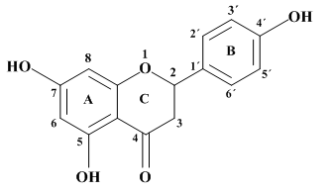
Figure 1 Chemical structure of naringenin.

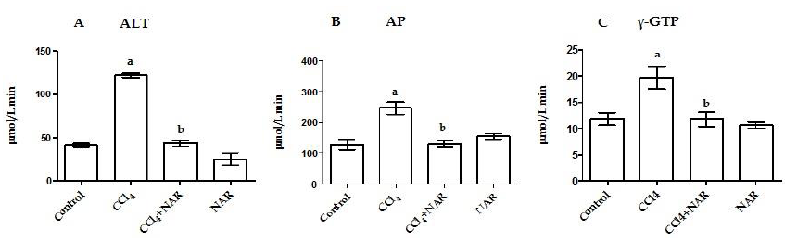
Figure 2 Naringenin prevents necrosis and cholestasis in CCl₄-treated rats. Alanine aminotransferase (ALT) (A); alkaline phosphatase (AP) (B) and γ-glutamyl transpeptidase (γ-GTP) (C) activities were determined in serum from control rats, carbon tetrachloride (CCl₄)-treated rats, CCl₄ plus naringenin rats (CCl₄ + NAR), and rats administered with NAR alone (NAR). Values represent the mean of experiments performed in duplicate assay ± SE (n = 8). ªP < 0.05 vs control group; ^{b}P < 0.05 vs CCl₄ group.

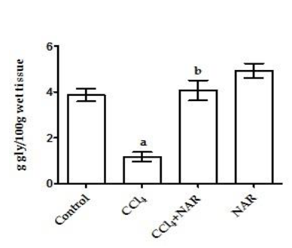
Figure 3 Naringenin prevents glycogen depletion in CCl₄-treated rats. Liver glycogen content determined in control rats, carbon tetrachloride (CCl₄)-treated rats, CCl₄ plus naringenin rats (CCl₄ + NAR), and rats administered with NAR alone (NAR). Each bar represents the mean value of experiments performed in duplicate assay ± SE (n = 8). ªP < 0.05 vs control group; ^{b}P < 0.05 vs CCl₄ group.

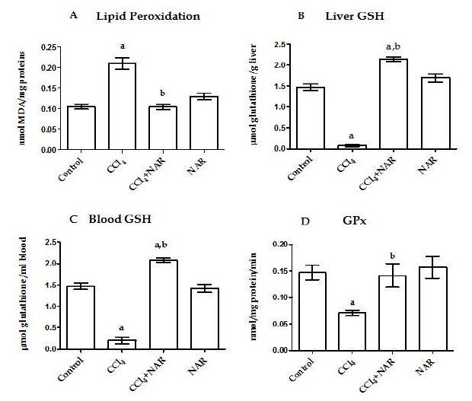
Figure 4 Naringenin prevents oxidative stress in CCl₄-treated rats. Lipid peroxidation (A), reduced glutathione (GSH) determinations in liver (B) and blood (C) and GPx activity (D) from control rats, carbon tetrachloride (CCl₄)-treated rats, CCl₄ plus naringenin rats (CCl₄ + NAR), and rats administered with NAR alone (NAR). Each bar represents the mean value of experiments performed in duplicate assay ± SE (n = 8). ªP < 0.05 vs control group; ^{b}P < 0.05 vs CCl₄ group.

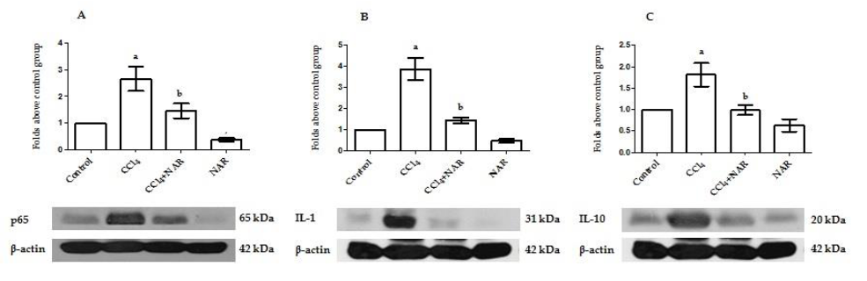
Figure 5 Naringenin prevents inflammation in CCl₄-treated rats. The NF-κB (A), IL-1 (B) and IL-10 (C) protein levels in samples of liver tissue were determined by western blot analysis from control rats, carbon tetrachloride (CCl₄)-treated rats, CCl₄ plus naringenin rats (CCl₄ + NAR), and rats administered with NAR alone (NAR). β-actin was used as a control. Values are expressed as fold increase of relative IOD normalized to the control group values (control = 1). Each bar represents the mean value of three rats ± SE. ªP < 0.05 vs control group; ^{b}P < 0.05 vs CCl₄ group.

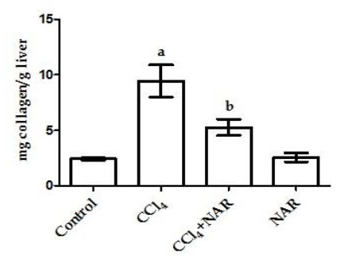
Figure 6 Naringenin prevents collagen deposition in CCl₄-treated rats. Liver collagen content determined in control rats, carbon tetrachloride (CCl₄)-treated rats, CCl₄ plus naringenin rats (CCl₄ + NAR), and rats administered with NAR alone (NAR). Each bar represents the mean value of experiments performed in duplicate assay ± SE (n = 8). ªP < 0.05 vs control group; ^{b}P < 0.05 vs CCl₄ group.

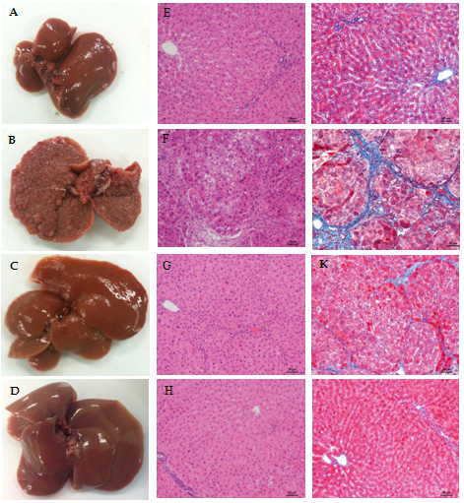
Figure 7 Naringenin effect on macroscopic and microscopic hepatic architecture in CCl₄-treated rats. Macroscopic aspect of livers in control rats (A), carbon tetrachloride (CCl₄)-treated rats (B), CCl₄ plus naringenin rats (CCl₄ + NAR) (C), and NAR alone rats (D). Hematoxylin and Eosin stain in livers of control rats (E), CCl₄-treated rats (F), CCl₄ + NAR rats (G), and rats administered with NAR alone (H). Masson’s trichromic staining in livers of control rats (I), CCl₄-treated rats (J), CCl₄ + NAR (K), and NAR alone rats (L). Bar scale = 50 μm. Magnification × 100.

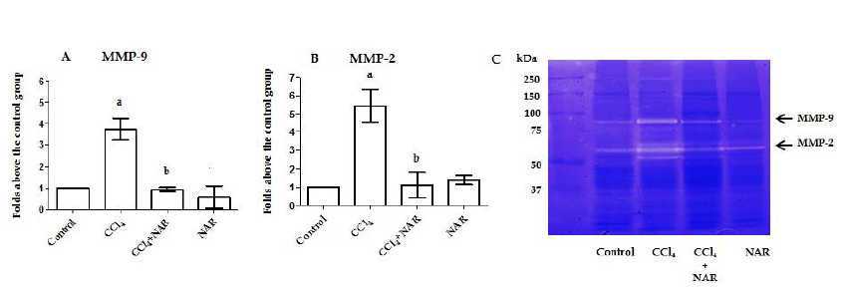
Figure 8 Naringenin prevents elevation of metalloproteinase-9 and 2 activities in CCl₄-treated rats. Matrix metalloproteinase (MMP)-9 (A) and MMP-2 (B) activities was analyzed by zymography using gelatin-substrate gels (C). Liver samples for control rats, carbon tetrachloride (CCl₄)-treated rats, CCl₄ plus naringenin rats (CCl₄ + NAR), and rats administered with NAR alone (NAR) were analyzed. Values are expressed as average of relative IOD, normalized to the control group values (control = 1). Each bar represents the mean value of three rats ± SE. ªP < 0.05 vs control group; ^{b}P < 0.05 vs CCl₄ group.

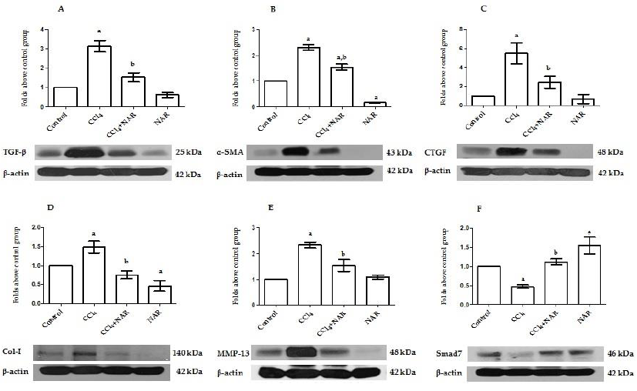
Figure 9 Naringenin prevents elevation of TGF-β, α-SMA, CTGF, MMP-13, and Col-1 protein levels, and decrease Smad7 protein levels in CCl₄-treated rats. The TGF-β (A), α-SMA (B), CTGF (C), MMP-13 (D), Col-1 (E) and Smad7 (F) protein levels in samples of liver tissue were determined by western blot analysis from control rats, carbon tetrachloride (CCl₄)-treated rats, CCl₄ plus naringenin rats (CCl₄ + NAR), and rats administered with NAR alone (NAR). β-actin was used as a control. Values are expressed as fold increase of relative IOD normalized to the control group values (control = 1). Each bar represents the mean value of three rats ± SE. ªP < 0.05 vs control group; ^{b}P < 0.05 vs CCl₄ group.

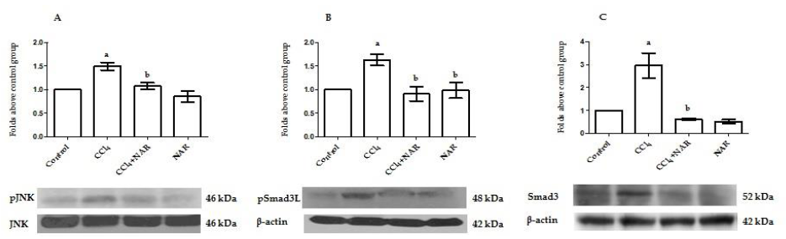
Figure 10 Naringenin prevents Smad3 linker phosphorylation by JNK inhibition in CCl₄-treated rats. pJNK (A) and pSmad3L protein activation (B) and Smad3 protein levels (C) in samples of liver tissue were determined by western blot analysis from control rats, carbon tetrachloride (CCl₄)-treated rats, CCl₄ plus naringenin rats (CCl₄ + NAR), and rats administered with NAR alone (NAR). β-actin was used as a control. Values are expressed as fold increase of relative IOD normalized to the control group values (control = 1). Each bar represents the mean value of three rats ± SE. ªP < 0.05 vs control group; ^{b}P < 0.05 vs CCl₄ group.

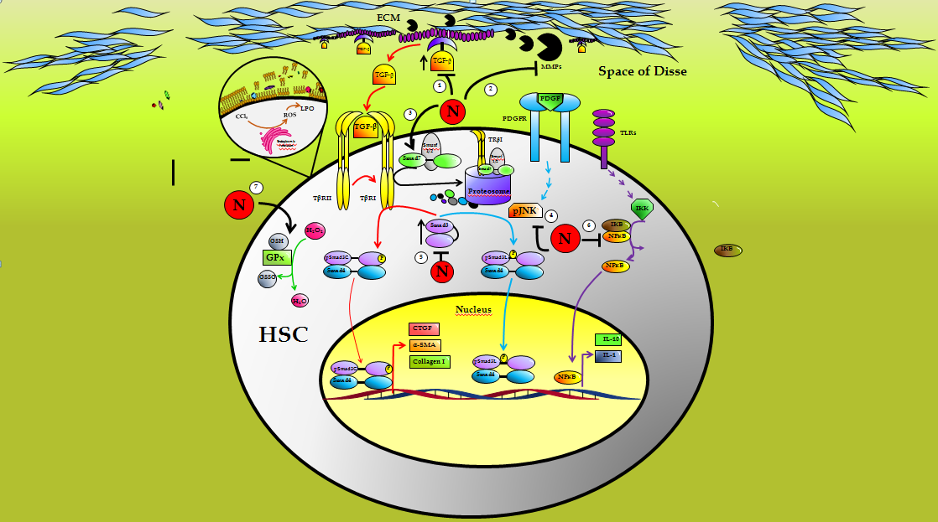
Figure 11 Schematic representation of the antifibrotic effect of naringenin. Naringenin (N) may act at 7 levels to prevent liver fibrosis: (1) by maintaining basal TGF-β levels, thus, preventing hepatic stellate cells activation (HSC), (2) preserving normal metalloproteinases (MMPs) activity blocking TGF-β liberation from extracellular matrix (ECM), (3) increasing the inhibitory protein Smad7, (4) by blocking the activation of JNK, (5) preserving Smad3 levels within control values, (6) blocking the proinflammatory factor NF-κB, (7) by counteracting oxidative stress, preserving reduced glutathione (GSH) levels, glutathione peroxidase (GPx) activity and lipid peroxidation (LPO) induced by reactive oxygen species (ROS), within normal levels.

