Name of Journal: World Journal of Clinical Cases
Manuscript NO: 56670
Manuscript Type: CASE REPORT

Pseudohyperkalemia caused by essential thrombocythemia in a patient with chronic renal failure: A case report

Guo Y et al. Pseudohyperkalemia in thrombocythemia with renal failure

Yi Guo, Hong-Chun Li

Yi Guo, Hong-Chun Li, Department of Laboratory Medicine, The Affiliated Hospital of Xuzhou Medical University, Xuzhou 221002, Jiangsu Province, China

Author contributions: Guo Y searched the medical records, reviewed the literature, contributed to data analysis, and wrote the manuscript; Li HC communicated with the patient's relatives and doctors, conceived the study, and revised the manuscript; All of the authors reviewed the manuscript.

Corresponding author: Hong-Chun Li, MSc, Assistant Professor, Department of Laboratory Medicine, The Affiliated Hospital of Xuzhou Medical University, No. 99 West Huaihai Road, Xuzhou 221002, Jiangsu Province, China. xyfylhch@126.com

Received: May 21, 2020
Revised: September 17, 2020
Accepted: September 29, 2020
Published online:

Abstract
BACKGROUND
Hyperkalemia is one of the most common complications of chronic renal failure. Pseudohyperkalemia is caused by elevated levels of serum potassium in vitro and is usually accompanied by thrombocythemia. Although an elevated level of potassium is typically correlated with impaired renal function, pseudohyperkalemia has been rarely reported in patients with chronic renal failure. Here, we conducted a review of the literature to study the case of pseudohyperkalemia caused by the essential thrombocythemia in a patient with chronic renal failure.

CASE SUMMARY
A 73-year-old woman was admitted to our hospital with complaints of palpitation, dyspnea, and acratia for 2 d and a history of essential thrombocythemia for 1 year. The routine blood test showed platelet count of 1460 × 10⁹/L, and biochemistry tests showed that the patient suffered from hyperkalemia (potassium: 7.50 mmol/L) and renal failure (estimated glomerular filtration rate: 8.88 mL/min). Initial treatment included medicines to lower her potassium-levels and hemodialysis. However, the therapy did not affect her serum potassium levels. Plasma potassium concentration measurements and a history of essential thrombocythemia established the diagnosis of pseudohyperkalemia. The treatments of the platelet disorder gradually normalized serum potassium levels; however, the treatments had to be discontinued later due to the severe leukopenia, and enhanced levels of serum potassium concentrations were observable in the patient. Since plasma sampling was not permitted, doctors had to use a diuretic just in case. Finally, the patient collapsed into unconsciousness and died due to multiple organ dysfunction and electrolyte disturbance.

CONCLUSION
We reviewed the literature and suggest that serum and plasma potassium values should both be measured for patients whose platelet counts exceed 500 × 10⁹/L to eliminate chances of pseudohyperkalemia, especially for those with chronic renal failure. An inappropriate treatment for pseudohyperkalemia can aggravate a patient's condition.

Key Words: Hyperkalemia; Pseudohyperkalemia; Thrombocythemia; Chronic renal failure; Case report

Guo Y, Li HC. Pseudohyperkalemia caused by essential thrombocythemia in a patient with chronic renal failure: A case report. World J Clin Cases 2020; In press

Core Tip: Pseudohyperkalemia in patients with chronic renal failure has been rarely reported, as an elevated level of potassium is typically correlated with impaired renal function. Herein, we studied pseudohyperkalemia caused by thrombocythemia in a patient suffering from chronic renal failure. A review of the literature is also provided to improve the overall awareness of the phenomenon in these patients. To our knowledge, our study was the first related literature review, and is the first to report the therapeutic process and outcome for an essential thrombocythemia patient with chronic renal failure.

INTRODUCTION
Hyperkalemia is a potentially life-threatening condition that needs to be treated^{[1]}. Chronic renal failure is the most common reason for potassium elevation^{[2]}. Pseudohyperkalemia is caused by elevated levels of serum potassium in vitro, and specific treatment is inappropriate^{[1]}. Thrombocythemia is often associated with this artificial potassium increase^{[3]}. Pseudohyperkalemia in patients with chronic renal failure has been rarely reported, as elevated potassium levels are usually associated with the impaired renal function. Herein, we studied pseudohyperkalemia caused by thrombocythemia in a patient suffering from chronic renal failure. To identify the timely detection of treatment alternatives for patients who showed poor prognosis, we reviewed three cases from the literature databases of pseudohyperkalemia in patients with chronic renal failure caused by an increase of platelets. To our knowledge, we are the first group to report the therapeutic process and outcomes of an essential thrombocythemia patient suffering from chronic renal failure.

CASE PRESENTATION
Chief complaints
A 73-year-old woman with symptoms such as palpitation, dyspnea, and acratia for 2 d was referred to the Emergency Department of our hospital on May 28, 2019.

History of present illness
The patient was diagnosed with essential thrombocythemia (Janus kinase 2 V617F mutation) 1 year ago, and the symptoms of palpitation, dyspnea, and acratia were detected within the past 2 d. The routine blood test showed that her platelet count was 1205 × 10⁹/L, and its reference range (RR) was 125-350 × 10⁹/L. She was transferred to the Hematology Department for further treatments on May 29, 2019.

History of past illness
The patient had a history of hypertension for 8 years. Renal insufficiency and cerebrovascular stenosis were diagnosed 4 years ago; however, her blood pressure was in control. She had aspirin irregularly, and the drug was discontinued due to purpura.

Physical examination
Slight pitting edema on both legs was revealed upon physical examination. Other remarkable abnormalities were not found. Vital signs were within normal limits, with a temperature of 36.7 °C, heart rate of 80 beats/min, respiratory rate of 18 breaths/min, and blood pressure of 120/63 mmHg.

Laboratory examinations
Repeated routine blood test showed white blood cell count of 51.4 × 10⁹/L (RR: 3.50-9.50 × 10⁹/L), hemoglobin of 60 g/L (RR: 115-150 g/L), and platelet count of 1460 × 10⁹/L. Blood biochemistry tests showed that the patient suffered from hyperkalemia (potassium: 7.50 mmol/L, RR: 3.60-5.00 mmol/L) and renal failure (urea nitrogen: 16.63 mmol/L, RR: 2.50-6.10 mmol/L; creatinine: 579 μmol/L, RR: 40-97 μmol/L; uric acid: 2578 μmol/L, RR: 149-446 μmol/L; estimated glomerular filtration rate (eGFR): 8.88 mL/min, RR: > 90.00 mL/min). Twelve lead resting electrocardiography results were normal.

Imaging examinations
The patient was diagnosed with essential thrombocythemia, chronic renal failure, and hyperkalemia.

FINAL DIAGNOSIS
The patient was diagnosed with essential thrombocythemia, chronic renal failure, and hyperkalemia.

TREATMENT
Treatment was initiated with insulin and glucose, calcium gluconate, and sodium bicarbonate. However, the therapy did not affect her serum potassium level, which was still high on the next day (8.27 mmol/L). Physicians attributed the refractory hyperkalemia to her renal failure and decided to perform hemodialysis. One day later, the level of creatinine fell to 268 μmol/L, but serum potassium concentration still fluctuated from 7.11 to 7.83 mmol/L.
Considering her high platelet counts and normal electrocardiogram (Figure 1), we inferred that the patient had pseudohyperkalemia caused by platelet clotting. Therefore, we collected two blood samples after three consecutive hemodialysis treatments. One sample was drawn into vacuum tubes with clot activator and gel separator, and the other one was injected into tubes coated with lithium heparin. Results showed that the potassium concentrations in serum were 2.35, 2.33, and 1.23 mmol/L higher than those in plasma in three tests, respectively, which verified the diagnosis of pseudohyperkalemia (Table 1).
Following suggestions from the clinical laboratory, the patient was treated with hydroxyurea to reduce the amounts of platelets on June 1, 2019. She received diuretics therapy (furosemide) at the same time. Consequently, the serum potassium concentrations decreased and were even lower than RR levels for a few days. The hydroxyurea treatment was discontinued on June 23, 2019, since the patient showed severe leukopenia (white blood cell count: 1.8 × 10⁹/L). As expected, the platelet counts and serum potassium concentrations began to increase gradually, while the serum creatinine concentrations were relatively stable. On July 16, 2019, her platelet counts increased to 1386 × 10⁹/L, and serum potassium concentration became 6.90 mmol/L. Her family members declined our initiative to collect her blood for plasma potassium concentration measurement, so physicians had to add another diuretic (torasemide) to reduce further her serum potassium level. Meanwhile, homoharringtonine was used to control platelet counts. Details are shown in Figure 2 and Table 2.

OUTCOME AND FOLLOW-UP
The patient collapsed into unconsciousness on July 19, 2019. Her family members refused favorable treatment options, and she died on August 8, 2019 due to multiple organ dysfunction and electrolyte disturbance.

DISCUSSION
Chronic kidney disease (CKD) is a potential causes of hyperkalemia. Among patients with eGFR < 60.00 mL/min, the rate of hyperkalemia (potassium: ≥ 5.50 mmol/L) and the risk of severe hyperkalemia (potassium: ≥ 6.00 mmol/L) were reported to be 8.2 events/100 patient-months and 2.6 events/100 patients-months, respectively. Such an observation represented a five-times increase in risk as compared to those without CKD^{[4]}. When the CKD progressed to renal failure (eGFR < 30 mL/min), the odds ratio of hyperkalemic events was 5.91 (95% confidence interval: 5.63-6.20) to 11.00 (95% confidence interval: 10.34-11.69)^{[5]}. In this case, the patient showed a history of chronic renal failure (eGFR = 8.88 mL/min) and increased serum potassium concentration (7.50 mmol/L) at the time of admission. Therefore, the diagnosis of hyperkalemia was plausible.
The thrombocythemia could cause hyperkalemia in vitro, and this is termed pseudohyperkalemia. Platelets in the blood samples can affect the potassium measurement when the counts exceeded 450 × 10⁹/L^{[6]}. At a platelet count of 500 × 10⁹/L or higher, 14% of samples are typically affected by pseudohyperkalemia^{[7]}. The activation of excess platelets during blood coagulation in the pro-coagulation tubes has been reported to be mainly responsible for the spurious hyperkalemia^{[6]}. Moreover, mechanical stress, such as centrifugation, can result in breakage of platelets, which could be another reason for the artificial increase in potassium concentration^{[8]}. Pseudohyperkalemia should be taken into account when the potassium concentration in serum is at least 0.40 mmol/L higher than those in plasma^{[9]}. For the needs of practical application, the discrepancy of 1.00 mmol/L between serum and plasma was recommended^{[8]}. In this case, serum potassium levels exceeded those of plasma by at least 1.00 mmol/L at three different blood sampling time points, which verified the occurrence of pseudohyperkalemia.
However, the patient was not diagnosed with pseudohyperkalemia at first since she had a history of renal failure. Doctors chose to lower actively the patient's serum potassium on a "just in case" basis, primarily due to concern about severe consequences of hyperkalemia. Unfortunately, kayexalate administration was invalidated, which brought potential risks to the disease progression.
In order to identify timely pseudohyperkalemia in thrombocytosis patients with chronic renal failure, we turned to the literature database for help. We systematically searched for relevant cases in the MEDLINE database (via PubMed) [1946 to current], EMBASE [1974 to current] and Web of Science [1990 to current] with the following search terms: ("pseudohyperkalemia" OR "spurious hyperkalemia" OR "artificial hyperkalemia") AND ("blood Platelets" OR "blood platelets" OR "blood platelet" OR "thrombocytes" OR "thrombocyte" OR "platelets" OR "platelet" OR "thrombocytosis"). Forty studies were retrieved from the aforementioned databases. After browsing the titles and abstracts, three cases met the inclusion criteria and were analyzed^{[8,10,11]}. In these cases, the patients' age ranged from 50 years to 62 years, and one patient was male. One patient complained about shortness of breath, nausea, and vomiting, while the other two presented to the hospital due to gastric ulcer bleeding with hemorrhagic shock and persistent hyperkalemia, respectively. All three cases had chronic renal failure. Two of these patients were diagnosed with essential thrombocythemia (Janus kinase 2 V617F mutation), and the other one showed increased platelet counts but refused bone marrow biopsy. Other medical history included diabetes mellitus, chronic hepatic disease, hypertension, atrial fibrillation, supraventricular tachycardia, and advanced chronic obstructive pulmonary disease. The first case believed that their patient had pseudohyperkalemia because of the relationship between serum potassium and platelet counts, but they did not measure her plasma potassium levels. In the second case, pseudohyperkalemia was suspected only when dialysis failed to lower the serum potassium concentration and was demonstrated by a difference of 2.60 mmol/L between serum and plasma potassium values. The case is similar to our study, in that both patients received some unnecessary treatments. In the third case, they set checkpoint levels in reporting laboratory test results. Since the increased potassium levels were not affected by hemolysis, an interpretative comment was added for the third case: Pseudohyperkalemia due to thrombocytosis is suspected. New samples in lithium heparin tubes were then collected, and the patient was freed from the inappropriate therapies. Therefore, we should learn from the checkpoint level system, which recommended regular serum and plasma potassium measurements for thrombocythemia patients to rule out the pseudohyperkalemia, especially for those with chronic renal failure. The cut-off value of increased platelet count was 500 × 10⁹/L^{[7]}.
The added value of our case is the description of the total therapeutic process for a thrombocythemia patient with chronic renal failure and the presentation of her outcomes. Medicines and dialysis failed to control the patient's "hyperkalemia", but treatment of the platelet disorder led to the normalization of serum potassium levels gradually. The relationship between cease of lowering the platelet counts and initiation of increasing in serum potassium values was also noticed. Therefore, thrombocythemia was mainly responsible for the elevated serum potassium levels and not the impaired renal function. Since plasma sampling was not permitted, doctors continued to use diuretics against the possible consequences induced by hyperkalemia. Jain et al^{[12]} recommended that patients receive treatment only when they were symptomatic or when they show cardiac effects of hyperkalemia on electrocardiogram. Thus, potassium-lowering treatments might be inappropriate for our patient and might aggravate the patients' condition. There are still no formal guidelines for physicians to deal with platelet-related pseudohyperkalemia. They prefer to take positive steps even if the serum potassium was spuriously elevated, since the consequences of hyperkalemia are severe^{[12]}. How to manage pseudohyperkalemia in thrombocythemia patients, especially those with renal failure, still requires further investigation with evidence-based studies.

CONCLUSION
In summary, we described a case of pseudohyperkalemia caused by the essential thrombocythemia in a patient with chronic renal failure and provide a review of the related literature. We suggest that serum and plasma potassium values should be measured for patients whose platelet counts exceeded 500 × 10⁹/L to eliminate complications due to pseudohyperkalemia, especially for those with chronic renal failure. Inappropriate treatment to pseudohyperkalemia may aggravate the patients' condition and lead to a poor outcome.

REFERENCES
1 Evans KJ, Greenberg A. Hyperkalemia: a review. J Intensive Care Med 2005; 20: 272-290 [PMID: 16145218 DOI: 10.1177/0885066605278969]
2 Gennari FJ. Disorders of potassium homeostasis. Hypokalemia and hyperkalemia. Crit Care Clin 2002; 18: 273-288 [PMID: 12053834 DOI: 10.1016/s0749-0704(01)00009-4]
3 Ong YL, Deore R, El-Agnaf M. Pseudohyperkalaemia is a common finding in myeloproliferative disorders that may lead to inappropriate management of patients. Int J Lab Hematol 2010; 32: e151-e157 [PMID: 19016918 DOI: 10.1111/j.1751-553X.2008.01114.x]
4 Seliger SL. Hyperkalemia in patients with chronic renal failure. Nephrol Dial Transplant 2019; 34: iii12-iii18 [PMID: 31800076 DOI: 10.1093/ndt/gfz231]
5 Einhorn LM, Zhan M, Hsu VD, Walker LD, Moen MF, Seliger SL, Weir MR, Fink JC. The frequency of hyperkalemia and its significance in chronic kidney disease. Arch Intern Med 2009; 169: 1156-1162 [PMID: 19546417 DOI: 10.1001/archinternmed.2009.132]
6 Roccaforte V, Daves M, Alfreijat A, Riva M, Leitner M, Filippi S, Angaroni G, Montani F, Platzgummer S, Lippi G. Spurious elevation of serum potassium concentration measured in samples with thrombocytosis. Diagnosis (Berl) 2016; 3: 71-74 [PMID: 29536889 DOI: 10.1515/dx-2016-0008]
7 Ranjitkar P, Greene DN, Baird GS, Hoofnagle AN, Mathias PC. Establishing evidence-based thresholds and laboratory practices to reduce inappropriate treatment of pseudohyperkalemia. Clin Biochem 2017; 50: 663-669 [PMID: 28288853 DOI: 10.1016/j.clinbiochem.2017.03.007]
8 Šálek T. Pseudohyperkalemia - Potassium released from cells due to clotting and centrifugation - a case report. Biochem Med (Zagreb) 2018; 28: 011002 [PMID: 29472808 DOI: 10.11613/BM.2018.011002]
9 Sevastos N, Theodossiades G, Archimandritis AJ. Pseudohyperkalemia in serum: a new insight into an old phenomenon. Clin Med Res 2008; 6: 30-32 [PMID: 18591376 DOI: 10.3121/cmr.2008.739]
10 Meka NP, Malik YO. Unexplained hyperkalemia: The tip of the iceberg. Am J Case Rep 2012; 13: 125-127 [PMID: 23569507 DOI: 10.12659/AJCR.883151]
11 Ifudu O, Markell MS, Friedman EA. Unrecognized pseudohyperkalemia as a cause of elevated potassium in patients with renal disease. Am J Nephrol 1992; 12: 102-104 [PMID: 1415352 DOI: 10.1159/000168425]
12 Jain AG, Tauseef A, Hasan SA, Jain SK, Wazir M, Majeed U. Pseudohyperkalemia: To Treat or not to Treat. Cureus 2018; 10: e3570 [PMID: 30648102 DOI: 10.7759/cureus.3570]

Footnotes
Informed consent statement: Informed written consent was obtained from the patient ' relatives for publication of this report.

Conflict-of-interest statement: The authors declare that they have no conflict of interest.

CARE Checklist (2016) statement: The authors have read the CARE Checklist (2016), and the manuscript was prepared and revised according to the CARE Checklist (2016).

Open-Access: This article is an open-access article that was selected by an in-house editor and fully peer-reviewed by external reviewers. It is distributed in accordance with the Creative Commons Attribution NonCommercial (CC BY-NC 4.0) license, which permits others to distribute, remix, adapt, build upon this work non-commercially, and license their derivative works on different terms, provided the original work is properly cited and the use is non-commercial. See: http://creativecommons.org/Licenses/by-nc/4.0/

Manuscript source: Unsolicited manuscript

Peer-review started: May 20, 2020
First decision: September 14, 2020
Article in press:

Specialty type: Medicine, research and experimental
Country/Territory of origin: China
Peer-review report’s scientific quality classification
Grade A (Excellent): 0
Grade B (Very good): B
Grade C (Good): 0
Grade D (Fair): 0
Grade E (Poor): 0

P-Reviewer: Yorioka N S-Editor: Zhang L L-Editor: Filipodia P-Editor:

Figure Legends
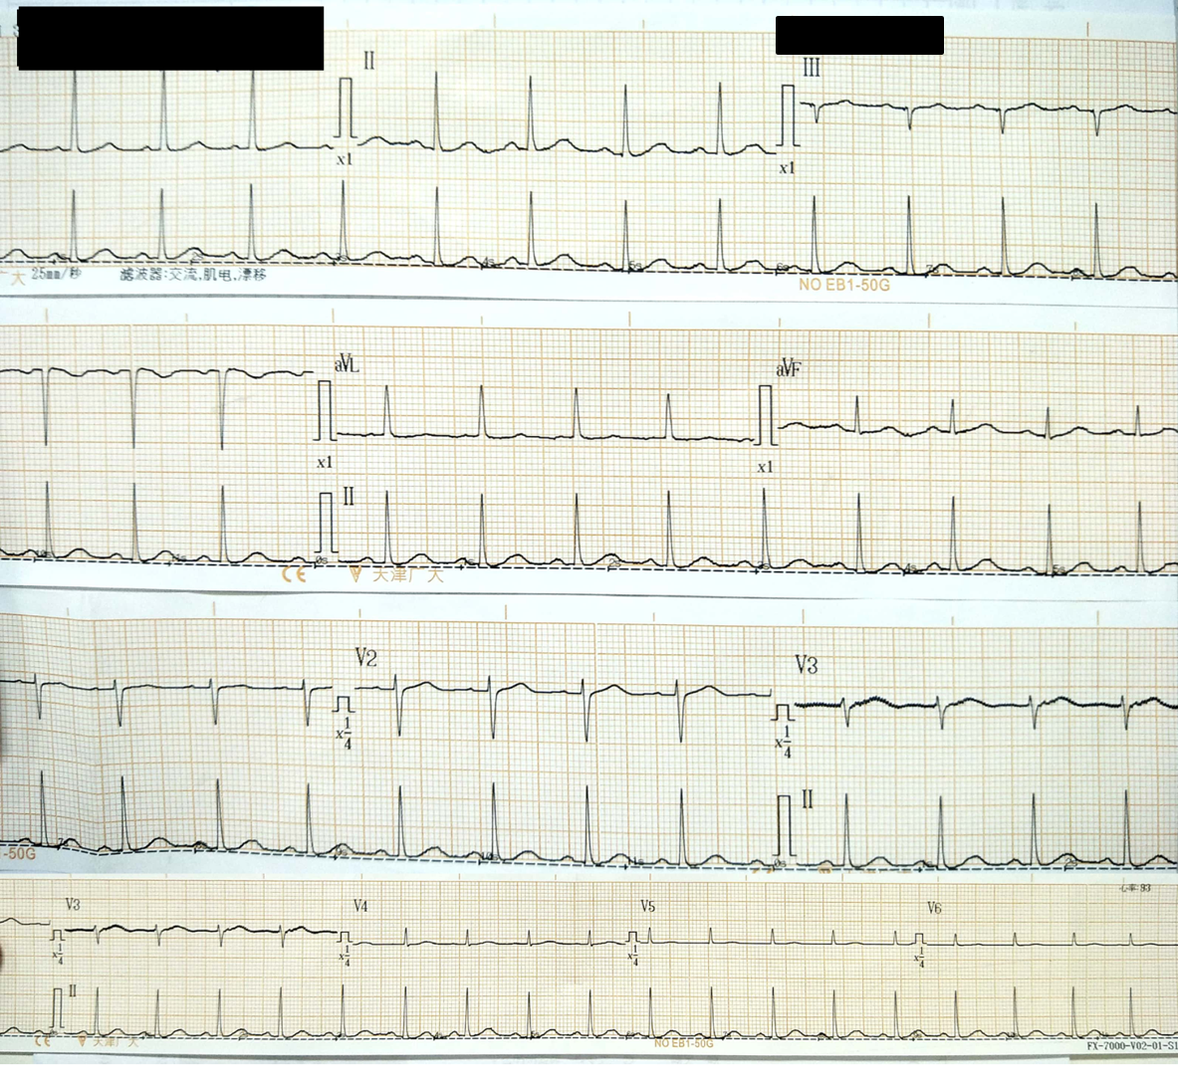
Figure 1 The patient's electrocardiogram on admission.
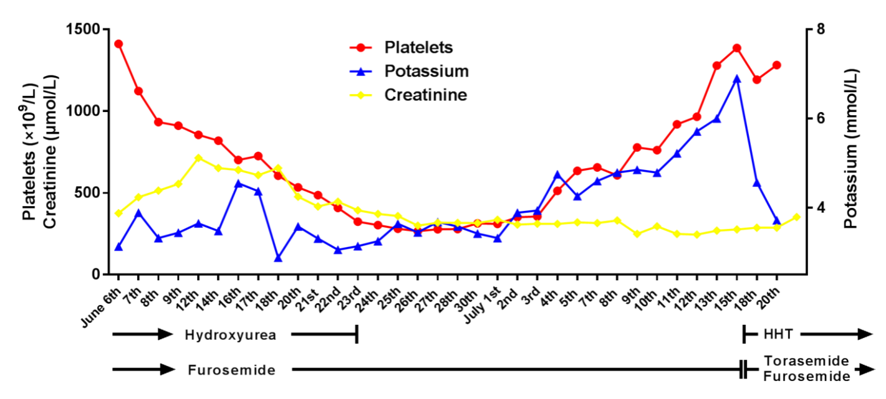
Figure 2 Monitoring the patient's serum potassium levels, serum creatinine levels, and platelet counts during treatment.
Table 1 The patient's electrolytes and renal function results from different sample types at different time points
 | June 1st |  | June 3rd |  | June 4th
 | Serum | Plasma | Serum | Plasma | Serum | Plasma
Potassium, mmol/L | 6.32 | 3.97 | 5.42 | 3.09 | 5.20 | 3.97
Sodium, mmol/L | 135.7 | 137.3 | 136.9 | 137.8 | 135.5 | 137.3
Chloride, mmol/L | 91.5 | 96.6 | 91.0 | 91.1 | 91.9 | 96.6
Calcium, mmol/L | 2.34 | 2.30 | 2.32 | 2.25 | 2.62 | 2.30
Urea nitrogen, mmol/L | 3.64 | 4.63 | 8.78 | 8.68 | 7.11 | 8.87
Creatinine, μmol/L | 220 | 240 | 469 | 481 | 346 | 315
Uric acid,  μmol/L | 541 | 606 | 2252 | 2236 | 710 | 825

Table 2 Monitoring the patient's serum potassium levels, serum creatinine levels, and platelet counts during treatment
 | Creatinine, μmol/L | Potassium, mmol/L | Platelets, × 10⁹/L
June 6th | 375 | 3.13 | 1411
June 7th | 473 | 3.89 | 1122
June 8th | 514 | 3.32 | 933
June 9th | 555 | 3.44 | 911
June 12th | 714 | 3.65 | 855
June 14th | 651 | 3.48 | 819
June 15th | 640 | 5.45 | 811
June 16th | 608 | 4.55 | 701
June 17th | 651 | 4.37 | 725
June 18th | 477 | 2.88 | 605
June 20th | 417 | 3.58 | 534
June 21st | 446 | 3.31 | 486
June 22nd | 393 | 3.06 | 408
June 23rd | 371 | 3.14 | 324
June 24th | 359 | 3.25 | 303
June 25th | 300 | 3.64 | 281
June 26th | 318 | 3.45 | 266
June 27th | 317 | 3.68 | 278
June 28th | 315 | 3.58 | 279
June 30th | 336 | 3.42 | 313
July 1st | 306 | 3.32 | 310
July 2nd | 311 | 3.89 | 351
July 3rd | 310 | 3.94 | 356
July 4th | 320 | 4.75 | 512
July 5th | 315 | 4.26 | 635
July 7th | 331 | 4.60 | 656
July 8th | 249 | 4.79 | 607
July 9th | 295 | 4.85 | 778
July 10th | 249 | 4.79 | 761
July 11th | 245 | 5.22 | 919
July 12th | 269 | 5.71 | 965
July 13th | 276 | 6.00 | 1278
July 14th | 287 | 6.90 | 1386
July 18th | 287 | 4.57 | 1192
July 20th | 352 | 3.72 | 1281

