Name of Journal: World Journal of Methodology
Manuscript NO: 66034
Manuscript Type: LETTER TO THE EDITOR

simplified figure to present direct and indirect comparisons: revisiting the graph 10 years later

Fadda V et al. Simplified figure for network meta-analysis geometry

Valeria Fadda, Laura Bartoli, Elisa Ferracane, Sabrina Trippoli, Andrea Messori

Valeria Fadda, Laura Bartoli, Elisa Ferracane, Sabrina Trippoli, Andrea Messori, HTA, ESTAR Toscana, Firenze 50132, Italy

Author contributions: Fadda V and Messori A were the main contributors of this paper; The other authors were involved in checking the manuscript, identifying inconsistencies, and generating the figure.

Corresponding author: Andrea Messori, BCPS, PharmD, Academic Fellow, Associate Chief Pharmacist, HTA, ESTAR Toscana, Via San Salvi 12, Firenze 50132, Italy. andrea.messori.it@gmail.com

Received: March 19, 2021
Revised: May 9, 2021
Accepted: May 27, 2021
Published online: July 20, 2021

Abstract
A “simplified” figure was proposed in 2011 to summarize the results of controlled trials that evaluate different treatments aimed at the same disease condition. The original criteria for classifying individual binary comparisons included superiority, inferiority and no significance difference; hence, they did not differentiate between no proof of difference vs proof of no difference. We updated the criteria employed in the original “simplified” figure in order to include this differentiation. A revised version of the simplified figure is proposed and described herein. An example of application is also presented. The example is focused on first-line treatments for paroxysmal atrial fibrillation. Three treatments (medical therapy, cryoballoon ablation, radiofrequency ablation) are compared with one another through direct and indirect comparisons.

Key Words: Randomised controlled trials; Outcome research; Meta-analysis; Direct comparisons; Indirect comparison; Statistics

©The Author(s) 2021. Published by Baishideng Publishing Group Inc. All rights reserved.

Citation: Fadda V, Bartoli L, Ferracane E, Trippoli S, Messori A. Simplified figure to present direct and indirect comparisons: Revisiting the graph 10 years later. World J Methodol 2021; 11(4): 228-230
URL: https://www.wjgnet.com/2222-0682/full/v11/i4/228.htm
DOI: https://dx.doi.org/10.5662/wjm.v11.i4.228

Core Tip: A “simplified” figure was proposed in 2011 to summarize the results of controlled trials that evaluate different treatments aimed at the same disease condition. This graphical tool presents the network geometry along with the results of the analysis. The original criteria for classifying individual binary comparisons (direct or indirect comparisons) did not differentiate between no proof of difference vs proof of no difference. We have therefore updated the criteria employed in the original “simplified” figure to include this differentiation.

TO THE EDITOR
In 2011, Fadda and coworkers published in the BMJ the proposal of a simplified graph that, in the context of a network meta-analysis, presents the results of direct and indirect comparisons^{[1]}. In 2019, another graph with very similar characteristics was proposed by De Vecchis et al^{[2]}. Both of these graphs adopt the symbol “+” for superiority, “-“ for inferiority, and “=” for the remaining cases.
Differentiating between no proof of difference (with p > 0.05) and proof of no difference (with p > 0.05 and p_{equivalence} < 0.05) is increasingly recognised to be important^{[3]}; the same applies to differentiation between no proof of difference and proof of non-inferiority (with p > 0.05 and p_{non-inferiority} < 0.05, respectively). Since the two graphs of Fadda et al^{[1]} and De Vecchis et al^{[2]} do not include this differentiation, we propose to limit the symbol “=” to cases of equivalence and to adopt the symbol “NI” for non-inferiority or “ND” for the remaining cases. The suffix “t” remains useful because it identifies cases where the binary comparison shows a trend in favour of a treatment though in the absence of a statistically significant difference.
An example of the revisited graph is presented in Figure 1 that compares three first line treatments in paroxysmal atrial fibrillation^{[4-8]}.
In the field of network meta-analysis, the issue of graphical communication is complex, and the debate is still ongoing^{[9-15]}. While the objective of describing the network geometry is quite straightforward^{[9,10]}, communication becomes more complex when it comes to presenting the results of the analysis^{[11-15]}. The graphical proposal described herein is aimed at presenting the network geometry along with the results of the analysis. In our view, despite some unavoidable aspects of complexity, this tool deserves to be used particularly when the number of comparators is small.

REFERENCES
1 Fadda V, Maratea D, Trippoli S, Messori A. Network meta-analysis. Results can be summarised in a simple figure. BMJ 2011; 342: d1555 [PMID: 21430004 DOI: 10.1136/bmj.d1555]
2 De Vecchis R, Ariano C, Rigopoulos A, Noutsias M. Graphical representation of network meta-analysis: an iconographic support to the complexity of multiple data comparisons. Eur J Clin Pharmacol 2019; 75: 131-132 [PMID: 30203129 DOI: 10.1007/s00228-018-2551-0]
3 Messori A, Fadda V, Gatto R, Maratea D, Trippoli S. Differentiating between "no proof of difference" and "proof of no difference" for new oral anticoagulants. BMJ 2014; 348: g1955 [PMID: 24604083 DOI: 10.1136/bmj.g1955]
4 Cosedis Nielsen J, Johannessen A, Raatikainen P, Hindricks G, Walfridsson H, Kongstad O, Pehrson S, Englund A, Hartikainen J, Mortensen LS, Hansen PS. Radiofrequency ablation as initial therapy in paroxysmal atrial fibrillation. N Engl J Med 2012; 367: 1587-1595 [PMID: 23094720 DOI: 10.1056/NEJMoa1113566]
5 Morillo CA, Verma A, Connolly SJ, Kuck KH, Nair GM, Champagne J, Sterns LD, Beresh H, Healey JS, Natale A; RAAFT-2 Investigators. Radiofrequency ablation vs antiarrhythmic drugs as first-line treatment of paroxysmal atrial fibrillation (RAAFT-2): a randomized trial. JAMA 2014; 311: 692-700 [PMID: 24549549 DOI: 10.1001/jama.2014.467]
6 Wazni OM, Marrouche NF, Martin DO, Verma A, Bhargava M, Saliba W, Bash D, Schweikert R, Brachmann J, Gunther J, Gutleben K, Pisano E, Potenza D, Fanelli R, Raviele A, Themistoclakis S, Rossillo A, Bonso A, Natale A. Radiofrequency ablation vs antiarrhythmic drugs as first-line treatment of symptomatic atrial fibrillation: a randomized trial. JAMA 2005; 293: 2634-2640 [PMID: 15928285 DOI: 10.1001/jama.293.21.2634]
7 Wazni OM, Dandamudi G, Sood N, Hoyt R, Tyler J, Durrani S, Niebauer M, Makati K, Halperin B, Gauri A, Morales G, Shao M, Cerkvenik J, Kaplon RE, Nissen SE; STOP AF First Trial Investigators. Cryoballoon Ablation as Initial Therapy for Atrial Fibrillation. N Engl J Med 2021; 384: 316-324 [PMID: 33197158 DOI: 10.1056/NEJMoa2029554]
8 Andrade JG, Wells GA, Deyell MW, Bennett M, Essebag V, Champagne J, Roux JF, Yung D, Skanes A, Khaykin Y, Morillo C, Jolly U, Novak P, Lockwood E, Amit G, Angaran P, Sapp J, Wardell S, Lauck S, Macle L, Verma A; EARLY-AF Investigators. Cryoablation or Drug Therapy for Initial Treatment of Atrial Fibrillation. N Engl J Med 2021; 384: 305-315 [PMID: 33197159 DOI: 10.1056/NEJMoa2029980]
9 Chaimani A, Higgins JP, Mavridis D, Spyridonos P, Salanti G. Graphical tools for network meta-analysis in STATA. PLoS One 2013; 8: e76654 [PMID: 24098547 DOI: 10.1371/journal.pone.0076654]
10 IBM SPSS Statistics (Version 27.0.1.0). Product documentation. [cited 9 May 2021]. Available from: https://www.ibm.com/docs/en/spss-statistics/26.0.0
11 Slee A, Nazareth I, Bondaronek P, Liu Y, Cheng Z, Freemantle N. Pharmacological treatments for generalised anxiety disorder: a systematic review and network meta-analysis. Lancet 2019; 393: 768-777 [PMID: 30712879 DOI: 10.1016/S0140-6736(18)31793-8]
12 Veroniki AA, Straus SE, Rücker G, Tricco AC. Is providing uncertainty intervals in treatment ranking helpful in a network meta-analysis? J Clin Epidemiol 2018; 100: 122-129 [PMID: 29432861 DOI: 10.1016/j.jclinepi.2018.02.009]
13 Seo M, Furukawa TA, Veroniki AA, Pillinger T, Tomlinson A, Salanti G, Cipriani A, Efthimiou O. The Kilim plot: A tool for visualizing network meta-analysis results for multiple outcomes. Res Synth Methods 2021; 12: 86-95 [PMID: 32524754 DOI: 10.1002/jrsm.1428]
14 Seide SE, Jensen K, Kieser M. Utilizing radar graphs in the visualization of simulation and estimation results in network meta-analysis. Res Synth Methods 2021; 12: 96-105 [PMID: 32367691 DOI: 10.1002/jrsm.1412]
15 Veroniki AA, Bender R, Glasziou P, Straus SE, Tricco AC. The number needed to treat in pairwise and network meta-analysis and its graphical representation. J Clin Epidemiol 2019; 111: 11-22 [PMID: 30905696 DOI: 10.1016/j.jclinepi.2019.03.007]

Footnotes
Conflict-of-interest statement: The authors declare no conflicts of interests.

Open-Access: This article is an open-access article that was selected by an in-house editor and fully peer-reviewed by external reviewers. It is distributed in accordance with the Creative Commons Attribution NonCommercial (CC BY-NC 4.0) license, which permits others to distribute, remix, adapt, build upon this work non-commercially, and license their derivative works on different terms, provided the original work is properly cited and the use is non-commercial. See: http://creativecommons.org/Licenses/by-nc/4.0/

Manuscript source: Unsolicited manuscript

Peer-review started: March 19, 2021
First decision: May 6, 2021
Article in press: May 27, 2021

Specialty type: Health care sciences and services
Country/Territory of origin: Italy
Peer-review report’s scientific quality classification
Grade A (Excellent): 0
Grade B (Very good): B
Grade C (Good): 0
Grade D (Fair): 0
Grade E (Poor): 0

P-Reviewer: Tsikopoulos K S-Editor: Ma YJ L-Editor: Filipodia P-Editor: Wang LYT

Figure Legends
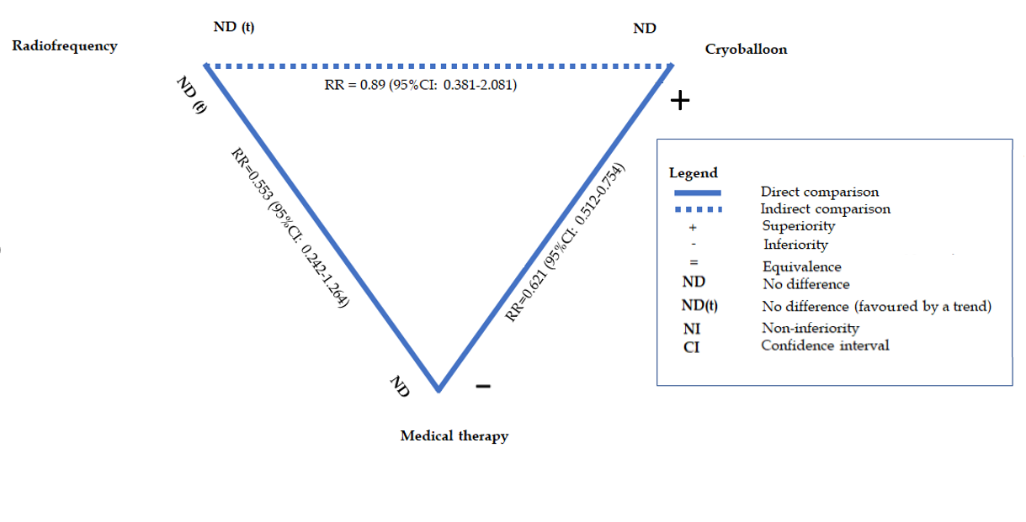
Figure 1 Direct and indirect comparisons across three first-line treatments for patients with paroxysmal atrial fibrillation. The comparisons of radiofrequency vs medical therapy and cryoballoon vs medical therapy are based on three^{[4-6]} and two trials^{[7,8]}, respectively.

Published by Baishideng Publishing Group Inc
7041 Koll Center Parkway, Suite 160, Pleasanton, CA 94566, USA
Telephone: +1-925-3991568
E-mail: bpgoffice@wjgnet.com
Help Desk: https://www.f6publishing.com/helpdesk
https://www.wjgnet.com

© 2021 Baishideng Publishing Group Inc. All rights reserved.

