Name of Journal: World Journal of Clinical Cases
Manuscript NO: 63604
Manuscript Type: CASE REPORT

Long-term outcome of indwelling colon observed seven years after radical resection for rectosigmoid cancer: A case report

Zhuang ZX et al. Long-term outcome of indwelling colon

Zi-Xuan Zhuang, Ming-Tian Wei, Xu-Yang Yang, Yang Zhang, Wen Zhuang, Zi-Qiang Wang

Zi-Xuan Zhuang, Ming-Tian Wei, Xu-Yang Yang, Yang Zhang, Wen Zhuang, Zi-Qiang Wang, Department of Gastrointestinal Surgery, West China Hospital, Sichuan University, Chengdu 610041, Sichuan Province, China

Author contributions: Zhuang ZX reviewed the literature and wrote the manuscript; Zhang Y analyzed and interpreted the imaging findings; Wang ZQ, Zhuang W, Yang XY, and Wei MT edited and revised the manuscript; all the authors have read and approved the final manuscript.

Corresponding author: Zi-Qiang Wang, MD, PhD, Chief Physician, Professor, Department of Gastrointestinal Surgery, West China Hospital, Sichuan University, No. 37 Guoxue Lane, Wuhou District, Chengdu 610041, Sichuan Province, China. wangziqiang@scu.edu.cn

Received: January 30, 2021
Revised: February 28, 2021
Accepted: May 19, 2021
Published online:

Abstract
BACKGROUND
Indwelling colon is characterized by an excluded segment of the colon after surgical diversion of the fecal stream with colostomy so that contents are unable to pass through this part of the colon. We report a rare case of purulent colonic necrosis that occurred 7 years after surgical colonic exclusion.

CASE SUMMARY
A 73-year-old male had undergone extended radical resection for rectosigmoid cancer. The invaded ileocecal area and sigmoid colon were removed during the procedure, and the ileum was anastomosed side-to-side with the rectum. The excluded ascending, transverse, and descending colon were sealed at both ends and left in the abdomen. After 7 years, the patient developed persistent abdominal pain and distension. Work-up indicated intestinal obstruction. The patient underwent ultrasound-guided catheter drainage of the descending colon and a large amount of viscous liquid was drained, but the symptoms persisted; therefore, surgery was planned. Intraoperatively, extensive adhesions were found in the abdominal cavity, and the small intestine and the indwelling colon were widely dilated. The dilated colon was 56 cm long, 5 cm wide (diameter), and contained about 1500 mL of viscous liquid. The indwelling colon was surgically removed and its histopathological examination revealed colonic congestion and necrosis with hyperplasia of granulation tissue. The bacterial culture of the secretions was negative. The patient recovered after the operation.

CONCLUSION
Although colonic exclusion is routinely performed, this report aimed to increase awareness regarding the possible long-term complications of indwelling colon.

Key Words: Colon; Colectomy; Intestinal obstruction; Diversion colitis; Sigmoid cancer; Colitis; Case Report

Zhuang ZX, Wei MT, Yang XY, Zhang Y, Zhuang W, Wang ZQ. Long-term outcome of indwelling colon observed seven years after radical resection for rectosigmoid cancer: A case report. World J Clin Cases 2021; In press

Core Tip: We present a case of purulent colonic necrosis in an indwelling colon that occurred 7 years after colonic exclusion. Although colonic exclusion is routinely performed for a variety of colonic diseases, indwelling colon can present with long-term complications after several years. The mechanism due to which such complications develop remains unclear, but both disuse atrophy and diversion colitis seem to play a role in their pathology. Surgeons should avoid sealing both ends of the excluded colon. We recommend continuous surveillance for an earlier detection and treatment of such complications.

INTRODUCTION
Indwelling colon is characterized by an excluded segment of the colon after surgical diversion of the fecal stream with colostomy or ileostomy^{[1]}. Evidence suggests that once there are no contents in the colon, prolonged colonic mucosal starvation may lead to functional and structural changes such as mucosal atrophy or mucosal inflammation, and these changes often aggravate with the passage of time^{[2]}. So far, very few studies have investigated the long-term changes in the indwelling colon. Herein, we report a rare case of colonic purulent necrosis with poor prognosis, wherein the necrosis occurred 7 years after surgical colonic exclusion.

CASE PRESENTATION
Chief complaints
A 73-year-old man was admitted to West China Hospital of Sichuan University due to persistent abdominal pain and bloating for half a month.

History of present illness
The patient presented with persistent abdominal pain and distension approximately half a month before admission. Work-up indicated an intestinal obstruction. The patient underwent ultrasound-guided catheter drainage of a large amount of viscous liquid from the descending colon. The symptoms persisted and he was admitted to our hospital for surgery.

History of past illness
The patient was diagnosed with sigmoid colon neoplasms in June 2013. Emergency surgery was received by the patient. The invaded ileocecal area and sigmoid colon were removed during the procedure, and the ileum was anastomosed side-to-side with the rectum, achieving an R0 resection. The excluded ascending, transverse, and descending colon segments were sealed at both ends and left in the abdomen. Unfortunately, the patient was diagnosed with lung cancer 4 years later and underwent right lung cancer resection without neoadjuvant chemoradiotherapy in 2017.

Personal and family history
The patient experienced no chronic or intermittent abdominal pain or other related symptoms during the follow-up period. He had no previous heart-related medical history, and no other significant medical or family history.

Physical examination
Physical examination revealed a bulging abdomen, tenderness near the original surgical incision, no obvious rebound pain and muscle tension.

Laboratory examinations
The results of laboratory examinations are shown in Table 1.

Imaging examinations
Abdominal computed tomography (CT) scan revealed severe intestinal distension with local short liquid gas level, multiple gas accumulation in the abdominal cavity and pelvis, part of the gastrointestinal wall swelling, signs of peritonitis, and incomplete intestinal obstruction (Figure 1). No clear signs of tumor metastasis and recurrence.

FINAL DIAGNOSIS
The indwelling colon histopathological examination revealed colonic congestion and necrosis with hyperplasia of granulation tissue.

TREATMENT
After failure of conservative treatment, the patient underwent exploratory laparotomy. Intraoperatively, extensive adhesions were found in the abdominal cavity, and the small intestine and the indwelling colon were widely dilated (Figure 2). The dilated colon was 56 cm long, 5 cm wide (diameter), and contained about 1500 mL of viscous liquid (Figure 3). The indwelling colon was surgically removed.

OUTCOME AND FOLLOW-UP
A postoperative CT examination showed symptom relief. The indwelling colon histopathological examination revealed colonic congestion and necrosis with hyperplasia of granulation tissue. The bacterial culture of the secretions was negative (Figure 4). The patient recovered well after the operation.

DISCUSSION
Indwelling colon is characterized by an excluded segment of the colon after colostomy or ileostomy^{[1]}. The intestinal contents are sufficiently diverted such that feces cannot reenter the distal colon temporarily, thereby minimizing the chances of infection. This is often employed as a surgical solution for a variety of colonic diseases^{[2]}.
The overall function of the colon is motility, secretion, nutrient absorption, and waste removal, and it handles approximately 9 L of fluid per day^{[3]}. After diversion of the colonic contents, the intestine cannot secrete hormones and enzymes normally, and thus, proper intestinal function cannot be maintained^{[4,5]}. Thus far studies have pointed out that the mechanism potentially responsible for causing change in the nonfunctional segment of the colon is "disuse" since disuse atrophy occurs when limbs and organs remain nonfunctional for a long period^{[6]}. However, different degrees of disuse atrophy of the colon have been observed clinically, which are accompanied by colitis and other symptoms^{[7,8]}. This condition, called diversion colitis, was first described by Glotzer et al^{[9]} in 1981. Diversion colitis is characterized by nonspecific mucosal inflammation. Its main clinical manifestations include intestinal bleeding, tenesmus, mucous discharge, and abdominal pain. The pathogenesis of this condition is unclear. A majority of the researchers think it is related to the nutritional deficiency of certain factors occurring in the colon, especially that of the short-chain fatty acids^{[10,11]}.
Available evidence suggests that this atypical symptom condition usually occurs in the early stage of the colonic exclusion, because after restoring the intestinal continuity, this colitis was noted to have resolved^{[2,12]}. However, in some cases, inflammatory lesions persist or even develop further as a continuation of the morphological and molecular changes in the colonic mucosa. The inflammation continues to worsen as the diversion is maintained for a longer duration. Repeated cycles of tissue damage and regeneration occur, leading to intestinal bleeding, necrosis, and granulation tissue proliferation^{[13]}.
Several factors that affect colonic metabolism and microflora, including defects in the intestinal barrier function, alterations in butyrate oxidation, or increased production of free oxygen radicals, seem to contribute to the inflammatory process^{[14]}. However, there is a lack of knowledge regarding the exact mechanisms underlying the complex pathology of intestinal tract inflammation. Therefore, in our patient, the most likely explanation for this condition is that the inflammatory exudate and mucus in the colon were probably not absorbed and discharged in time after the colon was closed, and eventually they accumulated to form a large amount of pus.
Our case highlights the following: (1) We should be more cautious with the surveillance of the patients with indwelling intestines, and ensure long-term follow-up, regular review of colonoscopy, and timely symptomatic treatment; (2) The surgical approach of sealing both ends of the colon for long-term exclusion is uncommon in clinical practice. This should only be done in case of emergency surgery or in exceptional cases. When both ends of the colon are sealed, regular surveillance with colonoscopy is not possible, and oral drugs and enema/suppositories cannot be used. Therefore, caution should be exercised when selecting this surgical approach; and (3) Indwelling intestines will continue to cause problems for the patients and the surgeons. Colostomy is maintained in many patients for a long period, and in some patients, the reconstruction of intestinal continuity might not be possible^{[15]}. Limited by a paucity of studies investigating the patients with long-term indwelling intestines, we cannot arrive at a reliable conclusion, but it is likely that a solution may soon emerge from current clinical observations and further research.

CONCLUSION
Even though, colonic exclusion is routinely performed, this report aimed to increase awareness regarding the long-term complications of indwelling colon after digestive tract reconstruction.

REFERENCES
1 Wu SW, Ma CC, Yang Y. Role of protective stoma in low anterior resection for rectal cancer: a meta-analysis. World J Gastroenterol 2014; 20: 18031-18037 [PMID: 25548503 DOI: 10.3748/wjg.v20.i47.18031]
2 Roediger WE. The starved colon--diminished mucosal nutrition, diminished absorption, and colitis. Dis Colon Rectum 1990; 33: 858-862 [PMID: 2209275 DOI: 10.1007/BF02051922]
3 Greenwood-Van Meerveld B, Johnson AC, Grundy D. Gastrointestinal Physiology and Function. Handb Exp Pharmacol 2017; 239: 1-16 [PMID: 28176047 DOI: 10.1007/164_2016_118]
4 Kobayashi M, Khalil HA, Lei NY, Wang Q, Wang K, Wu BM, Dunn JCY. Bioengineering functional smooth muscle with spontaneous rhythmic contraction in vitro. Sci Rep 2018; 8: 13544 [PMID: 30202095 DOI: 10.1038/s41598-018-31992-4]
5 Ritchie JA. Colonic motor activity and bowel function. I. Normal movement of contents. Gut 1968; 9: 442-456 [PMID: 5677279 DOI: 10.1136/gut.9.4.442]
6 Williamson RC. Disuse atrophy of the intestinal tract. Clin Nutr 1984; 3: 169-170 [PMID: 16829455 DOI: 10.1016/s0261-5614(84)80039-4]
7 Landerholm K, Wood C, Bloemendaal A, Buchs N, George B, Guy R. The rectal remnant after total colectomy for colitis - intra-operative,post-operative and longer-term considerations. Scand J Gastroenterol 2018; 53: 1443-1452 [PMID: 30451043 DOI: 10.1080/00365521.2018.1529195]
8 de Oliveira-Neto JP, de Aguilar-Nascimento JE. Intraluminal irrigation with fibers improves mucosal inflammation and atrophy in diversion colitis. Nutrition 2004; 20: 197-199 [PMID: 14962686 DOI: 10.1016/j.nut.2003.10.006]
9 Glotzer DJ, Glick ME, Goldman H. Proctitis and colitis following diversion of the fecal stream. Gastroenterology 1981; 80: 438-441 [PMID: 7450438]
10 Kabir SI, Kabir SA, Richards R, Ahmed J, MacFie J. Pathophysiology, clinical presentation and management of diversion colitis: a review of current literature. Int J Surg 2014; 12: 1088-1092 [PMID: 25150021 DOI: 10.1016/j.ijsu.2014.08.350]
11 Whelan RL, Abramson D, Kim DS, Hashmi HF. Diversion colitis. A prospective study. Surg Endosc 1994; 8: 19-24 [PMID: 8153859 DOI: 10.1007/BF02909487]
12 Szczepkowski M, Kobus A, Borycka K. How to treat diversion colitis?--Current state of medical knowledge, own research and experience. Acta Chir Iugosl 2008; 55: 77-81 [PMID: 19069697 DOI: 10.2298/aci0803077s]
13 Szczepkowski M, Banasiewicz T, Kobus A. Diversion colitis 25 years later: the phenomenon of the disease. Int J Colorectal Dis 2017; 32: 1191-1196 [PMID: 28357500 DOI: 10.1007/s00384-017-2802-z]
14 Son DN, Choi DJ, Woo SU, Kim J, Keom BR, Kim CH, Baek SJ, Kim SH. Relationship between diversion colitis and quality of life in rectal cancer. World J Gastroenterol 2013; 19: 542-549 [PMID: 23382634 DOI: 10.3748/wjg.v19.i4.542]
15 Szczepkowski M, Banasiewicz T, Krokowicz P, Dziki A, Wallner G, Drews M, Herman R, Lorenc Z, Richter P, Bielecki K, Tarnowski W, Kruszewski J, Kładny J, Głuszek S, Zegarski W, Kielan W, Paśnik K, Jackowski M, Wyleżoł M, Stojcev Z, Przywózka A. Polish consensus statement on the protective stoma. Pol Przegl Chir 2014; 86: 391-404 [PMID: 25294711 DOI: 10.2478/pjs-2014-0071]

Footnotes
Informed consent statement: Informed written consent was obtained from the patient for publication of this report and any accompanying images.

Conflict-of-interest statement: The authors declare that they have no conflict of interest.

CARE Checklist (2016) statement: The authors have read the CARE Checklist, and the manuscript was prepared and revised according to the CARE Checklist.

Open-Access: This article is an open-access article that was selected by an in-house editor and fully peer-reviewed by external reviewers. It is distributed in accordance with the Creative Commons Attribution NonCommercial (CC BY-NC 4.0) license, which permits others to distribute, remix, adapt, build upon this work non-commercially, and license their derivative works on different terms, provided the original work is properly cited and the use is non-commercial. See: http://creativecommons.org/Licenses/by-nc/4.0/

Manuscript source: Unsolicited manuscript

Peer-review started: January 30, 2021
First decision: February 25, 2021
Article in press:

Specialty type: Gastroenterology and Hepatology
Country/Territory of origin: China
Peer-review report’s scientific quality classification
Grade A (Excellent): 0
Grade B (Very good): 0
Grade C (Good): C, C, C
Grade D (Fair): 0
Grade E (Poor): 0

P-Reviewer: Chien SC, Teragawa H S-Editor: Wang JL L-Editor: Filipodia P-Editor:

Figure Legends
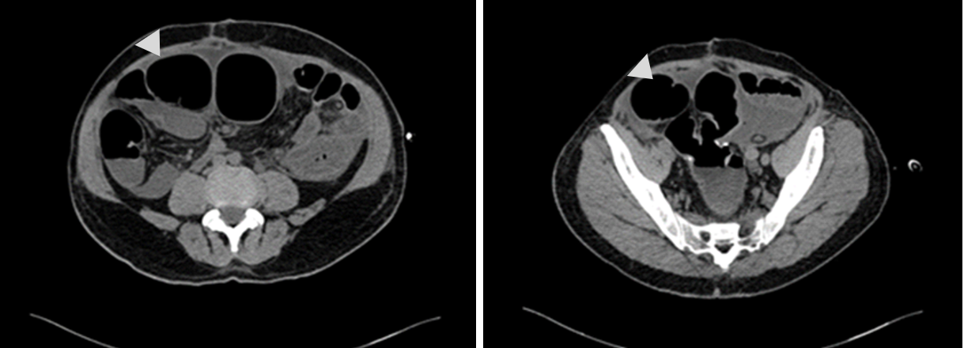
Figure 1 Abdominal computed tomography revealed sever intestinal distension of the indwelling colon.

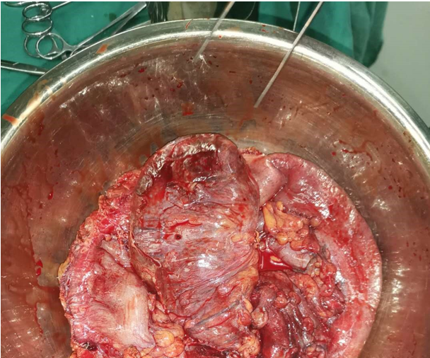
Figure 2 Congested and swollen colon were found during the operation.

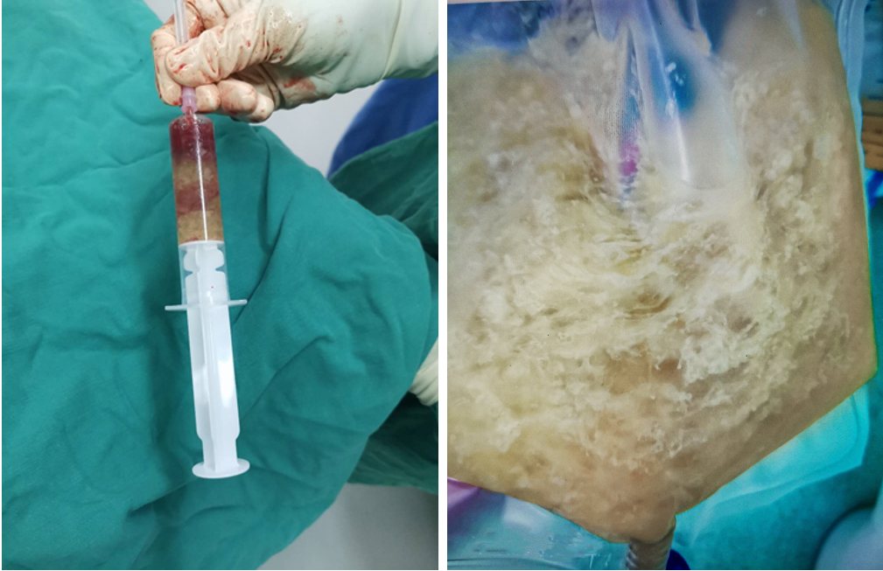
Figure 3 Large amounts of viscous liquid drained from the indwelling colon.

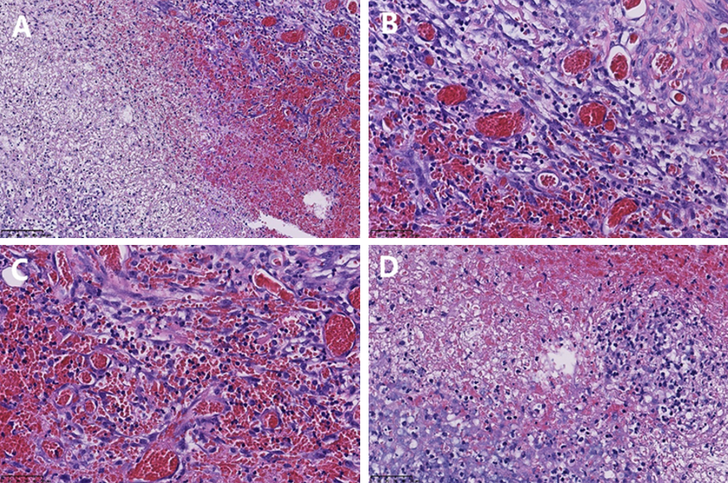
Figure 4 Pathological images of the distension colon. Colonic wall congestion and necrosis with hyperplasia of granulation tissue. A: Hematoxylin and eosin (HE) staining, × 200; B: HE staining, × 400; C: HE staining, × 400; D: HE staining, × 400.
Table 1 Laboratory examinations
 | Result | Reference range
WBC (× 10⁹ L) | 14.58 | 3.5-9.5
Hb (g/dL) | 13.5 | 13.0-17.5
Plt (× 1000/UL) | 155 | 100-300
PCT (ng/mL) | 1.39
CRP (mg/L) | 80.70
ALB (g/L) | 16.0
Na (mmol/L) | 132.3
K (mmol/L) | 3.94
GOT (IU/L) | 25
GPT (IU/L) | 27
INR | 1.33
PTT (s) | 39.0
CEA (ng/mL) | 2.19
CA199 (U/mL) | 1.91
ALB: Albumin; CA199: Carbohydrate antigen199; CEA: Carcinoma embryonic antigen; CRP: C reactive protein; GOT: Glutamic oxalacetic transaminase; GPT: Glutamic pyruvic transaminase; Hb: Hemoglobin; INR: International normalized ratio; PCT: Procalcitonin; Plt: Platelets; PT: Prothrombin time; WBC: White blood cells.

