Name of Journal: World Journal of Gastroenterology
Manuscript NO: 89790
Manuscript Type: EDITORIAL

From prediction to prevention: Machine learning revolutionizes hepatocellular carcinoma recurrence monitoring

Ramírez-Mejía MM et al. Machine learning: Predicting and preventing HCC

Mariana Michelle Ramírez-Mejía, Nahum Méndez-Sánchez

Mariana Michelle Ramírez-Mejía, Plan of Combined Studies in Medicine, Faculty of Medicine, National Autonomous University of Mexico, Distrito Federal 04510, Mexico

Mariana Michelle Ramírez-Mejía, Nahum Méndez-Sánchez, Liver Research Unit, Medica Sur Clinic & Foundation, Distrito Federal 14050, Mexico

Nahum Méndez-Sánchez, Faculty of Medicine, National Autonomous University of Mexico, Distrito Federal 04510, Mexico

Author contributions: Méndez-Sánchez N and Ramírez-Mejía MM contributed to this paper; Méndez-Sánchez N designed the overall concept and outline of the manuscript; Ramírez-Mejía MM contributed to the discussion and design of the manuscript; Méndez-Sánchez N and Ramírez-Mejía MM contributed to the writing and editing of the manuscript, the illustrations, and the review of the literature.

Corresponding author: Nahum Méndez-Sánchez, FAASLD, AGAF, FACG, MD, MSc, PhD, Doctor, Professor, Liver Research Unit, Medica Sur Clinic & Foundation, Puente de Piedra 150, Col. Toriello Guerra, Distrito Federal 14050, Mexico. nah@unam.mx

Received: November 13, 2023
Revised: December 12, 2023
Accepted: January 22, 2024
Published online:

Abstract
In this editorial, we comment on the article by Zhang et al entitled Development of a machine learning-based model for predicting the risk of early postoperative recurrence of hepatocellular carcinoma. Hepatocellular carcinoma (HCC), which is characterized by high incidence and mortality rates, remains a major global health challenge primarily due to the critical issue of postoperative recurrence. Early recurrence, defined as recurrence that occurs within 2 years posttreatment, is linked to the hidden spread of the primary tumor and significantly impacts patient survival. Traditional predictive factors, including both patient- and treatment-related factors, have limited predictive ability with respect to HCC recurrence. The integration of machine learning algorithms is fueled by the exponential growth of computational power and has revolutionized HCC research. The study by Zhang et al demonstrated the use of a groundbreaking preoperative prediction model for early postoperative HCC recurrence. Challenges persist, including sample size constraints, issues with handling data, and the need for further validation and interpretability. This study emphasizes the need for collaborative efforts, multicenter studies and comparative analyses to validate and refine the model. Overcoming these challenges and exploring innovative approaches, such as multi-omics integration, will enhance personalized oncology care. This study marks a significant stride toward precise, efficient, and personalized oncology practices, thus offering hope for improved patient outcomes in the field of HCC treatment.

Key Words: Hepatocellular carcinoma; Early recurrence; Machine learning; XGBoost model; Predictive precision medicine; Clinical utility; Personalized interventions

Ramírez-Mejía MM, Mendez-Sanchez N. From prediction to prevention: Machine learning revolutionizes hepatocellular carcinoma recurrence monitoring. World J Gastroenterol 2024; In press

Core Tip: Machine learning is an important approach for personalized oncology care, as it paves the way for precise and individualized postoperative strategies, thereby enhancing patient outcomes in the field of hepatocellular carcinoma treatment. Ongoing collaboration, larger sample sizes, and multicenter studies are crucial for validating and refining this innovative predictive model, thus ensuring its applicability and reliability in diverse clinical settings.

INTRODUCTION
In this editorial, we comment on the article by Zhang et al^{[1]} entitled Development of a machine learning-based model for predicting the risk of early postoperative recurrence of hepatocellular carcinoma. Hepatocellular carcinoma (HCC) is the most common form of primary liver cancer and is considered a major global health challenge due to its high incidence and mortality rates^{[2,3]}. Despite advances in medical and surgical interventions, recurrence remains a critical problem affecting the long-term survival of patients with HCC^{[4,5]}. Recurrence of HCC within the 2 years posttreatment is categorized as early recurrence. Early recurrence typically occurs due to the hidden spread of the primary tumor within the liver, and its incidence is correlated with the tumor's size and extent. On the other hand, recurrence after 2 years posttreatment is categorized as late recurrence. Late recurrence is associated with de novo HCC, indicating the development of new cancerous growth independent of the original tumor^{[6]}. Several predictive factors associated with recurrence have been recognized. Factors contributing to early recurrence include patient-related aspects such as age, the presence of underlying health conditions, liver function, viral load, the presence and activity of hepatitis, metabolic dysfunction-associated fatty liver disease, alcoholic liver disease and other etiologies, and the existence and activity of liver cirrhosis. Additionally, treatment-related factors, including the type of treatment employed, surgical margins, and specifics of the resection, also play a crucial role in predicting early recurrence^{[7]}. The intricate nature of liver cancer, coupled with the diverse factors influencing recurrence, makes it challenging to provide an accurate prognosis^{[8,9]}. Due to the constantly evolving landscape of HCC research, the quest for methods for predicting early recurrence has undergone a remarkable transformation in recent decades. Initially, researchers focused on deciphering the morphological characteristics of tumors as a basis for predictions^{[10]}. Factors such as vascular invasion, tumor multiplicity and large tumor size have emerged as fundamental, although somewhat rudimentary, indicators that establish the basis for understanding the complexities of HCC recurrence^{[11,12]}. Nevertheless, the paradigm shifted with the arrival of molecular analysis. Elevated alpha-fetoprotein (AFP) levels emerged as one of the first markers used for HCC prediction, offering insight into the intricate molecular landscape of this aggressive cancer^{[13,14]}. Despite these advances, the multifaceted nature of HCC recurrence requires more nuanced and sophisticated approaches. Researchers and clinicians alike recognize the limitations of relying solely on morphologic and molecular analyses^{[15]}. The quest for increasing predictive accuracy has led the scientific community to explore uncharted territory and harness the transformative power of technology, especially in the fields of imaging, genetics and computational sciences^{[16]}.
The evolution of technology has emerged as a pivotal catalyst, propelling HCC research into an era of unprecedented possibilities. Cutting-edge imaging techniques, coupled with advancements in genetic profiling, provide researchers with a comprehensive understanding of the tumor microenvironment^{[17-20]}. These insights, combined with the computational progress of modern data analysis, paved the way for a new generation of predictive models. These models transcended the limitations of traditional analyses, offering a more nuanced and accurate glimpse into the future course of HCC^{[21-24]}.

MACHINE LEARNING IN HCC RESEARCH
The exponential growth of computational power has heralded a new era in HCC research, where machine learning algorithms have emerged as valuable tools in handling vast datasets and deciphering complex patterns^{[25,26]}. This convergence of computational capabilities and healthcare needs represents a significant paradigm shift, transforming the landscape of HCC research. The integration of machine learning into the study of HCC offers a multitude of benefits and promises to address long-standing challenges in this field^{[27,28]}.
In a retrospective study, Zhang et al^{[1]}, harnessed the potential of supervised machine learning to develop a state-of-the-art preoperative prediction model for early postoperative HCC recurrence. Leveraging readily available clinical and imaging data, the team built six different risk prediction models, using ensemble learning, linear and neural network models, each meticulously designed to identify patients at high risk of recurrence. The study methodology consisted of analyzing the demographic and clinical data of 371 patients with HCC, excluding cases with incomplete data or previous neoadjuvant treatments. Using machine learning algorithms, the researchers identified eight key variables to predict early HCC recurrence: Age, intra-tumoral arteries, AFP, blood glucose, number of tumors, glucose-to-lymphocyte ratio (GLR), liver cirrhosis, and platelet count. These variables formed the basis for the construction of six different prediction models, of which the XGBoost model proved to be the most robust (Figure 1). The XGBoost model, outperformed its peers, showing unmatched performance on several metrics. In the training dataset, the model achieved an impressive area under the receiver operating characteristic curve (AUROC) of 0.993, proof of its accuracy. Even in the validation and test data sets, the XGBoost model maintained its excellence, with AUROC values of 0.734 and 0.706, respectively. Calibration curve analysis underscored the reliability of the model, confirming its alignment with real-world results. Furthermore, decision curve analysis highlighted the clinical utility of the XGBoost model, highlighting its potential to guide surgical strategies and usher in an era of individualized postoperative medicine. By employing the SHAP (SHapley Additive exPlanations) package, the study provided a detailed interpretation of the model results, unraveling the intricate relationships between variables. Preoperative glycemia emerged as a key factor, in line with previous research highlighting its role in HCC progression. The predictive power of the model was further demonstrated using an online calculator, designed to assist physicians in their daily practice. This user-friendly tool represents a major breakthrough, as it ensures the seamless integration of predictive analytics into clinical decision making.
The relevance of this study goes far beyond conventional medical research. Machine learning algorithms, used to decipher the intricate web of preoperative variables, have ushered in an era where predictive precision medicine reigns supreme. The identification of these eight key variables is a pivotal moment, providing physicians with unprecedented insight into the intricate factors that determine early postoperative recurrence.
Several research projects have been conducted to explore the use of machine learning in predicting HCC recurrence. Kucukkaya et al^{[29]} developed a predictive model based on the analysis of pre-treatment magnetic resonance imaging using the VGG16 and XGBoost machine learning models. This model aimed to predict recurrence in six different time intervals, ranging from 1 year to 6 years, and demonstrated performance with AUROC values between 0.71 and 0.85. In another study, Zeng et al^{[25]} compared the performance of random survival forest (RSF) models with Cox proportional hazard (CPH) models in predicting early recurrence using clinical features of the participants. In training and internal and external validation cohorts, the C-index of the RSF model was 0.725, 0.762, and 0.747, respectively. Although both studies highlighted the utility of machine learning, neither included the analysis of clinical and imaging variables, assuming a linear interaction of predictors for HCC recurrence. In this context, Zhang et al^{[1]} proposed a solution in their study, addressing the need to include clinical and imaging variables in the analysis. Their approach seeks to overcome the limitation of assuming linear interactions among predictors of HCC recurrence.

CHALLENGES AND FUTURE DIRECTIONS
This represents a significant advancement in early postoperative HCC recurrence prediction. Future research should focus on overcoming challenges related to sample size, data handling, validation, and interpretability. The authors acknowledge these limitations, emphasizing the need for future research endeavors to validate and refine the model further. These findings call for additional research, urging the scientific community to collaborate, expand sample sizes, and conduct multicenter studies. Comparative analyses with existing prediction models are crucial for ensuring the reliability and applicability of this innovative approach^{[30,31]}.

CONCLUSION
The development of accurate, interpretable, and widely applicable prediction models for early postoperative HCC recurrence represents a significant advance in personalized medicine. Addressing the challenges associated with data quality and model interpretability while exploring innovative approaches, such as multi-omics integration and continuous model refinement, will pave the way for improved patient outcomes and healthcare practices in the field of HCC treatment. Through collaborative efforts, continued research and the use of patient-centered approaches, the field of oncology can continue its journey toward more precise, efficient and personalized oncology care.

REFERENCES
1 Zhang YB, Yang G, Bu Y, Lei P, Zhang W, Zhang DY. Development of a machine learning-based model for predicting risk of early postoperative recurrence of hepatocellular carcinoma. World J Gastroenterol 2023; 29: 5804-5817 [PMID: 38074914 DOI: 10.3748/wjg.v29.i43.5804]
2 Singal AG, Lampertico P, Nahon P. Epidemiology and surveillance for hepatocellular carcinoma: New trends. J Hepatol 2020; 72: 250-261 [PMID: 31954490 DOI: 10.1016/j.jhep.2019.08.025]
3 Llovet JM, Kelley RK, Villanueva A, Singal AG, Pikarsky E, Roayaie S, Lencioni R, Koike K, Zucman-Rossi J, Finn RS. Hepatocellular carcinoma. Nat Rev Dis Primers 2021; 7: 6 [PMID: 33479224 DOI: 10.1038/s41572-020-00240-3]
4 Papaconstantinou D, Tsilimigras DI, Pawlik TM. Recurrent Hepatocellular Carcinoma: Patterns, Detection, Staging and Treatment. J Hepatocell Carcinoma 2022; 9: 947-957 [PMID: 36090786 DOI: 10.2147/JHC.S342266]
5 Tabrizian P, Jibara G, Shrager B, Schwartz M, Roayaie S. Recurrence of hepatocellular cancer after resection: patterns, treatments, and prognosis. Ann Surg 2015; 261: 947-955 [PMID: 25010665 DOI: 10.1097/SLA.0000000000000710]
6 Pagano D, Mamone G, Petridis I, Gruttadauria S. Hepatocellular Carcinoma Recurrence: How to Manage. In: Hepatocellular Carcinoma. Ettorre GM, editor. Cham: Springer International Publishing, 2023: 191-197 [DOI: 10.1007/978-3-031-09371-5_23]
7 Nevola R, Ruocco R, Criscuolo L, Villani A, Alfano M, Beccia D, Imbriani S, Claar E, Cozzolino D, Sasso FC, Marrone A, Adinolfi LE, Rinaldi L. Predictors of early and late hepatocellular carcinoma recurrence. World J Gastroenterol 2023; 29: 1243-1260 [PMID: 36925456 DOI: 10.3748/wjg.v29.i8.1243]
8 Zhu Y, Gu L, Chen T, Zheng G, Ye C, Jia W. Factors influencing early recurrence of hepatocellular carcinoma after curative resection. J Int Med Res 2020; 48: 300060520945552 [PMID: 33106072 DOI: 10.1177/0300060520945552]
9 Jung SM, Kim JM, Choi GS, Kwon CHD, Yi NJ, Lee KW, Suh KS, Joh JW. Characteristics of Early Recurrence After Curative Liver Resection for Solitary Hepatocellular Carcinoma. J Gastrointest Surg 2019; 23: 304-311 [PMID: 30215196 DOI: 10.1007/s11605-018-3927-2]
10 Izumi R, Shimizu K, Ii T, Yagi M, Matsui O, Nonomura A, Miyazaki I. Prognostic factors of hepatocellular carcinoma in patients undergoing hepatic resection. Gastroenterology 1994; 106: 720-727 [PMID: 8119543 DOI: 10.1016/0016-5085(94)90707-2]
11 Arii S, Tanaka J, Yamazoe Y, Minematsu S, Morino T, Fujita K, Maetani S, Tobe T. Predictive factors for intrahepatic recurrence of hepatocellular carcinoma after partial hepatectomy. Cancer 1992; 69: 913-919 [PMID: 1310434 DOI: 10.1002/1097-0142(19920215)69:4<913::aid-cncr2820690413>3.0.co;2-t]
12 Tung-Ping Poon R, Fan ST, Wong J. Risk factors, prevention, and management of postoperative recurrence after resection of hepatocellular carcinoma. Ann Surg 2000; 232: 10-24 [PMID: 10862190 DOI: 10.1097/00000658-200007000-00003]
13 Notarpaolo A, Layese R, Magistri P, Gambato M, Colledan M, Magini G, Miglioresi L, Vitale A, Vennarecci G, Ambrosio CD, Burra P, Di Benedetto F, Fagiuoli S, Colasanti M, Maria Ettorre G, Andreoli A, Cillo U, Laurent A, Katsahian S, Audureau E, Roudot-Thoraval F, Duvoux C. Validation of the AFP model as a predictor of HCC recurrence in patients with viral hepatitis-related cirrhosis who had received a liver transplant for HCC. J Hepatol 2017; 66: 552-559 [PMID: 27899297 DOI: 10.1016/j.jhep.2016.10.038]
14 Shirabe K, Takenaka K, Gion T, Shimada M, Fujiwara Y, Sugimachi K. Significance of alpha-fetoprotein levels for detection of early recurrence of hepatocellular carcinoma after hepatic resection. J Surg Oncol 1997; 64: 143-146 [PMID: 9047252 DOI: 10.1002/(sici)1096-9098(199702)64:2<143::aid-jso10>3.0.co;2-7]
15 Kim SJ, Kim JM. Prediction models of hepatocellular carcinoma recurrence after liver transplantation: A comprehensive review. Clin Mol Hepatol 2022; 28: 739-753 [PMID: 35468711 DOI: 10.3350/cmh.2022.0060]
16 Degroote H, Geerts A, Verhelst X, Van Vlierberghe H. Different Models to Predict the Risk of Recurrent Hepatocellular Carcinoma in the Setting of Liver Transplantation. Cancers (Basel) 2022; 14 [PMID: 35740638 DOI: 10.3390/cancers14122973]
17 Al-Ameri AAM, Wei X, Wen X, Wei Q, Guo H, Zheng S, Xu X. Systematic review: risk prediction models for recurrence of hepatocellular carcinoma after liver transplantation. Transpl Int 2020; 33: 697-712 [PMID: 31985857 DOI: 10.1111/tri.13585]
18 Guo D, Gu D, Wang H, Wei J, Wang Z, Hao X, Ji Q, Cao S, Song Z, Jiang J, Shen Z, Tian J, Zheng H. Radiomics analysis enables recurrence prediction for hepatocellular carcinoma after liver transplantation. Eur J Radiol 2019; 117: 33-40 [PMID: 31307650 DOI: 10.1016/j.ejrad.2019.05.010]
19 Zhao JW, Shu X, Chen XX, Liu JX, Liu MQ, Ye J, Jiang HJ, Wang GS. Prediction of early recurrence of hepatocellular carcinoma after liver transplantation based on computed tomography radiomics nomogram. Hepatobiliary Pancreat Dis Int 2022; 21: 543-550 [PMID: 35705443 DOI: 10.1016/j.hbpd.2022.05.013]
20 Son JA, Ahn HR, You D, Baek GO, Yoon MG, Yoon JH, Cho HJ, Kim SS, Nam SW, Eun JW, Cheong JY. Novel Gene Signatures as Prognostic Biomarkers for Predicting the Recurrence of Hepatocellular Carcinoma. Cancers (Basel) 2022; 14 [PMID: 35205612 DOI: 10.3390/cancers14040865]
21 Wang W, Wang F, Chen Q, Ouyang S, Iwamoto Y, Han X, Lin L, Hu H, Tong R, Chen YW. Phase Attention Model for Prediction of Early Recurrence of Hepatocellular Carcinoma With Multi-Phase CT Images and Clinical Data. Front Radiol 2022; 2: 856460 [PMID: 37492657 DOI: 10.3389/fradi.2022.856460]
22 An C, Kim DW, Park YN, Chung YE, Rhee H, Kim MJ. Single Hepatocellular Carcinoma: Preoperative MR Imaging to Predict Early Recurrence after Curative Resection. Radiology 2015; 276: 433-443 [PMID: 25751229 DOI: 10.1148/radiol.15142394]
23 Cho HJ, Kim B, Kim HJ, Huh J, Kim JK, Lee JH, Seo CW, Ahn HR, Eun JW, Kim SS, Cho SW, Cheong JY. Liver stiffness measured by MR elastography is a predictor of early HCC recurrence after treatment. Eur Radiol 2020; 30: 4182-4192 [PMID: 32189053 DOI: 10.1007/s00330-020-06792-y]
24 Chan AWH, Zhong J, Berhane S, Toyoda H, Cucchetti A, Shi K, Tada T, Chong CCN, Xiang BD, Li LQ, Lai PBS, Mazzaferro V, García-Fiñana M, Kudo M, Kumada T, Roayaie S, Johnson PJ. Development of pre and post-operative models to predict early recurrence of hepatocellular carcinoma after surgical resection. J Hepatol 2018; 69: 1284-1293 [PMID: 30236834 DOI: 10.1016/j.jhep.2018.08.027]
25 Zeng J, Zeng J, Lin K, Lin H, Wu Q, Guo P, Zhou W, Liu J. Development of a machine learning model to predict early recurrence for hepatocellular carcinoma after curative resection. Hepatobiliary Surg Nutr 2022; 11: 176-187 [PMID: 35464276 DOI: 10.21037/hbsn-20-466]
26 Saito A, Toyoda H, Kobayashi M, Koiwa Y, Fujii H, Fujita K, Maeda A, Kaneoka Y, Hazama S, Nagano H, Mirza AH, Graf HP, Cosatto E, Murakami Y, Kuroda M. Prediction of early recurrence of hepatocellular carcinoma after resection using digital pathology images assessed by machine learning. Mod Pathol 2021; 34: 417-425 [PMID: 32948835 DOI: 10.1038/s41379-020-00671-z]
27 Feng S, Wang J, Wang L, Qiu Q, Chen D, Su H, Li X, Xiao Y, Lin C. Current Status and Analysis of Machine Learning in Hepatocellular Carcinoma. J Clin Transl Hepatol 2023; 11: 1184-1191 [PMID: 37577233 DOI: 10.14218/JCTH.2022.00077S]
28 Zou ZM, Chang DH, Liu H, Xiao YD. Current updates in machine learning in the prediction of therapeutic outcome of hepatocellular carcinoma: what should we know? Insights Imaging 2021; 12: 31 [PMID: 33675433 DOI: 10.1186/s13244-021-00977-9]
29 Kucukkaya AS, Zeevi T, Chai NX, Raju R, Haider SP, Elbanan M, Petukhova-Greenstein A, Lin M, Onofrey J, Nowak M, Cooper K, Thomas E, Santana J, Gebauer B, Mulligan D, Staib L, Batra R, Chapiro J. Predicting tumor recurrence on baseline MR imaging in patients with early-stage hepatocellular carcinoma using deep machine learning. Sci Rep 2023; 13: 7579 [PMID: 37165035 DOI: 10.1038/s41598-023-34439-7]
30 Ahn JC, Qureshi TA, Singal AG, Li D, Yang JD. Deep learning in hepatocellular carcinoma: Current status and future perspectives. World J Hepatol 2021; 13: 2039-2051 [PMID: 35070007 DOI: 10.4254/wjh.v13.i12.2039]
31 Calderaro J, Seraphin TP, Luedde T, Simon TG. Artificial intelligence for the prevention and clinical management of hepatocellular carcinoma. J Hepatol 2022; 76: 1348-1361 [PMID: 35589255 DOI: 10.1016/j.jhep.2022.01.014]

Footnotes
Conflict-of-interest statement: All the authors declare that they have no conflicts of interest related to the manuscript.

Open-Access: This article is an open-access article that was selected by an in-house editor and fully peer-reviewed by external reviewers. It is distributed in accordance with the Creative Commons Attribution NonCommercial (CC BY-NC 4.0) license, which permits others to distribute, remix, adapt, build upon this work non-commercially, and license their derivative works on different terms, provided the original work is properly cited and the use is non-commercial. See: https://creativecommons.org/Licenses/by-nc/4.0/

Provenance and peer review: Invited article; Externally peer reviewed.
Peer-review model: Single blind

Peer-review started: November 13, 2023
First decision: December 5, 2023
Article in press:

Specialty type: Gastroenterology and hepatology
Country/Territory of origin: Mexico
Peer-review report’s scientific quality classification
Grade A (Excellent): 0
Grade B (Very good): 0
Grade C (Good): C, C
Grade D (Fair): 0
Grade E (Poor): E

P-Reviewer: Jin C, China; Yu H, China S-Editor: Lin C L-Editor: Filipodia P-Editor:
Figure Legends
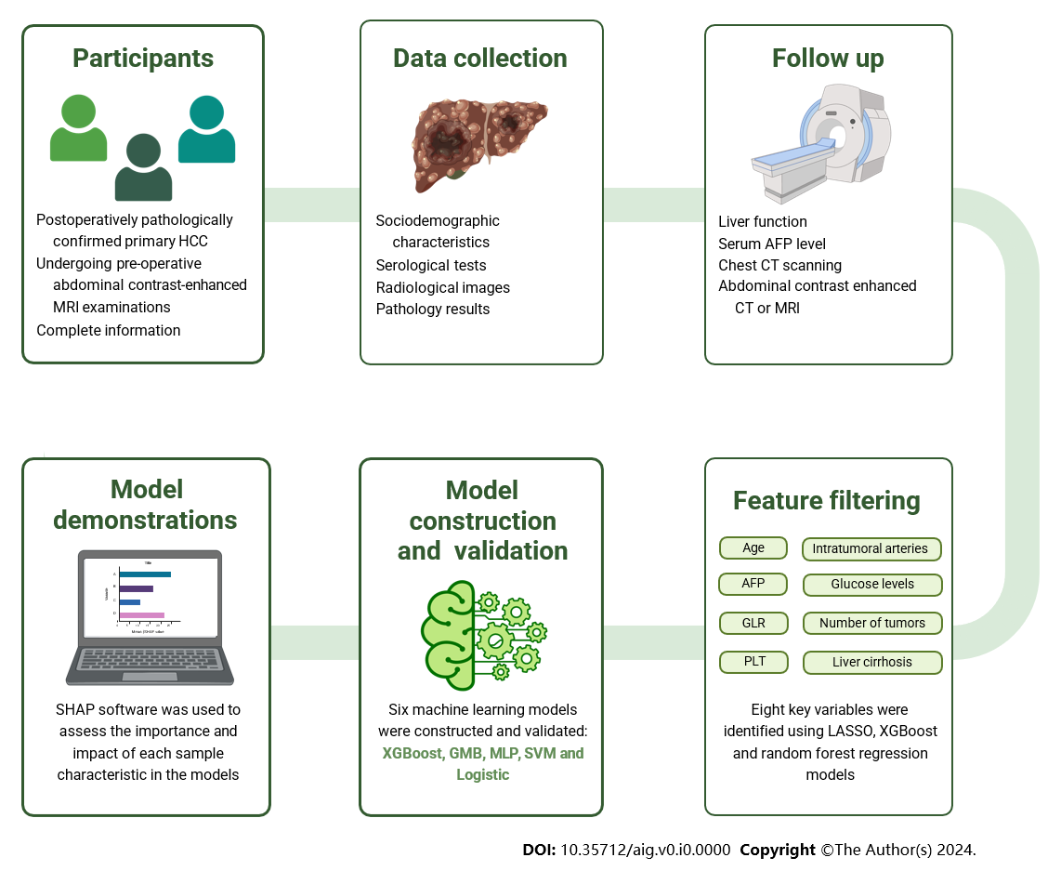
Figure 1 Summary of the study process. AFP: Alpha-fetoprotein; CT: Contrasted tomography; GLR: γ-glutamyl transferase-to-lymphocyte ratio; GMB: Complement NB; HCC: Hepatocellular carcinoma; MLP: Multilayer perceptron; MRI: Magnetic resonance imaging; PLT: Blood platelet; SVM: Support vector machine.

