Name of journal: World Journal of Gastroenterology
ESPS Manuscript NO: 19104
Manuscript Type: SYSTEMATIC REVIEW

Cooperative laparoscopic endoscopic and hybrid laparoscopic surgery for upper gastrointestinal tumors: current status

Ntourakis D et al. Cooperative laparoscopic and endoscopic surgery

Dimitrios Ntourakis, Georgios Mavrogenis

Dimitrios Ntourakis, Third Department of Surgery, University of Athens School of Medicine Attikon University HospitalRimini 1, 12462 Chaidari, Athens, Greece

Georgios Mavrogenis, Service de Gastroentérologie, Site Notre Dame, Grand Hôpital de Charleroi, 3 Grande Rue, 6000 Charleroi, Belgium

Georgios Mavrogenis, Gastroenterology and Endoscopy Center of Mytilene, Kavetsou 10, 81100 Mytilene, Greece

Author contributions: Ntourakis D designed the study and performed the research; Mavrogenis G analyzed data; Ntourakis D drew the figures. Ntourakis D and Mavrogenis G wrote the paper; All authors read and approved the final manuscript.

Conflict-of-interest statement: The authors have no conflict of interest to declare.

Data sharing statement: The paper dataset and literature search results are available from the corresponding author at dntourakis@hotmail.com

Open-Access: This article is an open-access article which was selected by an in-house editor and fully peer-reviewed by external reviewers. It is distributed in accordance with the Creative Commons Attribution Non Commercial (CC BY-NC 4.0) license, which permits others to distribute, remix, adapt, build upon this work non-commercially, and license their derivative works on different terms, provided the original work is properly cited and the use is non-commercial. See: http://creativecommons.org/licenses/by-nc/4.0/

Correspondence to: Dimitrios Ntourakis, MD, PhD, Third Department of Surgery, University of Athens School of Medicine, Attikon University Hospital, Rimini 1, T.K. 12462 Chaidari, Athens, Greece. dntourakis@hotmail.com
Telephone: +30-210-9822952
Fax: +30-210-5326411

Received: April 29, 2015
Peer-review started: May 12, 2015
First decision: August 25, 2015
Revised: September 15, 2015
Accepted: October 17, 2015
Article in press:
Published online:

Abstract
Aim: to investigate the cooperative laparoscopic and endoscopic techniques used for the resection of upper gastrointestinal tumors.

Methods: A systematic research of the literature was performed in PubMed for English and French language articles about laparoscopic and endoscopic cooperative, combined, hybrid and rendezvous techniques. Only original studies using these techniques for the resection of early gastric cancer, benign tumors and gastrointestinal stromal tumors of the stomach and the duodenum were included. By excluding case series of less than 10 patients, 25 studies were identified. The study design, number of cases, tumor pathology size and location, the operative technique name, the endoscopy team and surgical team role, operative time, type of closure of visceral wall defect, blood loss, complications and length of hospital stay of these studies were evaluated. Additionally all cooperative techniques found were classified and are presented in a systematic approach.

Results: The studies identified were case series and retrospective cohort studies. A total of 706 patients were operated on with a cooperative technique. The tumors resected were only gastrointestinal stromal tumors (GIST) in 4 studies, GIST and various benign submucosal tumors in 22 studies, early gastric cancer (pT1a and pT1b) in 6 studies and early duodenal cancer in 1 study. There was important heterogeneity between the studies. The operative techniques identified were: laparoscopic assisted endoscopic resection, endoscopic assisted wedge resection, endoscopic assisted transgastric and intragastric surgery, laparoscopic endoscopic cooperative surgery (LECS), laparoscopic assisted endoscopic full thickness resection (LAEFR), clean non exposure technique (Clean-NET) and non-exposed endoscopic wall-inversion surgery (NEWS). Each technique is illustrated with the roles of the endoscopic and laparoscopic teams; the indications, characteristics and short term results are described.

Conclusion: Along with the traditional cooperative techniques, new procedures like LECS, LAEFR and NEWS hold great promise for the future minimally invasive oncologic procedures.

Key words: Cooperative laparoscopic endoscopic; Hybrid laparoscopic; Laparoscopic endoscopic cooperative surgery; Endoscopy; Laparoscopy; Minimally invasive surgery; Gastrointestinal stromal tumors; Gastric cancer; Submucosal tumor

© The Author(s) 2015. Published by Baishideng Publishing Group Inc. All rights reserved.

Core tip: Cooperative laparoscopic and endoscopic surgery for the resection of upper gastrointestinal tumors combines the advantages of intraluminal and extraluminal approach: precise lesion localization, safe excision and reconstruction. It has been used for the resection of benign submucosal tumors and Gastrointestinal stromal tumors. Novel techniques like inverted laparoscopic endoscopic cooperative surgery, laparoscopic assisted endoscopic full thickness resection, clean non exposure technique and non-exposed endoscopic wall-inversion surgery have emerged for the minimally invasive treatment of early gastric cancer. Their oncologic principles are sound and the first results encouraging. Soon, the close collaboration of laparoscopic and endoscopic teams will be “conditio sine qua non” for the institutions that seek excellence in the treatment of upper gastrointestinal neoplasias.

Ntourakis D, Mavrogenis G. Cooperative laparoscopic endoscopic and hybrid laparoscopic surgery for upper gastrointestinal tumors: current status. World J Gastroenterol 2015; In press

INTRODUCTION
In the last decade there has been an important development in the minimally invasive treatment of benign and borderline benign tumors of the upper gastrointestinal tract. The creation of new operative tools and the invention of new operative techniques offer more options for the resection of these tumors than ever before.
For the interventional endoscopist, the possibilities for local excision with techniques such as endoscopic submucosal dissection (ESD) and endoscopic full thickness resection (EFTR) are approaching those that only a surgical approach could offer in the past^{[1,2]}. In a parallel course, thanks to the evolution of laparoscopic surgery, the gastrointestinal surgeons can now offer precise minimally invasive segmental resections that favor a more functional outcome and a faster patient recovery in comparison with more aggressive resections^{[3]}.
In this competitive race each of these two approaches have their strong points and weaknesses. Nevertheless we are noticing the emergence of a third approach: the cooperative laparoscopic and endoscopic approach, also called hybrid laparoscopic approach. This group of techniques aims to accumulate the strong points of intraluminal and intraperitoneal procedures, and at the same time, negate their limitations.
This is not a novel concept since many laparoscopic and endoscopic cooperative techniques have been described with different names: combined laparoscopic and endoscopic, hybrid laparoscopic, cooperative laparoscopic-endoscopic, rendezvous endoscopic. In spite of the nomenclature used, the idea remains the same: a simultaneous endoluminal and intraperitoneal approach for the localization of the lesion, its precise resection respecting oncologic principles and the closure of the defect.
Interestingly in the last decade, our better knowledge on the biological behavior of gastrointestinal stromal tumors (GIST) and early gastric cancer, as well as the more frequent detection of these two pathologies has increased the interest in precise, segmental and mini invasive resection techniques based on sound oncologic principles^{[4,5]}. Teams from Asiatic countries and pioneers like Hiki lead the effort of discovering new cooperative laparoscopic and endoscopic techniques.
The aim of this article is to review the data on cooperative laparoscopic and endoscopic techniques, identify and classify the different techniques described, define their indications and elaborate their characteristics.

Materials and methods
A systematic review of the literature from the databases of PubMed and MEDLINE from January 1960 to March 2015 was performed. The search algorithm used the following strategy:
("tumour"[All Fields] OR "tumor"[All Fields] OR "submucosal tumor"[All Fields] OR "early gastric cancer"[All Fields] OR "GIST"[All Fields] OR "gastrointestinal stromal tumor"[All Fields] OR "neoplasms"[MeSH Terms] OR "neoplasms"[All Fields])
AND [("laparoscopic"[All Fields] OR "laparoscopy"[All Fields] OR "laparoscopy"[MeSH Terms]) AND ("endoscopic"[All Fields] OR "endoscopy"[All Fields] OR "endoscopy"[MeSH Terms]) AND ("intragastric"[All Fields] OR "transgastric"[All Fields] OR "cooperative"[All Fields] OR "combined"[All Fields] OR "rendezvous"[All Fields] OR "hybrid"[All Fields])]
AND ("stomach"[MeSH Terms] OR "stomach"[All Fields] OR "gastric"[All Fields] OR "upper gastrointestinal"[All Fields] OR "Upper Gastrointestinal Tract"[MeSH Terms])

Inclusion criteria
The search results were screened by the two reviewers (DN, GM) for relevant publications. All original articles describing the combined techniques of laparoscopy and endoscopy for the treatment of tumors of the upper gastrointestinal tract were included. The list of references of each eligible article was manually evaluated for any relevance to the specific topic. Only the articles that were published in English and French were included.

Exclusion criteria
Animal studies and experimental studies were excluded. Duplicate publications, review articles without any original data and studies that did not clearly state in their methods that a combined endoscopic and laparoscopic approach was used were also excluded. When there was an overlap in the data between the two studies, only the most recent study was considered. Technical articles not reporting patient results were also excluded.

Data extraction and analysis
The included studies were assessed; and the relevant data that was extracted by the reviewers was filled onto a spreadsheet data extraction form. The extracted data for each study focused on: first author’s name, year of publication, country involved, study design, number of cases, lesion pathology, its’ size and location, operative technique name, endoscopy team and surgical team role, operative time, type of closure of visceral wall defect, any blood loss or complications and length of hospital stay. If a technique has a commonly used acronym this is given in a parenthesis after its name. The investigated outcomes for each technique were: type of technique used, number of cases, lesion size, tumor location, tumor pathology, role of endoscopic and of laparoscopic team, technique of visceral wall closure, operative time duration, adverse events and complications. Only descriptive statistics were used. Weighted averages were calculated based only on the number of patients of each study. Results are given as means ± SD.

RESULTS
The search returned 414 abstracts published from June 1971 to March 2015; 339 of these were excluded on the basis of their title or the abstract contents. From the remaining 75 abstracts, 50 were case reports or studies with less than 10 patients. The remaining 25 articles included 8 prospective case series, 4 retrospective cohort studies, and 13 retrospective series (table 1). The total number of patients operated by a cooperative laparoscopic endoscopic technique in these studies was 706.
Concerning the resected lesion pathology, 4 studies included only GIST, while 22 studies involved a variety of benign submucosal tumors (SMT) and GIST, 6 studies early gastric cancer (pT1a and pT1b) and only 1 study had to do with early duodenal cancer. The mean tumor size varied from 5 to 55 mm. Almost all tumors were located in the stomach, with only one study dealing with duodenal tumors. Heterogeneity existed concerning the name of the procedures, the patients’ characteristics and the reported outcomes (table 2). For consistency reasons, throughout this paper the term Cooperative Laparoscopic Endoscopic Techniques is used to include all the techniques described.
Eleven operative techniques using a cooperative laparoscopic and endoscopic approach were identified from the literature. In all publications the procedure was undertaken in the operating theater under general anesthesia. The operative techniques were classified into three categories according to the roles of the endoscopic and laparoscopic teams: the laparoscopy-assisted endoscopic resection (LAER) group where the resection was performed primarily by the endoscopic team under laparoscopic control; the endoscope-assisted laparoscopic resection (EALR) group where the laparoscopic team performed the resection under endoscopic monitoring; the combined laparoscopic endoscopic resection (CLER) group where the resection was performed jointly by the laparoscopic and the endoscopic team. The characteristics of these techniques, their indications and their reported outcomes are reported herein (table 3).
Weighted averages based on patient number were calculated: for the tumor size they were 3.1 mm for the LAER, 33.3 mm for the EARL and 28.5 mm for the CLER group; for the operative time they were 88.4 min for the CLER, 72.1 min for the LAER and 103.1 min for the EALR group; for the estimated blood loss were 3.5 ml, 29.8 ml and 50.6 ml for the CLER, LAER and EARL groups respectively; and for the hospital stay time were 9.9 d for the CLER group, 2 d for the LAER group and 8.5 d for the EARL group.

Group 1: LAER
In this category, endoscopic mucosal resections (EMR) and ESD are undertaken under laparoscopic control (Figure 1).
The endoscopic team performs an EMR or ESD while the laparoscopic team has a backup role; it monitors the endoscopic resection and provides an extraluminal treatment of any adverse effect like accidental perforation or difficulty in controlling blood loss^{[6]}. It may also provide assistance by presenting the tumor to the endoscopic team with manipulations on the serosal side of the gastric wall^{[7]}. Laparoscopy has been used for verification of the tumor location and orientation and for intraoperative ultrasound^{[8]}.
Benign SMT and GIST in the stomach and the duodenum have been resected with these methods^{[6-9]}. Concerning the complications, Qiu et al^{[6]} reported in a series of five patients, one late perforation and one episode of hemorrhage were both treated conservatively.

Group 2: EALR
In this group, the tumor is resected by laparoscopy while endoscopy plays an important role in locating the tumor, assisting with exposure and monitoring the laparoscopic procedure. Minimally invasive robot-assisted resections have also been combined with intraluminal endoscopy^{[10-12]}.

Endoscope-assisted wedge resection: The patient is placed in the operating theater in the standard position for laparoscopic upper gastrointestinal surgery. A 10-12 mm port for the optic is placed in the supraumbilical midline or, according to some teams, at about one third of the distance between the umbilicus and the xiphoid^{[13]}. Two to three 5-mm ports and a 12 mm port for the endoscopic stapler are added according to the surgical team habitude. A laparoscopic bowel clamp can be placed in the small bowel just distally to the angle of Treitz to avoid small bowel insufflation that hinders the laparoscopic exposure. Using the endoscopic vision and laparoscopic vision and palpation, the location of the SMT is confirmed and marked. Blood vessels in the excision area around the tumor are dissected and controlled in order to avoid hemorrhage. The gastric wall, including the SMT, is lifted by the laparoscopic team with seromuscular sutures placed or by traction from laparoscopic grasping forceps. The tumor, as well as a cuff of normal gastric tissue around it, is removed with a linear endoscopic gastrointestinal stapler in a wedge resection. The staple line can be reinforced with a running suture. Usually two to three stapler cartridges are used for the resection. The tumor is retrieved through an enlarged port hole, protected inside a specimen bag. At the end of the procedure, endoscopy confirms the complete resection and the absence of bleeding or leak (Figure 2).
For lesions located at the posterior gastric wall, the gastrocolic omentum is dissected and the greater curvature of the stomach mobilized laparoscopically. The greater curvature is retracted cephalad, exposing the posterior gastric wall via the lesser sac. Then the same technique is applied^{[14]}. If the tumor is located near the esophagogastric junction or pyloric ring, the endoscope is placed distally into the stomach or duodenum to protect the normal gastric wall from stenosis or damage. In these cases and in the case of large tumors it is proposed to resect the tumor by using laparoscopic ultrasound shears or a vascular sealing system as the application of a stapler may result in deformation of the stomach and stenosis^{[15]}. The gastric wall defect may be closed by laparoscopic sutures or a laparoscopic stapler^{[16]}.
This is by far the most common combined technique with more than 500 cases published. It has been used for the resection of gastric SMT and GIST^{[6,13-26]}. A few teams have described the resection of early gastric cancer of stages pT1aNx^{[27,28]} as well as the resection of duodenal SMT and duodenal submucosal cancer^{[29]}. The mean operative time is 44.3-180 min, the mean estimated blood loss is 3-196 ml and the mean hospitalization time is 3.4-15.1 d. The reported complications include: hemorrhage, hypoperistalsis, bowel injury, staple or suture line insufficiency and incomplete resection^{[14,15,19,20,22,24,27,29,30]}; in large series, the complication rate is 0%-3%^{[6,14,16,19]}.

Endoscope-assisted laparoscopic transluminal (transgastric) surgery: The same principles for the patient and the surgical team installation as the previous technique are applied. Once the lesion is located, the laparoscopic team makes a laparoscopic incision (gastrotomy) in the anterior abdominal wall overlying the lesion. The exact position of the gastrotomy is defined by palpation and transillumination by the gastroscope (figure 3). By applying traction on the adjacent normal mucosa, the lesion is delivered through the gastrotomy into the peritoneal cavity and is resected with an inverted wedge excision with a laparoscopic stapler^{[20]}. Alternatively, the laparoscopic team can perform a submucosal or full thickness excision of the lesion^{[25]}. The gastric wall opening is closed with an endoscopic stapler or with sutures^{[18]}.
This technique is used predominantly to resect lesions of the posterior gastric wall^{[16,18,22,25,30,31]} and posterior lesions of the duodenum^{[10]}. The reported mean operative time is 114-145 min, the mean blood loss 3-8 ml, and the mean hospital stay 3-8 d^{[16,22,25]}. There are rare incidents of hemorrhage, leak and surgical wound infection^{[22,25]}.

Endoscope-assisted laparoscopic intraluminal (intragastric) surgery: In this approach, first described by Ohashi in 1995, the laparoscopic ports are passed through the abdominal wall and then through the gastric wall, inside the gastric cavity^{[32]}. The procedure starts with a laparoscopic exploration of the peritoneal cavity and, if needed, mobilization of the gastric ligaments. Once the tumor location is pinpointed by endoscopy, the laparoscopic team punctures the gastric wall and inserts an optical port and two working ports inside the stomach (Figure 3). The ports rest in their place by means of an inflatable balloon at their tip; some authors prefer using standard laparoscopic ports and keep them in place by suspending the stomach at the anterior abdominal wall with sutures^{[33]}. The lesion can be removed by laparoscopic mucosal resection, full thickness resection or laparoscopic stapling. The endoscopist can facilitate the procedure by applying traction with a snare and in the end retrieve the resected lesion through the mouth. Large lesions can be retrieved by the surgical team through an enlarged gastrotomy. In the end, the gastric wall perforations are sutured and the stomach is inflated to verify the closure.
A modified laparoscopic intraluminal (intragastric) surgery (LIGS) procedure has been described by Dong et al^{[33]}. The stomach is suspended from the anterior abdominal wall and under the combined laparoscopic and endoscopic control, two 5 mm laparoscopic ports are inserted into the gastric cavity. Inside the stomach the surgeon performs a partial thickness resection of the tumor down to the muscular layer under vision from the gastroscope. The specimen is retrieved through the mouth by the endoscopist. The gastric wall defect and the gastric port holes are closed with endoscopic titanium clips.
LIGS has been used in more than 100 cases for the removal of benign SMT and GIST[13,15,20,25,27,28,30,32,34-38], as well as early gastric cancer^{[28,32]}. The mean operative time is 74.6-236 min, the mean blood loss is 10-100ml and the mean hospital stay is 3.3-10.2 d; reported complications include hemorrhage, posterior wall perforation and leak[13,15,20,25,27,28,30,32,35-38].

Endoscope-assisted laparoscopic intragastric stapling: Only one 12 mm laparoscopic port is inserted into the stomach. The endoscopist visualizes and exposes the tumor. A laparoscopic stapler is used to resect the lesion with an inverted wedge resection (Figure 3). The gastric port hole is stapled shut. This procedure is used mainly for endophytic benign lesions and has an operative time ranging 85-105 min^{[39-41]}.

Single Port LIGS: A 3 cm umbilical mini laparotomy is made, and through it the stomach is grasped and a 2 cm gastrotomy is performed. It is possible to make the mini laparotomy higher and to the left of the midline in order to get a better access to the stomach. A single port laparoscopic device is inserted through the abdominal wall into the stomach; the device’s shape maintains the gastric wall in contact with the abdominal wall. The single port allows the introduction of a laparoscope, laparoscopic instruments, and stapler (Figure 3). In the end of the procedure, the gastrotomy can be closed through the mini laparotomy by open suturing or by stapling^{[25,42,43]}.
This technique is used for posterior gastric wall benign lesions. It has a mean operative time of 74.6-145 min, a mean blood loss of 10 ml and a mean hospitalization of 5-8 d. Leak from the gastric wall closure has been reported in a single case^{[25,42,43]}.

Group 3: combined laparoscopic-endoscopic resection
This group is comprised of operative techniques where the endoscopic and the laparoscopic team are cooperating for the joint dissection of the tumor.

Laparoscopic endoscopic cooperative surgery: In this procedure, described by Hiki et al^{[44]} in 2008, the lesion is located and partially dissected by ESD. The resection is completed by laparoscopy.
The laparoscopic team is installed and the operative ports are placed in the standard position for upper gastrointestinal procedures. Then the endoscopic team marks by coagulation the periphery of the tumor keeping a safety margin. After submucosal injection, three-fourths of the marked area around the tumor are cut down to the submucosal layer using an insulated tip electrosurgical knife (IT Knife, Olympus, Japan). The presence of an insulated ceramic ball at the tip of this needle-knife is believed to reduce the chance of accidental muscle layer dissection. Following that, the endoscopist makes a perforation of the gastric wall at the dissection line, with the tip of a standard needle knife. Next, the surgical team intervenes laparoscopically. The tip of an ultrasonic shears device or alternatively of a vessel sealing system is inserted into the perforation and three-fourths of the circumference around the tumor are dissected following the endoscopic dissection path. Subsequently, the tumor is turned over, towards the peritoneal cavity. The serosa of the non-resected part of the tumor is grasped and retracted, exposing the extremity of the incision. Finally, the incision line is closed using a laparoscopic stapler (Figure 4). The specimen is retrieved and protected in a plastic bag, through a laparoscopic port hole. For the tumors located near the esogastric junction or pyloric ring, the gastric wall defect is closed with laparoscopic sutures, since any application of a stapling device in these areas may cause deformity of the stomach or stenosis.
Laparoscopic endoscopic cooperative surgery (LECS) has been used in 70 patients for the resection of benign SMT of the stomach and the duodenum ^{[44-50]} and in one case for the resection of an early duodenal cancer^{[51]}. The mean operative time of this procedure is 120-182 min, the mean blood loss 7.4-11.6 ml and the patient is hospitalized for a mean 5-11.6 d. Interestingly, there are no complications reported from the highly specialized team performing this procedure^{[44-51]}.

Inverted LECS: In order to prevent spillage of gastric content and consequently reduce the risk of tumor cell dissemination in the peritoneal cavity, a variation of the classic LECS procedure was described by Nunube et al^{[52]} in 2012 in a single case of early gastric cancer resection. The Inverted LECS procedure makes use of suspension sutures passed through the abdominal wall to lift the gastric wall around the tumor like a crown; this step reduces the risk of gastric content spillage. In addition, to prevent contact between the tumor and the peritoneal cavity, the tumor is inverted to face the intragastric cavity. The resection is terminated by application of a laparoscopic stapler that resects the tumor and closes the gastric wall defect and the specimen is removed trans-orally. Thus, the tumor is always kept inside the stomach and is never in direct contact with the perigastric viscera.

Laparoscopy-assisted endoscopic full-thickness resection: Laparoscopy-assisted endoscopic full-thickness resection (LAEFR) was described by Abe et al^{[53]}. It is based on the same principles of LECS but instead of a submucosal dissection, the endoscopic team performs a full thickness resection around the tumor. The laparoscopic team facilitates the exposure by traction from the serosal side of the gastric wall. After the 2/3 of the resection is completed, the exposure for the endoscopic team is hindered by the loss of CO₂ towards the peritoneal cavity. Then the laparoscopic team completes the full thickness resection with ultrasonic scissors or a vessel sealing device. The specimen is retrieved either per-orally or protected in a plastic bag through a port site and the gastric wall defect is hand-sewn by the laparoscopic team.
This technique has been used in 20 patients with GIST^{[53,54]} and other benign SMT and in 24 patients with early gastric cancer; in the case of early gastric cancer a sentinel node selective lymph node dissection was performed by laparoscopy^{[55-57]}. This difficult procedure has a mean operative time of 181-389 min, minimal blood loss and a mean hospitalization of 5.9-12.3 d. The expert teams performing LAEFR report no complications in their series^{[54-57]}.

Clean non exposure technique: Clean non exposure technique (Clean-NET) is a combined laparoscopic and endoscopic ‘non exposure’ full-thickness gastric wall resection described by Inoue et al^{[58]} in 2012. First the boundary of the lesion is marked by coagulation endoscopically with a 10 mm safety circumferential margin. The surgical team places 4 full thickness stay sutures around the lesion in order to fix the mucosa to the other layers. The endoscopic team injects the submucosal layer with a solution in a circle outside of the stay sutures. Then, the surgical team dissects the seromuscular layer around the tumor and outside of the stay sutures, down to the submucosal layer, using a laparoscopic electrocautery knife. Once the dissection is finished, traction is applied to the stay sutures and the specimen with the surrounding mucosa is pulled out of the stomach, sealed inside a protective mucosal “net”. A laparoscopic linear stapler is used to close the wall defect and resect the mucosal “net” containing the specimen. In the end, the specimen is put into a laparoscopic bag and is withdrawn from a port hole^{[58]}.

Non-exposed endoscopic wall-inversion surgery: Non-exposed endoscopic wall-inversion surgery (NEWS) was developed as a new full-thickness resection technique without intentional perforation mainly aimed at being a minimally-invasive procedure for early gastric cancer.
The NEWS procedure starts by placing marks with the coagulation around the tumor; on the mucosal surface by the endoscopic team and on the serosal surface by the laparoscopic team. A submucosal injection of sodium hyaluronate with an Indigo Carmine dye solution is performed by the endoscopist; this helps dissect the submucosal plane around the tumor. In the case of early gastric cancer, Indocyanine Green is used in order to stain the regional sentinel lymph nodes. The whole lymph node group containing the sentinel node is dissected and sent for frozen section; the procedure continues once the lymph nodes are confirmed free of cancer. Then the laparoscopic team proceeds with a circumferential seromuscular dissection down to the colored submucosal layer, around the tumor. Once the dissection is terminated, the tumor is inverted and the seromuscular layer is closed with a laparoscopic running suture; a surgical spacer (Securea®; Hogy Medical Co., Ltd., Tokyo, Japan), cut to fit the resection site, can be placed between the tumor and the suture line to facilitate the procedure. Finally the resection is completed by a circumferential muco-submucosal incision under endoscopy and the spacer is dug out. The resected specimen is retrieved through the mouth, and the mucosal defect at the resection site is closed with endoscopic clips (Figure 5).
The technique was initially described in a porcine model by Goto et al^{[59]} in 2011 and was applied to 6 patients with gastric GIST^{[60]}. It has been used in combination with a selective lymph node dissection to resect an early gastric cancer ^{61]}. The mean operative time is reported at 270 min and the mean blood loss is 10-113 ml. In two patients, the mucosal barrier was unintentionally breached during the dissection but no other adverse events have been reported^{[60,61]}.

DISCUSSION
A large armamentum of cooperative laparoscopic and endoscopic procedures are available for the multidisciplinary teams that wish to make use of them. What are, then, the indications for these cooperative procedures? The three largest published series totaling 256 patients involved primarily the resection of GISTs (82%) and secondly the resection of various benign SMT^{[6,14,16]}. According to the 2010 National Comprehensive Cancer Network (NCCN) GIST and the 2015 NCCN sarcoma guidelines, GISTs smaller than 5 cm may be treated by a laparoscopic resection by surgeons who have the appropriate experience; provided that a margin free resection is done, the GIST capsule is preserved and tumor spillage is avoided. It is recommended that the specimens should be removed from the abdomen in a plastic bag^{[62]}. Consequently, patients with gastric GISTs smaller than 5 cm irrespectively of their localization are good candidates for these cooperative techniques. The LECS procedure is on the national insurance list in Japan for benign SMT and small GIST since February 2014; it is currently widely being carried out and its’ use is rapidly increasing in Japanese Institutions^{[63]}.
In our data there were also reports and small case-series of cooperative resections for early gastric cancer for a total of 46 patients^{[27,28,32,52,55-57,61]}. Early gastric cancers (T1a) are amenable to endoscopic resection if they are well-differentiated, ≤ 2 cm, confined to the mucosa and not ulcerated; the associated lymph node metastatic risk is virtually zero for this group^{[64]}. The Japanese National Cancer Centre has expanded the inclusion criteria for ESD to tumors with intestinal-type histology, no evidence of lymphovascular involvement and to intramucosal cancers without ulceration regardless of tumour size; intra-mucosal cancers < 3 cm with ulceration or cancers with early invasion into the submucosa (sm1) measuring < 3 cm^{[65]}. A large retrospective study of 1485 patients comparing patients who had received a curative resection by means of ESD following the expanded criteria to those following the classic inclusion criteria did not find any difference in long term survival and outcomes^{[66]}. Even though the ESD achieves excellent en bloc resection rates in early gastric cancer it also presents a high possibility of bleeding, perforation, and long procedure times^{[67]}. Various ‘non exposure’ combined laparoscopic and endoscopic techniques have been developed for the treatment of early gastric cancer with the purpose of diminishing the risk of tumor cell seeding in the peritoneal cavity: inverted LECS, LAEFR, Clean-NET and NEWS. They may be considered for early gastric cancer lesions difficult to treat with ESD, including large intramucosal lesions located at the greater curvature of the gastric body and fornix, or for lesions with a strong ulcer scar^{[52]}. Clinical experience remains limited to case reports and case series from expert Asiatic centers, nevertheless, preliminary results are promising.
Cooperative laparoscopic endoscopic techniques present many theoretical advantages. Is there any clinical benefit to be gained by their application? In the series of endoscopy assisted laparoscopic resections from Wilhelm et al^{[16]}, tumor identification and localization solely by visual exploration and palpation of the abdominal cavity during initial laparoscopy was successful in 21 out of 93 patients (22.6%). In addition, the tumor localization was exact enough to permit a secure resection in only three patients. This was due to the inability to define whether a lesion was located in the anterior or posterior gastric wall. With the endoscopic endoluminal view, 92 tumors (98.9%) were exactly located ^{[16]}. This fivefold increase in the tumor detection is clinically and statistically significant (p < 0.001, χ² = 93.8) and achieves a detection rate similar to that of open surgery. Laparoscopic SMT wedge resection is comparable to the open surgical resection in respect to the duration of surgery and the complication rate, but has a significantly less intraoperative blood loss, faster first flatus passage and earlier resumption of oral intake^{[24]} as well as an earlier mobilization^{[26]} and a shorter hospital stay^{[30]}.
A small case-control study by Dong et al^{[68]} compared eight patients operated with a modified laparoscopic intragastric surgery (MLIGS) technique for GISTs to ten patients operated with an endoscopic full-thickness resection (EFR). The MLIGS technique was found to have a significantly shorter operative time (mean time, 85 vs 120 min; t = 2.371; p < 0.05) and blood loss (mean blood loss, 20 vs 48 ml; t = 2.372; P < 0.05). Also the patients operated by MLIGS had a tendency for bigger tumor size, shorter hospital stay and shorter abdominal pain duration in comparison to those treated by EFR^{[68]}. Therefore there is some evidence that a laparoscopic endoscopic cooperative approach has certain benefits over open surgery and other endoscopic techniques as well.
Some studies have tried to propose recommendations for the choice of the ideal cooperative technique according to the tumor characteristics. Tagaya et al^{[69]} suggest that the Endoscopy-assisted laparoscopic wedge resection (EAWR) is better suited for tumors located on the anterior wall and for exophytic tumors, while the Endoscopy-assisted laparoscopic transgastric resection (EATR) should be used for tumors < 4 cm located on the posterior wall. EAWR can resect easily lesions of the gastric fundus and of the greater curvature, while LIGS is more adapted for tumors of the lesser curvature and the gatroesophageal junction^{[15]}. A ROC curve analysis and multivariate logistic regression of 57 patients with SMT treated by EAWR and EATR, proposed a decision making algorithm based on the tumor size, location and growth pattern. An EATR seems to be the ideal choice for endophytic SMT ≤ 2 cm, situated high or low on the posterior gastric wall or lesser curvature, whereas an EAWR can be proposed for all other cases^{[70]}. The size of the SMT plays an important role in the choice of operative technique. For a wedge resection with a linear stapler, theoretically the radius of the resected gastric wall must be more than 2 π × the radius of the tumor. This translates to a gastric wall defect of more than three times the size of the tumor and for large tumors this may be the cause for deformation of the stomach and stenosis. Tsujimoto et al^{[49]} showed that a LECS requires resection of gastric wall less than 1.5 times the tumor size, reducing this risk. In addition, the endoscopic incision that traces the margin of resection for LECS is believed to provide a more accurate incision line in comparison to the extraluminal approaches^{[63]}.
The choice of which cooperative technique to use extensively depends on the team’s expertise (Table 4). For example Endoscope assisted laparoscopic resections do not require endoscopic dissection skills since the role of the endoscopist is to locate, inspect and guide the laparoscopic resection; these procedures can be reproduced by any team with expertise in laparoscopic surgery. This approach is attractive for starting endoscopic/laparoscopic teams and could be the first step towards more advanced combined procedures. Interestingly the combined procedures like LECS offer a significant advantage: the technical difficulty is weighed-down and shared between the endoscopic and the laparoscopic team. Additionally, any adverse events encountered by the endoscopic team may be easily controlled by the laparoscopic team and vice versa. The future may prove that the cooperative techniques will be used by all endoscopic and laparoscopic teams aiming for excellence.

COMMENTS
Background
Benign upper gastrointestinal tumors can be treated with local excision. Small gastrointestinal stromal tumors (GIST) can also be treated likewise as long as the resection margins are free in the pathological examination; no extensive surgical resection or lymph node dissection is required. These lesions are excellent candidates for mini-invasive procedures, either surgical or endoscopic. Each technique has its advantages and shortcomings and several groups have combined the two approaches into what is called cooperative laparoscopic endoscopic surgery, or hybrid laparoscopic surgery. The primary aim of this systematic review is to present in a comprehensive way the different combined laparoscopic and endoscopic techniques that have been described. In addition, the authors aim to delineate the indications for each technique with a special interest in describing its advantages and disadvantages.

Research frontiers
Endoscopy was found to be an invaluable tool for the localization of small gastric or duodenal lesions that were hard to identify during laparoscopic resection. With the evolution of interventional endoscopy, the role of the endoscopist during these cooperative procedures became progressively more active.

Innovations and breakthroughs
Hiki et al described first in 2008 an innovative procedure called laparoscopic endoscopic cooperative surgery (LECS) that combined the strongest points of interventional endoscopy and laparoscopic surgery for the removal of gastric wall lesions. Following that, a series of other innovative techniques such as inverted LECS, laparoscopic endoscopic full thickness resection, clean non exposure technique and non-exposed wall-inversion surgery have emerged. When performed by expert teams they show a lot of promise and achieve solid oncologic results.

Applications
The combined laparoscopic endoscopic techniques are mainly used to resect benign gastric wall lesions that are not resectable by endoscopic submucosal dissection. They have been extensively used for the resection of small GIST. Interestingly, highly expert teams from Asiatic countries are reporting good results in the application of these techniques for the treatment of early gastric cancer.

Terminology
The numerous procedures that have been described can be classified into three groups. The endoscopic assisted laparoscopic resection group is making use of endoscopic guidance while the laparoscopic team performs a wedge resection. In the laparoscopic assisted endoscopic resection group, the laparoscopic team has a backup role while the endoscopic team performs the resection. Finally the combined laparoscopic endoscopic group assembles the procedures that make use of the operative skills of both teams in order to achieve an optimal result.

Peer-review
This review investigated the cooperative laparoscopic and endoscopic techniques used for the resection of upper gastrointestinal tumors. This review was clearly written, and was reported all techniques used for this type of tumour.
References
1 Shim CN, Lee SK. Endoscopic submucosal dissection for undifferentiated-type early gastric cancer: do we have enough data to support this? World J Gastroenterol 2014; 20: 3938-3949 [PMID: 24744583 DOI: 10.3748/wjg.v20.i14.3938]
2 Abe N, Takeuchi H, Ooki A, Nagao G, Masaki T, Mori T, Sugiyama M. Recent developments in gastric endoscopic submucosal dissection: towards the era of endoscopic resection of layers deeper than the submucosa. Dig Endosc 2013; 25 Suppl 1: 64-70 [PMID: 23368096 DOI: 10.1111/j.1443-1661.2012.01387.x]
3 Lee HH, Hur H, Jung H, Park CH, Jeon HM, Song KY. Laparoscopic wedge resection for gastric submucosal tumors: a size-location matched case-control study. J Am Coll Surg 2011; 212: 195-199 [PMID: 21147003 DOI: 10.1016/j.jamcollsurg.2010.10.008]
4 Group EESNW. Gastrointestinal stromal tumors: ESMO Clinical Practice Guidelines for diagnosis, treatment and follow-up. Ann Oncol 2012; 23 Suppl 7: vii49-vii55 [PMID: 22997454 DOI: 10.1093/annonc/mds252]
5 Yada T, Yokoi C, Uemura N. The current state of diagnosis and treatment for early gastric cancer. Diagn Ther Endosc 2013; 2013: 241320 [PMID: 23533320 DOI: 10.1155/2013/241320]
6 Qiu WQ, Zhuang J, Wang M, Liu H, Shen ZY, Xue HB, Shen L, Ge ZZ, Cao H. Minimally invasive treatment of laparoscopic and endoscopic cooperative surgery for patients with gastric gastrointestinal stromal tumors. J Dig Dis 2013; 14: 469-473 [PMID: 23701957 DOI: 10.1111/1751-2980.12076]
7 Acker S, Dishop M, Kobak G, Vue P, Somme S. Laparoscopic-Assisted Endoscopic Resection of a Gastric Leiomyoma. European J Pediatr Surg Rep 2014; 2: 003-006 [PMID: 25642406 DOI: 10.1055/s-0034-1370773]
8 Kato M, Nakajima K, Nishida T, Yamasaki M, Nishida T, Tsutsui S, Ogiyama H, Yamamoto S, Yamada T, Mori M, Doki Y, Hayashi N. Local resection by combined laparoendoscopic surgery for duodenal gastrointestinal stromal tumor. Diagn Ther Endosc 2011; 2011: 645609 [PMID: 21808595 DOI: 10.1155/2011/645609]
9 Irino T, Nunobe S, Hiki N, Yamamoto Y, Hirasawa T, Ohashi M, Fujisaki J, Sano T, Yamaguchi T. Laparoscopic-endoscopic cooperative surgery for duodenal tumors: a unique procedure that helps ensure the safety of endoscopic submucosal dissection. Endoscopy 2015; 47: 349-351 [PMID: 25479560 DOI: 10.1055/s-0034-1390909]
10 Marzano E, Ntourakis D, Addeo P, Oussoultzoglou E, Jaeck D, Pessaux P. Robotic resection of duodenal adenoma. Int J Med Robot 2011; 7: 66-70 [PMID: 21341365 DOI: 10.1002/rcs.371]
11 Buchs NC, Bucher P, Pugin F, Hagen ME, Morel P. Robot-assisted oncologic resection for large gastric gastrointestinal stromal tumor: a preliminary case series. J Laparoendosc Adv Surg Tech A 2010; 20: 411-415 [PMID: 20459328 DOI: 10.1089/lap.2009.0385]
12 Moriyama H, Ishikawa N, Kawaguchi M, Hirose K, Watanabe G. Robot-assisted laparoscopic resection for gastric gastrointestinal stromal tumor. Surg Laparosc Endosc Percutan Tech 2012; 22: e155-e156 [PMID: 22678340 DOI: 10.1097/SLE.0b013e3182491ff6]
13 Novitsky YW, Kercher KW, Sing RF, Heniford BT. Long-term outcomes of laparoscopic resection of gastric gastrointestinal stromal tumors. Ann Surg 2006; 243: 738-45; discussion 745-7 [PMID: 16772777 DOI: 10.1097/01.sla.0000219739.11758.27]
14 Kang WM, Yu JC, Ma ZQ, Zhao ZR, Meng QB, Ye X. Laparoscopic-endoscopic cooperative surgery for gastric submucosal tumors. World J Gastroenterol 2013; 19: 5720-5726 [PMID: 24039367 DOI: 10.3748/wjg.v19.i34.5720]
15 Privette A, McCahill L, Borrazzo E, Single RM, Zubarik R. Laparoscopic approaches to resection of suspected gastric gastrointestinal stromal tumors based on tumor location. Surg Endosc 2008; 22: 487-494 [PMID: 17712592 DOI: 10.1007/s00464-007-9493-4]
16 Wilhelm D, von Delius S, Burian M, Schneider A, Frimberger E, Meining A, Feussner H. Simultaneous use of laparoscopy and endoscopy for minimally invasive resection of gastric subepithelial masses - analysis of 93 interventions. World J Surg 2008; 32: 1021-1028 [PMID: 18338207 DOI: 10.1007/s00268-008-9492-1]
17 Aogi K, Hirai T, Mukaida H, Toge T, Haruma K, Kajiyama G. Laparoscopic resection of submucosal gastric tumors. Surg Today 1999; 29: 102-106 [PMID: 10030732]
18 Basso N, Rosato P, De Leo A, Picconi T, Trentino P, Fantini A, Silecchia G. Laparoscopic treatment of gastric stromal tumors. Surg Endosc 2000; 14: 524-526 [PMID: 10890957 DOI: 10.1007/s004640000021]
19 Bouillot JL, Bresler L, Fagniez PL, Samama G, Champault G, Parent Y. [Laparoscopic resection of benign submucosal stomach tumors. A report of 65 cases]. Gastroenterol Clin Biol 2003; 27: 272-276 [PMID: 12700511]
20 Choi YB, Oh ST. Laparoscopy in the management of gastric submucosal tumors. Surg Endosc 2000; 14: 741-745 [PMID: 10954821]
21 Hindmarsh A, Koo B, Lewis MP, Rhodes M. Laparoscopic resection of gastric gastrointestinal stromal tumors. Surg Endosc 2005; 19: 1109-1112 [PMID: 16021371 DOI: 10.1007/s00464-004-8168-7]
22 Huguet KL, Rush RM, Tessier DJ, Schlinkert RT, Hinder RA, Grinberg GG, Kendrick ML, Harold KL. Laparoscopic gastric gastrointestinal stromal tumor resection: the mayo clinic experience. Arch Surg 2008; 143: 587-90; discussion 591 [PMID: 18559753 DOI: 10.1001/archsurg.143.6.587]
23 Marano L, Torelli F, Schettino M, Porfidia R, Reda G, Grassia M, Braccio B, Petrillo M, Di Martino N. Combined laparoscopic-endoscopic "Rendez-vous" procedure for minimally invasive resection of gastrointestinal stromal tumors of the stomach. Am Surg 2011; 77: 1100-1102 [PMID: 21944535]
24 Mochizuki Y, Kodera Y, Fujiwara M, Ito S, Yamamura Y, Sawaki A, Yamao K, Kato T. Laparoscopic wedge resection for gastrointestinal stromal tumors of the stomach: initial experience. Surg Today 2006; 36: 341-347 [PMID: 16554991 DOI: 10.1007/s00595-005-3164-7]
25 Sasaki A, Koeda K, Obuchi T, Nakajima J, Nishizuka S, Terashima M, Wakabayashi G. Tailored laparoscopic resection for suspected gastric gastrointestinal stromal tumors. Surgery 2010; 147: 516-520 [PMID: 20004449 DOI: 10.1016/j.surg.2009.10.035]
26 Shimizu S, Noshiro H, Nagai E, Uchiyama A, Mizumoto K, Tanaka M. Laparoscopic wedge resection of gastric submucosal tumors. Dig Surg 2002; 19: 169-173 [PMID: 12119518]
27 Ludwig K, Wilhelm L, Scharlau U, Amtsberg G, Bernhardt J. Laparoscopic-endoscopic rendezvous resection of gastric tumors. Surg Endosc 2002; 16: 1561-1565 [PMID: 12072999 DOI: 10.1007/s00464-001-9224-1]
28 Schubert D, Kuhn R, Nestler G, Kahl S, Ebert MP, Malfertheiner P, Lippert H, Pross M. Laparoscopic-endoscopic rendezvous resection of upper gastrointestinal tumors. Dig Dis 2005; 23: 106-112 [PMID: 16352889 DOI: 10.1159/000088591]
29 Ohata K, Murakami M, Yamazaki K, Nonaka K, Misumi N, Tashima T, Minato Y, Shozushima M, Mitsui T, Matsuhashi N, Fu K. Feasibility of endoscopy-assisted laparoscopic full-thickness resection for superficial duodenal neoplasms. ScientificWorldJournal 2014; 2014: 239627 [PMID: 24550694 DOI: 10.1155/2014/239627]
30 Matthews BD, Walsh RM, Kercher KW, Sing RF, Pratt BL, Answini GA, Heniford BT. Laparoscopic vs open resection of gastric stromal tumors. Surg Endosc 2002; 16: 803-807 [PMID: 11997826 DOI: 10.1007/s00464-001-8319-z]
31 Hepworth CC, Menzies D, Motson RW. Minimally invasive surgery for posterior gastric stromal tumors. Surg Endosc 2000; 14: 349-353 [PMID: 10790553]
32 Ohashi S. Laparoscopic intraluminal (intragastric) surgery for early gastric cancer. A new concept in laparoscopic surgery. Surg Endosc 1995; 9: 169-171 [PMID: 7597587]
33 Dong HY, Wang YL, Jia XY, Li J, Li GD, Li YQ. Modified laparoscopic intragastric surgery and endoscopic full-thickness resection for gastric stromal tumor originating from the muscularis propria. Surg Endosc 2014; 28: 1447-1453 [PMID: 24671350 DOI: 10.1007/s00464-013-3375-8]
34 Lamm SH, Steinemann DC, Linke GR, Eucker D, Simon T, Zerz A, Stoll R. Total inverse transgastric resection with transoral specimen removal. Surg Endosc 2014; Epub ahead of print [PMID: 25539694 DOI: 10.1007/s00464-014-4037-1]
35 Shim JH, Lee HH, Yoo HM, Jeon HM, Park CH, Kim JG, Song KY. Intragastric approach for submucosal tumors located near the Z-line: a hybrid laparoscopic and endoscopic technique. J Surg Oncol 2011; 104: 312-315 [PMID: 21465489 DOI: 10.1002/jso.21934]
36 Walsh RM, Ponsky J, Brody F, Matthews BD, Heniford BT. Combined endoscopic/laparoscopic intragastric resection of gastric stromal tumors. J Gastrointest Surg 2003; 7: 386-392 [PMID: 12654564 DOI: 10.1016/S1091-255X(02)00436-5]
37 Uchikoshi F, Ito T, Nishida T, Kitagawa T, Endo S, Matsuda H. Laparoscopic intragastric resection of gastric stromal tumor located at the esophago-cardiac junction. Surg Laparosc Endosc Percutan Tech 2004; 14: 1-4 [PMID: 15259576 DOI: 10.1097/00129689-200402000-00001]
38 Vecchio R, Marchese S, Amore FF, La Corte F, Ferla F, Spataro L, Intagliata E. Laparoscopic-endoscopic rendez-vous resection of iuxta-cardial gastric GIST. G Chir 2013; 34: 145-148 [PMID: 23837950 DOI: 10.11138/gchir/2013.34.5.145]
39 Ridwelski K, Pross M, Schubert S, Wolff S, Günther T, Kahl S, Lippert H. Combined endoscopic intragastral resection of a posterior stromal gastric tumor using an original technique. Surg Endosc 2002; 16: 537 [PMID: 11928044 DOI: 10.1007/s004640042014]
40 Pross M, Wolff S, Nestler G, Schubert D, Kahl S, Lippert H. A technique for endo-organ resection of gastric wall tumors using one intragastric trocar. Endoscopy 2003; 35: 613-615 [PMID: 12822099 DOI: 10.1055/s-2003-40239]
41 Sahm M, Pross M, Lippert H. Intraluminal resection of gastric tumors using intragastric trocar technique. Surg Laparosc Endosc Percutan Tech 2011; 21: e169-e172 [PMID: 21857452 DOI: 10.1097/SLE.0b013e318221749c]
42 Na JU, Lee SI, Noh SM. The single incision laparoscopic intragastric wedge resection of gastric submucosal tumor. J Gastric Cancer 2011; 11: 225-229 [PMID: 22324014 DOI: 10.5230/jgc.2011.11.4.225]
43 DE Vogelaere K, VAN DE Winkel N, Simoens C, Delvaux G. Intragastric SILS for GIST, a new challenge in oncologic surgery: first experiences. Anticancer Res 2013; 33: 3359-3363 [PMID: 23898104]
44 Hiki N, Yamamoto Y, Fukunaga T, Yamaguchi T, Nunobe S, Tokunaga M, Miki A, Ohyama S, Seto Y. Laparoscopic and endoscopic cooperative surgery for gastrointestinal stromal tumor dissection. Surg Endosc 2008; 22: 1729-1735 [PMID: 18074180 DOI: 10.1007/s00464-007-9696-8]
45 Hoteya S, Haruta S, Shinohara H, Yamada A, Furuhata T, Yamashita S, Kikuchi D, Mitani T, Ogawa O, Matsui A, Iizuka T, Udagawa H, Kaise M. Feasibility and safety of laparoscopic and endoscopic cooperative surgery for gastric submucosal tumors, including esophagogastric junction tumors. Dig Endosc 2014; 26: 538-544 [PMID: 24355070 DOI: 10.1111/den.12215]
46 Kawahira H, Hayashi H, Natsume T, Akai T, Uesato M, Horibe D, Mori M, Hanari N, Aoyama H, Nabeya Y, Shuto K, Matsubara H. Surgical advantages of gastric SMTs by laparoscopy and endoscopy cooperative surgery. Hepatogastroenterology 2012; 59: 415-417 [PMID: 21940370 DOI: 10.5754/hge11456]
47 Obuchi T, Sasaki A, Baba S, Nitta H, Otsuka K, Wakabayashi G. Single-port laparoscopic and endoscopic cooperative surgery for a gastric gastrointestinal stromal tumor: report of a case. Surg Today 2015; 45: 641-646 [PMID: 24633929 DOI: 10.1007/s00595-014-0870-z]
48 Ohi M, Yasuda H, Ishino Y, Katsurahara M, Saigusa S, Tanaka K, Tanaka K, Mohri Y, Inoue Y, Uchida K, Kusunoki M. Single-incision laparoscopic and endoscopic cooperative surgery for gastrointestinal stromal tumor arising from the duodenum. Asian J Endosc Surg 2013; 6: 307-310 [PMID: 24308591 DOI: 10.1111/ases.12059]
49 Tsujimoto H, Yaguchi Y, Kumano I, Takahata R, Ono S, Hase K. Successful gastric submucosal tumor resection using laparoscopic and endoscopic cooperative surgery. World J Surg 2012; 36: 327-330 [PMID: 22187132 DOI: 10.1007/s00268-011-1387-x]
50 Tsushimi T, Mori H, Harada T, Nagase T, Iked Y, Ohnishi H. Laparoscopic and endoscopic cooperative surgery for duodenal neuroendocrine tumor (NET) G1: Report of a case. Int J Surg Case Rep 2014; 5: 1021-1024 [PMID: 25460463 DOI: 10.1016/j.ijscr.2014.10.051]
51 Hirokawa F, Hayashi M, Miyamoto Y, Asakuma M, Shimizu T, Komeda K, Inoue Y, Umegaki E, Uchiyama K. Laparoscopic and endoscopic cooperative surgery for duodenal tumor resection. Endoscopy 2014; 46 Suppl 1 UCTN: E26-E27 [PMID: 24523166 DOI: 10.1055/s-0033-1358929]
52 Nunobe S, Hiki N, Gotoda T, Murao T, Haruma K, Matsumoto H, Hirai T, Tanimura S, Sano T, Yamaguchi T. Successful application of laparoscopic and endoscopic cooperative surgery (LECS) for a lateral-spreading mucosal gastric cancer. Gastric Cancer 2012; 15: 338-342 [PMID: 22350555 DOI: 10.1007/s10120-012-0146-5]
53 Abe N, Takeuchi H, Yanagida O, Masaki T, Mori T, Sugiyama M, Atomi Y. Endoscopic full-thickness resection with laparoscopic assistance as hybrid NOTES for gastric submucosal tumor. Surg Endosc 2009; 23: 1908-1913 [PMID: 19184206 DOI: 10.1007/s00464-008-0317-y]
54 Mori H, Kobara H, Fujihara S, Nishiyama N, Ayagi M, Matsunaga T, Yachida T, Masaki T. Establishment of the hybrid endoscopic full-thickness resection of gastric gastrointestinal stromal tumors. Mol Clin Oncol 2015; 3: 18-22 [PMID: 25469264 DOI: 10.3892/mco.2014.412]
55 Abe N, Mori T, Takeuchi H, Ueki H, Yanagida O, Masaki T, Sugiyama M, Atomi Y. Successful treatment of early stage gastric cancer by laparoscopy-assisted endoscopic full-thickness resection with lymphadenectomy. Gastrointest Endosc 2008; 68: 1220-1224 [PMID: 18547568 DOI: 10.1016/j.gie.2008.02.077]
56 Cho WY, Kim YJ, Cho JY, Bok GH, Jin SY, Lee TH, Kim HG, Kim JO, Lee JS. Hybrid natural orifice transluminal endoscopic surgery: endoscopic full-thickness resection of early gastric cancer and laparoscopic regional lymph node dissection--14 human cases. Endoscopy 2011; 43: 134-139 [PMID: 21108175 DOI: 10.1055/s-0030-1255955]
57 Hur H, Lim SG, Byun C, Kang JK, Shin SJ, Lee KM, Kim JH, Cho YK, Han SU. Laparoscopy-assisted endoscopic full-thickness resection with basin lymphadenectomy based on sentinel lymph nodes for early gastric cancer. J Am Coll Surg 2014; 219: e29-e37 [PMID: 25026878 DOI: 10.1016/j.jamcollsurg.2014.05.016]
58 Inoue H, Ikeda H, Hosoya T, Yoshida A, Onimaru M, Suzuki M, Kudo SE. Endoscopic mucosal resection, endoscopic submucosal dissection, and beyond: full-layer resection for gastric cancer with nonexposure technique (CLEAN-NET). Surg Oncol Clin N Am 2012; 21: 129-140 [PMID: 22098836 DOI: 10.1016/j.soc.2011.09.012]
59 Goto O, Mitsui T, Fujishiro M, Wada I, Shimizu N, Seto Y, Koike K. New method of endoscopic full-thickness resection: a pilot study of non-exposed endoscopic wall-inversion surgery in an ex vivo porcine model. Gastric Cancer 2011; 14: 183-187 [PMID: 21394421 DOI: 10.1007/s10120-011-0014-8]
60 Mitsui T, Niimi K, Yamashita H, Goto O, Aikou S, Hatao F, Wada I, Shimizu N, Fujishiro M, Koike K, Seto Y. Non-exposed endoscopic wall-inversion surgery as a novel partial gastrectomy technique. Gastric Cancer 2014; 17: 594-599 [PMID: 23974429 DOI: 10.1007/s10120-013-0291-5]
61 Goto O, Takeuchi H, Kawakubo H, Sasaki M, Matsuda T, Matsuda S, Kigasawa Y, Kadota Y, Fujimoto A, Ochiai Y, Horii J, Uraoka T, Kitagawa Y, Yahagi N. First case of non-exposed endoscopic wall-inversion surgery with sentinel node basin dissection for early gastric cancer. Gastric Cancer 2015; 18: 434-439 [PMID: 25087058 DOI: 10.1007/s10120-014-0406-7]
62 Demetri GD, von Mehren M, Antonescu CR, DeMatteo RP, Ganjoo KN, Maki RG, Pisters PW, Raut CP, Riedel RF, Schuetze S, Sundar HM, Trent JC, Wayne JD. NCCN Task Force report: update on the management of patients with gastrointestinal stromal tumors. J Natl Compr Canc Netw 2010; 8 Suppl 2: S1-41; quiz S42-4 [PMID: 20457867]
63 Hiki N, Nunobe S, Matsuda T, Hirasawa T, Yamamoto Y, Yamaguchi T. Laparoscopic endoscopic cooperative surgery. Dig Endosc 2015; 27: 197-204 [PMID: 25394216 DOI: 10.1111/den.12404]
64 Gastric Cancer. NCCN Clinical Practice Guidelines in Oncology 2015. Available from: URL: http: //www.nccn.org/professionals/physician_gls/PDF/gastric.pdf
65 Gotoda T, Yanagisawa A, Sasako M, Ono H, Nakanishi Y, Shimoda T, Kato Y. Incidence of lymph node metastasis from early gastric cancer: estimation with a large number of cases at two large centers. Gastric Cancer 2000; 3: 219-225 [PMID: 11984739 DOI: 10.1007/PL00011720]
66 Gotoda T, Iwasaki M, Kusano C, Seewald S, Oda I. Endoscopic resection of early gastric cancer treated by guideline and expanded National Cancer Centre criteria. Br J Surg 2010; 97: 868-871 [PMID: 20301163 DOI: 10.1002/bjs.7033]
67 Lian J, Chen S, Zhang Y, Qiu F. A meta-analysis of endoscopic submucosal dissection and EMR for early gastric cancer. Gastrointest Endosc 2012; 76: 763-770 [PMID: 22884100 DOI: 10.1016/j.gie.2012.06.014]
68 Dong HY, Wang YL, Li J, Pang QP, Li GD, Jia XY. New-style laparoscopic and endoscopic cooperative surgery for gastric stromal tumors. World J Gastroenterol 2013; 19: 2550-2554 [PMID: 23674858 DOI: 10.3748/wjg.v19.i16.2550]
69 Tagaya N, Tatsuoka T, Kubota Y, Takegami M, Sugamata N, Saito K, Okuyama T, Sugamata Y, Oya M. Intragastric surgery using laparoscopy and oral endoscopy for gastric submucosal tumors. World J Gastrointest Endosc 2015; 7: 53-58 [PMID: 25610534 DOI: 10.4253/wjge.v7.i1.53]
70 Lee CH, Hyun MH, Kwon YJ, Cho SI, Park SS. Deciding laparoscopic approaches for wedge resection in gastric submucosal tumors: a suggestive flow chart using three major determinants. J Am Coll Surg 2012; 215: 831-840 [PMID: 22951033 DOI: 10.1016/j.jamcollsurg.2012.07.009]
71 Shiwaku H, Inoue H, Minami H, Satodate H, Kudo S-E. M1605: Clinical Experience of Full-Thickness Resection (CLEAN-NET: Combination of Laparoscopic and Endoscopic Approaches to Neoplasia With Non-Exposure Technique) for Early Gastric Cancer With Severe Scar. Gastrointest Endosc 2010; 71: AB265 [DOI: 10.1016/j.gie.2010.03.606]
P-Reviewer: Kim BW, Ouaissi M S-Editor: Gong ZM
L-Editor: E-Editor:
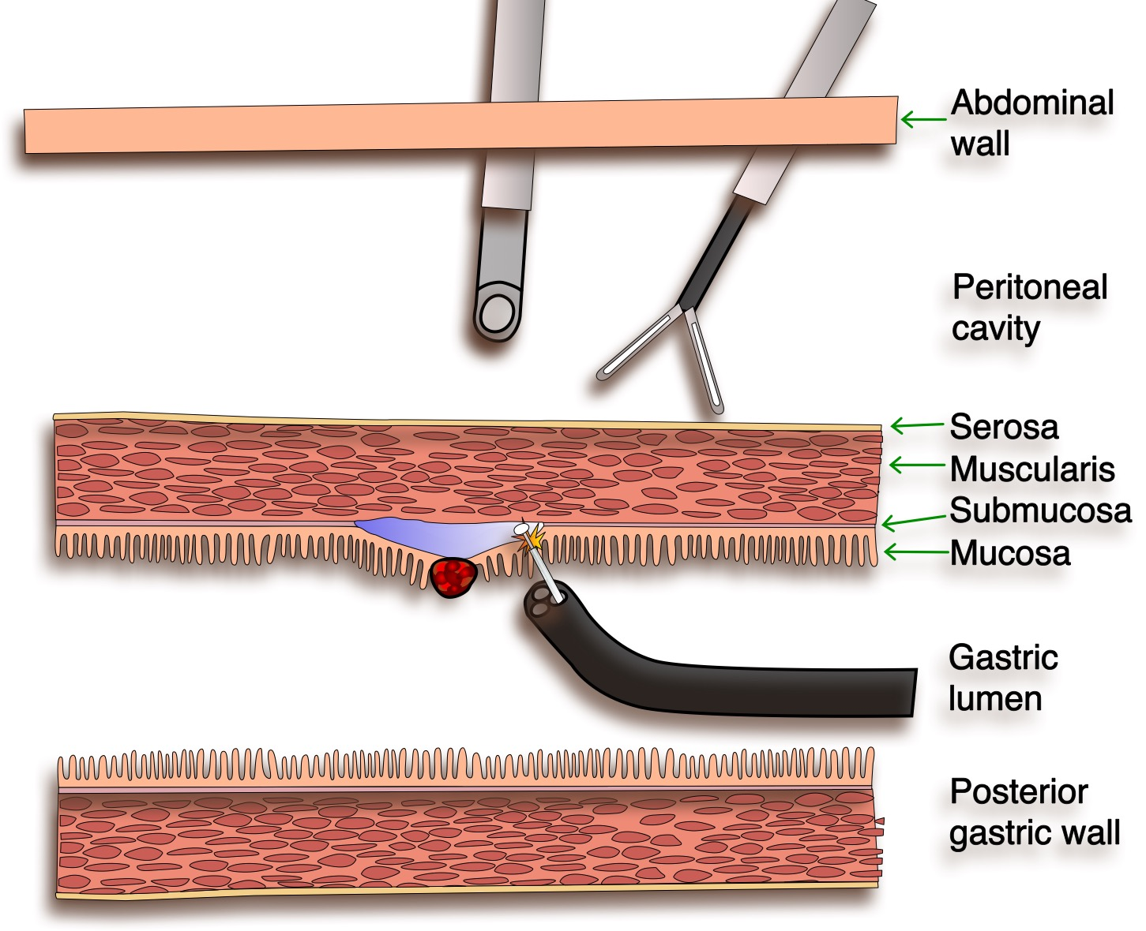
Figure 1 Laparoscopy-assisted endoscopic resection. The endoscopist is performing an endoscopic submucosal dissection while the laparoscopic team facilitates the exposure by external manipulations.

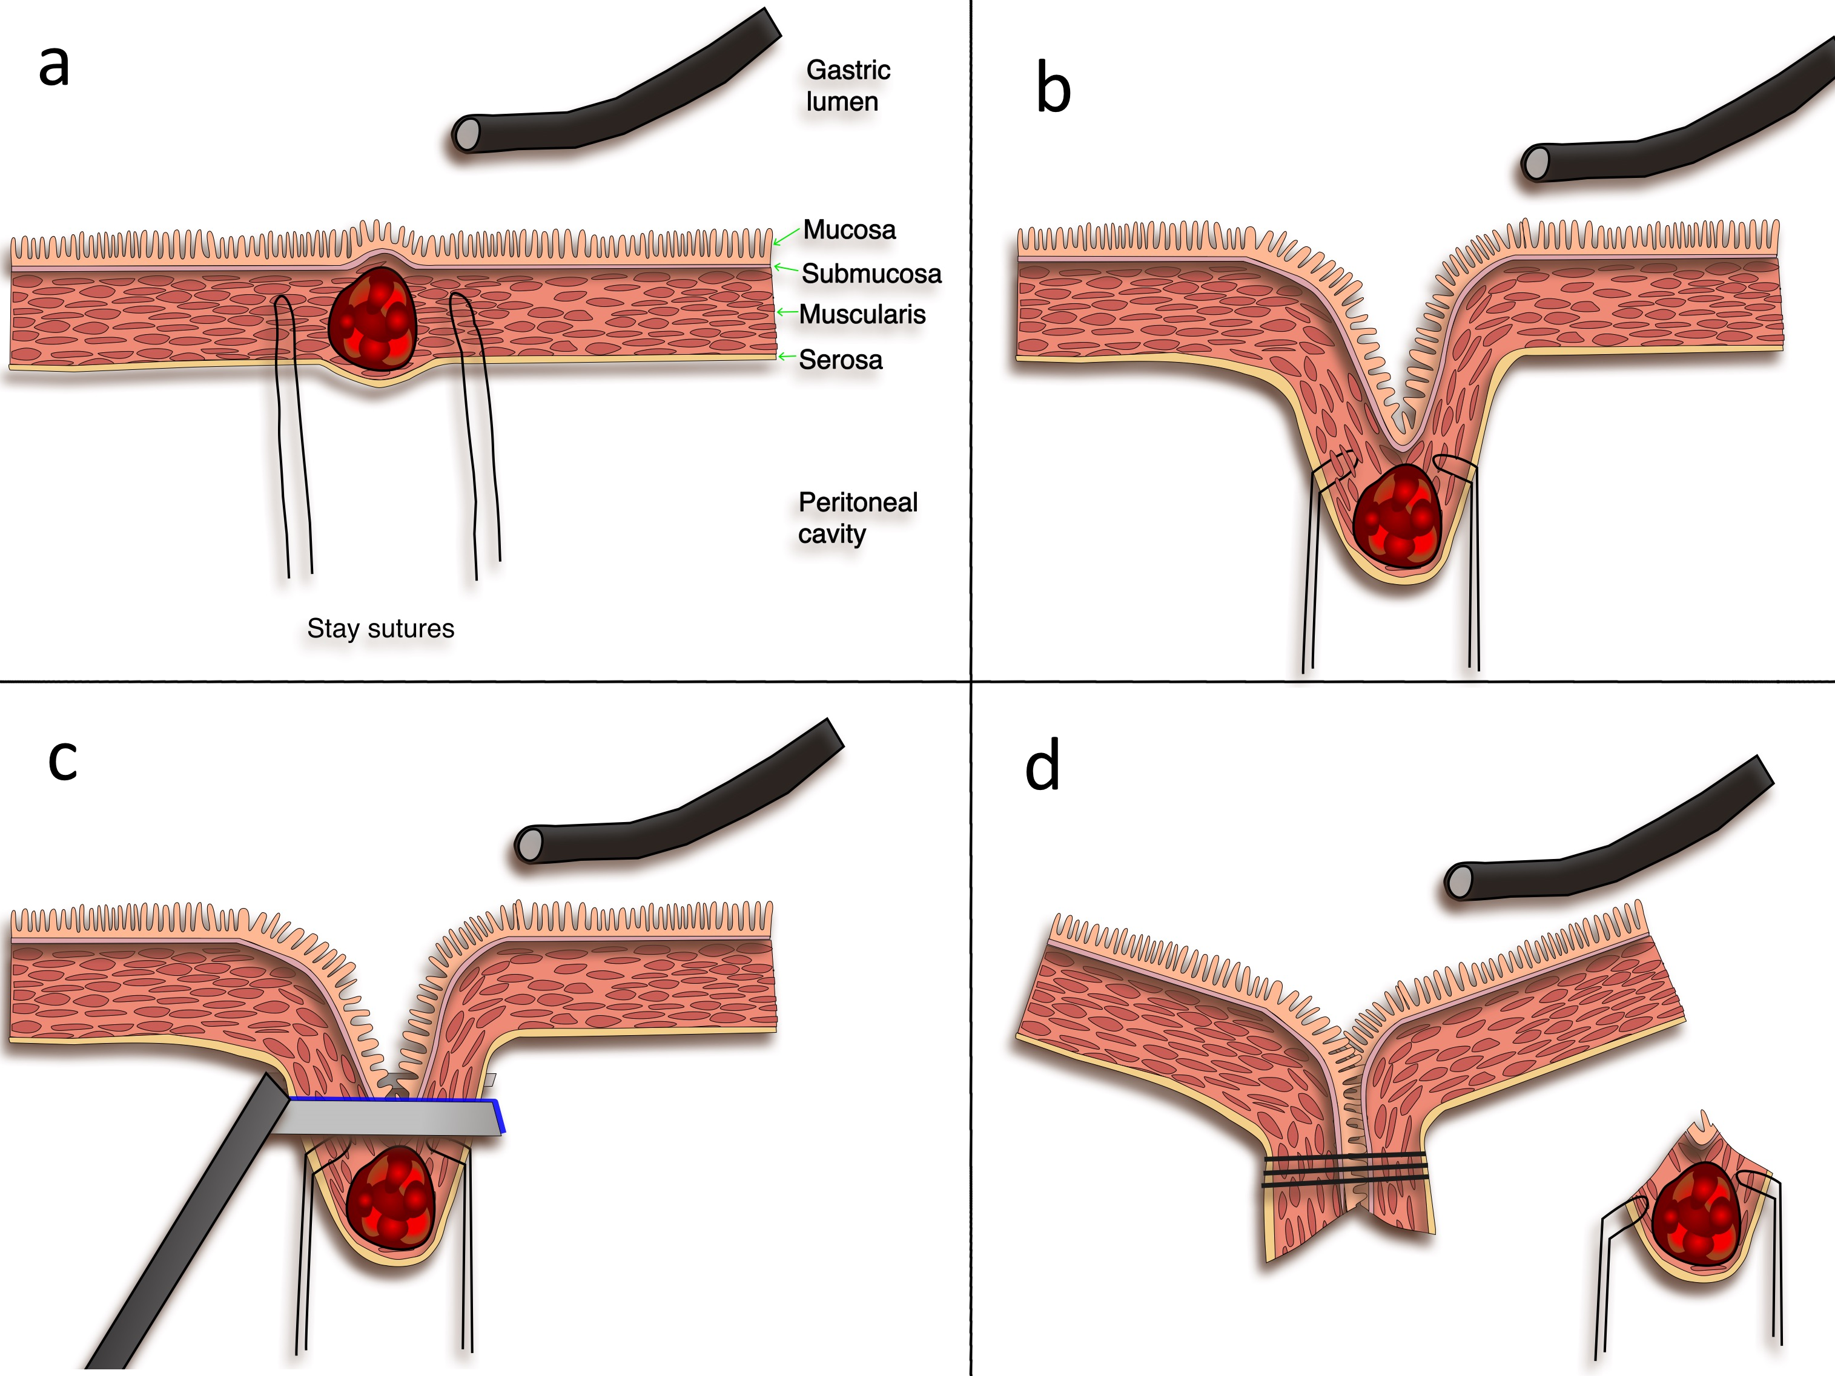
Figure 2 Endoscope-assisted laparoscopic wedge resection. A: The tumor is located by endoscopy and laparoscopy; two laparoscopic stay sutures are placed; B: Traction by the stay sutures creates tenting of the gastric wall; C: An endoscopic stapler is applied at the normal gastric wall distally to the tumor under endoscopic control; D: Full thickness resection with everted stapling of the gastric wall.

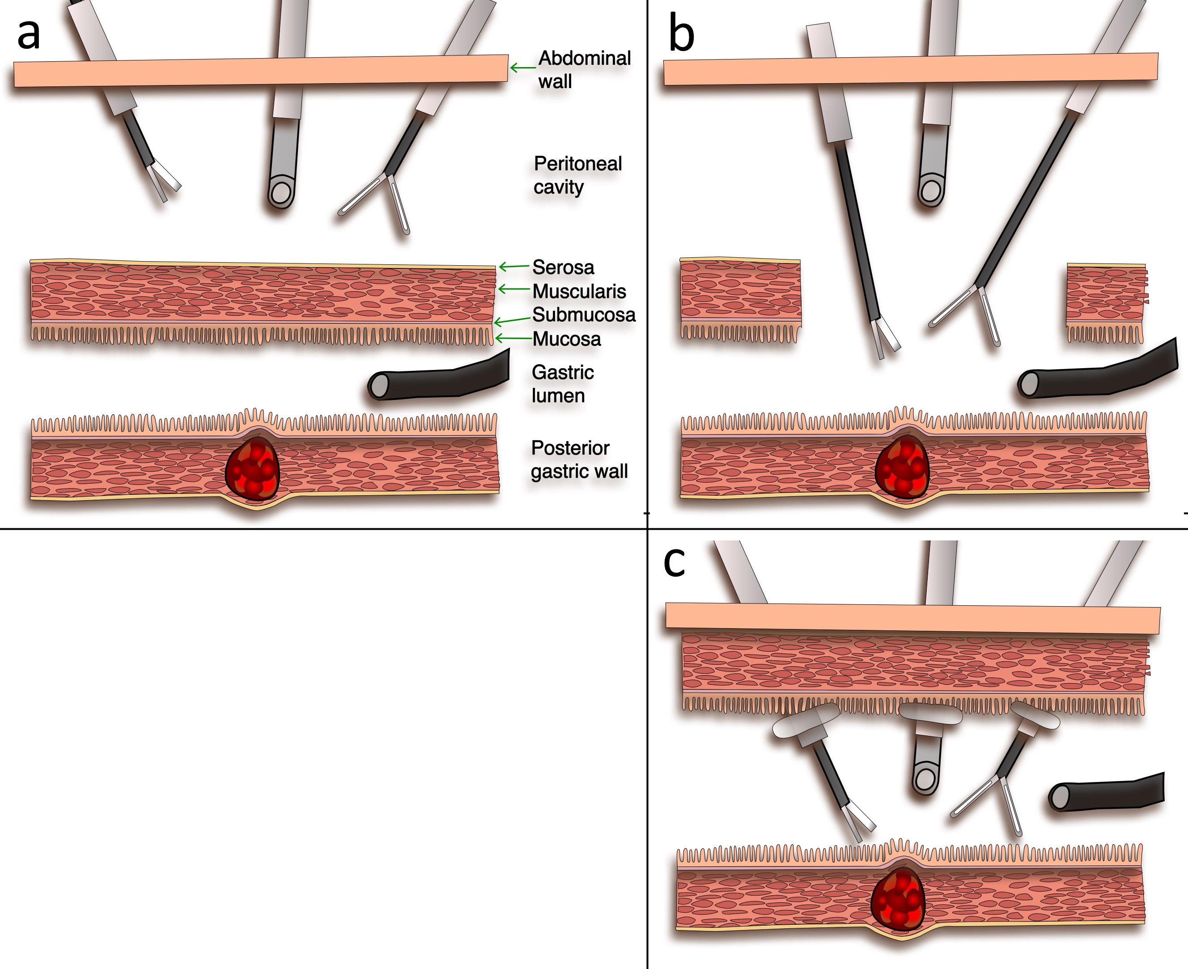
Figure 3 Endoscope-assisted laparoscopic intragastric and transgastric resection technique. A: Localization of the tumor at the posterior gastric wall by endoscopy and the position of the anterior gastric wall overlying the tumor is shown to the laparoscopic team by transillumination; B: Transgastric resection: the anterior gastric wall is sectioned (gastrotomy) to give laparoscopic access to the gastric lumen and the tumor; C: Intragastric resection: the laparoscopic ports are inserted through the abdominal wall and through the gastric wall inside the gastric lumen; the gastric wall is held in contact with the abdominal wall by means of the balloon tipped laparoscopic ports.

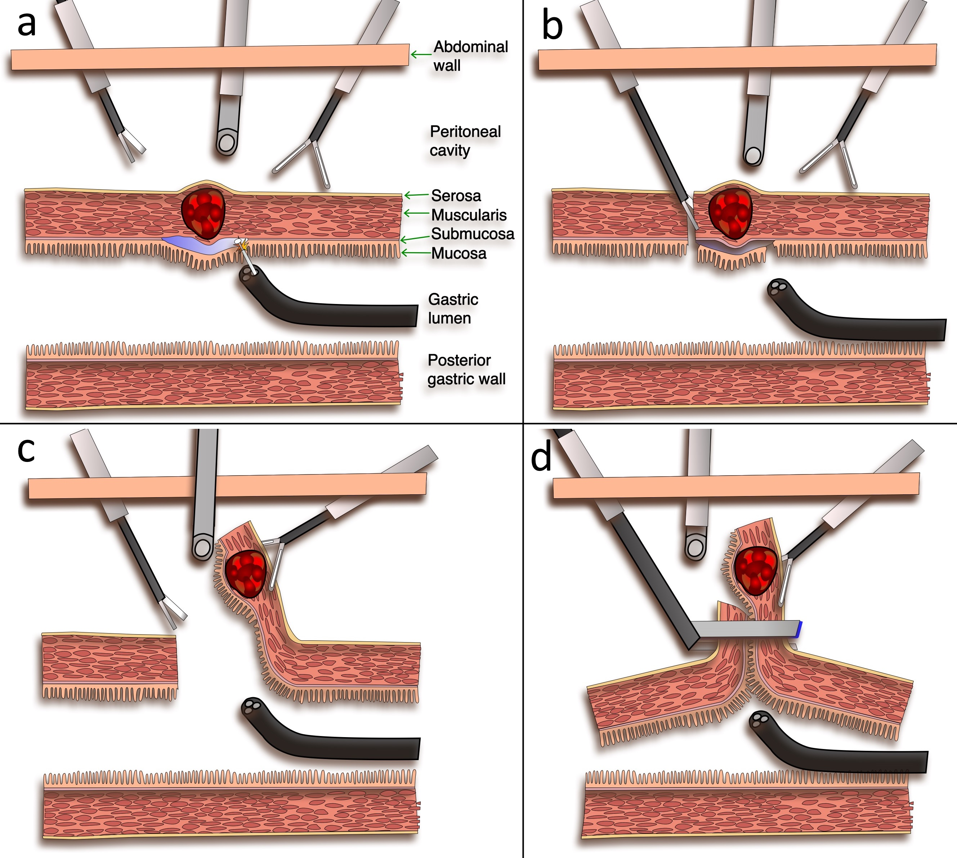
Figure 4 Laparoscopic endoscopic combined surgery. A: Submucosal injection and section of the mucosa around the tumor by the endoscopic team; B: After perforation of the gastric wall by the endoscopic team, the laparoscopic team makes a full thickness incision following the path of the endoscopic resection; C: Eversion of the tumor towards the peritoneal cavity and laparoscopic resection around the 2/3 of the gastric wall around it; D: Resection of the tumor and closure of the gastric wall by application of a laparoscopic stapler.

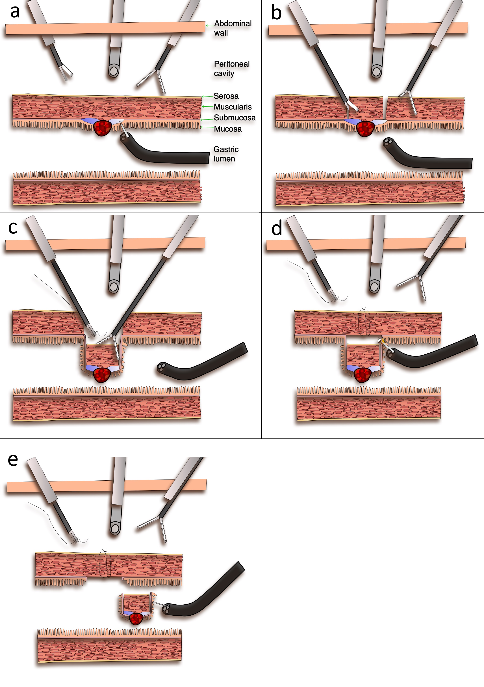
Figure 5 Non-exposed endoscopic wall-inversion surgery. A: Endoscopic submucosal injection around the tumor; B: Laparoscopic seromuscular dissection around the tumor down to the stained submucosal plane; C: Retraction of the tumor with its overlying normal gastric wall towards the gastric lumen, and closure of the gastric wall by laparoscopic seromuscular extramucosal suturing; D: The gastric wall opening is completely closed and the tumor is invaginated inside the gastric lumen; endoscopic mucosal resection around the tumor with a needle knife. e: Endoscopic extraction of the tumor, and the gastric mucosa is approximated with clips.

Table 1 Publications of cooperative laparoscopic endoscopic techniques with > 10 patients
Authors | Country | Year | Study type | No. Cases
Choi et al^{[20]} | Korea | 2000 | Retrospective series | 32
Shimizu et al^{[26]} | Japan | 2002 | Retrospective cohort | 11
Matthews et al^{[30]} | United States | 2002 | Retrospective cohort | 33
Ludwig et al^{[27]} | Germany | 2002 | Prospective case series | 18
Bouillot et al^{[19]} | France | 2003 | Multicenter retrospective case series | 56¹
Walsh et al^{[36]} | United States | 2003 | Retrospective series | 13
Hindmarsh et al^{[21]} | United Kingdom | 2005 | Retrospective series | 30
Schubert et al^{[28]} | Germany | 2005 | Retrospective series | 26
Mochizuki et al^{[24]} | Japan | 2006 | Retrospective series | 12
Novitsky et al^{[13]} | United States | 2006 | Prospective case series | 50
Huguet et al^{[22]} | United States | 2008 | Retrospective series | 33
Privette et al^{[15]} | United States | 2008 | Retrospective series | 12
Wilhelm et al^{[16]} | Germany | 2008 | Prospective case series | 93
Sasaki et al^{[25]} | Japan | 2010 | Prospective case series | 45
Kang et al^{[14]} | China | 2013 | Retrospective series | 101
Ohata et al^{[29]} | China | 2014 | Retrospective series | 22
Qiu et al^{[6]} | China | 2013 | Retrospective series | 69
Dong et al^{[68]} | China | 2014 | Retrospective cohort | 18
Tsujimoto et al^{[49]} | Japan | 2012 | Retrospective series | 20
Kawahira et al^{[46]} | Japan | 2012 | Retrospective cohort | 16
Hoteya et al^{[45]} | Japan | 2014 | Retrospective series | 25
Cho et al^{[56]} | Korea | 2011 | Prospective case series | 14
Hur et al ^{[57]} | Korea | 2014 | Prospective case series | 13
Mori et al ^{[54]} | Japan | 2015 | Prospective case series | 16
Shiwaku et al ^{[71]} | Japan | 2010 | Prospective case series | 16
¹Only 20 patients had a cooperative laparoscopic endoscopic procedure.

Table 2 Reported outcome for cooperative laparoscopic endoscopic techniques with > 10 patients
No | Authors | Year | Technique | #Cases | Lesion | Location | Lesion size (mm) | Operative time (min) | Blood loss (ml) | LOS (d)
1 | Choi et al ^{[20]} | 2000 | EAWR | 21 | SMT, leiomyo-sarcoma | Stomach | (20-60) | (80-180) | NR | (6-7)
 |  |  | LIGS | 10
 |  |  | proximal gastrectomy | 1
2 | Shimizu et al^{[26]} | 2002 | EAWR | 11 | SMT | Stomach | NR | 145 ± 43 | 98 ± 107 | 13.2 ± 3.7
3 | Matthews et al^{[30]} | 2002 | EAWR | 15 | GIST | Stomach | 45 (17-82) | 169 (65-300) | 106 (20-200) | 3.8 (2.7)
 |  |  | EATR | 3
 |  |  | needlescopic LIGS (enucleations) | 3
4 | Ludwig et al^{[27]} | 2002 | EAWR | 18 | SMT, EGC | Stomach | NR | 44.3 (31-67) | NR | 7.5 (3-11)
 |  |  | LIGS | 8 |  |  |  | 67.1 (49-102) |  | 10.2 (6-16)
5 | Bouillot et al^{[19]} | 2003 | EAWR | 20 | SMT | Stomach | 38 (15-100) | 104 (40-120) | NR | 6 (2-12)
6 | Walsh et al^{[36]} | 2003 | LIGS | 13 | SMT | Stomach | 38 (15-70) | 186 | NR | 3.8 (3-8)
7 | Hindmarsh et al^{[21]} | 2005 | EAWR | 30 | SMT | Stomach | 46.6 (12-90) | 73.8 (26-160) | 196 (0-1000) | 5 (1-11)
8 | Schubert et al^{[28]} | 2005 | EAWR | 16 | SMT, EGC | Stomach | 36 (16-47) | 53 (35-115) | NR | NR
 |  |  | LIGS | 7 | SMT, EGC | Stomach | 36 (16-47) | 83 (56-130)
9 | Mochizuki et al^{[24]} | 2006 | EAWR | 12 | SMT | Stomach | 27 (15-48)¹ | 100 (65-180)¹ | 0 (0-100)¹ | 7 (5-12)¹
10 | Novitsky et al^{[13]} | 2006 | EAWR | 30 | SMT | Stomach | 44 (10-85) | 135 (49-295) | NR | NR
 |  |  | LIGS | 17
 |  |  | other | 3
11 | Huguet et al^{[22]} | 2008 | EAWR  EATR | 11 | SMT | Stomach | 39 (5-10.5) ^{m} | NR | NR | 3 (1-40) ^{m}
12 | Privette et al^{[15]} | 2008 | EAWR | 5 | SMT | Stomach | 52 (25-60) | 180 (122-262) | 80 (50-100) | 3.4 (2-5)
 |  |  | distal gastrectomy | 3 |  |  | 55 (35-70) | 322 (256-340) | 167 (100-200) | 8.3 (8-9)
 |  |  | LIGS | 4 |  |  | 46 (25-75) | 236 (202-265) | 100 (50-200) | 3.3 (3-4)
13 | Wilhelm et al^{[16]} | 2008 | LAER | 1 | SMT | Stomach | 5 | 25 | NR | 2 (2)
 |  |  | EAWR | 55 |  |  | 25 (3-65) | 81.2 (35-202) |  | 7.68 (4-19)
 |  |  | EATR | 34 |  |  | 26 (5-55) | 114 (40-275) |  | 7.48 (2-14)
14 | Sasaki et al^{[25]} | 2010 | EAWR | 35 | SMT | Stomach | 32 (16-74) | 73 (30-150) | 3 (1-80) | 7 (5-14)
 |  |  | LIGS | 3 |  |  |  | 145 (100-240) | 10 (3-65) | 8 (5-9)
 |  |  | Single port LIGS | 3
 |  |  | EATR | 4
15 | Kang et al^{[14]} | 2013 | EAWR | 97 | SMT | Stomach | (10-82) | 113 ± 36) | 36 ± 18 | 4.5 ± 2.1
16 | Ohata et al^{[29]} | 2014 | EAWR | 22 | SMT, EDC | Duodenum | 13.3 ± 11.6 | 133 ± 45 | 16 ± 21.1 | 15.1 ± 7.7
17 | Qiu et al^{[6]} | 2013 | LAER | 5 | GIST | Stomach | 28 ± 16 | 81.6 ± 31.8 | 29.8 ± 15.4 | 4.6
 |  |  | EAWR | 64 | GIST | Stomach |  | 86.3 ± 28.5 | 31.4 ± 11.6
18 | Dong et al^{[68]} | 2014 | MLIGS | 8 | SMT | Stomach | 27.5 ± 10.7 | 85 ± 25.77 | 20 ± 10.4 | 7.5 ± 1.1
 |  |  | EFR | 10 |  |  | 16.5 ± 5.9 | 120 ± 34.72 | 48 ± 31.9 | 10.2 ± 9.1
19 | Tsujimoto et al^{[49]} | 2012 | LECS | 20 | SMT | Stomach | 37.9 (18-66) | 157.5 (89-316) | 3.5 (0-20) | 11.6 (6-13)
20 | Kawahira et al^{[46]} | 2012 | LECS | 16 | SMT | Stomach | NR | 172 | NR | 10
21 | Hoteya et al^{[45]} | 2014 | LECS | 25 | SMT | Stomach | NR | 156 | NR | 10.5
22 | Cho et al^{[56]} | 2011 | LAEFR + lymphadenectomy | 14 | EGC | Stomach | 26 (12-90)¹ | 143 (110-253)¹ | 16 (5-30)¹ | 6 (4-10)¹
23 | Hur et al^{[57]} | 2014 | LAEFR + lymphadenectomy | 9 | EGC | Stomach | 12 (4-32) | 181 (125-240) | NR | 5.9 ± 1.3 (4-8)
 |  |  | LADG | 4
24 | Mori et al^{[54]} | 2015 | LAEFR | 16 | GIST | Stomach | 28.3 (8-54) | 271 (100-480) | NR | 12.3 (10-15)
25 | Shiwaku et al^{[71]} | 2010 | Clean-NET | 16 | EGC | Stomach | NR | 182.1 | 19.4 | NR
Numbers are given as means ± sd, or means (range). 1-17: Endoscope-assisted laparoscopic resection group; 18: Laparoscope-assisted endoscopic resection group; 19-25: Combined laparoscopic endoscopic resection group. ¹median (range). EAWR: Endoscope-assisted laparoscopic wedge resection; LIGS: Laparoscopic intragastric surgery; ELIS: Endoscope-assisted laparoscopic intragastric stapling; EATR: Endoscope-assisted laparoscopic transgastric surgery; LAER: Laparoscopy-assisted endoscopic resection; EFR: Endoscopic full thickness resection; LECS: Laparoscopic endoscopic cooperative surgery; LAEFR: Laparoscopy-assisted endoscopic full thickness resection; NEWS: Non-exposed endoscopic wall-inversion surgery; SMT: Submucosal tumors; EGC: Early gastric cancer (T1a, T1b); EDC: Early duodenal cancer; LOS: Length of hospital stay in days; NR: not reported; Clean-NET: clean non exposure technique.

Table 3 Cooperative laparoscopic endoscopic techniques data comparison
Technique name | Lesion | Location | Endoscopy team role | Surgical team role | Closure type | Specimen retrieval | No. papers² | No. cases²
LAER^{[6,8,9,16]} | SMT | Stomach, Duodenum | endoscopic resection | monitoring | no closure | endoscopic | 4 | 10
EAWR ^{[6,13-29]} | SMT, EGC | Stomach, Duodenum | tumor localization, exposure | full thickness resection | stapler/sutures | surgical | 17 | 523
EATR^{[16,18,22,25,30,31]} | SMT | Stomach | tumor localization | mucosal resection, full thickness resection | stapler/sutures | surgical | 6 | 70
LIGS[13,15,20,25,27, 28,30,32,34-38] | SMT, EGC | Stomach | tumor localization, exposure | mucosal resection, full thickness resection | stapler/sutures/endo clips | endoscopic, surgical | 13 | 101
ELIS^{[39-41]} | SMT | Stomach | tumor localization, exposure, endoscopic guidance | stapling | stapler/sutures | endoscopic, surgical | 3 | 13
single port LIGS^{[25,42,43]} | SMT | Stomach | tumor localization | mucosal resection, full thickness resection | open sutures | surgical | 3 | 13
LECS^{[44-51]} | SMT, EDC | Stomach, Duodenum | submucosal dissection | seromuscular disection | stapler | surgical | 8 | 72
Inverted LECS^{[52]} | EGC | Stomach | submucosal dissection | seromuscular disection | stapler | endoscopic | 1 | 1
LAEFR^{[53,55-57]} | SMT, EGC¹ | Stomach | full thickness resection | full thickness resection | sutures | surgical, endoscopic | 5 | 48
Clean-NET^{[58,71]} | SMT, EGC | Stomach | tumor localization, submucosal injection | seromuscular disection | stapler | surgical | 1 | 16
NEWS ^{[60, 61]} | GIST, EGC¹ | Stomach | submucosal dissection | seromuscular disection | sutures | endoscopic | 2 | 7
¹Associated with sentinel lymph node dissection; ²Including publications with < 10 patients and case reports. LAER: Laparoscopy assisted endoscopic resection; LECS: Laparoscopic endoscopic cooperative surgery; LAEFR: Laparoscopy-assisted endoscopic full thickness resection; NEWS: Non-exposed endoscopic wall-inversion surgery; EAWR: Endoscope-assisted laparoscopic wedge resection; EATR: Endoscope-assisted laparoscopic transgastric surgery; LIGS: Laparoscopic intragastric surgery, ELIS: Endoscope-assisted laparoscopic intragastric stapling; SMT: Submucosal tumors; EGC: Early gastric cancer (T1a, T1b); EDC: Early duodenal cancer; Clean-NET: clean non exposure technique.
Table 4 Advantages and disadvantages of the various cooperative laparoscopic endoscopic techniques
Technique name | Pros | Cons
LAER | Minimally invasive approach.  Monitoring and backup from the laparoscopic team in case of accidental perforation. | Suitable for small lesions with intraluminal expansion.  Requires advanced endoscopy skills.
EAWR | Not requirement of advanced laparoscopic or endoscopic skills.  Good entry level for teams starting cooperative techniques | Leaves larger wall defects compared to other methods.  Risk of gastric deformation or stenosis from stapling.
EATR | Favorable access to lesions ≤ 2 cm, situated high on the posterior wall or lesser curvature without mobilizing the stomach. | Requires gastrotomy closure.  May lead to spillage with peritoneal contamination and dissemination.
LIGS | Similar to EATR | Risk of gastric deformation or stenosis from stapling.
ELIS | Same as EATR | Same as LIGS.  Difficulty in orienting the stapler under endoscopic view.
single port LIGS | Less invasive than the classic LIGS.  The gastrotomy can be closed through the single port incision. | Requires previous experience in single port laparoscopy.  More difficult than EATR and LIGS.
LECS | Combines the advantages of both endoscopy and laparoscopy. No restriction in the size or location of the tumor. | Requires advanced endoscopy and laparoscopy skills. More adapted in high volume centers.  Risk of spillage and contamination.  Not adapted for early gastric cancer
Inverted LECS | Diminishes the risk of peritoneal cancer dissemination. | Not adapted for early gastric cancer
LAEFR | Minimal invasive endoscopic resection.  The procedure is facilitated by the laparoscopic view and exposure. | Requires advanced endoscopy skills in dissection techniques and closure of wide wall defects with macro-clips or suturing devices.
Clean-NET | Diminishes the risk of peritoneal dissemination of gastric cancer. | Limited literature.  Requires special training.  Risk of mucosal tear with cancer cell dissemination
NEWS | Diminishes the risk of peritoneal dissemination of early gastric cancer. | Limited literature. Requires special training.
LAER: Laparoscopy assisted endoscopic resection; LECS: Laparoscopic endoscopic cooperative surgery; LAEFR: Laparoscopy-assisted endoscopic full thickness resection; NEWS: Non-exposed endoscopic wall-inversion surgery; EAWR: Endoscope-assisted laparoscopic wedge resection; EATR: Endoscope-assisted laparoscopic transgastric surgery; LIGS: Laparoscopic intragastric surgery; ELIS: Endoscope-assisted laparoscopic intragastric stapling; Clean-NET: clean non exposure technique.

