Name of Journal: World Journal of Gastrointestinal Surgery
Manuscript NO: 66059
Manuscript Type: CASE REPORT

Fluorescence in situ hybridization-based confirmation of acute graft-vs-host disease diagnosis following liver transplantation: A case report

Xiao JJ et al. FISH-based confirmation of aGvHD

Jing-Jing Xiao, Jin-Yu Ma, Jun Liao, Di Wu, Chao Lv, Hai-Yang Li, Shi Zuo, Hai-Tao Zhu, Hua-Jian Gu

Jing-Jing Xiao, Jin-Yu Ma, Jun Liao, Di Wu, Chao Lv, School of Clinical Medicine, Guizhou Medical University, Guiyang 550004, Guizhou Province, China

Hai-Yang Li, Shi Zuo, Hai-Tao Zhu, Department of Hepatobiliary Surgery, The Affiliated Hospital of Guizhou Medical University, Guiyang 550004, Guizhou Province, China

Hua-Jian Gu, Department of Pediatric Surgery, The Affiliated Hospital of Guizhou Medical University, Guiyang 550004, Guizhou Province, China

Author contributions: Xiao JJ and Ma JY were the patients’ surgeons and designed the research; Liao J, Wu D, and Lv C reviewed the literature and contributed to the drafting of the manuscript; Li HY and Zhu HT collected the surgical data and recordings; Zuo S processed the operation screenshots; Gu HJ was responsible for language editing and revision of the manuscript and supervised the revision of the manuscript; All authors took part in the final approval for the version to be submitted.

Corresponding author: Hua-Jian Gu, MD, Chief Physician, Department of Pediatric Surgery, The Affiliated Hospital of Guizhou Medical University, No. 16 Beijing Road, Guiyang 550004, Guizhou Province, China. zhaoyaree@sina.com

Received: March 20, 2021
Revised: June 5, 2021
Accepted: July 20, 2021
Published online: September 27, 2021

Abstract
BACKGROUND
Although acute graft-vs-host disease (aGvHD) is a rare complication of liver transplantation, it is poorly understood and has an extremely high mortality rate. No standardized diagnostic criteria or treatment regimens currently exist.

CASE SUMMARY
The present study investigated the etiology, diagnosis, and treatment of aGvHD following liver transplantation. Presentation, diagnosis, disease course, histology, and treatment of an aGvHD case are reported, and associated literature is reviewed. A 64-year-old female required LTx due to primary biliary cirrhosis. The donor was a 12-year-old male. Three weeks following liver transplantation, the recipient developed pyrexia, diarrhea, rashes, and antibiotic-unresponsive pancytopenia. Clinical symptoms together with laboratory investigations suggested a diagnosis of aGvHD, which was confirmed via peripheral blood fluorescent in situ hybridization. Donor XY chromosome fluorescent in situ hybridization indicating early chimerism achieved 93% sensitivity in the detection of GvHD. Existing immunosuppressants were discontinued, and high-dose intravenous methylprednisolone was initiated along with antibiotics. While diarrhea resolved, the patient’s general condition continued to deteriorate until demise due to multi-system organ failure at 37 d post-liver transplantation. This case illustrates the life-threatening nature of aGvHD.

CONCLUSION
Herein, we have summarized a post-LTx aGvHD case and reviewed associated literature in order to increase awareness and provide potentially risk-mitigating recommendations.

Key Words: Liver transplantation; Graft-vs-host disease; Fluorescence in situ hybridization cytogenetics; Chimerism; Diagnosis; Case report

©The Author(s) 2021. Published by Baishideng Publishing Group Inc. All rights reserved.

Citation: Xiao JJ, Ma JY, Liao J, Wu D, Lv C, Li HY, Zuo S, Zhu HT, Gu HJ. Fluorescence in situ hybridization-based confirmation of acute graft-vs-host disease diagnosis following liver transplantation: A case report. World J Gastrointest Surg 2021; 13(9): 1102-1109
URL: https://www.wjgnet.com/1948-9366/full/v13/i9/1102.htm
DOI: https://dx.doi.org/10.4240/wjgs.v13.i9.1102

Core Tip: At present, the risk factors, pathogenesis, optimal treatment, and prognosis associated with acute graft-vs-host disease following liver transplantation are unclear. Currently, the most reliable diagnostic method is specific immunostaining for donor-specific antigens. If the donor is male and the recipient is female, fluorescent in situ hybridization-based detection of the Y chromosome is a diagnostic option. In the present case, acute graft-vs-host disease was confirmed via fluorescent in situ hybridization, demonstrating the presence of male donor DNA.

INTRODUCTION
Acute graft-vs-host disease (aGvHD) is one of the most dangerous complications following liver transplantation (LTx)^{[1]}. It involves overactivation of donor helper T lymphocytes by recipient antigen-presenting cells, leading to a local inflammatory reaction against recipient tissue. Although the rate of aGvHD incidence after LTx is low (1%-2%), the mortality rate is extremely high (85%-90%)^{[2]}. Skin rash and pyrexia are the most frequently noted early signs, followed by leukopenia. Although aGvHD was first proposed as a clinical entity in 1988, its mechanisms and optimal treatment strategies remain controversial^{[3]}. Modification of the post-transplant treatment plan, including incorporation of more effective immunosuppressants, has a limited effect on the course of aGvHD^{[4,5]}. In most cases, death results from overwhelming sepsis or gastrointestinal hemorrhage as a consequence of bone marrow involvement^{[6]}. Due to the low incidence (but high mortality) of aGvHD following LTx, analysis of the present case with respect to existing literature is worthwhile in order to raise awareness regarding the condition, which may assist in the early diagnosis of suspected cases. It will also help improve diagnostic criteria and establish standardized evidence-based treatment regimens. Moreover, we wish to draw attention to the diagnostic utility of sex chromosome fluorescent in situ hybridization (FISH) when the donor and recipient are of different chromosomal sexes.

CASE PRESENTATION
Chief complaints
The patient was a 64-year-old female with primary biliary cirrhosis, esophageal-fundal variceal hemorrhages, and decompensated hepatocirrhosis in September 2017.

History of present illness
A 64-year-old female received a liver from an ABO-matched (A-positive) 12-year-old male cadaveric donor. The donor and recipient details are shown in Table 1. The donor was a 12-year-old male. Three weeks following liver transplantation, the recipient developed pyrexia, diarrhea, rashes, and antibiotic-unresponsive pancytopenia.

History of past illness
A 64-year-old female with primary biliary cirrhosis, esophageal-fundal variceal hemorrhages, and decompensated hepatocirrhosis.

Personal and family history
The patient grew up in her locality, denies any contact with contaminated water or radiation exposure, and denies smoking and alcohol consumption.

Physical examination
On physical examination, we found her poor nutritional status, the abdomen was moderately distended with mild tenderness, and there was moderately yellow staining of the skin and mucous membranes. The rest of the physical examination revealed no abnormal findings.

Laboratory examinations
The following timeline of events refers to post-operative days. On day 22, the patient developed pyrexia of unknown origin, fluctuating between 38.2 °C and 39.3 °C. On day 26, sex chromosome FISH was performed on peripheral venous blood samples. No gastrointestinal tract lesions were apparent, and no evidence of aGvHD was noted on gastrointestinal endoscopic biopsy (histologically normal esophagus, stomach, and ileum). On day 31, the presumptive diagnosis of GvHD was made based on the following clinical ground observations: Generalized maculopapular eruption (largely involving the back, neck, and face), pyrexia, pancytopenia, low blood pressure, and watery diarrhea (Figure 1 and Table 2). FISH revealed chimerism (presence of the fluorescently stained donor XY chromosome) consistent with aGvHD (Figure 2).
Two days following the development of thrombocytopenia, a bone marrow biopsy revealed marked hypocellularity. No skin rash was yet apparent. The findings of detailed post-operative laboratory investigation are summarized in Table 3. Because no sample of indwelling peripheral blood from the donor prior to LTx was available, donor lymphocytes could not be identified in recipient peripheral blood using short tandem repeat sequencing or human leukocyte antigen (HLA) typing.

Imaging examinations
Abdominal computed tomography and color ultrasound findings suggested laminar portal vein, inferior vena cava, hepatic artery, and hepatic venous flow (Figure 3).

FINAL DIAGNOSIS
aGvHD, primary biliary cirrhosis, esophageal-fundal variceal hemorrhages, and decompensated hepatocirrhosis.

TREATMENT
Initial treatment involved tapering the dosage of immunosuppressants to allow the recipient immune system to reject donor lymphocytes. Due to the inefficacy of this approach, the following treatment was administered subsequently: High-dose (500 mg/d) intravenous methylprednisolone, antibiotics, and immunoglobulin G (Table 2).

OUTCOME AND FOLLOW-UP
Severe inflammation induced multi-system organ failure, which led to the patient’s demise on post-operative day 37.

DISCUSSION
At present, the risk factors, pathogenesis, optimal treatment, and prognosis associated with aGvHD following LTx are unclear. Current (incomplete) understanding of aGvHD pathogenesis may be summarized as follows. The conditioning regimen induces initial recipient tissue damage, followed by auto- and alloantigen denudation in the recipient concomitant with antigen-presenting cell activation and massive inflammatory cytokine release (a “cytokine storm”). If a sufficient number of donor lymphocytes, especially T lymphocytes, of the correct specificity are present, direct recognition of and activation by antigen-presenting cell (either locally or within secondary lymphoid tissues) results in T lymphocyte interleukin (IL)-2 and IL-2R expression. Activated T-cells then stimulate donor monocytes to produce significant levels of myeloid cytokines (e.g., IL-1 and tumor necrosis factor) and also trigger a cascade of cytotoxic signal transduction pathways, such as the perforin/granzyme B or Fas/FasL pathways (although direct cytokine-mediated injury is also possible). Finally, inflammatory infiltration in the digestive tract, skin, and bone marrow leads to severe clinical presentations^{[7]}. In the present case, abnormally high numbers of CD8+ T lymphocytes were present during the acute phase of GvHD, while the CD4+ T lymphocyte:CD8+ T lymphocyte ratio was less than 0.1. This indicates that perhaps cytotoxic T lymphocytes (with a minor contribution by helper T lymphocytes) are the cells primarily involved in GvHD pathogenesis. In summary, the necessary conditions for the occurrence of aGvHD^{[8-10]} include the presence of donor immunoreactive cells within graft tissue, presence of recipient tissue antigens not present in donor organ tissue, and inability of the recipient immune system to eliminate effectively donor leukocytes.
Triulzi et al^{[9]} have described the diagnostic criteria for aGvHD following LTx in the following three requirements: (1) Characteristic clinical symptoms affecting related organ systems (e.g., skin, gastrointestinal tract, and bone marrow), including rash, diarrhea, and pancytopenia, among others; (2) Abnormal skin or digestive tract histology; and (3) HLA or DNA evidence of donor immunoreactive lymphocytes in involved organs or peripheral blood of the recipient. In addition to the above criteria, T lymphocyte counts and cytokine quantitation provide clear diagnostic support. Currently, the most reliable diagnostic method is specific immunostaining for donor-specific antigens. If the donor is male and the recipient is female, FISH-based detection of the Y chromosome is a diagnostic option^{[9,11,12]}. At present, no false negatives have been reported for this method. In the present case, aGvHD was confirmed via FISH, demonstrating the presence of male donor DNA.
Due to inter-individual differences in post-operative GvHD pathogenesis and presentation, no unified treatment plan exists. Each hospital follows a unique treatment plan associated with unique advantages and disadvantages. A commonality across most centers is reduction of the tacrolimus dose, cessation of anti-metabolic immunosuppressants, decreasing the steroid dose, and administering antilymphocyte globulin^{[13-15]}. Successful treatment via increasing immunosuppressant dosages has also been reported, with recommendations for cessation of all immunosuppressants in favor of isolated anti-human thymocyte globulin treatment^{[16]}. Certain patients also exhibit drug resistance or even resistance to the effects of some hormones^{[17]}. Treatment with anti-tumor necrosis factor-α or anti-IL-2 receptor monoclonal antibodies may prove beneficial^{[18,19]}. Currently, corticosteroids are the best-recognized first-line treatment agents for GvHD. Glucocorticoids exert efficient anti-inflammatory effects and can induce donor lymphocyte apoptosis. High-dose corticosteroid pulse therapy is administered during the acute phase of GvHD. It can inhibit inflammatory cell activation, thereby blocking the inflammatory cytokine cascade to improve systemic signs and symptoms. In cases of observation of GvHD symptoms (gastrointestinal disturbance, immunodeficiency despite overzealous inflammation, and deficient coagulation), hydration, electrolyte and acid-base rebalancing, nutritional support, restoration of gastrointestinal mucosal integrity, correction of microfloral imbalance, and transfusion of plasma and platelets can help mitigate poor outcomes, including severe infection^{[13,20]}.
In order to lessen mortality resulting from aGvHD, early detection and optimal standardized treatment are paramount. Additionally, an improved understanding of pathogenesis may assist in the prevention and treatment of this disorder. Based on our experience and the literature review, we make the following recommendations: Baseline (presurgical) donor and recipient blood samples should be obtained and cryopreserved. High-risk patients should routinely undergo HLA typing as a preliminary risk evaluation step. Ideally, the age difference between matched donors and recipients should not exceed 20 years. Pre-existing use of oral immunosuppressants should be minimized or discontinued prior to transplantation wherever possible. During perfusion of the donor abdominal aorta and portal vein, the effluent should run clear and the liver texture should soften. Finally, minimizing blood product infusion may lessen the rate of complications^{[15]}.

CONCLUSION
In the present case, aGvHD was confirmed via FISH, demonstrating the presence of male donor DNA. If the donor is male and the recipient is female, FISH-based detection of the Y chromosome is a diagnostic option.

REFERENCES
1 Perri R, Assi M, Talwalkar J, Heimbach J, Hogan W, Moore SB, Rosen CB. Graft vs. host disease after liver transplantation: a new approach is needed. Liver Transpl 2007; 13: 1092-1099 [PMID: 17663410 DOI: 10.1002/Lt.21203]
2 Taylor AL, Gibbs P, Bradley JA. Acute graft vs host disease following liver transplantation: the enemy within. Am J Transplant 2004; 4: 466-474 [PMID: 15023138 DOI: 10.1111/j.1600-6143.2004.00406.x]
3 Burdick JF, Vogelsang GB, Smith WJ, Farmer ER, Bias WB, Kaufmann SH, Horn J, Colombani PM, Pitt HA, Perler BA. Severe graft-versus-host disease in a liver-transplant recipient. N Engl J Med 1988; 318: 689-691 [PMID: 3278235 DOI: 10.1056/NEJM198803173181107]
4 Lee SJ, Onstad L, Chow EJ, Shaw BE, Jim HSL, Syrjala KL, Baker KS, Buckley S, Flowers ME. Patient-reported outcomes and health status associated with chronic graft-versus-host disease. Haematologica 2018; 103: 1535-1541 [PMID: 29858386 DOI: 10.3324/haematol.2018.192930]
5 Qian L, Dima D, Berce C, Liu Y, Rus I, Raduly LZ, Liu Y, Petrushev B, Berindan-Neagoe I, Irimie A, Tanase A, Jurj A, Shen J, Tomuleasa C. Protein dysregulation in graft vs host disease. Oncotarget 2018; 9: 1483-1491 [PMID: 29416707 DOI: 10.18632/oncotarget.23276]
6 Taylor AL, Gibbs P, Sudhindran S, Key T, Goodman RS, Morgan CH, Watson CJ, Delriviere L, Alexander GJ, Jamieson NV, Bradley JA, Taylor CJ. Monitoring systemic donor lymphocyte macrochimerism to aid the diagnosis of graft-versus-host disease after liver transplantation. Transplantation 2004; 77: 441-446 [PMID: 14966423 DOI: 10.1097/01.TP.0000103721.29729.FE]
7 Schrager JJ, Vnencak-Jones CL, Graber SE, Neff AT, Chari RS, Wright KJ Jr, Pinson CW, Stewart JH, Gorden DL. Use of short tandem repeats for DNA fingerprinting to rapidly diagnose graft-versus-host disease in solid organ transplant patients. Transplantation 2006; 81: 21-25 [PMID: 16421472 DOI: 10.1097/01.tp.0000190431.94252.3f]
8 Jacobs MT, Olson M, Ferreira BP, Jin R, Hachem R, Byers D, Witt C, Ghobadi A, DiPersio JF, Pusic I. The use of ruxolitinib for acute graft-versus-host disease developing after solid organ transplantation. Am J Transplant 2020; 20: 589-592 [PMID: 31446673 DOI: 10.1111/ajt.15579]
9 Triulzi D, Duquesnoy R, Nichols L, Clark K, Jukic D, Zeevi A, Meisner D. Fatal transfusion-associated graft-versus-host disease in an immunocompetent recipient of a volunteer unit of red cells. Transfusion 2006; 46: 885-888 [PMID: 16734803 DOI: 10.1111/j.1537-2995.2006.00819.x]
10 Kanehira K, Riegert-Johnson DL, Chen D, Gibson LE, Grinnell SD, Velgaleti GV. FISH diagnosis of acute graft-versus-host disease following living-related liver transplant. J Mol Diagn 2009; 11: 355-358 [PMID: 19460938 DOI: 10.2353/jmoldx.2009.080172]
11 Gonultas F, Akbulut S, Barut B, Kutluturk K, Yilmaz S. Graft-versus-host disease after living donor liver transplantation: an unpredictable troublesome complication for liver transplant centers. Eur J Gastroenterol Hepatol 2020; 32: 95-100 [PMID: 31524772 DOI: 10.1097/MEG.0000000000001530]
12 Di Ianni M, Del Papa B, Baldoni S, Di Tommaso A, Fabi B, Rosati E, Natale A, Santarone S, Olioso P, Papalinetti G, Giancola R, Accorsi P, Di Bartolomeo P, Sportoletti P, Falzetti F. NOTCH and Graft-Versus-Host Disease. Front Immunol 2018; 9: 1825 [PMID: 30147692 DOI: 10.3389/fimmu.2018.01825]
13 Triulzi DJ, Nalesnik MA. Microchimerism, GVHD, and tolerance in solid organ transplantation. Transfusion 2001; 41: 419-426 [PMID: 11274601 DOI: 10.1046/j.1537-2995.2001.41030419.x]
14 Perkins JL, Neglia JP, Ramsay NK, Davies SM. Successful bone marrow transplantation for severe aplastic anemia following orthotopic liver transplantation: long-term follow-up and outcome. Bone Marrow Transplant 2001; 28: 523-526 [PMID: 11593328 DOI: 10.1038/sj.bmt.1703177]
15 Ramachandran V, Kolli SS, Strowd LC. Review of Graft-Versus-Host Disease. Dermatol Clin 2019; 37: 569-582 [PMID: 31466596 DOI: 10.1016/j.det.2019.05.014]
16 Hill L, Alousi A, Kebriaei P, Mehta R, Rezvani K, Shpall E. New and emerging therapies for acute and chronic graft versus host disease. Ther Adv Hematol 2018; 9: 21-46 [PMID: 29317998 DOI: 10.1177/2040620717741860]
17 Schroeder T, Haas R, Kobbe G. Treatment of graft-versus-host disease with monoclonal antibodies and related fusion proteins. Expert Rev Hematol 2010; 3: 633-651 [PMID: 21083479 DOI: 10.1586/ehm.10.46]
18 Aladağ E, Kelkitli E, Göker H. Acute Graft-Versus-Host Disease: A Brief Review Turk J Haematol 2020; 37: 1-4 [PMID: 31475512 DOI: 10.4274/tjh.galenos.2019.2019.0157]
19 Murray J, Stringer J, Hutt D, Kenyon M, Babic A. Graft-Versus-Host Disease (GvHD) 2018 [PMID: 31314308 DOI: 10.1007/978-3-319-50026-3_11]
20 Whalen JG, Jukic DM, English JC 3rd. Rash and pancytopenia as initial manifestations of acute graft-versus-host disease after liver transplantation. J Am Acad Dermatol 2005; 52: 908-912 [PMID: 15858489 DOI: 10.1016/j.jaad.2005.01.126]

Footnotes
Informed consent statement: Informed written consent was obtained from the patients for publication of this report and any accompanying images.

Conflict-of-interest statement: The authors declare that they have no conflict of interest.

CARE Checklist (2016) statement: The authors have read the CARE Checklist (2016), and the manuscript was prepared and revised according to the CARE Checklist (2016).

Open-Access: This article is an open-access article that was selected by an in-house editor and fully peer-reviewed by external reviewers. It is distributed in accordance with the Creative Commons Attribution NonCommercial (CC BY-NC 4.0) license, which permits others to distribute, remix, adapt, build upon this work non-commercially, and license their derivative works on different terms, provided the original work is properly cited and the use is non-commercial. See: http://creativecommons.org/Licenses/by-nc/4.0/

Manuscript source: Unsolicited manuscript

Peer-review started: March 20, 2021
First decision: June 5, 2021
Article in press: July 20, 2021

Specialty type: Gastroenterology and hepatology
Country/Territory of origin: China
Peer-review report’s scientific quality classification
Grade A (Excellent): 0
Grade B (Very good): B
Grade C (Good): 0
Grade D (Fair): 0
Grade E (Poor): 0

P-Reviewer: Ferreira GSA S-Editor: Wu YXJ L-Editor: Filipodia P-Editor: Wu RR

Figure Legends
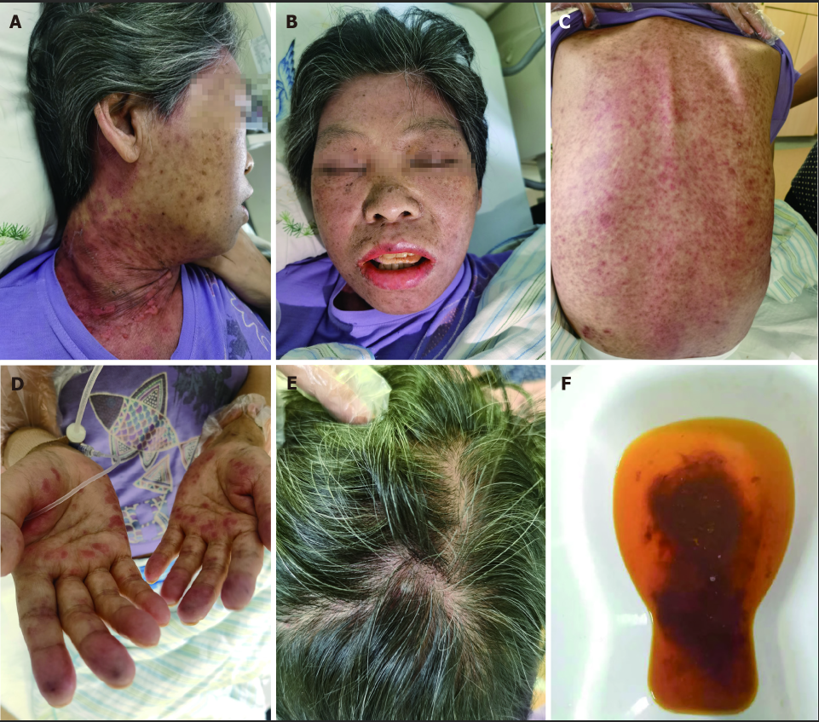
Figure 1 Clinical ground observations of graft-vs-host disease. A: Anterior cervical rash on post-operative day 24; B: Oral ulcers on post-operative day 25; C: Dorsal rash on post-operative day 25; D: Palmar rash on post-operative day 22; E: Scalp rash on post-operative day 27; F: Passage of three or more loose or liquid stools per day.

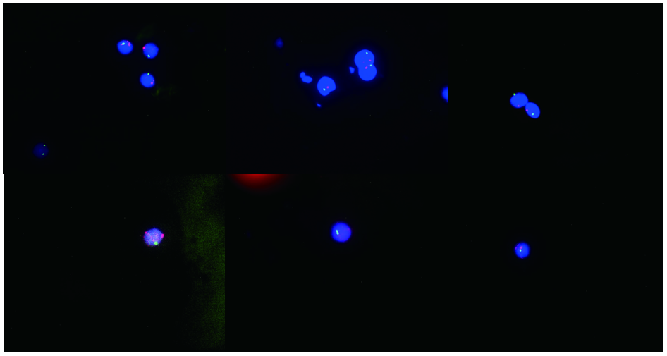
Figure 2 Twelve erythrocytes analyzed, 11 showed an XY signal pattern, while one showed an XX signal pattern (91.7% showed one X and one Y signal, and 8.3% showed two X signals). Y is the red fluorescent signal; X is the green fluorescent signal.

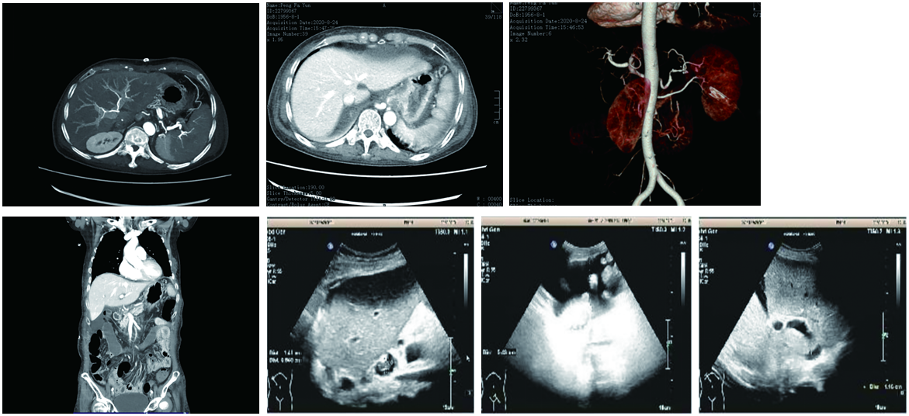
Figure 3 The portal vein, inferior vena cava, hepatic artery, and hepatic venous blood flow were smooth.

Table 1 Recipient and donor demographic, clinical, and typing data
Recipient | Donor
Age | 64 | 12
Sex | Female | Male
Primary complaint | PBC | Hypoxic-ischemic encephalopathy
Special history | Low-dose glucocorticoids | NA
Blood group | A | A
HLA | NA | NA
PBC: Primary biliary cirrhosis; HLA: Human leukocyte antigen; NA: Not applicable.

Table 2 Clinical manifestation and treatment timeline
 | Manifestations |  |  |  | Drugs
PO day | Temperature (°C) | Skin rash | Diarrhea | Myelosuppression | Tacrolimus (mg/d) | MMF (g/d) | MP | IgG (g/d) | Antibiotics
22 | 38.3 | Palm | 2 | NA | 3 | 0.25 | 500 | 10 | Yes
24 | 38.6 | Neck | 3 | NA | 2 | 0 | 500 | 10 | Yes
26 | 38.5 | Face | 6 | Yes | 2 | 0 | 120 | NA | Yes
28 | 38.2 | Trunk | 7 | Yes | 2 | 0 | 40 | NA | Yes
30 | 39 | > 35% | 6 | Yes | 2 | 0 | 20 | NA | Yes
32 | 38.6 | > 50% | 5 | Yes | 1.5 | 0 | 20 | 10 | Yes
34 | 38.7 | > 55% | 4 | Yes | 1.5 | 0 | 20 | 10 | NA
36 | Demise
PO: Post-operative; NA: Not applicable; MMF: Two oral formulations of mycophenolate mofetil; MP: Methylprednisolone; IgG: Immunoglobulin G. Antibiotics: Melophenan (1 g every 8 h) + carpophennet (50 mg per day) + vancomycin (0.5 g every 6 h).

Table 3 Post-operative laboratory investigation timeline
Post-operative laboratory investigation timeline
Value/PO day | 0 | 4 | 8 | 12 | 16 | 20 | 24 | 26 | 30 | 34 | 36
AST (U/L) | 643 | 47.6 | 56 | 48 | 64 | 75 | 63 | 56 | 44 | 52 | 74
ALT (U/L) | 772 | 88.1 | 96 | 86 | 107.3 | 62 | 59 | 64 | 66 | 71 | 83
Total bilirubin (mg/dL) | 231.4 | 123.5 | 119.5 | 76.9 | 65.5 | 23.7 | 25.8 | 24.2 | 35.1 | 45.6 | 48.7
Direct bilirubin (mg/dL) | 146.1 | 63.2 | 59.3 | 43.2 | 38.1 | 13.3 | 15.6 | 16.5 | 24.7 | 28.5 | 31.2
Leukocyte count × 10⁹/L | 17.5 | 8.7 | 12.4 | 17.3 | 7.2 | 6.7 | 1.3 | 0.39 | 0.24 | 0.12 | 0.08
Neutrophil % | 93 | 79 | 86 | 92 | 81 | 80 | 63 | 17.9 | 0 | 0 | 0
Hemoglobin (g/L) | 89 | 92 | 176 | 113 | 92 | 85 | 75 | 63 | 58 | 53 | 47
Hematocrit % | 42 | 46 | 50 | 32 | 26.5 | 23.3 | 22 | 17.6 | 16.5 | 15.6 | 14.8
Platelets × 10⁹/L | 21 | 26 | 44 | 58 | 77 | 73 | 71 | 56 | 47 | 46 | 41
Prothrombin time (s) | 17.9 | 19.9 | 16.5 | 22.4 | 13.5 | 13.1 | 12.7 | 13.1 | 12.8 | 13.2 | 13.6
INR | 1.82 | 1.7 | 1.34 | 1.98 | 1.05 | 1.01 | 0.97 | 0.99 | 0.98 | 1.02 | 1.07
Sodium (mmol/L) | 147 | 145 | 142 | 139 | 136 | 134 | 143 | 141 | 138 | 139 | 143
Potassium (mmol/L) | 3.8 | 4.5 | 3.1 | 3.4 | 3.6 | 3.8 | 3.9 | 4.2 | 4.1 | 3.9 | 3.7
Urea (mmol/L) | 32.52 | 29.8 | 16.42 | 4.55 | 4.77 | 4.46 | 4.13 | 3.8 | 4.17 | 3.74 | 4.02
Creatinine (μmol/L) | 89.73 | 85.64 | 64.59 | 43.78 | 58.44 | 53.76 | 49.19 | 46.52 | 27.26 | 24.54 | 30.45
PCT (ng/mL) | 5.73 | 3.86 | 11.5 | 5.1 | 1.86 | 2.65 | 2.58 | 2.45 | 2.18 | 3.65 | 4.53
PO: Post-operative; AST: Aspartate aminotransferase; ALT: Alanine aminotransferase; INR: International normalized ratio; PCT: Procalcitonin.

Published by Baishideng Publishing Group Inc
7041 Koll Center Parkway, Suite 160, Pleasanton, CA 94566, USA
Telephone: +1-925-3991568
E-mail: bpgoffice@wjgnet.com
Help Desk: https://www.f6publishing.com/helpdesk
https://www.wjgnet.com

© 2021 Baishideng Publishing Group Inc. All rights reserved.

