Name of Journal: World Journal of Diabetes
Manuscript NO: 86907
Manuscript Type: ORIGINAL ARTICLE

Randomized Clinical Trial
Acupuncture in diabetic peripheral neuropathy-neurological outcomes of the randomized acupuncture in diabetic peripheral neuropathy trial

Hoerder et al. Neurological outcomes of ACUDPN trial

Sebastian Hoerder, Isabel Valentina Habermann, Katrin Hahn, Gesa Meyer-Hamme, Miriam Ortiz, Weronika Grabowska, Stephanie Roll, Stefan N. Willich, Sven Schroeder, Benno Brinkhaus, Joanna Dietzel

Sebastian Hoerder, Isabel Valentina Habermann, Miriam Ortiz, Weronika Grabowska, Stephanie Roll, Stefan N. Willich, Benno Brinkhaus, Joanna Dietzel, Institute of Social Medicine, Epidemiology and Health Economics, Charité Universitätsmedizin, Berlin 10117, Germany

Katrin Hahn, Department of Neurology, Charité Universitätsmedizin, Charitéplatz 1, Berlin 10117, Germany

Gesa Meyer-Hamme, Sven Schroeder, HanseMerkur Center of Traditional Chinese Medicine at University Hospital Eppendorff, Martinistr 52, Hamburg 20246, Germany

Author contributions: The study was conceptualized and coordinated by Dietzel J, Brinkhaus B, Hahn K, Willich SN and Ortiz M; Dietzel J, Habermann IV, Hoerder S, Ortiz M, Meyer-Hamme G, and Schroeder S acquired the patient data and performed the treatments; Dietzel J, Roll S and Grabowska W conducted the main data analysis; Brinkhaus B had the overall medical responsibility, and Brinkhaus B and Schroeder S were equally supervising the trial; Hoerder S and Dietzel J prepared the manuscript.

Corresponding author: Joanna Dietzel, MD, Consultant Physician-Scientist, Institute for Social Medicine, Epidemiology and Health Economics, Charité Universitätsmedizin, Luisenstr 57, Berlin 10117, Germany. joanna.dietzel@charite.de

Received: July 14, 2023
Revised: October 2, 2023
Accepted: November 14, 2023
Published online: December 15, 2023

Abstract
BACKGROUND
Diabetic peripheral neuropathy (DPN) is a common complication of diabetes mellitus and can lead to serious complications. Therapeutic strategies for pain control are available but there are few approaches that influence neurological deficits such as numbness.

AIM
To investigate the effectiveness of acupuncture on improving neurological deficits in patients suffering from type 2 DPN.

METHODS
The acupuncture in DPN (ACUDPN) study was a two-armed, randomized, controlled, parallel group, open, multicenter clinical trial. Patients were randomized in a 1:1 ratio into two groups: The acupuncture group received 12 acupuncture treatments over 8 wk, and the control group was on a waiting list during the first 16 wk, before it received the same treatment as the other group. Both groups received routine care. Outcome parameters were evaluated after 8, 16 and 24 wk and included neurological scores, such as an 11-point numeric rating scale (NRS) 11 for hypesthesia, neuropathic pain symptom inventory (NPSI), neuropathy deficit score (NDS), neuropathy symptom score (NSS); nerve conduction studies (NCS) were assessed with a handheld point-of-care device.

RESULTS
Sixty-two participants were included. The NRS for numbness showed a difference of 2.3 (P < 0.001) in favor of the acupuncture group, the effect persisted until week 16 with a difference of 2.2 (P < 0.001) between groups and 1.8 points at week 24 compared to baseline. The NPSI was improved in the acupuncture group by 12.6 points (P < 0.001) at week 8, the NSS score at week 8 with a difference of 1.3 (P < 0.001); the NDS and the TNSc score improved for the acupuncture group in week 8, with a difference of 2.0 points (P < 0.001) compared to the control group. Effects were persistent in week 16 with a difference of 1.8 points (P < 0.05). The NCS showed no meaningful changes. In both groups only minor side effects were reported.

CONCLUSION
Study results suggest that acupuncture may be beneficial in type 2 diabetic DPN and seems to lead to a reduction in neurological deficits. No serious adverse events were recorded and the adherence to treatment was high. Confirmatory randomized sham-controlled clinical studies with adequate patient numbers are needed to confirm the results.

Key Words: Diabetic peripheral neuropathy; Numbness; Nerve conduction study; Acupuncture

©The Author(s) 2023. Published by Baishideng Publishing Group Inc. All rights reserved.

Citation: Hoerder S, Habermann IV, Hahn K, Meyer-Hamme G, Ortiz M, Grabowska W, Roll S, Willich SN, Schroeder S, Brinkhaus B, Dietzel J. Acupuncture in diabetic peripheral neuropathy-neurological outcomes of the randomized acupuncture in diabetic peripheral neuropathy trial. World J Diabetes 2023; 14(12): 1813-1823
URL: https://www.wjgnet.com/1948-9358/full/v14/i12/1813.htm
DOI: https://dx.doi.org/10.4239/wjd.v14.i12.1813

Core Tip: Diabetic peripheral neuropathy affects a high number of diabetic patients. It can lead to painful sensations of the lower extremities and loss of sensory function. The latter can lead to gait instability, falls and injury of the feet. Pharmacological treatments can only reduce painful symptoms but do not improve numbness; furthermore, they add to pharmacological burden of multimorbid patients. Acupuncture is a safe option to treat chronic pain; the potential to improve sensory loss is evaluated in this trial.

INTRODUCTION
According to the International Diabetes Federation (IDF), 537 million adults worldwide were already living with diabetes mellitus (DM) in 2021 and IDF estimates that there will be 783 million adults with diabetes by 2045^{[1]}. Diabetic distal sensorimotor polyneuropathy occurs in approximately 28% of hospitalized diabetic patients and in those in primary care^{[2]}, it is the most common neurological complication of DM. Moreover, diabetic peripheral neuropathy (DPN) can already occur in the presence of impaired glucose tolerance and thus before the manifestation of diabetes^{[3]}. DPN presents with stocking-like numbness, thermoanesthesia, hypesthesia, painful tingling, pricking, or burning sensations, and loss of proprioception. Especially hypesthesia and loss of proprioception may result in gait instability and falls; plantar injuries may go unnoticed and increase the risk for ulcerations or even amputation^{[4-6]}.
Pharmacological options to treat hypesthesia are missing. Symptomatic therapy addresses only plus-symptoms such as pain or tingling; here anticonvulsants and antidepressants are used^{[7]}. According to a Cochrane meta-analysis even strict glycemic control showed no recovery or prevention of neuronal demise^{[8]} and the used anticonvulsants have common side effects like fatigue or interact with other medication. Previous studies have also shown that the adherence of patients with neuropathic pain to the standard dosage of the above-mentioned medications is poor; this has been explained by the fear of side effects or the inadequate control of pain^{[9-11]}. Non-pharmacological options for treatment are therefore of interest.
A meta-analysis in 2017 showed that acupuncture is an effective and safe treatment for chronic pain^{[12]}. Besides pain control, several trials suggest that acupuncture also has a positive influence on nerve function with an improvement of nerve conduction^{[13-18]}.
The acupuncture in DPN (ACUDPN) trial investigates the effectiveness of acupuncture in diabetic patients suffering from DPN with a follow up of the effects until week 24. The results of the primary subjective parameters were published elsewhere and showed that acupuncture may be beneficial with a significant and clinically relevant reduction of overall DPN-related complaints and pain and disease-specific quality of life^{[19]}. In this manuscript we focus on the effects of acupuncture on neurological examination scores and nerve conduction studies (NCS).

MATERIALS AND METHODS
The study protocol was approved by the ethics committee Berlin (EA1/183/18) and Hamburg, Germany in October 2018. ACUDPN was performed in compliance with the Declaration of Helsinki and standards of Good Clinical Practice. Informed written and oral consent was given by all patients prior to beginning of the study. The trial was registered on ClinicalTrials.gov NCT03755960.
This trial is a two-armed, randomized, controlled, parallel group, multicenter clinical trial. It was conducted between February 2019 and April 2021 at the German Charité Universitätsmedizin Berlin and at an outpatient clinic for TCM (HanseMerkur Center for TCM) at the University Medical Center Hamburg-Eppendorf in Hamburg, Germany. Details regarding study methodology have been published elsewhere^{[20]}.

Eligibility criteria
Participants had to meet the following criteria to be eligible for the study: Female or male aged 18-80 years; with a diagnosis of DPN with at least moderate symptoms and a minimum of at least 40 mm on a 0-100 mm visual analogue scale (VAS) for overall DPN-related complaints; pathological nerve conduction velocity (NCV) < 42 m/s and/or an amplitude of the sural nerve < 6 μV; absence of severe DPN with muscular weakness of the proximal leg muscles or neuropathy due to other reasons (such as borrelia infection, human immunodeficiency virus infection, hereditary factors, alcohol, or a history of neurotoxic drug use or traumatic lesions of the nerves or vessels in the lower extremities); body mass index < 35; absence of anticoagulation or bleeding disorders; absence of severe peripheral artery disease in Fontaine stage IV or ulcers or gangrenous lesions of the feet; severe fatigue syndrome; if needed then previously (since 4 wk) unchanged doses of pain medication against DPN; no opioid use before inclusion in the study or regular use of cannabis or cannabinoids or lipoic acid infusions planned during participation in the trial; no scheduled psychotherapy during study participation; no additional therapy with complementary medicine or physical therapy for symptoms of DPN during the 6 wk before inclusion in the study or planned during the study; no pregnancy or lactation. In addition, patients had to be able to complete a diary for the self-evaluation of symptoms, to record the use of symptomatic medication.
Randomization with a 1:1 ratio was performed using a computer-generated randomization list with the statistical package SAS (SAS 9.4, SAS Institute Inc., Cary, NC, United States). The study physician received the information about the allocation by phone from the study nurse.
All patients were enrolled in the trial for 24 wk. The patients in the intervention group received a total of 12 acupuncture sessions over the first 8 wk, the control group was on a waiting list and received the same acupuncture treatment from week 16 onwards. All patients kept diaries for the first 8 wk, completed questionnaires, and attended follow ups. Both groups were allowed to continue their usual medication during the study. A detailed description of the methodology has been published elsewhere^{[19]}.
The main acupuncture points were inserted bilaterally (Figure 1). ST 40, LV3 and most of the EX-LE-10 “Bafeng” points are located in the innervation area of the peroneal nerve. SP 6 and KI 3 are located close to the tibial nerve. The acupuncture treatment was carried out with sterile, single use, stainless-steel 0, 25 mm × 30 mm (manufactured by Dong Bang AcuPrime) and 0, 25 mm × 40 mm needles (manufactured by PHOENIX).
This research focuses on improvement of sensory loss assessed with patient reported outcomes, clinical and neurophysiological outcomes: Changes in the neuropathy symptom score (NSS), neuropathy deficit score (NDS), the clinical total neuropathy score (TNSc), and the patient questionnaire neuropathic pain symptom inventory (NPSI), which uses an 11-point scale to capture 5 different subdimensions of neuropathic pain which are sensitive to treatment^{[21]}. Since the NPSI does not assess hypesthesia, we added the 11-point numeric rating scale (NRS) for patients to rate the numbness sensation on the soles of the feet. All outcomes were assessed at 8, 16 and 24 wk.
Neurophysiological assessment included measurements of the sural nerve. This nerve is typically affected in DPN and is commonly used in the diagnosis or to assess the progression of the disease^{[22-24]}. Amplitude of the sensory nerve action potential (SNAP) and the NCV of the suralis nerve were measured with the handheld point-of-care device (POCD) NC-stat®/DPNCheck™ (NeuroMetrix, Inc., Waltham, MA). This is a novel handheld point-of-care-device which automatically performs multiple single measurements with increasing intensity within 10 s to provide amplitude (μV) and velocity (m/s) of the sural nerve after supramaximal stimulation. The POCD utilizes a linear temperature compensation method for velocity. With the default skin temperature set to 28 ℃, the device automatically adjusts the velocity by 1.0 m/s per degree, with a maximum correction of 5 m/s. If skin temperature is lower than 23 ℃ or wrong placement or limb are recognized, the POCD displays a warning.
The device has been validated in multiple studies as an accurate screening and monitoring tool for DPN and diabetic foot risk assessment^{[22,25-27]}. Six trained researchers (four medical doctors and two medical students) performed the measurements in a standardized manner.
To collect the data, patients were lying on their side, with the leg to be examined on top and exposing the ankle. The POCD was manually programmed to assess the left or right leg of the patient. Electrode gel was applied to the stimulating probe before placing it behind the malleolus externus. The release button was pushed, and the device would automatically give up to 16 electric discharges of increasing intensity for supramaximal stimulation. The displayed values were noted in the case report file. Each leg was measured a minimum of two times, and if values were very discrepant a third or fourth measurement was added. The procedure was then repeated for the other leg.
The primary outcome of the ACUDPN trial was a VAS for overall DPN-related complaints including pain at week 8. The results of further secondary outcomes related to pain and quality of life were published elsewhere^{[19]}.

Statistical analysis
Sample size was calculated to detect a group difference in the mean values of the primary outcome parameter VAS DPN-related overall complaints after 8 wk^{[19,20]}. A sample size of 90 patients was calculated to provide 80% power plus 15% to account for estimated dropouts (45 per group).
Evaluation of the secondary outcome parameters was exploratory, therefore was carried out without adjustment for multiple testing. All endpoints were analyzed with an ANCOVA or logistic regression (depending on the scale of the outcome). The treatment group and study center were used as fixed-effect factors and the corresponding baseline values were defined as fixed covariates. The analysis of the primary endpoint was performed with the full analysis set based on an intention-to-treat principle, the results have been published elsewhere^{[19]}. Missing values were not replaced.
Additionally, the percentage change for the NRS 11 numbness was calculated for weeks 8 and 16 based on NRS 11 results obtained from the adjusted ANCOVA models. Data assessment was performed using SAS for Windows, version 9.4 or higher (SAS Institute, Cary, NC, United States), SPSS version 26 or higher (IBM SPSS Statistics for Windows, Armonk, NY: IBM Corp). The statistician was blinded to the groups until the end of analysis.
The trial was terminated prematurely due to strong restrictions on research with direct patient contact caused by the coronavirus disease 2019 (COVID-19) pandemic. Consequently, the previously calculated sample was not reached. Due to the lower sample size, the study center was not included as fixed effect in the statistical models for primary and secondary endpoints in the predefined statistical analysis plan. Instead, study center was included as a random effect in the analyses. The inclusion of a patient with an hemoglobin A1c below 6.5% represented a further protocol deviation with no impact on statistical analysis.

RESULTS
Altogether, 292 patients were screened for eligibility, 230 were excluded mainly because the required pathological NCV was not met or nerve conduction was within the normal age range; one patient was excluded because of very severe neuropathy with atrophy of the proximal leg muscles. Sixty-two participants [mean age 68.1 (SD 7.4); males 49 (79.0%), females 13 (21.0%)] met our inclusion criteria and were randomized 1:1 to either the intervention group or the waiting group. Recruitment was from February 2019 through to November 2020. Regarding the dropouts, 2 patients discontinued the trial in the control group because of the COVID-19 pandemic, and 3 dropped out of the intervention group, one due to intolerance to the acupuncture and 2 because of the pandemic (Figure 2, Table 1). Regarding the baseline parameters, there were no differences in demographic parameters. The control group had a few more participants with painful and severe neuropathy. Even though the relative difference could be considered significant, the absolute difference in groups was too small to address them through sensitivity analysis. Baseline characteristics are summarized in Table 1. The adherence rate was high; 96,8% of all 744 acupuncture treatments sessions were carried out.

Numbness 11-point NRS
The evaluation yielded a difference of 2.3 (P < 0.001) in favor of the acupuncture group, an effect that persisted until week 16 with a difference of 2.2 (P < 0.001), which corresponds to 35.4% and 32.4% improvement for the intervention group compared to control at weeks 8 and 16 respectively (Figure 3). At week 24, in the acupuncture group the reduction of subjectively perceived hypesthesia was still 1.8 points lower than at baseline (Table 2).

The neuropathy pain symptom inventory
The score was improved in the acupuncture group by 12.6 points (P < 0.001) at week 8 and the difference persisted with 11.7 points at week 16 compared to the control group. The most notable difference was in the subdimension of paresthesia and dysesthesia at week 8 and in the subdimension of paroxysmal pain in week 16. The results of the NPSI have already been published together with the primary endpoint and the other patient reported outcomes, but the results are provided again together with the NRS-11 on numbness to complete the report of subjectively perceived changes of the neuropathy^{[27]}.

The neurological examination total neuropathy score clinical TNSc
The score improved for the acupuncture group at week 8, with a difference of 2.0 points (P < 0.001) compared to the control group. Effects were persistent in week 16 with a difference of 1.8 points. Pre-post-comparisons in the acupuncture group showed persisting reductions of TNSc in week 24 in the acupuncture group compared to baseline 10.2 ± 4.1 vs. 7.9 ± 3 .5 (Table 2).

The NSS
The NSS total score at week 8 was in favor of the acupuncture group with a difference of 1.3 (P < 0.001); this effect was persistent at week 16 with a difference of 1.4 (P = 0.005). The NDS in the acupuncture group showed a better outcome in week 8 with a difference of 1.0 points. This effect was persistent in week 16 with a difference of 0.9.

Neurophysiological data
There was no considerable difference at week 8 in the mean nervus suralis conduction velocity between the acupuncture group and the control group with 0.4 m/s (P = 0.818). The amplitude of the nervus suralis at week 8 showed no difference between the groups with 0.6 µV (P = 0.156). With the mean velocities at 38.8 m/s for both groups, the lack of effect persisted in week 16. Similarly, there was no difference in amplitude between groups at week 16 [difference of 0.4 µV (P = 0.428)]. At week 24 the intervention group has a mean velocity of 41.1 ± 11.8 and an amplitude of 4.6 ± 2.0.
At the end of the study intervention at week 8, the difference between groups regarding the primary outcome VAS overall DPN-related complaints was 24.7 mm (95%CI 14.8; 34.7, P < 0.001) in favor of the acupuncture group. The change in VAS overall DPN-related complaints at week 8 compared to baseline was 34.8 (95%CI 27.8; 41.8) in the acupuncture group vs. 59.5 (95%CI 52.4; 66.6) in the control group; significant improvements persisted in week 16 and clinically relevant improvements until week 24. Relevant reductions of neurological deficit scores persisted until week 24 (Table 3) For details regarding pain and quality of life outcomes see previous publication^{[19]}.

Adverse events (AE)
The following AEs were reported during the study: one patient discontinued acupuncture due to persistent discomfort after the needling session, which resolved in over one week and did not require any medical attention. Further AE were mild and consisted of minor local hematomas (n = 18), transient pain at needling site (n = 5) transient paresthesia (n = 7), tiredness after treatments (n = 5), light-headedness (n = 1), transient intensifying of DPN-related symptoms (n = 4), cramps of thigh muscle after needling (n = 1) and itching at needling site (n = 1). Serious AE were not observed.

DISCUSSION
Summary of results
The results of this trial suggest that patients with moderate to severe DPN-related complaints benefit from a series of acupuncture treatments with reduction of dysesthesia and improvement of sensory function; the patient-reported outcomes are reflected in the neurological examinations. The improvements persist for up to 4 mo. Changes of nerve conduction parameters could not be shown with the POCD used in this trial.

Strength and limitations
This trial focuses on hypesthesia/numbness and loss of further sensory functions, which is crucial in the development of gait disorders, risk of falls and development of diabetic foot. This approach is a novelty in DPN research, which usually concentrates on reducing pain or tingling. The reduction of numbness is of equally high importance since there is no pharmacological option for this symptom and it is of high relevance in protecting the integrity of the feet. Our results showed the decrease of numbness at 8 and 16 wk to be above 32%, which is indicative of a clinically important improvement. Regarding the neurological examination scores, they have been assessed by different members of the two study centers, and the findings were consistent. The trial adds the important information that a lasting improvement of DPN-related symptoms and improvement of sensory function can be achieved in chronically ill patients with an ongoing risk factor for neuropathy. The high adherence rate shows again that repetitive acupuncture treatments were well tolerated and led to patient satisfaction.
However, this study has some limitations: The sample was smaller than initially planned; a bigger trial would be useful. The statistical analysis was adapted accordingly. The results are from an analysis of secondary endpoints, which is exploratory by nature. Furthermore, a placebo effect on the patient-related outcome must be considered, despite the persistent improvement 4 mo after the end of the treatment. Due to limited resources, the clinical assessments could not be performed through a blinded assessor. Furthermore, the trial failed to show these improvements in the neurophysiological endpoints, which might be due to the diagnostic device used, which is a POCD instead of conventional NCS. Although the DPN-check device has been validated as an accurate screening tool in previous studies, it´s reliability to monitor therapy response in an intervention study has not been evaluated.

Comparison with other studies
The ACUDIN trial was a three-armed randomized, placebo-controlled trial with 180 patients with confirmed type 2 diabetes-induced DPN that were either allocated to receive 10 sessions of needle acupuncture, laser acupuncture, or placebo laser acupuncture for 10 consecutive weeks^{[17]}. Neurological assessments, including NCS of sural and tibial nerves with the conventional method, were performed at baseline and weeks 6 and 15 with conventional neurography. Primary outcome was the delta of sural SNAP. Secondary outcomes included further NCS values, clinical scores, and patient-reported outcome measures (PROMs). The amplitude of the sural nerve improved by 1.95 in the acupuncture group vs 0.5 in the placebo group and the sural nerve conduction velocities improved significantly by a mean of 13.5 m/s in the acupuncture group compared to placebo lase with 3.4 m/s. However, sural nerve conduction and amplitude was evaluated in the ACUDIN with classical needle neurography by experienced neurologists, which might be more sensitive.
A systematic review with meta-analysis of 14 randomized control trials and 1 long-term follow-up study on the use of acupuncture for various neuropathies showed that acupuncture was effective for diabetic neuropathy, Bell’s palsy, and carpal tunnel syndrome^{[28]}. In the 4 Chinese trials on diabetic neuropathy neurological examination scores and conventional nerve conduction study improved significantly. In a study with a design comparable to ACUDPN with a randomized waiting-list control group, 87 Chinese patients with chemotherapy-induced neuropathy were investigated. Within this cohort, 10 acupuncture sessions resulted in significant clinical improvements after 8 wk regarding the primary outcome (pain) and also neurological assessment^{[29]}. A subset of patients was tested with NCS and had no or only borderline electrophysiological signs of neuropathy at baseline. These parameters did not change after 8 wk, the authors linked it to the small number of patients in this subset and to the absence of neurophysiological abnormal findings at baseline. However, the randomized crossover ACUCIN study with 60 patients with chemotherapy-induced neuropathy revealed improvement in NCS measured by classical neurography and PROMs^{[30]}.

Further research
The results of this trial showed beneficial effects in type 2 DPN, however there were several limitations which must be addressed in future research. Future trials should be conducted with a sham-control group and proper blinding, and with neurological outcomes as primary endpoint and conventional NCS in the secondary outcomes. Studies with larger sample size would be needed to address the potential impact on the study result by neuropathy subtype.

CONCLUSION
Results of this exploratory study suggest that body acupuncture seems to have a positive effect on DPN-related neurological impairment. In this study, acupuncture was generally safe. Improvement in numbness and clinical examination scores persist until 2 mo after end of treatment in a clinically significant way in comparison to the control group. High-quality randomized and sham-controlled clinical trials with adequate patient number are much needed to confirm these results and to identify specific effects.

ARTICLE HIGHLIGHTS
Research background
Peripheral neuropathy in patients with diabetes type 2 is common. It can lead to loss of sensory function which increases the risk of gait disturbances and falls, or injuries of the feet that go unnoticed. Painful sensations occur frequently in diabetic peripheral neuropathy (DPN) which have an impact on quality of life.

Research motivation
Non-pharmacological therapeutic options are warranted for a patient group who is already confronted with polypharmacy. Pain control as well as restoration of sensory function are the motivation to evaluate the effects of acupuncture treatments on outcomes of neuropathy of the lower extremities.

Research objectives
What are the effects of 12 acupuncture treatments administered over the course of 8 wk on the subdimension of neuropathy, such as pain, tingling and numbness? Are the treatments safe and well-tolerated? How long do the effects last over the course of 24 wk?

Research methods
Open, multicenter, randomized controlled trial with patients suffering from diabetes type 2 and moderate to severe peripheral neuropathy.

Research results
Sixty-two participants were included and randomized in the two trial arms. A numeric rating scale for numbness, neuropathy symptom scores and clinical examinations showed significant and relevant improvements of neuropathy at week 8. Improvements remained significant up to 16 wk after the end of the intervention. No changes could be recorded in the nerve conduction studies. Only minor adverse events were recorded.

Research conclusions
Body acupuncture seems to have a positive effect on DPN-related neurological impairment. Improvement in numbness and clinical examination scores persist until 2 mo after end of treatment in a clinically significant way in comparison to the control group.

Research perspectives
Sham-controlled clinical trials with adequate patient numbers are needed to confirm these results and to identify specific effects.

ACKNOWLEDGEMENTS
The authors thank the entire study team, in particular Margit Cree (study nurse) and Sylvia Binting (Data management), as well as Klaus Linde, Dominik Irnich, Michael Hammes, Rainer Nögel, Michael Wullinger, Velia Wortman, Josef Hummelsberger and Sven Schröder for their expert opinion on suitable acupuncture points for DPN.

REFERENCES
1 International Diabetes Federation. IDF Diabetes Atlas, 10th ed. Brussels, Belgium: International Diabetes Federation. 2021. [cited 13 January 2022]. Available from: https://diabetesatlas.org/
2 Ziegler D, Papanas N, Vinik AI, Shaw JE. Epidemiology of polyneuropathy in diabetes and prediabetes. Handb Clin Neurol 2014; 126: 3-22 [PMID: 25410210 DOI: 10.1016/B978-0-444-53480-4.00001-1]
3 Sumner CJ, Sheth S, Griffin JW, Cornblath DR, Polydefkis M. The spectrum of neuropathy in diabetes and impaired glucose tolerance. Neurology 2003; 60: 108-111 [PMID: 12525727 DOI: 10.1212/wnl.60.1.108]
4 Aumiller WD, Dollahite HA. Pathogenesis and management of diabetic foot ulcers. JAAPA 2015; 28: 28-34 [PMID: 25853673 DOI: 10.1097/01.JAA.0000464276.44117.b1]
5 Papanas N, Ziegler D. Risk Factors and Comorbidities in Diabetic Neuropathy: An Update 2015. Rev Diabet Stud 2015; 12: 48-62 [PMID: 26676661 DOI: 10.1900/RDS.2015.12.48]
6 Stino AM, Smith AG. Peripheral neuropathy in prediabetes and the metabolic syndrome. J Diabetes Investig 2017; 8: 646-655 [PMID: 28267267 DOI: 10.1111/jdi.12650]
7 Dohrn MF, Winter N, Dafotakis M. [Causes, spectrum, and treatment of the diabetic neuropathy]. Nervenarzt 2020; 91: 714-721 [PMID: 32647958 DOI: 10.1007/s00115-020-00948-3]
8 Callaghan BC, Little AA, Feldman EL, Hughes RA. Enhanced glucose control for preventing and treating diabetic neuropathy. Cochrane Database Syst Rev 2012; 6: CD007543 [PMID: 22696371 DOI: 10.1002/14651858.CD007543.pub2]
9 Daughton CG, Ruhoy IS. Lower-dose prescribing: minimizing "side effects" of pharmaceuticals on society and the environment. Sci Total Environ 2013; 443: 324-337 [PMID: 23201698 DOI: 10.1016/j.scitotenv.2012.10.092]
10 Kamble SV, Motlekar SA, D'souza LL, Kudrigikar VN, Rao SE. Low doses of amitriptyline, pregabalin, and gabapentin are preferred for management of neuropathic pain in India: is there a need for revisiting dosing recommendations? Korean J Pain 2017; 30: 183-191 [PMID: 28757918 DOI: 10.3344/kjp.2017.30.3.183]
11 White C, Kwong WJ, Armstrong H, Behling M, Niemira J, Lang K. Analysis of Real-World Dosing Patterns for the 3 FDA-Approved Medications in the Treatment of Fibromyalgia. Am Health Drug Benefits 2018; 11: 293-301 [PMID: 30464796]
12 Vickers AJ, Vertosick EA, Lewith G, MacPherson H, Foster NE, Sherman KJ, Irnich D, Witt CM, Linde K; Acupuncture Trialists' Collaboration. Acupuncture for Chronic Pain: Update of an Individual Patient Data Meta-Analysis. J Pain 2018; 19: 455-474 [PMID: 29198932 DOI: 10.1016/j.jpain.2017.11.005]
13 Bahrami-Taghanaki H, Azizi H, Hasanabadi H, Jokar MH, Iranmanesh A, Khorsand-Vakilzadeh A, Badiee-Aval S. Acupuncture for Carpal Tunnel Syndrome: A Randomized Controlled Trial Studying Changes in Clinical Symptoms and Electrodiagnostic Tests. Altern Ther Health Med 2020; 26: 10-16 [PMID: 31634868]
14 Iravani S, Kazemi Motlagh AH, Emami Razavi SZ, Shahi F, Wang J, Hou L, Sun W, Afshari Fard MR, Aghili M, Karimi M, Rezaeizadeh H, Zhao B. Effectiveness of Acupuncture Treatment on Chemotherapy-Induced Peripheral Neuropathy: A Pilot, Randomized, Assessor-Blinded, Controlled Trial. Pain Res Manag 2020; 2020: 2504674 [PMID: 32676134 DOI: 10.1155/2020/2504674]
15 Jiang HL, Jia P, Fan YH, Li MD, Cao CC, Li Y, Du YZ. Manual Acupuncture or Combination with Vitamin B to Treat Diabetic Peripheral Neuropathy: A Systematic Review and Meta-Analysis of Randomized Controlled Trials. Biomed Res Int 2020; 2020: 4809125 [PMID: 33954169 DOI: 10.1155/2020/4809125]
16 Maeda Y, Kim H, Kettner N, Kim J, Cina S, Malatesta C, Gerber J, McManus C, Ong-Sutherland R, Mezzacappa P, Libby A, Mawla I, Morse LR, Kaptchuk TJ, Audette J, Napadow V. Rewiring the primary somatosensory cortex in carpal tunnel syndrome with acupuncture. Brain 2017; 140: 914-927 [PMID: 28334999 DOI: 10.1093/brain/awx015]
17 Meyer-Hamme G, Friedemann T, Greten J, Gerloff C, Schroeder S. Electrophysiologically verified effects of acupuncture on diabetic peripheral neuropathy in type 2 diabetes: The randomized, partially double-blinded, controlled ACUDIN trial. J Diabetes 2021; 13: 469-481 [PMID: 33150711 DOI: 10.1111/1753-0407.13130]
18 Yu B, Li M, Huang H, Ma S, Huang K, Zhong Z, Yu S, Zhang L. Acupuncture treatment of diabetic peripheral neuropathy: An overview of systematic reviews. J Clin Pharm Ther 2021; 46: 585-598 [PMID: 33511675 DOI: 10.1111/jcpt.13351]
19 Dietzel J, Habermann IV, Hörder S, Hahn K, Meyer-Hamme G, Ortiz M, Hua K, Stöckigt B, Bolster M, Grabowska W, Roll S, Binting S, Willich SN, Schröder S, Brinkhaus B. Acupuncture in Patients with Diabetic Peripheral Neuropathy-Related Complaints: A Randomized Controlled Clinical Trial. J Clin Med 2023; 12 [PMID: 36983105 DOI: 10.3390/jcm12062103]
20 Dietzel J, Hörder S, Habermann IV, Meyer-Hamme G, Hahn K, Ortiz M, Roll S, Linde K, Irnich D, Hammes M, Nögel R, Wullinger M, Wortman V, Hummelsberger J, Willich SN, Schröder S, Brinkhaus B. Acupuncture in diabetic peripheral neuropathy-protocol for the randomized, multicenter ACUDPN trial. Trials 2021; 22: 164 [PMID: 33637134 DOI: 10.1186/s13063-021-05110-1]
21 Bouhassira D, Attal N, Fermanian J, Alchaar H, Gautron M, Masquelier E, Rostaing S, Lanteri-Minet M, Collin E, Grisart J, Boureau F. Development and validation of the Neuropathic Pain Symptom Inventory. Pain 2004; 108: 248-257 [PMID: 15030944 DOI: 10.1016/j.pain.2003.12.024]
22 Didangelos T, Karlafti E, Kotzakioulafi E, Margariti E, Giannoulaki P, Batanis G, Tesfaye S, Kantartzis K. Vitamin B12 Supplementation in Diabetic Neuropathy: A 1-Year, Randomized, Double-Blind, Placebo-Controlled Trial. Nutrients 2021; 13 [PMID: 33513879 DOI: 10.3390/nu13020395]
23 Dyck PJ, O'Brien PC. Meaningful degrees of prevention or improvement of nerve conduction in controlled clinical trials of diabetic neuropathy. Diabetes Care 1989; 12: 649-652 [PMID: 2676432 DOI: 10.2337/diacare.12.9.649]
24 Román-Pintos LM, Villegas-Rivera G, Rodríguez-Carrizalez AD, Miranda-Díaz AG, Cardona-Muñoz EG. Diabetic Polyneuropathy in Type 2 Diabetes Mellitus: Inflammation, Oxidative Stress, and Mitochondrial Function. J Diabetes Res 2016; 2016: 3425617 [PMID: 28058263 DOI: 10.1155/2016/3425617]
25 Binns-Hall O, Selvarajah D, Sanger D, Walker J, Scott A, Tesfaye S. One-stop microvascular screening service: an effective model for the early detection of diabetic peripheral neuropathy and the high-risk foot. Diabet Med 2018; 35: 887-894 [PMID: 29608799 DOI: 10.1111/dme.13630]
26 Hirayasu K, Sasaki H, Kishimoto S, Kurisu S, Noda K, Ogawa K, Tanaka H, Sakakibara Y, Matsuno S, Furuta H, Arita M, Naka K, Nanjo K. Difference in normal limit values of nerve conduction parameters between Westerners and Japanese people might need to be considered when diagnosing diabetic polyneuropathy using a Point-of-Care Sural Nerve Conduction Device (NC-stat®/DPNCheck™). J Diabetes Investig 2018; 9: 1173-1181 [PMID: 29430866 DOI: 10.1111/jdi.12818]
27 Scarr D, Lovblom LE, Cardinez N, Orszag A, Farooqi MA, Boulet G, Weisman A, Lovshin JA, Ngo M, Paul N, Keenan HA, Brent MH, Cherney DZ, Bril V, Perkins BA. Validity of a point-of-care nerve conduction device for polyneuropathy identification in older adults with diabetes: Results from the Canadian Study of Longevity in Type 1 Diabetes. PLoS One 2018; 13: e0196647 [PMID: 29709021 DOI: 10.1371/journal.pone.0196647]
28 Dimitrova A, Murchison C, Oken B. Acupuncture for the Treatment of Peripheral Neuropathy: A Systematic Review and Meta-Analysis. J Altern Complement Med 2017; 23: 164-179 [PMID: 28112552 DOI: 10.1089/acm.2016.0155]
29 Molassiotis A, Suen LKP, Cheng HL, Mok TSK, Lee SCY, Wang CH, Lee P, Leung H, Chan V, Lau TKH, Yeo W. A Randomized Assessor-Blinded Wait-List-Controlled Trial to Assess the Effectiveness of Acupuncture in the Management of Chemotherapy-Induced Peripheral Neuropathy. Integr Cancer Ther 2019; 18: 1534735419836501 [PMID: 30905173 DOI: 10.1177/1534735419836501]
30 Friedemann T, Kark E, Cao N, Klaßen M, Meyer-Hamme G, Greten JH, Rostock M, Buhlmann E, Zhao A, Schröder S. Acupuncture improves chemotherapy-induced neuropathy explored by neurophysiological and clinical outcomes - The randomized, controlled, cross-over ACUCIN trial. Phytomedicine 2022; 104: 154294 [PMID: 35785559 DOI: 10.1016/j.phymed.2022.154294]
Footnotes
Institutional review board statement: The study protocol was approved by the ethics committee Berlin (EA1/183/18), Germany in October 2018. ACUDPN was performed in compliance with the Declaration of Helsinki and standards of Good Clinical Practice.

Clinical trial registration statement: The trial was registered on ClinicalTrials.gov NCT03755960.

Informed consent statement: All study participants, or their legal guardian, provided informed written consent prior to study enrollment.

Conflict-of-interest statement: The authors declare no conflict of interest.

Data sharing statement: Data can be obtained from the corresponding author under reasonable request.

CONSORT 2010 statement: The authors have read the CONSORT 2010 Statement, and the manuscript was prepared and revised according to the CONSORT 2010 Statement.

Open-Access: This article is an open-access article that was selected by an in-house editor and fully peer-reviewed by external reviewers. It is distributed in accordance with the Creative Commons Attribution NonCommercial (CC BY-NC 4.0) license, which permits others to distribute, remix, adapt, build upon this work non-commercially, and license their derivative works on different terms, provided the original work is properly cited and the use is non-commercial. See: https://creativecommons.org/Licenses/by-nc/4.0/

Provenance and peer review: Unsolicited article; Externally peer reviewed.

Peer-review model: Single blind

Peer-review started: July 14, 2023
First decision: August 16, 2023
Article in press: November 14, 2023

Specialty type: Endocrinology and metabolism
Country/Territory of origin: Germany
Peer-review report’s scientific quality classification
Grade A (Excellent): 0
Grade B (Very good): B, B
Grade C (Good): 0
Grade D (Fair): D
Grade E (Poor): 0

P-Reviewer: Shibata Y, Japan; Xu D, China; Yu M, China S-Editor: Qu XL L-Editor: A P-Editor: Chen YX
Figure Legends
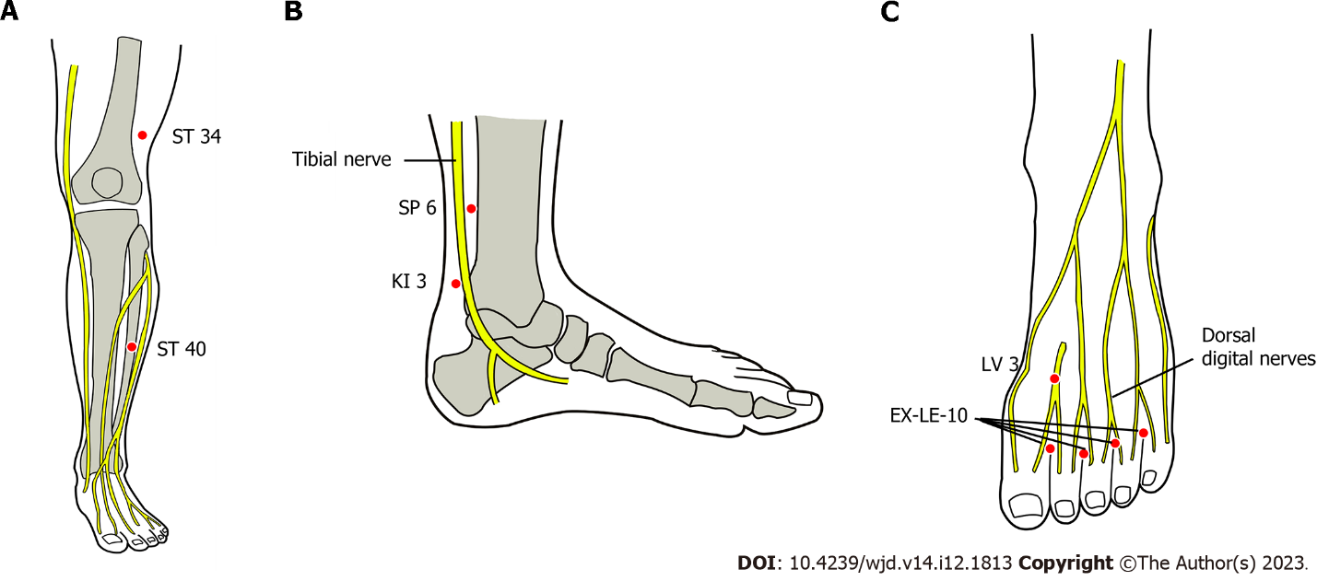
Figure 1 Mandatory acupuncture points used in the acupuncture in diabetic peripheral neuropathy study. Anatomical presentation of acupuncture points in relation to major nerves of the lower extremity; A: Anterior aspect of leg with points on stomach-meridian 34 and 40; B: Medial aspect of ankle with point 6 on spleen-meridian and point 3 on kidney–meridian; C: Dorsal foot with point 3 on liver-merdian and extra-points lower-extremity. ST: Stomach-meridian; SP: Spleen-meridian; KI: Kidney–meridian; LV: Liver-merdian; EX-LE: Extra-points lower-extremity.
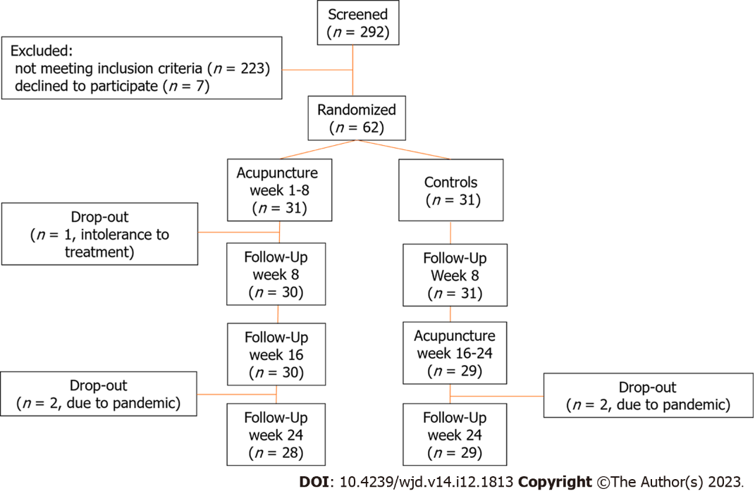
Figure 2 Flow-chart of the acupuncture in diabetic peripheral neuropathy-trial.

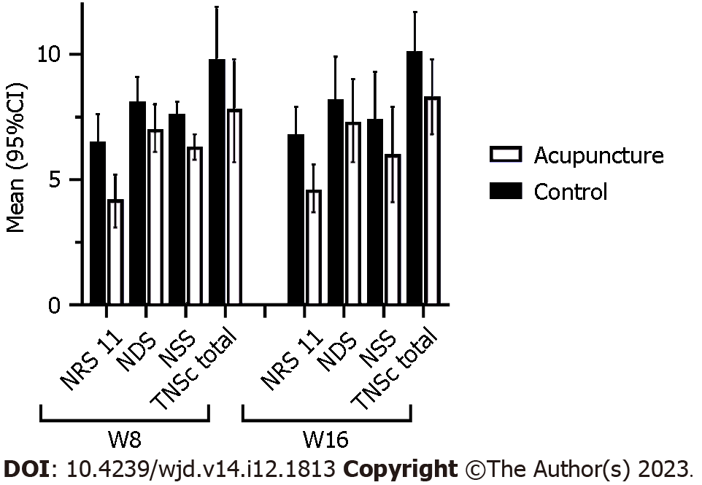
Figure 3 11 point numeric ratings scale, neuropathic pain symptom inventory neuropathy deficit score, neuropathy symptom score, total neuropathy score clinical, week 8 and week 16. NRS-11: 11 point numeric ratings scale; NDS: Neuropathy deficit score; NSS: Neuropathy symptom score; TNSc: Total neuropathy score clinical.

Table 1 Baseline characteristics, n (%)
Characteristics | Acupuncture group (n = 31) | Control group (n = 31)
Age mean (SD) | 66.7 (7.6) | 69.5 (7.2)
Age group > 60 yr | 24 (77.4) | 27 (87.1)
Male | 25 (80.6) | 24 (77.4)
BMI > 25 kg/m² | 27 (87.1) | 27 (87.1)
Duration of neuropathy symptoms >5 yr | 14 (45.2) | 19 (61.3)
Types of neuropathy
Painful neuropathy | 4 (12.9) | 7 (22.6)
Mixed neuropathy | 27 (87.1) | 24 (77.4)
Severe neuropathy | 3 (10.0) | 7 (24.1)
Palpable pedal pulse right | 29 (93.6) | 25 (80.7)
Palpable pedal pulse left | 25 (83.3) | 26 (86.7)
Relevant comorbidities (cardiovascular, hyperlipidemia, arthrosis) | 27 (87.1) | 27 (87.1)
Previous treatment with medication | 12 (38.1) | 13 (41.9)
NPSI total intensity score
Mean (SD) | 28.1 ± 15.8 | 28.8 ± 20.5
Median (range) | 30 (4-63) | 23 (0-72)
11-NRS scale for numbness
Mean (SD) | 5.8 ± 1.8 | 5.8 ± 2.0
Median (range) | 6 (0-9) | 6 (1-8)
NDS
Mean (SD) | 8.1 ± 2.6 | 8.1 ± 1.9
Median (range) | 9 (2-10) | 8 (4-10)
NSS
Mean (SD) | 7.2 ± 1.8 | 7.6 ± 1.5
Median (range) | 7 (4-10) | 7 (5-10)
TNSc Total
Mean (SD) | 10.2 ± 4.1 | 11.3 ± 3.9
Median (range) | 11 (2-17) | 11 (6-19)
NSS Sub-groups
Mild | 3 (9.7) | 0 (0.0)
Moderate | 8 (25.8) | 6 (19.3)
Severe | 20 (64.5) | 25 (80.7)
Sural nerve conduct velocity of both legs (m/s)
Mean (SD) | 40.9 ± 13.6 | 33.6 ± 19.9
Median (range) | 44 (0-59) | 44 (0-55)
Sural nerve Amplitude of the sensory nerve action potential of both legs (µV)
Mean (SD) | 4.0 ± 1.9 | 3.7 ± 2.1
Median (range) | 4 (0-7) | 4 (0-7)

TENS: Transcutaneous electrical nerve stimulation; NPSI: Neuropathy symptom pain inventory; NRS: Numeric rating scale; NDS: Neuropathy deficit score; NSS: Neuropathy symptom score; TNSc: Total clinical ceuropathy score; BMI: Body mass index.

Table 2 Overview of the outcome parameters
Outcome | Week | Acupuncture group adj. mean (95%CI) | Control group  adj. mean(95%CI) | Difference adj. mean (95%CI) | P value
NRS 11 numbness | 8 | 4.2 (3.1; 5.2) | 6.5 (5.4; 7.6) | 2.3 (1.3; 3.4) | < 0.001
 | 16 | 4.6 (3.7; 5.6) | 6.8 (5.8; 7.9) | 2.2 (1.3; 3.1) | < 0.001
NPSI | 8 | 17.4 (13.5; 21.4) | 30.0 (26.0; 34.0) | 12.6 (7.1; 18.0) | < 0.001
 | 16 | 20.9 (16.2; 25.6) | 32.6 (27.8; 37.4) | 11.7 (5.0; 18.4) | < 0.001
NDS | 8 | 7.0 (6.1; 8.0) | 8.1 (7.1; 9.1) | 1.0 (0.2; 1.9) | 0.021
 | 16 | 7.3 (5.7; 9.0) | 8.2 (6.5; 9.9) | 0.9 (0.1; 1.7) | 0.035
NSS | 8 | 6.3 (5.8; 6.8) | 7.6 (7.1; 8.1) | 1.3 (0.6; 2.0) | < 0.001
 | 16 | 6.0 (4.1; 7.9) | 7.4 (5.4; 9.3) | 1.4 (0.4; 2.3) | 0.005
TNSc | 8 | 7.8 (5.7; 9.8) | 9.8 (7.7; 11.9) | 2.0 (0.9; 3.1) | < 0.001
 | 16 | 8.3 (6.8; 9.8) | 10.1 (8.5; 11.7) | 1.8 (0.5; 3.1) | 0.010
N. suralis CV (m/s) | 8 | 38.2 (36.1; 40.4) | 38.6 (36.4; 40.7) | 0.4 (-2.7; 3.5) | 0.818
 | 16 | 38.8 (33.5; 44.1) | 38.8 (33.6; 44.1) | 0.0 (-6.2; 6.3) | 0.988
N. suralis ampl. (µV) | 8 | 3.8 (3.3; 4.4) | 4.4 (3.8; 4.9) | 0.6 (-0.2; 1.3) | 0.156
 | 16 | 4.2 (3.5; 5.0) | 4.6 (4.0; 5.3) | 0.4 (-0.6; 1.4) | 0.428

NRS-11: 11 point numeric ratings scale; NPSI: Neuropathic pain symptom inventory; NDS: Neuropathy deficit score; NSS: Neuropathy symptom score; TNSc: Total clinical ceuropathy score; CV: Conduction velocity.

Table 3 Pre and post comparison of outcomes in the acupuncture group at last follow-up in week 24. Intervention had ended in week 8
Variable unadjusted means (SD) | Pre (baseline) | Post (week 24)
NRS_11 | 5.8 ± 1.8 | 4.5 ± 2.3
NPSI | 28.1 ± 15.8 | 22.6 ± 16.8
NDS | 8.1 ± 2.0 | 7.2 ± 2.9
NSS | 7.2 ± 1.8 | 6.2 ± 2.4
TNSc | 10.2 ± 4.1 | 7.9 ± 3.5
Nervus suralis CV (ms) | 40.9 ± 13.6 | 41.1 ± 11.8
Nervus suralis amplitude (µV) | 4.0 ± 1.9 | 4.6 ± 2.0

NRS-11: 11 point numeric ratings scale; NPSI: Neuropathic pain symptom inventory; NDS: Neuropathy deficit score; NSS: Neuropathy symptom score; TNSc: Total clinical ceuropathy score; CV: Conduction velocity.

Published by Baishideng Publishing Group Inc
7041 Koll Center Parkway, Suite 160, Pleasanton, CA 94566, USA
Telephone: +19253991568
Email: bpgoffice@wjgnet.com
Help Desk: https://www.f6publishing.com/helpdesk
https://www.wjgnet.com

© 2023 Baishideng Publishing Group Inc. All rights reserved.

