Name of Journal: World Journal of Gastrointestinal Endoscopy
Manuscript NO: 61808
Manuscript Type: LETTER TO THE EDITOR

Vinyl bag cover method to avoid droplet-containing aerosol escape from endoscopic forceps channel caps during COVID-19 pandemic (with video)

Akahoshi K et al. Shielding for endoscopic forceps channel cap

Kazuya Akahoshi, Shinichi Tamura, Kazuaki Akahoshi, Yoriko Kaneshiro, Reiichi Sashihara, Kento Uemura, Kenta Sato

Kazuya Akahoshi, Shinichi Tamura, Kazuaki Akahoshi, Yoriko Kaneshiro, Reiichi Sashihara, Kento Uemura, Kenta Sato, Endoscopy Center, Aso Iizuka Hospital, Iizuka 820-8505, Japan

Author contributions: Akahoshi K designed the method; Akahoshi K, Tamura S, Akahoshi K, Kaneshiro Y, Sashihara R, Uemura K and Sato K conducted research; Akahoshi K (the first author) wrote the letter.

Corresponding author: Kazuya Akahoshi, MD, PhD, Chief Doctor, Director, Endoscopy Center, Aso Iizuka Hospital, 3-83 Yoshio, Iizuka 820-8505, Japan. kakahoshi2@aol.com

Received: December 24, 2020
Revised: February 6, 2021
Accepted: March 12, 2021
Published online:

Abstract
Endoscopists are at high risk of allowing transmission of coronavirus disease 2019 (COVID-19) during gastrointestinal endoscopy (GIE) procedures under pandemic conditions. The main avenues of droplet-containing aerosol generated during GIE are the mouth, anus, and endoscopic forceps channel. Although the usefulness of personal protective equipment for preventing COVID-19 dissemination has been well reported, measures to address infected aerosol escaping during endoscopic forceps use have been neglected. Pathogen-contaminated aerosol from the endoscopic forceps channel, leading into the gastrointestinal lumen, has been confirmed and is a highly problematic source of infection. We developed a technique that entails covering the forceps entry/exit hole with a vinyl bag, thereby preventing contamination of the endoscopy room by the infected aerosol that escapes from this hole. The technique can be used in daily clinical endoscopic practice. Furthermore, this shielding technique is useful for all patients who undergo GIE, regardless of the purpose of the procedure such as for making a diagnosis, administering therapy, or in an urgent situation. In this letter, we introduce our novel, easily performed, inexpensive method of infection prevention by disallowing infected aerosol to escape from a COVID-19-infected patient into the air during a procedure that requires the use of endoscopic forceps.

Key Words: Vinyl bag; Droplets; Endoscopy; COVID-19; Infection; Contamination

Akahoshi K, Tamura S, Akahoshi K, Kaneshiro Y, Sashihara R, Uemura K, Sato K. Vinyl bag cover method to avoid droplet-containing aerosol escape from endoscopic forceps channel caps during COVID-19 pandemic (with video). World J Gastrointest Endosc 2021; In press

Core Tip: The world is experiencing a viral pandemic. The main avenues of droplet-containing aerosol generated during gastrointestinal endoscopy are the mouth, anus, and endoscopic forceps channel. Although the usefulness of personal protective equipment for preventing coronavirus disease 2019 dissemination has been well reported, measures to address infected aerosol escaping via endoscopic forceps use have been neglected. We developed a technique using a vinyl bag to cover the hole through which forceps enter the gastrointestinal lumen. It prevents endoscopy room contamination by disallowing infected aerosol to escape via the forceps entrance. It thus protects the endoscopy room and staff during endoscopy.
TO THE EDITOR
Following the first reports of coronavirus disease 2019 (COVID-19) infections in December 2019 from Wuhan, China^{[1]}, the infection rapidly spread worldwide until it reached pandemic proportions. Recently, it has been reported that severe acute respiratory syndrome coronavirus 2 virus has been detected in the oral cavity and fecal samples of COVID-19-infected patients^{[2,3]}.
Gastrointestinal endoscopic procedures are performed by inflating the gastrointestinal tract with air or carbon dioxide, thereby inducing belching, vomiting, coughing, and flatus, each of which may generate virus-infected aerosol. The main sources of such aerosol generated during gastrointestinal endoscopy (GIE) are the mouth, anus, and endoscopic forceps channel. Johnston et al^{[4]} reported that the endoscopist’s face risks bacterial exposure during GIE and recommended the use of universal facial protection during these procedures. Furthermore, bacteria-contaminated aerosol from the endoscopic forceps channel, leading to the gastrointestinal lumen, has been confirmed and is a highly problematic source of infection^{[5]}. The endoscopic forceps channel cap usually loses its sealing ability through repeated insertion of the forceps. Hence, endoscopists are at high risk of COVID-19 transmission while performing GIE procedures.
There are many reports on the effectiveness of personal protective equipment for preventing COVID-19 infection during GIE^{[6,7]}. In addition, several useful protective shielding methods against the infected aerosol escaping from the patient’s mouth have been developed, such as aerosol chambers^{[8]} and face shields for the patients^{[9,10]}. However, little attention has been paid to infection control measures against infected aerosols escaping via the endoscopic forceps channel^{[5]} that communicates with the lumen of the gastrointestinal tract.
We therefore developed a technique for covering the forceps entrance hole cap with a vinyl bag (Figure 1) to prevent contamination of the endoscopy staff and endoscopy room by aerosols escaping from the “relaxed” forceps cap of the endoscope. We have been using the technique during GIE procedures in our daily practice since May 2020. The materials required include a vinyl bag, a round reinforcement label for marking, transparent adhesive tape, medical tape, and a toothpick, which are inexpensive and easily obtained worldwide (Figure 2).
The first step in preparing the apparatus is to make a small hole at the bottom of a small vinyl bag through which a device such as forceps can be inserted (Video 1). The second step is to cover the endoscopic forceps hole cap using the vinyl bag, which produces space in which to trap the infected droplet-containing aerosol, ultimately leading to reduced COVID-19 transmission. To obtain effective intra-vinyl bag space, there must be several centimeters of separation between the endoscopic forceps hole cap and the insertion hole of the vinyl bag. This separation ensures that the aerosol does not escape from the vinyl bag. We conducted an experiment with rapid retrograde injection of indigo carmine solution through a forceps channel, which showed that no dye-containing droplets had escaped from the vinyl bag (Video 2). Hence, it is extremely important for the endoscopists and assistants to carefully maintain the separation during GIE. Figure 3 shows the liquid from the aerosol trapped in a vinyl bag during colonic endoscopic submucosal dissection in a patient with a laterally spreading colonic tumor.
After the endoscopic procedure, the contaminated vinyl bag can be easily removed from the endoscope and safely discarded, making the apparatus disposable (Video 2). Furthermore, this shielding technique is useful for all patients who undergo GIE, regardless of the purpose of the procedure (e.g., diagnostic, therapeutic, urgent).
Although wearing full personal protective equipment is the most basic measure of infection control in this COVID-19 pandemic era, further measures to reduce the risk of infection are urgently needed in endoscopy suites. Our newly devised shielding method is thus a promising countermeasure to prevent contamination of the endoscopy staff and room by infected aerosol escaping from the patient’s gastrointestinal lumen via the entrance/exit hole for endoscopic forceps. The technique is inexpensive, and the apparatus is easily constructed, disposable, and practicable in endoscopy rooms worldwide. However, further aerodynamic study is needed to assess the effectiveness of the method.

ACKNOWLEDGEMENTS
We thank Wade C from the Education Promotion Office of Aso Iizuka Hospital for editing a draft of this manuscript.

REFERENCES
1 Huang C, Wang Y, Li X, Ren L, Zhao J, Hu Y, Zhang L, Fan G, Xu J, Gu X, Cheng Z, Yu T, Xia J, Wei Y, Wu W, Xie X, Yin W, Li H, Liu M, Xiao Y, Gao H, Guo L, Xie J, Wang G, Jiang R, Gao Z, Jin Q, Wang J, Cao B. Clinical features of patients infected with 2019 novel coronavirus in Wuhan, China. Lancet 2020; 395: 497-506 [PMID: 31986264 DOI: 10.1016/S0140-6736(20)30183-5]
2 Gu J, Han B, Wang J. COVID-19: Gastrointestinal Manifestations and Potential Fecal-Oral Transmission. Gastroenterology 2020; 158: 1518-1519 [PMID: 32142785 DOI: 10.1053/j.gastro.2020.02.054]
3 Song Y, Liu P, Shi XL, Chu YL, Zhang J, Xia J, Gao XZ, Qu T, Wang MY. SARS-CoV-2 induced diarrhoea as onset symptom in patient with COVID-19. Gut 2020; 69: 1143-1144 [PMID: 32139552 DOI: 10.1136/gutjnl-2020-320891]
4 Johnston ER, Habib-Bein N, Dueker JM, Quiroz B, Corsaro E, Ambrogio M, Kingsley M, Papachristou GI, Kreiss C, Khalid A. Risk of bacterial exposure to the endoscopist's face during endoscopy. Gastrointest Endosc 2019; 89: 818-824 [PMID: 30391253 DOI: 10.1016/j.gie.2018.10.034]
5 Vavricka SR, Tutuian R, Imhof A, Wildi S, Gubler C, Fruehauf H, Ruef C, Schoepfer AM, Fried M. Air suctioning during colon biopsy forceps removal reduces bacterial air contamination in the endoscopy suite. Endoscopy 2010; 42: 736-741 [PMID: 20806157 DOI: 10.1055/s-0030-1255615]
6 Gralnek IM, Hassan C, Beilenhoff U, Antonelli G, Ebigbo A, Pellisè M, Arvanitakis M, Bhandari P, Bisschops R, Van Hooft JE, Kaminski MF, Triantafyllou K, Webster G, Pohl H, Dunkley I, Fehrke B, Gazic M, Gjergek T, Maasen S, Waagenes W, de Pater M, Ponchon T, Siersema PD, Messmann H, Dinis-Ribeiro M. ESGE and ESGENA Position Statement on gastrointestinal endoscopy and the COVID-19 pandemic. Endoscopy 2020; 52: 483-490 [PMID: 32303090 DOI: 10.1055/a-1155-6229]
7 Sinonquel P, Roelandt P, Demedts I, Van Gerven L, Vandenbriele C, Wilmer A, Van Wijngaerden E, Bisschops R. COVID-19 and gastrointestinal endoscopy: What should be taken into account? Dig Endosc 2020; 32: 723-731 [PMID: 32335962 DOI: 10.1111/den.13706]
8 Sagami R, Nishikiori H, Sato T, Murakami K. Endoscopic shield: barrier enclosure during the endoscopy to prevent aerosol droplets during the COVID-19 pandemic. VideoGIE 2020; 5: 445-448 [PMID: 32395674 DOI: 10.1016/j.vgie.2020.05.002]
9 Sabbagh L, Huertas M, Preciado J, Sabbagh D. New protection barrier for endoscopic procedures in the era of pandemic COVID-19. VideoGIE 2020; 5: 614-617 [PMID: 32405605 DOI: 10.1016/j.vgie.2020.05.006]
10 Aponte Martín DM, Corso C, Fuentes C, Aponte Aparicio MV, Sabbagh LC. Use of a new face shield for patients of the endoscopy unit to avoid aerosol exchange in the COVID-19 era. VideoGIE 2020; 5: 522-524 [PMID: 32838096 DOI: 10.1016/j.vgie.2020.05.033]

Footnotes
Conflict-of-interest statement: Authors declare no conflicts of interest for this article.

Open-Access: This article is an open-access article that was selected by an in-house editor and fully peer-reviewed by external reviewers. It is distributed in accordance with the Creative Commons Attribution NonCommercial (CC BY-NC 4.0) license, which permits others to distribute, remix, adapt, build upon this work non-commercially, and license their derivative works on different terms, provided the original work is properly cited and the use is non-commercial. See: http://creativecommons.org/Licenses/by-nc/4.0/

Manuscript source: Unsolicited manuscript

Peer-review started: December 24, 2020
First decision: January 25, 2021
Article in press:

Specialty type: Gastroenterology and hepatology
Country/Territory of origin: Japan
Peer-review report’s scientific quality classification
Grade A (Excellent): 0
Grade B (Very good): B
Grade C (Good): C
Grade D (Fair): 0
Grade E (Poor): 0

P-Reviewer: Koulaouzidis A, Ng DC S-Editor: Gao CC L-Editor: P-Editor:
Figure Legends
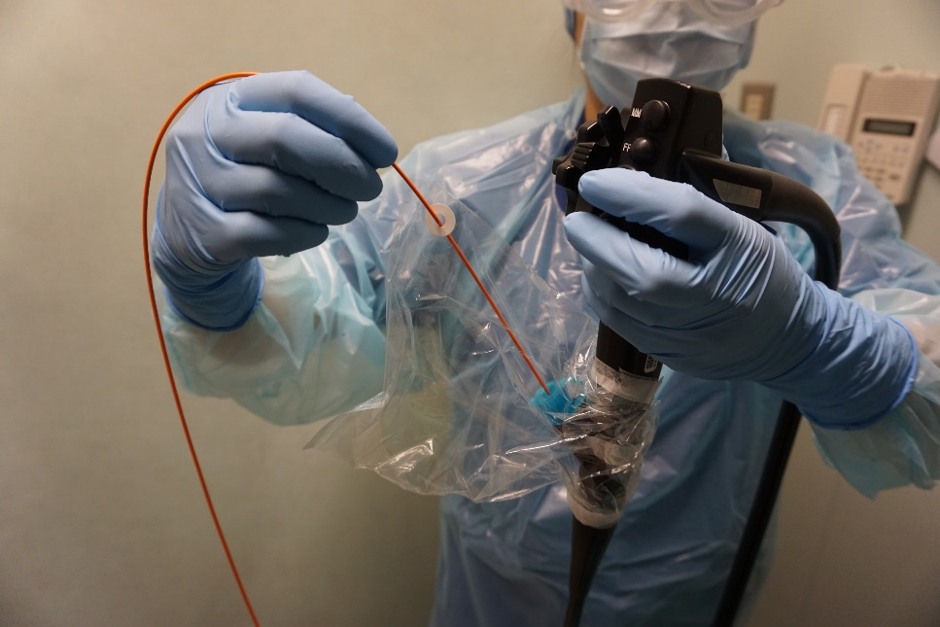
Figure 1 Overview photograph of the vinyl bag cover technique to prevent contamination of the endoscope room by droplet-containing aerosol escaping from the forceps hole of the endoscope.
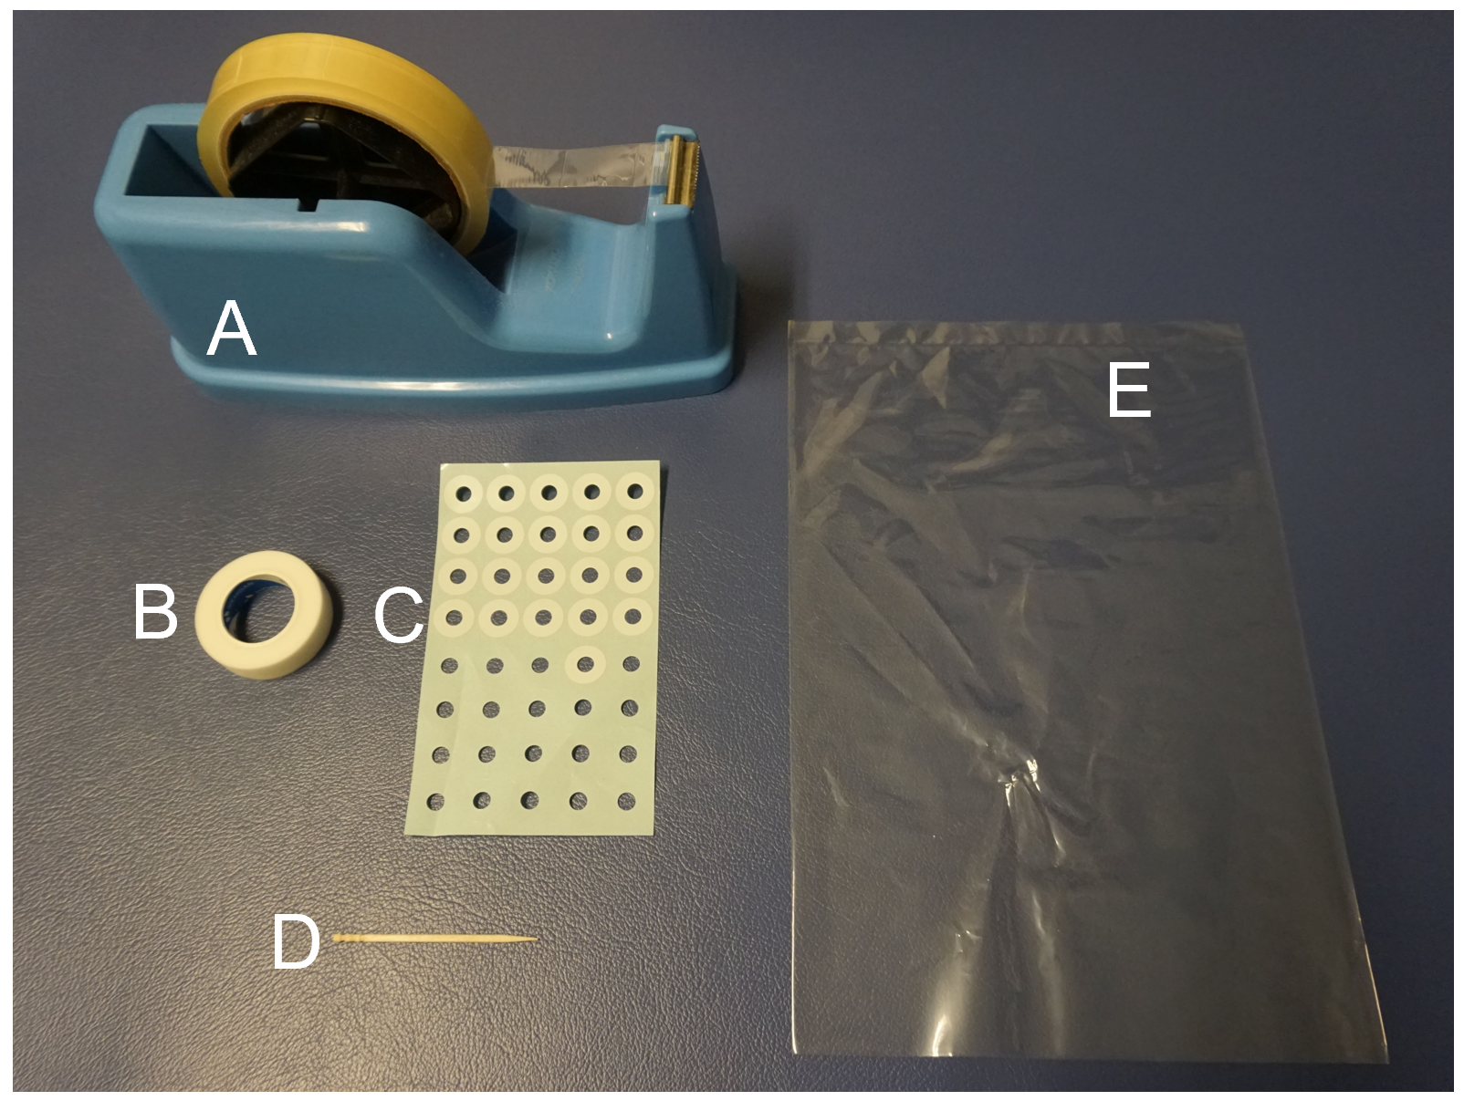
Figure 2 Materials required for constructing the apparatus. A: Transparent adhesive tape (e.g., sellotape, scotch tape); B: Medical tape; C: A round seal; D: Toothpick; E: A transparent vinyl bag (27 cm × 18 cm).
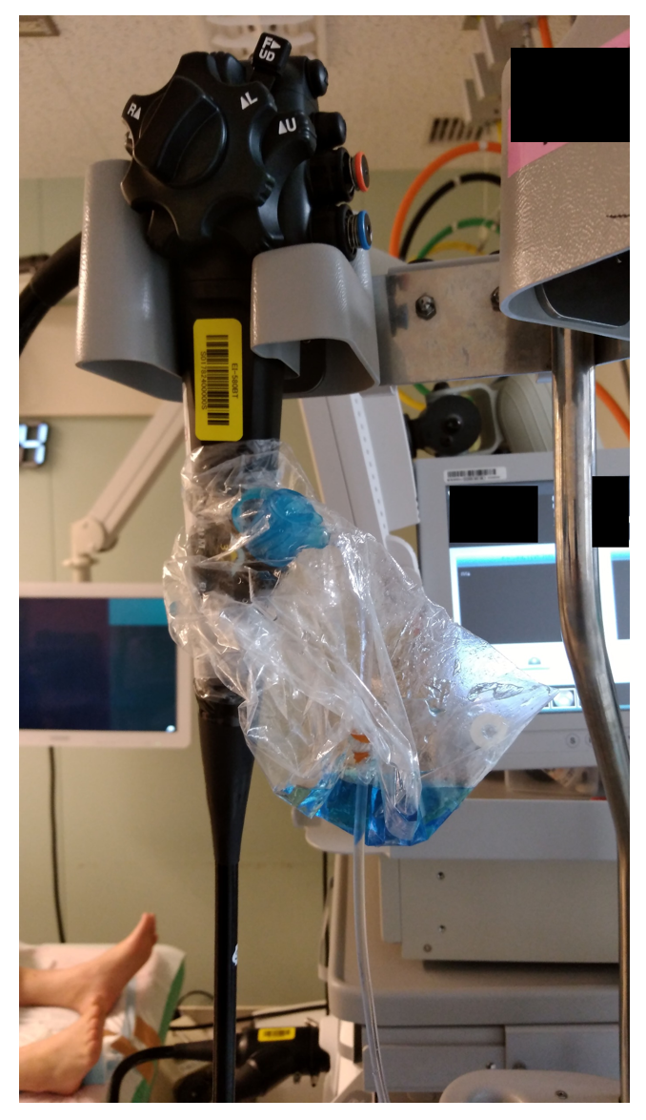
Figure 3 Apparatus in use. Liquid formed from droplet-containing aerosol escaping from the endoscopic forceps entrance/exit hole is being trapped in a vinyl bag during colonic endoscopic submucosal dissection.

