Name of Journal: World Journal of Clinical Cases

Manuscript NO: 43132

Manuscript Type: CASE REPORT

Castleman disease presenting with jaundice: A case report

Zhai B et al. CD with jaundice

Bo Zhai, Hai-Yang Ren, Wei-Dong Li, Shiva Reddy, Shu-Jun Zhang, Xue-Ying Sun

Bo Zhai, Hai-Yang Ren, Wei-Dong Li, Department of General Surgery, The Fourth Affiliated Hospital of Harbin Medical University, Harbin 150001, Heilongjiang Province, China

Bo Zhai, Wei-Dong Li, Xue-Ying Sun, Hepatosplenic Surgery Center, The First Affiliated Hospital of Harbin Medical University, Harbin 150001, Heilongjiang Province, China

Shu-Jun Zhang, Department of Pathology, The Fourth Affiliated Hospital of Harbin Medical University, Harbin 150001, Heilongjiang Province, China

Shiva Reddy, Xue-Ying Sun, Department of Molecular Medicine and Pathology, Faculty of Medical and Health Sciences, The University of Auckland, Auckland 1142, New Zealand

ORCID number: Bo Zhai (0000-0003-1903-6006); Hai-Yang (0000-0001-7965-4485); Wei-Dong Li (0000-0001-5924-7989); Shiva Reddy (0000-0002-4504-0511); Shu-Jun Zhang (0000-0002-9891-2782); Xue-Ying Sun (0000-0002-8065-8747).

Author contributions: Sun XY and Zhang SJ designed the report; Zhai B and Ren HY collected the patient’s clinical data; Li WD and Zhang SJ performed histological and immunohistochemical analyses; Reddy S participated in study design and revised the manuscript; Zhai B and Sun XY analyzed the data and wrote the paper; all the authors have finally approved the version of the article to be published.

Supported by the National Key Research and Development Program of China, No. 2017YFC1308602; and the National Natural Scientific Foundation of China, No. 81472321 and No. 81401975.

Informed consent statement: Consent was obtained from the patient for publication of this report and accompanying images.

Conflict-of-interest statement: The authors have no conflict of interests to declare.

CARE Checklist (2016) statement: The authors have read the CARE Checklist (2016), and the manuscript was prepared and revised according to the CARE Checklist (2016).

Open-Access: This is an open-access article that was selected by an in-house editor and fully peer-reviewed by external reviewers. It is distributed in accordance with the Creative Commons Attribution Non Commercial (CC BY-NC 4.0) license, which permits others to distribute, remix, adapt, build upon this work non-commercially, and license their derivative works on different terms, provided the original work is properly cited and the use is non-commercial. See: http://creativecommons.org/licenses/by-nc/4.0/

Manuscript source: Unsolicited manuscript

Corresponding author to: Xue-Ying Sun, MD, PhD, Professor, The Hepatosplenic Surgery Center, The First Affiliated Hospital of Harbin Medical University, No. 23, Youzheng Street, Harbin 150001, Heilongjiang Province, China. sunxueying@hrbmu.edu.cn
Telephone: +86-451-53643628
Fax: +86-451-53643628

Received: October 30, 2018

Peer-review started: October 30, 2018

First decision: November 14, 2018
Revised: November 26, 2018

Accepted: December 12, 2018

Article in press: December 12, 2018

Published online: February 6, 2019

Abstract

BACKGROUND
Castleman disease (CD) is a rare lymphoproliferative disorder that presents with various symptoms. CD accompanied with jaundice is uncommon since there are only 11 cases reported in the literature.

CASE SUMMARY
Here we report a 62-year-old woman who was admitted to the hospital with signs and symptoms of intermittent jaundice. Biochemical tests showed higher serum levels of total and direct bilirubin, and normal serum levels of tumor markers and interleukin-6. Contrast-enhanced computed tomography detected a 6 cm × 4 cm × 2.5 cm mass between the hepatoduodenal ligament and the inferior vena cava. The mass was successfully excised and the patient had a complete resolution of symptoms. A diagnosis of idiopathic unicentric CD was made based upon histological examination, which demonstrated the pathological features of CD of mixed type, including hyperplasia of follicular lymphoids with abundant plasma cells, degenerative germinal centers, interfollicular vascularity and hyaline degeneration. The diagnosis was corroborated by immunohistochemical analysis which detected multiple biomarkers.

CONCLUSION
This is the first study that describes the clinicopathological features of CD presenting with jaundice, which may deepen and extend our understanding of this disease.

Key words: Castleman disease; Jaundice; Case report; Clinicopathology; Immunohistochemistry

© The Author(s) 2019. Published by Baishideng Publishing Group Inc. All rights reserved.

Core tip: Castleman disease (CD) is a rare lymphoproliferative disorder that presents with various symptoms. Here we report an uncommon case of CD accompanied with intermittent jaundice caused by extrinsic compression of a mass located between the hepatoduodenal ligament and the inferior vena cava. Histological examination demonstrated the pathological features of idiopathic unicentric CD of mixed type, supported by the immunohistochemical detection of multiple markers. The clinicopathological and immunohistochemical study on the case of CD provides new insights and diagnostic criteria of this orphan disease.

Citation: Zhai B, Ren HY, Li WD, Reddy S, Zhang SJ, Sun XY. Castleman disease presenting with jaundice: A case report. World J Clin Cases 2019; 7(3): 373-381
URL: https://www.wjgnet.com/2307-8960/full/v7/i3/373.htm
DOI: https://dx.doi.org/10.12998/wjcc.v7.i3.373

INTRODUCTION
Castleman disease (CD) is a rare lymphoproliferative disorder that was first described by Benjamin Castleman in 1956^{[1,2]}. Its worldwide annual incidence is only around 15.9 to 19.1 cases per million subjects^{[3-5]}, but more cases have been reported recently^{[3]}. This disease can be clinically delineated as unicentric CD (UCD) and multicentric CD (MCD) subtypes with different outcomes^{[6,7]}. MCD occurs systemically, involves multiple groups of lymph nodes and is associated with systemic inflammatory symptoms, and the differential diagnosis is ascertained from lymphoma^{[8]}. By contrast, UCD affects a single lymph node or a group of adjacent lymph nodes in a specific anatomical site, commonly involving the mediastinum and thoracic lymph nodes; and the mass is usually observed incidentally upon physical or medical imaging examination. In some cases, UCD is found symptomatically because of the compression of local structures by the enlarged mass. In most patients, UCD can be curatively treated by surgical excision, while systemic therapy is required for the effective management of MCD^{[7]}. Three pathological types, namely, hyaline vascular, plasmacytic and mixed, have been reported in both UCD and MCD^{[7]}. Here we report a rare case of UCD presenting with intermittent jaundice caused by extrinsic compression of the mass located between the hepatoduodenal ligament and the inferior vena cava. In order to extend our understanding of this disease, we review the relevant literature and summarize a total of 11 cases involving CD accompanied by jaundice.

CASE PRESENTATION

Chief complaints

A 62-year-old woman of Han ethnicity was admitted at the Fourth Affiliated Hospital of Harbin Medical University with a one-month medical history of intermittent upper abdominal pain, and skin and sclera jaundice.

History of present illness

She reported a one-month medical history of intermittent upper abdominal pain, and skin and sclera jaundice.

History of past illness
The patient did not have a specific history of past illness.

Personal and family history
Nor did her family.

Physical examination upon admission
Slight right upper quadrant abdominal tenderness was the only observed clinical sign at the time of admission.

Laboratory examinations
Serum levels of total bilirubin (53 μmol/L) and direct bilirubin (35 μmol/L) were both above normal ranges (total bilirubin: 3.1-22.5 μmol/L; direct bilirubin: 1.3-7.2 μmol/L), but declined to 23 and 12 μmol/L, respectively, one day prior to operation. All the other laboratory tests including serum levels of alpha-fetoprotein (AFP), carcinoembryonic antigen (CEA) carbohydrate antigen (CA) 19-9 and interleukin-6 were within normal ranges.
Histological examination showed follicular lymphoid hyperplasia and a shortage of lymphatic sinuses. Lymphoid follicles were mainly composed of proliferating mantle cells, and concentrically layered around highly vascularized and degenerative germinal centers (Figure 1A). Vascularity was observed in the inter-follicular regions with vessels penetrating the germinal centers (Figure 1A). Partial tissues were of hyaline degeneration (Figure 1B). Plasma cells were abundant in tissues and Russell’s bodies were sparsely distributed (Figure 1C and D).
Further immunohistochemical examination using a panel of antibodies supported the diagnosis (Figure 2). CD20⁺ cells were mainly observed in the follicular regions and occasionally in the inter-follicular regions, corresponding to the distribution of plasma cells, since CD20 is expressed on the surface of all B-cells^{[9]}. Paired box protein (PAX)-5⁺ cells were observed in the follicular regions and to a lesser extent in the inter-follicular regions, since PAX-5 is expressed at early but not late stages of B-cell differentiation^{[10]}. These results imply that B cells were at a proliferative phase. B-cell lymphoma 2 (Bcl-2) was negative in, but positive outside of, the germinal centers, indicating degeneration of germinal centers since Bcl-2 regulates cell apoptosis^{[11]}. It has been reported that antibodies against Bcl-2 react with B-cells in the mantle zone^{[12]}. CD38⁺ cells were mainly observed in inter-follicular regions and sparsely distributed in the germinal centers, in accordance with the abundance of plasma cells since CD38 is downregulated in B cells and mature plasma cells^{[13]}. CD21, a marker of follicular dendritic cells^{[14]}, was positive, indicating the presence of intact follicular dendritic networks. CD3-positive T cells^{[15]} were mainly observed in the inter-follicular regions, but only sparsely in the follicular regions. Ki-67, a cellular marker for proliferation^{[16]}, was highly expressed in 80%-90% of cells within the germinal centers but was expressed in only 5% of cells outside of the germinal centers. Immunoglobulin free light chains Kappa and Lambda-positive cells were observed in the inter-follicular regions with a ratio of 1.2:1. The expression of these two molecules indicates the relative abundance of plasma cells and could be a differential diagnosis from B-cell lymphoma, in which one type of light chain is significantly more common than the other^{[17]}.

Imaging examinations
Contrast-enhanced computed tomography (CT) of the abdomen showed a mass between the hepatoduodenal ligament and the inferior vena cava, reaching the hepatic caudate lobe and the right renal vein plane. The front side was nearby the duodenal descending segment and the pancreatic head. The mass did not have a clear boundary with the caudate lobe and the duodenum, and the portal vein was oppressed (Figure 3A-C). There was no obvious difference in the density of the mass at arterial, portal venous and equilibrium phases of CT scanning (Figure 3A-C). By using three-dimensional (3D) visualization software (Intelligent Precise Service, Shenzhen Xudong Digital Medical Imaging Technology Co. Ltd., China), a 3D visualization model was generated to display the adjacent relationships between the mass and blood vessels, the pancreas, the gallbladder and the dilated bile duct (Figure 3D and E). Apart from this mass, there was an absence of additional lesions in the rest of the body as detected by physical and imaging examinations. A preoperative diagnosis of abdominal lesion was made and the patient underwent exploratory laparotomy after an appropriate preparation. A mass was found located between the hepatoduodenal ligament and the inferior vena cava and successfully excised. The mass had an intact capsule (Figure 3F) and a clear boundary with adjacent organs including the common bile duct. The mass was 6 cm × 4 cm × 2.5 cm in size and had a greyish-white granular cutting surface with local bleeding regions (Figure 3G).

FINAL DIAGNOSIS
Based on the above clinicopathological feature and immunohistochemical analyses, a diagnosis of UCD of mixed type was made.

TREATMENT
As described above, the mass was surgically removed. No non-surgical treatment was given to the patient.

OUTCOME AND FOLLOW-UP
After surgical treatment, the clinical manifestations disappeared and serum levels of bilirubin returned to normal. The patient remained well without jaundice after a 12-mo follow-up.

DISCUSSION
Until now, 12 cases of CD presenting with jaundice including the present case have been described in 10 reports in the literature (Table 1)^{[18-27]}. Of the 12 cases, MCD and UCD were equally divided; 7 (58.3%) were of hyaline vascular type, 3 (25%) of plasma cell type, and 2 (16.7%) of mixed type. All the cases of UCD were successfully excised and had a complete symptom resolution within the term of follow-up, while the cases of MCD were either partially controlled or relapsed.
CD comprises a heterogeneous group of disorders and presents with diverse symptoms and signs due to the location, size, extent and diffusion^{[4]}. This leads to difficulties in arriving at a differential diagnosis, and surgical excision is usually not only a diagnostic but also a curative method for the management of the disease, particularly for UCD. Therefore, in addition to clinical manifestations, evaluation of CD should also include pathological analysis with immunohistochemistry, laboratory investigation and systemic imaging.
MCD is classically distinguished from UCD by the presence of systemic symptoms, such as fever, asthenia, pleural effusion, ascites, the presence of lymph nodes in more than one region, hepatosplenomegaly, signs of inflammation and a poorer prognosis^{[7]}. However, in approximately 60% of cases of UCD, the presentation is asymptomatic with accidental detection of a mass^{[28]}. Some patients are diagnosed with UCD because enlarged lymph nodes impede nearby organs. The main manifestation of UCD is related to local complications of a mass with extrinsic compressions, such as renal obstruction, dyspnea, cough, abdominal pain and other signs^{[6]}. The plasma cell variants are the most common type of MCD (75%) but represent only 10%-20% of UCD^{[6,28,29]}. MCD may affect other organs containing lymphoid tissues and often occurs in people infected with the human immunodeﬁciency virus. Interleukin-6 has been shown to play a major role in the pathogenesis of both UCD and MCD since it stimulates B-cell proliferation and survival through multiple signaling pathways^{[9]}.
The majority of UCD cases are the hyaline-vascular variants, characterized by hyalinized blood vessels between follicles with few plasma cells, whereas a small number of cases are plasma cell variants, which show characteristic sheets of mature-appearing plasma cells in the interfollicular region^{[8]}. CD mimics a number of neoplastic entities and therefore immunohistochemistry can help for differential diagnosis^{[29]}. UCD involving the pancreas and bile duct is rare, with only 11 cases reported (Table 1)^{[18-27]}. In this case, UCD should also be differentiated from lymph node metastases of malignancies by using positron emission tomography/CT (PET-CT), magnetic resonance imaging (MRI) and/or endoscopic retrograde cholangiopancreatography (ERCP), which would guide the therapeutic management. An endoscopic ultrasound-guided fine needle aspiration biopsy (EUS-FNA) would also help to make a pathological diagnosis preoperatively. Unfortunately, none of the above examinations apart from dynamic CT were employed in this case due to the inaccessibility of facilities and high cost. Radiation therapy may be an option for the disease with incomplete excision, or if the patient is in poor health and unable to undergo surgery.
In summary, here we report a case of CD presenting with intermittent jaundice with slight abdominal tenderness. Contrast-enhanced CT scanning detected a mass between the hepatoduodenal ligament and the inferior vena cava, which was successfully excised, and the patient had a complete symptom resolution. Histological examination demonstrated the pathological features of idiopathic UCD of mixed type, supported by immunohistochemical detection of multiple markers. Excluding the current case, there have been only 11 reported cases of CD presenting with jaundice. To our knowledge, this is the first study that combines clinicopathology and immunohistochemistry in diagnosing CD accompanied with jaundice, which may deepen and extend our understanding of this orphan disease.

CONCLUSION
The case of CD with jaundice presented herein, together with literature review, indicates that CD may present with diverse clinical symptoms and signs because of the location, size, extent and diffusion of the mass. The information from clinical symptoms and signs, laboratory tests, imaging examinations, pathological and immunohistochemical analyses should be comprehensively considered. Other examinations not used in the present case, such as PET-CT, MRI, ERCP and EUS-FNA, may be helpful for an accurate preoperative diagnosis and therapeutic management.
REFERENCES
1 Castleman B, Iverson L, Menendez VP. Localized mediastinal lymphnode hyperplasia resembling thymoma. Cancer 1956; 9: 822-830 [PMID: 13356266]
2 CASE records of the Massachusetts General Hospital Weekly Clinicopathological Exercises: Case 40011. N Engl J Med 1954; 250: 26-30 [PMID: 13111435 DOI: 10.1056/NEJM195401072500107]
3 Munshi N, Mehra M, van de Velde H, Desai A, Potluri R, Vermeulen J. Use of a claims database to characterize and estimate the incidence rate for Castleman disease. Leuk Lymphoma 2015; 56: 1252-1260 [PMID: 25120049 DOI: 10.3109/10428194.2014.953145]
4 Simpson D. Epidemiology of Castleman Disease. Hematol Oncol Clin North Am 2018; 32: 1-10 [PMID: 29157611 DOI: 10.1016/j.hoc.2017.09.001]
5 Fujimoto S, Koga T, Kawakami A, Kawabata H, Okamoto S, Mizuki M, Yano S, Ide M, Uno K, Yagi K, Kojima T, Mizutani M, Tokumine Y, Nishimoto N, Fujiwara H, Nakatsuka SI, Shiozawa K, Iwaki N, Masaki Y, Yoshizaki K. Tentative diagnostic criteria and disease severity classification for Castleman disease: A report of the research group on Castleman disease in Japan. Mod Rheumatol 2018; 28: 161-167 [PMID: 28880697 DOI: 10.1080/14397595.2017.1366093]
6 Talat N, Belgaumkar AP, Schulte KM. Surgery in Castleman's disease: a systematic review of 404 published cases. Ann Surg 2012; 255: 677-684 [PMID: 22367441 DOI: 10.1097/SLA.0b013e318249dcdc]
7 Liu AY, Nabel CS, Finkelman BS, Ruth JR, Kurzrock R, van Rhee F, Krymskaya VP, Kelleher D, Rubenstein AH, Fajgenbaum DC. Idiopathic multicentric Castleman's disease: a systematic literature review. Lancet Haematol 2016; 3: e163-e175 [PMID: 27063975 DOI: 10.1016/S2352-3026(16)00006-5]
8 Wu D, Lim MS, Jaffe ES. Pathology of Castleman Disease. Hematol Oncol Clin North Am 2018; 32: 37-52 [PMID: 29157618 DOI: 10.1016/j.hoc.2017.09.004]
9 El-Osta HE, Kurzrock R. Castleman's disease: from basic mechanisms to molecular therapeutics. Oncologist 2011; 16: 497-511 [PMID: 21441298 DOI: 10.1634/theoncologist.2010-0212]
10 Medvedovic J, Ebert A, Tagoh H, Busslinger M. Pax5: a master regulator of B cell development and leukemogenesis. Adv Immunol 2011; 111: 179-206 [PMID: 21970955 DOI: 10.1016/B978-0-12-385991-4.00005-2]
11 Cleary ML, Smith SD, Sklar J. Cloning and structural analysis of cDNAs for bcl-2 and a hybrid bcl-2/immunoglobulin transcript resulting from the t(14;18) translocation. Cell 1986; 47: 19-28 [PMID: 2875799]
12 Young F, Mizoguchi E, Bhan AK, Alt FW. Constitutive Bcl-2 expression during immunoglobulin heavy chain-promoted B cell differentiation expands novel precursor B cells. Immunity 1997; 6: 23-33 [PMID: 9052834]
13 Oliver AM, Martin F, Kearney JF. Mouse CD38 is down-regulated on germinal center B cells and mature plasma cells. J Immunol 1997; 158: 1108-1115 [PMID: 9013949]
14 Qin D, Wu J, Carroll MC, Burton GF, Szakal AK, Tew JG. Evidence for an important interaction between a complement-derived CD21 ligand on follicular dendritic cells and CD21 on B cells in the initiation of IgG responses. J Immunol 1998; 161: 4549-4554 [PMID: 9794381]
15 Schuh E, Berer K, Mulazzani M, Feil K, Meinl I, Lahm H, Krane M, Lange R, Pfannes K, Subklewe M, Gürkov R, Bradl M, Hohlfeld R, Kümpfel T, Meinl E, Krumbholz M. Features of Human CD3+CD20+ T Cells. J Immunol 2016; 197: 1111-1117 [PMID: 27412413 DOI: 10.4049/jimmunol.1600089]
16 Cuylen S, Blaukopf C, Politi AZ, Müller-Reichert T, Neumann B, Poser I, Ellenberg J, Hyman AA, Gerlich DW. Ki-67 acts as a biological surfactant to disperse mitotic chromosomes. Nature 2016; 535: 308-312 [PMID: 27362226 DOI: 10.1038/nature18610]
17 Giachino C, Padovan E, Lanzavecchia A. kappa+lambda+ dual receptor B cells are present in the human peripheral repertoire. J Exp Med 1995; 181: 1245-1250 [PMID: 7869042]
18 Affes N, Mseddi A, Feriani N, Beyrouti MI. [Extrahepatic cholestasis secondary to Castleman's disease]. Rev Med Interne 2009; 30: 450-452 [PMID: 18818000 DOI: 10.1016/j.revmed.2008.07.009]
19 Al-Salamah SM, Khan IA, Khalid K, Al-Shakweer WA. Castleman disease presenting as obstructive jaundice. Saudi Med J 2005; 26: 111-113 [PMID: 15756365]
20 Fichtl J, Třeška V, Vodička J, Šulc R, Hes O, Tupý R. [Castleman disease - unusual finding after operation of retroperitoneal tumor of young patient]. Rozhl Chir 2016; 95: 91-94 [PMID: 27008172]
21 Heng LZ, Ong KW, Chow PK. An unusual case of recurrent obstructive jaundice. Gastroenterology 2011; 140: 1401, 1699 [PMID: 21447313 DOI: 10.1053/j.gastro.2010.07.064]
22 Mura G, Tauceri F, Feri M, Verdecchia GM. Report of two cases of Castleman's Disease: a case of benign localized disease and a case of fast progressive multicentric disease. Acta Biomed 2011; 82: 77-81 [PMID: 22069961]
23 Ozsoy M, Ozsoy Z, Sahin S, Arıkan Y. Rare Forms of Castleman Disease Mimicking Malignancy: Mesenteric and Pancreatic Involvement. Cureus 2018; 10: e2310 [PMID: 29755906 DOI: 10.7759/cureus.2310]
24 Park JB, Hwang JH, Kim H, Choe HS, Kim YK, Kim HB, Bang SM. Castleman disease presenting with jaundice: a case with the multicentric hyaline vascular variant. Korean J Intern Med 2007; 22: 113-117 [PMID: 17616028]
25 Przkora R, Bruns C, Zülke C, Heinkelein J, Rümmele P, Schalhorn A, Jauch KW. Castleman's disease causing obstructive jaundice. J Hepatol 2003; 38: 548-549 [PMID: 12663253]
26 Xiao X, Feng F, He MX, Zhu MH. Clinicopathologic feaures and differential diagnosis of abdominal Castleman disease. Zhen Duan Bing Li Xue Za Zhi 2014; 21: 129-133 [DOI: 10.3969/j.issn.1007-8096.2014.03.001]
27 Zhao TK, Zhang LM, Liang Y, Xiong T, Guo HX, Huang ZP. [Clinico-pathologic Analysis of 16 Cases of Castleman]. Zhongguo Shi Yan Xue Ye Xue Za Zhi 2015; 23: 1039-1043 [PMID: 26314442 DOI: 10.7534/j.issn.1009-2137.2015.04.026]
28 Yu L, Tu M, Cortes J, Xu-Monette ZY, Miranda RN, Zhang J, Orlowski RZ, Neelapu S, Boddu PC, Akosile MA, Uldrick TS, Yarchoan R, Medeiros LJ, Li Y, Fajgenbaum DC, Young KH. Clinical and pathological characteristics of HIV- and HHV-8-negative Castleman disease. Blood 2017; 129: 1658-1668 [PMID: 28100459 DOI: 10.1182/blood-2016-11-748855]
29 Szalat R, Munshi NC. Diagnosis of Castleman Disease. Hematol Oncol Clin North Am 2018; 32: 53-64 [PMID: 29157619 DOI: 10.1016/j.hoc.2017.09.005]

P-Reviewer: Aoki H, Mastoraki A
S-Editor: Ma RY L-Editor: Wang TQ E-Editor: Song H
Specialty type: Medicine, research and experimental
Country of origin: China
Peer-review report classification
Grade A (Excellent): 0
Grade B (Very good): 0
Grade C (Good): C, C
Grade D (Fair): 0
Grade E (Poor): 0

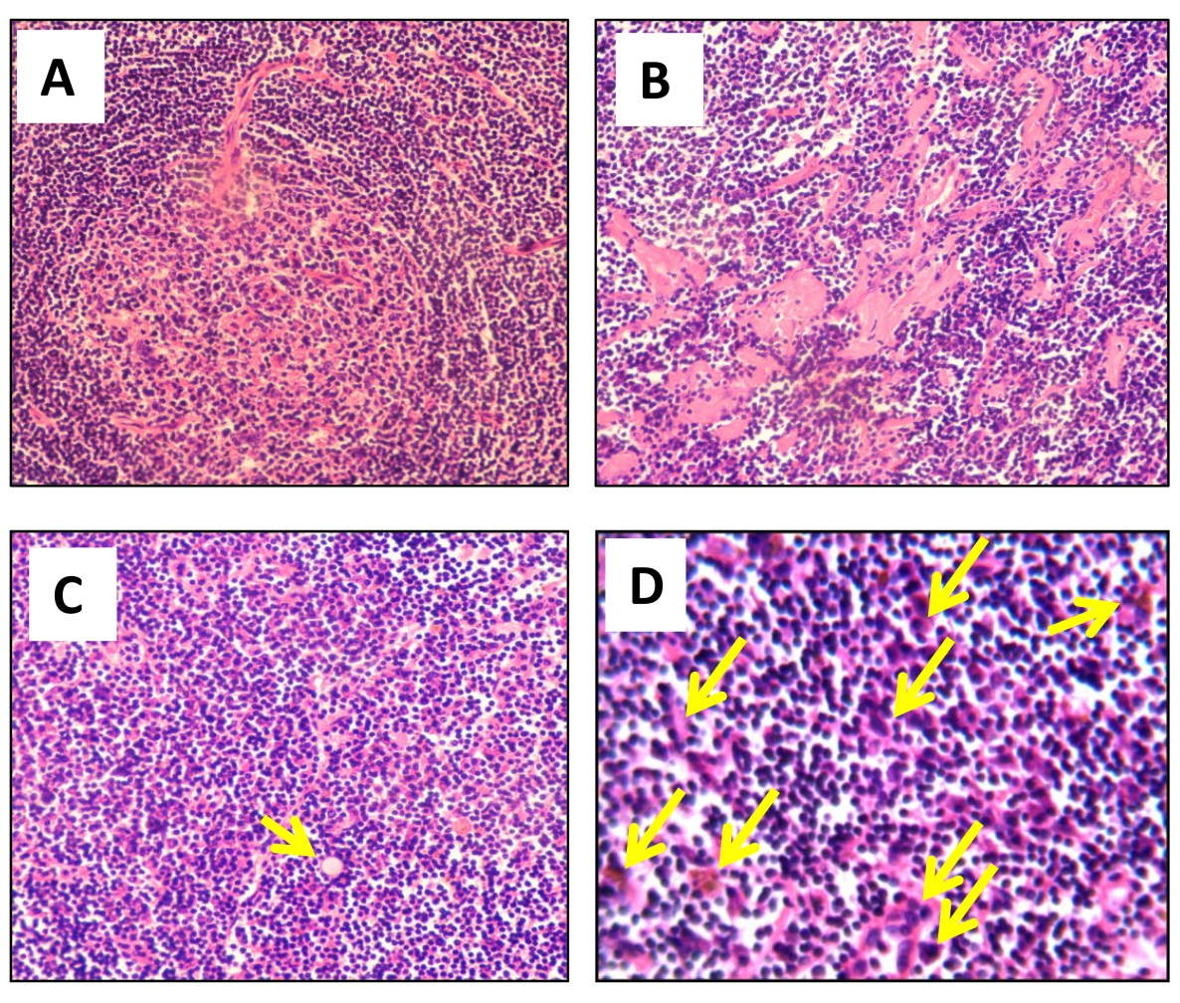
Figure 1 Major pathohistological features of mixed type Castleman disease. Tissue sections (5 μm) were stained with hematoxylin and eosin. Histological characteristics in representative images include hyperplasia of follicular lymphoids concentrically layered around vascularized and degenerative germinal centers and shortage of lymphatic sinuses (A), hyaline degeneration (B), existence of Russell’s body (arrow) (C), and abundant proliferating plasma cells (arrows) (C and D). Magnification, ×200 (A-C) and ×400 (D).

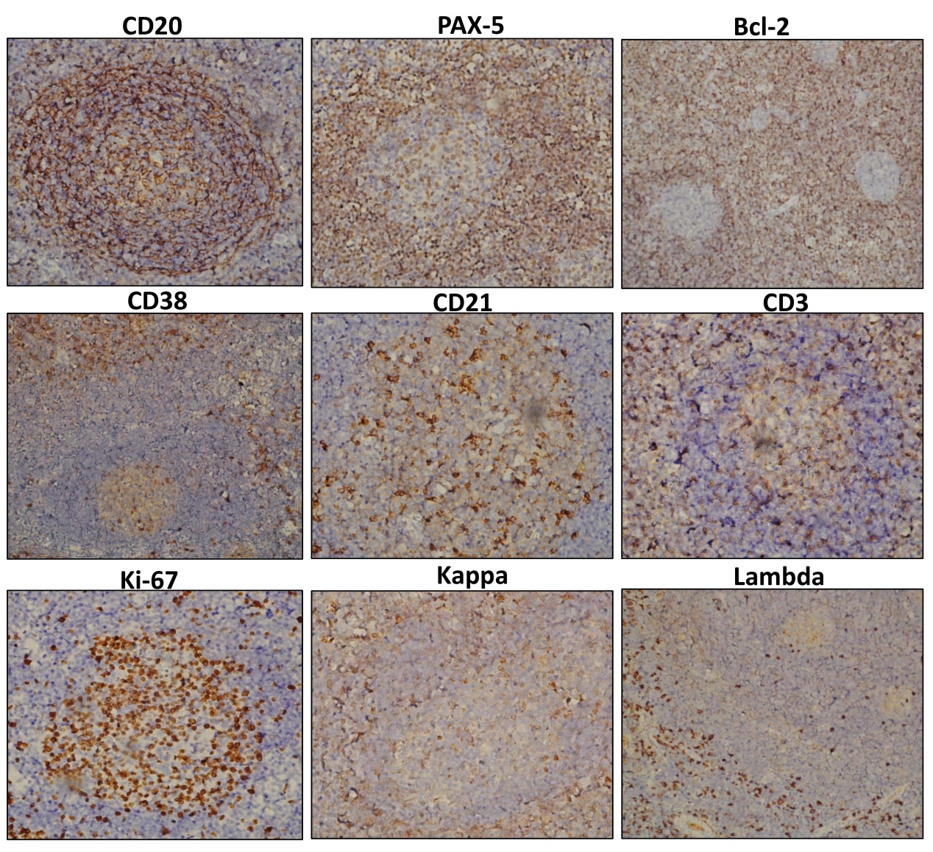
Figure 2 Immunohistochemistry. A panel of antibodies as indicated were used to immunostain the sections, which were subsequently counterstained with hematoxylin. Magnification, ×200. PAX-5: Paired box protein-5; Bcl-2: B-cell lymphoma 2.

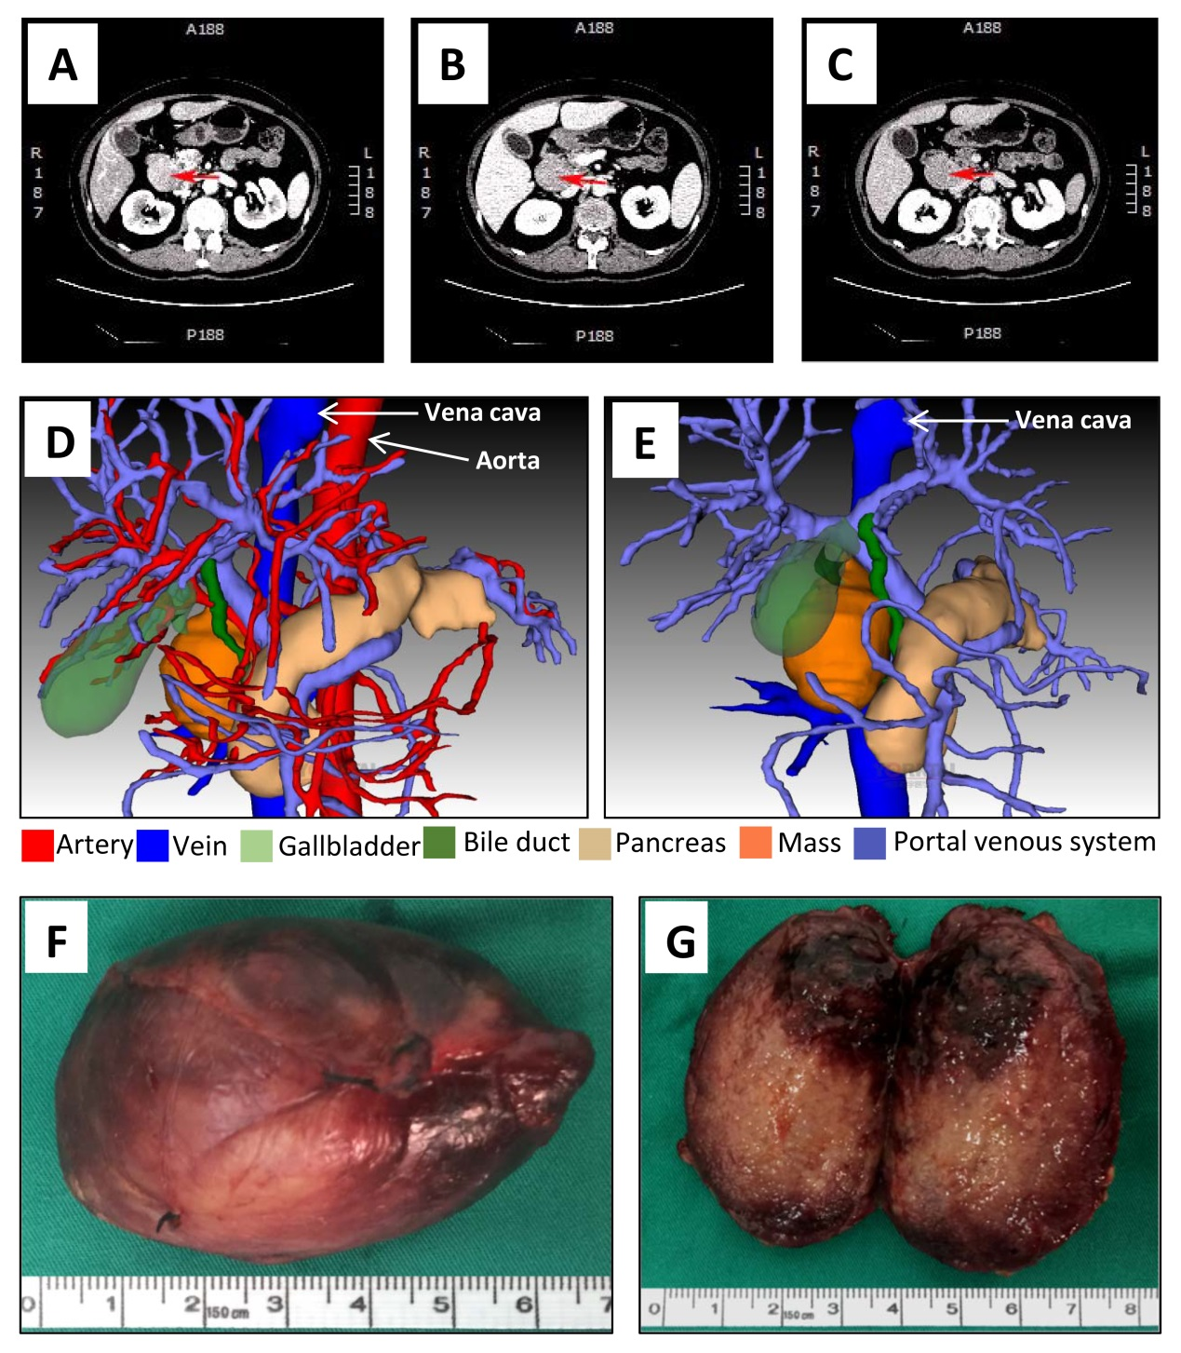
Figure 3 Computed tomography scan, three-dimensional visualization model and the mass. A-C: Representative images are from enhanced multi-phase abdominal computed tomography scans at the arterial (A), portal venous (B) and equilibrium (C) phases. Arrows point to the mass. D and E: Three-dimensional images were generated to show the adjacent relationship between the mass and adjacent organs and tissues. F: The excised mass. G: The cutting surface.

Table 1 Summary of reported cases of Castleman disease presenting with jaundice
Year | Age | Sex | Clinical features | Location | Clinical type | Histology | Managements | Outcomes | Ref.
2003 | 61 | Male | Painless jaundice | Common hepatic duct | UCD | HV | Bile duct resection;  Hepatobiliary reconstruction | 3-mo follow-up | [25]
2005 | 48 | Male | Jaundice;  Right upper abdominal quadrant tenderness | Porta hepatis, along CBD and lesser curvature of stomach | UCD | HV | Cholecystectomy;  Triple bypass comprising Roux-en-Y choledochojejunostomy,  retrocolic gastro jejunostomy and enteroenterostomy | Symptom free after 9-mo follow-up | [19]
2007 | 50 | Male | Jaundice;  Right upper quadrant abdominal pain | Cervical, right hilar, subcarinal, subaortic, peripancreatic areas; Both sides of neck and mediastinum;  Right supraclavicular area | MCD | HV | Corticosteroids | Mass shrank after 2-wk treatment | [24]
2009 | 76 | Male | Pruritis;  Jaundice | Chest and abdomen diffuse lymphadenopathy;  Compressing common bile duct and cystic duct | MCD | PC | Exploratory laparotomy;  Cholecystectomy;  Corticosteroid therapy | Partially controlled | [18]
2011 | 41 | Male | Weight loss;  Obstructive jaundice | Right supradiaphragmatic and periportal nodes; Periceliac, pericaval and aortocaval lymph nodes | MCD | PC | Video-assisted thoracoscopic surgery;  Prednisolone therapy with endoscopic resolution of the obstruction | Remained well without jaundice for at least 2 yr. | [21]
2011 | 58 | Female | Fast-progressive jaundice;  Liver failure | Right axilla;  Hepatic hilus;  Splenic hilus;  Retroperitoneal area | MCD | HV | Excision of axillary nodes;  CT-guided fine-needle biopsy of perihepatic lesions;  High-dose steroid therapy;  External biliary drainage | Partially controlled after steroid therapy  Relapsed  Progressive multi-organ failure Irreversible clinical worsening to death | [22]
2014 | 53 | Male | Jaundice;  Lower limb phlebitis;  Splenomegaly | Neck;  Hepatogastric gap | MCD | Mixed | Surgical resection;  Chemotherapy | Relapsed 11-mo follow-up | [26]
2014 | 41 | Male | Mild jaundice; Abdominal distension | Hepatic portal | UCD | HV | Surgical resection | 90-mo follow-up | [26]
2015 | 43 | Male | Fatigue;  Jaundice | Hepatoduodenal ligament | UCD | HV | Surgical resection | 25-mo follow-up | [27]
2016 | 29 | Male | Jaundice; Intermittent bowel obstruction | Retroperitoneal tumor in subhepatic space | MCD | HV | Surgical extirpation;  Adjuvant oncological treatment | Not shown | [20]
2018 | 62 | Female | Jaundice; Nausea;  Vomiting | Surrounding retropancreatic portal vein and hepatic artery | UCD | PC | Pancreaticoduodenectomy | Not shown | [23]
2018 | 62 | Female | Intermittent Jaundice | Between hepatoduodenal ligament and inferior vena cava | UCD | Mixed | Surgical resection | 12-mo follow-up | Current study
UCD: Unicentric Castleman disease; MCD: Multicentric Castleman disease; HV: Hyaline vascular; PC: Plasmacytic; CT: Computed tomography.

