Name of Journal: World Journal of Gastroenterology
Manuscript NO: 84445
Manuscript Type: CASE REPORT

Pulmonary hypertension, nephrotic syndrome, and polymyositis due to hepatitis C virus infection: A case report

Zhao YN et al. Pulmonary hypertension caused by hepatitis C

Ya-Nan Zhao, Guo-Hui Liu, Chang Wang, Yi-Xuan Zhang, Ping Yang, Ming Yu

Ya-Nan Zhao, Guo-Hui Liu, Chang Wang, Yi-Xuan Zhang, Ping Yang, Ming Yu, Department of Cardiology, China-Japan Union Hospital of Jilin University, Changchun 130033, Jilin Province, China

Author contributions: Zhao YN and Liu GH were the patient’s physicians; Yu M reviewed the literature and contributed to manuscript drafting; Wang C and Zhang YX performed the contributed to data collection; Yu M and Yang P were responsible for the revision of the manuscript for important intellectual content; All authors issued final approval for the version to be submitted.

Corresponding author: Ming Yu, Doctor, Department of Cardiology, China-Japan Union Hospital of Jilin University, No. 126 Xian-tai Street, Changchun 130033, Jilin Province, China. yuming2019@jlu.edu.cn

Received: March 14, 2023
Revised: April 17, 2023
Accepted: April 25, 2023
Published online: May 21, 2023

Abstract
BACKGROUND
Hepatitis C infection not only damages the liver but also often accompanies many extrahepatic manifestations. Incidences of pulmonary hypertension (PH) caused by hepatitis C are rare, and incidences of concurrent nephrotic syndrome and polymyositis are even rarer.

CASE SUMMARY
Herein we describe the case of a 57-year-old woman who was admitted to our department for intermittent chest tightness upon exertion for 5 years, aggravated with dyspnea for 10 d. After relevant examinations she was diagnosed with PH, nephrotic syndrome, and polymyositis due to chronic hepatitis C infection. A multi-disciplinary recommendation was that the patient should be treated with sildenafil and macitentan in combination and methylprednisolone. During treatment autoimmune symptoms, liver function, hepatitis C RNA levels, and cardiac parameters of right heart catheterization were monitored closely. The patient showed significant improvement in 6-min walking distance from 100 to 300 m at 3-mo follow-up and pulmonary artery pressure drops to 50 mmHg. Long-term follow-up is needed to confirm further efficacy and safety.

CONCLUSION
Increasing evidence supports a relationship between hepatitis C infection and diverse extrahepatic manifestations, but it is very rare to have PH, nephrotic syndrome, and polymyositis in a single patient. We conducted a literature review on the management of several specific extrahepatic manifestations of hepatitis C.

Key Words: Hepatitis C; Nephrotic syndrome; Polymyositis; Pulmonary hypertension; Case report

©The Author(s) 2023. Published by Baishideng Publishing Group Inc. All rights reserved.

Citation: Zhao YN, Liu GH, Wang C, Zhang YX, Yang P, Yu M. Pulmonary hypertension, nephrotic syndrome, and polymyositis due to hepatitis C virus infection: A case report. World J Gastroenterol 2023; 29(19): 3040-3047
URL: https://www.wjgnet.com/1007-9327/full/v29/i19/3040.htm
DOI: https://dx.doi.org/10.3748/wjg.v29.i19.3040

Core Tip: Hepatitis C virus (HCV) infection should be considered a systemic disease which is often associated with many extrahepatic manifestations, but it is very rare to have multiple different extrahepatic manifestations in a single patient. In this article, we report a case of pulmonary hypertension (PH), nephrotic syndrome, and polymyositis due to HCV infection. The optimal treatment strategy for hepatitis C-related extrahepatic manifestations remains to be determined. Our case confirms sildenafil and macitentan as effective treatment option for patients suffering from PH due to hepatitis C infection. However, randomized, controlled trials are warranted to confirm the present results.

INTRODUCTION
Hepatitis C virus (HCV) is a sporadic and a common cause of chronic hepatitis after blood transfusion. In recent years various authors have described associations between hepatitis C infection and a heterogeneous group of non-hepatic diseases such as cryoglobulinemia, rheumatoid arthritis, Sjogren’s syndrome, and glomerulonephritis, which are seen as extrahepatic manifestations of chronic hepatitis C infection^{[1]}.
Pulmonary hypertension (PH) is defined as a mean pulmonary arterial pressure (mPAP) ≥ 20 mmHg at rest with right heart catheterization^{[2]}. PH affects approximately 1% of the global population, up to 10% of individuals aged ≥ 65 years, and at least 50% of patients with heart failure^{[3]}. PH has several different causes with different management and outcomes. However, PH due to hepatitis C has rarely been reported. Herein we describe a case of PH, nephrotic syndrome, and polymyositis following chronic hepatitis C infection in a 57-year-old woman.

CASE PRESENTATION
Chief complaints
A 57-year-old Chinese woman presenting with untreated chest tightness, shortness of breath, and fatigue for 5 years and with dyspnea for 10 d was admitted to the China-Japan Union Hospital of Jilin University.

History of present illness
She had no precordial pain, orthopnea, or palpitation. She had no joint pain, dental ulcers, or rash.

History of past illness
Forty years previously she had received an intravenous blood transfusion for a right ovariectomy. Sixteen years previously she was diagnosed with hepatitis C, nephrotic syndrome, and hypertension, but did not receive standard treatment. Five years previously she developed mild PH with pulmonary arterial pressure of 54 mmHg measured by transthoracic echocardiography, which was not treated further. Three years previously she developed severe myopathy. She was diagnosed with polymyositis and administered methylprednisolone 40 mg once a day (QD) and cyclophosphamide 50 mg QD. She lapsed into intermittent coma due to hyperemic ammonia however, thus cyclophosphamide was discontinued, and methylprednisolone 20 mg QD was initiated and has been maintained to date.

Personal and family history
She had no family history of genetically related diseases, but her daughter had hepatitis C and had been treated with interferon.

Physical examination
Physical examination revealed no fever, heart rate 70 bpm, blood pressure 140/90 mmHg, O₂ saturation 94% on room air, second heart sound accentuation, and moderate edema in both lower limbs.

Laboratory examinations
Primary laboratory data on admission are shown in Table 1. The 6-min walking distance was 100 m.

Imaging examinations
Muscle biopsy showed striated muscle atrophy with inflammatory cell infiltration (Figure 1A). Electrocardiography indicated a normal sinus rhythm (Figure 1B). Transthoracic echocardiography showed enlargement of the left atrium (43.7 × 45.2 × 60.0), right atrium (59.8 × 39.4), and right ventricle (49.3), normal left ventricular ejection fraction (71.3%), elevated pulmonary artery pressure (61 mmHg), and reduced diastolic function (Figure 1C-F). Chest computed tomography (CT) depicted pulmonary arterial hypertension, right atrium and right ventricle enlargement, and no parenchymal lung disease (Figure 2A-C). Pulmonary ventilation/perfusion scanning indicated no evidence of typical signs of thromboembolic disease (Figure 2D). Abdominal CT suggested normal liver size with a hepato-renal shunt and a spleno-renal shunt (Figure 2E and F). Right heart catheterization showed that mPAP was 55.33, pulmonary artery wedge pressure (PAWP) was 24, and pulmonary vascular resistance (PVR) was 5.13 Woods units (WU) (Table 2).

FINAL DIAGNOSIS
Based on the medical history, symptoms, and auxiliary examinations, a diagnosis of moderate PH, nephrotic syndrome, polymyositis, hypertension, and hepatitis C was determined.

TREATMENT
The patient was treated with sildenafil 20 mg QD, macitentan 10 mg QD, irbesartan and hydrochlorothiazide 150 mg QD, furosemide 20 mg QD, and methylprednisolone 80 mg QD with the dose gradually reduced to 20 mg QD. Due to suspected hepatitis C-induced multiple organ injury the patient was referred to the gastroenterology department for further assessment of liver disease. There was no evidence of a liver tumor. Liver stiffness as evaluated by transient elastography was 8.3 kPa. Hepatitis C antibody was 6.8 S/CO, but serum tests were negative for HCV RNA. Therefore, she was not prescribed antiviral therapy.

OUTCOME AND FOLLOW-UP
At the 3-mo follow up the patient’s dyspnea was dramatically improved and the 6-min walking distance was 300 m and pulmonary artery pressure drops to 50 mmHg.

DISCUSSION
HCV infection should be considered a systemic disease which is often associated with many extrahepatic manifestations. According to different studies, 40%-80% of patients infected with HCV develop at least one extrahepatic manifestation^{[4]}. However, PH associated with HCV is relatively rare.
PH is divided into five clinical subgroups; pulmonary arterial hypertension (PAH), PH associated with left heart disease, PH associated with chronic lung disease and/or hypoxia, chronic thromboembolic, and PH with unclear and/or multifactorial mechanisms. Pre-capillary PH is hemodynamically defined as mPAP > 20 mmHg, PAWP ≤ 15 mmHg, and PVR > 2 WU. PAWP > 15 mmHg is the threshold of post-capillary PH. PVR is used to distinguish patients with post-capillary PH who have significant components of pre-capillary PH (PVR > 2 WU, combined with post-capillary and pre-capillary PH; CpcPH) from those who do not (PVR ≤ 2 WU, isolated post-capillary PH)^{[5]}. The current patient had no relevant family history to support a heritable cause of PH. Valvular/congenital heart diseases, lung diseases, chronic pulmonary artery obstruction, and human immunodeficiency virus infection were systemically eliminated via relevant tests. Drugs were also unlikely to have caused her PH. The onset of PH predated the polymyositis, and connective tissue disease could also be excluded as a cause of PH. Thus, the possibility remained that PH associated with portal hypertension was due to chronic hepatitis C.
Portal PH (PoPH) is a well-known serious complication of portal hypertension in chronic liver disease. According to statistics, PoPH occurs in 1%–2% of patients with liver disease and portal hypertension^{[6]}. The incidence of PoPH is higher in patients with HCV-related cirrhosis. In PAH registry studies, PoPH patients accounted for 5%–15% of PAH patients^{[7-9]}. Hemodynamically, patients with PoPH had significantly higher cardiac output and lower systemic and PVR than patients with idiopathic PH^{[10]}. The diagnosis of PoPH is based on the presence of otherwise unexplained pre-capillary PH in patients with portal hypertension or a portosystemic shunt^{[5]}. In patients with an established diagnosis of PoPH, treatment should follow the same general principles as in other patients with PAH. PAH medications can affect gas exchange, which may deteriorate with vasodilators in patients with PoPH^{[11]}. Various case series support the use of approved PAH medication in patients with PoPH. The survival and prognostic factors in PoPH remain controversial and are still poorly studied in the current era of PH management^{[7,12,13]}. The current patient had a history of HCV infection, mild liver fibrosis, and hepato-renal shunt, thus the diagnosis of PoPH was considered. The results of right heart catheterization in the present patient were consistent with CpcPH, considering that there may have been other factors involved in PH, not only PoPH. The patient had a history of hypertension with left atrium and right atrium enlargement, and the N-terminal-pro B-type natriuretic peptide was elevated. Therefore, heart failure with preserved ejection fraction was involved in PH. Sildenafil, macitentan, diuretics, and angiotensin receptor blocker were prescribed. Short-term follow-up indicated improvement in respiratory status and increased activity tolerance. Confirmation of further efficacy requires long-term follow-up.
What is intriguing in the current case is the coexistence of PH, nephrotic syndrome, and polymyositis in a chronic hepatitis C patient, which is reported herein for the first time to our knowledge. Increasing epidemiological evidence indicates an association between HCV infection and renal disease, with membranoproliferative glomerulonephritis and membranous nephropathy being the most common^{[14]}. The main clinical manifestations of nephrotic syndrome in HCV-infected patients are proteinuria and hypoalbuminemia, with or without a reduced glomerular filtration rate. Treatments include antiviral and nonspecific immunosuppressive therapy^{[15]}, but their efficacy and safety are controversial. HCV infection is often associated with autoimmune diseases such as cryoglobulinemia, rheumatoid arthritis, Sjogren’s syndrome, systemic lupus erythematosus, dermatomyositis, and polymyositis^{[1,16-18]}. Most of these diseases appear to be related to virus-induced non-specific activation of the immune system, including autoantibody production, cryoglobulinemia, autoimmune thyroid disorders, and B cell lymphomas^{[19]}. Although most data are based on small series and case reports, the association between chronic HCV infection and systemic autoimmune disease has received increasing attention. The exact etiology is unknown, but interaction between viral infection and autoimmune responses is thought to be one of the mechanisms involved. Chronic HCV infection should be considered as the cause of polymyositis if no other etiology is found. The diagnosis and treatment of HCV-associated autoimmune features has become a clinical challenge in patients with HCV infection. There are few reports on the outcome of corticosteroid treatment in patients with chronic HCV infection. Several studies have described rapid progression of liver disease after immunosuppression therapy in patients with chronic HCV infection^{[20]}. The current patient’s nephrotic syndrome and polymyositis may have been caused by chronic HCV infection via an autoimmune mechanism. The patient was initially treated with methylprednisolone and cyclophosphamide at the time of her polymyositis diagnosis. However, cyclophosphamide was discontinued and methylprednisolone was reduced because of her repeated episodes of abnormal behavior and coma due to hyperammonemia.
The optimal treatment strategy for hepatitis C-related extrahepatic manifestations remains to be determined. Due to the limited data available, more information is needed before definitive therapeutic recommendations can be established. The guidelines for treatment of HCV-related extrahepatic manifestations should be based on clinical features rather than underlying pathogenic mechanisms. Because of the poor prognosis and high mortality associated with these manifestations, the establishment of a safe and effective regimen for the therapy of HCV-related extrahepatic features requires further investigation.

CONCLUSION
Herein we have described a case of chronic hepatitis C with coexisting PoPH, nephrotic syndrome, and polymyositis. Increasing evidence supports a relationship between hepatitis C infection and diverse extrahepatic manifestations, but it is very rare to have multiple different extrahepatic manifestations in a single patient. To our knowledge, this is the first reported case. The exact mechanism by which hepatitis C mediated the development of diverse extrahepatic manifestations remains unclear. Further research on the specific mechanism involved is needed, to facilitated the development of safer and more effective treatment plans.

REFERENCES
1 Ramos-Casals M, Trejo O, García-Carrasco M, Font J. Therapeutic management of extrahepatic manifestations in patients with chronic hepatitis C virus infection. Rheumatology (Oxford) 2003; 42: 818-828 [PMID: 12730523 DOI: 10.1093/rheumatology/keg299]
2 Simonneau G, Montani D, Celermajer DS, Denton CP, Gatzoulis MA, Krowka M, Williams PG, Souza R. Haemodynamic definitions and updated clinical classification of pulmonary hypertension. Eur Respir J 2019; 53 [PMID: 30545968 DOI: 10.1183/13993003.01913-2018]
3 Hoeper MM, Humbert M, Souza R, Idrees M, Kawut SM, Sliwa-Hahnle K, Jing ZC, Gibbs JS. A global view of pulmonary hypertension. Lancet Respir Med 2016; 4: 306-322 [PMID: 26975810 DOI: 10.1016/S2213-2600(15)00543-3]
4 Böckle BC, Sepp NT. Hepatitis C virus and autoimmunity. Auto Immun Highlights 2010; 1: 23-35 [PMID: 26000104 DOI: 10.1007/s13317-010-0005-5]
5 Humbert M, Kovacs G, Hoeper MM, Badagliacca R, Berger RMF, Brida M, Carlsen J, Coats AJS, Escribano-Subias P, Ferrari P, Ferreira DS, Ghofrani HA, Giannakoulas G, Kiely DG, Mayer E, Meszaros G, Nagavci B, Olsson KM, Pepke-Zaba J, Quint JK, Rådegran G, Simonneau G, Sitbon O, Tonia T, Toshner M, Vachiery JL, Vonk Noordegraaf A, Delcroix M, Rosenkranz S; ESC/ERS Scientific Document Group. 2022 ESC/ERS Guidelines for the diagnosis and treatment of pulmonary hypertension. Eur Respir J 2023; 61 [PMID: 36028254 DOI: 10.1183/13993003.00879-2022]
6 Mancuso L, Scordato F, Pieri M, Valerio E, Mancuso A. Management of portopulmonary hypertension: new perspectives. World J Gastroenterol 2013; 19: 8252-8257 [PMID: 24363516 DOI: 10.3748/wjg.v19.i45.8252]
7 Krowka MJ, Miller DP, Barst RJ, Taichman D, Dweik RA, Badesch DB, McGoon MD. Portopulmonary hypertension: a report from the US-based REVEAL Registry. Chest 2012; 141: 906-915 [PMID: 21778257 DOI: 10.1378/chest.11-0160]
8 Lazaro Salvador M, Quezada Loaiza CA, Rodríguez Padial L, Barberá JA, López-Meseguer M, López-Reyes R, Sala-Llinas E, Alcolea S, Blanco I, Escribano-Subías P; REHAP Investigators. Portopulmonary hypertension: prognosis and management in the current treatment era - results from the REHAP registry. Intern Med J 2021; 51: 355-365 [PMID: 31943676 DOI: 10.1111/imj.14751]
9 Savale L, Guimas M, Ebstein N, Fertin M, Jevnikar M, Renard S, Horeau-Langlard D, Tromeur C, Chabanne C, Prevot G, Chaouat A, Moceri P, Artaud-Macari É, Degano B, Tresorier R, Boissin C, Bouvaist H, Simon AC, Riou M, Favrolt N, Palat S, Bourlier D, Magro P, Cottin V, Bergot E, Lamblin N, Jaïs X, Coilly A, Durand F, Francoz C, Conti F, Hervé P, Simonneau G, Montani D, Duclos-Vallée JC, Samuel D, Humbert M, De Groote P, Sitbon O. Portopulmonary hypertension in the current era of pulmonary hypertension management. J Hepatol 2020; 73: 130-139 [PMID: 32145258 DOI: 10.1016/j.jhep.2020.02.021]
10 Galiè N, Torbicki A, Barst R, Dartevelle P, Haworth S, Higenbottam T, Olschewski H, Peacock A, Pietra G, Rubin LJ, Simonneau G; Grupo de Trabajo sobre el diagnóstico y tratamiento de la Hipertensión Arterial Pulmonar de la Sociedad Europea de Cardiología. [Guidelines on diagnosis and treatment of pulmonary arterial hypertension]. Rev Esp Cardiol 2005; 58: 523-566 [PMID: 15899198 DOI: 10.1157/13074846]
11 Olsson KM, Meyer K, Berliner D, Hoeper MM. Development of hepatopulmonary syndrome during combination therapy for portopulmonary hypertension. Eur Respir J 2019; 53 [PMID: 30655448 DOI: 10.1183/13993003.01880-2018]
12 Le Pavec J, Souza R, Herve P, Lebrec D, Savale L, Tcherakian C, Jaïs X, Yaïci A, Humbert M, Simonneau G, Sitbon O. Portopulmonary hypertension: survival and prognostic factors. Am J Respir Crit Care Med 2008; 178: 637-643 [PMID: 18617641 DOI: 10.1164/rccm.200804-613OC]
13 Sithamparanathan S, Nair A, Thirugnanasothy L, Coghlan JG, Condliffe R, Dimopoulos K, Elliot CA, Fisher AJ, Gaine S, Gibbs JSR, Gatzoulis MA, E Handler C, Howard LS, Johnson M, Kiely DG, Lordan JL, Peacock AJ, Pepke-Zaba J, Schreiber BE, Sheares KKK, Wort SJ, Corris PA; National Pulmonary Hypertension Service Research Collaboration of the United Kingdom and Ireland. Survival in portopulmonary hypertension: Outcomes of the United Kingdom National Pulmonary Arterial Hypertension Registry. J Heart Lung Transplant 2017; 36: 770-779 [PMID: 28190786 DOI: 10.1016/j.healun.2016.12.014]
14 Sabry AA, Sobh MA, Sheaashaa HA, Kudesia G, Wild G, Fox S, Wagner BE, Irving WL, Grabowska A, El-Nahas AM. Effect of combination therapy (ribavirin and interferon) in HCV-related glomerulopathy. Nephrol Dial Transplant 2002; 17: 1924-1930 [PMID: 12401848 DOI: 10.1093/ndt/17.11.1924]
15 Fabrizi F, Martin P, Cacoub P, Messa P, Donato FM. Treatment of hepatitis C-related kidney disease. Expert Opin Pharmacother 2015; 16: 1815-1827 [PMID: 26161511 DOI: 10.1517/14656566.2015.1066333]
16 Arrais de Castro R, Vilas P, Borges-Costa J, Tato Marinho R. Hepatitis C virus infection: 'beyond the liver'. BMJ Case Rep 2018; 2018 [PMID: 30049677 DOI: 10.1136/bcr-2018-225817]
17 Uruha A, Noguchi S, Hayashi YK, Tsuburaya RS, Yonekawa T, Nonaka I, Nishino I. Hepatitis C virus infection in inclusion body myositis: A case-control study. Neurology 2016; 86: 211-217 [PMID: 26683644 DOI: 10.1212/WNL.0000000000002291]
18 Aisa Y, Yokomori H, Kashiwagi K, Nagata S, Yanagisawa R, Takahashi M, Hasegawa H, Tochikubo Y. Polymyositis, pulmonary fibrosis and malignant lymphoma associated with hepatitis C virus infection. Intern Med 2001; 40: 1109-1112 [PMID: 11757765 DOI: 10.2169/internalmedicine.40.1109]
19 Bianchi FB, Muratori P, Granito A, Pappas G, Ferri S, Muratori L. Hepatitis C and autoreactivity. Dig Liver Dis 2007; 39 Suppl 1: S22-S24 [PMID: 17936218 DOI: 10.1016/s1590-8658(07)80006-5]
20 Rockstroh JK, Spengler U, Sudhop T, Ewig S, Theisen A, Hammerstein U, Bierhoff E, Fischer HP, Oldenburg J, Brackmann HH, Sauerbruch T. Immunosuppression may lead to progression of hepatitis C virus-associated liver disease in hemophiliacs coinfected with HIV. Am J Gastroenterol 1996; 91: 2563-2568 [PMID: 8946987]

Footnotes
Informed consent statement: Written informed consent was obtained from the patient for publication of this report and any accompanying images.

Conflict-of-interest statement: All the authors report no relevant conflicts of interest for this article.

CARE Checklist (2016) statement: The authors have read CARE Checklist (2016), and the manuscript was prepared and revised according to CARE Checklist (2016).

Open-Access: This article is an open-access article that was selected by an in-house editor and fully peer-reviewed by external reviewers. It is distributed in accordance with the Creative Commons Attribution NonCommercial (CC BY-NC 4.0) license, which permits others to distribute, remix, adapt, build upon this work non-commercially, and license their derivative works on different terms, provided the original work is properly cited and the use is non-commercial. See: https://creativecommons.org/Licenses/by-nc/4.0/

Provenance and peer review: Unsolicited article; Externally peer reviewed.

Peer-review model: Single blind

Peer-review started: March 14, 2023
First decision: April 10, 2023
Article in press: April 25, 2023

Specialty type: Gastroenterology and hepatology
Country/Territory of origin: China
Peer-review report’s scientific quality classification
Grade A (Excellent): 0
Grade B (Very good): B
Grade C (Good): C, C
Grade D (Fair): 0
Grade E (Poor): 0

P-Reviewer: Beenet L, United States; Rodrigues AT, Brazil; Salvadori M, Italy S-Editor: Li L L-Editor: A P-Editor: Fan JR

Figure Legends
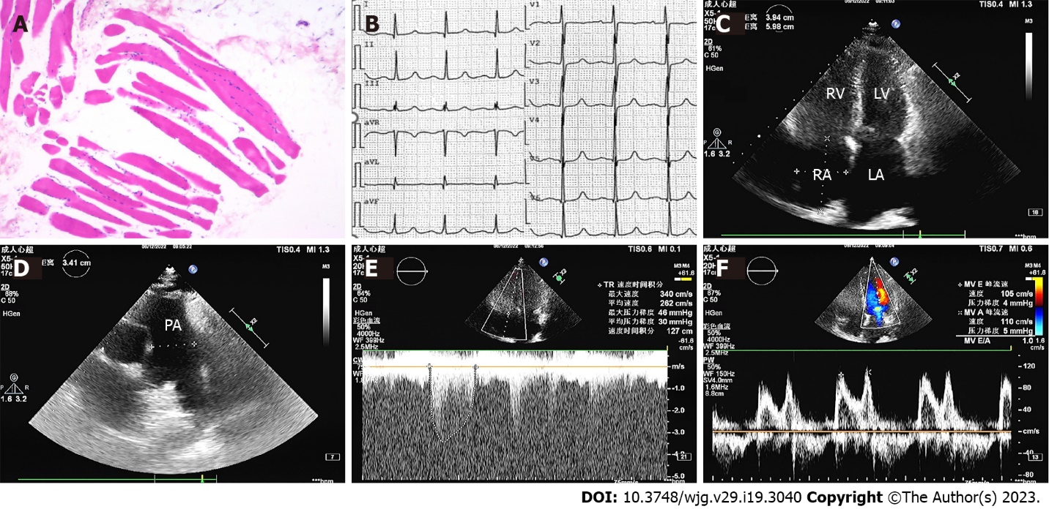
Figure 1 Pathological image of muscle, electrocardiogram, and Echocardiography upon admission. A: Muscle biopsy with hematoxylin and eosin staining (× 100) showed inflammatory cell infiltration; B: Electrocardiography indicated a normal sinus rhythm; C: A four-chamber view showed an enlarged right atrium, right ventricle, and left atrium; D: A long axis view of the pulmonary artery indicated widening of that artery; E: Doppler echocardiography showed that the peak tricuspid regurgitation velocity was 3.4 m/s, and the tricuspid regurgitation pressure gradient was 46 mmHg; F: Bicuspid valve doppler indicated reduced diastolic function. RV: Right ventricular; LV: Left ventricle; RA: Right atrium; LA: Left atrium; PA: Pulmonary artery.

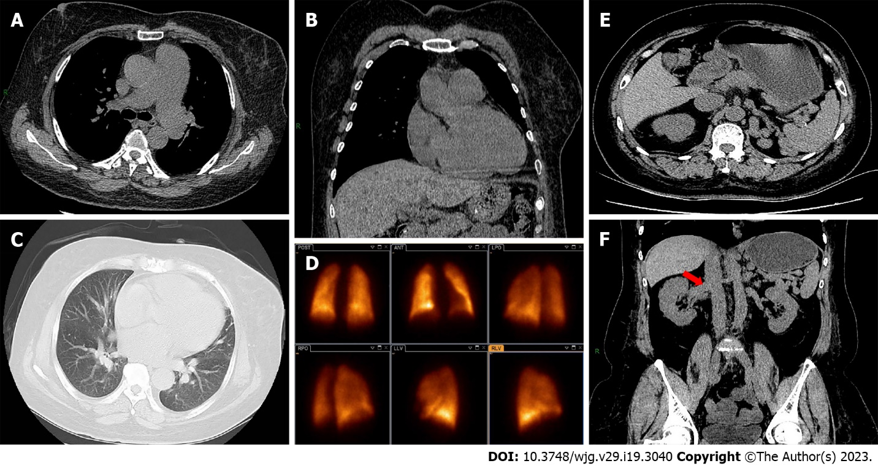
Figure 2 Computed tomography images and pulmonary ventilation/perfusion scan. A: Axial chest computed tomography (CT) depicted widening of the pulmonary artery; B: Coronal chest CT depicted right atrial and right ventricle enlargement; C: The pulmonary window showed no significant parenchymal pulmonary disease; D: A pulmonary ventilation/perfusion scan indicated normal perfusion function; E: An axial abdominal CT showed normal liver size, slight spleen enlargement, and multiple venous tortuosity; F: A coronal abdominal CT showed thickened venous shunt between the portal vein, splenic vein and left renal vein (red arrow).

Table 1 The patient’s laboratory data at admission and at 1-mo follow-up
Parameter | Value (admission) | Value (month 1) | References value | Unit
N-terminal-pro B-type natriuretic peptide | 590 |  | 0-125 | pg/mL
Urea | 10.02 | 11.6 | 2.5-6.1 | mmol/L
Creatinine | 123.4 | 124.9 | 46-92 | μmol/L
Troponin | < 0.01 |  | 0-0.04 | ng/mL
Myoglobin | 208.1 |  | 0-120 | ng/mL
Creatine kinase | 576.24 | 98.6 | 30-135 | U/L
Creatine kinase MB isoenzyme | 42.1 | 50.2 | 0-16 | U/L
Lactic dehydrogenase | 378.88 | 777.2 | 120-246 | U/L
D-dimer | 1.28 |  | 0-0.5 | μg/mL
White blood cell | 9.10 | 14.05 | 4-10 | 10⁹/L
Platelet | 140 | 111 | 125-350 | 10⁹/L
Hemoglobin | 119 | 152 | 110-150 | g/L
Alanine aminotransferase | 18.28 | 41.4 | 5-40 | IU/L
Aspartate aminotransferase | 15.44 | 16.1 | 8-40 | IU/L
Total bilirubin | 16.48 | 30.10 | 5-21 | μmol/L
Direct bilirubin | 3.36 | 7.40 | 0-3.4 | μmol/L
Indirect bilirubin | 13.12 | 22.70 | 1.6-21 | μmol/L
Albumin | 22.73 | 25.65 | 35-52 | g/L
Total cholesterol | 7.67 |  | 3.0-5.7 | mmol/L
Low density lipoprotein cholesterol | 3.65 |  | < 4.13 | mmol/L
High density lipoprotein cholesterol | 2.86 |  | 1.29-1.55 | mmol/L
Fasting blood glucose | 4.44 |  | 3.9-6.1 | Mmol/L
Urinary protein | 4+ |  | negative | -
24-h proteinuria | 416.01 |  | 0-150 | mg/d
Hepatitis B surface antigen | 0 |  | < 0.05 | IU/mL
Antibody to hepatitis C | 6.04 |  | < 1 | S/CO
Immunodeficiency virus antigen and antibody | 0.09 |  | < 1 | S/CO
Antibody to treponema pallidum | 0.07 |  | < 1 | S/CO
Hepatitis C virus RNA | 0 |  | 0 | IU/mL
Anti-nuclear antibodies | negative |  | negative | -
Anti-cyclic citrullinated peptide antibody | 13.89 |  | < 25 | RU/mL
Anti-cardiolipin antibody | 2.23 |  | 0-12 | RU/mL
Immunoglobulin G | 4.92 |  | 7.51-15.60 | g/L
Immunoglobulin A | 2.82 |  | 0.82-4.53 | g/L
Immunoglobulin M | 1.81 |  | 0.46-3.04 | g/L
C3 | 0.58 |  | 0.79-1.52 | g/L
C4 | 0.14 |  | 0.16-0.38 | g/L
Blood ammonia | 56 |  | 9-30 | μmol/L
Erythrocyte sedimentation rate | 22 | 6 | 0-20 | mm/h
Table 2 Results of right heart catheterization
Parameter | Value | Unit
Heart rate | 76 | bpm
Pulmonary arterial pressure | 90/38/55.33 | mmHg
Right atrium pressure | 12.17 | mmHg
Pulmonary artery wedge pressure | 34/19/24 | mmHg
Pulmonary vascular resistance | 5.13 | Wood units
Pulmonary vascular resistance | 410.23 | dyne s/cm
Cardiac output | 9.53 | L/min
Cardiac index | 4.51 | L/min/m²

Published by Baishideng Publishing Group Inc
7041 Koll Center Parkway, Suite 160, Pleasanton, CA 94566, USA
Telephone: +19253991568
Email: bpgoffice@wjgnet.com
Help Desk: https://www.f6publishing.com/helpdesk
https://www.wjgnet.com

© 2023 Baishideng Publishing Group Inc. All rights reserved.

