Name of Journal: World Journal of Clinical Cases
Manuscript NO: 71791
Manuscript Type: CASE REPORT

Laparoscopic radical resection for situs inversus totalis with colonic splenic flexure carcinoma: A case report

Zheng ZL et al. Lap-resection of colon cancer for SIT

Zi-Ling Zheng, Shou-Ru Zhang, Hao Sun, Mao-Cai Tang, Jing-Kun Shang

Zi-Ling Zheng, Shou-Ru Zhang, Hao Sun, Mao-Cai Tang, Jing-Kun Shang, Department of Gastrointestinal Cancer Center, Chongqing University Cancer Hospital, Chongqing 400030, China

Author contributions: Zheng ZL and Zhang SR performed the surgical method analyses and interpretation, and contributed to manuscript drafting; Tang MC and Shang JK analyzed and interpreted the imaging findings; Zhang SR and Sun H were responsible for the revision of the manuscript for important intellectual content; all authors issued final approval for the version to be submitted.

Supported by Chongqing medical scientific research project (Joint project of Chongqing Health Commission and Science and Technology Bureau), No. 2021MSXM309.

Corresponding author: Shou-Ru Zhang, Doctor, PhD, Associate Chief Physician, Department of Gastrointestinal Cancer Center, Chongqing University Cancer Hospital, No. 181 Hanyu Road, Shapingba District, Chongqing 400030, China. zsrhjp@126.com

Received: September 27, 2021
Revised: December 22, 2021
Accepted: April 22, 2022
Published online:

Abstract
BACKGROUND
Situs inversus totalis (SIT) is a rare group of congenital developmental malformations in the clinical setting, with all organs in the chest and abdomen existing in a mirror image reversal of their normal positions. Few reports have described laparoscopic surgery for colorectal cancer in patients with SIT, and it is considered difficult even for an experienced surgeon because of the mirror positioning. We present a case report of laparoscopic radical resection of a colonic splenic flexure carcinoma in a patient with SIT.

CASE SUMMARY
A 72-year-old male was referred to our hospital with colonic splenic flexure carcinoma, and computed tomography showed that all the organs in the chest and abdomen were inverted. Laparoscopic hemicolectomy with complete mesocolic excision was safely performed. The operating surgeon stood on the patient’s left side, which is opposite of the normal location.

CONCLUSION
Abdominal computed tomography is an effective method for diagnosing SIT preoperatively in patients with colonic splenic flexure carcinomas. Laparoscopic radical resection is difficult, but it is well established and safe. The surgeon should stand in the opposite position and perform backhand operations.

Key Words: Situs inversus totalis; Colonic splenic flexure carcinoma; Laparoscopic radical resection; Computed tomography; Case report

Zheng ZL, Zhang SR, Sun H, Tang MC, Shang JK. Laparoscopic radical resection for situs inversus totalis with colonic splenic flexure carcinoma: A case report. World J Clin Cases 2022; In press

Core Tip: The incidence of situs inversus totalis is very low, especially in patients with malignant tumors. Surgical resection is currently the primary treatment option for colon cancer. The safe performance of this surgery requires the use of a comprehensive imaging evaluation before the operation and a highly skilled and cooperative team.

INTRODUCTION
Situs inversus totalis (SIT) is a rare congenital anomaly in which the organs in the chest and abdomen are located in a mirror image reversal of their normal positions. SIT occurs in 1 of every 10000-50000 people^{[1]}, and the incidence of SIT with colon cancer is even rarer. The mechanism of SIT may act through the malrotation of organs during embryonic development^{[2]} or autosomal recessive inheritance, which occurs when parents have the same gene mutation^{[3]}. Although the organs are inverted, the relationship between the organs has not changed, and the physiological function is basically not affected. However, there may be some difficulties in the diagnosis and treatment of many diseases in patients with SIT.

CASE PRESENTATION
Chief complaints
A 72-year-old male was admitted because a "colon tumor was found by colonoscopy examination for 2 wk".

History of present illness
Two weeks before admission, the patient was examined in the outpatient clinic. He did not have abdominal pain, fullness, diarrhea, hematochezia, fever, cough, chest tightness, or other discomfort.

History of past illness
The patient had a negative previous medical history.

Personal and family history
The patient denied any family history.

Physical examination
The clinical examination revealed tenderness in his abdomen, and no lump was palpable. His general condition was otherwise good.

Laboratory examinations
Initial laboratory testing showed no abnormalities.

Imaging examinations
Computed tomography examination showed that all organs in the chest and abdomen were inverted and that the wall of the colonic splenic flexure was thickened. Colon cancer was considered, and the surrounding lymph nodes are shown in Figure 1. Colonoscopy was performed, and a neoplasm was found 50 cm from the anus. The neoplasm had surface ulceration and nodular changes involving the intestinal wall in approximately 2/3 of the circular folds. The pathological examination revealed adenocarcinoma of the colon. The patient was admitted to the hospital with "colon cancer".

FINAL DIAGNOSIS
The postoperative pathological examination revealed colonic splenic flexure adenocarcinoma.

TREATMENT
The patient was admitted to the hospital for further examination and treatment. Laparoscopic hemicolectomy with complete mesocolic excision was performed. The particular procedure is described here. After general anesthesia, the patient was placed in the lithotomy position. The operating surgeon and endoscopist were situated on the left, and the first assistant was situated on the right. The trocar position was arranged in a mirror image (Figure 2). A 3 cm subumbilical longitudinal incision was made. A 12 mm trocar was inserted into the abdomen to establish a CO₂ pneumoperitoneum and was observed through endoscopy. The second puncture point was located 5 cm under the costal edge of the left clavicular midline, and a 12 mm trocar was placed by the operating surgeon. A 5-mm trocar was placed in the left iliac fossa for traction, and 2 other 5-mm trocars were placed in the right iliac fossa and flank as working ports for the first assistant. Exploration of the peritoneal cavity showed total visceral inversion. The tumor was located in the splenic flexure of the right upper quadrant, so left hemicolectomy (actual right) was performed. The sigmoid and descending colons were mobilized using ultrasonic dissection. The right ureter and spermatic vessels were confirmed on the dorsal side and were avoided during dissection. Then, the inferior mesenteric artery was clipped with endoscopic vascular clips. We separated the mesentery, clipped the inferior mesenteric vein, and approached the inferior margin of the pancreas and the inferior margin of the spleen (Figure 3). Then, the transverse colon and transverse mesocolon were detached from the pancreas and spleen through a cranial approach, and the transverse colon, colonic splenic flexure, descending colon and sigmoid colon were mobilized. In the right upper abdomen, a longitudinal incision through the rectus abdominis muscle was made, and the specimen was extracted and resected. A purse-string suture was used to hold the anvil of a circular stapling device in the distalis colon. A 29-mm end-to-side anastomotic stapling device was inserted from the proximal colon, and the anastomosis was completed. The stump was closed by a linear stapler. The operation went smoothly and lasted 4 h. The intraoperative bleeding was approximately 50 mL.

OUTCOME AND FOLLOW-UP
The postoperative patient recovered well and was discharged from the hospital 7 d after the operation. Postoperative pathological examination revealed colonic splenic flexure adenocarcinoma.

DISCUSSION
SIT is a rare congenital anomaly in which the organs in the chest and abdomen are located in a mirror image reversal of their normal positions. SIT occurs in 1 out of every 10000-50000 people, and the incidence of SIT with colon cancer is even rarer. Colon cancer is a common malignant tumor of the alimentary canal. Surgical resection is currently the primary treatment option for colon cancer. Laparoscopic surgery can achieve the same radical effect as open surgery. Moreover, due to the continuous progress of laparoscopic colectomy, it has the advantages of less injury and quick recovery after operation. At present, the technique of laparoscopic radical resection for colon cancer is well established. However, additional details on the operating surgeon's position and the surgical approach for patients with SIT are still required^{[4-6]}.
Complete thoracic and abdominal visceral inversion with colorectal malignant tumors is relatively rare, and reports of SIT with colorectal malignant tumors have increased in recent years (Table 1)^{[7-13]}. Patients with SIT may have a higher risk of cancer, which may be related to intracellular motor proteins and the KIF3 complex^{[14]}. Patients with SIT congenitally lack the normal function of the KIF3 complex. Defects of the KIF3 complex prevent the transportation of N-cadherin to the cell surface, leading to an increased level of β-catenin in the cytoplasm. The accumulated β-catenin in the cytoplasm enters the nucleus and activates genes associated with cell proliferation, thus leading to the development and progression of cancer^{[15]}. At present, there are no reports about operations in patients with SIT complicated with cancer of the colonic splenic flexure. This patient had total visceral inversion. During the operation, the position of the operating surgeon and assistant and their cooperation are different from those of the conventional operation, which would make the procedures complicated, even for an experienced surgeon. The author believes that there are three details to consider for this type of surgery. (1) It is necessary to conduct a complete imaging evaluation before surgery to determine whether other vascular and anatomical malformations are complicated. In addition, the rehearsal of the operation before the operation plays a guiding role in surgery; (2) The operation requires the skilled cooperation of the team and transposition of the operating surgeon and assistant. A report proposed that left-handed surgical operators have advantages during laparoscopic procedures in patients with SIT. However, a large number of operating surgeons and assistants have to operate using a backhand grip, so it is difficult to cooperate; (3) Attention should be given to reverse thinking at all times during the operation. Moreover, the abnormal anatomical relationship of organs should be fully recognized to avoid unnecessary injury.

CONCLUSION
At present, there is a lack of research on the relationship between SIT, tumorigenesis and treatment. In addition, most patients with SIT who have tumors are reported as case reports. Whether SIT is related to tumorigenesis, including colon cancer, needs further research.

REFERENCES
1 Murakami S, Terakado M, Misumi M, Tsuji Y, Okubo K, Hirayama R, Inoue K, Arai E. Situs inversus totalis with malignant lymphoma of the stomach: report of a case. Surg Today 2003; 33: 533-536 [PMID: 14507000 DOI: 10.1007/s10595-002-2530-z]
2 Spoon JM. Situs inversus totalis. Neonatal Netw 2001; 20: 59-63 [PMID: 12143842 DOI: 10.1891/0730-0832.20.1.63]
3 Elbeshry TM, Ghnnam WM. Retrograde (fundus first) Laparoscopic Cholecystectomy in Situs Inversus Totalis. Sultan Qaboos Univ Med J 2012; 12: 113-115 [PMID: 22375268 DOI: 10.12816/0003097]
4 Benz SR, Tannapfel A, Tam Y, Stricker I. [Complete Mesocolic Excision for Right-Sided Colon Cancer - The Role of Central Lymph Nodes]. Zentralbl Chir 2015; 140: 449-452 [PMID: 25401370 DOI: 10.1055/s-0034-1383133]
5 Zurleni T, Cassiano A, Gjoni E, Ballabio A, Serio G, Marzoli L, Zurleni F. Correction to: Surgical and oncological outcomes after complete mesocolic excision in right-sided colon cancer compared with conventional surgery: a retrospective, single-institution study. Int J Colorectal Dis 2018; 33: 113-114 [PMID: 29214343 DOI: 10.1007/s00384-017-2936-z]
6 Oms LM, Badia JM. Laparoscopic cholecystectomy in situs inversus totalis: The importance of being left-handed. Surg Endosc 2003; 17: 1859-1861 [PMID: 14959744 DOI: 10.1007/s00464-003-9051-7]
7 Kudo T, Matsuda T, Urakawa N, Hasegawa H, Kanaji S, Yamashita K, Oshikiri T, Kakeji Y. Laparoscopic sigmoidectomy with splenic flexure mobilization for colon cancer in situs inversus totalis: Preoperative assessment and preparation. Asian J Endosc Surg 2021 [DOI:10.1111/ases.12944]
8 Kasai S, Hino H, Shiomi A, Kagawa H, Manabe S, Yamaoka Y, Kato S, Hanaoka M, Kinugasa Y. Robotic-assisted surgery for rectal cancer with situs inversus totalis: A case report. Asian J Endosc Surg 2021; 14: 803-806 [PMID: 33797194 DOI: 10.1111/ases.12937]
9 Chen W, Liang JL, Ye JW, Luo YX, Huang MJ. Laparoscopy-assisted resection of colorectal cancer with situs inversus totalis: A case report and literature review. World J Gastrointest Endosc 2020; 12: 310-316 [PMID: 32994862 DOI: 10.4253/wjge.v12.i9.310]
10 Takeda T, Haraguchi N, Yamaguchi A, Uemura M, Miyake M, Miyazaki M, Ikeda M, Sekimoto M. Laparoscopic sigmoidectomy in a case of sigmoid colon cancer with situs inversus totalis. Asian J Endosc Surg 2019; 12: 111-113 [PMID: 29601667 DOI: 10.1111/ases.12483]
11 Kojima Y, Sakamoto K, Tomiki Y, Sugimoto K, Okazawa Y, Makino Y. Laparoscopic right colectomy for a patient with situs inversus totalis. J Surg Case Rep 2019; 2019: rjz080 [PMID: 30949333 DOI: 10.1093/jscr/rjz080]
12 Yeom SS, Kim KH, Lee SY, Kim CH, Kim HR, Kim YJ. Reduced-Port Laparoscopic Surgery for Patients With Proximal Transverse Colon Cancer With Situs Inversus Totalis: A Case Report. Ann Coloproctol 2018; 34: 322-325 [PMID: 30630305 DOI: 10.3393/ac.2018.05.29.1]
13 Sasaki K, Nozawa H, Kawai K, Hata K, Kiyomatsu T, Tanaka T, Nishikawa T, Otani K, Kaneko M, Emoto S, Murono K, Watanabe T. Laparoscopic hemicolectomy for a patient with situs inversus totalis: A case report. Int J Surg Case Rep 2017; 41: 93-96 [PMID: 29055878 DOI: 10.1016/j.ijscr.2017.10.011]
14 Haruki T, Maeta Y, Nakamura S, Sawata T, Shimizu T, Kishi K, Miyasaka S, Maeta H, Morimoto K, Taniguchi I. Advanced cancer with situs inversus totalis associated with KIF3 complex deficiency: report of two cases. Surg Today 2010; 40: 162-166 [PMID: 20107958 DOI: 10.1007/s00595-009-4005-x]
15 Teng J, Rai T, Tanaka Y, Takei Y, Nakata T, Hirasawa M, Kulkarni AB, Hirokawa N. The KIF3 motor transports N-cadherin and organizes the developing neuroepithelium. Nat Cell Biol 2005; 7: 474-482 [PMID: 15834408 DOI: 10.1038/ncb1249]

Footnotes
Informed consent statement: The patient's informed consent has been obtained in this case.

Conflict-of-interest statement: The authors have no financial disclosures or conflicts of interest to declare.

CARE Checklist (2016) statement: The authors have read the CARE Checklist (2016), and the manuscript was prepared and revised according to the CARE Checklist (2016).

Open-Access: This article is an open-access article that was selected by an in-house editor and fully peer-reviewed by external reviewers. It is distributed in accordance with the Creative Commons Attribution NonCommercial (CC BY-NC 4.0) license, which permits others to distribute, remix, adapt, build upon this work non-commercially, and license their derivative works on different terms, provided the original work is properly cited and the use is non-commercial. See: https://creativecommons.org/Licenses/by-nc/4.0/

Provenance and peer review: Unsolicited article; Externally peer reviewed.
Peer-review model: Single blind

Peer-review started: September 27, 2021
First decision: December 10, 2021
Article in press:

Specialty type: Surgery
Country/Territory of origin: China
Peer-review report’s scientific quality classification
Grade A (Excellent): A
Grade B (Very good): B
Grade C (Good): 0
Grade D (Fair): D
Grade E (Poor): 0

P-Reviewer: Cristaldi PMF, Italy; Kung WM, Taiwan; Moshref L; Saudi Arabia S-Editor: Ma YJ L-Editor: A P-Editor: Ma YJ
Figure Legends

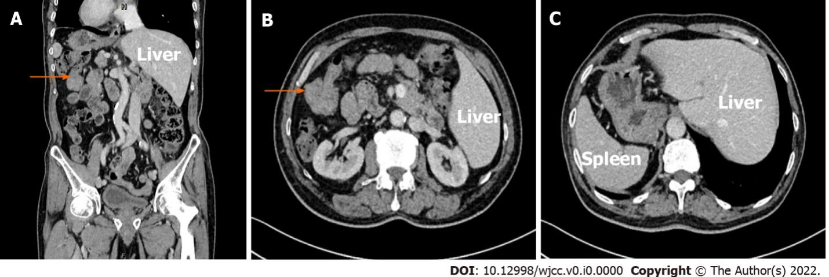
Figure 1 Computed tomography imaging. A: Coronal plane of contrasted computed tomography (CT); B: The arrow indicates splenic flexure cancer; C: Transverse section of contrasted CT.

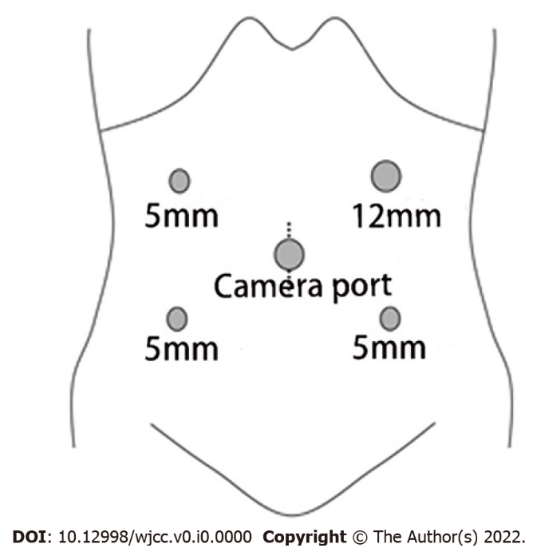
Figure 2 Trocar position. The position of the trocar was in a mirror image arrangement. The 12-mm trocar for the operating surgeon was located in the left upper quadrant.

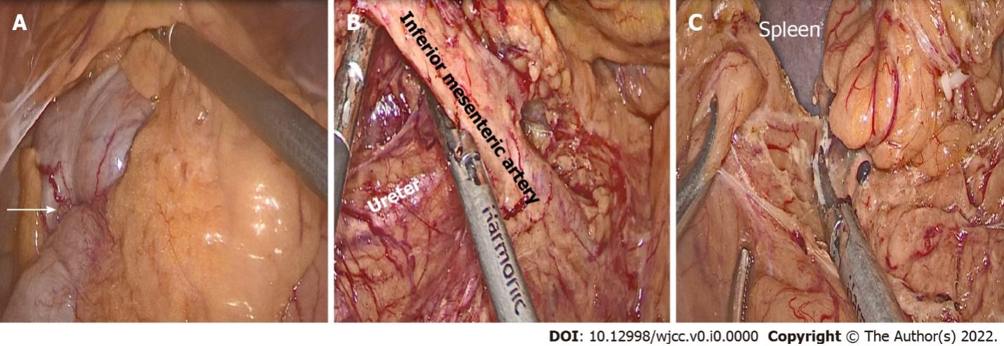
Figure 3 Intraoperative findings. A: The arrow shows the position of the tumor; B: The inferior mesenteric artery was mobilized, and the right ureter was confirmed on the dorsal side; C: Mobilization of the colonic splenic flexure.
Table 1 Cases of situs inversus totalis with colorectal malignant tumors
Ref. | Publish time | Gender/age (yr) | Tumor location | Treatment
Kudo et al^{[7]} | 2021 | Female/79 | Sigmoid colon | Laparoscopic surgery
Huang et al^{[8]} | 2021 | Female/60 | Rectum | Robotic surgery
Chen et al^{[9]} | 2020 | Female/59 | Sigmoid colon | Laparoscopic surgery
Takeda et al^{[10]} | 2019 | Female/72 | Sigmoid colon | Laparoscopic surgery
Kojima et al^{[11]} | 2019 | Female/76 | Ascending colon | Laparoscopic surgery
Yeom et al^{[12]} | 2018 | Female/85 | Transverse colon | Laparoscopic surgery
Sasaki et al^{[13]} | 2017 | Female/75 | Ascending colon | Laparoscopic surgery

