Name of journal: World Journal of Radiology
ESPS Manuscript NO: 9598
Columns: CASE REPORT

Peripheral primitive neuroectodermal tumor of kidney presenting with pulmonary tumor embolism: A case report

Chinnaa S et al. Renal PNET causing pulmonary tumor embolism

Sathya Chinnaa, Chandan J Das, Sanjay Sharma, Prabhjot Singh, Amlesh Seth, Suvendu Purkait, Sandeep R Mathur

Sathya Chinnaa, Chandan J Das, Sanjay Sharma, Department of Radiology, All India Institute Of Medical Sciences, New Delhi 110029, India

Prabhjot Singh, Amlesh Seth, Department of Urology, All India Institute Of Medical Sciences, New Delhi 110029, India

Suvendu Purkait, Sandeep R Mathur, Department of Pathology, All India Institute Of Medical Sciences, New Delhi 110029, India

Author contributions: Chinnaa S and Das CJ had done literature search and prepared the manuscript; Sharma S edited the manuscript; Singh P and Seth A operated on the patient; Purkait S and Mathur SR contributed to the pathological diagnosis.

Correspondence to: Chandan J Das, Assistant Professor, Department of Radiology, All India Institute of Medical Sciences, Aurobindo Marg, New Delhi 110029, India. dascj@yahoo.com

Telephone: +91-11-26593628 Fax: +91-11-26588663

Received: February 19, 2014 Revised: April 8, 2014
Accepted: August 27, 2014

Published online:

Abstract
Peripheral primitive neuroectodermal tumor (PNET) of the kidney is a rare, aggressive tumor, known for its recurrence and metastatic potential. Despite the frequency of venous extension to the renal veins and inferior vena cava, pulmonary tumor embolism at the initial presentation is not common. We report a case of 22-year-old female with PNET of the kidney who presented with tumor embolism in the inferior vena cava (IVC) and bilateral pulmonary artery. The patient underwent surgical resection and histopathological analysis confirmed the presence of tumor within the IVC and pulmonary arteries. The patient received adjuvant chemotherapy and is currently doing well on follow-up.

© 2014 Baishideng Publishing Group Inc. All rights reserved.

Key words: Primitive neuroectodermal tumor; Pulmonary tumor embolism; Computed tomography

Core tip: Traditionally an aggressive renal mass with pulmonary tumor embolism is an entity well described with renal cell carcinomas. However renal primitive neuroectodermal tumor (PNET), a rare and aggressive tumor can have the similar presentation. The severity of the clinical manifestations of pulmonary tumor embolism is highly variable and less predictable. Bland thrombus often mimics like tumor emboli in imaging and histopathology is often confirmatory. Tumoral extension into the pulmonary artery is not necessarily associated with pulmonary metastasis. Surgical removal of the thrombus along with the primary tumor followed by adjuvant chemotherapy may prolong the survival in these patients.

Chinnaa S, Das CJ, Sharma S, Singh P, Seth A, Purkait S, Mathur SR. Peripheral primitive neuroectodermal tumor of kidney presenting with pulmonary tumor embolism: A case report. World J Radiol 2014; In press

INTRODUCTION
Peripheral primitive neuroectodermal tumor (PNET)/Ewing’s sarcoma belong to the small round cell tumor family and most commonly occur in the central nervous system. The rarity of these tumors in the kidneys and their aggressive nature precludes the necessity for complete imaging work up for metastasis preoperatively. Although the radiological features of PNETs are non-specific, multiphasic computed tomography (CT) with 3D reconstruction can assess for vascular invasion and is essential prior to embolectomy. Histopatholoically, the differential diagnosis for PNETs is wide since they share immunophenotypical and genetic similarities with other small round cell tumors.

CASE REPORT
A 22-year-old female presented with complaints of right flank pain and hematuria for six weeks. The patient described the Pain as mild, dull, aching and non-radiating. There were six to seven episodes of gross hematuria, each episode subsided spontaneously. There was no history of fever or burning micturition. She was a non smoker and non alcoholic without any significant family history. Blood haemoglobin levels, renal and liver function tests were normal. Abdominal ultrasound showed a heterogeneous right renal mass of size 7.2 cm x 6.3 cm x 3.1 cm with right renal vein thrombus extending into the inferior vena cava (IVC). There was no hydronephrosis or dilated ureter. Contrast enhanced CT of chest and abdomen was planned in a helical 256 slice CT scanner (Definition flash, Siemens). After obtaining non-contrast scan of the renal mass, a bolus of 80-100 mL of IV contrast material (iopromide, ultravist) was administered at a rate of 2-3 mL/s. Non-contrast CT scan revealed an iso-hypodense mass arising from the right kidney without evidence of calcification or haemorrhage. Contrast enhanced CT scan showed 7.1 cm x 8.2 cm x 4.0 cm inhomogenous mass with predominantly non-enhancing centre and peripheral rim enhancement suggestive of necrosis (Figure 1A). It was a mass with extension into the renal pelvis. There was no infiltration into the perinephric fat or adjacent organs. Coronal contrast-enhanced CT (CECT) images demonstrates the vascular extension of the tumor mass expanding the lumen of right renal vein and suprarenal part of inferior vena cava (Figure 1B).The presence of contour abnormality of the vessel with area of contact of the tumor exceeding more than 50% circumference of the vessel raised suspicion of vascular invasion. Left kidney and left renal vein were normal. Contrast enhanced CT of chest showed saddle type non occlusive filling defect in the main pulmonary artery with extension noted into the segmental branches bilaterally (Figure 1C and D). Pleural based patchy consolidation with central lucency noted in the posterior segment of the right lower lobe (Figure 1E). Considering the shape, location and nature of consolidation, we had kept wedge shaped pulmonary infarct from the saddle pulmonary embolism as our first differential compared to cavitating pulmonary metastasis. No evidence of liver or bone metastasis was noted in CT and bone scan was normal.
The patient underwent right radical nephrectomy with IVC thrombectomy and cardiopulmonary bypass with pulmonary embolectomy and right atrial thrombectomy under deep hypothermic cardiac arrest (cardioplegia). The tumor was seen infiltrating into the renal sinus without perinephric extension. Hilar vessels showed tumor emboli in the lumen. Microscopically, the tumor cells were arranged in nests and small sheets with focal rosette formation (Figure 2). The cells demonstrated round nuclei with granular chromatin and scant to moderate cytoplasm. Immunohistochemical analysis revealed diffuse positivity for MIC-2 and focal positivity for neuron specific enolase (NSE), CD 56 and synaptophysin, while negative for pan CK, chromogranin. MIB-1 labelling index is 20%-25% at the highest proliferating area. Thrombi within the atrium, IVC and pulmonary artery revealed identical histology of the primary tumor. The patient had an uneventful postoperative period and was started on adjuvant chemotherapy.

DISCUSSION
Peripheral primitive neuroectodermal tumor/Ewing’s sarcoma (PNET/ES) belongs to “ewings family of tumors” and comprises 1% of all sarcomas^{[1]}. They have more predilection for adolescent age group. More commonly peripheral PNETs are found to arise in the chest wall and paraspinal regions^{[2]}. Skin, soft tissue and viscera (kidney, lungs, adrenal) and retroperitoneum are less commonly affected. ^{[3]} ES/PNET of kidney with pulmonary tumor embolism is very unusual with only two cases were reported till date^{[4,5]}. Similar presentation of renal PNET with pulmonary embolism was reported in 30-year-old male and 21-year-old female patient where tumor resection and thrombectomy were done in both cases, which was later confirmed on histopathology. Good chemotherapeutic response with more than 1 year disease free post operative period was mentioned in the female patient^{[4]}.
Renal PNET mostly presents with nonspecific symptoms such as abdominal pain, palpable masses or hematuria. Imaging features of renal PNET is indistinguishable from renal cell carcinoma. Although abdominal ultrasound can visualise the thrombus in renal vein and suprarenal IVC, contrast enhanced CT is mandatory to identify the cranial extent of tumor into supradiphragmatic IVC, atrial chambers and pulmonary artery because of the surgical implications. Imaging differentiation of bland (benign) thrombus and tumor thrombus is necessary because of the high rate of recurrence and dismal prognosis associated with the latter. Tumour thrombus causes expansion of the vascular lumen with thread and streaks arterial enhancement and shows continuity with primary tumour. Also restricted diffusion may be noted in the tumor thrombus. Infiltration of the IVC wall is considered as most specific sign for tumor embolism however it is less sensitive and if present, surgical resection of involved segment of IVC is necessary^{[6]}. CECT is also useful in providing information about the loco regional invasion of the tumor and to identify the presence of metastatic deposits in liver, bone, lungs and lymph nodes.
Histopathologically several diagnostic techniques need to be adopted to differentiate PNET/ES from other small round cell tumors. Peripheral PNET typically expresses high amounts of the MIC2 antigen (CD99) and exhibits highly characteristic chromosomal translocation [t (11, 22) (q24; q12)]^{[7]}. The most important identifying histologic feature to diagnose renal PNET is the presence of pseudorosettes^{[8]}. Neuron-specific enolase has been shown to stain positive in 95% of renal PNET cases^{[8]}. EWS gene arrangement, as seen in renal PNET, may also be observed in desmoplastic small round cell tumor, clear cell sarcoma, and neuroblastoma^{[9]}.
A case of spontaneous regression of metastatic lung nodules from renal PNET postnephrectomy has been documented^{[10]}. Pulmonary embolism secondary to vascular invasion does not always cause pulmonary metastasis as establishment of pulmonary metastasis requires both mechanical trapping and invasive potential of the tumor cells^{[11]}. The most common sites of metastasis reported in the literature are distant lymph nodes, lungs, and liver^{[8]}. Despite the combination of surgery, radiotheraphy and chemotheraphy, overall 5-year disease-free survival rate for peripheral PNETs to be between 45% and 55%^{[8]}.
The PNET of the kidney is an uncommon tumor and its presentation as pulmonary tumor embolism is extremely rare. Pulmonary infarct needs to be differentiated from metastasis in such conditions and adequate surgical resection of both primary tumor and thrombus can result in better outcome. We suggest that in a young patient presenting with renal mass invading renal vein, differential diagnosis of PNET needs to be considered and adequate preoperative imaging to include the chest is mandatory to rule out pulmonary tumor embolism.
.
COMMENTS
Case characteristics
Non radiating flank pain and gross hematuria for six weeks.

Clinical diagnosis
Renal malignancy.

Differential diagnosis
Renal calculi.

Laboratory diagnosi
Anemia.

Imaging diagnosis
Renal cell carcinoma.

Pathological diagnosis
Primitive neuroectodermal tumor.

Treatment
Right radical nephrectomy with inferior vena cava (IVC) thrombectomy and cardiopulmonary bypass with pulmonary embolectomy and adjuvant chemotherapy

Term explanation
Pulmonary tumor embolism is different from thromboembolism.

Experiences and lessons
Not all heterogeneous renal mass with IVC extension are renal cell carcinomas and preoperative biopsy should be done.

Peer review
The manuscript describes a very interesting presentation of a rare tumor. Also, the images provided nicely correlate with the clinical presentation.
REFERENCES
1 Funahashi Y, Hattori R, Yamamoto T, Mizutani K, Yoshino Y, Matsukawa Y, Sassa N, Okumura K, Gotoh M. Ewing's sarcoma / primitive neuroectodermal tumor of the kidney. Aktuelle Urol 2009; 40: 247-249 [PMID: 19294616 DOI: 10.1055/s-0028-1098827]
2 Gonlusen G, Ergin M, Paydas S, Bolat FA. Primitive neuroectodermal tumor of the kidney: a rare entity. Int Urol Nephrol 2001; 33: 449-451 [PMID: 12230269 DOI: 10.1023/A: 1019511205650]
3 Wedde TB, Lobmaier IV, Brennhovd B, Lohne F, Hall KS. Primary Ewing's Sarcoma of the Kidney in a 73-Year-Old Man. Sarcoma 2011; 2011: 978319 [PMID: 21776194 DOI: 10.1155/2011/978319]
4 Kim MS, Kim B, Park CS, Song SY, Lee EJ, Park NH, Kim HS, Kim SH, Cho KS. Radiologic findings of peripheral primitive neuroectodermal tumor arising in the retroperitoneum. AJR Am J Roentgenol 2006; 186: 1125-1132 [PMID: 16554591 DOI: 10.2214/AJR.04.1688]
5 Castro EC, Parwani AV. Ewing sarcoma/primitive neuroectodermal tumor of the kidney: two unusual presentations of a rare tumor. Case Rep Med 2012; 2012: 190581 [PMID: 22312368 DOI: 10.1155/2012/190581]
6 Didier D, Racle A, Etievent JP, Weill F. Tumor thrombus of the inferior vena cava secondary to malignant abdominal neoplasms: US and CT evaluation. Radiology 1987; 162: 83-89 [PMID: 3024211]
7 Dedeurwaerdere F, Giannini C, Sciot R, Rubin BP, Perilongo G, Borghi L, Ballotta ML, Cornips E, Demunter A, Maes B, Dei Tos AP. Primary peripheral PNET/Ewing's sarcoma of the dura: a clinicopathologic entity distinct from central PNET. Mod Pathol 2002; 15: 673-678 [PMID: 12065782 DOI: 10.1038/modpathol.3880585]
8 Ellinger J, Bastian PJ, Hauser S, Biermann K, Müller SC. Primitive neuroectodermal tumor: rare, highly aggressive differential diagnosis in urologic malignancies. Urology 2006; 68: 257-262 [PMID: 16904430 DOI: 10.1016/j.urology.2006.02.037]
9 Gardner LJ, Ayala AG, Monforte HL, Dunphy CH. Ewing sarcoma/peripheral primitive neuroectodermal tumor: adult abdominal tumors with an Ewing sarcoma gene rearrangement demonstrated by fluorescence in situ hybridization in paraffin sections. Appl Immunohistochem Mol Morphol 2004; 12: 160-165 [PMID: 15354743 DOI: 10.1097/00129039-200406000-00011]
10 Bostedt H. Studying the immobility of sheep in the perinatal period. Berl Munch Tierarztl Wochenschr 1976; 89: 156-161 [PMID: 1267757 DOI: 10.1053/jpsu.2003.50135]
11 Masumori N, Kumamoto Y, Tsukamoto T, Otani N, Miyao N, Yanase M, Takahashi A, Iwabe H. [Studies on pulmonary metastasis of renal cell carcinoma--pulmonary embolism revealed by lung-perfusion imaging and metastasis]. Nihon Hinyokika Gakkai Zasshi 1991; 82: 769-775 [PMID: 1875570]

P-Reviewer: Reilly C, Triantopoulou C S-Editor: Ji FF L-Editor: E-Editor:

A B C
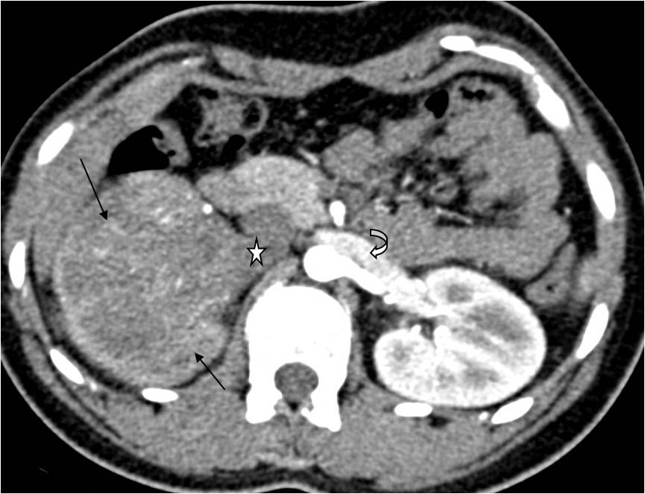 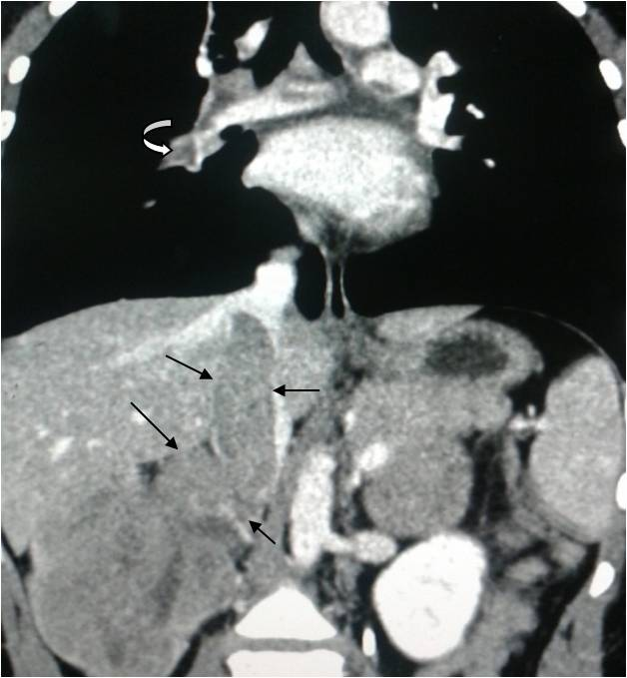 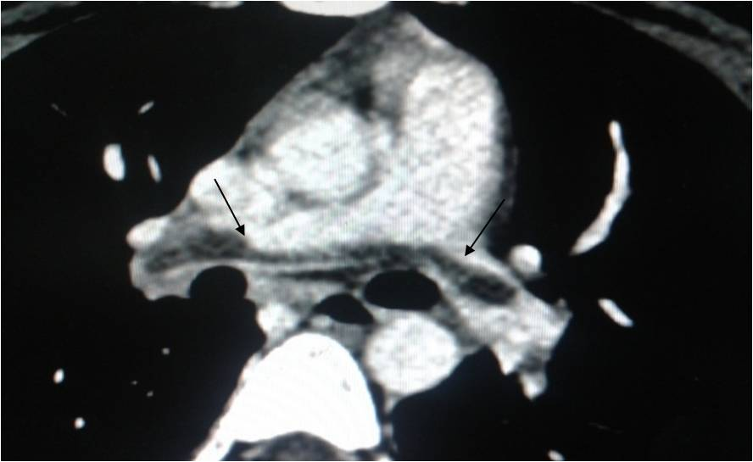
D E
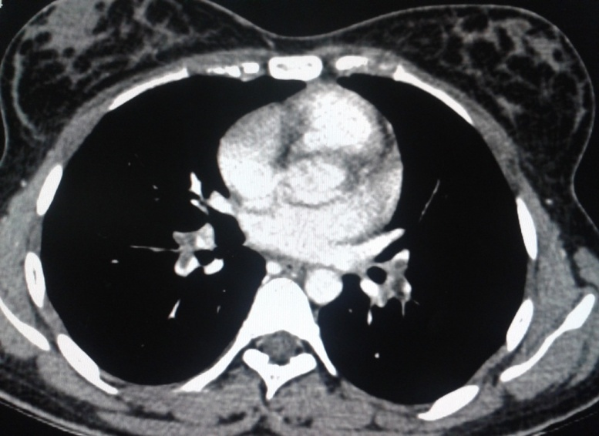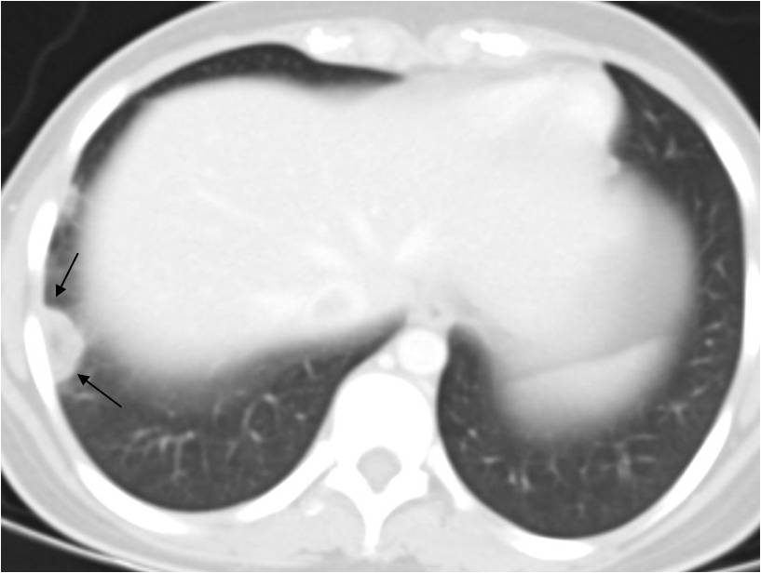
Figure 1 Contrast enhanced computed tomography of abdomen. Corticomedullary phase (A) shows a heterogeneous enhancing mass (arrows) in the right kidney with invasion into the right renal vein and inferior vena cava (arrow head). Note normally opacified left renal vein (curved arrow); Coronal reconstructed image (B) shows the intraluminal tumoral filling defect causing expansion of the right renal vein and inferior vena cava (straight arrows) in continuity with primary renal mass Tumor thrombus is also seen in right pulmonary artery (curved arrows); Axial contrast-enhanced computed tomography (CECT) of chest (C and D) shows saddle type filling defect (tumor thrombus) in the bifurcation of main pulmonary artery (arrows in C) and segmental branches of the bilateral pulmonary artery (arrows in D); Axial CECT of chest in lung window (E) shows wedge shaped patchy consolidation with central lucency in the subpleural region of the posterior segment in the right lower lobe (arrows) consistent with pulmonary infarct.

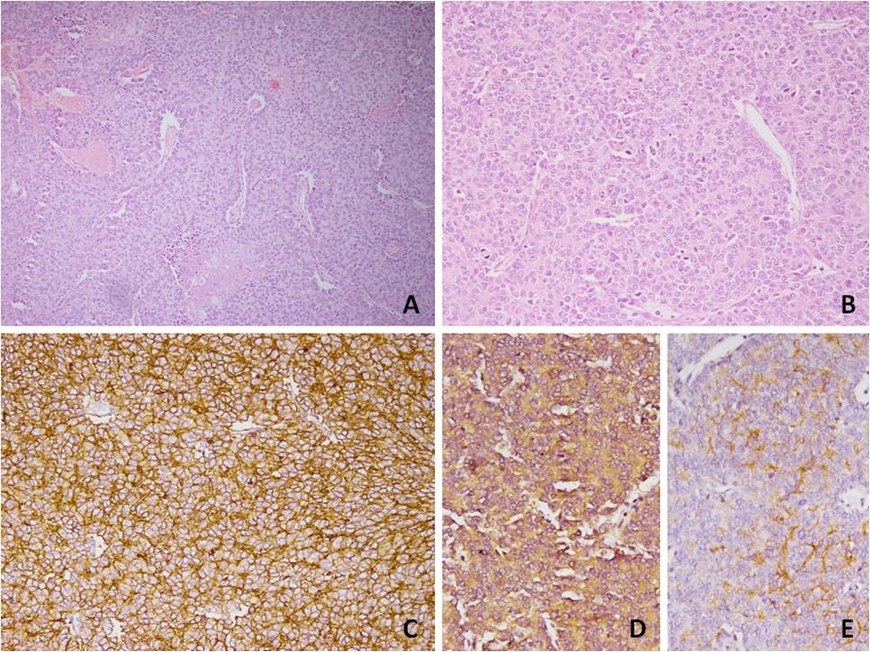
Figure 2 Photomicrograph showing tumour cells arranged in sheets with interspersed blood vessels and areas of necrosis (H and E × 100, A) with small to medium sized cell having round nuclei with stipple chromatin and moderate cytoplasm (H and E × 200, B). Diffuse membranous immunopositivity for MIC 2 (IHC × 200, C), cytoplasmic immunopositivity for neuron specific enolase (NSE) (IHC × 200, D) and cytoplasmic immunopositivity for Synaptophysin (IHC × 200, E) were also seen. IHC: Immunohistochemistry.

