Name of Journal: World Journal of Gastroenterology
Manuscript NO: 74944
Manuscript Type: REVIEW

Small nucleolar RNA host gene 3 functions as a novel biomarker in liver cancer and other tumour progression

Shan DD et al. LncRNA SNHG3 in liver cancer and other cancers

Dan-Dan Shan, Qiu-Xian Zheng, Jing Wang, Zhi Chen

Dan-Dan Shan, Qiu-Xian Zheng, Jing Wang, Zhi Chen, State Key Laboratory for Diagnosis and Treatment of Infectious Diseases, National Clinical Research Center for Infectious Diseases, National Medical Center for Infectious Diseases, Collaborative Innovation Center for Diagnosis and Treatment of Infectious Diseases, The First Affiliated Hospital, Zhejiang University School of Medicine, Hangzhou 310003, Zhejiang Province, China

Author contributions: Chen Z carried out the concepts and designed the definition of intellectual content; Shan DD and Zheng QX carried out the literature search and manuscript editing; Wang J performed manuscript review; All authors have read and approved the content of the manuscript.

Supported by the National Science and Technology Major Project of China, No. 2018ZX10302206 and 2017ZX10202203.

Corresponding author: Zhi Chen, MD, PhD, Professor, State Key Laboratory for Diagnosis and Treatment of Infectious Diseases, National Clinical Research Center for Infectious Diseases, National Medical Center for Infectious Diseases, Collaborative Innovation Center for Diagnosis and Treatment of Infectious Diseases, The First Affiliated Hospital, Zhejiang University School of Medicine, No. 79 Qingchun Road, Shangcheng District, Hangzhou 310003, Zhejiang Province, China. zjuchenzhi@zju.edu.cn

Received: January 18, 2022
Revised: February 9, 2022
Accepted: March 16, 2022
Published online:

Abstract
Cancer has become the most life-threatening disease in the world. Mutations in and aberrant expression of genes encoding proteins and mutations in noncoding RNAs, especially long noncoding RNAs (lncRNAs), have significant effects in human cancers. LncRNAs have no protein-coding ability but function extensively in numerous physiological and pathological processes. Small nucleolar RNA host gene 3 (SNHG3) is a novel lncRNA and has been reported to be differentially expressed in various tumors, such as liver cancer, gastric cancer, and glioma. However, the interaction mechanisms for the regulation between SNHG3 and tumor progression are poorly understood. In this review, we summarize the results of SNHG3 studies in humans, animal models, and cells to underline the expression and role of SNHG3 in cancer. SNHG3 expression is upregulated in most tumors and is detrimental to patient prognosis. SNHG3 expression in lung adenocarcinoma remains controversial. Concurrently, SNHG3 affects oncogenes and tumor suppressor genes through various mechanisms, including competing endogenous RNA effects. A deeper understanding of the contribution of SNHG3 in clinical applications and tumor development may provide a new target for cancer diagnosis and treatment.

Key Words: Small nucleolar RNA host gene 3; Long noncoding RNAs, Biomarker; Clinical characters; Molecular mechanism; Competing endogenous RNA; Liver cancer

Shan D, Zheng Q, Wang J, Chen Z. Small nucleolar RNA host gene 3 functions as a novel biomarker in liver cancer and other tumour progression. World J Gastroenterol 2022; In press

Core Tip: This review explores the differential expression of small nucleolar RNA host gene 3 (SNHG3) as a novel lncRNA in hepatocellular carcinoma as well as other tumours. SNHG3 is upregulated in most tumours and can influence tumourigenesis and progression through competing endogenous RNA effects and signalling pathways, thereby adversely affecting patient prognosis. Therefore, SNHG3 may become a new target for the diagnosis and treatment of many cancers, including hepatocellular carcinoma.
INTRODUCTION
Cancer has become one of the significant sources of mortality worldwide. Approximately 14.1 million individuals are newly diagnosed each year, and approximately 8.2 million deaths occurred in 2021 based on GLOBOCAN^{[1]}. Despite considerable achievements and advances in clinical practices, cancer remains a dreadful illness with a poor prognosis and high health burden, which presents a global threat to health^{[2]}. Cancer is a heterogeneous disease with substantial genotypic and phenotypic diversity^{[3]}. Genomic regulation of the cancer genome plays a vital role in cancer initiation, progression, and metastasis^{[4,5]}. It is of most importance to explore the intricate link underlying cancer development and progression.
Long noncoding RNAs (lncRNAs) are a class of noncoding RNAs (ncRNAs) with no protein-coding ability^{[6]}. Evidence has shown that lncRNAs participate in genomic regulation at the transcriptional, translational, and epigenetic levels^{[6,7]}. The regulatory functions of lncRNAs include activation and silencing of genes^{[8,9]}, recruitment of epigenetic regulator^{[10]}, modification of RNA interactions^{[11]}, transcriptional and posttranscriptional processes^{[12]}, mRNA decay^{[13]}, and protein recruitment^{[14]}. LncRNA-associated regulatory functions are dynamically regulated in a cell-, tissue-, development- and distribution-specific manner^{[15]}. LncRNAs in the cytoplasm may act as sponges, stabilizing mRNAs and regulating the mRNA translation process, thus modifying downstream target gene expression^{[16]}. LncRNAs located in the nucleus may play “cis-acting” or “trans-acting” functions^{[17-19]}. Recently, growing evidence demonstrates that lncRNAs are involved in various cancer functions and pathological processes, particularly in the initiation and progression of tumors^{[20]}. LncRNAs regulate various malignant activities, including tumor progression, proliferation, apoptosis, migration, invasion, chromatin remodeling, metabolism^{[21-23]}.
More recently, small nucleolar RNAs can be encoded by several lncRNAs called small RNA host genes, which are significantly differentially expressed in many diseases, including cancers^{[24]}. Studies have unveiled that small nucleolar RNA host gene 3 (SNHG3), which is affiliated with the lncRNA class, plays an influential regulatory role in cancer initiation, development, progression, and tumor-associated microenvironment formation. LncRNA SNHG3 is located in 1p35.3, as shown in Figure 1 (GeneCards, http://www.genecards.org). SNHG3 is mainly localized to the nucleus, mitochondrion, and extracellular space. Although many studies on SNHG3 and tumors have been published, clinical studies and research remains limited. This paper reviews the upregulation of SNHG3 expression in most human tumors and its relationship with negative prognosis as well as the role of SNHG3 in the mechanism of tumorigenesis. Finally, it was concluded that SNHG3 can function as a biomarker in the diagnosis and prognosis of different cancers.

CLINICAL CHARACTERS OF LNCRNA SNHG3
Growing evidence has demonstrated that SNHG3 acts as an oncogene and plays a critical regulatory role in the initiation and development of various cancers. SNHG3 exhibits characteristic oncogenic properties in multiple cancers. Studies have indicated that SNHG3 is significantly upregulated in hepatocellular carcinoma (HCC)^{[25,26]} and other cancers, such as cervical cancer (CC)^{[27,28]}, and breast cancer (BC)^{[29-34]}. Clear cell renal cell carcinoma (ccRCC)^{[35]}, colorectal cancer (CRC)^{[36-38]}, glioma^{[39,40]}, HCC^{[25,41,42]}, non-small cell lung cancer (NSCLC)^{[43-47]}, ovarian cancer (OC)^{[48-51]}, and papillary thyroid carcinoma (PTC)^{[52]}. Different views exist on SNHG3 expression in lung adenocarcinoma, as shown in Table 1. Aberrant SNHG3 expression might represent a prognostic prediction value and therapeutic target in various cancers.

HCC
HCC is one of the most widespread cancerous malignancies, ranking third in cancer-related deaths^{[53]}. Cures for HCC tend to be more effective when used at an early stage^{[54]}. However, patients at this stage do not have specific symptoms or lack biomarkers for early diagnosis, which usually delays diagnosis. Accordingly, the development of biomarkers for early diagnosis and prognosis is urgent. Recent studies have shown that SNHG3 expression is upregulated in HCC tissues compared with normal tissues and positively correlates with tumor stage (P < 0.001), tumor size (P = 0.003), lymph node metastasis (P < 0.001), distant metastasis (P < 0.001), portal vein tumor thrombosis (P = 0.014), and relapse (P = 0.038)^{[25,26]}. Based on the above evidence that SNHG3 influences HCC metastasis and growth, SNHG3 has the potential to be a reliable biomarker for the diagnosis and treatment of HCC.

BC
BC accounts for 30% of all female tumors and is the second leading contributor to cancer deaths in women^{[55]}. Early detection of BC can reduce mortality and improve patient survival^{[56-58]}. The discovery of a new biomarker appears critical. Ma et al^{[31]} reported elevated SNHG3 expression in BC tissues and correlated it with tumor malignancy. They also reported that SNHG3 expression was associated with clinicopathological features, such as histological grade (P = 0.016), tumor-node-metastasis (TNM) stage (P = 0.001), lymph node metastasis (P < 0.001), estrogen receptor (P = 0.009), and Her-2 (P = 0.001)^{[31]}. ER and Her-2 are major molecular targets in the pathogenesis of BC and are associated with prognosis and treatment options for BC^{[59]}. Therefore, SNHG3 plays a carcinogenic role in the progression and prognosis of BC. Therefore, SNHG3 may play an oncogenic role in the progression and prognosis of BC.

CC
CC is the fourth most prevalent cancer among women worldwide in terms of incidence and mortality^{[53]}. The survivability of patients with advanced CC is not desirable, and early diagnosis and treatment of CC improve its prognosis^{[60]}. It is important to further explore the mechanisms of CC development to develop new therapeutic approaches^{[61]}. The function of SNHG3 in CC has been recognized in several studies. Zhu et al^{[27]} published that SNHG3 expression was obviously upregulated in CC tissues, and high SNHG3 expression affected International Federation of Gynecology and Obstetrics (FIGO) stage (P = 0.011) and metastasis (P = 0.018), implying that SNHG3 is a possible prognostic biomarker and a target for treatment in CC.

ccRCC
With high morbidity and mortality, ccRCC is the most common and serious type of renal cell carcinoma^{[62]}. Using TCGA and GEO databases, Zhang et al^{[35]} found that lncRNA SNHG3 expression was elevated in ccRCC and positively correlated with many clinicopathological parameters. They further quantified the relative expression of SNHG3 in ccRCC tissues compared with normal tissues using qRT–PCR and discovered that the relative expression of SNHG3 was increased in ccRCC tissues^{[35]}. These results revealed that upregulated SNHG3 expression may play an essential role in the ccRCC pathway.

CRC
CRC is a dominant reason for morbidity and mortality worldwide, yet greater than half of patients have progressed to stage II/III at the time of diagnosis. The treatment of CRC typically consists of curative resection via surgery followed by adjuvant chemotherapy to reduce the risk of recurrence^{[63]}. Therefore, it is critical to further elucidate the mechanisms of CRC and to pursue the development of effective targeted therapies. SNHG3 expression was remarkably upregulated in CRC tissues compared to nearby normal tissues and correlated with poor outcomes in CRC^{[36-38]}. Moreover, Wen et al^{[36]} explored the connection between SNHG3 and clinicopathological parameters, and the results reflected a close association with tumor stage (P = 0.006) and distant metastasis (P = 0.0033). Overall, SNHG3 promotes the progression of CRC, leading to an unfavorable prognosis.

Glioma
Glioma is a fatal brain tumor that can be treated with radiation and surgery, but the median survival of patients is only approximately 14-17 mo^{[64]}. Effective curative treatments for glioma are lacking. Thus, it is especially vital to determine the molecular mechanisms of glioma and identify novel strategies for treatment^{[65]}. SNHG3 is highly expressed in glioma tissues compared to normal tissues^{[39,40]}. Zhang et al^{[39]} explored the relationship between SNHG3 expression and the clinicopathological features of GM patients, including tumor size (P = 0.0300) and World Health Organization classification (P = 0.0278). These studies indicated that SNHG3 offer new insights for the future treatment of glioma.

Lung cancer
Lung cancer is one of the cancers with the highest mortality and morbidity rates worldwide^{[66]}, with NSCLC accounting for 85% of lung cancer cases^{[67]}. Shi et al^{[44]} revealed that high expression of lncRNA SNHG3 in NSCLC tissues was associated with TNM stage (P = 0.0053), lymph node metastasis (P = 0.0006), and tumor size (P = 0.0005). Thus, elevated SNHG3 expression is relevant to the lower overall survival (OS) rate of NSCLC patients. Liu et al^{[67]} analyzed the TCGA database as well as the GSE19804 public database and found high SNHG3 expression in lung adenocarcinoma. These researchers used Kaplan–Meier plotter database analysis to determine that high SNHG3 expression decreases the OS time of lung adenocarcinoma patients. However, Kang et al^{[68]} used quantitative polymerase chain reaction to show that SNHG3 expression levels were decreased in lung adenocarcinoma tissues, and Kaplan–Meier analysis demonstrated that patients with low SNHG3 expression levels had a short OS. In conclusion, SNHG3 is associated with unfavorable prognosis in lung cancer patients, but the expression and function of SNHG3 in lung adenocarcinoma still requires further research.

Ovarian cancer
OC claims the lives of 151900 women worldwide each year and is one of the leading contributors to death in women^{[69]}. Because there are no specific symptoms in the early stages, greater than 79% of OC patients reach stage III or IV^{[70]}. The lack of effective biomarkers translates to a poor prognosis in OC patients. Recently, Hong et al^{[50]} described high SNHG3 expression in OC tissues compared with normal tissues adjacent to cancer, and a high SNHG3 expression level was positively correlated with the FIGO stage (P = 0.007) and lymph node metastasis (P = 0.001) of OC patients. This finding suggests that high SNHG3 expression may be an individual prognostic factor affecting OS in OC patients.

Papillary thyroid carcinoma
PTC is the most common type of thyroid cancer, and the incidence of PTC is increasing^{[71]}. The high rate of metastases in the cervical lymph nodes of PTC patients is closely related to the recurrence of PTC^{[72,73]}. It seems relevant to study the mechanism of metastasis in PTC. Sui et al^{[52]} analyzed 42 pairs of tissues and determined that SNHG3 expression was higher in PTC tissues compared with controls. High SNHG3 expression was positively correlated with TNM stage (P = 0.014) and lymph node metastasis (P = 0.0292) in advanced PTC. The above results suggest that SNHG3 could be a carcinogenic lncRNA in PTC.
Researchers have elucidated the high expression of SNHG3 in acute myeloid leukemia (AML)^{[74]}, esophageal cancer^{[75]}, gastric cancer (GC)^{[76-78]}, laryngeal carcinoma^{[79,80]}, oral squamous cell carcinoma^{[81,82]}, osteosarcoma^{[83,84]}, and prostate cancer^{[85,86]}, but have not yet explored the relationship between SNHG3 and clinicopathological features. Subsequent investigations into the biological mechanisms of SNHG3 in other diseases will further support the potential of SNHG3 as a new diagnostic and therapeutic biomarker.

SNHG3 IN VIVO STUDIES
SNHG3 may function as an oncogene and has the potential to become a novel potential therapeutic target for many cancers. Several studies have used animal models to explore the effect of SNHG3 in vivo. Zhao et al^{[25]} assessed the role of SNHG3 in HCC growth in vivo. They injected stable SNHG3-depleted HepG2 cells subcutaneously into the right dorsum of female BALB/c nude mice and measured the volume of tumor. The results showed that SNHG3-depleted tumors grew significantly slower than that of controls. HCC growth was inhibited in vivo due to the knockdown of the SNHG3 gene^{[25]}. Similarly, SNHG3 gene knockdown inhibited the growth of other tumors, such as BC^{[34]}, CC^{[27]}, ccRCC^{[35]}, CRC^{[36,37]}, GC^{[77]}, glioma^{[40]}, laryngeal carcinoma^{[80]}, NSCLC^{[45,46]}, OC^{[49]}, PTC^{[52]}, prostate cancer^{[85]}. Overall, SNHG3 promoted the progression of the abovementioned tumors.

BIOLOGICAL FUNCTION OF SNHG3 IN CANCER
In the following section, we will explore the biological function of SNHG3 in different cell lines. Many works have shown that SNHG3 affects cancer cell proliferation, epithelial-mesenchymal transition (EMT)^{[25,41,44,47,85-87]}, apoptosis, invasion, migration, and metabolism^{[29,48]} specifically through the action of different molecular mechanisms. In HCC, SNHG3 affects cell proliferation, apoptosis, metastasis and invasion mainly by means of competing endogenous RNA (ceRNA) and EMT signaling pathway, as shown in Figure 2 and Table 2.

SNHG3 function as a ceRNAs in cancers
LncRNAs and microRNAs (miRNAs) are ncRNAs. LncRNAs compete with miRNAs by acting as sponges for miRNAs to reduce the activity or expression of miRNAs^{[88]}. These lncRNAs are called ceRNAs. Numerous studies have found that SNHG3 can function as a ceRNA by competitively binding to various miRNAs, including miR-758-3p^{[74]}, miR-515-5p^{[87]}, miR-330^{[29]}, miR-326^{[25,30,34,78]}, miR-384^{[31,39,79]}, miR-154-3p^{[32]}, miR-186-5p^{[33,75]}, miR-3173–5p^{[89]}, miR-139-5p^{[35]}, miR-539^{[36]}, miR-182-5p^{[37]}, miR-370-5p^{[38]}, miR-3619-5p^{[76]}, miR-485-5p^{[40]}, miR-128^{[41]}, miR-214-3p^{[42,52]}, miR-340-5p^{[45,80]}, miR-890^{[68]}, miR-1343-3p^{[43]}, miR-216a^{[46]}, miR-515-5p^{[47]}, miR-2682-5p^{[81]}, miRNA-151a-3p^{[83]}, miR-196a-5p^{[84]}, miR-339-5p^{[49]}, miR-139-5p^{[51]}, miR-577^{[85]}, and miR-487a-3p^{[86]}. In HCC SNHG3 plays its role as a ceRNA mainly by binding to miR-128^{[41]}, miR-326^{[25]} and miR-214-3p^{[42]}. SNHG3 acts as a sponge to bind to miRNAs, subsequently blocking the effects of miRNAs on their downstream target mRNAs. Thus, SNHG3 regulates the expression of oncogenes or tumor suppressor genes, such as SRGN^{[74]}, PKM^{[29]}, HDGF^{[31]}, and c-Myc^{[37]}, ultimately affecting cancer cell proliferation, apoptosis, metastasis, metabolism and EMT, as shown in Figures 3 and 4.

EMT signaling pathway
The EMT process has been shown to be critical in cancer^{[90,91]}. Shi et al^{[44]} showed that human lung cancer cells overexpressing the SNHG3 gene exhibited increased expression of mesenchymal markers (N-calmodulin and waveform protein) and reduced expression of epithelial cell markers (E-calmodulin) while also promoting cancer cell proliferation and metastasis through the TGF-β pathway. In addition, Zhao et al^{[25]} learned that SNHG3 promotes cancer cell migration by upregulating the expression of ZEB1, a key transcription factor of EMT in HCC cells. The same conclusion was reached in BC^{[33]} and NSCLC^{[46]}. The above achievements point to the potential application of SNHG3 in the tumor EMT signaling pathway.

Notch signaling pathway
The Notch signaling pathway is a strongly conserved cellular signaling system in most multicellular organisms and is required for a variety of cellular processes, including stem cell functions, cell proliferation, differentiation, and cell death. Several lncRNAs have been proven to participate in the Notch signaling pathway. Zhang et al^{[51]} demonstrated that SNHG3 promotes OC proliferation and migration by regulating Notch1. In addition, Jiang et al^{[32]}, suggested that SNHG3 promotes BC cell proliferation and metastasis through upregulation of the Notch signaling pathway. These studies indicate that SNHG3 plays a crucial part in Notch pathways, which have the potential to develop novel therapeutic targets for cancer therapy.

Wnt/β-catenin signaling pathway
Aberrant activation of Wnt/β-catenin signaling was found in some tumors, and Wnt/β-catenin signaling can regulate oncogenes, such as c-Myc and Bcl-2, leading to tumorigenesis and cell proliferation. SNHG3 may upregulate the Wnt/β-catenin pathway by regulating miR-340-5p and YAP1 in laryngeal cancer cells^{[80]}. In addition, SNHG3 may also promote the proliferation and metastasis of oral squamous carcinoma cells by upregulating the NFYC and Wnt/β-catenin pathways^{[82]}. SNHG3 is involved in the Wnt/β-catenin signaling pathway that mediates tumor development and could represent a new tool for tumor therapy.

STAT3 signaling pathway
Tyrosine kinase signaling delivered by STAT3 is frequently activated in cancer cells, and the STAT3 signaling pathway plays an important role in cancer progression, where it can be activated by cytokines, such as IL-6^{[92]}, and growth factors^{[93,94]}. STAT3 is phosphorylated by receptor-associated JAK and thus enters the nucleus to act as a transcriptional activator, regulating oncogene expression^{[95]}. The impacts of STAT3 signaling in suppressing tumor immune surveillance have also been reported^{[96]}.
Sun et al^{[76]} demonstrated that SNHG3 was overexpressed in GC tissues, and cellular experiments revealed that IL-6-activated STAT3 positively regulates SNHG3 and that SNHG3 promotes stem cell-like properties in GC cells. Shi et al^{[44]} found that the IL-6/JAK2/STAT3 pathway activated SNHG3 in NSCLC and promoted cell proliferation and migration. This finding leads to the conclusion that the STAT3 signaling pathway involved in SNHG3 is a novel mechanism of carcinogenesis, suggesting that SNHG3 may represent a biomarker for the treatment of these carcinomas.

GSK-3β/β-catenin signaling pathway
GSK-3β can negatively regulate β-catenin signaling, which is also implicated in cell proliferation^{[97]}. Research has illustrated that GSK-3β/β-catenin signaling is, for example, one of the downstream drivers of SNHG3 in OC^{[50]}, and high expression of SNHG3 fosters cell proliferation and invasion via GSK-3β/β-catenin.
SNHG3 can revitalize multiple signaling pathways to promote human tumorigenesis, such as the Notch signaling pathway, Wnt/β-catenin signaling pathway, STAT3 signaling pathway, GSK-3β/β-catenin signaling pathway, and EMT signaling pathway. Thus, SNHG3 may become a target in the treatment of tumors.

CONCLUSION
LncRNAs function as multifunctional signaling modulators, facilitating tumor initiation, progression, and metastasis by regulating tumor cell proliferation, migration, apoptosis, cell cycle, drug resistance, epithelial-mesenchymal transition, metabolic reprogramming, and immune response^{[98-100]}. Compelling studies have suggested that lncRNAs can act as diagnostic indices, prognostic biomarkers, and therapeutic targets for diseases^{[101,102]}. These reports indicate that SNHG3 expression is upregulated in tumor tissues, such as HCC, GC, CC, PTC, and AML, compared to adjacent normal tissues. However, the expression of SNHG3 in lung adenocarcinoma has shown different results and needs to be further explored. At the same time, SNHG3 has been associated with various clinicopathological parameters such as staging and distant metastasis. In addition, SNHG3 has been shown to promote tumour development in in vivo experiments, and at the cellular level, SNHG3 plays a significant role in promoting tumour cell proliferation, migration and metastasis, disrupting the cell cycle and inhibiting apoptosis in a variety of cancers through a variety of signalling pathways, resulting in a poor prognosis for patients.In short, these findings implied that SNHG3 might function as a new target in the diagnosis and treatment of tumours.
In summary, a better understanding of the function of SNHG3 in the clinicopathological features and mechanisms of tumor development may help to improve the efficiency and targeting of treatment. Further studies on SNHG3 and its regulatory mechanism may pave the way to improve prevention, cancer diagnosis, and treatment based on patients' biological and pathological characteristics.

ACKNOWLEDGEMENTS
The authors gratefully acknowledge all the people that have made this study.

REFERENCES
1 Sharma Y, Miladi M, Dukare S, Boulay K, Caudron-Herger M, Groß M, Backofen R, Diederichs S. A pan-cancer analysis of synonymous mutations. Nat Commun 2019; 10: 2569 [PMID: 31189880 DOI: 10.1038/s41467-019-10489-2]
2 Nuevo-Tapioles C, Santacatterina F, Stamatakis K, Núñez de Arenas C, Gómez de Cedrón M, Formentini L, Cuezva JM. Coordinate β-adrenergic inhibition of mitochondrial activity and angiogenesis arrest tumor growth. Nat Commun 2020; 11: 3606 [PMID: 32681016 DOI: 10.1038/s41467-020-17384-1]
3 Ni Y, Schmidt KR, Werner BA, Koenig JK, Guldner IH, Schnepp PM, Tan X, Jiang L, Host M, Sun L, Howe EN, Wu J, Littlepage LE, Nakshatri H, Zhang S. Death effector domain-containing protein induces vulnerability to cell cycle inhibition in triple-negative breast cancer. Nat Commun 2019; 10: 2860 [PMID: 31253784 DOI: 10.1038/s41467-019-10743-7]
4 Dawson MA, Kouzarides T. Cancer epigenetics: from mechanism to therapy. Cell 2012; 150: 12-27 [PMID: 22770212 DOI: 10.1016/j.cell.2012.06.013]
5 Paull EO, Aytes A, Jones SJ, Subramaniam PS, Giorgi FM, Douglass EF, Tagore S, Chu B, Vasciaveo A, Zheng S, Verhaak R, Abate-Shen C, Alvarez MJ, Califano A. A modular master regulator landscape controls cancer transcriptional identity. Cell 2021; 184: 334-351.e20 [PMID: 33434495 DOI: 10.1016/j.cell.2020.11.045]
6 Statello L, Guo CJ, Chen LL, Huarte M. Gene regulation by long non-coding RNAs and its biological functions. Nat Rev Mol Cell Biol 2021; 22: 96-118 [PMID: 33353982 DOI: 10.1038/s41580-020-00315-9]
7 Yao RW, Wang Y, Chen LL. Cellular functions of long noncoding RNAs. Nat Cell Biol 2019; 21: 542-551 [PMID: 31048766 DOI: 10.1038/s41556-019-0311-8]
8 Dong H, Hu J, Zou K, Ye M, Chen Y, Wu C, Chen X, Han M. Activation of LncRNA TINCR by H3K27 acetylation promotes Trastuzumab resistance and epithelial-mesenchymal transition by targeting MicroRNA-125b in breast Cancer. Mol Cancer 2019; 18: 3 [PMID: 30621694 DOI: 10.1186/s12943-018-0931-9]
9 Li L, van Breugel PC, Loayza-Puch F, Ugalde AP, Korkmaz G, Messika-Gold N, Han R, Lopes R, Barbera EP, Teunissen H, de Wit E, Soares RJ, Nielsen BS, Holmstrøm K, Martínez-Herrera DJ, Huarte M, Louloupi A, Drost J, Elkon R, Agami R. LncRNA-OIS1 regulates DPP4 activation to modulate senescence induced by RAS. Nucleic Acids Res 2018; 46: 4213-4227 [PMID: 29481642 DOI: 10.1093/nar/gky087]
10 Wu H, Qin W, Lu S, Wang X, Zhang J, Sun T, Hu X, Li Y, Chen Q, Wang Y, Zhao H, Piao H, Zhang R, Wei M. Long noncoding RNA ZFAS1 promoting small nucleolar RNA-mediated 2'-O-methylation via NOP58 recruitment in colorectal cancer. Mol Cancer 2020; 19: 95 [PMID: 32443980 DOI: 10.1186/s12943-020-01201-w]
11 Shen SN, Li K, Liu Y, Yang CL, He CY, Wang HR. Down-regulation of long noncoding RNA PVT1 inhibits esophageal carcinoma cell migration and invasion and promotes cell apoptosis via microRNA-145-mediated inhibition of FSCN1. Mol Oncol 2019; 13: 2554-2573 [PMID: 31369196 DOI: 10.1002/1878-0261.12555]
12 Stojic L, Niemczyk M, Orjalo A, Ito Y, Ruijter AE, Uribe-Lewis S, Joseph N, Weston S, Menon S, Odom DT, Rinn J, Gergely F, Murrell A. Transcriptional silencing of long noncoding RNA GNG12-AS1 uncouples its transcriptional and product-related functions. Nat Commun 2016; 7: 10406 [PMID: 26832224 DOI: 10.1038/ncomms10406]
13 Gong C, Maquat LE. lncRNAs transactivate STAU1-mediated mRNA decay by duplexing with 3' UTRs via Alu elements. Nature 2011; 470: 284-288 [PMID: 21307942 DOI: 10.1038/nature09701]
14 McHugh CA, Chen CK, Chow A, Surka CF, Tran C, McDonel P, Pandya-Jones A, Blanco M, Burghard C, Moradian A, Sweredoski MJ, Shishkin AA, Su J, Lander ES, Hess S, Plath K, Guttman M. The Xist lncRNA interacts directly with SHARP to silence transcription through HDAC3. Nature 2015; 521: 232-236 [PMID: 25915022 DOI: 10.1038/nature14443]
15 Sun Q, Tripathi V, Yoon JH, Singh DK, Hao Q, Min KW, Davila S, Zealy RW, Li XL, Polycarpou-Schwarz M, Lehrmann E, Zhang Y, Becker KG, Freier SM, Zhu Y, Diederichs S, Prasanth SG, Lal A, Gorospe M, Prasanth KV. MIR100 host gene-encoded lncRNAs regulate cell cycle by modulating the interaction between HuR and its target mRNAs. Nucleic Acids Res 2018; 46: 10405-10416 [PMID: 30102375 DOI: 10.1093/nar/gky696]
16 Rashid F, Shah A, Shan G. Long Non-coding RNAs in the Cytoplasm. Genomics Proteomics Bioinformatics 2016; 14: 73-80 [PMID: 27163185 DOI: 10.1016/j.gpb.2016.03.005]
17 Gil N, Ulitsky I. Regulation of gene expression by cis-acting long non-coding RNAs. Nat Rev Genet 2020; 21: 102-117 [PMID: 31729473 DOI: 10.1038/s41576-019-0184-5]
18 Kopp F, Mendell JT. Functional Classification and Experimental Dissection of Long Noncoding RNAs. Cell 2018; 172: 393-407 [PMID: 29373828 DOI: 10.1016/j.cell.2018.01.011]
19 Tuunanen TH, Tervo TM. Excimer laser phototherapeutic keratectomy for corneal diseases: a follow-up study. CLAO J 1995; 21: 67-72 [PMID: 7712612]
20 Chen W, Yang J, Fang H, Li L, Sun J. Relevance Function of Linc-ROR in the Pathogenesis of Cancer. Front Cell Dev Biol 2020; 8: 696 [PMID: 32850817 DOI: 10.3389/fcell.2020.00696]
21 Atianand MK, Caffrey DR, Fitzgerald KA. Immunobiology of Long Noncoding RNAs. Annu Rev Immunol 2017; 35: 177-198 [PMID: 28125358 DOI: 10.1146/annurev-immunol-041015-055459]
22 Atianand MK, Fitzgerald KA. Long non-coding RNAs and control of gene expression in the immune system. Trends Mol Med 2014; 20: 623-631 [PMID: 25262537 DOI: 10.1016/j.molmed.2014.09.002]
23 Mowel WK, Kotzin JJ, McCright SJ, Neal VD, Henao-Mejia J. Control of Immune Cell Homeostasis and Function by lncRNAs. Trends Immunol 2018; 39: 55-69 [PMID: 28919048 DOI: 10.1016/j.it.2017.08.009]
24 Yang W, Zhang K, Li L, Ma K, Hong B, Gong Y, Gong K. Discovery and validation of the prognostic value of the lncRNAs encoding snoRNAs in patients with clear cell renal cell carcinoma. Aging (Albany NY) 2020; 12: 4424-4444 [PMID: 32126023 DOI: 10.18632/aging.102894]
25 Zhao Q, Wu C, Wang J, Li X, Fan Y, Gao S, Wang K. LncRNA SNHG3 Promotes Hepatocellular Tumorigenesis by Targeting miR-326. Tohoku J Exp Med 2019; 249: 43-56 [PMID: 31548493 DOI: 10.1620/tjem.249.43]
26 Zhang T, Cao C, Wu D, Liu L. SNHG3 correlates with malignant status and poor prognosis in hepatocellular carcinoma. Tumour Biol 2016; 37: 2379-2385 [PMID: 26373735 DOI: 10.1007/s13277-015-4052-4]
27 Zhu H, Zhu C, Feng X, Luo Y. Long noncoding RNA SNHG3 promotes malignant phenotypes in cervical cancer cells via association with YAP1. Hum Cell 2022; 35: 320-332 [PMID: 34816392 DOI: 10.1007/s13577-021-00644-7]
28 Sun Z, Hu J, Hu K, Tang M, Sun S, Fang Y, Yu H, Zhang Y. [Role of long noncoding RNA SNHG3 in regulating proliferation, migration and invasion of cervical cancer SiHa cells]. Nan Fang Yi Ke Da Xue Xue Bao 2021; 41: 931-936 [PMID: 34238747 DOI: 10.12122/j.issn.1673-4254.2021.06.17]
29 Li Y, Zhao Z, Liu W, Li X. SNHG3 Functions as miRNA Sponge to Promote Breast Cancer Cells Growth Through the Metabolic Reprogramming. Appl Biochem Biotechnol 2020; 191: 1084-1099 [PMID: 31956955 DOI: 10.1007/s12010-020-03244-7]
30 Wang P, Liu GZ, Wang JF, Du YY. SNHG3 silencing suppresses the malignant development of triple-negative breast cancer cells by regulating miRNA-326/integrin α5 axis and inactivating Vav2/Rac1 signaling pathway. Eur Rev Med Pharmacol Sci 2020; 24: 5481-5492 [PMID: 32495883 DOI: 10.26355/eurrev_202005_21333]
31 Ma Q, Qi X, Lin X, Li L, Chen L, Hu W. LncRNA SNHG3 promotes cell proliferation and invasion through the miR-384/hepatoma-derived growth factor axis in breast cancer. Hum Cell 2020; 33: 232-242 [PMID: 31586299 DOI: 10.1007/s13577-019-00287-9]
32 Jiang H, Li X, Wang W, Dong H. Long non-coding RNA SNHG3 promotes breast cancer cell proliferation and metastasis by binding to microRNA-154-3p and activating the notch signaling pathway. BMC Cancer 2020; 20: 838 [PMID: 32883233 DOI: 10.1186/s12885-020-07275-5]
33 Wan Q, Tang M, Sun SL, Hu J, Sun ZJ, Fang YT, He TC, Zhang Y. SNHG3 promotes migration, invasion, and epithelial-mesenchymal transition of breast cancer cells through the miR-186-5p/ZEB1 axis. Am J Transl Res 2021; 13: 585-600 [PMID: 33594311]
34 Zhang H, Wei N, Zhang W, Shen L, Ding R, Li Q, Li S, Du Y. lncRNA SNHG3 promotes breast cancer progression by acting as a miR-326 sponge. Oncol Rep 2020; 44: 1502-1510 [PMID: 32945476 DOI: 10.3892/or.2020.7690]
35 Zhang C, Qu Y, Xiao H, Xiao W, Liu J, Gao Y, Li M, Liu J. LncRNA SNHG3 promotes clear cell renal cell carcinoma proliferation and migration by upregulating TOP2A. Exp Cell Res 2019; 384: 111595 [PMID: 31505165 DOI: 10.1016/j.yexcr.2019.111595]
36 Dacheng W, Songhe L, Weidong J, Shutao Z, Jingjing L, Jiaming Z. LncRNA SNHG3 promotes the growth and metastasis of colorectal cancer by regulating miR-539/RUNX2 axis. Biomed Pharmacother 2020; 125: 110039 [PMID: 32187965 DOI: 10.1016/j.biopha.2020.110039]
37 Huang W, Tian Y, Dong S, Cha Y, Li J, Guo X, Yuan X. The long non-coding RNA SNHG3 functions as a competing endogenous RNA to promote malignant development of colorectal cancer. Oncol Rep 2017; 38: 1402-1410 [PMID: 28731158 DOI: 10.3892/or.2017.5837]
38 Zhang Y, Li L, Lu KX, Yu LB, Meng J, Liu CY. LncRNA SNHG3 is responsible for the deterioration of colorectal carcinoma through regulating the miR-370-5p/EZH1 axis. Eur Rev Med Pharmacol Sci 2021; 25: 6131-6137 [PMID: 34661273 DOI: 10.26355/eurrev_202110_26891]
39 Zhang X, Zheng W, Jiang W, Lin R, Xing C. Long non-coding RNA SNHG3 accelerates progression in glioma by modulating miR-384/HDGF axis. Open Life Sci 2020; 15: 654-664 [PMID: 33817254 DOI: 10.1515/biol-2020-0066]
40 Guo X, Zheng J, Yu MJ, Piao HZ, Zhao HY. Long noncoding RNA SNHG3 promotes glioma tumorigenesis by sponging miR-485-5p to upregulate LMX1B expression. Kaohsiung J Med Sci 2021; 37: 851-862 [PMID: 34153159 DOI: 10.1002/kjm2.12411]
41 Zhang PF, Wang F, Wu J, Wu Y, Huang W, Liu D, Huang XY, Zhang XM, Ke AW. LncRNA SNHG3 induces EMT and sorafenib resistance by modulating the miR-128/CD151 pathway in hepatocellular carcinoma. J Cell Physiol 2019; 234: 2788-2794 [PMID: 30132868 DOI: 10.1002/jcp.27095]
42 Zhan T, Gao X, Wang G, Li F, Shen J, Lu C, Xu L, Li Y, Zhang J. Construction of Novel lncRNA-miRNA-mRNA Network Associated With Recurrence and Identification of Immune-Related Potential Regulatory Axis in Hepatocellular Carcinoma. Front Oncol 2021; 11: 626663 [PMID: 34336642 DOI: 10.3389/fonc.2021.626663]
43 Zhao L, Song X, Guo Y, Ding N, Wang T, Huang L. Long non-coding RNA SNHG3 promotes the development of non-small cell lung cancer via the miR-1343-3p/NFIX pathway. Int J Mol Med 2021; 48 [PMID: 34132359 DOI: 10.3892/ijmm.2021.4980]
44 Shi J, Li J, Yang S, Hu X, Chen J, Feng J, Shi T, He Y, Mei Z, He W, Xie J, Li S, Jie Z, Tu S. LncRNA SNHG3 is activated by E2F1 and promotes proliferation and migration of non-small-cell lung cancer cells through activating TGF-β pathway and IL-6/JAK2/STAT3 pathway. J Cell Physiol 2020; 235: 2891-2900 [PMID: 31602642 DOI: 10.1002/jcp.29194]
45 He WW, Ma HT, Guo X, Wu WM, Gao EJ, Zhao YH. lncRNA SNHG3 accelerates the proliferation and invasion of non-small cell lung cancer by downregulating miR-340-5p. J Biol Regul Homeost Agents 2020; 34: 2017-2027 [PMID: 33225676 DOI: 10.23812/20-388-A]
46 Zhao S, Gao X, Zhong C, Li Y, Wang M, Zang S. SNHG3 Knockdown Suppresses Proliferation, Migration and Invasion, and Promotes Apoptosis in Non-Small Cell Lung Cancer Through Regulating miR-216a/ZEB1 Axis. Onco Targets Ther 2020; 13: 11327-11336 [PMID: 33177840 DOI: 10.2147/OTT.S263637]
47 Li Y, Gao L, Zhang C, Meng J. LncRNA SNHG3 Promotes Proliferation and Metastasis of Non-Small-Cell Lung Cancer Cells Through miR-515-5p/SUMO2 Axis. Technol Cancer Res Treat 2021; 20: 15330338211019376 [PMID: 34032148 DOI: 10.1177/15330338211019376]
48 Li N, Zhan X, Zhan X. The lncRNA SNHG3 regulates energy metabolism of ovarian cancer by an analysis of mitochondrial proteomes. Gynecol Oncol 2018; 150: 343-354 [PMID: 29921511 DOI: 10.1016/j.ygyno.2018.06.013]
49 Liu EL, Zhou YX, Li J, Zhang DH, Liang F. Long-Chain Non-Coding RNA SNHG3 Promotes the Growth of Ovarian Cancer Cells by Targeting miR-339-5p/TRPC3 Axis. Onco Targets Ther 2020; 13: 10959-10971 [PMID: 33149611 DOI: 10.2147/OTT.S249873]
50 Hong L, Chen W, Wu D, Wang Y. Upregulation of SNHG3 expression associated with poor prognosis and enhances malignant progression of ovarian cancer. Cancer Biomark 2018; 22: 367-374 [PMID: 29758922 DOI: 10.3233/CBM-170710]
51 Zhang L, Li G, Wang X, Zhang Y, Huang X, Wu H. lncRNA SNHG3 acts as oncogene in ovarian cancer through miR-139-5p and Notch1. Oncol Lett 2021; 21: 122 [PMID: 33552243 DOI: 10.3892/ol.2020.12383]
52 Sui G, Zhang B, Fei D, Wang H, Guo F, Luo Q. The lncRNA SNHG3 accelerates papillary thyroid carcinoma progression via the miR-214-3p/PSMD10 axis. J Cell Physiol 2020; 235: 6615-6624 [PMID: 32048306 DOI: 10.1002/jcp.29557]
53 Bray F, Ferlay J, Soerjomataram I, Siegel RL, Torre LA, Jemal A. Global cancer statistics 2018: GLOBOCAN estimates of incidence and mortality worldwide for 36 cancers in 185 countries. CA Cancer J Clin 2018; 68: 394-424 [PMID: 30207593 DOI: 10.3322/caac.21492]
54 Ren Z, Li A, Jiang J, Zhou L, Yu Z, Lu H, Xie H, Chen X, Shao L, Zhang R, Xu S, Zhang H, Cui G, Chen X, Sun R, Wen H, Lerut JP, Kan Q, Li L, Zheng S. Gut microbiome analysis as a tool towards targeted non-invasive biomarkers for early hepatocellular carcinoma. Gut 2019; 68: 1014-1023 [PMID: 30045880 DOI: 10.1136/gutjnl-2017-315084]
55 Siegel RL, Miller KD, Fuchs HE, Jemal A. Cancer Statistics, 2021. CA Cancer J Clin 2021; 71: 7-33 [PMID: 33433946 DOI: 10.3322/caac.21654]
56 Teh YC, Tan GH, Taib NA, Rahmat K, Westerhout CJ, Fadzli F, See MH, Jamaris S, Yip CH. Opportunistic mammography screening provides effective detection rates in a limited resource healthcare system. BMC Cancer 2015; 15: 405 [PMID: 25972043 DOI: 10.1186/s12885-015-1419-2]
57 O'Mahony M, Comber H, Fitzgerald T, Corrigan MA, Fitzgerald E, Grunfeld EA, Flynn MG, Hegarty J. Interventions for raising breast cancer awareness in women. Cochrane Database Syst Rev 2017; 2: CD011396 [PMID: 28185268 DOI: 10.1002/14651858.CD011396.pub2]
58 Coleman C. Early Detection and Screening for Breast Cancer. Semin Oncol Nurs 2017; 33: 141-155 [PMID: 28365057 DOI: 10.1016/j.soncn.2017.02.009]
59 Waks AG, Winer EP. Breast Cancer Treatment: A Review. JAMA 2019; 321: 288-300 [PMID: 30667505 DOI: 10.1001/jama.2018.19323]
60 Frumovitz M, Querleu D, Gil-Moreno A, Morice P, Jhingran A, Munsell MF, Macapinlac HA, Leblanc E, Martinez A, Ramirez PT. Lymphadenectomy in locally advanced cervical cancer study (LiLACS): Phase III clinical trial comparing surgical with radiologic staging in patients with stages IB2-IVA cervical cancer. J Minim Invasive Gynecol 2014; 21: 3-8 [PMID: 23911560 DOI: 10.1016/j.jmig.2013.07.007]
61 Wang L, Zhao Y, Wang Y, Wu X. The Role of Galectins in Cervical Cancer Biology and Progression. Biomed Res Int 2018; 2018: 2175927 [PMID: 29854732 DOI: 10.1155/2018/2175927]
62 Siegel RL, Miller KD, Jemal A. Cancer statistics, 2019. CA Cancer J Clin 2019; 69: 7-34 [PMID: 30620402 DOI: 10.3322/caac.21551]
63 Glaire MA, Domingo E, Sveen A, Bruun J, Nesbakken A, Nicholson G, Novelli M, Lawson K, Oukrif D, Kildal W, Danielsen HE, Kerr R, Kerr D, Tomlinson I, Lothe RA, Church DN. Tumour-infiltrating CD8⁺ lymphocytes and colorectal cancer recurrence by tumour and nodal stage. Br J Cancer 2019; 121: 474-482 [PMID: 31388185 DOI: 10.1038/s41416-019-0540-4]
64 Reifenberger G, Wirsching HG, Knobbe-Thomsen CB, Weller M. Advances in the molecular genetics of gliomas - implications for classification and therapy. Nat Rev Clin Oncol 2017; 14: 434-452 [PMID: 28031556 DOI: 10.1038/nrclinonc.2016.204]
65 Riabovol OO, Tsymbal DO, Minchenko DO, Lebid-Biletska KM, Sliusar MY, Rudnytska OV, Minchenko OH. Effect of glucose deprivation on the expression of genes encoding glucocorticoid receptor and some related factors in ERN1-knockdown U87 glioma cells. Endocr Regul 2019; 53: 237-249 [PMID: 31734653 DOI: 10.2478/enr-2019-0024]
66 Youlden DR, Cramb SM, Baade PD. The International Epidemiology of Lung Cancer: geographical distribution and secular trends. J Thorac Oncol 2008; 3: 819-831 [PMID: 18670299 DOI: 10.1097/JTO.0b013e31818020eb]
67 Liu L, Ni J, He X. Upregulation of the Long Noncoding RNA SNHG3 Promotes Lung Adenocarcinoma Proliferation. Dis Markers 2018; 2018: 5736716 [PMID: 30154938 DOI: 10.1155/2018/5736716]
68 Kang B, Qiu C, Zhang Y. The Effect of lncRNA SNHG3 Overexpression on Lung Adenocarcinoma by Regulating the Expression of miR-890. J Healthc Eng 2021; 2021: 1643788 [PMID: 34306585 DOI: 10.1155/2021/1643788]
69 Torre LA, Bray F, Siegel RL, Ferlay J, Lortet-Tieulent J, Jemal A. Global cancer statistics, 2012. CA Cancer J Clin 2015; 65: 87-108 [PMID: 25651787 DOI: 10.3322/caac.21262]
70 Torre LA, Trabert B, DeSantis CE, Miller KD, Samimi G, Runowicz CD, Gaudet MM, Jemal A, Siegel RL. Ovarian cancer statistics, 2018. CA Cancer J Clin 2018; 68: 284-296 [PMID: 29809280 DOI: 10.3322/caac.21456]
71 Seib CD, Sosa JA. Evolving Understanding of the Epidemiology of Thyroid Cancer. Endocrinol Metab Clin North Am 2019; 48: 23-35 [PMID: 30717905 DOI: 10.1016/j.ecl.2018.10.002]
72 Wang X, Lei J, Wei T, Zhu J, Li Z. Clinicopathological characteristics and recurrence risk of papillary thyroid microcarcinoma in the elderly. Cancer Manag Res 2019; 11: 2371-2377 [PMID: 31114316 DOI: 10.2147/CMAR.S198451]
73 Zheng X, Peng C, Gao M, Zhi J, Hou X, Zhao J, Wei X, Chi J, Li D, Qian B. Risk factors for cervical lymph node metastasis in papillary thyroid microcarcinoma: a study of 1,587 patients. Cancer Biol Med 2019; 16: 121-130 [PMID: 31119052 DOI: 10.20892/j.issn.2095-3941.2018.0125]
74 Peng L, Zhang Y, Xin H. lncRNA SNHG3 facilitates acute myeloid leukemia cell growth via the regulation of miR-758-3p/SRGN axis. J Cell Biochem 2020; 121: 1023-1031 [PMID: 31452272 DOI: 10.1002/jcb.29336]
75 Zhang M, Bai M, Wang L, Lu N, Wang J, Yan R, Cui M, Yan H, Zhang L. Targeting SNHG3/miR-186-5p reverses the increased m6A level caused by platinum treatment through regulating METTL3 in esophageal cancer. Cancer Cell Int 2021; 21: 114 [PMID: 33596916 DOI: 10.1186/s12935-021-01747-9]
76 Sun B, Han Y, Cai H, Huang H, Xuan Y. Long non-coding RNA SNHG3, induced by IL-6/STAT3 transactivation, promotes stem cell-like properties of gastric cancer cells by regulating the miR-3619-5p/ARL2 axis. Cell Oncol (Dordr) 2021; 44: 179-192 [PMID: 32930970 DOI: 10.1007/s13402-020-00560-2]
77 Xuan Y, Wang Y. Long non-coding RNA SNHG3 promotes progression of gastric cancer by regulating neighboring MED18 gene methylation. Cell Death Dis 2019; 10: 694 [PMID: 31534128 DOI: 10.1038/s41419-019-1940-3]
78 Rao J, Fu J, Meng C, Huang J, Qin X, Zhuang S. LncRNA SNHG3 Promotes Gastric Cancer Cells Proliferation, Migration, and Invasion by Targeting miR-326. J Oncol 2021; 2021: 9935410 [PMID: 34257656 DOI: 10.1155/2021/9935410]
79 Wang L, Su K, Wu H, Li J, Song D. LncRNA SNHG3 regulates laryngeal carcinoma proliferation and migration by modulating the miR-384/WEE1 axis. Life Sci 2019; 232: 116597 [PMID: 31238052 DOI: 10.1016/j.lfs.2019.116597]
80 Kang R, Yao DF, Xu GZ, Zhou YH. The knockdown of SNHG3 inhibits the progression of laryngeal squamous cell carcinoma by miR-340-5p/YAP1 axis and Wnt/β-catenin pathway. Neoplasma 2020; 67: 1094-1105 [PMID: 32538668 DOI: 10.4149/neo_2020_191022N1073]
81 Lu N, Yin Y, Yao Y, Zhang P. SNHG3/miR-2682-5p/HOXB8 promotes cell proliferation and migration in oral squamous cell carcinoma. Oral Dis 2021; 27: 1161-1170 [PMID: 32989886 DOI: 10.1111/odi.13656]
82 Liu Z, Tao H. Small nucleolar RNA host gene 3 facilitates cell proliferation and migration in oral squamous cell carcinoma via targeting nuclear transcription factor Y subunit gamma. J Cell Biochem 2020; 121: 2150-2158 [PMID: 31762107 DOI: 10.1002/jcb.29421]
83 Zheng S, Jiang F, Ge D, Tang J, Chen H, Yang J, Yao Y, Yan J, Qiu J, Yin Z, Ni Y, Zhao L, Chen X, Li H, Yang L. LncRNA SNHG3/miRNA-151a-3p/RAB22A axis regulates invasion and migration of osteosarcoma. Biomed Pharmacother 2019; 112: 108695 [PMID: 30797154 DOI: 10.1016/j.biopha.2019.108695]
84 Chen J, Wu Z, Zhang Y. LncRNA SNHG3 promotes cell growth by sponging miR-196a-5p and indicates the poor survival in osteosarcoma. Int J Immunopathol Pharmacol 2019; 33: 2058738418820743 [PMID: 30791797 DOI: 10.1177/2058738418820743]
85 Li T, Xing Y, Yang F, Sun Y, Zhang S, Wang Q, Zhang W. LncRNA SNHG3 sponges miR-577 to up-regulate SMURF1 expression in prostate cancer. Cancer Med 2020; 9: 3852-3862 [PMID: 32248648 DOI: 10.1002/cam4.2992]
86 Yu L, Ren Y. Long Noncoding RNA Small Nucleolar RNA Host Gene 3 Mediates Prostate Cancer Migration, Invasion, and Epithelial-Mesenchymal Transition by Sponging miR-487a-3p to Regulate TRIM25. Cancer Biother Radiopharm 2021 [PMID: 33416420 DOI: 10.1089/cbr.2020.3988]
87 Dai G, Huang C, Yang J, Jin L, Fu K, Yuan F, Zhu J, Xue B. LncRNA SNHG3 promotes bladder cancer proliferation and metastasis through miR-515-5p/GINS2 axis. J Cell Mol Med 2020; 24: 9231-9243 [PMID: 32596993 DOI: 10.1111/jcmm.15564]
88 Zhang H, Lu B. The Roles of ceRNAs-Mediated Autophagy in Cancer Chemoresistance and Metastasis. Cancers (Basel) 2020; 12 [PMID: 33050642 DOI: 10.3390/cancers12102926]
89 Sun ZP, Tan ZG, Peng C, Yi WM. LncRNA SNHG3 Facilitates the Malignant Phenotype of Cholangiocarcinoma Cells via the miR-3173-5p/ERG Axis. J Gastrointest Surg 2021 [PMID: 34647226 DOI: 10.1007/s11605-021-05160-5]
90 Li Z, Chen Y, An T, Liu P, Zhu J, Yang H, Zhang W, Dong T, Jiang J, Zhang Y, Jiang M, Yang X. Nuciferine inhibits the progression of glioblastoma by suppressing the SOX2-AKT/STAT3-Slug signaling pathway. J Exp Clin Cancer Res 2019; 38: 139 [PMID: 30922391 DOI: 10.1186/s13046-019-1134-y]
91 Scanlon CS, Van Tubergen EA, Inglehart RC, D'Silva NJ. Biomarkers of epithelial-mesenchymal transition in squamous cell carcinoma. J Dent Res 2013; 92: 114-121 [PMID: 23128109 DOI: 10.1177/0022034512467352]
92 Heinrich PC, Behrmann I, Müller-Newen G, Schaper F, Graeve L. Interleukin-6-type cytokine signalling through the gp130/Jak/STAT pathway. Biochem J 1998; 334 ( Pt 2): 297-314 [PMID: 9716487 DOI: 10.1042/bj3340297]
93 Miscia S, Marchisio M, Grilli A, Di Valerio V, Centurione L, Sabatino G, Garaci F, Zauli G, Bonvini E, Di Baldassarre A. Tumor necrosis factor alpha (TNF-alpha) activates Jak1/Stat3-Stat5B signaling through TNFR-1 in human B cells. Cell Growth Differ 2002; 13: 13-18 [PMID: 11801527]
94 Park OK, Schaefer TS, Nathans D. In vitro activation of Stat3 by epidermal growth factor receptor kinase. Proc Natl Acad Sci U S A 1996; 93: 13704-13708 [PMID: 8942998 DOI: 10.1073/pnas.93.24.13704]
95 Yang L, Lin S, Xu L, Lin J, Zhao C, Huang X. Novel activators and small-molecule inhibitors of STAT3 in cancer. Cytokine Growth Factor Rev 2019; 49: 10-22 [PMID: 31677966 DOI: 10.1016/j.cytogfr.2019.10.005]
96 Miklossy G, Hilliard TS, Turkson J. Therapeutic modulators of STAT signalling for human diseases. Nat Rev Drug Discov 2013; 12: 611-629 [PMID: 23903221 DOI: 10.1038/nrd4088]
97 Soda M, Willert K, Kaushansky K, Geddis AE. Inhibition of GSK-3beta promotes survival and proliferation of megakaryocytic cells through a beta-catenin-independent pathway. Cell Signal 2008; 20: 2317-2323 [PMID: 18804163 DOI: 10.1016/j.cellsig.2008.09.001]
98 Hu Q, Egranov SD, Lin C, Yang L. Long noncoding RNA loss in immune suppression in cancer. Pharmacol Ther 2020; 213: 107591 [PMID: 32473960 DOI: 10.1016/j.pharmthera.2020.107591]
99 Sun H, Huang Z, Sheng W, Xu MD. Emerging roles of long non-coding RNAs in tumor metabolism. J Hematol Oncol 2018; 11: 106 [PMID: 30134946 DOI: 10.1186/s13045-018-0648-7]
100 Zhang L, Xu X, Su X. Noncoding RNAs in cancer immunity: functions, regulatory mechanisms, and clinical application. Mol Cancer 2020; 19: 48 [PMID: 32122338 DOI: 10.1186/s12943-020-01154-0]
101 Liu K, Gao L, Ma X, Huang JJ, Chen J, Zeng L, Ashby CR Jr, Zou C, Chen ZS. Long non-coding RNAs regulate drug resistance in cancer. Mol Cancer 2020; 19: 54 [PMID: 32164712 DOI: 10.1186/s12943-020-01162-0]
102 Zhang X, Xie K, Zhou H, Wu Y, Li C, Liu Y, Liu Z, Xu Q, Liu S, Xiao D, Tao Y. Role of non-coding RNAs and RNA modifiers in cancer therapy resistance. Mol Cancer 2020; 19: 47 [PMID: 32122355 DOI: 10.1186/s12943-020-01171-z]

Footnotes
Conflict-of-interest statement: The authors declare that there is no conflict of interests regarding the publication of this paper.

Open-Access: This article is an open-access article that was selected by an in-house editor and fully peer-reviewed by external reviewers. It is distributed in accordance with the Creative Commons Attribution NonCommercial (CC BY-NC 4.0) license, which permits others to distribute, remix, adapt, build upon this work non-commercially, and license their derivative works on different terms, provided the original work is properly cited and the use is non-commercial. See: https://creativecommons.org/Licenses/by-nc/4.0/

Provenance and peer review: Unsolicited article; Externally peer reviewed.
Peer-review model: Single blind

Peer-review started: January 18, 2022
First decision: February 7, 2022
Article in press:

Specialty type: Biochemistry and molecular biology
Country/Territory of origin: China
Peer-review report’s scientific quality classification
Grade A (Excellent): 0
Grade B (Very good): B
Grade C (Good): C
Grade D (Fair): 0
Grade E (Poor): 0

P-Reviewer: Dalili S, Iran; Pang Y, China S-Editor: Zhang H L-Editor: A P-Editor: Zhang H

Figure Legends
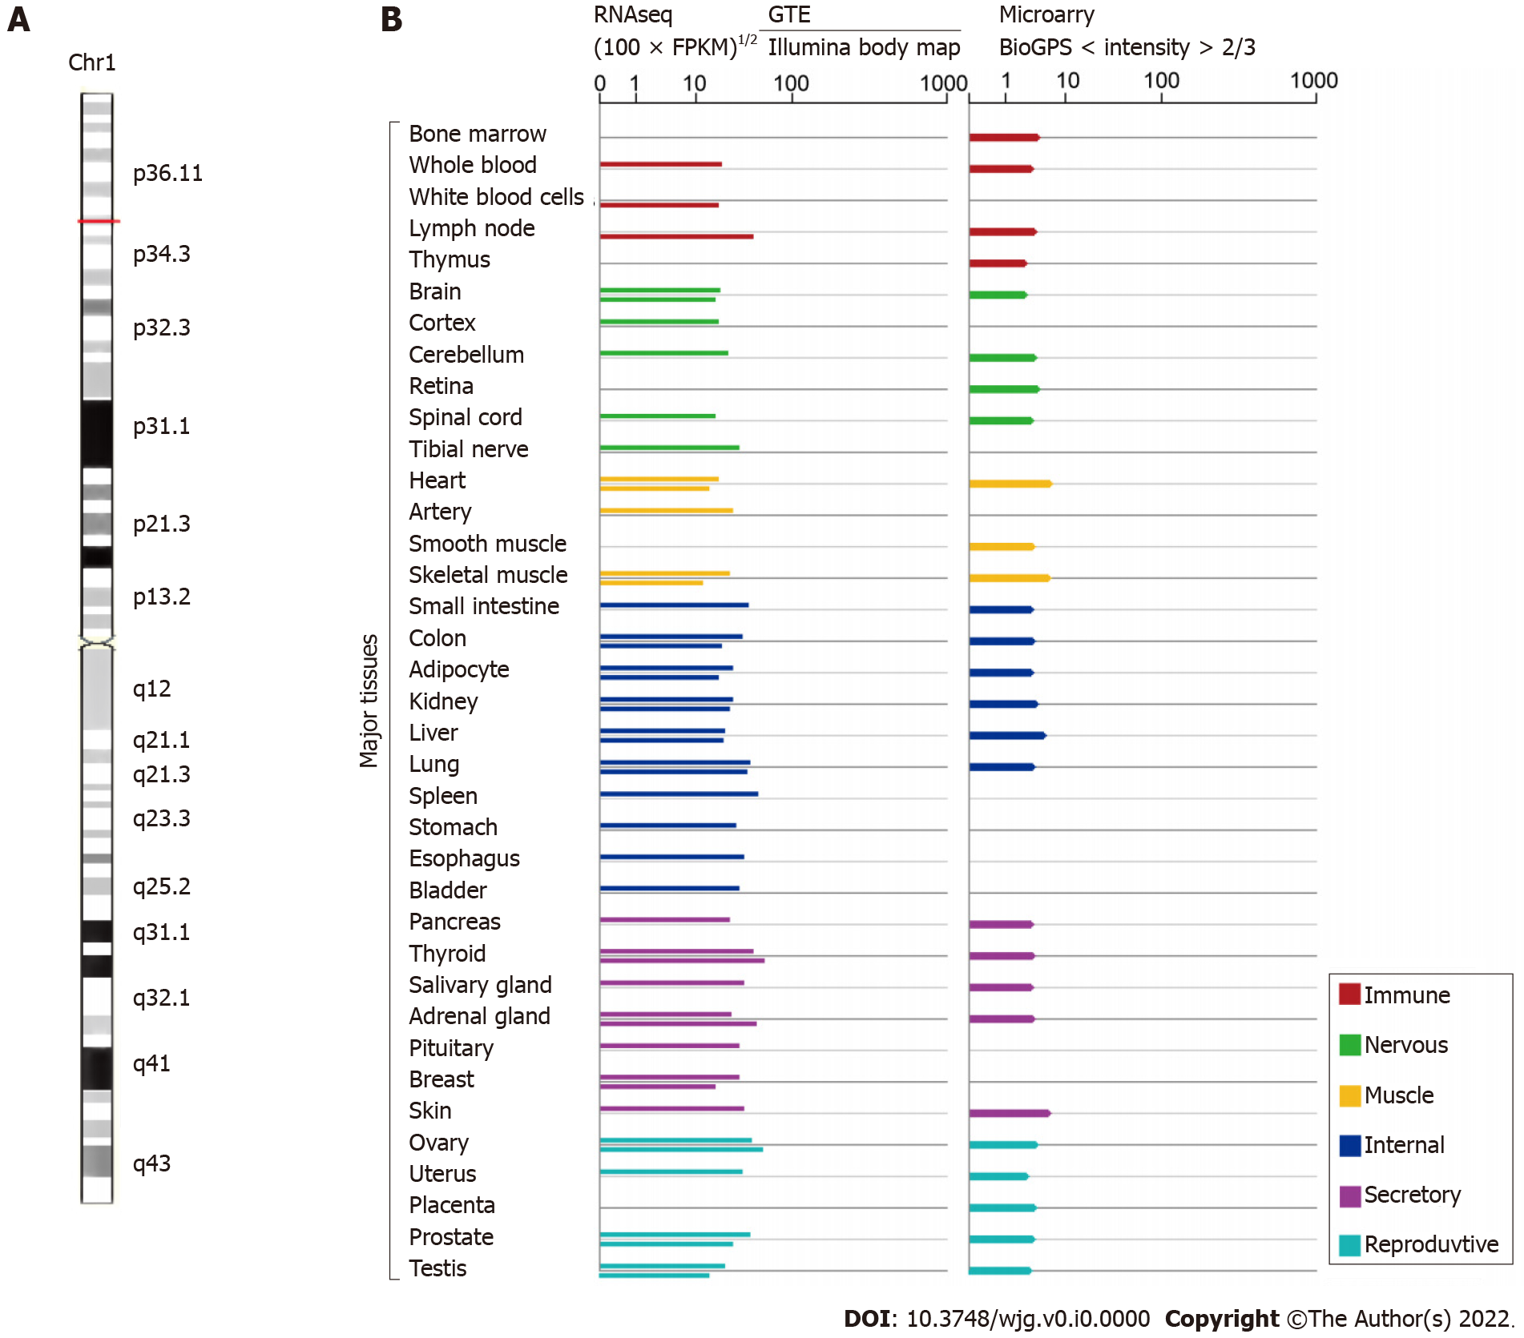
Figure 1 Small nucleolar RNA host gene 3 genomic information (GeneCards, http://www.genecards.org). A: The chromosomal localization of small nucleolar RNA host gene 3 (SNHG3); B: The expression level of SNHG3 in normal human tissues.
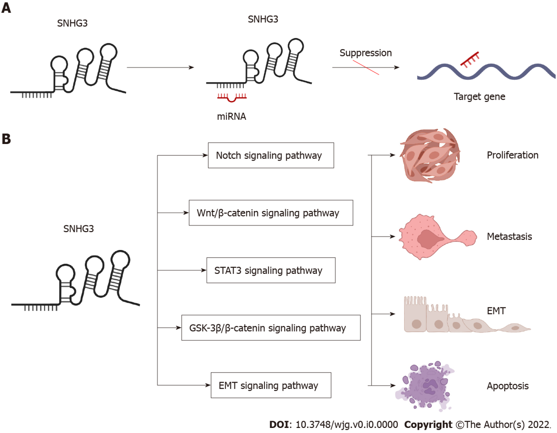
Figure 2 Small nucleolar RNA host gene 3-mediated mechanisms regulating cancer progression. A: Small nucleolar RNA host gene 3 (SNHG3) as a ceRNA; B: SNHG3 is involved in signaling pathways. SNHG3: Small nucleolar RNA host gene 3; EMT: Epithelial–mesenchymal transition.
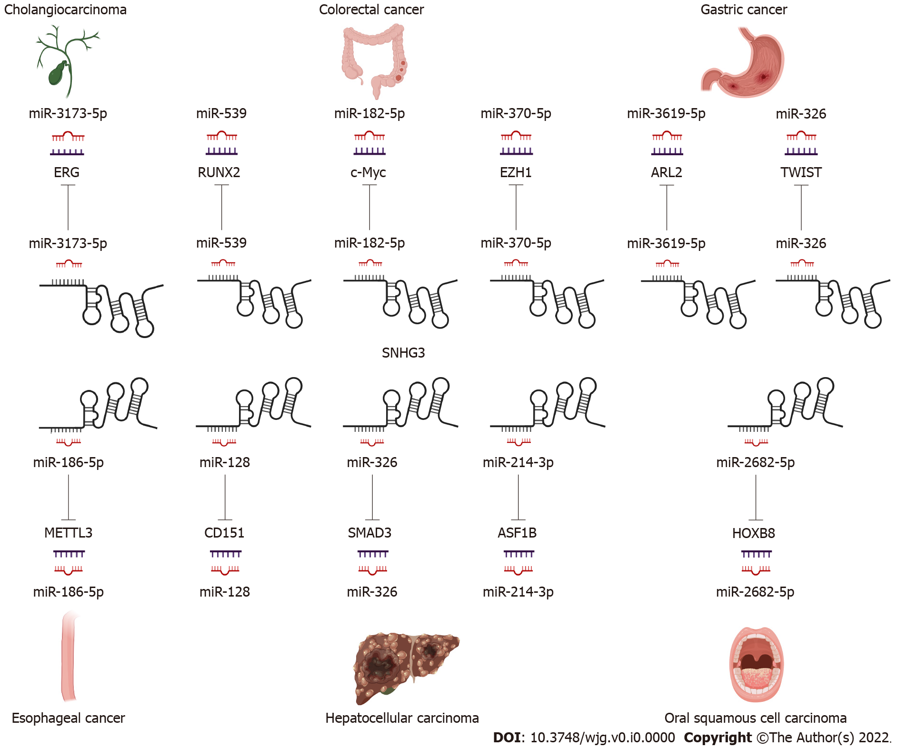
Figure 3 Small nucleolar RNA host gene 3 functions as a competing endogenous RNA in digestive system tumors.
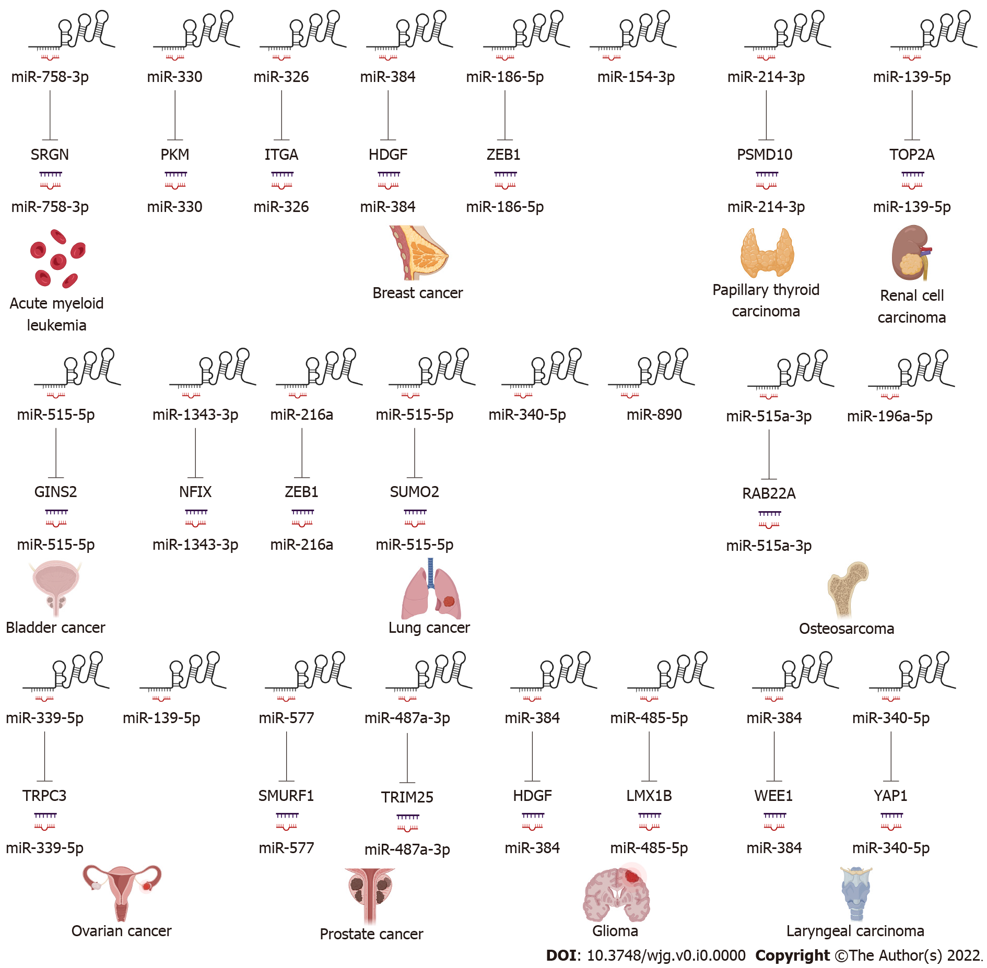
Figure 4 Small nucleolar RNA host gene 3 functions as a competing endogenous RNA in other systemic tumors.

Table 1 The expression of small nucleolar RNA host gene 3 and its clinical significance in liver cancer and other cancers
Cancer types | Cases | Expression | Clinicopathologic parameters | PMID
Hepatocellular carcinoma | 47 pairs | Upregulated | Tumor stage, lymph node metastasis, distant metastasis | 31548493
Hepatocellular carcinoma | 195 pairs | Upregulated | Tumor size, PVTT, relapse | 26373735
Breast cancer | 30 pairs | Upregulated |  | 32495883
Breast cancer | 60 pairs | Upregulated | Histological grade, TNM stage, lymph node metastasis, ER, Her-2 | 31586299
Breast cancer | 60 pairs | Upregulated |  | 32883233
Breast cancer | 48 pairs | Upregulated |  | 32945476
Cervical cancer | 88 pairs | Upregulated | FIGO stage, metastasis | 34816392
Clear cell renal cell carcinoma | 36 pairs | Upregulated | Distant metastasis, T stage, pathological TNM stage, histologic grade | 31505165
Colorectal cancer | 58 pairs | Upregulated | Tumor stage, distant metastasis | 32187965
 | 50 pairs | Upregulated |  | 34661273
Esophageal cancer | 384 pairs | Upregulated |  | 33596916
Gastric cancer | 60 pairs | Upregulated |  | 32930970
Glioma | 42 pairs | Upregulated | Tumor size, WHO grade | 33817254
Glioma | 8 low-grade and 8 high-grade and 8 normal tissues | Upregulated |  | 34153159
Laryngeal carcinoma | 18 pairs | Upregulated |  | 31238052
Laryngeal carcinoma | 25 pairs | Upregulated |  | 32538668
Lung Adenocarcinoma | 65 pairs | Downregulated | TNM stage, lymph node metastasis | 32538668
Non-small-cell lung cancer | 35 pairs | Upregulated | TNM stage, lymph node metastasis, tumor size | 34132359
Non-small-cell lung cancer | 32 pairs | Upregulated | TNM stage, lymph node metastasis, tumor size | 31602642
Non-small-cell lung cancer | 42 pairs | Upregulated | Stage, lymph node metastasis | 33177840
Non-small-cell lung cancer | 15 pairs | Upregulated |  | 34032148
Oral squamous cell carcinoma | 30 pairs | Upregulated |  | 32989886
Osteosarcoma | 54 pairs | Upregulated |  | 30797154
Osteosarcoma | 127 pairs | Upregulated |  | 30791797
Ovarian cancer | 18 pairs | Upregulated |  | 29921511
Ovarian cancer | 96 pairs | Upregulated | FIGO stage, histological grade, lymph node metastasis | 33149611
Ovarian cancer | 76 pairs | Upregulated | FIGO stage, lymph node metastasis | 29758922
Ovarian cancer | 40 patients with OC and 19 patients with benign OC | Upregulated |  | 33552243
Papillary thyroid carcinoma | 72 pairs | Upregulated | TNM stage, lymph node metastasis | 32048306
Prostate cancer | 50 pairs | Upregulated |  | 33416420
PVTT: Portal vein tumor thrombosis; TNM: Tumor-node-metastasis; FIGO: International Federation of Gynecology and Obstetrics; WHO: World Health Organization.
Table 2 Function and mechanism of small nucleolar RNA host gene 3 in liver cancer and other cancers
Cancer types | Assessed cancer cell lines | Expression | Related genes and pathways | Biological significance | PMID
Hepatocellular carcinoma | PLC/PRF/5, Hep3B, HepG2, MHCC97L, Huh7, SMMC-7721, HCCLM3 | Up | miR-128, CD151 | Invasion, EMT, sorafenib resistance | 30132868
Hepatocellular carcinoma | HepG2, HCCLM3 | Up | miR-326, SMAD3, ZEB1 | Proliferation, migration, EMT, anti-apoptosis | 31548493
Hepatocellular carcinoma | HepG2, HuH-7 | Up | miR-214-3p, ASF1B |  | 34336642
Acute myeloid leukemia | HL-60,THP-1,KG-1, NB4, MOLM-14 | Up | miR-758-3p, SRGN | Proliferation, anti-apoptosis | 31452272
Bladder cancer | 5637,T24 | Up | miR-515-5p, GINS2 | Proliferation, migration, invasion, EMT | 32596993
Breast cancer | MCF-7, MD-MBA-453 | Up | miR-330, PKM | Proliferation, mitochondrial metabolism | 31956955
Breast cancer | MDA-MB-231, BT-549, MDA-MB-468 | Up | miR-326, ITGA5 Vav2/Rac1 | Viability, migration, invasion, anti-apoptosis | 32495883
Breast cancer | MDA-MB-231, MCF-7 | Up | miR-384, HDGF | Proliferation, migration, invasion | 31586299
Breast cancer | MCF-7, MDA-MB-231, HCC1937, BT474, SKBr-3 | Up | miR-154-3p, Notch | Proliferation, migration, invasion | 32883233
Breast cancer | MDA-MB-231, MCF-7 | Up | miR-186-5p, ZEB1 | Proliferation, migration, invasion | 33594311
Breast cancer | MCF-7, MDA-MB-231, MDA-MB-468, BT-474 | Up | miR-326 | Proliferation, migration, invasion | 32945476
Cervical cancer | C33A, HeLa, SiHa, CaSki and HCC94 | Up | YAP1 | Proliferation, migration, invasion | 34816392
Cervical cancer | SiHa | Up |  | Proliferation, migration, invasion | 34238747
Cholangiocarcinoma | HCCC9810, QBC939, RBE, HUCCT1 | Up | miR-3173–5p, ERG | Proliferation, migration, invasion | 34647226
Clear cell renal cell carcinoma | ACHN, A498, Caki-1 | Up | miR-139-5p, TOP2A | Proliferation, migration, invasion | 31505165
Colorectal cancer | HCT116, LoVo, SW480, and SW620 | Up | miR-539, RUNX2 | Proliferation, migration, invasion | 32187965
Colorectal cancer | HT29, HCT116, SW480, and LoVo | Up | miR-182-5p, c-Myc | Proliferation, migration, invasion | 28731158
Colorectal cancer | SW480, SW620, HCT8, HT29 | Up | miR-370-5p, EZH1 | Proliferation, migration, invasion | 34661273
Esophageal cancer | KYSE-150, Eca-9706 | Up | miR-186-5p, METTL3, m6A |  | 33596916
Gastric cancer | MGC-803, AGS, BGC-823, SGC-7901, MKN-45, HGC-27 | Up | EZH2, MED18 | Proliferation, migration, invasion | 31534128
Gastric cancer | SGC7901, BGC823 | Up | IL-6, STAT3, SNHG3, miR-3619-5p, ARL2 | Proliferation | 32930970
Gastric cancer | HGC-27, GC9811-P | Up | miR-326, TWIST | Proliferation, migration, invasion | 34257656
Glioma | A172, SHG44 | Up | miR-384, HDGF | Proliferation, migration, invasion, anti-apoptosis | 33817254
Glioma | U-87-MG, U-251-MG | Up | miR-485-5p, LMX1B | Proliferation, migration, invasion | 34153159
Laryngeal carcinoma | 16HBE, TU212, TU686 | Up | miR-384, WEE1 | Proliferation, migration, invasion | 31238052
Laryngeal carcinoma | TU177, AMC-HN-8 | Up | Wnt/β-catenin, miR-340-5p, YAP1 | Proliferation, migration, anti-apoptosis, mitochondrial metabolism | 32538668
Lung adenocarcinoma | A549, H1299 | Up |  | Proliferation, cell cycle,anti-apoptosis | 30154938
Lung adenocarcinoma | A549, H1299, H1975 | Down | miR-890 | Anti-proliferation, anti-migration, anti-invasion, apoptosis | 34306585
Non-small-cell lung cancer | H1299, H358, A549, H1975 | Up | miR-1343-3p, NFIX | Proliferation, migration, invasion | 34132359
Non-small-cell lung cancer | CMT-167, LLC, CMT-170, CMT-181 | Up | TGF-β pathway, IL-6, JAK2, STAT3 pathway | Proliferation, migration, EMT | 31602642
Non-small-cell lung cancer | SPC-A1, A549, NCI-H23, NCI-H460 | Up | miR-340-5p | Lymph node infiltration, distant metastases | 33225676
Non-small-cell lung cancer | A549, H322, H1299, GLC-82, SPC-A1 | Up | miR-216a, ZEB1 | Proliferation, migration, invasion | 33177840
Non-small-cell lung cancer | A549, HCC827, H2170, H520 | Up | miR-515-5p, SUMO2 | Proliferation, migration, invasion, EMT | 34032148
Oral squamous cell carcinoma | SCC4, CAL-27 | Up | miR-2682-5p, HOXB8 | Proliferation, migration | 32989886
Oral squamous cell carcinoma | SCC-15, SCC-9, CAL-27, HN5 | Up | Wnt/β-catenin, NFYC | Proliferation, migration | 31762107
Osteosarcoma | Saos2, MG63, U2OS, HOS | Up | miR-151a-3p, RAB22A | Proliferation, migration, invasion | 30797154
Osteosarcoma | MG-63, 143B, HOS, SW-1353, Saos-2, U-2OS | Up | miR-196a-5p | Proliferation, colony formation | 30791797
Ovarian cancer | SK-OV3, TOV-21G, and OVCAR-3 | Up |  | Energy metabolism | 29921511
Ovarian cancer | SKOV3, HeyA8, A2780 | Up | miR-339-5p, TRPC3 | Proliferation, anti-apoptosis | 33149611
Ovarian cancer | SKOV3, 60OVCAR3, A2780, ES2 | Up | GSK3β/β-catenin | Proliferation, migration | 29758922
Ovarian cancer | A2780, SKOV3, OVCAR3, OV90 | Up | miR-139-5p, Notch1 | Proliferation, migration | 33552243
Papillary thyroid carcinoma | BCPAP, TPC-1 | Up | miR-214-3p, PSMD10 | Migration, invasion, proliferation, and colony formation | 32048306
Prostate cancer | PC3, DU145, 22RV1, NCaP | Up | miR-577, SMURF1 | Proliferation, migration, EMT, anti-apoptosis | 32248648
Prostate cancer | PC3, 22RV1, DU145, LNCaP | Up | miR-487a-3p,TRIM25 | Viability, migration, invasion, EMT | 33416420
EMT: Epithelial–mesenchymal transition.

