Name of journal: World Journal of Gastroenterology
Manuscript NO: 36949
Manuscript Type: Original Article

Retrospective Study
Performance of transient elastography in assessing liver fibrosis in patients with autoimmune hepatitis-primary biliary cirrhosis overlap syndrome

Wu HM et al. Transient elastography and AIH-PBC overlap syndrome

Hui-Min Wu, Li Sheng, Qi Wang, Han Bao, Qi Miao, Xiao Xiao, Can-Jie Guo, Hai Li, Xiong Ma, De-Kai Qiu, Jing Hua

Hui-Min Wu, Li Sheng, Qi Wang, Han Bao, Qi Miao, Xiao Xiao, Can-Jie Guo, Hai Li, Xiong Ma, De-Kai Qiu, Jing Hua, Division of Gastroenterology and Hepatology, Renji Hospital, Shanghai 200127, China

Hui-Min Wu, Li Sheng, Qi Wang, Han Bao, Qi Miao, Xiao Xiao, Can-Jie Guo, Hai Li, Xiong Ma, De-Kai Qiu, Jing Hua, School of Medicine, Shanghai Jiao-Tong University, Shanghai 200127, China

Hui-Min Wu, Li Sheng, Qi Wang, Han Bao, Qi Miao, Xiao Xiao, Can-Jie Guo, Hai Li, Xiong Ma, De-Kai Qiu, Jing Hua, Shanghai Institute of Digestive Disease, Key Laboratory of Gastroenterology and Hepatology, Ministry of Health, Shanghai 200127, China

ORCID number: Hui-Min Wu (0000-0002-3991-3857); Li Sheng (0000-0002-3641-5211); Qi Wang (0000-0002-6937-8306); Han Bao (0000-0003-2934-3990); Qi Miao (0000-0003-3370-9692); Xiao Xiao (0000-0002-7936-336X); Can-Jie Guo (0000-0001-5951-299X); Hai Li (0000-0001-9937-8852); Xiong Ma (0000-0002-7047-1962); De-Kai Qiu (0000-0002-6312-1702); Jing Hua (0000-0002-6100-9477).

Author contributions: Wu HM and Li S contributed equally to this work and collected and analyzed the data; Wang Q coordinated the research; Bao H and Xiao X performed the transient elastography and coordinated liver biopsy; Miao Q contributed to histological examination; Qiu DK, Ma X, Hua J, Li H and Guo CJ analyzed the data; Hua J designed the study; Wu HM, Li S and Hua J wrote the paper.

Supported by the National Natural Science Foundation of China, No. 81470842 and No. 81770572 to Hua J.

Institutional review board statement: The study received waiver of the approval requirement from the ethics committee.

Informed consent statement: All patients signed an informed consent for liver biopsy.

Conflict-of-interest statement: We declare that there is no conflict of interest to disclose.

Data sharing statement: No additional data are available.

Open-Access: This article is an open-access article that was selected by an in-house editor and fully peer-reviewed by external reviewers. It is distributed in accordance with the Creative Commons Attribution Non-Commercial (CC BY-NC 4.0) License, which permits others to distribute, remix, adapt, build upon this work non-commercially, and license their derivative works on different terms, provided the original work is properly cited and the use is non-commercial. See: http://creativecommons.org/licenses/by-nc/4.0/

Manuscript source: Unsolicited manuscript.

Correspondence to: Jing Hua, MD, PhD, Professor, Division of Gastroenterology and Hepatology, Renji Hospital, School of Medicine, Shanghai Jiao-Tong University, Shanghai Institute of Digestive Disease, No. 160 Pu Jian Road, Shanghai 200127, China. hua-jing88@hotmail.com
Telephone: +86-21-68383113
Fax: +86-21-63200874

Received: November 7, 2017
Peer-review started: November 8, 2017
First decision: November 21, 2017
Revised: December 5, 2017
Accepted: January 1, 2018
Article in press:
Published online:

Abstract
AIM
To investigate the performance of transient elastography (TE) for diagnosis of fibrosis in patients with autoimmune hepatitis and primary biliary cirrhosis overlap syndrome.

METHODS
A total of 70 patients with biopsy-proven autoimmune hepatitis-primary biliary cirrhosis (AIH-PBC) overlap syndrome were included. Spearman correlation test was used to analyze the correlation of liver stiffness measurement (LSM) and fibrosis stages. Independent samples Student’s t-test or one-way analysis of variance was used to compare quantitative variables. Receiver-operating characteristics curve was used to calculate the optimal cut-off values of LSM for predicting individual fibrosis stages. A comparison on the diagnostic accuracy for severe fibrosis was made between LSM and other serological scores.

RESULTS
Patients with AIH-PBC overlap syndrome had higher median LSM than healthy controls (11.3 ± 6.4 kPa vs 4.3 ± 1.4 kPa, P < 0.01). LSM was significantly correlated with fibrosis stage (r = 0.756, P < 0.01). LSM values enhanced gradually with an increased fibrosis stage. AUROC values of LSM for stages F ≥ 2, F ≥ 3 and F4 were 0.837 (95%CI: 0.729-0.914), 0.910 (0.817-0.965) and 0.966 (0.893-0.995), respectively. The optimal cut-off values of LSM for fibrosis stages F ≥ 2, F ≥ 3 and F4 were 6.55, 10.50 and 14.45 kPa, respectively. LSM was significantly superior to fibrosis-4, glutaglumyl-transferase/platelet ratio and aspartate aminotransferase-to-platelet ratio index score in detecting severe fibrosis (F ≥ 3) (0.910 vs 0.715, P < 0.01; 0.910 vs 0.649, P < 0.01; 0.910 vs 0.616, P < 0.01, respectively).

CONCLUSION
TE can accurately detect hepatic fibrosis as a non-invasive method in patients with AIH-PBC overlap syndrome.

Key words: Liver stiffness measurement; Transient elastography; Liver fibrosis; Autoimmune hepatitis; Primary biliary cirrhosis; Overlap syndrome

© The Author(s) 2018. Published by Baishideng Publishing Group Inc. All rights reserved.

Core tip: Our research determined that transient elastography can accurately detect hepatic fibrosis as a non-invasive method in patients with autoimmune hepatitis-primary biliary cirrhosis overlap syndrome. Liver stiffness measurements were significantly superior to fibrosis-4, glutaglumyl-transferase/platelet ratio and aspartate aminotransferase-to-platelet ratio index scores for detecting severe fibrosis.

Wu HM, Sheng L, Wang Q, Bao H, Miao Q, Xiao X, Guo CJ, Li H, Ma X, Qiu DK, Hua J. Performance of transient elastography in assessing liver fibrosis in patients with autoimmune hepatitis-primary biliary cirrhosis overlap syndrome. World J Gastroenterol 2018; In press

INTRODUCTION
Liver fibrosis, characterized by the accumulation of the extracellular matrix, has been considered a common progressive stage and predictor of undesirable prognosis in various chronic liver diseases^{[1]}. The evaluation of fibrosis is crucial in the assessment of chronic liver disease. Liver biopsy remains the gold standard for evaluating fibrosis but has some drawbacks, which has led to the development of non-invasive methods.
Transient elastography (TE) by FibroScan based on ultrasound can noninvasively evaluate the liver fibrosis via liver stiffness measurement (LSM)^{[2]}. It has been introduced as a non-invasive surrogate to liver biopsy for detection of hepatic fibrosis in patients with various chronic liver diseases^{[3-6]}. Numerous studies have shown that LSM values have a good correlation with histological fibrosis stages. Furthermore, compared to other serum biomarkers, such as aspartate aminotransferase-to-platelet ratio index (APRI) and the fibrosis-4 (FIB-4) scores, LSM is probably the most validated non-invasive method to assess the stage of fibrosis with better diagnostic accuracy^{[3,7,8]}.
Autoimmune hepatitis (AIH) and primary biliary cirrhosis (PBC) are two immune-mediated chronic liver diseases targeting hepatocytes and biliary epithelial cells, respectively^{[9]}. The overlap syndrome of AIH-PBC shares clinical, biochemical, serological and histological features of patients with AIH and PBC^{[10]}. AIH is usually a chronic and long-term spectrum disease, and approximately 25% of patients with AIH progress to hepatic fibrosis or cirrhosis despite immunosuppression intervention^{[11]}. Recently, studies reported that patients with AIH-PBC overlap syndrome exhibited a lower response rate to ursodeoxycholic acid and steroid combination therapy while having a more severe clinical prognosis compared with AIH patients^{[12]}. Therefore, accurately assessing hepatic fibrosis and initiating anti-fibrotic intervention are essential for some AIH-PBC overlap syndrome patients with rapid disease progression. Our recent study revealed that TE can reliably stage liver fibrosis in AIH patients^{[13]}. However, the evaluation of TE in assessing liver fibrosis in patients with AIH-PBC overlap syndrome still remains limited.
In the current study, we assessed the diagnostic performance of TE in evaluating liver fibrosis in biopsy-proven AIH-PBC overlap syndrome patients and made a comparison with other non-invasive methods.

MATERIALS AND METHODS
Patients
Patients who were suspected to have AIH-PBC overlap syndrome and eventually underwent liver biopsy at Renji Hospital (Shanghai, China) from September 2014 to July 2017 were recruited in this retrospective study. Ultimately, a total of 70 patients met the Paris AIH-PBC overlap syndrome criteria^{[10]}. Briefly, the requirement of at least two out of three specific criteria in each condition was met. The PBC criteria included: (1) ALP levels at least twice the ULN or gamma glutamyltransferase (GGT) levels at least five times the ULN, (2) AMA positive, and (3) florid bile duct lesion in liver biopsy. The AIH criteria comprised of: (1) alanine aminotransferase (ALT) levels at least five times the ULN, (2) IgG levels at least twice the ULN or positive anti-SMA, and (3) moderate to severe periportal or periseptal lymphocytic piecemeal necrosis in histological examination. All patients received no immunosuppressive therapy before liver biopsy.
The exclusion criteria included chronic infection of hepatic virus B or C, primary sclerosing cholangitis, primary biliary cirrhosis, autoimmune hepatitis, drug-induced liver disease, alcoholic or non-alcoholic fatty liver disease, hereditary metabolic liver disease, hepatobiliary parasitic infection, and severe systemic disease. Patients with acute severe attack with markedly elevated serum aminotransferase levels (ALT > 1000 U/L) and severe jaundice were excluded. Decompensated cirrhosis with ascites, hepatic encephalopathy, gastrointestinal bleeding, and hepatic carcinoma were excluded. Each participant of this study has read the written informed consent.

Histological examination
Percutaneous liver biopsy guided by ultrasound was performed in all patients under local anesthesia using a 16G disposable needle. Liver specimens at least 1 cm in length and with eight complete portal tracts were included. The specimens were fixed in 10% neutral formalin immediately, and after several hours were embedded in paraffin. Hematoxylin and eosin staining was used to observe the morphology of the liver, and Masson’s trichrome and reticulin staining was performed to detect fibrosis. Liver fibrosis and necroinflammatory activity were evaluated by a single experienced pathologist who was blinded to patients’ clinical data. A METAVIR-derived scoring system was used for evaluating liver fibrosis and inflammation by a single senior pathologist^{[14]}. In brief, the fibrosis staging description was F0, no fibrosis; F1, portal fibrosis without septa; F2, portal and periportal fibrosis with few septa; F3, portal and periportal fibrosis with numerous septa without cirrhosis; F4, cirrhosis. Hepatic inflammatory activity was graded as follows: A0, none; A1, mild; A2, moderate; A3, severe.

Clinical measurements
Medical records of all patients diagnosed with AIH-PBC overlap syndrome were reviewed, and clinical data and laboratory findings were collected and analyzed. Laboratory evaluation included liver biochemistries [i.e., alanine aminotransferase, aspartate aminotransferase (AST), alkaline phosphatase, GGT, total bilirubin, direct bilirubin, globulin, and albumin], serum immunoglobulin complements (IgG, IgM, and IgA), blood routine (white blood cell count and platelet count), and prothrombin time. APRI score was calculated by using the formula of Wai et al^{[15]} (AST/upper limit of normal considered as 40 IU/L)/platelet count × 10⁹/L. FIB-4 score was calculated by using the formula of Sterling et al^{[16]} (age × AST)/[(platelet count × ALT^{1/2})]. Gamma glutaglumyl-transferase/platelet ratio (GPR) was calculated by using the formula of Lemoine et al^{[17]}. GGT/platelet count × 10⁹/L. The serum autoantibodies, including anti-nuclear antibody (ANA), anti-mitochondrial antibody (AMA), and anti-smooth muscle antibody (ASMA) were detected by indirect immunofluorescence (Euroimmun AG, Hangzhou, China).

Liver stiffness measurement by transient elastography
TE with FibroScan and M probe ultrasound transducer (both from Echosens, Paris, France) was performed in all patients who underwent liver biopsy on the same day. According to the ultrasonography images, we selected an appropriate area for detection that contained at least 6-cm-thick liver parenchyma with absence of main blood vessels and gallbladder. We obtained 10 valid LSMs from each participant and considered LSM with an interquartile range ≤ 30% and a success rate ≥ 60% as reliable. The median value represented the value of LSM expressed in kilopascals (kPa). All the performances followed the manufacturer’s instructions. LSM assessment of 25 healthy people served as normal controls.

Statistical analysis
Data were analyzed by using SPSS software version 22.0 (SPSS Inc, Chicago, IL, United States). Normally distributed continuous variables were expressed as the mean ± SD. Quantitative variables were compared using independent samples Student’s t-test or one-way analysis of variance when appropriate. The Spearman’s rank correlation test was used to explore the correlation between the LSM and fibrosis grades. The diagnostic accuracy of LSM for the prediction of fibrosis stages was calculated using a receiver operator characteristic (ROC) curve. Optimal LSM cut-off values for F2-4 fibrosis were determined based on the highest combined sensitivity and specificity (Youden index). The performance characteristics of each cut-off value in terms of sensitivity and specificity were calculated. The area under ROC curves (AUROC) were performed to compare the diagnostic efficiency of each noninvasive predictor for severe fibrosis. A P-value < 0.05 was considered statistically significant.

RESULTS
Characteristics of the patients
A total of 70 biopsy-proven AIH-PBC overlap syndrome patients were included, with a mean age of 46.6 ± 10.2, and 84.3% of patients were female. In all patients, the prevalence of autoantibodies, including ANA, AMA, and ASMA, was 94.3%. AIH-PBC overlap syndrome was diagnosed based on the Paris criteria. The general characteristics of the patients are shown in Table 1.

Relationship between liver stiffness measurement and histological fibrosis stages
LSM was successfully performed in all patients. The mean LSM value of all AIH-PBC overlap syndrome patients was clearly higher than that of healthy normal controls (11.3 ± 6.4 kPa vs 4.3 ± 1.4 kPa, P < 0.01). LSM values for fibrosis stages F1, F2, F3 and F4 were 6.9 ± 3.4 kPa, 8.3 ± 2.0 kPa, 13.3 ± 5.5 kPa and 22.8 ± 8.3 kPa, respectively. LSM was closely correlated with fibrosis stages (r = 0.756, P < 0.01). Patients with higher fibrosis stages usually had higher LSM values (Figure 1).

Diagnostic accuracy of liver stiffness measurement
The AUROC values of LSM in detecting significant fibrosis F ≥ 2, severe fibrosis F ≥ 3 and cirrhosis F4 were 0.837, 0.910 and 0.966, respectively (Figure 2). The optimal cut-off values of LSM for fibrosis stages were 6.55 pKa for F ≥ 2, 10.50 kPa for F ≥ 3, and 14.45 pKa for F4 with the highest combined sensitivity and specificity (Table 2).

Comparison of the diagnostic accuracy of liver stiffness measurement for severe fibrosis with other serological scores
The biochemical scores FIB-4, GPR and APRI were calculated for all patients based on their laboratory parameters. AUROCs of FIB-4, APRI and GPR for detecting severe fibrosis (F ≥ 3) were 0.715 (95%CI: 0.594-0.816), 0.649 (0.525-0.759) and 0.616 (0.0.492-0.730), respectively. LSM was superior to FIB-4, GPR and APRI in detecting severe fibrosis (F ≥ 3) by AUROCs values (0.910 vs 0.715, P < 0.01; 0.910 vs 0.649, P < 0.01; 0.910 vs 0.616, P < 0.01, respectively) (Figure 3).

DISCUSSION
Timely and accurate assessment of the degree of liver fibrosis is crucial to the evaluation of disease progression and decision of therapeutic schedule in various chronic liver diseases^{[18]}. LSM assessed by TE was introduced and widely used as an effective and promising non-invasive tool for assessment of liver fibrosis in patients with chronic hepatitis B and C, as well as non-alcoholic fatty liver diseases^{[19-21]}. In the current study, we found that LSM had a strong correlation with histological fibrosis stage in patients with AIH-PBC overlap syndrome, while it was significantly superior to FIB-4, GPR and APRI scores in detecting severe fibrosis.
Our study illustrated favorable diagnostic performance of LSM for assessing different fibrosis stages in AIH-PBC overlap syndrome. The AUROCs of LSM in detecting significant fibrosis (F ≥ 2), severe fibrosis (F ≥ 3) and cirrhosis (F4) were 0.837, 0.910 and 0.966, respectively. The cut-off values for predicting F ≥ 2, F ≥ 3 and F4 were 6.55, 10.50 and 14.45 kPa, respectively. Compared with the cut-off values reported in our recent study in patients with AIH alone, in which the optimal LSM cut-off values for predicting significant fibrosis, severe fibrosis and cirrhosis were 6.45, 8.75 and 12.5 kPa^{[13]}, respectively, the LSM cut-off values in AIH-PBC overlap syndrome were slightly higher than those in AIH, especially in severe fibrosis and cirrhosis. Another study reported that the optimal LSM cut-off values for significant fibrosis, severe fibrosis and cirrhosis were 7.3 kPa, 9.8 kPa and 17.3 kPa, respectively, in PBC and PSC patients^{[22]}. It seemed that the patients with AIH-PBC overlap syndrome or PBC had relatively higher LSM values than AIH patients. The major reason was probably that AIH-PBC overlap syndrome patients had a poor treatment response and rapid disease progression. However, in a meta-analysis comprised of 22 studies and 4430 patients with different etiologies of liver disease, the estimated LSM cut-off values were 7.71 kPa for F ≥ 2 and 15.08 kPa for F = 4^{[23]}. Our findings were similar with these results, indicating that etiologies of liver disease had no significant effect on LSM assessment.
LSM by TE had a favorable diagnostic performance in evaluating liver fibrosis as a non-invasive method. Compared with APRI and FIB-4, which are widely used as non-invasive serologic methods, LSM showed better accuracy in detecting liver fibrosis^{[6,24]}. In the current study, we also found that LSM was significantly superior to FIB-4 and APRI in detecting severe fibrosis in AIH-PBC overlap syndrome patients, which was consistent with our previous result. More recently, GPR (gamma glutamyl-transferase/platelet ratio) had exhibited a better accuracy than APRI and FIB-4 in detecting liver fibrosis in CHB patients^{[17]}. Here, we found that GPR had a similar diagnostic performance for detecting severe fibrosis with APRI and FIB-4 scores but was inferior to LSM.
The major limitation of our study was the small patient sample size due to the low prevalence of AIH-PBC overlap syndrome. Larger studies are needed to confirm these results.
In conclusion, LSM by TE was an accurate and reliable non-invasive method in evaluating liver fibrosis in AIH-PBC overlap syndrome. LSM is significantly superior to APRI, GPR and FIB-4 scores for detecting severe fibrosis.

ARTICLE HIGHLIGHTS
Research background
Transient elastography (TE) can reliably stage liver fibrosis via liver stiffness measurement (LSM) in chronic liver disease. However, the accuracy of TE for assessment of liver fibrosis in patients with autoimmune hepatitis-primary biliary cirrhosis (AIH-PBC) overlap syndrome is still limited.

Research motivation
It is important to identify non-invasive markers of liver fibrosis to predict disease progression.

Research objectives
We evaluated the performance and usefulness of TE for detection of fibrosis in these patients and compared TE with other non-invasive diagnostic tools.

Research methods
The diagnostic accuracy of LSM for the prediction of fibrosis stages was calculated using a receiver operator characteristic (ROC) curve. Optimal LSM cut-off values for F2-4 fibrosis were determined based on the highest combined sensitivity and specificity.

Research results
TE can accurately detect hepatic fibrosis as a non-invasive method in patients with AIH-PBC overlap syndrome.

Research conclusions
For the first time, the current study evaluated TE as a non-invasive assessment of liver fibrosis in patients with AIH-PBC overlap syndrome and demonstrated it was a reliable tool to detect liver fibrosis that is superior to serum biomarker scores for predicting severe fibrosis.

Research perspectives
The impact of hepatic inflammation on LSM values was not analyzed due to the relatively small number of patients in each subgroup. Larger studies are needed to confirm these results.

REFERENCES
1 Lee YA, Wallace MC, Friedman SL. Pathobiology of liver fibrosis: a translational success story. Gut 2015; 64: 830-841 [PMID: 25681399 DOI: 10.1136/gutjnl-2014-306842]
2 Alvarez F, Berg PA, Bianchi FB, Bianchi L, Burroughs AK, Cancado EL, Chapman RW, Cooksley WG, Czaja AJ, Desmet VJ, Donaldson PT, Eddleston AL, Fainboim L, Heathcote J, Homberg JC, Hoofnagle JH, Kakumu S, Krawitt EL, Mackay IR, MacSween RN, Maddrey WC, Manns MP, McFarlane IG, Meyer zum Büschenfelde KH, Zeniya M. International Autoimmune Hepatitis Group Report: review of criteria for diagnosis of autoimmune hepatitis. J Hepatol 1999; 31: 929-938 [PMID: 10580593 DOI: 10.1016/S0168-8278(99)80297-9]
3 Vierling JM. Autoimmune Hepatitis and Overlap Syndromes: Diagnosis and Management. Clin Gastroenterol Hepatol 2015; 13: 2088-2108 [PMID: 26284592 DOI: 10.1016/j.cgh.2015.08.012]
4 Manns MP, Lohse AW, Vergani D. Autoimmune hepatitis--Update 2015. J Hepatol 2015; 62: S100-S111 [PMID: 25920079 DOI: 10.1016/j.jhep.2015.03.005]
5 European Association for the Study of the Liver. European Association for the Study of the Liver. EASL Clinical Practice Guidelines: The diagnosis and management of patients with primary biliary cholangitis. J Hepatol 2017; 67: 145-172 [PMID: 28427765 DOI: 10.1016/j.jhep.2017.03.022]
6 Castéra L, Vergniol J, Foucher J, Le Bail B, Chanteloup E, Haaser M, Darriet M, Couzigou P, De Lédinghen V. Prospective comparison of transient elastography, Fibrotest, APRI, and liver biopsy for the assessment of fibrosis in chronic hepatitis C. Gastroenterology 2005; 128: 343-350 [PMID: 15685546 DOI: 10.1053/j.gastro.2004.11.018]
7 Rockey DC, Caldwell SH, Goodman ZD, Nelson RC, Smith AD; American Association for the Study of Liver Diseases. Liver biopsy. Hepatology 2009; 49: 1017-1044 [PMID: 19243014 DOI: 10.1002/hep.22742]
8 Sandrin L, Fourquet B, Hasquenoph JM, Yon S, Fournier C, Mal F, Christidis C, Ziol M, Poulet B, Kazemi F, Beaugrand M, Palau R. Transient elastography: a new noninvasive method for assessment of hepatic fibrosis. Ultrasound Med Biol 2003; 29: 1705-1713 [PMID: 14698338 DOI: 10.1016/j.ultrasmedbio.2003.07.001]
9 Wang Q, Selmi C, Zhou X, Qiu D, Li Z, Miao Q, Chen X, Wang J, Krawitt EL, Gershwin ME, Han Y, Ma X. Epigenetic considerations and the clinical reevaluation of the overlap syndrome between primary biliary cirrhosis and autoimmune hepatitis. J Autoimmun 2013; 41: 140-145 [PMID: 23187010 DOI: 10.1016/j.jaut.2012.10.004]
10 Chazouillères O, Wendum D, Serfaty L, Montembault S, Rosmorduc O, Poupon R. Primary biliary cirrhosis-autoimmune hepatitis overlap syndrome: clinical features and response to therapy. Hepatology 1998; 28: 296-301 [PMID: 9695990 DOI: 10.1002/hep.510280203]
11 Montano-Loza AJ, Thandassery RB, Czaja AJ. Targeting Hepatic Fibrosis in Autoimmune Hepatitis. Dig Dis Sci 2016; 61: 3118-3139 [PMID: 27435327 DOI: 10.1007/s10620-016-4254-7]
12 Park Y, Cho Y, Cho EJ, Kim YJ. Retrospective analysis of autoimmune hepatitis-primary biliary cirrhosis overlap syndrome in Korea: characteristics, treatments, and outcomes. Clin Mol Hepatol 2015; 21: 150-157 [PMID: 26157752 DOI: 10.3350/cmh.2015.21.2.150]
13 Xu Q, Sheng L, Bao H, Chen X, Guo C, Li H, Ma X, Qiu D, Hua J. Evaluation of transient elastography in assessing liver fibrosis in patients with autoimmune hepatitis. J Gastroenterol Hepatol 2017; 32: 639-644 [PMID: 27505153 DOI: 10.1111/jgh.13508]
14 Bedossa P, Poynard T. An algorithm for the grading of activity in chronic hepatitis C. The METAVIR Cooperative Study Group. Hepatology 1996; 24: 289-293 [PMID: 8690394 DOI: 10.1002/hep.510240201]
15 Wai CT, Greenson JK, Fontana RJ, Kalbfleisch JD, Marrero JA, Conjeevaram HS, Lok AS. A simple noninvasive index can predict both significant fibrosis and cirrhosis in patients with chronic hepatitis C. Hepatology 2003; 38: 518-526 [PMID: 12883497 DOI: 10.1053/jhep.2003.50346]
16 Sterling RK, Lissen E, Clumeck N, Sola R, Correa MC, Montaner J, S Sulkowski M, Torriani FJ, Dieterich DT, Thomas DL, Messinger D, Nelson M; APRICOT Clinical Investigators. Development of a simple noninvasive index to predict significant fibrosis in patients with HIV/HCV coinfection. Hepatology 2006; 43: 1317-1325 [PMID: 16729309 DOI: 10.1002/hep.21178]
17 Lemoine M, Shimakawa Y, Nayagam S, Khalil M, Suso P, Lloyd J, Goldin R, Njai HF, Ndow G, Taal M, Cooke G, D'Alessandro U, Vray M, Mbaye PS, Njie R, Mallet V, Thursz M. The gamma-glutamyl transpeptidase to platelet ratio (GPR) predicts significant liver fibrosis and cirrhosis in patients with chronic HBV infection in West Africa. Gut 2016; 65: 1369-1376 [PMID: 26109530 DOI: 10.1136/gutjnl-2015-309260]
18 Trautwein C, Friedman SL, Schuppan D, Pinzani M. Hepatic fibrosis: Concept to treatment. J Hepatol 2015; 62: S15-S24 [PMID: 25920084 DOI: 10.1016/j.jhep.2015.02.039]
19 Jia J, Hou J, Ding H, Chen G, Xie Q, Wang Y, Zeng M, Zhao J, Wang T, Hu X, Schuppan D. Transient elastography compared to serum markers to predict liver fibrosis in a cohort of Chinese patients with chronic hepatitis B. J Gastroenterol Hepatol 2015; 30: 756-762 [PMID: 25353058 DOI: 10.1111/jgh.12840]
20 Ziol M, Handra-Luca A, Kettaneh A, Christidis C, Mal F, Kazemi F, de Lédinghen V, Marcellin P, Dhumeaux D, Trinchet JC, Beaugrand M. Noninvasive assessment of liver fibrosis by measurement of stiffness in patients with chronic hepatitis C. Hepatology 2005; 41: 48-54 [PMID: 15690481 DOI: 10.1002/hep.20506]
21 Yoneda M, Yoneda M, Fujita K, Inamori M, Tamano M, Hiriishi H, Nakajima A. Transient elastography in patients with non-alcoholic fatty liver disease (NAFLD). Gut 2007; 56: 1330-1331 [PMID: 17470477 DOI: 10.1136/gut.2007.126417]
22 Corpechot C, El Naggar A, Poujol-Robert A, Ziol M, Wendum D, Chazouillères O, de Lédinghen V, Dhumeaux D, Marcellin P, Beaugrand M, Poupon R. Assessment of biliary fibrosis by transient elastography in patients with PBC and PSC. Hepatology 2006; 43: 1118-1124 [PMID: 16628644 DOI: 10.1002/hep.21151]
23 Stebbing J, Farouk L, Panos G, Anderson M, Jiao LR, Mandalia S, Bower M, Gazzard B, Nelson M. A meta-analysis of transient elastography for the detection of hepatic fibrosis. J Clin Gastroenterol 2010; 44: 214-219 [PMID: 19745758 DOI: 10.1097/MCG.0b013e3181b4af1f]
24 E Anastasiou O, Büchter M, A Baba H, Korth J, Canbay A, Gerken G, Kahraman A. Performance and Utility of Transient Elastography and Non-Invasive Markers of Liver Fiibrosis in Patients with Autoimmune Hepatitis: A Single Centre Experience. Hepat Mon 2016; 16: e40737 [PMID: 28070199 DOI: 10.5812/hepatmon.40737]
P-Reviewer: Saez-Royuela F S-Editor: Gong ZM
L-Editor: E-Editor:
Specialty type: Gastroenterology and Hepatology
Country of origin: China
Peer-review report classification
Grade A (Excellent): 0
Grade B (Very good): 0
Grade C (Good): C
Grade D (Fair): 0
Grade E (Poor): 0

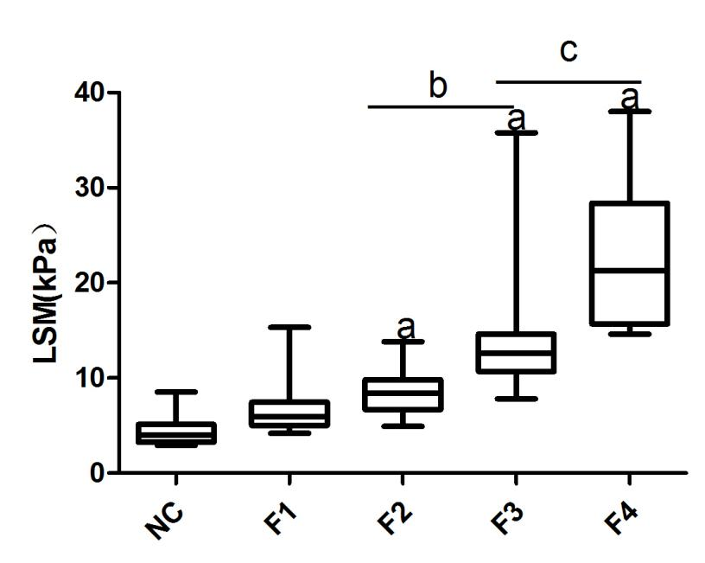
Figure 1 Correlation between liver stiffness measurement and histological fibrosis stage. LSM values assessed by TE in healthy normal controls and AIH-PBC overlap syndrome patients with different liver fibrosis stages based on the results of liver biopsy (F0-4). ªP < 0.01, F2, 3, 4 vs NC; ^{b}P < 0.01, F3 vs F2; ^{c}P < 0.01, F4 vs F3. LSM: Liver stiffness measurement; NC: Normal controls; AIH-PBC: Autoimmune hepatitis-primary biliary cirrhosis; TE: Transient elastography.

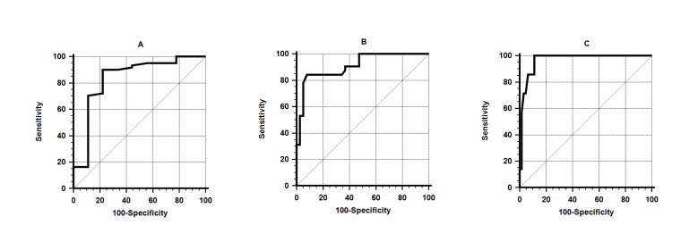
Figure 2 Area under receiver operator characteristic curve of liver stiffness measurement for the diagnosis of liver fibrosis stages. A: Significant fibrosis (F ≥ 2); B: Severe fibrosis (F ≥ 3); C: Cirrhosis (F4).

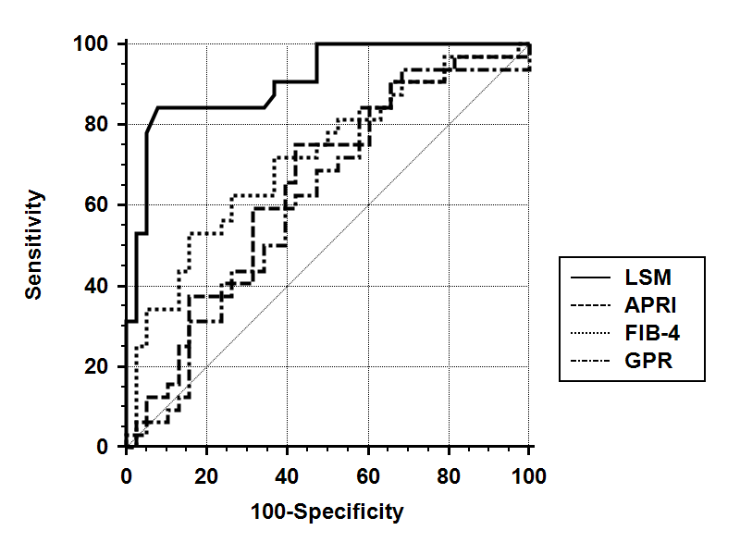
Figure 3 Area under receiver operator characteristic curve of liver stiffness measurement, fibrosis-4, aspartate aminotransferase-to-platelet ratio index and GRP for the detection of severe fibrosis (F ≥ 3).

Table 1 Baseline characteristics of the patients with autoimmune hepatitis- primary biliary cirrhosis overlap syndrome n (%)
Characteristic | n = 70
Age  Gender  Male  Female  Autoantibodies positive rate  Liver function tests (mean ± SD)  ALT(U/L)  AST(U/L)  GGT(U/L)  AKP(U/L)  Total bilirubin (μmol/L)  Albumin (g/L)  Serum IgG level (g/L)  Serum IgM level (g/L)  Biochemical scores (mean ± SD)  APRI  FIB-4  GPR  Liver biopsy  Fibrosis stage  0  1  2  3  4  Hepatic inflammatory activity  0  1  2  3  LSM value (kPa, maean ± SD) | 46.6 ± 10.2  11 (15.7)  59 (84.3)  94.3  185.6 ± 238.9  166.6 ± 190.7  363.2 ± 393.3  318.7 ± 245.9  32.3 ± 33.9  40.1 ± 8.0  17.0 ± 5.1  4.2 ± 6.9  2.47 ± 3.85  3.22 ± 3.53  1.93 ± 2.28  0 (0)  9 (12.9)  29 (41.4)  25 (35.7)  7 (10.0)  0 (0)  1 (1.4)  30 (42.3)  39 (55.7)  11.3 ± 6.4
AST: Aspartate aminotransferase; AKP: Alkaline phosphatase; APRI: Aspartate aminotransferase-to-platelet ratio index; FIB-4: fibrosis-4; GGT: Gamma glutamyltransferase; GPR: Glutaglumyl-transferase/platelet ratio; LSM: Liver stiffness measurement.

Table 2 Diagnostic accuracy of liver stiffness measurement in detecting liver fibrosis in patients with autoimmune hepatitis-primary biliary cirrhosis overlap syndrome
stage | AUROC (95%CI) | Cut-off (kPa) | Sensitivity | Specificity | PPV | NPV | +LR | -LR
F ≥ 2 | 0.837 (0.729-0.914) | 6.55 | 0.902 | 0.778 | 0.965 | 0.538 | 4.06 | 0.13
F ≥ 3 | 0.910 (0.817-0.965) | 10.50 | 0.844 | 0.921 | 0.900 | 0.875 | 10.69 | 0.17
F = 4 | 0.966 (0.893-0.995) | 14.45 | 1.000 | 0.889 | 0.500 | 1.000 | 9.00 | 0.00
ROC: Receiver operator characteristic.

