Name of Journal: World Journal of Clinical Cases
Manuscript NO: 77959
Manuscript Type: CASE REPORT

Recovery of brachial plexus injury after bronchopleural fistula closure surgery based on electrodiagnostic study: A case report and review of literature

Go YI et al. Brachial plexus injury after surgery

Young-In Go, Da-Sol Kim, Gi-Wook Kim, Yu Hui Won, Sung-Hee Park, Myoung-Hwan Ko, Jeong-Hwan Seo

Young-In Go, Da-Sol Kim, Gi-Wook Kim, Yu Hui Won, Sung-Hee Park, Myoung-Hwan Ko, Jeong-Hwan Seo, Department of Physical Medicine & Rehabilitation, Jeonbuk National University Medical School, Jeonju 54907, South Korea

Gi-Wook Kim, Yu Hui Won, Sung-Hee Park, Myoung-Hwan Ko, Jeong-Hwan Seo, Research Institute of Clinical Medicine of Jeonbuk National University, Biomedical Research Institute of Jeonbuk National University Hospital, Jeonju 54907, South Korea

Author contributions: Go YI performed the electrodiagnostic study and contributed to the manuscript drafting; Kim GW, Won YH, and Park SH contributed to the data analysis; Go YI, Ko MH, Seo JH, and Kim DS contributed to the final diagnoses; Kim DS was responsible for the manuscript revision and intellectual content; all authors issued final approval for the version to be submitted.

Corresponding author: Da-Sol Kim, MD, Clinical Assistant Professor, Research Assistant Professor, Department of Physical Medicine & Rehabilitation, Jeonbuk National University Medical School, No. 20 Geonji-ro, Deokjin-gu, Jeonju-si, Jeollabuk-do, Jeonju 54907, South Korea. dsolkim@jbnu.ac.kr

Received: May 30, 2022
Revised: August 5, 2022
Accepted: September 22, 2022
Published online: October 26, 2022

Abstract
BACKGROUND
Axillary thoracotomy and muscle flap are muscle- and nerve-sparing methods among the surgical approaches to bronchopleural fistula (BPF). However, in patients who are vulnerable to a nerve compression injury, nerve injury may occur. In this report, we present a unique case in which the brachial plexus (division level), suprascapular, and long thoracic nerve injury occurred after BPF closure surgery in a patient with ankylosing spondylitis and concomitant multiple joint contractures.

CASE SUMMARY
A 52-year-old man with a history of ankylosing spondylitis with shoulder joint contractures presented with right arm weakness and sensory impairment immediately after axillary thoracotomy and latissimus dorsi muscle flap surgery for BPF closure. During the surgery, the patient was positioned in a lateral decubitus position with the right arm hyper-abducted for approximately 6 h. Magnetic resonance imaging and ultrasound revealed subclavius muscle injury or myositis with brachial plexus (BP) compression and related neuropathy. An electrodiagnostic study confirmed the presence of BP injury involving the whole-division level, long thoracic, and suprascapular nerve injuries. He was treated with medication, physical therapy, and ultrasound-guided injections. Ultrasound-guided steroid injection at the BP, hydrodissection with 5% dextrose water at the BP and suprascapular nerve, and intra-articular steroid and hyaluronidase injection at the glenohumeral joint were performed. On postoperative day 194, the pain and arm weakness were resolved, and a follow-up electrodiagnostic study showed marked improvement.

CONCLUSION
Clinicians should consider the possibilities of multiple nerve injuries in patients with joint contracture, and treat each specific therapeutic target.

Key Words: Brachial plexus; Electrodiagnosis; Physical therapy; Surgical flaps; Thoracotomy; Case report

©The Author(s) 2022. Published by Baishideng Publishing Group Inc. All rights reserved.

Citation: Go YI, Kim DS, Kim GW, Won YH, Park SH, Ko MH, Seo JH. Recovery of brachial plexus injury after bronchopleural fistula closure surgery based on electrodiagnostic study: A case report and review of literature. World J Clin Cases 2022; 10(30): 11090-11100
URL: https://www.wjgnet.com/2307-8960/full/v10/i30/11090.htm
DOI: https://dx.doi.org/10.12998/wjcc.v10.i30.11090

Core Tip: We report a rare case of brachial plexus (division level), suprascapular, and long thoracic nerve injury after axillary thoracotomy and latissimus dorsi muscle flap surgery for bronchopleural fistula. The patient was diagnosed via the clinical course, magnetic resonance imaging, ultrasound, and electrodiagnostic study. This case recommends that clinicians should pay attention to patients’ underlying conditions, which are related to nerve complications such as severe multiple joint contractures, and prevent the complications.

INTRODUCTION
The nerves susceptible to damage during thoracic surgery include the vagus nerve, recurrent laryngeal nerve, stellate ganglion or sympathetic trunk, and brachial plexus (BP), and the anatomical position of the nerve and the occurrence of perioperative nerve injury are closely related to each other^{[1]}. The brachial plexus is responsible for the overall motor and sensory functions of the upper extremity, and when an injury occurs, it causes various symptoms, from minor sensory loss to large loss of functional ability; thus, an accurate understanding of anatomy during surgery is important^{[1]}. There are various causes of BP injury during surgery; however, perioperative mechanical forces, such as stretching, compression, and laceration, are the representative contributors. Stretching and compression are typically caused by poor limb padding and positioning during surgery, excessive surgical retractor use, prolonged immobility, and hematoma around the nerve, while laceration is often caused by direct damage from the blade or needle^{[2]}. The risk factors for intraoperative BP injury are inappropriate positioning, especially with arms abducted > 90°, old age (> 60 years), prolonged operation time (316 ± 62 min), hypotension, and hypothermia^{[3,4]}.
Axillary thoracotomy is a surgical method that approaches the axillary area, which includes the first rib or second and third rib resection, and smaller muscle transections are made compared to those in the original thoracotomy, which requires transection of the latissimus dorsi or serratus anterior muscle^{[5]}. It is mainly one of the surgical methods for the apical lung, pleural cavity, thoracic cavity, heart, and esophagus and is performed by exposing the axilla by flexing the ipsilateral arm in the lateral decubitus position. In patients with bronchopleural fistula (BPF) due to complications of suppurative pleuropulmonary disease, along with medical treatments, surgical closure, including muscle flap, is performed to provide fistula coverage^{[6]}. Axillary thoracotomy has a lower risk for muscle or nerve injury than the original thoracotomy, although there has been a case of injury to the intercostobrachial nerve or long thoracic nerve at the incision site or a very rare case of BP injury^{[7,8]}. We report a patient who simultaneously suffered from BP injury, whole-division level, suprascapular nerve, and long thoracic nerve injury immediately following BPF closure surgery under general anesthesia in thoracic surgery. Herein, we examine the causes and mechanisms that cause nerve damage during surgery and review the related literature.

CASE PRESENTATION
Chief complaints
A 52-year-old man complained of muscle weakness and paresthesia in the right arm immediately after BPF closure surgery.

History of present illness
During the surgery, the patient was placed in the left lateral decubitus position under general anesthesia, his right shoulder was abducted to approximately 90°, and his elbow was placed on a padded board with 90° of flexion and pronation. First, an incision was made in the right axillary region for entry, and subsequently, partial resection of the second and third ribs to expose the cavitary lesion and debridement were performed. An additional skin incision was performed to expose the latissimus dorsi muscle and dissect the muscle to a length that is sufficient to cover the cavity. After the latissimus dorsi myocutaneous flap was prepared, the wound cavity area was covered with this flap, and the surgical site was completely closed to complete the operation. The operation was performed for approximately 6 h, and there were no complications, such as excessive bleeding, hypotension, decreased oxygen saturation, or hypothermia during the operation.

History of past illness
The patient had a history of old pulmonary tuberculosis, newly detected aspergillosis at the BPF lesion, and asthma. In addition to pulmonary diseases, the patient was diagnosed with ankylosing spondylitis and underwent hip arthroplasty due to bilateral hip arthritis, and multiple joint angles were limited due to bilateral shoulder and elbow arthritis and bamboo spine.

Personal and family history
The patient had no personal or family history of neurologic diseases.

Physical examination
On the physical examination performed on postoperative day (POD) 1, the passive range of motion (ROM) of right shoulder flexion, extension, abduction, internal rotation, and external rotation were limited to 80°, 20°, 70 °, 0°, and 30°, respectively. Manual muscle testing (MMT) scores were 1 for shoulder flexion and extension, elbow flexion and extension, wrist flexion and extension, and finger flexion and extension. Sensation was decreased throughout the right arm; in particular, the patient complained of hypoesthesia and paresthesia (visual analog scale of 4) over the medial side of the upper arm, forearm, and hand.

Laboratory examinations
The routine blood tests, including complete blood count, electrolyte profile, infection indexes, and routine urine tests, were within the normal range.

Imaging examinations
On BP magnetic resonance imaging (MRI) performed on POD 4, the signal intensity of the subclavius muscle was increased on T2WI, and heterogeneous enhancement was observed, suggesting myositis or muscle injury. In addition, the BP was compressed at the division level by the hypertrophied subclavius muscle (Figure 1). Similarly, in the musculoskeletal ultrasound performed on POD 6, clear hyperechogenicity was observed in the right subclavius muscle, and marked swelling was observed when compared to the left (Figure 2).

FURTHER DIAGNOSTIC WORK-UP
Electrodiagnostic evaluation
In the nerve conduction study (NCS) on POD 9 and needle electromyography on POD 14, the results showed right BP injury, whole-division level, right long thoracic nerve injury (severe degree), and right suprascapular nerve injury (moderate degree) (Tables 1 and 2).

FINAL DIAGNOSIS
The final diagnosis of the presented case was right brachial plexus injury (division level), suprascapular nerve, and long thoracic nerve injury based on MRI, ultrasound, and electrodiagnostic study.

TREATMENT
The patient received physical therapy five times a week from POD 2 to 28. Passive, active-assisted ROM exercises, strengthening exercises, and neuromuscular electrical stimulation were performed to improve right arm weakness and shoulder ROM. For neuropathic pain control, gabapentin was increased from an initial dose of 600 mg orally per day to 1200 mg/d. On POD 6, ultrasound-guided perineural injection at the right BP below the clavicle was administered with 5 mg of dexamethasone and 4 mL of normal saline. On POD 16, ultrasound-guided hydrodissection at the right BP below the clavicle and suprascapular nerve were performed with 10 mL and 5 mL of 277.53 mmol/L dextrose solution, respectively.

OUTCOME AND FOLLOW-UP
After medication, ultrasound-guided injection, and physical therapy, right arm paresthesia was slightly improved, and the patient discontinued gabapentin on POD 62. However, right shoulder pain and the limited ROM of the right shoulder were continuously present, and an ultrasound intra-articular injection at the right shoulder was performed on POD 108. On the follow-up NCS performed on POD 61, the compound muscle action potential amplitude of the right long thoracic nerve was slightly improved, which was absent in the initial test. In addition, there was no significant difference (Table 3). Manual muscle testing scores improved to 2 for shoulder flexion and extension, 3 for elbow flexion and extension, 3 for wrist flexion and finger extension, and 4 for wrist extension and finger flexion. On POD 133, there was a marked improvement in MMT scores, which were 4 for flexion and extension of the whole right arm and limited ROM of the right shoulder joint. The grip power of the right hand, measured using a hand dynamometer, was 24 kg, which was improved compared to 12.7 kg on POD 17. On POD 194, the follow-up NCS showed recovery within the normal range (Table 4). The treatment was terminated because there was no significant hindrance to the patient’s daily activities.

DISCUSSION
In this study, we report a unique case of a patient with BPs injuries at the whole-division level, suprascapular, and long thoracic nerve, which presented various symptoms and severities, which occurred immediately after BPF closure. The well-known mechanisms of injury are compression by the clavicle during retraction in median sternotomy, compression by the thorax and humeral head in the lateral decubitus position, and stretching of the upper BP root by arm abduction and external rotation^{[2]}. However, the pathology of the injury in the current patient is different from the known pathology because it is caused by hypertrophied subclavius muscle. BP passes through the root and trunk at the supraclavicular level based on the clavicle and is divided into cords and branches at the infraclavicular level^{[9]}, and this nerve bundle is located below the subclavius muscle in the costoclavicular space^{[10]}. The subclavius muscle originates in the first rib and first costal cartilage and is inserted into the inferior middle third of the clavicle, which depresses the shoulder and pulls the clavicle in the anteroinferior direction^{[10,11]}. During shoulder abduction, downward movement of the scapula and coracoid occurs, and upward movement of the clavicle causes traction of the subclavius muscle^{[12,13]}. Hypertrophy may have occurred as a result of continuous excessive muscle tension while maintaining shoulder abduction posture during the operation period^{[14]}. Ankylosing spondylitis is a chronic inflammatory rheumatic disease that mainly affects the axial skeleton, with shoulder involvement in approximately 7%–33% of patients^{[15]}. The patient previously had severe shoulder joint ROM limitation, and a greater force would have been required to abduct the arm for > 90° during the surgery, and more stress would have been applied to the subclavius muscle. These conditions might cause secondary BP injuries due to the subclavius muscle injury during the surgery.
Suprascapular nerve palsy is caused by nerve entrapment by the anterior coracoscapular ligament and suprascapular ligament, compression by a lipoma-like mass, intraosseous ganglion cyst, or paralabral cyst, and repetitive overhead activity; however, injuries that occur during surgery are rarely reported^{[16,17]}. In this patient’s case, considering the incision site, the possibility of direct nerve transection is relatively low. On the other hand, secondary nerve stretching due to the subclavius muscle injury might be considered according to imaging and electrodiagnostic studies. In particular, mechanical stretching due to nerve kinking from the origin of the upper trunk of the Erb’s point^{[18]} or stretching (or compression) of the nerve by the superior transverse scapular ligament occurs at the suprascapular notch; the so-called sling effect^{[19]} is the most likely mechanism. These nerve injuries are particularly vulnerable to shoulder hyperflexion, hyperabduction, and external rotation postures^{[18-20]}. Furthermore, glenohumeral stiffness reportedly induces a compensatory wider scapulothoracic excursion, making the suprascapular nerve more susceptible to traction injury at the suprascapular notch and more easily irritated^{[21]}.
In the case of long thoracic nerve injury, direct nerve injury and traction injury were suspected during axillary thoracotomy or the latissimus dorsi muscle flap. The long thoracic nerve originates from the C5-C7 spinal nerve, passes down the clavicle and the first and second ribs, runs distally along the midaxillary line, and finally innervates the serratus anterior muscle^{[22]}. Unlike other nerve injuries, considering the course of the nerve, the long thoracic nerve transection may have occurred during the second and third rib resection (Figure 3). Alternatively, when flapping the latissimus dorsi muscle, transection and traction damage in the process of exposing and dissecting the muscle to the flap may occur. The pattern was different from the BP injury or suprascapular nerve in that the response was absent on the initial NCS; however, it showed improvement on the follow-up NCS and was considered a partial nerve injury due to direct nerve transection or traction.
As axonal regeneration of the peripheral nerve occurs at a rate of 1–2 mm/day in general, three months of conservative treatment is recommended for stretch/compression injury without laceration; however, exploration is recommended if there is no subsequent improvement^{[23,24]}. In the case of peripheral nerve injury, early rehabilitation is important, and the main goal of treatment is to prevent muscle atrophy and secondary deformity of the upper arm and to improve pain and somatosensory deficit^{[25]}. During the initial post-injury period, applying sling/splint and passive ROM exercises are recommended to maintain upper extremity joint mobility, and active assist or active ROM exercise is optional depending on the patient’s strength gain. Strengthening exercise with electrical stimulation of the denervated muscle using direct-current stimulation is also recommended^{[25-27]}. According to the Neuropathic Pain Special Interest Group guidelines and Canadian Pain Society guidelines, tricyclic antidepressants, gabapentin, and pregabalin are the first-line therapy for pain management, and opioid analgesics or tramadol are recommended as second- or third-line options^{[25,28]}. If non-operative treatment fails, minimally invasive treatment can be attempted, and perineural injection using anesthetic medications with steroids, such as bupivacaine and methylprednisolone, help relieve symptoms, and glenohumeral joint hydrodilatation is helpful for patients with adhesive capsulitis^{[29,30]}.
In the electrodiagnostic study, Wallerian degeneration was observed in the area below the BP division level, in the suprascapular nerve, and in the long thoracic nerve, which showed progressive improvement in the follow-up examination. In T2WI on BP MRI, a signal increase due to compression of the BP at the division level was observed; thus, axonotmesis of the BP may have occurred according to the Seddon Sunderland classification^{[9,31]}. Based on these studies, incomplete nerve injury was diagnosed, and axonal regeneration and spontaneous improvement could be expected. Ben-David and Stahl presented prognostic milestones for 1 wk and 6–8 wk for patients with intraoperative BP injury and noted a long-term residual neurological deficit if there is no sign of motor improvement within 6–8 wk^{[3]}. In our patient, the motor showed gradual improvement on POD 61, and almost full motor recovery was observed on POD 133, which is consistent with the previous literature.
This case involved multiple nerve injuries of the ipsilateral arm immediately after axillary thoracotomy and latissimus dorsi muscle flap for pulmonary tuberculosis and BPF caused by aspergillosis in a patient with underlying ankylosing spondylitis and severe multiple joint contractures. Based on the initial symptoms alone, it can be misdiagnosed as a simple BP injury at the root level. However, by observing the characteristics of the incision site, postoperative electrodiagnostic and imaging studies (musculoskeletal ultrasound and MRI), symptom progression, and prognosis, it was confirmed that suprascapular nerve and long thoracic nerve injuries occurred independently of BP injury. In addition, very rarely, compressive BP injury and whole-division level due to subclavius muscle swelling were observed. Along with ultrasound-guided injection, physical therapy, and drug treatment, numbness in the upper extremities and muscle weakness started to improve two months after the onset. Conversely, suprascapular nerve or long thoracic nerve injury did not show as much rapid improvement as BP in symptoms or electrodiagnostic study results and started to show improvement at three months after the onset of physical therapies and ultrasound-guided injections for each nerve.

CONCLUSION
In case of nerve damage after surgery, efforts should be made to find the cause using electrodiagnostic and imaging studies, and injection therapy, drug therapy, and physical therapy are needed according to the cause and pathophysiology of each nerve damage. In addition, if there are multiple joint angle restrictions due to underlying diseases, such as in this case, it is important to recognize the risk of nerve damage, especially during chest surgery, and efforts, such as intraoperative nerve monitoring, reducing the operating time, and excessive attention to patient posture, are needed to prevent nerve damage.

ACKNOWLEDGEMENTS
The authors thank all the members of the Department of Physical Medicine & Rehabilitation, Jeonbuk National University Hospital.

REFERENCES
1 Auchincloss HG, Donahue DM. Prevention and Management of Nerve Injuries in Thoracic Surgery. Thorac Surg Clin 2015; 25: 509-515 [PMID: 26515950 DOI: 10.1016/j.thorsurg.2015.07.012]
2 Lalkhen AG, Bhatia K. Perioperative peripheral nerve injuries. Contin Educ Anaesth Crit Care Pain 2012; 12: 38-42 [DOI: 10.1093/bjaceaccp/mkr048]
3 Ben-David B, Stahl S. Prognosis of intraoperative brachial plexus injury: a review of 22 cases. Br J Anaesth 1997; 79: 440-445 [PMID: 9389259 DOI: 10.1093/bja/79.4.440]
4 Canbaz S, Turgut N, Halici U, Sunar H, Balci K, Duran E. Brachial plexus injury during open heart surgery--controlled prospective study. Thorac Cardiovasc Surg 2005; 53: 295-299 [PMID: 16208616 DOI: 10.1055/s-2005-865672]
5 Irons ML, Kucharczuk JC. Muscle-sparing axillary thoracotomy. Oper Tech Thorac Cardiovasc Surg 2017; 22: 122-133 [DOI: 10.1053/j.optechstcvs.2018.02.004]
6 Dal Agnol G, Vieira A, Oliveira R, Ugalde Figueroa PA. Surgical approaches for bronchopleural fistula. Shanghai Chest 2017; 1: 14 [DOI: 10.21037/shc.2017.06.01]
7 Yeh C-M, Chou C-M. Brachial plexus injury during axillary thoracotomy. Formos J Surg 2012; 45: 55-58 [DOI: 10.1016/j.fjs.2011.12.005]
8 Isono T, Mori S, Kusumoto H, Shiono H. Winged scapula following axillary thoracotomy with long thoracic nerve preservation. BMJ Case Rep 2020; 13 [PMID: 32079587 DOI: 10.1136/bcr-2019-232970]
9 Dumitru D. Brachial Plexopathies and Proximal Mononeuropathies. In: Dumitru D, Amato A, Zwarts M. Electrodiagnostic medicine, 2nd ed. Philadelphia: Hanley & Belfus, 2001; 785
10 Liu Y, Zhang Z, Wang J, Wu G, Yu W, Cui S. Improved functional outcome in NTOS patients following resection of the subclavius muscle with radiological signs of nerve impingement: indication of participation of the subclavius in brachial plexus compression. J Neurosurg 2018; 1-11 [PMID: 30497168 DOI: 10.3171/2018.5.JNS18429]
11 Hyland S, Charlick M, Varacallo M. Anatomy, shoulder and upper limb, clavicle. In: StatPearls (Internet). Treasure Island (FL): Statspearl Publishing 2021 [PMID: 30252246]
12 Atasoy E. Thoracic outlet syndrome: anatomy. Hand Clin 2004; 20: 7-14 [PMID: 15005377 DOI: 10.1016/S0749-0712(03)00078-7]
13 Ludewig PM, Behrens SA, Meyer SM, Spoden SM, Wilson LA. Three-dimensional clavicular motion during arm elevation: reliability and descriptive data. J Orthop Sports Phys Ther 2004; 34: 140-149 [PMID: 15089027 DOI: 10.2519/jospt.2004.34.3.140]
14 Souza Jd, Gottfried C. Muscle injury: review of experimental models. J Electromyogr Kinesiol 2013; 23: 1253-1260 [PMID: 24011855 DOI: 10.1016/j.jelekin.2013.07.009]
15 Eksioglu E, Bal A, Gulec B, Aydog E, Cakci A. Assessment of shoulder involvement and disability in patients with ankylosing spondylitis. Rheumatol Int 2006; 27: 169-173 [PMID: 16932961 DOI: 10.1007/s00296-006-0182-8]
16 Economides CP, Christodoulou L, Kyriakides T, Soteriades ES. An unusual case of suprascapular nerve neuropathy: a case report. J Med Case Rep 2011; 5: 419 [PMID: 21871073 DOI: 10.1186/1752-1947-5-419]
17 Kostretzis L, Theodoroudis I, Boutsiadis A, Papadakis N, Papadopoulos P. Suprascapular Nerve Pathology: A Review of the Literature. Open Orthop J 2017; 11: 140-153 [PMID: 28400882 DOI: 10.2174/1874325001711010140]
18 Safran MR. Nerve injury about the shoulder in athletes, part 1: suprascapular nerve and axillary nerve. Am J Sports Med 2004; 32: 803-819 [PMID: 15090401 DOI: 10.1177/0363546504264582]
19 Cummins CA, Messer TM, Nuber GW. Suprascapular nerve entrapment. J Bone Joint Surg Am 2000; 82: 415-424 [PMID: 10724234 DOI: 10.2106/00004623-200003000-00013]
20 Ijiri T. The Function of Scapular Muscle. In: Suzuki T, editor. Clinical Physical Therapy [Internet]. London: IntechOpen; 2017 [DOI: 10.5772/67553]
21 Weaver HL. Isolated suprascapular nerve lesions. Injury 1983; 15: 117-126 [PMID: 6629486 DOI: 10.1016/0020-1383(83)90039-6]
22 Safran MR. Nerve injury about the shoulder in athletes, part 2: long thoracic nerve, spinal accessory nerve, burners/stingers, thoracic outlet syndrome. Am J Sports Med 2004; 32: 1063-1076 [PMID: 15150060 DOI: 10.1177/0363546504265193]
23 Kim DH, Cho YJ, Tiel RL, Kline DG. Outcomes of surgery in 1019 brachial plexus lesions treated at Louisiana State University Health Sciences Center. J Neurosurg 2003; 98: 1005-1016 [PMID: 12744360 DOI: 10.3171/jns.2003.98.5.1005]
24 Grinsell D, Keating CP. Peripheral nerve reconstruction after injury: a review of clinical and experimental therapies. Biomed Res Int 2014; 2014: 698256 [PMID: 25276813 DOI: 10.1155/2014/698256]
25 Smania N, Berto G, La Marchina E, Melotti C, Midiri A, Roncari L, Zenorini A, Ianes P, Picelli A, Waldner A, Faccioli S, Gandolfi M. Rehabilitation of brachial plexus injuries in adults and children. Eur J Phys Rehabil Med 2012; 48: 483-506 [PMID: 23075907]
26 de Santana Chagas AC, Wanderley D, de Oliveira Ferro JK, Alves de Moraes A, Morais de Souza FH, da Silva Tenório A, Araújo de Oliveira D. Physical therapeutic treatment for traumatic brachial plexus injury in adults: A scoping review. PM R 2022; 14: 120-150 [PMID: 33543603 DOI: 10.1002/pmrj.12566]
27 Kinlaw D. Pre-/postoperative therapy for adult plexus injury. Hand Clin 2005; 21: 103-108, vii [PMID: 15668070 DOI: 10.1016/j.hcl.2004.10.003]
28 O'Connor AB, Dworkin RH. Treatment of neuropathic pain: an overview of recent guidelines. Am J Med 2009; 122: S22-S32 [PMID: 19801049 DOI: 10.1016/j.amjmed.2009.04.007]
29 Leider JD, Derise OC, Bourdreaux KA, Dierks GJ, Lee C, Varrassi G, Sherman WF, Kaye AD. Treatment of suprascapular nerve entrapment syndrome. Orthop Rev (Pavia) 2021; 13: 25554 [PMID: 34745481 DOI: 10.52965/001c.25554]
30 Chang KV, Mezian K, Naňka O, Wu WT, Lin CP, Özçakar L. Ultrasound-guided interventions for painful shoulder: from anatomy to evidence. J Pain Res 2018; 11: 2311-2322 [PMID: 30349357 DOI: 10.2147/JPR.S169434]
31 Mitchell CH, Brushart TM, Ahlawat S, Belzberg AJ, Carrino JA, Fayad LM. MRI of sports-related peripheral nerve injuries. AJR Am J Roentgenol 2014; 203: 1075-1084 [PMID: 25341148 DOI: 10.2214/AJR.13.12183]

Footnotes
Informed consent statement: Informed written consent was obtained from the patient for publication of this report and any accompanying images.

Conflict-of-interest statement: All the authors report no relevant conflicts of interest for this article.

CARE Checklist (2016) statement: The authors have read the CARE Checklist (2016), and the manuscript was prepared and revised according to the CARE Checklist (2016).

Open-Access: This article is an open-access article that was selected by an in-house editor and fully peer-reviewed by external reviewers. It is distributed in accordance with the Creative Commons Attribution NonCommercial (CC BY-NC 4.0) license, which permits others to distribute, remix, adapt, build upon this work non-commercially, and license their derivative works on different terms, provided the original work is properly cited and the use is non-commercial. See: https://creativecommons.org/Licenses/by-nc/4.0/

Provenance and peer review: Unsolicited article; Externally peer reviewed.
Peer-review model: Single blind

Peer-review started: May 30, 2022
First decision: July 29, 2022
Article in press: September 22, 2022

Specialty type: Surgery
Country/Territory of origin: South Korea
Peer-review report’s scientific quality classification
Grade A (Excellent): 0
Grade B (Very good): B
Grade C (Good): C
Grade D (Fair): 0
Grade E (Poor): 0

P-Reviewer: Nayak S, India; Papazafiropoulou A, Greece S-Editor: Xing YX L-Editor: A P-Editor: Xing YX

Figure Legends
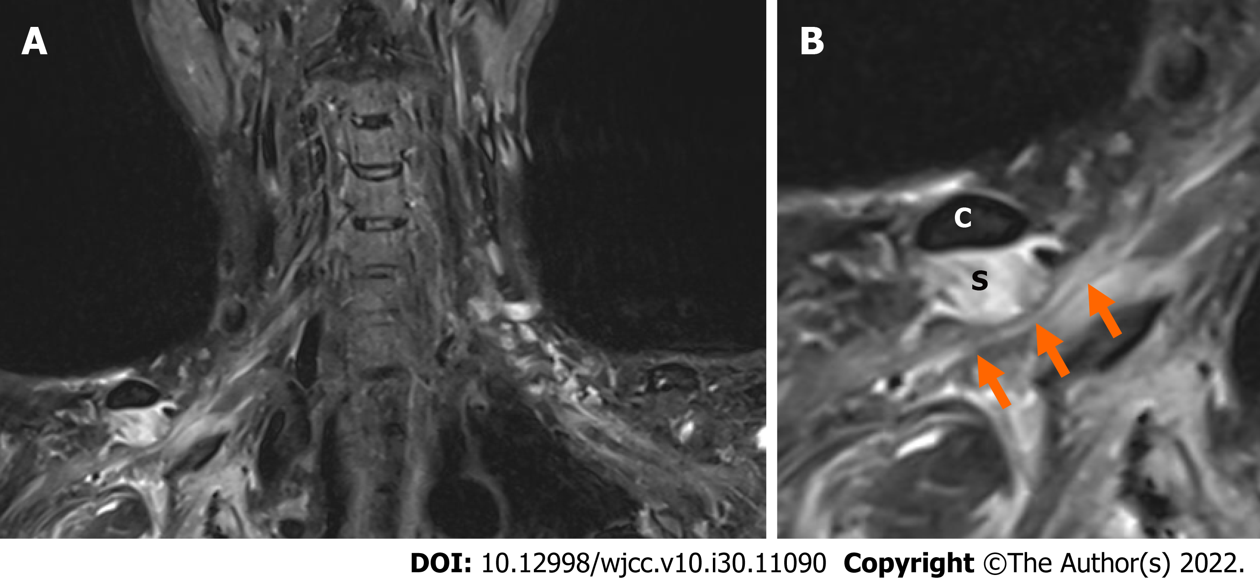
Figure 1 A T2-weighted magnetic resonance coronal image of the brachial plexus. A: A reduced version; B: An enlarged version. The hypertrophied subclavius muscle is compressing the underlying brachial plexus, and elevated signal intensity throughout the brachial plexus is shown (arrows). C: Clavicle; S: Subclavius muscle.

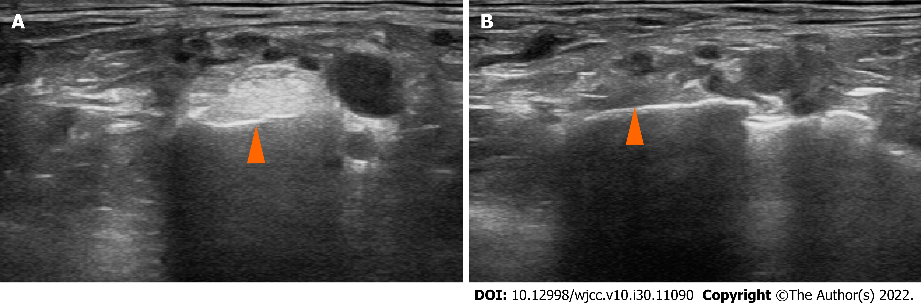
Figure 2 Musculoskeletal ultrasonography along the short axis of the subclavius muscle. A: Isolated hypertrophy of subclavius muscle (arrowhead) of the affected side; B: Normal finding of subclavius muscle (arrowhead) of the unaffected side.

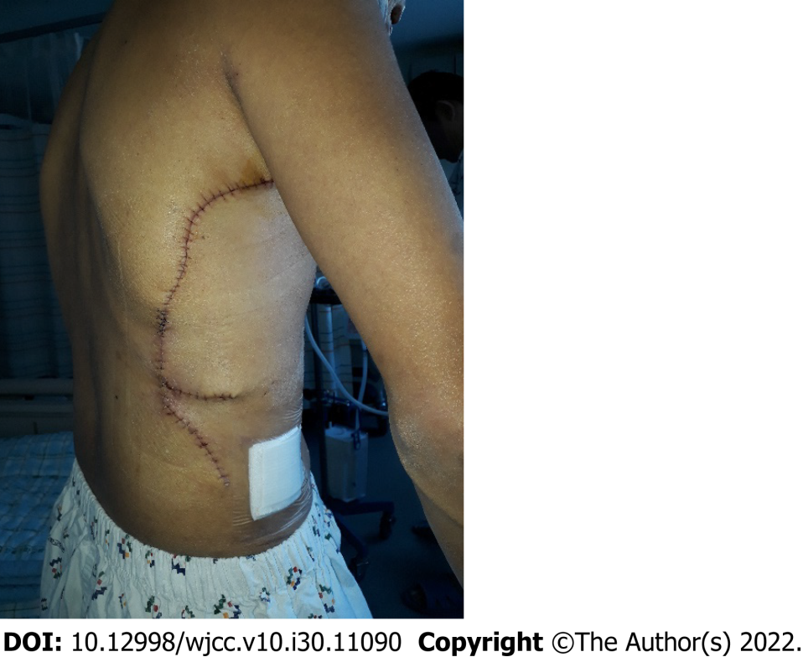
Figure 3 A photograph of the patient showing the incision site of the surgery.

Table 1 Results of the nerve conduction study in postoperative day 9
Nerve conduction  (motor) | Recording site | Stimulation site | Latency (ms) | Amplitude (mV) | Conduction velocity (m/s) | Nerve conduction (sensory) | Recording site | Stimulation site | Latency (ms) | Amplitude (mV) | Conduction velocity (m/s)
Right median | APB | Wrist | 2.75 | 11.7 |  | Right median | 3rd finger | Palm | 1.55 | 9.2 | 45.2
 |  | Elbow | 7.00 | 10.1 | 56.5 |  |  | Wrist | 3.05 | 7.8 | 46.7
Left median | APB | Wrist | 2.70 | 15.0 |  | Left median | 3rd finger | Palm | 1.25 | 36.5 | 56.0
 |  | Elbow | 6.90 | 13.4 | 5.71 |  |  | Wrist | 2.55 | 25.5 | 53.8
Right ulnar | ADM | Wrist | 2.45 | 16.8 |  | Right ulnar | 5th finger | Wrist | 2.60 | 23.5 | 53.8
 |  | Below elbow | 6.15 | 16.1 | 59.5 |  |  | Below elbow | 6.05 | 14.2 | 58.0
Left ulnar | ADM | Wrist | 2.70 | 14.3 |  | Left ulnar | 5th finger | Wrist | 2.55 | 22.2 | 54.9
 |  | Below elbow | 6.40 | 13.1 | 59.5 |  |  | Below elbow | 6.15 | 18.1 | 55.6
Right radial | EIP | Forearm | 1.65 | 8.9 |  | Right superficial  radial | Thumb | Forearm | 1.75 | 35.5 | 57.1
 |  | Above elbow | 5.60 | 8.9 | 63.3 | Left superficial  radial | Thumb | Forearm | 1.80 | 58.8 | 55.6
Left radial | EIP | Forearm | 1.65 | 8.9 |  | Right medial  antecubital | Forearm | Forearm | 2.45 | 11.3 | 53.1
 |  | Above elbow | 5.50 | 13.1 | 7.10 | Left medial  antecubital | Forearm | Forearm | 2.30 | 14.3 | 56.5
Right axillary | Deltoid | Erb’s point | 5.15 | 5.4 |  | Right lateral  antecubital | Forearm | Forearm |  | Absent
Left axillary | Deltoid | Erb’s point | 3.50 | 37.5 |  | Left lateral  antecubital | Forearm | Forearm | 1.90 | 18.5 | 63.2
Right musculocutaneous | Biceps | Erb’s point | 7.25 | 2.1
Left musculocutaneous | Biceps | Erb’s point | 3.75 | 24.0
Right long  thoracic | 5.6th rib | Erb’s point |  | Absent
Left long thoracic | 5.6th rib | Erb’s point | 3.15 | 4.1
Right dorsal  scapular | Rhomboideus | Erb’s point | 3.55 | 3.7
Left dorsal  scapular | Rhomboideus | Erb’s point | 4.10 | 2.6
Right suprascapular | Supraspinatus | Erb’s point | 4.40 | 5.3
 | Infraspinatus | Erb’s point | 4.80 | 4.6
Left suprascapular | Supraspinatus | Erb’s point | 2.30 | 19.8
 | Infraspinatus | Erb’s point | 4.00 | 13.4
APB: Abductor pollicis brevis; ADM: Abductor digiti minimi; EIP: Extensor indicis proprius.

Table 2 Results of needle electromyography
Muscle (right) | Abnormal spontaneous activity (positive sharp wave) | MUAP | Recruitment pattern
Cervical paraspinal | None | Normal | Normal
Rhomboid | None | Normal | Normal
Supraspinatus | None | Normal | Reduced
Infraspinatus | 2+ | Normal | Reduced
Teres major | 1+ | Normal | Reduced
Serratus anterior | 2+ | Normal | Reduced
Latissimus dorsi | 1+ | Normal | Reduced
Pectoralis major | 1+ | Normal | Reduced
Deltoid | 1+ | Normal | Reduced
Biceps brachii | 3+ | Normal | Reduced
Triceps | 1+ | Normal | Reduced
Pronator teres | 2+ | Normal | Reduced
Flexor carpi ulnaris | 1+ | Normal | Reduced
Extensor indicis proprius | 1+ | Normal | Reduced
Abductor pollicis brevis | 1+ | Normal | Reduced
MUAP: Motor unit action potential.

Table 3 Results of the nerve conduction study in postoperative day 61
Nerve conduction  (motor) | Recording site | Stimulation site | Latency (ms) | Amplitude (mV) | Conduction velocity (m/s) | Nerve conduction  (sensory) | Recording site | Stimulation site | Latency (ms) | Amplitude (mV) | Conduction velocity (m/s)
Right median | APB | Wrist | 2.95 | 9.7 |  | Right median | 3rd finger | Palm | 1.40 | 11.9 | 50.0
 |  | Elbow | 7.20 | 9.1 | 54.1 |  |  | Wrist | 3.10 | 8.2 | 41.2
Right ulnar | ADM | Wrist | 2.20 | 12.6 |  | Right ulnar | 5th finger | Wrist | 2.35 | 19.1 | 59.6
 |  | Below elbow | 6.05 | 12.3 | 55.8 |  |  | Below elbow | 5.80 | 14.0 | 60.9
Right radial | EIP | Forearm | 1.85 | 7.3 |  | Right superficial  radial | Thumb | Forearm | 1.75 | 27.4 | 57.1
 |  | Above elbow | 5.00 | 5.3 | 61.9 | Right medial  antecubital | Forearm | Forearm | 1.95 | 9.9 | 66.7
Right axillary | Deltoid | Erb’s point | 4.60 | 11.2 |  | Right lateral  antecubital | Forearm | Forearm |  | Absent
Right musculocutaneous | Biceps | Erb’s point | 6.25 | 12.4
Right long  thoracic | 5.6th rib | Erb’s point | 2.95 | 0.8
Right dorsal  scapular | Rhomboideus | Erb’s point | 3.45 | 6.6
Right suprascapular | Supraspinatus | Erb’s point | 1.65 | 5.5
 | Infraspinatus | Erb’s point | 1.90 | 3.7
APB: Abductor pollicis brevis; ADM: Abductor digiti minimi; EIP: Extensor indicis proprius.

Table 4 Results of the nerve conduction study in postoperative day 194
Nerve conduction  (motor) | Recording site | Stimulation site | Latency (ms) | Amplitude (mV) | Conduction velocity (m/s) | Nerve conduction  (sensory) | Recording site | Stimulation site | Latency (ms) | Amplitude (mV) | Conduction velocity (m/s)
Right median | APB | wrist | 2.85 | 17.0 |  | Right median | 3rd finger | Palm | 1.30 | 14.8 | 53.8
 |  | antecubital | 7.50 | 16.8 | 50.5 |  |  | Wrist | 2.35 | 9.5 | 66.7
Right ulnar | ADM | wrist | 2.35 | 16.7 |  | Right ulnar | 5th finger | Wrist | 2.40 | 36.3 | 58.3
 |  | Below elbow | 6.15 | 15.9 | 55.3 |  |  | Below elbow | 5.65 | 32.3 | 61.5
Right radial | EIP | forearm | 1.75 | 8.7 |  | Right superficial radial | Thumb | Forearm | 1.70 | 29.2 | 58.8
 |  | Above elbow | 5.65 | 8.1 | 65.4 | Right medial  antecubital | Forearm | Forearm | 2.40 | 11.6 | 54.2
Right axillary | Deltoid | Erb’s point | 3.75 | 31.6 |  | Right lateral  antecubital | Forearm | Forearm | 1.25 | 11.4 | 64.0
Right musculocutaneous | Biceps | Erb’s point | 5.80 | 17.7
Right long  thoracic | 5.6th rib | Erb’s point | 3.40 | 1.5
Right dorsal  scapular | Rhomboideus | Erb’s point | 4.25 | 6.3
Right suprascapular | Supraspinatus | Erb’s point | 1.60 | 12.7
 | Infraspinatus | Erb’s point | 2.40 | 9.5
APB: Abductor pollicis brevis; ADM: Abductor digiti minimi; EIP: Extensor indicis proprius.

Published by Baishideng Publishing Group Inc
7041 Koll Center Parkway, Suite 160, Pleasanton, CA 94566, USA
Telephone: +1-925-3991568
E-mail: bpgoffice@wjgnet.com
Help Desk: https://www.f6publishing.com/helpdesk
https://www.wjgnet.com

© 2022 Baishideng Publishing Group Inc. All rights reserved.

