Name of Journal: World Journal of Gastrointestinal Surgery
Manuscript NO: 63890
Manuscript Type: MINIREVIEWS

Benign vs malignant pancreatic lesions: Molecular insights to an ongoing debate

Aldyab M et al. Molecular insights to pancreatic mass lesions

Mahmoud Aldyab, Tony El Jabbour, Megan Parilla, Hwajeong Lee

Mahmoud Aldyab, Hwajeong Lee, Department of Pathology and Laboratory Medicine, Albany Medical Center, Albany, NY 12208, United States

Tony El Jabbour, Megan Parilla, Department of Pathology, Memorial Sloan Kettering Cancer Center, New York, NY 10065, United States

Author contributions: Aldyab M, El Jabbour T and Lee H drafted the manuscript; Aldyab M and Lee H prepared the figures, Parilla M and Lee H contributed to the editing of the manuscript; Lee H and Aldyab M provided the microscopic images; Aldyab M, El Jabbour T, Parilla M and Lee H gave final approval of the version to be published and are agreeable to be accountable for all aspects of the work in ensuring that questions that arise are investigated and the information is accurate.

Corresponding author: Hwajeong Lee, MD, Associate Professor, Department of Pathology and Laboratory Medicine, Albany Medical Center, 47 New Scotland Ave MC81, Albany, NY 12208, United States. leeh5@amc.edu

Received: February 5, 2021
Revised: March 30, 2021
Accepted: May 7, 2021
Published online:

Abstract
Several benign conditions such as chronic pancreatitis, autoimmune pancreatitis, and paraduodenal pancreatitis can present as mass lesions and may mimic pancreatic ductal adenocarcinoma (PDAC) clinically and radiologically. Thorough histologic examination with attention to certain morphologic features can assist in deciphering neoplastic from reactive, however small biopsies often remain a challenge. Variable histologic patterns in conventional PDAC may also confound the diagnosis of PDAC. Uncommon subtypes of pancreatic carcinoma such as adenosquamous and squamous cell carcinoma, colloid carcinoma, medullary carcinoma, hepatoid carcinoma and signet ring cell carcinoma necessitate excluding metastasis from other sites prior to rendering the diagnosis of pancreatic carcinoma. The use of immunohistochemical staining and molecular markers can aid in separating benign from malignant and PDAC from metastasis. PDAC expresses a few non-specific epithelial and mucin immunomarkers such as CK7, CK19, MUC1, MUC4 and MUC5AC. However, the only immunohistochemical marker that is specific for PDAC in the right clinical context is SMAD4. Loss of SMAD4 within atypical glands and ducts supports the diagnosis of PDAC in a limited sample. Unfortunately, this finding is seen only in 50% of PDAC cases. The identification of certain mutations can help support a diagnosis of PDAC when benign conditions are in the differential. At the molecular level, KRAS oncogene mutations are seen in approximately 93% of PDACs. Subsequent neoplastic progression is driven by additional mutations of tumor suppressor genes, such as CDKN2A, TP53, and SMAD4. Molecular markers can also provide an insight to the prognosis. For instance, the loss of SMAD4 is associated with a poor outcome whereas mutations in MLL, MLL2, MLL3, and ARID1A are associated with improved survival.

Key Words: Pancreas; Pancreatitis; Autoimmune; SMAD4; Molecular

Aldyab M, El Jabbour T, Parilla M, Lee H. Benign vs malignant pancreatic lesions: Molecular insights to an ongoing debate. World J Gastrointest Surg 2021; In press

Core Tip: Multiple benign entities share clinical and radiological features with pancreatic ductal adenocarcinoma requiring histologic examination to render the final diagnosis. However, the diagnosis of well differentiated adenocarcinoma can be challenging in a limited sample. Certain morphologic features and molecular markers can be used to resolve this issue.

INTRODUCTION
In the pancreas, several benign conditions such as chronic pancreatitis (CP), autoimmune pancreatitis (AIP), and paraduodenal pancreatitis (PDP) can present as mass lesions and mimic pancreatic ductal adenocarcinoma (PDAC) clinically and radiologically^{[1]}. The diagnosis of PDAC is relatively straightforward in resection specimens as multiple sections with large cut surfaces are available for microscopic examination. However, in small biopsy specimens (e.g., core needle biopsy) and intraoperative frozen sections, distinguishing PDAC from mass-forming benign lesions can be extremely challenging. Misdiagnosis in these settings may lead to an unnecessary surgical resection of a benign condition with resultant surgery-related complications. Alternatively, if one is too conservative at the microscope a diagnosis of resectable PDAC may be delayed with potentially adverse oncologic outcomes^{[2-4]}. The aim of this review is to describe the microscopic, immunohistochemical and molecular features that can help distinguish PDAC and benign mass-forming entities, especially CP. Also, we will review a few subtypes of non-conventional PDAC that may further confound the diagnosis with their differing morphologies.

WELL-DIFFERENTIATED PDAC AND ITS MIMMICKS
Smoking and CP are well-established risk factors of PDAC^{[4,5]}. Early stage PDAC can be asymptomatic. However, at an advanced stage, patients usually present with variable symptoms ranging from painless jaundice, anorexia, weight loss and abdominal pain to pancreatic endocrine and exocrine insufficiency^{[6]}. On magnetic resonance imaging and computed tomography, PDAC is usually seen as hypointense mass. However, PDAC not uncommonly shows similar intensity with surrounding tissue. In these cases, other features such as structural deformity, abrupt obstruction of the ducts, obstruction of both common bile duct and pancreatic duct (also known as “double duct sign”) and atrophy proximal to the lesion, may be helpful in rendering a correct diagnosis^{[3]}.
PDAC is derived from the epithelium of the pancreatic ductal tree. “Differentiation” of a malignant tumor is the degree of histomorphologic resemblance between the neoplastic cells and their origin. Therefore, a well-differentiated PDAC shows duct-like glands recapitulating the benign pancreatic ducts. Less differentiated (moderately, poorly, to undifferentiated) PDACs show more disorganized growth compared to well-differentiated tumors, with sheet-like, nested or single cell patterns of architecture. The invasion of neoplastic cells into surrounding tissue with a breach of the ductal basement membrane is usually accompanied by a proliferation of fibroblasts and fibrotic reaction of the neighboring stroma, called desmoplasia^{[2,3]}.

CP
CP is a progressive form of pancreatic injury subsequent to inflammation, fibrosis and atrophy^{[4,7]}. Risk factors of CP include alcoholism, mechanical obstruction of the biliary tract and hyperlipidemia. As stated above, CP can be a risk factor for PDAC. Conversely, PDAC may lead to CP in the background pancreas^{[4,5,7]}. Therefore, coexistence of CP and PDAC is not a rare occurrence and distinguishing these two is crucial given the differing management and prognosis^{[8]}. Unfortunately, there is a high degree of overlap in clinical signs and symptoms between CP and PDAC^{[4,7]}. Radiologically, dilation of the main pancreatic duct and branches with diffuse atrophy and calcification would favor CP over PDAC. However, again, focal atrophy and duct dilation can also be seen in PDAC and may be misleading^{[7]}.
Microscopically, there is a striking morphologic resemblance between CP and well-differentiated PDAC that may lead to diagnostic challenges. In CP, benign acinar components frequently undergo atrophy. While their lobular architecture tends to be maintained, atrophic acini may resemble small ducts and the native small branch ducts may appear relatively prominent within the atrophic acini. Fibrosis in CP often encases the atrophic small duct-like acini and native small ducts. Consequently, those elements appear as ductular structures embedded in fibrotic stroma, mimicking well-differentiated invasive PDAC in desmoplastic stroma^{[8]} (Figure 1).
The latest World Health Organization (WHO) classification of digestive system tumors listed relevant morphologic criteria in distinguishing PDAC and advanced CP. Architectural findings that are in favor of PDAC include the presence of irregular, ruptured, haphazard ducts in the immediate vicinity of neural structures or within the vessels^{[9]}. Also, “naked” ducts in the adipose tissue favor PDAC over CP^{[10]}. The presence of neutrophils and necrotic debris, rather than calculi and secretory plugs, is another histologic clue that supports the diagnosis of malignancy. Moreover, classic cytologic features of malignancy within the glands and ducts such as pleomorphism, nuclear hyperchromasia and increased mitotic rate support PDAC^{[9]}.

AIP
AIP is a rare form of CP. Type I AIP predominantly affects older males and type II affects younger patients without gender predilection^{[11-14]}. Clinically, AIP commonly presents with painless obstructive jaundice and/or pancreatic mass similar to PDAC, thus is prone to misdiagnosis^{[11,12]}.
Two histologic patterns had been recognized and later designated as type I and type II, respectively^{[15,16]}. Commonly found in the head of the pancreas, AIP is an important mimicker of PDAC, also commonly found in the head of the pancreas^{[11-13,17]}. Radiologically, AIP can present as a mass lesion with three radiologic patterns described: diffuse, focal and multifocal^{[12]}. Similar to pancreatic cancer, the most common clinical presentation is jaundice, but it can present with abdominal discomfort/pain and less commonly with weight loss^{[11,13]}.
Type I and type II AIP have distinct histologic appearances. Type I is characterized by a dense lymphoplasmacytic infiltrate with an increased IgG4 expression, storiform fibrosis and obliterative phlebitis^{[16,18,19]} (Figure 2). Type II AIP is seen in a younger age group compared to AIP type I. It is histologically characterized by the presence of granulocytes in the ductal epithelium with or without granulocytic involvement of the acini with low or absent IgG4 positive cells^{[16,18,19]} (Figure 3).
The diagnostic approach of AIP is complex, thus an interdisciplinary approach combining clinical, laboratory, and radiological features and typical pathologic findings, when available, is warranted^{[14,18,20]}. The HISORt criteria consisting of histology, imaging, serology, other organ involvement and response to therapy components are commonly used for a diagnosis of AIP by clinicians^{[7,18,20]}.

PDP
Also known as groove pancreatitis, PDP represents a localized type of CP affecting the region of pancreas between the pancreatic head, the duodenum, and the common bile duct ^{[21,22]}. The term PDP was introduced to include multiple pathologic entities such as cystic dystrophy of heterotopic pancreas and para-duodenal cysts^{[23]}. Increased alcohol intake is a risk factor for PDP, which predominantly affects middle aged men^{[22,24]}. Clinically PDP can manifest with a spectrum of symptoms including pain, vomiting, jaundice and weight loss^{[23,25]}.
Variable imaging modalities can be utilized to identify PDP. However, it is not uncommon to have an inconclusive radiologic diagnosis, with carcinoma of the pancreas as a differential diagnosis^{[25-27]}. Duodenal wall thickening, Brunner gland hyperplasia and inflammation are typical features of PDP, in addition to proliferation of myofibroblasts, smooth muscle hyperplasia, edema and heterotopic pancreatic tissue (Figure 4). Cyst formation is also a common histologic finding^{[21,23-25]}.
A summary of distinctive morphologic features of PDAC and its benign mimics is outlined in Table 1.

IMMUNOHISTOCHEMICAL MARKERS OF PDAC
PDAC originates from ductal epithelium. Therefore, PDAC expresses a number of non-specific epithelial and mucin immunomarkers such as CK7, CK19, MUC1, MUC4 and MUC5AC. However, these markers can also be expressed in any benign ducts. Hence, none of these markers is useful in differentiating between PDAC and CP. The only immunohistochemical marker that confirms malignancy is SMAD4; loss of SMAD4 within atypical glands or ducts would be useful in making a diagnosis of PDAC in a limited sample. Unfortunately, this finding is seen only in 50% of PDAC cases (Figures 5 and 6). Consequently, positive (retained) SMAD4 staining within the glands does not exclude a diagnosis of PDAC^{[28-30]}.

MOLECULAR MARKERS OF PDAC
Next generation sequencing (NGS) is a technique by which millions of nucleotide sequences are simultaneously deciphered and mutations or other genomic aberrations are detected. Using NGS, an entire human genome can be sequenced within a single day^{[31]}. The Cancer Genome Atlas (TCGA) is a project that aims to discover then classify major cancer-causing genomic alterations called drivers. A few potential drivers of PDAC have been identified^{[32]}. When a driver mutation is found in a pancreatic mass, a neoplastic process, such as PDAC, would be favored over CP.
According to the TCGA, KRAS oncogene mutations are seen in approximately 93% of PDACs. This mutation is usually seen early in the neoplastic process. Subsequent neoplastic progression is driven by mutations of tumor suppressor genes, such as CDKN2A, TP53, and SMAD4. Furthermore, genetic and epigenetic alterations lead to invasion and metastasis. These mutations are by far less frequent than KRAS mutation. For example, TP53 mutations and loss of SMAD4 are limited to approximately 50% of the cases^{[33-35]}. The loss of SMAD4 is also associated with a poor outcome^{[36]} whereas mutations in MLL, MLL2, MLL3, and ARID1A are associated with an improved survival^{[37]}.
A multitude of other genetic alterations have been suggested to drive neoplasia in KRAS wild-type PDACs. These alterations are sub-grouped into three categories: (1) Tumors with an activated MAPK pathway associated with BRAF mutation; (2) Tumors with microsatellite instability due to defective DNA mismatch repair (MMR) featuring a high tumor mutational burden; and (3) Tumors with kinase gene fusions^{[38]}.

SELECTED SUBTYPES OF PDAC
The following subtypes share a similar mutational profile with PDAC. Some of these may show additional pathognomonic or targetable mutations. Table 2 provides a summary of morphologic features and altered genes for PDAC subtypes.

Non-classified conventional PDAC
Conventional PDAC may exhibit any of the morphologic patterns listed below; currently, these patterns are not classified as separate categories by the WHO^{[9]}.
Large duct pattern: Macroscopically, tumors with a large duct pattern show cysts (5 to 7 cysts) that are > 0.5 cm in diameter. These cysts may mimic intrapancreatic mucinous neoplasm (IPMN) radiologically and macroscopically. Microscopically, these neoplastic cysts are lined by atypical cuboidal epithelium with occasional papillary projections^{[39]}.
Foamy gland pattern: The foamy gland pattern poses a diagnostic challenge especially on frozen section as the cytoarchitectural features of malignancy are subtle in this particular pattern. Tumors are composed of glands resembling benign endocervical glands or gastric foveolar glands, with foamy (microvesicular) cytoplasm. Condensed brush border-like bands are noted at the luminal aspect of the glands, and the raisinoid, small nuclei are basally located^{[40]}.
Cystic papillary pattern: This pattern may be related to the large duct pattern. It is characterized by a papillary cystic architecture intermixed with intervening areas of conventional PDAC. The biologic behavior of PDAC with this pattern is similar to that of poorly differentiated adenocarcinoma^{[9,41]}.

Adenosquamous and squamous cell carcinoma
Adenosquamous carcinoma is a tumor composed of both adenocarcinoma and squamous carcinoma components (Figure 7), with a poor prognosis. Some authors have suggested an arbitrary cut-off of 30% of the squamous component for the diagnosis^{[42-44]}. The proportion of squamous component had no effect on overall survival in Voong et al^{[45]}’s study. However, the presence of any degree of squamous differentiation in a PDAC appears to confer a worse outcome^{[44-46]}. Pure squamous cell carcinomas of the pancreas are extremely rare, and a metastasis should always be ruled out before establishing this diagnosis^{[44,47]}. At the molecular level, both adenosquamous and pure squamous carcinoma show the classic molecular alterations of PDAC^{[44,48-50]}.

Colloid carcinoma
More than 80% of extracellular mucin is required to establish the diagnosis of colloid carcinoma. Although focal signet-ring cells can be seen in this subtype, the overall prognosis of colloid carcinoma is more favorable than conventional PDAC^{[51-53]}. Studies have shown similar molecular profiles between the colloid carcinoma and intestinal-type IPMN; both of which harbor somatic mutations in GNAS. Thus, intestinal-type IPMN is considered to be a precursor of this particular subtype of PDAC^{[54-57]}. At the germline level, heterozygous mutations in the ATM gene seems to predispose patients to the development of the colloid subtype of PDAC^{[58]}. Furthermore, germline ATM aberrations are shown to increase the efficacy of antineoplastic drugs that induce synthetic lethality such as platinum drugs and PARP inhibitors (e.g., Olaparib)^{[59,60]}.

Signet-ring cell carcinoma
The diagnosis of signet-ring cell carcinoma is rendered when more than 80% of the tumor demonstrates signet ring cells. This subtype is extremely rare in the pancreas therefore its prognosis is unknown. Similar to the other uncommon subtypes listed above, metastatic malignancies with a signet ring cell component, notably gastric and mammary carcinomas, must be excluded before such a diagnosis is rendered^{[61,62]}. Due to its extreme rarity, molecular data on this subtype is currently unavailable in the literature^{[5]}.

Medullary carcinoma
The histologic hallmarks of this subtype include minimal glandular differentiation, a syncytial growth pattern and abundant inflammatory infiltrate^{[63]}. MMR deficiency is common in this subtype (up to 20%) conferring a better response to immune checkpoint inhibitors and a slightly better prognosis compared to conventional PDAC^{[9,63,64]}. Due to its rarity, molecular data are limited to some case reports. Kryklyva et al^{[65]} recently reported a case of pancreatic medullary carcinoma without MMR deficiency. However, a somatic mutation in the POLE gene was noted resulting in a high tumor mutation burden and theoretically, increased neoantigen exposure with potential responsiveness to immune checkpoint inhibitor therapy.

Hepatoid carcinoma
The diagnosis of hepatoid PDAC requires that over 50% of the lesion shows hepatocellular differentiation^{[9]}. This is another extremely rare subtype. Due to its extreme rarity, a metastatic hepatocellular carcinoma should always be considered first^{[66,67]}. Data on the prognosis of this subtype are limited^{[9]}. In the literature, molecular profiling of one case of pancreatic hepatoid carcinoma is available. This showed somatic mutations of BAP1 and NOTCH1. Both targets are considered not actionable by current precision immunotherapy^{[68]}.

CONCLUSION
While risk factors, clinical presentation and imaging studies can be helpful in the diagnosis of a mass lesion in the pancreas, there is a significant overlap between benign and malignant lesions. Therefore, histologic examination is a crucial component in the work-up of pancreatic mass. However, in a limited sample, histologic examination can be challenging due to paucity of glandular structures in PDAC, limited ability to evaluate architecture, and nonspecific stromal changes. In this review we outlined the clinical presentation, imaging findings and histologic findings of PDAC, CP, AIP and PDP in order to highlight the inherent difficulties we face in our daily practice. Making a correct diagnosis of these different entities can be extremely challenging, and surgical resection may be still required for the final diagnosis in some cases. Recently discovered molecular alterations in PDAC may help clear ambiguity, serve as prognosticators and broaden treatment options. The algorithm outlined in Figure 8 summarizes the steps in the workup of PDAC vs CP.

REFERENCES
1 Schima W, Böhm G, Rösch CS, Klaus A, Függer R, Kopf H. Mass-forming pancreatitis versus pancreatic ductal adenocarcinoma: CT and MR imaging for differentiation. Cancer Imaging 2020; 20: 52 [PMID: 32703312 DOI: 10.1186/s40644-020-00324-z]
2 Adsay NV, Bandyopadhyay S, Basturk O, Othman M, Cheng JD, Klöppel G, Klimstra DS. Chronic pancreatitis or pancreatic ductal adenocarcinoma? Semin Diagn Pathol 2004; 21: 268-276 [PMID: 16273946 DOI: 10.1053/j.semdp.2005.08.002]
3 Hermanová M, Lenz J. [Differential diagnosis of the chronic pancreatitis and the pancreatic ductal adenocarcinoma]. Cesk Patol 2012; 48: 135-140 [PMID: 23057427]
4 Pham A, Forsmark C. Chronic pancreatitis: review and update of etiology, risk factors, and management. F1000Res 2018; 7 [PMID: 29946424 DOI: 10.12688/f1000research.12852.1]
5 Ueda J, Tanaka M, Ohtsuka T, Tokunaga S, Shimosegawa T; Research Committee of Intractable Diseases of the Pancreas. Surgery for chronic pancreatitis decreases the risk for pancreatic cancer: a multicenter retrospective analysis. Surgery 2013; 153: 357-364 [PMID: 22989892 DOI: 10.1016/j.surg.2012.08.005]
6 Vareedayah AA, Alkaade S, Taylor JR. Pancreatic Adenocarcinoma. Mo Med 2018; 115: 230-235 [PMID: 30228728]
7 Al-Hawary MM, Kaza RK, Azar SF, Ruma JA, Francis IR. Mimics of pancreatic ductal adenocarcinoma. Cancer Imaging 2013; 13: 342-349 [PMID: 24060833 DOI: 10.1102/1470-7330.2013.9012]
8 Klöppel G, Adsay NV. Chronic pancreatitis and the differential diagnosis versus pancreatic cancer. Arch Pathol Lab Med 2009; 133: 382-387 [PMID: 19260744 DOI: 10.1043/1543-2165-133.3.382]
9 Hruban RH, Adsay NV, Esposito I, Fukushima N, Furukawa T, Kloppel G, Maitra A, Notohara K, Offerhaus GJA, Ohike N, Pitman MB, Zamboni G. WHO classification of tumours of the digestive system. 5th ed. Lyon, France: International Agency for Research on Cancer (IARC), 2019: 322-332
10 Bandyopadhyay S, Basturk O, Coban I, Thirabanjasak D, Liang H, Altinel D, Adsay NV. Isolated solitary ducts (naked ducts) in adipose tissue: a specific but underappreciated finding of pancreatic adenocarcinoma and one of the potential reasons of understaging and high recurrence rate. Am J Surg Pathol 2009; 33: 425-429 [PMID: 19092633 DOI: 10.1097/PAS.0b013e3181908e42]
11 Zamboni G, Lüttges J, Capelli P, Frulloni L, Cavallini G, Pederzoli P, Leins A, Longnecker D, Klöppel G. Histopathological features of diagnostic and clinical relevance in autoimmune pancreatitis: a study on 53 resection specimens and 9 biopsy specimens. Virchows Arch 2004; 445: 552-563 [PMID: 15517359 DOI: 10.1007/s00428-004-1140-z]
12 Crosara S, D'Onofrio M, De Robertis R, Demozzi E, Canestrini S, Zamboni G, Pozzi Mucelli R. Autoimmune pancreatitis: Multimodality non-invasive imaging diagnosis. World J Gastroenterol 2014; 20: 16881-16890 [PMID: 25493001 DOI: 10.3748/wjg.v20.i45.16881]
13 Lopes Vendrami C, Shin JS, Hammond NA, Kothari K, Mittal PK, Miller FH. Differentiation of focal autoimmune pancreatitis from pancreatic ductal adenocarcinoma. Abdom Radiol (NY) 2020; 45: 1371-1386 [PMID: 31493022 DOI: 10.1007/s00261-019-02210-0]
14 Dite P, Novotny I, Dvorackova J, Kianicka B, Blaho M, Svoboda P, Uvirova M, Rohan T, Maskova H, Kunovsky L. Pancreatic Solid Focal Lesions: Differential Diagnosis between Autoimmune Pancreatitis and Pancreatic Cancer. Dig Dis 2019; 37: 416-421 [PMID: 31079114 DOI: 10.1159/000499762]
15 Notohara K, Burgart LJ, Yadav D, Chari S, Smyrk TC. Idiopathic chronic pancreatitis with periductal lymphoplasmacytic infiltration: clinicopathologic features of 35 cases. Am J Surg Pathol 2003; 27: 1119-1127 [PMID: 12883244 DOI: 10.1097/00000478-200308000-00009]
16 Sugumar A, Klöppel G, Chari ST. Autoimmune pancreatitis: pathologic subtypes and their implications for its diagnosis. Am J Gastroenterol 2009; 104: 2308-10; quiz 2311 [PMID: 19727085 DOI: 10.1038/ajg.2009.336]
17 Klöppel G, Sipos B, Zamboni G, Kojima M, Morohoshi T. Autoimmune pancreatitis: histo- and immunopathological features. J Gastroenterol 2007; 42 Suppl 18: 28-31 [PMID: 17520220 DOI: 10.1007/s00535-007-2048-6]
18 Shimosegawa T, Chari ST, Frulloni L, Kamisawa T, Kawa S, Mino-Kenudson M, Kim MH, Klöppel G, Lerch MM, Löhr M, Notohara K, Okazaki K, Schneider A, Zhang L; International Association of Pancreatology. International consensus diagnostic criteria for autoimmune pancreatitis: guidelines of the International Association of Pancreatology. Pancreas 2011; 40: 352-358 [PMID: 21412117 DOI: 10.1097/MPA.0b013e3182142fd2]
19 Zhang L, Chari S, Smyrk TC, Deshpande V, Klöppel G, Kojima M, Liu X, Longnecker DS, Mino-Kenudson M, Notohara K, Rodriguez-Justo M, Srivastava A, Zamboni G, Zen Y. Autoimmune pancreatitis (AIP) type 1 and type 2: an international consensus study on histopathologic diagnostic criteria. Pancreas 2011; 40: 1172-1179 [PMID: 21975436 DOI: 10.1097/MPA.0b013e318233bec5]
20 Chari ST. Diagnosis of autoimmune pancreatitis using its five cardinal features: introducing the Mayo Clinic's HISORt criteria. J Gastroenterol 2007; 42 Suppl 18: 39-41 [PMID: 17520222 DOI: 10.1007/s00535-007-2046-8]
21 Tezuka K, Makino T, Hirai I, Kimura W. Groove pancreatitis. Dig Surg 2010; 27: 149-152 [PMID: 20551662 DOI: 10.1159/000289099]
22 Stolte M, Weiss W, Volkholz H, Rösch W. A special form of segmental pancreatitis: "groove pancreatitis". Hepatogastroenterology 1982; 29: 198-208 [PMID: 7173808 DOI: 10.1136/gut.23.12.1088]
23 Adsay NV, Zamboni G. Paraduodenal pancreatitis: a clinico-pathologically distinct entity unifying "cystic dystrophy of heterotopic pancreas", "para-duodenal wall cyst", and "groove pancreatitis". Semin Diagn Pathol 2004; 21: 247-254 [PMID: 16273943 DOI: 10.1053/j.semdp.2005.07.005]
24 Raman SP, Salaria SN, Hruban RH, Fishman EK. Groove pancreatitis: spectrum of imaging findings and radiology-pathology correlation. AJR Am J Roentgenol 2013; 201: W29-W39 [PMID: 23789694 DOI: 10.2214/AJR.12.9956]
25 Kim JD, Han YS, Choi DL. Characteristic clinical and pathologic features for preoperative diagnosed groove pancreatitis. J Korean Surg Soc 2011; 80: 342-347 [PMID: 22066058 DOI: 10.4174/jkss.2011.80.5.342]
26 Addeo G, Beccani D, Cozzi D, Ferrari R, Lanzetta MM, Paolantonio P, Pradella S, Miele V. Groove pancreatitis: a challenging imaging diagnosis. Gland Surg 2019; 8: S178-S187 [PMID: 31559185 DOI: 10.21037/gs.2019.04.06]
27 Kalb B, Martin DR, Sarmiento JM, Erickson SH, Gober D, Tapper EB, Chen Z, Adsay NV. Paraduodenal pancreatitis: clinical performance of MR imaging in distinguishing from carcinoma. Radiology 2013; 269: 475-481 [PMID: 23847255 DOI: 10.1148/radiol.13112056]
28 Tascilar M, Offerhaus GJ, Altink R, Argani P, Sohn TA, Yeo CJ, Cameron JL, Goggins M, Hruban RH, Wilentz RE. Immunohistochemical labeling for the Dpc4 gene product is a specific marker for adenocarcinoma in biopsy specimens of the pancreas and bile duct. Am J Clin Pathol 2001; 116: 831-837 [PMID: 11764071 DOI: 10.1309/WF03-NFCE-7BRH-7C26]
29 Liu H, Shi J, Anandan V, Wang HL, Diehl D, Blansfield J, Gerhard G, Lin F. Reevaluation and identification of the best immunohistochemical panel (pVHL, Maspin, S100P, IMP-3) for ductal adenocarcinoma of the pancreas. Arch Pathol Lab Med 2012; 136: 601-609 [PMID: 22646265 DOI: 10.5858/arpa.2011-0326-OA]
30 Wang HL, Kim CJ, Koo J, Zhou W, Choi EK, Arcega R, Chen ZE, Wang H, Zhang L, Lin F. Practical Immunohistochemistry in Neoplastic Pathology of the Gastrointestinal Tract, Liver, Biliary Tract, and Pancreas. Arch Pathol Lab Med 2017; 141: 1155-1180 [PMID: 28854347 DOI: 10.5858/arpa.2016-0489-RA]
31 Slatko BE, Gardner AF, Ausubel FM. Overview of Next-Generation Sequencing Technologies. Curr Protoc Mol Biol 2018; 122: e59 [PMID: 29851291 DOI: 10.1002/cpmb.59]
32 Tomczak K, Czerwińska P, Wiznerowicz M. The Cancer Genome Atlas (TCGA): an immeasurable source of knowledge. Contemp Oncol (Pozn) 2015; 19: A68-A77 [PMID: 25691825 DOI: 10.5114/wo.2014.47136]
33 Cancer Genome Atlas Research Network.; Cancer Genome Atlas Research Network. Integrated Genomic Characterization of Pancreatic Ductal Adenocarcinoma. Cancer Cell 2017; 32: 185-203.e13 [PMID: 28810144 DOI: 10.1016/j.ccell.2017.07.007]
34 Ren B, Liu X, Suriawinata AA. Pancreatic Ductal Adenocarcinoma and Its Precursor Lesions: Histopathology, Cytopathology, and Molecular Pathology. Am J Pathol 2019; 189: 9-21 [PMID: 30558727 DOI: 10.1016/j.ajpath.2018.10.004]
35 Waddell N, Pajic M, Patch AM, Chang DK, Kassahn KS, Bailey P, Johns AL, Miller D, Nones K, Quek K, Quinn MC, Robertson AJ, Fadlullah MZ, Bruxner TJ, Christ AN, Harliwong I, Idrisoglu S, Manning S, Nourse C, Nourbakhsh E, Wani S, Wilson PJ, Markham E, Cloonan N, Anderson MJ, Fink JL, Holmes O, Kazakoff SH, Leonard C, Newell F, Poudel B, Song S, Taylor D, Waddell N, Wood S, Xu Q, Wu J, Pinese M, Cowley MJ, Lee HC, Jones MD, Nagrial AM, Humphris J, Chantrill LA, Chin V, Steinmann AM, Mawson A, Humphrey ES, Colvin EK, Chou A, Scarlett CJ, Pinho AV, Giry-Laterriere M, Rooman I, Samra JS, Kench JG, Pettitt JA, Merrett ND, Toon C, Epari K, Nguyen NQ, Barbour A, Zeps N, Jamieson NB, Graham JS, Niclou SP, Bjerkvig R, Grützmann R, Aust D, Hruban RH, Maitra A, Iacobuzio-Donahue CA, Wolfgang CL, Morgan RA, Lawlor RT, Corbo V, Bassi C, Falconi M, Zamboni G, Tortora G, Tempero MA; Australian Pancreatic Cancer Genome Initiative, Gill AJ, Eshleman JR, Pilarsky C, Scarpa A, Musgrove EA, Pearson JV, Biankin AV, Grimmond SM. Whole genomes redefine the mutational landscape of pancreatic cancer. Nature 2015; 518: 495-501 [PMID: 25719666 DOI: 10.1038/nature14169]
36 Wang JD, Jin K, Chen XY, Lv JQ, Ji KW. Clinicopathological significance of SMAD4 loss in pancreatic ductal adenocarcinomas: a systematic review and meta-analysis. Oncotarget 2017; 8: 16704-16711 [PMID: 28053288 DOI: 10.18632/oncotarget.14335]
37 Sausen M, Phallen J, Adleff V, Jones S, Leary RJ, Barrett MT, Anagnostou V, Parpart-Li S, Murphy D, Kay Li Q, Hruban CA, Scharpf R, White JR, O'Dwyer PJ, Allen PJ, Eshleman JR, Thompson CB, Klimstra DS, Linehan DC, Maitra A, Hruban RH, Diaz LA Jr, Von Hoff DD, Johansen JS, Drebin JA, Velculescu VE. Clinical implications of genomic alterations in the tumour and circulation of pancreatic cancer patients. Nat Commun 2015; 6: 7686 [PMID: 26154128 DOI: 10.1038/ncomms8686]
38 Luchini C, Paolino G, Mattiolo P, Piredda ML, Cavaliere A, Gaule M, Melisi D, Salvia R, Malleo G, Shin JI, Cargnin S, Terrazzino S, Lawlor RT, Milella M, Scarpa A. KRAS wild-type pancreatic ductal adenocarcinoma: molecular pathology and therapeutic opportunities. J Exp Clin Cancer Res 2020; 39: 227 [PMID: 33115526 DOI: 10.1186/s13046-020-01732-6]
39 Kosmahl M, Pauser U, Anlauf M, Klöppel G. Pancreatic ductal adenocarcinomas with cystic features: neither rare nor uniform. Mod Pathol 2005; 18: 1157-1164 [PMID: 15920540 DOI: 10.1038/modpathol.3800446]
40 Adsay V, Logani S, Sarkar F, Crissman J, Vaitkevicius V. Foamy gland pattern of pancreatic ductal adenocarcinoma: a deceptively benign-appearing variant. Am J Surg Pathol 2000; 24: 493-504 [PMID: 10757396 DOI: 10.1097/00000478-200004000-00003]
41 Kelly PJ, Shinagare S, Sainani N, Hong X, Ferrone C, Yilmaz O, Fernández-del Castillo C, Lauwers GY, Deshpande V. Cystic papillary pattern in pancreatic ductal adenocarcinoma: a heretofore undescribed morphologic pattern that mimics intraductal papillary mucinous carcinoma. Am J Surg Pathol 2012; 36: 696-701 [PMID: 22367300 DOI: 10.1097/PAS.0b013e318249ce1c]
42 Madura JA, Jarman BT, Doherty MG, Yum MN, Howard TJ. Adenosquamous carcinoma of the pancreas. Arch Surg 1999; 134: 599-603 [PMID: 10367867 DOI: 10.1001/archsurg.134.6.599]
43 Trikudanathan G, Dasanu CA. Adenosquamous carcinoma of the pancreas: a distinct clinicopathologic entity. South Med J 2010; 103: 903-910 [PMID: 20697320 DOI: 10.1097/SMJ.0b013e3181ebadbd]
44 Kardon DE, Thompson LD, Przygodzki RM, Heffess CS. Adenosquamous carcinoma of the pancreas: a clinicopathologic series of 25 cases. Mod Pathol 2001; 14: 443-451 [PMID: 11353055 DOI: 10.1038/modpathol.3880332]
45 Voong KR, Davison J, Pawlik TM, Uy MO, Hsu CC, Winter J, Hruban RH, Laheru D, Rudra S, Swartz MJ, Nathan H, Edil BH, Schulick R, Cameron JL, Wolfgang CL, Herman JM. Resected pancreatic adenosquamous carcinoma: clinicopathologic review and evaluation of adjuvant chemotherapy and radiation in 38 patients. Hum Pathol 2010; 41: 113-122 [PMID: 19801164 DOI: 10.1016/j.humpath.2009.07.012]
46 Kovi J. Adenosquamous carcinoma of the pancreas: a light and electron microscopic study. Ultrastruct Pathol 1982; 3: 17-23 [PMID: 7071952 DOI: 10.3109/01913128209016621]
47 Moslim MA, Lefton MD, Ross EA, Mackrides N, Reddy SS. Clinical and Histological Basis of Adenosquamous Carcinoma of the Pancreas: A 30-year Experience. J Surg Res 2021; 259: 350-356 [PMID: 33190924 DOI: 10.1016/j.jss.2020.09.024]
48 Brody JR, Costantino CL, Potoczek M, Cozzitorto J, McCue P, Yeo CJ, Hruban RH, Witkiewicz AK. Adenosquamous carcinoma of the pancreas harbors KRAS2, DPC4 and TP53 molecular alterations similar to pancreatic ductal adenocarcinoma. Mod Pathol 2009; 22: 651-659 [PMID: 19270646 DOI: 10.1038/modpathol.2009.15]
49 Fang Y, Su Z, Xie J, Xue R, Ma Q, Li Y, Zhao Y, Song Z, Lu X, Li H, Peng C, Bai F, Shen B. Genomic signatures of pancreatic adenosquamous carcinoma (PASC). J Pathol 2017; 243: 155-159 [PMID: 28722109 DOI: 10.1002/path.4943]
50 Borazanci E, Millis SZ, Korn R, Han H, Whatcott CJ, Gatalica Z, Barrett MT, Cridebring D, Von Hoff DD. Adenosquamous carcinoma of the pancreas: Molecular characterization of 23 patients along with a literature review. World J Gastrointest Oncol 2015; 7: 132-140 [PMID: 26380056 DOI: 10.4251/wjgo.v7.i9.132]
51 Mostafa ME, Erbarut-Seven I, Pehlivanoglu B, Adsay V. Pathologic classification of "pancreatic cancers": current concepts and challenges. Chin Clin Oncol 2017; 6: 59 [PMID: 29307199 DOI: 10.21037/cco.2017.12.01]
52 Adsay NV, Pierson C, Sarkar F, Abrams J, Weaver D, Conlon KC, Brennan MF, Klimstra DS. Colloid (mucinous noncystic) carcinoma of the pancreas. Am J Surg Pathol 2001; 25: 26-42 [PMID: 11145249 DOI: 10.1097/00000478-200101000-00003]
53 Adsay NV, Merati K, Andea A, Sarkar F, Hruban RH, Wilentz RE, Goggins M, Iocobuzio-Donahue C, Longnecker DS, Klimstra DS. The dichotomy in the preinvasive neoplasia to invasive carcinoma sequence in the pancreas: differential expression of MUC1 and MUC2 supports the existence of two separate pathways of carcinogenesis. Mod Pathol 2002; 15: 1087-1095 [PMID: 12379756 DOI: 10.1097/01.MP.0000028647.98725.8B]
54 Scarpa A, Real FX, Luchini C. Genetic unrelatedness of co-occurring pancreatic adenocarcinomas and IPMNs challenges current views of clinical management. Gut 2018; 67: 1561-1563 [PMID: 29661802 DOI: 10.1136/gutjnl-2018-316151]
55 Felsenstein M, Noë M, Masica DL, Hosoda W, Chianchiano P, Fischer CG, Lionheart G, Brosens LAA, Pea A, Yu J, Gemenetzis G, Groot VP, Makary MA, He J, Weiss MJ, Cameron JL, Wolfgang CL, Hruban RH, Roberts NJ, Karchin R, Goggins MG, Wood LD. IPMNs with co-occurring invasive cancers: neighbours but not always relatives. Gut 2018; 67: 1652-1662 [PMID: 29500184 DOI: 10.1136/gutjnl-2017-315062]
56 Yamada M, Sekine S, Ogawa R, Taniguchi H, Kushima R, Tsuda H, Kanai Y. Frequent activating GNAS mutations in villous adenoma of the colorectum. J Pathol 2012; 228: 113-118 [PMID: 22374786 DOI: 10.1002/path.4012]
57 Amato E, Molin MD, Mafficini A, Yu J, Malleo G, Rusev B, Fassan M, Antonello D, Sadakari Y, Castelli P, Zamboni G, Maitra A, Salvia R, Hruban RH, Bassi C, Capelli P, Lawlor RT, Goggins M, Scarpa A. Targeted next-generation sequencing of cancer genes dissects the molecular profiles of intraductal papillary neoplasms of the pancreas. J Pathol 2014; 233: 217-227 [PMID: 24604757 DOI: 10.1002/path.4344]
58 Hutchings D, Jiang Z, Skaro M, Weiss MJ, Wolfgang CL, Makary MA, He J, Cameron JL, Zheng L, Klimstra DS, Brand RE, Singhi AD, Goggins M, Klein AP, Roberts NJ, Hruban RH. Histomorphology of pancreatic cancer in patients with inherited ATM serine/threonine kinase pathogenic variants. Mod Pathol 2019; 32: 1806-1813 [PMID: 31285527 DOI: 10.1038/s41379-019-0317-6]
59 Choi M, Kipps T, Kurzrock R. ATM Mutations in Cancer: Therapeutic Implications. Mol Cancer Ther 2016; 15: 1781-1791 [PMID: 27413114 DOI: 10.1158/1535-7163.MCT-15-0945]
60 Schmitt A, Feldmann G, Zander T, Reinhardt HC. Targeting Defects in the Cellular DNA Damage Response for the Treatment of Pancreatic Ductal Adenocarcinoma. Oncol Res Treat 2018; 41: 619-625 [PMID: 30286473 DOI: 10.1159/000493401]
61 El Hussein S, Khader SN. Primary signet ring cell carcinoma of the pancreas: Cytopathology review of a rare entity. Diagn Cytopathol 2019; 47: 1314-1320 [PMID: 31599130 DOI: 10.1002/dc.24324]
62 Radojkovic M, Ilic D, Ilic I. Primary signet ring cell carcinoma of the pancreas with a good response to chemotherapy: case report and literature review. Tumori 2017; 103: e50-e52 [PMID: 28708232 DOI: 10.5301/tj.5000671]
63 Wilentz RE, Goggins M, Redston M, Marcus VA, Adsay NV, Sohn TA, Kadkol SS, Yeo CJ, Choti M, Zahurak M, Johnson K, Tascilar M, Offerhaus GJ, Hruban RH, Kern SE. Genetic, immunohistochemical, and clinical features of medullary carcinoma of the pancreas: A newly described and characterized entity. Am J Pathol 2000; 156: 1641-1651 [PMID: 10793075 DOI: 10.1016/S0002-9440(10)65035-3]
64 Le DT, Uram JN, Wang H, Bartlett BR, Kemberling H, Eyring AD, Skora AD, Luber BS, Azad NS, Laheru D, Biedrzycki B, Donehower RC, Zaheer A, Fisher GA, Crocenzi TS, Lee JJ, Duffy SM, Goldberg RM, de la Chapelle A, Koshiji M, Bhaijee F, Huebner T, Hruban RH, Wood LD, Cuka N, Pardoll DM, Papadopoulos N, Kinzler KW, Zhou S, Cornish TC, Taube JM, Anders RA, Eshleman JR, Vogelstein B, Diaz LA Jr. PD-1 Blockade in Tumors with Mismatch-Repair Deficiency. N Engl J Med 2015; 372: 2509-2520 [PMID: 26028255 DOI: 10.1056/NEJMoa1500596]
65 Kryklyva V, Ter Linden E, Kroeze LI, de Voer RM, van der Kolk BM, Stommel MWJ, Hermans JJ, Luchini C, Wood LD, Hruban RH, Nagtegaal ID, Ligtenberg MJL, Brosens LAA. Medullary Pancreatic Carcinoma Due to Somatic POLE Mutation: A Distinctive Pancreatic Carcinoma With Marked Long-Term Survival. Pancreas 2020; 49: 999-1003 [PMID: 32658072 DOI: 10.1097/MPA.0000000000001588]
66 Vanoli A, Argenti F, Vinci A, La Rosa S, Viglio A, Riboni R, Necchi V, Pugliese L, Sessa F, Pietrabissa A, Paulli M. Hepatoid carcinoma of the pancreas with lymphoid stroma: first description of the clinical, morphological, immunohistochemical, and molecular characteristics of an unusual pancreatic carcinoma. Virchows Arch 2015; 467: 237-245 [PMID: 25989715 DOI: 10.1007/s00428-015-1788-6]
67 Tomino T, Ninomiya M, Matono R, Narutomi F, Oshiro Y, Watanabe K, Taniguchi D, Nishimura S, Zaitsu Y, Kajiwara Y, Yokota T, Minami K, Nishizaki T. Pure pancreatic hepatoid carcinoma: a surgical case report and literature review. Surg Case Rep 2019; 5: 186 [PMID: 31784920 DOI: 10.1186/s40792-019-0723-5]
68 Chang JM, Katariya NN, Lam-Himlin DM, Haakinson DJ, Ramanathan RK, Halfdanarson TR, Borad MJ, Pannala R, Faigel D, Moss AA, Mathur AK. Hepatoid Carcinoma of the Pancreas: Case Report, Next-Generation Tumor Profiling, and Literature Review. Case Rep Gastroenterol 2016; 10: 605-612 [PMID: 27920649 DOI: 10.1159/000448064]

Footnotes
Conflict-of-interest statement: There is no conflict of interest associated with any of the senior author or other coauthors contributed their efforts in this manuscript.

Open-Access: This article is an open-access article that was selected by an in-house editor and fully peer-reviewed by external reviewers. It is distributed in accordance with the Creative Commons Attribution NonCommercial (CC BY-NC 4.0) license, which permits others to distribute, remix, adapt, build upon this work non-commercially, and license their derivative works on different terms, provided the original work is properly cited and the use is non-commercial. See: http://creativecommons.org/Licenses/by-nc/4.0/

Manuscript source: Invited manuscript

Peer-review started: February 5, 2021
First decision: March 16, 2021
Article in press:

Specialty type: Gastroenterology and hepatology
Country/Territory of origin: United States
Peer-review report’s scientific quality classification
Grade A (Excellent): 0
Grade B (Very good): B, B
Grade C (Good): C, C
Grade D (Fair): 0
Grade E (Poor): 0

P-Reviewer: Aseni P, Chen Q, Sakamoto K, Zhao CF S-Editor: Yan JP L-Editor: P-Editor:
Figure Legends
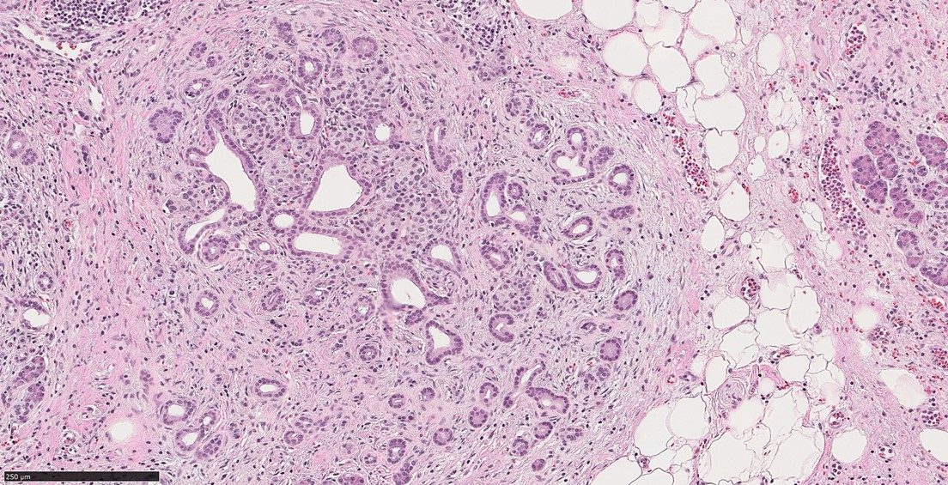
Figure 1 Atrophic glands in a background of chronic pancreatitis (hematoxylin & eosin, 150 ×, scale 250 µm). In a biopsy material it can be challenging to distinguish this morphology from well differentiated pancreatic ductal adenocarcinoma.

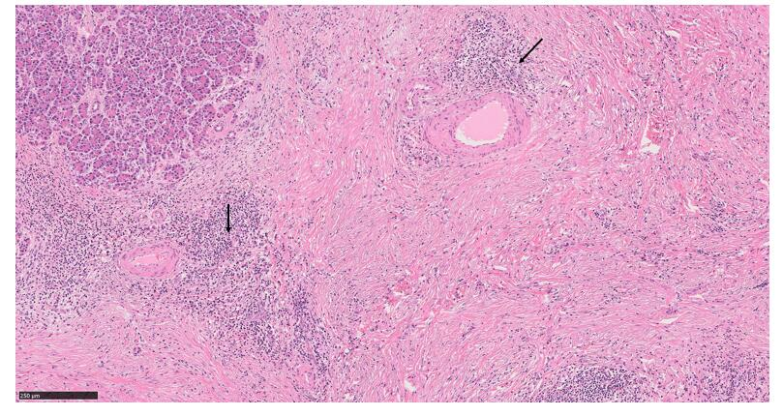
Figure 2 Autoimmune pancreatitis type 1. This image shows characteristic histologic features of this entity: lymphoplasmacytic infiltration, storiform fibrosis and obliterative phlebitis (arrows) (hematoxylin & eosin, 100 ×, scale 250 µm).

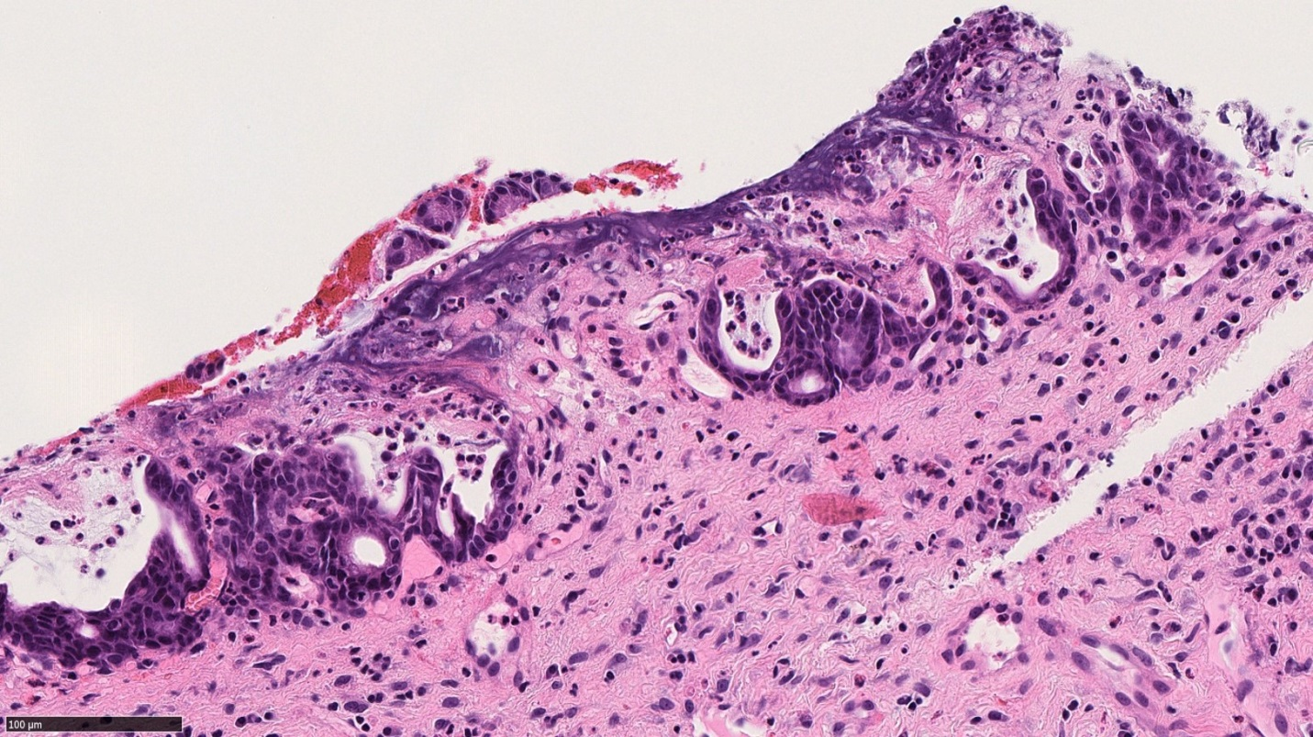
Figure 3 Autoimmune pancreatitis type 2. This image shows granulocytic infiltration of pancreatic ducts (hematoxylin & eosin, 300 ×, scale 100 µm).

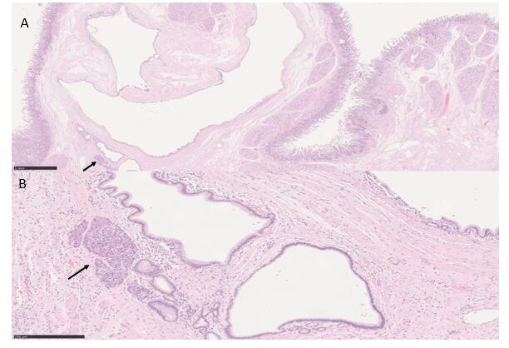
Figure 4 Paraduodenal pancreatitis. A: This image shows cyst formation, Brunner gland hyperplasia, and ectopic pancreatic tissue (solid arrow) with associated inflammation, consistent with paraduodenal pancreatitis, in a patient with history of significant alcohol use [hematoxylin & eosin (H&E), 20 ×, scale 1 mm]; B: A higher magnification to show the ectopic pancreatic tissue in association with other elements (H&E, 130 ×, scale 250 µm).

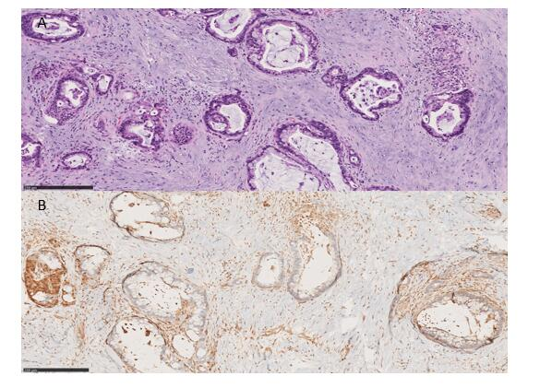
Figure 5 Pancreatic ductal adenocarcinoma. A: The ducts show features of malignancy including cytologic atypia and incomplete gland formation with loss of lobular architecture, in a prominent desmoplastic stroma (hematoxylin & eosin, 130 ×, scale 250 µm); B: SMAD4 immunostaining shows loss of SMAD4 expression in the malignant glands (SMAD4, 120 ×, scale 250 µm).

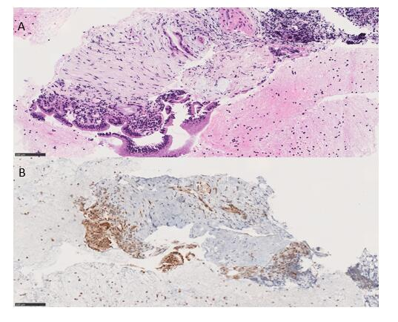
Figure 6 Pancreatic mass biopsy showing a minute focus of atypical glandular structure, highly suspicious for carcinoma. A: The atypical glands are surrounded by desmoplastic stromal reaction (hematoxylin & eosin, 190 ×, scale 100 µm); B: The atypical glands retain SMAD4 expression; this staining pattern does not rule out malignancy (SMAD4, 190 ×, scale 100 µm).

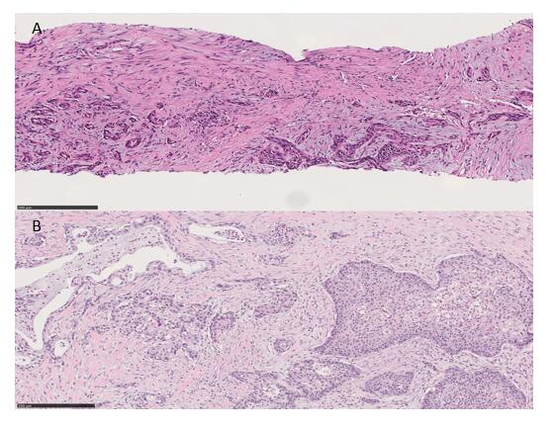
Figure 7 Adenosquamous carcinoma of the pancreas. A: Adenosquamous carcinoma of the pancreas in a biopsy material. Both squamous component (right) and glandular component (left) are found in this field [hematoxylin & eosin (H&E), 140 ×, scale 250 µm]; B: Adenosquamous carcinoma of the pancreas in a resection material. Squamous nests are noted (right). The glandular counterpart shows typical features to pancreatic ductal adenocarcinoma (left) (H&E, 136 ×, scale 250 µm).

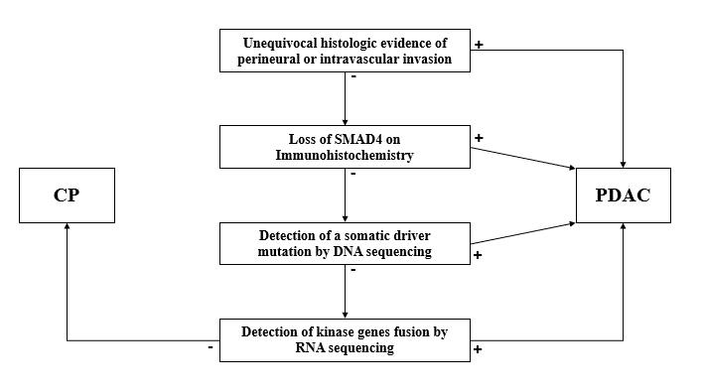
Figure 8 An algorithm outlining the steps for the microscopic, immunohistochemical and molecular work up of pancreatic ductal adenocarcinoma vs chronic pancreatitis. CP: Chronic pancreatitis; PDAC: Pancreatic ductal adenocarcinoma.

Table 1 Distinctive histologic features of pancreatic ductal adenocarcinoma and its benign mimics
PDAC | CP | AIP | PDP
Perineural invasion; Perivascular invasion; Naked glands in adipose tissue; Desmoplasia; Anisonucleosis (4:1 nuclear size variation) | Intact lobular architecture; Fibrosis; Secretory plugs | Type I: Dense lymphoplasmacytic infiltrate with an increased IgG4 expression; Storiform fibrosis; Obliterative phlebitis  Type II: Granulocytes in the ductal epithelium; Absent IgG4 positive cells | Duodenal wall thickening; Brunner gland hyperplasia; Smooth muscle hyperplasia; Heterotopic pancreatic tissue
PDAC: Pancreatic ductal adenocarcinoma; CP: Chronic pancreatitis; AIP: Autoimmune pancreatitis; PDP: Paraduodenal pancreatitis.

Table 2 Summary of morphologic features and altered genes of pancreatic ductal adenocarcinoma subtypes
Subtype | Colloid | Medullary | Adenosquamous | Hepatoid | Signet ring cell
Morphologic features | More than 80% of extracellular mucin; Focal signet-ring cells can be seen | Minimal glandular differentiation; Syncytial growth pattern; Abundant inflammatory infiltrate | More than 30% of squamous differentiation | More than 50% of hepatocellular differentiation | More than 80% of signet ring cell component
Altered genes | GNAS; ATM | MMR genes; POLE | SMAD4; CDKN2A | BAP1; Notch1 | NA
MMR: Mismatch repair; NA: Not available.

