Name of Journal: World Journal of Clinical Cases
Manuscript NO: 89620
Manuscript Type: SYSTEMATIC REVIEWS

Emerging roles of microRNAs as diagnostics and potential therapeutic interest in type 2 diabetes mellitus

Shrivastav D et al. miRNAs in diabetes and AGE/RAGE axis

Dharmsheel Shrivastav, Desh Deepak Singh

Dharmsheel Shrivastav, Desh Deepak Singh, Amity Institute of Biotechnology, Amity University Rajasthan, Jaipur 303002, India

Author contributions: Shrivastav D and Singh DD design and written the manuscript and all data were generated in-house and that no paper mill was used.

Corresponding author: Desh Deepak Singh, PhD, Associate Professor, Amity Institute of Biotechnology, Amity University Rajasthan, SP-1, Kant Kalwar, RIICO Industrial Area, NH-11C, Jaipur 303002, Rajasthan, India. ddsbms@gmail.com

Received: November 7, 2023
Revised: December 18, 2023
Accepted: January 3, 2024
Published online: January 26, 2024

Abstract
BACKGROUND
Type 2 diabetes mellitus (T2DM) is a metabolic disease of impaired glucose utilization. Uncontrolled high sugar levels lead to advanced glycation end products (AGEs), which affects several metabolic pathways by its receptor of advanced glycation end products (RAGE) and causes diabetic complication. MiRNAs are small RNA molecules which regulate genes linked to diabetes and affect AGEs pathogenesis, and target tissues, influencing health and disease processes.

AIM
To explore miRNA roles in T2DM's metabolic pathways for potential therapeutic and diagnostic advancements in diabetes complications.

METHODS
We systematically searched the electronic database PubMed using keywords. We included free, full-length research articles that evaluate the role of miRNAs in T2DM and its complications, focusing on genetic and molecular disease mechanisms. After assessing the full-length papers of the shortlisted articles, we included 12 research articles.

RESULTS
Several types of miRNAs are linked in metabolic pathways which are affected by AGE/RAGE axis in T2DM and its complications. miR-96-5p, miR-7-5p, miR-132, has_circ_0071106, miR-143, miR-21, miR-145-5p, and more are associated with various aspects of T2DM, including disease risk, diagnostic markers, complications, and gene regulation.

CONCLUSION
Targeting the AGE/RAGE axis, with a focus on miRNA regulation, holds promise for managing T2DM and its complications. MiRNAs have therapeutic potential as they can influence the metabolic pathways affected by AGEs and RAGE, potentially reducing inflammation, oxidative stress, and vascular complications. Additionally, miRNAs may serve as early diagnostic biomarkers for T2DM. Further research in this area may lead to innovative therapeutic strategies for diabetes and its associated complications.

Key Words: Type 2 diabetes mellitus; MicroRNAs; Advanced glycation end products; Receptor for advanced glycation end products

©The Author(s) 2024. Published by Baishideng Publishing Group Inc. All rights reserved.

Citation: Shrivastav D, Singh DD. Emerging roles of microRNAs as diagnostics and potential therapeutic interest in type 2 diabetes mellitus. World J Clin Cases 2024; 12(3): 525-537
URL: https://www.wjgnet.com/2307-8960/full/v12/i3/525.htm
DOI: https://dx.doi.org/10.12998/wjcc.v12.i3.525

Core Tip: Type 2 diabetes mellitus (T2DM) is a worldwide problem characterized by uncontrolled hyperglycemia. In T2DM, elevated glucose bound proteins and leading to formation advanced glycation end products. miRNAs play a major role in gene regulation of different proteins which are involved in various metabolic pathways including nuclear factor kappa beta, protein kinase C, and phosphoinositide-3-kinase–protein kinase B/Akt which are responsible for blood glucose and insulin secretion and T2DM. The target of these miRNA changes the regulation of metabolic pathways which can reduce oxidative stress and inflammation. So, the modulate the regulation of these miRNA could be possible approach of the treatment of T2DM.

INTRODUCTION
Type 2 diabetes mellitus (T2DM) characterizes by hyperglycemia which is a metabolic disorder affecting 400 million people worldwide, and projections by the World Health Organization estimate this number will rise to 600 million by 2040^{[1]}.
The main cause of diabetes is inadequate insulin production, which results from pancreatic cell dysfunction or reduced responsiveness of glucose receptors^{[2]}. In diabetes, elevated glucose levels are the primary contributors. In diabetic individuals, inadequate management of blood sugar levels is linked to the formation of advanced glycation end products (AGEs) which play an important role in the acceleration of vascular disease^{[3]}. AGEs are the result of a non-enzymatic reaction between the carbonyl group of reducing sugars and the amino groups of proteins and lipids. This process starts with the formation of Schiff bases, followed by Amadori rearrangement and oxidative modification, collectively known as the Maillard reaction (Figure 1)^{[4]}. Under normal physiological conditions, glycation is a spontaneous process contingent upon substrate availability^{[5]}. However, in diabetes, elevated glucose levels accelerate the glycation of various functional and structural proteins.
AGEs' pathophysiology can be categorized into two distinct mechanisms. In the first method, AGEs form direct associations with extracellular matrix proteins, including collagen, elastin, laminin, and vitronectin, through trapping, cross-linking, and intramolecular AGE-AGE covalent bonds^{[6,7]}. In the basement membrane, crosslinking of AGEs to collagen IV and elastin increases rigidity and decreases susceptibility to proteolytic digestion, thereby increasing vascular stiffness and causing diastolic dysfunction^{[8]}. Furthermore, AGEs alter the structure of low-density lipoproteins (LDL) through glycation and form glycosylated LDL, which prevent their normal physiological excretion. Glycosylated low-density lipoprotein cholesterol (LDL-C) is absorbed by circulatory monocytes or mast cells and produces foam cells^{[9]}. In the second mechanism, AGEs interact with Receptor for advanced glycation end products (RAGEs), specific cell surface receptors for AGEs^{[10]}. RAGE, a 404-amino acid transmembrane receptor belonging to the immunoglobulin superfamily, plays a central role in mediating cellular dysfunction over an extended period, giving rise to "metabolic memory," characterized by prolonged activation of nuclear factor kappa beta (NF-κB), inflammation, and oxidative stress^{[11]}. This interaction triggers signal transduction, activating various intracellular signaling molecules, including Extracellular signal-regulated protein kinases 1/2, phosphoinositide-3-kinase–protein kinase B/Akt (PI3/Akt), and Janus kinase/signal transducers and activators of transcription, ultimately resulting in the activation of NF-κB and the upregulation of tumor necrosis factor (TNF-α), C-reactive protein, and interleukin -6 (IL-6) mRNA expression^{[12]}.
MicroRNAs, a subclass of small non-coding RNA molecules with an average length of less than 200 nucleotides which are essential regulators of post-transcriptional gene expression. These minuscule genetic components are found extensively in a variety of bodily fluids, including as serum, urine, plasma, and saliva. They are also encased in donor cell exosomes and macrovesicles^{[13]}. MiRNA expression significantly influences the regulation of complex genomic, metabolic, and physiological cellular signaling cascades^{[14]}. Altered miRNA expression disrupts the function of various genes, leading to pathophysiological changes and can play a major role in various disease pathogenesis including cancer^{[15]}, Alzheimer's disease^{[16]}, spinal cord injury^{[17]}, epilepsy^{[18]}, neurodegenerative diseases^{[19]}, cardiac diseases^{[20]}, infectious diseases^{[21]}, and diabetes^{[22]}. Various miRNAs have been identified in different stages and types of diabetes. For instance, miR-148a-3p is consistently found in all stages of Type 1 diabetes mellitus (T1DM), indicating its potential as an early biomarker specific to T1DM etiology^{[23,24]}. miR-25 exhibits high expression in individuals newly diagnosed with T1DM^{[25]}. MiR-142, miR-126, and miR-21 are commonly associated with obesity, prediabetes, and T2DM^{[26]}. MiR-375 is shared by both prediabetes and T2DM patients, indicating its early involvement in T2DM pathogenesis^{[27]}. MiR-342-3p is shared among individuals with gestational diabetes mellitus (GDM), those at risk of developing T1DM, and T1DM patients, while miR-210 is shared between GDM and long-standing T1DM cases^{[28]}. miR-126 expression in T2DM patients compared to healthy individuals and proposed its potential use as a circulating biomarker for the early detection of T2DM. Additionally, individuals with miR-126 cycle threshold (relative quantification unit) values greater than 35 may develop T2DM over a two-year period^{[29]}. MiR-320 is downregulated in the context of hyperglycemia, AGEs, and diabetes. Overexpression of miR320 can reverse this effect by targeting vascular endothelial growth factor (VEGF). MiR-141 is upregulated in T2DM and affects INS-1 β cell proliferation and glucose-stimulated insulin secretion. Silencing miR-141 reduces T2DM-associated damage^{[30]}.
In this review, we comprehensively analyze the preclinical and clinical evidence regarding the role of miRNAs in the metabolic pathways activated by the AGE/RAGE axis and explore their potential in therapeutic interventions.

MATERIALS AND METHODS
The literature search was carried out in the PubMed NCBI database. The search strategy was carried out by combining "MicroRNAs" [Mesh AND "Glycation End Products, Advanced" [Mesh AND "Diabetes Mellitus, Type 2"] with each other using boolean operators. At the start of a literature search, search the NCBI PubMed data base. After applying filters for “free full text, in the last 5 years (2018–2023)" and further limiting it to English language research papers.
At the start of the literature search, the NCBI PubMed database showed 37 articles. After applying filters, limit the search to “full text in the last 5 years (2018–2023),” which gives 12 studies (Figure 2 and Table 1). Only full-length research articles are included.

RESULTS
After conducting a comprehensive literature search in the PubMed database, we found that in T2DM, miRNA plays a significant role in regulating the genetic and molecular mechanisms underlying the disease (Table 1).
miR-96-5p and miR-7-5p are potentially modulated gene and plays a major role in T2DM and osteoporosis, These miRNAs are involved in the phosphoinositide 3-kinase (PI3K)-Akt signalling pathway and the AGE-RAGE signalling pathway in diabetic complications, which may play a significant role in diabetic skeletal fragility^{[31]}. Over expression of miR-132 was identified in mild cognitive impairment (MCI) among patients with T2DM and emerged as a potential diagnostic biomarker for MCI in these patients^{[32]}. has_circ_0071106 increases the risk of T2DM by effecting protein binding and gene transcription, may be involved in the pathway of hsa-miR-29a-5p regulating diabetes, and could potentially serve as a diagnostic marker^{[33]}. The upregulated expression of miR-143 in the presence of the CC genotype of rs4705342 increases the risk of T2DM and potentially associated with higher levels of LDL-C, fasting blood glucose, and glycated haemoglobin^{[34]}. miR-21 expression is positively associated with glycosylated haemoglobin (HbA1c), fasting blood sugar, and triglyceride and can be considered a non-invasive and rapid tool for distinguishing individuals with pre-T2DM and T2DM from healthy individuals^{[35]}. miR-145-5p and miR-483-3p/5p control TP53-mediated apoptosis in T2DM. They also observed a significant fold change in miR-138-5p, miR-192-5p, miR-195-5p, miR-320b, and let-7a-5p in T2DM, all of which are involved in beta cell dysfunction^{[36]}. miR-let-7g-5p expression is suppressed by ET-1 (endothelin-1), subsequently leading to increased TNF-α and IL-6 expression in a dose-dependent manner. This suppression of miR-let-7g-5p contributes to reduced fat metabolism and increases inflammation, promoting myopathy^{[37]}. Taylor et al^{[38]} identified 84 heritable miRNAs and 5 miRNA-expression (miR-216a, miR-25, miR-30a-3p, and miR-30a-5p) quantitative trait loci associated with blood glucose and glycated HbA1c levels. miRNA-152-3p expression, despite initial consideration ineffectiveness as a prognostic indicator for the progression to end-stage renal disease, unlike serum CX3CL1 levels and urinary IgG, which showed promising efficacy in early prediction of nephropathy^{[39]}. Cirilli et al^{[40]} assessed the correlation between the amount of daily exercise recorded with a wearable gravitometer and selected biochemical and clinical parameters in sedentary T2D patients. The authors suggested that in the high-exercise group, miRNA-146a decreased, reducing inflammation and regulating systolic blood pressure, while the upregulation of microRNA-130a decreased HbA1c levels. Furthermore, the authors concluded that these miRNAs can serve as potential biomarkers for further investigation in T2DM^{[40]}. miR-24-3p expression, in conjunction with elevated reactive oxygen species (ROS) levels due to glycated albumin, contributes to the reduction in TRPM6 expression within renal tubular epithelial cells of type 2 diabetes (T2D)^{[41]}. Witkowski et al^{[42]} suggested that supplementation with metformin increases tissue factor expression by reducing lipopolysaccharide, indicating its potential for vascular protective properties and can regulate microRNA synthesis.

DISCUSSION
MiRNAs are crucial in regulating diabetic complications, especially in the context of AGE and RAGE-related processes. They play a key role in controlling important signaling pathways like NF-κB, protein kinase C (PKC), PI3K, and nitric oxide, which are essential in diabetic complication development (Table 2)^{[43]}.

Role of miRNA in AGE/RAGE targeted metabolic signaling pathways
The AGEs/RAGE axis initiates a complex signaling cascade involving various signaling molecules and transcription factors, and the synthesis of these factors is under the influence of miRNAs. The involvement of miRNAs in the AGEs/RAGE targeted metabolic pathways is discussed below.

Regulation of the NF-κB Pathway by miRNA: NF-κB, is a heterodimeric transcription factor that can efficiently bind to the target gene's regulatory region (promoter or/and enhancer)^{[44]}. The AGEs/RAGE axis, as well as the generation of oxidative stress, activate the NF-κB pathway and increase the pro-inflammatory response in diabetes^{[45]}. NF-κB activation is required for cellular proliferation and migration under physiological conditions. NF-κB significant release of cytokines including IL-1, IL-6, CD36, TNF-α, and Monocyte Chemoattractant Protein-1 as well as chemokines, tumor growth factor (TGF), and vesicular cell adhesion molecules, eventually leading to vascular damage^{[46]}. NF-κB dependent miR124, controls cytokine signaling in hyperglycemic conditions. The overexpression of miR124 downregulates exocytosis and decreases glucose-mediated insulin release^{[47]}. The relationship between microRNAs and NF-κβ across various health conditions, miR-21 showed an up-regulation in cases of Metabolic syndrome and obesity^{[48]}. miR-124 down-regulation in diabetic condition^{[49]}. miR-471-3p exhibited an up-regulation in instances of diabetic cardiomyopathy^{[50]}, and miR-46a displayed an up-regulation in cases of Hyperlipidemia^{[51]}. Conversely, both miR-200b and miR-200c were down-regulated in relation to NF-κβ^{[52]} (Figure 3).

Regulation of PKC pathway by miRNA: The interaction between AGEs/RAGE triggers the PKC (protein kinase C) pathway, promoting fibrosis and inflammation. Elevated glucose levels in diabetes result in increased diacylglycerol (DAG) synthesis through a de novo method, which upregulates the PKC pathway. MiRNAs have been found to regulate the PKC pathway in various diabetic complications^{[53]}. miR-210 downregulation plays a protective role in T2DM by regulating endothelial function. MiR-210 also mitigates AGE-mediated activation of JNK (c-Jun N-terminal kinase) and PKC, reversing pathological conditions in cardiomyocytes^{[54]}. MiR-25 regulates the AGE/RAGE-activated PKC pathway in diabetic nephropathy, inhibiting PKC phosphorylation and reducing oxidative stress^{[55]}. Furthermore, miR-21-3p upregulation in diabetic atherosclerosis inhibits ROS generation and promotes RAGE/NADPH (nicotinamide adenine dinucleotide phosphate hydrogen) oxidase signaling^{[56]}. Exposure to AGEs on diabetic endothelial cells increases the expression of miR-92a, which causes endothelium dysfunction and decreases the expression of heme oxygenase-1 and increases oxidative stress. Inhibition of miR-92a up-regulates the expression of heme oxygenase-1 and reverses endothelium dysfunction^{[57]} (Figure 4).

Regulation of the nitric oxide pathway by miRNA: Diabetes leads to endothelial dysfunction, partly due to reduced nitric oxide (NO) production. The AGEs/RAGE interaction lowers eNOS (endothelial Nitric Oxide Synthase) and NO levels, leading to endothelial dysfunction and an increased risk of cardiovascular diseases. MiRNAs also have a role in the regulation of NO pathway^{[58]}. In diabetic mice, miR-185 downregulation increases ROS generation and decreases NO levels. Treatment with Huayu Tongmai Granules can reverse these effects^{[59]}. MiR-195 and miR-582 upregulation in deep vein thrombosis affects NOS3 (nitric oxide synthase 3) expression and NO levels, contributing to the pathogenesis^{[60]} (Figure 5).

Regulation of the PI3K/AKT pathway by miRNAs: The PI3K/AKT pathway is essential for glucose and lipid metabolism, insulin secretion, and cellular glucose uptake. In diabetes, AGEs disrupt this pathway, leading to insulin resistance^{[61]}. Various miRNAs are involved in the regulation of the PI3K/AKT pathway. MiR-29b-3p, miR-29c-3p, miR-93-5p, miR-150-5p, miR-199a-5p, miR-345-3p, and miR-532-3p are all implicated in the downregulation of the slc2a4 gene and GLUT-4 expression, affecting glucose metabolism^{[62]}. MiR-25-3p modulates epithelial-mesenchymal transition in endothelial cells, affecting the PI3K/AKT pathway^{[63]}. MiR-214 downregulates oxidative stress in diabetic nephropathy by targeting the ROS/Akt/mTOR pathway^{[64]}. MiR-203 upregulation slows wound healing in diabetic foot ulcers by targeting the PI3/AKT/mTOR signaling pathway^{[65]}. Similarly, down-regulation of miR-129-5p and miR-146b-3p while showed an up-regulation of miR-191 and miR-29b-3p regulate the PI3K/AKT pathway^{[66-69]} (Figure 6).

MiRNA as therapeutics in diabetes mellitus
MiRNAs are thought to have a role in regulating various biological processes. This regulation can involve the direct targeting of specific tissues or cell types, potentially regulate both physiological and pathological processes^{[70]}. Due to this, researchers looking into alternative therapeutic approaches based on miRNA alteration have started to gain greater attention. Numerous techniques and strategies have recently been created to correct the dysregulated expression (overexpression or under expression) of miRNAs.
miRNAs' expression in metabolic disease and reported therapeutic approaches are given in Table 3. Lin et al^{[54]} suggested the therapeutic role of miR-210 in AGEs-exposed cardiomyocytes by using a miR-210 mimic and hypothesised that downregulation of miR-210 in AGEs-induced cardiomyocytes would reduce PKC-enhanced JNK-dependent mitochondrial damage. Chen et al^{[71]} suggested that downregulation of miR-29b plays a role in the development of diabetic nephropathy. MiR-29b therapy using an ultrasound-microbubble-mediated gene transfer technique can improve TGF-/Smad3-dependent renal fibrosis, NF-mediated renal inflammation, and reverse pathological changes. Similarly, the overexpression of miR-146a can significantly improve AGE-mediated pathological effects in the development of diabetic foot ulcers through miRNA mimicry^{[72]}. Another study shows that the overexpression of miRNA-339-5p ameliorates the AGES-induced complications in vascular endothelial progenitor cells in patients with PCOS by targeting PI3K, AKT, SIRT1, and PGC-1α by transfection with miRNA-339-5p mimic^{[73]}. The administration of RAGE-antagonist peptide (antagomir-21) in intracranial glioblastoma nanoparticles can reduce miR-21 Levels and enhance tumour cell poptosis. Furthermore, it inhibits RAGE expression and lowers VEGF levels in tumour cells^{[74]}. Trajkovski et al^{[75]} modified anti-miRNA oligonucleotides were administered to ob/ob mice and HFD-C57BL/6J by tail-vein injection to suppress both miR-107 and miR-103 in adipose tissue and liver, and they suggested that inhibition of miR-107 and miR-103 can improve insulin sensitivity in the liver and adipose tissues. In cerebral ischemia, hypoxia-induced RAGE plays a significant role, which is regulated by miR-181a. Kim et al^{[76]} suggested that the administration of AMO181a-chol-loaded exosomes (anti-microRNA oligonucleotide) downregulates the expression of miR-181a and reduces the damage to the ischemic brain. Apoptosis and TNF expression were also reduced.
MiRNAs play a complex role in various metabolic process especially related to AGE and RAGE. Understanding on miRNAs in regulation of pathways like NF-κB, PKC, Nitric Oxide, and PI3/AKT highlights their crucial importance in diabetes. However, beyond delineating these pathways, comprehending the broader implications of these findings is crucial for advancing therapeutic interventions in diabetes. These revelations open avenues for targeted therapeutic interventions that might potentially alleviate these complications, thereby mitigating the burden of diabetic-related cardiovascular disease.

Clinical implications and translation
Exploring the therapeutic potential of targeting specific miRNAs to modulate these pathways could revolutionize diabetes management. While current studies show promise in animal models and in vitro experiments. For miRNA-based therapies to be validated and effectively used as a therapeutic intervention for diabetes complications, more preclinical and clinical research is needed.

Limitations and future prospects
Despite the strides made in understanding miRNA-mediated mechanisms, several limitations persist. Comprehensive research is necessary to identify more miRNA-target interactions due to the intricate control of miRNA and the dynamic nature of cellular responses. Additionally, the translation of these findings from bench to bedside necessitates meticulous attention to the safety, efficacy, and delivery strategies of miRNA-based therapeutics.
Future research endeavours should focus on comprehensively elucidating the regulatory networks involving miRNAs in diabetic complications. Addressing the specific roles of understudied or newly discovered miRNAs in different diabetic complications could provide a more holistic understanding. Moreover, exploring innovative delivery systems and improving bioavailability could enhance the feasibility of miRNA-based therapeutics in clinical settings.

CONCLUSION
Targeting the AGE/RAGE axis, with a focus on miRNA regulation, holds promise for managing T2DM and its complications. MiRNAs have therapeutic potential as they can influence the metabolic pathways affected by AGEs and RAGE, potentially reducing inflammation, oxidative stress, and vascular complications. Additionally, miRNAs may serve as early diagnostic biomarkers for T2DM. Further research in this area may lead to innovative therapeutic strategies for diabetes and its associated complications.

ARTICLE HIGHLIGHTS
Research background
Type 2 diabetes mellitus (T2DM) as a metabolic disorder due to impaired glucose utilization. Uncontrolled high sugar levels generate advanced glycation end products (AGEs) via receptor of advanced glycation end products (RAGE) receptor, causing complications. MiRNAs regulate genes linked to diabetes, impacting AGEs pathogenesis and influencing T2DM aspects—risk, diagnostics, complications, and therapeutic potential in managing metabolic pathways, inflammation, oxidative stress, and vascular complications. MiRNAs also hold promise as early diagnostic biomarkers, paving the way for innovative diabetes therapies.

Research motivation
Understanding miRNA roles in T2DM's metabolic pathways and their influence on AGEs/RAGE axis presents therapeutic prospects for managing diabetes complications. Identifying miRNAs as diagnostic markers could revolutionize early intervention strategies. Exploring their impact on gene regulation offers insights for innovative therapeutic targets, potentially mitigating diabetes-related complexities.

Research objectives
To investigate the regulatory role of specific miRNAs in T2DM's metabolic pathways affected by AGEs/RAGE axis, exploring their potential as diagnostic markers and therapeutic targets for managing diabetes complications.

Research methods
The study systematically searched PubMed using specific keywords to identify free, full-length research articles evaluating miRNA involvement in T2DM and its complications. Twelve articles were selected after assessing relevance to genetic and molecular disease mechanisms. The investigation focused on miRNA impact on AGEs/RAGE axis and their associations with T2DM aspects.

Research results
Multiple miRNAs, including miR-96-5p, miR-7-5p, miR-132, has_circ_0071106, miR-143, miR-21, miR-145-5p, exhibit links to diverse facets of T2DM—risk, diagnostics, complications, and gene regulation. These miRNAs are intricately associated with metabolic pathways affected by the AGEs/RAGE axis, illuminating potential roles as diagnostic markers and therapeutic targets for managing T2DM complexities.

Research conclusions
Targeting the AGEs/RAGE axis via miRNA regulation holds promise for managing T2DM complexities. MiRNAs offer therapeutic potential by influencing affected metabolic pathways, potentially mitigating inflammation, oxidative stress, and vascular complications. Moreover, their role as early diagnostic biomarkers suggests innovative strategies for addressing diabetes and its associated complications.

Research perspectives
Further exploration of miRNA-mediated regulation in the context of the AGEs/RAGE axis holds significant promise for advancing T2DM management. Investigating specific miRNAs' functional roles could unveil novel therapeutic avenues, potentially targeting metabolic pathways to alleviate complications. Additionally, validating miRNAs as reliable early diagnostic markers might revolutionize diabetes intervention strategies.

REFERENCES
1 Saeedi P, Petersohn I, Salpea P, Malanda B, Karuranga S, Unwin N, Colagiuri S, Guariguata L, Motala AA, Ogurtsova K, Shaw JE, Bright D, Williams R; IDF Diabetes Atlas Committee. Global and regional diabetes prevalence estimates for 2019 and projections for 2030 and 2045: Results from the International Diabetes Federation Diabetes Atlas, 9(th) edition. Diabetes Res Clin Pract 2019; 157: 107843 [PMID: 31518657 DOI: 10.1016/j.diabres.2019.107843]
2 Cerf ME. Beta cell dysfunction and insulin resistance. Front Endocrinol (Lausanne) 2013; 4: 37 [PMID: 23542897 DOI: 10.3389/fendo.2013.00037]
3 Peppa M, Vlassara H. Advanced glycation end products and diabetic complications: a general overview. Hormones (Athens) 2005; 4: 28-37 [PMID: 16574629 DOI: 10.14310/horm.2002.11140]
4 Singh VP, Bali A, Singh N, Jaggi AS. Advanced glycation end products and diabetic complications. Korean J Physiol Pharmacol 2014; 18: 1-14 [PMID: 24634591 DOI: 10.4196/kjpp.2014.18.1.1]
5 Younus H, Anwar S. Prevention of non-enzymatic glycosylation (glycation): Implication in the treatment of diabetic complication. Int J Health Sci (Qassim) 2016; 10: 261-277 [PMID: 27103908 DOI: 10.12816/0048818]
6 Sharma C, Kaur A, Thind SS, Singh B, Raina S. Advanced glycation End-products (AGEs): an emerging concern for processed food industries. J Food Sci Technol 2015; 52: 7561-7576 [PMID: 26604334 DOI: 10.1007/s13197-015-1851-y]
7 Fedintsev A, Moskalev A. Stochastic non-enzymatic modification of long-lived macromolecules - A missing hallmark of aging. Ageing Res Rev 2020; 62: 101097 [PMID: 32540391 DOI: 10.1016/j.arr.2020.101097]
8 Aronson D. Cross-linking of glycated collagen in the pathogenesis of arterial and myocardial stiffening of aging and diabetes. J Hypertens 2003; 21: 3-12 [PMID: 12544424 DOI: 10.1097/00004872-200301000-00002]
9 Rafieian-Kopaei M, Setorki M, Doudi M, Baradaran A, Nasri H. Atherosclerosis: process, indicators, risk factors and new hopes. Int J Prev Med 2014; 5: 927-946 [PMID: 25489440]
10 Lue LF, Walker DG, Jacobson S, Sabbagh M. Receptor for advanced glycation end products: its role in Alzheimer's disease and other neurological diseases. Future Neurol 2009; 4: 167-177 [PMID: 19885375 DOI: 10.2217/14796708.4.2.167]
11 Rhee SY, Kim YS. The Role of Advanced Glycation End Products in Diabetic Vascular Complications. Diabetes Metab J 2018; 42: 188-195 [PMID: 29885110 DOI: 10.4093/dmj.2017.0105]
12 Younessi P, Yoonessi A. Advanced glycation end-products and their receptor-mediated roles: inflammation and oxidative stress. Iran J Med Sci 2011; 36: 154-166 [PMID: 23358382]
13 Cortez MA, Bueso-Ramos C, Ferdin J, Lopez-Berestein G, Sood AK, Calin GA. MicroRNAs in body fluids--the mix of hormones and biomarkers. Nat Rev Clin Oncol 2011; 8: 467-477 [PMID: 21647195 DOI: 10.1038/nrclinonc.2011.76]
14 Bu H, Wedel S, Cavinato M, Jansen-Dürr P. MicroRNA Regulation of Oxidative Stress-Induced Cellular Senescence. Oxid Med Cell Longev 2017; 2017: 2398696 [PMID: 28593022 DOI: 10.1155/2017/2398696]
15 Galvão-Lima LJ, Morais AHF, Valentim RAM, Barreto EJSS. miRNAs as biomarkers for early cancer detection and their application in the development of new diagnostic tools. Biomed Eng Online 2021; 20: 21 [PMID: 33593374 DOI: 10.1186/s12938-021-00857-9]
16 Angelucci F, Cechova K, Valis M, Kuca K, Zhang B, Hort J. MicroRNAs in Alzheimer's Disease: Diagnostic Markers or Therapeutic Agents? Front Pharmacol 2019; 10: 665 [PMID: 31275145 DOI: 10.3389/fphar.2019.00665]
17 Nieto-Diaz M, Esteban FJ, Reigada D, Muñoz-Galdeano T, Yunta M, Caballero-López M, Navarro-Ruiz R, Del Águila A, Maza RM. MicroRNA dysregulation in spinal cord injury: causes, consequences and therapeutics. Front Cell Neurosci 2014; 8: 53 [PMID: 24701199 DOI: 10.3389/fncel.2014.00053]
18 Henshall DC. MicroRNA and epilepsy: profiling, functions and potential clinical applications. Curr Opin Neurol 2014; 27: 199-205 [PMID: 24553459 DOI: 10.1097/WCO.0000000000000079]
19 Nelson PT, Wang WX, Rajeev BW. MicroRNAs (miRNAs) in neurodegenerative diseases. Brain Pathol 2008; 18: 130-138 [PMID: 18226108 DOI: 10.1111/j.1750-3639.2007.00120.x]
20 Romaine SP, Tomaszewski M, Condorelli G, Samani NJ. MicroRNAs in cardiovascular disease: an introduction for clinicians. Heart 2015; 101: 921-928 [PMID: 25814653 DOI: 10.1136/heartjnl-2013-305402]
21 Tribolet L, Kerr E, Cowled C, Bean AGD, Stewart CR, Dearnley M, Farr RJ. MicroRNA Biomarkers for Infectious Diseases: From Basic Research to Biosensing. Front Microbiol 2020; 11: 1197 [PMID: 32582115 DOI: 10.3389/fmicb.2020.01197]
22 Kim M, Zhang X. The Profiling and Role of miRNAs in Diabetes Mellitus. J Diabetes Clin Res 2019; 1: 5-23 [DOI: 10.33696/diabetes.1.003]
23 Grieco GE, Cataldo D, Ceccarelli E, Nigi L, Catalano G, Brusco N, Mancarella F, Ventriglia G, Fondelli C, Guarino E, Crisci I, Sebastiani G, Dotta F. Serum Levels of miR-148a and miR-21-5p Are Increased in Type 1 Diabetic Patients and Correlated with Markers of Bone Strength and Metabolism. Noncoding RNA 2018; 4 [PMID: 30486455 DOI: 10.3390/ncrna4040037]
24 Assmann TS, Recamonde-Mendoza M, De Souza BM, Crispim D. MicroRNA expression profiles and type 1 diabetes mellitus: systematic review and bioinformatic analysis. Endocr Connect 2017; 6: 773-790 [PMID: 28986402 DOI: 10.1530/EC-17-0248]
25 Nielsen LB, Wang C, Sørensen K, Bang-Berthelsen CH, Hansen L, Andersen ML, Hougaard P, Juul A, Zhang CY, Pociot F, Mortensen HB. Circulating levels of microRNA from children with newly diagnosed type 1 diabetes and healthy controls: evidence that miR-25 associates to residual beta-cell function and glycaemic control during disease progression. Exp Diabetes Res 2012; 2012: 896362 [PMID: 22829805 DOI: 10.1155/2012/896362]
26 Demirsoy İH, Ertural DY, Balci Ş, Çınkır Ü, Sezer K, Tamer L, Aras N. Profiles of Circulating MiRNAs Following Metformin Treatment in Patients with Type 2 Diabetes. J Med Biochem 2018; 37: 499-506 [PMID: 30584410 DOI: 10.2478/jomb-2018-0009]
27 Patoulias DI. Is miRNA-375 a promising biomarker for early detection and monitoring of patients with type 2 diabetes? Arch Med Sci Atheroscler Dis 2018; 3: e119-e122 [PMID: 30775601 DOI: 10.5114/amsad.2018.78775]
28 Jiang ZH, Tang YZ, Song HN, Yang M, Li B, Ni CL. miRNA-342 suppresses renal interstitial fibrosis in diabetic nephropathy by targeting SOX6. Int J Mol Med 2020; 45: 45-52 [PMID: 31746345 DOI: 10.3892/ijmm.2019.4388]
29 Zhang T, Lv C, Li L, Chen S, Liu S, Wang C, Su B. Plasma miR-126 is a potential biomarker for early prediction of type 2 diabetes mellitus in susceptible individuals. Biomed Res Int 2013; 2013: 761617 [PMID: 24455723 DOI: 10.1155/2013/761617]
30 Du H, Yin Z, Zhao Y, Li H, Dai B, Fan J, He M, Nie X, Wang CY, Wang DW, Chen C. miR-320a induces pancreatic β cells dysfunction in diabetes by inhibiting MafF. Mol Ther Nucleic Acids 2021; 26: 444-457 [PMID: 34631276 DOI: 10.1016/j.omtn.2021.08.027]
31 Mo L, Wang Z, Huang H, Li J, Ma C, Zhang J, Huang F, He W, Liu Y, Zhou C. Integrated Analysis of Crucial Genes and miRNAs Associated with Osteoporotic Fracture of Type 2 Diabetes. Biomed Res Int 2022; 2022: 3921570 [PMID: 35993048 DOI: 10.1155/2022/3921570]
32 Salama II, Sami SM, Abdellatif GA, Mohsen A, Rasmy H, Kamel SA, Ibrahim MH, Mostafa M, Fouad WA, Raslan HM. Plasma microRNAs biomarkers in mild cognitive impairment among patients with type 2 diabetes mellitus. PLoS One 2020; 15: e0236453 [PMID: 32726329 DOI: 10.1371/journal.pone.0236453]
33 Yingying Z, Yongji Y, Qiuting C, Rifang L, Zhuanping Z. has_circ_0071106 can be used as a diagnostic marker for type 2 diabetes. Int J Med Sci 2021; 18: 2312-2320 [PMID: 33967607 DOI: 10.7150/ijms.52575]
34 Kong D, Duan Y, Wang J, Liu Y. A functional polymorphism of microRNA-143 is associated with the risk of type 2 diabetes mellitus in the northern Chinese Han population. Front Endocrinol (Lausanne) 2022; 13: 994953 [PMID: 36213264 DOI: 10.3389/fendo.2022.994953]
35 Yazdanpanah Z, Kazemipour N, Kalantar SM, Vahidi Mehrjardi MY. Plasma miR-21 as a potential predictor in prediabetic individuals with a positive family history of type 2 diabetes mellitus. Physiol Rep 2022; 10: e15163 [PMID: 35076188 DOI: 10.14814/phy2.15163]
36 Nunez Lopez YO, Retnakaran R, Zinman B, Pratley RE, Seyhan AA. Predicting and understanding the response to short-term intensive insulin therapy in people with early type 2 diabetes. Mol Metab 2019; 20: 63-78 [PMID: 30503831 DOI: 10.1016/j.molmet.2018.11.003]
37 Tsai CH, Huang PJ, Lee IT, Chen CM, Wu MH. Endothelin-1-mediated miR-let-7g-5p triggers interlukin-6 and TNF-α to cause myopathy and chronic adipose inflammation in elderly patients with diabetes mellitus. Aging (Albany NY) 2022; 14: 3633-3651 [PMID: 35468098 DOI: 10.18632/aging.204034]
38 Taylor HJ, Hung YH, Narisu N, Erdos MR, Kanke M, Yan T, Grenko CM, Swift AJ, Bonnycastle LL, Sethupathy P, Collins FS, Taylor DL. Human pancreatic islet microRNAs implicated in diabetes and related traits by large-scale genetic analysis. Proc Natl Acad Sci U S A 2023; 120: e2206797120 [PMID: 36757889 DOI: 10.1073/pnas.2206797120]
39 Abdou AE, Anani HAA, Ibrahim HF, Ebrahem EE, Seliem N, Youssef EMI, Ghoraba NM, Hassan AS, Ramadan MAA, Mahmoud E, Issa S, Maghraby HM, Abdelrahman EK, Hassan HAM. Urinary IgG, serum CX3CL1 and miRNA-152-3p: as predictors of nephropathy in Egyptian type 2 diabetic patients. Tissue Barriers 2022; 10: 1994823 [PMID: 34689723 DOI: 10.1080/21688370.2021.1994823]
40 Cirilli I, Silvestri S, Marcheggiani F, Olivieri F, Galeazzi R, Antonicelli R, Recchioni R, Marcheselli F, Bacchetti T, Tiano L, Orlando P. Three Months Monitored Metabolic Fitness Modulates Cardiovascular Risk Factors in Diabetic Patients. Diabetes Metab J 2019; 43: 893-897 [PMID: 31339009 DOI: 10.4093/dmj.2018.0254]
41 Hirota C, Takashina Y, Yoshino Y, Hasegawa H, Okamoto E, Matsunaga T, Ikari A. Reactive Oxygen Species Downregulate Transient Receptor Potential Melastatin 6 Expression Mediated by the Elevation of miR-24-3p in Renal Tubular Epithelial Cells. Cells 2021; 10 [PMID: 34440664 DOI: 10.3390/cells10081893]
42 Witkowski M, Friebel J, Tabaraie T, Grabitz S, Dörner A, Taghipour L, Jakobs K, Stratmann B, Tschoepe D, Landmesser U, Rauch U. Metformin Is Associated with Reduced Tissue Factor Procoagulant Activity in Patients with Poorly Controlled Diabetes. Cardiovasc Drugs Ther 2021; 35: 809-813 [PMID: 32940892 DOI: 10.1007/s10557-020-07040-7]
43 Piperi C, Goumenos A, Adamopoulos C, Papavassiliou AG. AGE/RAGE signalling regulation by miRNAs: associations with diabetic complications and therapeutic potential. Int J Biochem Cell Biol 2015; 60: 197-201 [PMID: 25603271 DOI: 10.1016/j.biocel.2015.01.009]
44 Yu Y, Wan Y, Huang C. The biological functions of NF-kappaB1 (p50) and its potential as an anti-cancer target. Curr Cancer Drug Targets 2009; 9: 566-571 [PMID: 19519322 DOI: 10.2174/156800909788486759]
45 Yan SF, Ramasamy R, Schmidt AM. The RAGE axis: a fundamental mechanism signaling danger to the vulnerable vasculature. Circ Res 2010; 106: 842-853 [PMID: 20299674 DOI: 10.1161/CIRCRESAHA.109.212217]
46 Suryavanshi SV, Kulkarni YA. NF-κβ: A Potential Target in the Management of Vascular Complications of Diabetes. Front Pharmacol 2017; 8: 798 [PMID: 29163178 DOI: 10.3389/fphar.2017.00798]
47 Sebastiani G, Po A, Miele E, Ventriglia G, Ceccarelli E, Bugliani M, Marselli L, Marchetti P, Gulino A, Ferretti E, Dotta F. MicroRNA-124a is hyperexpressed in type 2 diabetic human pancreatic islets and negatively regulates insulin secretion. Acta Diabetol 2015; 52: 523-530 [PMID: 25408296 DOI: 10.1007/s00592-014-0675-y]
48 Das NA, Carpenter AJ, Belenchia A, Aroor AR, Noda M, Siebenlist U, Chandrasekar B, DeMarco VG. Empagliflozin reduces high glucose-induced oxidative stress and miR-21-dependent TRAF3IP2 induction and RECK suppression, and inhibits human renal proximal tubular epithelial cell migration and epithelial-to-mesenchymal transition. Cell Signal 2020; 68: 109506 [PMID: 31862399 DOI: 10.1016/j.cellsig.2019.109506]
49 Dong N, Xu B, Shi H, Lu Y. miR-124 Regulates Amadori-Glycated Albumin-Induced Retinal Microglial Activation and Inflammation by Targeting Rac1. Invest Ophthalmol Vis Sci 2016; 57: 2522-2532 [PMID: 27159442 DOI: 10.1167/iovs.15-18224]
50 Liu G, Yan D, Yang L, Sun Y, Zhan L, Lu L, Jin Z, Zhang C, Long P, Chen J, Yuan Q. The effect of miR-471-3p on macrophage polarization in the development of diabetic cardiomyopathy. Life Sci 2021; 268: 118989 [PMID: 33417962 DOI: 10.1016/j.lfs.2020.118989]
51 Yang ZX, Wang YZ, Jia BB, Mao GX, Lv YD, Wang GF, Yu H. Downregulation of miR-146a, cyclooxygenase-2 and advanced glycation end-products in simvastatin-treated older patients with hyperlipidemia. Geriatr Gerontol Int 2016; 16: 322-328 [PMID: 25727911 DOI: 10.1111/ggi.12472]
52 Wu XD, Liu WL, Zeng K, Lei HY, Zhang QG, Zhou SQ, Xu SY. Advanced glycation end products activate the miRNA/RhoA/ROCK2 pathway in endothelial cells. Microcirculation 2014; 21: 178-186 [PMID: 25279428 DOI: 10.1111/micc.12104]
53 Geraldes P, King GL. Activation of protein kinase C isoforms and its impact on diabetic complications. Circ Res 2010; 106: 1319-1331 [PMID: 20431074 DOI: 10.1161/CIRCRESAHA.110.217117]
54 Lin KH, Ng SC, Paul CR, Chen HC, Zeng RY, Liu JS, Padma VV, Huang CY, Kuo WW. MicroRNA-210 repression facilitates advanced glycation end-product (AGE)-induced cardiac mitochondrial dysfunction and apoptosis via JNK activation. J Cell Biochem 2021; 122: 1873-1885 [PMID: 34545968 DOI: 10.1002/jcb.30146]
55 Zhang Y, Song C, Liu J, Bi Y, Li H. Inhibition of miR-25 aggravates diabetic peripheral neuropathy. Neuroreport 2018; 29: 945-953 [PMID: 29877948 DOI: 10.1097/WNR.0000000000001058]
56 Ramasamy R, Shekhtman A, Schmidt AM. The RAGE/DIAPH1 Signaling Axis & Implications for the Pathogenesis of Diabetic Complications. Int J Mol Sci 2022; 23 [PMID: 35562970 DOI: 10.3390/ijms23094579]
57 Gou L, Zhao L, Song W, Wang L, Liu J, Zhang H, Huang Y, Lau CW, Yao X, Tian XY, Wong WT, Luo JY, Huang Y. Inhibition of miR-92a Suppresses Oxidative Stress and Improves Endothelial Function by Upregulating Heme Oxygenase-1 in db/db Mice. Antioxid Redox Signal 2018; 28: 358-370 [PMID: 28683566 DOI: 10.1089/ars.2017.7005]
58 Manuck TA, Eaves LA, Rager JE, Sheffield-Abdullah K, Fry RC. Nitric oxide-related gene and microRNA expression in peripheral blood in pregnancy vary by self-reported race. Epigenetics 2022; 17: 731-745 [PMID: 34308756 DOI: 10.1080/15592294.2021.1957576]
59 Liu X, Wang D, Yang X, Lei L. Huayu Tongmai Granules protects against vascular endothelial dysfunction via up-regulating miR-185 and down-regulating RAGE. Biosci Rep 2018; 38 [PMID: 30201694 DOI: 10.1042/BSR20180674]
60 Qin JZ, Wang SJ, Xia C. microRNAs regulate nitric oxide release from endothelial cells by targeting NOS3. J Thromb Thrombolysis 2018; 46: 275-282 [PMID: 29948755 DOI: 10.1007/s11239-018-1684-4]
61 Sima Y, Li L, Xiao C, Xu L, Wang L, Chen Y. Advanced glycation end products (AGEs) downregulate the miR-4429/PTEN axis to promote apoptosis of fibroblasts in pelvic organ prolapse. Ann Transl Med 2022; 10: 821 [PMID: 36035012 DOI: 10.21037/atm-22-628]
62 Esteves JV, Yonamine CY, Pinto-Junior DC, Gerlinger-Romero F, Enguita FJ, Machado UF. Diabetes Modulates MicroRNAs 29b-3p, 29c-3p, 199a-5p and 532-3p Expression in Muscle: Possible Role in GLUT4 and HK2 Repression. Front Endocrinol (Lausanne) 2018; 9: 536 [PMID: 30258406 DOI: 10.3389/fendo.2018.00536]
63 Zha X, Xi X, Fan X, Ma M, Zhang Y, Yang Y. Overexpression of METTL3 attenuates high-glucose induced RPE cell pyroptosis by regulating miR-25-3p/PTEN/Akt signaling cascade through DGCR8. Aging (Albany NY) 2020; 12: 8137-8150 [PMID: 32365051 DOI: 10.18632/aging.103130]
64 Yang S, Fei X, Lu Y, Xu B, Ma Y, Wan H. miRNA-214 suppresses oxidative stress in diabetic nephropathy via the ROS/Akt/mTOR signaling pathway and uncoupling protein 2. Exp Ther Med 2019; 17: 3530-3538 [DOI: 10.3892/etm.2019.7359]
65 Yuan L, Sun Y, Xu M, Zeng F, Xiong X. miR-203 Acts as an Inhibitor for Epithelial-Mesenchymal Transition Process in Diabetic Foot Ulcers via Targeting Interleukin-8. Neuroimmunomodulation 2019; 26: 239-249 [PMID: 31707396 DOI: 10.1159/000503087]
66 Li W, Wu L, Sun Q, Yang Q, Xue J, Shi M, Tang H, Zhang J, Liu Q. MicroRNA-191 blocking the translocation of GLUT4 is involved in arsenite-induced hepatic insulin resistance through inhibiting the IRS1/AKT pathway. Ecotoxicol Environ Saf 2021; 215: 112130 [PMID: 33743404 DOI: 10.1016/j.ecoenv.2021.112130]
67 Zeng Y, Cui Z, Liu J, Chen J, Tang S. MicroRNA-29b-3p Promotes Human Retinal Microvascular Endothelial Cell Apoptosis via Blocking SIRT1 in Diabetic Retinopathy. Front Physiol 2019; 10: 1621 [PMID: 32063865 DOI: 10.3389/fphys.2019.01621]
68 Ma XL, Li SY, Shang F. Retraction notice to "Effect of microRNA-129-5p targeting HMGB1-RAGE signaling pathway on revascularization in a collagenase-induced intracerebral hemorrhage rat model" [Biomed. Pharmacother. 93 (2017) 238-244]. Biomed Pharmacother 2023; 167: 115366 [PMID: 37802726 DOI: 10.1016/j.biopha.2023.115366]
69 Samra YA, Saleh HM, Hussein KA, Elsherbiny NM, Ibrahim AS, Elmasry K, Fulzele S, El-Shishtawy MM, Eissa LA, Al-Shabrawey M, Liou GI. Adenosine Deaminase-2-Induced Hyperpermeability in Human Retinal Vascular Endothelial Cells Is Suppressed by MicroRNA-146b-3p. Invest Ophthalmol Vis Sci 2017; 58: 933-943 [PMID: 28170537 DOI: 10.1167/iovs.16-19782]
70 Catalanotto C, Cogoni C, Zardo G. MicroRNA in Control of Gene Expression: An Overview of Nuclear Functions. Int J Mol Sci 2016; 17 [PMID: 27754357 DOI: 10.3390/ijms17101712]
71 Chen HY, Zhong X, Huang XR, Meng XM, You Y, Chung AC, Lan HY. MicroRNA-29b inhibits diabetic nephropathy in db/db mice. Mol Ther 2014; 22: 842-853 [PMID: 24445937 DOI: 10.1038/mt.2013.235]
72 Zhang HC, Wen T, Cai YZ. Overexpression of miR-146a promotes cell proliferation and migration in a model of diabetic foot ulcers by regulating the AKAP12 axis. Endocr J 2022; 69: 85-94 [PMID: 34483150 DOI: 10.1507/endocrj.EJ21-0177]
73 Zhang J, Xu W, Li S, Zhang J, Shang Y, Gui J. The role of miRNA-339-5p in the function of vascular endothelial progenitor cells in patients with PCOS. Reprod Biomed Online 2022; 44: 423-433 [PMID: 35151575 DOI: 10.1016/j.rbmo.2021.09.017]
74 Ha J, Kim M, Lee Y, Lee M. Intranasal delivery of self-assembled nanoparticles of therapeutic peptides and antagomirs elicits anti-tumor effects in an intracranial glioblastoma model. Nanoscale 2021; 13: 14745-14759 [PMID: 34474460 DOI: 10.1039/d1nr03455c]
75 Trajkovski M, Hausser J, Soutschek J, Bhat B, Akin A, Zavolan M, Heim MH, Stoffel M. MicroRNAs 103 and 107 regulate insulin sensitivity. Nature 2011; 474: 649-653 [PMID: 21654750 DOI: 10.1038/nature10112]
76 Kim M, Lee Y, Lee M. Hypoxia-specific anti-RAGE exosomes for nose-to-brain delivery of anti-miR-181a oligonucleotide in an ischemic stroke model. Nanoscale 2021; 13: 14166-14178 [PMID: 34477698 DOI: 10.1039/d0nr07516g]

Footnotes
Conflict-of-interest statement: All the authors declare that they have no conflict of interest.

PRISMA 2009 Checklist statement: The authors have read the PRISMA 2009 Checklist, and the manuscript was prepared and revised according to the PRISMA 2009 Checklist.

Open-Access: This article is an open-access article that was selected by an in-house editor and fully peer-reviewed by external reviewers. It is distributed in accordance with the Creative Commons Attribution NonCommercial (CC BY-NC 4.0) license, which permits others to distribute, remix, adapt, build upon this work non-commercially, and license their derivative works on different terms, provided the original work is properly cited and the use is non-commercial. See: https://creativecommons.org/Licenses/by-nc/4.0/

Provenance and peer review: Invited article; Externally peer reviewed.
Peer-review model: Single blind

Peer-review started: November 7, 2023
First decision: December 15, 2023
Article in press: January 3, 2024

Specialty type: Biochemistry and molecular biology
Country/Territory of origin: India
Peer-review report’s scientific quality classification
Grade A (Excellent): 0
Grade B (Very good): 0
Grade C (Good): C
Grade D (Fair): 0
Grade E (Poor): 0

P-Reviewer: Wang D, China S-Editor: Liu JH L-Editor: A P-Editor: Xu ZH
Figure Legends
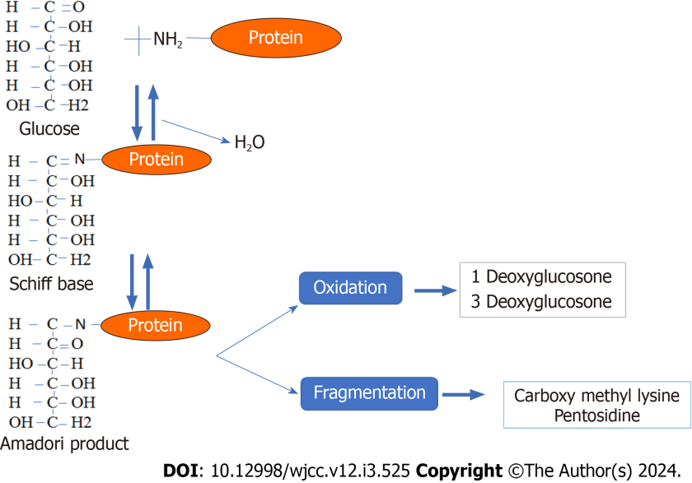
Figure 1 Advanced glycation end products formation. Reaction between the carbonyl group of reducing sugar and the amino group of proteins and lipids via a Schiff base reaction cascade, followed by amadori rearrangement and oxidative modification.

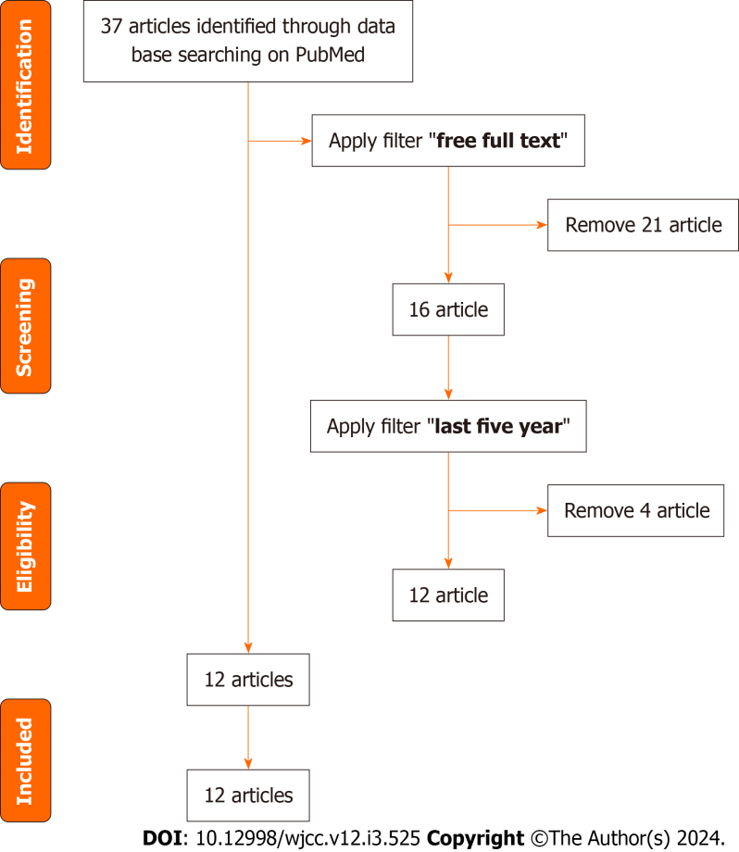
Figure 2 PRISMA flow diagram of study selection process for preclinical and clinical evidence.

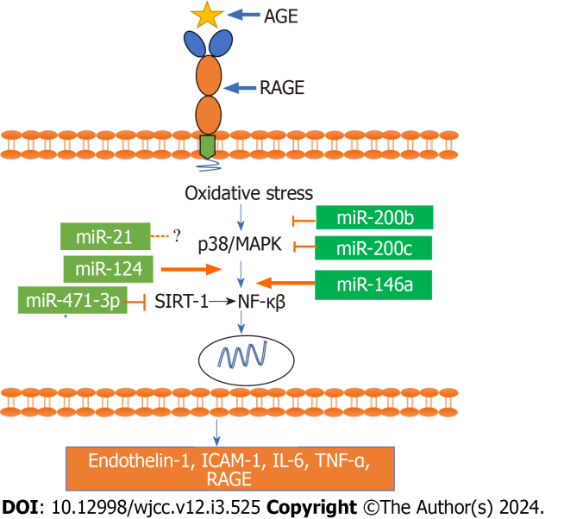
Figure 3 MiRNA regulation in the advanced glycation end product/receptor of advanced glycation end products activated nuclear factor pathway. Advanced glycation end product - receptor of advanced glycation end product interaction activates the nuclear factor pathway, which is inhibited by miR-200b, miR-200c, and miR-471-3p and upregulated by miR-124 and miR-146a. AGE: Advanced glycation end product; RAGE: Receptor of advanced glycation end product; MAPK: Mitogen-activated protein kinases; NF-κB: Nuclear factor kappa beta; TNF-α: Tumor necrosis factor.

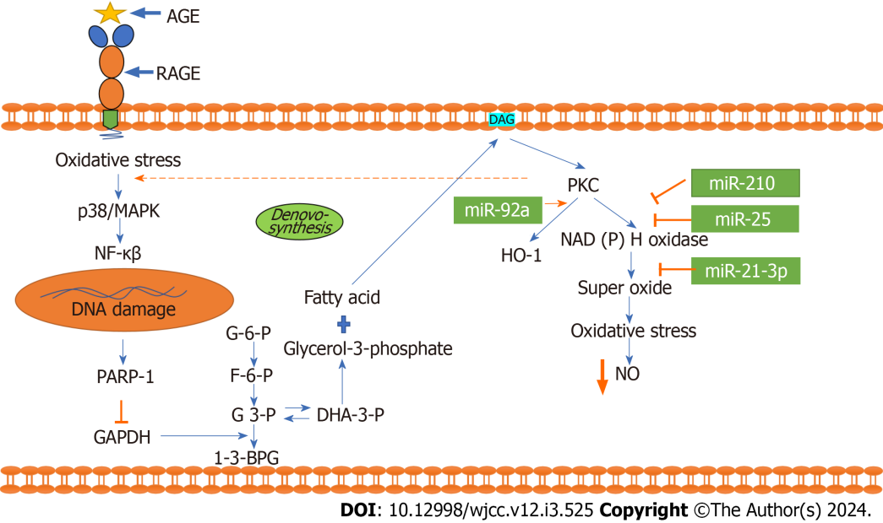
Figure 4 Interaction of advanced glycation end product and receptor of advanced glycation end product activates the protein kinase C pathway: The interaction of advanced glycation end product and advanced glycation end product activates the nuclear factor pathway and damages DNA, causing PARP-1 to be released and GAPDH to be inhibited. The inhibition of GAPDH affects the glycolysis pathway and increases fatty acid synthesis. This increased synthesis of fatty acids activates diacyl glycerol in the cell membrane, which is a potent activator of protein kinase C (PKC). Increased PKC promotes synthesis of NADPH oxidase, super oxide and oxidative stress and ultimately decreases cellular nitric oxide. In this pathway, miRNA 210, miR-25, and miR-21-3p inhibit NADPH oxidase and oxidative stress. Apart from that, miR 92a promotes the expression of the antioxidant HO-1. AGE: Advanced glycation end product; RAGE: Receptor of advanced glycation end product; NF-κB: Nuclear factor kappa beta.

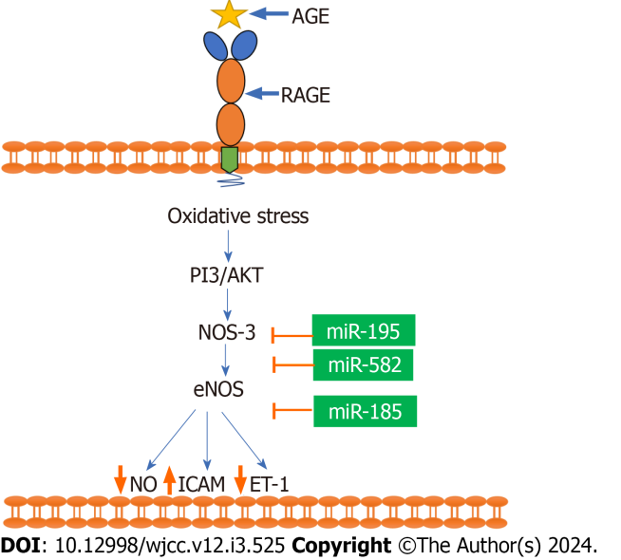
Figure 5 Regulation of miRNA in the nitric oxide pathway: The interaction of advanced glycation end product and receptor of advanced glycation end product affects the availability of Nitric Oxide via inhibition of eNOS. miR-195, miR-582, and miR-182 all inhibit AGE/RAGE-mediated eNOS alterations and nitric oxide production. AGE: Advanced glycation end product; RAGE: Receptor of advanced glycation end product; NF-κB: Nuclear factor kappa beta; NO: Nitric oxide.

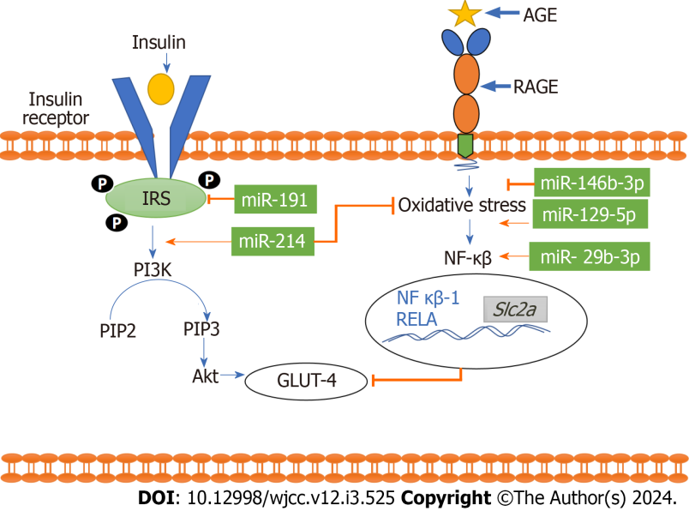
Figure 6 Functional role of miRNA in the advanced glycation end product/receptor of advanced glycation end products activated phosphoinositide 3-kinase pathway. The advanced glycation end product/receptor of advanced glycation end products -activated nuclear factor (NF) pathway inhibits GLUT-4 release from the cellular membrane. miR-129-5p, miR-29b-3p upregulate the pathway. However, miR-191, miR-146b-3p and miR-191 show an inhibitory effect. Furthermore, miR 214 increases GLUT-4 expression by simultaneously upregulating the PI3k/AKT pathway and inhibiting the NF- pathway. AGE: Advanced glycation end product; RAGE: Receptor of advanced glycation end product; NF-κB: Nuclear factor kappa beta.

Table 1 MiRNAs involved in type 2 diabetes clinical and pre-clinical evidence
No. | Micro RNA | Status | Disease | Model | Publish year | Ref.
1 | miR-96-5p and miR-7-5p |  | T2DM | Bioinformatic | 2022 | [31]
2 | miR-132 | Upregulated | T2DM | Human | 2020 | [32]
3 | hsa-miR-29a-5p | Upregulated | T2DM | Human | 2021 | [33]
4 | miR-143 | Upregulated | T2DM | Human | 2022 | [34]
5 | mir-21 and miR-126 | Upregulated | T2DM | Human | 2022 | [35]
6 | miR-145-5p, miR-483-3p/5p, miR-138-5p, miR-192-5p, miR-195-5p, miR-320b, and let-7a-5p |  | T2DM | Human | 2019 | [36]
7 | miR-let-7g-5p | Downregulated | T2DM | Human | 2022 | [37]
8 | miR-187-3p, miR-21-5p, miR-668, miR-199b-5p, mir-216a, miR-25 miR-30a-3p miR-30a-5p |  | T2DM | Human | 2023 | [38]
9 | miRNA-152-3p | Upregulated | T2DM | Human | 2022 | [39]
10 | Microrna-146a and microrna-130a | Upregulated | T2DM | Human | 2019 | [40]
11 | miR-24-3p | Upregulated | T2DM | Human | 2021 | [41]
12 | miR-126-3p/u6sno | Upregulated | T2DM | Human | 2021 | [42]
T2DM: Type 2 diabetes mellitus.

Table 2 Role of miRNA in various metabolic pathways
No. | miRNA | Target pathway | Model | Disease | Effect | Ref.
1 | miR-21 | NF-κβ | db/db mice | Metabolic syndrome and obesity | Up-regulated | [48]
2 | miR-124 | NF-κβ | Primary rat retinal microglial cells |  | Down-regulated | [49]
3 | miR-471-3p | NF-κβ | Raw264.7 cells and db/db mice | Diabetic cardiomyopathy | Up-regulated | [50]
4 | miR-46a | NF-κβ | Human blood | Hyperlipidemia | Up-regulated | [51]
5 | miR-200b | NF-κβ | Huvec line |  | Down-regulated | [52]
6 | miR-200c | NF-κβ | Huvec line |  | Down-regulated | [52]
7 | miR-210 | PKC |  |  | Down-regulated | [54]
8 | miR-25 | PKC | Adult male balb/c mice and diabetic db/db mice | Diabetic peripheral neuropathy | Down-regulated | [55]
9 | miR-21-3p | PKC | Human aortic vsmcs (C-12511, promocell, and human vets | Diabetic atherosclerosis | Down-regulated | [56]
10 | miR-92a | PKC | db/db mice | Diabetes mellitus | Up-regulated | [57]
11 | miR-185 | NO | Three-month-old male sprague–dawley rats | Diabetes mellitus | Down-regulated | [59]
12 | miR-195 | NO | Mvec cell lines | Deep vein thrombosis | Down-regulated | [60]
13 | miR-582 | NO | Mvec cell lines | Deep vein thrombosis | Down-regulated | [60]
14 | miR-191 | PI3K/AKT | Male C57bl/6j mice |  | Up-regulated | [62]
15 | miR-29b-3p | PI3K/AKT | Human serum and Hek-293t cells | Diabetic retinopathy | Up-regulated | [62]
16 | miR-29c-3p | PI3K/AKT | Rat | Diabetes mellitus | Up-regulated | [62]
17 | miR-199a-5p | PI3K/AKT | Rat | Diabetes mellitus | Down-regulated | [62]
18 | miR-532-3p | PI3K/AKT | Rat | Diabetes mellitus | Down-regulated | [62]
19 | miR-93-5p | PI3K/AKT | Rat | Diabetes mellitus | Down-regulated | [62]
20 | miR-150-5p | PI3K/AKT | Rat | Diabetes mellitus | Down-regulated | [63]
21 | miR-345-3p | PI3K/AKT | Rat | Diabetes mellitus | Down-regulated | [64]
22 | miR-25-3p | PI3K/AKT | Human blood | Diabetic retinopathy | Down-regulated | [65]
23 | miR-214 | PI3K/AKT | Male sprague dawley rats | Diabetic nephropathys | Down-regulated | [66]
24 | miR-203 | PI3K/AKT | Rat | Diabetic foot ulcer | Up-regulated | [67]
25 | miR-129-5p | PI3K/AKT | Sprague dawley rats | Intracerebral Haemorrhage | Down-regulated | [68]
26 | miR-146b-3p | PI3K/AKT | Human blood |  | Down-regulated | [69]
PI3K: Phosphoinositide 3-kinase; NF-κβ: Nuclear factor kappa B subunit 1.

Table 3 miRNAs expression in metabolic disease and reported therapeutic approaches
No. | miRNA | Model | Method | Disease | Target | Ref.
1 | miR-210 | H9c2 cells (rat embryonic cardiac myoblast; ATCC) | miR-210 mimic and inhibitor | Diabetic cardiomyopathy | c-Jun N-terminal kinase (JNK) | [54]
2 | miR-29b | db/db mice | Ultrasound-microbubble–mediated gene transfer technique was used to deliver doxycline (Dox)-inducible pre-miR-29b | Diabetic nephropathy | TGF-β/Smad3 | [71]
3 | miR-146a | HaCaT cells | Mimic and inhibitor miR-146a deliver via lipofecter liposomal transfection | Diabetic foot ulcer | AKAP12, Wnt3a and β-catenin | [72]
4 | miRNA-339 | Endothelial progenitor cell of humans | Transfection with miRNA-339-5p mimic or miRNA-339-5p inhibitor | Polycystic ovary syndrome | PI3K, AKT and SIRT1 PGC-1α | [73]
5 | miR-21 | C6 glioblastoma cells | Antagomir-21/RAP nanoparticles | Intracranial glioblastoma | PTEN and PDCD4 | [74]
6 | miR-107 and miR-103 | C57BL/6J | Antagomir of miR-103 and miR-107 delivered by liver-targeting lipid nanoparticle | Diabetes | Caveolin-1 | [75]
7 | miR-181a | Mouse neuroblastoma cells (Neuro2A) and HEK293T cells and male sprague dawley rats | AMO181a-chol loaded exosomes | Cerebral ischemia | Hypoxia-induced RAGE and Bcl2 | [76]
RAGE: Receptor of advanced glycation end products; TGF: Tumor growth factor.

Published by Baishideng Publishing Group Inc
7041 Koll Center Parkway, Suite 160, Pleasanton, CA 94566, USA
Telephone: +1-925-3991568
E-mail: office@baishideng.com
Help Desk: https://www.f6publishing.com/helpdesk
https://www.wjgnet.com

© 2024 Baishideng Publishing Group Inc. All rights reserved.

