Name of Journal: World Journal of Gastroenterology

Manuscript Type: BASIC STUDY

Three-dimensional perfused human in vitro model of non-alcoholic fatty liver disease

Kostrzewski T et al. Human in vitro model of NAFLD

Tomasz Kostrzewski, Terri Cornforth, Sophie A. Snow, Larissa Ouro-Gnao, Cliff Rowe, Emma M. Large, David J. Hughes

CN Bio Innovations Limited, BioPark, Broadwater Rd, Welwyn Garden City, AL7 3AX, UK.

Supplementary material

Supplemental Figure 1 –Cryopreserved human hepatocyte donors have varying lipid content but all load with fat in NAFLD model. A) Equivalent numbers of cells of cryopreserved human hepatocyte donors were thawed and stained with Oil Red O to measure fat content. Oil Red O staining was quantified by absorbance at 510 nm. B) Cells from three donors were cultured for 7 days in lean or fat conditions and fat loading was determined by measuring Oil Red O staining and normalising to total cellular protein content. Data is a mean ± SD (n =3), a = P < 0.05.

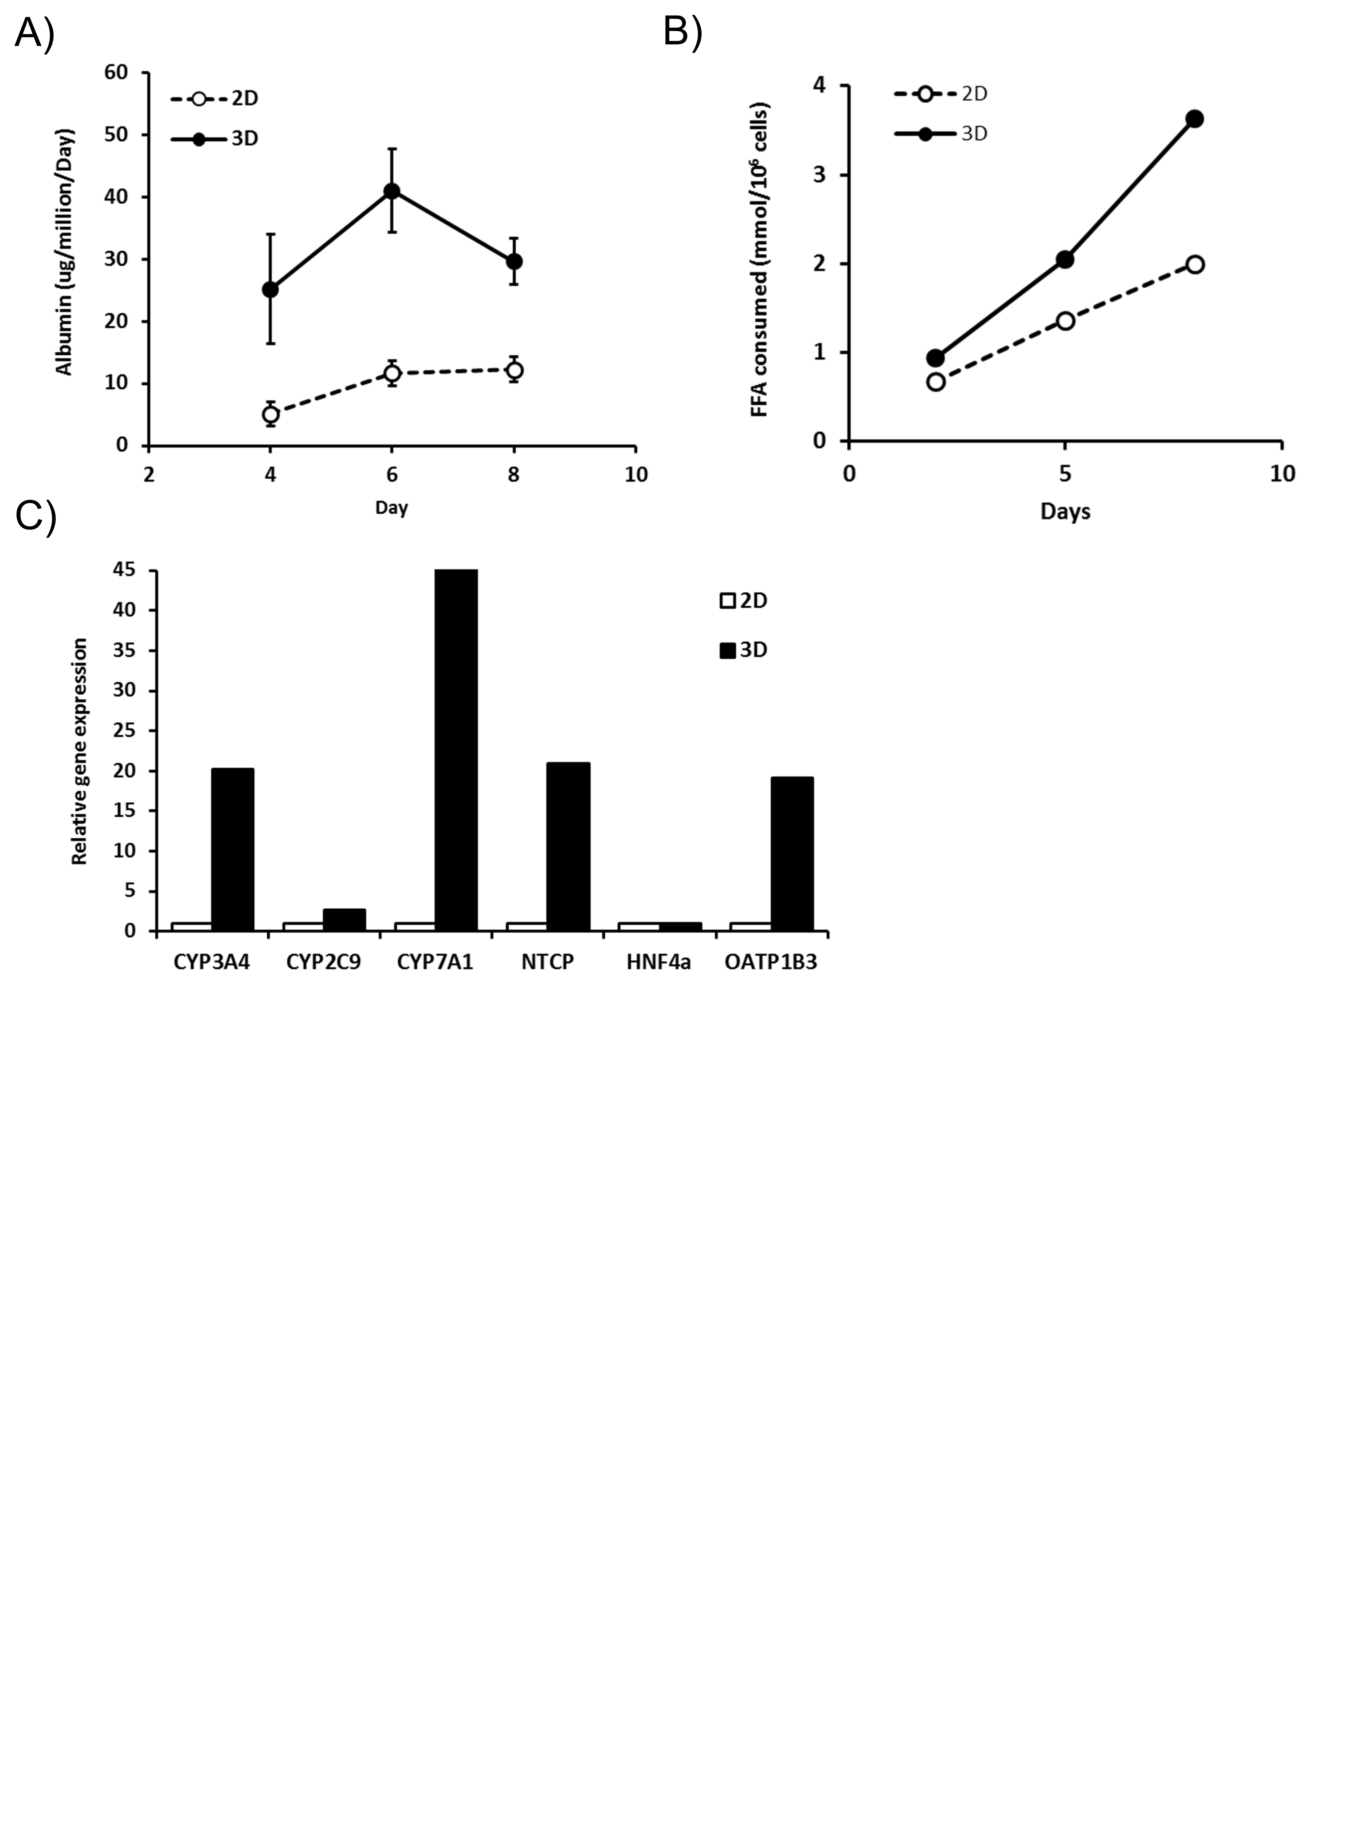

Supplemental Figure 2 – Hepatocytes cultured in 3D outperform those cultured in 2D and accumulate greater quantities of fat. Hepatocytes were cultured in LiverChip (3D) or in static 2D plates for seven days under fat conditions. Equivalent samples were compared for A) Albumin production. B) Fat consumed by cells over 7 days of culture was calculated by analysing culture medium for the presence of free fatty acids using enzyme-based colorimetric assay. C) Relative expression of hepatic genes, as measured by QPCR; expression of each gene was normalised to GAPDH and is shown as relative to 2D sample. Data shown are a mean ± SD, n =3 [C) n=2].

Supplemental Figure 3 – Hepatocytes are viable under fat conditions and have functional mitochondria. Hepatocytes were cultured for 14 days (A, B) or 7 days (C, D) in fat and lean conditions and compared for (A) LDH release; (B) urea production; C) cellular glutathione (GSH) concentrations; and D) WST-1 turnover. Each data point is a mean of 3 independent cultures, ± SD.

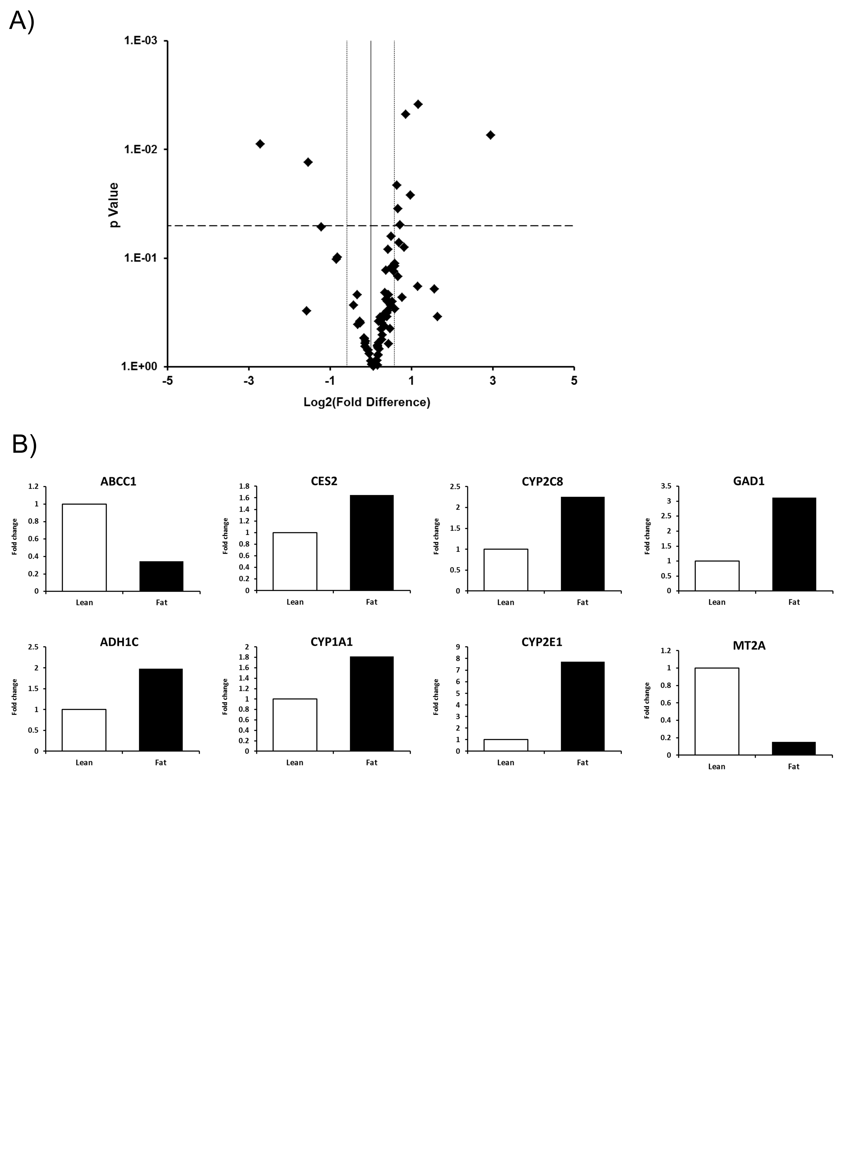

Supplemental Figure 4 – Hepatocytes cultured in fat media have altered gene expression profiles. Hepatocytes were cultured in fat or lean conditions for 7 days before total RNA was extracted and gene expression was compared using Drug Metabolism RT² Profiler PCR Arrays. A) Gene expression changes were defined by a fold change >1.95 and P = < 0.05. B) Fold change in expression in fat vs lean condition of key genes, filled bars = fat, white bars = lean. Data are means ± SEM from three independent cultures.

Supplemental Table 1 – Gene expression changes in NAFLD model analysed by Human Fatty Liver RT² Profiler™ PCR Arrays
Gene | Lean |  | Fat |  | Fold regulation
 | Ct average | 2^-ΔCt | Ct average | 2^-ΔCt
ABCA1 | 25.44 | 1.28E-02 | 25.8 | 1.32E-02 | 1.04
ACACA | 23.88 | 3.78E-02 | 24.2 | 4.01E-02 | 1.06
ACADL | 23.03 | 6.82E-02 | 23.26 | 7.73E-02 | 1.13
ACLY | 21.87 | 1.52E-01 | 22.1 | 1.72E-01 | 1.13
ACOX1 | 21.92 | 1.47E-01 | 21.97 | 1.89E-01 | 1.29
ACSL5 | 22.35 | 1.09E-01 | 22.86 | 1.02E-01 | -1.07
ACSM3 | 24.98 | 1.76E-02 | 24.61 | 3.04E-02 | 1.73
ADIPOR1 | 22.8 | 7.97E-02 | 23.05 | 8.94E-02 | 1.12
ADIPOR2 | 22.93 | 7.32E-02 | 22.89 | 9.97E-02 | 1.36
AKT1 | 23.87 | 3.82E-02 | 23.96 | 4.75E-02 | 1.24
APOA1 | 17.56 | 3.01E+00 | 17 | 5.92E+00 | 1.95
APOB | 17.62 | 2.90E+00 | 17.64 | 3.80E+00 | 1.31
APOC3 | 15.32 | 1.43E+01 | 15.19 | 2.08E+01 | 1.46
APOE | 19.86 | 6.14E-01 | 19.75 | 8.82E-01 | 1.44
ATP5C1 | 20.69 | 3.46E-01 | 20.81 | 4.21E-01 | 1.22
CASP3 | 24.39 | 2.66E-02 | 24.67 | 2.91E-02 | 1.09
CD36 | 30.21 | 4.70E-04 | 30.23 | 6.13E-04 | 1.31
CEBPB | 23.37 | 5.38E-02 | 23.17 | 8.21E-02 | 1.53
CNBP | 21.63 | 1.80E-01 | 21.8 | 2.12E-01 | 1.18
CPT1A | 25.3 | 1.41E-02 | 25.29 | 1.89E-02 | 1.34
CPT2 | 24.11 | 3.22E-02 | 23.68 | 5.76E-02 | 1.79
CYP2E1 | 23.57 | 4.68E-02 | 21.59 | 2.46E-01 | 5.26
CYP7A1 | 23.41 | 5.24E-02 | 21.36 | 2.88E-01 | 5.49
DGAT2 | 21.91 | 1.49E-01 | 21.97 | 1.89E-01 | 1.27
FABP1 | 18.68 | 1.39E+00 | 18.1 | 2.76E+00 | 1.98
FABP3 | 27.05 | 4.21E-03 | 26.62 | 7.51E-03 | 1.78
FABP5 | 26.39 | 6.64E-03 | 26.24 | 9.77E-03 | 1.47
FAS | 22.9 | 7.44E-02 | 23.31 | 7.45E-02 | 1.00
FASN | 19.36 | 8.68E-01 | 19.21 | 1.28E+00 | 1.47
FOXA2 | 24.74 | 2.08E-02 | 24.86 | 2.54E-02 | 1.22
FOXO1 | 27.66 | 2.76E-03 | 27.71 | 3.54E-03 | 1.28
G6PC | 24.96 | 1.79E-02 | 24.56 | 3.14E-02 | 1.75
G6PD | 29.73 | 6.56E-04 | 29.61 | 9.49E-04 | 1.45
GCK | 26.19 | 7.60E-03 | 25.99 | 1.16E-02 | 1.53
GK | 26.18 | 7.68E-03 | 25.72 | 1.40E-02 | 1.82
GSK3B | 23.75 | 4.14E-02 | 24.02 | 4.55E-02 | 1.10
HMGCR | 21.91 | 1.48E-01 | 21.79 | 2.14E-01 | 1.44
HNF4A | 23.25 | 5.87E-02 | 23.25 | 7.74E-02 | 1.32
IFNG | 35 | 1.70E-05 | 35 | 2.30E-05 | 1.33
IGF1 | 24.61 | 2.27E-02 | 24.3 | 3.75E-02 | 1.65
IGFBP1 | 25.06 | 1.67E-02 | 23.99 | 4.64E-02 | 2.78
IL10 | 35 | 1.70E-05 | 35 | 2.30E-05 | 1.33
IL1B | 32.83 | 7.70E-05 | 34.38 | 3.50E-05 | -2.21
IL6 | 32.94 | 7.10E-05 | 33.82 | 5.10E-05 | -1.39
INSR | 23.8 | 4.00E-02 | 23.76 | 5.45E-02 | 1.36
IRS1 | 26.1 | 8.09E-03 | 25.97 | 1.18E-02 | 1.46
LDLR | 22.48 | 9.99E-02 | 22.41 | 1.39E-01 | 1.39
LEPR | 24.54 | 2.40E-02 | 24.3 | 3.75E-02 | 1.57
LPL | 32.01 | 1.35E-04 | 32.31 | 1.46E-04 | 1.08
MAPK1 | 22.88 | 7.55E-02 | 22.99 | 9.30E-02 | 1.23
MAPK8 | 25.11 | 1.61E-02 | 25.33 | 1.84E-02 | 1.14
MLXIPL | 22.82 | 7.91E-02 | 23.02 | 9.12E-02 | 1.15
MTOR | 22.74 | 8.33E-02 | 22.76 | 1.10E-01 | 1.32
NDUFB6 | 26.33 | 6.93E-03 | 26.55 | 7.90E-03 | 1.14
NFKB1 | 25.59 | 1.15E-02 | 25.64 | 1.49E-02 | 1.29
NR1H2 | 25.53 | 1.20E-02 | 25.64 | 1.48E-02 | 1.23
NR1H3 | 24.54 | 2.39E-02 | 24.66 | 2.92E-02 | 1.22
NR1H4 | 22.63 | 8.98E-02 | 23.19 | 8.12E-02 | -1.11
PCK2 | 22.69 | 8.64E-02 | 22.79 | 1.07E-01 | 1.23
PDK4 | 25.22 | 1.49E-02 | 23.45 | 6.77E-02 | 4.54
PIK3CA | 24.55 | 2.37E-02 | 24.62 | 3.00E-02 | 1.27
PIK3R1 | 23.55 | 4.77E-02 | 23.52 | 6.45E-02 | 1.35
PKLR | 21.9 | 1.49E-01 | 21.8 | 2.13E-01 | 1.43
PNPLA3 | 23.92 | 3.69E-02 | 23.98 | 4.69E-02 | 1.27
PPA1 | 21.01 | 2.75E-01 | 21.28 | 3.04E-01 | 1.10
PPARA | 23.88 | 3.78E-02 | 23.74 | 5.52E-02 | 1.46
PPARG | 25.85 | 9.66E-03 | 25.88 | 1.26E-02 | 1.30
PPARGC1A | 25.69 | 1.08E-02 | 26.03 | 1.13E-02 | 1.05
PRKAA1 | 23.33 | 5.53E-02 | 23.63 | 5.95E-02 | 1.08
PTPN1 | 26.28 | 7.19E-03 | 26.45 | 8.47E-03 | 1.18
RBP4 | 15.63 | 1.15E+01 | 15.98 | 1.20E+01 | 1.05
RXRA | 23.48 | 4.99E-02 | 23.28 | 7.61E-02 | 1.52
SCD | 18.02 | 2.19E+00 | 18.27 | 2.45E+00 | 1.12
SERPINE1 | 20.71 | 3.41E-01 | 21.39 | 2.82E-01 | -1.21
SLC27A5 | 24.63 | 2.25E-02 | 24.87 | 2.53E-02 | 1.12
SLC2A1 | 30.91 | 2.90E-04 | 31.55 | 2.46E-04 | -1.18
SLC2A2 | 21.22 | 2.39E-01 | 21.35 | 2.90E-01 | 1.21
SLC2A4 | 28.52 | 1.51E-03 | 27.72 | 3.52E-03 | 2.32
SOCS3 | 33.56 | 4.60E-05 | 33.3 | 7.30E-05 | 1.59
SREBF1 | 25.05 | 1.68E-02 | 25.56 | 1.57E-02 | -1.07
SREBF2 | 23.47 | 5.04E-02 | 23.53 | 6.38E-02 | 1.27
STAT3 | 22.36 | 1.08E-01 | 22.74 | 1.11E-01 | 1.02
TNF | 34.57 | 2.30E-05 | 34.38 | 3.50E-05 | 1.51
XBP1 | 20.71 | 3.39E-01 | 20.91 | 3.93E-01 | 1.16

Supplemental Table 2 – Gene expression changes in NAFLD model analysed by Human Drug Metabolism RT² Profiler™ PCR Arrays
Gene | Lean |  | Fat |  | Fold regulation
 | Ct average | 2^-ΔCt | Ct average | 2^-ΔCt
ABCB1 | 22.97 | 6.8E-02 | 22.96 | 8.6E-02 | 1.27
ABCC1 | 30.36 | 4.0E-04 | 32.24 | 1.4E-04 | -2.91
AOC1 | 31.83 | 1.5E-04 | 31.68 | 2.1E-04 | 1.41
ADH1B | 18.46 | 1.5E+00 | 17.99 | 2.7E+00 | 1.76
ADH1C | 18.15 | 1.9E+00 | 17.51 | 3.8E+00 | 1.98
ADH4 | 23.05 | 6.4E-02 | 24.21 | 3.6E-02 | -1.76
ADH5 | 22.37 | 1.0E-01 | 22.60 | 1.1E-01 | 1.08
ADH6 | 22.61 | 8.7E-02 | 22.90 | 9.0E-02 | 1.04
AHR | 22.96 | 6.8E-02 | 23.11 | 7.8E-02 | 1.15
ALAD | 22.79 | 7.7E-02 | 22.73 | 1.0E-01 | 1.32
ALDH1A1 | 18.67 | 1.3E+00 | 19.15 | 1.2E+00 | -1.10
ALOX12 | 31.78 | 1.5E-04 | 31.64 | 2.1E-04 | 1.40
ALOX15 | 30.70 | 3.2E-04 | 31.36 | 2.5E-04 | -1.25
ALOX5 | 32.28 | 1.1E-04 | 32.45 | 1.2E-04 | 1.13
APOE | 19.24 | 9.0E-01 | 19.62 | 8.7E-01 | -1.03
ARNT | 25.57 | 1.1E-02 | 25.89 | 1.1E-02 | 1.02
ASNA1 | 24.28 | 2.7E-02 | 24.26 | 3.5E-02 | 1.29
BLVRA | 26.99 | 4.2E-03 | 27.03 | 5.1E-03 | 1.23
BLVRB | 21.12 | 2.4E-01 | 21.31 | 2.7E-01 | 1.11
CES1 | 17.57 | 2.8E+00 | 17.85 | 3.0E+00 | 1.05
CES2 | 20.54 | 3.6E-01 | 20.16 | 6.0E-01 | 1.65
CES3 | 25.92 | 8.8E-03 | 26.07 | 1.0E-02 | 1.14
CHST1 | 34.08 | 3.1E-05 | 33.27 | 6.8E-05 | 2.23
COMT | 20.82 | 3.0E-01 | 21.23 | 2.9E-01 | -1.05
CYB5R3 | 21.50 | 1.9E-01 | 21.60 | 2.2E-01 | 1.18
CYP11B2 | 34.38 | 2.5E-05 | 33.16 | 7.3E-05 | 2.95
CYP17A1 | 31.13 | 2.4E-04 | 31.21 | 2.8E-04 | 1.19
CYP19A1 | 34.80 | 2.0E-05 | 34.53 | 2.8E-05 | 1.39
CYP1A1 | 25.83 | 9.3E-03 | 25.30 | 1.7E-02 | 1.82
CYP2B6 | 23.99 | 3.3E-02 | 23.73 | 5.1E-02 | 1.51
CYP2C19 | 23.42 | 4.9E-02 | 23.20 | 7.3E-02 | 1.48
CYP2C8 | 20.95 | 2.7E-01 | 20.12 | 6.2E-01 | 2.26
CYP2C9 | 20.29 | 4.3E-01 | 20.21 | 5.8E-01 | 1.35
CYP2D6 | 20.59 | 3.5E-01 | 20.76 | 4.0E-01 | 1.13
CYP2E1 | 23.73 | 4.0E-02 | 21.13 | 3.1E-01 | 7.71
CYP2F1 | 34.61 | 2.1E-05 | 34.51 | 2.9E-05 | 1.36
CYP2J2 | 22.83 | 7.5E-02 | 22.58 | 1.1E-01 | 1.50
CYP3A4 | 20.17 | 4.7E-01 | 20.35 | 5.3E-01 | 1.12
CYP3A5 | 20.46 | 3.9E-01 | 20.27 | 5.6E-01 | 1.45
EPHX1 | 19.41 | 8.0E-01 | 19.06 | 1.3E+00 | 1.62
FAAH | 27.41 | 3.1E-03 | 27.43 | 3.9E-03 | 1.25
FBP1 | 21.80 | 1.5E-01 | 21.70 | 2.1E-01 | 1.36
GAD1 | 33.21 | 5.6E-05 | 31.91 | 1.7E-04 | 3.12
GAD2 | 39.71 | 1.8E-05 | 34.60 | 2.8E-05 | 1.60
GCKR | 23.77 | 3.9E-02 | 23.60 | 5.5E-02 | 1.43
GPI | 21.63 | 1.7E-01 | 21.94 | 1.7E-01 | 1.02
GPX1 | 19.20 | 9.2E-01 | 19.71 | 8.2E-01 | -1.12
GPX2 | 24.99 | 1.7E-02 | 25.67 | 1.3E-02 | -1.26
GPX3 | 22.28 | 1.1E-01 | 21.95 | 1.7E-01 | 1.59
GPX4 | 19.09 | 9.9E-01 | 19.06 | 1.3E+00 | 1.30
GPX5 | 37.74 | 1.6E-05 | 34.93 | 2.2E-05 | 1.33
GSR | 27.54 | 2.9E-03 | 28.02 | 2.6E-03 | -1.11
GSTA3 | 27.61 | 2.7E-03 | 28.80 | 1.5E-03 | -1.80
GSTA4 | 25.29 | 1.4E-02 | 25.53 | 1.5E-02 | 1.07
GSTM2 | 27.39 | 3.1E-03 | 27.56 | 3.6E-03 | 1.13
GSTM3 | 23.40 | 5.0E-02 | 23.47 | 6.0E-02 | 1.20
GSTM5 | 34.86 | 1.8E-05 | 34.72 | 2.5E-05 | 1.40
GSTP1 | 28.75 | 1.2E-03 | 29.16 | 1.2E-03 | -1.05
GSTT1 | 20.91 | 2.8E-01 | 21.38 | 2.6E-01 | -1.09
GSTZ1 | 23.96 | 3.4E-02 | 24.56 | 2.9E-02 | -1.20
HK2 | 31.99 | 1.3E-04 | 33.90 | 4.4E-05 | -2.98
HSD17B1 | 30.56 | 3.5E-04 | 30.57 | 4.4E-04 | 1.26
HSD17B2 | 21.42 | 2.0E-01 | 21.33 | 2.7E-01 | 1.35
HSD17B3 | 27.41 | 3.1E-03 | 27.57 | 3.5E-03 | 1.13
LPO | 36.81 | 1.4E-05 | 38.21 | 2.1E-05 | 1.50
MGST1 | 16.55 | 5.8E+00 | 16.49 | 7.6E+00 | 1.32
MGST2 | 20.84 | 3.0E-01 | 20.91 | 3.6E-01 | 1.20
MGST3 | 21.24 | 2.2E-01 | 21.17 | 3.0E-01 | 1.33
MPO | 34.97 | 1.7E-05 | 34.53 | 2.8E-05 | 1.71
MT2A | 18.37 | 1.6E+00 | 21.43 | 2.5E-01 | -6.58
MT3 | 36.58 | 1.6E-05 | 34.94 | 2.1E-05 | 1.32
MTHFR | 27.84 | 2.3E-03 | 28.01 | 2.6E-03 | 1.12
NAT1 | 29.23 | 8.8E-04 | 29.37 | 1.0E-03 | 1.15
NAT2 | 23.00 | 6.6E-02 | 22.93 | 8.8E-02 | 1.33
NOS3 | 34.39 | 2.5E-05 | 34.14 | 3.7E-05 | 1.51
NQO1 | 27.91 | 2.2E-03 | 28.52 | 1.8E-03 | -1.21
PKLR | 22.07 | 1.3E-01 | 22.41 | 1.3E-01 | -1.00
PKM | 25.34 | 1.3E-02 | 25.01 | 2.1E-02 | 1.59
PON1 | 19.77 | 6.2E-01 | 20.27 | 5.6E-01 | -1.11
PON2 | 21.42 | 2.0E-01 | 21.68 | 2.1E-01 | 1.06
PON3 | 21.73 | 1.6E-01 | 21.78 | 2.0E-01 | 1.22
SNN | 27.22 | 3.6E-03 | 26.92 | 5.5E-03 | 1.56
SRD5A1 | 23.07 | 6.3E-02 | 23.83 | 4.7E-02 | -1.34
SRD5A2 | 23.15 | 6.0E-02 | 24.71 | 2.6E-02 | -2.32

