Name of Journal: World Journal of Clinical Cases
Manuscript NO: 69380
Manuscript Type: CASE REPORT

Iatrogenic giant pseudomeningocele of the cervical spine: A case report

Kim KW et al. Iatrogenic giant pseudomeningocele of cervical spine

Koh-Woon Kim, Jae-Heung Cho

Koh-Woon Kim, Jae-Heung Cho, Department of Korean Medicine Rehabilitation, College of Korean Medicine, Kyung Hee University, Seoul 02447, South Korea

Author contributions: Cho JH was the patient’s doctor of Korean medicine, reviewed the literature and contributed to manuscript drafting; Kim KW analyzed and interpreted the imaging findings and was responsible for the revision of the manuscript for important intellectual content; all authors issued final approval for the version to be submitted.

Corresponding author: Jae-Heung Cho, MD, PhD, Associate Professor, Department of Korean Medicine Rehabilitation, College of Korean Medicine, Kyung Hee University, 26 Kyungheedae-ro, Dongdaemun-gu, Seoul 02447, South Korea. vetkong95@hanmail.net

Received: June 28, 2021
Revised: July 27, 2021
Accepted: September 19, 2021
Published online: November 6, 2021

Abstract
BACKGROUND
Only a few cases of giant pseudomeningoceles have been reported in the literature. Herein, we report a giant pseudomeningocele of the cervical spine that was found after cervical laminectomy for an epidural hematoma following epidural blockade.

CASE SUMMARY
A 47-year-old man presented with recurrent neck pain and posterior neck swelling after spinal surgery. Magnetic resonance imaging of the cervical spine revealed fluid collection (5.6 cm × 6.6 cm × 11.2 cm) at the C3-6 level; this proved to be a pseudomeningocele. Symptoms related to the pseudomeningocele resolved following dural repair and fat graft transplantation.

CONCLUSION
Although rare, pseudomeningocele is a possibility in patients with recurrent back pain, radicular pain, or a persistent headache following spinal surgery. Continuous attention should be paid throughout the spinal procedure, whether conservative or non-conservative.

Key words: Iatrogenic spinal pseudomeningocele; Giant pseudomeningocele; Cervical spine; C3-6 level; Cervical laminectomy; Case report

©The Author(s) 2021. Published by Baishideng Publishing Group Inc. All rights reserved.

Citation: Kim KW, Cho JH. Iatrogenic giant pseudomeningocele of the cervical spine: A case report. World J Clin Cases 2021; 9(31): 9686-9690
URL: https://www.wjgnet.com/2307-8960/full/v9/i31/9686.htm
DOI: https://dx.doi.org/10.12998/wjcc.v9.i31.9686

Core Tip: Only a few cases of giant pseudomeningoceles have been reported in the literature. Here we present a rare case of a giant pseudomeningocele of the cervical spine identified after cervical laminectomy for an epidural hematoma after epidural blockade. The patient presented with recurrent neck pain and posterior neck swelling after spinal surgery. Magnetic resonance imaging of the cervical spine revealed fluid collection at the C3-6 level that proved to be a pseudomeningocele. This case highlights that, despite its rarity, giant pseudomeningocele must be taken in consideration in patients who report recurrent back pain, radicular pain, or a persistent headache after spinal surgery.

INTRODUCTION
A pseudomeningocele forms when the dura is torn and the leptomeninges and subarachnoid space protrude through the dural defect^{[1]}. Three types of pseudomeningocele (congenital, iatrogenic, and traumatic) have been reported^{[2,3]}. An iatrogenic pseudomeningocele usually occurs as a postoperative complication following lumbar spinal laminectomy^{[4]}. Giant pseudomeningoceles have rarely been reported^{[2,5,6]}. Only a few cases of giant cervical pseudomeningoceles have been reported in the literature, and most were associated with brachial plexus injury^{[5,6]}.
The current report describes a 47-year-old man with a giant pseudomeningocele after cervical laminectomy for an epidural hematoma following epidural block. To our knowledge, no cases of iatrogenic giant pseudomeningoceles of the cervical spine have been reported. In the current case, in which a large dead space existed in the pseudomeningocele, a dural repair, local epidural fat graft transplantation, and additional abdominal subcutaneous vascularized fat graft transplantation successfully closed the dead space.

CASE PRESENTATION
Chief complaints
A 47-year-old man was admitted for pain in the left posterior nuchal and shoulder regions and left-sided weakness and numbness.

History of present illness
Three hours prior to admission, he had received a cervical epidural block for head and neck pain. One hour after this block, he felt severe neck pain followed by left-sided weakness.

History of past illness
The patient had diabetes and had recently received medication (Amaryl M 2/500 mg). He had experienced a traffic accident six months prior to admission and since then had taken intermittent conservative treatments for persistent head and neck pain from another local hospital. The patient reported that he did not undergo magnetic resonance imaging (MRI) and that X-ray scanning had revealed no significant abnormalities.

Personal and family history
The patient had a free personal and family history.

Physical examination
Upon admission, a neurological examination revealed global weakness on the left side (hand grasping (V/II), elbow extension (V/III), elbow flexion (V/III), knee flexion (V/III), knee extension (V/III), hip flexion (V/III), and hip extension (V/III)). Sensory testing revealed painful numbness (allodynia) on the lateral side of the left upper arm. The anal sphincter tone was intact.

Laboratory examinations
Laboratory findings were normal.

Imaging examinations
Emergency MRI revealed an epidural hemorrhage at the C2-T6 level causing central spinal canal stenosis and cord compression at the C3-T1 level (Figure 1).

Further diagnostic work-up
Following the diagnosis of a cervical epidural hematoma, the patient was transferred to the Neurosurgery Department for continued care. A total C3-6 laminectomy with a partial laminectomy at the C2 level (dome-like enlargement) and the upper lamina at the C7 level, with hematoma removal and lateral mass screw fixation at C3-6, as well as posterior fusion were performed. Postoperatively, neurologic recovery was initially observed, but five days later, the patient’s neck pain worsened severely. Continuous oozing was seen at the hemovac removal site and swelling was observed in the posterior nuchal area. A follow-up MRI demonstrated fluid collection (5.6 cm × 6.6 cm × 11.2 cm) at the posterior operative site at the C3-6 level (Figure 2).

FINAL DIAGNOSIS
The final diagnosis of the presented case was a giant pseudomeningocele of the cervical spine identified after cervical laminectomy for an epidural hematoma following epidural blockade.

TREATMENT
As severe neck pain aggravated by the Valsalva maneuver was sustained, the decision was made to proceed with surgery. Intraoperatively, a 3-4 mm dural opening was observed at the left C5-6 laminectomy site from which cerebrospinal fluid (CSF) was leaking. The dural opening was closed with local fat graft transplantation, and an abdominal subcutaneous vascularized fat graft transplantation was used to close the large dead space. Thereafter, no active CSF leakage was observed.

OUTCOME AND FOLLOW-UP
Postoperatively, the patient’s neck pain resolved, and he was ambulatory and able to return to work at the time of discharge. No significant fluid collection or posterior epidural hematoma, observed on the previous MRI, was found (Figure 3).

DISCUSSION
In the current report, we described a giant pseudomeningocele of the cervical spine following cervical laminectomy for an epidural hematoma following an epidural block. The surgical dural repair of the pseudomeningocele was successful without any recurrence in clinical symptoms or radiologic abnormalities.
A pseudomeningocele is an abnormal extradural collection of CSF in the soft tissue of the back that occurs due to a dural tear^{[2,7]}. Three types of pseudomeningoceles (congenital, iatrogenic, and traumatic) were reported by Miller et al^{[3]} in 1968. The pseudomeningocele in the current case had two possible pathogeneses. The first is iatrogenic dural micropuncture during the cervical block. It is essential to ensure the integrity of the dura to prevent leaks regardless of spinal level. However, the surgeon may not have noticed a fine dural tear during the operation, which may have led to pseudomeningocele formation. The second is that a pseudomeningocele may have resulted from a dural tear that went unnoticed during the laminectomy and may have been left open during the surgical procedure. Either possibility could be categorized as an iatrogenic pseudomeningocele, which stresses the importance of suitably training spine surgeons to appropriately handle intraoperative CSF leaks.
In the current case, the patient’s posterior neck muscles were thin due to persistent neck pain after the whiplash injury. Secondarily, the surgeons used additional abdominal vascularized fat graft transplantation to close the large amount of dead space, a common plastic surgery technique. However, this technique may be controversial, and comparisons between treatment options should be performed in future studies.
Continuous attention should be paid throughout spinal treatment procedures, whether conservative or non-conservative in nature, and pseudomeningoceles should be considered the causative etiology for patients with recurrent back and neck pain, radicular pain, or a persistent headache after spinal surgery.

CONCLUSION
Herein, we presented a rare case of giant pseudomeningocele at the cervical level after cervical laminectomy for an epidural hematoma following an epidural block that was successfully repaired with a local fat graft and additional abdominal vascularized fat transplantation. Our findings suggest that pseudomeningoceles should be carefully considered a reason for recurrent back and neck pain following spinal surgery.

ACKNOWLEDGMENTS
We would like to appreciate our patient for consenting to have his case presented and published.

REFERENCES
1 Agrawal D, Mishra S. Post-traumatic intradiploic pseudomeningocele. Indian Pediatr 2010; 47: 271-273 [PMID: 20371894 DOI: 10.1007/s13312-010-0036-z]
2 Weng YJ, Cheng CC, Li YY, Huang TJ, Hsu RW. Management of giant pseudomeningoceles after spinal surgery. BMC Musculoskelet Disord 2010; 11: 53 [PMID: 20302667 DOI: 10.1186/1471-2474-11-53]
3 Miller PR, Elder FW Jr. Meningeal pseudocysts (meningocele spurius) following laminectomy. Report of ten cases. J Bone Joint Surg Am 1968; 50: 268-276 [PMID: 5642816 DOI: 10.2106/00004623-196850020-00005]
4 Lee KS, Hardy IM 2nd. Postlaminectomy lumbar pseudomeningocele: report of four cases. Neurosurgery 1992; 30: 111-114 [PMID: 1738437 DOI: 10.1227/00006123-199201000-00020]
5 Hader WJ, Fairholm D. Giant intraspinal pseudomeningoceles cause delayed neurological dysfunction after brachial plexus injury: report of three cases. Neurosurgery 2000; 46: 1245-1249 [PMID: 10807259 DOI: 10.1097/00006123-200005000-00044]
6 Kotani Y, Abumi K, Ito M, Terae S, Hisada Y, Minami A. Neurological recovery after surgical treatment of giant cervical pseudomeningoceles extending to lumbar spine associated with previous brachial plexus injury. Eur Spine J 2010; 19 Suppl 2: S206-S210 [PMID: 20383537 DOI: 10.1007/s00586-010-1387-9]
7 Pau A. Postoperative "meningocele spurius." Report of two cases. J Neurosurg Sci 1974; 18: 150-152 [PMID: 4465412]

Footnotes
Informed consent statement: Informed written consent was obtained from the patient for publication of this report and any accompanying images.

Conflict-of-interest statement: The authors declare that they have no conflict of interest.

CARE Checklist (2016) statement: The authors have read the CARE Checklist (2016), and the manuscript was prepared and revised according to the CARE Checklist (2016).

Open-Access: This article is an open-access article that was selected by an in-house editor and fully peer-reviewed by external reviewers. It is distributed in accordance with the Creative Commons Attribution NonCommercial (CC BY-NC 4.0) license, which permits others to distribute, remix, adapt, build upon this work non-commercially, and license their derivative works on different terms, provided the original work is properly cited and the use is non-commercial. See: http://creativecommons.org/Licenses/by-nc/4.0/

Manuscript source: Unsolicited manuscript

Peer-review started: June 28, 2021
First decision: July 26, 2021
Article in press: September 19, 2021

Specialty type: Clinical neurology
Country/Territory of origin: South Korea
Peer-review report’s scientific quality classification
Grade A (Excellent): A
Grade B (Very good): 0
Grade C (Good): 0
Grade D (Fair): 0
Grade E (Poor): 0

P-Reviewer: Dye DC S-Editor: Wu YXJ L-Editor: A P-Editor: Xing YX
Figure Legends
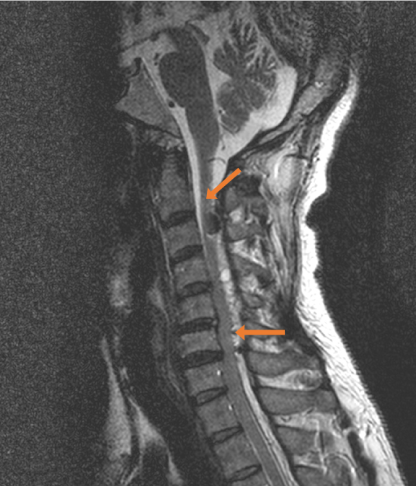
Figure 1 T2-weighted sagittal cervical magnetic resonance image demonstrating an epidural hemorrhage with gas bubbles from C2 to the upper thoracic level, resulting in central spinal canal stenosis and cord compression at the C3-T1 level (orange arrows).

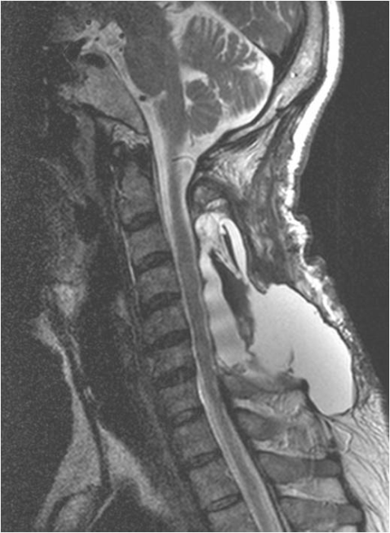
Figure 2 T2-weighted magnetic resonance image demonstrating fluid collection (5.6 cm × 6.6 cm × 11.2 cm) at the laminectomy site and in the posterior soft tissue at the C3-T1 level.
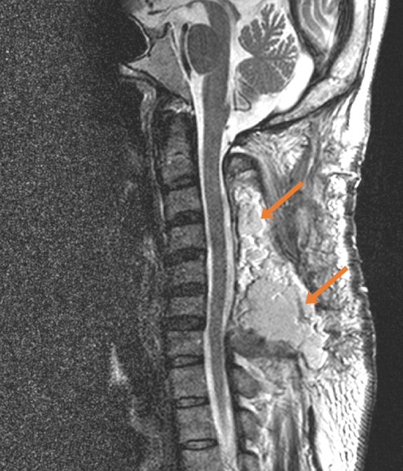
Figure 3 T2-weighted magnetic resonance image demonstrating a repaired pseudomeningocele and an abdominal vascularized fat graft transplantation (orange arrows).

Published by Baishideng Publishing Group Inc
7041 Koll Center Parkway, Suite 160, Pleasanton, CA 94566, USA
Telephone: +1-925-3991568
E-mail: bpgoffice@wjgnet.com
Help Desk: https://www.f6publishing.com/helpdesk
https://www.wjgnet.com

© 2021 Baishideng Publishing Group Inc. All rights reserved.

