Name of Journal: World Journal of Stem Cells
Manuscript NO: 58085
Manuscript Type: ORIGINAL ARTICLE

Basic Study
Glutathione metabolism is essential for self-renewal and chemoresistance of pancreatic cancer stem cells

Jagust P et al. Glutathione metabolism in pancreatic CSCs

Petra Jagust, Sonia Alcalá, Bruno Sainz Jr, Christopher Heeschen, Patricia Sancho

Petra Jagust, Molecular Pathology Programme, Spanish National Cancer Research Centre (CNIO), Madrid 28029, Spain

Sonia Alcalá, Bruno Sainz Jr, Department of Biochemistry, Autónoma University of Madrid, Instituto de Investigaciones Biomédicas "Alberto Sols" CSIC-UAM, Madrid 28029, Spain

Christopher Heeschen, Center for Single-Cell Omics, Shanghai Jiao Tong University School of Medicine, Shanghai Cancer Institute, Shanghai 200025, China

Patricia Sancho, Hospital Universitario Miguel Servet, IIS Aragon, Zaragoza 50009, Spain

Author contributions: Jagust P and Sancho P performed the experiments, acquired and analyzed data; Alcalá S and Sainz Jr B compiled and validated the samples for RNAseq analysis; Heeschen C and Sancho P interpreted data, designed the study and wrote the manuscript; all authors approved the final version of the manuscript.

Supported by ERC Advanced Investigator Grant, No. Pa-CSC 233460; European Community's Seventh Framework Programme, No. 602783; Instituto de Salud Carlos III and European Funds (FSE: “el FSE invierte en tu futuro” and FEDER: “una manera de hacer Europa”) Miguel Servet Fellowship, No. CP16/00121; and Fondo Investigaciones Sanitarias, No. PI17/00082.

Corresponding author: Patricia Sancho, PhD, Senior Scientist, Hospital Universitario Miguel Servet, IIS Aragon, Isabel la Católica 1-3, Zaragoza 50009, Spain. psancho@iisaragon.es

Received: July 10, 2020
Revised: August 19, 2020
Accepted: September 25, 2020
Published online:

Abstract
BACKGROUND
Cellular metabolism regulates stemness in health and disease. A reduced redox state is essential for self-renewal of normal and cancer stem cells (CSCs). However, while stem cells rely on glycolysis, different CSCs, including pancreatic CSCs, favor mitochondrial metabolism as their dominant energy-producing pathway. This suggests that powerful antioxidant networks must be in place to detoxify mitochondrial reactive oxygen species (ROS) and maintain stemness in oxidative CSCs. Since glutathione metabolism is critical for normal stem cell function and CSCs from breast, liver and gastric cancer show increased glutathione content, we hypothesized that pancreatic CSCs also rely on this pathway for ROS detoxification.

AIM
To investigate the role of glutathione metabolism in pancreatic CSCs.

METHODS
Primary pancreatic cancer cells of patient-derived xenografts (PDXs) were cultured in adherent or CSC-enriching sphere conditions to determine the role of glutathione metabolism in stemness. Real-time polymerase chain reaction (PCR) was used to validate RNAseq results involving glutathione metabolism genes in adherent vs spheres, as well as the expression of pluripotency-related genes following treatment. Public TCGA and GTEx RNAseq data from pancreatic cancer vs normal tissue samples were analyzed using the webserver GEPIA2. The glutathione-sensitive fluorescent probe monochlorobimane was used to determine glutathione content by fluorimetry or flow cytometry. Pharmacological inhibitors of glutathione synthesis and recycling [buthionine-sulfoximine (BSO) and 6-Aminonicotinamide (6-AN), respectively] were used to investigate the impact of glutathione depletion on CSC-enriched cultures. Staining with propidium iodide (cell cycle), Annexin-V (apoptosis) and CD133 (CSC content) were determined by flow cytometry. Self-renewal was assessed by sphere formation assay and response to gemcitabine treatment was used as a readout for chemoresistance.

RESULTS
Analysis of our previously published RNAseq dataset E-MTAB-3808 revealed up-regulation of genes involved in the KEGG (Kyoto Encyclopedia of Genes and Genomes) Pathway Glutathione Metabolism in CSC-enriched cultures compared to their differentiated counterparts. Consistently, in pancreatic cancer patient samples the expression of most of these up-regulated genes positively correlated with a stemness signature defined by NANOG, KLF4, SOX2 and OCT4 expression (P < 10⁻⁵). Moreover, 3 of the upregulated genes (MGST1, GPX8, GCCT) were associated with reduced disease-free survival in patients [Hazard ratio (HR) 2.2-2.5; P = 0.03-0.0054], suggesting a critical role for this pathway in pancreatic cancer progression.
CSC-enriched sphere cultures also showed increased expression of different glutathione metabolism-related genes, as well as enhanced glutathione content in its reduced form (GSH). Glutathione depletion with BSO induced cell cycle arrest and apoptosis in spheres, and diminished the expression of stemness genes. Moreover, treatment with either BSO or the glutathione recycling inhibitor 6-AN inhibited self-renewal and the expression of the CSC marker CD133. GSH content in spheres positively correlated with intrinsic resistance to gemcitabine treatment in different PDXs r = 0.96, P = 5.8 × 10¹¹). Additionally, CD133⁺ cells accumulated GSH in response to gemcitabine, which was abrogated by BSO treatment (P < 0.05). Combined treatment with BSO and gemcitabine-induced apoptosis in CD133⁺ cells to levels comparable to CD133⁻ cells and significantly diminished self-renewal (P < 0.05), suggesting that chemoresistance of CSCs is partially dependent on GSH metabolism.

CONCLUSION
Our data suggest that pancreatic CSCs depend on glutathione metabolism. Pharmacological targeting of this pathway showed that high GSH content is essential to maintain CSC functionality in terms of self-renewal and chemoresistance.

Key Words: Pancreatic cancer; Cancer stem cells; Glutathione; Self-renewal; Chemoresistance; Redox

Jagust P, Alcalá S, Sainz Jr B, Heeschen C, Sancho P. Glutathione metabolism is essential for self-renewal and chemoresistance of pancreatic cancer stem cells. World J Stem Cells 2020; In press

Core Tip: Several glutathione metabolism genes are upregulated in pancreatic cancer stem cells (CSCs), and their expression correlates with a stemness signature and predicts survival in clinical samples. Increased glutathione concentration in CSCs promotes viability, cell cycle progression and pluripotency gene expression. Inhibition of glutathione synthesis or recycling impairs CSC functionalities such as self-renewal and chemoresistance. Our data demonstrate a targetable metabolic vulnerability of this aggressive subpopulation of cancer cells.
INTRODUCTION
Pancreatic cancer has the worst outcome of any cancer in the world, and is currently the 3rd most frequent cause of cancer-related deaths^{[1]}. At the same time, the incidence of pancreatic cancer keeps increasing, with approximately 448000 new cases in 2019. This number is predicted to further increase in the coming years and, due to its extreme lethality and lack of effective treatments available^{[2]}, pancreatic cancer may even become the 2nd most frequent cause of cancer-related deaths by 2030^{[3]}.
One possible explanation for the poor outcome associated with pancreatic cancer is that, previously, only little attention had been paid to the efficient elimination of cancer stem cells (CSCs). Pancreatic cancer contains stem cell-like cells, which are the sole drivers of tumorigenesis, much like normal stem cells fuel proliferation and differentiation in normal tissue, and therefore have been termed CSCs^{[4–8]}. While CSCs represent only a small fraction of all the cancer cells, they are extremely tumorigenic down to a single cell, and exclusively metastatic^{[4,6]}. Current treatment strategies for pancreatic cancer spare CSCs due to their inherent chemoresistance^{[8–10]} and therefore likely represent the key cellular source driving disease relapse. To develop more effective treatment strategies for pancreatic cancer, we need to obtain a thorough understanding of the regulatory machinery of CSCs, including their cellular metabolism.
Increasing evidence suggests that, similar to normal stem cells, cellular metabolism is highly regulated in CSCs and governs essential aspects of their functionality. Indeed, a reduced intracellular redox state with low reactive oxygen species (ROS) levels allows for self-renewal, while ROS accumulation induces differentiation^{[11]}. Since relatively high amounts of ROS are formed as by-products of mitochondrial oxidative phosphorylation, glycolysis was traditionally considered the preferred metabolic pathway for both stem cells and CSCs^{[12]}. However, CSCs across a wide range of cancers maintain low ROS levels^{[13–15]}, even if they favor mitochondrial metabolism as their dominant energy-producing pathway^{[16]}. In particular, we have shown that pancreatic CSCs are dependent on mitochondrial oxidative phosphorylation for full stemness and tumorigenicity, in a process controlled by the balanced expression of c-MYC and the mitochondrial biogenesis factor PGC-1α^{[7]}. We observed that pancreatic CSCs bear low levels of mitochondrial ROS and they are especially sensitive to the mitochondrial ROS inducer menadione, making the redox state of this organelle a relevant target for CSC elimination.
Glutathione (L-γ-glutamyl-L-cysteinyl-glycine; GSH) is the most abundant non-protein antioxidant in eukaryotic cells. Although it is synthesized in the cytosol, glutathione levels are particularly high in mitochondria, where it maintains redox balance through ROS detoxification and protects phospholipids in the mitochondrial membrane^{[17]}. Interestingly, glutathione levels are strongly increased in murine embryonic stem cells and mesenchymal stem cells, supporting defense against diverse insults and maintenance of stemness^{[18]}. Similarly, glutathione content and specific GSH-related enzymes are up-regulated in CSCs from breast^{[13]}, liver^{[19]} and gastric cancer^{[14]}. Additionally, different components of the glutathione metabolism pathway have been shown to promote tumor initiation^{[20]}, metastasis^{[21,22]} and chemoresistance^{[23]}; features frequently associated with CSCs.
However, little is known about the role of this pathway in pancreatic CSCs. Here we now show that pancreatic CSCs display increased GSH content and expression of diverse genes involved in the glutathione metabolism pathway, which correlated with stemness and disease-free survival in pancreatic cancer patients. Depletion of GSH levels in sphere cultures with pharmacological inhibitors of glutathione synthesis or recycling induced cell cycle arrest and apoptosis. This translated into diminished self-renewal capacity and reduced expression of the CSC surface marker CD133. Importantly, GSH depletion sensitized CSCs to gemcitabine, suggesting an important role for glutathione in chemoresistance in pancreatic cancer.

MATERIALS AND METHODS
Primary human pancreatic cancer cells
Human pancreatic cancer Patient-Derived Xenografts [PDXs, either pancreatic ductal adenocarcinoma (PDAC) or pancreatic cancer of hepatobiliary origin] were obtained through the Biobank of the Spanish National Cancer Research Centre (CNIO), Madrid, Spain (reference 1204090835CHMH). For primary cultures, PDX tissue fragments previously expanded in nude mice (passages 1-13) were minced, enzymatically digested with collagenase (Stem Cell Technologies, Vancouver, Canada) for 90 min at 37°C^{[24]}, and after centrifugation for 5 min at 1200 rpm the pellets were resuspended and cultured in RPMI, 10% fetal bovine serum (FBS), and 50 U/mL penicillin/streptomycin. For the experiments, cells were cultured in DMEM:F12 supplemented with B-27, L-Glutamine (all from Gibco, Life Technologies, Carlsbad, CA, USA), 50 U/mL penicillin–streptomycin (Sigma-Aldrich, St. Louis, MO, USA) and β-FGF (PeproTech, Rocky Hill, NJ, USA).

CSC-enriching culture
Pancreatic cancer spheres were generated and expanded in supplemented DMEM-F12. A total of 10⁴ cells/mL was seeded in ultra-low attachment plates (Corning, Corning, NY, USA) as described previously^{[25]}.

Sphere formation assay
Cells were seeded in triplicate in ultra-low attachment 24-well plates (Corning) at 10⁴ cells/well in supplemented DMEM-F12 with or without the corresponding treatments, which were refreshed every other day. After 7 d, spheres were counted using a microscope at 20× magnification.

RNA preparation and real-time polymerase chain reaction
Total RNAs from human primary pancreatic cancer cells and spheres were extracted with the TRIzol kit (Life Technologies) according to the manufacturer’s instructions. One microgram of total RNA was used for cDNA synthesis with SuperScript II reverse transcriptase (Life Technologies) and random hexamers. Quantitative real-time polymerase chain reaction (PCR) was performed using SYBR Green PCR master mix (Qiagen, Hilden, Germany), according to the manufacturer’s instructions. The list of utilized primers is detailed in Table 1.

GSH content
The glutathione-sensitive fluorescent probe monochlorobimane (mCLB, Sigma-Aldrich) was used to analyze the reduced intracellular glutathione content. Cells were trypsinized on the day of the experiment, washed, protected from light and incubated for 1 h at 37°C with 2 mmol/L mCLB diluted in phosphate buffered saline (PBS). Cells were then washed and resuspended in PBS and fluorescence (excitation: 380 nm, emission: 461 nm) was measured on a FLUOstar OPTIMA Microplate Reader. Values were corrected for cell content by measuring the protein concentration of the sample with the Bradford assay. Alternatively, cells were incubated with DAPI and analyzed by flow cytometry using a FACS Canto II (BD, Franklin Lakes, NJ, USA) and data were analyzed with FlowJo 9.2 software (Ashland, OR, USA) or Cytobank (Beckman Coulter, CA, USA).

CSC content by flow cytometry
To identify pancreatic CSCs, the anti-CD133/1 (APC or PE, Miltenyi Biotec, Bergisch Gladbach, Germany) or corresponding control Immunoglobulin G (IgG) 1 antibody were used. Briefly, cells were stained for 30 min on ice with gentle rocking. DAPI was used for exclusion of dead cells (eBiosciences, San Diego, CA, USA). All samples were analyzed by flow cytometry using a FACS Canto II (BD) and data were analyzed with FlowJo 9.2 software or Cytobank.

Apoptosis assay by flow cytometry
Five-day old spheres or adherent cultures were treated for 48 h in the presence of 100 mmol/L buthionine-sulfoximine (BSO) or BSO and gemcitabine (1 μmol/L). Attached and floating cells were collected, resuspended and stained with Annexin V (550474) diluted in Annexin V binding buffer (556454, all from eBiosciences) for 20 min at room temperature, following the manufacturer’s instructions. Cells were then incubated with DAPI for an additional 5 min.

Cell-cycle analysis by flow cytometry
Spheres were trypsinized, washed in PBS, centrifuged, and pellets were fixed in 200 µL of 70% ethanol and stored at -20°C until use. The cells were centrifuged and pellets resuspended in 200 µL of PBS, 10 µg/mL of RNAse A was added and the cells were incubated for 1 h at 37°C. Subsequently, the cells were resuspended in propidium iodide solution (0.1% sodium citrate, 0.1% TritonX-100, and 50 µg/mL propidium iodide).

RNAseq data of CSC-enriched conditions
Expression of the genes contained in the KEGG (Kyoto Encyclopedia of Genes and Genomes) Pathway Glutathione Metabolism was investigated in our published RNAseq dataset E-MTAB-3808 (Array Express), which compares primary PDX cells cultured either by adherence or as spheres^{[7]}. All original bioinformatic analyses on this dataset E-MTAB-3808 were performed at the Bioinformatics Unit and Structural Biology and Biocomputing Programme, Spanish National Cancer Research Centre (CNIO), Madrid 28029, Spain. Differential expression of genes across the different conditions was calculated with Cuffdiff^{[26]}.

Human data analysis
Expression data from pancreatic cancer and normal tissue from the TCGA and the GTEx projects were analyzed using the webserver GEPIA2^{[27]}. Pearson correlation coefficient was calculated for correlation analysis of glutathione-related genes with a stemness signature defined by the combined expression of the pluripotency-related genes NANOG, KLF4, SOX2 and OCT4. For disease-free survival analysis, the Hazard ratio (HR) was calculated using the Cox Proportional Hazards model for pancreatic cancer patients from upper and lower quartiles of expression of the indicated genes.

Statistical analyses
Results for continuous variables are presented as mean ± SE unless stated otherwise. Treatment groups were compared with the independent samples t-test. Pair-wise multiple comparisons were performed with the one-way ANOVA (two-sided) with Bonferroni adjustment. Correlation analysis was performed by calculating the Pearson correlation coefficient. P values < 0.05 were considered statistically significant. All analyses were performed using Prism GraphPad (version 5.04).

RESULTS
Connection of glutathione metabolism with stemness in human pancreatic cancer samples
In order to determine a possible connection between glutathione metabolism and stemness in pancreatic cancer, we first analyzed our previously published RNAseq dataset E-MTAB-3808 comparing 5 different PDAC PDX models cultured in differentiating (adherent) or CSC-enriching (spheres) conditions (Figure 1A)^{[7]}. We focused on genes related to the KEGG Pathway Glutathione Metabolism, which we categorized into four different classes: gamma-glutamyltransferases (GGTs), glutathione-s-transferases (GSTs), glutathione peroxidases (GPXs), and genes involved in glutathione synthesis and recycling. As summarized in Table 2, CSC-enriched cultures generally up-regulated genes from the four classes, although the specific genes varied among the different PDXs.
We have previously demonstrated that pancreatic CSCs show increased expression of several pluripotency-related genes such as NANOG, KLF4, SOX2 and OCT4, which we have routinely used as a stemness signature^{[5–7]}. In order to further support a connection between glutathione metabolism and stemness, we used the webserver GEPIA2 to analyze our target genes in human expression data from normal pancreas and PDAC tissues included in the TCGA and GTEx projects. Thus, we performed gene expression correlation studies between the different glutathione-related genes up-regulated in spheres and our defined stemness signature in normal vs PDAC samples. Interestingly, expression of 17 of the 25 genes up-regulated in CSCs positively correlated with the stemness signature in human samples, with P-values below 10⁻⁵ (Figure 1B). Since disease recurrence can be mainly attributed to CSCs due to their ability to regenerate tumors following treatment, we next investigated whether the expression of any of the 17 genes correlated with disease-free survival in patients (Figure 1C). We found that high expression of MGST1, GPX8 and GGCT predicted between 2.2-2.5 times increased risk of recurrence in PDAC patients (P = 0.0054, 0.03 and 0.0054, respectively). Together, our results suggest a functional link between glutathione metabolism, stemness and the aggressiveness of pancreatic cancer.

Glutathione metabolism is enhanced in primary sphere cultures of pancreatic cancer PDXs
Next, we aimed to further validate the above RNAseq results. Therefore, we analyzed the expression of 2-4 genes from each subgroup by real-time PCR. We included two additional PDX models [one PDAC (PDX163) and one pancreatic tumor of hepatobiliary origin (PDX247)] resulting in a total of seven PDX models for this validation. As shown in Figure 2, we detected enhanced expression of glutathione metabolism genes in CSC-enriching conditions for all seven PDX models, ranging between 2.5 to 600-fold.
For further functional validation, we used the thiol-sensitive probe monochlorobimane to assess the content of intracellular glutathione content in its reduced form (GSH). First, we measured the GSH content in primary cells cultured in adherent or sphere conditions using the same panel of seven PDX models. Interestingly, except for PDX247 (of hepatobiliary origin) GSH content was 2 to 8 times higher in CSC-enriching conditions (Figure 3A; P values < 0.05-0.01), reinforcing the results obtained by gene expression analysis. Next, we validated the increased GSH levels observed by analyzing CD133– and CD133⁺ subpopulations by flow cytometry. As shown in Figure 3B and 3C, CD133⁺ CSCs accumulated more intracellular GSH (1.94-fold, P = 0.04). In summary, our results indicate that expression of glutathione metabolism genes and GSH content are upregulated in CSC-enriched conditions.

Depletion of GSH content impairs CSC functionality
In order to evaluate the significance of the increased GSH content for CSCs, we performed a series of GSH depletion assays using two distinct pharmacological approaches. We first tested the inhibitor of GSH synthesis BSO, which irreversibly blocks the enzyme gamma-glutamylcysteine synthetase (γ-GCS). Incubation of CSC-enriched spheres with increasing doses of BSO for 48 h resulted in a dose-dependent decline in GSH content, and with doses > 50 µmol/L depleted the GSH content below 50% (Figure 4A; P values ranging between 0.0023 and 0.00032). Treatment of CSC-enriched spheres with BSO at 100 µmol/L for 48 h resulted in the accumulation of cells in G1 phase, indicative of cell cycle arrest (Figure 4B). In addition, we observed an increase in the percentage of cells in both early and late apoptosis after BSO treatment, suggesting that full GSH content is necessary for proliferation and survival of CSCs (Figure 4C).
Considering these results, we next focused on alternative features directly linked to CSCs. First, BSO treatment decreased the expression of the aforementioned stemness signature defined by NANOG, KLF4, SOX2 and OCT4 (Figure 5A). Next, we measured the effect of BSO on CSC self-renewal. Since we had observed an up-regulation of genes involved in GSH recycling (Table 2), we also tested the GSH recycling inhibitor 6-aminonicotinamide (6-AN), which blocks the oxidative branch of the pentose phosphate pathway that is necessary for reduction of oxidized GSSG into GSH. Incubation with either BSO or 6-AN consistently reduced the number of spheres formed by day 7, indicative of diminished self-renewal capacity (Figure 5B). Consistently, the percentage of CD133⁺ cells assessed by flow cytometry was also reduced following treatment with either inhibitor (Figure 5C). Together these results indicate that depletion of GSH content directly impacts CSC viability and self-renewal.

Depletion of GSH content in CSC-enriched cultures enhances response to gemcitabine
Apart from the ability to self-renew, another key feature of CSCs is chemoresistance. Notably, several glutathione-related enzymes such as GSTs are directly implicated in detoxification of xenobiotics, suggesting another potential link between glutathione metabolism and CSC features^{[28]}. Indeed, we found that the absolute GSH concentration in spheres, but not adherent cultures, positively correlated with the percentage of surviving cells after gemcitabine treatment (Figure 6A; Pearson’s r = 0.96, P = 5.89 × 10⁻¹¹). Gemcitabine treatment induced GSH accumulation exclusively in CD133⁺ cells (Figure 6B), which was abrogated by co-treatment with BSO. This translated in sensitization of CD133⁺ cells to treatment with gemcitabine, approximating levels of apoptosis observed in differentiated CD133– cells (Figure 6C), and diminished sphere formation as compared to single treatments (Figure 6D; P < 0.05). These results demonstrate that chemoresistance in CSCs is, at least in part, dependent on GSH synthesis.
In summary, our results suggest that glutathione metabolism plays an essential role in PDAC aggressiveness, supporting CSC survival, self-renewal and chemoresistance.

DISCUSSION
Any living cell produces ROS, either as a by-product of mitochondrial respiration or in a controlled manner by different oxidases to modulate cell signaling. Specifically, intracellular ROS levels regulate the complex balance between symmetric and asymmetric division in stem cells, thus controlling differentiation and self-renewal^{[29]}. In these cells, avoiding ROS accumulation is particularly important, since it prevents the accumulation of hereditary mutations and premature senescence^{[30]}. For these reasons, quiescent stem cells reside in a low oxygen niche favoring glycolysis over mitochondrial respiration and express high levels of antioxidant systems^{[18,31]}.
Similar to normal stem cells, publications on different cancer types indicate that CSCs have lower ROS levels than their differentiated counterparts to support self-renewal and tumorigenicity^{[13,14,19]}. However, the mechanisms by which they keep a reduced redox state may differ, since many CSCs depend on mitochondrial oxidative metabolism^{[12,16]}. In fact, while glycolysis maintains reduced ROS levels in gemcitabine-resistant pancreatic PaTU8988 cells^{[32]}, primary human pancreatic CD133⁺ CSCs have low mitochondrial ROS concomitant with full oxidative metabolic (OXPHOS) activity^{[7]}. These findings suggest that, rather than controlling ROS release from the primary production site, CSCs favor ROS detoxification as a common feature. Indeed, CD44⁺CD24⁺ Panc-1 cells survive radiation by blocking ROS accumulation, which also points to increased ROS scavenging in CSCs^{[33]}.
GSH is a key antioxidant defense in mammalian cells, maintaining intracellular redox homeostasis. Coupled to different enzymes such as GPXs or GSTs, GSH not only reacts with ROS and electrophiles, but also prevents oxidation of thiol groups in proteins, acts as a cysteine reserve pool, and detoxifies xenobiotics^{[28]}. Interestingly, most of the representative works describing low ROS content in CSCs also reported high levels of GSH and/or GSH-related enzymes. For example, GCLM and GSS were upregulated in liver CD13⁺N-cadherin⁻ CSCs^{[19]}, and GSH content and GPXs expression were increased in gastric CD44⁺ cells^{[14]}. In addition, breast CSCs defined either as CD24–/Low CD44⁺Lin– or ALDH⁺ showed elevated GSH concentration and glutathione synthesis enzymes^{[13,34]}, which, in the case of ALDH⁺ cells, was further enhanced with upregulation of GPXs and GSTs^{[34,35]}.
To date, the few published reports connecting glutathione metabolism and stemness-related features in pancreatic cancer have focused on GPXs, with different isoforms playing contradictory roles. On the one hand, GPX1 was described to play a tumor suppressor role counteracting features attributed to CSCs in MiaPaca-2 cells. GPX1 overexpression inhibited clonogenicity and tumor growth in vivo^{[36]}, while GPX-1 silencing induced EMT (epithelial-to-mesenchymal transition) and chemoresistance^{[37]}. On the other hand, Panc-1 spheroids up-regulate GPX1 and GPX4 in hypoxic conditions, but only GPX4 seems to be important for self-renewal and invasion under both normoxia and hypoxia^{[38]}.
Here, we show that CSC-enriched cultures established from 7 human PDX models not only up-regulate several GPX genes, but also numerous genes related to GSH synthesis and recycling, as well as GSTs (Table 2 and Figure 2). However, although there is a global upregulation of the pathway, our results suggest that expression patterns of the specific isoform(s) of GPXs and GSTs expressed vary considerably across patients (Table 2). This apparent heterogeneity argues against the universality of the previously mentioned studies on GPX isoforms, which were based on just one or two established cell lines^{[36–38]}. Interestingly, our analysis of human normal or PDAC samples indicate a strong correlation of GSH-related genes with stemness and poor outcome (Figure 1). In addition, and in line with the gene expression data, intracellular GSH levels were also increased in spheres and CD133⁺ cells, respectively, as compared to differentiated cells (Figure 2). Together, these results support the notion that pancreatic CSCs resemble CSCs from other cancer types in terms of glutathione metabolism, and corroborate the evidence for the crucial role of this pathway in cancer stemness.
Oxidative CSCs need to counteract ROS produced in cellular respiration. Notably, enhanced GSH metabolism is often linked to increased mitochondrial function, conferring protection from ROS produced during respiration and by detoxifying lipid hydroperoxides and electrophiles^{[28]}. In fact, glutathione peroxidases such as GPX4 or transferases such as GSTP have been shown to maintain OXPHOS activity and preserve mitochondrial function^{[39,40]}. Importantly, OXPHOS metabolism is linked to glutathione metabolism and antioxidative defense via a process controlled by NRF2, thereby promoting breast CSCs maintenance and self-renewal^{[34]}. In this context, we have previously shown that PGC-1α promotes mitochondrial respiration and is required for full stemness, connecting both processes in pancreatic CSCs^{[7]}. Interestingly, one of the main physiological functions of PGC-1α is to balance mitochondrial ROS production and scavenging by coordinating mitochondrial biogenesis and antioxidative response. Indeed, PGC-1α has been shown to control the expression of several antioxidants and glutathione-related enzymes such as GPXs and GSTs, likely via NRF2 activation^{[41,42]}. Moreover, it modulates GSH levels by regulating its synthesis through direct gamma-glutamylcysteine ligase and glutathione synthase transcriptional control^{[41,43]}. Therefore, glutathione metabolism could support stemness downstream of PGC-1α in pancreatic CSCs by detoxifying mitochondrial ROS.
Our results suggest that pancreatic CSCs are particularly sensitive to glutathione depletion. We have shown that inhibition of GSH synthesis induces cell cycle arrest and apoptosis of pancreatic CSCs (Figure 4), resulting in reduced expression of stemness genes, self-renewal capacity and, consequently, CD133⁺ content (Figure 5). In contrast, breast and colorectal CSCs seem to be resistant to BSO as a single treatment, and they up-regulate thioredoxins as a compensatory mechanism to counteract ROS and maintain self-renewal under BSO treatment^{[34,44]}. Interestingly, inhibition of self-renewal was achieved not only with the glutathione synthesis inhibitor BSO, but also by pharmacological inhibition of GSH recycling using 6-AN. These results functionally validate our RNAseq data, in which we observed that pancreatic CSCs upregulated genes related to both synthesis (GCLC) and recycling processes (GSR, PGD), and suggest that GSH metabolism is highly dynamic in pancreatic CSCs. Of note, the specific balance of synthesis vs recycling processes determining the actual GSH content may vary between patients. For example, PDX215 cells were partially resistant to BSO, while they responded to 6AN similarly to the other PDXs tested (Figure 5).
Depletion of intracellular GSH with BSO has been shown to sensitize breast CSCs to radiotherapy, inducing oxidative DNA damage that leads to apoptosis^{[13,45]}. However, glutathione synthesis inhibition has been mainly tested in combination with conventional chemotherapy: treatment with BSO enhanced toxicity of melphalan^{[46]}, paclitaxel^{[47]}, cisplatin and gemcitabine^{[48]} in different in vitro models, but showed no effect for 5-fluorouracil^{[46]}. Our results further underscore the role of glutathione in chemoresistance, by regulating CSCs survival and functionality. First, we show that GSH content in CSC-enriched cultures, but not in adherent cultures, positively correlates with global survival under gemcitabine treatment (Figure 6A). Moreover, we found that CD133⁺ cells, but not CD133–, accumulate more intracellular GSH in response to gemcitabine (Figure 6B). Counteracting this defense response by BSO treatment induced apoptosis in both subpopulations to a similar degree (Figure 6C).
Other combination therapies involving glutathione synthesis inhibition have been tested in pancreatic cancer with reasonable success. For instance, inhibition of the PI3K/AKT pathway in combination with BSO blocked mRNA translation and impaired tumor growth in vivo, mimicking NRF2 loss in pancreatic cancer^{[49]}. Although BSO is the most utilized treatment to achieve GSH depletion, other strategies such as inhibition of cysteine/glutamate transport showed a synergistic effect in combination with gemcitabine for inhibiting proliferation of pancreatic cancer cell lines^{[50]}.

CONCLUSION
In summary, we find that glutathione metabolism plays an essential role in pancreatic cancer aggressiveness, supporting CSC survival, self-renewal and chemoresistance. Our results point to a novel metabolic vulnerability of pancreatic CSCs that should be exploited for the design of new therapeutic strategies aimed at the elimination of this highly aggressive subpopulation of cancer cells.

ARTICLE HIGHLIGHTS
Research background
Redox metabolism modulates stem cell and cancer stem cell (CSC) functionality in different model systems, regardless of their dominant metabolic phenotype. In fact, CSCs from several cancer types show increased glutathione content and associated enzymes.

Research motivation
Identification of metabolic vulnerabilities of highly aggressive CSCs can lead to the development of more effective treatment strategies for pancreatic cancer.

Research objectives
The present study aimed to determine the importance of glutathione metabolism for pancreatic CSCs as compared to their differentiated counterparts.

Research methods
Comparisons between CSCs and non-CSCs in primary pancreatic cancer cells of patient-derived xenografts were carried out by culturing in adherent or CSC-enriching sphere conditions and confirmed by CD133 staining by flow cytometry. Gene expression analyses were performed by RNAseq or real-time PCR. Public TCGA and GTEx RNAseq data from pancreatic cancer vs normal tissue samples were analyzed using the webserver GEPIA2. Staining for measurement of glutathione (monochlorobimane), cell cycle (propidium iodide) or apoptosis (Annexin-V) were determined by fluorimetry or flow cytometry. Pharmacological glutathione depletion was achieved with inhibitors of glutathione synthesis (buthionine-sulfoximine) and recycling (6-Aminonicotinamide). Self-renewal was assessed by sphere formation assay and response to gemcitabine treatment was used as a readout for chemoresistance.

Research results
Several glutathione metabolism genes were upregulated in pancreatic CSCs, and their expression correlates with a stemness signature and predicts survival in clinical samples. Increased glutathione concentration in CSCs promotes viability, cell cycle progression and pluripotency gene expression. Inhibition of glutathione synthesis or recycling impairs CSC functionalities such as self-renewal and chemoresistance.

Research conclusions
Our data suggest that pancreatic CSCs depend on glutathione metabolism. Pharmacological targeting of this pathway showed that high GSH (glutathione in its reduced form) content is essential to maintain CSC functionality in terms of self-renewal and chemoresistance.

Research perspectives
Our data demonstrate a targetable metabolic vulnerability of this aggressive subpopulation of cancer cells, which could be exploited for therapeutic purposes.

ACKNOWLEDGEMENTS
We thank Courtois S, Espiau P and Parejo B for critical reading of the manuscript. The authors would like to acknowledge the use of the Cytometry Units from CNIO and IACS-Universidad de Zaragoza.

REFERENCES
1 GBD 2017 Risk Factor Collaborators. Global, regional, and national comparative risk assessment of 84 behavioural, environmental and occupational, and metabolic risks or clusters of risks for 195 countries and territories, 1990-2017: a systematic analysis for the Global Burden of Disease Study 2017. Lancet 2018; 392: 1923-1994 [PMID: 30496105 DOI: 10.1016/S0140-6736(18)32225-6]
2 Siegel RL, Miller KD, Jemal A. Cancer Statistics, 2017. CA Cancer J Clin 2017; 67: 7-30 [PMID: 28055103 DOI: 10.3322/caac.21387]
3 Rahib L, Smith BD, Aizenberg R, Rosenzweig AB, Fleshman JM, Matrisian LM. Projecting cancer incidence and deaths to 2030: the unexpected burden of thyroid, liver, and pancreas cancers in the United States. Cancer Res 2014; 74: 2913-2921 [PMID: 24840647 DOI: 10.1158/0008-5472.CAN-14-0155]
4 Hermann PC, Huber SL, Herrler T, Aicher A, Ellwart JW, Guba M, Bruns CJ, Heeschen C. Distinct populations of cancer stem cells determine tumor growth and metastatic activity in human pancreatic cancer. Cell Stem Cell 2007; 1: 313-323 [PMID: 18371365 DOI: 10.1016/j.stem.2007.06.002]
5 Lonardo E, Hermann PC, Mueller MT, Huber S, Balic A, Miranda-Lorenzo I, Zagorac S, Alcala S, Rodriguez-Arabaolaza I, Ramirez JC, Torres-Ruíz R, Garcia E, Hidalgo M, Cebrián DÁ, Heuchel R, Löhr M, Berger F, Bartenstein P, Aicher A, Heeschen C. Nodal/Activin signaling drives self-renewal and tumorigenicity of pancreatic cancer stem cells and provides a target for combined drug therapy. Cell Stem Cell 2011; 9: 433-446 [PMID: 22056140 DOI: 10.1016/j.stem.2011.10.001]
6 Miranda-Lorenzo I, Dorado J, Lonardo E, Alcala S, Serrano AG, Clausell-Tormos J, Cioffi M, Megias D, Zagorac S, Balic A, Hidalgo M, Erkan M, Kleeff J, Scarpa A, Sainz B Jr, Heeschen C. Intracellular autofluorescence: a biomarker for epithelial cancer stem cells. Nat Methods 2014; 11: 1161-1169 [PMID: 25262208 DOI: 10.1038/nmeth.3112]
7 Sancho P, Burgos-Ramos E, Tavera A, Bou Kheir T, Jagust P, Schoenhals M, Barneda D, Sellers K, Campos-Olivas R, Graña O, Viera CR, Yuneva M, Sainz B Jr, Heeschen C. MYC/PGC-1α Balance Determines the Metabolic Phenotype and Plasticity of Pancreatic Cancer Stem Cells. Cell Metab 2015; 22: 590-605 [PMID: 26365176 DOI: 10.1016/j.cmet.2015.08.015]
8 Sancho P, Alcala S, Usachov V, Hermann PC, Sainz B Jr. The ever-changing landscape of pancreatic cancer stem cells. Pancreatology 2016; 16: 489-496 [PMID: 27161173 DOI: 10.1016/j.pan.2016.04.004]
9 Lonardo E, Hermann PC, Heeschen C. Pancreatic cancer stem cells - update and future perspectives. Mol Oncol 2010; 4: 431-442 [PMID: 20580623 DOI: 10.1016/j.molonc.2010.06.002]
10 Cioffi M, Trabulo SM, Sanchez-Ripoll Y, Miranda-Lorenzo I, Lonardo E, Dorado J, Reis Vieira C, Ramirez JC, Hidalgo M, Aicher A, Hahn S, Sainz B Jr, Heeschen C. The miR-17-92 cluster counteracts quiescence and chemoresistance in a distinct subpopulation of pancreatic cancer stem cells. Gut 2015; 64: 1936-1948 [PMID: 25887381 DOI: 10.1136/gutjnl-2014-308470]
11 Zhou D, Shao L, Spitz DR. Reactive oxygen species in normal and tumor stem cells. Adv Cancer Res 2014; 122: 1-67 [PMID: 24974178 DOI: 10.1016/B978-0-12-420117-0.00001-3]
12 Sancho P, Barneda D, Heeschen C. Hallmarks of cancer stem cell metabolism. Br J Cancer 2016; 114: 1305-1312 [PMID: 27219018 DOI: 10.1038/bjc.2016.152]
13 Diehn M, Cho RW, Lobo NA, Kalisky T, Dorie MJ, Kulp AN, Qian D, Lam JS, Ailles LE, Wong M, Joshua B, Kaplan MJ, Wapnir I, Dirbas FM, Somlo G, Garberoglio C, Paz B, Shen J, Lau SK, Quake SR, Brown JM, Weissman IL, Clarke MF. Association of reactive oxygen species levels and radioresistance in cancer stem cells. Nature 2009; 458: 780-783 [PMID: 19194462 DOI: 10.1038/nature07733]
14 Ishimoto T, Nagano O, Yae T, Tamada M, Motohara T, Oshima H, Oshima M, Ikeda T, Asaba R, Yagi H, Masuko T, Shimizu T, Ishikawa T, Kai K, Takahashi E, Imamura Y, Baba Y, Ohmura M, Suematsu M, Baba H, Saya H. CD44 variant regulates redox status in cancer cells by stabilizing the xCT subunit of system xc(-) and thereby promotes tumor growth. Cancer Cell 2011; 19: 387-400 [PMID: 21397861 DOI: 10.1016/j.ccr.2011.01.038]
15 Chang CW, Chen YS, Chou SH, Han CL, Chen YJ, Yang CC, Huang CY, Lo JF. Distinct subpopulations of head and neck cancer cells with different levels of intracellular reactive oxygen species exhibit diverse stemness, proliferation, and chemosensitivity. Cancer Res 2014; 74: 6291-6305 [PMID: 25217518 DOI: 10.1158/0008-5472.CAN-14-0626]
16 Jagust P, de Luxán-Delgado B, Parejo-Alonso B, Sancho P. Metabolism-Based Therapeutic Strategies Targeting Cancer Stem Cells. Front Pharmacol 2019; 10: 203 [PMID: 30967773 DOI: 10.3389/fphar.2019.00203]
17 Calabrese G, Morgan B, Riemer J. Mitochondrial Glutathione: Regulation and Functions. Antioxid Redox Signal 2017; 27: 1162-1177 [PMID: 28558477 DOI: 10.1089/ars.2017.7121]
18 Jeong EM, Yoon JH, Lim J, Shin JW, Cho AY, Heo J, Lee KB, Lee JH, Lee WJ, Kim HJ, Son YH, Lee SJ, Cho SY, Shin DM, Choi K, Kim IG. Real-Time Monitoring of Glutathione in Living Cells Reveals that High Glutathione Levels Are Required to Maintain Stem Cell Function. Stem Cell Reports 2018; 10: 600-614 [PMID: 29307581 DOI: 10.1016/j.stemcr.2017.12.007]
19 Kim HM, Haraguchi N, Ishii H, Ohkuma M, Okano M, Mimori K, Eguchi H, Yamamoto H, Nagano H, Sekimoto M, Doki Y, Mori M. Increased CD13 expression reduces reactive oxygen species, promoting survival of liver cancer stem cells via an epithelial-mesenchymal transition-like phenomenon. Ann Surg Oncol 2012; 19 Suppl 3: S539-S548 [PMID: 21879266 DOI: 10.1245/s10434-011-2040-5]
20 Harris IS, Treloar AE, Inoue S, Sasaki M, Gorrini C, Lee KC, Yung KY, Brenner D, Knobbe-Thomsen CB, Cox MA, Elia A, Berger T, Cescon DW, Adeoye A, Brüstle A, Molyneux SD, Mason JM, Li WY, Yamamoto K, Wakeham A, Berman HK, Khokha R, Done SJ, Kavanagh TJ, Lam CW, Mak TW. Glutathione and thioredoxin antioxidant pathways synergize to drive cancer initiation and progression. Cancer Cell 2015; 27: 211-222 [PMID: 25620030 DOI: 10.1016/j.ccell.2014.11.019]
21 Obrador E, Carretero J, Ortega A, Medina I, Rodilla V, Pellicer JA, Estrela JM. gamma-Glutamyl transpeptidase overexpression increases metastatic growth of B16 melanoma cells in the mouse liver. Hepatology 2002; 35: 74-81 [PMID: 11786961 DOI: 10.1053/jhep.2002.30277]
22 Obrador E, Benlloch M, Pellicer JA, Asensi M, Estrela JM. Intertissue flow of glutathione (GSH) as a tumor growth-promoting mechanism: interleukin 6 induces GSH release from hepatocytes in metastatic B16 melanoma-bearing mice. J Biol Chem 2011; 286: 15716-15727 [PMID: 21393247 DOI: 10.1074/jbc.M110.196261]
23 Rocha CR, Kajitani GS, Quinet A, Fortunato RS, Menck CF. NRF2 and glutathione are key resistance mediators to temozolomide in glioma and melanoma cells. Oncotarget 2016; 7: 48081-48092 [PMID: 27344172 DOI: 10.18632/oncotarget.10129]
24 Mueller MT, Hermann PC, Witthauer J, Rubio-Viqueira B, Leicht SF, Huber S, Ellwart JW, Mustafa M, Bartenstein P, D'Haese JG, Schoenberg MH, Berger F, Jauch KW, Hidalgo M, Heeschen C. Combined targeted treatment to eliminate tumorigenic cancer stem cells in human pancreatic cancer. Gastroenterology 2009; 137: 1102-1113 [PMID: 19501590 DOI: 10.1053/j.gastro.2009.05.053]
25 Gallmeier E, Hermann PC, Mueller MT, Machado JG, Ziesch A, De Toni EN, Palagyi A, Eisen C, Ellwart JW, Rivera J, Rubio-Viqueira B, Hidalgo M, Bunz F, Göke B, Heeschen C. Inhibition of ataxia telangiectasia- and Rad3-related function abrogates the in vitro and in vivo tumorigenicity of human colon cancer cells through depletion of the CD133(+) tumor-initiating cell fraction. Stem Cells 2011; 29: 418-429 [PMID: 21308861 DOI: 10.1002/stem.595]
26 Trapnell C, Roberts A, Goff L, Pertea G, Kim D, Kelley DR, Pimentel H, Salzberg SL, Rinn JL, Pachter L. Differential gene and transcript expression analysis of RNA-seq experiments with TopHat and Cufflinks. Nat Protoc 2012; 7: 562-578 [PMID: 22383036 DOI: 10.1038/nprot.2012.016]
27 Tang Z, Kang B, Li C, Chen T, Zhang Z. GEPIA2: an enhanced web server for large-scale expression profiling and interactive analysis. Nucleic Acids Res 2019; 47: W556-W560 [PMID: 31114875 DOI: 10.1093/nar/gkz430]
28 Ribas V, García-Ruiz C, Fernández-Checa JC. Glutathione and mitochondria. Front Pharmacol 2014; 5: 151 [PMID: 25024695 DOI: 10.3389/fphar.2014.00151]
29 Ito K, Hirao A, Arai F, Matsuoka S, Takubo K, Hamaguchi I, Nomiyama K, Hosokawa K, Sakurada K, Nakagata N, Ikeda Y, Mak TW, Suda T. Regulation of oxidative stress by ATM is required for self-renewal of haematopoietic stem cells. Nature 2004; 431: 997-1002 [PMID: 15496926 DOI: 10.1038/nature02989]
30 Yahata T, Takanashi T, Muguruma Y, Ibrahim AA, Matsuzawa H, Uno T, Sheng Y, Onizuka M, Ito M, Kato S, Ando K. Accumulation of oxidative DNA damage restricts the self-renewal capacity of human hematopoietic stem cells. Blood 2011; 118: 2941-2950 [PMID: 21734240 DOI: 10.1182/blood-2011-01-330050]
31 Oburoglu L, Tardito S, Fritz V, de Barros SC, Merida P, Craveiro M, Mamede J, Cretenet G, Mongellaz C, An X, Klysz D, Touhami J, Boyer-Clavel M, Battini JL, Dardalhon V, Zimmermann VS, Mohandas N, Gottlieb E, Sitbon M, Kinet S, Taylor N. Glucose and glutamine metabolism regulate human hematopoietic stem cell lineage specification. Cell Stem Cell 2014; 15: 169-184 [PMID: 24953180 DOI: 10.1016/j.stem.2014.06.002]
32 Zhao H, Duan Q, Zhang Z, Li H, Wu H, Shen Q, Wang C, Yin T. Up-regulation of glycolysis promotes the stemness and EMT phenotypes in gemcitabine-resistant pancreatic cancer cells. J Cell Mol Med 2017; 21: 2055-2067 [PMID: 28244691 DOI: 10.1111/jcmm.13126]
33 Wang L, Li P, Hu W, Xia Y, Hu C, Liu L, Jiang X. CD44⁺CD24⁺ subset of PANC-1 cells exhibits radiation resistance via decreased levels of reactive oxygen species. Oncol Lett 2017; 14: 1341-1346 [PMID: 28789349 DOI: 10.3892/ol.2017.6301]
34 Luo M, Shang L, Brooks MD, Jiagge E, Zhu Y, Buschhaus JM, Conley S, Fath MA, Davis A, Gheordunescu E, Wang Y, Harouaka R, Lozier A, Triner D, McDermott S, Merajver SD, Luker GD, Spitz DR, Wicha MS. Targeting Breast Cancer Stem Cell State Equilibrium through Modulation of Redox Signaling. Cell Metab 2018; 28: 69-86.e6 [PMID: 29972798 DOI: 10.1016/j.cmet.2018.06.006]
35 Lu H, Chen I, Shimoda LA, Park Y, Zhang C, Tran L, Zhang H, Semenza GL. Chemotherapy-Induced Ca²⁺ Release Stimulates Breast Cancer Stem Cell Enrichment. Cell Rep 2017; 18: 1946-1957 [PMID: 28228260 DOI: 10.1016/j.celrep.2017.02.001]
36 Liu J, Hinkhouse MM, Sun W, Weydert CJ, Ritchie JM, Oberley LW, Cullen JJ. Redox regulation of pancreatic cancer cell growth: role of glutathione peroxidase in the suppression of the malignant phenotype. Hum Gene Ther 2004; 15: 239-250 [PMID: 15018733 DOI: 10.1089/104303404322886093]
37 Meng Q, Shi S, Liang C, Liang D, Hua J, Zhang B, Xu J, Yu X. Abrogation of glutathione peroxidase-1 drives EMT and chemoresistance in pancreatic cancer by activating ROS-mediated Akt/GSK3β/Snail signaling. Oncogene 2018; 37: 5843-5857 [PMID: 29980787 DOI: 10.1038/s41388-018-0392-z]
38 Peng G, Tang Z, Xiang Y, Chen W. Glutathione peroxidase 4 maintains a stemness phenotype, oxidative homeostasis and regulates biological processes in Pancâ€‘1 cancer stemâ€‘like cells. Oncol Rep 2019; 41: 1264-1274 [PMID: 30535490 DOI: 10.3892/or.2018.6905]
39 Cole-Ezea P, Swan D, Shanley D, Hesketh J. Glutathione peroxidase 4 has a major role in protecting mitochondria from oxidative damage and maintaining oxidative phosphorylation complexes in gut epithelial cells. Free Radic Biol Med 2012; 53: 488-497 [PMID: 22634395 DOI: 10.1016/j.freeradbiomed.2012.05.029]
40 Fujitani N, Yoneda A, Takahashi M, Takasawa A, Aoyama T, Miyazaki T. Silencing of Glutathione S-Transferase Pi Inhibits Cancer Cell Growth via Oxidative Stress Induced by Mitochondria Dysfunction. Sci Rep 2019; 9: 14764 [PMID: 31611630 DOI: 10.1038/s41598-019-51462-9]
41 Aquilano K, Baldelli S, Pagliei B, Cannata SM, Rotilio G, Ciriolo MR. p53 orchestrates the PGC-1α-mediated antioxidant response upon mild redox and metabolic imbalance. Antioxid Redox Signal 2013; 18: 386-399 [PMID: 22861165 DOI: 10.1089/ars.2012.4615]
42 Marmolino D, Manto M, Acquaviva F, Vergara P, Ravella A, Monticelli A, Pandolfo M. PGC-1alpha down-regulation affects the antioxidant response in Friedreich's ataxia. PLoS One 2010; 5: e10025 [PMID: 20383327 DOI: 10.1371/journal.pone.0010025]
43 Vazquez F, Lim JH, Chim H, Bhalla K, Girnun G, Pierce K, Clish CB, Granter SR, Widlund HR, Spiegelman BM, Puigserver P. PGC1α expression defines a subset of human melanoma tumors with increased mitochondrial capacity and resistance to oxidative stress. Cancer Cell 2013; 23: 287-301 [PMID: 23416000 DOI: 10.1016/j.ccr.2012.11.020]
44 Tanaka G, Inoue K, Shimizu T, Akimoto K, Kubota K. Dual pharmacological inhibition of glutathione and thioredoxin systems synergizes to kill colorectal carcinoma stem cells. Cancer Med 2016; 5: 2544-2557 [PMID: 27485632 DOI: 10.1002/cam4.844]
45 Miran T, Vogg ATJ, Drude N, Mottaghy FM, Morgenroth A. Modulation of glutathione promotes apoptosis in triple-negative breast cancer cells. FASEB J 2018; 32: 2803-2813 [PMID: 29301945 DOI: 10.1096/fj.201701157R]
46 Schnelldorfer T, Gansauge S, Gansauge F, Schlosser S, Beger HG, Nussler AK. Glutathione depletion causes cell growth inhibition and enhanced apoptosis in pancreatic cancer cells. Cancer 2000; 89: 1440-1447 [PMID: 11013356]
47 Ramanathan B, Jan KY, Chen CH, Hour TC, Yu HJ, Pu YS. Resistance to paclitaxel is proportional to cellular total antioxidant capacity. Cancer Res 2005; 65: 8455-8460 [PMID: 16166325 DOI: 10.1158/0008-5472.CAN-05-1162]
48 Li Q, Yin X, Wang W, Zhan M, Zhao B, Hou Z, Wang J. The effects of buthionine sulfoximine on the proliferation and apoptosis of biliary tract cancer cells induced by cisplatin and gemcitabine. Oncol Lett 2016; 11: 474-480 [PMID: 26870236 DOI: 10.3892/ol.2015.3879]
49 Chio IIC, Jafarnejad SM, Ponz-Sarvise M, Park Y, Rivera K, Palm W, Wilson J, Sangar V, Hao Y, Öhlund D, Wright K, Filippini D, Lee EJ, Da Silva B, Schoepfer C, Wilkinson JE, Buscaglia JM, DeNicola GM, Tiriac H, Hammell M, Crawford HC, Schmidt EE, Thompson CB, Pappin DJ, Sonenberg N, Tuveson DA. NRF2 Promotes Tumor Maintenance by Modulating mRNA Translation in Pancreatic Cancer. Cell 2016; 166: 963-976 [PMID: 27477511 DOI: 10.1016/j.cell.2016.06.056]
50 Lo M, Ling V, Wang YZ, Gout PW. The xc- cystine/glutamate antiporter: a mediator of pancreatic cancer growth with a role in drug resistance. Br J Cancer 2008; 99: 464-472 [PMID: 18648370 DOI: 10.1038/sj.bjc.6604485]

Footnotes
Institutional review board statement: The study was reviewed and approved by the IIS Aragon Institutional Review Board.

Conflict-of-interest statement: Authors declare no conflict of interest.

Data sharing statement: RNAseq dataset E-MTAB-3808 is available at https://www.ebi.ac.uk/arrayexpress/

Open-Access: This article is an open-access article that was selected by an in-house editor and fully peer-reviewed by external reviewers. It is distributed in accordance with the Creative Commons Attribution NonCommercial (CC BY-NC 4.0) license, which permits others to distribute, remix, adapt, build upon this work non-commercially, and license their derivative works on different terms, provided the original work is properly cited and the use is non-commercial. See: http://creativecommons.org/Licenses/by-nc/4.0/

Manuscript source: Invited manuscript

Peer-review started: July 10, 2020
First decision: August 9, 2020
Article in press:

Specialty type: Cell and tissue engineering
Country/Territory of origin: Spain
Peer-review report’s scientific quality classification
Grade A (Excellent): 0
Grade B (Very good): 0
Grade C (Good): C
Grade D (Fair): 0
Grade E (Poor): 0

P-Reviewer: Chen Q S-Editor: Gao CC L-Editor: Webster JR P-Editor:
Figure Legends
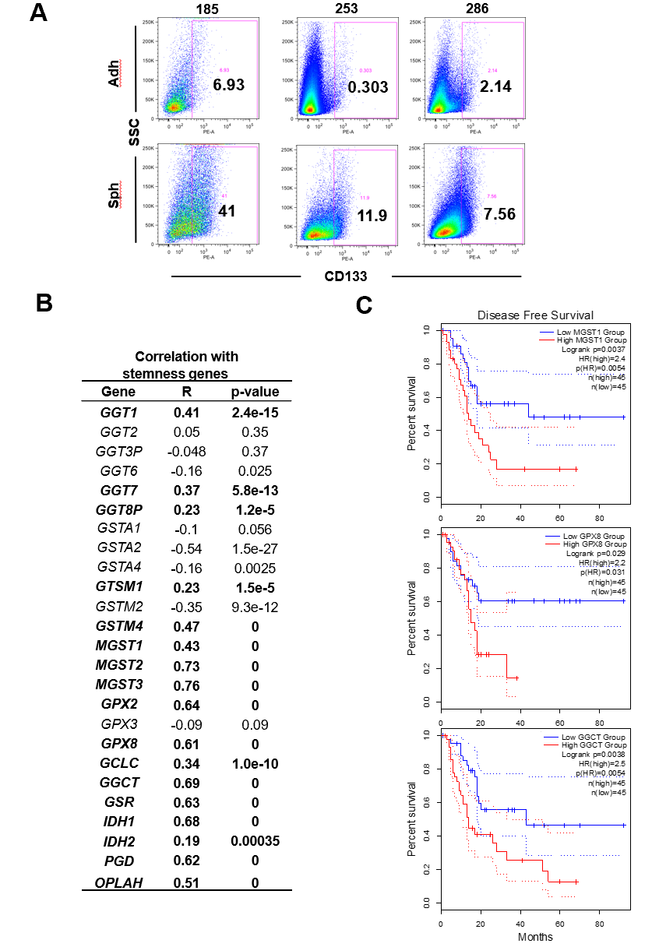
Figure 1 Expression of glutathione metabolism genes positively correlates with a stemness signature in human pancreatic cancer samples and predicts poor outcome. A: Enrichment in CD133⁺ cells in sphere cultures vs adherent cultures, as determined by flow cytometry. Representative flow cytometry histograms of the indicated patient-derived xenograft models; B: Correlation of genes that were up-regulated in cancer stem cell-enriched cultures with a stemness signature defined by combined expression of the pluripotency-related genes NANOG, KLF4, SOX2 and OCT4. Pearson´s r and corresponding P values for individual correlations are shown; C: Disease-free survival in pancreatic cancer patients from upper and lower quartiles of expression of the indicated genes. Hazard ratio was calculated using the Cox Proportional Hazards model. Dotted lines represent the 95% confidence interval. Data in A and B were calculated using GEPIA2 (http://gepia2.cancer-pku.cn), using public data compiled in TCGA and GTEx. Sph: Sphere culture; Adh: adherent culture; HR: Hazard ratio.
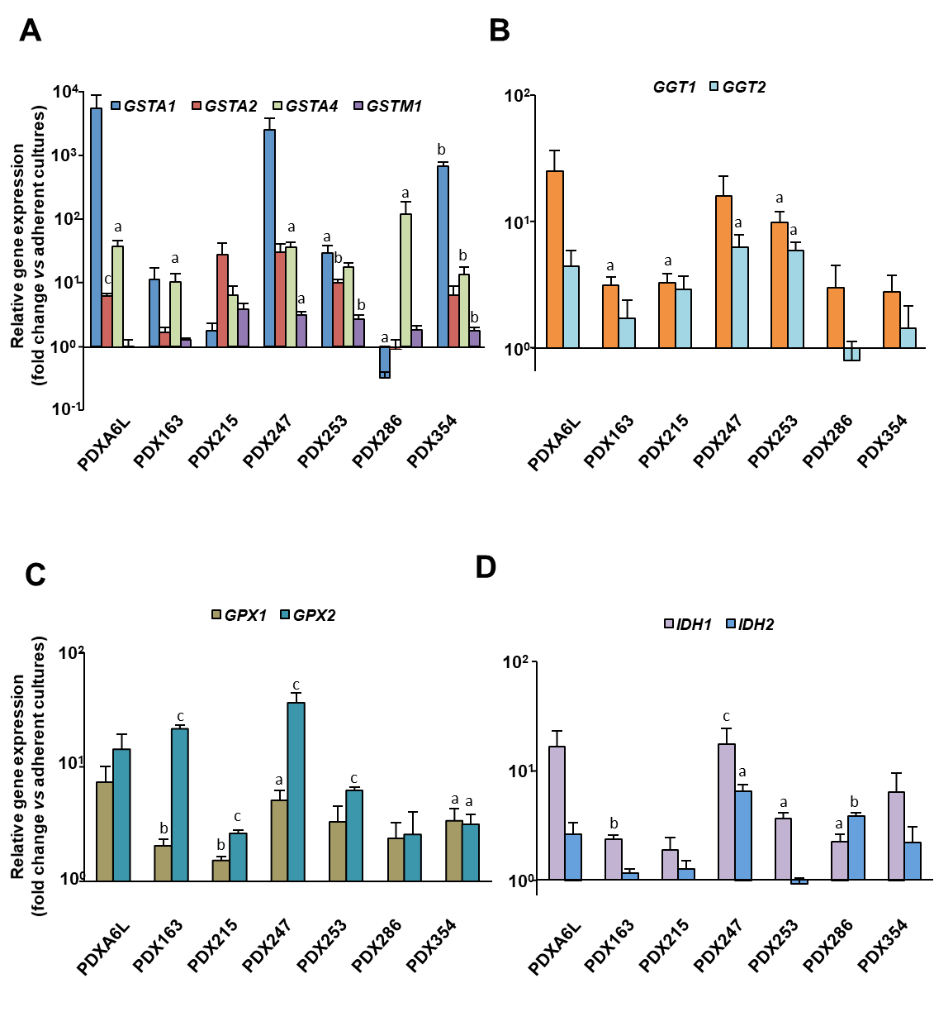
Figure 2 Glutathione metabolism-related genes are up-regulated in cancer stem cell-enriched conditions. Primary cells from different patient-derived xenograft models as indicated in the figure were cultured in adherent or low-attachment cancer stem cell-enriching conditions. On day 7 the expression of several glutathione (GSH)-related genes was evaluated by real-time polymerase chain reaction (PCR). A: Glutathione-S-Transferases A1, A2, A4, M1; B: Gamma-glutamyltransferases 1 and 2; C: Glutathione Peroxidases 1 and 2; D: Isocitrate Dehydrogenases 1 and 2. Data were normalized to HPRT and are shown as mean ± SE fold change expression levels of sphere vs adherent cultures in logarithmic scale. ªP < 0.05; ^{b}P < 0.01; ^{c}P < 0.001. PDX: Patient-derived xenograft; GGT: Gamma-glutamyltransferase; GST: Glutathione-s-transferase; GPX: Glutathione peroxidase.
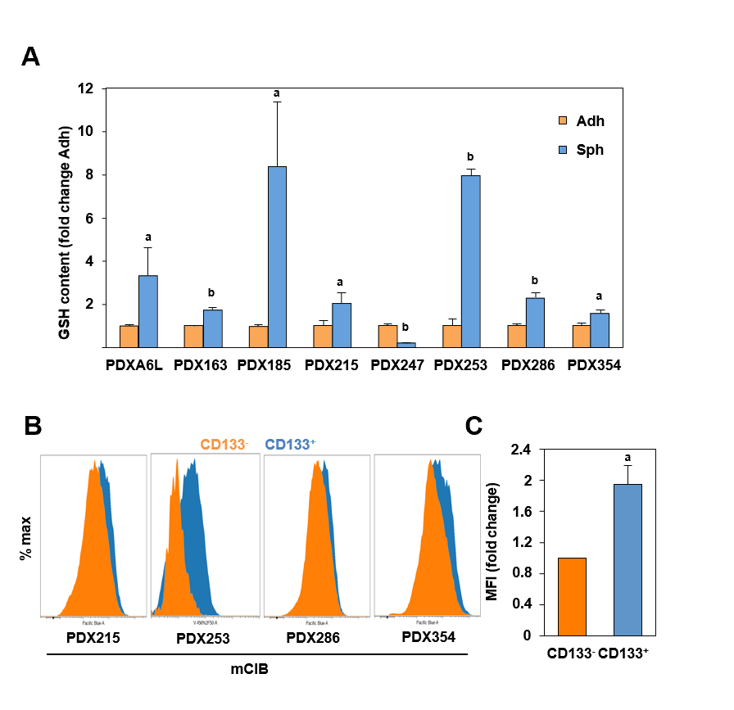
Figure 3 Reduced glutathione content is increased in cancer stem cell-enriching conditions. Reduced glutathione (GSH) content was measured using the fluorescent thiol-reactive probe monochlorobimane (mClB). A: GSH content in cellular lysates was assessed by fluorimetry. Primary cells from different patient-derived xenograft (PDX) models as indicated in the figure were cultured in adherent or low-attachment cancer stem cell-enriching conditions for 7 d. Data were normalized for protein content; B: GSH content in CD133 positive and negative subpopulations as determined by flow cytometry. Representative flow cytometry histograms of the indicated PDX models are shown, with the following mean fluorescence intensities (MFI) for CD133– and CD133⁺ populations, respectively: PDX215 (2787 vs 4880), PDX286 (2748 vs 4364), PDX354 (4138 vs 6988); C: Pooled MFI data from PDX215, 286 and 354. Data in A and C are shown as mean ± SE fold change for sphere vs adherent cultures (A) or CD133⁺ vs CD133–. ªP < 0.05; ^{b}P < 0.01. GSH: Glutathione content in its reduced form; PDX: Patient-derived xenograft; Sph: Sphere culture; Adh: adherent culture; MFI: Mean fluorescence intensities.
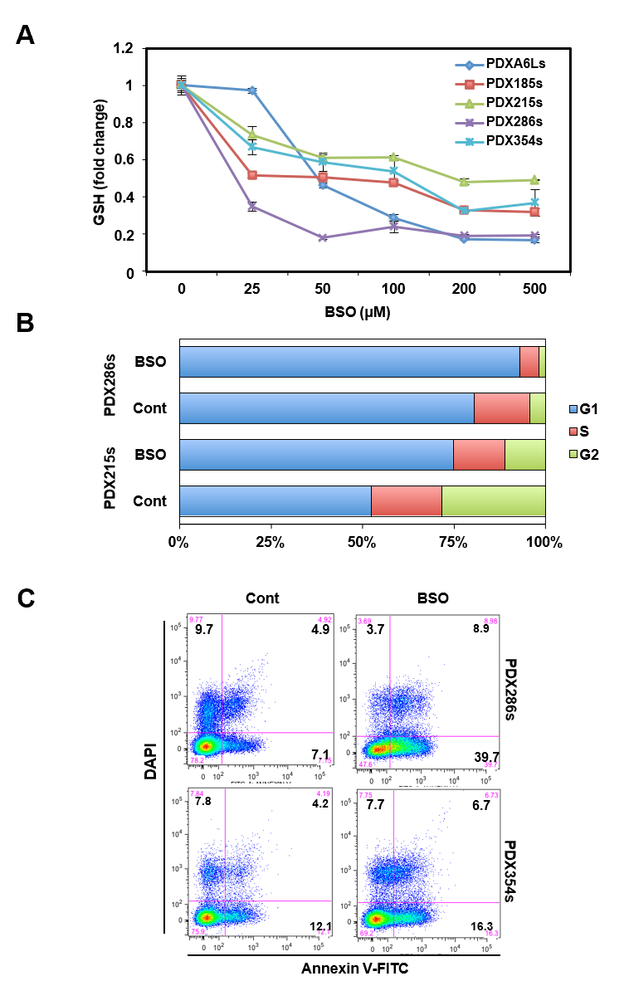
Figure 4 Inhibition of glutathione synthesis blocks cell cycle progression and induces apoptosis in cancer stem cell-enriched cultures. Cells from the indicated patient-derived xenograft models were grown in cancer stem cell-enriching conditions as spheres for 5 d and then treated for 48 h with 100 µmol/L buthionine-sulfoximine (BSO), unless indicated otherwise. A: Dose-dependent inhibition of glutathione (GSH) content by BSO measured by fluorimetry after staining with monochlorobimane (mClB); B: Percentage of cells in the different phases of the cell cycle as assessed by flow cytometry; C: Representative FACS plots of an Annexin-V/DAPI staining to detect apoptosis under the indicated conditions. GSH: Glutathione content in its reduced form; BSO: Buthionine-sulfoximine; PDX: Patient-derived xenograft.

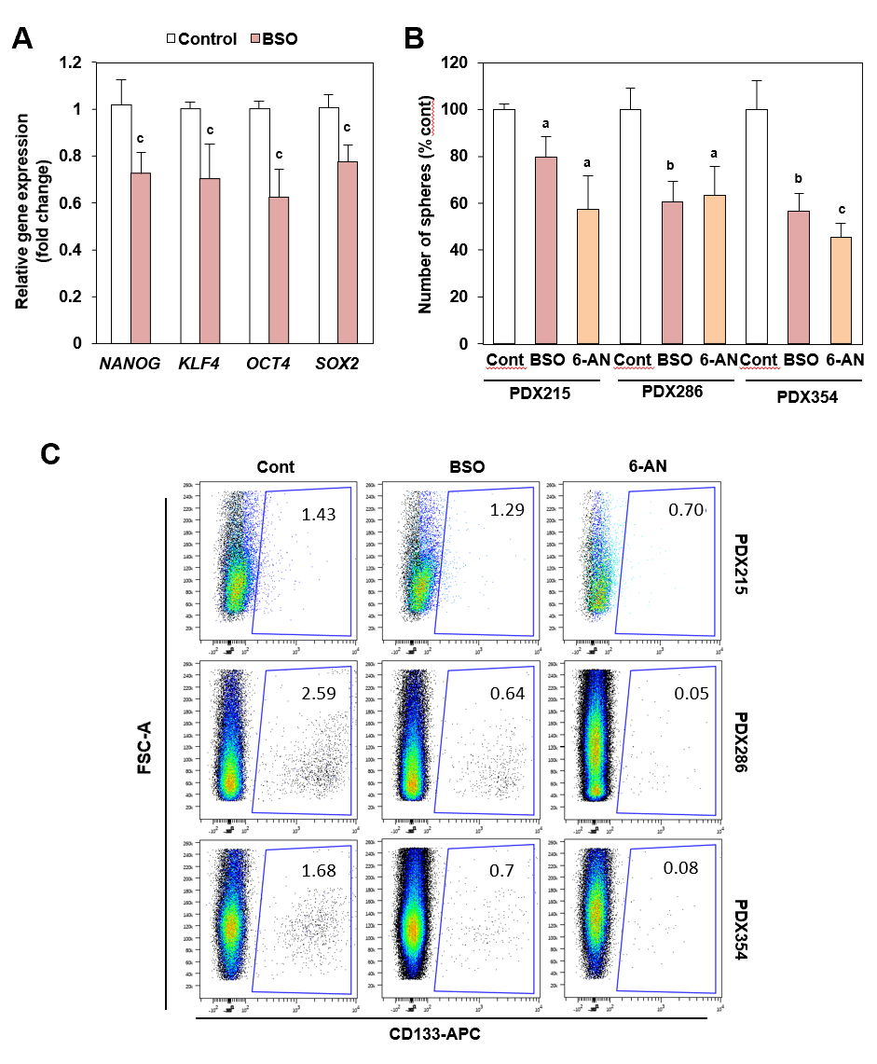
Figure 5 Inhibition of glutathione synthesis and recycling decreases self-renewal and CD133 expression. Cells from the indicated patient-derived xenografts (PDXs) were treated with 100 µmol/L buthionine-sulfoximine or 1 µmol/L 6-Aminonicotinamide as indicated. A: Expression of stemness gene expression following 72 h of treatment; B: Sphere formation ability after 7 d of treatment, replenished every other day. Data are shown as fold change vs untreated conditions (Cont) for each PDX model, mean ± SE; C: Representative flow cytometry plots for CD133 expression after 48 h of treatment. ªP < 0.05; ^{b}P < 0.01; ^{c}P < 0.001. BSO: Buthionine-sulfoximine; PDX: Patient-derived xenograft; 6-AN: 6-Aminonicotinamide.
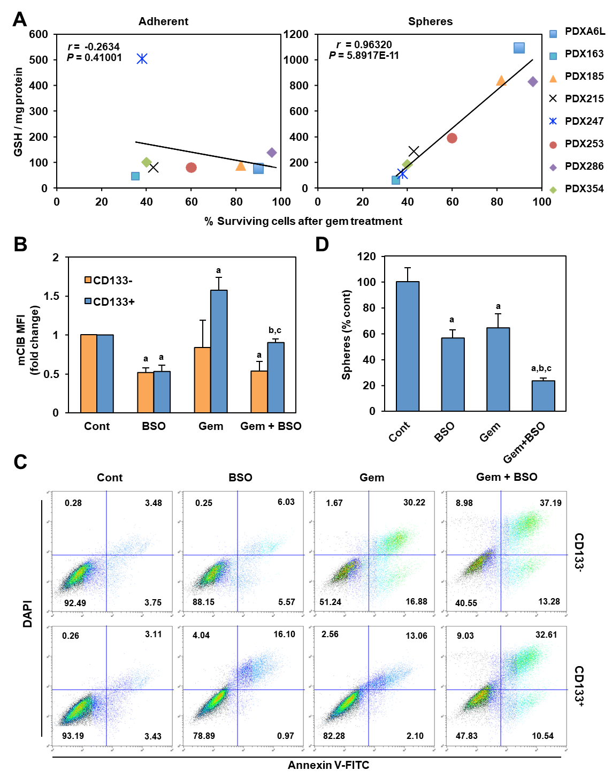
Figure 6 Depletion of glutathione (GSH) content in cancer stem cells enhances response to Gemcitabine. A: Correlation of the absolute glutathione (GSH) content per milligram of protein in lysates from adherent (left panel) or sphere (right panel) cultures vs the percentage of surviving cells following gemcitabine treatment (300 nM, 48 h). Values for Pearson´s r and corresponding P values are shown; B-D: Patient-derived xenograft 354 cells were treated with 100 µmol/L buthionine-sulfoximine (BSO) alone or in combination with 1 µmol/L Gemcitabine; B: mClB staining for GSH content in CD133– vs CD133⁺ cells after 48 h of treatment; C: Representative flow cytometry plots for Annexin V/DAPI staining for samples shown in B; D: Number of spheres following 7 d of treatment. Data in B and D are shown as mean fold change or mean percentage ± SE, with untreated conditions (Cont) set as 1.0 or 100%, respectively. ªP < 0.001 vs Cont; ^{b}P < 0.001 vs BSO; ^{c}P < 0.001 vs Gemcitabine. GSH: Glutathione content in its reduced form; PDX: Patient-derived xenograft; MFI: Mean fluorescence intensities; BSO: Buthionine-sulfoximine.
Table 1 List of utilized primers
Gene | Primer
HPRT
Forward | TGACCTTGATTTATTTTGCATACC
Reverse | CGAGCAAGACGTTCAGTCCT
GCLC
Forward | GCCGCTGAGCTGGGAGGAAA
Reverse | ATTCCACCTCATCGCCCCACT
GPX1
Forward | TATCGAGAATGTGGCGTCCC
Reverse | GATGCCCAAACTGGTTGCAC
GPX2
Forward | GGACATCAGGAGAACTGTCAGA
Reverse | TCAGGTAGGCGAAGACAGGA
GGT1
Forward | CAACCTGCCCACAGTGAAGA
Reverse | TTCTTGGCCTCCATGACTGC
GGT2
Forward | CCCTTCTTTCAGTGGGAGGG
Reverse | ATGCTGTCACCTTTGTGGCT
GSTM1
Forward | AGGAAAAGAAGTACACGATGGG
Reverse | TTGCTCTGGGTGATCTTGTG
GSTA1
Forward | CAACCTGCCCACAGTGAAGA
Reverse | TTCTTGGCCTCCATGACTGC
GSTA2
Forward | CCCTTCTTTCAGTGGGAGGG
Reverse | ATGCTGTCACCTTTGTGGCT
GSTA
Forward | TCCGTGAGATGGGTTTTAGC
Reverse | CTGTACCAACTTCATCCCGTC
IDH1
Forward | CAAGTGACGGAACCCAAAAG
Reverse | ACCCTTAGACAGAGCCATTTG
IDH2
Forward | ACAACACCGACGAGTCCATC
Reverse | GCCCATCGTAGGCTTTCAGT

Table 2 RNAseq reveals that glutathione metabolism genes are up-regulated in cancer stem cell-enriched cultures from pancreatic cancer patient-derived xenografts
PDX | GGTs | GSTs | GPXs | Synthesis and recycling
PDX185 | GGT1, GGT2, GGT3P, GGT6, GGT7 | GSTA1, GSTA2, GSTT1, MGST2, MGST3 | GPX2, GPX3 | GCLC, GSR, PGD, IDH1
PDX215 | GGT1, GGT2, GGT7, GGT8P | GSTA1, GSTA4, GSTM2, GSTM4, MGST2 |  | OPLAH, IDH1
PDX253 | GGT1, GGT2, GGT3P, GGT6 | GSTA1, GSTA2, GSTA4, MGST1, MGST2, MGST3 | GPX2, GPX8 | GSR, IDH1
PDX354 |  | GSTA1, GSTA2, MGST1, GSTM2 | GPX3, GPX8 | GCLC, GGCT, IDH1
PDX265 |  | GSTA4, GSTM1, GSTM2, GSTM4 | GPX2 | GGCT, PGD, IDH1, IDH2
PDX: Patient-derived xenograft; GGTs: Gamma-glutamyltransferases; GSTs: Glutathione-s-transferases; GPXs: Glutathione peroxidases.

