Name of Journal: World Journal of Gastrointestinal Surgery
Manuscript NO: 66884
Manuscript Type: ORIGINAL ARTICLE

Retrospective Study
Reappraisal of surgical decision-making in patients with splenic sclerosing angiomatoid nodular transformation: Case series and literature review

Tseng H et al. Surgical decision of SANT

Hao Tseng, Cheng-Maw Ho, Yu-Wen Tien

Hao Tseng, School of Medicine, National Taiwan University College of Medicine, Taipei 100, Taiwan

Hao Tseng, Department of Medical Education, and Department of Surgery, National Taiwan University Hospital, Taipei 100, Taiwan

Cheng-Maw Ho, Yu-Wen Tien, Department of Surgery, National Taiwan University Hospital and National Taiwan University College of Medicine, Taipei 100, Taiwan

Author contributions: Tseng H drafted the manuscript; Tseng H and Ho CM designed the study; Tseng H conducted data processing; Tseng H, Ho CM and Tien YW performed data analysis; Ho CM and Tien YW were the directors responsible for general organization and instruction; all authors have read and agreed to the published version of the manuscript.

Corresponding author: Cheng-Maw Ho, MD, PhD, Associate Professor, Department of Surgery, National Taiwan University Hospital and National Taiwan University College of Medicine, No. 7 Chung-Shan South Road, Taipei 100, Taiwan. miningho@ntu.edu.tw

Received: April 13, 2021
Revised: June 28, 2021
Accepted: July 19, 2021
Published online:

Abstract
BACKGROUND
Many clinicians and surgeons are unfamiliar with the sclerosing angiomatoid nodular transformation (SANT), which is gaining recognition as a benign splenic tumor. We challenge that SANT is rare and whether surgical intervention could be avoided through critical imaging review.

AIM
To evaluate the incidence of SANT among splenic tumors and the decision-making process of SANT management.

METHODS
Twenty hospitalized patients who underwent splenectomy in 2018 and 2019 in a tertiary university hospital were retrospectively reviewed, and their data on imaging, diagnosis, surgical indications, and courses were recorded. All pathology results were confirmed by pathologist. Discriminative features differentiating SANT from other non-SANT splenic tumors were descriptively analyzed in this case series.

RESULTS
Fourteen out of 20 patients who underwent splenectomy had splenic tumors, including 3 SANTs (21% splenic tumors), 6 non-SANT benign lesions (43%), 2 metastatic tumors, and 3 lymphomas. Hypointensity on T2-weighted magnetic resonance imaging (MRI), spoke wheel enhancing pattern in contrasted computed tomography or MRI, and cold spot (low fluorodeoxyglucose uptake) in positron emission tomography (PET) scan helped establish the diagnosis of SANT. Lymphoma, presenting with a hot spot on the PET scan were differentiated from SANT. Surgical indications were reformatted for splenic tumors. Splenectomy need not be performed in patients with typical imaging features of SANT.

CONCLUSION
SANT is not a rare disease entity in clinical practice. Splenectomy should not be routinely indicated as the only management option for SANT with typical imaging features.

Key Words: Splenic tumor; Diagnosis; Surgical decision-making; Sclerosing angiomatoid nodular transformation; Retrospective study

Tseng H, Ho CM, Tien YW. Reappraisal of surgical decision-making in patients with splenic sclerosing angiomatoid nodular transformation: Case series and literature review. World J Gastrointest Surg 2021; In press

Core Tip: Sclerosing angiomatoid nodular transformation (SANT) used to be considered a rare but benign lesion since it was recognized. However, SANT comprised one fifth patients who received splenectomy for splenic tumors in our university hospital cohort. The unique diagnostic image features of SANT include spoke wheel enhancing pattern in contrasted computed tomography or magnetic resonance imaging (MRI) and hypo-intensity on T2-weighted images of MRI. Clinicians should recognize this disease entity to avoid unnecessary overtreatment.
INTRODUCTION
With the increasing use of imaging modalities, such as computed tomography (CT), incidental finding of splenic lesions is increasingly common. Clinicians and surgeons are frequently faced with difficult decision-making regarding the management of splenic tumors. Benign splenic masses include cysts, hemangiomas, lymphangiomas, hamartomas, sclerosing angiomatoid nodular transformation (SANT), and sarcoidosis, whereas malignant lesions include lymphoma, metastasis, and rarely angiosarcoma^{[1-3]}. Splenic cysts and hemangiomas are well recognized, but the others are not common in daily practice, and therefore cause a diagnostic dilemma that may eventually lead to unnecessary splenectomy.
SANT, a newly defined rare benign tumor, first reported in 2004, was re-named as cord capillary hemangioma, a variant of hamartoma, or a multinodular hemangioma^{[4]}. Reported patterns in CT images include well-circumscribed lesions that are solitary, hypodense, and present with peripheral enhancement with central progression and radiating lines. On magnetic resonance imaging (MRI), SANT appears isointense and hypointense on T1 and T2 images, with the same enhancing pattern as CT images, with the so-called spoke-wheel enhancement^{[2]}. Splenectomy is considered the standard treatment because the diagnostic imaging features of SANT are not well-established^{[5]}. However, in light of the benign nature of the pathogenesis^{[6]} and the clinical course (no reported relapse or metastasis after splenectomy), the indication for splenectomy is controversial.
Splenectomy is commonly performed in the setting of hematological autoimmune disease (idiopathic thrombocytopenic purpura and autoimmune hemolytic anemia) and malignancies^{[7]}, whereas for other splenic tumors (including SANT), the indications are not well recognized. In our study, we reviewed the patients who underwent splenectomy for splenic tumors and found that many SANTs were diagnosed within a short period. We hypothesize that SANT is not rare, but an unrecognized disease entity. We aimed to evaluate the decision-making process for the management of SANT (conservative observation or surgery) by determining the typical imaging features to distinguish SANT and critically review current indications for splenectomy in the literature.

MATERIALS AND METHODS
We retrospectively reviewed 20 hospitalized patients who underwent splenectomy at the National Taiwan University Hospital in 2018 and 2019. Six patients were excluded from the study because the indications for splenectomy were not the presence of tumors. Fourteen eligible patients were further divided into SANT and non-SANT groups based on the histopathological diagnosis. Demographic and clinical characteristics, including age, sex, symptoms, past history, radiographic imaging findings [CT, MRI, positron emission tomography (PET)], tentative diagnosis made by radiologists, operative methods (open or laparoscopic), and postoperative complications were reviewed. Furthermore, we compared the imaging features of SANT and non-SANT tumors largely based on literature^{[1-3,8]}, with an intent to identify the decisive factor distinguishing non-SANT from SANT. This study was approved by the Institutional Review Board of the National Taiwan University Hospital, Taipei, Taiwan (NTUH REC: 202102011RIND). Because this was a retrospective study using chart review, the institutional review board waived the need for informed consent.

Statistical analysis
Descriptive statistics were used to summarize the characteristics (frequency distribution, central tendency, and variation) of the dataset. Data are presented as mean, median, range, or percentage when appropriate. Analysis were performed using the Statistical Package for Social Sciences (SPSS)® version 21.0 (SPSS Inc., Chicago, IL, United States).

RESULTS
Patients
Between 2018 and 2019, 20 patients underwent splenectomy (11 open and 9 Laparoscopic approaches). Their surgical indication and final pathologic diagnosis are shown in Figure 1. Among these, 14 cases were splenic tumors, and 9 (64.3%) were benign, including 3 cases of SANT. Malignant tumors included two metastatic lesions (renal cell carcinoma and lung pleomorphic carcinoma), and three newly diagnosed lymphomas, with a median hospital stay of eight days (4-105 d). One patient with diffuse large B-cell lymphoma underwent re-operation for gastric perforation 12 d after open distal pancreatectomy and splenectomy, and was transferred to the intensive care unit after re-open surgery. A total of seven patients had minor complications (two cases of intra-abdominal infection, two cases of pneumonia, and three cases of wound infection) according to the Clavien-Dindo classification.

Clinical features of SANT
The clinical characteristics of the three patients who were finally diagnosed with SANT are summarized in Table 1. The average tumor size was 4.7 cm (3.5-5.5 cm). On CT scan, all three tumors showed non-contrast hypodense to isodense lesions with progressive peripheral enhancement, with a hypodense center in the venous phase (Figure 2). Case 1 showed a typical lobulated lesion and septate enhancement, which is referred to as centripetal enhancement or spoke wheel pattern^{[2]}. SANTs cases 1 and 2 had hypo- to iso-intense appearance on T1-weighted and T2-weighted sequences, with peripheral or lobulated enhancement (Figure 2). Case 3 underwent a PET scan for lymphoma follow-up, and presented with diffuse mild hypermetabolism within the splenic tumor (standardized uptake value max = 4.2, Figure 2F). Splenectomy was indicated for diagnostic purpose (n = 2) or symptom relief (n = 1).

Image characteristics of non-SANT splenic tumors
Splenectomies performed for other benign or malignant splenic tumors (n = 11) were included in this study to compare imaging features of SANT and five types of non-SANT tumors (Table 2). All 20 splenic tumors were hypodense on non-contrast CT. Some features, such as enhancement patterns (e.g., peripheral for hemangioma and poor for lymphoma) may be suggestive of SANT, but are difficult for radiologists to definitely diagnose. We reasoned that MRI outperformed CT in that hyperintensity on T2-weighted images (Figure 3) could suggest hemangioma or non-lymphoma metastasis (Figure 3B and D)^{[1,2]}, and the latter is rarely found in patients without an underlying malignancy^{[9]}. In contrast, both SANT and lymphoma showed hypo intensity on T2 and a poor enhancement pattern (Figure 3A and C). Homogeneous splenomegaly with a focal infarct (Figure 4A) or multifocal splenic tumors (Figure 4B) could indicate a systemic lymphoma; however, when isolated lymphoma presents as a solitary splenic tumor (Figure 4C), distinguishing it from SANT becomes difficult because the spoke-wheel pattern can also be seen in lymphoma (Figure 4C and D). Additional imaging, such as PET (Figure 2F), or biopsy are necessary if splenectomy is not considered.

Splenectomy for splenic tumors
No cases of SANT were diagnosed preoperatively. Indications of splenectomy for two cases of SANT and five malignant splenic tumors were oncological concerns. Interestingly, although one MRI reported a splenic tumor resembling lymphoma or SANT, splenectomy was still performed for the increasing tumor size, and the final diagnosis given was lymphoma. Notably, none of the three lymphomas in our series had abnormal blood parameters.
The indications for splenectomy in the two metastatic cases were a rapidly enlarging cystic lesion (8 cm in 6 mo) during follow-up and a newly suspected metastasis showing hyperintensity on T2-weighted images with central necrosis (Figure 3D).
Benign neoplasms in our series other than SANT were resected due to symptoms or an increase in size during follow-up, and the final pathologic reports were compatible with the preoperative diagnoses.

DISCUSSION
In our small cohort including patients from the 2-year study period, SANT was not uncommon, accounting for 3 out of the 14 splenic tumors. Since the first case series published in 2004^{[4]}, less than 200 cases have been reported, and almost all reports defined this novel lesion as a rare benign tumor. A disease is defined as rare when the approximate case number ranges between 1/1500 and 1/2000^{[10,11]}. We argue that SANT is unidentified rather than rare in common clinical practice. Milosavljević et al^{[12]} reported that SANT represented 3.3% of all the benign lesions that underwent splenectomy and in our series, 21.4% of all splenectomies in the 2 years. As more SANT cases are reported in the literature, the term “rare” may be inappropriate and deviates from reality.
Differential diagnosis of splenic tumors based on imaging features is generally difficult. However, T2 weighted imaging on MRI may provide additional diagnostic value for SANT (hypointensity) by excluding hemangioma and metastasis (hyperintensity). The presence of primary malignancy also suggests a diagnosis of metastatic splenic tumor^{[13]}, although rare. Solitary splenic metastasis is more uncommon, with only 5% of all metastases involving the spleen^{[9]}. The chance of spleen as a metastatic focus is probably considered only in patients with an underlying known malignancy. Although rare, solitary lymphoma^{[8]} could appear very similar to SANT on CT or MRI. Clinical clues, such as lymphadenopathy, hepatomegaly, symptoms of systemic lymphoma^{[1]} tumor central necrosis, cytopenia, and size-increasing primary splenic lymphoma may help distinguish lymphoma from SANT^{[1,14]}. However, SANT may coexist with extrasplenic lymphoma, as seen in case 3 in Table 1. High fluorodeoxyglucose uptake in the PET scan may be a promising diagnostic feature of lymphoma, which warrants further investigation^{[15]}.
Management of splenic tumors involves conservative follow-up or surgical resection. Surgical resection (total or partial splenectomy) is universally recommended for the diagnosis and treatment of SANT in the literature^{[16]}; however, since a diagnosis can be made without pathology, the indication for surgery is questionable. Recently, Jin et al^{[16]} reported a large series of 37 patients who were diagnosed with SANT over a 10-year-period, estimating an average of 4 cases per year. This finding was consistent with our statement that SANT should not be considered a rare tumor. A further review of 37 patients revealed that progressive enhancement was present in 9 cases on dynamic contrast-enhanced MRI studies that also looked more like malignant disease. Splenectomy could have been avoided in at least 28 cases, if SANT was identified by the clinicians^{[16]}. We propose a list of indications for splenectomy for splenic tumors (Table 3). For those with typical imaging features of benign tumors, such as cysts, hemangiomas, and SANTs, symptoms were the most reasonable indication for splenectomy, although malignant splenic tumors tend to be more symptomatic than benign tumors^{[17]}. For suspected benign splenic tumors, surgical intervention is appropriate for increasing size, splenic rupture, patient decision, and diagnostic purpose. In addition to surgical complications, splenectomy may be associated with an increased risk of infection, thromboembolism, and possibly cancer development^{[18]}. When diagnosed, malignant splenic tumors do not always require splenectomy. Accumulating evidence has shown that splenic lymphoma can be effectively treated with immunochemotherapy, resulting in a decreasing need for therapeutic splenectomy^{[19,20]}. Splenectomy for splenic lymphoma is reserved for patients who experience abdominal fullness due to large spleens and cytopenia due to spleen sequestration^{[19,20]}. Diagnosis of tissue proof to determine the nature of lymphoma could be another important indication of splenectomy for highly suspected systemic lymphoma with absence of a definite diagnosis from another site. Splenectomy for splenic metastasis can be beneficial in metastatic carcinoma, either to achieve tumor-free status or to reduce tumor load in debulking surgery (such as ovarian cancer)^{[9]}. Splenectomy could be avoided in disseminated metastatic disease because the benefit of survival or diagnosis remains low.
If surgery is not performed based on the radiological findings, the best strategy for the follow up of these patients and how the patients are counselled require additional consideration. In patients with underlying malignancies, the follow-up interval could be in line with the current schedule. As for incidental cases, 6-mo or 12-mo follow-up imaging is recommended^{[13]}. The changing nature of tumor in images or clinical presentation should initiate a surgical re-evaluation. However, if patients do not feel reassured after counselling, an individualized decision of a short-interval follow-up recommendation or a direct referral to a surgeon is also justified.
Our study is limited by the small number of patients and its retrospective nature, precluding an extensive analysis of the specificity and sensitivity of imaging features. Patients who underwent conservative management of splenic tumors were not included. However, we aim to raise the awareness of this emerging diagnosis of SANT, which is currently categorized as a rare disease, but hopefully will be more commonly recognized with time, among clinicians and surgeons. We hope that this would assist the decision-making in the future management of splenic tumors, particularly SANT.

CONCLUSION
SANT should be considered uncommon. The surgical indications for SANT should be reconsidered. Further studies are needed to confirm the diagnostic features of SANT in imaging, such as hypo-intensity on T2-weighted images of MRI and spoke wheel enhancing pattern.

ARTICLE HIGHLIGHTS
Research background
Clinicians are not familiar with the sclerosing angiomatoid nodular transformation (SANT), which is gaining recognition as a benign splenic tumor.

Research motivation
We challenge that SANT is rare and whether critical imaging review could help avoid unnecessary splenectomy.

Research objectives
This study aimed to evaluate the incidence of SANT among splenic tumors and the decision-making process of SANT management.

Research methods
Twenty hospitalized patients who underwent splenectomy in 2018 and 2019 in a tertiary university hospital were retrospectively reviewed. Discriminative features differentiating SANT from other non-SANT splenic tumors were descriptively analyzed.

Research results
Fourteen splenectomies were indicated for splenic tumors, including 3 SANTs (21%). Hypointensity on T2-weighted magnetic resonance imaging, spoke wheel enhancing pattern, and cold spot in positron emission tomography scan helped establish the diagnosis of SANT. Splenectomy need not be performed in patients with typical imaging features of SANT.

Research conclusions
SANT is not rare. Splenectomy should not be routinely indicated as the only management option for SANT with typical imaging features.

Research perspectives
Further studies are needed to confirm the diagnostic imaging features of SANT in the future.

ACKNOWLEDGEMENTS
We thank Dr. Chen CY (Division of Hematology, Department of Internal Medicine, National Taiwan University Hospital) for providing critical comments.

REFERENCES
1 Ricci ZJ, Kaul B, Stein MW, Chernyak V, Rozenblit AM, Oh SK, Flusberg M, Mazzariol FS. Improving diagnosis of atraumatic splenic lesions, Part III: malignant lesions. Clin Imaging 2016; 40: 846-855 [PMID: 27179158 DOI: 10.1016/j.clinimag.2016.02.015]
2 Ricci ZJ, Mazzariol FS, Flusberg M, Chernyak V, Oh SK, Kaul B, Stein MW, Rozenblit AM. Improving diagnosis of atraumatic splenic lesions, part II: benign neoplasms/nonneoplastic mass-like lesions. Clin Imaging 2016; 40: 691-704 [PMID: 27317213 DOI: 10.1016/j.clinimag.2016.02.002]
3 Ricci ZJ, Oh SK, Chernyak V, Flusberg M, Rozenblit AM, Kaul B, Stein MW, Mazzariol FS. Improving diagnosis of atraumatic splenic lesions, part I: nonneoplastic lesions. Clin Imaging 2016; 40: 769-779 [PMID: 27317223 DOI: 10.1016/j.clinimag.2016.01.012]
4 Martel M, Cheuk W, Lombardi L, Lifschitz-Mercer B, Chan JK, Rosai J. Sclerosing angiomatoid nodular transformation (SANT): report of 25 cases of a distinctive benign splenic lesion. Am J Surg Pathol 2004; 28: 1268-1279 [PMID: 15371942 DOI: 10.1097/01.pas.0000138004.54274.d3]
5 Cipolla C, Florena AM, Ferrara G, Di Gregorio R, Unti E, Giannone AG, Lazzaro LA, Graceffa G, Pantuso G. Sclerosing Angiomatoid Nodular Transformation: Laparoscopic Splenectomy as Therapeutic and Diagnostic Approach at the Same Time. Case Rep Surg 2018; 2018: 7020538 [PMID: 29854543 DOI: 10.1155/2018/7020538]
6 Awamleh AA, Perez-Ordoñez B. Sclerosing angiomatoid nodular transformation of the spleen. Arch Pathol Lab Med 2007; 131: 974-978 [PMID: 17550330 DOI: 10.5858/2007-131-974-SANTOT]
7 Browning MG, Bullen N, Nokes T, Tucker K, Coleman M. The evolving indications for splenectomy. Br J Haematol 2017; 177: 321-324 [PMID: 27018168 DOI: 10.1111/bjh.14060]
8 Lee HJ, Kim JW, Hong JH, Kim GS, Shin SS, Heo SH, Lim HS, Hur YH, Seon HJ, Jeong YY. Cross-sectional Imaging of Splenic Lesions: RadioGraphics Fundamentals | Online Presentation. Radiographics 2018; 38: 435-436 [PMID: 29528823 DOI: 10.1148/rg.2018170119]
9 Sauer J, Sobolewski K, Dommisch K. Splenic metastases--not a frequent problem, but an underestimate location of metastases: epidemiology and course. J Cancer Res Clin Oncol 2009; 135: 667-671 [PMID: 18936972 DOI: 10.1007/s00432-008-0502-3]
10 Griggs RC, Batshaw M, Dunkle M, Gopal-Srivastava R, Kaye E, Krischer J, Nguyen T, Paulus K, Merkel PA; Rare Diseases Clinical Research Network. Clinical research for rare disease: opportunities, challenges, and solutions. Mol Genet Metab 2009; 96: 20-26 [PMID: 19013090 DOI: 10.1016/j.ymgme.2008.10.003]
11 Baldovino S, Moliner AM, Taruscio D, Daina E, Roccatello D. Rare Diseases in Europe: from a Wide to a Local Perspective. Isr Med Assoc J 2016; 18: 359-363 [PMID: 27468531]
12 Milosavljević V, Tadić B, Grubor N, Erić D, Matić S. Laparoscopic Vs. Open Surgery in Management of Benign Neoplasms of Spleen—Single Institution Experience. Indian J Surg 2020: 82: 355-359 [DOI: 10.1007/s12262-019-01974-5]
13 Heller MT, Harisinghani M, Neitlich JD, Yeghiayan P, Berland LL. Managing incidental findings on abdominal and pelvic CT and MRI, part 3: white paper of the ACR Incidental Findings Committee II on splenic and nodal findings. J Am Coll Radiol 2013; 10: 833-839 [PMID: 24183552 DOI: 10.1016/j.jacr.2013.05.020]
14 Li M, Zhang L, Wu N, Huang W, Lv N. Imaging findings of primary splenic lymphoma: a review of 17 cases in which diagnosis was made at splenectomy. PLoS One 2013; 8: e80264 [PMID: 24278265 DOI: 10.1371/journal.pone.0080264]
15 Karunanithi S, Sharma P, Roy SG, Vettiyil B, Sharma A, Thulkar S, Bal C, Kumar R. Use of 18F-FDG PET/CT imaging for evaluation of patients with primary splenic lymphoma. Clin Nucl Med 2014; 39: 772-776 [PMID: 25036015 DOI: 10.1097/RLU.0000000000000523]
16 Jin Y, Hu H, Regmi P, Li F, Cheng N. Treatment options for sclerosing angiomatoid nodular transformation of spleen. HPB (Oxford) 2020; 22: 1577-1582 [PMID: 32063479 DOI: 10.1016/j.hpb.2020.01.014]
17 Siewert B, Millo NZ, Sahi K, Sheiman RG, Brook OR, Sun MRM, Kane RA. The Incidental Splenic Mass at CT: Does It Need Further Work-up? An Observational Study. Radiology 2018; 287: 156-166 [PMID: 29369753 DOI: 10.1148/radiol.2017170293]
18 Kristinsson SY, Gridley G, Hoover RN, Check D, Landgren O. Long-term risks after splenectomy among 8,149 cancer-free American veterans: a cohort study with up to 27 years follow-up. Haematologica 2014; 99: 392-398 [PMID: 24056815 DOI: 10.3324/haematol.2013.092460]
19 Arcaini L, Rossi D, Paulli M. Splenic marginal zone lymphoma: from genetics to management. Blood 2016; 127: 2072-2081 [PMID: 26989207 DOI: 10.1182/blood-2015-11-624312]
20 Fallah J, Olszewski AJ. Diagnostic and therapeutic splenectomy for splenic lymphomas: analysis of the National Cancer Data Base. Hematology 2019; 24: 378-386 [PMID: 30885066]

Footnotes
Institutional review board statement: This study was approved by the Institutional Review Board of the National Taiwan University Hospital, Taipei, Taiwan (NTUH REC: 202102011RIND).

Informed consent statement: Because this was a retrospective study using chart review, the institutional review board waived the need for informed consent.

Conflict-of-interest statement: Tseng H, Ho CM and Tien YW all declare no conflict of interest.

Data sharing statement: The datasets used and analyzed during the current study are available from the corresponding author upon reasonable request.

Open-Access: This article is an open-access article that was selected by an in-house editor and fully peer-reviewed by external reviewers. It is distributed in accordance with the Creative Commons Attribution NonCommercial (CC BY-NC 4.0) license, which permits others to distribute, remix, adapt, build upon this work non-commercially, and license their derivative works on different terms, provided the original work is properly cited and the use is non-commercial. See: http://creativecommons.org/Licenses/by-nc/4.0/

Manuscript source: Unsolicited manuscript

Peer-review started: April 13, 2021
First decision: June 23, 2021
Article in press:

Specialty type: Gastroenterology and hepatology
Country/Territory of origin: Taiwan
Peer-review report’s scientific quality classification
Grade A (Excellent): 0
Grade B (Very good): B
Grade C (Good): 0
Grade D (Fair): 0
Grade E (Poor): 0

P-Reviewer: Ali SM S-Editor: Gao CC L-Editor: P-Editor:
Figure Legends
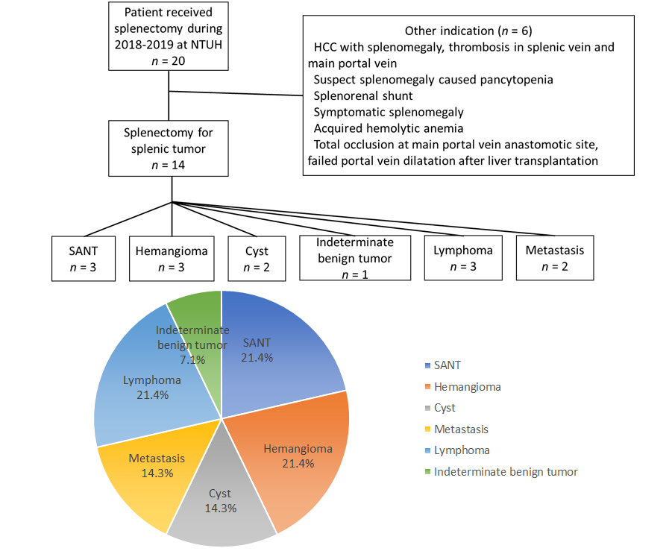
Figure 1 Schema of patient selection process and splenic tumor classification. SANT: Sclerosing angiomatoid nodular transformation; HCC: Hepatocellular carcinoma; NTUH: National Taiwan University Hospital.
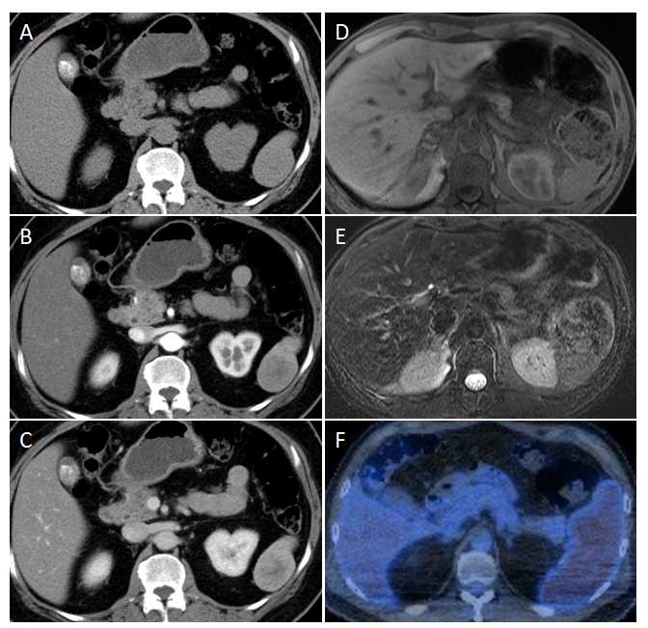
Figure 2 Typical image features of sclerosing angiomatoid nodular transformation. A-C: Computed tomography (CT), non-contrast (A), arterial phase (B), venous phase (C) (Case 2); D and E: Magnetic resonance imaging (MRI), MRI T1 (D), MRI T2 (E) (Case 1); F: Positron emission tomography-CT (Case 3).
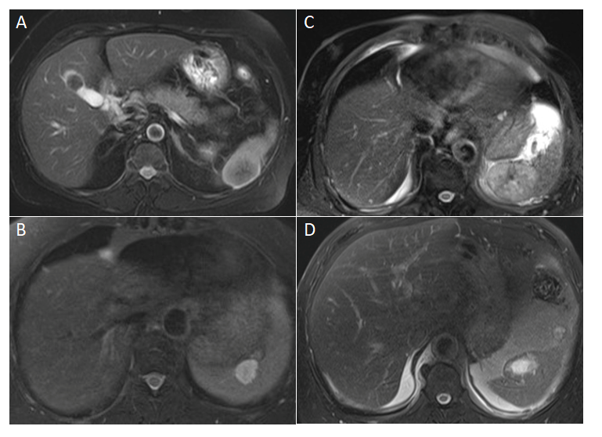
Figure 3 Non-sclerosing angiomatoid nodular transformation tumors compared with sclerosing angiomatoid nodular transformation base on magnetic resonance imaging T2 signals. A: Sclerosing angiomatoid nodular transformation (hypointensity); B: Hemangioma (hyperintensity); C: Lymphoma (hypointensity); D: Metastasis, central necrosis (hyperintensity).
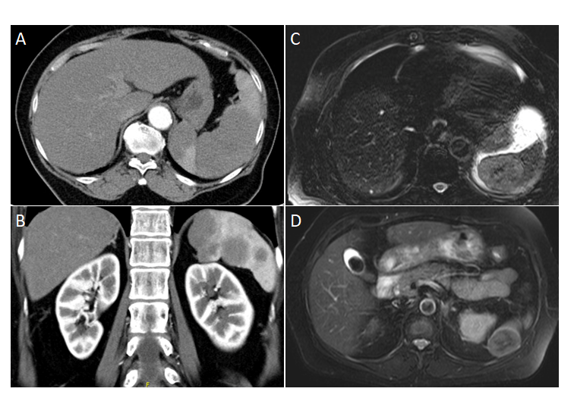
Figure 4 Image comparison between splenic lymphoma and sclerosing angiomatoid nodular transformation. A: Computed tomography, homogenous splenomegaly; B: Computed tomography, multifocal lesion (splenic lymphoma); C: Magnetic resonance imaging T2, solitary mass with spoke wheel pattern (splenic lymphoma); D: Magnetic resonance imaging T2, solitary mass with spoke wheel pattern (sclerosing angiomatoid nodular transformation).

Table 1 Characteristic of three patients with sclerosing angiomatoid nodular transformation
No. | Age (yr) | Sex | Indication | Symptoms | Size | CT |  | MRI |  | PET | Follow up | Surgery
 |  |  |  |  |  | A phase | V phase | T1/T2 | Contrast
1 | 48 | M | Diagnostic splenectomy, for Atypical hemangioma MRI pattern, suspect lymphoma | 8 kg loss in 2 yr; left abdominal pain  Fatigue | 5.5 cm | Septate enhancement | Mild progressing peripheral enhancement with centrally remained iso-hypodense | Iso-hypodense/iso-hypodense | Heterogenous  gradual enhancement and diffusion restriction | Nil | 2 mo | Open
2 | 61 | F | Diagnostic splenectomy, for elevated CA19-9, malignancy cannot be rule out | Nil | 4.1 cm | Mild enhancement | Mild progressing peripheral enhancement with centrally remained iso-hypodense | Iso-hypodense/hypodense | Mild peripheral enhancement | Nil | 6 mo | Laparoscopy
3 | 52 | M | Diagnostic splenectomy, for suspect lymphoma splenic involvement¹ | Nil | 3.5 cm | Peripheral enhancement | Nil | Nil |  | Diffuse mild hypermetabolism at spleen  (²SUVmax = 4.2) | 4 mo | Laparoscopy
¹Underlying with B-cell non-Hodgkin lymphoma, Ann Arbor stage IV, IPI score 2, suspected marginal zone lymphoma, status post R-CHOP (VI, 2019/1/7-2019/07/19). ²SUVmax: maximum standardized uptake value. SUV: Standardized uptake value; CT: Computed tomography; MRI: Magnetic resonance imaging; PET: Positron emission tomography; Non contrast CT: Iso-hypodense.
Table 2 Comparison of Image characteristics among common splenic tumor
 | Tumor | Tumor shape, features, and characteristics | MRI T1 | MRI T2 | CT/MRI enhancing pattern | Other image characteristics probably aid diagnosis
Benign | SANT | Well-circumscribed, commonly lobulated, solitary mass | Iso-hypointense | Hypointense | Spoke-Wheel pattern; Poor enhancement | PET/CT: Low FDG accumulation
 | Hemangioma | Single nodule  multiple nodules  diffuse masses enlarging the spleen | Hypointense | Hyperintense | Homogenous or peripheral enhancement | Mostly small, asymptomatic, and slow growth
 | Cyst | Cystic lesion | Hypointense | Hyperintense | No enhancement | Ultrasound: Thin wall, anechoic, peripheral brightly echogenicity, and distal shadows due to wall calcification
Malignant | Systemic lymphoma | Homogenous splenomegaly; Infiltrative miliary lesions (1-5 mm); Multifocal lesions (2-10 cm); Uncommon solitary lesions (7-14 cm) | Isointense | Hypointense | Poor enhancing | Splenomegaly; Splenic infarct; PET: Intense heterogenous FDG activity; Extra-splenic findings: Hepatomegaly, lymphadenopathy
 | Primary splenic lymphoma | Solitary mass > uncommonly Splenomegaly | Isointense | Hypointense | Poor enhancing | Central necrosis
 | Metastasis | Variously | Iso-hypointense | Hyperintensity | Similar to the primary tumor | PET/CT: FDG-avid tumor; Poorly marginated; Heterogenous
CT: Computed tomography; MRI: Magnetic resonance imaging; PET: Positron emission tomography; FDG: Fluorodeoxyglucose.
Table 3 Indication list of splenectomy proposed for splenic tumors
Imaging features | Rationale for splenectomy
Benign tumor: Cyst; Hemangioma; SANT; other | Symptom-relief
 | Probable splenic rupture
 | Increasing tumor size or numbers
 | Rule out malignancy with atypical image features
 | Patient desire
Lymphoma | Symptom-relief
 | Treatment for cytopenia without heavy bone marrow infiltration
 | Diagnosis for tissue proof to determine the nature of lymphoma
Angiosarcoma | Treatment
Metastasis | Total tumor free
 | Debulking after chemotherapy
 | Diagnosis and total tumor free for isolated splenic metastasis
SANT: Sclerosing angiomatoid nodular transformation.

