Name of Journal: World Journal of Cardiology
ESPS Manuscript NO: 31152
Manuscript Type: Meta-Analysis

Ivabradine in the treatment of systolic heart failure - A systematic review and meta-analysis

Narayanan MA et al. Ivabradine and heart failure

Mahesh Anantha Narayanan, Yogesh NV Reddy, Janani Baskaran, Abhishek Deshmukh, David G Benditt, Ganesh Raveendran

Mahesh Anantha Narayanan, Janani Baskaran, David G Benditt, Ganesh Raveendran, Division of Cardiovascular Diseases, University of Minnesota Medical Center, Minneapolis, MN 55455, United States

Yogesh NV Reddy, Abhishek Deshmukh, Division of Cardiovascular Diseases, Mayo Clinic, Rochester, MN 55905, United States

Author contributions: All authors contributed to this manuscript.

Conflict-of-interest statement: Drs. Mahesh Anantha Narayanan, Yogesh NV Reddy, Janani Baskaran and Ganesh Raveendran have no disclosures; Dr. Benditt is a consultant for and holds equity in Medtronic Inc., and St Jude Medical Inc. Dr. Benditt is supported in part by a grant from the Dr. Earl E Bakken Family in support of heart-brain research.

Data sharing statement: Since this is a meta-analysis and data was generated from previous published papers, data is not available for sharing beyond that contained within the report.

Open-Access: This article is an open-access article which was selected by an in-house editor and fully peer-reviewed by external reviewers. It is distributed in accordance with the Creative Commons Attribution Non Commercial (CC BY-NC 4.0) license, which permits others to distribute, remix, adapt, build upon this work non-commercially, and license their derivative works on different terms, provided the original work is properly cited and the use is non-commercial. See: http://creativecommons.org/licenses/by-nc/4.0/

Manuscript source: Invited manuscript

Correspondence to: Mahesh Anantha Narayanan, MD, Division of Cardiovascular Diseases, University of Minnesota Medical Center, 500 SE Harvard Street, Minneapolis, MN 55455, United States. manantha@umn.edu
Telephone: +1-507-3192446
Fax: +1-612-6264411

Received: November 1, 2016
Peer-review started: November 4, 2016
First decision: December 15, 2016
Revised: January 7, 2017
Accepted: January 16, 2017
Article in press:
Published online:

Abstract
AIM
To perform a systematic-review and meta-analysis to compare outcomes of ivabradine combined with beta-blocker to beta-blocker alone in heart failure with reduced ejection fraction (HFrEF).

METHODS
We searched PubMed, Cochrane, EMBASE, CINAHL and Web of Science for trials comparing ivabradine + beta-blocker to beta-blocker alone in HFrEF. We performed a systematic-review and meta-analysis of published literature. Primary end-point was combined end point of cardiac death and hospitalization for heart failure.

RESULTS
Six studies with 17671 patients were included. Mean follow-up was 8.7 ± 7.9 mo. Combined end-point of heart failure readmission and cardiovascular death was better in ivabradine + beta-blocker group compared to beta-blocker alone (RR: 0.93, 95%CI: 0.79-1.09, P = 0.354). Mean difference (MD) in heart rate was higher in the ivabradine+beta-blocker group (MD: 6.14, 95%CI: 3.80-8.48, P < 0.001). There was no difference in all cause mortality (RR: 0.98, 95%CI: 0.89-1.07, P = 0.609), cardiovascular mortality (RR: 0.99, 95%CI: 0.86-1.15, P = 0.908) or heart failure hospitalization (RR: 0.87, 95%CI: 0.68-1.11, P = 0.271).

CONCLUSION
From the available clinical trials, ivabradine + beta-blocker resulted in a significantly greater reduction in HR coupled with improvement in combined end-point of heart failure readmission and cardiovascular death but with no improvement in all cause or cardiovascular mortality. Given the limited evidence, further randomized controlled trials are essential before widespread clinical application of ivabradine + beta-blocker is advocated for HFrEF.

Key words: Ivabradine; Heart failure

© The Author(s) 2017. Published by Baishideng Publishing Group Inc. All rights reserved.

Core tip: Ivabradine was recently given a class IIa indication in the 2016 focused update on systolic heart failure in the ACC/AHA/HFSA guidelines. But it is unclear whether ivabradine offers any additional benefit over and above that offered by beta blockers. Our analysis showed lower heart rate and combined end point of cardiac death and heart failure hospitalization at follow-up with ivabradine combined with beta blocker compared to beta blocker alone. Combined therapy did not improve cardiovascular mortality, all cause mortality or heart failure hospitalization. Further studies are essential before widespread use of combination therapy with ivabradine can be recommended.

Narayanan MA, Reddy YNV, Baskaran J, Deshmukh A, Benditt DG, Raveendran G. Ivabradine in the treatment of systolic heart failure - A systematic review and meta-analysis. World J Cardiol 2017; In press

INTRODUCTION
Chronic congestive heart failure affects nearly 2%-3% of population and is associated with a one-year mortality of 6.4% in a recent study^{[1]}. Standard pharmacological treatment for heart failure with reduced ejection fraction (HFrEF) includes beta-blockade which unequivocally decreases cardiovascular and heart failure related morbidity and mortality, in addition to promoting beneficial reverse remodeling^{[2,3]}.
Elevated resting heart rates (HR) have been shown to be both an independent predictor of mortality in heart failure presumably acting through increased myocardial oxygen demand, and also to serve as a marker of severity of underlying neurohormonal activation and cardiovascular disease^{[4-6]}. In regard to the former, in patients with left ventricular dysfunction associated with ischemic cardiomyopathy, HR > 70 beats per minute (bpm) are associated with a 34% increase in cardiovascular mortality and 53% increase in hospitalization when compared to heart rates below 70 bpm^{[7]}. Benefits derived from beta-blockers seem to be derived partly from their heart rate lowering properties^{[8]}. However, their negative inotropic properties can have undesirable actions on myocardial contractility^{[9]}.
Ivabradine is a novel drug that inhibits the pacemaker current If -thereby slowing heart rates without exhibiting negative inotropic effect on the myocardium^{[10]} or altering ventricular action potential^{[11]}. In SHIFT^{[12]}, ivabradine improved the composite end point of hospitalization and cardiovascular death in patients with HFrEF in sinus rhythm with heart rates ≥ 70^{[12,13]}. The 2016 American College of Cardiology/American Heart Association/Heart Failure Society of America (ACC/AHA/HFSA) Focused Update on the Management of Heart Failure^{[14]} and the European Society of Cardiology (ESC) guidelines^{[15]} have given a Class IIa (level of evidence B) recommendation for ivabradine use for patients with chronic HFrEF who are on guideline directed medical therapy (includes a maximum tolerated dose of beta-blocker, ACEi and mineralocorticoid receptor antagonist (MRA)) and who are in sinus rhythm with resting heart rates above 70 bpm (> 75 bpm in the European Society). It should be noted that in the SHIFT trial^{[12]}, only 26% of the patient population were on target beta-blocker dosage. Thus the utility of ivabradine in the modern era, particularly with the recent approval of sacubitril with its dramatic improvement in mortality and heart failure outcomes^{[16]} remains uncertain. To consolidate the available evidence regarding ivabradine in HFrEF, we performed a systematic review and meta-analysis including all the available clinical trials to date to evaluate the benefit of ivabradine therapy in combination with beta-blocker compared to beta-blocker alone in chronic HFrEF.

MATERIALS AND METHODS
Data search
An electronic database search was performed with the following search terms “ivabradine”, “heart failure with reduced ejection fraction”, “resting heart rates” and “systolic heart failure” in PubMed, EMBSASE, Cochrane, CINAHL and Web of Science for studies published between January-1960 and August-2016 comparing the addition of ivabradine to beta-blocker vs beta-blocker only therapy. Supplementary appendix-1 shows PubMed search strategy.

The systematic review and meta-analysis was performed per PRISMA guidelines as shown in the Supplementary checklist^{[17]} and Supplementary Figure 1 shows the PRISMA flowchart. We also reviewed relevant editorials, review articles and reference sections of included studies. We excluded conference abstracts with unpublished data as mentioned in the Cochrane guidelines for meta-analysis. An expert biostatistician has reviewed the paper for statistical accuracy.

Inclusion criteria
Studies selected met the following criteria: Randomized controlled trials (RCTs), retrospective or prospective observational cohorts; included HFrEF of < 40%; compared two groups, one with ivabradine and beta-blocker and the other with beta-blocker alone; included adult patients; published in English language.

Study definitions
We defined all cause mortality as death from any cause at follow-up. Cardiovascular mortality was defined as death from any cardiac cause including heart failure, myocardial infarction, arrhythmia, sudden cardiac death or stroke.

Data extraction
Table 1 shows extracted patient demographics including mean age, sample size, co-morbidities, mortality data and risk estimates. Authors Mahesh Anantha Narayanan and Yogesh NV Reddy reviewed the studies independently. A consensus was achieved by a third reviewer when the first two reviewers could not resolve any disagreement. We sought help from an experienced librarian when articles were not available online.

Outcomes
The primary outcome was combined end-point of heart failure and cardiovascular death. Secondary outcomes included, mean reduction in heart rate at follow up compared to baseline, all cause mortality, cardiovascular mortality, six-minute walking distance (6MWD) and ejection fraction (EF) at follow up.

Statistical analysis
We used comprehensive meta-analysis (CMA) version 3.3.07 for statistical analysis. Categorical events were pooled using the random effects model, with pooled effect size represented by Mantel-Haenszel (MH) risk ratio (RR) with a 95% confidence interval (CI) limit. MH RR is a technique that generates an estimate of association between exposure and outcome after adjusting for confounding. Difference in Means (MD) was used for reporting outcomes with continuous variables. The combined ivabradine and beta-blocker group was the experimental group and so any MH RR (with 95%CI) that is less than 1 favors this cohort. Funnel-plots were used for assessing bias visually. Cochrane’s Q-statistics were used to determine heterogeneity. I² values of > 50%, 25%-50% and 0%-25% were considered to be high, moderate and low heterogeneity, respectively. We used an exclusion sensitivity analysis to analyze heterogeneity when required. P value of < 0.05 was considered statistically significant. A meta-regression was performed when necessary to analyze the impact of moderator variables on outcomes of interest.

RESULTS
Characteristics of the included studies
A total of 696 studies were obtained using the initial search strategy as shown in Supplementary Figure 1. Initially 7 studies^{[12,18-23]} met our inclusion criteria. We excluded the SHIFT sub group study as the sub group was not independent of the main SHIFT study population. Finally, we included 6 studies^{[12,18-21,23]} with a total of 17671 patients. Mean follow-up was 8.7 ± 7.9 mo. A total of 8845 patients received ivabradine with a beta-blocker and 8826 patients received only a beta-blocker. Table 1 shows characteristics of the included studies and Supplementary Table 1 summarizes the results of analyses comparing ivabradine and beta-blocker vs beta-blocker alone in patients with chronic HFrEF.

Combined end point of cardiovascular death and hospitalization for worsening heart failure
A total of two studies reported combined end-point of cardiovascular death and hospitalization at follow up between the combined ivabradine + beta-blocker and the beta-blocker only group (Figure 1). MH RR was lower in the combined therapy group when compared to beta-blocker only group (MH RR: 0.93, 95%CI: 0.79-1.09, P = 0.354). Heterogeneity was high (I² = 87%) among the included studies.

Heart rates at follow up
Change in heart rates at follow up from baseline was reported in all included studies. Difference in means (MD) for reduction in heart rate from baseline was greater in the ivabradine + beta-blocker group when compared to beta-blocker alone (difference in means (MD): 6.14, 95%CI: 3.80-8.48, P < 0.001 (Figure 2). Funnel-plot showed low risk of bias as shown in Supplementary Figure 2A and heterogeneity was high (I² = 95). A sensitivity analysis performed with exclusion of the study^{[18]} with the maximum strength did not alter the results of the analysis (MD: 6.24, 95%CI: 2.71-9.78; P = 0.001). Analysis of only RCTs still showed that mean reduction in heart rates from baseline was greater in the combined ivabradine and beta-blocker group when compared to beta-blocker alone (MD: 6.88, 95%CI: 4.17-9.59; P < 0.001 for RCTs) (Figure 3).

All cause mortality
Three studies that reported all cause mortality at follow-up were analyzed (Figure 4). There was no difference in all cause mortality between the combined group and the beta-blocker alone group (MH RR: 0.98, 95%CI: 0.89-1.07, P = 0.609). Heterogeneity was low (I² = 17%). When we excluded the study with maximum weight^{[12]}, results remained unaltered (MH RR: 1.04, 95%CI: 0.89-1.07, P = 0.609). A meta-regression of follow up time on all cause mortality was insignificant (Supplementary Figure 2B).

Cardiovascular mortality
Two studies reporting adverse events at follow-up were analyzed (Figure 5). There was no difference in cardiovascular mortality between the combined group and the beta-blocker alone group (MH RR: 0.99, 95%CI: 0.86-1.15, P = 0.908). Heterogeneity was high (I² = 66%).

Hospitalization for heart failure
Two studies reported hospitalization for heart failure (Figure 6). There was no difference in heart failure hospitalization between the combined group and the beta-blocker alone group (MH RR: 0.87, 95%CI: 0.68-1.11, P = 0.271). Heterogeneity was high (I² = 89%).

6MWD
Two studies reported 6MWD at follow up when compared to baseline between the combined therapy group with ivabradine plus beta-blocker and the beta-blocker alone group (Figure 7). 6MWD improved significantly from baseline in the combined therapy group (MD: 46.47, 95%CI: 14.678.3, P = 0.004). Heterogeneity was low (I² = 0%).

Ejection fraction
Three studies reported ejection fraction at follow up (Figure 8). Improvement in ejection fraction was better in the combined therapy group with ivabradine plus beta-blocker when compared to the beta-blocker alone group (MD: 3.27, 95%CI: 0.42-6.13, P = 0.025). Heterogeneity was moderate (I² = 45%).

DISCUSSION
In this meta-analysis, ivabradine combined with beta-blockers resulted in a greater reduction of heart rates at follow up when compared to beta-blocker only group. Also, combined therapy was associated with significantly lower composite end-point of cardiovascular death or hospitalization for worsening heart failure. On the other hand, in the relatively short follow-up offered by the included studies, there was no improvement in secondary outcomes including isolated cardiovascular or all cause mortality or individual outcome of heart failure hospitalization. However surrogate markers such as 6MWD and ejection fraction appeared to improve in the ivabradine plus beta-blocker group vs beta-blocker alone. The importance of an improvement in EF with more bradycardia is difficult to determine since at slower heart rates more complete emptying can occur and may manifest as an improvement in EF without a true increase in LV intrinsic contractility or end systolic elastance.
Ivabradine was approved by the United Sates Food and Drug Administration for treatment of HFrEF in 2015. It is a very specific inhibitor of hyperpolarization activated cyclic nucleotide gated channels, which decreases the diastolic if current and reduces sinus rate^{[24]}. Ivabradine has no effect on the atrio ventricular node itself^{[24]}. In addition, it has been shown that If channels may increase in chronic heart failure in ventricular myocytes that could be arrhythmogenic^{[25]} and so inhibition of these channels by ivabradine could be beneficial in patients with HFrEF. It has use dependency^{[26]} and thus the reduction in heart rate is proportional to the baseline heart rate in individuals. Given all these characteristics and its effect of lowering heart rate without inducing the negative inotropic effect of beta-blockers, it was expected to not only be better tolerated than beta-blockers in HFrEF, but also to be beneficial by minimizing the adverse cardiac structural changes associated with tachycardia^{[12]}.

Summary of existing trials
In the BEAUTIFUL trial^{[18]}, a double blind RCT, 10917 patients with coronary disease and HFrEF and an EF < 40% were randomized to either ivabradine or placebo. Both groups were on optimal conventional heart failure medications with 87% of the patient population in both groups on beta-blockers; though there was no mention if the subjects were on maximal tolerated beta-blocker doses. The BEAUTIFUL study^{[18]} reported that 84% of population was in NYHA Class II or III. Four percent of subjects were lost during follow-up. Results indicated that the ivabradine group had a greater improvement in heart rates at follow up with a MD (difference in means) in change from baseline of 5.6 bpm at 24 mo when compared to the placebo group. However, although mortality benefit with heart rates reduction has been shown in multiple studies, BEAUTIFUL^{[18]} failed to show any benefit in terms of combined cardiovascular end-point of cardiovascular death, hospital admission for myocardial infarction or new onset worsening heart failure. Also there was no improvement in individual secondary outcomes including all cause mortality, cardiac mortality, hospitalization or worsening heart failure in both the groups.
In the sub-group with heart rates of 70 bpm or more^{[18]}, the MD in change from baseline was 6.9 bpm at 24 mo in the ivabradine arm but there was still no difference between the groups in their primary end-points but there was a statistically significant reduction in secondary outcomes including number of follow up hospital admissions for myocardial infarction and coronary revascularization. A borderline reduction in the composite end-point was noted in the ivabradine group when 14% of patients with activity limiting angina were analyzed separately, both in the overall and in the sub group of HR > 70 bpm.
The SHIFT trial^{[12]} is the next largest ivabradine RCT, and randomized 6505 patients with stable chronic ischemic and non-ischemic HFrEF of < 35% to receive either ivabraine or placebo in conjunction with optimal medical therapy for heart failure. SHIFT reported that 89% of patient population were being treated with beta-blockers at the beginning of the trial. All patients were in NYHA Class II-IV with almost 99% patient population in class II and III. The study mentioned that only 26% of the patient population was receiving optimal target dose of beta-blocker, and the most common reason for not being able to achieve the target dose was hypotension (almost 45% population in both groups). The results showed that the ivabradine group had a lower incidence of combined end-point of cardiovascular death or hospitalization for worsening of heart failure though all cause-mortality was not different between the groups. The sub-group carvedilol only study^{[22]} still retained the benefit for combined end-point in the ivabradine plus carvedilol but cardiovascular mortality was not different between ivabradine plus carvedilol and the carvedilol only group.
In a pooled analysis of the SHIFT^{[12]}, and the BEAUTIFUL^{[18]}, trials^{[27]}, ivabradine achieved highest heart rate control in patients with a baseline HR of > 75 bpm when compared to patients with HR < 60 bpm; this finding is consistent with the use-dependence property of the drug. The lower heart rate at follow up in the ivabradine sub-group was associated with the lowest mortality (17.4% in < 60 bpm vs 32.4% in > 75 bpm). When the investigators did a statistical adjustment for heart rate and other prognostic factors, the benefit of ivabradine was eliminated. Consequently, it may be that ivabradine improved the combined end-point mainly by heart rate reduction, although other possible mechanisms including if blockade in ventricular myocardium in chronic HFrEF cannot be eliminated. In SHIFT^{[12]}, the MD in heart rate from baseline in the ivabradine group was greater than in BEAUTIFUL^{[18]}; the relatively lower heart rate reduction achieved in BEAUTIFUL could be a possible explanation for absence of improvement in combined end-point of cardiovascular death or hospitalization for heart failure in the latter.
It should be noted in SHIFT^{[12]} that patients on < 50% of the target beta-blocker dosage achieved more benefit of the combined end-point when combined with ivabradine when compared to the overall group. One possible explanation could be patients with < 50% of target beta-blocker dosage have a higher HR and these patients tend to achieve higher benefit with ivabradine therapy than patients with a lower HR (secondary to the use-dependence property of ivabradine).
In ETHIC-AHF, a smaller recent RCT published by Hidalgo et al^{[23]}, 71 patients with acute heart failure and with EF of < 40%, sinus rhythm and HR > 70 bmp were randomized to ivabradine plus beta-blockers and beta-blockers alone. HR at 1-mo and at 4-mo follow-up were lower in the ivabradine group but the difference did not translate into improved clinical outcomes which showed no difference between the two groups in hospitalization rates for heart failure or death at follow-up.
The European Medical Agency set 75 bpm as HR cut-off^{[15]} while the ACC/AHA guidelines^{[14]} recommended 70 bpm as cut off for use of ivabradine in chronic HFrEF. Though the combined end-point of heart failure hospitalization or cardiac mortality was reduced along with improvement in ejection fraction and 6MWD, there was no reduction in all cause mortality, cardiovascular mortality or heart failure hospitalization alone in the current study. Also, in SHIFT^{[12]}, the benefit was higher in patients on < 50% target dose of beta-blocker limiting its generalizability and suggesting there may be only a sub group that might benefit from ivabradine therapy. Therefore, before further evidence becomes available, it is essential to follow the current guidelines and up-titrate the dosage of beta-blockers before initiating ivabradine therapy for HFrEF. Further randomized trials with long term follow-up will determine if the short-term benefit in composite end-point translates to long term mortality.

Limitations
The limitations of our meta-analysis are similar to any meta-analysis, including all limitations and biases associated with the original studies. We did not have access to patient level data and so we were not able to include outcomes of interest not reported in some articles. The meta-analysis included four RCTs and two sub-groups from RCTs along with two non-randomized trials and could be a source of bias. To diminish the bias, we analyzed RCTs separately which did not alter the outcomes. We could not adjust for confounding variables that were not adjusted for in the primary studies. The optimal dosage of beta-blockers tolerated was not reported in some trials and thus we could not analyze the correlation between baseline beta-blocker dose and ivabradine dependent outcomes. Thus, it still remains unclear if ivabradine would maintain its efficacy in patients who are on maximal tolerated doses of beta-blockers. Unavoidably, publication bias is a limitation of any meta-analysis.
In summary, the results of our systematic review and meta-analysis of the published literature supports use of ivabradine in patients with chronic HFrEF in sinus rhythm and with HR of > 70 bpm per guidelines however the strength of evidence supporting this recommendation is weak. This approach is associated with demonstrable benefit in terms of composite end-point of cardiovascular mortality or hospitalization for heart failure. There was an improvement in ejection fraction and 6MWD at follow up but this was not reported in the majority of the published trials. More evidence is needed before ivabradine can be recommended more broadly to patients with HFrEF. The current evidence supporting its approval is limited.

ACKNOWLEDGEMENTS
We acknowledge Baskaran Krishnamoorthy for reviewing the article for English language, spelling and grammar corrections.

COMMENTS
Background
Ivabradine is a novel heart rate reducing agent by selectively inhibiting the cardiac pacemaker current if thereby slowing heart rates without exhibiting negative inotropic effect on the myocardium. It was approved by the United States Food and Drug Administration for treatment of heart failure with reduced ejection fraction (HFrEF) in 2015.

Research frontiers
The 2016 American College of Cardiology/American Heart Association/Heart Failure Society of America (ACC/AHA/HFSA) Focused Update on the Management of Heart Failure and the European Society of Cardiology (ESC) guidelines have given a Class IIa (level of evidence B) recommendation for ivabradine use for patients with chronic HFrEF who are on guideline directed medical therapy. It is unclear, however, whether ivabradine offers any additional benefit when combined with beta-adrenergic blockade.

Innovations and breakthroughs
Two large RCTs (BEAUTIFUL and SHIFT) and some small RCTs compared the efficacy of ivabradine with beta blockers combined with beta blocker alone in people with chronic systolic heart failure. Both BEAUTIFUL and SHIFT failed to show mortality benefit but target beta blocker dosage achieved in these studies was lower, creating bias and suggesting there may be only a sub group that might benefit from ivabradine therapy.

Applications
The systematic review and meta-analysis supports use of ivabradine in patients with chronic HFrEF in sinus rhythm and with HR of > 70 bpm per the updated guidelines. Further randomized controlled trials are essential before ivabradine can be recommended more broadly to patients with HFrEF and the current evidence supporting its approval is limited.

Peer-review
A useful and interesting paper that should be published after authors make some changes to ensure the article is clearer, easy to read and not too technical statistically.

REFERENCES
1 Crespo-Leiro MG, Anker SD, Maggioni AP, Coats AJ, Filippatos G, Ruschitzka F, Ferrari R, Piepoli MF, Delgado Jimenez JF, Metra M, Fonseca C, Hradec J, Amir O, Logeart D, Dahlström U, Merkely B, Drozdz J, Goncalvesova E, Hassanein M, Chioncel O, Lainscak M, Seferovic PM, Tousoulis D, Kavoliuniene A, Fruhwald F, Fazlibegovic E, Temizhan A, Gatzov P, Erglis A, Laroche C, Mebazaa A. European Society of Cardiology Heart Failure Long-Term Registry (ESC-HF-LT): 1-year follow-up outcomes and differences across regions. Eur J Heart Fail 2016; 18: 613-625 [PMID: 27324686 DOI: 10.1002/ejhf.566]
2 McMurray JJ, Adamopoulos S, Anker SD, Auricchio A, Böhm M, Dickstein K, Falk V, Filippatos G, Fonseca C, Gomez-Sanchez MA, Jaarsma T, Køber L, Lip GY, Maggioni AP, Parkhomenko A, Pieske BM, Popescu BA, Rønnevik PK, Rutten FH, Schwitter J, Seferovic P, Stepinska J, Trindade PT, Voors AA, Zannad F, Zeiher A, Bax JJ, Baumgartner H, Ceconi C, Dean V, Deaton C, Fagard R, Funck-Brentano C, Hasdai D, Hoes A, Kirchhof P, Knuuti J, Kolh P, McDonagh T, Moulin C, Popescu BA, Reiner Z, Sechtem U, Sirnes PA, Tendera M, Torbicki A, Vahanian A, Windecker S, McDonagh T, Sechtem U, Bonet LA, Avraamides P, Ben Lamin HA, Brignole M, Coca A, Cowburn P, Dargie H, Elliott P, Flachskampf FA, Guida GF, Hardman S, Iung B, Merkely B, Mueller C, Nanas JN, Nielsen OW, Orn S, Parissis JT, Ponikowski P. ESC guidelines for the diagnosis and treatment of acute and chronic heart failure 2012: The Task Force for the Diagnosis and Treatment of Acute and Chronic Heart Failure 2012 of the European Society of Cardiology. Developed in collaboration with the Heart Failure Association (HFA) of the ESC. Eur J Heart Fail 2012; 14: 803-869 [PMID: 22828712 DOI: 10.1093/eurjhf/hfs105]
3 Yancy CW, Jessup M, Bozkurt B, Butler J, Casey DE, Drazner MH, Fonarow GC, Geraci SA, Horwich T, Januzzi JL, Johnson MR, Kasper EK, Levy WC, Masoudi FA, McBride PE, McMurray JJ, Mitchell JE, Peterson PN, Riegel B, Sam F, Stevenson LW, Tang WH, Tsai EJ, Wilkoff BL. 2013 ACCF/AHA guideline for the management of heart failure: a report of the American College of Cardiology Foundation/American Heart Association Task Force on Practice Guidelines. J Am Coll Cardiol 2013; 62: e147-e239 [PMID: 23747642 DOI: 10.1016/j.jacc.2013.05.019]
4 Böhm M, Swedberg K, Komajda M, Borer JS, Ford I, Dubost-Brama A, Lerebours G, Tavazzi L. Heart rate as a risk factor in chronic heart failure (SHIFT): the association between heart rate and outcomes in a randomised placebo-controlled trial. Lancet 2010; 376: 886-894 [PMID: 20801495 DOI: 10.1016/S0140-6736(10)61259-7]
5 Fox K, Borer JS, Camm AJ, Danchin N, Ferrari R, Lopez Sendon JL, Steg PG, Tardif JC, Tavazzi L, Tendera M. Resting heart rate in cardiovascular disease. J Am Coll Cardiol 2007; 50: 823-830 [PMID: 17719466 DOI: 10.1016/j.jacc.2007.04.079]
6 Braunwald E. Control of myocardial oxygen consumption: physiologic and clinical considerations. Am J Cardiol 1971; 27: 416-432 [PMID: 4396726]
7 Fox K, Ford I, Steg PG, Tendera M, Robertson M, Ferrari R. Heart rate as a prognostic risk factor in patients with coronary artery disease and left-ventricular systolic dysfunction (BEAUTIFUL): a subgroup analysis of a randomised controlled trial. Lancet 2008; 372: 817-821 [PMID: 18757091 DOI: 10.1016/S0140-6736(08)61171-X]
8 McAlister FA, Wiebe N, Ezekowitz JA, Leung AA, Armstrong PW. Meta-analysis: beta-blocker dose, heart rate reduction, and death in patients with heart failure. Ann Intern Med 2009; 150: 784-794 [PMID: 19487713]
9 Frishman WH. beta-Adrenergic blockers: a 50-year historical perspective. Am J Ther 2008; 15: 565-576 [PMID: 19127141 DOI: 10.1097/MJT.0b013e318188bdca]
10 Savelieva I, Camm AJ. I f inhibition with ivabradine: electrophysiological effects and safety. Drug Saf 2008; 31: 95-107 [PMID: 18217787]
11 DiFrancesco D, Borer JS. The funny current: cellular basis for the control of heart rate. Drugs 2007; 67 Suppl 2: 15-24 [PMID: 17999560]
12 Swedberg K, Komajda M, Böhm M, Borer JS, Ford I, Dubost-Brama A, Lerebours G, Tavazzi L. Ivabradine and outcomes in chronic heart failure (SHIFT): a randomised placebo-controlled study. Lancet 2010; 376: 875-885 [PMID: 20801500 DOI: 10.1016/S0140-6736(10)61198-1]
13 Böhm M, Borer J, Ford I, Gonzalez-Juanatey JR, Komajda M, Lopez-Sendon J, Reil JC, Swedberg K, Tavazzi L. Heart rate at baseline influences the effect of ivabradine on cardiovascular outcomes in chronic heart failure: analysis from the SHIFT study. Clin Res Cardiol 2013; 102: 11-22 [PMID: 22575988 DOI: 10.1007/s00392-012-0467-8]
14 Yancy CW, Jessup M, Bozkurt B, Butler J, Casey DE, Colvin MM, Drazner MH, Filippatos G, Fonarow GC, Givertz MM, Hollenberg SM, Lindenfeld J, Masoudi FA, McBride PE, Peterson PN, Stevenson LW, Westlake C. 2016 ACC/AHA/HFSA Focused Update on New Pharmacological Therapy for Heart Failure: An Update of the 2013 ACCF/AHA Guideline for the Management of Heart Failure: A Report of the American College of Cardiology/American Heart Association Task Force on Clinical Practice Guidelines and the Heart Failure Society of America. J Am Coll Cardiol 2016; 68: 1476-1488 [PMID: 27216111 DOI: 10.1016/j.jacc.2016.05.011]
15 Ponikowski P, Voors AA, Anker SD, Bueno H, Cleland JG, Coats AJ, Falk V, González-Juanatey JR, Harjola VP, Jankowska EA, Jessup M, Linde C, Nihoyannopoulos P, Parissis JT, Pieske B, Riley JP, Rosano GM, Ruilope LM, Ruschitzka F, Rutten FH, van der Meer P. 2016 ESC Guidelines for the diagnosis and treatment of acute and chronic heart failure: The Task Force for the diagnosis and treatment of acute and chronic heart failure of the European Society of Cardiology (ESC)Developed with the special contribution of the Heart Failure Association (HFA) of the ESC. Eur Heart J 2016; 37: 2129-2200 [PMID: 27206819 DOI: 10.1093/eurheartj/ehw128]
16 McMurray JJ, Packer M, Desai AS, Gong J, Lefkowitz MP, Rizkala AR, Rouleau JL, Shi VC, Solomon SD, Swedberg K, Zile MR. Angiotensin-neprilysin inhibition versus enalapril in heart failure. N Engl J Med 2014; 371: 993-1004 [PMID: 25176015 DOI: 10.1056/NEJMoa1409077]
17 Moher D, Liberati A, Tetzlaff J, Altman DG. Preferred reporting items for systematic reviews and meta-analyses: the PRISMA statement. BMJ 2009; 339: b2535 [PMID: 19622551]
18 Fox K, Ford I, Steg PG, Tendera M, Ferrari R. Ivabradine for patients with stable coronary artery disease and left-ventricular systolic dysfunction (BEAUTIFUL): a randomised, double-blind, placebo-controlled trial. Lancet 2008; 372: 807-816 [PMID: 18757088 DOI: 10.1016/S0140-6736(08)61170-8]
19 Amosova E, Andrejev E, Zaderey I, Rudenko U, Ceconi C, Ferrari R. Efficacy of ivabradine in combination with Beta-blocker versus uptitration of Beta-blocker in patients with stable angina. Cardiovasc Drugs Ther 2011; 25: 531-537 [PMID: 21830063 DOI: 10.1007/s10557-011-6327-3]
20 Volterrani M, Cice G, Caminiti G, Vitale C, D'Isa S, Perrone Filardi P, Acquistapace F, Marazzi G, Fini M, Rosano GM. Effect of Carvedilol, Ivabradine or their combination on exercise capacity in patients with Heart Failure (the CARVIVA HF trial). Int J Cardiol 2011; 151: 218-224 [PMID: 21764469 DOI: 10.1016/j.ijcard.2011.06.098]
21 Bagriy AE, Schukina EV, Samoilova OV, Pricolota OA, Malovichko SI, Pricolota AV, Bagriy EA. Addition of ivabradine to β-blocker improves exercise capacity in systolic heart failure patients in a prospective, open-label study. Adv Ther 2015; 32: 108-119 [PMID: 25700807 DOI: 10.1007/s12325-015-0185-5]
22 Bocchi EA, Böhm M, Borer JS, Ford I, Komajda M, Swedberg K, Tavazzi L. Effect of Combining Ivabradine and β-Blockers: Focus on the Use of Carvedilol in the SHIFT Population. Cardiology 2015; 131: 218-224 [PMID: 25968495 DOI: 10.1159/000380812]
23 Hidalgo FJ, Anguita M, Castillo JC, Rodríguez S, Pardo L, Durán E, Sánchez JJ, Ferreiro C, Pan M, Mesa D, Delgado M, Ruiz M. Effect of early treatment with ivabradine combined with beta-blockers versus beta-blockers alone in patients hospitalised with heart failure and reduced left ventricular ejection fraction (ETHIC-AHF): A randomised study. Int J Cardiol 2016; 217: 7-11 [PMID: 27167103 DOI: 10.1016/j.ijcard.2016.04.136]
24 Roubille F, Tardif JC. New therapeutic targets in cardiology: heart failure and arrhythmia: HCN channels. Circulation 2013; 127: 1986-1996 [PMID: 23671179 DOI: 10.1161/CIRCULATIONAHA.112.000145]
25 Cerbai E, Pino R, Porciatti F, Sani G, Toscano M, Maccherini M, Giunti G, Mugelli A. Characterization of the hyperpolarization-activated current, I(f), in ventricular myocytes from human failing heart. Circulation 1997; 95: 568-571 [PMID: 9024140]
26 Bucchi A, Tognati A, Milanesi R, Baruscotti M, DiFrancesco D. Properties of ivabradine-induced block of HCN1 and HCN4 pacemaker channels. J Physiol 2006; 572: 335-346 [PMID: 16484306 DOI: 10.1113/jphysiol.2005.100776]
27 Fox K, Komajda M, Ford I, Robertson M, Böhm M, Borer JS, Steg PG, Tavazzi L, Tendera M, Ferrari R, Swedberg K. Effect of ivabradine in patients with left-ventricular systolic dysfunction: a pooled analysis of individual patient data from the BEAUTIFUL and SHIFT trials. Eur Heart J 2013; 34: 2263-2270 [PMID: 23536611 DOI: 10.1093/eurheartj/eht101]

P-Reviewer: Boos CJ, Ong HT, Shimada Y S-Editor: Ji FF L-Editor: E-Editor:

Table 1 Patient demographics
Ref. | Type of study | Total No. of patients | Age mean or median in years |  | Ivabradine + beta blocker (n) | Beta blocker alone (n) | Follow up time (mean/ median) months | Mean baseline HR | NYHA class III - IV % |  | Coronary artery disease n (%) | Mean baseline Ejection Fraction | Atrial fibrillation | Beta Blockers
 |  |  | Ivabradine + beta blocker | Beta blocker alone |  |  |  |  | Ivabradine + beta blocker | Beta blocker alone |  |  |  | Ivabradine + beta blocker | Beta blocker alone
ETHIC-AHF^{[23]}  2016 | RCT | 71 | 66 (15) | 68 (12) | 33 | 38 | 4 | 88 | 93 | 97 | 5 (10) | 30% | NA | 88 | 97
Bagriy et al^{[21]} 2015 | Prospective non-randomized | 69 | 63 (12) | 62 (11) | 33 | 36 | 5 | 83 | 59 | 58 | 39 (57) | 37% | NA | 100 | 100
CARVIVA HF^{[20]} 2011 | RCT | 80 | 67 (9) | 67 (10) | 42 | 38 | 3 | 78 | 50 | 42 | NA | 27% | NA | 55 | 57
Amosova et al^{[19]} 2011 | Retrospective cohort | 29 | 59 (5) | 59 (6) | 17 | 12 | 2 | 75 | NA | NA | 29 (100) | 39% | NA | 100 | 100
BEAUTIFUL^{[18]} 2011 | RCT | 10917 | 65 (9) | 65 (8) | 5479 | 5438 | 19 | 72 | 24 | 23 | 9645 (88) | 32% | NA | 87 | 87
SHIFT^{[12]} 2010 | RCT | 6505 | 61 (11) | 60 (12) | 3241 | 3264 | 23 | 80 | 52 | 52 | 3666 (56) | 29% | 8% | 89 | 90
HR: Heart rate; RCT: Randomized controlled trial.

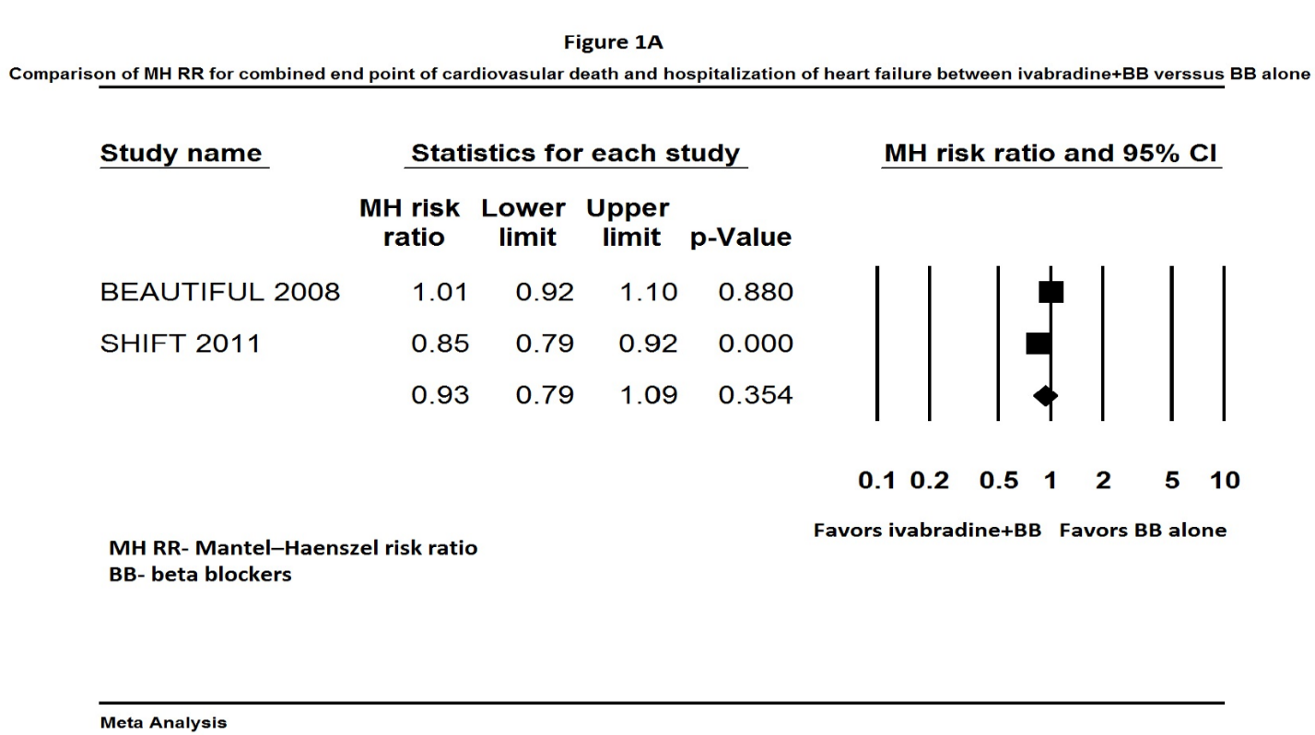

Figure 1 Comparison of Mantel-Haenszel risk ratio for combined end points of cardiovascular death and hospitalization for heart failure between ivabradine + beta-blocker vs beta-blocker alone.

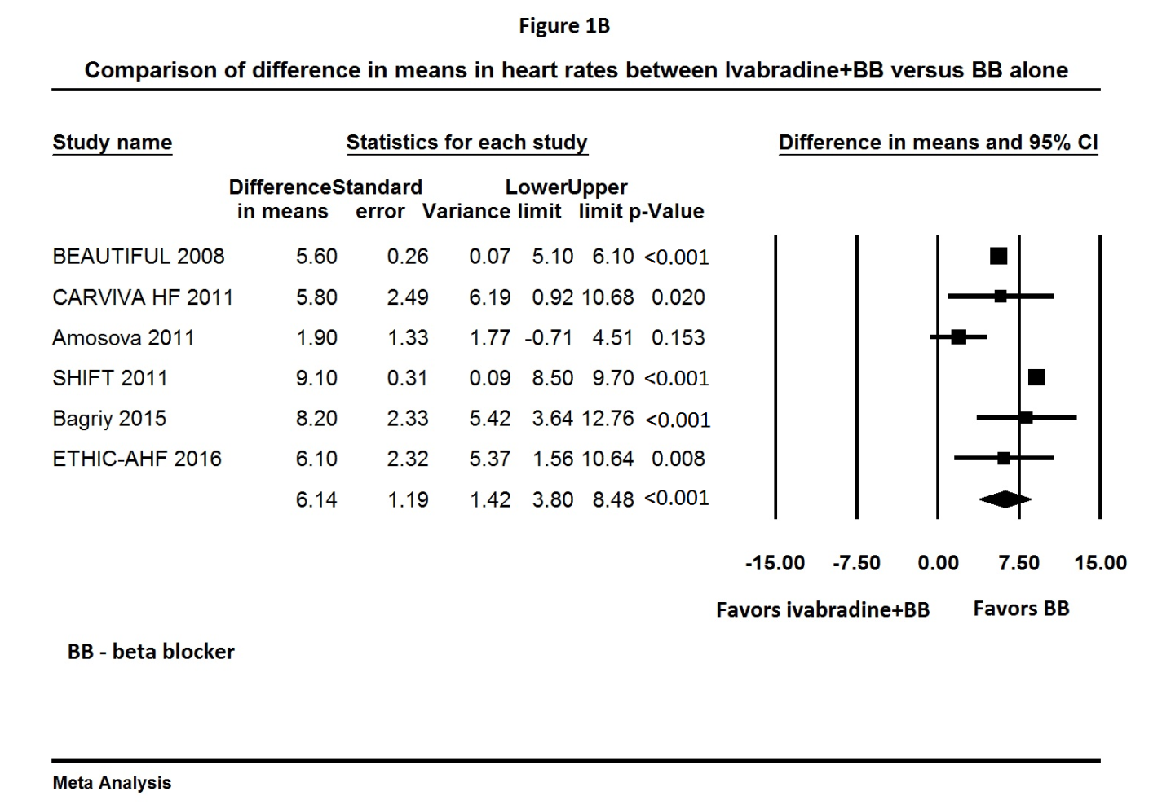
Figure 2 Comparison of mean change in heart rates from baseline between ivabradine + beta-blocker vs beta-blocker alone.

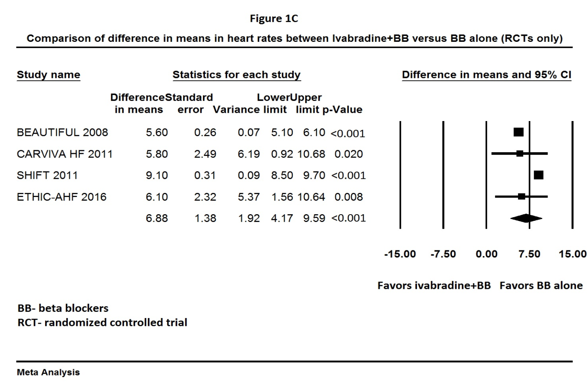
Figure 3 Comparison of mean change in heart rates from baseline between ivabradine + beta-blocker vs beta-blocker alone including only randomized controlled trials.

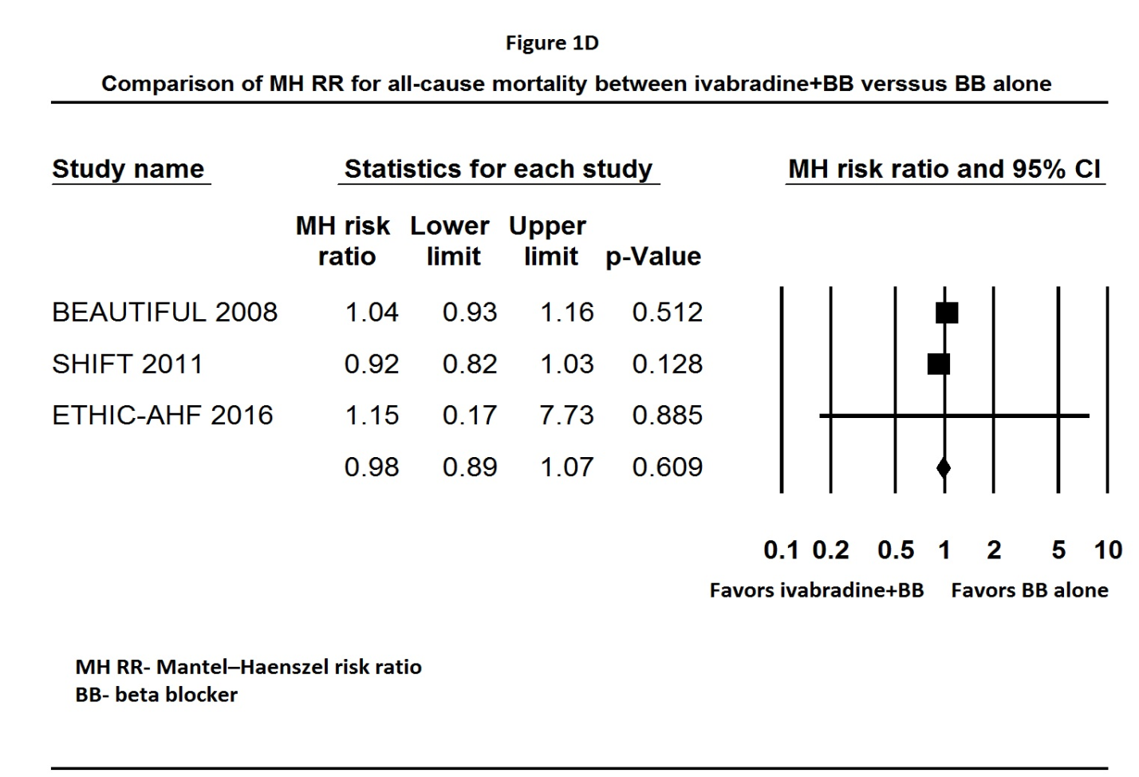
Figure 4 Comparison of Mantel-Haenszel risk ratio for all cause mortality between ivabradine + beta-blocker vs beta-blocker alone.

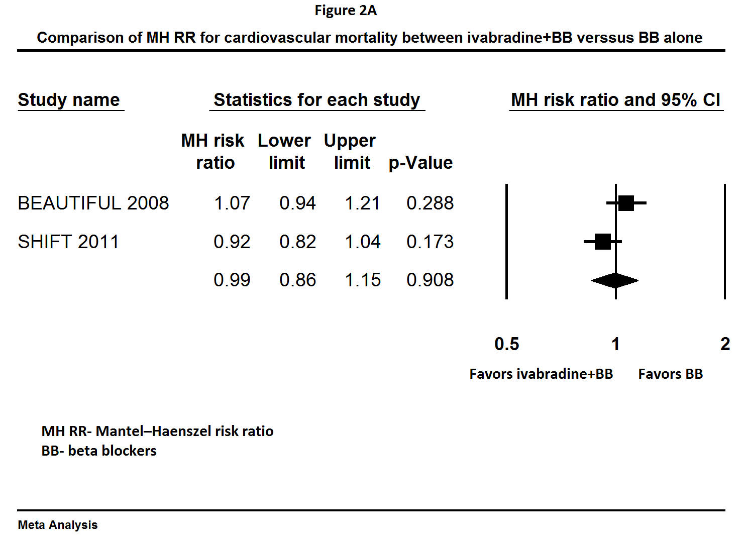
Figure 5 Comparison of Mantel-Haenszel risk ratio for cardiovascular mortality between ivabradine + beta-blocker vs beta-blocker alone.

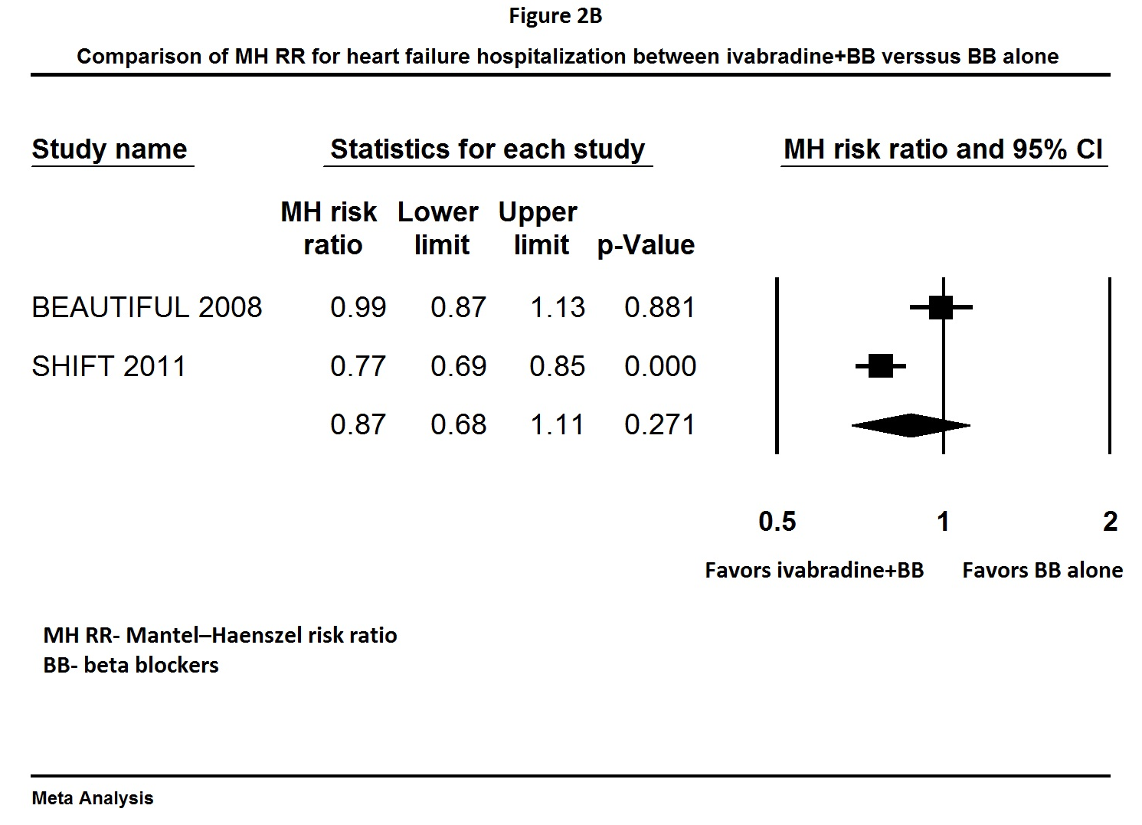
Figure 6 Comparison of Mantel-Haenszel risk ratio for heart failure hospitalization between ivabradine + beta-blocker vs beta-blocker alone.

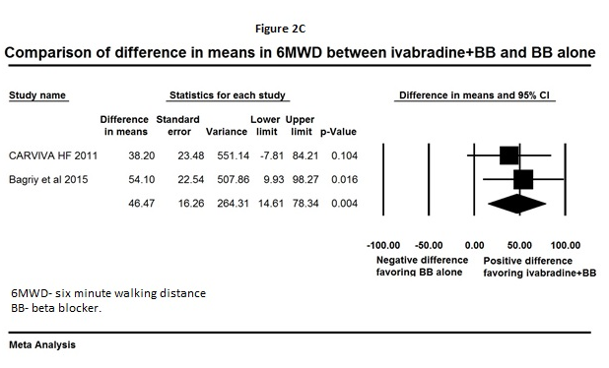
Figure 7 Comparison of difference in means of 6-minute walking distance between ivabradine + beta-blocker vs beta-blocker alone.

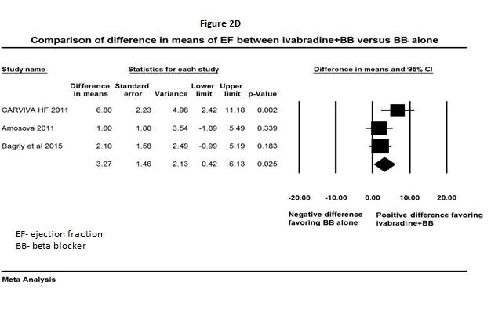
Figure 8 Comparison of difference in means of ejection fraction between ivabradine + beta-blocker vs beta-blocker alone.

