Name of Journal: World Journal of Clinical Cases
Manuscript NO: 78624
Manuscript Type: CASE REPORT

Closed reduction of hip dislocation associated with ipsilateral lower extremity fractures: A case report and review of the literature

Xu Y et al. Closed reduction technique for hip dislocation

Yong Xu, Ming Lv, Shu-Qiang Yu, Guang-Ping Liu

Yong Xu, Department of Orthopaedics, Chengdu Second People’s Hospital, Chengdu 610000, Sichuan Province, China

Ming Lv, Guang-Ping Liu, Department of Orthopaedics, Zibo Central Hospital, Shandong University, Zibo 255000, Shandong Province, China

Shu-Qiang Yu, Department of Orthopaedics, The Fourth People's Hospital of Zibo, Zibo 255000, Shandong Province, China

Author contributions: Liu GP and Lv M conceived and formulated the surgery protocol; Xu Y and Yu SQ assembled previous reported records and drafted the manuscript; Liu GP performed the surgery and revised the manuscript for important intellectual content; and all authors read and approved the final manuscript.

Corresponding author: Guang-Ping Liu, MD, PhD, Chief Doctor, Surgeon, Department of Orthopaedics, Zibo Central Hospital, Shandong University, No. 54 Gongqingtuan Road, Zibo 255000, Shandong Province, China. guangpingpp@126.com

Received: September 15, 2022
Revised: October 17, 2022
Accepted: November 11, 2022
Published online: December 6, 2022

Abstract
BACKGROUND
Traumatic hip dislocation usually occurs following high-velocity trauma. It is imperative that the dislocation be reduced in a timely manner, especially in a closed manner, as an orthopedic emergency. However, closed reduction can hardly be achieved in patients who also have ipsilateral lower extremity fractures. Herein, we focus on hip dislocation associated with ipsilateral lower extremity fractures, excluding intracapsular fractures (femoral head and neck fractures), present an early closed hip joint reduction method for this injury pattern, and review the literature to discuss the appropriate closed reduction technique for this rare injury pattern.

CASE SUMMARY
We report a case of a 37-year-old male who sustained a left acetabular posterior wall fracture, an ipsilateral comminuted subtrochanteric fracture and dislocation of the hip. The hip dislocation was reduced urgently in a closed manner using the joy-stick technique with a T-shaped Schanz screw. The fractures were reduced and fixed as a 2nd-stage surgery procedure. At the 17-month postoperative follow-up, the patient had full range of motion of the affected hip.

CONCLUSION
Closed reduction of a hip dislocation associated with ipsilateral lower extremity fractures is rarely achieved by regular maneuvers. Attempts at closed reduction, by means of indirectly controlling the proximal fracture fragment or reconstructing the femoral leverage rapidly with the aid of various external reduction apparatuses, were shown to be effective in some scenarios. Mandatory open reduction is indicated in cases of failed closed reduction, particularly in irreducible dislocations.

Key Words: Trauma; Hip dislocation; Close reduction; Open reduction; Fracture; Case report

©The Author(s) 2022. Published by Baishideng Publishing Group Inc. All rights reserved.

Citation: Xu Y, Lv M, Yu SQ, Liu GP. Closed reduction of hip dislocation associated with ipsilateral lower extremity fractures: A case report and review of the literature. World J Clin Cases 2022; 10(34):12654-12664
URL: https://www.wjgnet.com/2307-8960/full/v10/i34/12654.htm
DOI: https://dx.doi.org/10.12998/wjcc.v10.i34.12654

Core Tip: Hip dislocation associated with ipsilateral lower extremity fractures could be more efficiently managed with the aid of a T-shaped Schanz screw. Furthermore, this is the first review of similar techniques for early closed hip joint reduction for this injury pattern.

INTRODUCTION
The hip joint is a ball and socket joint, in which its stability is maintained by the combination of bone and strong soft-tissue structures. Generally, traumatic hip dislocation occurs in young patients after high-energy trauma. The incidence of traumatic hip dislocation accounts for approximately 5% of all traumatic joint dislocations^{[1]}. The common mechanisms of hip dislocation are motor vehicle accidents, falls from a height, motorcycle accidents, sports injuries and so on^{[2-4]}. Due to the significant dislocation force, hip dislocation has a high rate of associated hip district fractures^{[5]} or ipsilateral knee injuries^{[6,7]}. Sahin et al^{[4]} reported that 71% of patients diagnosed with hip dislocation had concomitant injuries, either systemic or musculoskeletal.
Traumatic hip dislocation is considered an orthopedic emergency. Urgent reduction should be performed to diminish the incidence and severity of major sciatic nerve injury^{[3]}, to reduce the duration of ischemia to the femoral head and minimize the incidence of osteonecrosis^{[2,8]}. The longer the duration of hip dislocation, the higher the risk of osteonecrosis of the femoral head^{[9]}. Generally, the priority is closed reduction as the initial treatment choice. In patients who have hip dislocation associated with ipsilateral lower extremity injuries (especially fractures), closed reduction can hardly be achieved because the concomitant injuries may be exacerbated by closed reduction maneuvers^{[8]}. The early recognition and assessment of concomitant injuries is imperative to optimize the treatment procedures. The paucity of literature on closed reduction of this hip dislocation type poses a challenge for orthopedic surgeons for the reduction of this type of hip dislocation in a timely manner.

CASE PRESENTATION
Chief complaints
A 37-year-old male with hypotension was transferred to our trauma center from a local hospital after a vehicle crashed into the left side of his motorcycle on April 12, 2021. The patient complained of severe pain in the left hip and chest.

History of present illness
The patient had no present illness.

History of past illness
The patient had no past illness.

Personal and family history
The patient had no personal or family history.

Physical examination
The patient's blood pressure was 96/62 mmHg, and his heart rate was 85-110 beats/min with a normal sinus rhythm. Physical examination revealed minor pallor of the conjunctiva and shortening, external rotation and abduction deformities of the left leg. The femoral head was palpable in the gluteal region. Upon neurological examination, he was unable to dorsiflex his left foot and toes, and his sensory touch was impaired in the calf and foot regions. There was no distal vascular deficit noted.

Laboratory examinations
The laboratory examinations appeared unremarkable, except for leukocytosis (white blood cell count, 15.98 × 10⁹ cells/L) before resuscitation.

Imaging examinations
The computed tomography (CT) scan from a local hospital revealed hydropneumothorax, pulmonary contusions, multiple rib fractures, a left acetabular posterior wall fracture, an ipsilateral comminuted subtrochanteric fracture and dislocation of the hip (Figure 1).

FINAL DIAGNOSIS
The patient was diagnosed with a left hip dislocation fracture associated with an ipsilateral comminuted subtrochanteric fracture and a closed chest injury.

TREATMENT
After advanced trauma life support, the patient was urgently taken to the operating room and positioned in the right lateral decubitus position under deep conscious sedation through propofol. We inserted a T-shaped Schanz screw into the subtrochanteric cortex percutaneously under fluoroscopic guidance and manipulated the femoral head into the acetabulum using the joy-stick technique. The reduction was intraoperatively confirmed by fluoroscopy (Figure 2). Proximal tibial skeletal traction was performed to prevent femoral head redislocation, fracture immobilization and limb length restoration. Then, the patient was transferred to the intensive care unit, and fluid resuscitation and the optimization of physiological status continued. In the interim, to illustrate the acetabular fractures in detail for the development of the definitive surgical strategy, we performed post-reduction CT scans (Figure 3) which showed an acetabular posterior wall fracture, a marginal impaction fracture and an intra-articular loose body.
The 2nd-stage definitive fracture fixation was performed as soon as the patient’s physiological status was stable enough. The patient was positioned in the right lateral decubitus position under general anesthesia. First, we explored the sciatic nerve and addressed the acetabular fractures through a Kocher-Langenbeck approach. After removal of the loose body, the impaction fracture was elevated and filled with an autograft. The acetabular posterior wall fracture was reduced and stabilized using 2 Lag screws and a buttress plate. Then, the femoral subtrochanteric fracture was reduced with a closed procedure and fixed with an antegrade intramedullary nail (Figure 4A). Intraoperative fluoroscopy was performed to confirm a concentric reduction, and hip stability was assessed by gently moving and applying force in the direction of the dislocation. Postoperatively, skin traction was applied to the affected leg for 2 wk until the stitches were removed. Then, non-weight-bearing activity with axillary crutches ambulating was allowed for another 4 wk.

OUTCOME AND FOLLOW-UP
Full weight-bearing activity was allowed when the radiographs demonstrated a solid union of the subtrochanteric fracture at 6 mo after surgery (Figure 4B). At the 17-mo postoperative follow-up, the patient had full range motion of the affected hip with residual foot droop. Radiographs revealed no evidence of avascular necrosis of the femoral head (Figure 4C).

DISCUSSION
Early closed reduction is the priority for traumatic hip dislocation since it can often be conveniently manipulated in the emergency room, it can shorten the duration of femoral head ischemia, and it can be carried out in conditions that are not suitable for the definitive management of associated fractures. Moreover, early closed reduction could also promptly relieve any distortion of the nerve from a dislocated femoral head or a displaced acetabular fracture in cases of nerve injury^{[10]}. In contrast to open reduction, closed reduction tends to have better clinical outcomes, possibly because of less disruption of the remaining blood supply to the femoral head^{[11]}. All kinds of closed reduction maneuvers, whether for anterior or posterior dislocation, rely on an intact ipsilateral lower extremity to transmit inline traction force and allow the femur to act as a lever to manipulate the femoral head into the acetabulum. Regardless of the closed reduction maneuver and hip dislocation type, the surgeon needs to place his or her hand (or knee/arm/shoulder/forearm) underneath the ipsilateral knee of the affected hip and needs to apply a longitudinal traction force with internal and external rotation until the hip is reduced^{[8]}. When a hip dislocation is associated with ipsilateral lower extremity fractures, closed reduction can hardly be achieved due to the ineffective traction fulcrum resulting from fractures around the knee or the absence of an intact femur necessary to transmit the traction force. We reviewed similar cases (Table 1) to discuss the appropriate closed reduction technique for this rare trauma pattern to improve the clinical outcomes.
The first reported method of closed reduction for posterior hip dislocation associated with an ipsilateral femoral shaft fracture seems to have been published by Wiltberger in 1948^{[13]}. The attempt at early closed reduction with the aid of two threaded pins (reduction apparatus) placed approximately four inches apart into the lateral aspect of the left femoral trochanter had failed. After 3 d of tibial tubercle traction, the author threaded a two-foot length gas pipe over the crossbar of the reduction apparatus and successfully reduced the dislocation eventually. Although the dislocation was managed in a closed manner, delayed reduction increased the risk of femoral head necrosis. In clinical practice, early open reduction should be performed as an alternative once the attempt at closed reduction fails.
Ingram et al^{[14]} introduced another closed reduction method in 1954. This seems to be the first description of an early closed reduction for hip dislocation with an ipsilateral femoral shaft fracture. He inserted a large Steinmann pin through the greater trochanter in an anteroposterior direction and clamped the Steinmann pin with large vice-grip pliers anteriorly and posteriorly at the skin edge. Then, closed reduction was accomplished by strong manual traction. In 1958, Murray DS^{[15]} also successfully reduced hip dislocation by this method. This technique is effective, however, there is a high risk of puncturing the sciatic nerve behind the greater trochanter while the pin transfixes the greater trochanter percutaneously because of the nonanatomic position of the greater trochanter. In 1982, Harper et al^{[19]} inserted the Steinmann pin in a posterior-anterior direction, taking care to stay lateral to the sciatic nerve, and successfully treated two patients with dislocations.
Some surgeons advocate closed reduction by manipulating the proximal fracture fragment with the aid of various apparatuses, such as Scuderi traction screw^{[11]}, Smith traction screw^{[16]}, large bone clamp^{[18]}, Lardennois hoop^{[21]}, tourniquet^{[23]}, Hoffmann half pin^{[24]}, and temporary external fixator^{[43]}. However, Schoenecker et al^{[18]} achieved 2 dislocations by gentle manual traction in a regular manner, ignoring the ipsilateral femoral fracture, which may involve distraction and angulation of the soft tissues at the fracture site and could inevitably jeopardize the neurovascular bundle.
Among all the reduction apparatuses, the Schanz screw has been the most preferred^{[25,29,30,35,51]}. It is inserted percutaneously under fluoroscopic guidance and is connected with a universal AO chuck or T handle universal chuck to manipulate the proximal fracture fragment to facilitate reduction. In our present case, we also performed closed reduction with the aid of a Schanz screw, although we were unaware of these previous reports at that time. The Schanz screw we used was T-shaped and was whole without any connector, which is often applied to pull the femoral head laterally in our reduction of acetabular fractures. Due to eliminating the potential loosening between the screw and the connector, the T-shaped Schanz screw played a role of pulling and levering the dislocated femoral head more easily as a whole and facilitated the joystick maneuver more efficiently to reduce the dislocation.
In 2019, Rana et al^{[49]} recommended a novel approach to perform closed manipulation of a hip dislocation with a femoral shaft fracture. He restored the leverage of the fractured femur by temporarily fixing the femur with an external fixator instead of controlling the proximal fracture fragment with an external fixator. In 2020, Iftekhar et al^{[52]} also addressed hip dislocation with the same protocol. A temporary external fixator was applied to reduce and fix the femoral shaft fracture. The femoral lever arm was obtained, and hip reduction was achieved with a closed procedure. This practical technique reconstructs the continuity and leverage of the femur by means of external fixator osteosynthesis to transmit the traction force and manipulate the affected leg.
Although many closed reduction methods have been reported and do truly work, they are not always successful^{[54]}. Open reduction could never be abandoned as an alternative, and its importance cannot be overemphasized. Many factors, such as the buttonholed femoral head through the capsule or abductors, a large interposed intra-articular fragment from the femoral head or acetabular wall, and soft tissue impingement, always contribute to irreducible dislocations^{[55-57]}. Forced closed reduction may exacerbate these concomitant fractures or cause iatrogenic bone and peripheral neurovascular injuries^{[8,58]}. Multiple attempts at closed reduction may result in further traumatic injury to the chondral surface of the femoral head^{[3]} and increase the risk for iatrogenic femoral neck fracture^{[59]}. In this situation, mandatory open reduction should eventually be performed as an alternative after a failed closed reduction attempt for the hemodynamically stable patients. Another situation is the presence of nonconcentric joint after reduction, which also needs surgery to eliminate intra-articular osteochondral fragments or suture the labral tear to obtain the reduction adequacy and excellent long-term clinical outcome^{[60]}.
Analyzing the reported similar cases (Table 1), the success rate of initial closed reduction has been reduced, although various closed reduction techniques have been reported. This is because surgeons have had to tackle more complex associated fractures rather than simple femoral shaft fractures in recent years. This may result from the increasing incidence and severity of such complex injury patterns due to increased high-velocity trauma, especially road traffic accidents. On the other hand, experienced trauma teams and modern resuscitation equipment have allowed an increasing number of patients with associated serious complex fractures to survive^{[61]}. Another tendency was the increased prevalence of associated acetabular and per-trochanteric fractures. In such situations, immediate closed reduction has also been favored over open reduction, especially if the patient’s general condition is too unstable for open procedures or if the patient’s acetabular fractures need no surgical intervention. For patients who require a prolonged transfer to receive definitive surgery, management should also include immediate closed reduction as the primary procedure of the staged treatment strategy at the local hospital. Although hip dislocation associated with an ipsilateral femoral fracture or knee injury was considered a contraindication for closed reduction in some literature^{[3,8,59]}, attempts at closed reduction could also be performed with the aid of various external reduction apparatuses. The rational mechanism of effective indirect reduction techniques is controlling the proximal fracture fragment more easily or reconstructing the femoral leverage rapidly.

CONCLUSION
Closed reduction of a hip dislocation associated with ipsilateral lower extremity fractures is rarely achieved by regular maneuvers. Attempts at closed reduction, by means of indirectly controlling the proximal fracture fragment or reconstructing the femoral leverage rapidly with the aid of various external reduction apparatuses, were shown to be effective in some scenarios. Although closed reduction tends to have better clinical outcomes, mandatory open reduction is indicated in cases of failed closed reduction and particularly irreducible dislocations.

REFERENCES
1 Brav EA. Traumatic dislocation of the hip: Army experience and results over a twelveyear period. J Bone Joint Surg 1962; 44: 1115-1134 [DOI: 10.2106/00004623-196244060-00007]
2 Foulk DM, Mullis BH. Hip dislocation: evaluation and management. J Am Acad Orthop Surg 2010; 18: 199-209 [PMID: 20357229 DOI: 10.5435/00124635-201004000-00003]
3 Hillyard RF, Fox J. Sciatic nerve injuries associated with traumatic posterior hip dislocations. Am J Emerg Med 2003; 21: 545-548 [PMID: 14655233 DOI: 10.1016/j.ajem.2003.08.014]
4 Sahin V, Karakaş ES, Aksu S, Atlihan D, Turk CY, Halici M. Traumatic dislocation and fracture-dislocation of the hip: a long-term follow-up study. J Trauma 2003; 54: 520-529 [PMID: 12634533 DOI: 10.1097/01.TA.0000020394.32496.52]
5 Pape HC, Rice J, Wolfram K, Gänsslen A, Pohlemann T, Krettek C. Hip dislocation in patients with multiple injuries. A followup investigation. Clin Orthop Relat Res 2000: 99-105 [PMID: 10943190 DOI: 10.1097/00003086-200008000-00014]
6 Schmidt GL, Sciulli R, Altman GT. Knee injury in patients experiencing a high-energy traumatic ipsilateral hip dislocation. J Bone Joint Surg Am 2005; 87: 1200-1204 [PMID: 15930527 DOI: 10.2106/JBJS.D.02306]
7 Tabuenca J, Truan JR. Knee injuries in traumatic hip dislocation. Clin Orthop Relat Res 2000: 78-83 [PMID: 10943187 DOI: 10.1097/00003086-200008000-00011]
8 Dawson-Amoah K, Raszewski J, Duplantier N, Waddell BS. Dislocation of the Hip: A Review of Types, Causes, and Treatment. Ochsner J 2018; 18: 242-252 [PMID: 30275789 DOI: 10.31486/toj.17.0079]
9 Ahmed G, Shiraz S, Riaz M, Ibrahim T. Late versus early reduction in traumatic hip dislocations: a meta-analysis. Eur J Orthop Surg Traumatol 2017; 27: 1109-1116 [PMID: 28578459 DOI: 10.1007/s00590-017-1988-7]
10 Cornwall R, Radomisli TE. Nerve injury in traumatic dislocation of the hip. Clin Orthop Relat Res 2000: 84-91 [PMID: 10943188 DOI: 10.1097/00003086-200008000-00012]
11 Lyddon DW Jr, Hartman JT. Traumatic dislocation of the hip with ipsilateral femoral fractures. A case report. J Bone Joint Surg Am 1971; 53: 1012-1016 [PMID: 5557603 DOI: 10.2106/00004623-197153050-00018]
12 Henry AK, Bayumi M. Fracture of the femur with luxation of the ipsilateral hip. Br J Surg 1934; 22: 204-230 [DOI: 10.1002/bjs.1800228603]
13 Wiltberger BR, Mitchell CL, Hedrick DW. Fracture of the femoral shaft complicated by hip dislocation; a method of treatment. J Bone Joint Surg Am 1948; 30A: 225-228 [PMID: 18921642 DOI: 10.2106/00004623-194830010-00024]
14 Ingram AJ, Turner TC. Bilateral traumatic posterior dislocation of the hip complicated by bilateral fracture of the femoral shaft: report of a case. J Bone Joint Surg Am 1954; 36-A: 1249-1255 [PMID: 13211718 DOI: 10.2106/00004623-195436060-00014]
15 MURRAY DS. Method of reducing fracture-dislocation of hip-joint with fractured femur on same side. Br Med J 1958; 2: 427-428 [PMID: 13560889 DOI: 10.1136/bmj.2.5093.427]
16 Helal B, Skevis X. Unrecognised dislocation of the hip in fractures of the femoral shaft. J Bone Joint Surg Br 1967; 49: 293-300 [PMID: 6026515 DOI: 10.1302/0301-620X.49B2.293]
17 Ehtisham SM. Traumatic dislocation of hip joint with fracture of shaft of femur on the same side. J Trauma 1976; 16: 196-205 [PMID: 1255836 DOI: 10.1097/00005373-197603000-00004]
18 Schoenecker PL, Manske PR, Sertl GO. Traumatic hip dislocation with ipsilateral femoral shaft fractures. Clin Orthop Relat Res 1978: 233-238 [PMID: 639395 DOI: 10.1097/00003086-197801000-00025]
19 Harper MC. Traumatic dislocation of the hip with ipsilateral femoral shaft fracture: a method of treatment. Injury 1982; 13: 391-394 [PMID: 7085052 DOI: 10.1016/0020-1383(82)90091-2]
20 Barquet A, Mussio A. Fracture-dislocation of the femoral head with associated ipsilateral trochanteric and shaft fracture of the femur. Arch Orthop Trauma Surg (1978) 1983; 102: 61-63 [PMID: 6639314 DOI: 10.1007/BF00443042]
21 Verdonk R, de Smet L. Hip dislocation combined with femoral shaft fracture. Two cases treated with the Lardennois hoop. Acta Orthop Scand 1984; 55: 185-186 [PMID: 6711286 DOI: 10.3109/17453678408992334]
22 Shannak AO. Bilateral traumatic dislocation of the hips with ipsilateral femoral fracture. Clin Orthop Relat Res 1987: 126-129 [PMID: 3802627 DOI: 10.1097/00003086-198702000-00017]
23 Carlsen AW, Lind J. Traumatic dislocation of the hip with ipsilateral fracture of the femur: a method of reduction. Injury 1991; 22: 68-69 [PMID: 2030040 DOI: 10.1016/0020-1383(91)90170-j]
24 Wu CC, Shih CH, Chen LH. Femoral shaft fractures complicated by fracture-dislocations of the ipsilateral hip. J Trauma 1993; 34: 70-75 [PMID: 8437199 DOI: 10.1097/00005373-199301000-00013]
25 Maqsood M, Walker AP. Asymmetrical bilateral traumatic hip dislocation with ipsilateral fracture of the femoral shaft. Injury 1996; 27: 521-522 [PMID: 8977845 DOI: 10.1016/0020-1383(96)00053-8]
26 Maini L, Mishra P, Jain P, Upadhyay A, Aggrawal A. Three part posterior fracture dislocation of the hip without fracture of the femoral head: review of literature and a case report. Injury 2004; 35: 207-209 [PMID: 14736483 DOI: 10.1016/s0020-1383(03)00166-9]
27 Duygulu F, Calis M, Argun M, Guney A. Unusual combination of femoral head dislocation associated acetabular fracture with ipsilateral neck and shaft fractures: A case report. J Trauma 2006; 61: 1545-1548 [PMID: 17159705 DOI: 10.1097/01.ta.0000224898.83708.e1]
28 Sié EJB, Kodo M, Traoré A, Mobiot C, Lambin Y, Lambin Y. Floating knee with ipsilateral floating hip injury equivalent variant: A Case report. Nigerian J Orthop Trauma 2006; 5: 50-53
29 Singh R, Sharma SC, Goel T. Traumatic inferior hip dislocation in an adult with ipsilateral trochanteric fracture. J Orthop Trauma 2006; 20: 220-222 [PMID: 16648705 DOI: 10.1097/00005131-200603000-00010]
30 Singh AP, Singh AP, Mittal V. Traumatic inferior hip dislocation with ipsilateral open subtrochanteric fracture: A rare case. Injury Extra 2008; 39: 384-385 [DOI: 10.1016/j.injury.2008.08.002]
31 Alexa O, Puha B, Veliceasa B, Păduraru D. Posterior dislocation of the hip associated with ipsilateral trochanteric fracture--a very rare case. Chirurgia (Bucur) 2009; 104: 761-764 [PMID: 20187480]
32 Almosalamy MH, Mehrz MH, Al-Mukaimi A. Traumatic posterior hip fracture dislocation with ipsilateral intertrochanteric fracture and sciatic nerve palsy in an adult patient. J Kuwait Med Assoc 2010; 42: 324-327
33 Rodriguez-Martin J, Pretell-Mazzini J, Porras-Moreno MA, Hernanz-Gonzalez Y, Resines-Erasun C. A polytrauma patient with an unusual posterior fracture-dislocation of the femoral head: a case report. Strategies Trauma Limb Reconstr 2010; 5: 47-51 [PMID: 20360877 DOI: 10.1007/s11751-009-0078-8]
34 Sen RK, Tripathy SK, Krishnan V, Goyal T, Jagadeesh V. Ipsilateral fracture dislocations of the hip and knee joints with contralateral open fracture of the leg: a rare case and its management principles. Chin J Traumatol 2011; 14: 183-187 [PMID: 21635808]
35 Kuhn KM, Boudreau JA, Watson JT. Rare combination of ipsilateral acetabular fracture-dislocation and pertrochanteric fracture. Am J Orthop (Belle Mead NJ) 2013; 42: 372-375 [PMID: 24078956]
36 Radulescu R, Badila A, Japie I, Papuc A, Manolescu R. Anterior dislocation of the hip associated with intertrochanteric fracture of the femur - Case presentation. J Med Life 2013; 6: 336-339 [PMID: 24146697]
37 Sinha S, Naik AK, Arya RK, Jain VK. Ipsilateral Traumatic Posterior Hip Dislocation, Posterior Wall and Transverse Acetabular Fracture with Trochanteric Fracture in an adult: Report of First Case. J Orthop Case Rep 2013; 3: 31-34 [PMID: 27298928 DOI: 10.13107/jocr.2250-0685.128]
38 Yousefi A, Ashraf H, Mashhadinezhad A, Birjandinejad A. Posterior hip dislocation associated with posterior wall acetabular fracture and ipsilateral intertrochantric fracture: a very rare case report. Trauma Mon 2013; 17: 409-411 [PMID: 24350139 DOI: 10.5812/traumamon.8520]
39 Zhen P. Traumatic posterior hip dislocation with an ipsilateral comminuted femoral intertrochanteric fracture: a case report. Orthop Surg 2013; 5: 219-221 [PMID: 24002841 DOI: 10.1111/os.12051]
40 Jamshidi MH, Mirkazemi M, Birjandinejad A. Posterior hip fracture -dislocation associated with ipsilateral intertrochantric fracture; a rare case report. Arch Bone Jt Surg 2014; 2: 75-78 [PMID: 25207320]
41 Chotai PN, Ebraheim NA, Hart R, Wassef A. Concomitant Posterior Hip Dislocation, Ipsilateral Intertrochanteric- and Proximal Tibial- Fractures with Popliteal Artery Injury: A Challenging Trauma Mélange. Clin Pract 2015; 5: 776 [PMID: 26918095 DOI: 10.4081/cp.2015.776]
42 Panigrahi R, Mahapatra AK, Palo N, Priyadarshi A. Neglected Pipkin's fracture dislocation with bilateral femoral shaft fractures: an unusual combination. J Surg Case Rep 2015; 2015 [PMID: 25759170 DOI: 10.1093/jscr/rjv013]
43 Alhammoud A, Alnouri M, Arbash MA, Baco AM. Posterior Hip Dislocation with Ipsilateral Femoral Head and Shaft Fracture - Using a Temporary External Fixator as a Method for Closed Reduction. J Orthop Case Rep 2016; 6: 44-46 [PMID: 28507965]
44 Qi BC, Zhao Y, Wang CX, Wang TJ, Zhang JT, Ju WN, Sun DH. Posterior dislocation of the hip with bilateral femoral fractures: An unusual combination. Technol Health Care 2016; 24: 281-286 [PMID: 26578280 DOI: 10.3233/THC1111]
45 Ul Haq R, Kumar J, Dhammi IK, Jain AK. Posterior dislocation of hip with ipsilateral intertrochanteric fracture: A report of two cases. Indian J Orthop 2016; 50: 571-576 [PMID: 27746503 DOI: 10.4103/0019-5413.189614]
46 Uzun E, Günay AE, Karaman İ, Mısır A, Kızkapan TB, Özçamdallı M. Unusual combination of femoral head dislocation associated acetabular fracture with multipart femoral fractures: Case report. Int J Surg Case Rep 2017; 34: 32-35 [PMID: 28415025 DOI: 10.1016/j.ijscr.2017.02.043]
47 Fageir M, Veettil MKP. Posterior dislocation of a native hip joint associated with ipsilateral per-trochanteric fracture: A rare case report. Trauma Case Rep 2018; 13: 1-13 [PMID: 29644290 DOI: 10.1016/j.tcr.2017.09.003]
48 Desai KB, Dhamangaonkar AC. A case of posterior HIP dislocation with intertrochanteric fracture: Beware of the sharp calcar spike. J Clin Orthop Trauma 2019; 10: 975-980 [PMID: 31528079 DOI: 10.1016/j.jcot.2019.04.014]
49 Rana R, Patra SK, Khuntia S, Jain M, Patro BP. Traumatic Posterior Dislocation of Hip with Ipsilateral Fracture of Shaft of Femur: Temporary Fixator-assisted Reduction and Final Fixation with Interlocking Nail. Cureus 2019; 11: e5488 [PMID: 31656714 DOI: 10.7759/cureus.5488]
50 Benabbouha A, Boussouga M, Fjouji S, Lamkhanter A, Jaafar A. Simultaneous Ipsilateral Floating Hip and Knee: A Complex Combination and Difficult Surgical Challenge. Case Rep Orthop 2020; 2020: 9197872 [PMID: 32095304 DOI: 10.1155/2020/9197872]
51 Gokulprasath S, Prashanth KRT. Anterior Hip Dislocation with Ipsilateral Subtrochanteric Femur Fracture in a Young Adult - A Rare Case Report. J Orthop Case Rep 2020; 10: 63-66 [PMID: 33954139]
52 Iftekhar N, Rasool T, Zhitny VP, Rasool S. Ipsilateral Posterior Hip Dislocation and Femur Shaft Fracture - A Rare Presentation. J Orthop Case Rep 2020; 10: 3-5 [PMID: 33585305]
53 Su C, Liu Y, Wu P, Yuan J, Lang J, Wu C, Zhang Y, Chen L, Chen L. Ipsilateral femoral neck and intertrochanteric fractures with posterior dislocation of the hip: A report of two cases. J Orthop Surg (Hong Kong) 2020; 28: 2309499019900449 [PMID: 32336196 DOI: 10.1177/2309499019900449]
54 Anand V, Deviprasad, Praba K, Babar S, Babu M. Ipsilateral floating hip and knee, or floating lower limb - A rare case report. Trauma Case Rep 2021; 31: 100390 [PMID: 33365379 DOI: 10.1016/j.tcr.2020.100390]
55 Pathinathan K, Marage N, Fernando N. Bilateral irreducible asymmetrical fracture-dislocation of the hip: A case report and literature review. Int J Surg Case Rep 2021; 81: 105803 [PMID: 33774447 DOI: 10.1016/j.ijscr.2021.105803]
56 Fernandez M, Williams T, Dubrana F, Di Francia R. A rare case of an irreducible Pipkin II fracture-dislocation of the femoral head in a young patient following low-energy trauma. Int J Surg Case Rep 2020; 70: 234-237 [PMID: 32422586 DOI: 10.1016/j.ijscr.2020.04.005]
57 Pascarella R, Maresca A, Cappuccio M, Reggiani LM, Boriani S. Asymmetrical bilateral traumatic fracture dislocation of the hip: a report of two cases. Chir Organi Mov 2008; 92: 109-111 [PMID: 18504531 DOI: 10.1007/s12306-008-0045-4]
58 Chen W, Gao Z, Ma L. Failed reduction of posterior hip dislocation accompanied by femoral head fracture: causes and resolving strategy. Int Orthop 2021; 45: 1609-1614 [PMID: 33108471 DOI: 10.1007/s00264-020-04856-8]
59 Mandell JC, Marshall RA, Weaver MJ, Harris MB, Sodickson AD, Khurana B. Traumatic Hip Dislocation: What the Orthopedic Surgeon Wants to Know. Radiographics 2017; 37: 2181-2201 [PMID: 29131775 DOI: 10.1148/rg.2017170012]
60 Mitsionis GI, Lykissas MG, Motsis E, Mitsiou D, Gkiatas I, Xenakis TA, Beris AE. Surgical management of posterior hip dislocations associated with posterior wall acetabular fracture: a study with a minimum follow-up of 15 years. J Orthop Trauma 2012; 26: 460-465 [PMID: 22357088 DOI: 10.1097/BOT.0b013e31822c4d6c]
61 Liebergall M, Segal D, Peyser A, Mosheiff R. Combined injuries to the lower limbs. Injury 1999; 30 Suppl 2: B29-B33 [PMID: 10562858 DOI: 10.1016/s0020-1383(99)90005-0]

Footnotes
Informed consent statement: Informed written consent was obtained from the patient.

Conflict-of-interest statement: The authors declare that they have no conflict of interest.

CARE Checklist (2016) statement: The authors have read the CARE Checklist (2016), and the manuscript was prepared and revised according to the CARE Checklist (2016).

Open-Access: This article is an open-access article that was selected by an in-house editor and fully peer-reviewed by external reviewers. It is distributed in accordance with the Creative Commons Attribution NonCommercial (CC BY-NC 4.0) license, which permits others to distribute, remix, adapt, build upon this work non-commercially, and license their derivative works on different terms, provided the original work is properly cited and the use is non-commercial. See: https://creativecommons.org/Licenses/by-nc/4.0/

Provenance and peer review: Unsolicited article; Externally peer reviewed.
Peer-review model: Single blind

Peer-review started: September 15, 2022
First decision: September 27, 2022
Article in press: November 11, 2022

Specialty type: Orthopedics
Country/Territory of origin: China
Peer-review report’s scientific quality classification
Grade A (Excellent): 0
Grade B (Very good): B
Grade C (Good): C
Grade D (Fair): 0
Grade E (Poor): 0

P-Reviewer: Muthu S, India; Muthu S, India; Zharikov YO, Russia S-Editor: Wang JL L-Editor: A P-Editor: Wang JL

Figure Legends
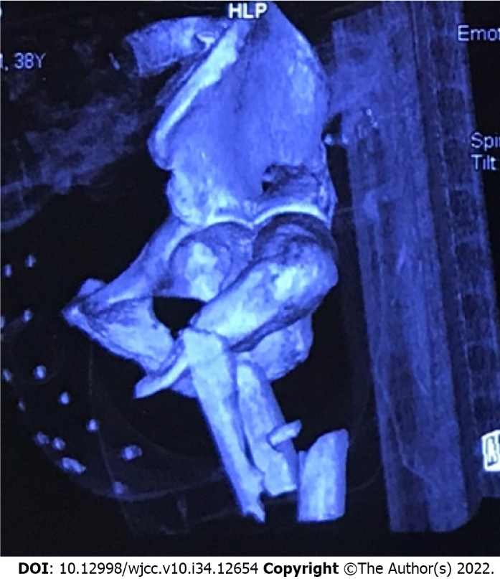
Figure 1 Three-dimensional computed tomography from a local hospital. The image shows a left acetabular posterior wall fracture, an ipsilateral comminuted subtrochanteric fracture and dislocation of the hip.

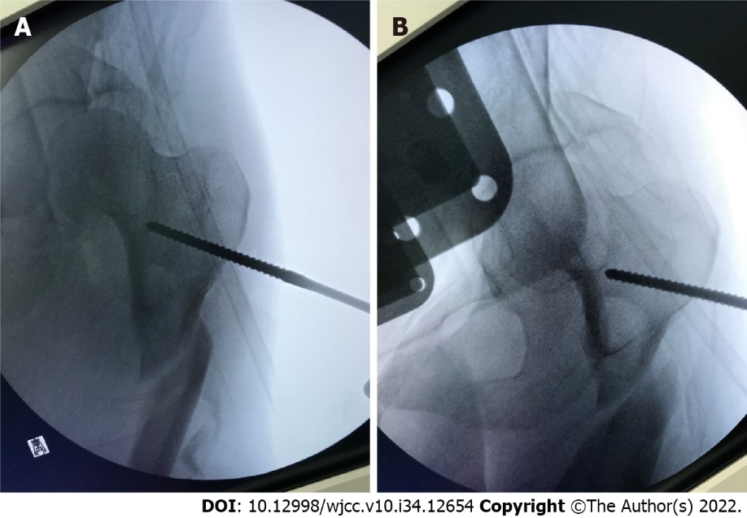
Figure 2 Intraoperative fluoroscopy showing reduction of a dislocation. A: Prereduction and T-shaped Schanz screw; B: Postreduction.

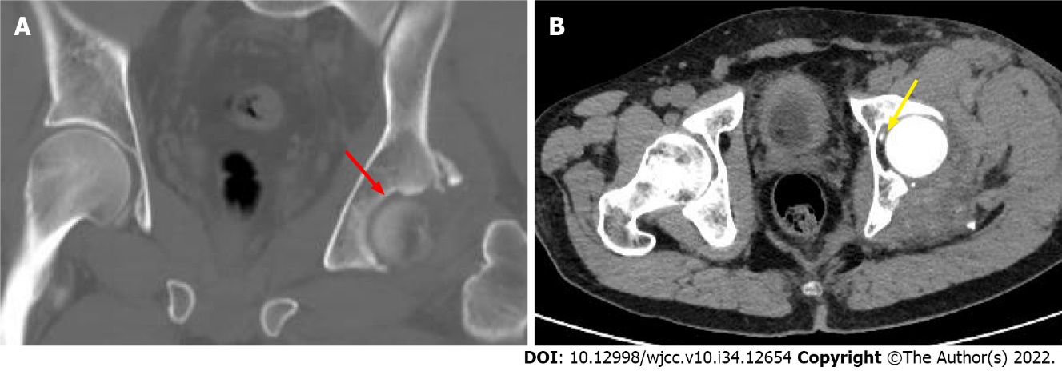
Figure 3 Computed tomography scans. A, B: The images show an acetabular posterior wall fracture associated with a marginal impaction fracture (red arrow) and an intra-articular loose body (yellow arrow).

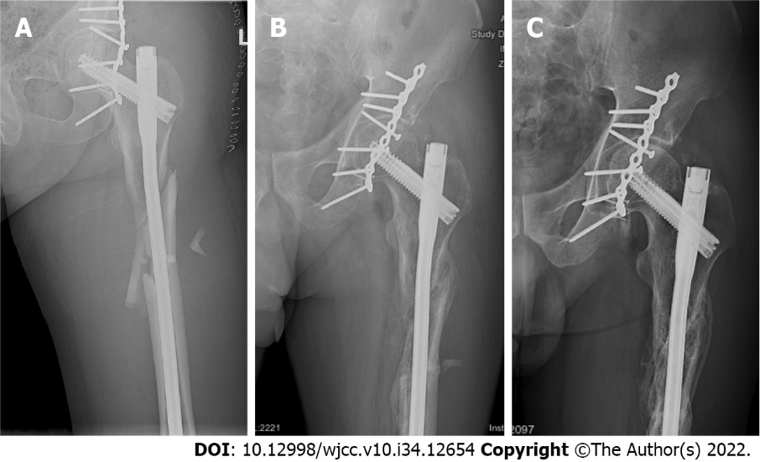
Figure 4 Left hip radiographs. A: Postoperative; B: 6 mo later; C: 17 mo later.
Table 1 Review of reported cases of hip dislocation associated with ipsilateral lower extremity fractures
No. | Ref. | Age (yr) | Gender | Cause of injury | Dislocation type | Associated fractures of ipsilateral lower extremity | Method
1 | Henry et al^{[12]}, 1934 | 64 | F | - | P | Femoral shaft | Open
2 | Wiltberger et al^{[13]}, 1948 | 35 | M | Industrial accident | P | Femoral shaft | Closed
3 | Ingram et al^{[14]}, 1954 | 17 | M | Automobile vehicle accident | P | Femoral shaft | Closed
4 | Murray et al^{[15]}, 1958 | 25/18 | M/- | Motorcycle accident/- | P | Supracondylar of femur/tibia and supracondylar of femur | Open/closed
5 | Helal et al^{[16]}, 1967 | - | - | - | P | Femoral shaft | Closed
6 | Lyddon et al^{[11]}, 1971 | 47 | M | Automobile accident | Obturator | Femoral shaft | Closed
7 | Ehtisham et al^{[17]}, 1976 | 19/19/; 19/17 | - | Road traffic accident/ motorcycle accident (3) | A/P/P/A | Femoral shaft/femoral shaft/femoral shaft and roof of the acetabulum/femur, tibia and medial malleolus | Open
8 | Schoenecker et al^{[18]}, 1978 | 18 | M | Motor vehicle accident | A | Femoral shaft | Closed
9 | Harper et al^{[19]}, 1982 | 17/19 | M/F | Automobile accident | P | Femoral shaft | Closed
10 | Barquet et al^{[20]}, 1983 | 25 | M | Automobile collision | P | Femoral head, trochanter and shaft | Closed¹
11 | Verdonk et al^{[21]}, 1984 | 17/21 | M | Motor cycle accident/- | P | Femoral shaft | Closed
12 | Shannak^{[22]}, 1987 | 29 | M | Automobile accident | Bi (A/P) | Femoral shaft/acetabulum, tibia and fibula | Closed
13 | Carlsen et al^{[23]}, 1991 | 42 | - | Motorcycle-car accident | P | Femoral shaft | Closed
14 | Wu et al^{[24]}, 1993 | 16 cases | - | - | P (11) C (5) | Femoral shaft | Closed
15 | Maqsood et al^{[25]}, 1996 | 21 | M | Run over by a jeep | P | Femoral shaft | Closed
16 | Maini et al^{[26]}, 2004 | 25 | M | Railway accident | P | Femoral neck and greater trochanter | Open
17 | Duygulu et al^{[27]}, 2006 | 52 | M | Motor vehicle collision | P | Transverse and posterior wall acetabular fracture, femoral neck and shaft | Open
18 | Sié EJB et al^{[28]}, 2006 | 24 | M | Fall from a moving truck | P | Shaft, supra and intercondylar of femur, patella, tibial and medial malleolus | Closed¹
19 | Singh et al^{[29]}, 2006 | 35 | M | Roadside accident | Inferior | IT fracture | Closed
20 | Singh et al^{[30]}, 2008 | 55 | M | Fall from a moving bus | Inferior | Open femoral subtrochanteric fracture | Closed
21 | Alexa et al^{[31]}, 2009 | 41 | M | Traffic accident | P | IT fracture | Open
22 | Almosalamy et al^{[32]}, 2010 | 28 | M | Car accident | P | Posterior wall acetabular and IT fracture | Open
23 | Rodriguez-Martin et al^{[33]}, 2010 | 27 | M | Car accident | P | Femoral head and intertrochanteric fracture | Open
24 | Sen et al^{[34]}, 2011 | 32 | M | Car accident | P | Femoral head, acetabular wall, knee dislocation and tibial plateau fracture | Open
25 | Kuhn et al^{[35]}, 2013 | 44 | M | Motor vehicle collision | P | Posterior wall acetabular and femoral per-trochanteric fracture | Closed
26 | Radulescu et al^{[36]}, 2013 | 44 | M | Precipitation | A | IT fracture | Open
27 | Sinha et al^{[37]}, 2013 | 45 | M | Fall from moving train | P | Transverse and posterior wall acetabular fracture, IT fracture | Open
28 | Yousefi et al^{[38]}, 2013 | 43 | M | Motor vehicle accident | P | Posterior wall acetabular and IT fracture | Open
29 | Zhen^{[39]}, 2013 | 59 | M | Car crash | Inferior | Posterior wall acetabular fracture and IT fracture | Total hip arthroplasty
30 | Jamshidi et al^{[40]}, 2014 | 26 | M | Motor vehicle accident | P | Posterior wall acetabular and IT fracture, tibia, fibula | Closed¹
31 | Chotai et al^{[41]}, 2015 | 25 | M | Motor vehicle accident | P | IT fracture and proximal tibial | Open
32 | Panigrahi et al^{[42]}, 2015 | 20 | M | Road traffic accident | P | Femoral head, shaft and medial condylar fracture | Open
33 | Alhammoud et al^{[43]}, 2016 | 30 | M | Motor vehicle collision | P | Femoral head and shaft | Closed
34 | Qi et al^{[44]}, 2016 | 43 | M | Car accident | P | Transverse and posterior wall acetabular fracture, femoral shaft | Open
35 | Ul Haq et al^{[45]}, 2016 | 26/36 | M/F | Road traffic accident | P | IT fracture/femoral head and intertrochanteric fracture | Open
36 | Uzun et al^{[46]}, 2017 | 20 | M | Traffic accident | P | Transverse and posterior wall acetabular fracture, IT and lateral condyle | Open
37 | Fageir et al^{[47]}, 2018 | 31 | M | Fire truck accident | P | IT fracture | Open
38 | Desai et al^{[48]}, 2019 | 19 | M | Road traffic accident | P | IT fracture | Open
39 | Rana et al^{[49]}, 2019 | 18 | M | Road traffic accident | P | Femoral shaft | Closed
40 | Benabbouha et al^{[50]}, 2020 | 56 | F | Hit by a car | P | Posterior wall acetabular fracture, femoral shaft, tibia and fibula | Closed¹
41 | Gokulprasath et al^{[51]}, 2020 | 26 | M | Road traffic accident | A | Subtrochanteric fracture | Closed
42 | Iftekhar et al^{[52]}, 2020 | 24 | M | Motor vehicle accident | P | Femoral shaft | Closed
43 | Su et al^{[53]}, 2020 | 38/29 | F/M | Train crash/traffic accident | P | Acetabulum, IT and neck fracture/IT and neck fracture | Open
44 | Anand et al^{[54]}, 2021 | 50 | M | Road traffic accident | P | Transverse-posterior acetabular fracture, IT and shaft, tibia, fibula | Open
45 | Present case (2022) | 37 | M | Vehicle accident | P | Posterior wall acetabular fracture, and subtrochanteric fracture | Closed
¹The closed reduction maneuver was not mentioned in the literature.
IT: Intertrochanteric; A: Anterior; P: Posterior; C: Central; -: Not mentioned.

Published by Baishideng Publishing Group Inc
7041 Koll Center Parkway, Suite 160, Pleasanton, CA 94566, USA
Telephone: +1-925-3991568
E-mail: bpgoffice@wjgnet.com
Help Desk: https://www.f6publishing.com/helpdesk
https://www.wjgnet.com

© 2022 Baishideng Publishing Group Inc. All rights reserved.

