Name of Journal: World Journal of Clinical Cases
Manuscript NO: 73440
Manuscript Type: CASE REPORT

Solitary plasmacytoma of the left rib misdiagnosed as angina pectoris: A case report

Yao J et al. A case of misdiagnosed rib SP

Jian Yao, Xu He, Cheng-Yuan Wang, Li Hao, Li-Li Tan, Chun-Jian Shen, Ming-Xiao Hou

Jian Yao, Xu He, Cheng-Yuan Wang, Chun-Jian Shen, Ming-Xiao Hou, Department of Cardiothoracic Surgery, Second Affiliated Hospital of Shenyang Medical College, The Veterans General Hospital of Liaoning Province, Shenyang 110001, Liaoning Province, China

Li Hao, Department of Pathology, Second Affiliated Hospital of Shenyang Medical College, the Veterans General Hospital of Liaoning Province, Shenyang 110001, Liaoning Province, China

Li-Li Tan, Department of Cardiology, Second Affiliated Hospital of Shenyang Medical College, the Veterans General Hospital of Liaoning Province, Shenyang 110001, Liaoning Province, China

Author contributions: Yao J, He X and Wang CY performed the operation; Shen CJ, Tan LL provided guidance on preoperative diagnosis; Hao L completed the pathological analysis and diagnosis; Yao J and Hou MX wrote and reviewed the paper; all authors issued final approval for the version to be submitted.

Corresponding author: Jian Yao, MD, Doctor, Department of Cardiothoracic Surgery, Second Affiliated Hospital of Shenyang Medical College, The Veterans General Hospital of Liaoning Province, No. 20 Beijiu Road, Heping District, Shenyang 110001, Liaoning Province, China. yaoyao5506@hotmail.com

Received: November 22, 2021
Revised: December 24, 2021
Accepted: May 22, 2022
Published online:

Abstract
BACKGROUND
Solitary plasmacytoma in the left rib is rare and can cause chest discomfort such as chest pain and tightness, and its clinical manifestations are not typical, so it is often misdiagnosed. We report a case of left costal plasmacytoma misdiagnosed as angina pectoris. We also review the literature and provide suggestions as to how to avoid misdiagnosis.

CASE SUMMARY
A 77-year-old man with a history of intermittent chest tightness for 3 years presented with pain in the left chest for 1 wk and was admitted to hospital. The cardiologists initially diagnosed angina pectoris but the findings of coronary angiography were not consistent with the symptoms. Computed tomography showed that the left eighth rib mass was accompanied by bone destruction. The patient was transferred to our department for further treatment. Preoperative biopsy indicated that the lesion was possibly malignant, and elective surgery was performed to remove the lesion. The size of the tumor was about 4 cm. The tumor was spindle-shaped and protruded into the pleural cavity, without invading the lungs. Postoperative pathology confirmed that the left rib lesion was plasmacytoma. After 14 mo follow-up, the patient died of systemic metastasis.

CONCLUSION
Left rib solitary plasmacytoma is a rare disease confined to a specific rib and can cause local pain. Attention should be paid to the differential diagnosis of angina pectoris to avoid misdiagnosis.

Key Words: Solitary plasmacytoma; Rib; Misdiagnosis; Angina pectoris; Case report

Yao J, He X, Wang CY, Hao L, Tan LL, Shen CJ, Hou MX. Solitary plasmacytoma of the left rib misdiagnosed as angina pectoris: A case report. World J Clin Cases 2022; In press

Core Tip: In the diagnosis of rib solitary plasmacytoma (SP), attention should be paid to the following aspects: the patient has an unknown cause of rib fracture or there is a long-term chest pain; and the computed tomography of the rib shows that osteolysis of ribs coexists with soft tissue mass around the rib. Local surgical resection is the first choice for the treatment of rib SP. Postoperative radiotherapy should be performed to obtain a better curative effect, prolong patient survival and prevent tumor progression and recurrence. Attention should be paid to the differential diagnosis from angina pectoris to avoid misdiagnosis.

INTRODUCTION
A 77-year-old man with a history of intermittent chest tightness for 3 years, presented with pain in the left chest for 1 wk, and was admitted to hospital.

CASE PRESENTATION
Chief complaints
The patient’s chest pain was dull and had not dissipated. The pain increased on rising and lying in bed. No awakening or sweating occurred at night. After oral administration of nitroglycerin tablets, chest tightness was significantly reduced, but chest pain was not obviously alleviated.

History of present illness
The patient had a history of angina pectoris for 3 years.

History of past illness
The patient was conscious, with normal temperature, blood pressure, heart rate and rhythm, and slightly increased respiration (22 breaths/min). Electrocardiography at admission showed a sinus heart rate with ST segment depression of 0.05 mV in leads V4–V6. There was no chest pain on palpation. The primary diagnosis by the cardiologist was recurrent angina pectoris.

Personal and family history
Both the patient and his family denied that they had a family history of cancer.

Physical examination
The patient was conscious, with normal temperature, blood pressure, heart rate and rhythm, and slightly increased respiration (22 breaths/min). Electrocardiography at admission showed a sinus heart rate with ST segment depression of 0.05 mV in leads V4–V6. There was no chest pain on palpation. The primary diagnosis by the cardiologist was recurrent angina pectoris.

Laboratory examinations
Routine blood tests, renal function, ion levels and myocardial enzymes were normal.

Imaging examinations
Chest X-ray showed no significant abnormalities (Figure 1). Coronary angiography performed by cardiologists showed that the intima of the coronary arteries was not smooth, and the proximal segment of the left anterior descending branch (LAD) was narrowed by 40%, the middle segment of the LAD by 50%, the middle segment of the right coronary artery (RCA) by 40%–50%, and the distal segment of the RCA by 30%–40%. Compared with 3 years ago, the degree of stenosis had not changed significantly. Chest computed tomography (CT) (Figure 2A) showed that left eighth rib mass was accompanied by bone destruction.

FINAL DIAGNOSIS
Postoperative pathology (Figures 3 and 4) showed that many immature plasma cells proliferated diffusely, with CD 138(+) and ki-67 (20%+). Therefore, the left rib tumor was finally diagnosed as a plasmacytoma.

TREATMENT
After coronary angiography, the cardiology department invited the cardiothoracic surgery department for consultation, and the left rib lesion was found after careful reading of the CT. The patient was transferred to our department for further treatment. A puncture biopsy was performed on the rib masses. Postoperative pathology showed a high degree of suspicion of malignant tumor (Figure 5A and B). Whole body CT scan showed no other bone damage. Ribectomy was performed under general anesthesia. The rib lesions showed fusiform growth, protruding to the pleural cavity, and did not invade the lungs. The tumor was about 4 cm and 2 cm in size, and another small lump was about 1.5 cm and 0.8 cm away from the larger one, and the rib surface was damaged. At 5 cm from the medial and lateral ends of the mass, the ribs were cut off and the rib mass was completely removed (Figure 2B).

OUTCOME AND FOLLOW-UP
Chest pain was significantly relieved after the operation. Patients were unaware of the fact that they had a malignant tumor. The patient’s family unanimously disagreed with the patient’s radiotherapy and chemotherapy. Therefore, after discharge, the patient took thalidomide and dexamethasone tablets orally. Due to serious gastrointestinal reactions, the patient voluntarily gave up taking the above-mentioned drugs. Unfortunately, after 14 mo follow-up, the patient died of systemic metastasis.

DISCUSSION
Plasmacytoma is a malignant tumor mainly caused by abnormal proliferation of plasmacytoma clones. Clinically, multiple myxomas are common, and isolated plasmacytoma is rare. Solitary plasmacytoma (SP) is characterized by a single clonal plasma cell mass; no or only a small amount of bone marrow plasma cell degeneration; and no symptoms except those of the primary lesion. SP can present as extramedullary (extraosseous) plasmacytoma, that is, in soft tissues, or as solitary bone plasmacytoma (SBP)^{[1]}. SP is a rare disease with a cumulative incidence of 0.15/100 000^{[1,2]}. SBP comprises 70% of all SP cases ^{[1]}.
SP is difficult to diagnose preoperatively, with a high misdiagnosis rate and limited sites of occurrence. It can occur in any bone tissue but most commonly in the spine and skull, followed by ribs, clavicle and scapula, and rarely in the long tubular bones of the lower limbs, and generally without bone marrow abnormality. Rib SP is a rarer disease with no definite criteria for diagnosis and treatment. SP is confined to a specific rib, causing local pain, and its clinical manifestations are not characteristic, so it is often misdiagnosed^{[3]}.
We conducted a literature search on PubMed using the search terms “solitary plasmacytoma and rib” and identified 23 case reports published between 1992 and 2020^{[4-26]} (Table 1). Among these rib SP patients, 14 were male and nine were female (with a male to female ratio of 1.6:1), aged between 26 and 75 years (mean 50.5 ± 15.6 years; median 46 years). The ratio of right rib to the left rib was 1.8: 1, and most tumors occurred in the fourth to sixth rib (65.2%). In our case, the lesion was located in the left eighth rib (the overlap areas of common angina pain, i.e., precordial area), and the patient also had a history of angina pectoris. Electrocardiography at the time of admission showed a sinus heart rate with ST segment depression of 0.05 mV in leads V4–V6. However, the results of coronary angiography did not explain the cause of the patient’s left chest pain. After coronary angiography, the cardiology department invited the cardiothoracic surgery department for consultation, and the left rib lesion was found after careful reading of the CT. Because the tumor location was covered by the heart and diaphragm, it could not be observed in the chest X-ray. Undoubtedly, it is highly likely to be misdiagnosed as angina pectoris for early stage of left-sided rib tumor. In addition, nitroglycerin has a relaxing effect on bronchial smooth muscle. This may be related to the relief of chest tightness. It is the relief of the patient’s symptoms after the application of nitroglycerin that misled the initial judgment of the cardiologist. The currently recommended diagnostic criteria^{[27]} for SPB include: (1) Absence of bone marrow plasma cells; (2) Single lesion of bone or soft tissue; (3) Negative whole body imaging for additional lesions; and (4) Absence of end organ damage: Hypercalcemia, renal dysfunction, or anemia. In our case, the patient underwent a biopsy before removing the rib mass. Pathology revealed a malignant tumor of plasma cells. Other parts of the body were scanned with CT but no similar lesions were found in other bone tissues. Therefore, rib SP was considered before the operation. At present, the diagnosis of SP is based on biopsy, histology and immunohistochemistry to confirm homogeneous infiltration of monoclonal plasma cells, which usually express CD138 and/or CD38^{[1]}. In our case, postoperative immunohistochemical pathology showed CD138 (+), which met the above pathological diagnosis criteria.
Plasmacytomas usually do not require surgical resection, because these malignancies are sensitive to radiation. In most cases, surgical resection is reserved in the case of loss of anatomical integrity or emergency decompression, necessitating resection due to compression of the spinal cord or nerve root. If surgery is performed, it is usually before radiotherapy, and it is used to assist deterministic radiotherapy^{[1,27]}. According to our literature review, costal plasmacytoma was treated with surgical resection combined with radiotherapy, and the tumor recurrence-free or remission-free duration was 6–30 mo (average 16.1 ± 8.9, median 12 mo)^{[5,7,9,13-16,23,25]}. For patients who received only surgical resection without postoperative radiotherapy, the tumor relapse-free duration was 18 mo^{[21,23]}. For those who had undergone surgical resection combined with chemotherapy^{[22]}, or surgical resection combined with radiotherapy and chemotherapy^{[17]}, the tumor recurrence-free duration after surgery appeared to be longer, and could be > 33 mo. In our case, the patient underwent surgery combined with chemotherapy, but due to serious adverse drug reactions, the patient stopped drug chemotherapy, resulting in tumor recurrence and death 14 mo after surgery. Despite good local control, most patients with SP eventually develop multiple myeloma^{[27]}. Sustained high levels of monoclonal protein after radiotherapy are now an important factor in prognosis. Serum monoclonal protein > 0.5 g/dL and abnormal serum-free light chain could be negative prognostic factors, according to the results of a retrospective study by Dingli et al^{[28]}. In addition, it has been suggested that early diagnosis of SP may prevent SP from developing into multiple myeloma and enable patients to obtain prolonged tumor-free survival or cure by reducing tumor burden by surgery and postoperative adjuvant radiotherapy. Therefore, the timeliness of SP diagnosis is also a factor affecting prognosis.

CONCLUSION
Rib SP is a rare disease confined to a specific rib and can cause local pain. The majority of patients are male and the location of onset is mostly in the right rib, with the majority occurring in the fourth to sixth ribs. Surgical resection combined with postoperative radiotherapy or chemotherapy appears to result in longer tumor recurrence-free survival. If the SP is in the left rib, attention should be paid to the differential diagnosis of angina pectoris to avoid misdiagnosis.

REFERENCES
1 Caers J, Paiva B, Zamagni E, Leleu X, Bladé J, Kristinsson SY, Touzeau C, Abildgaard N, Terpos E, Heusschen R, Ocio E, Delforge M, Sezer O, Beksac M, Ludwig H, Merlini G, Moreau P, Zweegman S, Engelhardt M, Rosiñol L. Diagnosis, treatment, and response assessment in solitary plasmacytoma: updated recommendations from a European Expert Panel. J Hematol Oncol 2018; 11: 10 [PMID: 29338789 DOI: 10.1186/s13045-017-0549-1]
2 Dimopoulos MA, Moulopoulos LA, Maniatis A, Alexanian R. Solitary plasmacytoma of bone and asymptomatic multiple myeloma. Blood 2000; 96: 2037-2044 [PMID: 10979944 DOI: 10.1182/blood.v96.6.2037.h8002037_2037_2044]
3 Burt M, Karpeh M, Ukoha O, Bains MS, Martini N, McCormack PM, Rusch VW, Ginsberg RJ. Medical tumors of the chest wall. Solitary plasmacytoma and Ewing's sarcoma. J Thorac Cardiovasc Surg 1993; 105: 89-96 [PMID: 8419714 DOI: 10.1016/S0022-5223(19)33852-8]
4 Ikeda T, Minakata Y, Inui H, Yukawa S, Nomoto H, Tsujimoto M. [A case of plasmacytoma of the ribs with intrathoracic tumors]. Nihon Kyobu Shikkan Gakkai Zasshi 1992; 30: 133-137 [PMID: 1625389]
5 Hihara J, Takeo S, Furuyama M, Saku M. [A case of solitary plasmacytoma that originated in a rib]. Nihon Kyobu Geka Gakkai Zasshi 1993; 41: 456-460 [PMID: 8478576]
6 Hanawa T, Sawai S, Matsui T, Chiba W, Watanabe S, Matsubara Y, Hatakenaka R, Funatsu T, Ikeda S. [A case of solitary plasmacytoma of the chest wall]. Nihon Kyobu Shikkan Gakkai Zasshi 1994; 32: 616-620 [PMID: 8089954]
7 Hirai T, Hamada Y, Kanou T, Kobayashi J, Endo K, Morishita Y. [Solitary plasmacytoma of the rib--a case report and review of Japanese literatures]. Nihon Kyobu Geka Gakkai Zasshi 1995; 43: 205-209 [PMID: 7714385]
8 Mankodi AK, Rao CV, Katrak SM. Solitary plasmacytoma presenting as peripheral neuropathy: a case report. Neurol India 1999; 47: 234-237 [PMID: 10514586]
9 Kadokura M, Tanio N, Nonaka M, Yamamoto S, Kataoka D, Kushima M, Kimura S, Nakamaki T, Sato I, Takaba T. A surgical case of solitary plasmacytoma of rib origin with biclonal gammopathy. Jpn J Clin Oncol 2000; 30: 191-195 [PMID: 10830989 DOI: 10.1093/jjco/hyd051]
10 Sato Y, Hara M, Ogino H, Kaji M, Yamakawa Y, Wakita A, Tateyama H. CT-pathologic correlation in a case of solitary plasmacytoma of the rib. Radiat Med 2001; 19: 303-305 [PMID: 11837581]
11 George SM, Ratnakar KS, Shome DK, Nair R, Al Ajmi A. Plasmacytoma of the rib in young male. Asian Cardiovasc Thorac Ann 2002; 10: 282-284 [PMID: 12213762 DOI: 10.1177/021849230201000325]
12 Yan TQ, Guo W, Tang XD, Tang S. [Clinical study of solitary bone plasmacytoma]. Zhonghua Wai Ke Za Zhi 2003; 41: 749-752 [PMID: 14766047]
13 Bousnina S, Zendah I, Marniche K, Yalaoui S, El Mezni F, Megdiche ML, Chabbou A. [Solitary plasmocytoma of the rib: a rare tumor not to miss]. Rev Pneumol Clin 2006; 62: 243-246 [PMID: 17075549 DOI: 10.1016/s0761-8417(06)75448-7]
14 Xiao P, Lin P. [A case report of solitary plasmacytoma of the rib]. Ai Zheng 2008; 27: 559-560 [PMID: 18479611]
15 Ketata W, Triki F, Msaad S, Ayadi L, Fouzi S, Ayadi H, Ayoub A. [A rare localization of solitary plasmocytoma]. Rev Pneumol Clin 2009; 65: 165-168 [PMID: 19524806 DOI: 10.1016/j.pneumo.2009.03.001]
16 Pattanayak L, Samantaray S, Rout N. Solitary plasmacytoma of the rib: a rare cytological detection. Indian J Cancer 2010; 47: 485-486 [PMID: 21131776 DOI: 10.4103/0019-509X.73566]
17 Kodate M, Takagishi T, Osaki T. [Plasmacytoma of chest wall]. Kyobu Geka 2010; 63: 879-882 [PMID: 20845698]
18 Singal R, Dalal U, Dalal AK, Attri AK, Gupta S, Raina R. Solitary plasmacytoma of the rib: A rare case. Lung India 2011; 28: 309-311 [PMID: 22084551 DOI: 10.4103/0970-2113.85699]
19 Lee HY, Kim JI, Kim KN. Solitary plasmacytoma of the rib. Korean J Thorac Cardiovasc Surg 2012; 45: 269-271 [PMID: 22880177 DOI: 10.5090/kjtcs.2012.45.4.269]
20 Santos VM, Brito EF, Paz BC, Leal CT. Rib plasmacytoma and IgA multiple myeloma with hyperviscosity syndrome. Arch Iran Med 2012; 15: 517-519 [PMID: 22827791]
21 Tajima K, Uchida N, Azuma Y, Okada T, Sasamoto H, Yokoo H, Kuwano H. Surgical resection of a solitary plasmacytoma originating in a rib. Ann Thorac Cardiovasc Surg 2014; 20 Suppl: 609-612 [PMID: 24088906 DOI: 10.5761/atcs.cr.12-02235]
22 Razafimanjato NN, Ravoatrarilandy M, Rakotoarisoa AJ, Hasiniatsy R, Hunald AF, Rakototiana AF, Rafaramino F, Rakotovao HJ. [Solitary plasmacytoma of the rib: about a case]. Pan Afr Med J 2014; 18: 179 [PMID: 25419306 DOI: 10.11604/pamj.2014.18.179.2550]
23 García Franco CE, Jiménez Hiscock L, Zapatero Gaviria J. [Solitary plasmacytoma in a rib]. Arch Bronconeumol 2004; 40: 100 [PMID: 14746735 DOI: 10.1016/s0300-2896(04)75481-2]
24 Caffery T, Foy M. Plasmacytoma presenting as missing rib on chest film: a case report and review of the literature. J La State Med Soc 2014; 166: 63-66 [PMID: 25075597]
25 Jia R, Xue L, Liang H, Gao K, Li J, Zhang Z. Surgery combined with radiotherapy for the treatment of solitary plasmacytoma of the rib: a case report and review of the literature. J Cardiothorac Surg 2015; 10: 125 [PMID: 26464186 DOI: 10.1186/s13019-015-0335-5]
26 Singh V, Suraj AK, Mishra V, Ora M, Gambhir S. Rib Plasmacytoma With Unusual Sunburst Periosteal Reaction. Clin Nucl Med 2020; 45: 461-462 [PMID: 32332314 DOI: 10.1097/RLU.0000000000003030]
27 Pham A, Mahindra A. Solitary Plasmacytoma: a Review of Diagnosis and Management. Curr Hematol Malig Rep 2019; 14: 63-69 [PMID: 30788667 DOI: 10.1007/s11899-019-00499-8]
28 Dingli D, Kyle RA, Rajkumar SV, Nowakowski GS, Larson DR, Bida JP, Gertz MA, Therneau TM, Melton LJ 3rd, Dispenzieri A, Katzmann JA. Immunoglobulin free light chains and solitary plasmacytoma of bone. Blood 2006; 108: 1979-1983 [PMID: 16741249 DOI: 10.1182/blood-2006-04-015784]

Footnotes
Informed consent statement: The patient provided written informed consent to publish this case report and accompanying images.

Conflict-of-interest statement: All the authors report no relevant conflicts of interest for this article.

CARE Checklist (2016) statement: The authors have read the CARE Checklist (2016), and the manuscript was prepared and revised according to the CARE Checklist (2016).

Open-Access: This article is an open-access article that was selected by an in-house editor and fully peer-reviewed by external reviewers. It is distributed in accordance with the Creative Commons Attribution NonCommercial (CC BY-NC 4.0) license, which permits others to distribute, remix, adapt, build upon this work non-commercially, and license their derivative works on different terms, provided the original work is properly cited and the use is non-commercial. See: https://creativecommons.org/Licenses/by-nc/4.0/

Provenance and peer review: Unsolicited article; Externally peer reviewed.
Peer-review model: Single blind

Peer-review started: November 22, 2021
First decision: December 10, 2021
Article in press:

Specialty type: Oncology
Country/Territory of origin: China
Peer-review report’s scientific quality classification
Grade A (Excellent): 0
Grade B (Very good): 0
Grade C (Good): C, C, C
Grade D (Fair): D
Grade E (Poor): 0

P-Reviewer: Aziz JMA, Iraq; Sung WY, South Korea; Surani S, United States; Teragawa H, Japan A-Editor: Hasan A, Egypt S-Editor: Xing YX L-Editor: A P-Editor: Xing YX
Figure Legends
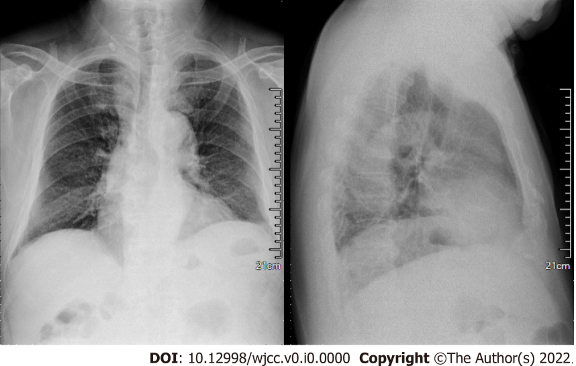
Figure 1 Chest X-ray. No significant cardiopulmonary abnormalities were seen.
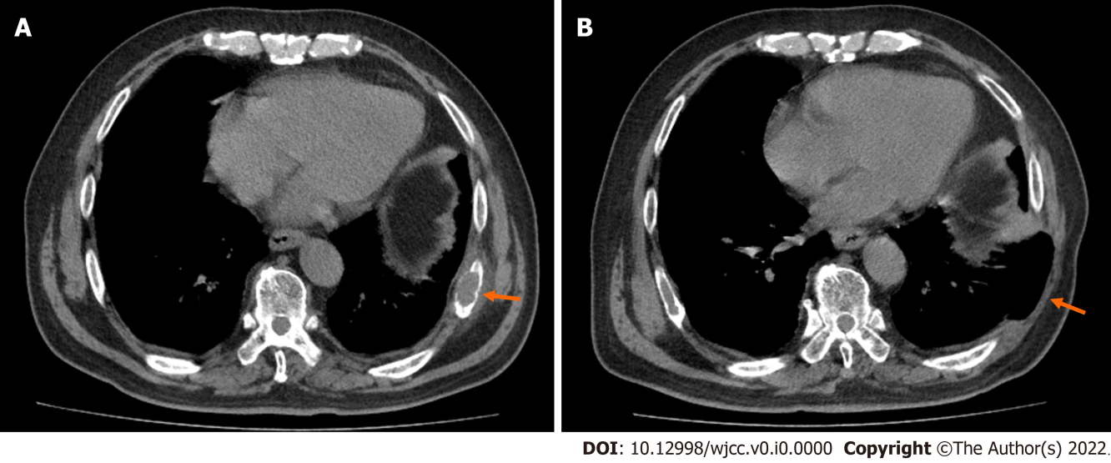
Figure 2 Comparison of computed tomography (CT) images of left eighth rib mass before and after surgery. A: CT scan of lung before surgery showed that the left eighth rib mass was accompanied by bone destruction (orange arrow); B: Lung CT scan after surgery showed changes after resection of the left eighth rib (orange arrow).
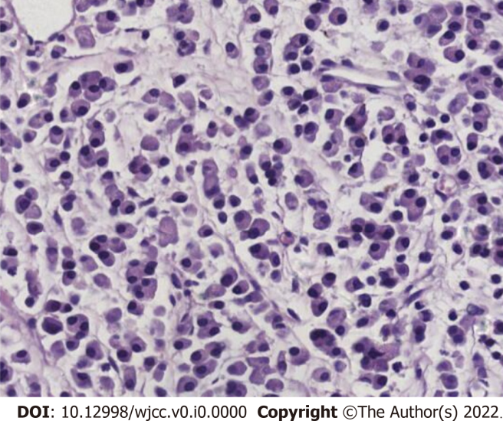
Figure 3 Postoperative pathology showed that a large number of immature plasma cells proliferated after decalcification (HE, × 400).
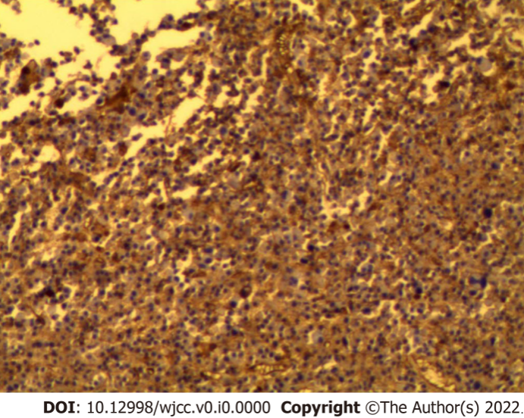
Figure 4 Immunohistochemical staining showed diffuse CD 138(+) in the tumor cell membrane (× 100).
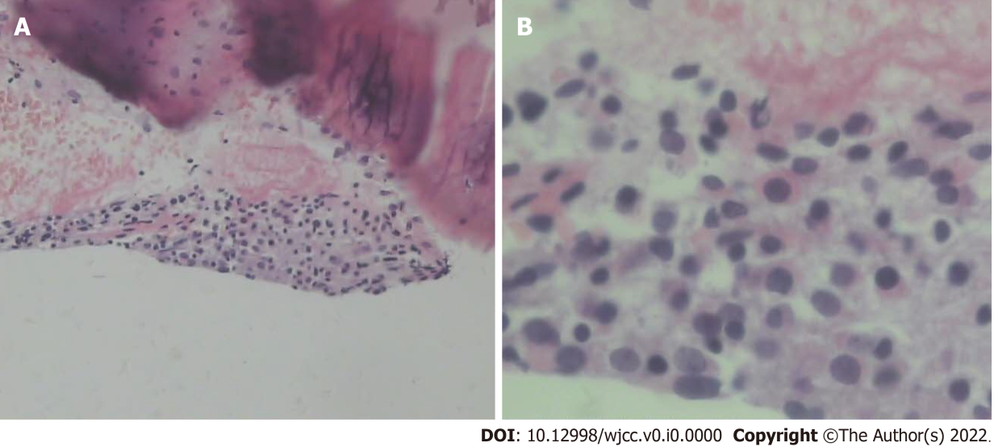
Figure 5 Pathology of rib biopsy. A: The pathological findings of rib biopsy showed that it was mainly striated muscle tissue, with a small amount of connective tissue, skin and bone tissue, and short spindle cells (HE, × 100); B: Rib biopsy pathology showed that under high magnification, some cells were short spindle-shaped, and the nuclei were slightly dark stained, with non-nuclear divisions (HE, × 400).

Table 1 Literature review of features of solitary plasmacytoma of the ribs
 | Ref. | Gender | Age | Location of rib | Treatment | Prognosis
1 | Ikeda et al^{[4]}, 1992 | M | 75 | Left 4th | R | NM
2 | Hihara et al^{[5]}, 1993 | F | 52 | Left 4th | NM | Relapse-free for 23 months’ follow-up
3 | Hanawa et al^{[6]}, 1994 | M | 58 | Right 7th and 8th | S+R | Recurrence on the left side after 7 mo
4 | Hirai et al^{[7]}, 1995 | F | 72 | Right 5th | S+R | Relapse-free for 23 mo’ follow-up
5 | Mankodi et al^{[8]}, 1999 | F | 26 | Left 6th | S+R | NM
6 | Kadokura et al^{[9]}, 2000 | M | 44 | Left 7th | S+R | Relapse-free for 24 mo’ follow-up
7 | Sato et al^{[10]}, 2001 | M | 46 | Right 5th | S | NM
8 | George et al^{[11]}, 2002 | M | 29 | Right 11th | S+R | NM
9 | Yan et al^{[12]}, 2003 | F | 45 | 7th rib (left or right NM) | R | Relapse-free for 24 mo’ follow-up
10 | García et al^{[23]}, 2004 | F | 32 | Right 9th | S | Relapse-free for 18 mo’ follow-up
11 | Bousnina et al^{[13]}, 2006 | M | 52 | Left 6th | S+R | Relapse-free for 12 mo’ follow-up
12 | Xiao et al^{[14]}, 2008 | F | 30 | Right 4th | S+R | Relapse-free for 11 mo’ follow-up
13 | Ketata et al^{[15]}, 2009 | M | 60 | Left 1st | S+R | Relapse-free for 8 mo’ follow-up
14 | Pattanayak et al^{[16]}, 2010 | M | 60 | Right 4th | S+R | Remission for 8 mo
15 | Kodate et al^{[17]}, 2010 | M | 70 | Right 4th | S+R+C | Remission for 33 mo
16 | Singal et al^{[18]}, 2011 | F | 43 | Right 5th | S+R | Relapse-free for 30 mo’ follow-up
17 | Lee et al^{[19]}, 2012 | M | 73 | Right 5th | S+R | NM
18 | Santos et al^{[20]}, 2012 | F | 65 | Right 6th | NM | NM
19 | Tajima et al^{[21]}, 2014 | F | 71 | Right 3rd | S | Relapse-free for 18 mo’ follow-up
20 | Razafimanjato et al^{[22]}, 2014 | M | 42 | Left 2nd | S+C | Relapse-free for 36 mo’ follow-up
21 | Caffery et al^{[24]}, 2014 | M | 33 | Right 5th | R | NM
22 | Jia et al^{[25]}, 2015 | M | 44 | Right 6th | S+R | Relapse-free for 6 mo’ follow-up
23 | Singh et al^{[26]}, 2020 | M | 39 | Left 4th | NM | NM
F: Female; M: Male; S: Surgery, R: Radiotherapy, C: Chemotherapy, NM: Not mentioned.

