Name of Journal: World Journal of Gastrointestinal Endoscopy
Manuscript NO: 37202
Manuscript Type: Systematic Reviews

Comparison between endoscopic sphincterotomy vs endoscopic sphincterotomy associated with balloon dilation for removal of bile duct stones: A systematic review and meta-analysis based on randomized controlled trials

de Clemente Junior CC et al. Sphincterotomy with vs without balloon dilation

Cesar Capel de Clemente Junior, Wanderley Marques Bernardo, Tomazo Prince Franzini, Gustavo Oliveira Luz, Marcos Eduardo Lera dos Santos, Jonah Maxwell Cohen, Diogo Turiani Hourneaux de Moura, Fábio Ramalho Tavares Marinho, Martin Coronel, Paulo Sakai, Eduardo Guimarães Hourneaux de Moura

Cesar Capel de Clemente Junior, Wanderley Marques Bernardo, Tomazo Prince Franzini, Gustavo Oliveira Luz, Marcos Eduardo Lera dos Santos, Diogo Turiani Hourneaux de Moura, Fábio Ramalho Tavares Marinho, Martin Coronel, Paulo Sakai, Eduardo Guimarães Hourneaux de Moura, Gastrointestinal Endoscopy Unit, Department of Gastroenterology, University of Sao Paulo Medical School, Sao Paulo 05403-010, Brazil

Jonah Maxwell Cohen, Beth Israel Deaconess Medical Center, Harvard Medical School, Boston, MA 02215, United States

ORCID number: Cesar Capel de Clemente Junior (0000-0002-5272-4065); Wanderley Marques Bernardo (0000-0002-8597-5207); Tomazo Prince Franzini (0000-0002-5477-4939); Gustavo Oliveira Luz (0000-0001-7396-8440); Marcos Eduardo Lera dos Santos (0000-0001-9759-3807); Jonah Maxwell Cohen (0000-0002-2967-9841); Diogo Turiani Hourneaux de Moura (0000-0002-7446-0355); Fábio Ramalho Tavares Marinho (0000-0002-7509-7113); Martin Coronel (0000-0002-4246-3324); Paulo Sakai (0000-0003-3088-9210); Eduardo Guimarães Hourneaux de Moura (0000-0003-1215-5731).

Author contributions: de Clemente Junior CC and Franzini TP contributed equally to the work; de Clemente Junior CC conceptualized and designed the review together with Bernardo WM; de Clemente Junior CC, Luz GO, dos Santos MEL, Marinho FRT, Coronel M and de Moura EGH carried out the analysis; de Clemente Junior CC and Sakai P drafted the initial manuscript; de Moura DTH, Cohen JM contributed to the major review changes and language; all authors reviewed and approved the final manuscript as submitted.

Conflict-of-interest statement: The authors declare that there is no conflict of interests regarding the publication of this paper.

Data sharing statement: No additional data are available.

Open-Access: This article is an open-access article which was selected by an in-house editor and fully peer-reviewed by external reviewers. It is distributed in accordance with the Creative Commons Attribution Non Commercial (CC BY-NC 4.0) license, which permits others to distribute, remix, adapt, build upon this work non-commercially, and license their derivative works on different terms, provided the original work is properly cited and the use is non-commercial. See: http://creativecommons.org/licenses/by-nc/4.0/

Manuscript source: Unsolicited manuscript

Correspondence to: Cesar Capel de Clemente Junior, MD, Academic Research, Gastrointestinal Endoscopy Unit, Department of Gastroenterology, University of Sao Paulo Medical School, R. Dr. Ovídio Pires de Campos, 255-Cerqueira César, Sao Paulo 05403-010, Brazil. cesar.capel@hc.fm.usp.br
Telephone: +55-11-26616467

Received: November 20, 2017
Peer-review started: November 21, 2017
First decision: December 12, 2017
Revised: March 2, 2018
Accepted: March 28, 2018
Article in press:
Published online:

Abstract
AIM
To compare gallstones removal rate and incidence of bleeding, pancreatitis, use of mechanical lithotripsy, cholangitis and perforation between isolated sphincterotomy vs sphincterotomy associated with balloon dilation of papilla in choledocholithiasis through the meta-analysis of randomized clinical trials.

METHODS
We conducted a systematic review according to the PRISMA guidelines. Literature search was restricted to randomized controlled trials (RCTs) on MedLine, Cochrane Library, LILACS, and EMBASE database platforms in July 2017. The manual search included references of retrieved articles. We extracted data focusing on outcomes: The primary endpoint was the stones removal rate; Secondary endpoints were rates of pancreatitis, bleeding, use of mechanical lithotripsy (ML), perforation and cholangitis.

RESULTS
Eleven RCTs with 1824 patients were included. EST was associated with more post-endoscopic retrograde cholangiopancreatography (ERCP) bleeding [FE RD-0.02, CI (-0.03, -0.00), I² = 33%, P = 0.05] and more need of mechanical lithotripsy in general [RE RD-0.16, CI (-0.25, -0.06), I² = 90%, P = 0.002] and in subgroup analysis of stones greater than 15 mm [RE RD-0.20, CI (-0.38, -0.02), I² = 82%, P = 0.003]. Incidence of pancreatitis [FE RD-0.01, CI (-0.03, 0.01), I² = 0, P = 0.36], cholangitis [FE RD-0.00, CI (-0.01, 0.01), I² =0, P = 0.97] and perforation [FE RD-0.01, CI (-0.01, 0.00), I² = 0, P = 0.23] was similar between the groups as well as similar stone removal rates in general [FE RD-0.01, CI (-0.01, 0.04), I² = 0, P = 0.23] and pooled analysis of stones greater than 15 mm [FE RD-0.02, CI (-0.02, 0.07), I² = 11%, P = 0.31].

CONCLUSION
Through meta-analysis of randomized clinical trials we found that isolated sphincterotomy was associated with more post-ERCP bleeding and more need for mechanical lithotripsy. However, there was no statistical difference in the stone removal rate between isolated sphincterotomy and sphincterotomy associated with balloon dilation in the approach to remove gallstones.

Key words: Cholangiopancreatography; Endoscopic retrograde; Endoscopic retrograde cholangiopancreatography; Cholangiography; Sphincterotomy; Papillotomy; Dilation

© The Author(s) 2018. Published by Baishideng Publishing Group Inc. All rights reserved.

Core tip: Our initial motivation was to determine if there is a preferential endoscopic approach in choledocholithiasis, comparing efficacy and safety data between the two most widespread endoscopic methods, which is sphincterotomy with vs without large balloon dilation. Through the systematic review, it was possible to perform the meta-analysis of a large sample of patients obtained from properly conducted randomized clinical trials. We found that endoscopic sphincterotomy associated with large balloon dilation was a safer method compared to isolated sphincterotomy, since this last group carried an increased risk of post ERCP bleeding and required more frequent complementation with use of mechanical lithotripsy.

de Clemente Junior CC, Bernardo WM, Franzini TP, Luz GO, dos Santos MEL, Cohen JM, de Moura DTH, Marinho FRT, Coronel M, Sakai P, de Moura EGH. Comparison between endoscopic sphincterotomy vs endoscopic sphincterotomy associated with balloon dilation for removal of bile duct stones: A systematic review and meta-analysis based on randomized controlled trials. World J Gastrointest Endosc 2018; In press

INTRODUCTION
Endoscopic sphincterotomy as well as balloon dilation of major papilla are recognized endoscopic treatment approaches to choledocholithiasis. These two techniques, however, are associated with adverse events such as bleeding, perforation and pancreatitis. Additionally, gallstones cannot be removed in approximately 5% to 10% of patients using sphincterotomy or balloon dilation alone^{[1]}.
Sphincterotomy presents high resolution rates for most cases, but in complex situations, especially regarding large stones, the resolution can become a challenge^{[2]}. Endoscopic balloon dilation of the duodenal major papilla is part of the available arsenal for choledocholithiasis resolution, but its isolated application was practically abandoned at the present time due to the unsatisfactory results and greater risk of pancreatitis when compared to isolated sphincterotomy, restricting its indication to selected cases with high hemorrhagic risk.
Is there a preferential approach in choledocholithiasis with lower rates of adverse events while maintaining high effectiveness?
To compare stones removal rate and incidence of adverse events such as bleeding, pancreatitis, perforation, cholangitis and use of mechanical lithotripsy between isolated sphincterotomy vs sphincterotomy associated with balloon dilation in choledocholithiasis through the meta-analysis of randomized clinical trials.

MATERIALS AND METHODS
This systematic review was conducted according to the PRISMA Statement (Preferred Reporting Items for Systematic reviews and Meta-Analyses)^{[3]}.
Inclusion criteria were defined according to the parameters established in PICO Model: (1) Participants (P): Patients with choledocholithiasis, over 18 years old; (2) interventions (I) and comparisons (C): To compare isolated sphincterotomy (ES) vs sphincterotomy associated with balloon dilation (ESBD); (3) outcomes (O): Primary-Stones removal rate, Secondary: bleeding, pancreatitis, use of mechanical lithotripsy (ML), cholangitis and perforation; and (4) study design: Randomized clinical trials (RCT). There were no restrictions on language or date of publication.

Information sources
The search was performed in the electronic databases MedLine (via PubMed), Cochrane Library, LILACS, EMBASE, the CAPES database (Brazil), and gray/manual literature from included references of retrieved articles.

Search
The keywords used to perform the search were (Cholangiopancreatograph* OR Endoscopic Retrograde OR ERCP OR Cholangiograph*) AND (Sphincterotom* OR papillotom*), without the use of filters.

Selection of studies
The evaluation of eligibility and selection of articles was done independently and standardized by two reviewers based initially on the title and abstract. In doubtful cases the full text was consulted prior to inclusion when it was possible. Disagreements among the reviewers were resolved by consensus or with the assistance of a third author. The present study involves only randomized clinical trials comparing exclusively isolated sphincterotomy (ES) vs combined sphincterotomy and balloon dilation of papilla (ESBD).

Data collection process
Data extraction from selected clinical trials was performed independently by the two authors in spreadsheets until consensus was obtained on all data in case of divergence. Only published data were considered.
The variables searched were: stone removal rates, pancreatitis, cholangitis, bleeding, perforation and use of mechanical lithotripsy. The raw numbers were used for analysis.

Statistical analysis
For all outcomes, absolute risk difference was weighted by intention-to-treat analysis (ITT) and the 95%CI and P < 0.05 as statistically significant.
Treatment effect and heterogeneity of the studies^{[4]} were analyzed by the method proposed by Higgins et al^{[5]}, called I², with fixed (FE) and random effects (RE), using Review Manager software version 5.3. The difference between the outcomes was calculated by the risk difference (RD), with fixed effect, for the dichotomous variables and as difference of mean for the continuous variables. Sensitivity analysis was used to attempt to identify a study with a higher likelihood of outlier publication when the heterogeneity, calculated using the chi-square test and quantified by the method proposed by Higgins et al^{[5]}, called I², was higher or equal to 50%. If this was not present the random effect was used in the analysis. For the synthesis of results, analytical graphs were generated using funnel plot and forest plot.

RESULTS
Initial search identified 4194 articles. After reviewing the title and abstracts, 4158 were excluded because they were not RCTs. 36 articles were fully evaluated, 25 were excluded because they were retrospective, compared to other methods or because they were systematic reviews. At the end 11 RCTs were included. A total of 1.824 patients with choledocholithiasis were evaluated, of which 914 were submitted to sphincterotomy plus balloon dilation and 910 underwent isolated sphincterotomy (Figure 1).

Risk of bias
Of the 11 RCTs, none cited blinding, two presented significant differences in population in relation to some variable and one did not present complete data (Table 1).
The studies were classified by methodological quality according to the JADAD Score^{[6]} (Table 2).
The following outcomes were analyzed according to the data presented by each study: stone removal rate, pancreatitis, bleeding, cholangitis, perforation and use of mechanical lithotripsy (Table 3).

Stone removal rate
All included studies^{[7-17]} evaluated stone removal rate. The meta-analysis of the results (n = 1824 patients) demonstrated heterogeneity of I² = 54% (Figure 2). Sensitivity analysis was performed with funnel plot, which identified an outlier study (Karsenti)^{[15]} (Figure 3). By removing it from the analysis, heterogeneity has disappeared (I² = 0). Considering a total of 1674 patients in this analysis, no statistical difference was observed between the two methods (Figure 4).

Stone removal rate in patients with stones greater than 15 mm
Six studies^{[9,11,12,14,16,17]} presented data relevant to this meta-analysis, totaling a number of 484 patients, being not statistically different between the groups (Figure 5).

Pancreatitis
All included studies^{[7-17]} evaluated the presence of post-procedure pancreatitis as an adverse event totaling 1802 patients, there was no statistical difference between the groups (Figure 6).

Bleeding
All included studies^{[7-17]} evaluated post-procedure bleeding as an adverse event in a total of 1802 patients, there was statistical difference between the groups, being ESBD a protective factor (P = 0.05) (Figure 7).

Cholangitis
All included studies^{[7-17]} evaluated the presence of post-procedure cholangitis as an adverse event in a total of 1802 patients, there was no statistical difference between the groups (Figure 8).

Use of mechanical lithotripsy in general
All included studies^{[7-17]} evaluated the use of mechanical lithotripsy, totaling a number of 1802 patients. Heterogeneity of 90% (Figure 9) was observed, then sensitivity analysis was performed with funnel plot, which did not identify only one outlier study (Figure 10), therefore it was assumed true heterogeneity, and then the random effect was used in the evaluation (Figure 11). There was a statistically significant difference between the groups with ES associated with balloon dilation (ESBD) as a protective factor against need for ML (P = 0.002).

Use of mechanical lithotripsy in patients with stones greater than 15mm
From available data it was possible to extract and to analyze a subgroup with patients who had stones greater than or equal to 15 mm. Six studies^{[9,11,12,14,16,17]} presented data relevant to this meta-analysis totaling 432 patients. Heterogeneity of 82% (Figure 12) was observed, then sensitivity analysis was performed with funnel plot, which did not identify only one outlier study (Figure 13), therefore it was assumed true heterogeneity, and then the random effect was used in the evaluation (Figure 14). There was a statistically significant difference between the groups with ES associated with balloon dilation (ESBD) as a protective factor against need for ML (P = 0.03).

Perforation
All included studies^{[7-17]} evaluated the presence of perforation during the procedure as an adverse event in a total number of 1802 patients, there was no statistical difference between the groups. (Figure 15).

DISCUSSION
Eleven RCTs with a total of 1824 patients were included in this systematic review and meta-analysis. Regarding efficacy there was no statistical difference in primary outcome stipulated as stone removal rate. The analysis from data of included studies showed statistical difference in safety between the methods since incidence of post-ERCP bleeding was higher in EST group.
Systematic reviews of randomized clinical trials on choledocholithiasis treatment methods in the past compared isolated sphincterotomy vs isolated dilation^{[18-20]}.
Feng et al^{[18]} found a lower mechanical lithotripsy (ML) use and a lower bleeding frequency in isolated dilation group in the general analysis.
Liu et al^{[19]}, by including non-randomized and randomized studies, found in his meta-analysis that isolated dilation caused more pancreatitis after ERCP and increased need for ML, whereas isolated ES had lower rates of bleeding. Jin et al^{[20]} identified lower ML use in the group submitted to isolated dilation both in general and subgroup of gallstones larger than 15 mm analysis.
In recent years it is remarkable in the literature a greater interest in comparing the ESBD vs ES methods by randomized clinical trials or by retrospective studies and even by systematic reviews. An important landmark in this sense was reported by Ersoz et al^{[21]}, who performed the first attempt to combine sphincterotomy and large balloon dilation to extract difficult bile duct stones in order to minimize adverse events rate. This technique successfully removed the stones in 89% of cases with disproportion between gallstones and distal bile duct, in addition to 95% in cases with giant stones, with adverse event rates significantly lower than in previous studies that prioritized one technique over the other without associating them.
Posterior studies have revealed the promising effect of sphincterotomy associated with balloon dilation of papilla in choledocholithiasis^{[22-26]}. Inversely proportional is the number of published articles comparing single dilation to any other method.
Liu et al^{[22]} analyzed non-randomized and randomized clinical trials comparing sphincterotomy associated with balloon dilation (ESBD) vs isolated sphincterotomy (ES) identifying in a separated analysis into subgroups a lower occurrence of bleeding in the ESBD from RCT analysis (n = 355) and in the non-randomized clinical trials (NRCT) the group of patients retrospectively submitted to ESBD obtained a higher success in the gallstones removal rate, as well as a lower need for ML and a lower rate of adverse events in general. In this same subgroup of NRCTs, patients were sub grouped according to presence of gallstones greater than 15 mm, reaching statistical difference in the lower use of ML when compared to ES group.
A meta-analysis of Yang et al^{[23]} demonstrated that the ESBD group had a lower rate of adverse events and a lower use of ML when compared to the ES group, which was more evident in the subgroup with patients with gallstones greater than 15 mm. It is important to note that this review included among the selected papers the clinical trial of Stefanidis that compares ESBD vs ES plus ML, not having an ES only arm in this study.
Stefanidis et al^{[24]} and Xu et al^{[25]} included four randomized clinical trials involving 496 patients. In order to avoid the possible inclusion bias of the aforementioned Stefanidis study, which was also included in his selection and evaluates different methods from the other three RCTs contained in the review, Xu chose to separate the analysis of this trial, losing in some meta-analysis its 90 patients. By doing so, he obtained statistically significant difference concluding that ESBD reduces the use of ML in patients with stones greater than 15 mm. After an isolated analysis of the study of Stefanidis, Xu concludes that there is statistical difference in the sample obtaining a higher rate of cholangitis in patients who performed ML after ES, still citing as probable causes: trauma to the wall of the bile duct by the lithotripter wire, inadequate sphincterotomy and edema at the site of sphincterotomy.
The last meta-analysis on this topic was made by Park and published in July 2017, this analysis show that ESBD had superior efficacy to endoscopic papillary balloon dilation (EPBD) in terms of stone removal in the first endoscopic session. Mechanical lithotripsy was less frequently required in ESBD than in EPBD. Post-ERCP pancreatitis tended to be less common in ESBD and EST than in EPBD, although the difference was not statistically significant. However, ESBD and EST carried a higher risk of post-ERCP bleeding than did EPBD. The author used indirect analysis to compare the outcomes and identified significant inconsistency between direct and indirect evidence in outcomes such as post-ERCP bleeding and perforation, which was attributed to an extremely low incidence. They selected 25 trials, of which 17 compared EST vs balloon dilation (EPBD). Only seven articles with 1253 patients compared EST to ESBD, the two methods that our review compares, since it is not part of the current guidelines the isolated use of balloon dilation, except in selected cases of irreversible coagulopathy. Among the seven selected, Stefanidis's above-mentioned work is present^{[26]}.
The literature review of the previous meta-analysis shows that authors did follow diverse methodology and were faced with limitations related to the selection of available studies, either by grouping different methods in the same analysis group, or by grouping prospective to retrospective studies or finally reaching a low total number of patients when they tried a more rigorous selection. However, we can identify among the studies, a lower tendency to use ML when balloon dilation is associated to sphincterotomy, especially in large gallstones.
This systematic review sought to homogenize the selection of clinical trials to compare the outcomes of the two most commonly used endoscopic methods in the extraction of gallstones from common bile duct, isolated sphincterotomy (ES) and sphincterotomy associated with balloon dilation (ESBD), besides presenting the largest sample involved up to the present moment. The incorporation of recent trials updates the understanding of the choledocholithiasis approach, and the sampling and selection of only randomized clinical trials provide greater magnitude and accuracy.
The selected RCTs applied, in general, similar exclusion criteria among themselves, such as: Active acute pancreatitis; cholangitis; acute cholecystitis; intrahepatic duct stones; pancreatobiliary malignancy; surgical history involving the biliary tree (not including the gall bladder) or gastrointestinal tract, such as the stomach or small bowel (Billroth II or Roux-en-Y reconstruction), which can change the papillary location; coagulation disorders; currently taking clopidogrel; pregnancy and inability to give informed consent.
Regarding safety, all selected trials define post-ERCP bleeding according to the Cotton consensus^{[27]} with the exception of not being able to extract this information from the only three selected trials published in abstract format^{[10,15,16]}. Of our eleven selected trials, four tended to have more bleeding in the EST group^{[8,13,16,17]}, but only Li et al^{[13]} presented statistical difference, its sample was significantly larger than the sample from each of the other trials, hence its presence was decisive for the final result, however, without compromising the analysis of heterogeneity (I² = 33%). We obtained that EST group presented more post-ERCP bleeding (3.4% vs 1.9%, P = 0.02) with a total of 1802 patients included in this analysis. This corroborates with the previous findings in 2013 systematic review done by Liu^{[22]}. It is worth to mention that its result was generated from a separated analysis with only three RCTs selected with a total of 355 patients, of which 155 were extracted from a single clinical trial that addressed only patients with periampullary diverticulum, adding an important selection bias to the analysis^{[28]}. The recently published meta-analysis by Park CH did not observe this difference in bleeding risk between ESBD and EST, but obtained that both ESBD and EST had more bleeding than EPBD^{[26]}.
Although there is a precedent in the literature on this finding, care should be taken when checking the presence of bias in the analysis, also identified by PARK CH et al^{[26]}, regarding the difference in sphincterotomy extension among selected trials, an important isolated variable related to the risk of bleeding, as assessed in a retrospective study done by Park et al^{[29]}.
All studies included in this review proceeded to the technique of partial sphincterotomy (one-third or half of the conventional length) associated with balloon dilation vs total sphincterotomy (performed on the full length of the transverse fold), with the exception of Karsenti´s trial^{[7]}, who underwent total sphincterotomy in all patients. This peculiarity did not change the results, since there is no tendency for a greater risk of post-procedure bleeding in any of the groups of his clinical trial. On the other hand, its full length cut approach may have been the main cause of the discrepancy in their results compared to the other trials in primary outcome assessment (stone removal rate), being evident when its inclusion in this analysis increased the heterogeneity of the group from I² = 0 to I² = 54%, therefore was identified as the only outlier study after sensitivity analysis was performed with funnel plot and withdrawn from that analysis. The author advocates against the use of small sphincterotomy as a cautious attitude against adverse events from results based on previous trials showing safety in total sphincterotomy prior to dilation^{[17,30]}, obfuscating the association found in Park SJ retrospective study^{[29]}. Finally, Karsenti et al^{[7]} obtained in their trial a clear advantage in the stone removal rate in favor to ESBD group, in addition to a lower need for ML in the same group without difference between techniques in the adverse events rate from a sample of 150 patients.
In our clinical experience at the Hospital das Clínicas of the University of São Paulo Medical School, endoscopists underwent total sphincterotomy prior to dilation in all selected complex cases without presenting rates of adverse events higher than those found in the literature. In our procedures the balloon was kept inflated during three minutes to avoid bleeding and reinflated for the same period if hemorrhage is noted.
Perforation was a rare event, affecting only five of 1802 patients effectively submitted to ERCP, being all from EST group and conducted with conservative non-surgical resolution. This demonstrates how techniques and accessories have evolved bringing greater safety to the procedure.
Regarding efficacy, in the assessment of primary outcome defined as stone removal rate, from available data it was possible to extract and to analyze a subgroup with patients who had stones greater than or equal to 15 mm with the final sum of 484 patients. Despite the tendency in favor to the ESBD group, there was no statistical difference among the groups. This outcome was expected to be the one that most could have differentiated the methods efficacy about the balloon dilation association in the process, perhaps the subgroup sample was too small to evidence it. So it may be required more large-scale specific RCTs.
However, ML was less needed in ESBD group both in general and in subgroup analysis with stones greater than 15 mm, reinforcing previous data in the literature^{[7,10,11-13,15,16]}. Therefore this association should be part of the approach decision algorithm according to physician’s experience with one technique or another, since if he opts less often for dilation he will be more susceptible to the need for ML.
We found that ESBD was a safer method compared to ES since ES group carried a higher risk of post-ERCP bleeding and required more frequent therapeutic complementation with use of mechanical lithotripsy, being exposed to a greater theoretical risk of bile duct injury, in addition to a potential longer procedure cost and time. In terms of efficacy, we obtained statistical similarity between groups, with tendency to superiority in ESBD group.
The review of the literature necessary to perform this work, coupled with the authors' clinical experience in their reference services, has led to the hypothesis that it is safe to perform the total sphincterotomy prior to large balloon dilation. However, in order to add a greater degree of scientific evidence, we suggest a pertinent study design to confirm this hypothesis: A large multicentric randomized clinical trial with standardized techniques and assessments based on up-to-date consensus involving patients with complex gallstones (greater than 15 mm or in number greater than 10 or with size disproportion between stone and distal CBD) comparing partial vs total sphincterotomy, both associated with large balloon dilation.
The future research should also consider the latest technologies incorporated into the available tools arsenal for the management of difficult bile duct stones, such as the use of cholangioscopy with target endobiliary therapies without the need for large biliary dilation and sphincterotomies, which can reduce possible adverse events. A recent randomized controlled trial totaling 100 patients comparing cholangioscopy vs papillary large balloon dilation for complex biliary stones management performed by Gastrointestinal Endoscopy Unit of the University of São Paulo Medical School concludes that the two techniques presented similar high success rates and low incidence of adverse events. Furthermore, the association of the methods improved biliary clearance, thus they can be complementary to each other^{[34]}.
Finally we present the flow chart of current clinical approach in our reference service (Figure 16).
The first limitation of this systematic review appeared in the initial search, because there are insufficient number of specific clinical trials for giant gallstones (≥ 15 mm), and studies with relatively large gallstones are heterogeneous in the sample and subdivided into groups with different cutoff size of the stones (12 mm, 15 mm or 20 mm). Only six studies of the eleven have pooled stones larger than 15 mm.
There was heterogeneity in technical details of procedures between the RCTs, such as different time of balloon insufflation and different length of sphincterotomy, this last seems to be an isolated variable that generates conflict in results interpretation when grouping different techniques in systematic reviews, this way we can infer that it is not only a limitation of the paper, but perhaps a point to be discussed and explored in future trials.
The nature of the intervention did not allow blinding after randomization. There was population heterogeneity between groups after randomization with regard to age in Karsenti trial and on the presence of periampular diverticulum on Guo trial.
We included three trials published in abstract format; we consider that it brings a limitation for the biases analysis, since they could not be fully evaluated in these works, such as adequate randomization or possible losses. In addition, it is important to emphasize the impossibility of accessing in these trials the adverse events definitions adopted (post-ERCP hemorrhage and pancreatitis). It was not possible to extract sphincterotomy technique data (small or total) from only one trial published in abstract format^{[16]}.
Regarding the results of these studies, the inclusion of the abstracts was not considered an absolute limitation, since the availability of all required data for the meta-analysis was a pre-requisite for inclusion in our study.
Through meta-analysis of randomized clinical trials we found that there was no statistical difference in the stone removal rate between isolated sphincterotomy and sphincterotomy associated with balloon dilation in the approach to remove gallstones. However, isolated sphincterotomy was associated with more post-ERCP bleeding and more need for mechanical lithotripsy.

ARTICLE HIGHLIGHTS
Research background
Endoscopic retrograde cholangiopancreatography (ERCP) has become one of the most important techniques for the treatment of choledocholithiasis, a pathology with an important prevalence in the population, which incidence increases with age, with an estimated 5% to 10% of patients with cholelithiasis at the time of cholecystectomy even without any predictive factors. The techniques and endoscopic instruments have evolved a lot in the last decades, with a significant improvement in effectiveness and safety, but we still have challenging situations (gallstones larger than 15 mm or in number greater than 10 or when there is a disproportion between stone size and the distal bile duct caliber). In this sense, we should seek solidified data in the available scientific literature to support our most appropriate therapeutic decision.

Research motivation
Endoscopic sphincterotomy as well as balloon dilation of duodenal major papilla are recognized endoscopic treatment approaches to choledocholithiasis. These two techniques, however, are associated with adverse events such as hemorrhage, perforation and pancreatitis. Additionally, gallstones cannot be removed in approximately 5% to 10% of patients, especially those with difficult duct biliary stones. Our initial motivation was to know if there is a preferential approach in choledocholithiasis with lower rates of adverse events while maintaining high effectiveness. From the literature review about the subject, we realized some characteristics that we interpreted as important limitations in the previous works. Thereafter, this study tried to remove these limitations and to follow a rigorous methodological approach in the selection and analysis of clinical trials in order to enhance the knowledge about safety and efficacy data.

Research objectives
We want to compare efficacy and safety data between the two most widespread endoscopic approach methods in choledocholithiasis: endoscopic sphincterotomy vs endoscopic sphincterotomy associated with large balloon dilation. It was possible to obtain in the literature a large sample of patients taken from properly conducted clinical trials. We believe that future systematic reviews on this issue can be based on our selection and analysis methodology and just add new trials which shall be published in order to update and to bring a greater dimension to the theme.

Research methods
This systematic review was conducted according to the PRISMA Statement (Preferred reporting items for systematic reviews and meta-analyses). The search was performed in the electronic databases MedLine (via PubMed), Cochrane Library, LILACS, EMBASE, the CAPES database (Brazil), and gray literature. The incorporation of recent trials updates the understanding of the choledocholithiasis approach, and the sampling and selection of only randomized clinical trials provide greater magnitude and accuracy.

Research results
Eleven randomized controlled trials (RCTs) with 1824 patients were included. EST was associated with more post-ERCP bleeding (P = 0.05) and more need for mechanical lithotripsy in general (P = 0.002) and in subgroup analysis of stones greater than 15 mm (P = 0.003). Incidence of pancreatitis, cholangitis and perforation was similar between the groups as well as similar stone removal rates in general and in pooled analysis of stones greater than 15 mm. We obtained the largest sample already described in the literature that directly compares the EST vs sphincterotomy associated with balloon dilation (ESBD) methods in choledocholithiasis through data extracted from published randomized clinical trials. We were expecting that the primary outcome defined as stone removal rate have differentiated the methods efficacy about the balloon dilation association at least for the subgroup analysis of patients with stones greater than 15 mm, but, despite the tendency to favors the ESBD group, there was no statistical difference among the groups. Perhaps the subgroup sample (484 patients) was too small to evidence it. So it may be required more large-scale specific RCTs.

Research conclusions
Through the direct meta-analysis of the largest sample ever pulled exclusively from randomized clinical trials addressing choledocholithiasis, we found that isolated sphincterotomy was associated with higher post-ERCP bleeding as well as an increased need for mechanical lithotripsy than when associated with balloon dilation. Regarding efficacy, stone removal rate tended to be better in ESBD than in EST, although the difference was not statistically significant. This study sought to remove the bias from the lack of methodological rigor applied in the selection and analysis of clinical trials identified in the previous reviews, thus obtaining more purified results, even though they are similar. We found that ESBD was a greater safety method compared to isolated sphincterotomy (ES) since ES group carried a higher risk of post-ERCP bleeding and required more frequent therapeutic complementation with use of mechanical lithotripsy, being exposed to a greater theoretical risk of bile duct injury, in addition to a potential longer procedure cost and time. In terms of efficacy, we obtained statistical similarity between groups, with tendency to superiority in stone removal rate for the ESBD group. This study proposes that the complement with balloon dilation after sphincterotomy of the papilla is associated with greater safety in ERCP for choledocholithiasis, since isolated sphincterotomy was associated with more post-ERCP bleeding. Taking into account the fact that mechanical lithotripsy (ML) was less needed in ESBD group both in general and in subgroup analysis with stones greater than 15 mm, this association should be part of the approach decision algorithm according to physician’s experience with one technique or another, since if he opts less often for dilation he will be more susceptible to the need for ML. This systematic review sought to homogenize the selection of randomized clinical trials and to compare the outcomes of the two most commonly used endoscopic methods in the extraction of gallstones from common bile duct: isolated sphincterotomy ES and ESBD, besides presenting the largest sample involved up to the present moment submitted to direct analysis. The incorporation of recent clinical trials updates the understanding of the choledocholithiasis approach, and the sampling and selection of only randomized clinical trials provide greater magnitude and accuracy. All the phenomena found had already occurred separately in previous studies, so, this study corroborates and reinforces with the findings of the literature. To achieve greater impact through direct analysis of the largest sample taken exclusively from the RCT so far, we can confirm some findings from the literature review as a higher risk of bleeding in the EST group compared to ESBD and less need for ML in the ESBD group when performing ERCP for choledocholithiasis resolution.

Research perspectives
The legitimacy of comparing these two methods through meta-analyzes always seems to be influenced by the technical differences applied in each trial, such as the sphincterotomy length, once it shows an evident disturbance in the results of this study. Continuous assessment of efficacy and safety data for difficult cases of choledocholithiasis, focusing on compares the outcomes between partial vs total sphincterotomy, both associated to large balloon dilation. A pertinent study design to the theme would be a large multicentric randomized clinical trial with standardized techniques and assessments based on up-to-date consensus involving patients with complex gallstones (greater than 15 mm or in number greater than 10 or with size disproportion between stone and distal CBD) comparing small vs total sphincterotomy, both associated with large balloon dilation.

REFERENCES
1 Hochberger J, Tex S, Maiss J, Hahn EG. Management of difficult common bile duct stones. Gastrointest Endosc Clin N Am 2003; 13: 623-634 [PMID: 14986790 DOI: 10.1016/S1052-5157(03)00102-8]
2 Katanuma A, Maguchi H, Osanai M, Takahashi K. Endoscopic treatment of difficult common bile duct stones. Dig Endosc 2010; 22 Suppl 1: S90-S97 [PMID: 20590781 DOI: 10.1111/j.1443-1661.2010.00979.x]
3 Preferred reporting items for systematic review and meta-analysis protocols (PRISMA-P) 2015: elaboration and explanation. BMJ 2016; 354: i4086 [PMID: 27444514 DOI: 10.1136/bmj.i4086]
4 Review Manager software. [Computer program]. Version 5.3. Copenhagen: The Nordic Cochrane Center, The Cochrane Collaborations 26
5 Higgins JP, Thompson SG, Deeks JJ, Altman DG. Measuring inconsistency in meta-analyses. BMJ 2003; 327: 557-560 [PMID: 12958120 DOI: 10.1136/bmj.327.7414.557]
6 Jadad AR, Moore RA, Carroll D, Jenkinson C, Reynolds DJ, Gavaghan DJ, McQuay HJ. Assessing the quality of reports of randomized clinical trials: is blinding necessary? Control Clin Trials 1996; 17: 1-12 [PMID: 8721797 DOI: 10.1016/0197-2456(95)00134-4]
7 Karsenti D, Coron E, Vanbiervliet G, Privat J, Kull E, Bichard P, Perrot B, Quentin V, Duriez A, Cholet F, Subtil C, Duchmann JC, Lefort C, Hudziak H, Koch S, Granval P, Lecleire S, Charachon A, Barange K, Cesbron EM, De Widerspach A, Le Baleur Y, Barthet M, Poincloux L. Complete endoscopic sphincterotomy with vs. without large-balloon dilation for the removal of large bile duct stones: randomized multicenter study. Endoscopy 2017; 49: 968-976 [PMID: 28753698 DOI: 10.1055/s-0043-114411]
8 Chu X, Zhang H, Qu R, Huang G, Guo C, Wang F, Cheng M. Small endoscopic sphincterotomy combined with endoscopic papillary large-balloon dilation. Eur Surg 2017; 49: 9-16 [DOI: 10.1007/s10353-016-0388-2]
9 Guo Y, Lei S, Gong W, Gu H, Li M, Liu S, Zhi F. A Preliminary Comparison of Endoscopic Sphincterotomy, Endoscopic Papillary Large Balloon Dilation, and Combination of the Two in Endoscopic Choledocholithiasis Treatment. Med Sci Monit 2015; 21: 2607-2612 [PMID: 26334173 DOI: 10.12659/MSM.894158]
10 Hisa T. Can Endoscopic Papillary Balloon Dilation With Minor Sphincterotomy Be a Standard Treatment for the Conventional Bile Duct Stone? Gastrointest Endosc 2015; 81: 5S [DOI: 10.1016/j.gie.2015.03.1953]
11 Teoh AY, Cheung FK, Hu B, Pan YM, Lai LH, Chiu PW, Wong SK, Chan FK, Lau JY. Randomized trial of endoscopic sphincterotomy with balloon dilation versus endoscopic sphincterotomy alone for removal of bile duct stones. Gastroenterology 2013; 144: 341-345.e1 [PMID: 23085096 DOI: 10.1053/j.gastro.2012.10.027]
12 Jun Bo Q, Li Hua X, Tian Min C, Liu Gen G, Yan Mei Y, Hua Sheng L. Small Endoscopic Sphincterotomy plus Large-Balloon Dilation for Removal of Large Common Bile Duct Stones during ERCP. Pak J Med Sci 2013; 29: 907-912 [PMID: 24353657 DOI: 10.12669/pjms.294.3662]
13 Li G, Pang Q, Zhang X, Dong H, Guo R, Zhai H, Dong Y, Jia X. Dilation-assisted stone extraction: an alternative method for removal of common bile duct stones. Dig Dis Sci 2014; 59: 857-864 [PMID: 24254339 DOI: 10.1007/s10620-013-2914-4]
14 Kim HG, Cheon YK, Cho YD, Moon JH, Park DH, Lee TH, Choi HJ, Park SH, Lee JS, Lee MS. Small sphincterotomy combined with endoscopic papillary large balloon dilation versus sphincterotomy. World J Gastroenterol 2009; 15: 4298-4304 [PMID: 19750573 DOI: 10.3748/wjg.15.4298]
15 Kim TH, Oh HJ, Lee JY, Sohn YW. Can a small endoscopic sphincterotomy plus a large-balloon dilation reduce the use of mechanical lithotripsy in patients with large bile duct stones? Surg Endosc 2011; 25: 3330-3337 [PMID: 21533521 DOI: 10.1007/s00464-011-1720-3]
16 Hong GY, Park SW, Seo KS, Moon H. Endoscopic sphincterotomy plus large- balloon dilation versus endoscopic sphincterotomy for removal of large common bile duct stones. Gastrointest Endosc 2009; 69: AB148 [DOI: 10.1016/ j.gie.2009.03.233]
17 Heo JH, Kang DH, Jung HJ, Kwon DS, An JK, Kim BS, Suh KD, Lee SY, Lee JH, Kim GH, Kim TO, Heo J, Song GA, Cho M. Endoscopic sphincterotomy plus large-balloon dilation versus endoscopic sphincterotomy for removal of bile-duct stones. Gastrointest Endosc 2007; 66: 720-726; quiz 768, 771 [PMID: 17905013 DOI: 10.1016/j.gie.2007.02.033]
18 Feng Y, Zhu H, Chen X, Xu S, Cheng W, Ni J, Shi R. Comparison of endoscopic papillary large balloon dilation and endoscopic sphincterotomy for retrieval of choledocholithiasis: a meta-analysis of randomized controlled trials. J Gastroenterol 2012; 47: 655-663 [PMID: 22361862 DOI: 10.1007/s00535-012-0528-9]
19 Liu Y, Su P, Lin S, Xiao K, Chen P, An S, Zhi F, Bai Y. Endoscopic papillary balloon dilatation versus endoscopic sphincterotomy in the treatment for choledocholithiasis: a meta-analysis. J Gastroenterol Hepatol 2012; 27: 464-471 [PMID: 21913984 DOI: 10.1111/j.1440-1746.2011.06912.x]
20 Jin PP, Cheng JF, Liu D, Mei M, Xu ZQ, Sun LM. Endoscopic papillary large balloon dilation vs endoscopic sphincterotomy for retrieval of common bile duct stones: a meta-analysis. World J Gastroenterol 2014; 20: 5548-5556 [PMID: 24833886 DOI: 10.3748/wjg.v20.i18.5548]
21 Ersoz G, Tekesin O, Ozutemiz AO, Gunsar F. Biliary sphincterotomy plus dilation with a large balloon for bile duct stones that are difficult to extract. Gastrointest Endosc 2003; 57: 156-159 [PMID: 12556775 DOI: 10.1067/mge.2003.52]
22 Liu Y, Su P, Lin Y, Lin S, Xiao K, Chen P, An S, Bai Y, Zhi F. Endoscopic sphincterotomy plus balloon dilation versus endoscopic sphincterotomy for choledocholithiasis: A meta-analysis. J Gastroenterol Hepatol 2013; 28: 937-945 [PMID: 23489041 DOI: 10.1111/jgh.12192]
23 Yang XM, Hu B. Endoscopic sphincterotomy plus large-balloon dilation vs endoscopic sphincterotomy for choledocholithiasis: a meta-analysis. World J Gastroenterol 2013; 19: 9453-9460 [PMID: 24409076 DOI: 10.3748/wjg.v19.i48.9453]
24 Stefanidis G, Viazis N, Pleskow D, Manolakopoulos S, Theocharis L, Christodoulou C, Kotsikoros N, Giannousis J, Sgouros S, Rodias M, Katsikani A, Chuttani R. Large balloon dilation vs. mechanical lithotripsy for the management of large bile duct stones: a prospective randomized study. Am J Gastroenterol 2011; 106: 278-285 [PMID: 21045816 DOI: 10.1038/ajg.2010.421]
25 Xu L, Kyaw MH, Tse YK, Lau JY. Endoscopic sphincterotomy with large balloon dilation versus endoscopic sphincterotomy for bile duct stones: a systematic review and meta-analysis. Biomed Res Int 2015; 2015: 673103 [PMID: 25756050 DOI: 10.1155/2015/673103]
26 Park CH, Jung JH, Nam E, Kim EH, Kim MG, Kim JH, Park SW. Comparative efficacy of various endoscopic techniques for the treatment of common bile duct stones: a network meta-analysis. Gastrointest Endosc 2018; 87: 43-57.e10 [PMID: 28756105 DOI: 10.1016/j.gie.2017.07.038]
27 Cotton PB, Lehman G, Vennes J, Geenen JE, Russell RC, Meyers WC, Liguory C, Nickl N. Endoscopic sphincterotomy complications and their management: an attempt at consensus. Gastrointest Endosc 1991; 37: 383-393 [PMID: 2070995 DOI: 10.1016/S0016-5107(91)70740-2]
28 Liu F, Li F, Zhou Y, Xi M, Zou D, Li Z. Minor endoscopic sphincterotomy plus endoscopic balloon dilation is an effective and safer alternative for endoscopic sphincterotomy during ERCP in patients with peiampullary diverticula and bile duct stones. Gastrointest. Endosc 2008; 67: B230 [DOI: 10.1016/j.gie.2008.03.583]
29 Park SJ, Kim JH, Hwang JC, Kim HG, Lee DH, Jeong S, Cha SW, Cho YD, Kim HJ, Kim JH, Moon JH, Park SH, Itoi T, Isayama H, Kogure H, Lee SJ, Jung KT, Lee HS, Baron TH, Lee DK. Factors predictive of adverse events following endoscopic papillary large balloon dilation: results from a multicenter series. Dig Dis Sci 2013; 58: 1100-1109 [PMID: 23225136 DOI: 10.1007/s10620-012-2494-8]
30 Oh MJ, Kim TN. Prospective comparative study of endoscopic papillary large balloon dilation and endoscopic sphincterotomy for removal of large bile duct stones in patients above 45 years of age. Scand J Gastroenterol 2012; 47: 1071-1077 [PMID: 22934594 DOI: 10.3109/00365521.2012.690046]
31 Disario JA, Freeman ML, Bjorkman DJ, Macmathuna P, Petersen BT, Jaffe PE, Morales TG, Hixson LJ, Sherman S, Lehman GA, Jamal MM, Al-Kawas FH, Khandelwal M, Moore JP, Derfus GA, Jamidar PA, Ramirez FC, Ryan ME, Woods KL, Carr-Locke DL, Alder SC. Endoscopic balloon dilation compared with sphincterotomy for extraction of bile duct stones. Gastroenterology 2004; 127: 1291-1299 [PMID: 15520997 DOI: 10.1053/j.gastro.2004.07.017]
32 Collins C, Maguire D, Ireland A, Fitzgerald E, O'Sullivan GC. A prospective study of common bile duct calculi in patients undergoing laparoscopic cholecystectomy: natural history of choledocholithiasis revisited. Ann Surg 2004; 239: 28-33 [PMID: 14685097 DOI: 10.1097/01.sla.0000103069.00170.9c]
33 Higgins J, Green Se. Cochrane Handbook for Systematic Reviews of Interventions Version 5, 1,0 [updated March 2011]. The Cochrane Collaboration. 2011: Available from: URL: www.cochrane-handbook.org
34 Franzini T, Moura RN, Bonifácio P, Luz GO, de Souza TF, Dos Santos MEL, Rodela GL, Ide E, Herman P, Montagnini AL, D'Albuquerque LAC, Sakai P, de Moura EGH. Complex biliary stones management: cholangioscopy versus papillary large balloon dilation - a randomized controlled trial. Endosc Int Open 2018; 6: E131-E138 [PMID: 29399609 DOI: 10.1055/s-0043-122493]

P-Reviewer: Altonbary A, Guerra IG, Rabago LR, Reddy DN
S-Editor: Wang XJ L-Editor: E-Editor:
Specialty type: Gastroenterology and hepatology
Country of origin: Brazil
Peer-review report classification
Grade A (Excellent): 0
Grade B (Very good): B
Grade C (Good): C, C, C
Grade D (Fair): 0
Grade E (Poor): 0
Table 1 Descriptive table of bias in therapeutic studies
Chu, 2016 | ESBD vs ES | Yes | Yes | NO | YES | HOMOGENEOUS | Extraction rate of stones, bleeding, pancreatitis, perforation, use of mechanical lithotripsy (ML) and cholangitis. | No
Karsenti, 2017 | ESBD vs ES | Yes | YES | NO | NO | Age significantly higher in ES population compared with ESBD population | Extraction rate of stones, bleeding, pancreatitis, perforation | Yes
Takeshi, 2015 | ESBD vs ES | Yes | Do not quote | No | No | HOMOGENEOUS | Extraction rate of stones, bleeding, perforation, use of mechanical lithotripsy (ML) and cholangitis. | Yes
Guo, 2015 | ESBD vs ES | Yes | Do not quote | NO | NO | Statistical difference in the population with the highest rate of periampular diverticulum in the ESBD group | Extraction rate of stones, bleeding, pancreatitis, perforation, use of mechanical lithotripsy (ML) and cholangitis. | Yes
Qian, 2013 | ESBD vs ES | Yes | Yes | No | Yes | HOMOGENEOUS | Extraction rate of stones, perforation, use of mechanical lithotripsy (ML), cholangitis. And recurrence of choledocolithiasis. | Yes
Li, 2013 | ESBD vs ES | Yes | Yes | No | Yes | HomogeneoUS | Extraction rate of stones, perforation, use of mechanical lithotripsy (ML) and cholangitis. | Modified ITT analysis
Teoh, 2013 | ESBD vs ES | Yes | Yes | No | No | HomogeneoUS | Extraction rate of stones, perforation, use of mechanical lithotripsy (ML) and cholangitis. | Yes
Hong, 2009 | ESBD vs ES | Yes | Do not quote | No | Do not quote | HomogeneoUS | Extraction rate of stones, bleeding, pancreatitis, perforation and cholangitis. | Yes
Kim HG, 2009 | ESBD vs ES | Yes | Do not quote | No | No | Homogeneous | Extraction rate of stones, bleeding, pancreatitis, perforation, use of mechanical lithotripsy (ML) and cholangitis. | Yes
Kim TH, 2009 | ESBD vs ES | Yes | Do not quote | No | No | Homogeneous | Extraction rate of stones, bleeding, pancreatitis, perforation, use of mechanical lithotripsy (ML). | Yes
Heo, 2007 | ESBD vs ES | Yes | Yes | No | No | Homogeneous | Extraction rate of stones, bleeding, pancreatitis, perforation, use of mechanical lithotripsy (ML) and cholangitis. | Yes
Study | Question | RAndomization | Allocation | Blindness | Losses | Prognosis | Outcomes | ITT

Table 2 JADAD score
 | R | aR | B | aB | W | Total
Chu, 2016 | 1 | 1 | 0 | 0 | 1 | 3
Karsenti, 2017 | 1 | 1 | 0 | 0 | 1 | 3
Guo, 2015 | 1 | 0 | 0 | 0 | 1 | 2
Takeshi, 2015 | 1 | - | 0 | 0 | 1 | 2
Teoh, 2013 | 1 | 1 | 0 | 0 | 1 | 3
Qian, 2013 | 1 | 1 | 0 | 0 | 1 | 3
Li, 2013 | 1 | 1 | 0 | 0 | 1 | 3
Kim HG, 2009 | 1 | 0 | 0 | 0 | 1 | 2
Kim TH, 2009 | 1 | 0 | 0 | 0 | 1 | 2
Hong, 2009 | 1 | - | 0 | 0 | 1 | 2
Heo, 2007 | 1 | 1 | 0 | 0 | 1 | 3
R: Randomization; Ar: appropriate randomization; B: Blinding; aB: Appropriate Blinding; W: Withdrawals.

Table 3 Frequency of outcomes based on systematic review
 | Sphincterotomy | Sphincterotomy associated with balloon dilation | P
Stone removal rate | 773/837 (92.3%) | 786/837 (93.9%) | 0.10
Stone removal rate with stones greater than 15 mm | 218/240 (90.8%) | 228/244 (93.4%) | 0.14
Pancreatitis | 48/891 (5.3%) | 40/911 (4.4%) | 0.16
Bleeding | 31/891 (3.4%) | 18/911 (1.9%) | 0.02
Cholangitis | 7/891 (0.78%) | 7/911 (0.76%) | 0.48
Perforation | 5/911 (0.54%) | 0/891 (0) | 0.08
Use of mechanical lithotripsy | 262/910 (28.8%) | 105/914 (11.5%) | < 0.00001
Use of mechanical lithotripsy with stones greater than 15 mm | 115/218 (52.7%) | 54/214 (25.2%) | < 0.00001

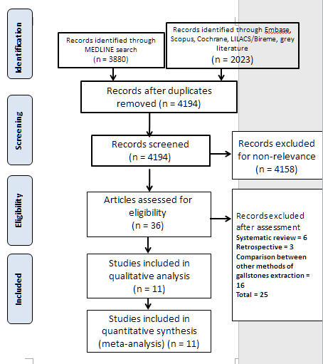

Figure 1 Flow diagram of studies included in the meta-analysis.

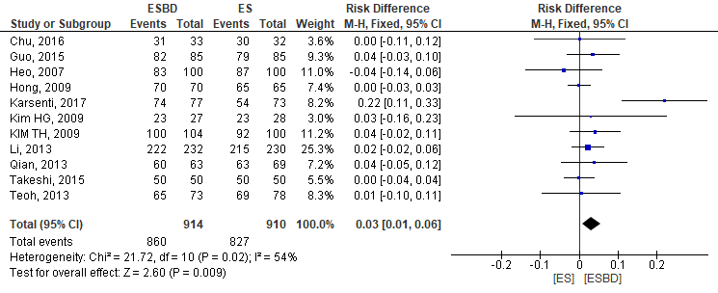 Figure 2 Stone removal rate forest plot enrolling all studies.

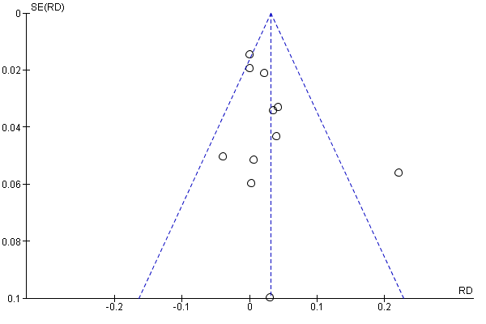
Figure 3 Funnel plot showing one outlier study in the stone removal rate analysis.

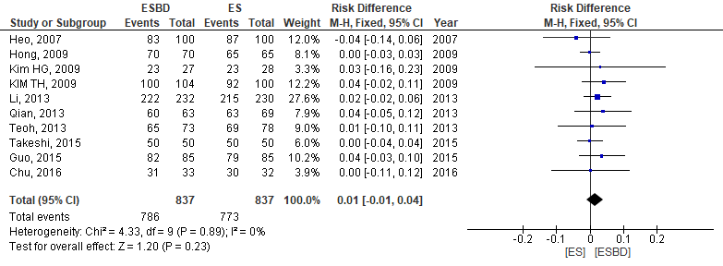 Figure 4 Stone removal rate forest plot after removing the outlier study.

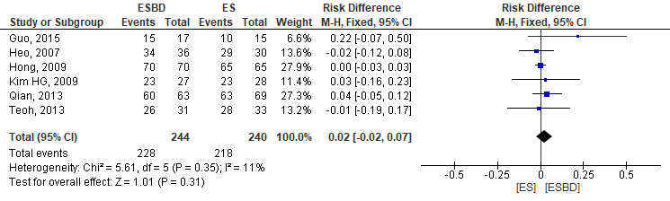Figure 5 Forest plot of stone removal rate in patients with stones greater than 15 mm.

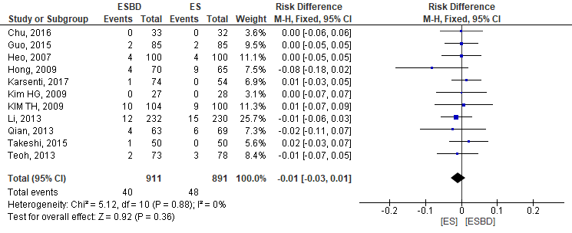 Figure 6 Forest plot of post-endoscopic retrograde cholangiopancreatography pancreatitis rate.

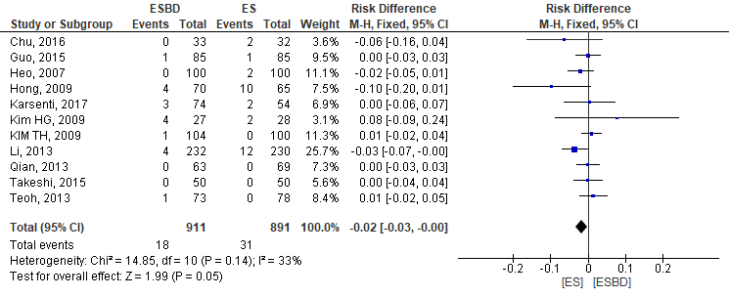 Figure 7 Forest plot of post-procedure bleeding rate (P = 0.05).

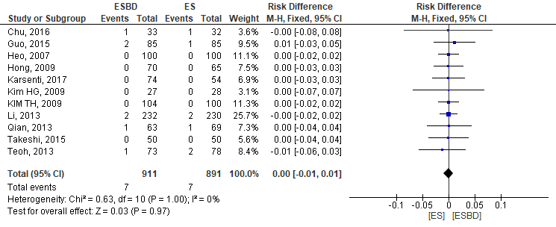 Figure 8 Forest plot of post-procedure cholangitis rate.

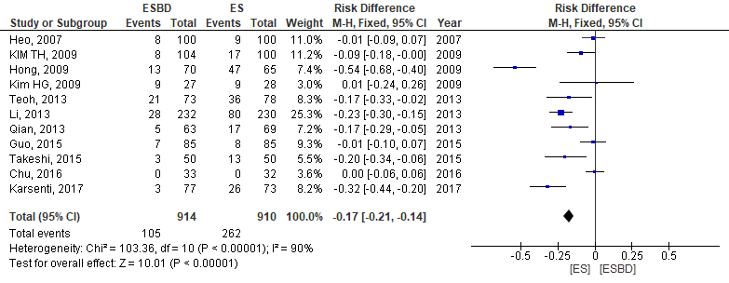
Figure 9 Forest plot with fixed effect comparing the use of mechanical lithotripsy (P < 0.00001).

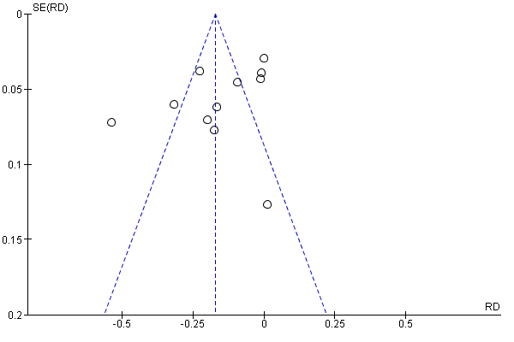 Figure 10 Funnel plot showing true heterogeneity in the use of mechanical lithotripsy general analysis.

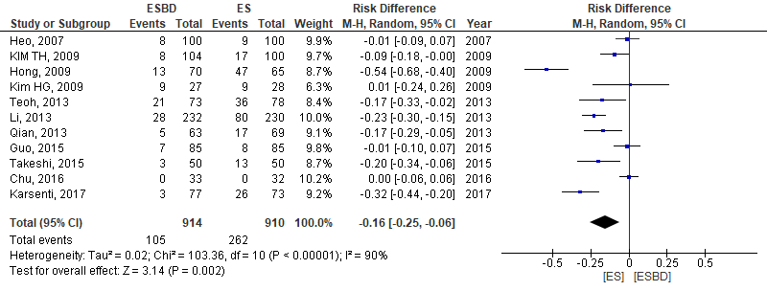 Figure 11 Forest plot with random effect comparing the use of mechanical lithotripsy (P < 0.002).

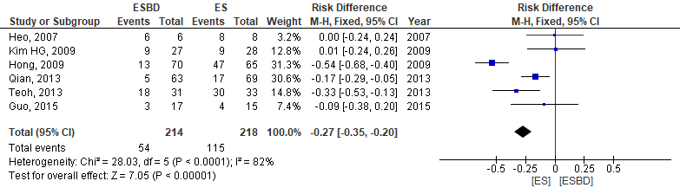
Figure 12 Forest plot with fixed effect comparing the use of mechanical lithotripsy in patients with stones greater than 15 mm (P < 0.00001).

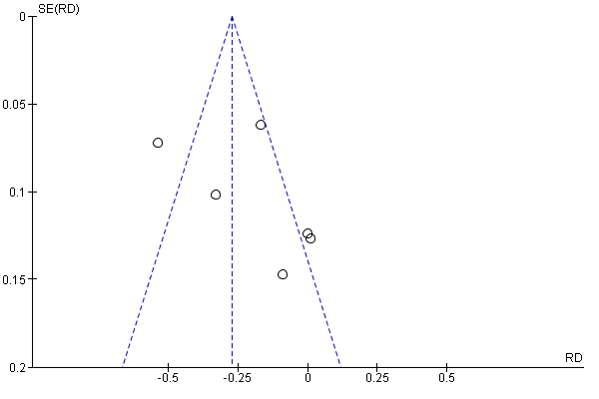Figure 13 Funnel plot showing true heterogeneity in the use of mechanical lithotripsy in patients with stones greater than 15 mm analysis.

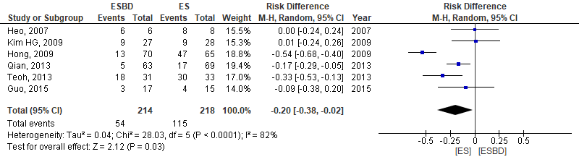 Figure 14 Forest plot with random effect comparing the use of mechanical lithotripsy in patients with stones greater than 15 mm analysis (P = 0.03).

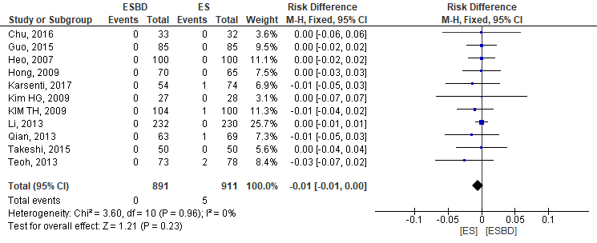 Figure 15 Forest plot comparing perforation rates during the procedure.

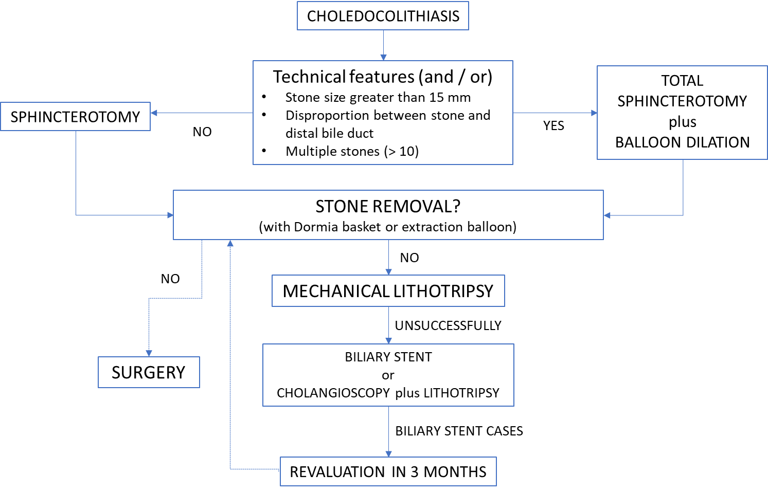
Figure 16 Flow chart of current clinical approach in our reference service.

