Name of Journal: World Journal of Gastroenterology
Manuscript NO: 42697
Manuscript Type: MINIREVIEWS

Post-translational modifications of prostaglandin-endoperoxide synthase 2 in colorectal cancer: An update

Jaén RI et al. PTGS2 in colorectal tumorigenesis

Rafael I Jaén, Patricia Prieto, Marta Casado, Paloma Martín-Sanz, Lisardo Boscá

Rafael I Jaén, Patricia Prieto, Lisardo Boscá, Department of Metabolism and Physiopathology of Inflammatory Diseases, Instituto de Investigaciones Biomédicas Alberto Sols, Madrid 28029, Spain

Marta Casado, Department of Biomedicine, Instituto de Biomedicina de Valencia, Valencia 46010, Spain

Marta Casado, Paloma Martín-Sanz, Lisardo Boscá, Centro de Investigación Biomédica en Red de Enfermedades Cardiovasculares, y Hepáticas y Digestivas, ISCIII, Madrid 28029, Spain

Paloma Martín-Sanz, Lisardo Boscá, Unidad Asociada IIBM-ULPGC, Universidad de las Palmas de Gran Canaria (ULPGC), Las Palmas de Gran Canaria 35001, Spain

ORCID number: Rafael I Jaén (0000-0002-7298-2125); Patricia Prieto (0000-0001-6943-7663); Marta Casado (0000-0001-6457-4650); Paloma Martín-Sanz (0000-0002-0758-9749); Lisardo Boscá (0000-0002-0253-5469).

Author contributions: Jaén RI and Prieto P contributed equally to the discussion of the minireview and provided key information on the glycosylation of prostaglandin-endoperoxide synthase 2 in colorectal cancer samples. Casado M, Martín-Sanz P and Boscá L revised the literature, organized the content of the minireview and prepared the figures of the manuscript.

Supported by Ministerio de Ciencia Innovación y Universidades, No. SAF2017-82436R and SAF2016-75004R; Comunidad de Madrid, No. S2017/BMD-3686; Fundación Ramón Areces, No. 2016/CIVP18A3864; and Instituto de Salud Carlos III and by Fondos FEDER, No. Cibercv and Ciberehd.

Conflict-of-interest statement: The authors have declared no conflicts of interest.

Open-Access: This is an open-access article that was selected by an in-house editor and fully peer-reviewed by external reviewers. It is distributed in accordance with the Creative Commons Attribution Non Commercial (CC BY-NC 4.0) license, which permits others to distribute, remix, adapt, build upon this work non-commercially, and license their derivative works on different terms, provided the original work is properly cited and the use is non-commercial. See: http://creativecommons.org/licenses/by-nc/4.0/

Manuscript source: Invited manuscript

Corresponding author: Lisardo Boscá, BM, BCh, PhD, Doctor, Professor, Senior Research Fellow, Department of Metabolism and Physiopathology of Inflammatory Diseases, Instituto de Investigaciones Biomédicas Alberto Sols, Arturo Duperier 4, Madrid 28029, Spain. lbosca@iib.uam.es.

Telephone: +34-91-4972747
Fax: +34-91-4972747

Received: October 7, 2018
Peer-review started: October 7, 2018
First decision: November 7, 2018
Revised: November 13, 2018
Accepted: November 16, 2018
Article in press: November 16, 2018
Published online: December 28, 2018

Abstract
The biosynthesis of prostanoids is involved in both physiological and pathological processes. The expression of prostaglandin-endoperoxide synthase 2 (PTGS2; also known as COX-2) has been traditionally associated to the onset of several pathologies, from inflammation to cardiovascular, gastrointestinal and oncologic events. For this reason, the search of selective PTGS2 inhibitors has been a focus for therapeutic interventions. In addition to the classic non-steroidal anti-inflammatory drugs, selective and specific PTGS2 inhibitors, termed coxibs, have been generated and widely used. PTGS2 activity is less restrictive in terms of substrate specificity than the homeostatic counterpart PTGS1, and it accounts for the elevated prostanoid synthesis that accompanies several pathologies. The main regulation of PTGS2 occurs at the transcription level. In addition to this, the stability of the mRNA is finely regulated through the interaction with several cytoplasmic elements, ranging from specific microRNAs to proteins that control mRNA degradation. Moreover, the protein has been recognized to be the substrate for several post- translational modifications that affect both the enzyme activity and the targeting for degradation via proteasomal and non-proteasomal mechanisms. Among these modifications, phosphorylation, glycosylation and covalent modifications by reactive lipidic intermediates and by free radicals associated to the pro-inflammatory condition appear to be the main changes. Identification of these post-translational modifications is relevant to better understand the role of PTGS2 in several pathologies and to establish a correct analysis of the potential function of this protein in diseases progress. Finally, these modifications can be used as biomarkers to establish correlations with other parameters, including the immunomodulation dependent on molecular pathological epidemiology determinants, which may provide a better frame for potential therapeutic interventions.

Key words: Prostaglandins; Prostaglandin-endoperoxide synthase 2; Post-translational modifications; Glycosylation; Colorectal cancer; Inflammation

© The Author(s) 2018. Published by Baishideng Publishing Group Inc. All rights reserved.

Core tip: The post-translational modifications of prostaglandin-endoperoxide synthase 2 (PTGS2) appear to be specific signatures of this enzyme in human colorectal cancer (CRC). Glycosylations of PTGS2 that alter the electrophoretic mobility of the protein are mainly observed in the tumor samples but are absent in the non-tumor samples obtained from these patients. These modifications not only may play a pathophysiological role in the progression of CRC but also may provide new biomarkers to develop specific therapeutic interventions.

Citation: Jaén RI, Prieto P, Casado M, Martín-Sanz P, Boscá L. Post-translational modifications of prostaglandin-endoperoxide synthase 2 in colorectal cancer: An update. World J Gastroenterol 2018; 24(48): 5454-5461
URL: https://www.wjgnet.com/1007-9327/full/v24/i48/5454.htm
DOI: https://dx.doi.org/10.3748/wjg.v24.i48.5454

INTRODUCTION
The role of prostaglandin-endoperoxide synthase 2 (PTGS2) in physiology and pathophysiology has been addressed in different studies since this enzyme is induced under several circumstances, including inflammation, tumor progression and cell survival^{[1-6]}. Two PTGSs are present in mammalian cells: PTGS1, which is constitutively expressed in almost all tissues at low levels, playing a homeostatic role; and PTGS2, which is considered as an immediate early gene that is expressed in response to a wide array of cell challenges and stressors^{[7-10]}. Both enzymes catalyze the same reaction, which constitutes the rate-limiting step in the biosynthesis of different prostanoids, such as several prostaglandins, via tissue specific prostaglandin synthases, thromboxane A2 and other eicosanoids^{[11,12]}. Provision of arachidonic acid as substrate is dependent on the activation of phospholipase A2, which in turn, responds to different cell stressors connecting phospholipid hydrolysis to prostanoid synthesis^{[10,11,13,14]} (Figure 1). Both PTGS isoforms are conserved among mammals and weight 70-75 kDa. They share more than 60% sequence homology in mammalian species and retain more than 85% identity when comparing orthologues from different species, displaying conserved regulatory and catalytic domains as depicted in Figure 2. Structural studies show that the isoleucine located at position 523 in PTGS1 is substituted by valine in PTGS2 (position 509) and this difference in hydrophobicity and size constitutes the basis for the design of selective, isoenzyme- specific hydrophobic inhibitors, such as the coxibs^{[15-17]}. Regarding the conserved protein motifs, they include an epidermal growth factor-like domain followed by a membrane- binding region that allows positioning of the different PTGS in cytoplasmic micro-ambiances. The catalytic site of the enzyme involves two independent activities: the deoxygenation of arachidonic acid and an additional site responsible for the subsequent reduction via the peroxidase activity^{[18]}. These domains are relevant for the subcellular localization of PTGS allowing the protein to interact with the luminal space of the endoplasmic reticulum and with the nuclear membrane. This is important to understand the activity of the enzyme since phospholipases and their targets, the phospholipids required to release arachidonic acid, are located in biological membranes^{[19-23]}. Additionally, other free fatty acids, such as eicosanepentaenoic acid^{[24]}, docosahexaenoic acid^{[23]}, α- and γ-linolenic acid or linoleic acid can be metabolized by PTGS2 leading to molecules involved in the control of inflammation^{[25,26]} (Figure 3). Several works described selective distribution of both PTGS isoforms in the cell, with a preferred positioning of PTGS2 near the nuclear structure. This is also pertinent for the fate of the products of the enzymes^{[10]}. These prostanoids can be released to the extracellular milieu and exert their autocrine or paracrine actions either by the specific G protein-coupled receptor (GPCR)-coupled prostaglandin E₂ (PGE₂) receptor (EP) receptors^{[27]}, by diffusion or through the interaction with several transporters (i.e., the prostaglandin transporter system, the ABC cassettes, or the scavenger lipid receptor CD36^{[28-30]}). In addition to GPCR-mediated early signaling, prostanoids may alter gene transcription after interaction with several nuclear receptors, such as the peroxisomal proliferator activated receptors (PPARs)^{[31-33]}.

PTGS2 EXPRESSION IN COLORECTAL CANCER TUMORIGENESIS
The role of PTGS2 expression in the initiation and progress of colorectal cancer (CRC) still remains a matter of debate. On one hand, epidemiological studies using broad (aspirin, indomethacin) or selective inhibitors of the PTGS isoforms at least suggest that under these conditions, prevention occurs in the development of CRC^{[1,16,31,34,35]}. However, direct measurement of PGE₂ levels in samples from adenomatous vs healthy tissue fails to show a clear cut-off supporting tumor growth and survival. In addition to this, the use of selective inhibitors of the EP receptors also contributes to the suggestion that autocrine signaling is perhaps critical in the commitment of the tumor cells to proliferate and invade the tissue via activation of mitogenic and metastatic pathways^{[6,27,31,34,36,37]}. In addition to this, it is well known the capacity of PGE₂ to favor angiogenesis of epithelial cells, contributing to the spreading and survival of the tumor. Moreover, due to the immunosuppressive activity of extracellular prostanoids, the anti-tumor role of the immune system is compromised, favoring the survival of the transformed cells in this microenvironment^{[3,33]}. Not only the released products of PTGS2 have this capacity to alter cell fate, but at the intracellular level, prostaglandins itself or as result of oxidation due to increased oxidative stress may contribute to activate nuclear receptors, such as PPARs, that oppose to the pro- inflammatory defense mechanism favoring oncogenic progression^{[31,32]}. Thus, the amount and fate of the products released by PTGS2 activity have different functions in the onset of CRC. Moreover, several authors have considered the possibility that, at least for PTGS1, it may exert “moonlighting” functions whose biological relevance remains to be established^{[38,39]}. Additionally, the PTGS products can be modified by another series of enzymes, the 15PGDHs, which are transcriptionally regulated and determine the prostanoid levels coming from the PTGS activity, contributing in this way to the fine tuning of the activity of these lipid mediators and their involvement on the pathophysiology of CRC tumorigenesis^{[40,41]}. Indeed, agreement exists in the opposite regulation of PTGS2 and 15PGDH in the sense that elevated PTGS2 levels repress 15PGDH expression and vice versa, elevated 15PGDH use to repress PTGS levels through different complementary mechanisms, involving destabilization of the PTGS2 mRNA via specific interaction with microRNAs^{[8,14,42]}. Finally, the interplay between different contributors to CRC is moving towards a new integrative view that considers the immunological modulation due to several agents, including vitamin D, polyunsaturated fatty acids, diets with specific content in omega-3/-6, and pharmacological treatment with broad (aspirin) or selective PTGS2 inhibitors (coxibs). Together, these factors determine the immune modulation of what is defined as the immunomodulatory molecular pathological epidemiology (PME), as an integrated view of the environment-tumor-immune interactions, that may establish efficient protocols for immunoprevention and immunotherapy, leading to a better precision medicine^{[43,44]}.
PTGS2 is mainly regulated at the transcription level. The promoter region of PTGS2 contains several regulatory elements conferring response to transcription factors such as activating protein-2 (AP-2), nuclear factor kappa B (NF- κB), cAMP response element (CRE), E-box and Sp1, with various sites with impact on the promoter activity^{[35,45-47]} (Figure 2). Despite this presence of canonical conserved transcription regulatory elements, preliminary data from our group show that the activity of the promoter has specific signatures when comparing its activity in rodent vs human cells, at least in the response to the engagement of NF-AT sites. Indeed, NF-AT inhibition with cyclosporine A or tacrolimus results in the repression of the pro-inflammatory transcriptional regulation in human cells, but not in the rodent counterparts, suggesting a specific fine-tuning of the promoter activity of this gene, at least in myeloid and hepatic cell lines (Figure 4). Moreover, PTGS2 expression is controlled also at post-transcriptional level; from a gene containing 10 exons and producing at least three products ranging from 4.6 to 2.8 kb, a regulatory site, positioned in the last exon that contains the 3’-UTR encoding sequences, is responsible for RNA instability^{[48]}. As a result of this complex regulation, the levels of prostaglandins may vary significantly among several pathological situations, due to the availability of different substrates for the enzyme, the post-translational modifications occurring in a given tissue and/or the capacity to export and degrade the PTGS products (15PGDH; lipooxygenases, etc.). Indeed, it has been proposed a role for PGE₂ in the CRC stem cell expansion and metastasis, at least in mice models of the disease^{[34]}. Nevertheless, consensus exists regarding the fact that PTGS2 expression is associated with various pathophysiological events, ranging from inflammatory diseases to different cancers. The main problem encountered by researchers in the field is the frequent lack of correlation between mRNA and protein levels of PTGS2 and the corresponding biosynthesis of prostanoids, mainly PGE₂. This is due to the exquisite control on the transcription of the gene; the existence of sequences that destabilize the mRNA and the posttranslational modifications that alter not only the catalytic activity of the enzyme, but also the stability of the protein, usually favoring proteasomal and non-proteasomal degradation^{[49-51]}. Indeed, some suggestion of a ‘moonlighting’ effect for the protein has been reported for PTGS, an aspect of growing interest in the cancer field^{[38,39,52]}. Finally, more than 40 clinical trials on the use of coxibs in CRC have been registered (ClinicalTrials.gov). Despite the controversy on the use of selective (coxibs) vs less specific PTGS2 inhibitors (NSAIDS) the main problems coming from these studies of chemoprevention are associated to the lack of specific biomarkers on the progress of the disease^{[53]} and the existence of side effects that, at the end, represent a serious bias in the establishment of the critical parameters associated to the onset of the pathology^{[16,34,54]}.

PATHOPHYSIOLOGICAL RELEVANCE OF THE POST-TRANSLATIONAL REGULATION OF PTGS2
Apart from the classic pharmacological acetylation by aspirin on Ser530 in PTGS1 and Ser516 in PTGS2^{[55]}, that prevents the full activity of the enzyme [PTGS2 retains the ability to generate 15R-hydroxyeicosatetraenoic acid (HETE) from arachidonic acid], other physiological post-translational modifications have been described for the PTGS isoenzymes. These modifications have an impact on the catalytic activity, on the subcellular localization, and on the targeting of the protein for degradation via proteasomal or non-proteasomal (endoplasmic reticulum-dependent pathways) pathways^{[51]}. Overall, these modifications are in the basis of most of the pathophysiological responses associated to the different conditions in which PTGS2 is expressed.
Since the catalytic activity of PTGS requires a functional heme group in the protein and this can be modified by different oxidants, such as nitric oxide and other free radicals interacting with the prosthetic group, the enzymatic activity can be altered in this way^{[56]}. This is especially relevant in situations in which the high throughput nitric oxide synthase (NOS-2) is expressed and a high synthesis of NO occurs; however, this cannot exclude other NOS isoenzymes that, although releasing lesser NO, because of the proximity to PTGS may selectively affect its activity, although discrepancies in the literature exist describing either inhibition or activation by NO. In fact, a complex crosstalk between the NOS and the PTGS systems has been reported in spheroid cultures of CRC: NO inhibits PTGS activity through different pathways, including S-nitrosylation by peroxynitrite^{[57]}.
Western blot analysis of PTGS2 in samples of CRC patients and in tumor colonic cell lines have evidenced the presence of several immunodetected bands corresponding to PTGS2. The change in electrophoretic mobility of the proteins is due to the presence of glycosylated motifs in the protein as confirmed by biochemical and proteomic studies. Indeed, proteomic analysis of PTGS2 characterized the main glycosylated aminoacidic residues^{[58]}. Both N- and O-linked glycosylation in asparagine and serine/threonine are possible. This glycosylated form is prevalent in CRC samples and in tumor colonic cell lines, but is usually absent in samples of healthy colonic tissue when PTGS2 is expressed^{[21,59-61]}. Indeed, this glycosylated PTGS2 is more resistant to proteolytic degradation than the non-glycosylated counterpart; however, we have been unable to identify the specific glycosylation(s) of this PTGS2 by using proteomic approaches. In fact, this is surprising since previous work identified the N- glycosylation at Asn580/594 as a condition favoring its proteolysis through the ER-dependent pathway^{[51]}. However, the absence of glycosyl marks in the protein, after treatment with glucosamine that reverts the glycosylated band to the non-glycosylated form, targets the protein for a rapid degradation, as reflected by the absence of changes in the mRNA levels, but inducing a significant decrease in the protein levels of HT29 cells treated with glucosamine^{[61]}. Moreover, inhibitors of the proteasome prevent the degradation of PTGS2 in colonic cell lines treated with glucosamine. In addition to this, the catalytic activity of glycosylated PTGS2 is lesser than the corresponding to the non- glycosylated form^{[59,61]}. Finally, additional work is required to address the effect of PTGS2 glycosylation on the response to the classic inhibitors of the enzyme, a condition of pharmacologic and therapeutic interest in the regulation of the catalytic activity of the enzyme^{[62]}. Figure 5 summarizes the effect of glycosylation on PTGS2 activity and fate.
Another issue no completely resolved in the post-translational modifications of PTGS2 is the phosphorylation in tyrosine and serine/threonine residues. In fact, PTGS2 contains consensus motifs for the phosphorylation by protein tyrosine kinases, such as FYN. However, direct proofs for the occurring of such phosphorylations have failed to provide sufficient evidence. The same happens for the PKC phosphorylation motifs present in the protein. However, it appears that specific tyrosine phosphorylation is required for the functional glycosylation of PTGS2, suggesting the convergence of different pathways in the final post-translational modifications of the enzyme, with relevance not only for the enzymatic activity but also for the targeting and degradation^{[9]}.

CONCLUSION
Understanding the pathophysiological role of the post-translational modifications of PTGS2 remains a subject of research in the area of oncology. Assessment of the role of prostanoids in CRC initiation and progression may contribute to a better management of the patients and in the proposal of therapeutic interventions intended to regulate colonic PTGS2 activity. Finally, the possibility exists to use PTGS2 post-translational modifications in biopsies as an additional predictive biomarker in CRC evaluation, and a better integration in the immunomodulatory-molecular pathological epidemiology^{[43]}.

REFERENCES
1 Benelli R, Venè R, Ferrari N. Prostaglandin-endoperoxide synthase 2 (cyclooxygenase-2), a complex target for colorectal cancer prevention and therapy. Transl Res 2018; 196: 42-61 [PMID: 29421522 DOI: 10.1016/j.trsl.2018.01.003]
2 Kawamura M, Inaoka H, Obata S, Harada Y. Why do a wide variety of animals retain multiple isoforms of cyclooxygenase? Prostaglandins Other Lipid Mediat 2014; 109-111: 14-22 [PMID: 24721150 DOI: 10.1016/j.prostaglandins.2014.03.002]
3 Kobayashi K, Omori K, Murata T. Role of prostaglandins in tumor microenvironment. Cancer Metastasis Rev 2018 Epub ahead of print [PMID: 29926309 DOI: 10.1007/s10555-018-9740-2]
4 Mitchell JA, Kirkby NS. Eicosanoids, prostacyclin and cyclooxygenase in the cardiovascular system. Br J Pharmacol 2018 Epub ahead of print [PMID: 29468666 DOI: 10.1111/bph.14167]
5 Su CW, Zhang Y, Zhu YT. Stromal COX-2 signaling are correlated with colorectal cancer: A review. Crit Rev Oncol Hematol 2016; 107: 33-38 [PMID: 27823649 DOI: 10.1016/j.critrevonc.2016.08.010]
6 Vosooghi M, Amini M. The discovery and development of cyclooxygenase-2 inhibitors as potential anticancer therapies. Expert Opin Drug Discov 2014; 9: 255-267 [PMID: 24483845 DOI: 10.1517/17460441.2014.883377]
7 Chen SF, Wu CH, Lee YM, Tam K, Tsai YC, Liou JY, Shyue SK. Caveolin-1 interacts with Derlin-1 and promotes ubiquitination and degradation of cyclooxygenase-2 via collaboration with p97 complex. J Biol Chem 2013; 288: 33462-33469 [PMID: 24089527 DOI: 10.1074/jbc.M113.521799]
8 Kangwan N, Kim YJ, Han YM, Jeong M, Park JM, Hahm KB. Concerted actions of ameliorated colitis, aberrant crypt foci inhibition and 15-hydroxyprostaglandin dehydrogenase induction by sonic hedgehog inhibitor led to prevention of colitis-associated cancer. Int J Cancer 2016; 138: 1482-1493 [PMID: 26476372 DOI: 10.1002/ijc.29892]
9 Yu SM, Kim SJ. Protein phosphorylation on tyrosine restores expression and glycosylation of cyclooxygenase-2 by 2-deoxy-D-glucose-caused endoplasmic reticulum stress in rabbit articular chondrocyte. BMB Rep 2012; 45: 317-322 [PMID: 22617457 DOI: 10.5483/BMBRep.2012.45.5.317]
10 Yuan C, Smith WL. A cyclooxygenase-2-dependent prostaglandin E2 biosynthetic system in the Golgi apparatus. J Biol Chem 2015; 290: 5606-5620 [PMID: 25548276 DOI: 10.1074/jbc.M114.632463]
11 Martín-Sanz P, Casado M, Boscá L. Cyclooxygenase 2 in liver dysfunction and carcinogenesis: Facts and perspectives. World J Gastroenterol 2017; 23: 3572-3580 [PMID: 28611510 DOI: 10.3748/wjg.v23.i20.3572]
12 Martín-Sanz P, Mayoral R, Casado M, Boscá L. COX-2 in liver, from regeneration to hepatocarcinogenesis: what we have learned from animal models? World J Gastroenterol 2010; 16: 1430-1435 [PMID: 20333781 DOI: 10.3748/wjg.v16.i12.1430]
13 Backshall A, Alferez D, Teichert F, Wilson ID, Wilkinson RW, Goodlad RA, Keun HC. Detection of metabolic alterations in non-tumor gastrointestinal tissue of the Apc(Min/+) mouse by (1)H MAS NMR spectroscopy. J Proteome Res 2009; 8: 1423-1430 [PMID: 19159281 DOI: 10.1021/pr800793w]
14 Castro-Sánchez L, Agra N, Llorente Izquierdo C, Motiño O, Casado M, Boscá L, Martín-Sanz P. Regulation of 15-hydroxyprostaglandin dehydrogenase expression in hepatocellular carcinoma. Int J Biochem Cell Biol 2013; 45: 2501-2511 [PMID: 23954207 DOI: 10.1016/j.biocel.2013.08.005]
15 Consalvi S, Biava M, Poce G. COX inhibitors: a patent review (2011 - 2014). Expert Opin Ther Pat 2015; 25: 1357-1371 [PMID: 26566186 DOI: 10.1517/13543776.2015.1090973]
16 Garcia Rodriguez LA, Cea-Soriano L, Tacconelli S, Patrignani P. Coxibs: pharmacology, toxicity and efficacy in cancer clinical trials. Recent Results Cancer Res2013; 191: 67-93 [PMID: 22893200 DOI: 10.1007/978-3-642-30331-9_4]
17 Rouzer CA, Marnett LJ. Cyclooxygenases: structural and functional insights. J Lipid Res 2009; 50 Suppl: S29-S34 [PMID: 18952571 DOI: 10.1194/jlr.R800042-JLR200]
18 Wang P, Bai HW, Zhu BT. Structural basis for certain naturally occurring bioflavonoids to function as reducing co-substrates of cyclooxygenase I and II. PLoS One 2010; 5: e12316 [PMID: 20808785 DOI: 10.1371/journal.pone.0012316]
19 Alexanian A, Sorokin A. Cyclooxygenase 2: protein-protein interactions and posttranslational modifications. Physiol Genomics 2017; 49: 667-681 [PMID: 28939645 DOI: 10.1152/physiolgenomics.00086.2017]
20 Hu Y, Suarez J, Fricovsky E, Wang H, Scott BT, Trauger SA, Han W, Hu Y, Oyeleye MO, Dillmann WH. Increased enzymatic O-GlcNAcylation of mitochondrial proteins impairs mitochondrial function in cardiac myocytes exposed to high glucose. J Biol Chem 2009; 284: 547-555 [PMID: 19004814 DOI: 10.1074/jbc.M808518200]
21 Jang BC, Sung SH, Park JG, Park JW, Bae JH, Shin DH, Park GY, Han SB, Suh SI. Glucosamine hydrochloride specifically inhibits COX-2 by preventing COX-2 N-glycosylation and by increasing COX-2 protein turnover in a proteasome-dependent manner. J Biol Chem 2007; 282: 27622-27632 [PMID: 17635918 DOI: 10.1074/jbc.M610778200]
22 Kassassir H, Siewiera K, Talar M, Stec-Martyna E, Pawlowska Z, Watala C. Non-enzymatic modifications of prostaglandin H synthase 1 affect bifunctional enzyme activity - Implications for the sensitivity of blood platelets to acetylsalicylic acid. Chem Biol Interact 2016; 253: 78-92 [PMID: 27083140 DOI: 10.1016/j.cbi.2016.04.021]
23 Raman P, Madhavpeddi L, Gonzales RJ. Palmitate induces glycosylation of cyclooxygenase-2 in primary human vascular smooth muscle cells. Am J Physiol Cell Physiol 2018; 314: C545-C553 [PMID: 29384693 DOI: 10.1152/ajpcell.00254.2017]
24 Fauvelle F, Boccard J, Cavarec F, Depaulis A, Deransart C. Assessing Susceptibility to Epilepsy in Three Rat Strains Using Brain Metabolic Profiling Based on HRMAS NMR Spectroscopy and Chemometrics. J Proteome Res 2015; 14: 2177-2189 [PMID: 25761974 DOI: 10.1021/pr501309b]
25 Kozak KR, Crews BC, Ray JL, Tai HH, Morrow JD, Marnett LJ. Metabolism of prostaglandin glycerol esters and prostaglandin ethanolamides in vitro and in vivo. J Biol Chem 2001; 276: 36993-36998 [PMID: 11447235 DOI: 10.1074/jbc.M105854200]
26 Prieto P, Rosales-Mendoza CE, Terrón V, Toledano V, Cuadrado A, López-Collazo E, Bannenberg G, Martín-Sanz P, Fernández-Velasco M, Boscá L. Activation of autophagy in macrophages by pro-resolving lipid mediators. Autophagy 2015; 11: 1729-1744 [PMID: 26506892 DOI: 10.1080/15548627.2015.1078958]
27 O'Callaghan G, Houston A. Prostaglandin E2 and the EP receptors in malignancy: possible therapeutic targets? Br J Pharmacol 2015; 172: 5239-5250 [PMID: 26377664 DOI: 10.1111/bph.13331]
28 Shirasaka Y, Shichiri M, Kasai T, Ohno Y, Nakanishi T, Hayashi K, Nishiura A, Tamai I. A role of prostaglandin transporter in regulating PGE₂ release from human bronchial epithelial BEAS-2B cells in response to LPS. J Endocrinol 2013; 217: 265-274 [PMID: 23528477 DOI: 10.1530/JOE-12-0339]
29 Jay AG, Hamilton JA. The enigmatic membrane fatty acid transporter CD36: New insights into fatty acid binding and their effects on uptake of oxidized LDL. Prostaglandins Leukot Essent Fatty Acids 2018; 138: 64-70 [PMID: 27288302 DOI: 10.1016/j.plefa.2016.05.005]
30 Glatz JF. Lipids and lipid binding proteins: a perfect match. Prostaglandins Leukot Essent Fatty Acids 2015; 93: 45-49 [PMID: 25154384 DOI: 10.1016/j.plefa.2014.07.011]
31 Dixon DA, Blanco FF, Bruno A, Patrignani P. Mechanistic aspects of COX-2 expression in colorectal neoplasia. Recent Results Cancer Res 2013; 191: 7-37 [PMID: 22893198 DOI: 10.1007/978-3-642-30331-9_2]
32 Marion-Letellier R, Savoye G, Ghosh S. Fatty acids, eicosanoids and PPAR gamma. Eur J Pharmacol 2016; 785: 44-49 [PMID: 26632493 DOI: 10.1016/j.ejphar.2015.11.004]
33 Salvado MD, Alfranca A, Haeggström JZ, Redondo JM. Prostanoids in tumor angiogenesis: therapeutic intervention beyond COX-2. Trends Mol Med 2012; 18: 233-243 [PMID: 22425675 DOI: 10.1016/j.molmed.2012.02.002]
34 Wang D, Fu L, Sun H, Guo L, DuBois RN. Prostaglandin E2 Promotes Colorectal Cancer Stem Cell Expansion and Metastasis in Mice. Gastroenterology 2015; 149: 1884-1895.e4 [PMID: 26261008 DOI: 10.1053/j.gastro.2015.07.064]
35 Cebola I, Custodio J, Muñoz M, Díez-Villanueva A, Paré L, Prieto P, Aussó S, Coll-Mulet L, Boscá L, Moreno V, Peinado MA. Epigenetics override pro-inflammatory PTGS transcriptomic signature towards selective hyperactivation of PGE2 in colorectal cancer. Clin Epigenetics 2015; 7: 74 [PMID: 26207152 DOI: 10.1186/s13148-015-0110-4]
36 Valverde A, Peñarando J, Cañas A, López-Sánchez LM, Conde F, Hernández V, Peralbo E, López-Pedrera C, de la Haba-Rodríguez J, Aranda E, Rodríguez-Ariza A. Simultaneous inhibition of EGFR/VEGFR and cyclooxygenase-2 targets stemness-related pathways in colorectal cancer cells. PLoS One 2015; 10: e0131363 [PMID: 26107817 DOI: 10.1371/journal.pone.0131363]
37 Venè R, Tosetti F, Minghelli S, Poggi A, Ferrari N, Benelli R. Celecoxib increases EGF signaling in colon tumor associated fibroblasts, modulating EGFR expression and degradation. Oncotarget 2015; 6: 12310-12325 [PMID: 25987127 DOI: 10.18632/oncotarget.3678]
38 Boukouris AE, Zervopoulos SD, Michelakis ED. Metabolic Enzymes Moonlighting in the Nucleus: Metabolic Regulation of Gene Transcription. Trends Biochem Sci2016; 41: 712-730 [PMID: 27345518 DOI: 10.1016/j.tibs.2016.05.013]
39 Min KW, Lee SH, Baek SJ. Moonlighting proteins in cancer. Cancer Lett 2016; 370: 108-116 [PMID: 26499805 DOI: 10.1016/j.canlet.2015.09.022]
40 Na HK, Park JM, Lee HG, Lee HN, Myung SJ, Surh YJ. 15-Hydroxyprostaglandin dehydrogenase as a novel molecular target for cancer chemoprevention and therapy. Biochem Pharmacol 2011; 82: 1352-1360 [PMID: 21856294 DOI: 10.1016/j.bcp.2011.08.005]
41 Ramanan M, Doble M. Transcriptional Regulation of mPGES1 in Cancer: An Alternative Approach to Drug Discovery? Curr Drug Targets 2017; 18: 119-131 [PMID: 27570080 DOI: 10.2174/1389450117666160826093137]
42 Agra Andrieu N, Motiño O, Mayoral R, Llorente Izquierdo C, Fernández-Alvarez A, Boscá L, Casado M, Martín-Sanz P. Cyclooxygenase-2 is a target of microRNA-16 in human hepatoma cells. PLoS One 2012; 7: e50935 [PMID: 23226427 DOI: 10.1371/journal.pone.0050935]
43 Ogino S, Nowak JA, Hamada T, Milner DA Jr., Nishihara R. Insights into Pathogenic Interactions Among Environment, Host, and Tumor at the Crossroads of Molecular Pathology and Epidemiology. Annu Rev Pathol 2018 Epub ahead of print [PMID: 30125150 DOI: 10.1146/annurev-pathmechdis-012418-012818]
44 Ogino S, Nowak JA, Hamada T, Phipps AI, Peters U, Milner DA Jr, Giovannucci EL, Nishihara R, Giannakis M, Garrett WS, Song M. Integrative analysis of exogenous, endogenous, tumour and immune factors for precision medicine. Gut 2018; 67: 1168-1180 [PMID: 29437869 DOI: 10.1136/gutjnl-2017-315537]
45 Schumacher Y, Aparicio T, Ourabah S, Baraille F, Martin A, Wind P, Dentin R, Postic C, Guilmeau S. Dysregulated CRTC1 activity is a novel component of PGE2 signaling that contributes to colon cancer growth. Oncogene 2016; 35: 2602-2614 [PMID: 26300003 DOI: 10.1038/onc.2015.283]
46 Callejas NA, Boscá L, Williams CS, DuBOIS RN, Martín-Sanz P. Regulation of cyclooxygenase 2 expression in hepatocytes by CCAAT/enhancer-binding proteins. Gastroenterology 2000; 119: 493-501 [PMID: 10930384 DOI: 10.1053/gast.2000.9374]
47 Callejas NA, Fernández-Martínez A, Castrillo A, Boscá L, Martín-Sanz P. Selective inhibitors of cyclooxygenase-2 delay the activation of nuclear factor kappa B and attenuate the expression of inflammatory genes in murine macrophages treated with lipopolysaccharide. Mol Pharmacol 2003; 63: 671-677 [PMID: 12606776 DOI: 10.1124/mol.63.3.671]
48 Appleby SB, Ristimäki A, Neilson K, Narko K, Hla T. Structure of the human cyclo-oxygenase-2 gene. Biochem J 1994; 302 (Pt 3): 723-727 [PMID: 7945196 DOI: 10.1042/bj3020723]
49 Mbonye UR, Wada M, Rieke CJ, Tang HY, Dewitt DL, Smith WL. The 19-amino acid cassette of cyclooxygenase-2 mediates entry of the protein into the endoplasmic reticulum-associated degradation system. J Biol Chem 2006; 281: 35770-35778 [PMID: 17001073 DOI: 10.1074/jbc.M608281200]
50 Mbonye UR, Yuan C, Harris CE, Sidhu RS, Song I, Arakawa T, Smith WL. Two distinct pathways for cyclooxygenase-2 protein degradation. J Biol Chem 2008; 283: 8611-8623 [PMID: 18203712 DOI: 10.1074/jbc.M710137200]
51 Wada M, Saunders TL, Morrow J, Milne GL, Walker KP, Dey SK, Brock TG, Opp MR, Aronoff DM, Smith WL. Two pathways for cyclooxygenase-2 protein degradation in vivo. J Biol Chem 2009; 284: 30742-30753 [PMID: 19758985 DOI: 10.1074/jbc.M109.052415]
52 Ho MY, Tang SJ, Ng WV, Yang W, Leu SJ, Lin YC, Feng CK, Sung JS, Sun KH. Nucleotide-binding domain of phosphoglycerate kinase 1 reduces tumor growth by suppressing COX-2 expression. Cancer Sci 2010; 101: 2411-2416 [PMID: 20731664 DOI: 10.1111/j.1349-7006.2010.01691.x]
53 Chisanga D, Keerthikumar S, Pathan M, Ariyaratne D, Kalra H, Boukouris S, Mathew NA, Al Saffar H, Gangoda L, Ang CS, Sieber OM, Mariadason JM, Dasgupta R, Chilamkurti N, Mathivanan S. Colorectal cancer atlas: An integrative resource for genomic and proteomic annotations from colorectal cancer cell lines and tissues. Nucleic Acids Res 2016; 44: D969-D974 [PMID: 26496946 DOI: 10.1093/nar/gkv1097]
54 Wright JM. The double-edged sword of COX-2 selective NSAIDs. CMAJ 2002; 167: 1131-1137 [PMID: 12427705]
55 Lucido MJ, Orlando BJ, Vecchio AJ, Malkowski MG. Crystal Structure of Aspirin-Acetylated Human Cyclooxygenase-2: Insight into the Formation of Products with Reversed Stereochemistry. Biochemistry 2016; 55: 1226-1238 [PMID: 26859324 DOI: 10.1021/acs.biochem.5b01378]
56 Sorokin A. Nitric Oxide Synthase and Cyclooxygenase Pathways: A Complex Interplay in Cellular Signaling. Curr Med Chem 2016; 23: 2559-2578 [PMID: 27480213 DOI: 10.2174/0929867323666160729105312]
57 Paduch R, Kandefer-Szerszeń M. Nitric Oxide (NO) and Cyclooxygenase-2 (COX-2) Cross-Talk in Co-Cultures of Tumor Spheroids with Normal Cells. Cancer Microenviron 2011; 4: 187-198 [PMID: 21909878 DOI: 10.1007/s12307-011-0063-x]
58 Nemeth JF, Hochgesang GP Jr, Marnett LJ, Caprioli RM. Characterization of the glycosylation sites in cyclooxygenase-2 using mass spectrometry. Biochemistry2001; 40: 3109-3116 [PMID: 11258925 DOI: 10.1021/bi002313c]
59 Cao C, Gao R, Zhang M, Amelio AL, Fallahi M, Chen Z, Gu Y, Hu C, Welsh EA, Engel BE, Haura EB, Cress WD, Wu L, Zajac-Kaye M, Kaye FJ. Role of LKB1-CRTC1 on glycosylated COX-2 and response to COX-2 inhibition in lung cancer. J Natl Cancer Inst 2014; 107: 358 [PMID: 25465874 DOI: 10.1093/jnci/dju358]
60 Park SH, Hong H, Han YM, Kangwan N, Kim SJ, Kim EH, Hahm KB. Nonsteroidal anti-inflammatory drugs (NSAID) sparing effects of glucosamine hydrochloride through N-glycosylation inhibition; strategy to rescue stomach from NSAID damage. J Physiol Pharmacol 2013; 64: 157-165 [PMID: 23756390]
61 Prieto P, Jaén RI, Calle D, Nú-ez E, Gómez M. HRMAS and proteomic analysis of new biomarkers in colorectal cancer: the paradigm of posttranslational modifications of COX-2. Submitted 2018
62 Sevigny MB, Graham K, Ponce E, Louie MC, Mitchell K. Glycosylation of human cyclooxygenase-2 (COX-2) decreases the efficacy of certain COX-2 inhibitors. Pharmacol Res 2012; 65: 445-450 [PMID: 22245433 DOI: 10.1016/j.phrs.2012.01.001]
P-Reviewer: Chan AT
S-Editor: Ma RY L-Editor: A E-Editor: Yin SY
Specialty type: Gastroenterology and hepatology
Country of origin: Spain
Peer-review report classification
Grade A (Excellent): A
Grade B (Very good): 0
Grade C (Good): 0
Grade D (Fair): 0
Grade E (Poor): 0
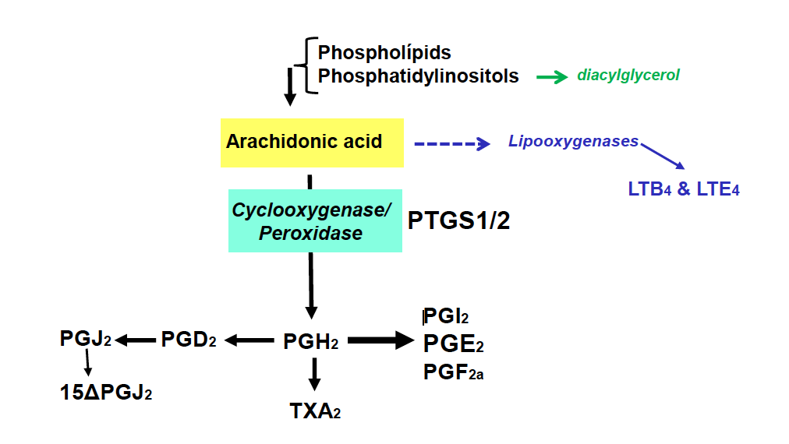
Figure 1 Biochemical reactions catalyzed by prostaglandin-endoperoxide synthase using arachidonic acid as substrate. Phospholipids are cleaved by phospholipases to render arachidonic acid. Prostaglandin-endoperoxide synthase activity generates the precursor prostaglandin H2 that is converted in the different prostaglandins (PGs) by prostaglandin synthases and thromboxane A2, by thromboxane synthase. PG: Prostaglandin; PTGS: Prostaglandin-endoperoxide synthase.

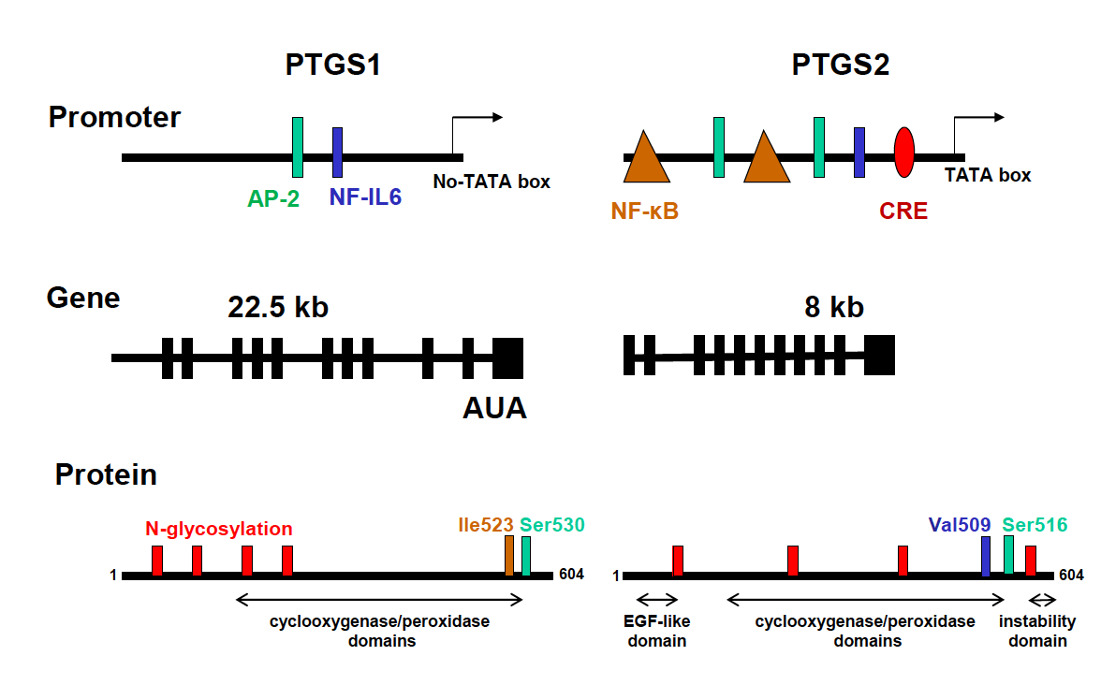
Figure 2 Comparison of the promoter region, gene structure and protein sequence of consensus prostaglandin-endoperoxide synthase 1 and 2. The scheme shows the main transcription factors involved in the transcriptional control of prostaglandin-endoperoxide synthase (PTGS), the structure of the mRNA and the structural motifs present in the protein and relevant for the activity of the enzyme. The glycosylation of PTGS has effects on the activity and fate of the protein, protecting PTGS2 from proteasomal degradation. In addition to this, the electrophoretic mobility of the protein is altered by the glycosylation status of the protein. PTGS: Prostaglandin-endoperoxide synthase; AP-2: Activating protein 2; CRE: cAMP response element; NF-κB: Nuclear factor kappa B.

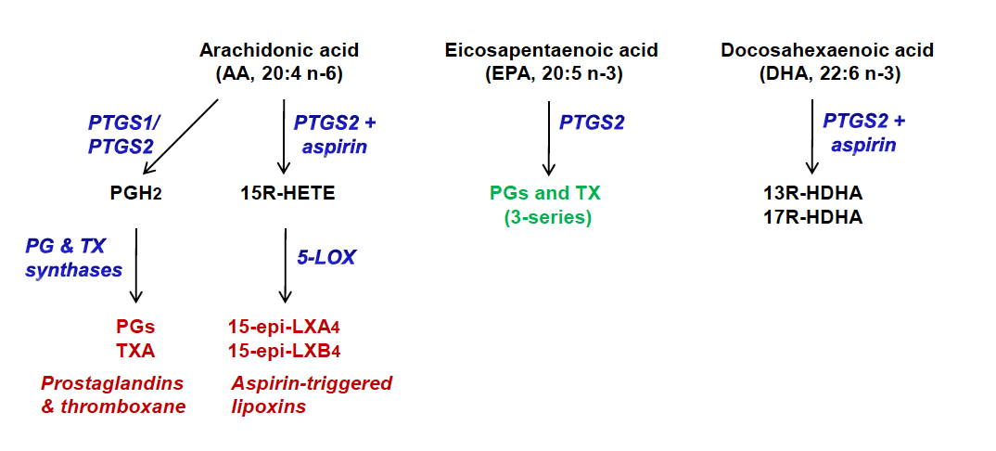
Figure 3 Alternative use of polyunsaturated fatty acids. Aspirin may alter the activity of prostaglandin-endoperoxide synthase (PTGS) since it inhibits PTGS1, but retains the cyclooxygenase activity from PTGS2, leading to the synthesis of 15R-hydroxyeicosatetraenoic acid, from arachidonic acid, or 13- or 17R-hydroxy-docosahexaenoic acid, from docosahexaenoic acid. PTGS: Prostaglandin-endoperoxide synthase; HETE: Hydroxyeicosatetraenoic acid; HDHA: Hydroxy-docosahexaenoic acid.

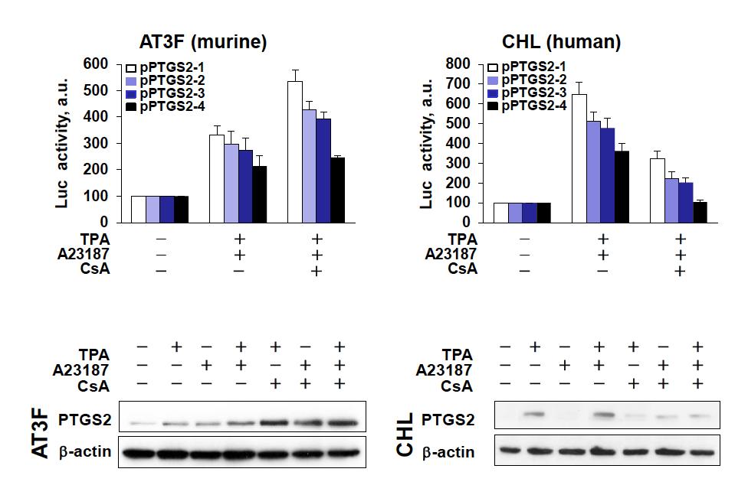
Figure 4 Prostaglandin-endoperoxide synthase 2 exhibits species-specific transcriptional control. Despite the broad conservation of the transcription factor motifs in the prostaglandin-endoperoxide synthase 2 promoter, the activity of the promoter in response to the NF-AT inhibitor cyclosporine A (CsA) is repressed in human hepatic cell lines, but enhanced in murine hepatic counterparts. To confirm this effect, murine AT3F hepatic cells and human CHL hepatic cells were transfected with different constructions of the promoter linked to a luciferase reporter gene (see^{[46]} for details). The protein levels and the luciferase activity were determined at 24h after treatment with the indicated stimuli: tetradecanoylphorbol acetate 100 nmol/L, Ca²⁺-ionophore A23187 1 µmol/L; CsA 100 nmol/L. TPA: Tetradecanoylphorbol acetate; CsA: Cyclosporine A; PTGS: Prostaglandin-endoperoxide synthase.

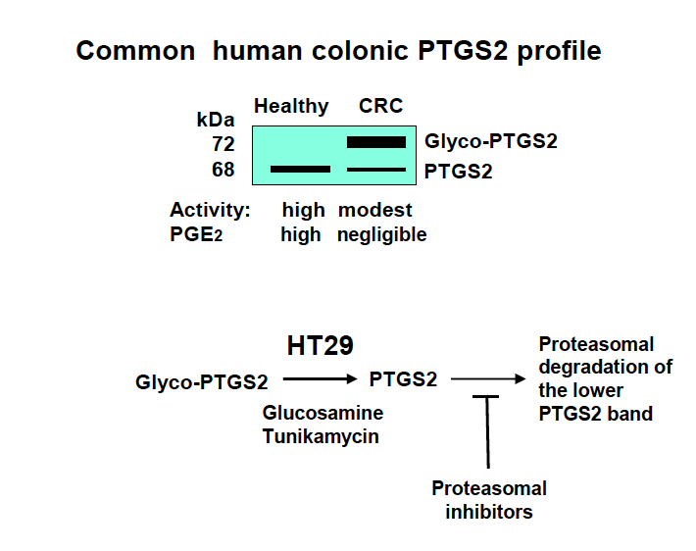
Figure 5 Glycosylation of prostaglandin-endoperoxide synthase 2 in colorectal cancer. The main form in colorectal cancer tissues is the glycosylated 72 kDa protein. This glycosylated prostaglandin-endoperoxide synthase 2 (PTGS2) is also expressed in several tumor colonic cell lines and can be deglycosylated after incubation of the cells with glucosamine or tunikamycin. After this treatment, PTGS2 is rapidly degraded via proteasomal activity. CRC: Colorectal cancer; PTGS: Prostaglandin-endoperoxide synthase.

