Name of journal: World Journal of Gastroenterology
ESPS Manuscript NO: 4065
Columns: BRIEF ARTICLE

Transarterial embolization for massive gastrointestinal hemorrhage following abdominal surgery

Embolization for postoperative gastrointestinal hemorrhage

Chun-Gao Zhou, Hai-Bin Shi, Sheng Liu, Zheng-Qiang Yang, Lin-Bo Zhao, Jin-Guo Xia, Wei-Zhong Zhou, Lin-Sun Li

Chun-Gao Zhou, Hai-Bin Shi, Sheng Liu, Zheng-Qiang Yang, Lin-Bo Zhao, Jin-Guo Xia, Wei-Zhong Zhou, Lin-Sun Li, Department of Interventional Radiology, the First Affiliated Hospital of Nanjing Medical University, 300 Guangzhou Road, Nanjing 210029, Jiangsu Province, China

Author contributions: Zhou CG and Shi HB designed the study and wrote the manuscript; Liu S and Yang ZQ performed transarterial embolization procedures; Zhou CG, Zhao LB, Xia JG and Zhou WZ assisted in patient recruitment and interviews; Shi HB and Li LS corrected the manuscript.

Correspondence to: Dr. Hai-Bin Shi, Department of Interventional Radiology, the First Affiliated Hospital of Nanjing Medical University, 300 Guangzhou Road, Nanjing 210029, Jiangsu Province, China. hbshi346@163.com
Telephone: +86-25-83724440 Fax: +86-25-83724440

Received: June 12, 2013 Revised: July 29, 2013
Accepted: August 16, 2013

Published online:

Abstract
AIM: To evaluate the clinical results of angiography and embolization for massive gastrointestinal hemorrhage after abdominal surgery.

METHODS: This retrospective study included twenty-six patients with postoperative hemorrhage after abdominal surgery. All patients underwent emergency transarterial angiography, and twenty-one patients underwent emergency embolization. We retrospectively analyzed the angiographic features and the clinical outcomes of transcatheter arterial embolization.

RESULTS: Angiography showed that a discrete bleeding focus was detected in 21 (81%) of 26 patients. Positive angiographic findings included extravasations of contrast medium (n = 9), pseudoaneurysms (n = 9), and fusiform aneurysms (n = 3). Transarterial embolization was technically successful in 21 (95%) of 22 patients. Clinical success was achieved in 18 (82%) of 22 patients. No postembolization complications were observed. Three patients died of rebleeding.

CONCLUSION: The rate of positive angiographic findings of postoperative gastrointestinal hemorrhage in 26 patients was 81%. Transcatheter arterial embolization seems to be an effective and safe method in the management of postoperative gastrointestinal hemorrhage.

© 2013 Baishideng. All rights reserved.

Key words: Transcatheter arterial embolization; Postoperative hemorrhage; Complications; Surgery.

Core tip: Postoperative gastrointestinal hemorrhage is one of the most fatal complications after abdominal surgery. It is very difficult for surgeon to deal with. Reopration is often difficult or even unsuccessful in patients with postoperative hemorrhage, especially those with two or more previous abdominal operations, due to the anatomical inaccessibility of the arteries, postoperative adhesions, and inflammatory reaction. This study showed that transcatheter embolization was a useful microinvasive treatment option for the identification and occlusion of a massive bleeding site after abdominal surgery.

Zhou CG, Shi HB, Liu S, Yang ZQ, Zhao LB, Xia JG, Zhou WZ, Li LS. Transarterial embolization for massive gastrointestinal hemorrhage following abdominal surgery.

Available from: URL:
DOI:

INTRODUCTION
Postoperative gastrointestinal hemorrhage is one of the most fatal complications after abdominal surgery. It prolongs hospital stay, requires urgent radiological or surgical intervention, and increases mortality after abdominal surgery. The incidence of postoperative gastrointestinal hemorrhage after abdominal surgery is low, but increases with an increase in surgical procedures, the severity of illness, and the comorbid conditions in the patient’s population. The incidence of postoperative gastrointestinal hemorrhage has been reported to be from 0.4% to 4% in recent series ^{[1-7]}, and from 2% to 18% in early series^{[8-14]}. Although recent studies have shown that its mortality has been decreased, it still remains a serious and life-threatening condition.
Traditionally, open ligation or excision has been considered to be the first-line therapeutic option for patients with massive gastrointestinal hemorrhage after abdominal surgery. However, the bleeding site is difficult to be found because of local inflammatory response after abdominal surgery. In addition, patients with postoperative gastrointestinal hemorrhage have been reported to be poor candidates for emergency surgery because of cicatrization and friability of postoperative tissues^{[15]}.
Transcatheter angiographic embolization is a less invasive procedure that has been known to be a safe and effective treatment to control massive gastrointestinal hemorrhage. With the development of endovascular techniques over the past decade, transarterial embolization has been widely used in the clinics for the treatment of postoperative gastrointestinal hemorrhage after abdominal surgery despite the possibility of gastrointestinal infarction^{[16-19]}.
In this study, we retrospectively reviewed and analyzed the angiographic findings and clinical outcomes of transarterial angiography and embolization in 26 patients with postoperative hemorrhage after abdominal surgery.

MATERIALS AND METHODS
This study was approved by our institutional review board, and all patients gave their informed consent before procedure. This study included 26 patients (22 males and 4 females) who underwent emergency transarterial angiography and embolization for postoperative hemorrhage after abdominal surgery between August, 2007 and April, 2012 at our hospital. The mean age was 57.2 years (range, 35-86 years). The average time of the onset of postoperative hemorrhage was 27.7 d (range, 3-65 d). The abdominal surgeries included surgeries for gastric carcinoma (n = 13), pancreatic head carcinoma (n = 2), common bile duct carcinoma (n = 2), duodenal papilla carcinoma (n = 2), ascending colon carcinoma (n = 1), severe pancreatitis (n = 1), gallbladder carcinoma (n = 1), cholangiolithiasis (n = 1), and intra-abdominal abscess (n = 1), as well as splenomegaly (n = 1), and mesenteric torsion (n = 1). Clinical presentations included hematemesis, hematochezia/melena, and bleeding from surgical drains. The volume of bleeding was more than 1000 mL in 24 hours.
The diagnostic angiography was performed via transfemoral approach, using a 5-F angiographic catheter (COOK, Bloomington, United States) and a 5-F sheath (Terumo, Tokyo, Japan). In all cases, celiac and superior mesenteric angiographies were routinely performed to detect the bleeding points. If celiac and superior mesenteric angiographies did not detect any bleeding points, inferior mesenteric angiographies were performed. Hemorrhage was diagnosed based on the presence of extravasation of contrast agent, a pseudoaneurysm, and a fusiform aneurysm on angiography. Immediately after bleeding points were identified, transarterial embolization was performed with microcoils (COOK, Bloomington, United States) and /or gelatin sponge (gelfoam particles) through a coaxial 2.7-F microcatheter (Terumo, Tokyo, Japan). Transarterial embolization was also performed with gelfoam in one patient without positive angiographic findings. Technical success was defined as devascularization of the target vessels on the postembolization angiography. Clinical success was defined as cessation of clinical symptoms (including melena, hematemesis, and hematochezia), and no requirement for subsequent hemostatic interventions (such as surgery, endoscopic therapy, and second embolization).
The diameter of microcoils we used was from 2 mm to 6 mm. The length of microcoils was from 3cm to 8cm. And the diameter of gelfoam particles was about 1mm. Clinical follow up period was three months in all patients.

RESULTS
Fifteen patients presented with haematemesis/melena, and eleven patients presented with bleeding from surgical drains. Twenty-two patients had signs of shock (systolic blood pressure of less than 100 mmHg and pulse rate of more than 100 per min). The clinical features and angiographic findings are summarized in Table 1. Results of transarterial embolization are summarized in Table 2.
Bleeding points near the surgical fields were detected on the angiography in 21 (81%) of 26 patients. Positive angiographic findings included extravasation of contrast medium (n = 9) (Figure 1), pseudoaneurysms (n = 9) (Figures 2 and 3), and fusiform aneurysms (n = 3). Extravasation of contrast medium was observed from the jejunal artery (n = 2), the gastroduodenal artery (n = 2), the right hepatic artery and gastroduodenal artery (n = 1), the great pancreatic artery (n = 1), the inferior pancreaticoduodenal artery (n = 1), the dorsal pancreatic artery (n = 1), and the ileocolic artery (n = 1). Pseudoaneurysms were found in the gastroduodenal artery (n = 3), the common hepatic artery (n = 1), the right hepatic artery (n = 1), the inferior pancreaticoduodenal artery (n = 1), the splenic artery and right gastroepiploic artery (n = 1), the jejunal artery (n = 1), and the superior rectal artery (n = 1). The fusiform aneurysms were identified in the gastroduodenal artery (n = 2), and the proper hepatic artery (n = 1).
Transarterial embolization was performed in 20 of 21 patients with positive angiographic findings and one patient without positive angiographic findings. The embolized arteries are summarized in Table 2. Transarterial embolization of bleeding arteries was performed using a combination of microcoils and gelatin sponge in six cases, microcoils in thirteen cases, and gelatin sponge in two cases. Transarterial embolization was not performed in one patient with positive angiographic finding, because the bleeding vessels were capillaries and could not be superselected. This patient underwent a second surgery after angiography immediately, and recovered after second surgery. However, there are five patients without positive angiographic findings in our study. Among these five patients, one died of rebleeding after blind embolizaton. One recovered after conservative treatment. And the other three patients also recovered after second surgery. In the surgical procedure, we found that the bleeding vessels were come from splenic vein, portal vein behind the gastrointestinal anastomotic stoma, and left gastroomental vein, respectively.
Technical success was achieved in 21 (95%) of 22 patients (20 patients with positive angiographic findings and one patient without positive angiographic findings). Clinical success was achieved in 18 (82%) of 22 patients. Three patients were unsuccessfully treated, including two patients with rebleeding after embolization, and one patient with rebleeding after blind embolization.
Postembolization complications such as intestinal ischemia and liver infarction did not occur in all patients during the follow-up period. Three patients (two patients with positive angiographic findings and one patient without positive angiographic findings) died of rebleeding after embolization.

DISCUSSION
Postoperative gastrointestinal hemorrhage is a life-threatening complication that occurs after abdominal surgery, particularly in the case of pancreaticoduodenectomy. The incidence of postoperative gastrointestinal hemorrhage after abdominal surgery is not very high (0.4-18%)^{[1-14]}. Early hemorrhagic complications occur during the first 24 h postoperatively, and are usually caused by intraoperative technical failure, such as improper ligation of vessels in the operative area, and damages to small vessels during lymph node dissection. Delayed postoperative hemorrhage has a different pathophysiology of bleeding from early postoperative hemorrhage, and is complicated with intraabdominal lesions such as marginal ulcer, anastomotic leakage, intraabdominal abscess, and sepsis. In this study, the interval from surgery to bleeding ranged from three days to sixty-five days, and was more than five d for the majority of patients. The intra-abdominal complications such as pancreatic juice leakage, intestinal juice leakage, and intraabdominal abscess were the main causes of gastrointestinal bleeding in our study. In order to reduce the rate of postoperative gastrointestinal hemorrhage after abdominal surgery, we must decrease abdominal surgery complications, such as stomal leak, marginal ulcer, and abscess et al.
Early diagnosis and prompt treatment are necessary to decrease the mortality of the patients with postoperative hemorrhage after abdominal surgery. Endoscopy is usually served as the first-line diagnostic procedure. However, exact diagnosis via urgent gastrointestinal endoscopy can be severely impaired by excessive blood and clots in the gastrointestinal tract^{[20,21]}. CTA, Doppler Ultrasound, and radionuclide scan can also be used in the diagnosis of postoperative hemorrhage^{[5,22,23]}. Compared with these diagnosis methods, angiography is more quick, safe, and accurate to localize the bleeding points. In addition, angiography allows immediate embolization to stop gastrointestinal hemorrhage. On the other hand, angiographic findings of postoperative gastrointestinal hemorrhage have a little different from that of gastrointestinal hemorrhage without surgical procedure. Positive angiographic findings of gastrointestinal hemorrhage without surgical procedure mainly included extravasation of contrast medium, tumor staining, and vascular malformation. Charbonnet P et al. reported that angiography had a positive angiographic findings rate of 31% in all consecutive patients without abdominal surgical procedure^{[24]}. Kim et al^{[19]} reported that angiography had a positive angiographic findings rate of 79% in patients after abdominal surgical procedure. However, positive angiographic findings of postoperative gastrointestinal hemorrhage mainly included extravasation of contrast medium and pseudoaneurysms. In our study, the positive findings were 81% (21 of 26), and the rate of positive findings was much higher than that of gastrointestinal hemorrhage without abdominal surgical procedure and was similar to that of gastrointestinal hemorrhage with abdominal surgical procedure. Therefore, angiography should be the first choice option for postoperative gastrointestinal hemorrhage after abdominal surgery, especially for the patients with hemodynamic instability and poor general conditions. If celiac angiography fails to identify a source of bleeding, superselective angiography near the surgical field should be performed. However, angiography also has some limitations. If bleeding rate was too low to be detected, bleeding comes from veins, bleeding was stopped during angiography, or vasoactive agents were used before angiography, angiography can not detect the bleeding sites. In this study, angiography demonstrated the bleeding points in 21(81%) of 26 patients. Reoperation were performed in three patients with negative angiographic findings, surgeons found that the bleeding vessels were left gastroomental vein, portal vein behind anastomotic stoma, and splenic vein in surgical procedure, respectively.
Reoperation to control postoperative bleeding is the traditional approach to manage gastrointestinal hemorrhage after abdominal surgery. However, emergency surgical exploration has been reported to be associated with a mortality rate of as high as 64% in high risk patients with hemodynamic instability and poor general conditions ^{[25,26]}. In addition, the surgical approach is often difficult or even unsuccessful in patients with postoperative hemorrhage, especially those with two or more previous abdominal operations, due to the anatomical inaccessibility of the arteries, postoperative adhesions, and inflammatory reaction. Endoscopy is another approach to manage postoperative hemorrhage^{[1-4,27-32]}. However, emergency endoscopy for postoperative hemorrhage may be difficult owing to excessive blood and clots in the gastrointestinal tract, and inaccessibility of the bleeding sites in small intestine.
Transarterial embolization has been known to be very effective for postoperative hemorrhage, especially for the patients with hemodynamic instability and poor general conditions. However, the safety and clinical results of embolization have not been assessed in a large patient group. Beyer et al^{[5]} reported that embolization had a success rate of 100% in nine patients with delayed hemorrhage after pancreaticoduodenectomy. Miyamoto et al. demonstrated a success rate of 80% with superselective embolization in ten patients with massive upper gastrointestinal hemorrhage after upper abdominal surgery^{[33]}. Compared with these studies, the clinical success rate (82%) of this study is similar. However, the technical success rate in this study was 95% because we used highly resolution digital angiographic machine and microcatheter. There also had three patients died during the follow-up period. The cause of death was rebleeding after embolization, including one blind embolization.
The clinical results of blind embolization (defined as embolization without positive angiography) are controversial. Morris et al. found that blind embolization of the left gastric artery was effective in preventing rebleeding when an active bleeding site was localized by endoscopy^{[34]}. Kim et al^{[19]} successfully treated four patients with blind embolization after an active bleeding site was identified by endoscopy or scintigraphy, or was suspicious on angiogram. In our study, blind embolization was performed only in one patient after the bleeding site was localized by endoscopy. However, the patient died of rebleeding three days after the interventional procedure.
The most serious complications of postembolization are liver infarction and irreversible bowel ischemia. However, the liver can tolerate considerable arterial embolization without significant liver infarction, because the liver has a dual blood supply by the hepatic artery and portal vein, and the hepatic artery has abundant collateral pathways. Arterial embolization in the upper gastrointestinal tract above the ligament of Treitz is generally considered very safe because of the rich collateral supply to the stomach and duodenum^{[34]}. In contrast to the upper gastrointestinal tract, the lower gastrointestinal tract does not have a rich collateral artery, and is susceptible to embolization-induced ischemia. However, significant ischemia may be avoided if the embolic agent is delivered precisely to the bleeding sites. In our study, postembolization complications such as liver infarction and bowel ischemia were not encountered. Therefore, we believe that transarterial embolization is a safe method to treat postoperative gastrointestinal hemorrhage.
In conclusion, we retrospectively analyzed the angiographic findings and clinical outcomes of transarterial angiography and embolization in 26 patients with postoperative hemorrhage after abdominal surgery. Angiography was found to be a sensitive approach to detect the bleeding site, especially for the patients with postoperative gastrointestinal hemorrhage. Transarterial embolization is an effective and safe method for the treatment of postoperative hemorrhage.

COMMENTS
Background
Gastrointestinal hemorrhage after abdominal surgery is an unusual complication. However, when it occurs, it can cause tremendous hemorrhagic shock that leads to a fatal outcome. This complication may occur as a result of an anastomotic leakage, localized infection, or intraoperative arterial injury. Traditionally, reoperation was regarded as the first line therapy. However, its usage is largely limited by the poor conditions of patients with postoperative gastrointestinal hemorrhage and the difficulty in indentifying the bleeding sites during surgery. With advances in technology, a newer and less invasive technique-- transcatheter arterial embolization has been developed and was reported to be safe and effective, especially in high-surgical-risk patients.

Research frontiers
For postoperative gastrointestinal hemorrhage, the first important thing is to localize the bleeding site. Transarterial angiography is considered to be a better tool than endoscopy or noninvasive diagnostic imaging examinations such as CT angiography and ultrasound. Transarterial access not only can provide diagnostic information but also has the advantage of intraarterial embolization of the bleeding site simultaneously.

Innovations and breakthroughs
The surgical approach to control postoperative bleeding is often difficult or even unsuccessful in patients with postoperative hemorrhage, especially those with two or more previous abdominal operations, due to the anatomical inaccessibility of the arteries, postoperative adhesions, and inflammatory reaction. Therefore, its mortality rate was as high as 64% in high risk patients with hemodynamic instability and poor general conditions in literature. However, with the advancement of technique and microcatheter, transcatheter arterial embolization was performed to control postoperative bleeding. In this retrospective study, the technical success rate was 95%, and the clinical success rate was 82%. There were no procedure-related complications.

Applications
The results of this study suggest that transcatheter arterial embolization is a safe and effective treatment for massive gastrointestinal hemorrhage following abdominal surgery.

Peer review
This is a good descriptive study in which authors evaluated the clinical results of angiography and embolization for massive gastrointestinal hemorrhage after abdominal surgery. The results are interesting and suggest that transcatheter arterial embolization is a safe and effective treatment for massive gastrointestinal hemorrhage following abdominal surgery, especially for the patients with hemodynamic instability and poor general conditions.

REFERENCES
1 Tanizawa Y, Bando E, Kawamura T, Tokunaga M, Ono H, Terashima M. Early postoperative anastomotic hemorrhage after gastrectomy for gastric cancer. Gastric Cancer 2010; 13: 50-57 [PMID: 20373076 DOI: 10.1007/s10120-009-0535-6]
2 Malik AH, East JE, Buchanan GN, Kennedy RH. Endoscopic haemostasis of staple-line haemorrhage following colorectal resection. Colorectal Dis 2008; 10: 616-618 [PMID: 18215199 DOI: 10.1111/j.1463-1318.2007.01459.x]
3 Martínez-Serrano MA, Parés D, Pera M, Pascual M, Courtier R, Egea MJ, Grande L. Management of lower gastrointestinal bleeding after colorectal resection and stapled anastomosis. Tech Coloproctol 2009; 13: 49-53 [PMID: 19288245 DOI: 10.1007/s10151-009-0458-6]
4 Linn TY, Moran BJ, Cecil TD. Staple line haemorrhage following laparoscopic left-sided colorectal resections may be more common when the inferior mesenteric artery is preserved. Tech Coloproctol 2008; 12: 289-293 [PMID: 19018473 DOI: 10.1007/s10151-008-0437-3]
5 Beyer L, Bonmardion R, Marciano S, Hartung O, Ramis O, Chabert L, Léone M, Emungania O, Orsoni P, Barthet M, Berdah SV, Brunet C, Moutardier V. Results of non-operative therapy for delayed hemorrhage after pancreaticoduodenectomy. J Gastrointest Surg 2009; 13: 922-928 [PMID: 19224299 DOI: 10.1007/s11605-009-0818-6]
6 Yekebas EF, Wolfram L, Cataldegirmen G, Habermann CR, Bogoevski D, Koenig AM, Kaifi J, Schurr PG, Bubenheim M, Nolte-Ernsting C, Adam G, Izbicki JR. Postpancreatectomy hemorrhage: diagnosis and treatment: an analysis in 1669 consecutive pancreatic resections. Ann Surg 2007; 246: 269-280 [PMID: 17667506 DOI: 10.1097/01.sla.0000262953.77735.db]
7 Vernadakis S, Christodoulou E, Treckmann J, Saner F, Paul A, Mathe Z. Pseudoaneurysmal rupture of the common hepatic artery into the biliodigestive anastomosis. A rare cause of gastrointestinal bleeding. JOP 2009; 10: 441-444 [PMID: 19581753]
8 Dixon JM, Armstrong CP, Duffy SW, Elton RA, Davies GC. Upper gastrointestinal bleeding. A significant complication after surgery for relief of obstructive jaundice. Ann Surg 1984; 199: 271-275 [PMID: 6608323 DOI: 10.1097/00000658-198403000-00004]
9 Yeo CJ. Management of complications following pancreaticoduodenectomy. Surg Clin North Am 1995; 75: 913-924 [PMID: 7660254]
10 Rumstadt B, Schwab M, Korth P, Samman M, Trede M. Hemorrhage after pancreatoduodenectomy. Ann Surg 1998; 227: 236-241 [PMID: 9488522 DOI: 10.1097/00000658-199802000-00013]
11 Welch CE, Rodkey GV, von Ryll Gryska P. A thousand operations for ulcer disease. Ann Surg 1986; 204: 454-467 [PMID: 3767481 DOI: 10.1097/00000658-198610000-00014]
12 Ikeguchi M, Oka S, Gomyo Y, Tsujitani S, Maeta M, Kaibara N. Postoperative morbidity and mortality after gastrectomy for gastric carcinoma. Hepatogastroenterology 2001; 48: 1517-1520 [PMID: 11677999]
13 Bokey EL, Chapuis PH, Fung C, Hughes WJ, Koorey SG, Brewer D, Newland RC. Postoperative morbidity and mortality following resection of the colon and rectum for cancer. Dis Colon Rectum 1995; 38: 480-46; discussion 480-46; [PMID: 7736878 DOI: 10.1007/BF02148847]
14 Tsiotos GG, Munoz Juarez MM, Sarr MG. Intraabdominal hemorrhage complicating surgical management of necrotizing pancreatitis. Pancreas 1996; 12: 126-130 [PMID: 8720657 DOI: 10.1097/00006676-199603000-00003]
15 Reber PU, Baer HU, Patel AG, Triller J, Büchler MW. Life-threatening upper gastrointestinal tract bleeding caused by ruptured extrahepatic pseudoaneurysm after pancreatoduodenectomy. Surgery 1998; 124: 114-115 [PMID: 9663263 DOI: 10.1016/S0039-6060(98)70086-8]
16 Radeleff B, Noeldge G, Heye T, Schlieter M, Friess H, Richter GM, Kauffmann GW. Pseudoaneurysms of the common hepatic artery following pancreaticoduodenectomy: successful emergency embolization. Cardiovasc Intervent Radiol 2007; 30: 129-132 [PMID: 16933158 DOI: 10.1007/s00270-005-0372-x]
17 Miura F, Asano T, Amano H, Yoshida M, Toyota N, Wada K, Kato K, Yamazaki E, Kadowaki S, Shibuya M, Maeno S, Furui S, Takeshita K, Kotake Y, Takada T. Management of postoperative arterial hemorrhage after pancreato-biliary surgery according to the site of bleeding: re-laparotomy or interventional radiology. J Hepatobiliary Pancreat Surg 2009; 16: 56-63 [PMID: 19110653 DOI: 10.1007/s00534-008-0012-3]
18 Liu C, Qiu YH, Luo XJ, Yi B, Jiang XQ, Tan WF, Yu Y, Wu MC. Treatment of massive pancreaticojejunal anastomotic hemorrhage after pancreatoduodenectomy. World J Gastroenterol 2009; 15: 1625-1629 [PMID: 19340906 DOI: 10.3748/wjg.15.1625]
19 Kim J, Kim JK, Yoon W, Heo SH, Lee EJ, Park JG, Kang HK, Cho CK, Chung SY. Transarterial embolization for postoperative hemorrhage after abdominal surgery. J Gastrointest Surg 2005; 9: 393-399 [PMID: 15749603 DOI: 10.1016/j.gassur.2004.07.015]
20 Vreeburg EM, Snel P, de Bruijne JW, Bartelsman JF, Rauws EA, Tytgat GN. Acute upper gastrointestinal bleeding in the Amsterdam area: incidence, diagnosis, and clinical outcome. Am J Gastroenterol 1997; 92: 236-243 [PMID: 9040198]
21 Toyoda H, Nakano S, Takeda I, Kumada T, Sugiyama K, Osada T, Kiriyama S, Suga T. Transcatheter arterial embolization for massive bleeding from duodenal ulcers not controlled by endoscopic hemostasis. Endoscopy 1995; 27: 304-307 [PMID: 7555935 DOI: 10.1055/s-2007-1005697]
22 Moran J, Del Grosso E, Wills JS, Hagy JA, Baker R. Laparoscopic cholecystectomy: imaging of complications and normal postoperative CT appearance. Abdom Imaging 1994; 19: 143-146 [PMID: 8199546 DOI: 10.1007/BF00203489]
23 Walker TG, Salazar GM, Waltman AC. Angiographic evaluation and management of acute gastrointestinal hemorrhage. World J Gastroenterol 2012; 18: 1191-1201 [PMID: 22468082 DOI: 10.3748/wjg.v18.i11.1191]
24 Charbonnet P, Toman J, Bühler L, Vermeulen B, Morel P, Becker CD, Terrier F. Treatment of gastrointestinal hemorrhage. Abdom Imaging 2005; 30: 719-726 [PMID: 16252149 DOI: 10.1007/s00261-005-0314-8]
25 Lerut JP, Gianello PR, Otte JB, Kestens PJ. Pancreaticoduodenal resection. Surgical experience and evaluation of risk factors in 103 patients. Ann Surg 1984; 199: 432-437 [PMID: 6712319 DOI: 10.1097/00000658-198404000-00010]
26 Smith CD, Sarr MG, vanHeerden JA. Completion pancreatectomy following pancreaticoduodenectomy: clinical experience. World J Surg 1992; 16: 521-524 [PMID: 1350387 DOI: 10.1007/BF02104459]
27 Cirocco WC, Golub RW. Endoscopic treatment of postoperative hemorrhage from a stapled colorectal anastomosis. Am Surg 1995; 61: 460-463 [PMID: 7733557]
28 Lee YC, Wang HP, Yang CS, Yang TH, Chen JH, Lin CC, Tsai CY, Chang LY, Huang SP, Wu MS, Lin JT. Endoscopic hemostasis of a bleeding marginal ulcer: hemoclipping or dual therapy with epinephrine injection and heater probe thermocoagulation. J Gastroenterol Hepatol 2002; 17: 1220-1225 [PMID: 12453283 DOI: 10.1046/j.1440-1746.2002.02875.x]
29 Perez RO, Sousa A, Bresciani C, Proscurshim I, Coser R, Kiss D, Habr-Gama A. Endoscopic management of postoperative stapled colorectal anastomosis hemorrhage. Tech Coloproctol 2007; 11: 64-66 [PMID: 17357871 DOI: 10.1007/s10151-007-0330-5]
30 Trottier DC, Friedlich M, Rostom A. The use of endoscopic hemoclips for postoperative anastomotic bleeding. Surg Laparosc Endosc Percutan Tech 2008; 18: 299-300 [PMID: 18574422 DOI: 10.1097/SLE.0b013e318169039b]
31 Umano Y, Horiuchi T, Inoue M, Shono Y, Oku Y, Tanishima H, Tsuji T, Tabuse K. Endoscopic microwave coagulation therapy of postoperative hemorrhage from a stapled anastomosis. Hepatogastroenterology 2005; 52: 1768-1770 [PMID: 16334775]
32 Wisniewski B, Rautou PE, Drouhin F, Narcy-Lambare B, Chamseddine J, Karaa A, Grange D. Endoscopic hemoclips in postoperative bleeding. Gastroenterol Clin Biol 2005; 29: 933-934 [PMID: 16294165 DOI: 10.1016/S0399-8320(05)86460-7]
33 Miyamoto N, Kodama Y, Endo H, Shimizu T, Miyasaka K. Hepatic artery embolization for postoperative hemorrhage in upper abdominal surgery. Abdom Imaging 2003; 28: 347-353 [PMID: 12719904 DOI: 10.1007/s00261-002-0041-3]
34 Morris DC, Nichols DM, Connell DG, Burhenne HJ. Embolization of the left gastric artery in the absence of angiographic extravasation. Cardiovasc Intervent Radiol 1986; 9: 195-198 [PMID: 3094950 DOI: 10.1007/BF02577940]

P-Reviewers Beart R, Caumes E, Takeda R S-Editor Wen LL L-Editor E-Editor

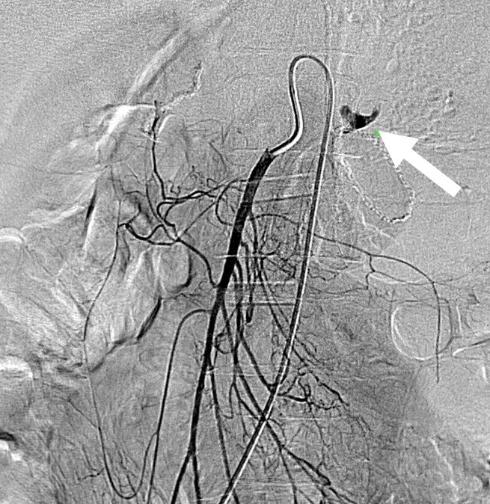
Figure 1 A 35-year-old male with massive upper gastrointestinal bleeding after gastrectomy of gastric carcinoma. Selective superior mesenteric artery angiogram shows active arterial contrast extravasation (white arrow) from the jejunal artery.

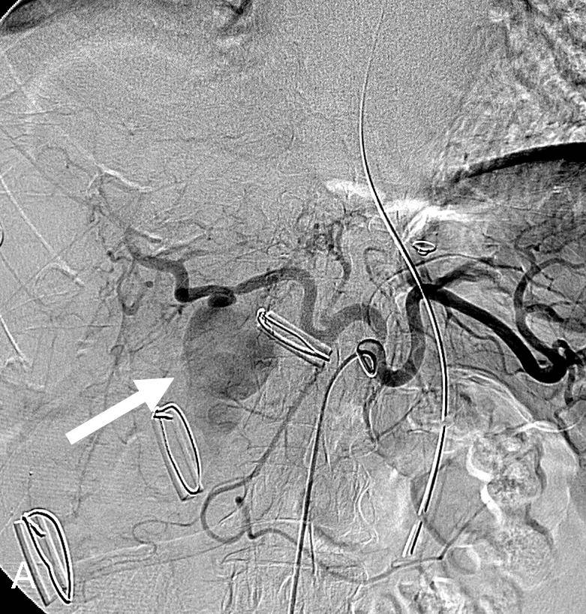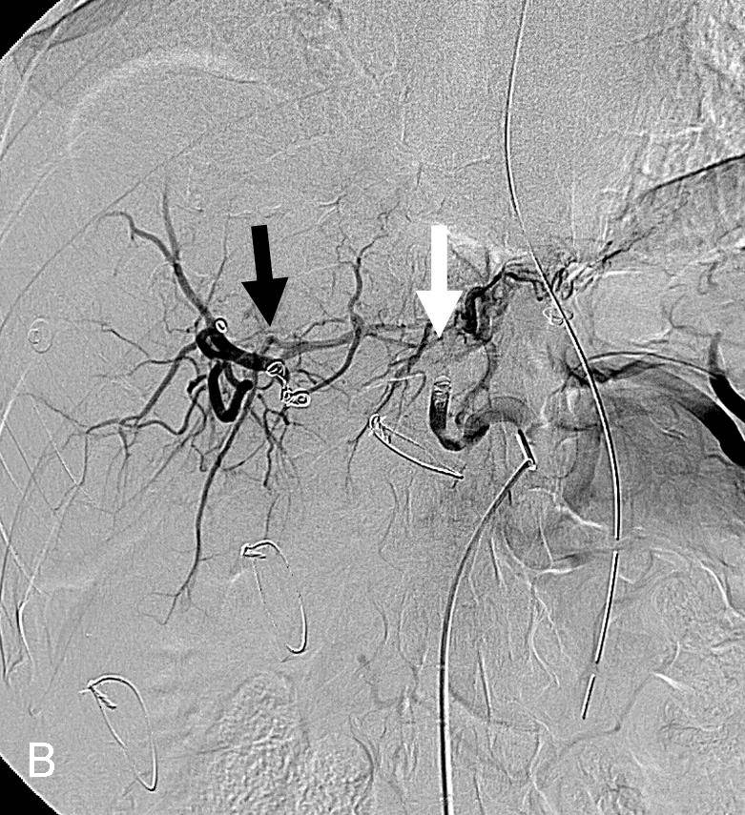
Figure 2 A 56-year-old male presented with massive bleeding from surgical drains after choledocholithotomy due to common bile duct stone. A: Selective celiac artery angiogram shows a pseudoaneurysm (arrow) arising from the right hepatic artery; B: Selective celiac artery angiogram after embolization with microcoils and gelfoam demonstrates that the pseudoaneurysm disappears. Embolic agents were inserted proximally (white arrow) and distally (black arrow) to the origin of the pseudoaneurysm.

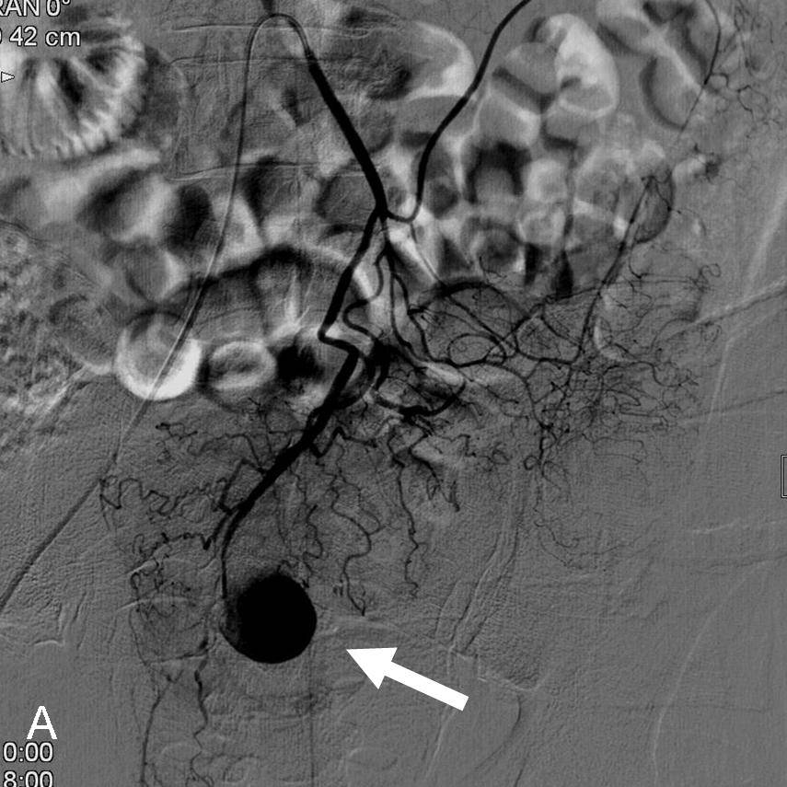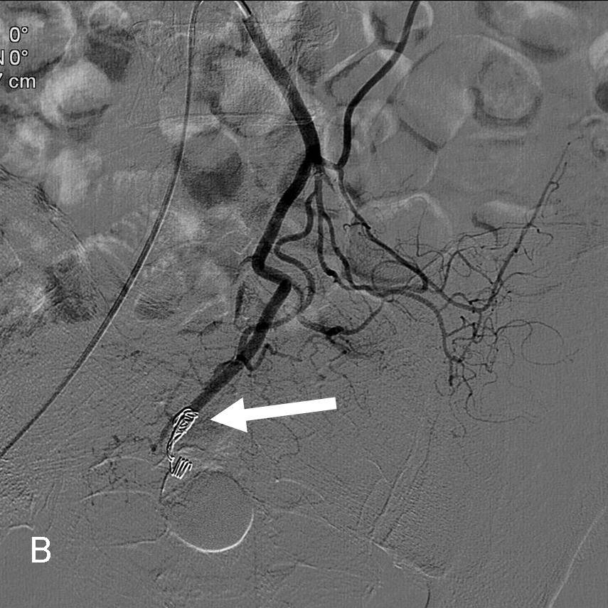
Figure 3 A 61-year-old male presented with massive bleeding from surgical drains three d after excision of intra-abdominal abscess. A: Selective inferior mesenteric arteriography shows a pseudoaneurysm (arrow) arising from the superior rectal artery; B: Selective inferior mesenteric arteriography after embolization with microcoils demonstrates complete occlusion (arrow) of the distal end of the superior rectal artery.

Table 1 Clinical features of patients with postoperative hemorrhage after abdominal surgery
Case | Sex | Age (yr) | Diseases | Surgical procedure | Interval from operation to bleeding (d) | Clinical  presentations
1 | male | 61 | gastric carcinoma | gastrectomy | 11 | haematemesis/melena
2 | male | 72 | pancreatitis | pancreatitic necrosectomy | 15 | bleeding from drain
3 | male | 46 | duodenal papilla carcinoma | pancreaticoduodenectomy | 38 | bleeding from drain
4 | male | 64 | gastric carcinoma | gastrectomy | 14 | bleeding from drain
5 | male | 37 | gastric carcinoma | gastrectomy | 27 | haematemesis/melena
6 | female | 44 | gastric carcinoma | gastrectomy | 18 | bleeding from drain
7 | male | 51 | gastric carcinoma | gastrectomy | 20 | haematemesis/melena
8 | male | 35 | gastric carcinoma | gastrectomy | 28 | haematemesis/melena
9 | male | 41 | gastric carcinoma | gastrectomy | 64 | haematemesis/melena
10 | male | 56 | pancreatic carcinoma | pancreaticoduodenectomy | 10 | haematemesis/melena
11 | female | 45 | gallbladder carcinoma | extended cholecystectomy | 25 | haematemesis/melena
12 | male | 86 | ascending colon carcinoma | right hemicolectomy | 34 | hematochezia /melena
13 | male | 59 | gastric carcinoma | gastrectomy | 50 | haematemesis/melena
14 | male | 69 | gastric carcinoma | gastrectomy | 49 | bleeding from drain
15 | male | 61 | intra-abdominal abscess | excision of intra-abdominal abscess | 3 | bleeding from drain
16 | male | 65 | common bile duct carcinoma | pancreaticoduodenectomy | 29 | bleeding from drain
17 | male | 73 | gastric carcinoma | gastrectomy | 38 | hematochezia /melena
18 | male | 60 | bile duct carcinoma | pancreaticoduodenectomy | 29 | bleeding from drain
19 | female | 62 | gastric carcinoma | gastrectomy | 21 | haematemesis/melena
20 | male | 80 | duodenal papilla carcinoma | pancreaticoduodenectomy | 8 | bleeding from drain
21 | male | 42 | pancreatic carcinoma | pancreaticoduodenectomy | 46 | haematemesis/melena
22 | male | 45 | splenomegaly | splenectomy | 9 | bleeding from drain
23 | male | 56 | bile duct stone | choledocholithotomy | 26 | bleeding from drain
24 | female | 62 | gastric carcinoma | gastrectomy | 65 | hematochezia /melena
25 | male | 76 | gastric carcinoma | gastrectomy | 29 | haematemesis/melena
26 | male | 40 | mesenteric torsion | partial intestinal resection | 15 | haematemesis/melena

Table 2 Angiographic findings and clinical results of patients with postoperative hemorrhage after abdominal surgery
Case | Angiography ﬁnding | Embolized artery | Embolic agent | Clinical results
1 | negative | none | none | conservative treatment and clinical success
2 | negative | none | none | repeat surgery and clinical success
3 | negative | none | none | repeat surgery and clinical success
4 | negative | none | none | repeat surgery and clinical success
5 | extravasation | none | none | conservative treatment and clinical success
6 | extravasation | inferior pancreaticoduodenal artery | microcoil | clinical success
7 | extravasation | jejunal artery | microcoil | clinical success
8 | extravasation | jejunal artery | microcoil | clinical success
9 | extravasation | inferior pancreaticoduodenal artery | microcoil | clinical success
10 | extravasation | great pancreatic artery | gelfoam | clinical success
11 | negative | right hepatic artery and gastroduodenal artery | gelfoam | die of rebleeding
12 | extravasation | ileocolic artery | microcoil | clinical success
13 | pseudoaneurysm | gastroduodenal artery | microcoil | clinical success
14 | extravasation | gastroduodenal artery | microcoil | clinical success
15 | pseudoaneurysm | superior rectal artery | microcoil | clinical success
16 | pseudoaneurysm | gastroduodenal artery | microcoil | clinical success
17 | fusiform aneurysm | gastroduodenal artery | microcoil | clinical success
18 | pseudoaneurysm | common hepatic artery | microcoil | clinical success
19 | extravasation | gastroduodenal artery | microcoil | die of rebleeding
20 | pseudoaneurysm | gastroduodenal artery | microcoil | die of rebleeding
21 | fusiform aneurysm | proper hepatic artery | microcoil + gelfoam | clinical success
22 | pseudoaneurysm | splenic artery and right gastroepiploic artery | microcoil + gelfoam | clinical success
23 | pseudoaneurysm | right hepatic artery | microcoil + gelfoam | clinical success
24 | pseudoaneurysm | inferior pancreaticoduodenal artery | microcoil + gelfoam | clinical success
25 | fusiform aneurysm | gastroduodenal artery | microcoil + gelfoam | clinical success
26 | pseudoaneurysm | jejunal artery | microcoil + gelfoam | clinical success

